Supporting information

Robust aortic media adhesion using hydrophobically-modified Alaska pollock gelatin-based adhesive for aortic dissections

Temmei Ito^{1, 2}, Ryo Mizuta^{1, 2}, Shima Ito^{1,2}, Tetsushi Taguchi^{1, 2}*

¹Graduate School of Pure and Applied Sciences, University of Tsukuba, 1-1-1 Tennodai, Tsukuba, Ibaraki 305-8577, Japan
²Biomaterials Field, Research Center for Macromolecules and Biomaterials, National Institute for Materials Science, 1-1 Namiki, Tsukuba, Ibaraki 305-0044, Japan

* Author to whom correspondence should be addressed.
Tel: +81-29-60-4498
Fax: +81-29-851-4714
E-mail: TAGUCHI.Tetsushi@nims.go.jp

Table S1 Preparation and characterization of hm-ApGltns with different modification ratios.
Abbreviation | Hydrophobic acid chloride added (mol%) | Hydrophobic group modified (mol%) | Yield (%)
Org-ApGltn | - | - | -
3.2C3-ApGltn | 10 | 3.2 | 88.3
6.4C3-ApGltn | 20 | 6.4 | 96.4
14C3-ApGltn | 40 | 13.8 | 91.1
2.1C6-ApGltn | 10 | 2.1 | 87.0
8.5C6-ApGltn | 20 | 8.5 | 90.7
18C6-ApGltn | 40 | 18.3 | 85.6
3.8C12-ApGltn | 10 | 3.8 | 92.3
9.0C12-ApGltn | 20 | 9.0 | 88.6
19C12-ApGltn | 40 | 19.0 | 95.5
4.0C18-ApGltn | 10 | 4.0 | 96.5
9.6C18-ApGltn | 20 | 9.6 | 92.5
19C18-ApGltn | 40 | 18.7 | 95.7
4.9Chol-ApGltn | 5 | 4.9 | 90.4
7.5Chol-ApGltn | 10 | 7.5 | 91.5
12Chol-ApGltn | 20 | 12.2 | 92.5

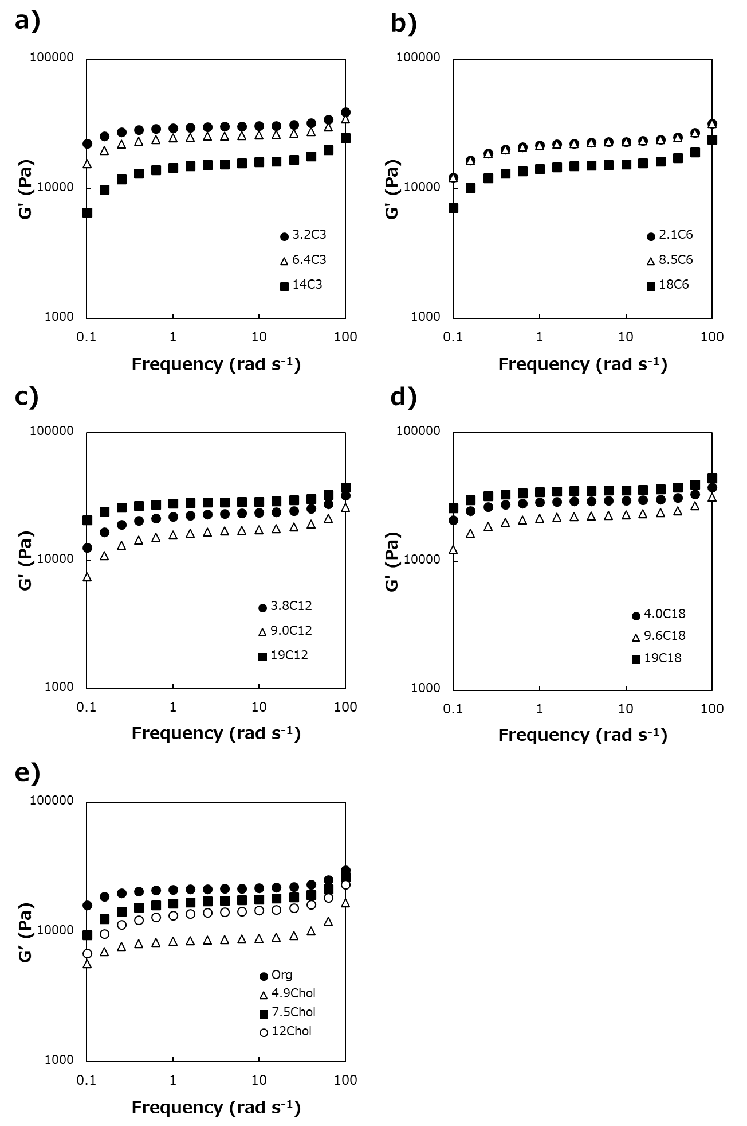
Figure S1. Rheological properties of adhesive hydrogels based on hm-ApGltns with various modification ratios / hydrophobic groups and 4S-PEG. a) C3, b) C6, c) C12, d) C18, e) Chol and Org-ApGltn.

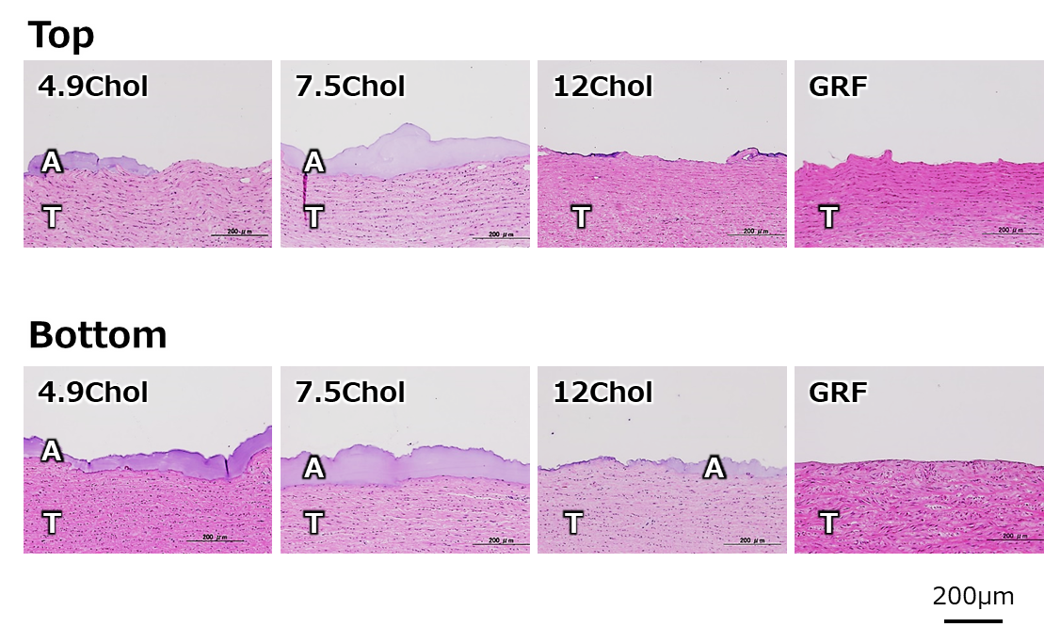
Figure S2. Histology of both sides of porcine aortic media after adhesion strength measurement using Chol-ApGltn adhesives. GRG glue® were used as a control adhesive. A, adhesive; T, tissue.

