Validity of the constant relaxation time approximation in topological insulator: Sn-BSTS a case study
Yuya Hattori^{1, 2, a)} , Takako Konoike¹, Shinya Uji¹, Yuki Tokumoto², Keiichi Edagawa² and Taichi Terashima¹
¹Research Center for Materials Nanoarchitectonics (MANA), National Institute for Materials Science, Sakura, Tsukuba, Ibaraki 305-0003, Japan
²Institute of Industrial Science, The University of Tokyo, Komaba, Meguro-ku, Tokyo 153-8505, Japan

^{a)} Electronic mail: HATTORI.Yuya@nims.go.jp (Yuya Hattori),

Abstract
Gate-voltage dependent quantum oscillations in topological insulator Sn_{0.02}Bi_{1.08}Sb_{0.9}Te₂S (Sn-BSTS) are analyzed on the basis of the Lifshitz−Kosevich theory. The angular dependence of the quantum oscillations and Landau-level fan diagram analysis show that the quantum oscillations originate from topological surface states with the Berry phase of $π$. Gate voltage control allows precise control of the Fermi energy, and a very weak energy dependence of the relaxation time $τ$ of the topological surface states is revealed. By a simple algebraic argument using the linear response theory, it is shown that the weak energy dependence of $τ$ validates the constant relaxation time approximation ($τ\left(E,T\right)=τ_{0}$) in the calculation of the Seebeck coefficient $S$ and $zT_{el}=σS^{2}T/κ_{el}$.

Recently, thermoelectric (TE) materials have attracted significant interest to achieve a sustainable society with diversified energy sources. TE conversion makes it possible to generate electricity from waste heat, which amounts to approximately 60 % of the primary energy. The efficiency of TE materials is represented by the dimensionless TE figure of merit $zT=σS^{2}T/κ$, where $σ, S,T$, and $κ$ are the electrical conductivity, Seebeck coefficient, absolute temperature, and thermal conductivity, respectively. Before the 1990s, TE conversion was a niche technology and the $zT$ values of most bulk TE materials were below $zT=1.0$. However, the $zT$ values in cutting-edge TE materials now exceed $zT=2.0$ in several classes of materials [1–3]. The recent drastic leap in TE performance can be attributed to new concepts in materials design such as band convergence [4–6] and all-scale hierarchical structures [1,7,8]. Theoretically, exhaustive material searches based on first-principles calculations have made significant contributions to the development of TE materials [9–11].
In the calculation of the Seebeck coefficient $S$ and conductivity $σ$ from the linear response theory, the most important information is the energy dependence of the density of states $D\left(E\right)$, group velocity $v\left(E\right)$, and the relaxation time $τ\left(E\right)$ [12–14]. Recent experimental studies of the electronic structure using angle-resolved photoemission spectroscopy (ARPES) [15,16] and scanning tunneling microscopy (STM) [17,18] have shown that first-principles calculations can predict the density of states $D\left(E\right)$ and group velocity $v\left(E\right)$ with sufficient accuracy. However, the calculation of $τ\left(E\right)$ is rather complicated because several scattering mechanisms including impurity and numerous phonon modes should be considered [9,19]. Therefore, the constant relaxation time approximation is often postulated [20–22] to calculate the physical properties of TE materials. Historically, studies on semiconductors [23,24] discussed $τ(E)$ by measuring the temperature dependence of the mobility $μ(T)$. Still, there is no unified theory that includes all the scattering mechanisms, and experimental evaluation of $τ(E)$ is challenging. Accordingly, the energy dependence $τ\left(E\right)$ remains unknown for most materials, being the missing link in ab initio calculations of TE properties.
One of the exceptions, where $τ\left(E\right)$ can be experimentally determined, is in two-dimensional (2D) electron systems. By applying a gate voltage to 2D electrons, one can change the Fermi energy $E_{F}$ without changing the dopant/defect concentration. If the system is clean enough to exhibit quantum oscillations, the energy dependence of $τ$ can be directly determined from the analysis based on the Lifshitz−Kosevich (LK) theory [25]. In contrast to conventional measurements of the mobility $μ=eτ/m^{*}$ (where $e$ and $m^{*}$ are the elementary charge and effective mass, respectively), the analyses of quantum oscillations allow the separate determination of $m^{*}$ and $τ$. Topological insulators are a class of materials characterized by high-mobility 2D electrons on their surfaces [26]. The peculiar electronic properties of topological insulators, such as the prohibition of complete backscattering and helical spin texture, guarantee new designs of TE devices [27–30]. These properties are completely different from those of conventional bulk TE materials, and some theoretical studies predict extraordinarily high $zT$ values such as $zT>10$ [29] and $zT\sim 2.0$ [31] in films with thicknesses of several nanometers. However, the lack of information on $τ\left(E\right)$ hinders valid predictions of the TE performance of topological insulators.
Here, we experimentally investigate the gate-voltage dependent quantum oscillations of the topological surface states (TSS) in topological insulator Sn_{0.02}Bi_{1.08}Sb_{0.9}Te₂S (Sn-BSTS). We determine the energy dependence of the relaxation time $τ$ by the analyses based on the LK theory, and find that the relaxation time of the TSS can be regarded as practically energy independent. By a simple algebraic argument using the linear response theory, it is shown that the weak energy dependence of $τ$ validates the constant relaxation time approximation in the calculation of the Seebeck coefficient $S$ and $zT_{el}=σS^{2}T/κ_{el}$, where $κ_{el}$ is the electron part of the thermal conductivity.
Single crystals of Sn-BSTS were synthesized by the vertical Bridgman technique [32]. Its crystal structure was investigated by powder X-ray diffraction (XRD), and the XRD spectrum matched those of the tetradymite compound Bi₂Te₂S (see the supplementary material). Electrical resistivity measurements were performed on a micro-flake with a size of about $200 μm×140 μm×0.8 μm$ (Fig. 1 (a)), which was transferred to a SiO₂/Si substrate in air atmosphere using the scotch-tape method. Figure 1(b) is a schematic of the device. The electrical contact for gate bias control was attached to the Si side of the substrate. Electrical contacts to the sample were made with a conductive carbon paste (XC-12, Fujikura Kasei Co. Ltd.). This setup allowed us to measure both the resistance $R_{xx}$ (current: probes 1 to 2, voltage: probes 3 and 4) and Hall resistance $R_{xy}$ (current: 1 to 4, voltage: 2 and 3). The measurements were performed from $T=300$ to $1.4 K$, and the magnetic field was applied up to $B=14.5 T$. The top surface of our sample was intentionally oxidized to degrade the top TSS. Therefore, the Shubnikov–de Haas (SdH) oscillations arise only from the bottom TSS, simplifying the LK analyses.
Figure 2 (a) shows the temperature dependence of the resistivity. The Fermi energy of the bulk states of Sn-BSTS is located in the band gap, and the resistivity of thick samples increases with decreasing the temperature [32]. In contrast, the total electrical conduction in thin Sn-BSTS samples is dominated by the TSS, and the temperature dependence of the resistivity shows metallic behavior [33]. In Fig. 2(a), the resistivity increases from 300 to 230 K, and then decreases to 1.4 K. This result indicates that the electrical conductivity is contributed by both bulk states and surface states, and is dominated by the surface states at low temperatures.
Figure 2 (b) shows the magnetoresistance at different magnetic field angles $θ$, defined as the angles between the magnetic field and the normal to the sample. The measurements were performed at $T=1.4 K$ and a gate bias of $V_{G}=-1.5 V$. At high fields ($B>5 T$), clear SdH oscillations are observed. In general, the angular dependence of quantum oscillations provides information on the Fermi surface [34,35]. In 2D electron systems, only the perpendicular part of $B$ to the 2D electrons contributes to the Landau quantization, and the angular dependence of the SdH frequency $F$ should follow $F=F_{0}/cosθ$ [26]. Figure 2 (c) shows the Fourier transform spectra of the oscillations, and the inset shows the angular dependence of $F$. It shows that the experimental values of $F$ are well fitted by $F_{0}/cosθ$. Thus, we can conclude that the SdH oscillations in Fig. 2 (b) stem from 2D electrons.
Figure 2 (d) shows the magnetic field dependences of $R_{xy}$ and the oscillatory part of the resistance ($ΔR_{xx}$). The $R_{xy}$ plateaus at high fields can be ascribed to the integer quantum Hall effect occurring on the bottom TSS. Note that $R_{xy}$ at the plateaus does not match $h/e^{2}N$, where $N$ is an integer, because carriers on the bottom TSS coexist with other carriers. The integer quantum Hall effect in Sn-BSTS has been previously reported in [33,36,37]. In the LK theory [25,26], the oscillatory part of $σ_{xx}$ in 2D (spinless) electron systems under a magnetic field is expressed as:
$$\begin{aligned}Δσ_{xx}∝cos\left[2π\left(\frac{F}{B}-\frac{1}{2}+β\right)\right],\#\left(1\right)\end{aligned}$$
where $β$ is a factor originating from the Berry phase. In 2D Schrödinger electrons, $β=0$, and $β=0.5$ for 2D Dirac electrons with the Berry phase $π$ [26]. The value of $σ_{xx}$ is minimized when
$$\begin{aligned}2π\left(\frac{F}{B}-\frac{1}{2}+β\right)=\left(2N-1\right)π,\#\left(2\right)\end{aligned}$$
where $N$ is the Landau index. Then, if we plot $\frac{1}{B}$ versus $N$ at each minimum of $σ_{xx}$, the value of $β$ is obtained at the $N$-intercept of the linear fit (Landau-level fan diagram analysis). Because of the irregular sample shape and differing current distribution between $R_{xx}$ and $R_{xy}$ measurements, we cannot calculate $σ_{xx}$ from the measured $R_{xx}$ and $R_{xy}$ in the present case. However, we observe in Fig. 2(d) that $ΔR_{xx}$ peaks when $R_{xy}$ transitions from one plateau to another, as is usual for 2D electron systems exhibiting the integer quantum Hall effect [38,39]. This allows us to identify the $R_{xx}$ minimums as the $σ_{xx}$ minimums. In Fig. 2 (e), we plot the $B^{-1}$ values at the minimums of $ρ_{xx}$ (minimums of $σ_{xx}$) versus the Landau index $N$. Linear fitting of the plot shows that the $β$ values in this sample are determined as $β=0.52, 0.47, and 0.44$ for $V_{G}=-2.0, 0, and+2.0 V$, respectively. These values are close enough to $1/2$ expected in electron systems with the Berry phase of $π$. Thus, we can safely conclude that the quantum oscillations in Fig. 2 (d) originate from the bottom TSS with the Berry phase of $π$.
Figure 2 (f) shows the temperature dependence of the SdH amplitude (red points), and its fitting with the LK formula. According to the LK formula, the temperature dependence of the SdH amplitude ($Δρ_{xx}\left(T\right)$) is expressed by the temperature reduction factor of the quantum oscillations $R_{T}$ [25,40]:
$$\begin{aligned}\frac{Δρ_{xx}\left(T\right)}{ρ_{0}\left(T\right)}∝R_{T}=\frac{\frac{Kμ_{c}T}{B}}{sinh\left(\frac{Kμ_{c}T}{B}\right)},\#\left(3\right)\end{aligned}$$
where $ρ_{0}\left(T\right)$ is the non-oscillating component of the resistivity, and $μ_{c}=m_{c}/m_{0}$ with $m_{c}$ and $m_{0}$ being the cyclotron mass and free electron mass, respectively. $K$ is a constant value and $K=2π^{2}m_{0}k_{B}/eℏ$. As shown in Fig. 2 (f), the cyclotron mass of $m_{c}=0.072m_{0}$ is determined from the fit with Eq. (3), represented by the blue curve. The cyclotron mass $m_{c}$ is related to the cross section of the Fermi surface $A_{F}$ perpendicular to the magnetic field:
$$\begin{aligned}m_{c}=\frac{ℏ^{2}}{2π}\left(\frac{∂A_{F}}{∂E}\right).\#\left(4\right)\end{aligned}$$
In the TSS with the linear dispersion, $A_{F}=k_{F}^{2}π$ and $E=ℏv_{D}k_{F}$, where $v_{D}$ is the group velocity of the 2D Dirac electrons. Judging from previous ARPES measurements on Sn-BSTS [32], the band dispersion of the TSS can be judged as approximately linear. Then, the group velocity $v_{D}$ can be calculated as $v_{D}=ℏk_{F}/m_{c}.$ Using $F=81.7 T$ and $m_{c}=0.072 m_{0}$ at $V_{G}=-1.0 V$, we obtain $v_{D}=5.2 eVÅ$. This value is close to that of Sn-BSTS in the previous ARPES measurement [32] ($v_{D}=4.9 eVÅ$). In the following analyses, we use the group velocity from our SdH analyses ($v_{D}=5.2 eVÅ$).
Figure 3 (a) shows the oscillatory part of the resistance $ΔR_{xx}$ at different gate voltages from $V_{G}=-2.0$ to $+2.0 V$. It clearly shows that the Fermi energy is successfully tuned by the gate voltage. In Fig. 3 (b), the gate bias dependence of the frequency of the quantum oscillations $F$ is plotted. $F$ increases from $F=70.2 T$ (corresponding to $n=1.69×{10}^{12} cm^{-2}$) to $F=102 T$ ($n=2.46×{10}^{12} cm^{-2}$). Since the frequency of quantum oscillations $F$ increases with electron doping, the bottom TSS in our sample have n-type carriers ($F$ decreases if they have p-type carriers).
Fine control of the Fermi energy allows a precise analysis of the quantum oscillations. The relaxation time $τ$ can be determined from the magnetic field dependence of quantum oscillations. From the LK theory [25,40], the magnetic field dependence of the oscillation amplitude is given by:
$$\begin{aligned}\frac{{Δρ}_{xx}\left(B\right)}{ρ_{0}\left(B\right)}\frac{1}{R_{T}}∝R_{D},\#\left(5\right)\end{aligned}$$
where $R_{D}$ is the Dingle reduction factor. Then,
$$\begin{aligned}\ln\left(\frac{{Δρ}_{xx}\left(B\right)}{ρ_{0}\left(B\right)}\frac{1}{R_{T}}\right)=\ln\left(R_{D}\right)=-\frac{Kμ_{c}T_{D}}{B}.\#\left(6\right)\end{aligned}$$
Therefore, the Dingle temperature $T_{D}=ℏ/(2πτk_{B})$, can be determined by plotting $\ln\left(\frac{{Δρ}_{xx}\left(B\right)}{ρ_{0}\left(B\right)}\frac{1}{R_{T}}\right)$ versus $1/B$ (Dingle plot) as shown in Fig. 3 (c). The corresponding value of the relaxation time is $τ=3.2×{10}^{-14} s$ at $V_{G}=0 V$, and it is slightly smaller or of the same order as those observed in other topological insulators such as Bi₂Te₂Se ($9.7×{10}^{-14} s$ [41]) and Bi_{1.5}Sb_{0.5}Te_{1.7}Se_{1.3} ($4.2×{10}^{-14} s$ [42]). The same analyses were performed at other biases, and the Fermi energy dependence of $τ$ is shown in Fig. 3 (d). The relaxation time $τ$ is practically constant in this energy range.
The weak energy dependence of the relaxation time is also reported for the TSS of Bi₂Se₃ from the band-width analysis in an ARPES measurement [43], although it is unclear whether the relaxation time estimated from ARPES measurements is the same as that from quantum oscillations. We note that the previous analyses of $S(T)$ in Sn-BSTS using the Mott formula suggested the energy dependence $τ(E)∝E^{0.21}$ [33], using the simplified Mott formula for the TSS:
$$\begin{aligned}S\left(T\right)=\frac{π^{2}k_{B}^{2}}{3e}\frac{T}{E_{F}}\left(γ+1\right).\#\left(7\right)\end{aligned}$$
Eq. (7) is derived from the Mott formula postulating that the TSS have a perfectly linear dispersion, and the energy dependence of $τ$ is assumed to be $τ(E)∝E^{γ}$ [33]. In addition, the determination of $γ$ from the temperature dependence of the Seebeck coefficient $S$ in experiments is sensitive to the estimation of the Fermi energy $E_{F}$. In contrast, our LK analyses of the SdH oscillations directly give $τ$ as a function of $E_{F}$. We therefore ascribe the small difference between their results and ours to the uncertainty of $E_{F}$ in Eq. (7).
We note that theoretical studies on 2D Dirac electrons assume an isolated scattering center, and calculate the energy dependence of the relaxation time as $τ(E)∝E$ for Coulomb scattering from ionized impurities, and $τ(E)∝E^{-1}$ for short-range scattering [44,45]. In contrast, an experiment on graphene showed that the energy dependence of the relaxation time becomes weak in the presence of potential fluctuations [46]. We speculate that charge puddles from crystal defects in Sn-BSTS are the source of the nearly energy-independent relaxation time. Indeed, STM studies have shown that topological insulators in general have a high defect density [47,48]. Defects form charge puddles with typical diameters of $d\sim 20-50 nm$ and fluctuations of the Fermi energy $ΔE_{F}\sim 10-20 meV$ [47,48]. This situation is quite different from that of an isolated scattering center [44,45], and instead resembles the situation of graphene containing a high density of charge puddles from substrates [46].
The validity of the constant relaxation time approximation, where $τ\left(E,T\right)=τ_{0}$ is assumed, has always been a subject of debate in condensed matter physics. For instance, ARPES studies on cuprate superconductors show the linear energy dependence of the relaxation time [49,50], which is a hallmark of non-Fermi liquid. Also, the energy/temperature dependence of the relaxation time plays a key role in the TE properties of some materials such as superconductors [49,50], valence fluctuating materials [51], and ferromagnetic materials [52]. However, in most materials, the energy dependence of the relaxation time is not strong [13,53] as compared to that of the density of states and group velocity. Accordingly, the use of the constant relaxation time approximation has played a key role in discovering new TE materials [54,55] and understanding TE properties [56,57]. It is noteworthy that BoltzTraP [58], which is a widely used software for the calculation of the TE properties (i.e.: $σ, S, κ$), takes the constant relaxation time approximation as the default setting.
We note the effect of the temperature dependence of $τ$ on the TE properties. Generally, $τ$ is a function of the energy, temperature, and the wavenumber: $τ(E,T,k)$, but now we neglect the $k$ dependence of $τ$ for simplicity. From the linear response theory, the electrical conductivity $σ$, Seebeck coefficient $S$, and the electron part of the thermal conductivity $κ_{el}$ are expressed as [13]:
$$\begin{aligned}σ(T)=\int_{-∞}^{∞}{σ\left(E,T\right)\left(-f_{FD}^{'}\right)dE},\#\left(8\right)\end{aligned}$$
$$\begin{aligned}S(T)=-\frac{1}{\left|e\right|T}\frac{\int_{-∞}^{∞}{\left(E-ξ\right)σ\left(E,T\right)\left(-f_{FD}^{'}\right)dE}}{\int_{-∞}^{∞}{σ\left(E,T\right)\left(-f_{FD}^{'}\right)dE}},\#\left(9\right)\end{aligned}$$
$$\begin{aligned}κ_{el}(T)=\frac{1}{e^{2}T}\int_{-∞}^{∞}{{\left(E-ξ\right)}^{2}σ\left(E,T\right)\left(-f_{FD}^{'}\right)dE}-\frac{1}{e^{2}T}\frac{{\left\{\int_{-∞}^{∞}{\left(E-ξ\right)σ\left(E,T\right)\left(-f_{FD}^{'}\right)dE}\right\}}^{2}}{\int_{-∞}^{∞}{σ\left(E,T\right)\left(-f_{FD}^{'}\right)dE}},\#\left(10\right)\end{aligned}$$
where $ξ$ and $f_{FD}^{'}$ are the chemical potential and energy derivative of the Fermi-Dirac distribution. Since $σ\left(E,T\right)=\frac{e^{2}}{2}N\left(E\right)v^{2}\left(E\right)τ(E,T)$ in 2D systems ($\frac{e^{2}}{3}N\left(E\right)v^{2}\left(E\right)τ(E,T)$ in three-dimensional systems), $τ(E,T)$ would be taken out of the integrals in Eq. (9), and be canceled out if the energy dependence of $τ$ is negligible. Accordingly, $τ(T)$ has no significant effect on the Seebeck coefficient $S(T)$ [59]. In contrast, the values of $σ(T)$ and $κ_{el}(T)$ are both proportional to $τ(T)$. Therefore, $zT_{el}=σS^{2}T/κ_{el}$, which is often calculated to estimate the maximum value of $zT$ in a material system [13,54], is independent of $τ(T)$. In summary, if the system has a very weak energy dependence of $τ$, the constant relaxation time approximation with $τ\left(E,T\right)=τ_{0}$ predicts the values of $S$ and $zT_{el}$ with sufficient accuracy, while the values of $σ(T)$ and $κ_{el}(T)$, both of which depend on $τ(T)$, cannot be accurately obtained by the constant relaxation time approximation.
Lastly, we note on the limitation of our method for measuring $τ(E)$. Since we change the carrier density by tuning the gate voltage, it can be applied only to 2D electron systems. In addition, since quantum oscillations can be observed only at low temperatures, our scheme for measuring the relaxation time $τ$ is applicable when impurity (not electron-phonon) scattering is dominant.
In conclusion, we have performed measurements of gate-voltage dependent quantum oscillations in the topological insulator Sn-BSTS, and analyzed them using the LK theory. The angular dependence of the quantum oscillations and Landau-level fan diagram analysis show that the quantum oscillations originate from the bottom TSS with the Berry phase of $π$. The energy dependence of the relaxation time $τ$ of the TSS is shown to be very weak. The weak energy dependence of $τ$ validates the constant relaxation time approximation in the calculation of the Seebeck coefficient $S$ and $zT_{el}=σS^{2}T/κ_{el}$. Information on the energy dependence of the relaxation time $τ$ is as important as that of the density of states when predicting TE properties from first-principles calculations. We hope that our scheme will be used to investigate $τ(E)$ in other topological insulators, and will stimulate the design of TE materials utilizing the TSS.
See the supplementary material for detailed information about the powder XRD result on the Sn-BSTS sample.
YH acknowledges financial support by JSPS KAKENHI (Grant Nos. JP21K20496 and JP22K14467). KE by JSPS KAKENHI (No. JP22H01765). SU by JSPS KAKENHI (No. JP22H01173). MANA was established by World Premier International Research Center Initiative (WPI), MEXT, Japan.

AUTHOR DECLARATIONS
Conflict of Interest
The authors have no conflicts to disclose.
Data availability
The data that supports the findings of this study are available within the article and its supplementary material.

References
[1] K. Biswas, J. He, I. D. Blum, C.-I. Wu, T. P. Hogan, D. N. Seidman, V. P. Dravid, and M. G. Kanatzidis, Nature 489, 414 (2012).
[2] L.-D. Zhao, S.-H. Lo, Y. Zhang, H. Sun, G. Tan, C. Uher, C. Wolverton, V. P. Dravid, and M. G. Kanatzidis, Nature 508, 373 (2014).
[3] S. Roychowdhury, T. Ghosh, R. Arora, M. Samanta, L. Xie, N. K. Singh, A. Soni, J. He, U. V. Waghmare, and K. Biswas, Science 371, 722 (2021).
[4] Y. Pei, X. Shi, A. LaLonde, H. Wang, L. Chen, and G. J. Snyder, Nature 473, 66 (2011).
[5] P. Jood, J. P. Male, S. Anand, Y. Matsushita, Y. Takagiwa, M. G. Kanatzidis, G. J. Snyder, and M. Ohta, J. Am. Chem. Soc. 142, 15464 (2020).
[6] Y. Hattori, S. Yoshizawa, K. Sagisaka, Y. Tokumoto, K. Edagawa, T. Konoike, S. Uji, and T. Terashima, Phys. Rev. B 108, 125119 (2023).
[7] S. Bhattacharya, A. Bohra, R. Basu, R. Bhatt, S. Ahmad, K. N. Meshram, A. K. Debnath, A. Singh, S. K. Sarkar, M. Navneethan, Y. Hayakawa, D. K. Aswal, and S. K. Gupta, J. Mater. Chem. A 2, 17122 (2014).
[8] V. Vargiamidis and N. Neophytou, Phys. Rev. B 99, 045405 (2019).
[9] S. Huang, H. J. Liu, D. D. Fan, P. H. Jiang, J. H. Liang, G. H. Cao, R. Z. Liang, and J. Shi, J. Phys. Chem. C 122, 4217 (2018).
[10] R. Guo, X. Wang, Y. Kuang, and B. Huang, Phys. Rev. B 92, 115202 (2015).
[11] G. K. H. Madsen, J. Am. Chem. Soc. 128, 12140 (2006).
[12] T. Takeuchi, T. Kondo, T. Takami, H. Takahashi, H. Ikuta, U. Mizutani, K. Soda, R. Funahashi, M. Shikano, M. Mikami, S. Tsuda, T. Yokoya, S. Shin, and T. Muro, Phys. Rev. B 69, 125410 (2004).
[13] T. Takeuchi, Mater. Trans. 50, 2359 (2009).
[14] M. Matsubara, T. Yamamoto, and H. Fukuyama, J. Phys. Soc. Jpn. 92, 104704 (2023).
[15] K. Yaji, Y. Ohtsubo, S. Hatta, H. Okuyama, K. Miyamoto, T. Okuda, A. Kimura, H. Namatame, M. Taniguchi, and T. Aruga, Nat. Commun. 1, 17 (2010).
[16] Y. Tanaka, Z. Ren, T. Sato, K. Nakayama, S. Souma, T. Takahashi, K. Segawa, and Y. Ando, Nat. Phys. 8, 800 (2012).
[17] Y. Hattori, K. Sagisaka, S. Yoshizawa, Y. Tokumoto, and K. Edagawa, Phys. Rev. B 108, L121408 (2023).
[18] M. Nurmamat, E. E. Krasovskii, K. Kuroda, M. Ye, K. Miyamoto, M. Nakatake, T. Okuda, H. Namatame, M. Taniguchi, E. V. Chulkov, K. A. Kokh, O. E. Tereshchenko, and A. Kimura, Phys. Rev. B 88, 081301(R) (2013).
[19] H. Mori, M. Ochi, and K. Kuroki, Phys. Rev. B 104, 235144 (2021).
[20] I. Bejenari and V. Kantser, Phys. Rev. B 78, 115322 (2008).
[21] J. Gooth, J. G. Gluschke, R. Zierold, M. Leijnse, H. Linke, and K. Nielsch, Semicond. Sci. Technol. 30, 015015 (2015).
[22] H. Osterhage, J. Gooth, B. Hamdou, P. Gwozdz, R. Zierold, and K. Nielsch, Appl. Phys. Lett. 105, 123117 (2014).
[23] G. Ottaviani, L. Reggiani, C. Canali, F. Nava, and A. Alberigi-Quaranta, Phys. Rev. B 12, 3318 (1975).
[24] K. Takeda, N. Matsumoto, A. Taguchi, H. Taki, E. Ohta, and M. Sakata, Phys. Rev. B 32, 1101 (1985).
[25] E. M. Lifsitz and A. M. Kosevich, J. Phys. Chem. Solids 4, 1 (1958).
[26] Y. Ando, J. Phys. Soc. Jpn. 82, 102001 (2013).
[27] R. Takahashi and S. Murakami, Phys. Rev. B 81, 161302(R) (2010).
[28] R. Takahashi and S. Murakami, Semicond. Sci. Technol. 27, 124005 (2012).
[29] Y. Xu, Z. Gan, and S.-C. Zhang, Phys. Rev. Lett. 112, 226801 (2014).
[30] N.-X. Yang, Y.-F. Zhou, P. Lv, and Q.-F. Sun, Phys. Rev. B 97, 235435 (2018).
[31] J. Liang, L. Cheng, J. Zhang, H. Liu, and Z. Zhang, Nanoscale 8, 8855 (2016).
[32] S. K. Kushwaha, I. Pletikosić, T. Liang, A. Gyenis, S. H. Lapidus, Y. Tian, H. Zhao, K. S. Burch, J. Lin, W. Wang, H. Ji, A. V. Fedorov, A. Yazdani, N. P. Ong, T. Valla, and R. J. Cava, Nat. Commun. 7, 11456 (2016).
[33] S. Y. Matsushita, K. Ichimura, K. K. Huynh, and K. Tanigaki, Phys. Rev. Mater. 5, 014205 (2021).
[34] T. Terashima, N. Kikugawa, D. Graf, H. T. Hirose, S. Uji, Y. Matsushita, H. Lin, X. Zhu, H.-H. Wen, T. Nomoto, K. Suzuki, and H. Ikeda, Phys. Rev. B 99, 134501 (2019).
[35] S. Uji, T. Konoike, Y. Hattori, T. Terashima, T. Oguchi, T. Yamada, D. Hirai, and Z. Hiroi, Phys. Rev. B 105, 235103 (2022).
[36] K. Ichimura, S. Y. Matsushita, K.-K. Huynh, and K. Tanigaki, Appl. Phys. Lett. 115, 052104 (2019).
[37] F. Xie, S. Zhang, Q. Liu, C. Xi, T.-T. Kang, R. Wang, B. Wei, X.-C. Pan, M. Zhang, F. Fei, X. Wang, L. Pi, G. L. Yu, B. Wang, and F. Song, Phys. Rev. B 99, 081113(R) (2019).
[38] K. v. Klitzing, G. Dorda, and M. Pepper, Phys. Rev. Lett. 45, 494 (1980).
[39] Y. Zhang, Y.-W. Tan, H. L. Stormer, and P. Kim, Nature 438, 201 (2005).
[40] T. Terashima, H. T. Hirose, D. Graf, Y. Ma, G. Mu, T. Hu, K. Suzuki, S. Uji, and H. Ikeda, Phys. Rev. X 8, 011014 (2018).
[41] Z. Ren, A. A. Taskin, S. Sasaki, K. Segawa, and Y. Ando, Phys. Rev. B 85, 155301 (2012).
[42] A. A. Taskin, Z. Ren, S. Sasaki, K. Segawa, and Y. Ando, Phys. Rev. Lett. 107, 016801 (2011).
[43] Z.-H. Pan, A. V. Fedorov, D. Gardner, Y. S. Lee, S. Chu, and T. Valla, Phys. Rev. Lett. 108, 187001 (2012).
[44] K. Nomura and A. H. MacDonald, Phys. Rev. Lett. 98, 076602 (2007).
[45] T. Ando, NPG Asia Mater. 1, 17 (2009).
[46] J. Duan, X. Wang, X. Lai, G. Li, K. Watanabe, T. Taniguchi, M. Zebarjadi, and E. Y. Andrei, Proc. Natl. Acad. Sci. U. S. A. 113, 14272 (2016).
[47] T. Knispel, W. Jolie, N. Borgwardt, J. Lux, Z. Wang, Y. Ando, A. Rosch, T. Michely, and M. Grüninger, Phys. Rev. B 96, 195135 (2017).
[48] H. Beidenkopf, P. Roushan, J. Seo, L. Gorman, I. Drozdov, Y. S. Hor, R. J. Cava, and A. Yazdani, Nat. Phys. 7, 939 (2011).
[49] M. Horio, T. Adachi, Y. Mori, A. Takahashi, T. Yoshida, H. Suzuki, L. C. C. Ambolode 2nd, K. Okazaki, K. Ono, H. Kumigashira, H. Anzai, M. Arita, H. Namatame, M. Taniguchi, D. Ootsuki, K. Sawada, M. Takahashi, T. Mizokawa, Y. Koike, and A. Fujimori, Nat. Commun. 7, 10567 (2016).
[50] A. Kaminski, H. M. Fretwell, M. R. Norman, M. Randeria, S. Rosenkranz, J. C. Campuzano, J. Mesot, T. Sato, T. Takahashi, T. Terashima, M. Takano, K. Kadowaki, Z. Z. Li, and H. Raffy, Phys. Rev. B 71, 014517 (2005).
[51] K. Kuga, M. Matsunami, S. Singh, S. Nakatsuji, and T. Takeuchi, Appl. Phys. Lett. 119, 223905 (2021).
[52] S. Singh, D. Kumar, and S. K. Pandey, J. Phys. Condens. Matter 29, 105601 (2017).
[53] T. Kondo, T. Takeuchi, U. Mizutani, T. Yokoya, S. Tsuda, and S. Shin, Phys. Rev. B 72, 024533 (2005).
[54] M. Miyata, T. Ozaki, T. Takeuchi, S. Nishino, M. Inukai, and M. Koyano, J. Electron. Mater. 47, 3254 (2018).
[55] K. Choudhary, K. F. Garrity, and F. Tavazza, J. Phys. Condens. Matter 32, 475501 (2020).
[56] S. Jantrasee, S. Pinitsoontorn, and P. Moontragoon, J. Electron. Mater. 43, 1689 (2014).
[57] J. L. A. Ponce-Ruiz, S. Ishizuka, Y. Todaka, Y. Yamada, A. R. Serrato, and J. M. Herrera-Ramirez, ACS Omega 7, 15451 (2022).
[58] G. K. H. Madsen and D. J. Singh, Comput. Phys. Commun. 175, 67 (2006).
[59] T. Takeuchi, Y. Toyama, and A. Yamamoto, Mater. Trans. 51, 421 (2010).

Figures and captions
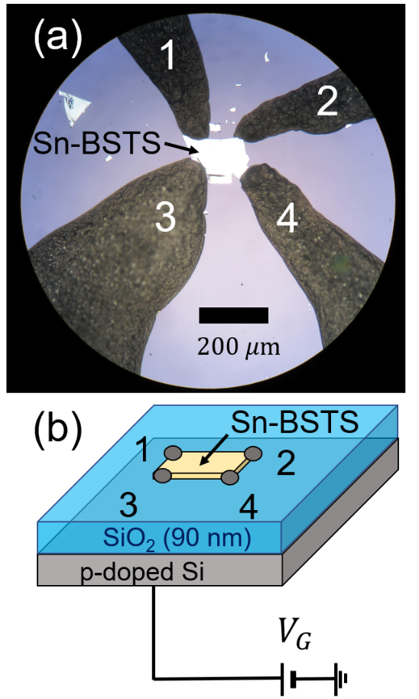
FIG. 1 (a): Picture of Sn-BSTS device on the SiO₂/Si substrate. (b): Schematic diagram of Sn-BSTS device on the SiO₂/Si substrate with probes 1-4. The gate voltage probe is attached to the bottom of the Si substrate.

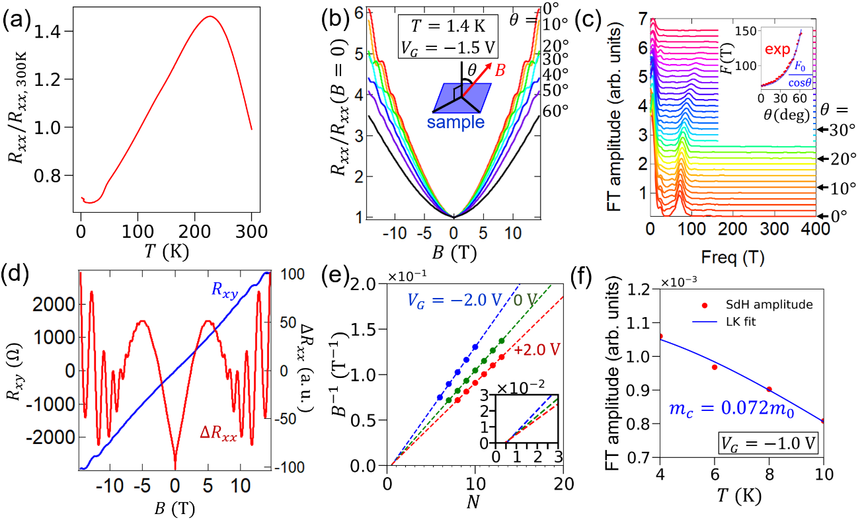
FIG. 2 (a): Temperature dependence of the resistance $R_{xx}$, normalized to $R_{xx}$ at $T=300 K$. (b): Magnetoresistance at different magnetic field directions. The measurement was performed at $T=1.4 K$ and at $V_{G}=-1.5 V$. The definition of the field angle $θ$ is shown in the inset. (c): Fourier transform spectra of SdH oscillations at different angles. The inset shows the angular dependence of the experimental SdH frequencies $F$ (red points) together with the fitted curve with $F=F_{0}/cosθ$ (blue curve). (d): Magnetic field dependence of $R_{xy}$ and $ΔR_{xx}$. (e): Landau-level fan diagram for SdH oscillations at different sample biases. The inset shows a magnified view. (f): Temperature dependence of the amplitude of the SdH oscillations (red points) and its fitting to the LK formula (blue curve).

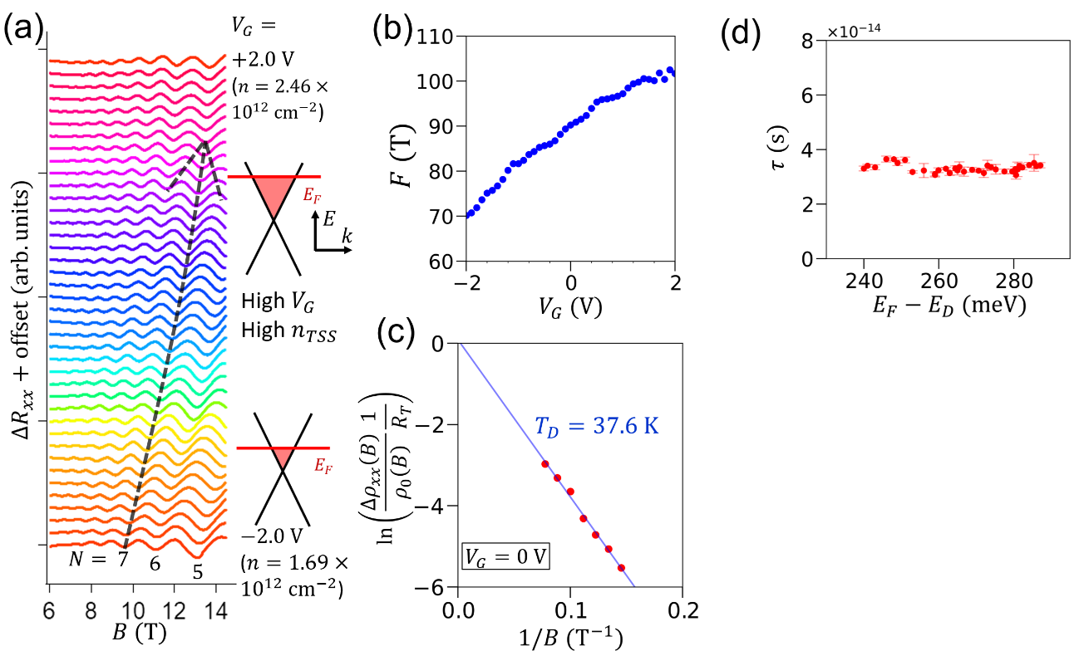
FIG. 3 (a): Bias dependence of the oscillatory part of the magnetoresistance ($ΔR_{xx}$), together with schematics of the Fermi level of the TSS. (b): Bias dependence of the SdH frequency $F$. (c): Dingle plot of the oscillations for $ΔR_{xx}$ at $V_{G}=0 V$. (d): Fermi energy dependence of the relaxation time $τ$.

