Chapter 6 Galfenol/Single-Crystal Diamond MEMS Magnetic Sensor
Zilong Zhang, Meiyong Liao*
Research Center for Electronic and Optical Materials, National Institute for Materials Science (NIMS), 1-1 Namiki, Tsukuba, Ibaraki, 305-0044, Japan
E-mail: meiyong.liao@nims.go.jp
Abstract Single-crystal diamond (SCD) is a promising material for high-performance and high-reliability micro-electromechanical system (MEMS) superior to other semiconductor materials (Si, III-nitrides, SiC, etc.,) in terms of the outstanding mechanical strength, thermal conductivity, and chemical inertness. In this chapter, we review our recent progress in diamond MEMS magnetic sensors by integrating a magneto-strictive galfenol (FeGa) thin film on SCD MEMS resonators for high-temperature conditions. The magnetic sensing mechanism of magnetic sensors is discussed. The thermal stability of the sensors is analyzed and the strategies to enhance the magnetic sensing performance of the magnetic sensors are described.

Keyword: Single-crystal diamond, MEMS, Magnetostrictive effect, Magnetic sensor

6.1 Introduction

6.1.1 Background of Diamond MEMS
Diamond is an ideal candidate material for microelectromechanical system (MEMS) due to its superior electrical properties, mechanical strength and chemical inertness in harsh environments [1]. Table 6.1 summarizes the outstanding material properties of diamond compared to other wide band-gap semiconductors, such as high Young’s modulus, compressive strength, the highest mechanical hardness and low coefficient of friction. The excellent tribological properties ensure the wear lifetime of diamond 10,000 times that of Si, which paves the way for high-reliability MEMS devices. Owing to the high thermal-conductivity of diamond, inherent losses such as thermoelastic damping limited by material properties can be significantly reduced for MEMS applications, resulting in the devices with high quality (Q) factors [2]. In addition, due to the chemical inertness of diamond material, there is no natural oxide on its surface, which reduces the surface loss of MEMS devices. The wide bandgap energy and high radiation resistance of diamond ensure the stable operation of diamond MEMS devices in harsh environments. Therefore, compared to other semiconductor materials, diamond is an ideal material for MEMS applications [3, 4].

Table 6.1 Comparisons of properties of diamond other wide band-gap semiconductors in view of MEMS applications [5-11].
Properties | Diamond | Si | SiC | GaAs | GaN | CdZnTe
Bandgap (eV) | 5.5 | 1.12 | 3.0 | 1.43 | 3.45 | 1.5~2.2
Dielectric constant | 5.5 | 11.8 | 9.7 | 12.5 | 9 | 10.9
Resistivity (Ω cm) | 10¹³ | 10⁵ | 150 | 10⁸ | 10¹⁰ | 10¹¹
Electron mobility (cm²/(V s)) | 2200 | 1500 | 400 | 8500 | 1250 | 1350
Hole mobility (cm²/(V s)) | 1800 | 600 | 50 | 400 | 850 | 120
Breakdown field (10⁴ V/cm) | 1000 | 0.15 | 400 | 40 | >100 | 0.15
Density (g cm⁻³) | 3.52 | 2.33 | 3.21 | 5.32 | 6.10 | 5.9
Young’s modulus (GPa) | 1100 | 130 | 450 | 60-115 | 210 | 20-50
Hardness (GPa) | 100 | 10 | 33 | 6-10 | 12 | 1.21
Thermal conductivity (W/(cm K)) | 24 | 1.5 | 5 | 0.46 | 1.95 | 0.02-0.04

Single crystal diamond (SCD) is desirable to develop high-performance and high-reliability MEMS devices to make full using of the extreme properties of diamond. At present, the application fields of SCD MEMS devices can be divided into conventional MEMS applications [12] and MEMS photonics applications [13, 14]. At this stage, the applications of SCD MEMS are still in its infancy. The resonator structure is a common structure for the SCD MEMS device. It detects different physical quantities by detecting the force change through the nano-micro displacement movement. SCD MEMS resonators can be employed in atomic force microscopy [15-17], capacitive pressure sensors [18], and NV center magnetic imaging sensors, etc. [19, 20], and MEMS switches [21]. SCD MEMS photonics applications are based on the systems coupling the optical mode with the MEMS mode. MEMS photonics applications include waveguides, photonic crystals, and optical micro-nano resonators [22, 23], which promote the development of cavity optomechanics [24, 25].
In this chapter, we review our recent results on the SCD MEMS magnetic sensors. The contents include the fabrication of SCD MEMS magnetic sensor, the basic magnetic sensing mechanism, the growth of the ferromagnetic thin film on SCD, the thermal-stability analysis of SCD resonators, the realization of magnetic sensing from room temperature to high temperatures, and the tailoring of the magnetic sensing performances of the SCD MEMS magnetic sensors.

6.1.2 Diamond MEMS for Magnetic Sensors
Nowadays, magnetic sensors play an important role in the Internet of Things, such as biomedical sensors, automotive sensors, navigation systems, non-contact sensing, and nondestructive testing, etc. [26-28]. The current magnetic sensors mainly include superconducting quantum interference devices (SQUID), fluxgate sensors, Hall sensors, giant magnetoresistance (GMR) sensors, and MEMS magnetic sensors, etc. [26-30]. These magnetic sensors still have various shortcomings, such as high cost, low temperature requirements, and complex infrastructure for SQUID devices, low sensitivity for Hall sensors, high volume and high power consumption for fluxgate sensors, limited magnetic fields for giant magnetic sensors [27, 31]. Compared with other magnetic sensors, MEMS magnetic sensors have the advantages of small size, batch manufacturing, low-power consumption, high sensitivity and resolution, and facile integration with CMOS [27]. The magnetic sensing principles can be mainly divided into: (1) Lorentz force principle [32-37]; (2) ΔE effect based on the magneto-strictive effect [30, 38-43]; (3) Magnetoelectric effect [44-46]. Recently, the resonators coupling with multilayer thin-films based on ΔE effect for magnetic sensors were reported. The magnetic sensor based on the ΔE effect was actuated through a piezoelectric layer and used an amplitude modulation model to measure the readout [38-41, 47, 48]. However, these magnetic sensors exhibited poor reliability due to the adopting silicon material as the substrate and the multilayer structure. The presence of high magneto-mechanical damping and interfacial energy loss limited Q factors of these sensors to less than 1000 [49].
As shown in the 6.1.1 section, compared with other semiconductor materials, SCD has excellent mechanical strength, thermal conductivity, electronic properties, and chemical inertness. It is an ideal material for the fabrication of the MEMS resonators with high performance and high reliability. Our pervious works showed that the Q factors of SCD cantilever resonators could exceed 10⁶, 1~2 orders of magnitudes higher than those of resonators made of silicon and other semiconductor materials [50, 51]. The ultra-low thermal expansion coefficient and strong chemical stability of SCD make it as a perfect platform to achieve high thermal stability and weak interfacial diffusion. Considering the high-temperature characteristics of diamond materials, the combination of SCD MEMS and magnetostrictive thin films provides an ideal strategy for the fabrication of magnetic sensors working from room temperature to high temperature. Galfenol (FeGa) material with extremely high magnetostriction coefficient and ultra-high Curie temperature (~950 K) is as an ideal material for high-temperature magnetic sensors [30, 52-54]. Considering the excellent material properties of the SCD and the FeGa, the integration SCD MEMS with the FeGa thin film creates an ideal system for producing high-performance and high-reliability magnetic sensors. With the SCD MEMS resonator device concept, we developed a series of FeGa/SCD-based MEMS sensors that exhibited high sensitivity and high reliability across a wide temperature range, from room temperature to high temperatures.

6.2 Production Process for Diamond MEMS

6.2.1 Fabrication of Diamond MEMS Resonators
Owning to its high mechanical hardness and chemical inertness, the microfabrication process of SCD cannot simply replicate the traditional process of silicon and other wide bandgap semiconductor materials. Additionally, wafer-scale SCDs cannot be grown on heterogeneous substrates. The current main methods for making SCD MEMS devices can be summarized as (1) ion-implantation assisted lift-off (IAL) technology or smart-cut method [55-57]; (2) anisotropic plasma etching (APE) technology [58, 59]; (3) diamond-on-insulator (DOI) technology [60, 61].
The IAL technique was first proposed by Parikh et al. [62] for thin diamond plate. It is currently applied for the suspended diamond structures [1, 18, 21, 55, 56]. We used the IAL technique for SCD MEMS/NEMS, which has the advantages of high quality and high repeatability for the batch fabrication of SCD MEMS devices. In our works, the fabrication of SCD MEMS cantilever resonances was based on the epilayer of SCD substrate. The fabricated process of the SCD cantilevers is described in Fig. 6.1 [63]. The fabrication process began with the implantation of the high-pressure high-temperature (HPHT) type-Ib SCD (100) substrates with high-energy carbon ions. The homoepitaxial diamond layers with different thicknesses from 0.37 to 1.81 μm were grown on the ion-implanted HPHT diamond substrates in a microwave plasma chemical vapor deposition (MPCVD) system. During the growth, a graphite-like layer with a thickness around 200 nm induced by the ion implantation treatment was formed below the diamond surface, which acted as the sacrificial layer to SCD cantilever configuration. The SCD cantilever was fabricated by a standard photolithography technique. In order to etch diamond with oxygen plasma, an aluminum layer with a thickness of around 200 nm was deposited on the patterned diamond epilayer. Finally, the metallization was then removed and the resonators were released.
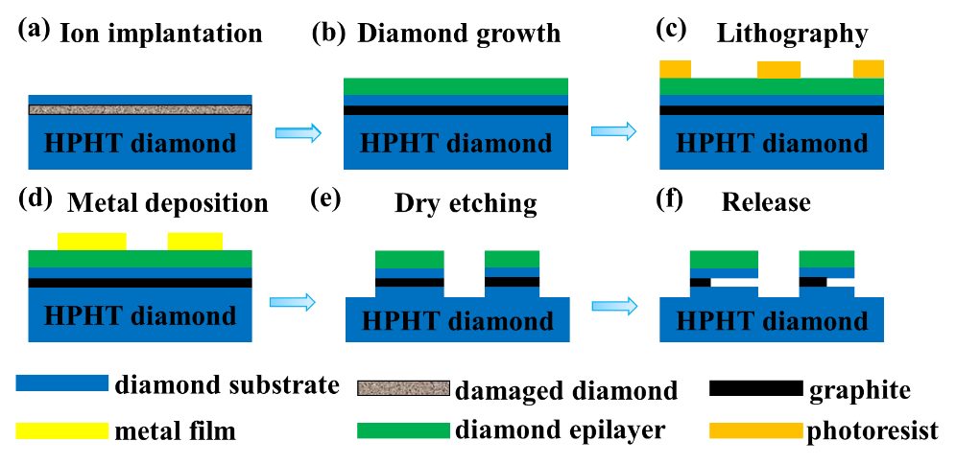
Fig. 6.1 The single-crystal diamond (SCD) cantilevers fabricated the ion-implantation assisted lift-off (IAL) method. (a) Ion implantation into the type-Ib SCD substrate by the carbon ions. (b) Deposition of a homoepitaxial SCD layer by the micro-wave plasma chemical vapor system. (c) Patterning of SCD by the lithography method. (d) Deposition of Al deposition as a mask for the next etching. (e) Reactive ion etching (RIE) by inductively couple plasma (ICP) apparatus in a pure oxygen ambient. (f) Removal the metallization and release of the SCD cantilevers [63]. Copyright ©2019, Elsevier.

A three-dimensional fabrication technique based on anisotropic plasma etching at an oblique angle, was proposed by Burek et al. to produce the freestanding SCD nanostructures, including mechanical resonators, optical waveguides, and photonic crystal and microdisk cavities, as shown in Fig. 6.2 [59]. In this method, a 200 nm thick Ti etch mask was deposited on the SCD substrate by using the electron beam evaporation and electron beam lithography techniques. The transformation of the etch mask pattern into the SCD was performed by a conventional top-down anisotropic plasma etching. Then, a second anisotropic etch with an oblique angle to the substrate surface was used to release the nanostructures and achieve the final suspended nanobeams. The Faraday cage was employed in the second angled-etching to shield the nanostructures from electromagnetic fields.
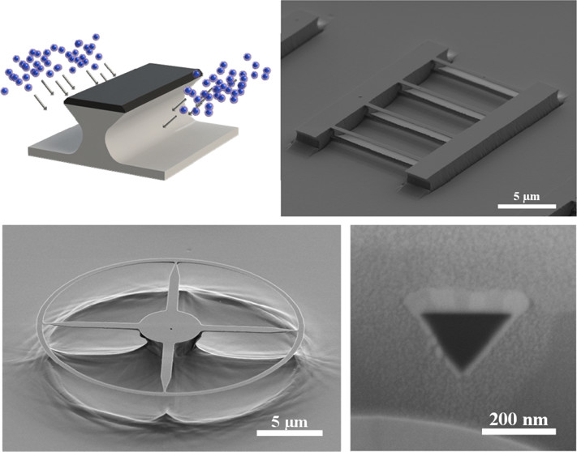
Fig. 6.2 Schematic of angled-etching fabrication for SCD MEMS structures [59]. Copyright © 2012, American Chemical Society

The SCD resonators with high Q factors as high as 338000 at room temperature were fabricated by the DOI technique [60]. In order to fabricate the DOI structure, the commercial electronic grade SCD plates, suffered from the cut and polishing treatments, were mounted on silicon carrier wafers with van der Waals forces. A 30 nm layer of SiO₂ was deposited on the diamond plate using plasma-enhanced chemical vapor deposition (PECVD). The SCD plate with the SiO₂ layer was mounted on a Si substrate and then bonded to an oxidized Si chip using a low-temperature oxide bonding technique, as shown in Fig. 6.3(a). The ArCl₂ RIE/ICP technique was utilized to etch the SCD layer to the desired thickness. The DOI structure were photolithographically patterned to form the SCD cantilever structures (Fig. 6.3(b)). Finally, the DOI structure was etched in a buffered hydrofluoric acid to etch the 1-μm thick SiO₂ layer underneath the cantilevers to release the SCD cantilevers are released. The patterned SCD cantilevers with different dimensions are shown in Figs. 6.3(c) and (d). The DOI method provides a facile approach to fabricate the SCD cantilevers with high Q factors.
Fig. 6.3 The SCD cantilevers fabricated by the diamond-on-insulator (DOI) method. (a) Scanning electron microscopy (SEM) image of the cross-section in the DOI structure. (b) SEM image of the SCD cantilever patterns on SiO₂. (c) Released the SCD cantilevers. (d) Optical image of the suspended SCD cantilevers [60]. Copyright © 2012, American Institute of Physics

6.2.2 Fabrication of Diamond MEMS Magnetic Sensors
The SCD MEMS resonator was fabricated through the IAL approach, as described in our previous works [63-66]. The SCD MEMS magnetic sensors are based on the structures of SCD MEMS resonators integrated with a magentostrictive FeGa thin film. In order to fabricate FeGa thin film with excellent soft magnetic properties of low coercivity (Hc) of 26.2 Oe, low saturation magnetization field (Hs) of 450 Oe, and high remanence ratio (Mr/Ms) of 0.9, the growth parameters were investigated in detail [67]. Figure 6.4 exhibits the microstructure and element distribution of the as-grown FeGa thin film on the SCD substrate with a thickness of 90 nm. The FeGa thin film presents columnar feature, as shown in Figs. 6.4(a) and (b) by the HRTEM diagram of the FeGa/SCD structure interface. The FeGa thin film had the (220) crystal-plane of D0₃ phase, which was confirmed by the interplanar spacing of 2.05 Å. Figure 6.4(c) shows the SAED image corresponding to the red dotted circle with crystal-plane families of (110), (211) and (310) for the FeGa thin film. Figure 6.4(d) depicts the atom weight percentage of Fe to Ga is 83.1% to 16.9%. In order to figure out the impacts of thermal expansion coefficient, lattice mismatch, and adhesion at the FeGa/SCD interface on the microstructures, magnetic properties, and thermal-stability of FeGa films, the interlayers of Ti (10 nm), WC (20 nm), and Ti (5 nm)/WC (10 nm) films were deposited on the SCD substrates through the RF-magnetron sputtering technique before the growth of the FeGa film, respectively. A series of structure kinds of FeGa/SCD, FeGa/Ti/SCD, FeGa/WC/SCD and FeGa/Ti/WC/SCD were suffered from the annealing treatments, which were utilized to examine the thermal stability of the microstructures and magnetic properties of the FeGa films. The thickness of the FeGa thin film was around 90 nm (Fig. 6.4(a)).
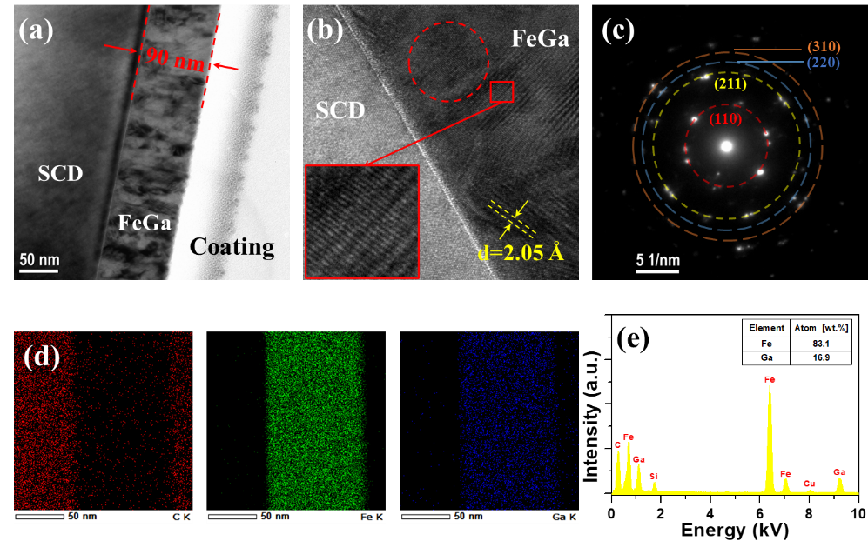
Fig. 6.4 The structures and element distributions of the as-deposited FeGa thin film on the SCD substrate. (a) TEM bright-field image. (b) HRTEM image. The image remarked by red rectangle shows the interplanar spacing. (c) The SAED image corresponding to the area marked by dashed circle in (b). (d) Element distributions. (e) Element distribution spectrum [67]. Copyright ©2021, Elsevier

6.3 Sensing Principle for Diamond MEMS Magnetic Sensors

6.3.1 Resonance Performance of Diamond MEMS Resonators
For a plane prismatic uniform beam, its mechanical vibration characteristics can be described and analyzed by the Euler-Bernoulli law [68]. When the beam is under the axial force of N, the deflection, w(x, τ) is a function of position, x and time, τ, which is expressed as [69, 70],
$EI\frac{∂^{4}w(x,τ)}{∂x^{4}}+ρA\frac{∂^{2}w\left(x,τ\right)}{∂t^{2}}-N\frac{∂^{2}w(x,t)}{∂x^{2}}=F(x,τ)$ (6.1)
wherein E and ρ are the Young’s modulus and the mass density of the beam, respectively. A and I are the cross-sectional area and the inertia moment of the beam, respectively. F(x, τ) represents the external force per length unit, x is the spatial coordinate along the beam length, and τ is the time. Under a harmonic transverse vibration, the vibration behavior is followed as w(x, τ)=Ф(x)T(τ). In the case of no applying force and no axial force, the characteristic frequency, ω, can be depicted as,
$-\frac{EI}{ρA}\frac{1}{ϕ}\frac{∂^{4}Φ}{∂x^{4}}=\frac{1}{T}\frac{∂^{2}T}{∂τ^{2}}=-ω^{2}$ (6.2)
Thus, the solution for the time is, T(τ)=asin(ωτ+φ). a and φ are constants determined by the boundary conditions. The general solution for position variation is described as,
Ф(x)=a₁sin(βx)+a₂cos(βx)+a₃sinh(βx)+a₄cosh(βx) (6.3)
where a₁, a₂, a₃ and a₄ are parameters determined by the boundary conditions. The variable β is defined as,
$β=({\frac{\hat{ρ}Aω^{2}}{\hat{E}I})}^{\frac{1}{4}}$ (6.4)
wherein A=wt and I=wt³/12. $\hat{E}$ and $\hat{ρ}$ are effective Young’s modulus and effective mass density of the resonator, respectively. L, w, and t are length, width, and thickness of the resonator, respectively. For a clamped-free beam (a cantilever structure), there is no displacement at one clamping point. Hence, the boundary conditions are: w(0, τ)=0, dw(0, τ)/dx=0, d²w(L, τ)/dx²=0, and d³w(L, τ)/dx³=0. L is the beam length. Based on these above boundary conditions, the β should fulfill the following condition: cos(βL)cosh(βL)+1=0. Thus, γ_{n}=β_{n}L=1.875, 4.694, 7.855, (2n-1)π/2·····(n=1, 2, 3, n>3·····). n corresponds to the discrete harmonics of the beam. Thus, the resonance frequency of a cantilever beam is given as,
$f_{n}=\frac{ω_{n}}{2π}=\frac{{β_{n}}^{2}}{2π}\sqrt{\frac{\hat{E}I}{\hat{ρ}A}}=k\frac{t}{L^{2}}\sqrt{\frac{\hat{E}}{\hat{ρ}}}$ (6.5)
The first mode is usually utilized to characterize the resonance frequency of a cantilever, indicating k is equal to 0.162. For a cantilever beam with single layer cantilever beam, $\hat{E}$=E and $\hat{ρ}$=ρ. For a cantilever beam with a bilayer, the effective Young's modulus and mass density are shown in the following expressions,
$\hat{E}=\frac{E_{s}^{2}t_{s}^{4}+E_{f}^{2}t_{f}^{4}+2E_{s}E_{f}t_{s}t_{f}({2t}_{s}^{2}+2t_{f}^{2}+3t_{s}t_{f})}{{\left(t_{s}+t_{f}\right)}^{3}(E_{s}t_{s}{+E_{f}t}_{f})}$ (6.6)
$\hat{ρ}=\frac{ρ_{s}t_{s}+ρ_{f}t_{f}}{t_{s}+t_{f}}$ (6.7)
Where E_{s} and E_{f} are Young’s modulus of the substrate and the epilayer, respectively. ρ_{s} and ρ_{f} are the mass density of the substrate and the epilayer, respectively.

6.3.2 Actuation and Readout Systems of Diamond MEMS Resonators
The lab-made optical system of the interferometric velocity and displacement technique were used to detect the out-of-plane resonance frequencies of the SCD MEMS cantilevers. This involved utilizing the Doppler effect of a focused laser (He-Ne laser, 633 nm, <1mW) at a vertical incidence to the substrate [50, 63, 66]. The measurements were carried out in a vacuum chamber with a pressure below 10⁻³ Pa to eliminate the air damping loss. The actuation of the resonators was performed by using a RF signal to drive a piezoceramic element that was physically placed at the bottom of the SCD samples or by a micro-probe connected to a RF range signal set near the cantilevers.

6.3.3 Magnetic Sensing Mechanism of Diamond MEMS magnetic sensors
Figure 6.5 illustrates the basic structure and principle of a magnetic sensor that utilizes the SCD cantilever coupling with a large magnetostrictive FeGa film. When applying an external magnetic field, which was parallel to the cantilever surface, the stress condition and the Young’s modulus of the bilayer system were altered, resulting in a shift in the resonance frequency. The magnetic sensing of the multilayer configuration was implemented via the ΔE effect, which was demonstrated as the change in elastic modulus E under the applying magnetic fields [38, 71]. The manifestation of the ΔE effect is a result of the magnetic fields applied, causing changes in the shapes or dimensions of the soft magnetic materials. A high magnetostrictive constant of the soft magnetic material aids in enhancing the ΔE effect. At room temperature, for the multilayers structure, the resonance frequency shift of the magnetic sensor can be expressed as,
$∆f=\left|f_{H}-f_{0}\right|=k\frac{t}{L^{2}\sqrt{ρ}}\left|\sqrt{E_{H}}-\sqrt{E_{0}}\right|$ (6.8)
where E_{H}, and E₀ are the Young’s modulus with and without applying the magnetic field, respectively. f_{H} and f₀ represent the resonance frequencies of the magnetic sensor with and without applying the magnetic field. The magnetic sensitivity of the FeGa/SCD MEMS sensor is characterized by the frequency sensitivity, Δf/ΔH, where ΔH is the variation of the magnetic field. To evaluate the magnetic sensing performance at different temperatures, the temperature-dependent ΔE of the multilayer structure, considering the strain-coupling effect, can be expressed as the follow,
$∆E={∆E}_{300K}+{∆E}_{T}$ (6.9)
Wherein ΔE_{300K} represents the change in Young’s modulus of the FeGa film at 300 K. ΔE_{T} presents the additional variation in Young’s modulus caused by the temperature variation.
Fig. 6.5 Schematic diagram of the sensing principle of a magnetic sensor that utilizes a heterogeneous structure of FeGa/SCD cantilever resonator. Due to the magnetostrictive (ΔE) effect, the Young’s modulus and the stress condition will be changed under applying a magnetic field. The stress condition determines the resonance frequency shift of the magnetic sensor, indicating that the compressive stress leads to a decrease in the resonance frequency, vice versa. The vibration of the FeGa/SCD cantilever is measured using the optical readout with a lock-in amplifier. [63]. Scale bar: 20 μm. Copyright ©2019, Elsevier.

6.4 Diamond Coupling with FeGa Thin Films

6.4.1 FeGa Thin Films on Diamond
In Fig. 6.6(a), the FeGa/SCD cantilever is depicted with the unit cell structures for both materials. The cross-sectional bright-field profile of the as-grown FeGa film is presented in Fig. 6.6(b), which shows the formation of columnar nanograins with a grain size of approximately 20-30 nm and a thickness of about 90 nm. Furthermore, Figure 6.6(c) displays the element distribution of the FeGa film, while Figure 6.6(d) illustrates the high-resolution TEM (HRTEM) profile of the as-grown FeGa film on SCD. The yellow dotted line in Fig. 6.6(d) shows the disordered layer with a thickness of approximately 0.5 nm between the FeGa film and diamond. The interplanar spacing of the as-grown FeGa film is 2.05 Å, corresponding to the (110) plane of A2 or D0₃ phase [72-74]. The FeGa film has a smooth surface with an RMS value of 0.844 nm, as shown in Fig. 6.6(e). The XRD result shown in Fig. 6.6(f) confirms the formation of a highly (220)-textured FeGa film with a body-centered cubic (bcc)-phase of A2 and D0₃ on SCD. Due to the short-range interaction of Ga atom pairs and the coexistence of A2 and D0₃ phases, the magnetostriction property of the FeGa film can be enhanced [75, 76].
Fig. 6.6 (a) Schematic diagram of the galfenol (FeGa) film on the SCD. (b) Bright-field image of the as-grown FeGa film on the SCD. (c) EDS images of Fe and Ga elements. (d) HRTEM image of as-grown FeGa film. The inset shows the SAED patterns of FeGa film. (e) AFM surface profile of the as-grown FeGa film. (f) XRD spectrum of the as-grown FeGa film [63, 65]. Copyright ©2019, Elsevier. Copyright ©2020, Taylor & Francis.

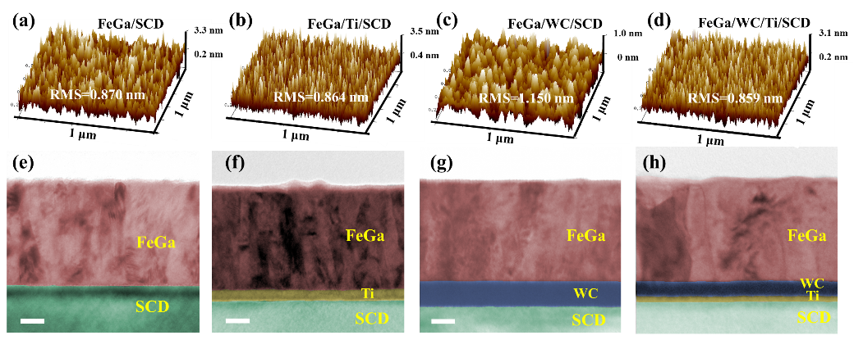
Fig. 6.7 (a)-(d) Atom force microscopy (AFM) images and surface morphologies of the FeGa films in various structures. (e)-(h) TEM bright-field images of cross-section FeGa films on various structures. [77]. Scale bar: 20 nm. Copyright ©2022, Elsevier.

To optimize the magnetic sensing performance, it was necessary to consider the impact of thermal expansion coefficient, lattice mismatch, and adhesion at the FeGa/SCD interface. To address this issue, an interlayer was proposed for the growth of FeGa thin films on Si substrates [78, 79]. The use of Ti and WC films as interlayers improved the interface adhesion of the heterostructures [78, 80]. To assess the impact of various interlayers on FeGa films, the Ti, WC, and WC/Ti thin films were deposited on the SCD cantilevers to produce the FeGa/SCD, FeGa/Ti/SCD, FeGa/WC/SCD, and FeGa/WC/Ti/SCD structures. The surface morphologies and roughness of FeGa films on these structures are shown in Figs. 6.7(a)-(d), with RMS roughness within 1.2 nm for the FeGa films in these multilayer structures. The FeGa films deposited on the SCD substrates without and with a Ti interlayer, respectively, exhibited a dense structure with grains forming strips and islands (Figs. 6.7(a) and (b)), while the WC interlayer resulted in a higher RMS roughness and strip shape for FeGa film (Fig. 6.7(c)). The use of a composite WC/Ti interlayer favored obtaining a cylindrical shaped FeGa film (Fig. 6.7(d)). To maintain high Q factors of the SCD cantilevers and tune the crystal orientation of FeGa films, the Ti, WC, and Ti/WC interlayers with thicknesses of 10 nm, 20 nm, and 5 nm/10 nm were deposited on SCD substrates, respectively. The TEM bright-field images of these multilayers (Figs. 6.7(e)-(h)) showed smooth interfaces. Furthermore, the grains of the FeGa films exhibited a columnar structure with sizes within 20~30 nm.

6.4.2 Thermal-stability of FeGa Thin Films on Diamond
The magnetic properties of FeGa alloy were significantly influenced by its phase structure [72, 81, 82]. This study utilized XRD to investigate the thermal stability of the FeGa film structures under different annealing temperatures. Figure 6.8 displays the XRD patterns of the FeGa films with various interlayers on SCD at different temperatures [64, 65, 77]. The FeGa/SCD films maintained a highly (110)-textured orientation of bcc phase at temperatures below 573 K, while higher temperatures led to the appearance of L1₂ (Fig. 6.8(a)). The FeGa films in the FeGa/Ti/SCD structure possessed a highly (220)-textured structure up to 773 K (Fig. 6.8(b)). The FeGa films in the FeGa/WC/SCD and FeGa/WC/Ti/SCD structures mainly consisted of (200)-oriented bcc phases with annealing temperature ranging from 300 K-773 K, without undergoing the transformation from the bcc phase structure to the face-centered cubic (fcc) phase structure (Figs. 6.8(c) and (d)). However, at an annealing temperature of 873 K, the peak of the (200)-orientation of FeGa film in the FeGa/WC/SCD structure disappeared, while the intensity of FeGa film in the FeGa/WC/Ti/SCD structure decreased. The FeGa films in the FeGa/SCD and FeGa/Ti/SCD structures mainly maintained (220)-oriented bcc phases within the annealing temperature below 773 K, while (111)-oriented fcc phases appeared in FeGa films of the FeGa/WC/SCD structure and the FeGa/WC/Ti/SCD structures at annealing temperature above 573 K. At 873 K, the diffraction intensity of the FeGa film in the FeGa/SCD structure decreased sharply, illustrating significant degradation in the crystal characteristic, while the FeGa film in the FeGa/Ti/SCD structure increased intensely with the production of multi-oriented grains. Thus, the main phase structures of FeGa films in these four structures exhibited high thermal stability during annealing treatment ranging from 300 K to 773 K
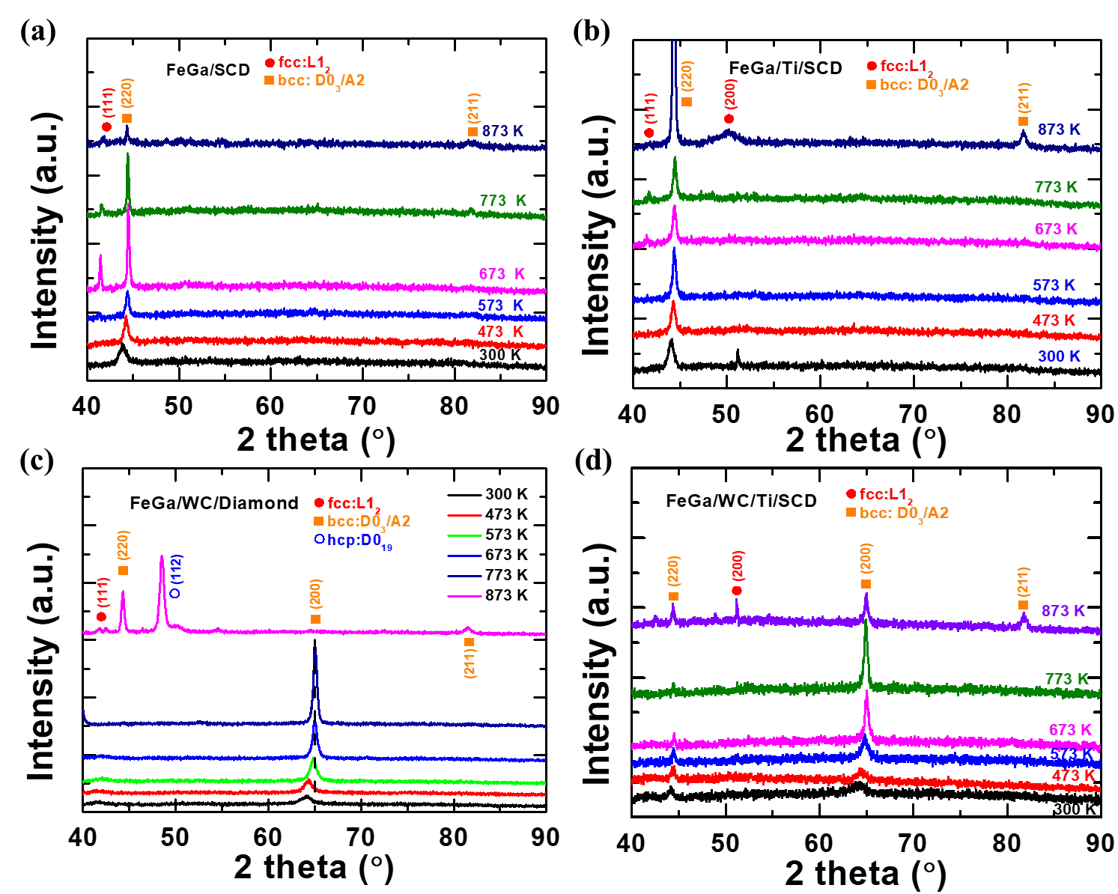
Fig. 6.8 XRD patterns of the annealed FeGa films on the SCD substrates with different interlayers at different temperatures for 1 h from 300 K to 873 K. (a) FeGa/SCD structure [65]. (b) FeGa/Ti/SCD structure [64]. (c) FeGa/WC/SCD structure; (d) FeGa/WC/Ti/SCD structure [77]. Copyright ©2020, Taylor & Franics. Copyright ©2020, American Chemical Society. Copyright ©2022, Elsevier.

The magnetic properties of FeGa films in various structures after annealing treatments in the range of 300 K to 873 K were investigated using the vibrating sample magnetometer (VSM) technique. The magnetic fields were parallel to the sample surfaces. The hysteresis loops of the FeGa films in different multilayer structures under annealing treatment are depicted in Fig. 6.9 [64, 65]. The FeGa films exhibited varying thermal-stability of magnetic properties under annealing treatments from 300 K to 873 K.
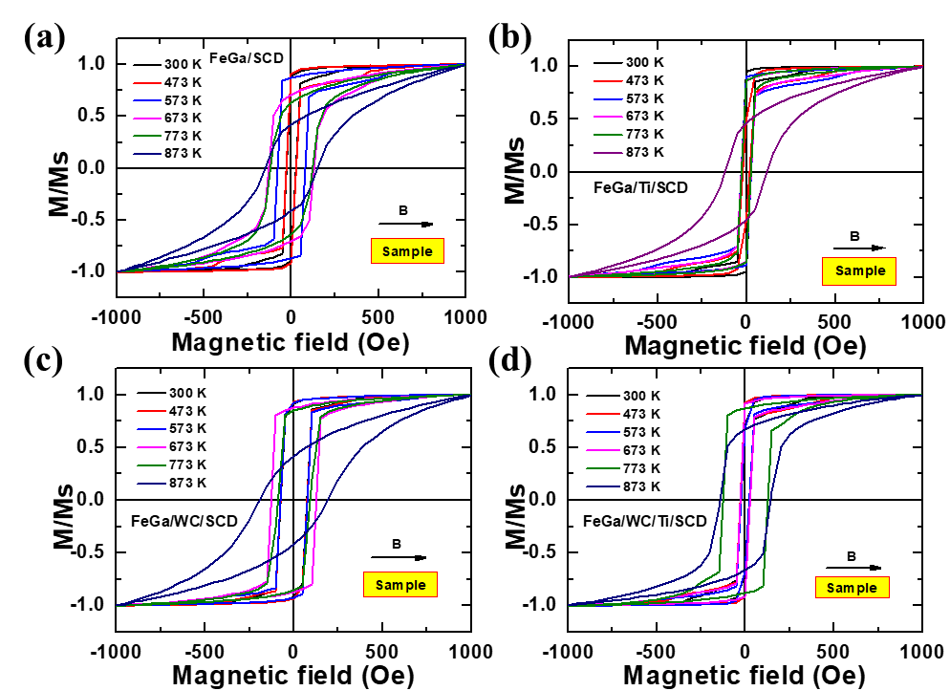

Fig. 6.9 Hysteresis loops of the FeGa films in various multilayer structure under annealing treatment (300 K-873 K) measured via the vibrating sample magnetometer (VSM) system with the magnetic fields parallel to the samples surface [64, 65]. Copyright ©2020, Taylor & Francis. Copyright ©2020, American Chemical Society.

Additionally, the changes in saturation magnetization, Ms and Hc of the FeGa films with different interlayers at different annealing temperatures are depicted in Fig. 6.10 [64, 65, 77]. Notably, a critical temperature was observed for all the structures, which was marked by a sudden decrease in Ms and an increase in Hc. For the FeGa films in the FeGa/SCD and FeGa/WC/SCD structures, the critical temperature was 573 K, beyond which Ms declined with increasing the temperature. Similarly, for the FeGa film in the FeGa/Ti/SCD structure, the critical temperature was 773 K, and the FeGa films in the FeGa/WC/Ti/SCD structure had a critical temperature of 673 K. On the other hand, the Hc of FeGa films in the FeGa/SCD, FeGa/Ti/SCD, FeGa/WC/SCD, and FeGa/WC/Ti/SCD structures exhibited a sharp increase with a critical temperature of 473 K, 773 K, 573 K, and 673 K, respectively. The maximum stable temperatures of Ms and Hc were consistent with the surface morphologies and phase structures with the temperature increasing. Thus, the thermal stability of phase structures and microstructures of FeGa films exhibited significant influence on thermal-stability of magnetic properties.
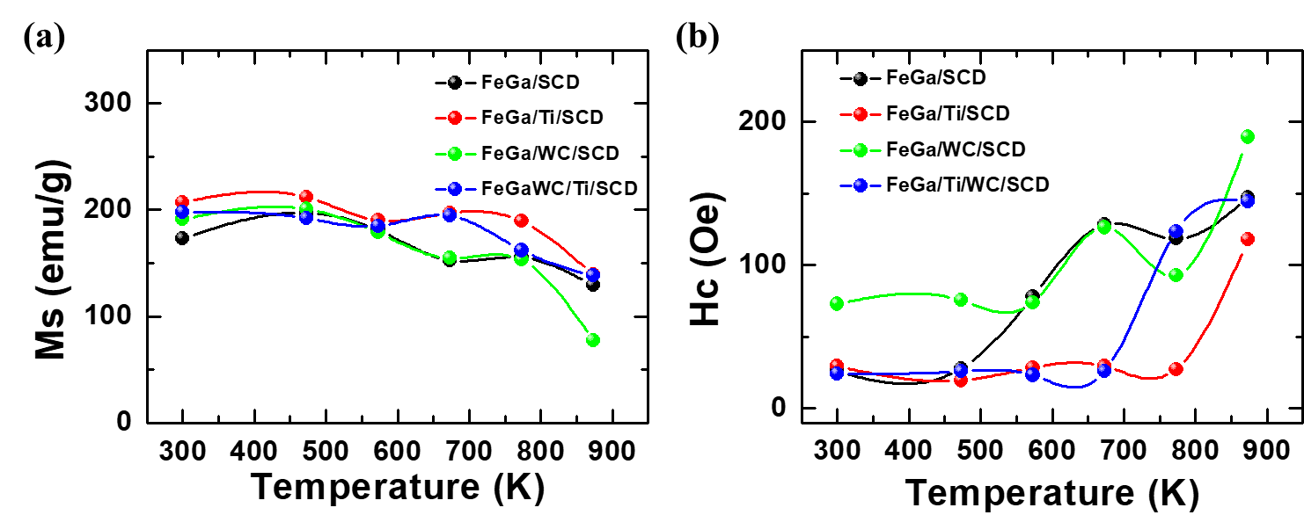
Fig. 6.10 Temperature dependences of (a) the saturation magnetization, Ms and (b) coercive field, Hc, respectively, of the FeGa films in various multilayer structures [64, 65, 77]. Copyright ©2020, Taylor & Franics. Copyright ©2020, American Chemical Society. Copyright ©2022, Elsevier.

6.5 Performance Stability of Diamond MEMS Resonators

6.5.1 Resonance Frequency of Diamond MEMS Resonators
Figure 6.11 shows the resonance spectra of the cantilevers with a length of 160 μm, width of 12 μm, and different thicknesses under different driving voltages. The resonance frequencies of the SCD cantilevers followed the square root of the Lorentz distribution. The amplitude of the driving signal applied on the piezoceramic had no effect on the resonance frequency of each cantilever, and the resonance peak amplitude showed a linear increase with the driving amplitude. Consistent with the equation (6.5), the resonant frequency of the SCD cantilevers was proportional to L⁻² and t. Figure 6.12 shows the relationship between the resonant frequency and the length and thickness of three groups of SCD cantilevers of different sizes. It can be seen that for each group of SCD cantilevers, when t and w remained constant, the relationship between f and L strictly followed the expression of the equation (6.5). Based on the actual results, the Young's modulus of SCD material was estimated by the equation (6.5) to be 1100 GPa, close to that of the bulk SCD material of 1143 GPa.
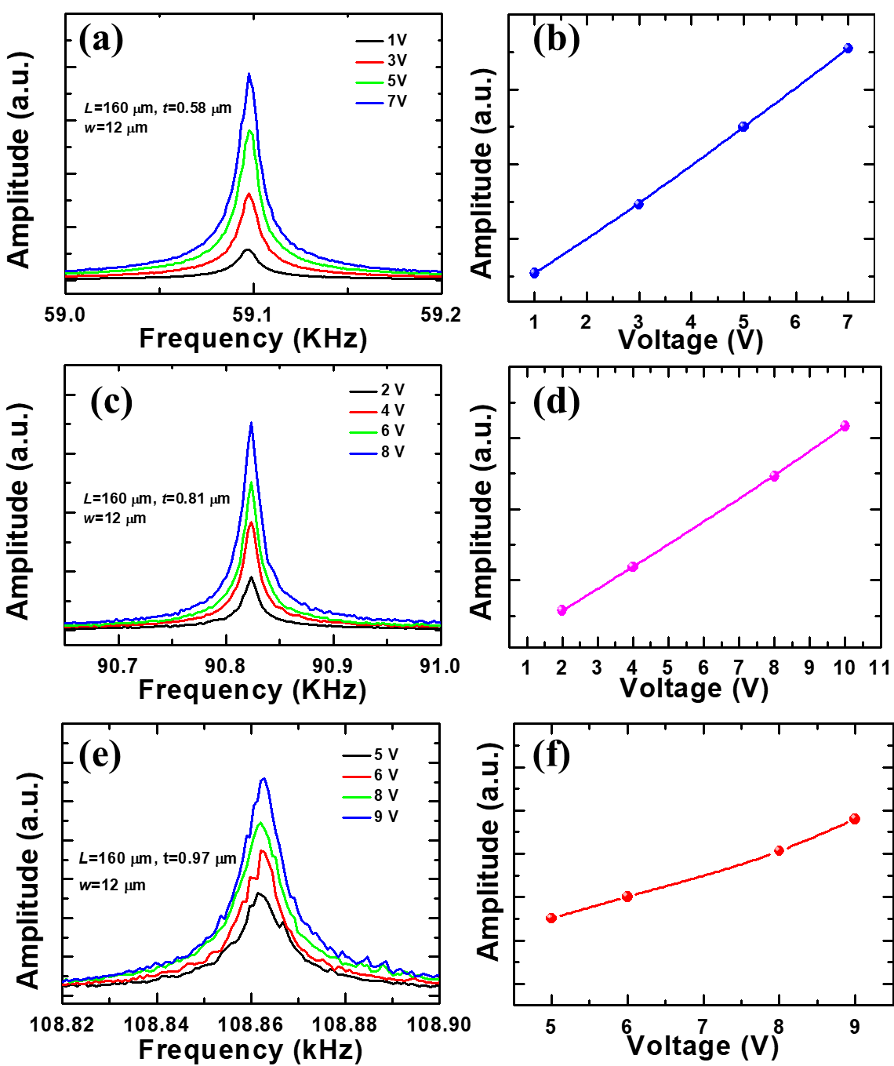
Fig. 6.11 Resonance spectra of the SCD cantilevers with different dimensions and the relationships between the maximum resonance amplitudes and the excitation drive voltages. (a) and (b) t=0.58 μm. (c) and (d) t=0.81 μm. (e) and (f) t=0.97 μm.

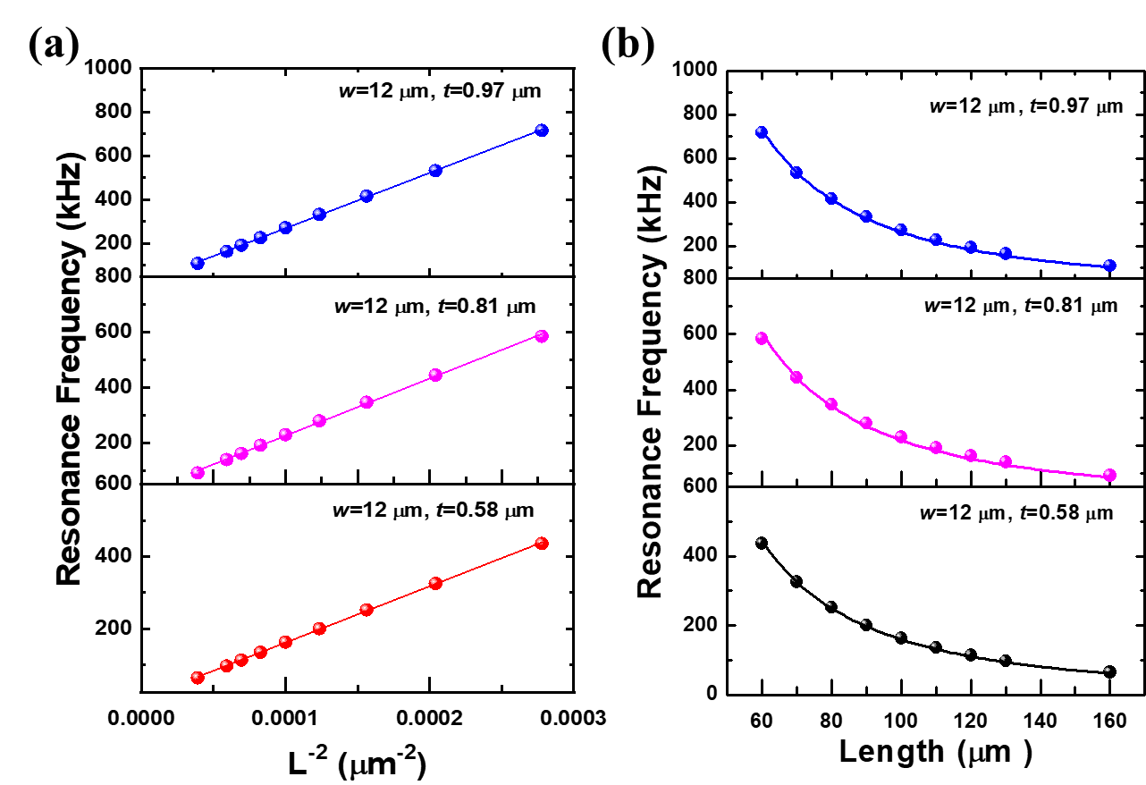
Fig. 6.12 The relationships between resonance frequencies of SCD cantilevers and (a) L and (b) L⁻².

Since this mechanical vibration was measured under vacuum condition, the air damping was ignored. The predominant dissipative mechanism affecting the Q factor can be evaluated based on the experimental results. Figure 6.13 shows the relationship between the Q factor and L of the cantilevers with different thicknesses. The Q factor of each group of cantilevers changed little with the increase of L. On the other hand, the surface effects such as the damage to the bottom of the cantilever caused by ion implantation, defects at the edge of the cantilever beam caused by reactive ion etching (RIE), and surface stress caused the energy dissipation, leading to a decrease in the Q factor of the cantilever beam.
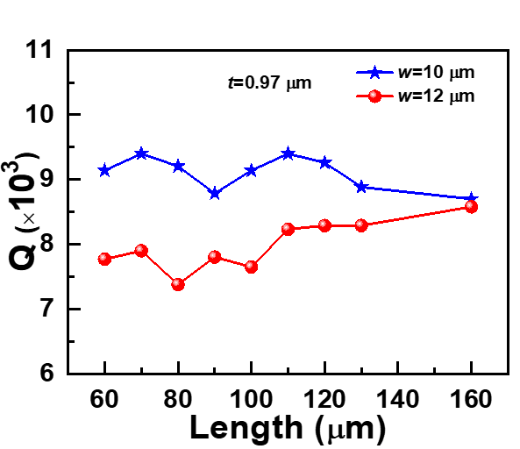
Fig. 6.13 The relationship between Q factors and lengths for the SCD cantilevers.

6.5.2 Thermal-stability of Diamond MEMS Resonators
The thermal stability of the SCD cantilevers was revealed by the temperature coefficient of resonance frequency (TCF), which was TCF=(Δf_{T}/f₀)/ΔT. Where Δf_{T}=f_{T}−f_{T0}. f_{T0} is the fundamental resonance frequency when T=300 K. Based on the equation (6.5) the resonance frequency exhibited a strong relationship with the Young’s modulus of the cantilever. In addition, the temperature had a negative effect on Young’s modulus of materials as [83-85],
$E=E_{T0}-ATexp(-\frac{T_{0}}{T})$ (6.10)
where the E_{T0} is the Young’s modulus of material with the temperature of T₀. A is a constant. The high temperatures resulted in the decrease in the Young’s modulus of SCD. The resonance frequency decreases with the temperature increasing due to the decrease in E (Figs. 6.14(a) and (b)). As shown in Fig. 6.14(c), the TCF of the bare SCD cantilever is lower than -3.2 ppm/K with temperature in the range of 300 K to 773 K, significantly lower than that of Si with a value of -35 ppm/K [86, 87]. The Q factors of SCD cantilevers maintain above 3000 at 773 K (Fig. 6.14(d)). The Q factor presented a negative dependence on the temperature. The energy dissipations which determined Q factor increased with the temperature increasing, the Q factors of the SCD cantilevers decreased to above 3000 at 773 K.
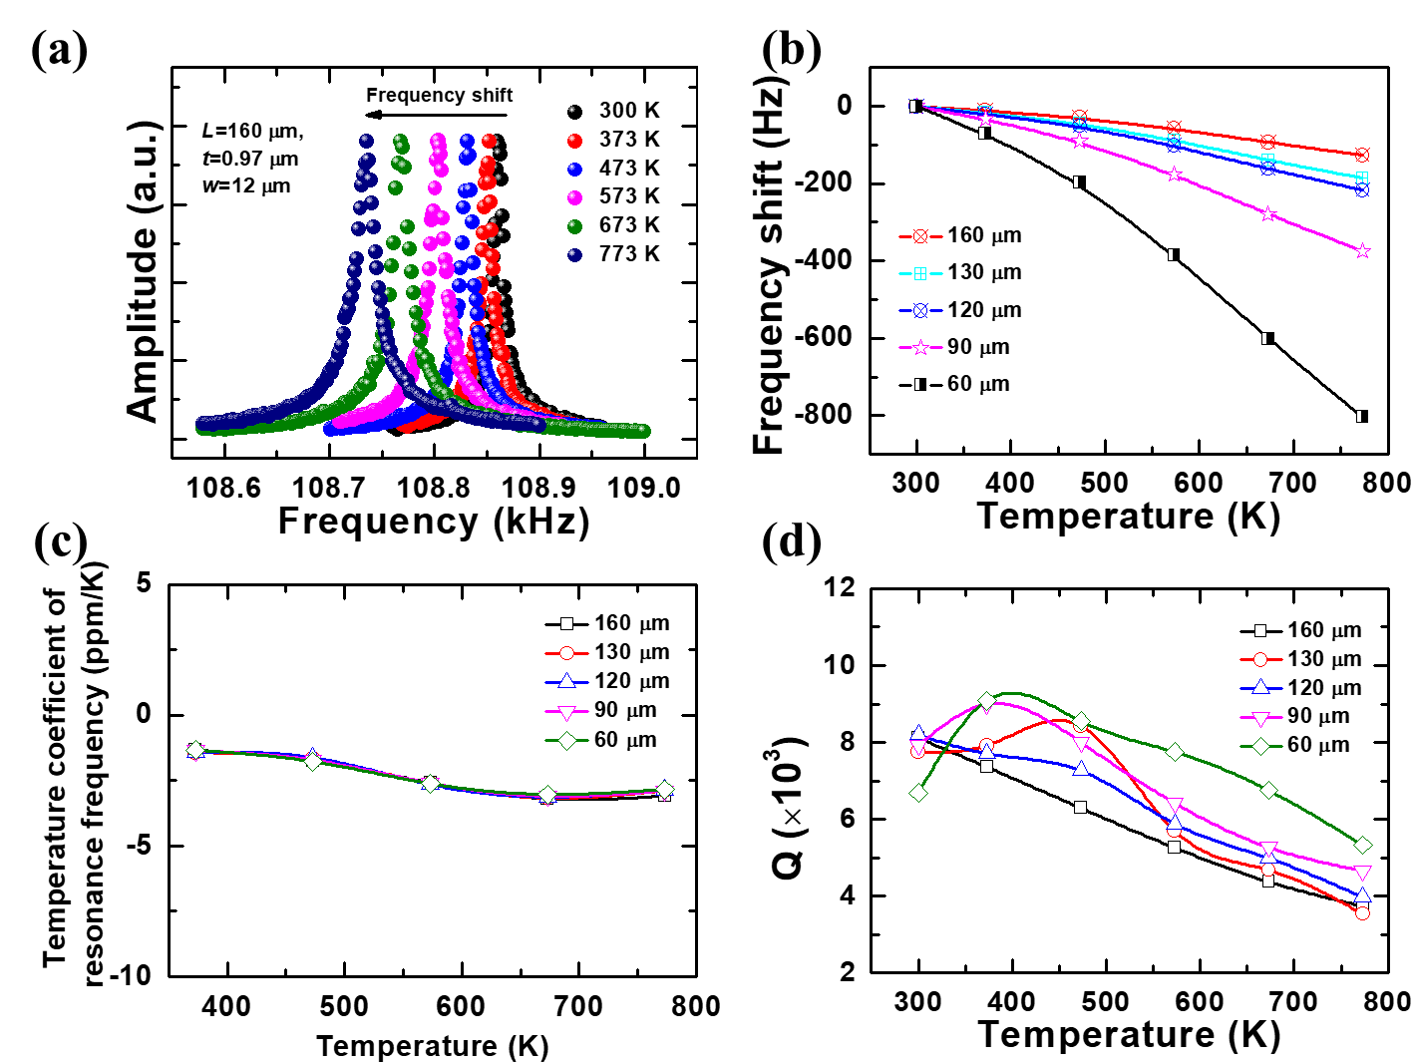
Fig. 6.14 (a) Resonance frequency shift as the measurement temperature of a bare SCD cantilever. (b) Temperature dependences of the resonance frequency shifts of the bare SCD cantilevers with varying length dimensions. (c) Temperature coefficients of resonance frequencies of the SCD cantilevers. (d) Temperature dependences of Q factors of the SCD cantilevers [65]. Copyright ©2020, Taylor & Francis

6.6 Diamond MEMS Magnetic Sensors

6.6.1 Effect of FeGa on Resonance Properties of Diamond MEMS Resonators
FeGa films with different thicknesses (20-80 nm) were deposited on the SCD cantilevers (t=1.2 μm), and the change in the resonance frequency and Q factors of the FeGa/SCD cantilevers were analyzed. The relationship between the resonance frequency spectra of the SCD cantilever (L=160 μm) and the driving voltage with different FeGa thin film thicknesses are displayed in Fig. 6.15.The illustration in each inset of Fig. 6.15 represents the relationship between the maximum resonance peak amplitude and the driving voltage. With the thickness of FeGa films ranging from 20 nm to 80 nm, the resonance frequency and Q factors of the FeGa/SCD cantilever gradually decreased (Fig. 6.15). In addition, from Fig. 6.15, it is disclosed that with different FeGa thicknesses, the maximum resonance peak amplitude of the FeGa/SCD cantilever had a linear increase relationship with the driving voltage. Figures. 6.16(a) and (b) show the relationship between the resonance frequency of SCD cantilevers and L and 1/L² with different FeGa thin films, respectively. The dashed line represented the line fitted by the equation (6.5). The resonance frequencies of FeGa/SCD cantilevers deposited with different thicknesses of FeGa thin films were in accordance with the equation (6.5) between L and 1/L². Thus, the consistence between the experimental and fitting data revealed the high reproducibility of the fabrication approach of the SCD cantilevers with the depositions of FeGa films of different thicknesses.
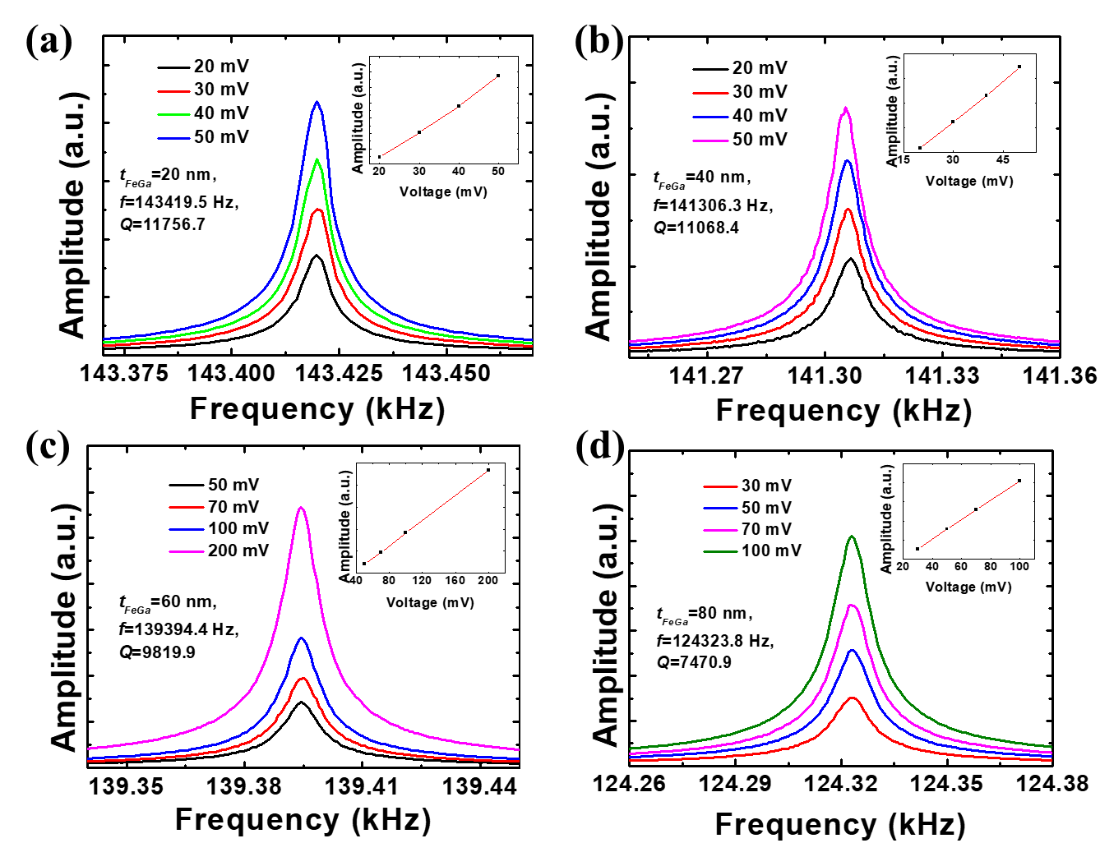
Fig. 6.15 Resonance spectra of the SCD (L=160 μm) cantilevers deposited with the FeGa films with different thicknesses: (a) 20 nm; (b) 40 nm; (c) 60 nm; (d) 80 nm. The inset in each figure shows the linear relationship between the resonance peak amplitude and the drive voltage.
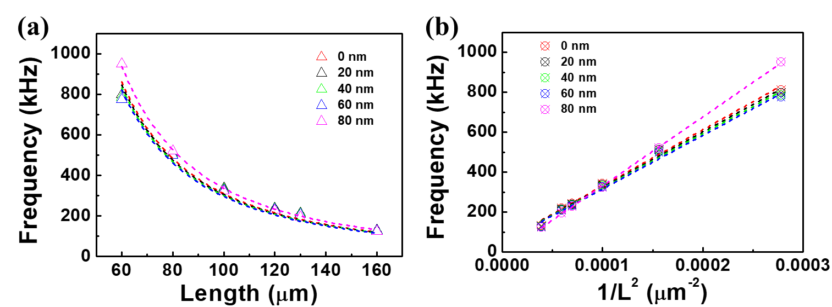
Fig. 6.16 Variations of the resonance frequencies of SCD cantilevers deposited with the different thicknesses of FeGa films with (a) L and (b) 1/L² [63]. Copyright ©2019, Elsevier.

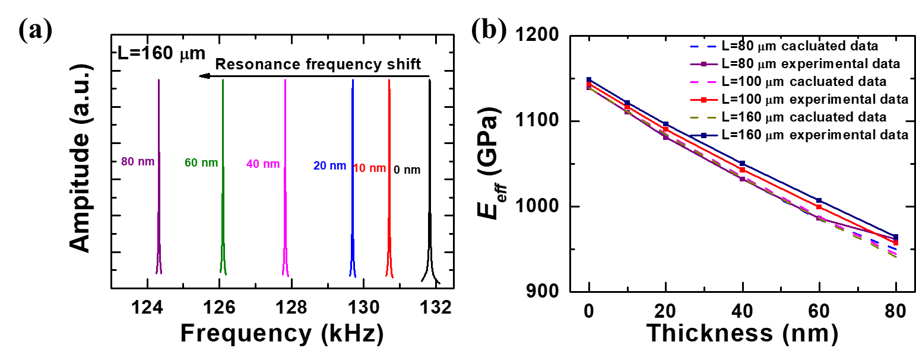
Fig. 6.17 (a) Resonance frequency shifts of a 160 μm-length FeGa/SCD cantilever after depositing FeGa films with various thicknesses. (b) The effective Young’s modulus of the FeGa/SCD cantilevers with the FeGa film thicknesses [63]. Copyright ©2019, Elsevier.

Figure 6.17(a) demonstrates that the resonance frequency of the 160 μm-long FeGa/SCD cantilever decreases linearly as the thickness of the FeGa film increases. The experimental data (the equation (6.5)) and theoretical calculations (the equation (6.6)) allowed for the extraction of the effective Young’s modulus, E_{eff}. Figure 6.17(b) illustrates the E_{eff} changes with FeGa film thickness with various SCD cantilever lengths (80 μm, 100 μm, and 160 μm). It was disclosed that the E_{eff} decreased with the increase in the FeGa film thickness, demonstrating that the E_{eff} of the bilayer structure was mainly dominated by the lower E layer. A slight difference in the experimental and theoretical E_{eff} was observed with various FeGa film thicknesses. Therefore, it suggested that the strain induced by the deposition of FeGa film was insignificant in this bilayer system.

6.6.2 Room-temperature Magnetic Sensing Performance

6.6.2.1 FeGa/Diamond Resonators for Magnetic Sensing
The integration a magneto-strictive FeGa thin film with an SCD cantilever presented a promising approach for developing micro scale magnetic sensors utilizing the ΔE effect [38-40, 47]. It referred to the change in Young’s modulus induced by the magnetization [88]. As discussed earlier, the FeGa film with a thickness of 80 nm deposited on SCD cantilevers exhibited exceptional soft magnetic properties for fabricating a MEMS magnetic sensor, as illustrated in Fig. 6.18(a) [63]. The frequency response of the FeGa/SCD cantilever with L=160 μm to the magnetic field is depicted in Fig. 6.18(b), indicating that the resonance frequency shifted to a lower frequency with increasing the magnetic field. Figure 6.18(c) further reveals that the resonance frequency shifts of the FeGa/SCD cantilevers display a linear relationship with the applied magnetic field, irrespective of the lengths of SCD cantilevers. The inset in Fig. 6.18(c) demonstrates that the magnetic field sensitivity of 4.83 Hz/mT is achieved for the FeGa/SCD cantilever with L=60 μm. Currently, the sensitivity expressed by the resonance frequency shift dependence on the magnetic field are mainly employed in the magnetic sensors based on the Lorentz force and the magnetostrictive force. The magnetic sensitivities for various MEMS magnetic sensors at room temperature are summarized in Table 6.2. It was noted that the magnetic sensors based on the magnetostrictive force can achieve high sensitivity. The sensitivity of the magnetic sensor based on the FeGa/SCD cantilever was greatly enhanced through the addition of Ti thin film.

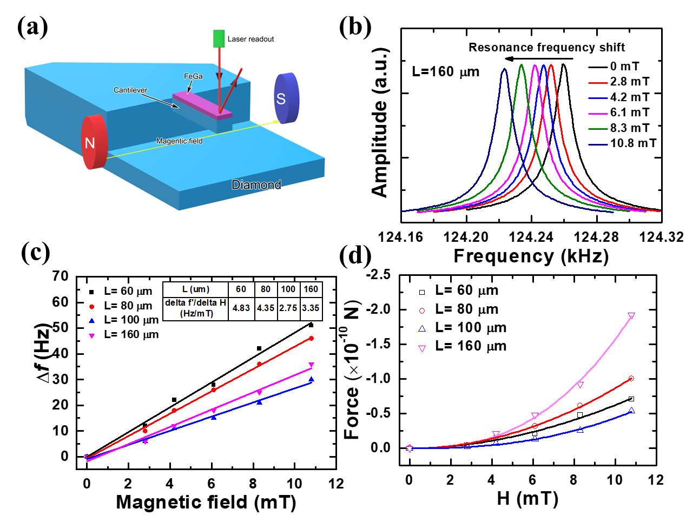
Fig. 6.18 (a) Schematic illustration of a magnetic sensor based on a FeGa/SCD cantilever resonator. (b) Resonance frequency response of a 80 nm-thick FeGa/SCD cantilever (L=160 μm) upon varying applied magnetic fields. (c) The dependences of the resonance frequency shifts and (d) detectable force of the FeGa/SCD cantilevers on the magnetic fields. The negative sign of force means the compressive stress [63]. Copyright ©2019, Elsevier.

Table 6.2 Comparison of magnetic sensitivities for various MEMS magnetic sensors at room temperature.
Magnetic sensor | Material | f (◊10³) | Q | Sensitivity (Hz/mT) | Ref.
Lorentz force | Si | 38.074 | 15000 | 0.087 | [89]
Lorentz force | Si | 175 | ~600 | 60 | [33]
Lorentz force | SOI | 49.3 | 100000 | 0.01 | [90]
Lorentz force | SOI | 22.6 | 540 | 0.59 | [91]
Magnetostrictive force | FeGa/quartz | 38.199 | 3318 | 35 | [30]
Magnetostrictive force | FeGa/PZT | 12.450 | 1132 | 5.47 | [92]
Magnetostrictive force | FeGa/SCD | 949.966 | 8201 | 4.83 | [63]
Magnetostrictive force | FeGa/Ti/SCD | 147.916 | 3889 | 35.6 | [64]
Note: silicon-on-insulator (SOI), lead zirconate titanate (PZT)

The FeGa film generates a magnetostrictive stress that was transformed into longitudinal force acting on the SCD cantilever. This, in turn, altered the resonance frequency of the cantilever. In the case of a uniform beam system exposed to longitudinal force F, the basic resonant frequency, f_{r} can be expressed as [69],
$f_{r}=f_{0}\sqrt{1+γ_{n}F\frac{l^{2}}{E_{d}w_{d}t_{d}^{3}}}$ (6.11)
where f₀ is the resonance frequency of a SCD cantilever with the 80 nm-thick FeGa film. E_{d}, t_{d}, w_{d}, and l are Young’s modulus, thickness, width and length of the bare SCD cantilever. For the fundamental mode, the constant γ₀ is 0.295. Therefore, the resonance frequency shift of the SCD cantilever caused by the longitudinal force is,
${∆f}^{'}={|f}_{r}-f_{0}|=|f_{0}\left(\sqrt{1+γ_{0}F\frac{l^{2}}{E_{d}w_{d}t_{d}^{3}}}-1\right)|$ (6.12)
The value of Δf’ is equal to Δf due to the integrality vibration of the bilayer cantilever system. According to the equation (6.11), when the beam undergoes tensile stress, the resonant frequency f_{r} increases with the longitudinal force F [30, 93]. While the beam undergoes compressive stress, the f_{r} decreases with the F. The cantilever structure determines the direction of F generated by the magneto-strictive material. Figure 6.18(b) demonstrates a shift in resonance frequency towards lower frequencies, indicating a compressive stress to the SCD cantilever when a magnetic field is applied. Figure 6.18(d) shows the variations of the magneto-strictive force calculated from the equation (6.12) for the FeGa/SCD cantilevers with applying magnetic fields. The calculation showed that the magneto-strictive force between the FeGa thin film and the SCD cantilever was 2.14×10⁻¹² N at 10.8 mT for the 160 µm-long SCD cantilever.
Alternatively, the minimum detectable force and energy of a rectangular cantilever are represented by the following equations [94],
$∆F_{min}=\frac{\sqrt{(4kk_{B}T)}}{Q}$ (6.13)
$∆E_{min}=\frac{2k_{B}T}{Q^{2}}$ (6.14)
where the k is spring constant [95], k_{B} is the Boltzmann’s constant. T is temperature. One can calculate the minimum magnetic field by using the equations (6.12) and (6.13). For example, the minimum detectable force for the 160 µm-long SCD cantilever was calculated to be 1.76×10⁻¹⁴ N, which corresponded to the minimum detectable magnetic field as low as 1.42×10⁻¹⁰ T (142 pT).

Figure 6.19 shows the relationship between the sensitivity and Q factor of magnetic sensors (length L=160 μm) with the FeGa film of different thickness. The sensitivity of the magnetic sensor increased with the increase of the thickness of FeGa thin film, and the Q factor decreased with the increase of the thickness of FeGa thin film. The thicker FeGa thin film can result in the large magnetostrictive force, which was favor of achieving the huge ∆E effect. The magnetic sensitivity was enhanced through the thicker FeGa thin film. In addition, for a cantilever with the bilayer structure consisting of a substrate and a surface layer, the Q factor was significantly determined by the surface energy dissipation. the Q factor exhibited the negative thickness-dependence of the surface layer [51, 96]. Thus, for the SCD cantilever with the deposition of FeGa thin film, the Q factor decreased with the increase in the thickness of FeGa film.
Fig. 6.19 Dependences of the magnetic sensitivity and Q factor of the SCD cantilever magnetic sensors on the thickness of FeGa film.

6.6.2.2 Enhanced Magnetic Sensing through Boron-doped FeGa Film
The magnetic sensitivity of the SCD cantilevers was enhanced by using a boron-doped FeGa (FeGaB) thin film [66].The relationships between the resonance frequency of the SCD cantilevers and length before and after growing the FeGaB thin film were in line with equation (6.5). The frequency shift variations in response to magnetic fields of the 60 μm-length FeGaB/SCD cantilevers with and without the Ti interlayer are depicted in Fig. 6.20. As shown in Figs. 6.20(a) and (b), the FeGaB (50 W)/SCD and FeGaB (50 W)/Ti/SCD magnetic sensor structures display two-segments response to magnetic fields, characterized by an unsaturated range and a saturated range. In the unsaturated range, where the magnetic field was less than 1.97 mT, the frequency shift increased linearly with a magnetic sensitivity of 76.7 Hz/mT and 152.1 Hz/mT for the FeGaB (50 W)/SCD and FeGaB (50 W)/Ti/SCD magnetic sensors, respectively. However, when the magnetic field exceeded 1.97 mT, the magnetization of the amorphous FeGaB thin film became saturated, leading to a decline in the magnetic sensitivity. This saturation field was consistent with the VSM measurements. Therefore, it was desirable to detect the low magnetic fields (<2 mT) for the magnetic sensor structure consisting of an amorphous FeGaB thin film on the SCD MEMS resonator. The insertion of a Ti interlayer significantly enhanced the magnetic sensing performance by strengthening the interface interaction and adhesion, resulting in a more efficient transmission of the magnetostrictive force [65]. In Fig. 6.20(c), the resonance frequency shift of the FeGaB (100 W)/SCD magnetic sensor exhibits a positive correlation with the magnetic field without the saturation, showing a magnetic sensitivity of 49.8 Hz/mT. Note that the amorphous FeGaB thin film had better magnetostrictive performance compared to the polycrystalline FeGaB thin film [97]. Furthermore, the SCD-based magnetic sensor incorporating the FeGaB thin film exhibited superior magnetic sensitivity to those of using the FeGa film with the same thickness [63, 65].

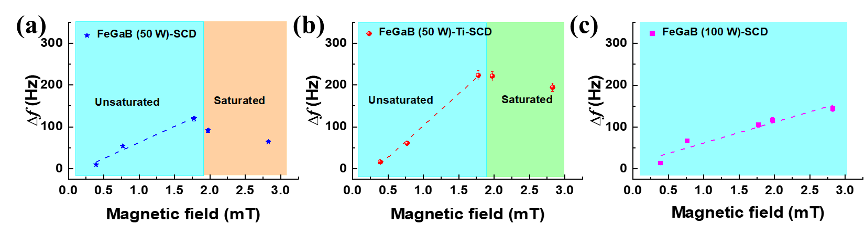
Fig. 6.20 Resonance frequency shifts of the FeGaB thin films grown on a 60 µm-length SCD cantilever under the sputtering power of 50 W (a) without the Ti interlayer, (b) with the Ti interlayer, (c) under the sputtering power of 100 W without the Ti interlayer. The fit line for each case is drawn as a dashed line [66]. Copyright ©2020, Elsevier

6.6.3 High-temperature Magnetic Sensing Performance
A high-temperature magnetic sensor utilizing the FeGa/SCD MEMS resonator was developed for magnetic sensing up to 573 K [65]. Figure 6.21(a) shows the measurement setup for the FeGa/SCD cantilever magnetic sensor. To measure the resonance frequency at high temperatures, the magnetic sensor was measured until it reached a steady state. Figure 6.21(b) provides a schematic of the magnetic sensing of a 160 μm-length FeGa/SCD cantilever with and without a magnetic field at various temperatures. The dependences of the frequency shifts on temperatures during the heating-cooling process (300 K to 573 K) are illustrated in Fig. 6.21(c). The frequency shift increased slightly with the temperature. The dependences of the frequency shifts on the magnetic fields at high temperatures are presented in Fig. 6.21(d), indicating a linear increase in frequency shift with the magnetic field. The FeGa/SCD cantilever demonstrated stable response to the applied magnetic field even at 573 K. As mentioned above, the (110)-textured structure and smooth surface of the FeGa film were maintained up to 573 K, demonstrating the cantilever magnetic sensor with high reliability at elevated temperatures.
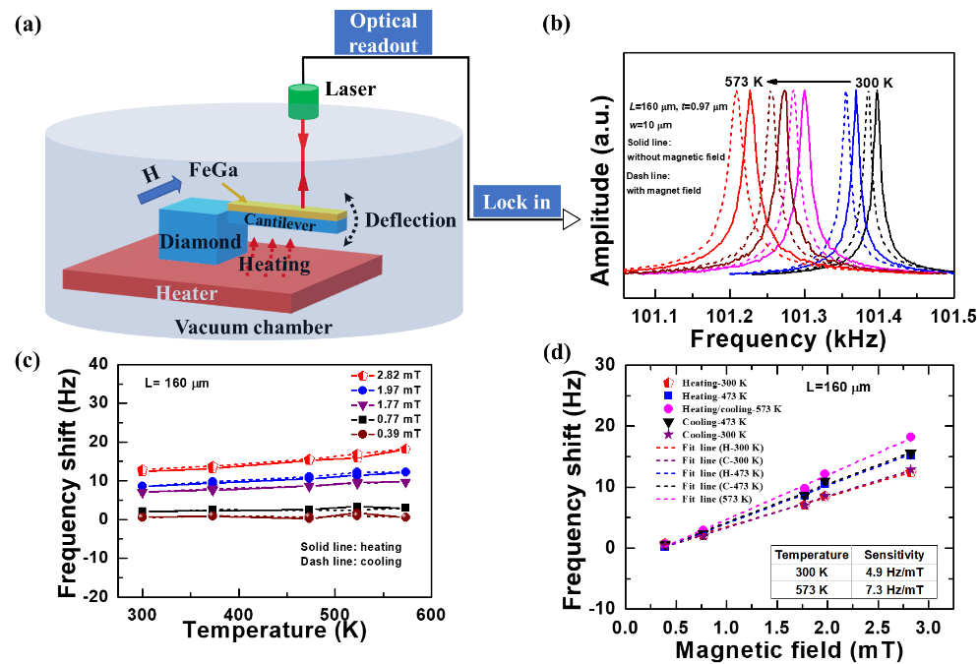
Fig. 6.21 (a) Measurement setup of magnetic sensing at elevated temperatures. (b) Resonance frequency shifts vs measurement temperatures of the FeGa/SCD cantilever without and with a magnetic field. (c) Dependences of the resonance frequency shifts on temperatures during the heating-cooling treatment. (d) The resonance frequency shifts as a function of magnetic fields at elevated temperatures [65]. Copyright ©2020, Taylor & Francis.

The intrinsic magnetic noise (b_{n}) of magnetic sensor, which is determined by the thermomechanical noise, is expressed as follows [98],
$b_{n}=\frac{μ_{0}}{2}(\frac{dH}{df})\sqrt{\frac{2πk_{B}Tf_{0}}{QVσ}}$ (6.15)
where the μ₀(dH/df) is the magnetic sensitivity. σ is the stress. The calculated noise of the intrinsic magnetic sensor noises of the FeGa/SCD cantilever were ~589 pT/√Hz at 300 K and 530 pT/√Hz at 573 K, respectively.
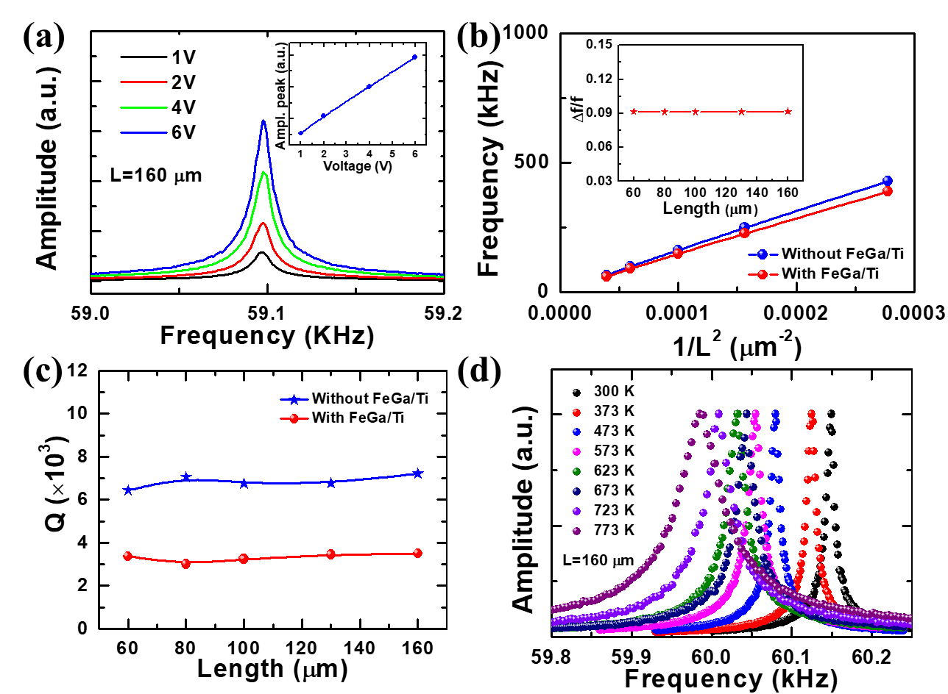
Fig. 6.22 (a) Resonance frequency patterns of a 160 μm-length FeGa/Ti/SCD cantilever. (b) Resonance frequencies and (c) Q factors vs the lengths of the SCD cantilevers without and with deposition of FeGa/Ti films. (d) Schematic diagram of the resonance frequency shifts as the measurement temperatures of a 160 μm-length FeGa/Ti/SCD cantilever [64]. Copyright ©2020, American Chemical Society.
To achieve both higher operating temperatures and magnetic sensitivity, a Ti layer was inserted between FeGa and SCD to form the FeGa/Ti/SCD resonator structure [64]. Figure 6.22(a) displays the typical resonance frequency spectra of a 160 μm-length FeGa/Ti/SCD cantilever. Figure 6.22(b) illustrates the resonance frequency dependences on the lengths of the SCD cantilevers with and without the deposition of FeGa/Ti films. The variation of the resonance frequency was utilized to show the influence of the deposition of FeGa/Ti films on SCD cantilever, which was defined in the 6.5.2 section. The inset of Fig. 6.22(b) illustrates that the relative variation of the resonance frequency is almost identical for the cantilevers with different dimensions. The SCD cantilevers without and with FeGa/Ti films showed the consistency with the equation (6.5). According to the equation (6.6), the Young’s modulus of the multilayer structure was dominated by the SCD cantilever and the deposited films. Due to the Young’s modulus of FeGa/Ti significantly lower than that of the SCD, the E_{eff} of the FeGa/Ti/SCD cantilever decreases with the depositions of the FeGa/Ti films, which leads to the decrease in the resonance frequency, as shown in Fig. 6.22(b). Due to the FeGa/Ti films with the limited thickness of ~90 nm, the Q factors of the FeGa/Ti/SCD cantilevers remain as high as 3000~4000 (Fig. 6.22(c)). Figure 6.22(d) exhibits the resonance frequency shifts toward the low frequency due to the decrease in E_{eff} of the multilayers resulting from the temperature increase. The temperature-dependent Young’s modulus was expressed in the equation (6.10), which revealed that the high temperature results in the decreasing in Young’s modulus. Thus, the resonance spectra shifted downward with the reduction in E_{eff}.

The magnetic sensitivity of the FeGa/Ti/SCD cantilever was measured by the resonance frequency shift caused by the ∆E effect. Figures 6.23(a) and (b) display the changes in the resonance frequency shifts of a 100 μm-length FeGa/Ti/SCD cantilever when exposed to magnetic fields with the temperatures varying during the heating-cooling processes. The resonance frequency shift increased proportionally with the temperature with applying an external magnetic field. Figures 6.23(c) and (d) depict the relationships between the resonance frequency shift and the magnetic field during the heating-cooling process. The resonance frequency shifts followed a linear trend with the magnetic fields, with a maximum magnetic sensitivity of 71.1 Hz/mT up to 773 K.
Based on the relationship between the frequency shifts and the applied magnetic fields, we measured the magnetic noise levels of the FeGa/Ti/SCD resonator magnetic sensor at 300 K and 773 K, respectively. Figures 6.23(e) and (f) display the magnetic noise spectra of the 100 μm-length FeGa/Ti/SCD resonator magnetic sensor, revealing the low magnetic noise levels of 20 nT/√Hz at 300 K and 10 nT/√Hz at 773 K, respectively. With the equation (6.15), the intrinsic magnetic noises of the FeGa/Ti/SCD magnetic sensor were estimated approximately ~206.7 pT/√Hz at 300 K and 212.4 pT/√Hz at 773 K. The discrepancy between the measured and evaluated magnetic noise levels may be attributed to the noise source of the testing apparatus. The improvement of the thermal stability of the SCD MEMS magnetic sensor was due to the enhanced adhesion between the FeGa and the SCD by the Ti layer. In addition, the magnetic sensing performances of the main reported high-temperature magnetic sensors with the current FeGa/Ti/SCD cantilever sensor are compared in Table 6.3. It was disclosed that the SCD-based magnetic sensor had high sensitivity, low noise level and high thermal-reliability compared to other magnetic sensors.
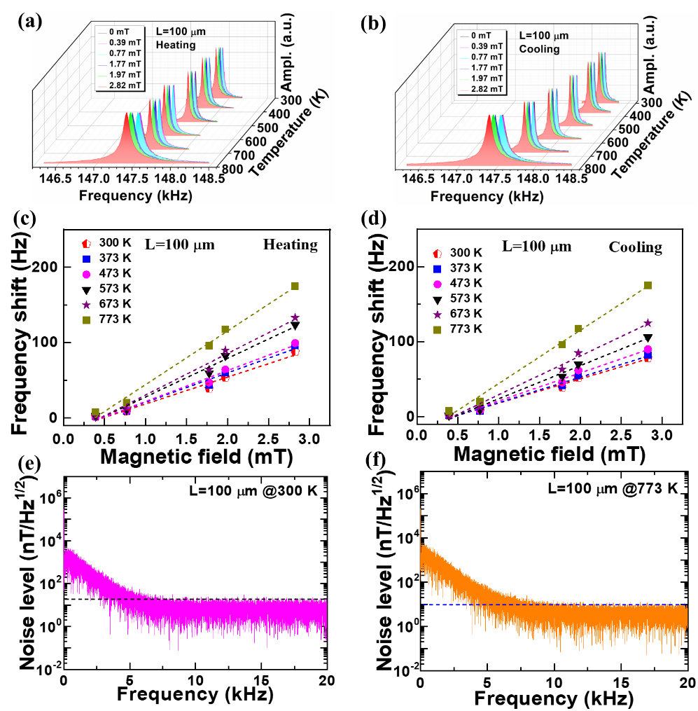
Fig. 6.23 (a) and (b) Resonance frequency shifts of a 100 μm-length FeGa/Ti/SCD cantilever as a function of the measurement temperatures and the external magnetic fields during the heating-cooling process, respectively. (c) and (d) Dependences of the resonance frequency shiftS on the magnetic fieldS during the heating and cooling process, respectively. (e) and (f) Magnetic noise spectra of the 100 μm-length FeGa/Ti/SCD resonator magnetic sensor at 300 K and 773 K, respectively [64]. Copyright ©2020, American Chemical Society.

Table 6.3 Comparison of magnetic sensing performances of various high-temperature magnetic sensors [64]. Copyright ©2020, American Chemical Society
Magnetic sensor | Materials | Sensitivity | Noise level | Working temperature | Ref.
AMR | Si-based | -- | ~2.6 nT/√Hz | 498 K | [99]
Hall | Si | -- | >82 nT/√Hz | 673 K | [100]
Hall | AlGaN∕GaN | -- | 35 μT/√Hz | 873 K | [101]
Hall | 4H-SiC | 80 V/(A∙T) | -- | 770 K | [102]
Fluxgate | Cu coil | -- | 0.79 nT/√Hz | 523 K | [103]
MEMS | FeGa/Ti/SCD | 71.1 Hz/mT | 10 nT/√Hz | 773 K | [64]

6.7 Summary and Outlook
In summary, the SCD MEMS resonators integrated with a magneto-strictive FeGa thin film were fabricated to realize magnetic sensing with high-sensitivity and high-reliability at high temperatures by using the ΔE effect. The sensing principle, resonance properties, sensing performances, and interface engineering in the SCD-based multilayer sensor were investigated. The temperature coefficient of resonance frequency of the bare SCD resonator was as low as -3.2 ppm/K with temperatures in the range of 300 K to 773 K. The magnetic sensing performances of SCD-based MEMS magnetic sensors were enhanced through the boron-doped FeGa film or the insertion of a Ti interlayer. The FeGaB/Ti/SCD MEMS magnetic sensor exhibited a high magnetic sensitivity of 152.1 Hz/mT at room temperature. The FeGa/Ti/SCD MEMS magnetic sensor showed an enhanced high sensitivity of 71.1 Hz/mT and a low noise level of ~10 nT/Hz^{1/2} at 773 K. The SCD MEMS resonators with the magneto-strictive material provides a promising strategy for magnetic sensing with high sensitivity and high reliability under extreme environments.
The development of magnetic image sensors with high sensitivity and high reliability is the future target of the SCD-based MEMS magnetic sensors integration with electronics. In order to realize the magnetic imaging of the SCD-based magnetic sensors, the follows need to be addressed: 1) the design of SCD resonators in nanoscale (the thickness < 100 nm) for high force sensitivity, 2) the improvement of Q factor for increasing the signal-to-noise ratio and reducing the magnetic noise. 3) the exploitation of SCD-based sensors array for enhancing magnetic sensitivity and employing in magnetic imaging.

Acknowledgements This was partially supported by a Grant-in-Aid of JSPS KAKENHI (Grant Number 20H02212, 22K18957, 15H03999), JSPS Research Fellowship (22F21341), Tsukuba Global Innovation Promotion Agency and Nanotechnology Platform projects sponsored by the Ministry of Education, Culture, Sports, and Technology (MEXT) of Japan.

References
1. M. Liao, Y. Koide, L. Sang. in Single crystal diamond micromechanical and nanomechanical resonators. ed. by (Springer; 2019), pp. 91-121.
2. R. Lifshitz, M. L. Roukes. Thermoelastic damping in micro-and nanomechanical systems. Phys. Rev. B. 61(8), 5600 (2000).
3. M. Liao, Y. Koide. Carbon-based materials: Growth, properties, mems/nems technologies, and MEMS/NEMS switches. Critical Rev. Solid State Mater. Sci. 36(2), 66-101 (2011).
4. M. Liao. Progress in semiconductor diamond photodetectors and mems sensors. Functional Diamond. 1(1), 29-46 (2022).
5. A. M. Zaitsev. Optical properties of diamond: A data handbook. (Springer Science & Business Media; 2013), pp. 389-393.
6. W. Gajewski, P. Achatz, O. A. Williams, K. Haenen, E. Bustarret, M. Stutzmann, J. A. Garrido. Electronic and optical properties of boron-doped nanocrystalline diamond films. Phys. Rev. B. 79(4), 045206 (2009).
7. M. Akaishi, S. Yamaoka. Physical and chemical properties of the heat resistant diamond compacts from diamond-magnesium carbonate system. Mater. Sci. Eng. A. 209(1-2), 54-59 (1996).
8. C.-H. Su. Thermal conductivity, electrical conductivity, and thermoelectric properties of CdTe and Cd0.8Zn0.2Te crystals between room temperature and 780℃. AIP Adv. 5(5), 057118 (2015).
9. M. Liao, Y. Koide, L. Sang. Single crystal diamond micromechanical and nanomechanical resonators. Novel Aspects of Diamond: From Growth to Applications. 91-121 (2019).
10. L. Sang. Diamond as the heat spreader for the thermal dissipation of GaN-based electronic devices. Functional Diamond. 1(1), 174-188 (2022).
11. H. Yang, Y. Ma, Y. Dai. Progress of structural and electronic properties of diamond: A mini review. Functional Diamond. 1(1), 150-159 (2022).
12. K. Ekinci, M. Roukes. Nanoelectromechanical systems. Rev. Sci. Instrum. 76(6), 061101 (2005).
13. A. D. Greentree, B. A. Fairchild, F. M. Hossain, S. Prawer. Diamond integrated quantum photonics. Mater. Today. 11(9), 22-31 (2008).
14. I. Aharonovich, A. D. Greentree, S. Prawer. Diamond photonics. Nat. Photonics. 5(7), 397-405 (2011).
15. A. N. Obraztsov, P. G. Kopylov, B. A. Loginov, M. A. Dolganov, R. R. Ismagilov, N. V. Savenko. Single crystal diamond tips for scanning probe microscopy. Rev. Sci. Instrum. 81(1), 13703-13700
16. F. T. Tuyakova, E. A. Obraztsova, R. R. Ismagilov. Single-crystal diamond pyramids: Synthesis and application for atomic force microscopy. J. Nanophotonics. 10(1), 012517 (2015).
17. Y. Tao, C. L. Degen. Single-crystal diamond nanowire tips for ultrasensitive force microscopy. Nano Letters. 15(12), 7893-7897 (2015).
18. J. Fu, T. Zhu, Y. Liang, Z. Liu, R. Wang, X. Zhang, H.-X. Wang. Fabrication of capacitive pressure sensor using single crystal diamond cantilever beam. Sci. Rep. 9(1), 1-6 (2019).
19. P. Maletinsky, S. Hong, M. S. Grinolds, B. Hausmann, M. D. Lukin, R. L. Walsworth, M. Loncar, A. Yacoby. A robust scanning diamond sensor for nanoscale imaging with single nitrogen-vacancy centres. Nature Nanotech. 7(5), 320 (2012).
20. P. Appel, E. Neu, M. Ganzhorn, A. Barfuss, M. Batzer, M. Gratz, A. Tschöpe, P. Maletinsky. Fabrication of all diamond scanning probes for nanoscale magnetometry. Rev. Sci. Instrum. 87(6), 063703 (2016).
21. M. Liao, S. Hishita, E. Watanabe, S. Koizumi, Y. Koide. Suspended single-crystal diamond nanowires for high-performance nanoelectromechanical switches. Adv. Mater. 22(47), 5393-5397 (2010).
22. M. K. Bhaskar, D. D. Sukachev, A. Sipahigil, R. E. Evans, M. J. Burek, C. T. Nguyen, L. J. Rogers, P. Siyushev, M. H. Metsch, H. Park. Quantum nonlinear optics with a germanium-vacancy color center in a nanoscale diamond waveguide. Phys. Rev. Lett. 118(22), 223603 (2017).
23. M. J. Burek, Y. Chu, M. S. Liddy, P. Patel, J. Rochman, S. Meesala, W. Hong, Q. Quan, M. D. Lukin, M. Lončar. High quality-factor optical nanocavities in bulk single-crystal diamond. Nature Commun. 5(1), 1-7 (2014).
24. M. Mitchell, B. Khanaliloo, D. P. Lake, T. Masuda, J. P. Hadden, P. E. Barclay. Single-crystal diamond low-dissipation cavity optomechanics. Optica. 3(9), 963-970 (2016).
25. M. Aspelmeyer, T. J. Kippenberg, F. Marquardt. Cavity optomechanics. Reviews of Modern Physics. 86(4), 1391 (2014).
26. J. Lenz, S. Edelstein. Magnetic sensors and their applications. IEEE Sens. J. 6(3), 631-649 (2006).
27. A. Herrera-May, L. Aguilera-Cortés, P. García-Ramírez, E. Manjarrez. Resonant magnetic field sensors based on mems technology. Sensors. 9(10), 7785-7813 (2009).
28. Y. Wang, J. Li, D. Viehland. Magnetoelectrics for magnetic sensor applications: Status, challenges and perspectives. Mater. Today. 17(6), 269-275 (2014).
29. X. Zhao, Y. Bai, Q. Deng, C. Ai, X. Yang, D. Wen. Research of the monolithic integrated 3-d magnetic field sensor based on mems technology. IEEE Sens. J. 17(18), 5849-5856 (2017).
30. L. Bian, Y. Wen, Y. Wu, P. Li, Z. Wu, Y. Jia, Z. Zhu. A resonant magnetic field sensor with high quality factor based on quartz crystal resonator and magnetostrictive stress coupling. IEEE Trans. Electron Devices. 65(6), 2585-2591 (2018).
31. D. Robbes. Highly sensitive magnetometers-a review. Sens. Actuators A Phys. 129(1-2), 86-93 (2006).
32. A. Herrera-May, P. García-Ramírez, L. Aguilera-Cortés, J. Martínez-Castillo, A. Sauceda-Carvajal, L. García-González, E. Figueras-Costa. A resonant magnetic field microsensor with high quality factor at atmospheric pressure. J. Micromech. Microeng. 19(1), 015016 (2008).
33. R. Sunier, T. Vancura, Y. Li, K.-U. Kirstein, H. Baltes, O. Brand. Resonant magnetic field sensor with frequency output. J Microelectromech. Syst. 15(5), 1098-1107 (2006).
34. D. Wickenden, J. Champion, R. Osiander, R. Givens, J. Lamb, J. Miragliotta, D. Oursler, T. Kistenmacher. Micromachined polysilicon resonating xylophone bar magnetometer. Acta Astronaut. 52(2-6), 421-425 (2003).
35. A. Herrera-May, L. Aguilera-Cortés, L. García-González, E. Figueras-Costa. Mechanical behavior of a novel resonant microstructure for magnetic applications considering the squeeze-film damping. Microsyst. Technol. 15(2), 259-268 (2009).
36. Z. Kádár, A. Bossche, P. Sarro, J. Mollinger. Magnetic-field measurements using an integrated resonant magnetic-field sensor. Sens. Actuators A Phys. 70(3), 225-232 (1998).
37. H. Emmerich, M. Schofthaler. Magnetic field measurements with a novel surface micromachined magnetic-field sensor. IEEE Trans. Electron Devices. 47(5), 972-977 (2000).
38. B. Gojdka, R. Jahns, K. Meurisch, H. Greve, R. Adelung, E. Quandt, R. Knöchel, F. Faupel. Fully integrable magnetic field sensor based on delta-e effect. Appl. Phys. Lett. 99(22), 223502 (2011).
39. R. Jahns, S. Zabel, S. Marauska, B. Gojdka, B. Wagner, R. Knöchel, R. Adelung, F. Faupel. Microelectromechanical magnetic field sensor based on δ e effect. Appl Phys Lett. 105(5), 052414 (2014).
40. S. Zabel, C. Kirchhof, E. Yarar, D. Meyners, E. Quandt, F. Faupel. Phase modulated magnetoelectric delta-e effect sensor for sub-nano tesla magnetic fields. Appl Phys Lett. 107(15), 152402 (2015).
41. S. Zabel, J. Reermann, S. Fichtner, C. Kirchhof, E. Quandt, B. Wagner, G. Schmidt, F. Faupel. Multimode delta-e effect magnetic field sensors with adapted electrodes. Appl. Phys. Lett. 108(22), 222401 (2016).
42. N. Okada, T. Sasabuchi, K. Koike, T. Mineta. Mems magnetic sensor with bridge-type resonator and magnetostrictive thin film. Electron. Commun. Jpn. 101(3), 90-95 (2018).
43. T. Nan, Y. Hui, M. Rinaldi, N. X. Sun. Self-biased 215mhz magnetoelectric nems resonator for ultra-sensitive dc magnetic field detection. Sci. Rep. 3(1), 1-6 (2013).
44. H. Greve, E. Woltermann, H.-J. Quenzer, B. Wagner, E. Quandt. Giant magnetoelectric coefficients in (fe 90 co 10) 78 si 12 b 10-aln thin film composites. Appl. Phys. Lett. 96(18), 182501 (2010).
45. S. Marauska, R. Jahns, H. Greve, E. Quandt, R. Knöchel, B. Wagner. Mems magnetic field sensor based on magnetoelectric composites. J. Micromech. Microeng. 22(6), 065024 (2012).
46. R. Jahns, H. Greve, E. Woltermann, E. Quandt, R. H. Knochel. Noise performance of magnetometers with resonant thin-film magnetoelectric sensors. IEEE Trans. Instrum. Meas. 60(8), 2995-3001 (2011).
47. J. Reermann, G. Schmidt, S. Zabel, F. Faupel. Adaptive multi-mode combination for magnetoelectric sensors based on the delta-e effect. Procedia Eng. 120, 536-539 (2015).
48. N. Yoshizawa, I. Yamamoto, Y. Shimada. Magnetic field sensing by an electrostrictive/magnetostrictive composite resonator. IEEE Trans. Magn. 41(11), 4359-4361 (2005).
49. S. Atalay, P. Squire. Magnetomechanical damping in fesib amorphous wires. J Appl Phys. 73(2), 871-875 (1993).
50. M. Liao, M. Toda, L. Sang, S. Hishita, S. Tanaka, Y. Koide. Energy dissipation in micron-and submicron-thick single crystal diamond mechanical resonators. Appl. Phys. Lett. 105(25), 251904 (2014).
51. H. Wu, L. Sang, Y. Li, T. Teraji, T. Li, M. Imura, J. You, Y. Koide, M. Toda, M. Liao. Reducing intrinsic energy dissipation in diamond-on-diamond mechanical resonators toward one million quality factor. Phys. Rev. Mater. 2(9), 090601 (2018).
52. J. Atulasimha, A. B. Flatau. A review of magnetostrictive iron–gallium alloys. Smart Mater. Struct. 20(4), 043001 (2011).
53. R. R. Basantkumar, B. Stadler, W. P. Robbins, E. Summers. Integration of thin-film galfenol with mems cantilevers for magnetic actuation. Magnetics Conference, 2006 INTERMAG 2006 IEEE International. 459-459 (2006)
54. P. Zhao, Z. Zhao, D. Hunter, R. Suchoski, C. Gao, S. Mathews, M. Wuttig, I. Takeuchi. Fabrication and characterization of all-thin-film magnetoelectric sensors. Appl Phys Lett. 94(24), 243507 (2009).
55. M. Liao, C. Li, S. Hishita, Y. Koide. Batch production of single-crystal diamond bridges and cantilevers for microelectromechanical systems. J. Micromech. Microeng. 20(8), 085002 (2010).
56. P. Olivero, S. Rubanov, P. Reichart, B. C. Gibson, S. T. Huntington, J. Rabeau, A. D. Greentree, J. Salzman, D. Moore, D. N. Jamieson. Ion-beam-assisted lift-off technique for three-dimensional micromachining of freestanding single-crystal diamond. Adv. Mater. 17(20), 2427-2430 (2005).
57. M. Liao, M. Toda, L. Sang, T. Teraji, M. Imura, Y. Koide. Improvement of the quality factor of single crystal diamond mechanical resonators. Jpn. J. Appl. Phys. 56(2), 024101 (2017).
58. M. J. Burek, D. Ramos, P. Patel, I. W. Frank, M. Lončar. Nanomechanical resonant structures in single-crystal diamond. Appl. Phys. Lett. 103(13), 131904 (2013).
59. M. J. Burek, N. P. De Leon, B. J. Shields, B. J. Hausmann, Y. Chu, Q. Quan, A. S. Zibrov, H. Park, M. D. Lukin, M. Lončar. Free-standing mechanical and photonic nanostructures in single-crystal diamond. Nano Letters. 12(12), 6084-6089 (2012).
60. P. Ovartchaiyapong, L. Pascal, B. Myers, P. Lauria, A. Bleszynski Jayich. High quality factor single-crystal diamond mechanical resonators. Appl. Phys. Lett. 101(16), 163505 (2012).
61. Y. Tao, C. Degen. Facile fabrication of single-crystal-diamond nanostructures with ultrahigh aspect ratio. Adv. Mater. 25(29), 3962-3967 (2013).
62. N. Parikh, J. Hunn, E. McGucken, M. Swanson, C. White, R. Rudder, D. Malta, J. Posthill, R. Markunas. Single-crystal diamond plate liftoff achieved by ion implantation and subsequent annealing. Appl. Phys. Lett. 61(26), 3124-3126 (1992).
63. Z. Zhang, H. Wu, L. Sang, J. Huang, Y. Takahashi, L. Wang, M. Imura, S. Koizumi, Y. Koide, M. Liao. Single-crystal diamond microelectromechanical resonator integrated with a magneto-strictive galfenol film for magnetic sensing. Carbon. 152(788-795 (2019).
64. Z. Zhang, H. Wu, L. Sang, Y. Takahashi, J. Huang, L. Wang, M. Toda, I. M. Akita, Y. Koide, S. Koizumi. Enhancing delta e effect at high temperatures of galfenol/Ti/single-crystal diamond resonators for magnetic sensing. ACS Appl. Mater. Interfaces. 12(20), 23155-23164 (2020).
65. Z. Zhang, Y. Wu, L. Sang, H. Wu, J. Huang, L. Wang, Y. Takahashi, R. Li, S. Koizumi, M. Toda. Coupling of magneto-strictive fega film with single-crystal diamond mems resonator for high-reliability magnetic sensing at high temperatures. Mater. Res. Lett. 8(5), 180-186 (2020).
66. Z. Zhang, L. Sang, J. Huang, W. Chen, L. Wang, Y. Takahashi, S. Mitani, Y. Koide, S. Koizumi, M. Liao. Enhanced magnetic sensing performance of diamond mems magnetic sensor with boron-doped fega film. Carbon. 170, 294-301 (2020).
67. Z. Zhang, L. Sang, J. Huang, L. Wang, S. Koizumi, M. Liao. Tailoring the magnetic properties of galfenol film grown on single-crystal diamond. J. Alloys Comp. 858, 157683 (2021).
68. W. Weaver Jr, S. P. Timoshenko, D. H. Young. Vibration problems in engineering. John Wiley & Sons (1991).
69. H. A. Tilmans, M. Elwenspoek, J. H. Fluitman. Micro resonant force gauges. Sens. Actuators A Phys. 30(1-2), 35-53 (1992).
70. M. Imboden, P. Mohanty. Dissipation in nanoelectromechanical systems. Phys. Rep. 534(3), 89-146 (2014).
71. R. C. O’handley. Soft magnetic materials. Modern Magnetic Materials. (2000).
72. Q. Xing, Y. Du, R. McQueeney, T. Lograsso. Structural investigations of FeGa alloys: Phase relations and magnetostrictive behavior. Acta Mater. 56(16), 4536-4546 (2008).
73. Y. He, C. Jiang, W. Wu, B. Wang, H. Duan, H. Wang, T. Zhang, J. Wang, J. Liu, Z. Zhang. Giant heterogeneous magnetostriction in Fe-Ga alloys: Effect of trace element doping. Acta Mater. 109, 177-186 (2016).
74. T. Ma, J. Gou, S. Hu, X. Liu, C. Wu, S. Ren, H. Zhao, A. Xiao, C. Jiang, X. Ren. Highly thermal-stable ferromagnetism by a natural composite. Nature Commun. 8, 13937 (2017).
75. T. I. Fitchorov, S. Bennett, L. Jiang, G. Zhang, Z. Zhao, Y. Chen, V. G. Harris. Thermally driven large magnetoresistance and magnetostriction in multifunctional magnetic FeGa-Tb alloys. Acta Mater. 73, 19-26 (2014).
76. J. Cullen, A. Clark, M. Wun-Fogle, J. Restorff, T. A. Lograsso. Magnetoelasticity of FeGa and FeAl alloys. J. Magn. Magn. Mater. 226, 948-949 (2001).
77. Z. Zhang, L. Sang, J. Huang, L. Wang, Y. Koide, S. Koizumi, M. Liao. Enhancement of magnetic sensing performance of diamond resonators coupling with magnetic-strictive fega films by various interlayers. Carbon. 200, 401-409 (2022).
78. A. Acosta, K. Fitzell, J. D. Schneider, C. Dong, Z. Yao, R. Sheil, Y. E. Wang, G. P. Carman, N. X. Sun, J. P. Chang. Underlayer effect on the soft magnetic, high frequency, and magnetostrictive properties of fega thin films. J. Appl. Phys. 128(1), 013903 (2020).
79. J. Shi, C. Lu, H. Jiang, W. Ming, W. Hu, Y. Zhao, J. Wang, M. Li, X. Mu, J. Zhu. Structural, magnetic and magnetostrictive properties of Fe83Ga17 films with a ti adhesion layer. J. Magn. Magn. Mater. 475, 662-667 (2019).
80. R. Isono, T. Tanimoto, Y. Iijima, S. A. Kusumawan, T. Harigai, Y. Suda, H. Takikawa, M. Kamiya, S. Kaneko, S. Kunitsugu. Improvement of adhesion of hydrogen-free dlc film by employing an interlayer of tungsten carbide. AIP Conf Proc. 1929(1), 020019 (2018)
81. E. Summers, T. Lograsso, M. Wun-Fogle. Magnetostriction of binary and ternary Fe–Ga alloys. Journal of Materials Science. 42(23), 9582-9594 (2007).
82. J. Gou, T. Yang, R. Qiao, Y. Liu, T. Ma. Formation mechanism of tetragonal nanoprecipitates in Fe-Ga alloys that dominate the material's large magnetostriction. Scripta Materialia. 185, 129-133 (2020).
83. Y. Varshni. Temperature dependence of the elastic constants. Phys. Rev. B. 2(10), 3952 (1970).
84. S. C. Lakkad. Temperature dependence of the elastic constants. J. Appl. Phys. 42(11), 4277-4281 (1971).
85. J. Wachtman Jr, W. Tefft, D. Lam Jr, C. Apstein. Exponential temperature dependence of Young's modulus for several oxides. Phys. Rev. 122(6), 1754 (1961).
86. M. Toda, N. Inomata, T. Ono, I. Voiculescu. Cantilever beam temperature sensors for biological applications. IEEJ Trans. Electr. Electron. Eng. 12(2), 153-160 (2017).
87. I. Voiculescu, M. Liao, M. Zakerin, R. Berger, T. Ono, M. Toda. Pico-thermogravimetric material properties analysis using diamond cantilever beam. Sens. Actuators A Phys. 271, 356-363 (2018).
88. R. C. O'handley. Modern magnetic materials: Principles and applications. (Wiley; New York, 2000), pp. 240-244.
89. B. Bahreyni, C. Shafai. A resonant micromachined magnetic field sensor. IEEE Sensors J. 7(9), 1326-1334 (2007).
90. W. Zhang, J. E.-Y. Lee. Frequency-based magnetic field sensing using lorentz force axial strain modulation in a double-ended tuning fork. Sens. Actuators A Phys. 211, 145-152 (2014).
91. M. Li, S. Nitzan, D. A. Horsley. Frequency-modulated lorentz force magnetometer with enhanced sensitivity via mechanical amplification. IEEE Electron Device Lett. 36(1), 62-64 (2014).
92. M. A. Indianto, M. Toda, T. Ono. Comprehensive study of magnetostriction-based mems magnetic sensor of a fega/pzt cantilever. Sens. Actuators A Phys. 331, 112985 (2021).
93. L. Bian, Y. Wen, P. Li, Y. Wu, X. Zhang, M. Li. Magnetostrictive stress induced frequency shift in resonator for magnetic field sensor. Sens. Actuators A Phys. 247, 453-458 (2016).
94. D. Smith. Limits of force microscopy. Rev. Sci. Instrum. 66(5), 3191-3195 (1995).
95. J. Cleveland, S. Manne, D. Bocek, P. Hansma. A nondestructive method for determining the spring constant of cantilevers for scanning force microscopy. Rev. Sci. Instrum. 64(2), 403-405 (1993).
96. K. Y. Yasumura, T. D. Stowe, E. M. Chow, T. Pfafman, T. W. Kenny, B. C. Stipe, D. Rugar. Quality factors in micron-and submicron-thick cantilevers. J. Microelectromech. Syst. 9(1), 117-125 (2000).
97. J. Lou, R. E. Insignares, Z. Cai, K. S. Ziemer, M. Liu, N. X. Sun. Soft magnetism, magnetostriction, and microwave properties of fegab thin films. Appl. Phys. Lett. 91(18), 182504 (2007).
98. S. Bennett, J. Baldwin, M. Staruch, B. Matis, J. LaComb, O. J. van't Erve, K. Bussmann, M. Metzler, N. Gottron, W. Zappone. Magnetic field response of doubly clamped magnetoelectric microelectromechanical AlN-FeCo resonators. Appl. Phys. Lett. 111(25), 252903 (2017).
99. B. B. Pant, L. Withanawasam, M. Bohlinger, M. Larson, B. W. Ohme. W. High Temperature Anisotropic Magnetoresistive (AMR) Sensors. J. Microelectron. Electron. Packag. 12, 205-211 (2015).
100. R. S. Popovic. R. S. In High Resolution Hall Magnetic Sensors, Proceedings of 2014 29th International Conference on Mcroelectronics (MIEL), pp 69-74 (2014).
101. T. Yamamura, D. Nakamura, M. Higashiwaki, T. Matsui, A. Sandhu. High sensitivity and quantitative magnetic field measurements at 600℃. J. Appl. Phys. 99(8), 08B302 (2006).
102. T. Ciuk, B. Stanczyk, K. Przyborowska, D. Czolak, A. Dobrowolski, J. Jagiello, W. Kaszub, M. Kozubal, R. Kozlowski, P. Kaminski. High-temperature hall effect sensor based on epitaxial graphene on high-purity semiinsulating 4H-SiC. IEEE Trans. Electron Devices. 66(7), 3134-3138 (2019).
103. D. Rühmer, S. Bögeholz, F. Ludwig, M. Schilling. Vector fluxgate magnetometer for high operation temperatures up to 250℃. Sens. Actuators A Phys. 228, 118-124 (2015).

