Catalytic Synergy between Pd Nanoclusters and Ligand-Functionalized Layered Silicates for Improved Formic Acid Dehydrogenation
Esmail Doustkhah*^{,a}, Muhammed Yusufoğlu^{b,c}, Hamza El-Hosainy^{d,e}, Hamaneh Zarenezhad^{b}, Yusuke Ide^{d,f,}*, José Julio Gutiérrez Moreno^{g}, M. Hussein N. Assadi^{a,h,}*
ª Chemistry Department, Faculty of Engineering and Natural Sciences, Istinye University, 34396 Sarıyer, Istanbul, Turkey
^{b} Koç University Tüpraş Energy Center (KUTEM), Istanbul 34450, Turkey
^{c} Materials Science and Engineering, Koç University, 34450 Istanbul, Türkiye
^{d} Research Center for Materials Nanoarchitechtonics (MANA), National Institute for Materials Science (NIMS), 1-1 Namiki, Tsukuba, Ibaraki 305-0044, Japan
^{e} Institute of Nanoscience and Nanotechnology, Kafrelsheikh University, Kafrelsheikh 33511, Egypt
^{f} Graduate School of Engineering Science, Yokohama National University, 79-5 Tokiwadai, Hodogaya-ku, Yokohama 240-8501, Japan
^{g} Barcelona Supercomputing Center, Plaça d'Eusebi Güell, 1-3, 08034 Barcelona, Spain
^{h} RIKEN Center for Emergent Matter Science (CEMS), 2-1 Hirosawa, Wako, Saitama 351–0198, Japan
Esmail.Doustkhah@istinye.edu.tr, IDE.yusuke@nims.go.jp, h.assadi.2008@ieee.org
Abstract
The synthesis and stabilization of Pd nanoclusters on a support, as well as simultaneously achieving optimal catalytic activity, remain challenging tasks. Functionalizing the support surface with specific ligands offers a promising solution, but it often requires carefully balancing trade-offs between reaction yield and catalyst stability. Here, we used two different ligands (propylamine and propylthiol) to functionalize the layered silicate’s interlayer surface for Pd nanocluster synthesis and stabilization. For dehydrogenating formic acid, Pd nanoclusters on aminopropyl groups achieved a catalytic activity ~27-fold higher than that of thiopropyl groups at 70 °C. Our density functional calculations compared the adsorption energetics and bonding characteristics of single Pd atoms and Pd₁₃ nanoclusters on amino- and thio-functionalized silicate surfaces. Pd‒N bonds were predicted to be weaker with minimal covalency, while Pd‒S bonds exhibit greater covalency due to higher 4d‒3p hybridization, resulting in better stability. However, Pd₁₃ clusters undergo a severe structural deformation on thiol-functionalized surfaces, resulting in a smaller overall surface area and diminished catalytic stability.

Keywords: H₂ generation, formic acid dehydrogenation, dehydrocoupling, Pd nanoclusters, single atom catalyst, density functional calculations

Introduction
Tailoring the nanoarchitecture of noble metals such as Pd is indispensable for developing state-of-the-art photo- and electro-catalysts.^{1,2} In this regard, nanoclusters, typically consisting of up to a few hundred atoms, have been increasingly in research focus because of their superior properties, such as high active catalytic sites, surface energy, and synthetic feasibility. Additionally, nanoclusters are more cost-effective and operate more sustainably.³ Nonetheless, guaranteeing competitive catalytic activity for Pd NCs on a given support is still elusive.^{4,5} Potential complications arise from the constraints imposed by design criteria, such as reactivity, element economy, and environmental benignity, which may not work in synergy with Pd NCs.⁴ Moreover, the metal-support interaction (MSI) could negatively influence the catalytic activity of the supported Pd, necessitating careful considerations.^{5–9} Therefore, it is inevitable to investigate the effects of supports on loaded noble metal nanoclusters on a case-by-case basis to understand how supports and loaded metals interact.
Layered materials,^{10,11} which are only a few atoms thick in one dimension and extend widely in the other two, are highly promising for loading catalytically active metals and maximizing the number of active catalytic sites.^{12–14} Nonetheless, the MSI phenomenon becomes critical in the case of such layered materials. For example, layered oxides play a critical role in shaping the supported metals’ electronic structure and catalytic performance through charge transfer from the metal to oxygen.^{5,15} We previously demonstrated that the catalytic activity of Pd nanoplates loaded on layered silicate could diminish if the Pd nanoplate were thinner than 6 atomic layers due to the MSI phenomenon.⁴ Therefore, the thickness of the Pd nanoplates should be rigorously controlled to negate MSI impact while kept thin enough to retain a surface area as high as possible.
Moreover, the post-functionalized groups, such as amine or thiol, on a support material can also critically influence the supported metal’s catalytic activity by determining how MSI manifests. This impact originates from the metal-ligand charge transfer (MLCT) phenomenon that can considerably determine the electronic structure of metals.^{16–19} Predicting the MLCT impact on catalytic performance is rather difficult due to the lack of a universally accepted mechanistic understanding. Recently, we demonstrated that the stability and binding strength of the single-atom Pd supported on an organofunctionalized silica system is inversely correlated to its catalytic activity.²⁰ Here, we extend our investigation into the electronic structure of Pd NCs supported on different organofunctionalized layered silicates and examine how functionalization influences catalytic activity. Accordingly, we functionalized the layered silicate support with amino- and thiopropyl groups, leading to similarly-sized Pd NCs loaded on both supports, but significantly differed in the catalytic performances. Here, we will reveal the origin of this difference by conducting appropriate experiments, characterizations, and density functional calculations. We establish why the catalytic activity of Pd NCs supported on the aminopropyl group is considerably higher than that of thiopropyl groups.
2. Experiment
2.1. Materials characterizations
XRD patterns were collected by a powder X-ray diffractometer (RIGAKU) with Cu Kα X-ray radiation source set at 40 kV and 30 mA. The Pd contents in the samples were determined by the inductively coupled plasma optical emission spectroscopy (ICP-OES) of the dissolved samples using an Agilent 5800 manufactured by Agilent Technologies. Pd species’ morphology and aggregation were recorded on a HITACHI SU-8000 SEM. TEM and STEM images were taken with a JEOL JEM-2100F microscope, operated at 300 kV. XPS spectra were recorded on a Thermo K-alpha spectrometer system with an Al Kα radiation source for excitation. The energies were calibrated as C 1s peak as 284.6 eV. UV-visible spectra of the powder samples were recorded on a JASCO V-570 spectrophotometer equipped with an integrating sphere (ISV-722 attachment). The samples’ thermogravimetric–differential thermal analysis (TG-DTA) data were measured on a Pt cup under an oxygen atmosphere with a 10 °C/min ramp via a Rigaku Thermo plus TG8120 apparatus.
2.2. Materials synthesis
Synthesis of C₁₆-LS, LS-SH and LS-NH₂
The sodium layered silicate (LS), sourced from Nippon Chemical Industrial Co. Ltd, was used as starting material and was pre-intercalated by exchanging the alkylammonium part of the cetyltrimethylammonium chloride (FUJIFILM Wako Pure Chemical Corporation, 95%) with interlayer’s sodium ions in an aqueous solution (0.1 m, 100 mL) for two days at room temperature, as described in the literature.^{4,21,22} The C₁₆TMA-LS was then dispersed in toluene (60 mL). Then, the organosilane functional group agent was added to the dispersion and stirred for 30 min at room temperature. (3-aminopropyl)triethoxysilane (30 mmol, FUJIFILM Wako Chemical Corporation, 96%) for the synthesis of LS-NH₂, and (3-mercaptopropyl)trimethoxysilane (30 mmol, FUJIFILM Wako Chemical Corporation, 96%) for the synthesis of LS-SH were used. In the next step, the dispersion temperature was raised to 110 °C and stirred for 48 h under reflux conditions. After centrifugation of the dispersion, the product was washed with ethanol and freeze-dried for 12 h to obtain the corresponding LS-SH or LS-NH₂.
2.3. Synthesis of LS-NH₂/Pd and LS-SH/Pd
LS-NH₂ (0.1 g), dispersed in ethanol solution (40 mL), was mixed with an aqueous solution of K₂PdCl₄ (0.46 mM, Strem Chemicals, Inc., 99%, 10 mL). The mixture was sonicated for 3 min, stirred at room temperature for 20 min, and dried at 70 °C. The obtained powder was then redispersed in H₂O:EtOH (1:1, 40 mL), and a methanolic solution of NaBH₄ (1 mg/mL, 5 mL) was added dropwise to the mixture while stirring. After 30 min, the reaction was stopped, and the final solid was centrifuged at 3400 rpm, washed with distilled water and ethanol solution (50:50) three times, and dried at 40 °C in a vacuum. LS-SH/Pd was synthesized using the same method as above, except LS-SH was used as support to load Pd NCs, and the stirring time after adding the NaBH₄ to the solution was 60 min.
2.4. Catalytic measurement
The sample powder as catalyst was added to an aqueous solution of formic acid (6.5 mmol, 5 mL; supplied by FUJIFILM Wako Pure Chemical Corporation, 99%) in a Pyrex glass tube (34 mL), sonicated, and bubbled by flowing Ar into the solution to remove the oxygen inside the tube. The tube was then sealed with a rubber septum and stirred at different temperatures (20, 50, and 70 °C). At different time intervals, the headspace gas in the glass tube was withdrawn with a gastight syringe and quantified on a Shimadzu GC-2010 plus gas chromatograph equipped with a barrier-discharge ionization detector (BID).
2.5. Computational settings
Density functional calculations were performed using the Vienna ab initio simulation package within the projector augmented wave formalism.^{23,24} The generalized gradient approximation developed by Perdew, Burke, and Ernzerhof was used for the exchange-correlation term.^{25,26} Dispersion effects were incorporated using the Grimme et al. D3 method.²⁷ The energy cut-off was set to be 550 eV. A 3 × 3 × 1 k-point mesh was used for optimizing the geometries of supercells containing one functional group. For larger supercells containing four functional groups, 2 × 2 × 1 k-points were utilized. A ten-fold denser mesh was used for partial density of states (PDOS) analysis. The energy and force component thresholds were set to be 10⁻⁵ eV and 10⁻² eV/Å, respectively.
3. Results and discussion
3.1. Materials synthesis and characterization
The X-ray diffraction (XRD) patterns of the amino- and thio-functionalized LSs were obtained in low and wide angles and compared with the protonated LS (LS-H), C₁₆TMA-intercalated LS (C₁₆TMA-LS), respectively (Figure S1). The amino-functionalized LS (LS-NH₂) XRD pattern in the low angles shows two characteristic peaks at 2θ = 2.74° and 5.54°, corresponding to the d spacing values of 3.22 nm and 1.60 nm, respectively. The peak that appeared at lower 2θ can be assigned to the residual C₁₆TMA⁺ species. However, the LS-SH shows only one peak at 4.33° (d = 2.04 nm), for which the reduction in the d value is due to the complete removal of C₁₆TMA⁺ from the interlayers.²⁸ The diffraction peak in the case of protonated LS (LS-H) is at 7.68° (d = 1.15 nm). The larger d values of LS-SH and LS-NH₂ in the low-angle XRD pattern (Figure S1), compared to LS-H (d = 1.15 nm), demonstrate the intercalation of functional groups in the interlayer surface. After Pd loading onto LS-SH and LS-NH₂ (the products are LS-SH/Pd and LS-NH₂/Pd, respectively), the low-angle XRD peaks appear at 2θ of 4.12° (d = 2.14 nm) and 5.82° (d = 1.52 nm), respectively. The d value of LS-SH/Pd show that after loading the Pd, the interlayer space does not change significantly and is retained during the post-modification processes. On the other hand, the d value of LS-NH₂/Pd significantly decreased from 3.22 nm to 1.52 nm, which was because of the removal of the remained C₁₆TMA⁺.
The UV-visible spectra of LS-SH/Pd and LS-NH₂/Pd show a significant absorption compared to the LS-H (Ligandless form), which can be ascribed to the presence of organic functional groups (i.e., -NH₂ and -SH) and further interaction of ligands with the Pd NCs (Figure 1). Moreover, in the case of LS-SH/Pd, a further significant absorption band appears at 390 nm, where its absorption edge exceeds 550 nm. This absorption band can be due to the ligand-to-metal-charge-transfer (LMCT),^{29–31} indicating chemical coordination of the Pd species by the thiol ligand and a subsequent Pd 4d ‒ S 3p hybridization.³² Notably, this band at 390 nm becomes significant only when coordinated metals are in single-atom or nanocluster forms. Therefore, this absorption band is evidence of the nanoscale size of Pd species in LS-SH.^{31,33}
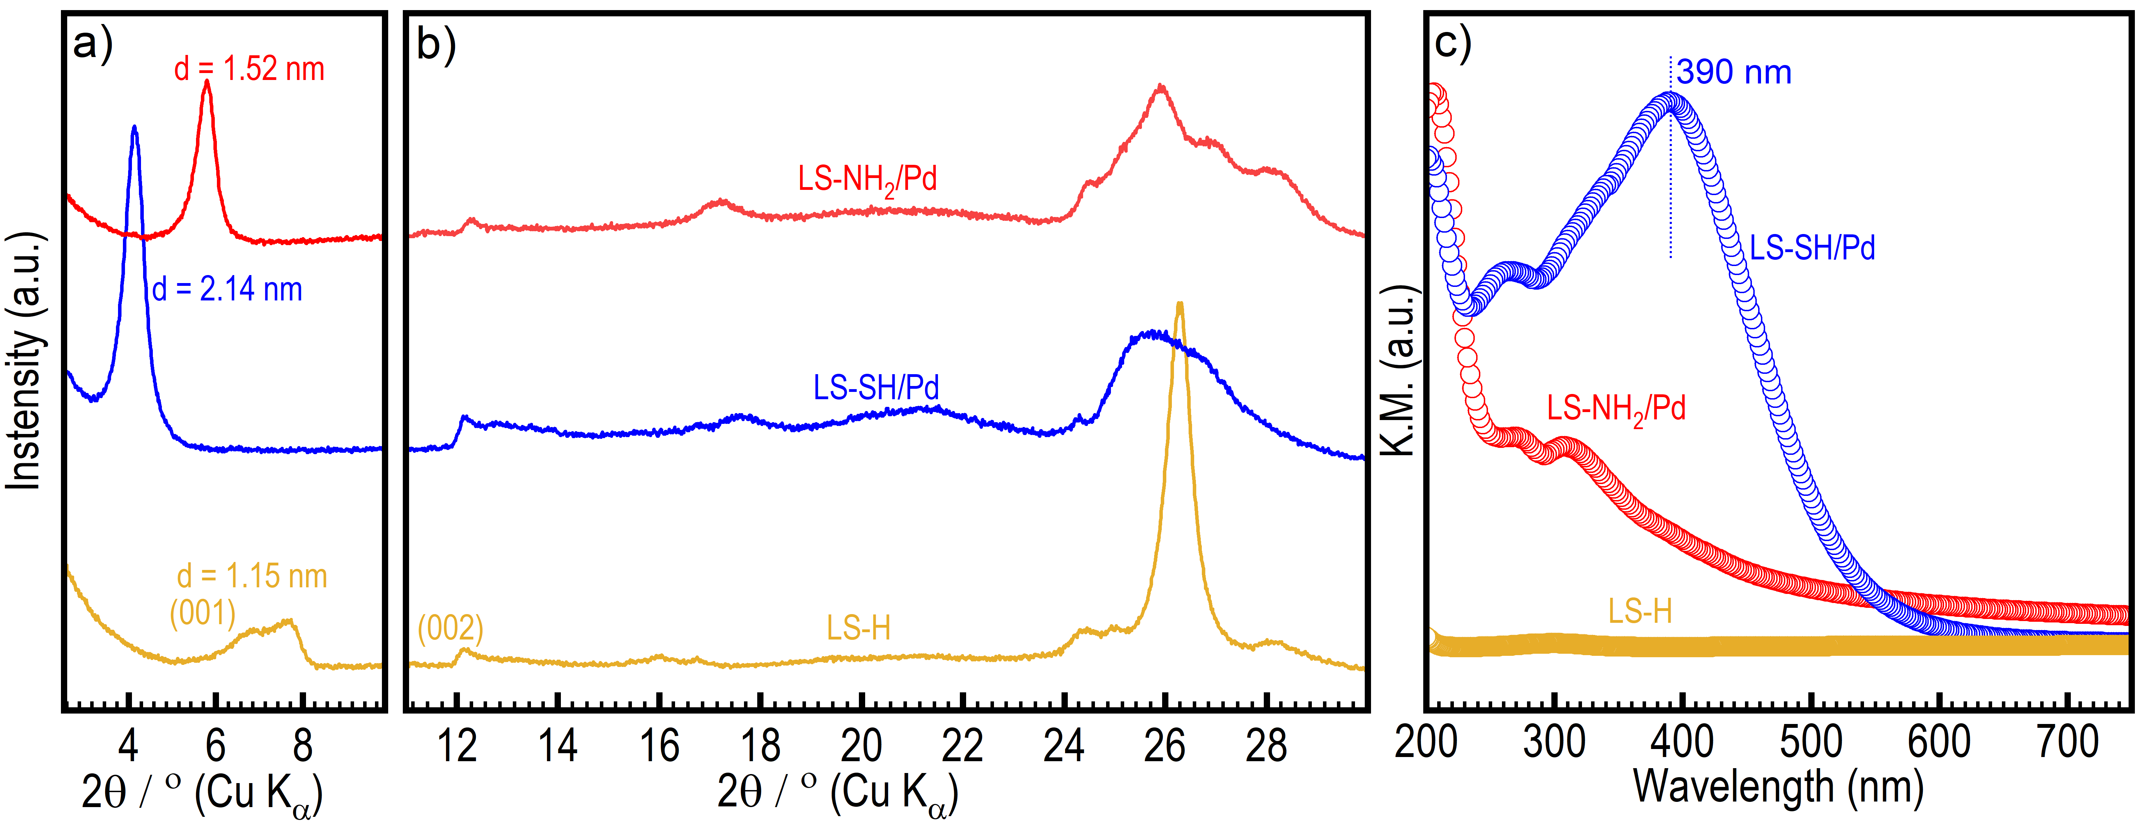
Figure 1. Low angle (a) and wide angle (b) XRD patterns and (c) UV-visible spectra of LS-H, LS-NH₂/Pd, and LS-SH/Pd versus Kubelka-Munk (KM) function.
The TG-DT analysis was performed to measure the ratio of organic to inorganic matter (Figure S2). The weight loss in TGA up to 250 °C can be assigned to the trapped solvents and lattice water molecules. The significant weight loss in the TG profile starting from 250-450 °C in both LS-SH and LS-NH₂ can be attributed to organic motifs’ decomposition. The appearance of two sharp peaks in DTA at 286 °C and 429 °C related to the LS-NH₂ and LS-SH, respectively, can further ascertain the presence of organic molecules. According to the TGA, the ratios of organic molecules to inorganic molecules in LS-NH₂ and LS-SH are 1:10 and 1:7, respectively.
The captured SEM images of the LS-SH/Pd and LS-NH₂/Pd (Figures 2a,d) compared to the C₁₆TMA⁺-intercalated LS (C₁₆TMA-LS), the parent sodium-type LS (LS-Na), and the protonated form (LS-H) (Figure S3) indicate that all the C₁₆TMA⁺ pre-intercalation, functionalization, and Pd NC growth have not significantly altered the plate-like morphology of each LS particle but has significantly caused disaggregation and significant exfoliation of the stacked nanosheets which is expectable.^{4,22} The high-resolution transmission electron microscopy (HRTEM) and scanning transmission electron microscopy (STEM) images of LS-NH₂/Pd (Figures 2b,c) and LS-SH/Pd (Figures 2e,f) both show the lateral sizes of Pd NCs in narrow distribution (Figure 2c, inset), where the average distribution sizes according to the STEM and HRTEM images were found to be 1.3 nm and 1.1 nm, respectively, which corresponds to the width of ~ 9 ‒ 10 atoms of Pd along the basal directions, respectively. Since the Pd particles are laterally larger than their thickness, the STEM imaging captures the Pd NC more clearly than the HRTEM. Judging from the basal spacing d values of LS-NH₂/Pd (1.52 nm) and LS-SH/Pd (2.14 nm), considering the single layer thickness of the layered silicate used (~1 nm), the thickness of Pd NC formed in the interlayer space are less than 0.5 nm and 1.1 nm, respectively.
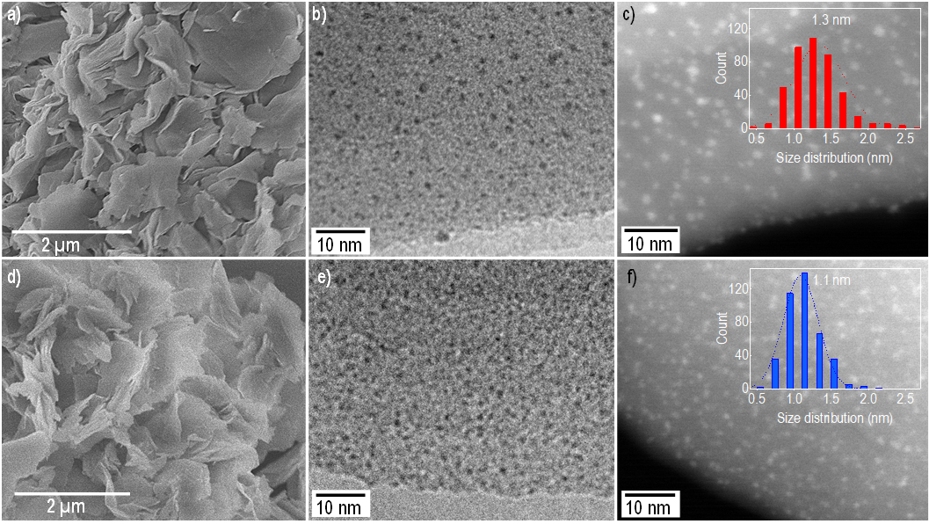
Figure 2. SEM images, high-resolution TEM images, and STEM images of a-c) LS-SH/Pd and d-f) LS-NH₂/Pd. The inset in c) shows the Pd NC distribution size in LS-NH₂/Pd. The inset in e) shows the corresponding LS-SH/Pd sample.
3.2. Catalytic activity
Previously, the Pd on amine functionality has been speculated to show higher catalytic activity due to its basicity and dissociating O-H bond in formic acid, resulting in more efficient dehydrogenation since the O-H bond dissociation is a critical step in the dehydrogenation step.³⁴⁻³⁷ However, additional factors also play a significant role in determining the overall catalytic performance. Here, we studied the dehydrogenation activity of LS-SH/Pd and LS-NH₂/Pd in formic acid in aqueous conditions to elucidate the effect of functional groups on the electronic structure of Pd NCs and their subsequent catalytic activity (Figure 3a, b). Therefore, we synthesized the Pd NCs on amino-functionalized and thio-functionalized LSs, keeping the Pd NC size and distribution on both samples similar. We found that the catalytic behavior of Pd NCs drastically varied by changing the functional group from amine to thiol, where the catalytic activity of LS-NH₂/Pd (TOF = 246 h⁻¹ at 70 °C) is significantly higher than that of LS-SH/Pd (TOF = 9 h⁻¹ at 70 °C). Examining the catalytic activities at three different temperatures (22, 45, and 70 °C) indicates that the TOF (h⁻¹) values and yields rise by raising the reaction temperatures. For instance, elevating the temperature from 22 °C to 45 °C caused a ~2.9-fold increase, and a further elevation from 45 °C to 70 °C led to 2.6 times improvement in the TOF values of LS-NH₂/Pd. Likewise, LS-SH/Pd, although its catalytic activity at room temperature (22 °C) was trivial, had a rise in TOF value and the reaction yield when the temperature was elevated to 45 °C and subsequently to 70 °C, though still ~7-fold smaller than that of LS-NH₂/Pd. Obtaining the activation energy (E_{a}), using the Arrhenius equation, for both catalysts indicates that LS-NH₂/Pd requires less activation energy, E_{a} = 56.1 kJ/mol, than LS-SH/Pd, 79.9 kJ/mol, for the H₂ generation from formic acid. The smaller E_{a} of LS-NH₂/Pd than LS-SH/Pd indicates that the amine functional group also kinetically favors the dehydrogenation reaction more than the thiol functional group.
Next, we compared the catalytic activities of LS-NH₂/Pd and LS-SH/Pd with other Pd species loaded on different supports (Figure 3c), synthesized to provide comparisons. In this case, the catalytic activity for the Pd NC on the amino-functionalized surface was higher than the SA, NPs, and nanoplate morphologies of Pd loaded on similar or different substrates. Compared to Pd-nanoplates, which sit directly on the layered silicate surface, the catalytic performance may be impacted by the interface of the Pd with the silicate surface, while Pd NC on amino-functionalized LS mainly sits on propylamine groups, so that the ligands also act as spacer for the LS and the Pd NCs. Although SA Pd (NHC-Pd)⁴ has the highest ratio of active catalytic sites to the actual loaded amount, its catalytic activity was found to be lower than the LS-NH₂/Pd. This phenomenon, as we discussed before, can be due to the negative impact of the metal-support interaction,^{4,6} where the strong interaction with the support’s anion causes catalytically labile Pd 4d electrons to shift lower into the valence band, leading to a fall in the catalytic activity of Pd NC.
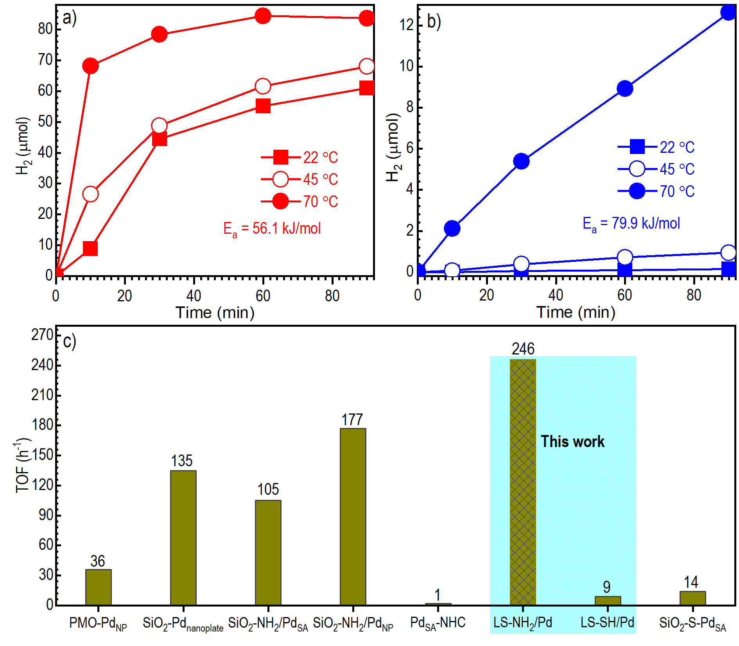
Figure 3. The catalytic activity of (a) LS-NH₂/Pd and (b) LS-SH/Pd at different temperatures in formic acid (5 V/V%) dehydrogenation. (c) The catalytic comparison of the various Pd species on different supports in terms of TOF in formic acid dehydrogenation under identical reaction conditions.
3.3. Density functional calculations
Here, we use density functional calculations to investigate the stability of electronic structures of single Pd atoms and Pd nanoclusters when loaded on functionalized hydrogen silicate. First, a suitable layered hydrogen silicate structure was obtained from the Materials Project database (mp-626083)³⁸. This structure has a square cross-section with a lateral lattice parameter of a = b = 5.222 Å (DFT optimized), comfortably accommodating a function group within its surface. This structure was cleaved along the long axis, resulting in two Si₂H₂O₅ sheets, each terminated by OH groups. One OH from one of the facets was removed to expose a Si atom to which a propyl group was attached. A hydrogen atom was swapped from the outermost C atom with either an amine or a thiol group. The resulting structures, shown in Figure S4, were the building blocks for investigating Pd’s behavior.
Figures 4a and b show the optimized structures of a single Pd atom loaded on an amine and a thiol-terminated functional group attached to the layered silicate surface. In the case of the amine functional group, the Pd‒N bond length was calculated to be 2.11 Å. The relative electronic charge density (ρ/ρ_{Max}) and the electronic localization function (η) along this bond can elucidate the bonding nature between Pd and N. As blue arrows in Figures 4c,d indicate, both ρ/ρ_{Max} and η diminish in the middle of the Pd-N bonds, indicating a lack of covalency and, consequently, a weaker bond in the catalysis medium. This notion is further reinforced by the PDOS in Figure 4e, where there is little hybridization between the Pd 4d and N 2p states. For the thiol functional group, the Pd‒S bond was calculated to be 2.27 Å long. However, despite the larger bond length, as shown in Figures 4f,g, ρ/ρ_{Max} and η have considerable values in the middle of the Pd‒S bonds, indicating a relative degree of covalency, which may aid in the stability in the catalysis medium. The PDOS in Figure 4h, which shows the significant overlap between the S 3p most prominent peak and the Pd 4d states near the Fermi level, further supports the likelihood of 4d–3p hybridization and strong Pd‒S bonds.
Figure 4. The optimized structure of a single Pd atom adsorbed on an amine group (a) and a thiol group (b). The (c) and (d) panels show the relative charge density and the electronic localization function (η) along the Pd‒N bond, while (e) shows the N and Pd partial electronic density of states. The mirror panels (f), (g), and (h) show the same quantities for Pd and S.
Identifying the most favorable adsorption sites for Pd in nanocluster form is also critical to understanding experimental observations. Here, a Pd₁₃ nanocluster’s deposition on a 2 × 2 supercell constructed from the structures shown in Figure S4 was simulated. The Pd₁₃ cluster forms a stable icosahedral structure, a common geometry in metallic systems. This structure is large enough to capture interfacial properties while maintaining a reasonable computational cost for accurate DFT calculations. The supercell contained four functional groups at its top interacting facet. For the Pd₁₃ nanocluster adsorption, we explored three different and non-equivalent configurations, from which the system’s energies and forces were minimized following a conjugate gradient algorithm. These configurations correspond to the cluster adsorbed: (1) atop, directly above one of the functional groups; (2) bridging, between two functional groups, with Pd₁₃ binding with both functional groups; and (3) center, in the middle of the four terminations with all four functional groups biding to the Pd₁₃ cluster. In these adsorption models, one H atom from the binding functional group was removed to promote bond formation between the surface and the metallic cluster, leaving a NH- or S-terminated functional group bonding to a Pd atom in the cluster. Figure 5 shows the optimized structures of Pd₁₃ adsorbed on the amine-terminated surfaces, while Figure 6 shows the adsorption on thiol terminations.
The structures of the Pd₁₃ cluster were initially generated with icosahedral structure and relaxed with DFT within a large box (>38 Å side) to avoid self-interaction through the periodic boundary conditions (shown in Figure S5). Pd₁₃ geometry optimization was performed using the same computational settings as other calculations but on a single Γ-point k-point. The adsorption energies (E^{ads}) were estimated using the following expression:
$E^{ads} =E_{DFT}^{total} -E_{DFT}^{surface} - E_{DFT}\left({Pd}_{13} \right)+ n·\frac{E_{DFT}\left(H_{2}\right)}{2}$ (1)
This equation compares the energy of the final Pd-modified structure ($E_{DFT}^{total}$) with the sum of the contributions of the surface model before depositing the cluster ($E_{DFT}^{surface}$), the free-standing Pd₁₃ cluster [E_{DFT}(Pd₁₃)], and the corresponding removed hydrogens (n) taking as reference a free-standing H₂ molecule [E_{DFT}(H₂)].
Figure 5. The top and side views of the atop (a), bridge (b), and center (c) configurations of Pd₁₃ nanoparticle adsorbed on amino-functionalized layered hydrogen silicate. The circles mark the adsorption sites. The adsorption energy values are indicated on the bottom.
Figure 6. The top and side views of the atop (a), bridge (b), and center (c) configurations of Pd₁₃ nanoparticle adsorbed on thiol-functionalized layered hydrogen silicate. The circles mark the adsorption sites.
We found that the adsorption of Pd₁₃ is stronger at the thiol-modified surfaces than at amine in all the cases understudy. This adsorption energy becomes stronger as interacting functional groups increase. The Pd₁₃/thiol adsorption energy is robust, ranging between −3.909 eV for the atop configuration and −6.849 eV for the center adsorption configuration. On the other hand, the adsorption at the amine-terminated surface is also still exothermic but much weaker than at thiol, with values around −1.8 eV for the atop (which is the most stable) and center adsorption configurations and almost zero for the bridge configuration. Next, we focus on the most stable configuration of each system (atop for amine and center for thiol) to investigate how the choice of the functional group affects catalytic performance.
From a morphological viewpoint, as shown in Figure 5a, on the amino-functionalized surface, the Pd₁₃ nanoparticle largely retained its structural integrity and did not merge with neighboring Pd nanoclusters, maintaining a sub-nanometer dimensional character. However, on the thiol-functionalized surface (Figure 6c), Pd₁₃ was significantly distorted from its initial nearly icosahedral shape before the adsorption (Figure S5). Here, the optimized centered structure was reshaped into a flatter, two-atomic-layer-thick structure. The Pd atoms in the optimized structure maximize the metal-covered surface area and the number of Pd‒S bonds formed at the interface. The flattening of Pd nanoclusters appears to form a quasi-two-dimensional structure on the thiol-functionalized surface, leading to a reduced overall Pd surface area compared to the amino-functionalized surface. It is essential to remember that these are downhill relaxations from our initial model, which are exclusively driven by the optimization algorithm in the absence of temperature (0 K). However, we expect systems with slight energy differences to coexist at the surface in room conditions since small barriers could be overcome.
Electronically, we compared the PDOS of the Pd₁₃ in the atop configuration on the amino-functionalized surface (Figure 7a) to that of the center configuration on the thiol-functionalized surface (Figure 7b). Figure 7a shows that for the atop adsorption configuration on amine groups, the main contributions around the Fermi level (E_{Fermi}) are due to Pd 4d states, which form a broad and relatively flat band extending from E_{Fermi} to ~ 6 eV below, with no prominent peaks. Furthermore, the N (nearest anion to Pd) 2p states do not hybridize significantly with the 4d states as they are confined to two sharp peaks at ~ −2.2 and ~ −4 eV (marked with black arrows). The contribution of O 2p states is also insignificant to those near the Fermi level, as they gravitate to the bottom of the valence band (E < −4 eV). In contrast, Figure 7b shows that for the centered adsorption configuration on thiol functional groups, the Pd 4d states exhibit a distinct feature of having a prominent peak localized around −1 eV, a characteristic absent in the previous system. Additionally, the S 3p states significantly hybridize with Pd 4d states (marked with a brown arrow). Similarly, the contribution of O 2p states is also significant, with a major band starting at ~ −2 eV (marked with a yellow arrow). As a result, the stronger hybridization with the closest anion in the functional group and O 2p states’ shift toward the Fermi energy indicates greater structural stabilization.
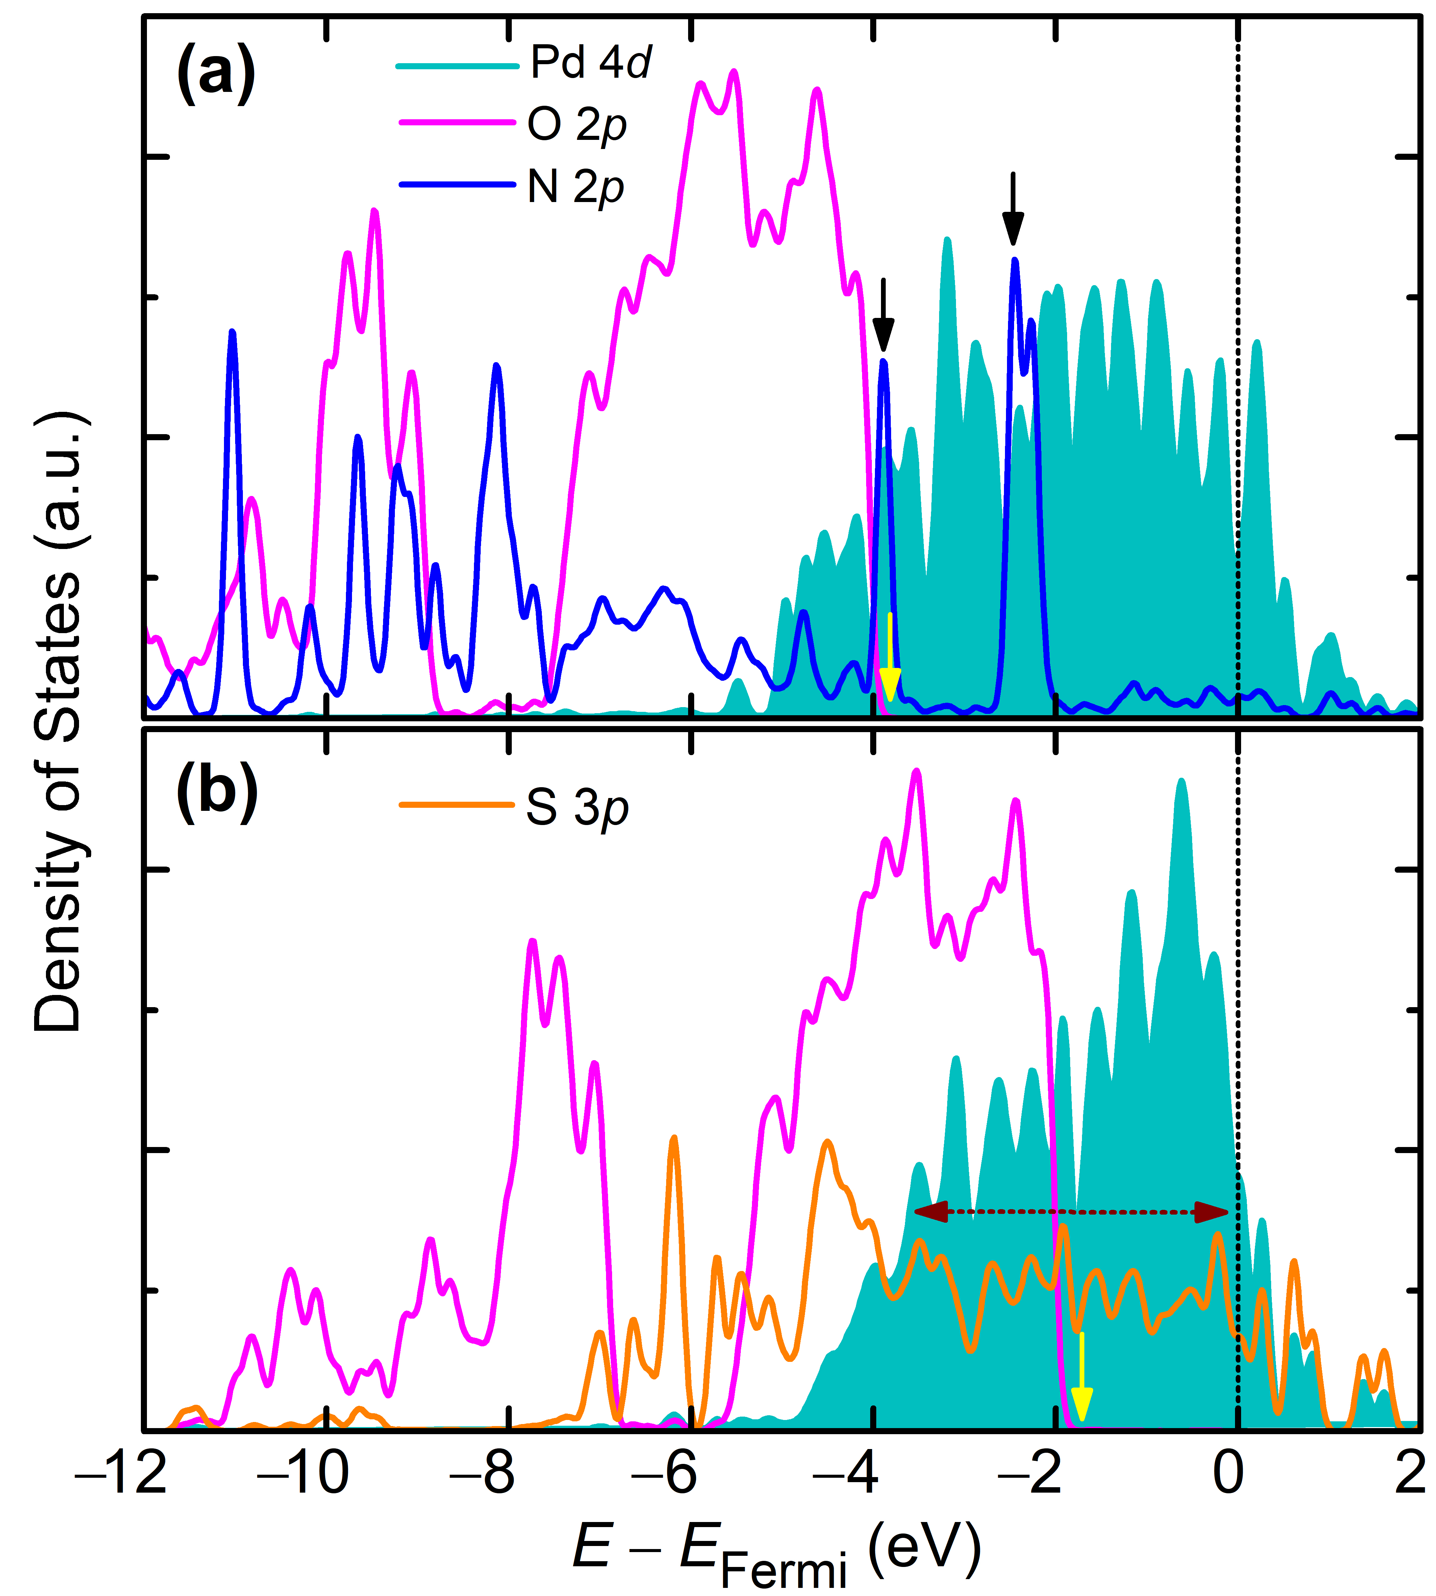
Figure 7. The partial density of states for (a) Pd₁₃ on the amino-functionalized surface in the atop configuration and (b) Pd₁₃ on the thiol-functionalized surface in the center configuration. Pd, N, and S PDOS were magnified to aid visualization. More detailed PDOS graphs are provided in Figure S6 and Figure S7 of the supporting information.
3.4. XPS investigations
The XPS measurements in Figure 8 provide a comparative analysis between Pd nanoclusters loaded on layered silicates functionalized with propylamine (LS-NH₂/Pd) and propylthiol (LS-SH/Pd). The binding energy (BE) of Pd 3d_{5/2} in LS-NH₂/Pd exhibits a main peak at 336.0 eV and a shoulder at 338.2 eV, while in the case of LS-SH/Pd, only one distinct peak is observable at 337.3 eV. Relative to the main peak of the LS-NH₂/Pd, the LS-SH/Pd peaks appeared in higher BE. The lower BEs of Pd in LS-NH₂/Pd imply that the loaded nanoclusters have a weaker binding with the amine-functionalized surface, perhaps because of fewer Pd-N bonds at the metal support interface. Accordingly, Pd NCs on amine functionality retain more metallic characteristics. In contrast, by exhibiting higher BE, Pd NCs in LS-SH/Pd undergo a stronger binding with enhanced hybridization with the thiol ligand. Compared to Pd NCs binding to amine groups, this hybridization reduces metallic character by transferring charge from Pd to S through a more numerous Pd-S bond network at MSI.
Assuming that the binding energy also correlates with the strength of Pd NC interactions with the functionalized surface, the XPS results fully corroborate the calculated Pd-ligand hybridization. As shown in Figure 7, the d–p hybridization in LS-SH/Pd is stronger (marked with a brown arrow), indicating charge transfer from Pd. This results in fewer available 4d electrons for catalysis, reducing the potency of the catalytic active sites. Associated with this charge transfer, the deformed, flatter geometry and the linking of Pd NCs, as shown in Figure 6c, further reduces the total Pd surface area and the number of active sites. Consequently, this morphological change and the more substantial charge transfer from Pd to S work hand in hand to diminish the catalytic activity of Pd NCs loaded on the thiol-functionalized surface. In the XPS spectra of the recovered samples after the formic acid dehydrogenation (Figure S8), the Pd peaks of LS-SH/Pd and LS-NH₂/Pd adapt a relative position similar to the pristine, unused samples. In other words, Pd species on amine functionality appear in lower BE than the Pd NCs that are loaded on -SH groups.
Furthermore, the recovered LS-SH/Pd shows a major peak for Pd at 337.3 eV, which is identical to that of the pristine one (337.3 eV), indicating that Pd NCs are robustly anchored to the thiol groups and do not undergo any change during the reaction. However, the recovered Pd on amine functionality has a slight shift into lower BE (335.3 eV) with respect to that of the pristine sample (336.0 eV), again confirming that Pd NCs with -NH₂ are not as firmly anchored to the surface. Consequently, Pd NCs on the amine functional groups tend to agglomerate and grow in size during the catalytic activity, as demonstrated by the BE shift.
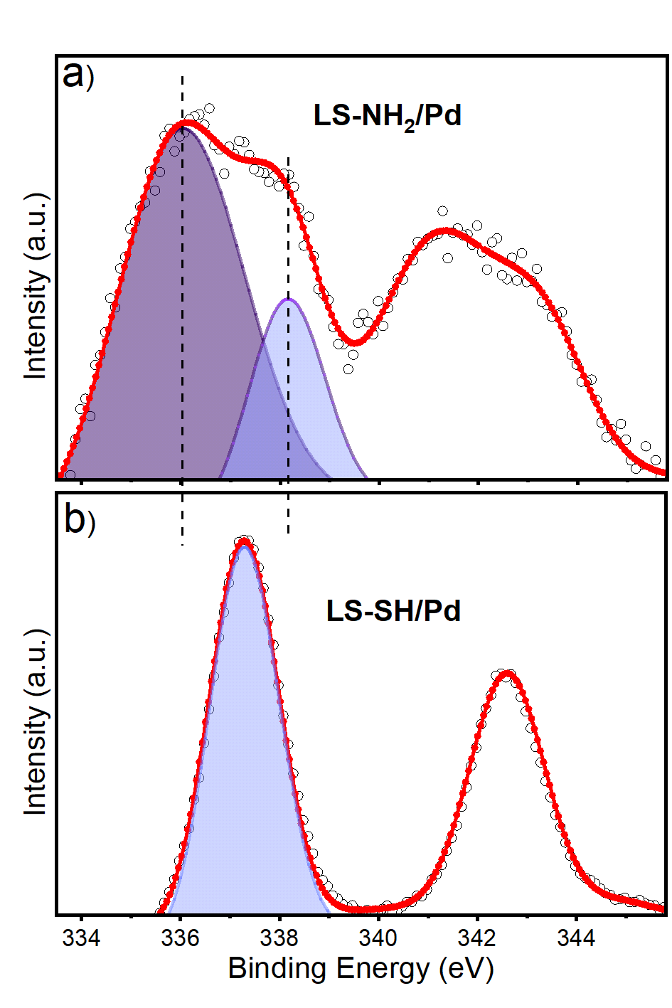
Figure 8. Pd 3d XPS spectra of (a) LS-NH₂/Pd and (b) LS-SH/Pd. Pd species with high binding energy are given in dark purple, and those with less binding energy are shaded in light purple.
Conclusion
In conclusion, we demonstrated how significantly the support’s surface ligand influenced the electronic structure of the loaded Pd NCs and determined the catalytic performance of Pd NCs. The superior catalytic activity of LS-NH₂/Pd was ascribed to the weaker hybridization between the 4d Pd electrons with 2p N orbitals, resulting in weaker covalency. Moreover, the trivial activity of LS-SH/Pd was attributed to the stronger hybridization between 4d electrons from Pd NC with 3p orbitals from S in thiol groups, causing greater covalency in Pd–S bonds. This theoretical description was corroborated by the UV-visible spectra and XPS measurements. Simulating the Pd₁₃ NC shows stronger adsorption on thiol-functionalized surfaces (E^{ads} = −3.909 eV to −6.849 eV) compared to amino-functionalized surfaces (E^{ads} = 0.025 eV to −1.8 eV). Our simulations showed that Pd₁₃ NC retains its structure on the amino-functionalized surface. In contrast, the thiol-functionalized surface flattens the Pd NC into a two-dimensional-like structure due to the stronger affinity between P and S. Our results show the trade-off between structural stability obtained by thiol functionalization and catalytically favorable morphology obtained by amine functionalization. In conclusion, the catalytic activity of the Pd NCs loaded on a proper functional group may preserve the catalytic activity of the Pd from unfavorable effects of MSI. Further research on other types of functional groups, such as phosphines, heterocyclic amines, and sulfites, would be worth exploring to see how the metal NC stability versus catalytic activity can be regulated.
Supporting Information
The schematics of the standalone icosahedral Pd₁₃ nanoparticle, the DFT optimized structures of functionalized hydrogen silicate surfaces without Pd, the partial density of states of the most stable configurations in Figure 5 and Figure 6
Acknowledgments
This research was supported by funding from the Japan Science and Technology Agency (JST) and TÜBİTAK (Project No. 123N224) as the EIG CONCERT-JAPAN program under the project entitled 2023-MLALH with reference PCI2023-143426 funded by MCIN/AEI/10.13039/501100011033 and the European Union. The support provided by the Spanish State Research Agency to the MaX Center of Excellence, under grant reference PCI2022-135083-2, is also acknowledged. The HOKUSAI system at RIKEN, JAPAN, provided computational resources.
Reference
(1) Zhu, C.; Du, D.; Eychmüller, A.; Lin, Y. Engineering Ordered and Nonordered Porous Noble Metal Nanostructures: Synthesis, Assembly, and Their Applications in Electrochemistry. Chem. Rev. 2015, 115 (16), 8896–8943.
(2) Guselnikova, O.; Lim, H.; Kim, H.-J.; Kim, S. H.; Gorbunova, A.; Eguchi, M.; Postnikov, P.; Nakanishi, T.; Asahi, T.; Na, J. New Trends in Nanoarchitectured SERS Substrates: Nanospaces, 2D Materials, and Organic Heterostructures. Small 2022, 18 (25), 2107182.
(3) Eswaramoorthy, S. K.; Dass, A. Atomically Precise Palladium Nanoclusters with 21 and 38 Pd Atoms Protected by Phenylethanethiol. J. Phys. Chem. C 2022, 126 (1), 444–450. https://doi.org/10.1021/acs.jpcc.1c09453.
(4) Doustkhah, E.; Tsunoji, N.; Assadi, M. H. N.; Ide, Y. Pd Thickness Optimization on Silicate Sheets for Improving Catalytic Activity. Adv. Mater. Interfaces 2023, 10 (4), 2202368. https://doi.org/10.1002/admi.202202368.
(5) Ament, K.; Köwitsch, N.; Hou, D.; Götsch, T.; Kröhnert, J.; Heard, C. J.; Trunschke, A.; Lunkenbein, T.; Armbrüster, M.; Breu, J. Nanoparticles Supported on Sub-Nanometer Oxide Films: Scaling Model Systems to Bulk Materials. Angew. Chem., Int. Ed. 2021, 60 (11), 5890–5897. https://doi.org/10.1002/anie.202015138.
(6) Zhao, J.; Fu, J.; Wang, J.; Tang, K.; Liu, Q.; Huang, J. Particle-Size-Dependent Electronic Metal–Support Interaction in Pd/TiO₂ Catalysts for Selective Hydrogenation of 3-Nitrostyrene. J. Phys. Chem. C 2022, 126 (36), 15167–15174. https://doi.org/10.1021/acs.jpcc.2c03945.
(7) Murata, K.; Kosuge, D.; Ohyama, J.; Mahara, Y.; Yamamoto, Y.; Arai, S.; Satsuma, A. Exploiting Metal–Support Interactions to Tune the Redox Properties of Supported Pd Catalysts for Methane Combustion. ACS Catal. 2020, 10 (2), 1381–1387. https://doi.org/10.1021/acscatal.9b04524.
(8) van Deelen, T. W.; Hernández Mejía, C.; de Jong, K. P. Control of Metal-Support Interactions in Heterogeneous Catalysts to Enhance Activity and Selectivity. Nat. Catal. 2019, 2 (11), 955–970. https://doi.org/10.1038/s41929-019-0364-x.
(9) Wu, P.; Tan, S.; Moon, J.; Yan, Z.; Fung, V.; Li, N.; Yang, S.-Z.; Cheng, Y.; Abney, C. W.; Wu, Z.; Savara, A.; Momen, A. M.; Jiang, D.; Su, D.; Li, H.; Zhu, W.; Dai, S.; Zhu, H. Harnessing Strong Metal–Support Interactions via a Reverse Route. Nat. Commun. 2020, 11 (1), 3042. https://doi.org/10.1038/s41467-020-16674-y.
(10) Miró, P.; Audiffred, M.; Heine, T. An Atlas of Two-Dimensional Materials. Chem. Soc. Rev. 2014, 43 (18), 6537–6554. https://doi.org/10.1039/C4CS00102H.
(11) Ide, Y.; Tominaka, S.; Kono, H.; Ram, R.; Machida, A.; Tsunoji, N. Zeolitic Intralayer Microchannels of Magadiite, a Natural Layered Silicate, to Boost Green Organic Synthesis. Chem. Sci. 2018, 9 (46), 8637–8643. https://doi.org/10.1039/C8SC03712D.
(12) Gao, G.; Jiao, Y.; Waclawik, E. R.; Du, A. Single Atom (Pd/Pt) Supported on Graphitic Carbon Nitride as an Efficient Photocatalyst for Visible-Light Reduction of Carbon Dioxide. J. Am. Chem. Soc. 2016, 138 (19), 6292–6297. https://doi.org/10.1021/jacs.6b02692.
(13) Doustkhah, E.; Kotb, A.; Tafazoli, S.; Balkan, T.; Kaya, S.; Hanaor, D. A. H.; Assadi, M. H. N. Templated Synthesis of Exfoliated Porous Carbon with Dominant Graphitic Nitrogen. ACS Mater. Au 2023, 3 (3), 231–241. https://doi.org/10.1021/acsmaterialsau.2c00074.
(14) Üstünel, T.; Ide, Y.; Kaya, S.; Doustkhah, E. Single-Atom Sn-Loaded Exfoliated Layered Titanate Revealing Enhanced Photocatalytic Activity in Hydrogen Generation. ACS Sustainable Chem. Eng. 2023, 11 (8), 3306–3315. https://doi.org/10.1021/acssuschemeng.2c06181.
(15) Walton, A. S.; Fester, J.; Bajdich, M.; Arman, M. A.; Osiecki, J.; Knudsen, J.; Vojvodic, A.; Lauritsen, J. V. Interface Controlled Oxidation States in Layered Cobalt Oxide Nanoislands on Gold. ACS Nano 2015, 9 (3), 2445–2453. https://doi.org/10.1021/acsnano.5b00158.
(16) Liu, J.; Zou, Y.; Cruz, D.; Savateev, A.; Antonietti, M.; Vilé, G. Ligand–Metal Charge Transfer Induced via Adjustment of Textural Properties Controls the Performance of Single-Atom Catalysts during Photocatalytic Degradation. ACS Appl. Mater. Interfaces 2021, 13 (22), 25858–25867. https://doi.org/10.1021/acsami.1c02243.
(17) Zhu, X.; Guo, Q.; Sun, Y.; Chen, S.; Wang, J.-Q.; Wu, M.; Fu, W.; Tang, Y.; Duan, X.; Chen, D.; Wan, Y. Optimising Surface d Charge of AuPd Nanoalloy Catalysts for Enhanced Catalytic Activity. Nat. Commun. 2019, 10 (1), 1428. https://doi.org/10.1038/s41467-019-09421-5.
(18) Sahoo, M.; Parida, K. M. Pd(II) Loaded on Diamine Functionalized LDH for Oxidation of Primary Alcohol Using Water as Solvent. Appl. Catal. A: Gen. 2013, 460–461, 36–45. https://doi.org/10.1016/j.apcata.2013.04.003.
(19) Hu, P.; Chen, L.; Kang, X.; Chen, S. Surface Functionalization of Metal Nanoparticles by Conjugated Metal–Ligand Interfacial Bonds: Impacts on Intraparticle Charge Transfer. Acc. Chem. Res. 2016, 49 (10), 2251–2260. https://doi.org/10.1021/acs.accounts.6b00377.
(20) Doustkhah, E.; Tsunoji, N.; Mine, S.; Toyao, T.; Shimizu, K.; Morooka, T.; Masuda, T.; Assadi, M. H. N.; Ide, Y. Feeble Single-Atom Pd Catalysts for H2 Production from Formic Acid. ACS Appl. Mater. Interfaces 2024. https://doi.org/10.1021/acsami.3c18709.
(21) Yanagisawa, T.; Kuroda, K.; Kato, C. Organic Derivatives of Layered Polysilicates: I. Trimethylsilylation of Magadiite and Kenyaite. React. Solids 1988, 5 (2), 167–175. https://doi.org/10.1016/0168-7336(88)80085-8.
(22) Doustkhah, E.; Ide, Y. Bursting Exfoliation of a Microporous Layered Silicate to Three-Dimensionally Meso–Microporous Nanosheets for Improved Molecular Recognition. ACS Appl. Nano Mater. 2019, 2 (12), 7513–7520. https://doi.org/10.1021/acsanm.9b01508.
(23) Kresse, G.; Furthmüller, J. Efficiency of Ab-Initio Total Energy Calculations for Metals and Semiconductors Using a Plane-Wave Basis Set. Comput. Mater. Sci. 1996, 6 (1), 15–50. https://doi.org/10.1016/0927-0256(96)00008-0.
(24) Kresse, G.; Joubert, D. From Ultrasoft Pseudopotentials to the Projector Augmented-Wave Method. Phys. Rev. B 1999, 59 (3), 1758–1775. https://doi.org/10.1103/PhysRevB.59.1758.
(25) Perdew, J. P.; Burke, K.; Ernzerhof, M. Generalized Gradient Approximation Made Simple. Phys. Rev. Lett. 1996, 77 (18), 3865–3868. https://doi.org/10.1103/PhysRevLett.77.3865.
(26) Perdew, J. P.; Burke, K.; Ernzerhof, M. Generalized Gradient Approximation Made Simple [Phys. Rev. Lett. 77, 3865 (1996)]. Phys. Rev. Lett. 1997, 78 (7), 1396–1396. https://doi.org/10.1103/PhysRevLett.78.1396.
(27) Grimme, S.; Antony, J.; Ehrlich, S.; Krieg, H. A Consistent and Accurate Ab Initio Parametrization of Density Functional Dispersion Correction (DFT-D) for the 94 Elements H-Pu. J. Chem. Phys. 2010, 132 (15), 154104. https://doi.org/10.1063/1.3382344.
(28) Ide, Y.; Ogawa, M. Efficient Way to Attach Organosilyl Groups in the Interlayer Space of Layered Solids. Bulletin of the Chemical Society of Japan 2007, 80 (8), 1624–1629. https://doi.org/10.1246/bcsj.80.1624.
(29) Potter, M. E.; Le Brocq, J. J. M.; Oakley, A. E.; McShane, E. B.; Mhembere, P. M.; Carravetta, M.; Vandegehuchte, B. D.; Raja, R. Thiol Functionalised Supports for Controlled Metal Nanoparticle Formation for Improved C–C Coupling. Chem. Asian J. 2021, 16 (22), 3610–3614. https://doi.org/10.1002/asia.202100732.
(30) Yang, Z.; Smetana, A. B.; Sorensen, C. M.; Klabunde, K. J. Synthesis and Characterization of a New Tiara Pd(II) Thiolate Complex, [Pd(SC12H25)2]6, and Its Solution-Phase Thermolysis to Prepare Nearly Monodisperse Palladium Sulfide Nanoparticles. Inorg. Chem. 2007, 46 (7), 2427–2431. https://doi.org/10.1021/ic061242o.
(31) Yoshii, T.; Umemoto, D.; Kuwahara, Y.; Mori, K.; Yamashita, H. Engineering of Surface Environment of Pd Nanoparticle Catalysts on Carbon Support with Pyrene–Thiol Ligands for Semihydrogenation of Alkynes. ACS Appl. Mater. Interfaces 2019, 11 (41), 37708–37719. https://doi.org/10.1021/acsami.9b12470.
(32) Sun, T.; Huang, F.; Liu, J.; Yu, H.; Feng, X.; Feng, X.; Yang, Y.; Shu, H.; Zhang, F. Strengthened d-p Orbital-Hybridization of Single Atoms with Sulfur Species Induced Bidirectional Catalysis for Lithium–Sulfur Batteries. Adv. Funct. Mater. 2023, 33 (51), 2306049. https://doi.org/10.1002/adfm.202306049.
(33) Creighton, J. A.; Eadon, D. G. Ultraviolet–Visible Absorption Spectra of the Colloidal Metallic Elements. J. Chem. Soc., Faraday Trans. 1991, 87 (24), 3881–3891. https://doi.org/10.1039/FT9918703881.
(34) Martis, M.; Mori, K.; Fujiwara, K.; Ahn, W.-S.; Yamashita, H. Amine-Functionalized MIL-125 with Imbedded Palladium Nanoparticles as an Efficient Catalyst for Dehydrogenation of Formic Acid at Ambient Temperature. J. Phys. Chem. C 2013, 117 (44), 22805–22810. https://doi.org/10.1021/jp4069027.
(35) Mori, K.; Fujita, T.; Yamashita, H. Boosting the Activity of PdAg Alloy Nanoparticles during H₂ Production from Formic Acid Induced by CrO_{x} as an Inorganic Interface Modifier. EES. Catal. 2023, 1 (1), 84–93. https://doi.org/10.1039/D2EY00049K.
(36) Kim, Y.; Kim, S.; Ham, H. C.; Kim, D. H. Mechanistic Insights on Aqueous Formic Acid Dehydrogenation over Pd/C Catalyst for Efficient Hydrogen Production. Journal of Catalysis 2020, 389, 506–516. https://doi.org/10.1016/j.jcat.2020.06.033.
(37) Masuda, S.; Mori, K.; Futamura, Y.; Yamashita, H. PdAg Nanoparticles Supported on Functionalized Mesoporous Carbon: Promotional Effect of Surface Amine Groups in Reversible Hydrogen Delivery/Storage Mediated by Formic Acid/CO₂. ACS Catal. 2018, 8 (3), 2277–2285. https://doi.org/10.1021/acscatal.7b04099.
(38) Jain, A.; Ong, S. P.; Hautier, G.; Chen, W.; Richards, W. D.; Dacek, S.; Cholia, S.; Gunter, D.; Skinner, D.; Ceder, G.; Persson, K. A. Commentary: The Materials Project: A Materials Genome Approach to Accelerating Materials Innovation. APL Mater. 2013, 1 (1), 011002. https://doi.org/10.1063/1.4812323.

Graphical Abstract

