X-ray Diffraction Analysis of Natural Calcite Minerals found in General Santos City and Sarangani Province, Southern Philippines by Williamson−Hall Method

Abstract
This study employs the Williamson−Hall (W−H) models to examine the microstrains and crystallite sizes of CaCO₃ in the form of calcite in limestone samples found in General Santos City and Sarangani Province, Southern Philippines. The average sizes were computed to be nearly identical from using both Uniform Deformation Model (UDM) and Uniform Stress Deformation (USDM) models, implying minimal strain influence. The consistency of resulting measurements extends to the microstrain, revealing uniform results for all samples. Correlation between crystallite sizes and microstrains in the calcite crystals were observed, where high-purity calcites exhibit larger crystallite size and microstrain. The crystallite sizes decrease with microstrains for calcites with higher Mg concentration, which could be attributed to lattice distortion and formation of defects. The release of stress forms these defects; hence, leading to a reduction of microstrains. Moreover, the samples exhibited distinctly variable responses to strain, which could be influenced by either their anisotropic properties, or other additional components. In the W−H models, both the UDM and USDM consistently predict crystallite sizes, and thus offering insights into the uniform stress responses of calcites. However, the USDM proves especially relevant for anisotropic samples, as its display deviations of crystallite sizes, which are indicative of anisotropic nature of the natural calcites.

Keywords: calcite, x-ray diffraction, Williamson−Hall analysis, crystallite size, microstrain

Introduction
Limestones are sedimentary rocks made of calcium carbonates (CaCO₃) [1-2]. They exist as minerals in the form of calcites, aragonites, or valerite polymorphs phases [3-4]. These sedimentary rocks may contain a considerable amount of magnesium carbonate (MgCO₃), and calcium (Ca). One of these minerals is called dolomite, MgCa(CO₃)₂ [5]. Calcium carbonate is one of the most abundant minerals found on the Earth’s crust [6]. It is most prevalent in warm, tropical, and subtropical seas where organisms such as algae, corals, snails, clams, and other organic debris that produce carbonate sediments could thrive [6].
Limestones are used in many industrial and non-industrial applications [1, 5, 7], signifying their high economic value. Among their many applications, they are used for road/building constructions and they are the materials found in cement, aggregates, building stones, chalks, and crushed stones. Limestones are also fired in kilns to produce cement, serve as dimension stones, and act as roofing granules providing weather- and heat- resistant coatings for roofing materials. Limestones also functions as an agricultural lime (aglime) for the treatment of acidic soils by neutralizing the acidity. It is also the source of lime (CaO), and is used as a pH regulator for extracting mineral gold from quartz, reagents in laboratories for dehydration, precipitation reactions, cement, glass, and paper industries, and in iron and steel-making [8-13].
Recently, the researchers confirmed that the limestone found in General Santos City and in other areas in Sarangani Province are mainly composed of the mineral calcites, which can consist of a combination with an aragonite phase [14]. Using x-ray diffraction (XRD) analysis, the variations in the a and c lattice constants of the calcite phase of the samples were due to the incorporation of magnesium (Mg) in the CaCO₃ lattice; thus, changing their properties, among which are the microstrains and crystallite sizes. The substitution of Mg atoms into the lattice distorts a calcite crystal because of the smaller radius of Mg compared to Ca atoms. From having large (few micrometres) and ideally ordered crystalline array, the incorporation of Mg atoms may result into smaller crystallite sizes and microstrains. There are two types of lattice strain associated with nanocrystalline materials [15-16]. The first type extends over the entire lattice and is denoted by the shifts in the XRD peak positions. The second type extends only over a few lattice spacings and is often referred to as “microstrain” or “localized lattice strain” [17]. The microstrain is produced by residual stresses, vacancies, grain boundaries, faults, dislocations, and other defects that cause a non-uniform lattice distortion in the crystal. Hence, the microstrain is an indirect measure of the concentration of defects in the sample and can be a useful structural parameter for structure-property correlation [17].
The deviations from the perfect crystal lattice ordering extend in all directions, leading to the broadening of the diffraction peaks [18, 19]. The crystallite size and the microstrain are the two main properties that can be extracted from the peak width analysis of x-ray diffraction patterns. In the formation of polycrystalline aggregates, the crystallite size of the particle is not the same as the particle size, the crystallite size is considered as the smallest undistorted region in the crystal. The deviations due to the above contributions affect the Bragg peak by broadening (peak broadening) and correspondingly shifting its position.
In this paper, the XRD patterns of the natural calcite mineral found in some areas in Southern Philippines are analysed using the UDM and USDM models of the W−H method. In addition, the data gathered is used to look into the effect of the Mg incorporation on the quality of the calcite crystals obtained. The two analytical methods separate the crystallite size and microstrain contributions to the XRD line broadening. While the first method assumes a uniform deformation model (UDM) for elastically isotropic crystals, the other considers the anisotropic nature of the elastic constants of the crystal, using a uniform stress deformation model (USDM) [20-21]. The USDM model takes into account the anisotropic nature of the crystal and more often correctly predicts the system’s property than those that do not take anisotropy into account, such as the UDM [17, 22-24]. The difference in results from both models would verify and quantify the anisotropy of the samples.

Materials and Methods
The sedimentary limestone samples were collected either from the boulders that are accumulated by the hill road during or the cut slope after road widening operations from different and random locations in General Santos City and Sarangani Province, taking into consideration their distances and ease of collection [14]. The samples were pulverized by mortar and pestle and classified using the Tyler sieve analysis. The pulverized samples were passed through a 200-mesh sieve, corresponding to a particle size of ~75 𝜇m. To remove moisture, the samples were dried in an oven under an ambient atmosphere and at 105 °C for 12 hours. After cooling, the samples were stored either in a desiccator or in a sealed plastic bag to prevent moisture contamination.
The XRD analysis was carried out using the Rigaku MiniFlex 600 (Japan) to identify the type of minerals present in the samples and determine their crystallite sizes and microstrain. The x-ray radiation used was the Cu-K𝛼 with a wavelength of 1.5406 Å, operated under 40 kV acceleration voltage and 10 mA current. The samples were scanned over a range of 10° to 90° at a scan rate of 20°/min.

Results and Discussion
XRD Analysis
The powder XRD patterns of the four different samples are shown in Figure 1. The sharp and narrow Bragg peaks indicate a high quality, good crystallinity, and fine grain size nature of the samples. The analysis of the XRD peaks confirmed the existence of calcite (CaCO₃) for all the samples, because the calcite has a trigonal crystal structure belonging to the hexagonal crystal system (JCPDS 05-0586) [25]. An aragonite phase was also confirmed in Sample 2. From the powder XRD data, the lattice constants were calculated to be a = 4.9794 − 4.9867 Å, and c = 17.0160 − 17.0555 Å, where the variation can be attributed to the Mg at different concentrations in the samples [14, 26-28]. The detailed identification process and analysis of the samples will be presented elsewhere [14].

Figure 1.

Crystallite Size and Strain Analysis by Williamson–Hall Methods
Uniform Deformation Model (UDM)
Using the powdered XRD patterns, the crystallite size and microstrain were estimated from the broadening of the XRD linewidths. The linewidth broadening is mainly due to the instrumental effect, the crystallite size, and the lattice strain. The instrumental effect was eliminated using the following relation:
β_{hkl} = [(β_{hkl} _{measured})² - (β_{hkl Instrumental)}²]^{1/2}. (1)
The average crystallite size d was then calculated using the Debye–Scherrer formula [29-31]:
d = Kλ / β_{hkl} cos θ_{hkl}, (2)
where λ is the wavelength of the X-ray used (1.54056 Å), β_{hkl} the FWHM width of the diffraction peak, θ the diffraction angle, and K the Scherrer constant, commonly taken as 0.94.
Further, the strain ε induced in powders due to crystal imperfection and distortion was calculated using the formula:
ε = β_{hkl} / 4 tan θ_{hkl}. (3)
Assuming that particle size and strain contribution to line broadening are independent of each other, then the observed line breadth is the sum of the crystallite size and strain:
β_{hkl} = Kλ / d cos θ_{hkl} + 4ε tan θ_{hkl}. (4)
By rearranging the equation, the Williamson−Hall equation [18] is written below.
β_{hkl} cos θ_{hkl} = Kλ / d+ 4ε sin θ_{hkl}, (5)
Equation (5) represents the UDM, where the strain is assumed to be uniform in all crystallographic directions, giving the material properties independent of the direction along which they are measured.
Figure 2 plots the 4sinθ along the x-axis and β_{hkl} cosθ along the y-axis, where a linear fit is obtained. From the linear fit data, the slope can be interpreted as strain ε and crystallite size d as the intercept.
Figure 2.

Uniform Stress Deformation Model (USDM)
On the other hand, as crystals are generally anisotropic, the elastic constant is bound to be direction-dependent. Hence, the assumption in UDM that the strain has the same value in all crystallographic directions cannot be taken into an account in these samples. Therefore, the Williamson−Hall method is modified such that the anisotropic nature of the elastic constant is incorporated, hence now called USDM [20-21]. The deviations between the two models provide data that would quantify the anisotropic quality of the samples. In using USDM, within the elastic limit of the Hooke’s law, there exists a linear proportionality relation between the stress σ and strain ε, given by σ = εY_{hkl}, where Y_{hkl} is the Young’s modulus [32-33]. The W–H is thus modified accordingly by substituting the value of ε in Eq. (5):
β_{hkl} cos θ_{hkl} = Kλ / d+ 4σ sin θ /Y_{hkl}. (6)
The Y_{hkl} is the crystallographic direction dependent in the direction perpendicular to the set of (hkl) planes. For hexagonal crystal, the Young’s modulus equation and equations relating elastic compliances (S_{ij}) and stiffness constants (C_{ij}) are given by the following relation [31-36]:
$Y_{hkl}=\frac{{[h^{2}+\frac{{\left(h+2k\right)}^{2}}{3}+{(\frac{al}{c})}^{2}]}^{2}}{S_{11}({h^{2}+\frac{{\left(h+2k\right)}^{2}}{3}) }^{2}+S_{33}({\frac{al}{c})}^{4}+\left(2S_{13}+S_{44}\right)(h^{2}+\frac{{\left(h+2k\right)}^{2}}{3})({\frac{al}{c})}^{2}}$, (7)
where
S₁₁ = C₃₃/2c + 1 / 2(C₁₁−C₁₂),
S₁₃ = -C₁₃/c, S₃₃ = (C₁₁+C₁₂)/c,
S₄₄ = 1/C₄₄, c = (C₁₁+C₁₂)C₃₃−2C₁₃².
The values of the four independent S_{ij}’s (in TPa⁻¹) are calculated by substituting correspondingly the C_{ij} (in GPa) constants [37], and thus obtaining the following values:
S₁₁ = 10.35,
S₁₃ = -6.624,
S₃₃ = 21.61,
and S₄₄ = 28.57.
Young’s modulus calculated for all samples was ~100.5 GPa.
Figure 3 shows the plot of 4sinθ/Y_{hkl} along the x-axis vs β_{hkl} cosθ along the y-axis for all the samples using the USDM. A linear fit was also obtained to calculate the microstrains and particle sizes.

Figure 3.
Table 1 summarizes the crystallite sizes and microstrains for all samples. Comparing the two models, the computed average crystallite sizes for all samples are nearly identical, indicating that introducing a strain in the W–H method has a minimal impact on the crystallite size of CaCO₃ particles. This is also for microstrain using both models for all samples. Moreover, a correlation exists between crystallite size and microstrain in the calcite crystal as larger crystallite sizes correspond to higher internal stress, and vice versa. Sample 3 with the largest crystallite size indicates almost no Mg impurity in the CaCO₃ crystal. As Mg incorporation increases, the crystallite size decreases, denoting that substituting Ca with Mg could have reduced the crystallite size. This observation is evident in Sample 2, resulting in smaller crystallite size.

Table 1.

Figure 4 illustrates the relationship between the microstrains and the crystallite sizes of the samples. Sample 3 exhibits the highest strain and largest crystallite size demonstrating that reducing the crystallite size increases strain. This lattice relaxation could be attributed to Mg substitution, as also observed in Sample 4. However, Sample 1, despite having a lesser amount of Mg substitution, displays a lesser strain compared to Sample 4. This is possibly influenced by the defects and dislocations already within the sample. In the case of Sample 2, which contains aragonite phases, there is less strain. The presence of aragonite could have also contributed to lattice relaxation although more studies are needed to elucidate this observation. Hence, the variation of strain value could be directly influenced by the anisotropic nature and the presence of additional impurities within the samples.
Figure 4.

Figure 5 shows the relationship between microstrain (Fig. 5a) and crystallite size (Fig. 5b) with the CaCO₃ lattice constants as obtained from the samples. Also shown in the figures is the plot of Mg incorporation with a- and c-lattice constants obtained from the JCPDS standard patterns (Pure calcite: JCPDS 05-0586, Mg_{0.03}Ca_{0.9}7CO₃: JCPDS 97-008-6161, and Mg_{0.06}Ca_{0.94}CO₃: JCPDS 89-1305). As observed, the a- and c-lattice constants decrease with increasing Mg concentration as expected. Hence, the lattice constants calculated from the XRD patterns of the samples can be attributed to their different Mg concentrations. Moreover, it can be observed that both microstrain and crystallite size are largest for the (almost) pure calcite sample, and decrease with increasing Mg concentration. Although the decreasing trend may not correlate exactly with that of either the crystallite size or microstrain, one can deduce that both the crystallite size and the microstrain decrease with the incorporation of Mg in the calcites. Hence, the incorporation of Mg atoms could have distorted the calcite lattice, decreasing their crystallite size as lattice distortion creates defects (lattice relaxation) such as dislocations, vacancies, and faults, thereby releasing the stress or microstrain in the calcite [14, 19, 26-27]. TEM analysis of the samples could better measure the actual crystallite size as well as the directly observation of defects in the calcites. This will be a subject for further studies.

Figure 5.

Because the limestone samples used for this study were collected close to the marine environment (i.e., cut slopes and boulders by the hill roads along the Sarangani Bay), the calcite was formed in sedimentary environments via biological, chemical and physical processes in the past. Therefore, the limestone samples were most likely formed over time by the deposition and accumulation of dead calcareous material in the form of corals, shells and skeletons of sea animals at the bottom of the sea [38]. Microscopic marine organisms such as planktons and foraminifera extract dissolved calcium and carbonate ions from seawater to build these corals, shells and skeletons. Moreover, the low Mg concentrations in the samples as inferred from the data suggest that the marine environment in which the calcites were formed was during the geologic period when the Mg/Ca ratio in seawater was low [39-40]. Hence, the Mg incorporation into the calcite crystal could have distorted the calcite lattice, forming defects by the release of stress; therefore, reducing the microstrain. Although further studies are needed to validate these observations.

Conclusion
The powder XRD analysis reveals the crystalline characteristics of the natural calcites found from the different locations in Southern Philippines. The distinct Bragg peaks of the samples exhibit well-formed crystalline structures dominated by calcites, and some even featuring an aragonite phase. The calculated lattice constants denote different amounts of Mg incorporation within the calcites. The Williamson−Hall method is modified into the Unified Stress Distribution Method (USDM), to accommodate elastic anisotropy. The Young's modulus value for hexagonal crystals was calculated to be ~100.5 GPa. Comparative study validates both UDM and USDM, revealing consistent crystallite sizes and microstrain values. The anisotropic traits as found in Sample 2, was observed most notably by deviations in the crystallite sizes, highlights the pivotal role of USDM. The possible incorporation of Mg atoms could have distorted the calcite lattice and decreased the crystallite size, which in turn results to lattice distortion creating defects (lattice relaxation) such as dislocations, vacancies, and faults. This releases stress and reduces microstrains in the calcites.
The study exhibits the significance of using the USDM of the W−H model and enhances understanding of the microstructural complexities of anisotropic calcites, particularly those found in General Santos City and Sarangani Province, Southern Philippines. However, characterizations, such as TEM and X-ray Fluorescence (XRF) are needed to comprehensively understand the calcite limestone in greater detail.
.

References
[1] Siegel, F.R. (1967). Chapter 9 Properties and Uses of the Carbonates. Developments in Sedimentology, 9(B), 343-393. doi:10.1016/S0070-4571(08)71036-7.
[2] Schwab, F.L. (2003). Sedimentary Petrology. (R.A. Meyers, Ed.). Encyclopedia of Physical Science and Technology. 3rd ed. (pp. 495-529). Academic Press. doi: 10.1016/B0-12-227410-5/00678-5.
[3] Gunasekaran, S., Anbalagan, G. and Pandi, S. (2006). Raman and Infrared Spectra of Carbonates of Calcite Structure. Journal of Raman Spectroscopy, 37, 892-899. doi: 10.1002/jrs.1518.
[4] Levin, E.M., Roth, R.S. and Martin, J.B. (1961). Polymorphism Of ABO₃ Type Rare Earth Borates. The American Mineralogist, 46, 1030-55.
[5] Sivrikaya, O. (2018). A Study on the Physicochemical and Thermal Characterisation of Dolomite and Limestone Samples for Use in Ironmaking and Steelmaking. Ironmaking & Steelmaking, 45(8), 764-772. doi:110.1080/03019233.2017.1337264.
[6] Boggs, Sam Jr. (2009). Petrology of Sedimentary Rocks. 2nd ed. Cambridge, UK: Cambridge University Press.
[7] Lamar, J.E. (1961). Uses of Limestone and Dolomite. 2nd ed. Urbana, IL: Illinois Geological Survey Library.
[8] Hawkins, P., Tennis, P. and Detwiler, R. (2003). The Use of Limestone in Portland Cement: A State-of-the-Art Review. Skokie, IL: Portland Cement Association.
[9] Sdiri, A., Higashi, T., Hatta, T., Jamoussi, F. and Tase, N. (2010). Mineralogical and Spectroscopic Characterization, and Potential Environmental Use of Limestone from the Abiod Formation, Tunisia. Environmental Earth Sciences, 61, 1275-1287. doi: 10.1007/s12665-010-0450-5.
[10] Deng, T.F. and Du, S.C. (2014). Dissolution Mechanism of Dolomite in Converter Slag at 1873K. Ironmaking & Steelmaking, 41(1), 75-80. doi: 10.1179/1743281212Y.0000000101.
[11] Dwarapudi, S., Sekhar, C., Paul, I., Prasad, Y.S., Modi, K. and Chakraborty, U. (2014). Effect of Fluxing Agents on the Swelling Behavior of Hematite Pellets. International Journal of Mineral Processing, 126, 76-89. doi: 10.1016/j.minpro.2013.11.012.
[12] Umadevi, T., Nelson, K., Mahapatra, P.C., Prahbu, M. and Ranjan, M. (2009). Influence of Magnesia on Iron Ore Sinter Properties and Productivity. Ironmaking & Steelmaking, 36(7), 515-520. doi: 10.1179/174328109X445741.
[13] Oates, J.A.H. (2008). Lime and Limestone: Chemistry and Technology, Production and Uses. New York: John Wiley & Sons. 2008.
[14] Banal, R.G. et al. In preparation.
[15] Ungár, T. (2006). Microstructure of Nanocrystalline Materials Studied by Powder Diffraction. Ninth European Powder Diffraction Conference: Prague, September 2-5, 2004. München: Oldenbourg Wissenschaftsverlag, 313-318. doi: 10.1524/9783486992526-053.
[16] Maniammal, K., Madhu, G. and Biju, V. (2017). X-ray Diffraction Line Profile Analysis of Nanostructured Nickel Oxide: Shape Factor and Convolution of Crystallite Size and Microstrain Contributions. Physica E: Low-dimensional Systems and Nanostructures, 85, 214-222. doi: 10.1016/j.physe.2016.08.035.
[17] Madhu, G.M., Bose, V.C., Maniammal, K. Aiswarya Raj, A.S. and Biju, V. (2013). Physica B: Condensed Matter, 421, 87-91. doi: 10.1016/j.physb.2013.04.028.
[18] Yogamalar, R., Srinivasan, R., Vinu, A., Ariga, K. and Bose, A.C. (2009). X-ray Peak Broadening Analysis in ZnO Nanoparticles. Solid State Communications, 149 (43-44), 1919-1923. doi: 10.1016/j.ssc.2009.07.043.
[19] Ameh, E. S. (2019). A Review of Basic Crystallography and X-ray Diffraction Applications. The International Journal of Advanced Manufacturing Technology, 105, 3289-3302. doi:10.1007/s00170-019-04508-1.
[20] Williamson, G.K. and Hall, W.H. (1953). X-ray Line Broadening from Filed Aluminium and Wolfram. Acta Metallurgica, 1(1), 22-31. doi: 10.1016/0001-6160(53)90006-6.
[21] Prabhu, Y.T., Rao, K.V., Kumar, V.S.S. and Kumari, B.S. (2014). X-Ray Analysis by Williamson-Hall and Size-Strain Plot Methods of ZnO Nanoparticles with Fuel Variation. World Journal of Nano Science and Engineering, 4, 21-28. doi: 10.4236/wjnse.2014.41004.
[22] Rosenberg, Y., Machavariani, V.S., Voronel, A., Garber, S., Rubshtein, A., Frenkel, A.I. and Stern, E.A. (2000). Strain Energy Density in the X-ray Powder Diffraction from Mixed Crystals and Alloys. Journal of Physics: Condensed Matter, 12, 8081-8088. doi: 10.1088/0953-8984/12/37/307.
[23] Mote, V., Purushotham, Y. and Dole, B. (2012). Williamson-Hall Analysis in Estimation of Lattice Strain in Nanometer-sized ZnO Particles. Journal of Theoretical and Applied Physics, 6(1), 1-8. doi: 10.1186/2251-7235-6-6.
[24] Venkateswarlu, K., Chandra Bose, A. and Rameshbabu, N. (2010). X-ray Peak Broadening Studies of Nanocrystalline Hydroxyapatite by Williamson–Hall Analysis. Physica B: Condensed Matter, 405(20), 4256-4261. doi: 10.1016/j.physb.2010.07.020.
[25] Sun, J., Wu, Z., Cheng, H., Zhang, J. and Frost, R.L. (2014). A Raman Spectroscopic Comparison of Calcite and Dolomite. Spectrochimica Acta Part A: Molecular and Biomolecular Spectroscopy, 117, 158-162. doi: 10.1016/j.saa.2013.08.014.
[26] Aufort, J. and Demichelis, R. (2020). Magnesium Impurities Decide the Structure of Calcium Carbonate Hemihydrate. Crystal Growth & Design, 20, 8028-8038. doi: 10.1021/acs.cgd.0c01282.
[27] Kunitake, M.E., Baker, S.P. and Estroff, L.A. (2012). The Effect of Magnesium Substitution on the Hardness of Synthetic and Biogenic Calcite. MRS Communications, 2 (3), 113-116. doi: 10.1557/mrc.2012.20.
[28] Islam, S., Ullah, S.M., Jolly, Y.N., Islam, A. and Biswas, P.K. (2021). Petrological, Geochemical, and Microfacies Analysis of the Sylhet Limestone, Bengal Basin, Bangladesh: Implication for Depositional Environment and Diagenesis. Arabian Journal of Geosciences, 14 (1), 1-22. doi: 10.1007/s12517-020-06308-4.
[29] Langford, J.I. and Wilson, A.J.C. (1978). Scherrer after Sixty Years: A Survey and Some New Results in the Determination of Crystallite Size. Journal of Applied Crystallography, 11, 102-113. doi: 10.1107/S0021889878012844.
[30] Cullity, B.D. (1978). Elements of X-ray Diffraction (2nd Ed. ed.). Addison-Wesley Publishing Company.
[31] Balzar, D., Audebrand, N., Daymond, M.R., Fitch, A., Hewat, A., Langford, J.I., Le Bail, A., Louër, D., Masson, O., McCowan, C.N., Popa, N.C., Stephens, P.W. and Toby, B.H. (2004). Size–strain Line-broadening Analysis of the Ceria Round-robin Sample. Journal of Applied Crystallography, 37(6), 911-924. doi: 10.1107/S0021889804022551.
[32] Pandiyarajan, T. and Karthikeyan, B. (2012). Cr Doping Induced Structural, Phonon and Excitonic Properties of ZnO Nanoparticles. Journal of Nanoparticle Research, 14(1), 647-655. doi: 10.1007/s11051-011-0647-x.
[33] Bindu, P. and Thomas, S. (2014). Estimation of Lattice Strain in ZnO Nanoparticles: X-ray Peak Profile Analysis. Journal of Theoretical and Applied Physics, 8, 123-134. doi: 10.1007/s40094-014-0141-9.
[34] Zhang, J.-M., Zhang, Y., Xu, K.-W. and Ji, V. (2006). General Compliance Transformation Relation and Applications for Anisotropic Hexagonal Metals. Solid State Communications, 139, 87-91. doi: 10.1016/j.ssc.2006.05.026.
[35] Balzar, D. and Ledbetter, H.J. (1993). Voigt Function Modeling in Fourier Analysis of Size and Strain Broadened X-ray Diffraction Peaks. Journal of Applied Crystallography, 26, 97-103. doi: 10.1107/S0021889892008987.
[36] Warren, B.E. and Averbach, B.L. (1950). The Effect of Cold-work Distortion on X- ray Patterns. Journal of Applied Physics, 21, 595. doi: 10.1063/1.1699713.
[37] Peselnick, L. and Robie, R.A. (1962). Elastic Constants of Calcite. Journal of Applied Physics, 33, 2889-2892. doi: 10.1063/1.1702572.
[38] Klein, C. and Hurlbut, Jr. C.S., (1993). Manual Of Mineralogy (after James D. Dana). Rev. 21st Ed. New York, NY. John Wiley & Sons, Inc.
[39] Wilkinson, B.H. and Given, R.K. (1986). Secular Variation in Abiotic Marine Carbonates: Constraints on Phanerozoic Atmospheric Carbon Dioxide Contents and Oceanic Mg/Ca Ratios. The Journal of Geology, 94(3), 321-333. doi: 10.1086/629032.
[40] Hain, M.P., Sigman, D.M., Higgins J.A. and Haug, G.H. (2015). The Effects of Secular Calcium and Magnesium Concentration Changes on the Thermodynamics of Seawater Acid/base Chemistry: Implications for Eocene and Cretaceous Ocean Carbon Chemistry and Buffering. Global Biogeochemical Cycles, 29, 1-17. doi:10.1002/2014GB004986.

Tables
Table 1. Crystallite sizes and microstrains as calculated using USM and USDM.
 |  |  | Williamson–Hall Analysis
 | lattice constant [14] |  | USM |  | USDM
Sample No. | a (Å) | c (Å) | d (nm) | ε (%) | d (nm) | ε (%)
Sample 1 | 4.9843 | 17.0555 | 71.7 | 0.0012 | 71.7 | 0.0012
Sample 2 | 4.9812 | 17.0173 | 54.6 | 0.00087 | 55.7 | 0.00087
Sample 3 | 4.9867 | 17.0476 | 134.1 | 0.0017 | 131.6 | 0.0017
Sample 4 | 4.9794 | 17.0558 | 101.3 | 0.0016 | 103.4 | 0.0016

Figures
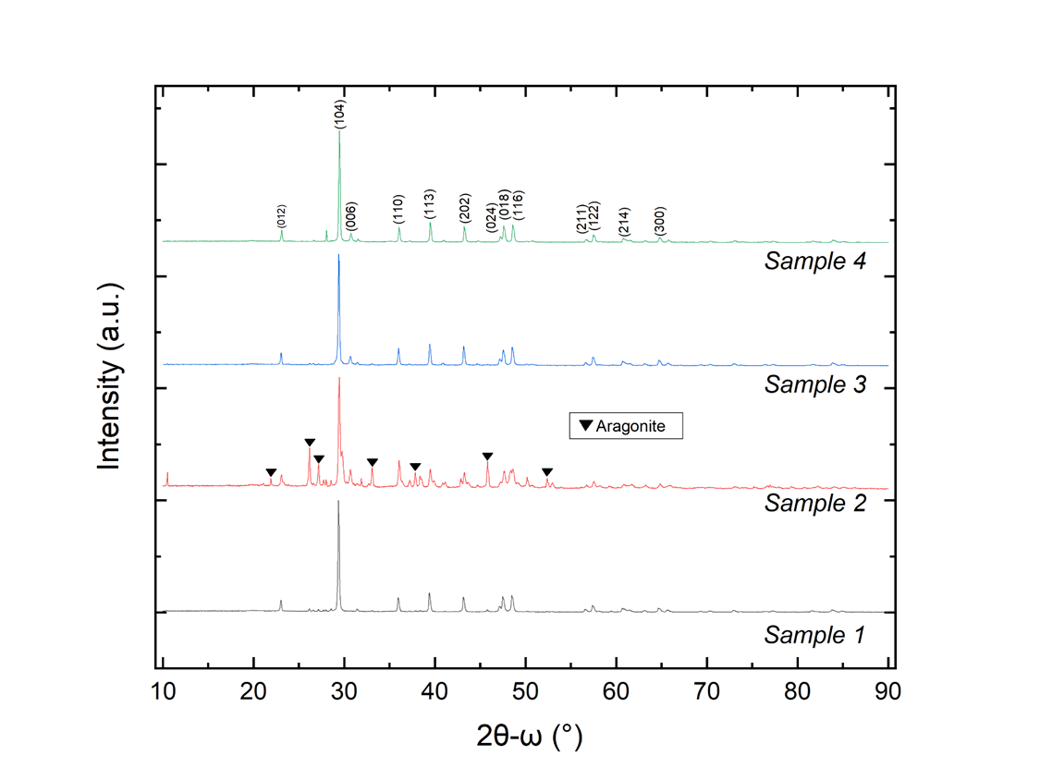
Figure 1. Powder x-ray diffraction profiles of sedimentary limestones.
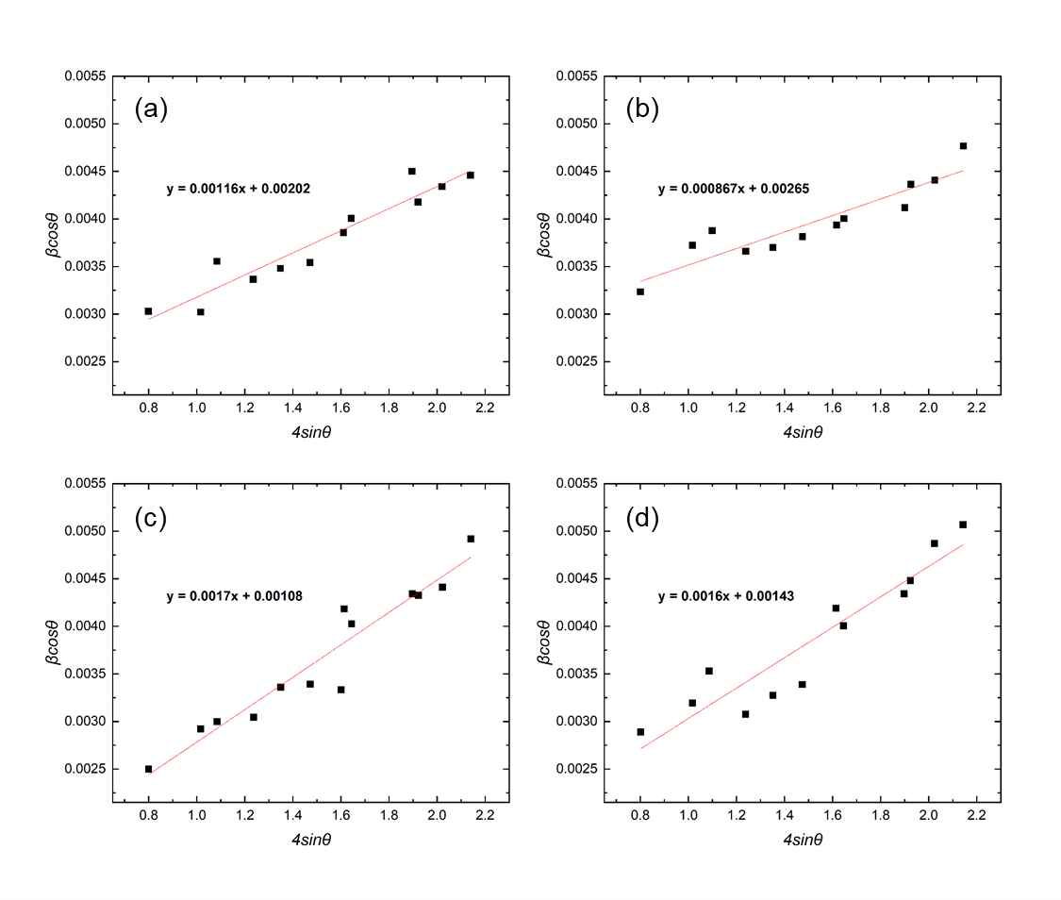
Figure 2. W–H analysis of CaCO₃ polymorph in the limestone samples using UDM. The microstrain and crystallite size were extracted from the linear fitting for (a) Sample 1, (b) Sample 2, (c) Sample 3, and (d) Sample 4.

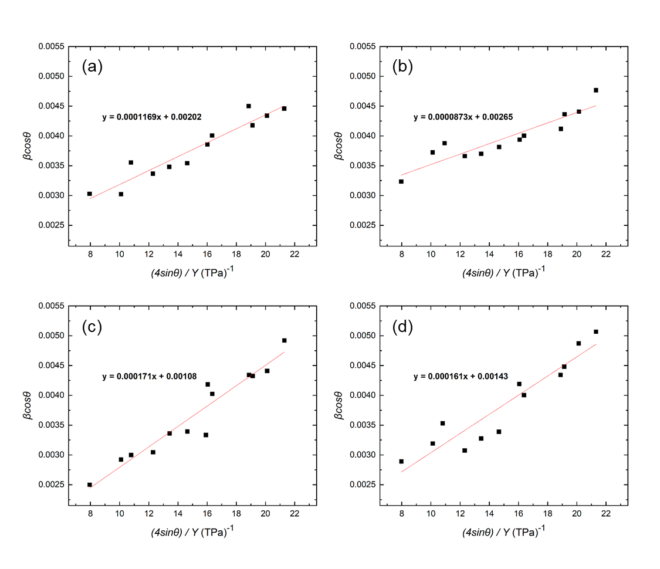
Figure 3. Modified W–H analysis of CaCO₃ in the limestone samples using the USDM. The microstrain and crystallite size were extracted from the linear fitting for (a) Sample 1, (b) Sample 2, (c) Sample 3, and (d) Sample 4.
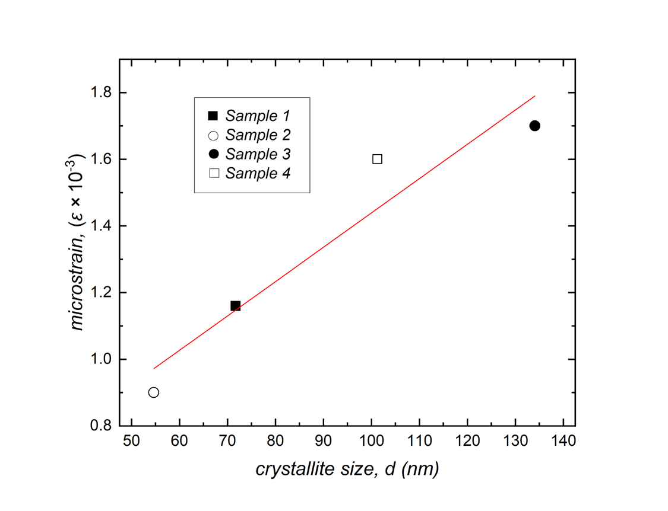
Figure 4. Crystallite sizes and microstrains obtained from W–H analysis of the samples.

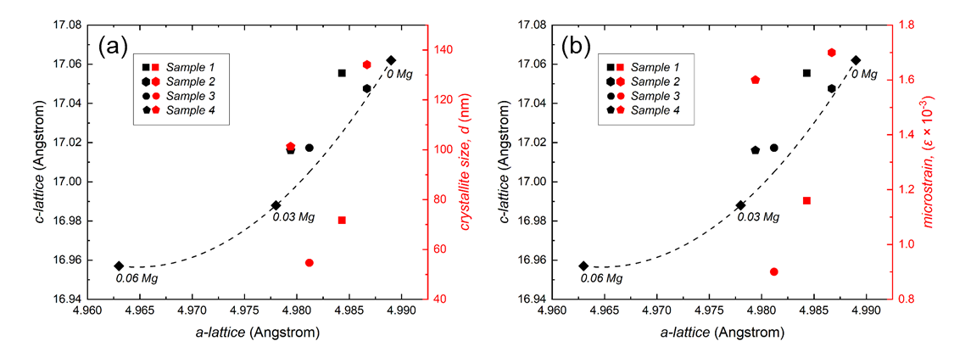
Figure 5. (a) Crystallite sizes and (b) microstrains with the lattice constants of all the samples. The amount of Mg incorporation in the CaCO₃ is indicated by closed diamonds obtained from JCPDS standard patterns for zero- and low-Mg content calcites (Pure calcite: JCPDS 05-0586, Mg_{0.03}Ca_{0.9}7CO₃: JCPDS 97-008-6161, and Mg_{0.06}Ca_{0.94}CO₃: JCPDS 89-1305).

