Quantitative fluorescent detection of antibacterial activity with pyrene-bearing tannic acid

Takehiro Fujita, ¹ Jun Hasegawa, ² Miki Onoue, ¹ Ryohei Matsubara, ² Takako Yamamoto, ² and Masanobu Naito ^{1*}
¹ Data-driven Polymer Design Group, Research and Services Division of Materials Data and Integrated System (MaDIS), National Institute for Materials Science (NIMS), 1-2-1, Sengen, Tsukuba, Ibaraki 305-0047, Japan
² Development Strategy Department, Technology Innovation Center, Business Development Division, TOPPAN INC., 1, Kanda Izumicho, Chiyoda-ku, Tokyo 101-0024, Japan


E-mail: < NAITO.Masanobu@nims.go.jp >
Masanobu Naito
Research and Services Division of Materials Data and Integrated System (MaDIS), National Institute for Materials Science (NIMS), 1-2-1 Sengen, Tsukuba, Ibaraki, 305-0047 Japan

Abstract
Quantitative evaluation of the antibacterial activity of conventional antibacterial agents in situ is difficult. In this study, we demonstrated that antibacterial activity can be quantitatively estimated from the photoluminescence intensity of pyrene fluorophores incorporated into tannic acid, a naturally occurring antibacterial agent.

Keywords: Antibacterial activity, Tannic acid, Fluorescence

Antibacterial agents play an important disinfecting role in wounds, medical equipment and care, and personal hygiene, making them indispensable in our daily lives.¹ In particular, the COVID-19 pandemic has made it an urgent social issue to control the spread of viral and bacterial infections.² As a countermeasure, disinfection of hands, personal belongings, and equipment has become mandatory in public places and households. This has led to an increased demand for common disinfectants, such as alcohol, hydrogen peroxide, and quaternary ammonium, although the excessive use of disinfectants is a potential threat to human health and the environment.³ For example, ingestion of low concentrations of hydrogen peroxide (3% aqueous solution) has been shown to cause mild gastrointestinal and mucosal irritation, portal vein thrombosis, and vomiting.⁴ Accidental or intentional ingestion of isopropanol can cause severe respiratory or central nervous system depression.⁵ Ethanol toxicity has also been associated with respiratory depression, which can cause respiratory arrest, hypothermia, arrhythmia, and in some cases cardiac arrest, hypoglycemia, ketoacidosis, and hypotension.⁶ In contrast, premixed materials containing antibacterial agents, such as silver ions, exert antibacterial activity when the antibacterial component is eluted from the base material. In other words, if the exact, preferred amount of antibacterial agent on a surface can be determined, it may lead to the proper use of antibacterial agents, thus reducing anxiety toward invisible bacteria.
We have focused on tannic acid (TA, 1a), a water-soluble polyphenol dendroid, as a naturally occurring antibacterial agent (Figure 1a). ⁷⁻¹⁰ Recently, we reported that with an n-alkyl substituent, water-soluble TA transforms into hydrophobic TA, which can be used as a water-insoluble non-eluting antibacterial coating (partially n-alkylated tannic acid, PATA).^{11,12} PATA can be used for the quantitative detection of antibacterial activity because the antibacterial activity of PATA correlates with the amount of PATA applied onto the substrate, unlike conventional eluting type antibacterial agents. Thus, if a hydrophobic fluorophore is introduced as a substituent of PATA, quantitative evaluation of antibacterial ability is possible through in situ fluorescence measurements.
Figure 1. (a) Structure of tannic acid 1a and the pyrene source 2. (b) Synthesis of 1b and 1c.

Among the various fluorophores, pyrene was specifically chosen as the hydrophobic aromatic substituent. Pyrene-bearing TA (PBTA) was prepared by esterification between 2b and the gallic acid moiety in 1a (Figure 1). PBTAs with different numbers of pyrene substituents were obtained by varying the composition ratio of 1a and 2b (Figure 1b). The resulting PBTAs were isolated as light brown solids (Figure S1) and identified by means of ¹H and ¹³C NMR spectroscopies (Figures S15-S18). Successful incorporation of pyrene groups into 1a was confirmed by the appearance of typical aromatic peaks at 7.5–8.5 ppm in the ¹H NMR spectra. To optimize the number of pyrene moieties, a series of PBTAs with varying degrees of substitution were prepared. For example, 1b and 1c were prepared with 1.1 and 5.5 equivalents of 1-pyrenebutyryl chloride to 1a, respectively. As a result, 1.0 and 4.6 equivalents of pyrene moieties were introduced into 1b and 1c, respectively. Solubility of PBTAs in common solvents are listed in Table S1, along with the Hildebrand solubility parameter.¹³ Here, 1.0 µmol of PBTA was dissolved in 1 mL of a solvent, and solubility was evaluated by the naked eye (Figures S2 and S3). PBTAs were soluble in common polar organic solvents, and both 1b and 1c were insoluble in water. However, as the number pyrene moieties increased, solubility in polar solvents decreased, which likely occurred because PBTAs aggregated, facilitated by the relatively strong π-π interactions among the pyrene moieties. Here, it is noteworthy that natural TA consists of a glucose core surrounded by covalently linked gallic acid residues with 25 phenolic hydroxyl groups connected through ester bonds. Therefore, PBTAs, especially 1b with a single pyrene moiety, were expected to retain the original properties of 1a imparted by the phenolic group of gallic acid, such as adhesive, antioxidant, antimicrobial, and antiviral properties, although their solubility in organic solvents was significantly improved by introducing a pyrene moiety into 1a. Indeed, 1b exhibited good binding ability to various substrates when 1b was processed into a thin film via simple solvent casting on various substrates, such as metals and glass. It is likely that the dihydroxyphenyl (catechol) and trihydroxyphenyl (pyrogallol) moieties imparted binding ability through chemical and physical interactions, similar to the adhesion mechanism of 3,4-dihydroxyphenylalanine (DOPA)-enriched adhesive foot protein of blue mussels.¹⁴
Figure 2. (a) UV spectra of 1a (black), 1b (blue), and 2a (red) in acetonitrile (10 μmol L⁻¹). (b) Photoluminescence (PL) spectra of 1b (blue) in acetonitrile (10 μmol L⁻¹) and film state (5.1 × 10¹ nmol cm⁻²), and 2a (red) in acetonitrile (10 μmol L⁻¹).

1b in solvent and cast film was further characterized through UV–vis and photoluminescence (PL) measurements (Figure 2). Pristine TA (1a) showed a broad UV absorption band at 𝜆_{max} = 270 nm, originating from the gallic acid moiety of TA. By introducing a pyrene moiety to 1a, new absorption bands appeared at 220, 260, 275, 320, and 345 nm, which were assigned to the pyrene moiety. To avoid overlapping absorption bands from TA and the pyrene moiety in the range of 220–320 nm, the excitation wavelength for PL measurements of 1b was chosen to be 350 nm. For PL measurements, 1b was dissolved in acetonitrile (10 μmol L⁻¹), and 2a was used as the reference. Completely dissolved 2a exhibited typical¹⁵ vibronic bands at 370, 400, and 420 nm. However, 1b exhibited a broad, unstructured band ranging from 425 to 550 nm, centered at approximately 460 nm, in addition to vibronic bands from the monomeric pyrene moiety. These bands arise because the two pyrene rings of the formed excimer are close to each other, i.e., within ~0.33 nm.¹³ Furthermore, when 1b was fabricated into a thin film, only the broad band of the excimer appeared, whereas the monomer peaks disappeared. Considering that 1b has a single pyrene moiety, an equilibrium favoring the co-existence of the excimer and monomer likely existed in the solution state (Figures 3a-c). However, this equilibrium shifted toward the excimer state during the drying process.
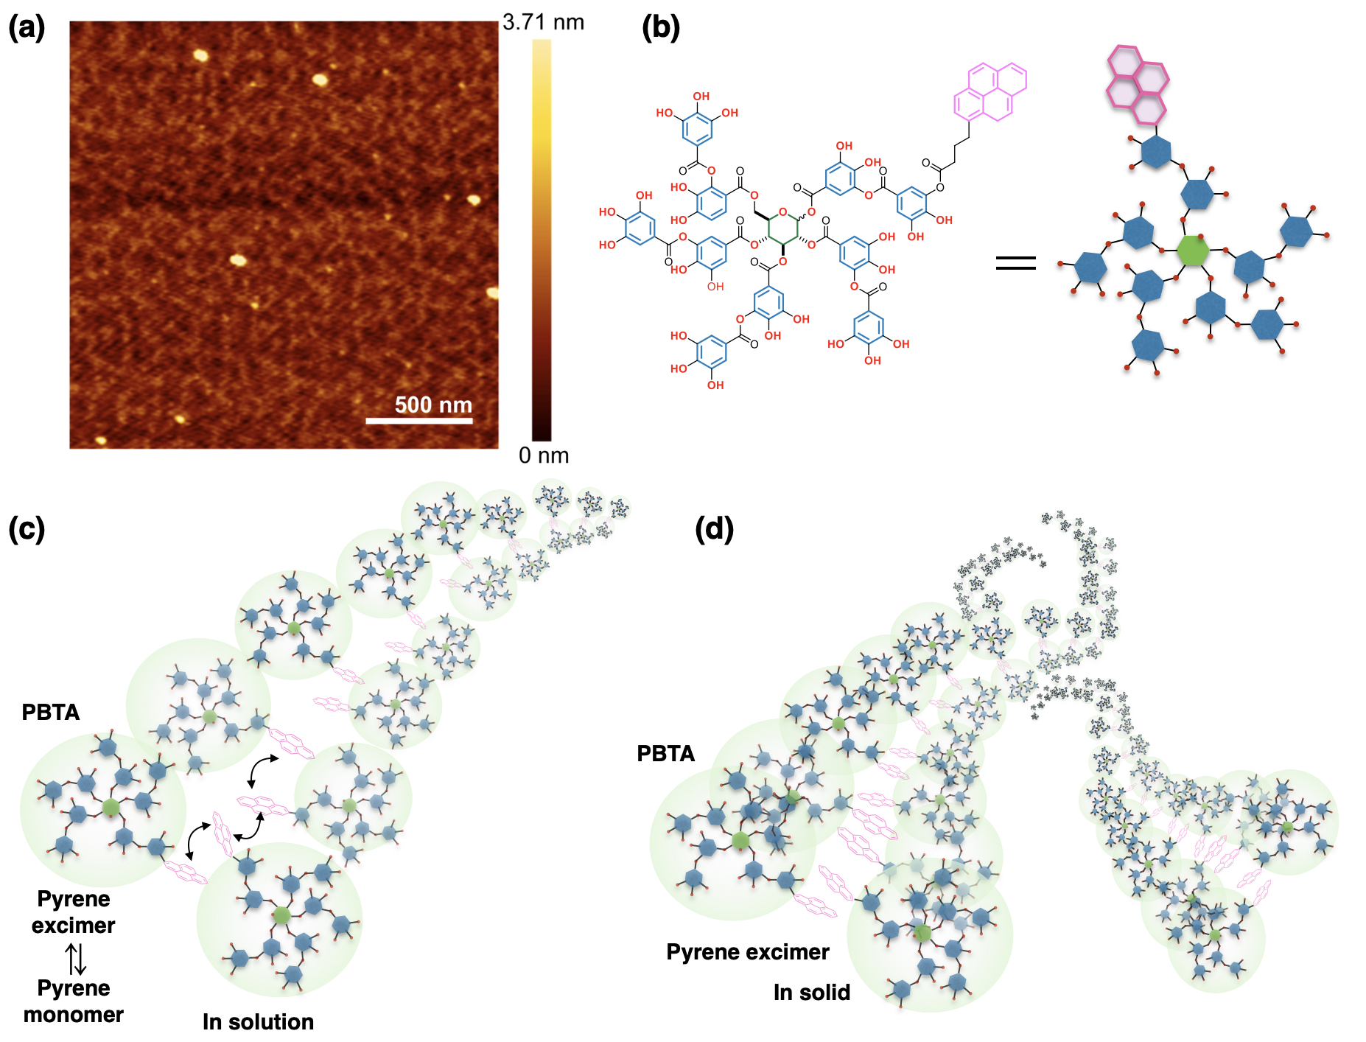
Figure 3. (a) AMF image of 1b on mica substrate (b) chemical structure and schematic image of 1b. (c) Proposed assembly structure of 1b in solution state (c) and in solid (d).

The surface morphology of the 1b thin film was characterized using atomic force microscopy (AFM) images. As shown Figure 3d, 1b formed highly developed fibril networks with 1.5~1.8 nm in height, which is in good agreement with an extended distance between the ends of the galloyl moieties (~2.0 nm) in 1b estimated by a density functional theory calculation (Figure S14). On the other hand, pristine 1a forms spherical aggregates under the same casting condition (Figure S12). Thus, 1b likely spontaneously assembled via intermolecular π-π interactions between the pyrene moieties, leading to the formation of highly developed fibril networks (Figures 3d). Furthermore, self-quenching of the pyrene moiety in 1b did not occur as the amount of 1b cast on the surface increased, supporting the absence of unstructured aggregates of the pyrene moiety (Table 1). Additionally, 1b formed the thin films by simple casting, further supporting the formation of highly developed fibril networks. This unique P property of 1b in addition to the formation of fibril networks enabled us to estimate the amount of antibacterial agent, leading to quantitative evaluation of antibacterial activity on substrates.
Polyphenols are known to exhibit antibacterial activity against various bacteria because of the physiological effects of the aromatic hydroxyl group, such as inhibition of hydrolytic enzymes, specific interactions for inactive microbial adhesion, binding to the cell wall/membrane, and metal ion complexation.⁷⁻¹⁰ By taking advantage of this feature, we previously demonstrated that PATA can be used as a non-eluting type antibacterial coating because unreacted phenolic moieties can exert antibacterial effects.¹¹ More importantly, the introduction of alkyl substituents to 1a does not affect the antibacterial activity but suppresses the elution of PATA into the aqueous medium. This feature enabled us to develop a unique renewable antibacterial coating. However, in the case of PATA, at least 20 % of phenolic hydroxyl groups must be modified with alkyl groups to obtain good solubility in common organic solvents. In contrast, 1b, with only one pyrene moiety introduced, was insoluble in water and was expected to be a highly effective antibacterial coating. To test our hypothesis, direct contact antibacterial activity of 1b cast on glass plates (5.1 ×10^{1~-2} nmol cm⁻²) was evaluated using Escherichia coli¹⁶ (E. coli) (Table 1). An uncoated glass substrate was used as the control. E. coli was incubated on various 1b coatings at 35 °C for 24 h. The results showed that E. coli was completely killed when 1b was cast at a concentration of more than 5.1 nmol cm⁻². As the amount of 1b cast on the substrate decreased, the antibacterial effect gradually weakened and was lost at a concentration of 5.1 × 10⁻² nmol cm⁻². In the case of PATA, we have confirmed that all E. coli was killed at ~10² nmol cm⁻².¹¹ Considering that, 1b has a similar or better antibacterial property to PATA, implying that the effective amount of polyphenol units exposed on the surface are almost comparable among PATA and 1b.

Table 1. Comparison of dynamic contact antimicrobial activity of control and 1b-coated glass substrates.
Concentrationª (nmol cm⁻²) | Viable cells^{c}  (cfu^{d} cm⁻²) | PL intensity  at 470 nm^{f} (cps^{g})
5.1 × 10¹ | <10e | 680,000
5.1 × 10⁰ | <10e | 39,000
5.1 × 10⁻¹ | 9.8 × 10² | 2,400
5.1 × 10⁻² | 1.8 × 10⁵ | 340
0^{b} | 3.2 × 10⁵ | 0
ªAmount of 1b on the glass substrate. ^{b} Uncoated glass plate (5 × 5 cm²). ^{c} The initial concentration of bacteria was ~10⁻⁵ cfu mL⁻¹. ^{d}cfu = colony forming unit. ^{e}No colony formation was observed. ^{f}Excitation wavelength λ_{ex} = 350 nm was employed for PL spectroscopy (Figure S9). Bandwidths of emission and excitation were set to be 2 nm. ^{g}cps = counts per second.

Because both PL intensity and antibacterial activity were proportional to the cast amount of PBTA, correlation between PL intensity and antimicrobial activity was clarified (Table 1). Figure 4 is a double logarithmic plot of PL intensity (cps) and number of viable cells after 24 h of antibacterial testing. Consequently, in the region between 10² and 10⁵ cps of the PL intensity, antibacterial activity decreased in correlation with PL intensity, and it can be expressed as $y=(5.7×{10}^{10})x^{-2.1}$. Here, x and y axis indicate PL intensity (cps) and viable cells (cfu cm⁻²), respectively. In addition, when the PL intensity was more than 10⁵ cps, bactericidal effect was evident because no bacteria survived. Therefore, it was successfully demonstrated that antimicrobial activity can be quantitatively evaluated from the PL intensity of the 1b-coated substrates. The fluorescence intensity of the 1b applied on a substrate did not change after 2 weeks in the air (Figure S13). In addition, antibacterial tests were conducted after the thin films were exposed to air for three weeks. These results suggest that this system is viable for the long term.
Figure 4. Relationship among the number of viable cells and the PL intensity of 1b in the thin film. Both x and y axes are expressed as logarithmic scales.
In conclusion, we demonstrated that the PL intensity of pyrene-bearing tannic acid (PBTA) can be used for the quantitative evaluation of antibacterial activity. The pyrene moiety was introduced into tannic acid as a fluorophore and hydrophobic moiety to produce PBTAs. In particular, 1b formed highly developed fibril networks, most likely via π-π interactions, among the pyrene moieties. As a result, 1b was able to form stable thin films. Its antibacterial ability showed a clear correlation with PL intensity between 10² and 10⁵ cps originating from pyrene excimer in 1b. This finding will enable us to easily visualize the amount of effective antibacterial agents, leading to the appropriate use of antibacterial agents. In addition, because the visible antibacterial agent proposed in this study is soluble in a variety of organic solvents, various water-insoluble non-eluting antibacterial formulations can be prepared to prevent the spread of infectious diseases.

Acknowledgement
We thank Prof. Dr. Masayuki Takeuchi and Dr. Norihiko Sasaki from the National Institute for Materials Science (NIMS) for measuring the AFM image, and Prof. Dr. Naoto Shirahata and Ms Fumie Takazawa from NIMS for measuring the PL spectra of the films. This work was partially supported by the Core Research for Evolutional Science and Technology (CREST) program “Revolution material development by fusion of strong experiments with theory/data science” of the Japan Science and Technology Agency (JST), Japan, under Grant JPMJCR19J3.

Supporting Information
Experimental procedures, spectra data, photographs and results of DFT calculation for 1b and 1c.

References
- S. Saidin, M. A. Jumat, N. A. A. M. Amin, A. S. S. A.-Hammadi, Mater. Sci. Eng. C 2021, 118, 11382.
- J. N. Nkengasong, Nat. Med. 2021, 27, 364.
- D. Ghafoor, Z. Khan, A. Khan, D. Ualiyeva, N. Zaman, Curr. Res. Toxicol. 2021, 2, 159.
- J. M. Moon, B. J. Chun, Y. I. Min, J. Emerg. Med. 2006, 30, 403.
- A. Mahmood, M. Eqan, S. Pervez, H. A. Alghamdi, A. B. Tabinda, A. Yasar, K. Brindhadevi, A. Pugazhendhi, Sci. Total Environ. 2020, 742, 140561.
- N. J. Gormley, A. C. Bronstein, J. J. Rasimas, M. Pao, A. T. Wratney, J. Sun, H. A. Austin, A. F. Suffredini, Crit. Care Med. 2012, 40, 290.
- B. Balasubramaniam, Prateek, S. R., M. Saraf, P. Kar, S. P. Singh, V. K. Thakur, A. Singh, R. K. Gupta, ACS Pharmacol. Transl. Sci. 2021, 4, 8.
- B. Kaczmarek, Materials 2020, 13, 3224.
- A. Scalbert, Phytochemistry, 1991, 30, 3875.
- M. Daglia, Curr. Opin. Biotechnol. 2012, 23, 174.
- D. Payra, M. Naito, Y. Fujii, Y, Nagao, Chem. Commun. 2016, 52, 312
- D. Payra, Y. Yamauchi, S. Samitsu, M. Naito, Chem. Mater. 2018, 30, 8025.
- A. F. M. Barton, Chem. Rev. 1975, 75, 731.
- D. W. R. Balkenende, S. M. Winkler, P. B. Messersmith, Eur. Polym. J. 2019, 116, 134.
- F. M. Winnik Chem. Rev. 1993, 93, 587.
- a Japanese Industrial Standard/Antimicrobial products-Test for antimicrobial activity and efficacy JIS Z 2801:2010 (Japanese standard7 association 4-1-24, Akasaka, Minato-ku, Tokyo, 107-8440 Japan.)

Graphical Abstract

<Title>
Quantitative fluorescent detection of antibacterial activity with pyrene-bearing tannic acid
<Authors' names>
Takehiro Fujita, Jun Hasegawa, Miki Onoue, Ryohei Matsubara, Takako Yamamoto, and Masanobu Naito*
<Summary>
Quantitative evaluation of the antibacterial activity of conventional antibacterial agents in situ is difficult. In this study, we demonstrated that antibacterial activity can be quantitatively estimated from the photoluminescence intensity of pyrene fluorophores incorporated into tannic acid, a naturally occurring antibacterial agent.
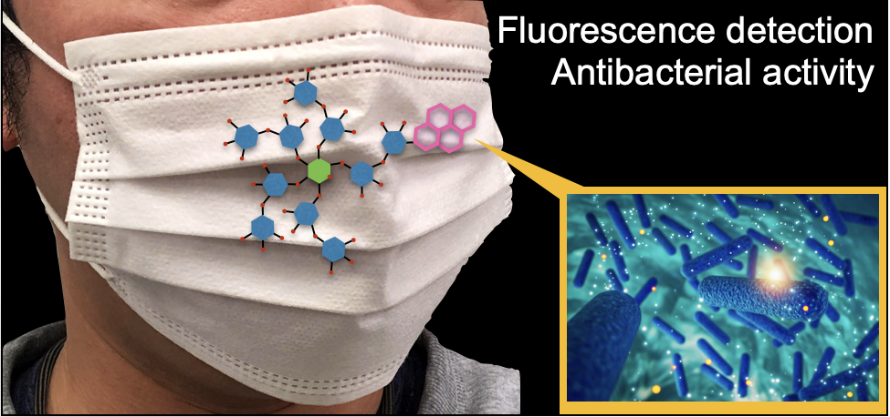
<Diagram>

