High-coercivity fine-grained SmFe₁₂-based anisotropic sintered magnets
A. K. Srinithi^{a,b}, Xin Tang^{a,c*}, H. Sepehri-Amin^{a,b}, J. Zhangª, T. Ohkuboª, K. Hono^{a,b}
ª National Institute for Materials Science, Tsukuba 305-0047, Japan
^{b} Graduate School of Science and Technology, University of Tsukuba, Tsukuba 305-8577, Japan
^{c}International Center for Young Scientist, National Institute for Materials Science,Tsukuba 305-0047, Japan
*Corresponding author; Email: Tang.Xin@nims.go.jp
Abstract
We achieved a record-high coercivity of 1.40 T in SmFe₁₂-based ThMn₁₂-type anisotropic sintered magnets. This magnet was prepared by sintering jet-milled powder made from strip-cast alloys with a nominal composition of Sm₈Fe_{73.5}Ti₈V₈Al₂Cu_{0.5}, using the conventional process for anisotropic sintered magnet production. Detailed microstructural investigations conducted using scanning electron microscopy and transmission electron microscopy revealed that the formation of weak-ferromagnetic Sm-rich intergranular phases (with ~14-15 at.% of Fe) surrounding the fine SmFe₁₂ phase grains resulted in the high coercivity. Nanobeam electron diffraction patterns showed that the intergranular phases (IGPs) exhibiting excellent wettability in this magnet are mainly composed of two phases: a hexagonal close-packed Mg-type Sm-based phase and a primitive cubic CsCl-type SmCu-based phase, which co-exist in the same intergranular region. The presence of these phases as the IGPs can be the reason for their substantially low Fe content, which is indicative of their weak-ferromagnetic nature. Such Fe-lean IGPs minimize the intergranular exchange coupling in the SmFe₁₂ main phase contributing to the high coercivity in contrast to Fe-rich IGPs, as revealed by Kerr microscopy observation. Overall, this study provides detailed coercivity-microstructure correlations and insights for the future development of high-performance SmFe₁₂-based sintered magnets.
Keywords: Hard magnets, SmFe₁₂ sintered magnets, coercivity, microstructure.
1. Introduction
An increasing demand for permanent magnets (PMs) is driven by the global transition in favor of green energy technologies, wherein the PM-based motors and generators play major roles in efficient energy conversions [1–4]. Currently, the (Dy,Nd)–Fe–B magnets are mainly used for these applications, but the high cost of the rare earth elements, Nd and Dy, has led to accelerated research towards finding an alternative cost-effective PM [5, 6]. The rare-earth-lean SmFe₁₂-based hard-ferromagnetic compounds with a strong uniaxial magneto-crystalline anisotropy have been intensively studied as candidates for permanent magnets [7–9]. These compounds have the ThMn₁₂-type structure, which needs to be stabilized by the substitution of elements such as Ti, V, or their combinations. Owing to its low material cost and promising intrinsic magnetic properties, the SmFe₁₂-based compound has the potential for a better performance-to-cost ratio and hence is considered as a next-generation permanent magnet candidate [10, 11]. To make this practical, extensive research is being carried out to improve its extrinsic magnetic properties, mainly its coercivity (H_{c}).
The coercivity is governed by various microstructural features, such as grain size, grain morphology, presence of secondary phases, type of intergranular phase and its chemical composition (magnetism), and interfacial defects [12, 13]. For instance, the presence of secondary ferromagnetic phases can deteriorate the coercivity; the formation of a non-ferromagnetic intergranular phase (IGP) can improve the coercivity owing to weakened intergranular exchange-coupling in the main phase. Several fundamental studies have been conducted on coercivity enhancement of the Sm(Fe,Ti)₁₂-based compound [14–22]. Gabay et al. reported the highest coercivity of 1.26 T in monocrystalline Sm(Fe,Ti)₁₂-based powder made by the reduction–diffusion process [14]. However, many factors hinder the realization of high coercivity values in bulk Sm(Fe,Ti)₁₂-based alloys. The major bottlenecks include the inability to eliminate secondary soft-ferromagnetic phases and to form a weak-ferromagnetic IGP surrounding the hard-ferromagnetic SmFe₁₂ grains [15–22]. Recently, a study comparing TiV-stabilized SmFe₁₀TiV (µ₀H_{c} = 1.1 T) and Ti-stabilized SmFe₁₁Ti (µ₀H_{c} = 0.5 T) melt-spun ribbons, demonstrated that the existence of Sm-rich IGPs surrounding the SmFe₁₂ grains is the key reason for the higher coercivity of V-doped ribbons [21]. Otsuka et al. carried out a similar comparative study on sintered magnets, and found that the V-stabilized Sm(Fe,V)₁₂ alloy had a high coercivity (0.8 T) owing to the formation of a Sm-rich IGP, whereas the Ti-stabilized Sm(Fe,Ti)₁₂ alloy ended up with secondary soft-ferromagnetic phases and lack of IGP, and thus a low coercivity (~0.01 T) [22]. These reports show that V substitution for Fe is crucial in terms of avoiding the undesired secondary phases while maintaining the microstructure favorable for high coercivity. However, the reported coercivity for the SmFe₁₂-based anisotropic sintered magnets is limited to 0.8–1.0 T, which is only ~10% of their anisotropy field and is insufficient for practical applications [22, 23]. Hence, further work on tuning the microstructure of the SmFe₁₂-based magnets needs to be conducted to fully utilize its strong anisotropy field and improve the coercivity.
The limited coercivity in previously reported anisotropic sintered magnets possibly originate from coarse SmFe₁₂-based grains and the Fe content in the IGPs. The average grain size in these sintered magnets was mostly around 9–10 µm [22, 24]. Hence, grain refinement approaching the single domain size (0.6 to 0.75 µm) is expected to improve the coercivity of the SmFe₁₂-based magnets. Note that the previously reported SmFe₁₂-based anisotropic magnets were prepared using optimally annealed as-cast ingots as the starting material [22–24]. It is known from the conventional metallurgical process for sintered Nd–Fe–B magnets, that the grain size of the final product can be refined by the use of strip-cast alloys as the parent material for the powder preparation [25]. A similar processing method needs to be investigated for the SmFe₁₂ sintered magnets. Furthermore, the Fe concentration in IGPs has been reported to be around 50 at.% in the previous studies on SmFe₁₂-based sintered magnets, [22, 23]. For example, in the SmFe₁₀V₂ sintered magnets by Otsuka et al., the SmFe₁₂ grains were separated by 2 nm thick Sm–Fe-based IGPs in several regions, and the Fe content in these IGPs was between 40 to 50 at.% [22]. Zhang et al. reported a higher coercivity of 1 T in Sm₈Fe_{73.5}Ti₈V₈Al₂Ga_{0.5} magnets; in this case, the IGPs were based on Sm–Fe, with 45–55 at.% of Fe [23]. A reduction of the Fe content in the IGP can lead to weaker intergranular exchange coupling and higher coercivities in SmFe₁₂-based sintered magnets. Recently, Schönhöbel et al. reported an improvement in the coercivity from 0.88 to 0.96 T by doping Cu in nanocrystalline Sm–Fe–V-based isotropic magnets [27]. Ogawa et al. also reported that grain boundary infiltration of Cu in SmFe₁₂ thin films resulted in coercivity enhancement [28]. Similar compositional modification of the SmFe₁₂-based sintered magnets can also help in the coercivity enhancement.
In this study, by optimizing the processing method and microalloying with Cu, weak-ferromagnetic IGPs enveloping the main phase grains is obtained. This enabled achievement of a record-high coercivity of 1.4 T in the SmFe₁₂-based sintered magnets. Microstructural investigations were performed to gain an overall perspective on how the grain size of the SmFe₁₂ main phase and the crystal structure and composition of the secondary phases, influence the coercivity.
2. Experimental
Ingots with the composition of Sm₈Fe₇₄Ti₈V₈Al₂ (denoted as Cu0) and Sm₈Fe_{73.5}Ti₈V₈Al₂Cu_{0.5} in at.% (denoted as Cu0.5) were prepared by melting and casting in an induction furnace, with appropriate amounts of excess Sm added to compensate for the evaporation. Unlike in the previous reports [22–24], the strip-casting technique was employed in this study to produce alloys for powder preparation. The as-cast ingots were strip-cast into flakes using a Cu wheel with a quenching-surface speed of 1–2 m/s, after which the flakes were annealed at 1273 K for phase formation. Hydrogen decrepitation was carried out such that the strip-cast flakes could be easily crushed into powder, followed by jet milling with N₂ gas at 1.0 MPa in an Ar-filled glove box. The jet-milled powders were oriented using a pulse magnetizer, pressed into a green compact, and sintered at 1373 K for 2 h. These sintered magnets which were made with the strip-cast flakes as the starting material are referred to as Cu0 and Cu0.5 magnets based on their compositions. To elucidate the effect of processing routes on magnetic properties, a sintered magnet made using annealed ingots as the starting material is also prepared and referred to the Cu0.5-I magnet. The density values of the sintered magnets were found to be ~7.3 g/cm³.
Powder X-ray diffraction patterns for phase identification were obtained using a Rigaku MiniFlex X-ray diffractometer with Cr–Kα radiation. Magnetic hysteresis (M–H) loops were measured along the alignment direction (easy) and its perpendicular direction (hard) using a 14 T physical property measurement system with a vibrating sample magnetometer setup (VSM). The oven-module connected to the VSM was used to measure the temperature-dependent coercivity. A Carl Zeiss Cross-Beam 550 scanning electron microscope (SEM) equipped with an in-lens detector was used to observe the overall microstructure. Detailed analysis of the crystal structure and the composition of the constituent phases was conducted using an FEI Titan G2 80-200 transmission electron microscope (TEM) with a probe aberration corrector coupled with an EDS detector. The elemental concentrations found from EDS analysis can have up to 5 at.% of error. The TEM specimen was prepared by the lift-out method using an FEI Helios G4-UX focused ion beam system. A magneto-optical Kerr microscope (equipped with 1.2 T electromagnets) was used to observe the magnetization reversal dynamics.
3. Results
3.1. Magnetic properties
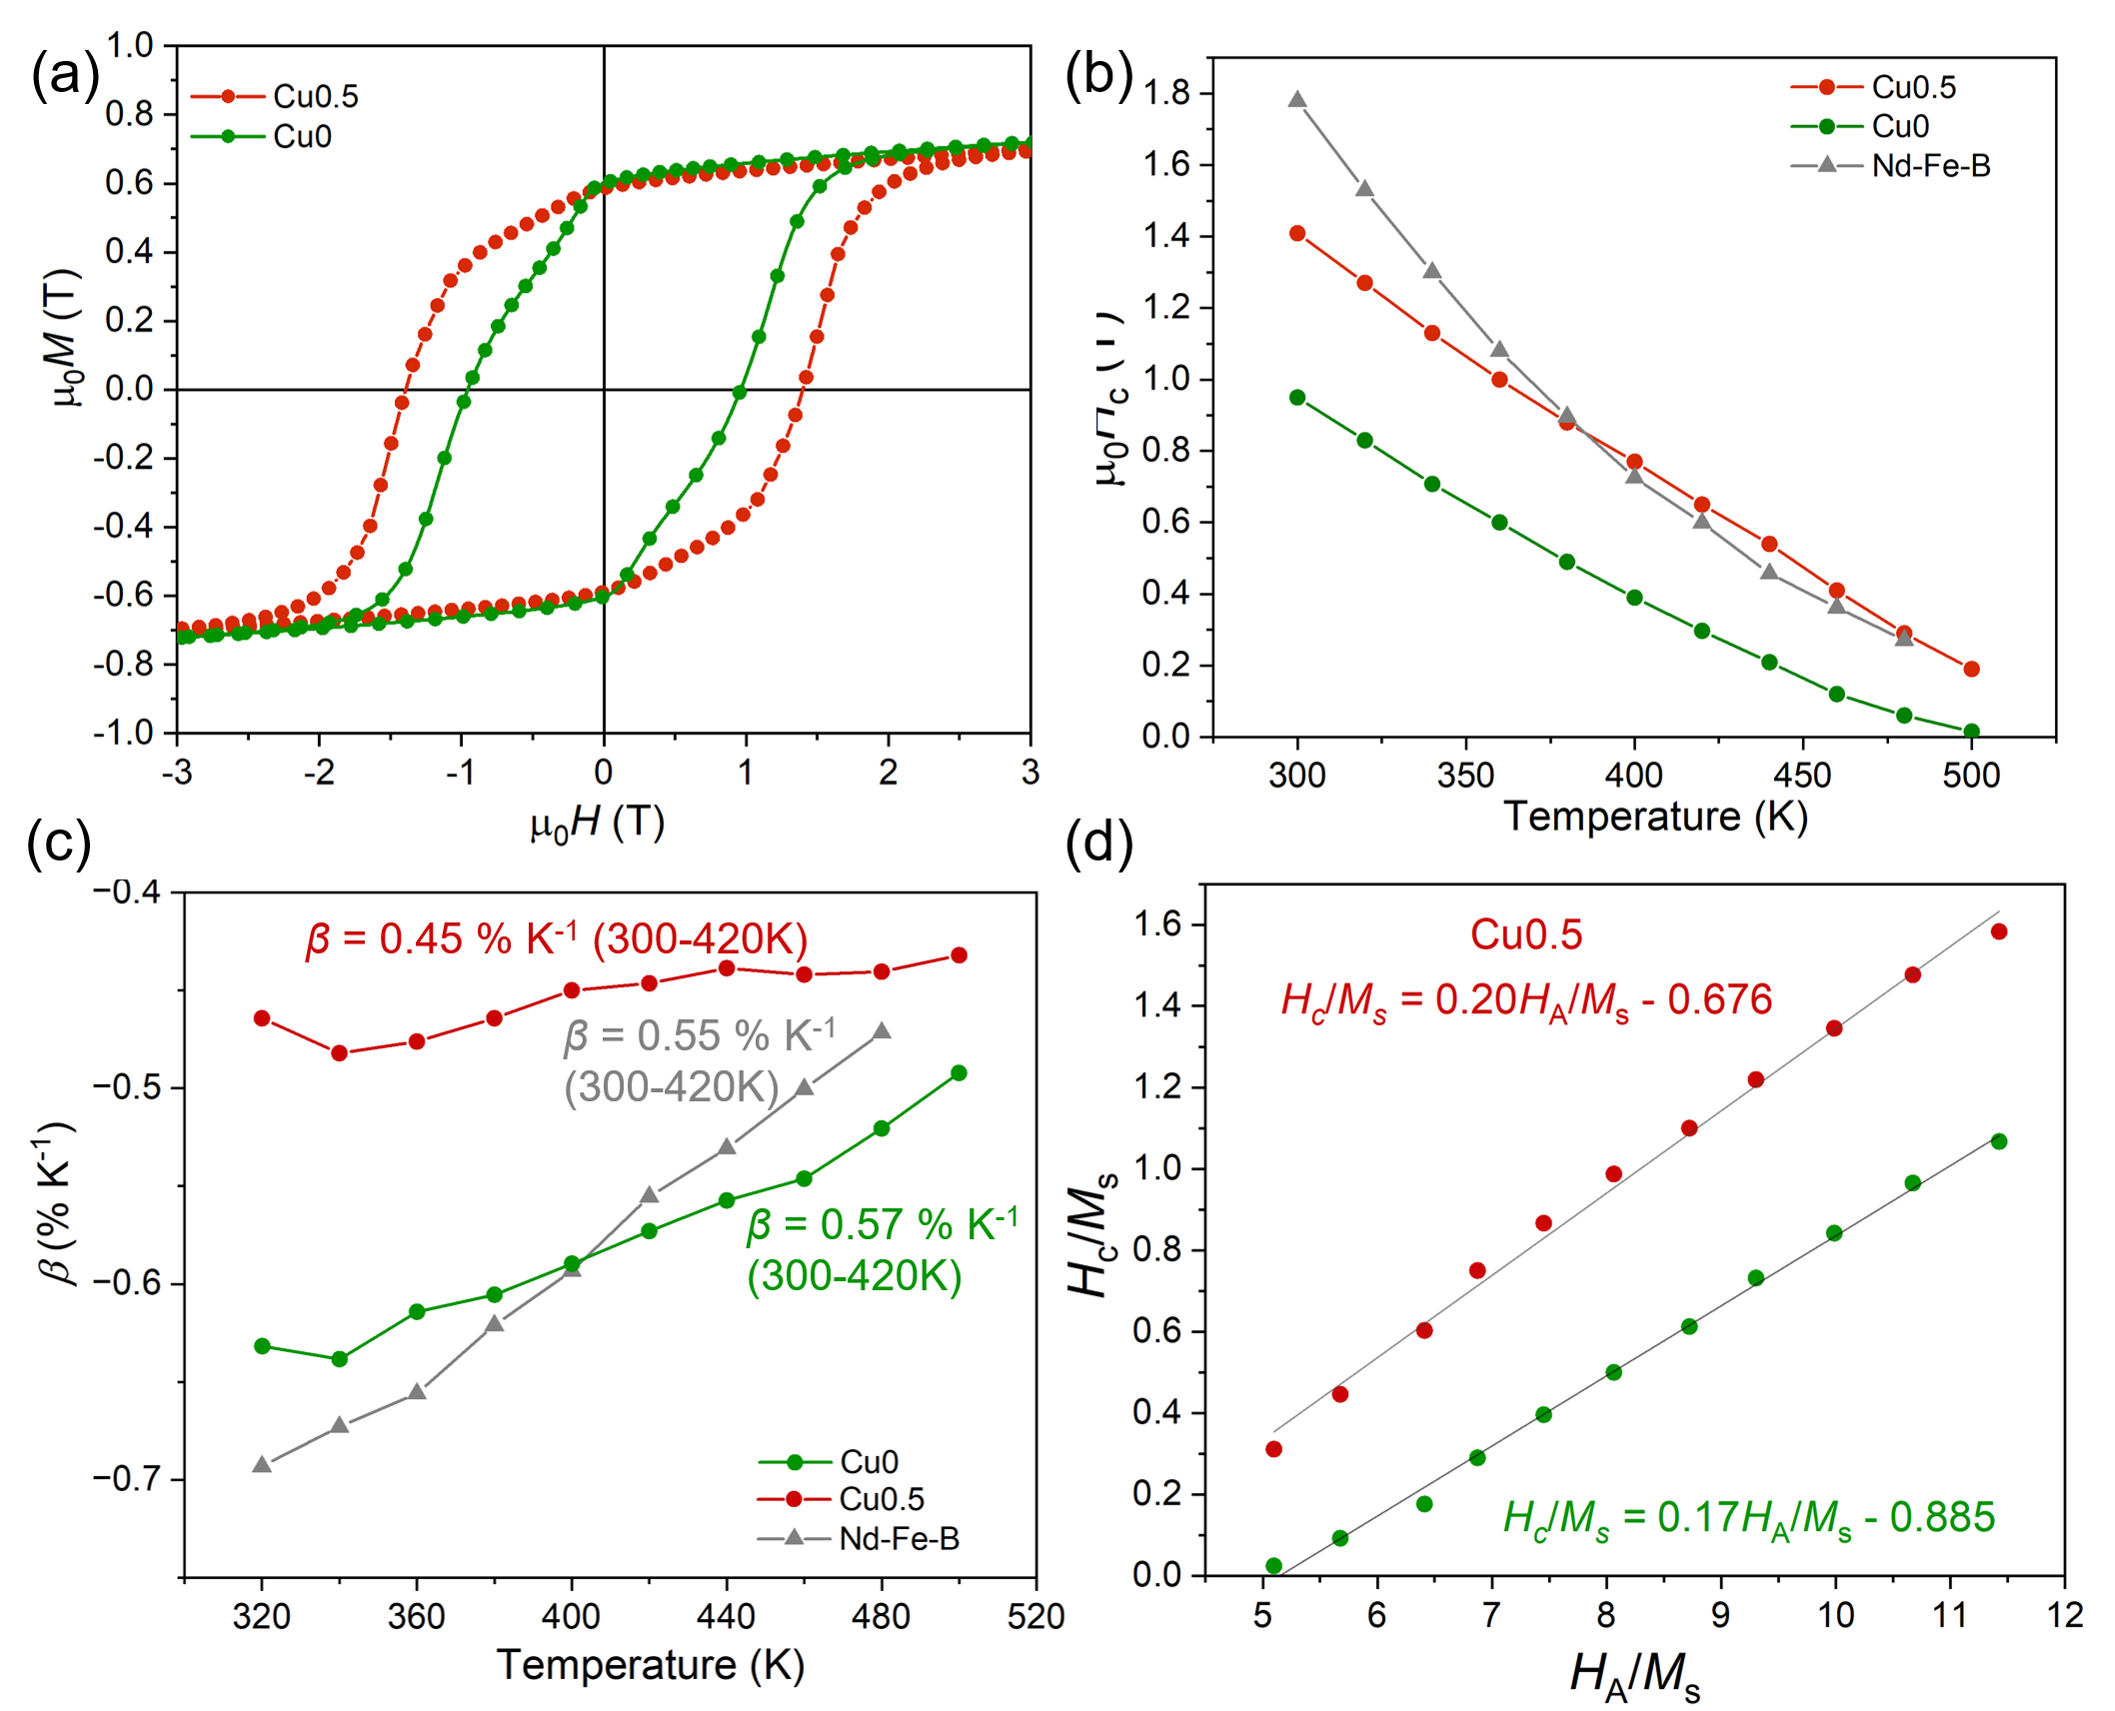
Fig. 1. (a) M–H hysteresis loops of Cu0 and Cu0.5 sintered magnets measured along the easy axis. (b) Temperature-dependent coercivity values and (c) temperature coefficients of coercivity (β) of Cu0, Cu0.5 and Nd–Fe–B [29] sintered magnets. (d) Linear fitting of H_{c}/M_{s} vs. H_{A}/M_{s} values to obtain the Kronmüller equation for the Cu0 and Cu0.5 magnet.

Figure 1(a) shows the magnetic hysteresis (M–H) along the easy axis for anisotropic Cu0 and Cu0.5 sintered magnets, which were made using strip-cast flakes as the starting material. The remanent magnetization and coercivity values are 0.61 and 0.95 T for the Cu0 magnet, and 0.6 T and 1.4 T for Cu0.5 magnet. The coercivity of 1.4 T obtained for the Cu0.5 magnet is the highest reported so far for the SmFe₁₂-based magnets. The Cu0.5-I magnet, which was made using ingots as the starting material, has a much lower coercivity (0.85 T) than the Cu0.5 magnet as shown in xx, although the composition was the same, indicating that processing route is crucial.
The temperature dependencies of coercivity for the Cu0 and Cu0.5 magnets, in comparison with a high-coercivity N50 grade Nd–Fe–B sintered magnet [29], [30] is shown in Fig. 1(b). Here, the Nd-Fe-B sintered magnet with a high coercivity (µ₀H_{c} =1.8 T, H_{c}/H_{A} = 0.26) is chosen for comparison. The temperature-coefficient of coercivity, β = [H_{c}(T) – H_{c}(RT)]/[H_{c}(RT)*ΔT], is –0.57% K⁻¹ for Cu0 in the temperature range 300 K to 420 K, which is substantially improved to –0.45% K⁻¹ after microalloying with Cu0.5. The β is even larger than that (0.55% K⁻¹) for high-coercivity Nd-Fe-B sintered magnets. This comparison shows that the coercivity in the Cu0.5 SmFe₁₂-based magnet is more thermally stable than the Nd-Fe-B sintered magnet. Hence, Cu0.5 SmFe₁₂-based magnet exhibits a higher coercivity above 380 K compared to Nd-Fe-B sintered magnet regardless of its a lower room-temperature coercivity. At the typical operating temperature of 423 K, the coercivity of the Cu0.5 magnet is 0.63 T, higher than that of the Nd–Fe–B magnet (0.57 T) [23]. In addition, there is no significant variation in β with the temperature for the Cu0.5 magnet, unlike Cu0, wherein it varies from –0.63 to –0.49 % K⁻¹, as presented in Fig. 1(c). There is a possibility that the stable β against temperature in Cu0.5 indicates weaker ferromagnetism of intergranular phases than in Cu0 [31]. Treating the temperature dependence of coercivity with that of the intrinsic properties, anisotropy field (H_{A}) and saturation magnetization (M_{s}) (adopted from Ref. [23]), according to H_{c} (T) = αH_{A}(T) – N_{eff}M_{s}(T) [32] as presented in Fig. 1(d), we found the microstructural parameters, α and N_{eff}. The enhanced α and reduced N_{eff} of Cu0.5 compared to Cu0, suggests that the microstructural factors play an important role in the coercivity improvement. To understand the reason for the improved coercivity in the Cu0.5 magnet, a detailed microstructural analysis using the combination of SEM and TEM was conducted.

3.2. Overall microstructure
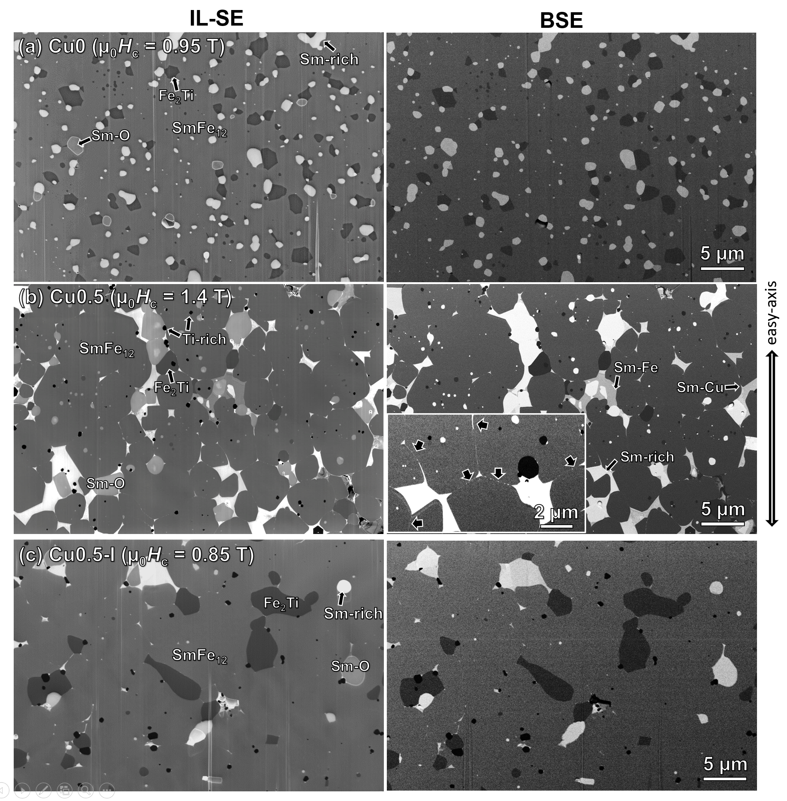
Fig. 2. In-lens secondary electron (IL-SE) and back-scattered electron (BSE) SEM images of (a) Cu0 (b) Cu0.5 and (c) Cu0.5-I sintered magnets.

Figure 2 shows the SEM micrographs obtained from the in-lens secondary electron (IL-SE) and back scattered electron (BSE) detectors, where the various phases present in the Cu0, Cu0.5 and Cu0.5-I sintered magnets can be differentiated based on the image contrast. The main phase is the SmFe₁₂-based phase and its mean grain size (d_{m}) is ~2.5 µm ± [] µm for the Cu0 magnet and 4.2 ± 1.8 µm for Cu0.5 magnet, which is shown in detail in Fig. S2. Compared to the previous reports on SmFe₁₂-based sintered magnets, we achieved smaller grain size, approaching the single domain size (~0.6–0.75 µm) [23]. The overall fine grain size could be attributed to the process route adopted, where the average particle size of the as-jet milled powder was as small as ~2 µm on average (as detailed in Fig. S3).
The phases showing bright contrast in the BSE image of Fig. 2(a) correspond to Sm enriched phases such as Sm-based and SmO-based phases; in addition to these phases, Sm–Cu-based phase can be seen in the Cu0.5 magnet. The Sm-based phase has the brightest contrast in both the IL-SE and BSE images. The SmO-based phase has almost the same contrast as the Sm-based phase in the BSE image, while it appears to be darker in the IL-SE image. In the Cu0.5 magnet, the Sm–Cu-based phase can be differentiated due to its relatively darker contrast with respect to the Sm-based phase in the BSE image. The phases having dark contrast with respect to the SmFe₁₂-based main phase correspond to the Ti-rich phases (Fe₂Ti and Ti).
Of particular interest is the IGP along the grain boundaries with bright contrast is visible in both the IL-SE and BSE images in the Cu0.5 magnet (Fig. 2(b)), indicating the strong partitioning of heavier element, i.e., Sm in IGP. In contrast, it is rare to find bright contrast features along the grain boundaries in Cu0 magnet. The above microstructure comparison suggests that the better wettability of Sm-rich IGP surrounding the matrix grains achieved in Cu0.5 magnet could be ascribed to the microalloying with Cu. On the other hand, the Cu0.5-I magnet shown in Fig. 2(c) does not have clearly visible Sm-rich IGPs in comparison with the Cu0.5 magnet. Hence, the good wettability of the Sm-rich IGPs in the Cu0.5 magnet is not only attributed to its composition, but also to the process route followed, wherein strip-cast flakes were used as the starting material. The reason for improved coverage of Sm-rich phase in the Cu0.5 magnet than in the Cu0.5-I magnet, could be attributed to a better homogeneity and distribution of the Sm enriched phases in the strip-cast flakes than in ingots (Supplementary Fig. S3). Overall, the SEM observation indicates that the intergranular phases can be a crucial contributor to the high coercivity in the Cu0.5 magnet, and hence, we performed detailed microstructure characterization on this sample to study the crystal structure and composition of the triple junctions and IGPs.

3.3. Crystal structures of triple junction and intergranular phases (Cu0.5 magnet)
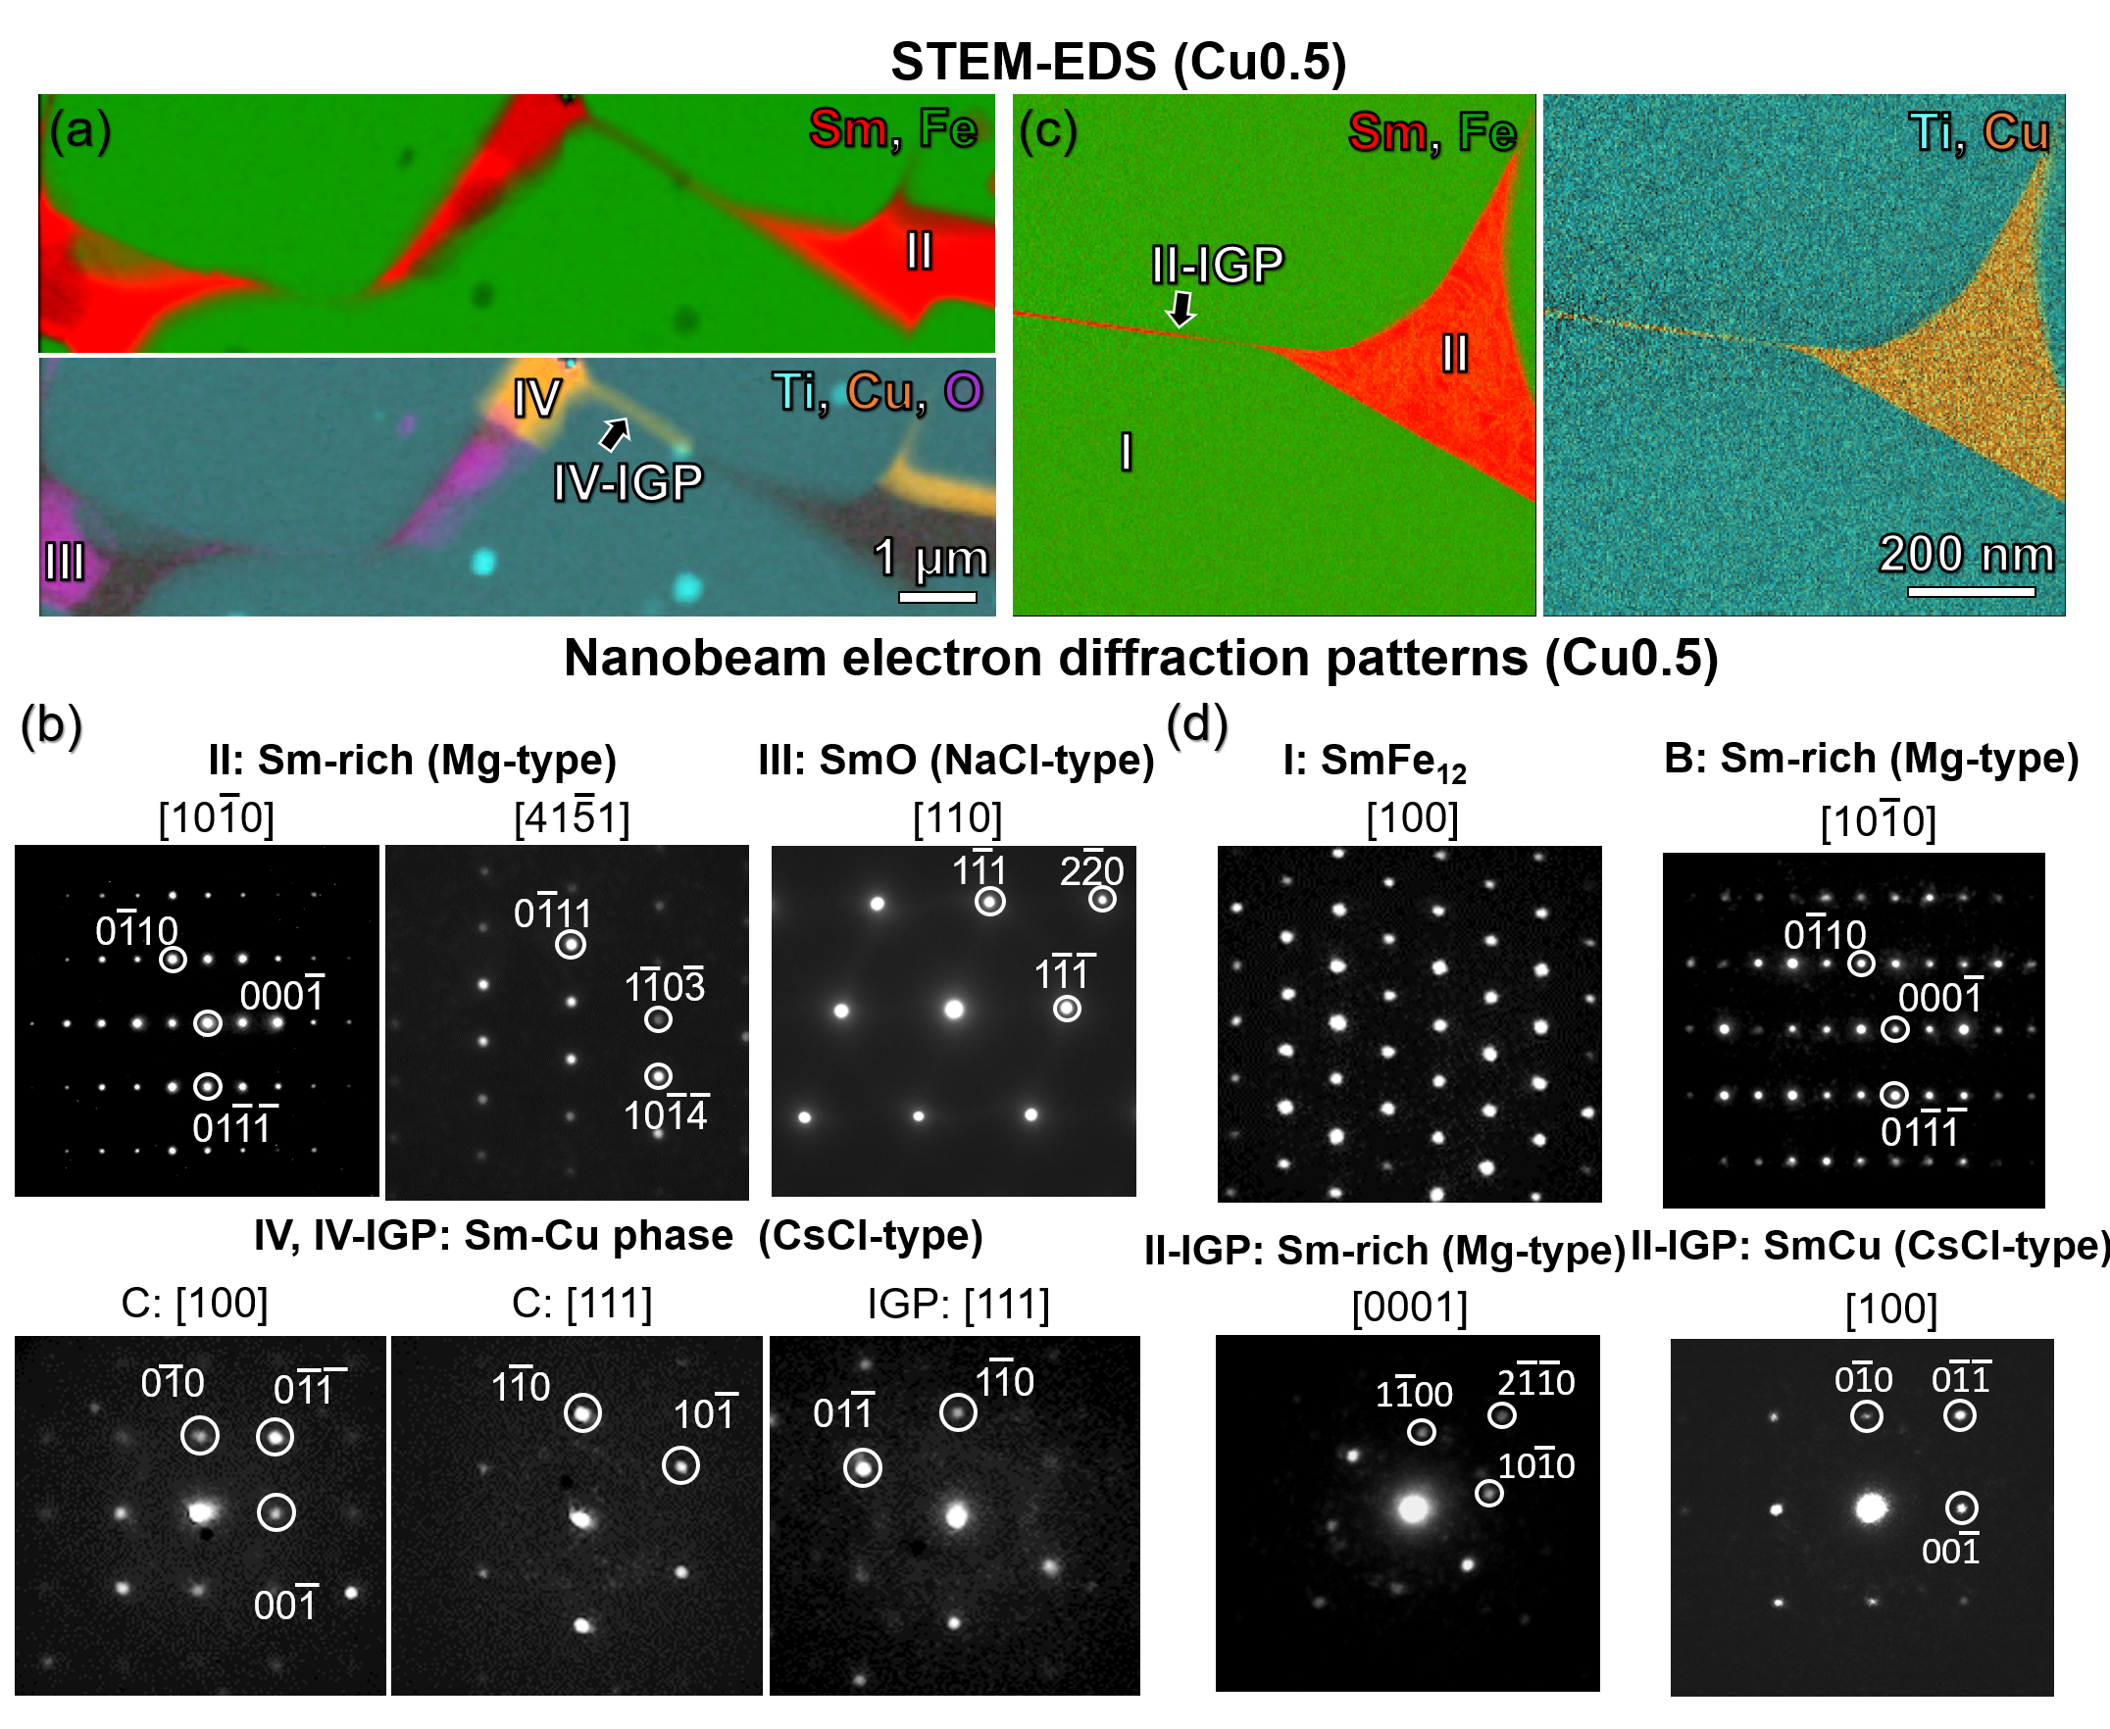
Fig. 3. (a), (c) STEM–EDS maps and (b), (d) respective sets of nano-beam electron diffraction patterns obtained from the different regions in the maps for the Cu0.5 magnet.
Table 1 Compositions (at.%) of Sm-rich triple junction phases obtained from STEM–EDS
Region | STEM-EDS Composition (at.%) | Phase
I | Sm_{9.1}Fe_{74.2}Ti_{6.0}V_{8.9}Al_{1.5}Cu_{0.3} | ThMn₁₂-type SmFe₁₂
II | Sm_{83.6}Fe_{8.7}Al_{4.4}Cu_{1.2}V_{1.5}Ti_{0.6} | HCP Mg-type Sm
III | Sm_{48.4}O_{45.5}Fe_{3.8}Al_{2.3} | FCC NaCl-type SmO
IV | Sm_{52.1}Cu_{36.1}Fe_{5.3}Al_{5.5}V_{0.7}Ti_{0.3} | PC CsCl-type SmCu

Figures 3(a) and (c) show the STEM–EDS maps, and Figures 3(b) and (d) show the nano-beam electron diffraction (NBED) patterns from the constituent phases of the Cu0.5 magnet. The Sm-rich triple-junction phases with bright contrast in the BSE SEM images (Fig. 2(b)) are marked in the STEM–EDS maps, and their compositions are presented in Table 3. In Fig. 3(a), Region II, which shows the brightest contrast in both the IL-SE and BSE SEM images (Fig. 2(b)), has the composition, Sm_{83.6}Fe_{8.7}Al_{4.4}Cu_{1.2}V_{1.5}Ti_{0.6} (at.%), and its NBED patterns reveal the hexagonal close-packed Mg-type crystal structure (P63/mmc). The low Fe content (8.57 at.%) is indicative of the weak-ferromagnetic nature of this phase. Regions III and IV correspond to the SmO and Sm–Cu regions marked in the SEM images, respectively (Fig. 2). The region III has the SmO phase with the face-centered cubic NaCl-type structure. The composition of the Sm–Cu phase in the triple junction (Region IV) is determined to be Sm_{52.1}Cu_{36.1}Fe_{5.3}Al_{5.5}V_{0.7}Ti_{0.3}, and further NBED patterns reveal the primitive cubic SmCu-based phase with the CsCl-type structure (Fm$\overset{¯}{3}$m). Note that this phase also has a very small amount of Fe (~ 5.2 at.%) and is considered to be weak-ferromagnetic. A thick Sm–Cu-based intergranular phase (IV-IGP) isolating the main phase grains can be seen extending from the SmCu triple junction (IV), which indicates its good wettability. This IV-IGP was also found to have the CsCl-type phase, the same as the SmCu triple junction phase, as shown in Fig 3b (IV-IGP). Fig. 3(c) shows a case where the Mg-type Sm-based triple junction (Region II) has infiltrated into the nearby grain boundary, forming an intergranular phase (II-IGP). Interestingly, two different crystal structures were resolved by NBED within the II-IGP region: one is the Mg-type Sm phase, the same as the triple junction, the other being the CsCl-type SmCu phase. This observation indicates the existence of the (Sm+SmCu)-based low-melting eutectic around the SmFe₁₂ grains, which could be the reason for the good wettability of Sm-rich IGP network in the high-coercivity Cu0.5 magnet.

3.4 Nanochemistry of the intergranular phases
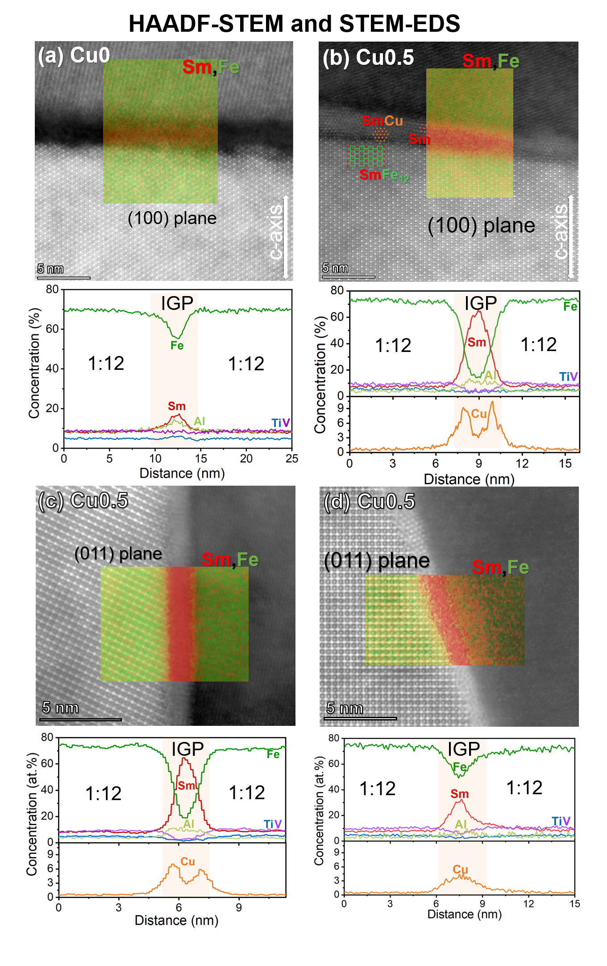
Fig. 4. High-resolution HAADF-STEM images super-imposed with EDS maps, and corresponding elemental concentration profiles for c-plane IGPs of (a) Cu0 and (b) Cu0.5, and for (c), (d) ab-plane IGPs of Cu0.5.
Fig. 4(a) shows a high-resolution HAADF-STEM image of the typical c-plane intergranular phase for the Cu0 magnet. The IGP is ~3 nm thick and has the composition, ~Sm_{19.5}Fe₅₅Al_{12.5}Ti₅V₈ (at.%), as shown in the elemental concentration profiles. In the Cu0.5 magnet (Fig. 4(b)), the IGP has a composition of ~Sm_{64.6}Fe_{14.2}Al_{9.8}Ti_{3.7}V_{3.9}Cu_{3.8} (at.%). The Fe content in the IGP is around ~14 at.%, which is significantly lower compared to that of the Cu0 magnet (55 at.%) as well as the previously-reported SmFe₁₂-based sintered magnets, where the Fe content was around ~45–55 at.% [19, 20]. Although the error from these nanometer-scale analysis is inevitable, the relative change in the IGP compositions is considerable. This reduction in the Fe content in the IGP can cause weakening of the ferromagnetism of the intergranular phases and contribute to the coercivity enhancement. It is noteworthy that close to the interfaces between the IGP region and the SmFe₁₂ phase, enrichment of Cu is observed. This could be related to the existence of the two types of phases (hcp-Sm and CsCl-SmCu) found using the NBED (Fig. 3(c-d)). Moreover, it was found that the Sm-rich intergranular phases are less pronounced in the SEM images when the c-axis is out-of-plane, compared to the case in which the easy-axis is in-plane (Fig. S4). Fig. 4(c) shows a high-resolution STEM–HAADF image of an ab-plane IGP of the Cu0.5 magnet. The composition (having ~18 at.% Fe) and thickness are similar to those of the c-plane IGP, and the Cu-enrichment near the interfaces between the SmFe₁₂ phase and the IGP region can also be observed. Another case of the ab-plane intergranular phase is shown in Fig. 4(d), where the Sm concentration in the IGP is only about 32 at.%. Correspondingly, there is a large amount of Fe (50.4 at.%) in this IGP. There is no Cu-enrichment in the SmFe₁₂/IGP interface in this case, in contrast to the other IGPs observed. This denotes that Cu plays a vital role in suppressing the Fe content of the IGP, which in turn results in high coercivity values. In addition, it should be noted that the Cu content within the SmFe₁₂ grains is negligible, showing that the role of Cu is only in the tuning of IGP magnetism, while not affecting the magnetization of the main phase. Hence, the addition of Cu in the SmFe₁₂-based sintered magnets is highly desirable for optimizing the microstructure to achieve high coercivity.

3.5 Magnetization reversal process
The above results reveal that the high coercivity is mainly attributed to the formation of Fe-lean intergranular phases surrounding the SmFe₁₂ grains. Here, we investigate how the composition in IGPs can influence the magnetization reversal process using a magneto-optical Kerr microscope as shown in Fig. 5. The magnets are shown with its c-axis in plane. These were saturated by use of external magnetic field, and then the field is applied in the opposing direction. In most cases for both the Cu0 and Cu0.5 magnets, the nucleation of reversed domains (dark contrast) occurred near the secondary phases, due to larger stray field. In the Cu0 magnet (Fig. 5(a)), the nucleation of reverse domains can be seen in several regions for the applied field (H_{ext}) of -0.18 T. As H_{ext} slightly decreases to -0.38 T, the size of the reverse domains grows quickly (marked by black arrows) due to exchange-coupling of grains through Fe-rich IGP, and the domains get pinned at only few regions as indicated by white arrow heads. In contrast, in Cu0.5 magnet, with decreasing the external field from -0.48 to -0.77 T, the strong pinning force can be evidently seen as the propagation of the reverse domains is slow. As a result, the size of the reversed domains is smaller than that in Cu0 magnet. With further reduction in magnetic field to 0.98 T, the reversal process proceeds only in a few grains next to the grains with reversed magnetic domains. This indicates the Cu0.5 magnets become more resistive against the demagnetizing field by the reduction of Fe concentration in the IGP after alloying with Cu, hence, the high coercivity is achieved in the Cu0.5 magnet.
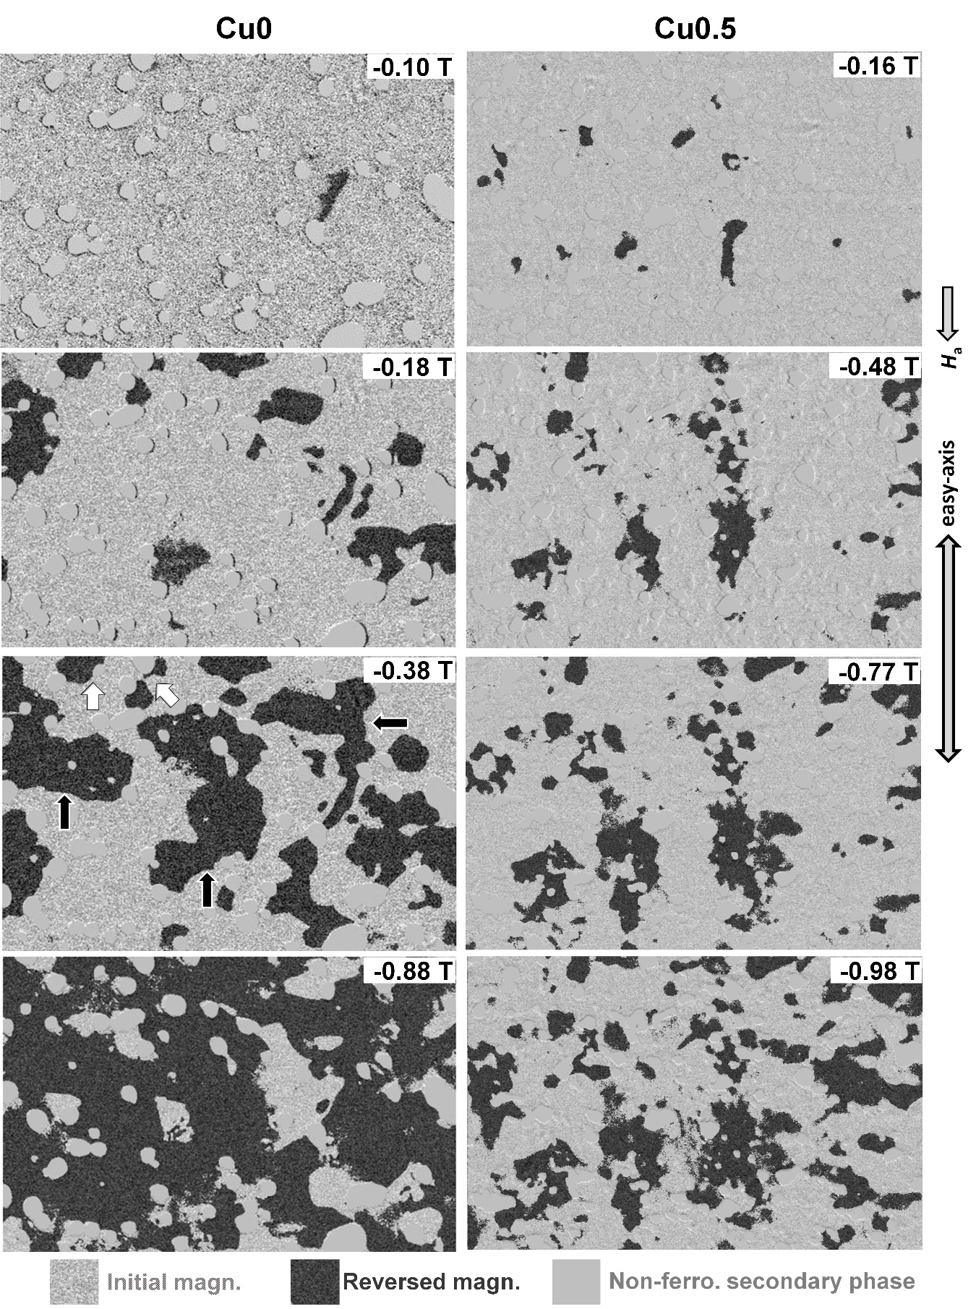
Fig. 5. Kerr microscopy images of Cu0 and Cu0.5 magnets under increasing external magnetic field.

4. Discussion

In this work, we reported a record-high coercivity of 1.40 T in an anisotropic sintered fine-grained Cu-containing SmFe₁₂-based magnet (Cu0.5) produced using strip-cast flakes as the starting material. The average grain size of Cu0.5 magnet was 4.2 μm, larger than that of the Cu0 magnet (2.5 μm), in spite of which, the coercivity of Cu0.5 (1.4 T) is higher than that of Cu0 (0.95 T). This reveals that the GB chemistry plays a crucial role in the coercivity enhancement for this case. It was revealed by microstructure observation (Fig. 3) that Fe content (~14-18 at.%) of the IGPs of the Cu0.5 magnet was lower compared to that in Cu0 (50-60 at.%). How the Fe-lean IGPs were obtained in the Cu0.5 magnet is by the formation of Sm-based Mg-type and SmCu-based CsCl-type structures, co-existing within the intergranular regions (Fig. 4(d)). As a result, the IGP ferromagnetism is considered to be weakened for the Cu0.5 magnet compared to the Cu0 magnet, which not only contributes to large coercivity at room temperature, but also leads to better thermal stability of coercivity as revealed by micromagnetic studies for Nd-Fe-B magnet []. This give rises to stable β over temperature and can be considered as another evidencefor weakening of the IGP ferromagnetism in the Cu0.5 magnet. The Kerr microscopy results (Fig. 5) depict the stronger pinning effect of the domain walls at grain boundaries in the Cu0.5 magnet compared to that of Cu0 magnet, making the importance of Fe-lean IGPs clearly visible. Therefore, the enhanced coercivity of the Cu0.5 magnet is due to the weakened inter-grain exchange-coupling of the SmFe₁₂-based phase, caused by the formation of Fe-lean weak-ferromagnetic IGPs with good wettability. The improved microstructural parameter, α, of the Cu0.5 magnet compared to the Cu0 magnet (Table 1), could mainly stem from the strenthening of exchange-decoupling of the matrix grains (Fig. 3) []. Similarly, the reduced N_{eff} of the Cu0.5 magnet is a result of the reduced stray field from the weakening of exchange-coupling in grains. It is to be acknowledged that the benefit of the refined grain size in the Cu0.5 magnet can be effective only when the grains are exchange-decoupled. Hence, the fine grain size and more importantly, the formation of Fe-lean IGP in this magnet led to the record-breaking coercivity value.

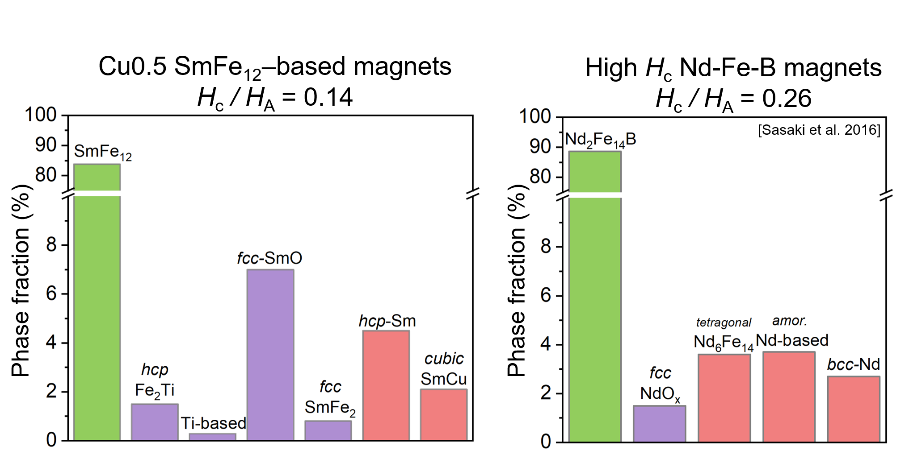
Fig. 6. Areal fraction of constituent phases in the Cu0.5 sintered magnet and a high-coercivity Nd-Fe-B sintered magnet [30].

How to improve the extrinsic magnetic properties beyond the currently reported values in SmFe₁₂-based magnets remains an open question. Using the latest high-coercivity Nd–Fe–B magnet as the model, the pathway to an achievable microstructure and coercivity can be drawn for the SmFe₁₂ magnets. Figure 5 presents the areal fraction of the constituent phases in the Cu0.5 SmFe₁₂-based magnet of this study (µ₀H_{c} = 1.4 T, H_{c}/H_{A} = 0.14) compared with that of a high-coercivity Nd–Fe–B magnet (µ₀H_{c} = 1.8 T, H_{c}/H_{A} = 0.26) [30]. In the case of the Cu0.5 magnet, the fraction of the rare-earth-oxide phase (SmO) is higher (6.8%) compared to that of the Nd–Fe–B magnet (NdO_{x} ~ 1.5%). This oxide phase serves against achieving better continuity of the IGPs [33] and, also contributes to increased reverse nucleation sites (as found in from Kerr microscopy). Therefore, the processing requires further optimization to reduce the oxidation of the SmFe₁₂-based alloy powder. Further, in the Nd–Fe–B magnet, the fraction of the desirable rare-earth-rich phases was higher (9.9%), which resulted in a typically 10 nm thick non-ferromagnetic IGP. This indicates that an increase in the fraction of the rare-earth-rich (Sm+SmCu)-based phase can lead to better continuity of thicker non-ferromagnetic IGPs enveloping all the SmFe₁₂ phase grains, resulting in even higher coercivity values. Moreover, a further decrease of the grain size towards the single domain size 0.6-0.75 µm [23] while avoiding oxidization can also be exploited as another approach for coercivity enhancement. This demonstrates the potential of the SmFe₁₂-based magnet to exhibit a higher coercivity (up to or above 25% H_{A}) through microstructure engineering, including grain boundary engineering and grain refinement. As for remanence improvement, composition and process optimizations are required to eliminate the undesired SmO-, SmFe₂-, Fe₂Ti- and Ti-based phases (mainly SmO), as these phases are expected to dilute the magnetization while having no contribution to coercivity improvement. Ultra low oxygen environment control in the sintering instruments could help in the reduction of the SmO phase. Overall, this comparison gives a guideline on how to further improve the magnetic properties of SmFe₁₂-based sintered magnets toward their practical application.

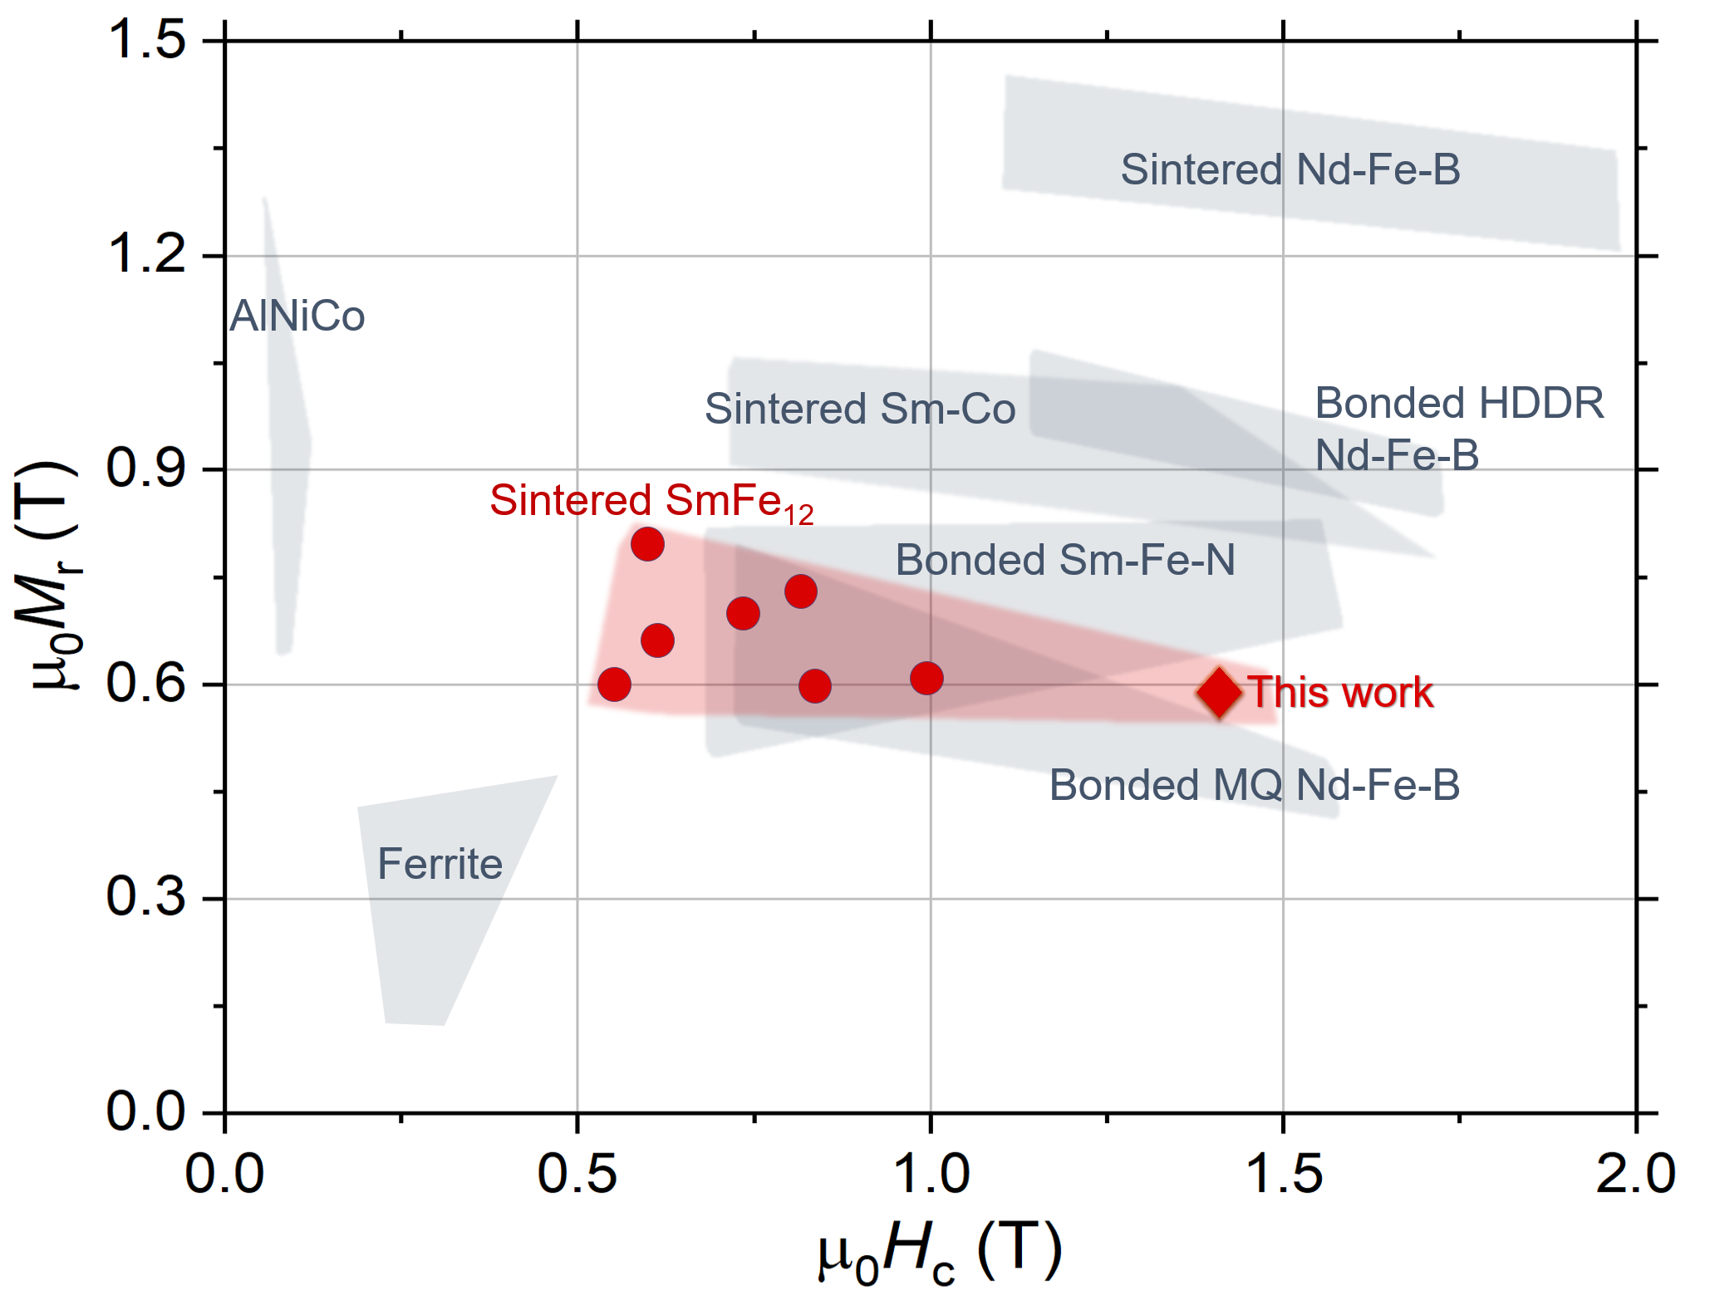
Fig. 6 Remanence versus coercivity benchmark diagram for bulk permanent magnets [22–24], [38–41].

From the perspective of practical applications, the hard-magnetic properties of the Cu0.5 sintered magnet compared with other PM systems are shown in the remanence versus coercivity benchmark diagram, Fig. 6. It is seen that the coercivity reported in this work is the highest for SmFe₁₂-based magnets, and the M_{r} and H_{c} are comparable to those of isotropic Nd–Fe–B bonded magnets. Given the low cost of SmFe₁₂-based magnets, these can be considered as an alternative candidate for applications that use bonded Nd-Fe-B magnets but require good thermal stability [38]–[41]. However, for practical applications, an improvement of the M_{r} is necessary. It is to be noted that the SmFe₁₂ sintered magnets are mostly successfully prepared only with large amounts of stabilizers (Ti and V). Future studies need to be carried out on how to minimize these to achieve higher M_{r} while maintaining the H_{c} values.

5. Conclusions
In this work, we optimized the processing route, alloy composition and achieved a high coercivity of 1.4 T in SmFe₁₂-based ThMn₁₂-type anisotropic sintered magnet. The general microstructure study revealed that microalloying with Cu in combination with use of strip-cast alloy as starting materials leads to formation of Fe-lean IGP enveloping the SmFe₁₂ grains, it hence suppresses exchange-coupling of the main phase grains and contributes to record-breaking coercivity. This is experimentally confirmed as stronger pinning effect was observed in the demagnetization process using MOKE microscopy. The role of Cu in improving the wettability is further revealed using TEM that the Sm-rich phases, such as, the desirable Mg-type Sm-based and CsCl-type SmCu-based phases at the triple junctions, infiltrate into the grain boundaries forming the respective phases as the intergranular phases. This led to the Fe-lean nature of the IGPs, which in turn led to the weakening of the exchange-coupling between the SmFe₁₂ grains and thus the high coercivity. A comparison of the constituent phases of this magnet with that of a high-coercivity Nd–Fe–B sintered magnet as a model, provides the direction for further enhancement in coercivity via the formation of thicker non-ferromagnetic intergranular phases, and for realizing higher remanence by minimizing the undesirable phases, mainly SmO. Overall, this work provides new insights on the microstructure dependency of coercivity in SmFe₁₂-based sintered magnets and discusses the future direction for the development of high-performance industrially viable SmFe₁₂-based magnets.
Acknowledgments
We acknowledge Mr. Y. Toyooka for technical support. Xin Tang acknowledges ICYS for the provision of ICYS fellowship. A. K. Srinithi acknowledges the University of Tsukuba-NIMS joint graduate program for the provision of research assistantship and Dr. Yukiko Takahashi for facilitating measurements.

References
- https://www.marketsandmarkets.com/Market-Reports/permanent-magnet-market-806.html
- https://www.marketsandmarkets.com/Market-Reports/permanent-magnet-motor-market-218887711.html
- https://www.virta.global/en/global-electric-vehicle-market
- https://www.transparencymarketresearch.com/permanent-magnet-generators-market.html
- R. W. McCallum, L. H. Lewis, R. Skomski, M. J. Kramer, and I. E. Anderson, Practical Aspects of Modern and Future Permanent Magnets Annual Review of Materials Research, 44 (2014), pp. 451–477, 10.1146/annurev-matsci-070813-113457
- J. M. D. Coey, Perspective and Prospects for Rare Earth Permanent Magnets Engineering, 6 (2020), pp. 119–131, 10.1016/j.eng.2018.11.034
- K. Ohashi, Y. Tawara, R. Osugi, M. Shimao, Magnetic properties of Fe‐rich rare‐earth intermetallic compounds with a ThMn12 structure, J. Appl. Phys., 64 (2018), pp. 5714–5716, 10.1063/1.342235
- S. F. Cheng, V. K. Sinha, Y. Xu, J. M. Elbicki, E. B. Boltich,W.E. Wallace, S.G. Sankar, D.E. Laughlin, Magnetic and structural properties of SmTiFe11-xCox alloys, J. Magn. Magn. Mater., 75 (1988), pp. 330–338, 10.1016/0304-8853(88)90039-X
- A. M. Gabay, G. C. Hadjipanayis, Recent developments in RFe12-type compounds for permanent magnets, Scripta Mater., 154 (2018), pp. 284–288, 10.1016/j.scriptamat.2017.10.033
- Y. Hirayama, Y. K. Takahashi, S. Hirosawa, K. Hono, Intrinsic hard magnetic properties of Sm(Fe-1 (-) Co-x(x))(12) compound with the ThMn12 structure, Scripta Mater., 138 (2017), 10.1016/j.scriptamat.2017.05.029
- P. Tozman, H. Sepehri-Amin, K. Hono, Prospects for the development of SmFe12-based permanent magnets with a ThMn12-type phase, Scripta Mater. 194 (2021), 113686, 10.1016/j.scriptamat.2020.113686
- D. Goll, Kronmuller, S. Parkin, Micromagnetism-microstructure relations and the hysteresis loop, in Handbook of Magnetism and Advanced Magnetic Materials, New York, NY, USA:Wiley, 2 (2007) pp. 1-36, doi.org/10.1002/9780470022184.hmm214
- K. Hono, H. Sepehri-Amin, Strategy for high-coercivity Nd–Fe–B magnets, Scripta Mater., 67 (2012), pp. 530–535, 10.1016/j.scriptamat.2012.06.038
- A. M. Gabay, G. C. Hadjipanayis, High-coercivity ThMn12-type monocrystalline Sm–Zr–Fe–Co–Ti particles by high-temperature reduction diffusion, Scripta Mater., 196 (2021), 113760, 10.1016/j.scriptamat.2021.113760
- D. Palanisamy, S. Ener, M. Maccari, L. Schäfer, K.P. Skokov, O. Gutfleisch, D. Raabe, B. Gault, Grain boundary segregation, phase formation, and their influence on the coercivity of rapidly solidified SmFe11Ti hard magnetic alloys, Phys. Rev. Mater. 4 (2020), pp. 054404, 10.1103/PhysRevMaterials.4.054404
- C. Zhu, Z. Liu, X. Fan, X. Gao, Z. Liu, W. Cheng, Z. Jia, R. Chen, A. Yan, X. Liu, Phase evolution of ThMn12-type Sm-Fe-Co-Ga-Ti alloys with annealing treatment J. Alloys. Comp., 932 (2023), pp. 167604, 10.1016/j.jallcom.2022.167604
- I. Dirba, H. Sepehri-Amin, I. J. Choi, J. H. Choi, H. S. Uh, T. H. Kim, S. J. Kwon, T. Ohkubo, K. Hono SmFe12-based hard magnetic alloys prepared by reduction-diffusion process, J. Alloys. Comp., 861 (2021), pp. 157993, 10.1016/j.jallcom.2020.157993
- L. Zhao, C. Li, X. Zhang, S. Bandaru, K. Su, X. Liu, Q. Zhou, L. Li, J. M. Greneche, J. Jin, M. Yan, Effects of Sm content on the phase structure, microstructure and magnetic properties of the SmxZr0.2(Fe0·8Co0.2)11.5Ti0.5 (x=0.8–1.4) alloys, J. Alloys. Comp., 828 (2020), pp. 154428, 10.1016/j.jallcom.2020.154428
- I. Dirba, H. Sepehri-Amin, T. Ohkubo, K. Hono, Development of ultra-fine grain sized SmFe12-based powders using hydrogenation disproportionation desorption recombination process, Acta Mater., 165 (2019), pp. 373–380, 10.1016/j.actamat.2018.11.065
- T. Saito, F. Watanabe, D. Nishio-Hamane, Magnetic properties of SmFe12-based magnets produced by spark plasma sintering method, J. Alloys. Comp., 773 (2019), pp. 1018–1022, 10.1016/j.jallcom.2018.09.297
- X. Tang, J. Li, A. K. Srinithi, H. Sepehri-Amin, T. Ohkubo, K. Hono, Role of V on the coercivity of SmFe12-based melt-spun ribbons revealed by machine learning and microstructure characterizations ,Scripta Mater. 200 (2021), 113925, 10.1016/j.scriptamat.2021.113925
- K. Otsuka, M. Kamata, T. Nomura, H. Iida, H. Nakamura, Coercivities of Sm–Fe–M Sintered Magnets with ThMn₁₂-Type Structure (M = Ti, V), Mater. Trans., 62 (2021), pp. 887-891, 10.2320/matertrans.MT-MBW2020003
- J. S. Zhang, X. Tang, H. Sepehri-Amin, A. K. Srinithi, T. Ohkubo, K. Hono, Origin of coercivity in an anisotropic Sm(Fe,Ti,V)12-based sintered magnet, Acta Mater., 217 (2021), 117161, 10.1016/j.actamat.2021.117161
- J. S. Zhang, X. Tang, A. Bolyachkin, A. K. Srinithi, T. Ohkubo, H. Sepehri-Amin, K. Hono, Microstructure and extrinsic magnetic properties of anisotropic Sm(Fe,Ti,V)12-based sintered magnets, Acta Mater. 238 (2022), 118228, 10.1016/j.actamat.2022.118228
- W. Pei, C. He, F. Lian, G. Zhou, H. Yang, Structures and magnetic properties of sintered Nd–Fe–B magnets produced by strip casting technique, J. Magn. Magn. Mater., 239 (2002), pp. 475–478, 10.1016/S0304-8853(01)00654-0
- H. Jung et al, S. Kim, H. Moon, Y. S. Oh, Y-J. Lee, H-S. Lee, W. Lee, Influence of Cooling Condition of Casted Strips on Magnetic Properties of Nd–Fe–B Sintered Magnets Met. Mater. Int., 24 (2018), pp. 1422–1431, 10.1007/s12540-018-0147-y
- A. M. Schönhöbel, R. Madugundo, A. M. Gabay. J. M. Barandiaran, G. C. Hadjipanayis, Nanocrystalline Sm-based 1:12 magnets, Acta Materialia, 200 (2020), pp. 652–658, 10.1016/j.actamat.2020.08.075
- D. Ogawa, X. D. Xu, Y. K. Takahashi, T. Ohkubo, S. Hirosawa, K. Hono, Emergence of coercivity in Sm(Fe0.8Co0.2)12 thin films via eutectic alloy grain boundary infiltration, Scripta Mater., 164 (2019), pp. 140–144, 10.1016/j.scriptamat.2019.02.001
- J. Li , X. Tang, H. Sepehri-Amin, T. T. Sasaki, T. Ohkubo, K. Hono, Angular dependence and thermal stability of coercivity of Nd-rich Ga-doped Nd–Fe–B sintered magnet, Acta Mater., 187 (2020), pp. 66–72, 10.1016/j.actamat.2020.01.035
- T. T. Sasaki, T. Ohkubo, Y. Takeda, T. Sato, A. Kato, Y. Kaneko, K. Hono Formation of non-ferromagnetic grain boundary phase in a Ga-doped Nd-rich Nd–Fe–B sintered magnet, Scripta Mater., 113 (2016), pp. 218–221, 10.1016/j.scriptamat.2015.10.042
- J. Li, X. Tang, H. Sepehri-Amin, T. Ohkubo, K. Hioki, A. Hattori, K. Hono, On the temperature-dependent coercivities of anisotropic Nd-Fe-B magnet, Acta Mater., 199 (2020), pp. 288–296, 10.1016/j.actamat.2020.08.040
- H. Kronmüller, K.-D. Durst, M. Sagawa Analysis of the magnetic hardening mechanism in RE-FeB permanent magnets, J. Magn. Magn. Mater., 74 (1988), pp. 291–302, 10.1016/0304-8853(88)90202-8
- W. F. Li, T. Ohkubo, K. Hono, M. Sagawa, The origin of coercivity decrease in fine grained Nd–Fe–B sintered magnets, J. Magn. Magn. Mater., 321 (2009), pp. 1100–1105, 10.1016/j.jmmm.2008.10.032
- H. Lee, M. K. Kang, G. Lee, J. Kim, Magnetic Properties and Microstructures of Sm–Fe–Ti Alloys With ThMn12 Structure Prepared by Melt-Spinning Method, IEEE Trans. Magn., 58 (2022), pp. 1–6, 10.1109/TMAG.2022.3144221
- E. W. Singleton, J. Strzeszewski, G. C. Hadjipanayis, D. J. Sellmyer, Magnetic and structural properties of melt‐spun rare‐earth transition‐metal intermetallics with ThMn12 structure, J. Appl. Phys., 64 (1988), pp. 5717–5719, 10.1063/1.342236
- A. K. Srinithi, H. Sepehri-Amin, Xin Tang, P. Tozman, J. Li, J. Zhang, S. Kobayashi, T. Ohkubo, T. Nakamura, K. Hono, Phase relations and extrinsic magnetic properties of Sm–(Fe,Co)–Ti–(Ga)-based alloys for ThMn12-type permanent magnets, J. Magn. Magn. Mater., 529 (2021), 167866, 10.1016/j.jmmm.2021.167866
- Y. Wang, G. C. Hadjipanayis, A. Kim, N. C. Liu, D. J. Sellmyer, Magnetic and structural studies in Sm‐Fe‐Ti magnets, J. Appl. Phys., 67 (1990), pp. 4954–4956, 10.1063/1.344745
- https://mqitechnology.com/applications/automotive/
- https://product.tdk.com/en/products/magnet/index.html
- http://www.umag.com.cn/index.php?m=&c=Index&a=lists&catid=2
- K. Binnemans, P. T. Jones, T. Müller, L. Yurramendi, Rare, Earths and the Balance Problem: How to Deal with Changing Markets, J. Sustain. Metall., 4 (2018), pp. 126–146, 10.1007/s40831-018-0162-8

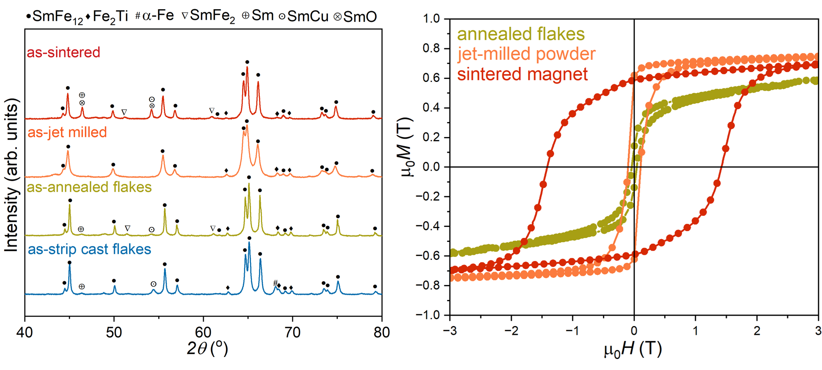
Fig. S1. XRD and M-H loops for the different stages in the sintered magnet making for the Cu0.5 magnet.

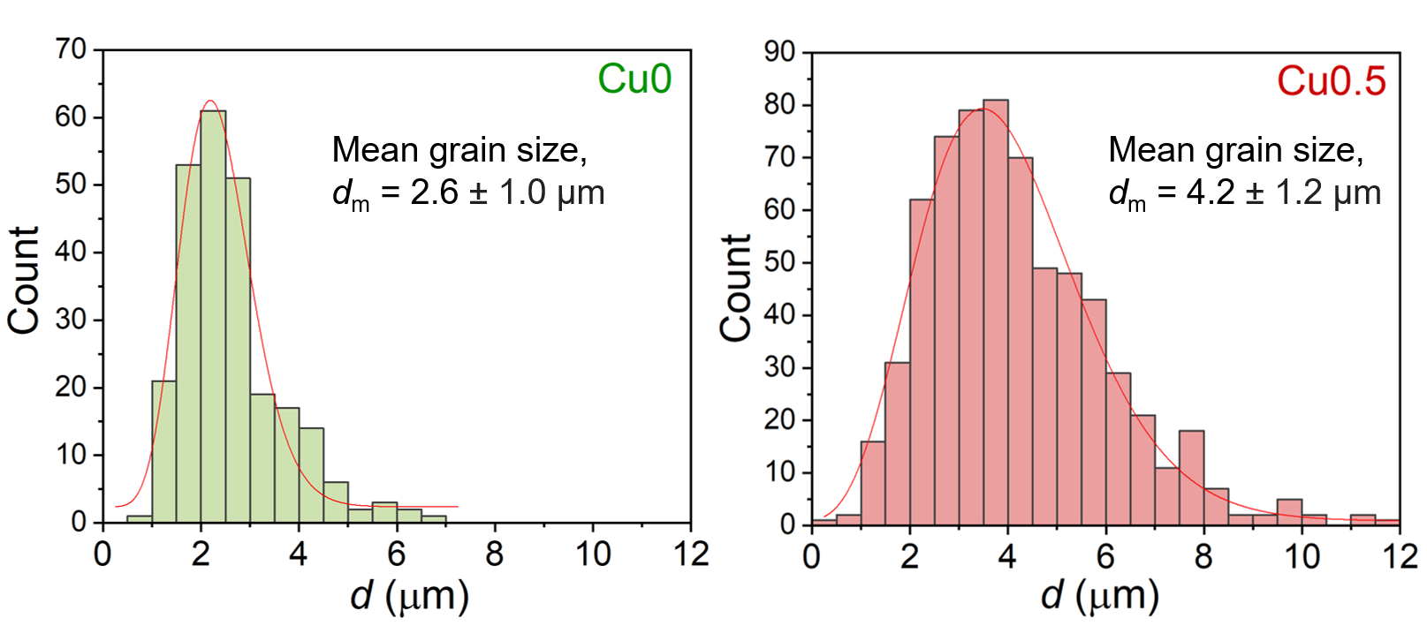
Fig. S2. Grain size distributions for the Cu0 and Cu0.5 sintered magnets.

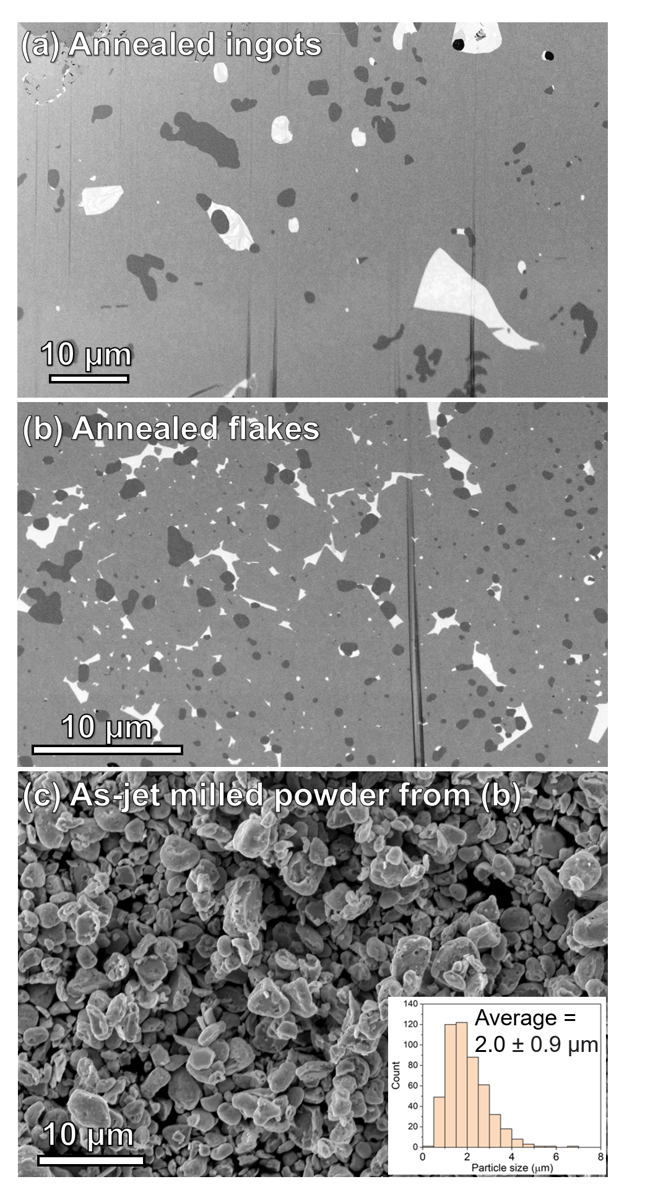
Fig. S3. (a) BSE-SEM of annealed ingots used as the starting material for the Cu0.5-I sintered magnet, (b) annealed strip-cast flakes used as the starting material for the Cu0.5 sintered magnet, and (b) as-jet milled powder made from (b).

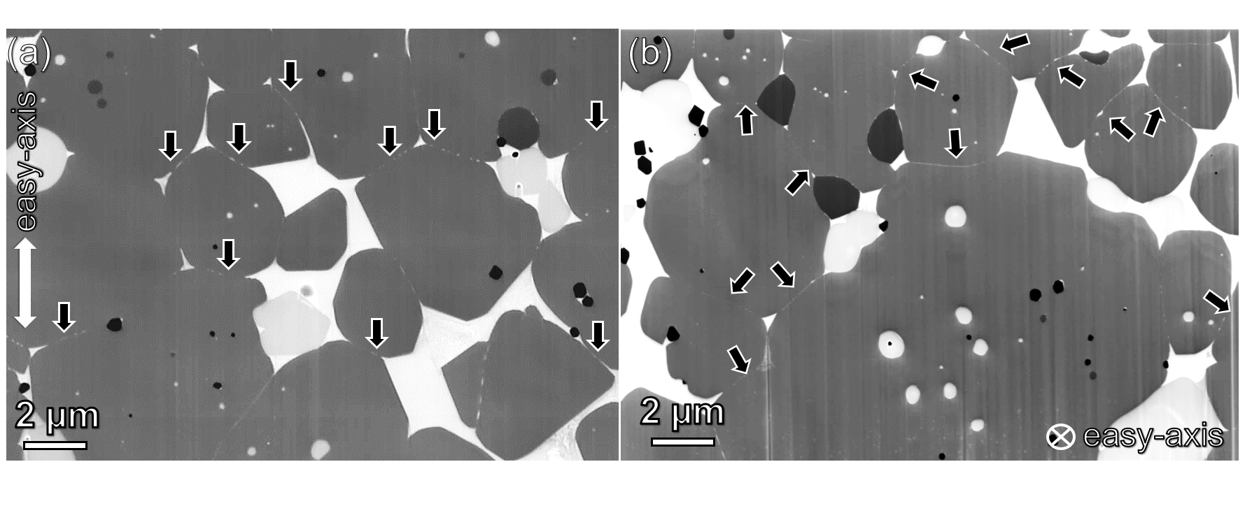
Fig. S4. IL-SE images of Cu0.5 magnet with its easy axis in-plane and out-of-plane, showing that the Sm-rich IGP is more pronounced in the former. There are some cases where the Sm-rich IGPs are not present in the latter.

