α-Al₂O₃/Ga₂O₃ superlattices coherently grown on r-plane sapphire

Takayoshi Oshima^{1,}*, Yuji Kato¹, Masataka Imura², Yoshiko Nakayama³, Masaki Takeguchi³

¹Department of Electrical and Electronic Engineering, Saga University, 1 Honjo, Saga, Saga 840-8502, Japan
²National Institute for Materials Science (NIMS), 1-1 Namiki, Tsukuba, Ibaraki 305-0044, Japan
³NIMS, 1-2-1 Sengen, Tsukuba, Ibaraki 305-0047, Japan

E-mail: oshima@cc.saga-u.ac.jp

Abstract
10-period binary α-Al₂O₃/Ga₂O₃ superlattices were fabricated on r-plane sapphire substrates by molecular beam epitaxy. By systematic variation of the α-Ga₂O₃ thickness and evaluation through X-ray reflectivity and diffraction measurements and scanning transmission electron microscopy, we verified that the superlattice with the α-Ga₂O₃ thickness up to ~1 nm had coherent interfaces without misfit dislocation in spite of the large lattice mismatches. This successful fabrication of coherent α-Al₂O₃/Ga₂O₃ superlattices will encourages further development of α-(Al_{x}Ga_{1-x})₂O₃-based heterostructures including superlattices.

Recently, not only β-Ga₂O₃ but also α-Ga₂O₃ has gained momentum as an emerging wide band gap semiconductor.^{1,2} Although being metastable, corundum-structured α-Ga₂O₃ can be epitaxially stabilized on isostructural sapphire substrate,^{3,4} which allows various studies including epitaxial growth^{4–9} and impurity doping,^{7,10–12} leading to recent demonstration of field effect transistors¹³ and Schottky barrier didoes (SBDs)^{7,14}. Surprisingly, SBDs fabricated using peeled α-Ga₂O₃ layers from the substrate showed low on-resistances less than 1 mΩ cm² regardless of high breakdown voltages nearly 1 kV, whose device performances are comparable to those of SiC- and β-Ga₂O₃-based SBDs.^{7,14–16} These preliminary data encouraging future power electronic applications have made α-Ga₂O₃ a focus of attention from semiconductor academia and industry.
Along with the research and development of α-Ga₂O₃ semiconductor, α-(Al_{x}Ga_{1-x})₂O₃ alloy and its heterostructures have also lured interests. Among the α-Ga₂O₃-based alloy systems,^{14,17} α-(Al_{x}Ga_{1-x})₂O₃ is considered to be the most suitable platform for fabricating high quality semiconductor heterostructures owing to the close ionic radii¹⁸ between 0.62 (Ga³⁺) and 0.535 Å (Al³⁺) and the availability of high quality sapphire substrates. Moreover, relatively strong quantum effects are expected in the α-(Al_{x}Ga_{1-x})₂O₃-based heterostructures because of the large difference in their bandgaps (8.8 and 5.3 eV for α-Al₂O₃ and α-Ga₂O₃, respectively)^{4,19}, which regards the heterostructures attracting and worthy to investigate.
So far, there are some reports on α-(Al_{x}Ga_{1-x})₂O₃-based alloy and its heterostructures. In 2010, growth of Nd-doped α-(Al_{x}Ga_{1-x})₂O₃ epitaxial films with entire x was first reported by molecular beam epitaxy (MBE), where coherent growth was realized under x = 0.61.²⁰ Later in 2012, mist chemical deposition (Mist-CVD) of undoped α-(Al_{x}Ga_{1-x})₂O₃ films (0 ≤ x ≤ 0.81) was reported to show continuous tuning of the bandgap by optical absorption spectroscopy.²¹ Their group also reported enhanced thermal stability of α-Ga₂O₃ by alloying with α-Al₂O₃ in 2015.²² Moreover in 2016, an quasi-composition-graded buffer layer alternatively stacked with α-(Al_{0.2}Ga_{0.8})₂O₃ and α-(Al_{0.9}Ga_{0.1})₂O₃ layers was fabricated using Mist-CVD technique to reduce dislocations in the α-Ga₂O₃ layer deposited thereon.²³ Furthermore very recently in 2018, band discontinuities of the α-Ga₂O₃/(Al_{x}Ga_{1-x})₂O₃ (0.1≤x≤0.8) heterojunction interfaces were revealed by using X-ray photoemission spectroscopy.²⁴ These reports encourage the notion of α-(Al_{x}Ga_{1-x})₂O₃-based heterostructures, but there still needs much efforts to understand the heterostructures.
One of the subjects for the development of α-(Al_{x}Ga_{1-x})₂O₃-based heterostructures is to realize coherent α-Al₂O₃/Ga₂O₃ superlattices (SLs). Because presence of the simple binary SLs comprised of the two end members guarantees fabrication of all the possible α-(Al_{x}Ga_{1-x})₂O₃-based heterostructures including SLs with entire x, aside from the limitation of each layer thickness to maintain the structural coherence. As for the critical thickness of the α-Ga₂O₃ layer, a few literatures on detailed structural analysis for Ga₂O₃ epitaxial films directly grown on c- and a-plane sapphire substrates revealed that it is as small as ~1 nm,^{25,26} which is expected from large lattice mismatches (4.8 and 3.4% along a- and c-axis, respectively)^{27,28}. This fact indicates the high possibility of realization of coherent α-Al₂O₃/Ga₂O₃ SLs though the thickness of α-Ga₂O₃ layer (d_{Ga}) is very small.
We, therefore, attempted to fabricate α-Al₂O₃/Ga₂O₃ SLs with different d_{Ga} on sapphire substrates and investigate their layered structure and crystallinity systematically. The results in detail are given below.
10-period Al₂O₃/Ga₂O₃ SLs were fabricated directly on sapphire substrates by conventional plasma-assisted MBE. In this study, we used r-plane (0112) sapphire (Kyocera Corp.) as substrate because its face is known to facilitate homoepitaxial growth of α-Al₂O₃.²⁹ Prior to the growth these substrates were degreased by ultrasonic cleaning in acetone and methanol. Our growth was performed by supplying elemental metals of Ga and Al and oxygen radicals to the heated rotating substrate from conventional effusion cells and an inductively coupled plasma cell, respectively. The Ga and Al beam equivalent pressures were set at 0.9×10⁻⁷ and 1.89×10⁻⁶ Pa by regulating their cell temperatures at 716 and 1050°C, respectively. While the plasma cell was operated under an input RF power of 200 W and an O₂ flow rate of 0.50 sccm. The substrate holder temperature was maintained at 560–580°C, which was monitored through a pyrometer. By controlling Ga and Al cell shutters, Ga₂O₃ and Al₂O₃ layers were alternately stacked to produce 10-period SLs. To evaluate the dependence of d_{Ga}, we prepared three SL samples labeled A, B, and C by changing a supply period of Ga beam (40, 80, and 120 s, respectively) under a constant Al beam supply period (270 s).
After each growth, reflection high-energy electron diffraction (RHEED) was performed to evaluate surface crystallinity, as shown in Fig. 1. In the case of samples A and B, streaky patterns with Kikuchi lines were observed, reflecting highly crystalline flat films. In contrast, a halo pattern was appeared for sample C, suggesting poor crystallinity of the top layer. The transition of the crystallinity is considered to be attributed to increase in d_{Ga}.
To determine the layer thicknesses of the SLs, X-ray reflectivity (XRR) measurement was carried out. Figure 2(a) shows XRR patterns for the SLs samples. In all the patterns, 8 short-period weaker peaks between long-period stronger ones were identified, which are consistent as the pattern of 10-period SL. From the reflectivity patterns, α-Al₂O₃ layer thickness (d_{Al}) and d_{Ga} were extracted by fitting multilayer model curves to the measured data [See dashed lines in Fig. 2 (a)]. Note that densities of α-Al₂O₃ and α-Ga₂O₃ layers in the models were set as those of bulk ones (D_{Al} = 4.00 gcm⁻³ and D_{Ga} = 6.47 gcm⁻³, respectively) under the assumption that their unit cell volumes are irrelevant to the strain. The obtained d_{Al} and d_{Ga} are summarized in Table 1. The roughly constant d_{Al} of 5.8–6.1 nm and increased d_{Ga} from 0.5 to 1.3 nm in order from sample A to C reflect the designed Al and Ga metal supply periods in the growth. The corresponding growth rates were 1.3–1.4 and 0.65–0.75 nm/min for α-Al₂O₃ and α-Ga₂O₃ layers, respectively. We also list average Al compositions (x_{ave}) of the SLs, which are equivalent to the fraction of number of constituent atoms of the α-Al₂O₃ layer in one period calculated as follows:
$$x_{\text{ave}}=\frac{{\text{D}}_{\text{Al}}{\text{d}}_{\text{Al}}{S/{\text{M}}_{\text{Al}}}_{}^{}}{{\text{D}}_{\text{Al}}{\text{d}}_{\text{Al}}{S/{\text{M}}_{\text{Al}}}_{}^{}\text{+}{\text{D}}_{\text{Ga}}{\text{d}}_{\text{Ga}}{S/{\text{M}}_{\text{Ga}}}_{}^{}}$$
, where S is an unit area and M_{Al} and M_{Ga} are molecular weight of α-Al₂O₃ and α-Ga₂O₃, respectively.
To further reveal crystallinity of the α-Al₂O₃/Ga₂O₃ SLs, X-ray diffraction (XRD) measurement was conducted. Figures 2(b) and (c) show XRD θ-2θ patterns of the SLs in wide and narrow 2θ ranges, respectively. Only the reflection peaks attributed to 0112 and 0224 were recorded in the wide scan patterns, indicating successful epitaxial stabilization of the corundum phase [See Fig. 2(b)]. These peaks were consisted of zeroth order and higher order satellite peaks attributed to SL structures, as seen in the narrow scan patterns [See Fig. 2(b)]. In particular, for the samples A and B, 8 peaks between the zeroth order and the first order satellite peaks were clearly identified, showing relatively high crystallinity. On the other hand, no such fine structure was observed for the sample C owing to poor crystallinity. The full width at half maximums of 0224 rocking curves of the zeroth peaks were 230, 205, and 573 arcsec for samples A, B, and C, respectively. From the out-of-plane XRD analysis together with the RHEED observation, we speculated that lattice relaxation caused by the thicker d_{Ga} was responsible for the poor crystallinity of the sample C.
To evaluate structural coherency of the SLs, asymmetric reciprocal space maps were taken. Figure 3 shows XRD reciprocal space maps near 2246 spots of the SL samples. Zeroth order spots of all the SLs were detected near those of the substrates, but their positional relationships were different from sample to sample. The spots for samples A and B were on the same Q_{X} lines as those of the substrates, whereas the spot for sample C was partially displaced from the line. These results indicate that the fabricated α-Al₂O₃/Ga₂O₃ SLs maintained structural coherence to the sapphire substrates up to d_{Ga} ~ 1 nm (Samples A and B), but relaxed when d_{Ga} surpassed ~ 1 nm (Sample C) owing to the large compressive strain in the α-Ga₂O₃ layer. The critical thickness of ~ 1 nm is coincide with the reported value of single α-Ga₂O₃ films on sapphire substrates.^{25,26} We also noticed that x_{ave} = 0.86 of sample C is much larger than x = 0.61 of the coherently grown α-(Al_{x}Ga_{1-x})₂O₃ alloy film on sapphire substrate reported in Ref. ²⁰. Therefore, d_{Ga} is more responsible for maintaining the coherency in α-Al₂O₃/Ga₂O₃ SLs than x_{ave}.
Finally, to directly observe the crystal lattices of the SL, cross-sectional scanning transmission electron microscopy (STEM) was performed for Sample B. For this purpose, a TEM specimen was prepared by conventional focused ion beam lift out technique. First, a 40 kV beam was employed to dig the both sides of the target position roughly, followed by making it thinner to be 100 nm thick with a 30 kV beam. The lamella TEM specimen with a thickness less than 70nm was obtained by further careful thinning with a 10 kV beam. Final gentle polishing with a 5kV beam for 60 s for each side resulted in minimizing the damage layer of the specimen. The acceleration voltage and viewing direction were 200 kV and [2110], respectively. As designed, 10-period α-Al₂O₃ (brighter contrast)/Ga₂O₃ (darker contrast) SL structure was observed as shown in the bright-field (BF) STEM image [Fig. 4(a)]. In this image, lots of darker contrast areas spread from α-Ga₂O₃ layers were also seen in the α-Al₂O₃ layers, indicating strong strain in the lattices stemming from the interfaces. However, we did not find any trace of misfit dislocation near the interfaces as shown in the magnified BF and high-angle annular dark-field (HAADF) views [Figs. 4(b) and (c)]. Particularly in the HAADF-STEM image, where heavier (lighter) elements contribute to brighter (darker) contrast owing to the Z contrast rule,³⁰ we clearly observed arrays of dumbbells consisting of metal atoms in the corundum structure [See Fig. 4(d)], and verified that in plane array of Al dumbbells (darker contrast) perfectly matched with those of Ga dumbbells (brighter contrast) at the interfaces. Note that image contrast of O atoms were not significantly seen because O atom is lighter than Al. These results mean coherent α-Al₂O₃/Ga₂O₃ SLs without misfit dislocations can be fabricated in spite of the large mismatches.
In conclusion, in order to explore and encourage the study on α-(Al_{x}Ga_{1-x})₂O₃-alloy-based heterostructures, we fabricated α-Al₂O₃/Ga₂O₃ model SLs for the first time on r-plane sapphire by MBE, and evaluated their layered and epitaxial structures using RHEED, XRR, XRD, and STEM techniques. We found that d_{Ga} was the most important parameter to maintain coherency of heterojunction interfaces and the critical thickness was as small as ~1 nm, whose value is roughly coincided with the reported thickness of the α-Ga₂O₃ interlayer existed at the interface of β-Ga₂O₃ thick film on sapphire substrate. Although the critical thickness of d_{Ga} in the binary SLs was small, it can be increased for α-(Al_{x}Ga_{1-x})₂O₃ (0 < x < 1) alloy-based heterostructures including SLs. We believe our provided results will contribute for further development of α-(Al_{x}Ga_{1-x})₂O-based heterostructure studies.

Acknowledgments
This work was supported by a JSPS Grant-in-Aid for Scientific Research (No. 16K13673) and NIMS microstructural characterization platform as a program of "Nanotechnology Platform" of the Ministry of Education, Culture, Sports, Science and Technology (MEXT), Japan.

References
¹ AFRL, Assessment of Gallium Oxide Technology (2017).
² S.J. Pearton, J. Yang, P.H. Cary, F. Ren, J. Kim, M.J. Tadjer, and M.A. Mastro, Appl. Phys. Rev. 5, 11301 (2018).
³ R. Roy, V.G. Hill, and E.F. Osborn, J. Amer. Chem. Soc. 74, 719 (1952).
⁴ D. Shinohara and S. Fujita, Jpn. J. Appl. Phys. 47, 7311 (2008).
⁵ M. Oda, K. Kaneko, S. Fujita, and T. Hitora, Jpn. J. Appl. Phys. 55, 1202B4 (2016).
⁶ Y. Oshima, E.G. Víllora, and K. Shimamura, Appl. Phys. Express 8, 55501 (2015).
⁷ M. Oda, R. Tokuda, H. Kambara, T. Tanikawa, T. Sasaki, and T. Hitora, Appl. Phys. Express 9, 21101 (2016).
⁸ H. Nishinaka, D. Tahara, S. Morimoto, and M. Yoshimoto, Mater. Lett. 205, 28 (2017).
⁹ K. Kaneko, H. Kawanowa, H. Ito, and S. Fujita, Jpn. J. Appl. Phys. 51, 20201 (2012).
¹⁰ T. Kawaharamura, G.T. Dang, and M. Furuta, Jpn. J. Appl. Phys. 51, 40207 (2012).
¹¹ K. Akaiwa and S. Fujita, Jpn. J. Appl. Phys. 51, 70203 (2012).
¹² K. Akaiwa, K. Kaneko, K. Ichino, and S. Fujita, Jpn. J. Appl. Phys. 55, 1202BA (2016).
¹³ G.T. Dang, T. Kawaharamura, M. Furuta, and M.W. Allen, IEEE Trans. Electron Devices 62, 3640 (2015).
¹⁴ K. Kaneko, S. Fujita, and T. Hitora, Jpn. J. Appl. Phys. 57, 02CB18 (2018).
¹⁵ K. Konishi, K. Goto, H. Murakami, Y. Kumagai, A. Kuramata, S. Yamakoshi, and M. Higashiwaki, Appl. Phys. Lett. 110, 103506 (2017).
¹⁶ J. Yang, S. Ahn, F. Ren, S.J. Pearton, S. Jang, J. Kim, and A. Kuramata, Appl. Phys. Lett. 110, 192101 (2017).
¹⁷ S. Fujita and K. Kaneko, J. Cryst. Growth 401, 588 (2014).
¹⁸ R.D. Shannon, Acta Crystallogr. Sect. A 32, 751 (1976).
¹⁹ R.H. French, J. Am. Ceram. Soc. 73, 477 (1990).
²⁰ R. Kumaran, T. Tiedje, S.E. Webster, S. Penson, and W. Li, Opt. Lett. 35, 3793 (2010).
²¹ H. Ito, K. Kaneko, and S. Fujita, Jpn. J. Appl. Phys. 51, 100207 (2012).
²² S. Lee, Y. Ito, K. Kaneko, and S. Fujita, Jpn. J. Appl. Phys. 54, 3 (2015).
²³ R. Jinno, T. Uchida, K. Kaneko, and S. Fujita, Appl. Phys. Express 9, 71101 (2016).
²⁴ T. Uchida, R. Jinno, S. Takemoto, K. Kaneko, and S. Fujita, Jpn. J. Appl. Phys. 57, 40314 (2018).
²⁵ R. Schewski, G. Wagner, M. Baldini, D. Gogova, Z. Galazka, T. Schulz, T. Remmele, T. Markurt, H. von Wenckstern, M. Grundmann, O. Bierwagen, P. Vogt, and M. Albrecht, Appl. Phys. Express 8, 11101 (2015).
²⁶ Z. Cheng, M. Hanke, P. Vogt, O. Bierwagen, and A. Trampert, Appl. Phys. Lett. 111, 162104 (2017).
²⁷ M. Marezio, J. Chem. Phys. 46, 1862 (1967).
²⁸ N. Ishizawa, T. Miyata, I. Minato, F. Marumo, and S. Iwai, Acta Crystallogr. Sect. B Struct. Crystallogr. Cryst. Chem. 36, 228 (1980).
²⁹ T. Maeda, M. Yoshimoto, T. Ohnishi, G.H. Lee, and H. Koinuma, J. Cryst. Growth 177, 95 (1997).
³⁰ Z.C. Feng, III-Nitride Devices and Nanoengineering (Imperial College Press, 2008).

Figures
Fig. 1. RHEED patterns of the sample A, B, and C taken after the growth. The incident electron beam direction was [2110].

Fig. 2. X-ray θ-2θ scan patterns of the sample A, B, and C. Patterns of (a) show XRR, and those of (b) and (c) show XRD in wide and narrow scan ranges, respectively. Dashed lines in (a) were obtained by curve fitting under the assumption that densities of the α-Al₂O₃ and α-Ga₂O₃ layers are the same as those of bulk ones. Note that monochromatic Cu K_{α1} radiation was used for XRR and XRD measurements.

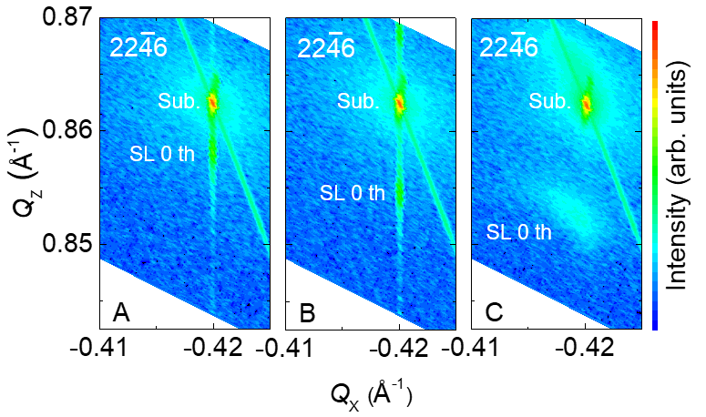
Fig. 3. XRD reciprocal space map in the vicinity of 2246 spots of the sample A, B, and C. Directions of Q_{Z} and Q_{X} are along 0112 and 2110, respectively.

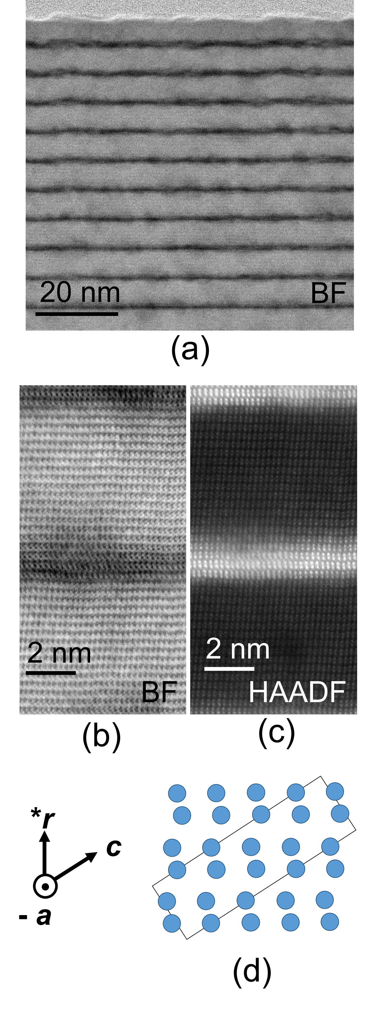
Fig. 4. (a) and (b) BF- and (c) HAADF-STEM images of the SL sample B with incident beam direction along [2110]. (b) and (c) are images from the same area. (d) Metal atom positions (circles) of the corundum structure around the unit cell (solid line).

Table 1. Summary of each layer thickness and x_{ave} for the SL samples.
Sample | d_{Al} (nm) | d_{Ga} (nm) | d_{Al} + d_{Ga} (nm) | x_{ave}
A | 5.8 | 0.5 | 6.3 | 0.94
B | 6.1 | 1.0 | 7.1 | 0.89
C | 6.0 | 1.3 | 7.3 | 0.86

