In-situ formed nano-Cu pathways in binders endowing pastes high conductivity with low metal content
Wanli Li ª, Pengcheng Rui ª, Songtang Li ª, Lingying Li ^{b}, Minari Takeo ^{b}, Su Ding ^{a,}*, Ke Li ª

ª School of Intelligent Manufacturing, Jiangnan University, Wuxi 214122, China
^{b} Research Center for Functional Materials, National Institute for Materials Science, Tsukuba, Ibaraki 3050044, Japan
*Corresponding authors
E-mail addresses: dingsu@jiangnan.edu.cn (Su Ding)

Abstract
Although adding binders could significantly improve the adhesion between metal pastes and polymer substrates, they also considerably decrease conductivity of printed circuits, limiting its applications in printed electronics. This study innovatively adds the copper (Cu) precursor into the paste to solve this problem. Cu nanoparticles are formed on the surface of Cu flakes and within the binders due to their in–situ decomposition characteristics. The decomposed Cu nanoparticles construct more conductive pathways that improves the conductivity of printed circuits. Furthermore, this study employs an orthogonal test to investigate the relationship between the formulation of pastes and the performance of printed circuits, optimizing the proportion of the Cu precursor and binders based on these results. Compared to conventional pastes that consist solely of Cu fillers, binders, and solvents, the paste developed in this study exhibits high conductivity which is approximately 2.6 times of the pure Cu flake paste at low metal content around 40%. Thus, with more binders, the printed circuits not only met the 5B level according to ASTM D3359 standards but also showed excellent electrical property after curing at 200 °C for 5 min, achieving a resistivity as low as 331 μΩ·cm. Additionally, the paste exhibited outstanding performance in application of heaters and ultra-broadband (UWB) antennas, further confirming its considerable potential for commercial printed circuits.

Keywords: copper pastes, printed electronics, precursor, resin, heaters, antennas

Introduction
Printed electronics is an emerging technology that utilizes printing techniques to fabricate electronic devices and circuits¹. Compared with manufacturing methods of traditional electronics, printed electronics offers a simple process, reduced material waste, and lower environmental pollution, providing economic and ecological benefits². Metal conductive pastes attracting increasing attention due to their critical role in determining printed circuits' conductivity, stability, and reliability ³⁻⁵.

To date, silver (Ag) pastes have played a crucial role in printed electronics due to their excellent conductivity⁶⁻⁹. They are widely used in fields such as 5G communication devices¹⁰, radio frequency identification (RFID) tags¹¹⁻¹³, solar cells¹⁴, and new energy vehicles¹⁵. However, the price of Ag has increased by approximately 80% over the past five years, resulting in a massive rise in the cost of Ag pastes and related products. To mitigate these costs, copper (Cu) pastes have garnered increasing attention¹⁶. Cu exhibits comparable electrical and thermal conductivity to Ag and just 1% of the cost of Ag. Nevertheless, Cu is susceptible to oxygen, especially at the nanoscale, that it can be oxidized rapidly, even at room temperature. Compared to nano-Cu materials, larger Cu particles or Cu flakes can enhance the oxidation resistance of Cu. This improvement is attributed to their relatively smaller specific surface area and lower surface energy¹⁷. However, the low packing density and sintering driving force of larger Cu particles and flakes make it challenging to attain high conductivity in printed circuits.

On the other hand, the lack of stable chemical bonds between metals and polymer substrates results in inadequate interfacial adhesion of pastes, directly impacting the practical performance of printed circuits. To solve this problem, researchers have explored various methods to improve adhesion, which can be broadly categorized into physical and chemical approaches. Physical methods include surface pretreatment and localized softening of the substrate, which effectively enhance the contact area between the substrate and the conductive paste. For example, Zhou et al. performed etching treatments on the substrate surface¹⁸, resulting in a distinctive recessed structure that effectively anchors paste and enhances adhesion. However, the significant expense associated with etching treatments and the potential environmental pollution concerns cannot be overlooked. Liu et al. utilized photonic sintering to rapidly generate high local temperatures¹⁹, partially softening the substrate to embed the conductive structure. Nonetheless, this process necessitates that the substrates endure these instantaneous high temperatures without deforming, thereby restricting the selection of substrate. In contrast, chemical methods involve the direct addition of binders into a conductive paste to enhance connections between the substrate and the paste through additives. For instance, Sakurai et al. found that the functional groups at both ends of silane coupling agents can form covalent bonds with the polymer substrate and the metal, enhancing interfacial adhesion²⁰. However, as the thickness of the conductive structure increases, the effectiveness of silane coupling agents decreases, resulting in diminished reliability. Ma et al. discovered that resins can form a highly cross-linked three-dimensional network structure that stabilizes the metal, while the hydroxyl groups on the resin create strong chemical bonds with the substrate surface, further enhancing adhesion²¹. However, this structure can render printed circuits excessively brittle, failing to meet flexibility requirements. Ryu et al. discovered that adding cellulose as an alternative to the part of resins can ensure the adhesion of printed circuits while maintaining flexibility²². However, the desired adhesion can only be achieved when the total addition of resin and cellulose exceeds 30 wt.% ^{12, 23}. These excess binders will form an insulating layer between the conductive fillers, resulting in a substantial reduction in the electrical performance of printed circuits.

In this study, we propose a novel synthesis method for Cu pastes by adding Cu precursor into the resin. Cu nanoparticles are grown in the insulating matrix composed of resin and cellulose by utilizing the in-situ decomposition characteristics of the precursor. This process effectively constructs conductive pathways, thereby enhancing the electrical performance of printed circuits. Compared to conventional pastes that contain only Cu, binders, and solvents, the newly developed paste achieves approximately 2.6 times greater electrical performance while reducing the total metal content by about 15 wt.%. This finding provides new ideas for developing high-conductivity pastes with low metal content, thereby enhancing the practical application of Cu pastes in the printing of flexible electronics.

Experimental section
Materials: ethylene glycol (EG), 2-amino-2-methyl-1-propanol (AMP), 1-butanol, and ethyl cellulose ether were purchased from Adamas. Cu (II) formate tetrahydrate was purchased from Alfa Chemicals. Cu flakes (5-10 μm) were provided by Hangzhou Xinshichuanglian Technology Co., Ltd. Phenolic resin (70-75% solid content) was purchased from Wuxi Guangming Chemical Co., Ltd. The PI film with a thickness of 25 μm was purchased from Yingda Hardware Co., Ltd.

Synthesis of Cu precursor: The synthesis of the Cu precursor was performed following the method in reference²⁴. First, AMP and Cu (II) formate tetrahydrate powder was mixed with a mole ratio of 2:1 and stirred in a planetary mixer for 5 min to promote the formation of Cu complexes. The mixture was then stirred with a magnetic stirrer for 4h to achieve a homogeneous Cu precursor.

Preparation of Cu pastes and post-treatment: Initially, the mass of the Cu flakes was used as a reference to mix them with 0-50 wt.% phenolic resin and 0–50 wt.% ethyl cellulose. Subsequently, the Cu precursor was added by various mass ratios (Cu flake: Precursor was set from 10:0 to 0:10). An appropriate amount of 1-butanol and EG was then added to adjust the viscosity of the paste. The resulting mixture was placed in a planetary mixer and stirred for 10 min to obtain a homogeneous Cu paste. The printed circuits were fabricated using a screen-printing process, where the paste was printed onto a polyimide (PI) substrate to create the pattern. The samples were subsequently placed in a nitrogen atmosphere for thermal curing, with a temperature range of 140–220 °C and a curing duration of 1-120 min.

Fabrication of heaters and antennas: The Cu paste was printed on the PI substrate into the designed heater and antenna patterns using a screen-printing process. Then, the printed samples were placed in a nitrogen furnace for thermal curing, with a temperature of 200 °C and a duration of 5 min.

Characterization: The surface microstructure of the printed circuits was observed by a scanning electron microscope (SEM, EVO18, Carl Zeiss). The thermal behavior of the paste was characterized with a thermal analyzer (TG-DSC, STA 6000, PerkinElmer). The crystal phase of the printed circuits was analyzed using an X-ray diffractometer (XRD, D2 PHASER A26-X1-A2E0B2A0, Bruker). The resistance of the printed circuits was measured by a multimeter (UT61A/C, UNI-T). The resistivity was assessed by a four-point probe resistivity tester (ST2263, Suzhou Lattice Electronics Co., Ltd.). The adhesion of the printed circuits was evaluated according to ASTM D3359 standards. The flexibility of the printed circuits was evaluated through five bending tests with a radius of 12 mm. Surface morphology was examined with an optical microscope (GP-660V, Highpoint). The temperature variations of the heater samples were measured by a thermal infrared imager (H36, Hikvision). The gain performance, radiation pattern, and return loss values of the antenna samples were assessed by a vector network analyzer (Keysight E5063A, Keysight Technologies).

Results and discussion
Figure 1a shows a schematic diagram of the in-situ formed nano-conductive pathways using Cu precursor in the paste. First, Cu flakes, Cu precursor, solvents, and resins are uniformly mixed to create a metal paste. The Cu precursor decomposes in situ during the curing process to generate Cu nanoparticles. These particles create conductive pathways within the insulating resin matrix and facilitate additional routes for electron transfer between the Cu flakes.

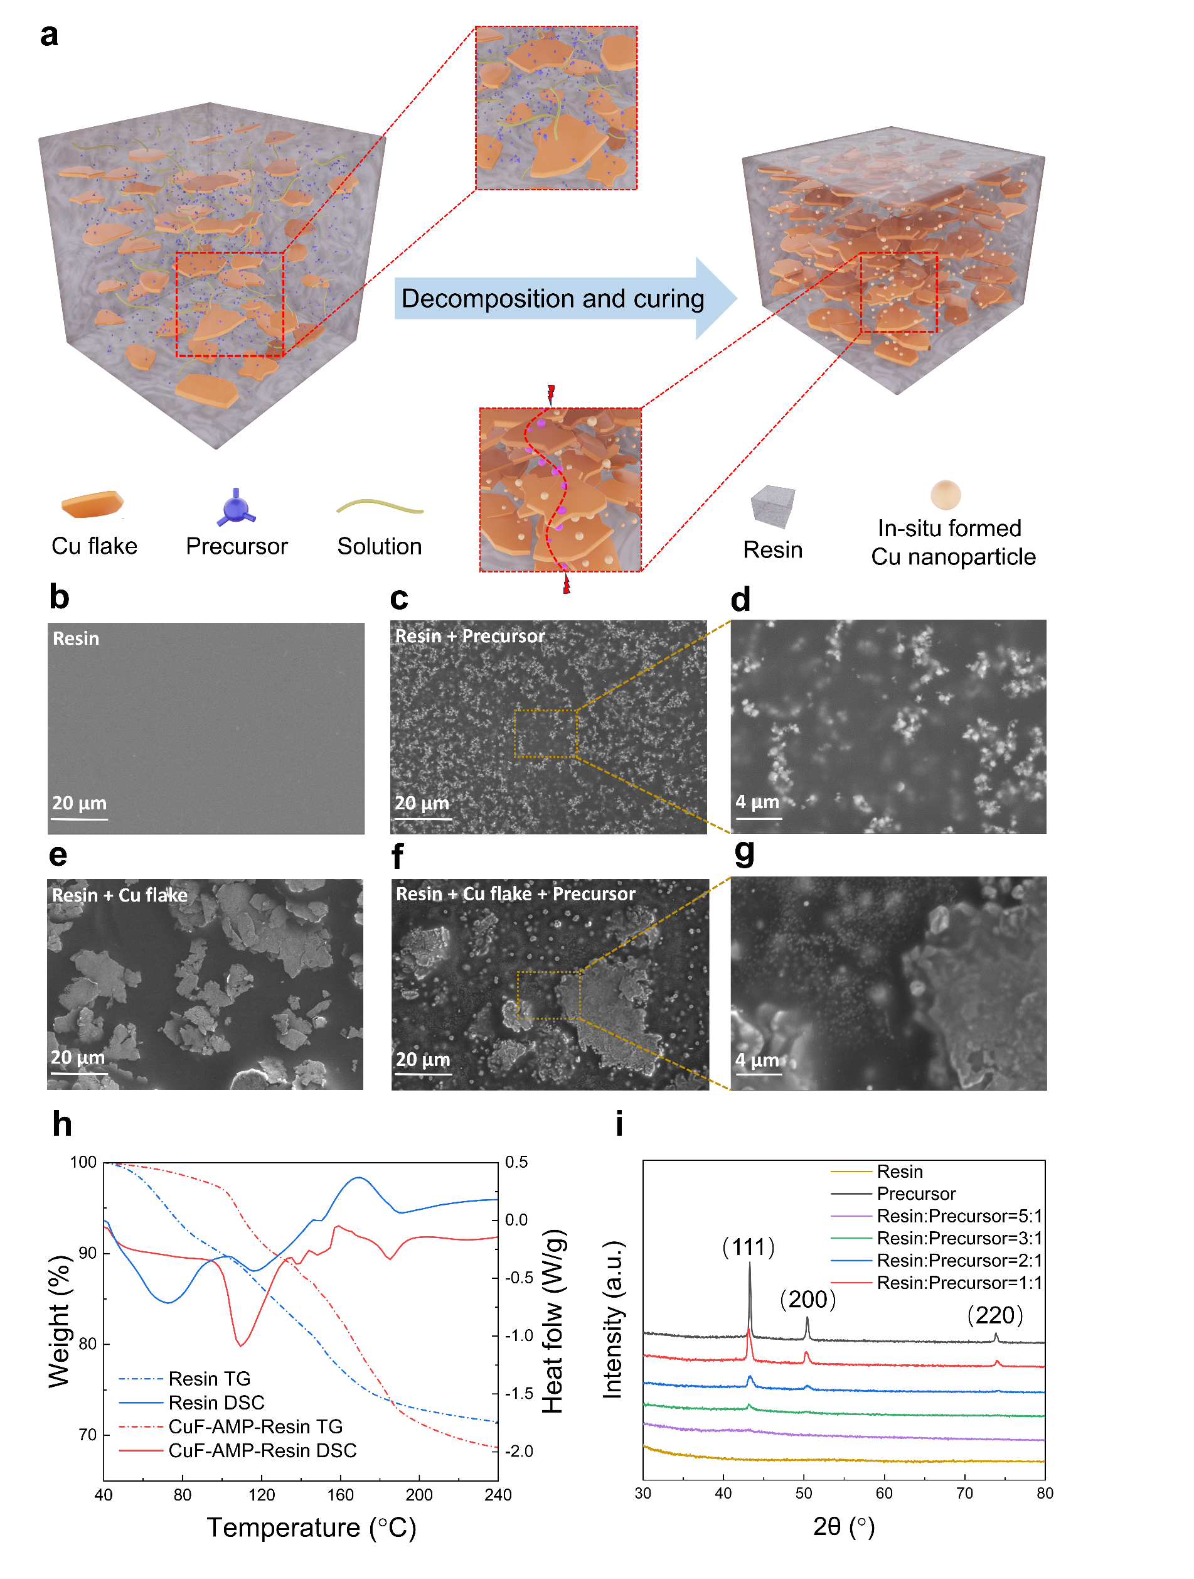
Figure 1 (a) Schematic diagram of the in-situ decomposition of Cu nanoparticles to form a conductive network within the resin matrix. (b) SEM images of pure resin and(c-d) resin mixed with Cu precursor after curing. (e) SEM images of the paste without Cu precursor and (f-g) mixed with Cu precursor after curing. (h) TG-DSC characterization of resin and Cu precursor/resin mixture (CuF-AMP-Resin). (i) XRD patterns of resin, CuF-AMP, and CuF-AMP-resin (Resin: CuF-AMP = 5-1:1) after heat treatment at 180 °C for 5 min in a nitrogen atmosphere.

Figure 1b shows the SEM image of pure resin after curing. The surface of the resin matrix is uniformly smooth and free of impurities. In contrast, numerous nanoparticle clusters, ranging in size from approximately 500 to 1000 nm, appear within the resin matrix after adding precursor (Figures 1c, d). Figure 1e shows the SEM image of the cured mixture of resin and Cu flakes, illustrating that the large Cu flakes are uniformly embedded within the resin matrix. Many nanoparticles, ranging in size from approximately 50 to 300 nm, can be observed on the surface of the cured resin matrix and the Cu flakes following the addition of precursor into the mixture (Figures 1f, g). These particles are the result of the decomposition of the Cu precursor. The differences in the shapes and sizes of the particles formed in the resin matrix are likely attributed to the addition of Cu flakes.

Figure 1h shows the TG-DSC results of pure resin and CuF-AMP-Resin. The DSC curve of pure resin exhibits a first endothermic peak at 70 °C. This peak is perhaps associated with dehydration reactions involving benzene rings and aldehyde groups, contributing to the formation of phenolic resin molecules. As the temperature rises to 110 °C, a second endothermic peak is observed, indicating the evaporation of moisture from the phenolic resin. When the temperature reaches 170 °C, the first exothermic peak appears, which is attributed to the cross-linking of phenolic resin molecules and the formation of molecular chains¹². In contrast, the TG-DSC results of CuF-AMP-Resin reveal a small exothermic peak around 150 °C, accompanied by similar endothermic/exothermic trends. This peak is associated with the decomposition of the Cu precursor (Figure S1). Figure 1i displays the XRD spectra of the resin matrix containing varying amounts of precursor. The XRD results of the pure resin do not show prominent characteristic peaks, which can be attributed to the amorphous characteristics of the resin. In contrast, the XRD results of the resin mixed with precursor show peaks at 43.1°, 50.4°, and 73.8°, corresponding to the (111), (200), and (220) planes of the face-centered cubic structure of Cu, respectively. The three peaks become more obvious as the proportion of Cu precursor in the mixture increases. As a result, it is believed that the Cu precursor in the paste decompose in situ during thermal curing, resulting in the formation of Cu nanoparticles in the insulating resin matrix.
Figure 2a shows the effect of Cu precursor quantity on the printed circuits' electrical performance. When the addition of Cu precursor increases, the resistance of the printed circuits initially decreases and then increases. The decline of the resistance can be attributed to the in-situ formation of Cu nanoparticles decomposed from the precursor in the resin matrix, which create new conductive pathways for electron transport (Figure 1a). The subsequent increase in resistance is likely due to the gradual decrease in the metal content of the paste (Figure 2a). As illustrated in Figure 2b, the metal content of the paste consists of pure Cu flake and the resin is approximately 50 wt.%, whereas the metal content in the paste containing precursor and resin is only about 15 wt.%. When the ratio of Cu flakes to the precursor in increased in the paste, the total metal content in the circuit obviously decreases, which leads to the ineffective formation of conductive paths. Notably, the total metal content is reduced by approximately 15 wt.% compared to Cu Flake-Resin pastes when the proportion of Cu precursor reaches a specific ratio (Cu flake: Precursor = 4: 6), yet its conductivity is significantly enhanced, increasing to approximately 2.6 times (resistance decreasing from 1.15 Ω to 0.45 Ω). These results confirm that adding an appropriate amount of Cu precursor can improve the conductivity of the paste while reducing its metal content. This finding offers new insights for developing high-conductivity pastes with low metal content.
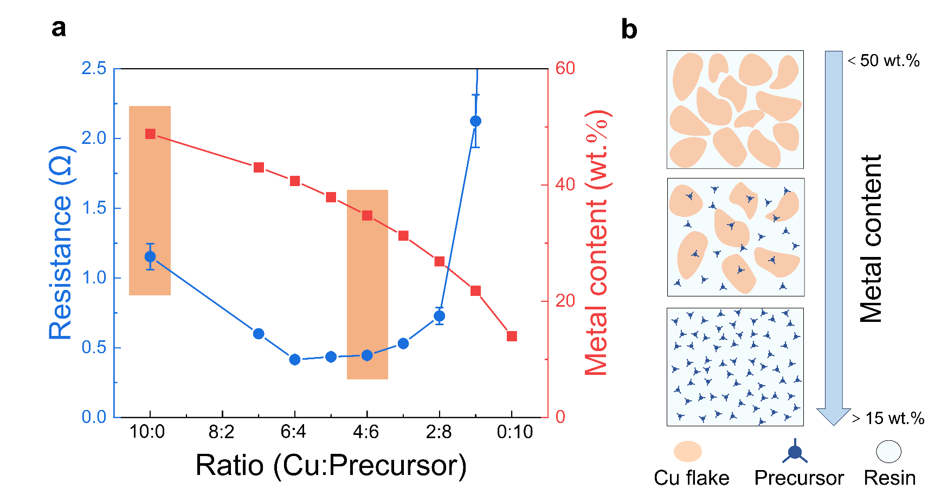
Figure 2 (a) Impact of Cu precursor addition on the resistivity and metal content of the printed circuits. (b) Schematic diagram of the principle underlying the reduction of metal content.

To further enhance the electrical and mechanical properties of printed patterns, this study optimizes the composition and concentration of additives in the paste. Figure 3a illustrates the influence of resin content on the conductivity and adhesion of printed circuits. As the amount of resin increases, the adhesion performance of the printed circuits significantly improves while electrical performance gradually declines. When the resin content exceeds 30 wt.%, the resistivity increases sharply from 2645 μΩ·cm to 3889 μΩ·cm. The resin content in the paste is controlled in the range of 0-30 wt.% to prevent excessive resistivity for the printed circuits. This study adds cellulose to improve flexibility due to the thermal curing characteristics of the resin, which can diminish the flexibility of the printed circuits ^{23, 25, 26}. It was observed that interface delamination occurs during bending tests when the total amount of resin and cellulose exceeds 50 wt.% (Figure S2). Therefore, the cellulose content is set within 0-30 wt.%. Figure 3b shows the effect of Cu precursor content on the electrical performance and adhesion of printed circuits. As the amount of Cu precursor increases, the resistivity improves. However, when the ratio of Cu flakes to precursor is increased to 6: 4, numerous globular protrusions appear on the surface of the printed circuits (Figure S3). These globular protrusions are susceptible to detachment during adhesion and bending tests, leading to defects. To avoid these issues, the amount of Cu precursor is maintained within the range of Cu: Precursor = 10: 0-7: 3.

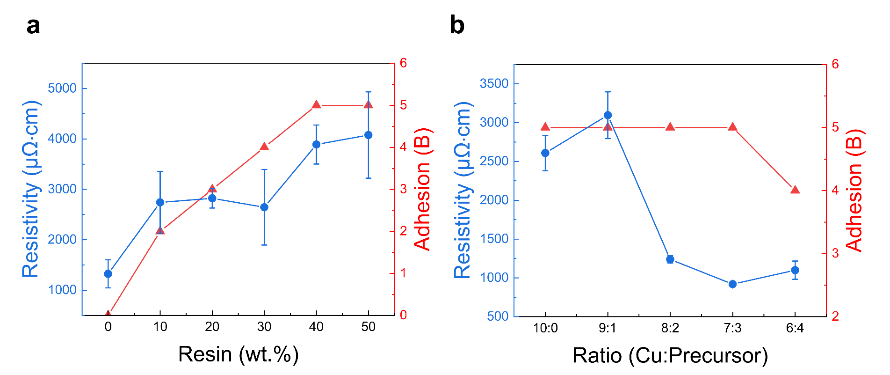
Figure 3 The influence of (a) phenolic resin and (b) Cu precursor addition on the resistivity and adhesion of the printed circuits after heat treatment for 5 min at 180 °C in a nitrogen atmosphere.

To minimize the number of experiments, this study employs an orthogonal test to optimize the concentrations of various additive components. The value ranges for the aforementioned factors are categorized into four levels, and an L₁₆(4³) orthogonal test is employed. The experimental results are assessed using three performance indicators: resistivity, adhesion, and flexibility (Table 1). Five samples were tested and the average value was taken. Given that mechanical reliability is essential for the commercial viability of printed circuits, this study emphasizes adhesion and flexibility as critical evaluation metrics. Among the experimental samples, samples 4, 8, 10, and 12 achieved a level 5B in the ASTM D3359 standard (Figure S4). However, samples 4 and 8 did not meet the flexibility requirements. Therefore, the selected qualified samples are 10 and 12.
Table 1 Results of the orthogonal test involving three factors at four levels.
No. | Precursor | Resin (wt.%) | Cellulose (wt.%) | Resistivity (μΩ·cm) | Adhesion (B) | Flexibility
1 | 10：0 | 0 | 0 | 1177.4 | 0 | √
2 | 10：0 | 10 | 10 | 1673.1 | 2 | √
3 | 10：0 | 20 | 20 | 994.7 | 3 | √
4 | 10：0 | 30 | 30 | 1039.0 | 5 | ×
5 | 8：2 | 0 | 10 | 408.5 | 1 | √
6 | 8：2 | 10 | 0 | 175.1 | 3 | √
7 | 8：2 | 20 | 30 | 603.9 | 4 | ×
8 | 8：2 | 30 | 20 | 656.9 | 5 | ×
9 | 9：1 | 0 | 20 | 495.6 | 3 | √
10 | 9：1 | 10 | 30 | 717.6 | 5 | √
11 | 9：1 | 20 | 0 | 543.9 | 4 | √
12 | 9：1 | 30 | 10 | 908.6 | 5 | √
13 | 7：3 | 0 | 30 | 377.3 | 3 | √
14 | 7：3 | 10 | 20 | 314.7 | 4 | √
15 | 7：3 | 20 | 10 | 320.2 | 4 | √
16 | 7：3 | 30 | 0 | 352.0 | 4 | ×

This study conducts a range and significance analysis of their resistivity to understand the effects of various factors on the conductivity of printed circuits. Table 2 presents the results of these analyses, with k1, k2, k3, and k4 representing the average resistivity values corresponding to different levels of each factor. R represents the range of average resistivity values, indicating the strength of each factor's impact on conductivity. P corresponds to the mean square error analysis of resistivity, which quantifies the influence of these factors on the results. A P-value less than 0.05 indicates that a factor has a significant effect on resistivity, while a P-value greater than 0.05 suggests that the effect is not significant²⁷⁻³⁰. As shown in Table 2, the range R of the Cu precursor (879.96) is greater than that of both cellulose (265.27) and resin (124.23). Therefore, in descending order, the three factors that influence resistivity are Cu precursor, cellulose, and resin. The magnitude of P quantifies the influence of these three factors, with the P for the Cu precursor being significantly less than 0.05, while the P for resin and cellulose are both significantly greater than 0.05. These results indicate that the Cu precursor significantly affects resistivity in this study and is a key factor in determining the conductivity of the paste.
Table 2 Range and significance analysis results for the orthogonal test.
Factors | Precursor | Resin | Cellulose
k1 | 1221.04 | 614.71 | 562.12
k2 | 666.24 | 720.12 | 827.40
k3 | 461.10 | 615.69 | 615.48
k4 | 341.08 | 738.94 | 684.45
R | 879.96 | 124.23 | 265.27
P | 0.019 | 0.517 | 0.265

Samples 10 and 12 contain an identical amount of Cu precursor (Cu: Precursor =9:1). However, the resistivity of sample 10 is lower than that of sample 12 (717 μΩ·cm < 908 μΩ·cm). Therefore, this study selects sample 10 as the primary reference and further optimizes its resistivity by adjusting the quantity of the Cu precursor. Figure 4 shows the effect of Cu precursor addition on resistivity with the same quantity of resin and cellulose in sample 10. As the amount of the Cu precursor increases, the resistivity initially decreases and then subsequently rising. When the ratio is adjusted to 7:3, the electrical performance of the printed circuits significantly improves, achieving a minimum resistivity of 358 μΩ·cm, which is approximately 50% of the resistivity of sample 10. Additionally, the adhesion of the printed circuits meets the Level 5B. In summary, the primary recipe for the paste is formulated as follows: Cu flakes: Cu precursor: phenolic resin: ethyl cellulose: solvents = 38: 17: 4: 12: 29.
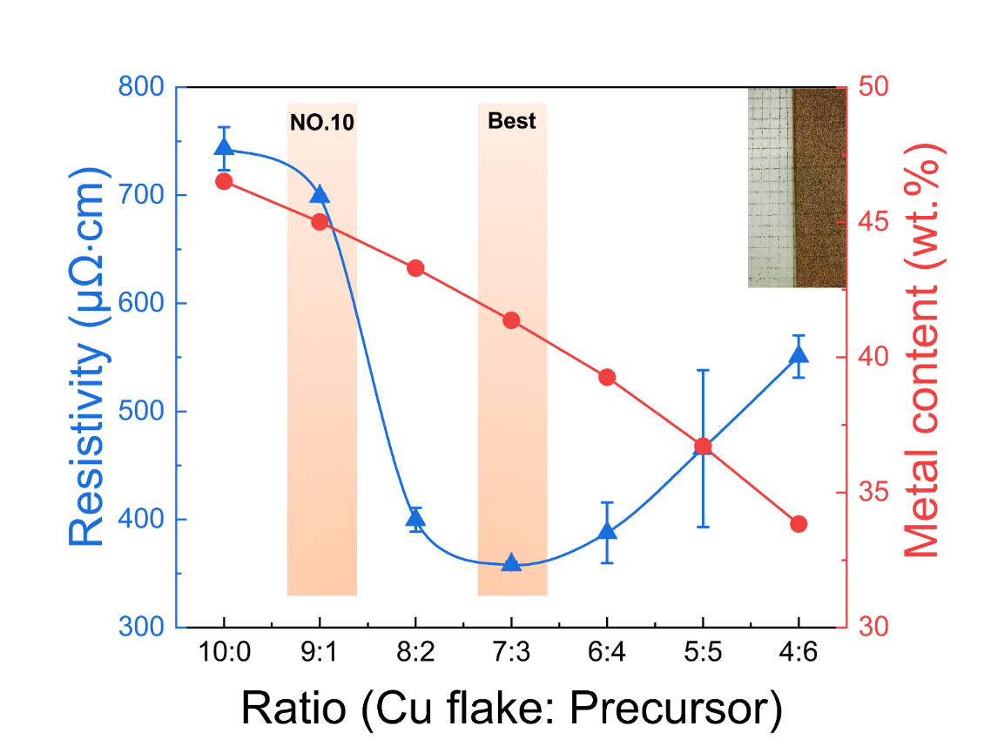
Figure 4 Optimization effect of precursor addition on the resistivity of the printed circuits. The inset in the upper right corner illustrates the adhesion of the printed circuits at a 7:3 ratio.

The performance of the printed circuits fabricated by the Cu paste is greatly influenced by the curing process. The resistivity under various curing times (5-120 min) and temperatures (140-220 °C) are measured (Figure 5). The results reveal that as the curing temperature and sintering time increased, the electrical performance of the printed circuits improved. When the curing temperature is set at 140 °C, and the duration is no less than 80 minutes, the lowest resistivity achieved is 477 μΩ·cm. Further increasing the temperature to 180 °C results in a reduction of resistivity to 346 μΩ·cm, which is approximately 69% of the resistivity measured at 140 °C. This improvement is likely attributed to the complete decomposition of the Cu precursor and the formation of conductive pathways during the curing process. At the same time, the shrinkage of the resin during curing enables the Cu flakes to be packed more closely together, thereby enhancing their electrical performance. Moreover, the study finds that when the curing temperature is increased to 200 °C, the printed circuits achieved comparable levels of resistivity with a curing time of only 5 minutes, reducing its resistivity to approximately 331 μΩ·cm. To ensure optimal resistivity while minimizing time costs, this study employs a curing method at 200 °C for 5 minutes.
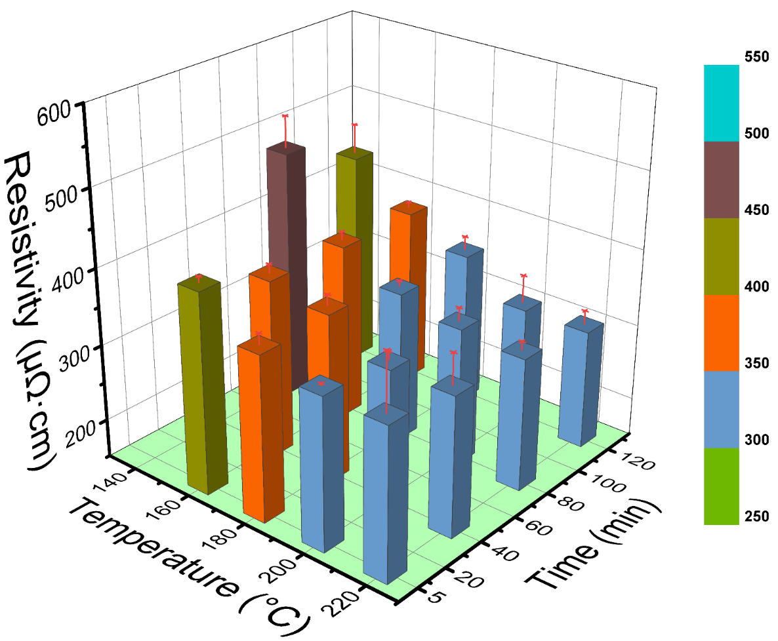
Figure 5 Effect of curing time and temperature on the resistivity of the printed circuits.

To demonstrate the applications of this paste, the paste was used to fabricate flexible heaters with large sale of 72 mm × 60 mm (Figure 6a) and the performances was examined. Figure 6b displays the temperature profiles of the heater under different voltages. The heater's temperature rapidly rises upon powering on at an ambient temperature of 27 °C. It reaches a maximum temperature of 85 °C in just 9 seconds and a voltage of 4.5 V, while returning to its initial state in about 19 seconds, demonstrating excellent performance. In addition, the heater demonstrates exceptional stability during continuous voltage ramping ranging from 2 V to 4.5 V (Figure 6c). To assess its durability, the thermal stability of the heater was evaluated by repeatedly switching on/off the applied voltage of 3 V every 30 seconds (Figure 6d). The results indicate that the surface temperature of the heater remained consistently stable within the range of 29 °C to 56 °C even after 20 cycles of testing, with minimal fluctuations. Additionally, this study utilized infrared thermography to observe the heat distribution of the heater under applied voltages ranging from 2 V to 4.5 V. Figure 6e shows that the heat distribution of the heater is uniform, further confirming its reliability for practical applications.

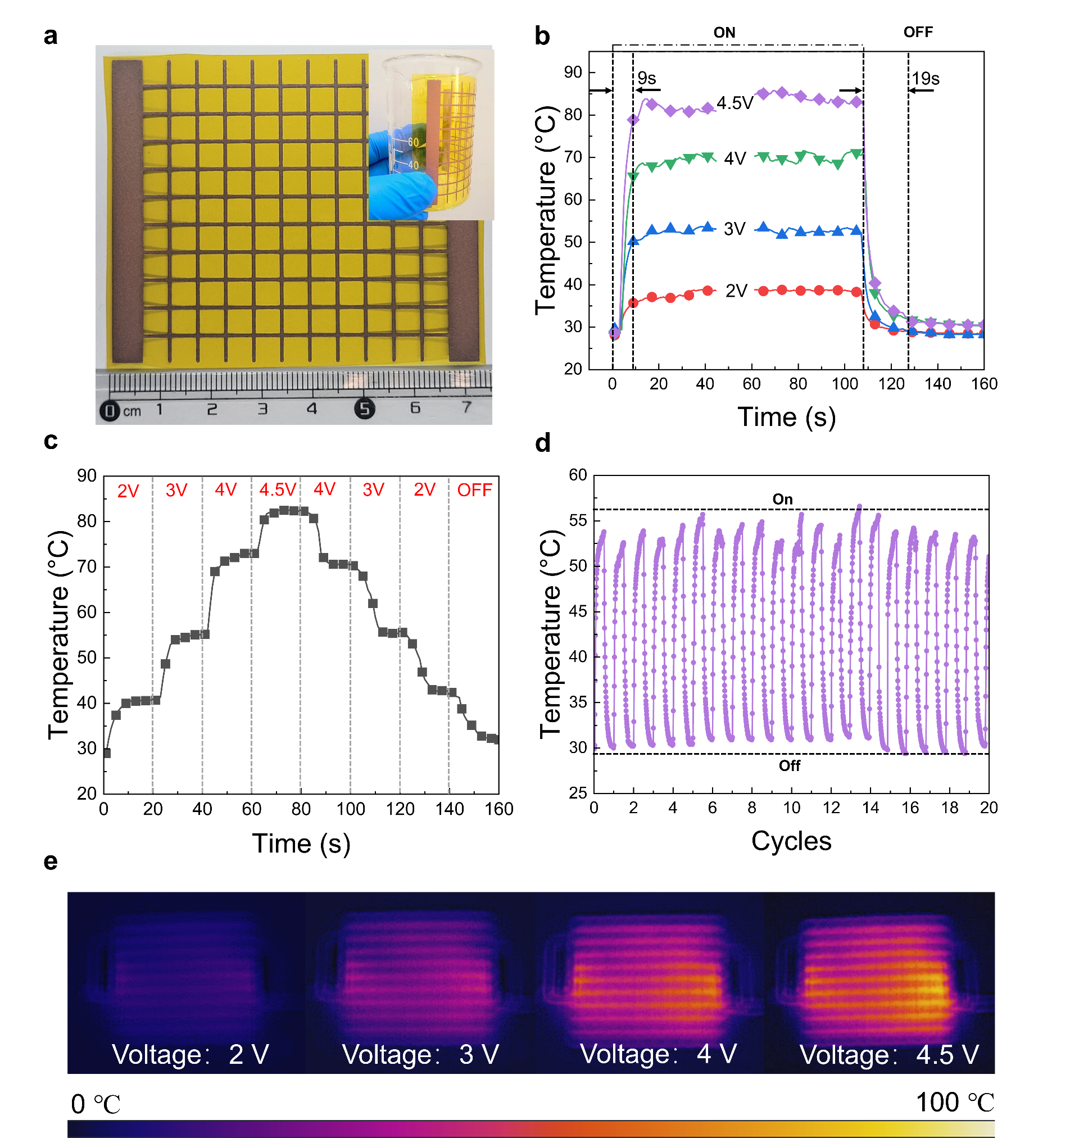
Figure 6 The application and performance of the heaters prepared by the Cu paste. (a) Screen-printed heater pattern on a PI substrate. (b) Temperature profiles of the heater under different applied voltages. (c) Temperature curve distribution of the heater with increasing and decreasing applied voltage. (d) Thermal stability performance of the heater when switching the voltage between 0 to 3V every 30 seconds. (e) Infrared images of the heater under different applied voltages.

In addition, this study employed the Cu paste to fabricate ultra-broadband (UWB) antenna, demonstrating its potential applications in the field of wireless communication. The performance of printed antennas is generally influenced by factors such as the conductivity of the paste and the thickness of the substrate. Based on simulations, the antenna size was 22 mm × 17 mm × 35 μm (Figure 7a). Antenna samples were prepared using screen printing and curing processes (Figures 7b, c). Figure 7d illustrates the simulated radiation pattern of the antenna, which is symmetric and demonstrates that the virtual antenna exhibits excellent omnidirectionality. Figures 7e and 7f show the results for the antenna's gain and radiation patterns. The minimum gain within the operational frequency range is 2.8 dBi, while the maximum gain reaches 13.8 dBi. Furthermore, the radiation pattern in the H-plane is elliptical, while the E-plane shows an "8" form. These results demonstrate that the antenna's radiation performance is exceptional and is consistent with the simulated results. Figure 7g presents the results of the antenna samples over the frequency range of 2 to 18 GHz. A lower S11 value indicates greater efficiency of the antenna within this frequency range. The results show that the S11 values of the antenna samples are all below -10 dB across the frequency range of 3.44 to 16.2 GHz, effectively covering the standard operational frequency range for ultra-broadband antennas (3.1 to 10.6 GHz). Additionally, the S11 value at a frequency of 5.56 GHz is -38 dB, reflecting outstanding performance and suitability for practical applications.

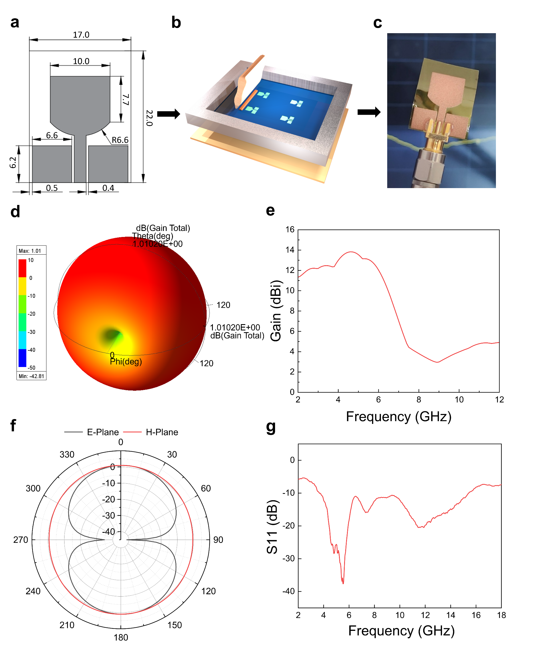

Figure 7 The performance of UWB antenna prepared by the Cu paste. (a) Design of the antenna, (b) Schematic diagram of the printing process for the UWB antenna using Cu paste. (c) A photo of the Cu antenna. (d) The simulated radiation pattern of the UWB antenna. (e) Gain performance of the UWB antenna sample. (f) The radiation pattern of the UWB antenna sample. (g) Return loss values of the UWB antenna sample.

4.Conclusion
In this study, we innovatively designed a novel Cu paste by adding Cu precursor into the resin, thereby achieving a balance between printed circuits' conductivity and adhesion. The Cu precursor improves the conductivity of the paste due to the in-situ decomposition of Cu formatted into Cu nanoparticles during the curing process. These Cu nanoparticles create additional conductive pathways in the insulating resin matrix, thereby enhancing electronic transport between the Cu flakes. As a result, the Cu paste achieves an approximately 2.6 times improvement in electrical performance despite a 15 wt.% reduction in total metal content due to the addition of the Cu precursor. This approach provides a promising method for developing high-conductivity pastes with low metal content. Furthermore, through orthogonal tests and analysis, we clarified the relationship between the paste formulation and the performance of printed circuits. The optimal formulation of the paste is demonstrated as follows Cu flakes: Cu precursor: phenolic resin: ethyl cellulose: solvents = 38: 17: 4: 12: 29. After subtle optimization, the pastes of this formulation were treated with nitrogen thermosetting at 200 °C for 5 minutes, resulting in a minimum resistivity of 331 μΩ·cm, which demonstrates excellent conductivity. Additionally, the printed circuits produced achieved a level 5B in the ASTM D3359 standard, ensuring their reliability for practical applications. We successfully utilized this novel paste to fabricate heaters and ultra-broadband (UWB) antennas by screen printing processes. The resulting samples show outstanding performance in response speed, stability, flexibility, and radiation characteristics. These results substantiate the broad application potential and commercial value of this innovative paste.

References

(1) Casiraghi, C.; Jurchescu, O. D.; Magdassi, S.; Su, W. M. Introduction to nanomaterials for printed electronics. Nanoscale 2023, 15 (25), 10480-10483. DOI: 10.1039/d3nr90072j.
(2) Wu, W. Inorganic nanomaterials for printed electronics: a review. Nanoscale 2017, 9 (22), 7342-7372. DOI: 10.1039/c7nr01604b.
(3) Sun, J. Z.; Sun, R.; Jia, P.; Ma, M. D.; Song, Y. L. Fabricating flexible conductive structures by printing techniques and printable conductive materials. Journal of Materials Chemistry C 2022, 10 (25), 9441-9464. DOI: 10.1039/d2tc01168a.
(4) Li, D. D.; Lai, W. Y.; Zhang, Y. Z.; Huang, W. Printable Transparent Conductive Films for Flexible Electronics. Advanced Materials 2018, 30 (10). DOI: 10.1002/adma.201704738.
(5) Huang, Q. J.; Zhu, Y. Printing Conductive Nanomaterials for Flexible and Stretchable Electronics: A Review of Materials, Processes, and Applications. Advanced Materials Technologies 2019, 4 (5). DOI: 10.1002/admt.201800546.
(6) Zhang, Y. X.; Cen, Q. Y.; Xu, X. X.; Li, W. J.; Zhao, Y.; Li, W.; Liu, Q. J.; Chen, M. F.; Guo, N. Y.; Wu, W. X.; Sun, S. Z. The effect of PVAc in silver ink for adhesion and conductivity of conductive pattern. Journal of Materials Research and Technology-Jmr&T 2022, 18, 4277-4284. DOI: 10.1016/j.jmrt.2022.04.095.
(7) Jiu, J.; Nogi, M.; Sugahara, T.; Tokuno, T.; Araki, T.; Komoda, N.; Suganuma, K.; Uchida, H.; Shinozaki, K. Strongly adhesive and flexible transparent silver nanowire conductive films fabricated with a high-intensity pulsed light technique. Journal of Materials Chemistry 2012, 22 (44), 23561-23567. DOI: 10.1039/c2jm35545k.
(8) Mou, Y.; Wang, H.; Peng, Y.; Liu, J. X.; Cheng, H.; Sun, Q. L.; Chen, M. X. Low temperature enhanced flexible conductive film by Ag flake/ion composite ink. Materials & Design 2020, 186. DOI: 10.1016/j.matdes.2019.108339.
(9) Roberson, D. A.; Wicker, R. B.; Murr, L. E.; Church, K.; MacDonald, E. Microstructural and Process Characterization of Conductive Traces Printed from Ag Particulate Inks. Materials 2011, 4 (6), 963-979. DOI: 10.3390/ma4060963.
(10) Li, W.; Zhang, H.; Kagita, S.; Shamim, A. All Screen-Printed, Polymer-Nanowire Based Foldable Electronics for mm-Wave Applications. Advanced Materials Technologies 2021, 6 (11), 2100525. DOI: https://doi.org/10.1002/admt.202100525 (acccessed 2024/08/19).
(11) Knapp, H.; Romagnoli, G. RFID systems optimisation through the use of a new RFID network planning algorithm to support the design of receiving gates. Journal of Intelligent Manufacturing 2023, 34 (3), 1389-1407. DOI: 10.1007/s10845-021-01858-0.
(12) Hong, S. Q.; Liu, C. M.; Hao, S. Q.; Fu, W. X.; Peng, J.; Wu, B. H.; Zheng, N. F. Antioxidant high-conductivity copper paste for low-cost flexible printed electronics. Npj Flexible Electronics 2022, 6 (1). DOI: 10.1038/s41528-022-00151-1.
(13) Vaseem, M.; McKerricher, G.; Shamim, A. Robust Design of a Particle-Free Silver-Organo-Complex Ink with High Conductivity and Inkjet Stability for Flexible Electronics. Acs Applied Materials & Interfaces 2016, 8 (1), 177-186. DOI: 10.1021/acsami.5b08125.
(14) Jost, N.; Askins, S.; Dixon, R.; Ackermann, M.; Domínguez, C.; Antón, I. Array of Micro Multijunction Solar Cells Interconnected by Conductive Inks. SSRN Electronic Journal 2022.
(15) Hong, H.; Jiang, L. H.; Tu, H. T.; Hu, J. Y.; Moon, K. S.; Yan, X.; Wong, C. P. Rational design and evaluation of UV curable nano-silver ink applied in highly conductive textile- based electrodes and flexible silver-zinc batteries. Journal of Materials Science & Technology 2022, 101, 294-307. DOI: 10.1016/j.jmst.2021.04.061.
(16) Li, W. L.; Sun, Q. Q.; Li, L. Y.; Jiu, J. T.; Liu, X. Y.; Kanehara, M.; Minari, T.; Suganuma, K. The rise of conductive copper inks: challenges and perspectives. Applied Materials Today 2020, 18. DOI: 10.1016/j.apmt.2019.100451.
(17) Li, W. L.; Li, L. Y.; Gao, Y.; Hu, D. W.; Li, C. F.; Zhang, H.; Jiu, J. T.; Nagao, S.; Suganuma, K. Highly conductive copper films based on submicron copper particles/copper complex inks for printed electronics: Microstructure, resistivity, oxidation resistance, and long-term stability. Journal of Alloys and Compounds 2018, 732, 240-247. DOI: 10.1016/j.jallcom.2017.10.193.
(18) Zhou, Z. Y.; Walker, S. B.; LeMieux, M.; Leu, P. W. Polymer-Embedded Silver Microgrids by Particle-Free Reactive Inks for Flexible High-Performance Transparent Conducting Electrodes. Acs Applied Electronic Materials 2021, 3 (5), 2079-2086. DOI: 10.1021/acsaelm.1c00107.
(19) Liu, L.; Wong, D.; Lee, J.; Park, S. S. Flexibility Enhancements of Hybrid Copper Inks with Cellulose Nanocrystals. International Journal of Precision Engineering and Manufacturing-Green Technology 2021, 8 (6), 1755-1766. DOI: 10.1007/s40684-020-00278-4.
(20) Sakurai, S.; Uda, T.; Kawasaki, H. Enhanced flexibility and environmental durability of copper electrode produced with conductive ink containing silane coupling agents with diamine and ether spacer. Journal of Materials Science-Materials in Electronics 2019, 30 (13), 12130-12139. DOI: 10.1007/s10854-019-01571-y.
(21) Ma, W. Y.; Cheng, Y. Y.; Chen, J. K.; Chan, K. H.; Lin, Z. J.; Chou, W. H.; Chang, W. C. Synthesis of Antioxidative Conductive Copper Inks with Superior Adhesion. Journal of Nanoscience and Nanotechnology 2018, 18 (1), 318-322. DOI: 10.1166/jnn.2018.14591.
(22) Ryu, C. H.; Moon, C. J.; Kim, H. S. A study on the relationship between print-ability and flash light sinter-ability of Cu nano/micro-ink for printed electronics. Thin Solid Films 2019, 671, 36-43. DOI: 10.1016/j.tsf.2018.12.021.
(23) Zhao, C. F.; Wang, J.; Lu, L. N. Preparation and application of water-based nano-silver conductive ink in paper-based 3D printing. Rapid Prototyping Journal 2022, 28 (4), 747-755. DOI: 10.1108/rpj-05-2020-0112.
(24) Li, W. L.; Cong, S. R.; Jiu, J. T.; Nagao, S.; Suganuma, K. Self-reducible copper inks composed of copper-amino complexes and preset submicron copper seeds for thick conductive patterns on a flexible substrate. Journal of Materials Chemistry C 2016, 4 (37), 8802-8809. DOI: 10.1039/c6tc02914k.
(25) Xu, W.; Xu, Q.; Huang, Q.; Tan, R.; Shen, W.; Song, W. Electrically conductive silver nanowires-filled methylcellulose composite transparent films with high mechanical properties. Materials Letters 2015, 152, 173-176. DOI: https://doi.org/10.1016/j.matlet.2015.03.111.
(26) Arai, S.; Kanazawa, T. Electroless deposition and evaluation of Cu/multiwalled carbon nanotube composite films on acrylonitrile butadiene styrene resin. Surface & Coatings Technology 2014, 254, 224-229. DOI: 10.1016/j.surfcoat.2014.06.017.
(27) Xu, C. Y.; Shi, X. M.; Guo, L.; Wang, X.; Wang, X. Y.; Li, J. Y. Optimization of Graphene Conductive Ink with 73 wt% Graphene Contents. Journal of Nanoscience and Nanotechnology 2018, 18 (6), 4014-4021. DOI: 10.1166/jnn.2018.15201.
(28) Liu, S. J.; Li, X. W.; Hao, Y. P.; Li, X.; Liu, F. L. Optimization of Cu/Sn Alloy Sputtering Process Based on Orthogonal Experimental Design Method. Micromachines 2023, 14 (8). DOI: 10.3390/mi14081539.
(29) Li, H. Y.; Wei, P.; Wang, J. Q.; Tang, S. G.; Guo, C. Properties of Cu/ZnO/Al<sub>2</sub>O<sub>3</sub> Catalysts Modified by Titanium Additives in Synthesis of Methanol from Syngas Using Orthogonal Experimental Design. Asian Journal of Chemistry 2013, 25 (12), 6795-6801. DOI: 10.14233/ajchem.2013.14695.
(30) Jin, W. B.; Zhou, Y. M. Fabrication of Cu-adhered silicon carbide particles and its effect on properties of Fe-based matrix composites. Materials Research Express 2022, 9 (6). DOI: 10.1088/2053-1591/ac719f.

