Influence of Nucleation on Relaxation, Molecular Cooperativity, and Physical Stability of Celecoxib Glass

Xue Han^{1,2}, Kexin, Dai^{1,3,4}, Kohsaku Kawakami^{1,2,*}

¹ Research Center for Macromolecules and Biomaterials, National Institute for Materials Science, 1-1 Namiki, Tsukuba, Ibaraki 305-0044, Japan
² Graduate School of Pure and Applied Sciences, University of Tsukuba, 1-1-1 Tennodai, Tsukuba, Ibaraki 305-8577, Japan
³ Department of Chemical Engineering, University of California, Santa Barbara, CA 93106, United States
⁴ Present address: Department of Chemical Engineering, Massachusetts Institute of Technology, 77 Massachusetts Avenue, Cambridge, Massachusetts 02139, United States

* Corresponding author
E-mail: kawakami.kohsaku@nims.go.jp, Tel. +81-29-860-4424

Manuscript pages: 27
Figures: 11
Tables: 2

Submitted to Molecular Pharmaceutics

Abstract

Although nucleation is considered as the first step in the crystallization of glass materials, the structure and properties of the nuclei are not understood well. Influence of nucleation on the structure and dynamics of celecoxib glass was evaluated in this study. The nuclei for Form III were induced by annealing the glass at freezing temperature, and their impact on the relaxation behavior was investigated using thermal analysis and broadband dielectric spectroscopy to find accelerated α relaxation and suppressed β relaxation. Also observed after nucleation was decrease in cooperativity of the molecular motion, presumably because of appearance of void spaces in the glass structure. During long-term isothermal crystallization studies, crystal growth to Form III was accelerated in the presence of the nuclei, whereas this effect was less remarkable when a different crystal form dominated the crystallization behavior. These observations should provide more detailed insights into the nucleation mechanism and impact of nucleation on molecular dynamics including physical stability of pharmaceutical glasses. Also discussed is remarkable acceleration of the crystallization rate of the celecoxib glass just below its T_{g}, which could be understood by diffusionless crystal growth.

Keywords: Glass, Nucleation, Crystallization, Relaxation, Cooperative rearranging region

1 Introduction
Although amorphous solid dispersion is now one of the most important options for developing poorly soluble candidates¹⁻³, glass theory still involves many unsolved issues. As glasses are thermodynamically unstable, they may eventually be transformed to more stable crystalline forms. Crystallization kinetics are closely related to molecular mobility^{4,5}. However, many other physicochemical and practical factors, including mechanical stress^{4,6,7}, thermal history⁸, surface area^{9,10}, and sample size¹¹ can also influence behavior of glasses, which must be clarified to precisely control glass stability.
The modes of molecular mobility can be divided into primary relaxation (i.e., α relaxation), in which the glass structure is rearranged mainly by molecular diffusion to achieve a more energetically favored state, and secondary relaxation (β, γ, and δ relaxation), which is more local and fast movement. Generally, an amorphous solid is physically stable below T_{g} −50 °C¹² because of disappearance of the excess entropy, where proceeding of α relaxation is not expected. However, the contribution of the secondary relaxation to glass stability requires further investigation. Secondary relaxation occurs over shorter time scales at lower temperature ranges relative to α relaxation to enable intermolecular movement within restricted domains¹³. Furthermore, secondary relaxation can in turn initiate primary relaxation, which may influence glass stability¹⁴. Paladi et al. proposed that the relatively fast nucleation of the o-benzylphenol system is induced by β relaxation, even at low temperatures¹⁵, whereas Okamoto et al. indicated that nucleation proceeds even at a temperature 186 °C below the T_{g}¹⁶. It is frequently reported that secondary relaxation may be related to the nucleation and crystal growth of glasses^{17,18}.
In our previous study⁸, the nucleation of celecoxib (CEL) glass was found to proceed at the freezing temperature. The maximum nucleation rate was found to exist at -50 °C, which is below its T_{g} by 108 °C. As nuclei are difficult to detect directly, nucleation may not be recognized unless crystal growth follows. It can happen if the temperatures for nucleation and crystal growth are sufficiently separated. Glasses with or without nuclei may exhibit different performances, even though they are characterized the same using conventional evaluation methods including x-ray powder diffraction and differential scanning calorimetry. In fact, the nucleated CEL glass failed to form a supersaturated state after suspension of the glass in aqueous media, although it was observed for the non-nucleated glass¹⁹. In this study, we evaluated the influence of nucleation on glass dynamics in comparison with the non-nucleated glass with emphasis on their relaxation, molecular cooperativity, and crystallization behaviors.

2 Experimental

2.1 Materials
CEL (Fig. 1) was purchased from Tokyo Kasei (Tokyo, Japan) and used without further purification. Four crystal forms, form I to IV, have been identified so far, where form III is the most stable form at room temperature. Form I is the stable form at higher temperature, which has thermodynamically enantiotropic relationship with form III. The transition temperature between form I and III has not been identified but expected to exist at slightly higher than room temperature. T_{g} of CEL glass is 58 °C^{4,8}.
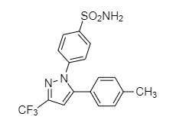
Fig. 1 Chemical structure of CEL.

2.2 Preparation of Glass Samples
Differential scanning calorimetry (DSC) (Q2000, TA Instruments, New Castle, DE, USA) was used to prepare the glass samples. The instrument was calibrated using indium and sapphire, and dry nitrogen was used as the inert gas during the measurements at a flow rate of 50 mL/min. Approximately 5 mg of the crystalline CEL was heated to 180 °C for melting in a crimped aluminum pan. The sample was then cooled to 25 °C at a rate of 20 °C/min to obtain “intact glass.” The “nucleated glass” was prepared by cooling the melt to −20 °C at a rate of 20 °C/min, followed by storage in a freezer in which the temperature was maintained at −20 °C for 16 h.

2.3 Annealing Study
Both types of glasses were annealed in DSC or temperature-controlled ovens for predetermined periods. DSC was used when the annealing time was shorter than 2 h, whereas ovens were used for longer annealing times. For the oven-storage, the samples (in the DSC pans) were enclosed in air-tight boxes with silica-gel. The difference in annealing procedure was confirmed to have a negligible influence by applying both protocols for some studies. To observe the impact of nucleation and subsequent annealing on cold crystallization behavior, the samples were subjected to DSC measurements at a heating rate of 10 °C /min. All measurements were at least triplicated.
Relaxation experiments were performed using the modulated mode, in which a 0.5 °C amplitude and 60 s period were applied at a heating rate of 2 °C /min.
A nonreversing heat flow was used to evaluate the relaxation behavior. To offset the frequency effect, the recovery enthalpy values for the non-annealed glass were subtracted from the enthalpy of the annealed glass. The relaxation function, Φ, is expressed as follows:

Φ = 1 − (${{\text{∆}\text{H}}_{\text{t}}}/{{\text{∆}\text{H}}_{\text{∞}}}$) , (2)

where ΔH_{t} is the enthalpy recovery measured under the given conditions and ΔH∞ is the maximum enthalpy recovery calculated using the following equation:

${\text{∆}\text{H}}_{\text{∞}}$ = $\text{∆}\text{C}\text{p}\text{(}\text{T}\text{g} \text{-} \text{T}\text{a}\text{)}$ , (3)

where T_{g} and T_{a} are the glass transition temperature and annealing temperature, respectively, and ΔC_{p} is the change in heat capacity at T_{g}. The mean relaxation time, τ, was calculated by fitting the relaxation enthalpy data to the Kohlrausch-Williams-Watts (KWW) equation^{20,21}:

Φ = $\text{exp}\left\{-{\text{(}{\text{t}}/{\text{τ}}\text{)}}^{\text{β}}\right\}$ , (4)

where β (0 < β ≤ 1) is a fitting parameter, generally believed to describe the distribution of relaxation time.

2.4 Broadband Dielectric Spectroscopy (BDS)
BDS measurements were performed on a Novocontrol Alpha dielectric spectrometer (Montabaur, Germany) in the frequency range of 10⁻² to 10⁷ Hz under ambient pressure. The glass samples were prepared by melting CEL crystal on a stainless-steel sample stage using a hot plate heated to 200 °C. The prepared samples were transferred to the dielectric spectrometer after cooling down to the room temperature, and then heating up to 220 °C and quench again in spectrometer for completely removing water. The nucleated glass was prepared by cooling the sample for 60 min at −50 °C in the equipment. The measurement temperatures ranged from −120 °C to 120 °C, which was controlled by the Quatro system using nitrogen gas generated from liquid nitrogen. When the nucleated glass was investigated, the temperature was raised from the lowest temperature with intervals of 4 °C (below 0 °C), and 2 °C (above 0 °C). The intact glass was investigated with the same intervals for those for the nucleated glass without pre-annealing, and all the measurements are triplicated for confirming reproducibility. Temperature stability was ensured to be within ± 0.2 °C of the designated temperature.
The relaxation curves were fitted using the Havriliak-Negami (HN) function as shown below to obtain the average relaxation time²²:

${\text{ε}}^{\text{*}}\left(\text{ω}\right) \text{=} {\text{ε}}^{\text{'}}\left(\text{ω}\right) \text{-} \text{i}{\text{ε}}^{\text{''}}\left(\text{ω}\right) \text{=} {\text{ε}}_{\text{∞}} \text{+} \sum_{\text{k}}{\frac{\text{∆}\text{ε}\text{k}}{{\text{[1} \text{+} {\left(\text{i}\text{ω}τ\right)}^{\text{a}}\text{]}}^{\text{b}}}}$ (5)

where ε*(ω) is the complex permittivity, ε'(ω) and ε"(ω) are the real and imaginary parts of the complex dielectric permittivity, ε∞ is the high-frequency limit permittivity, k denotes either the primary or secondary process, ∆ε_{k} is the relaxation strength, and a and b are exponents of the relaxation processes. The relaxation map (the relaxation times as a function of temperature) was drawn by analyzing the dielectric spectra acquired at various temperatures. As determination of the α relaxation time was difficult in experimental timeframes especially below T_{g}, the structural relaxation peak was horizontally shifted to the lower frequencies side for the deconvolution based on the master plot as generally accepted.

2.5 X-ray Powder Diffraction
X-ray powder diffraction (XRPD) data were obtained on a Rigaku RINT Ultima X-ray Diffraction System (Rigaku Denki, Tokyo, Japan) with Cu K-α radiation. The samples for the measurements were prepared in DSC pans. Approximately 5 mg of crystalline CEL was subjected to the DSC heating/cooling/annealing treatments as described previously. The samples were subsequently heated at a rate of 10 °C /min until cold crystallization was completed. Then, heating was terminated to collect the samples for the XRPD measurements. The voltage and current were set to 40 kV and 40 mA, respectively. Data were acquired at a scan rate of 2 °C /min with 0.02° intervals (2θ).

2.6 Density Measurement
The true density of the CEL glass was measured on an AccuPyc II gas pycnometer (Micromeritics, Norcross, GA, USA) using helium gas. Approximately 0.5 g of crystalline CEL was melted on a hot plate and then cooled under ambient atmosphere. Subsequently, the obtained glass pellets were ground using a mortar and pestle. The powder was confirmed to be completely amorphous by XRPD and DSC. The measurement was repeated ten times to obtain the mean value.

3 Results

3.1 Effect of Nucleation on DSC Curves
Figure 2 shows the DSC curves of the intact and nucleated glasses after annealing at various temperatures. The recovery enthalpy grew for both glasses with increasing annealing time due to the proceeding relaxation. Meanwhile, for the intact glass, the temperature of the recovery peaks shifted to higher temperature with increasing annealing time at all annealing temperature conditions, which is a typical phenomenon after annealing²¹. For the nucleated glasses, a small endothermic pre-T_{g} peak appeared after short-term annealing (indicated by arrows in the figure), which shifted to higher temperature and merged with the recovery peak with increasing annealing time. The pre-T_{g} peak was observed relatively clearly for the glasses annealed at 30 °C, whereas it was only found occasionally at 35 and 40 °C, and never at 45 °C. As a result, the recovery enthalpy temperature was lowered after long-term annealing, particularly at 30 and 35 °C. Another important finding was broadening of the DSC curves in the glass transition region after nucleation, which was most likely because of increase in size of cooperative rearranging region (CRR)^{23,24}.
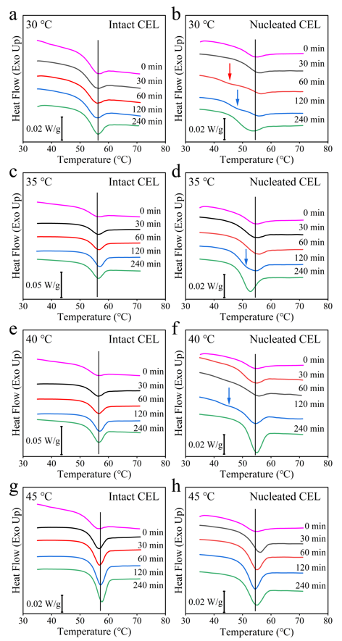
Fig. 2 Change in the total heat flow curves after annealing of intact and nucleated CEL glasses. The nucleated glass was prepared by storing the intact one at −20 °C for 16 h. The annealing temperature and time are indicated in the figure. The vertical lines in the figures show the peak-top temperature of the recovery peak of the non-annealed glasses. Arrows indicate pre-T_{g} peaks. An example of the separation into reversing and nonreversing heat flows is supplied in the supporting information.

3.2 Effect of Nucleation on α Relaxation
Figure 3 (a) and (b) show the fraction of remaining excess enthalpy, Φ, as function of annealing time at various temperatures. The obtained KWW parameters are listed in Table 1. The nucleated CEL glass exhibited a faster relaxation over the entire temperature range compared with the intact glass. The distribution of the relaxation time was almost the same for both glasses below 35 °C, as judged from their similar β values; however, the distribution was likely to be wider for the nucleated glass above 40 °C. Figure 3(c) shows Arrhenius plots of the relaxation time, where τ^{β} was employed for comparison to take the distribution of the relaxation time into consideration²¹. The activation energy for the nucleated glass was larger (126 kJ/mol) than that of the intact glass (86.7 kJ/mol).

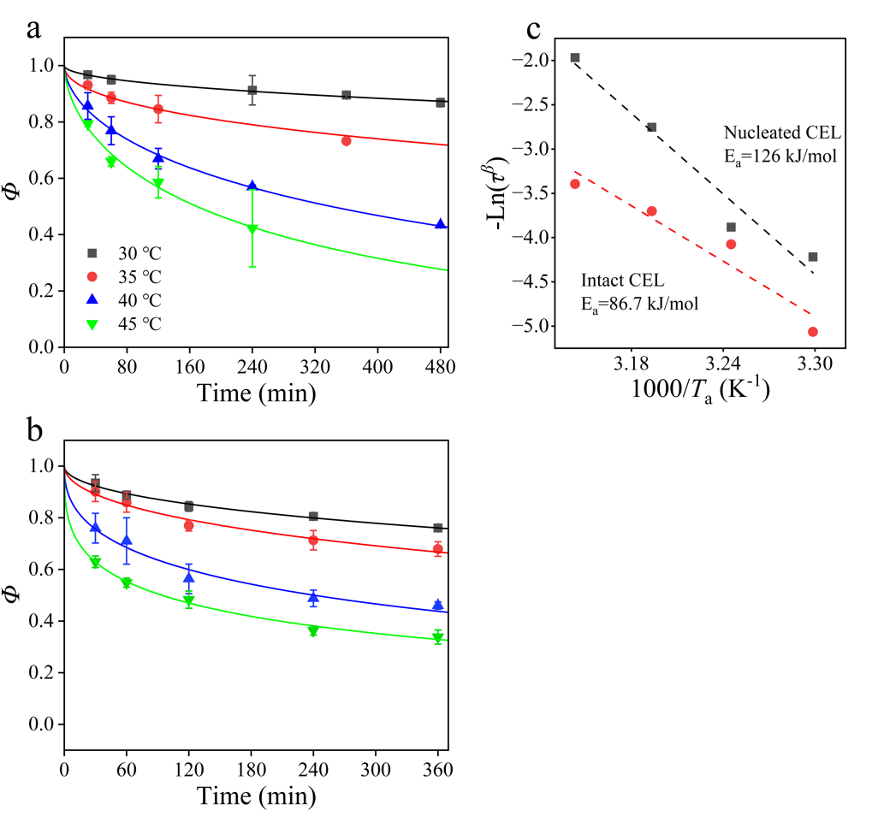
Fig. 3 The fraction of remaining excess enthalpy Φ of (a) intact and (b) nucleated CEL glasses after annealing for a series of temperatures (shown in the figures) fitted by the KWW equation; (c) Arrhenius plot for the relaxation times.

Table 1 KWW Parameters of CEL glass annealing at different temperatures.
Temperature | τ (min) |  | β |  | τ^{β}
(°C) | Nucleated | Intact | Nucleated | Intact | Nucleated | Intact
30 | 4910 | 27200 | 0.50 | 0.50 | 67.9 | 158
35 | 2160 | 4870 | 0.51 | 0.48 | 48.5 | 58.9
40 | 559 | 647 | 0.44 | 0.57 | 15.7 | 40.5
45 | 266 | 315 | 0.35 | 0.59 | 7.15 | 29.8

3.3 Deactivation or Formation of Nuclei during Annealing
Assumption of nuclei formation during annealing at the freezing temperature is supported by the fact that the probability of cold crystallization occurring during DSC heating dramatically increases after the freezing temperature annealing⁸. However, subsequent annealing at higher temperatures decreased the probability of crystallization and/or changed the form of the obtained crystal. Thus, annealing at higher temperatures was likely to deactivate the nuclei at certain conditions.
Figure 4 (a) shows the typical heating curves of the nucleated CEL glasses after subsequent annealing at 30 °C for 60 or 240 min. After annealing for 60 min, cold crystallization and melting were observed at approximately 120 and 162 °C, respectively, in most cases. This observation can be interpreted as the crystallization and melting of Form III²⁵⁻²⁷. However, after annealing for 240 min, cold crystallization and melting were observed occasionally at approximately 110 and 164 °C, respectively, which can be considered as behaviors of Form I²⁵⁻²⁷. Figure 4 (b) shows the XRPD patterns of the corresponding samples collected after the cold crystallization during the DSC measurements. The sample annealed at 30 °C for 60 min produced diffraction peaks for Form III as represented by those at 14.4, 15.7, 19.2, 21.1 degrees²⁵⁻²⁷, for which lattice parameters were reported as a = 10.136, b = 16.778, c = 5.066, α = 97.62, β = 100.65, γ = 95.95 (triclinic)²⁸. The diffraction peaks for the 240-min annealed sample were represented by those at 5.5, 5.7, 7.2, 16.6 degrees, which can be assigned as those for Form I²⁵⁻²⁷.

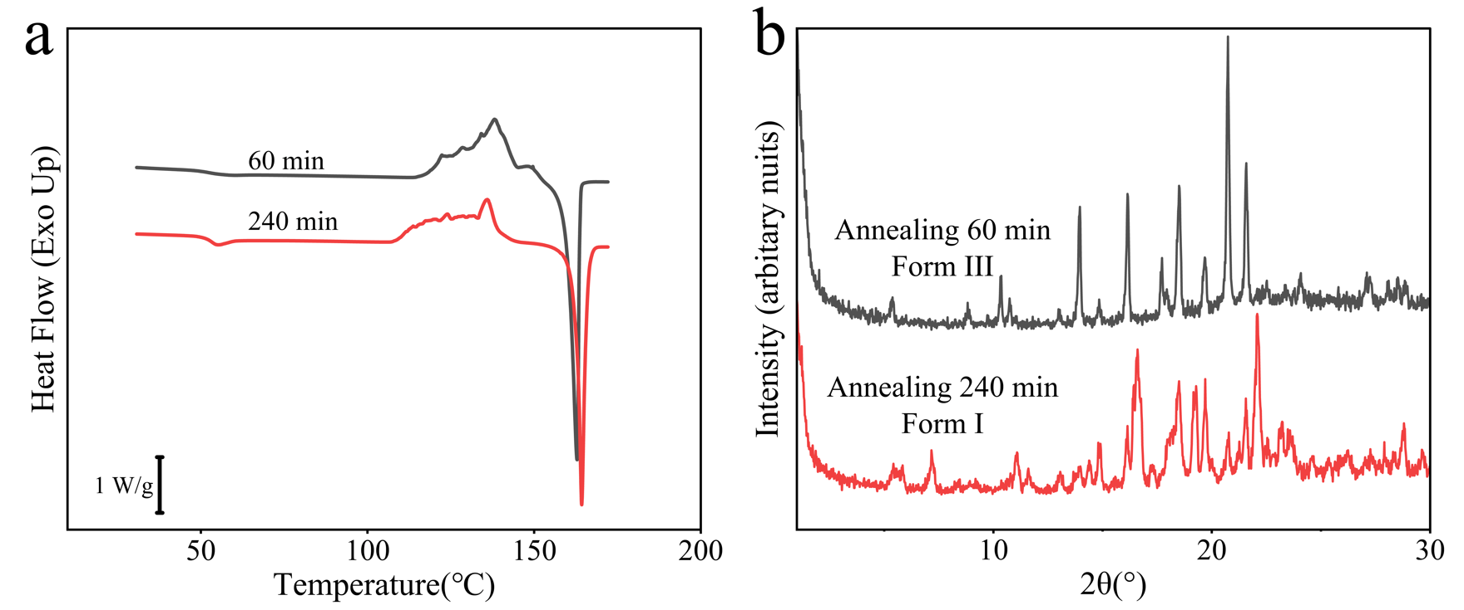
Fig. 4 (a) Typical DSC heating curves of the nucleated glass after subsequent annealing at 30 °C for 60 or 240 min. (b) XRPD patterns of the nucleated glass after the annealing at 30 °C for 60 and 240 min and DSC heating up to 150 °C.

Figure 5 shows the probability of crystallization to each form after subsequent annealing of the nucleated glass at 30, 35, and 40 °C. Unless annealing was applied, crystallization resulted in the development of Form III. However, it was not always to obtain pure Form III after annealing. For example, when annealed at 30 °C for 30 min, a mixture of Form I and III was obtained more frequently than pure Form III. The probability of crystallization to such mixture or to Form I increased with increasing annealing time. Interestingly, this trend was intensified with increasing annealing temperature. Thus, Form I nuclei were more likely to be obtained during annealing.

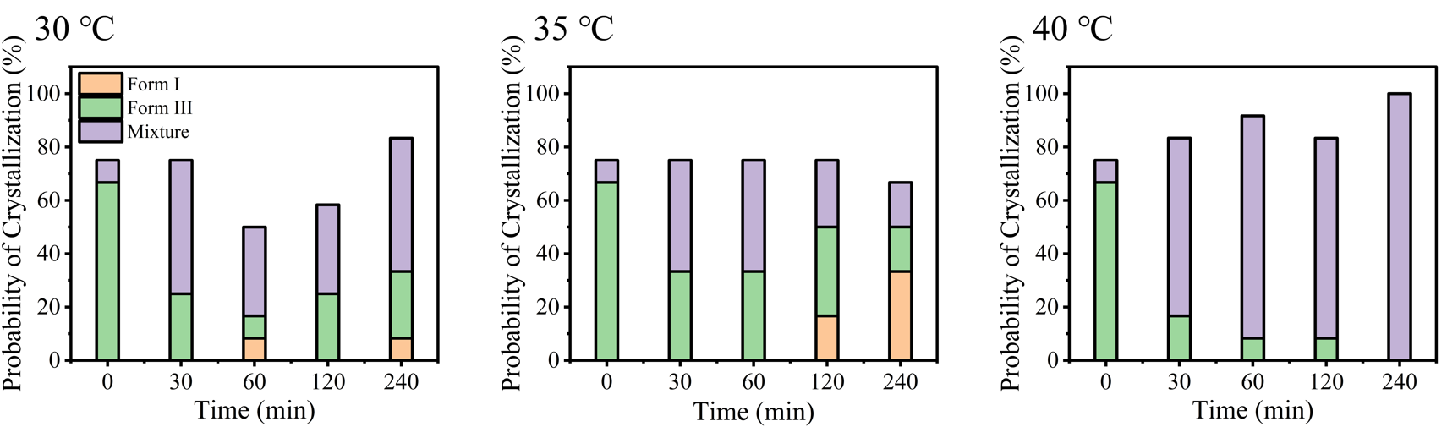
Fig. 5 Probability of crystallization to Form III, Form I, and their mixture after the annealing at the indicated temperature (n = 12).

3.4 Impact of Nucleation on Secondary Relaxation
Figure 6(a) and 6(d) show the dielectric loss spectra of the intact and nucleated CEL glasses below T_{g} under ambient pressure, where contributions of the secondary relaxation processes (β, γ and δ) could be observed. Figure 6(b) and 6(e) are examples of the spectra obtained at -120 °C deconvoluted by the CC functions for γ and δ relaxations. These processes were not affected by the nucleation. However, nucleation was found to influence the β relaxation. Figure 6(c) and 6(f) show the spectra obtained at 36 °C for both glasses. The maxima of the peak (v_{p}) obtained after the deconvolution shifted to the lower frequency after the nucleation, which suggested suppression of the β relaxation by the nucleation. According to previous literature²⁹, the β process was considered to reflect the small-angle reorientations of intermolecular origin of the entire drug molecule; the γ process represents the rotation of the phenyl ring with respect to the sulfonamide group (Ph−SO₂NH₂), which enables H-bond formation; and the δ process is associated with rotations of the phenyl ring with respect to the methyl group (Ph−CH₃), which does not form hydrogen bonds with other molecules. The temperature dependencies of the relaxation times for both glasses are presented in Figure 7. The activation energies for the three secondary relaxation processes of the intact CEL glass are as follows: ∆E_{β} = 79.1 kJ/mol for β relaxation, ∆E_{γ} = 33.9 kJ/mol for γ relaxation, ∆E_{δ} = 23.9 kJ/mol for δ relaxation, which agree with the values reported by Grzybowska et al³⁰. The nucleated CEL glass exhibited similar γ (∆E_{γ} = 40.8 kJ/mol) and δ (∆E_{δ} = 22.1 kJ/mol) processes but larger β relaxation time than that of the intact one with larger activation energy (∆E_{β} = 94.9 kJ/mol). This presumably means nucleation partially suppressed local molecular mobility.

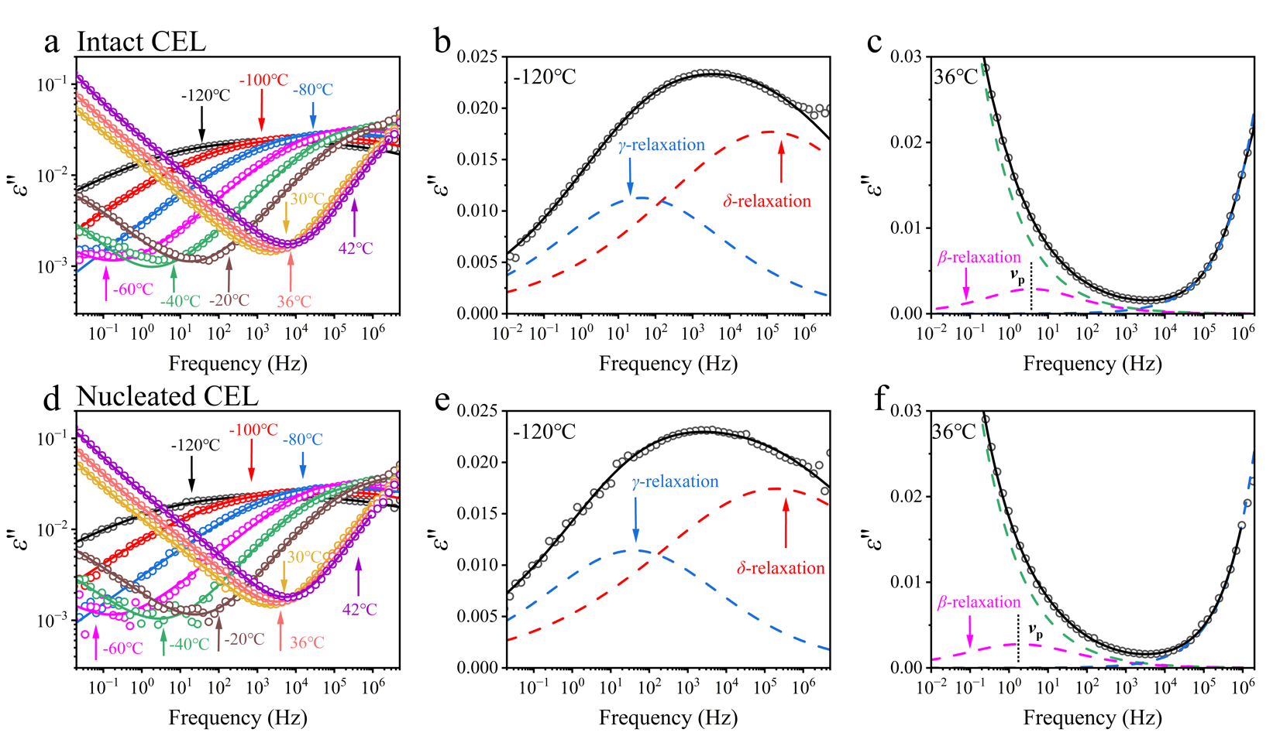
Fig. 6 Dielectric loss spectra of (a) intact CEL glass at different temperatures; Examples of dielectric loss spectra of intact CEL obtained at (b) -120 °C (deconvoluted into γ and δ relaxations using CC functions as presented by blue and red dashed lines, respectively) and (c) 36 °C (deconvoluted into α, β, and γ relaxations using HN function (for α) and CC function (for β and γ) as presented by green, magenta, and blue lines, respectively.) Dielectric loss spectra of (d) nucleated CEL glass at different temperatures; Examples of dielectric loss spectra of nucleated CEL obtained at (e) -120 °C and (f) 36 °C deconvoluted as same as for the intact glasses.

Fig. 7 The temperature dependencies of secondary relaxation times of intact (open symbols) and nucleated (closed symbols) CEL glass. Activation energies were determined by the Arrhenius equation and presented in the figure (Underlined: Nucleated CEL; No line: Intact CEL). (a) The entire relaxation map for all secondary relaxations. (b) Expanded map for β-relaxation.

3.5 Isothermal Crystallization of CEL Glass
Figure 8 shows the evolution of the crystallinity of the intact and the nucleated CEL glasses at 35 and 40 °C as a function of the storage period. The crystallinity of CEL was calculated by using ΔC_{p} under the assumption that it was proportional to the amorphous fraction. The data were fitted using the Avrami–Erofeev equation, as shown below^{5,10}:

Χ (%) = 100[1− exp {−k (t − d)^{n} }] (7)

where k is the crystallization rate, d corresponds to the induction time, and n is the Avrami parameter, which is related to both the nucleation mechanism and crystal growth dimensions. Despite the absence of a statistically meaningful difference, the nucleated glass appeared to exhibit faster crystallization compared to the intact one at 35 °C, whereas no difference in the crystallization rate was observed at a 40 °C storage. The kinetic parameters for crystallization are summarized in Table 2. At 35 °C, the faster crystallization of the nucleated glass was revealed to be because of faster initiation of the crystal growth (i.e., smaller t₁₀). No obvious difference was found for the crystallization rates of both glasses. Unusual small Avrami constants, small t₁₀, and fast crystallization rates were obtained for storage at 40 and 45 °C for both glasses and at 50 °C for the nucleated glass; this was likely to be explained by the simultaneous crystallization of two types of crystals, Form I and III. Thus, a comparison of the crystallization parameters to evaluate effect of the nucleation is only meaningful for data at 35 and 60 °C. The nucleated glass exhibited smaller t₁₀ at 60 °C than that for the intact one, suggesting that initiation of the crystal growth was enhanced by the preformed nuclei. However, the faster the crystallization rate was found for the intact glass. Thus, it is difficult to evaluate whether the preformed nuclei accelerated the crystallization.
Figure 9 shows the DSC curves of the stored CEL glasses. The glasses stored at 35 °C primarily crystallized into Form III, whereas those stored at 60 °C crystallized into Form I, as could be judged from the melting behaviors. The glasses stored at a temperature range of 40-50 °C crystallized into both forms as revealed by double melting peaks, which was likely the reason of the low apparent values of the Avrami constants.

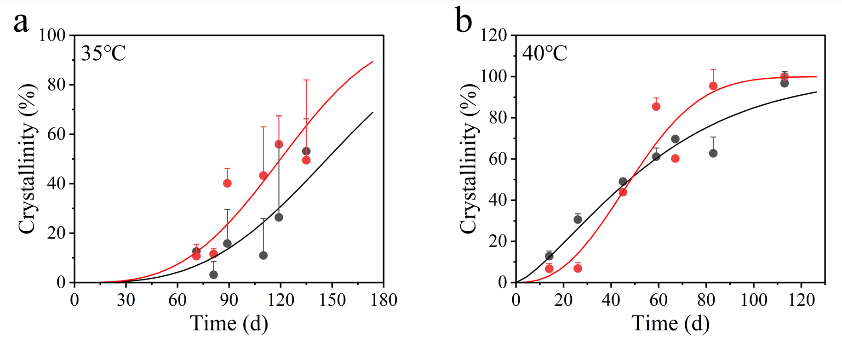
Fig. 8 Evolution of crystallinity of intact (black circles and lines) and nucleated glasses (red circles and lines) stored at (a) 35 °C and (b) 40 °C. The fitting lines are drawn by the Avrami-Erofeev equation.

Table 2. Kinetic Parameters for Isothermal Crystallization of CEL Glasses
 | Intact |  |  | Nucleated
Temperature (°C) | k (h⁻¹) | t₁₀ (h) | n | k (h⁻¹) | t₁₀ (h) | n
35 | 9.36×10⁻¹⁶ | 1930 | 3.1 | 9.51×10⁻¹⁶ | 1590 | 3.2
40 | (1.17×10⁻⁵) | (285) | (1.4) | (5.55×10⁻¹¹) | (538) | (2.5)
45 | (3.59×10⁻⁸) | (391) | (1.9) | (1.34×10⁻⁷) | (301) | (1.8)
50 | 9.10×10⁻¹⁷ | 1130 | 3.5 | (9.88×10⁻¹⁰) | (696) | (2.1)
60 | 4.57×10⁻¹⁸ | 2830 | 3.5 | 1.34×10⁻¹⁸ | 2340 | 3.7
The values in parenthesis are apparent ones obtained for simultaneous crystallization to multiple crystal forms. t₁₀: Time to reach 10% crystallinity calculated by the Avrami-Erofeev equation.

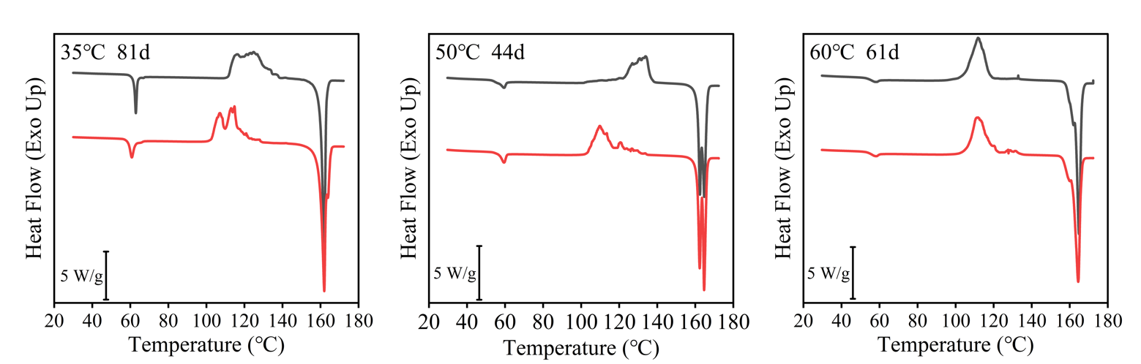
Fig. 9 DSC curves of the intact (black) and nucleated (red) CEL glasses after isothermal storage. The storage temperature and periods are indicated in the figure.

Figure 10 shows evolution of crystallinity of intact CEL glass as functions of storage temperature and time. Although investigation was also made at 30 °C, no crystallization was found for 150 days. The crystallization was obviously the fastest at 40 and 45 °C, which could be elucidated by diffusionless crystal growth³¹⁻³⁴. The same trend was confirmed for the nucleated glass.
Fig. 10 Evolution of crystallinity of intact CEL glass as functions of storage temperature and time. The data was fitted with Avrami-Erofeev equation. Storage temperatures are indicated in the figure. All data were at least triplicated but only mean values are presented without error bars for clarity.

4 Discussion

4.1 Impact of Nucleation on Glass Structure and Dynamics
Nucleation is the initial step in crystallization. If the difference between the optimum temperatures for nucleation and crystal growth is sufficiently large, the nucleated state may be retained without proceeding of crystal growth. Further crystallization proceeds easily once the nucleated glass is exposed to an appropriate temperature condition for crystal growth.
During nucleation, structural ordering is expected to accompany local densification. Thus, spatial heterogeneity should be induced by nucleation, which seems to significantly impact relaxation dynamics; α relaxation of the high- and low-density regions is expected to be suppressed and accelerated, respectively. Based on the relaxation study performed by DSC, the fast dynamics originating from the low-density region appear to have a greater impact than the slow dynamics of the high-density region. Echeverría et al. made a similar speculation when comparing enthalpy and creep relaxation; enthalpy relaxation was assumed to depend sensitively on the high molecular mobility region when structural heterogeneity exists³⁵. Spatial heterogeneity was also suggested by small β values in the KWW equation. BDS provided larger relaxation time and larger activation energies for β relaxation of the nucleated CEL, indicating that the local motion of the molecule was also influenced. This observation agrees with previous findings, where nucleation was observed to have relevance to the β relaxation^{17,18}.
Figure 11 shows a schematic representation of the possible impact of nucleation on the glass structure. As nuclei are expected to have higher density than non-nucleated glass, local condensation should occur after nucleation. It may leave void spaces in the glass structure if molecular diffusion is not sufficiently fast. It is likely for the CEL glass, as the nucleation temperature is much lower than T_{g}. Two notable differences were observed for the DSC curves of the nucleated and intact glasses: the nucleated glass had a wide glass transition region and a pre-T_{g} peak (Figures 2 and 3). The wide glass transition region of the nucleated glasses reflects the low cooperative molecular motion of the CEL molecules, which might be produced by the disruption of the glass structure caused the presence of void spaces. The size of CRR was determined to be 2.7 and 2.2 nm for intact and nucleated glass, respectively. Its typical value for organic glasses are approximately 2 nm²³ if it is determined by width of the glass transition region; thus, these values appeared to be general. Using the true density value of 1.41 g/cm³, the number of the CEL molecules can be calculated as 28 and 15 for intact and nucleated glass, respectively, per the region. The number of 15 may be regarded as the number of molecules per nuclei. In the supporting information, change in the CRR size during the annealing is presented. Although the deviation of the data was large, the CRR size of the nucleated glass was likely to increase during the annealing at 40 and 45 °C. It may be connected to deactivation of nuclei, which can be a partial reason for absence of efficacy of nuclei for the stability at 40 °C (Figure 8b). As for the pre-T_{g} peak, similar peaks were previously reported for indomethacin glass, which was obtained by annealing it at temperatures much lower than its T_{g}³⁶. It was explained by the nucleation of Form α. As the pre-T_{g} peak shifted to a higher temperature and merged with the enthalpy recovery peak at T_{g}, it was observed only during the short annealing periods. The molecules in the low-density region may be responsible for the pre-T_{g} peak. Because molecules in that region are expected to exhibit higher mobility, it may be reasonable to assume that their enthalpy recovery could be observed at temperatures lower than the T_{g}.

Fig. 11 Schematic representation of the nucleation process. Nucleation causes local densification, by which void space is formed. The CRR becomes smaller after nucleation because of disruption by the void spaces.

4.2 Effect of Preformed Nuclei on Glass Stability
The nuclei formed at the freezing temperature were expected to crystallize into Form III. However, annealing temperatures higher than room temperature revealed that Form I could also be obtained. With increase in the annealing temperature, the probability of crystallization into Form I and Form III increased and decreased, respectively. Thermodynamic stability of Form I and III have an enantiotropic relationship, and Form III is the stable form at ambient temperature. One possible reason of appearance of Form I is that Form I may have higher thermodynamic stability above 30 °C, that is, spontaneous transformation from Form III to From I might proceed. Another simple assumption is that the nucleation temperature of Form I may exist above the ambient temperature. In fact, nucleation temperatures are frequently found near T_{g}³⁷⁻³⁹.
The crystallization proceeded into Form I at 60 °C (Figure 9). Although the nuclei formed at the freezing temperature were those for Form III, initiation of the crystal growth into Form I at 60 °C was a little faster for the nucleated glass (Table 2). Thus, formation of the Form III nuclei seems to assist nucleation/crystal growth of Form I by any means. The presence of the low-density region may assist in the formation of nuclei of Form I. Promotion of formation of different crystal form is a known phenomenon called as cross-nucleation⁴⁰, in which the original crystal appears to work as a template for the new crystal form. The intact glass exhibited faster crystal growth relative to the nucleated one, which may be related to formation of the void spaces.
The long-term storage stability is anticipated to be poor if nuclei exist. It was true to some extent if Form III was the dominant form after the crystallization (35 °C). The effect was unclear when two crystal forms grew together (40-50 °C) or a different crystal form dominated the crystallization behavior (60 °C). Impact of the preformed nuclei on the glass stability was demonstrated to depend on the following storage condition.

4.3 Diffusionless Crystal Growth below T_{g}
The isothermal crystallization behavior was observed in the temperature range from 30 °C to 60 °C to find the fastest crystallization at 40 and 45 °C, which can be understood by the frequently reported phenomenon of accelerated crystallization just below T_{g}, called diffusionless crystal growth or GC mode³¹⁻³⁴. Its mechanism has been interpreted as the possible formation of embryos and the decrease in interfacial energy between the crystal/glass interface. Since acceleration of the crystallization was observed for both the intact and nucleated glasses, this observation is not necessarily related to the presence of the preformed nuclei. Moreover, the observation did not have relevance to the resultant crystal form.
In the series of our studies, initiation time for crystallization, t₁₀, was shown to depend only on temperature for compounds with high crystallization tendency^{4,5,10,41}. This conclusion was made by mainly observing the crystallization kinetics above T_{g}. However, the t₁₀ values obtained in this study for the CEL glass cannot be explained by this general rule due to significant effect of the diffusionless crystal growth. Although remarkable enhancement of the crystallization rate based on this mechanism has been observed for small molecules such as toluene³¹, degree of the enhancement has been marginal for larger compounds. For example, the crystal growth rate for ROY (5-methyl-2-[(2-nitrophyenyl)amino]-3-thiophenecarbonitrile, molecular weight: 259 Da) just below T_{g} was shown to be larger only by an order of magnitude than that just above T_{g}³⁴. However, this study revealed that the crystallization rate of the CEL glass at 40 °C was faster than that at 60 °C by more than eleven orders of magnitude. Hatase et al. suggested that the phenyl ring might play an important role for the diffusionless crystal growth³². Based on this assumption, two benzene rings in CEL might have some contribution. Relationship between chemical structure of organic compounds and appearance of the diffusionless crystal growth is of great importance to understand crystallization mechanism of small organic compounds.

5 Conclusion
The properties of nucleated CEL glass were investigated and compared with those of the intact one to understand how the presence of nuclei influences the structure and dynamics of organic glasses. The nucleated glass exhibited faster structural relaxation and a wider distribution of relaxation times than the intact one, presumably because of the spatial heterogeneity of its glass structure, which included condensed and void portions. The concept of void formation also explains the smaller CRR of the nucleated glass. BDS measurements revealed that β relaxation was suppressed by nucleation. In the long-term isothermal crystallization study, the crystal growth of Form III was accelerated in the presence of the nuclei at 35 °C. However, the nuclei for Form I also appeared at higher temperatures, diminishing the influential role of the preformed nuclei. Nevertheless, presence of form III nuclei and/or the formation of the void space after nucleation appeared to assist the formation of nuclei for form I. The crystallization rates just below T_{g} (40 °C) were faster than that just above T_{g} (60 °C) by more than eleven orders of magnitude, which could be explained by diffusionless crystal growth. These observations provide a better insight into the crystallization mechanism of small organic glasses.

Supporting Information
The supporting Information is available free of charge at
https://pubs.acs.org/doi/XXXXXX
The Supporting Information includes an example of the separation of the DSC heat flow curve into reversing and nonreversing heat flows, where presence of pre-Tg peak in the reversing heat flow and widening of the glass transition region found in the nonreversing heat flow are presented. Also included is quantitative analysis on change in the size of the CRR after nucleation and during the annealing.

Conflict of Interest
The authors declare no conflict of interest.

References
- Murdande, S. B.; Pikal, M. J.; Shanker, R. M.; Bogner, R. H. Solubility Advantage of Amorphous Pharmaceuticals: I. A Thermodynamic Analysis. J. Pharm. Sci. 2010, 99, 1254-1264.
- Kawakami, K. Modification of Physicochemical Characteristics of Active Pharmaceutical Ingredients and Application of Supersaturatable Dosage Forms for Improving Bioavailability of Poorly Absorbed Drugs. Adv. Drug Deliv. Rev. 2012, 64, 480-495.
- Kawakami, K. Theory and Practice of Supersaturatable Formulations for Poorly Soluble Drugs. Ther. Delivery 2015, 6, 339-352.
- Kawakami, K. Crystallization Tendency of Pharmaceutical Glasses: Relevance to Compound Properties, Impact of Formulation Process, and Implications for Design of Amorphous Solid Dispersions. Pharmaceutics 2019, 11, 202.
- Kawakami, K.; Harada, T.; Miura, K.; Yoshihashi, Y.; Yonemochi, E.; Terada, K.; Moriyama, H., Relationship between Crystallization Tendencies During Cooling from Melt and Isothermal Storage: Toward a General Understanding of Physical Stability of Pharmaceutical Glasses. Mol. Pharmaceutics 2014, 11, 1835-1843.
- Bhugra, C.; Shmeis, R.; Pikal, M. J. Role of Mechanical Stress in Crystallization and Relaxation Behavior of Amorphous Indomethacin. J. Pharm. Sci. 2008, 97, 4446-4458.
- Kawakami, K.; Miyoshi, K.; Tamura, N.; Yamaguchi, T.; Ida, Y. Crystallization of Sucrose Glass under Ambient Conditions: Evaluation of Crystallization Rate and Unusual Melting Behavior of Resultant Crystals. J. Pharm. Sci. 2006, 95, 1354-1363.
- Kawakami, K. Nucleation and Crystallization of Celecoxib Glass: Impact of Experience of Low Temperature on Physical Stability. Thermochim. Acta 2019, 671, 43-47.
- Wu, T.; Yu, L. Surface Crystallization of Indomethacin below Tg. Pharm. Res. 2006, 23, 2350-2355.
- Kawakami, K. Surface Effects on the Crystallization of Ritonavir Glass. J. Pharm. Sci. 2015, 104, 276-279.
- Alcoutlabi, M.; McKenna, G. B. Effects of Confinement on Material Behavior at the Nanometre Size Scale. J. Phys. Condens. Matter. 2005, 17, R461-R524.
- Newman, A.; Zografi, G. What Are the Important Factors That Influence API Crystallization in Miscible Amorphous API-Excipient Mixtures during Long-Term Storage in the Glassy State? Mol. Pharmaceutics, 2022, 19, 378-391.
- Jakobsen, B.; Niss, K.; Olsen, N. B. Dielectric and Shear Mechanical Alpha and Beta Relaxations in Seven Glass-Forming Liquids. J. Chem. Phys. 2005, 123, 234511.
- Johari, C. P.; Goldstein, M. Viscous Liquids and the Glass Transition. II. Secondary Relaxations in Glasses of Rigid Molecules. J. Chem. Phys. 1970, 53, 2372–2388.
- Paladi, F.; Oguni, M. Anomalous Generation and Extinction of Crystal Nuclei in Nonequilibrium Supercooled Liquid O-Benzylphenol. Phys. Rev. B. 2002, 65, 144202.
- Okamoto, N.; Oguni, M.; Sagawa, Y. Generation and Extinction of a Crystal Nucleus below the Glass Transition Temperature. J. Phys. Condens. Matter. 1997, 9, 9187–9198.
- Oguni, M. “Intra-Cluster Rearrangement” Model for the α-Process in Supercooled Liquids, as Opposed to “Cooperative Rearrangement of Whole Molecules within a Cluster.” J. Non. Cryst. Solids. 1997, 210, 171–177.
- Hikima, T.; Hanaya, M.; Oguni, M. Microscopic Observation of a Peculiar Crystallization in the Glass Transition Region and β-Process as Potentially Controlling the Growth Rate in Triphenylethylene. J. Mol. Struct. 1999, 479, 245-250.
- Song, J.; Kawakami, K. Nucleation during Storage Impeded Supersaturation in the Dissolution Process of Amorphous Celecoxib. Mol. Pharmaceutics 2023, 20, 4050-4057.
- Angell, C. A.; Ngai, K. L.; McKenna, G. B.; McMillan, P. F.; Martin, S. W. Relaxation in Glassforming Liquids and Amorphous Solids. Appl. Phys. Rev. 2000, 88, 3113-3157.
- Kawakami, K.; Pikal, M. J. Calorimetric Investigation of the Structural Relaxation of Amorphous Materials: Evaluating Validity of the Methodologies. J. Pharm. Sci. 2005, 94, 948–965.
- Grzybowska, K.; Capaccioli, S.; Paluch, M. Recent Developments in the Experimental Investigations of Relaxations in Pharmaceuticals by Dielectric Techniques at Ambient and Elevated Pressure. Adv. Drug Delivery Rev. 2016, 100, 158-182.
- Donth, E. The Size of Cooperatively Rearranging Regions at the Glass Transition. J. Non-Cryst. Solids. 1982, 53, 325–330.
- Kawakami, K. Dynamics of Ribavirin Glass in Sub-Tg Temperature Region. J. Phys. Chem. B, 2011, 115, 11375-11381.
- Chawla, G.; Gupta, P.; Thilagavathi, R.; Chakraborti, A. K.; Bansal, A. K. Characterization of Solid-State Forms of Celecoxib. Eur. J. Pharm. Sci. 2003, 20, 305-317.
- Ferro, L. J.; Miyake, P. S. Polymorphic Crystalline Forms of Celecoxib. US Patent 2004/0087640 A1, 2004.
- Lu, G. W.; Hawley, M.; Smith, M.; Geiger, B. M.; Pfund, W. Characterization of a Novel Polymorphic Form of Celecoxib. J. Pharm. Sci. 2006, 95, 305–317.
- Vasu Dev, R.; Shashi Rekha, K.; Vyas, K.; Mohanti, S. B.; Rajender, Kumar, P.; Om Reddy, G.; Celecoxib, a COX-II Inhibitor, Acta Cryst. 1999, C55.
- Grzybowska, K.; Chmiel, K.; Knapik-Kowalczuk, J.; Grzybowski, A.; Jurkiewicz, K.; Paluch, M. Molecular Factors Governing the Liquid and Glassy States Recrystallization of Celecoxib in Binary Mixtures with Excipients of Different Molecular Weights. Mol. Pharmaceutics 2017, 14, 1154–1168.
- Grzybowska, K.; Paluch, M.; Grzybowski, A.; Wojnarowska, Z.; Hawelek, L.; Kolodziejczyk, K.; Ngai, K. L. Molecular Dynamics and Physical Stability of Amorphous Anti-Inflammatory Drug: Celecoxib. J. Phys. Chem. B. 2010, 114, 12792–12801.
- Hatase, M.; Hanaya, M.; Hikima, T.; Oguni, M. Discovery of Homogeneous-Nucleation-Based Crystallization in Simple Glass-Forming Liquid of Toluene below Its Glass-Transition Temperature. J. Non-Cryst. Solids. 2002, 307-310, 257-263.
- Hatase, M.; Hanaya, M.; Oguni, M. Studies of Homegeneous-Nucelation-Based Crystal Growth: Significant Role of Phenyl Rings in the Structure Formation. J. Non-Cryst. Solids. 2004, 333, 129-136.
- Konishi, T.; Tanaka, H. Possible Origin of Enhanced Crystal Growth in a Glass, Phys. Rev. B 2007, 76, 220201.
- Sun, Y.; Xi, H.; Chen, S.; Ediger, M. D.; Yu, L. Crystallization near Glass Transition: Transition from Diffusion-Controlled to Diffusionless Crystal Growth Studied with Seven Polymorphs. J. Phys. Chem. B 2008, 112, 5594-5601.
- Echeverría, I.; Kolel, P. L.; Plazek, D. J.; Simon, S. L. Enthalpy Recovery, Creep and Creep-Recovery Measurements during Physical Aging of Amorphous Selenium. J. Non-Cryst. Solids, 2003, 324, 242-255.
- Vyazovkin, S.; Dranca, I. Effect of Physical Aging on Nucleation of Amorphous Indomethacin. J. Phys. Chem. B 2007, 111, 7283–7287.
- Descamps, M.; Dudognon, E. Crystallization from the Amorphous State: Nucleation-Growth Decoupling, Polymorphism Interplay, and the Role of Interfaces. J. Pharm. Sci. 2014, 103, 2615-2628.
- Yao, X.; Huang, C.; Benson, E. G.; Shi, C.; Zhang., G. G. Z.; Yu, L. Effect of Polymers on Crystallization in Glass-Forming Molecular Liquids: Equal Suppression of Nucleation and Growth and Master Curve for Prediction. Cryst. Growth. Des. 2020, 20, 237-244.
- Wu, H.; Yao, X.; Gui, Y.; Hao, H.; Yu, L. Surface Enhancement of Crystal Nucleation in Amorphous Acetaminophen. Cryst. Growth. Des. 2022, 22, 5598-5606.
- Yu, L. Nucleation of one polymorph by another. J. Am. Chem. Soc. 2003, 125, 6380-6381.
- Kawakami, K. Pharmaceutical Application of Thermal Analysis. In Handbook of Thermal Analysis and Calorimetry, 2nd Ed.; Vyazovkin, S., Koga, N., Schick, C., Eds.; Elsevier: Amsterdam, 2018; 6, pp 613-641.

