Supporting Information
Structure-Activity Relationship in PtCo L10 Ordered Phase ORR Catalysts: Pt-rich Shell having Anisotropic Lattice Distortion Revealed by PDF and XAS Analysis

Yunfei Gao^{1†}, Mukesh Kumar^{1†*}, Neha Thakur¹, Weijie Cao¹, Toshiki Watanabe¹, Satoshi Tominaka^{2†*}, Kazutaka Sonobe², Akihiko Machida³, Ryota Sato⁴, Toshiharu Teranishi⁴, Masashi Matsumoto⁵, Hideto Imai⁵, Tomoya Uruga⁶, Yoshiharu Sakurai⁶, Yoshiharu Uchimoto¹
¹ Graduate School of Human and Environmental Studies, Kyoto University, Yoshida Nihonmatsu-cho, Sakyo-ku, Kyoto 606-8501, Japan
² Center for Basic Research on Materials, National Institute for Materials Science, Namiki, Tsukuba, Ibaraki 305-0044, Japan
³ Synchrotron Radiation Research Center, National Institutes for Quantum Science and Technology (QST), SPring-8, Sayo, Hyogo 679-5148, Japan
⁴ Institute for Chemical Research, Kyoto University, Uji, Kyoto 611-0011, Japan
⁵ Fuel Cell Cutting-Edge Research Center Technology Research Association, Aomi, Koto, Tokyo, 135-0064 Japan
⁶ Japan Synchrotron Radiation Research Institute (JASRI), Koto, Sayo, Hyogo, 679-5198, Japan

*Corresponding authors: kumar.mukesh.5x@kyoto-u.ac.jp, TOMINAKA.Satoshi@nims.go.jp

† Authors contributed equally to this work
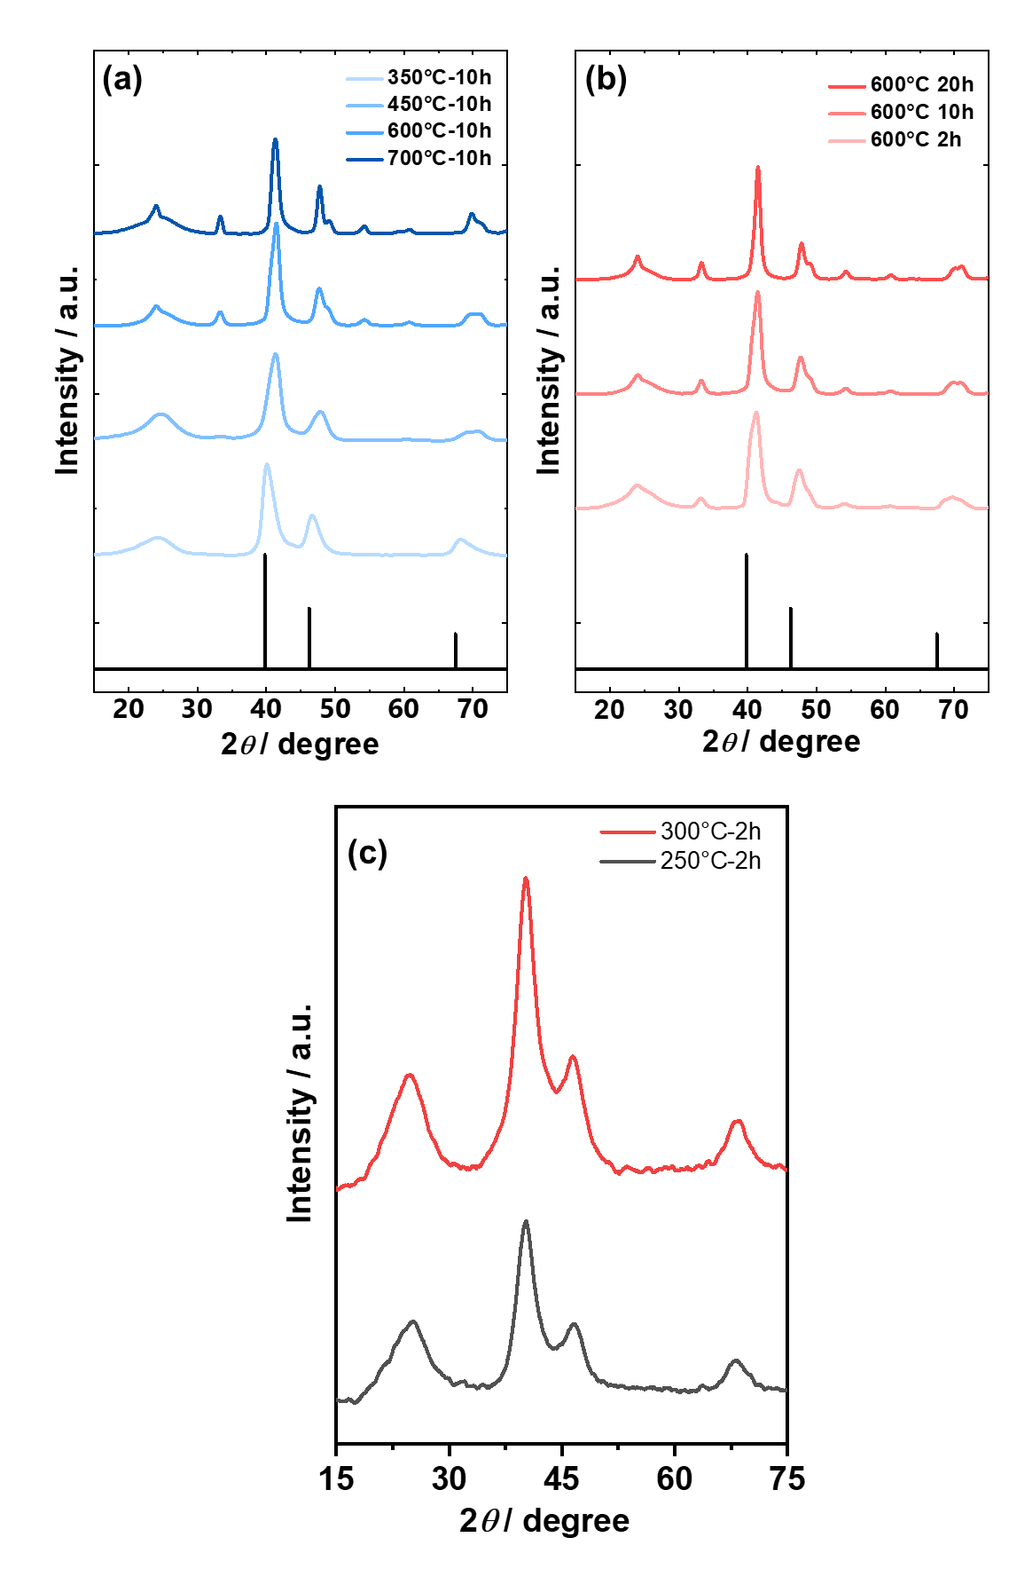

Figure S1 XRD patterns of PtCo alloys (a) treated at different thermal temperatures and (b) different thermal treatment times, (c) XRD of PtCo alloys at 250 and 300 °C. Black lines represent the standard reference for fct L1₀ PtCo JCPDS: 65-8969.
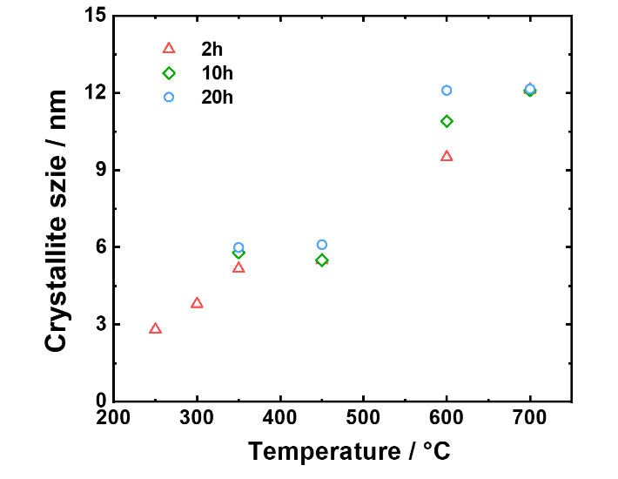
Figure S2 Crystallite size of PtCo catalysts as a function of annealing temperature. The crystallite size was estimated from the 111 reflections in the XRD patterns using the Scherrer equation.

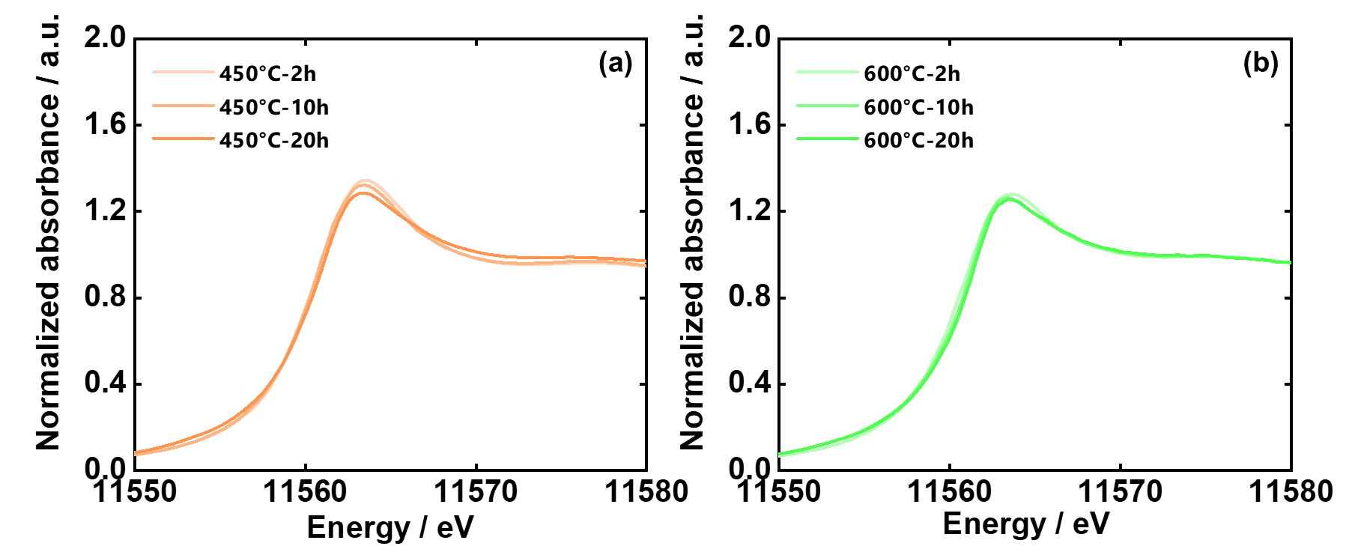

Figure S3. Pt L₃-edge XANES spectra of the catalysts treated for different times at (a) 450 °C and (d) 600 °C.

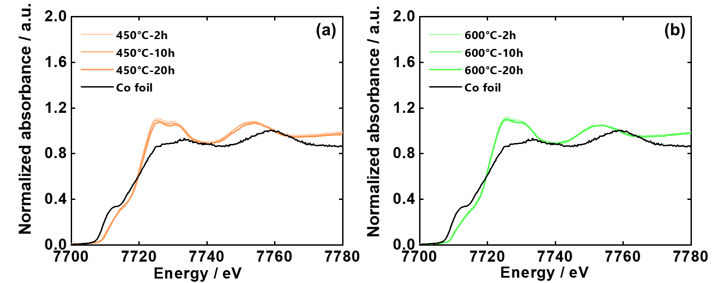

Figure S4. The Co K-edge XANES spectra of the catalysts treated for different times at (a) 450 °C and (b) 600 °C.

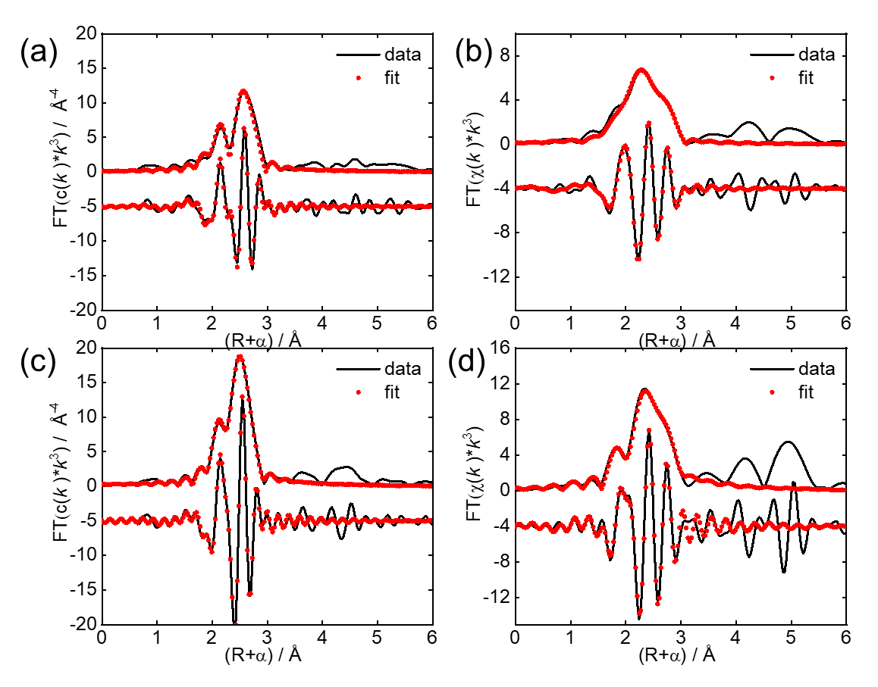
Figure S5. EXAFS fitting details for the Pt L₃-edge for (a) PtCo-350°C-10h-A and (b) PtCo-700°C-10h-A. EXAFS fitting details for the Co K-edge for (c) PtCo-350°C-10h-A and (d) PtCo-700°C-10h-A.
The r space data was used to fit with the application of k³ weighting over the ranges 3.0 ≤ k ≤ 16.0 and 1.5 ≤ r ≤ 3.3 for the Pt L₃-edge. For the Co K-edge, fits were undergone in R-space for 1.4 ≤ r ≤ 3.1 Å, and the k^{,3} weighting over the ranges 3.0 ≤ k ≤ 12.0. During the fitting, the following constraints were introduced:
$$r_{Pt-Co}= r_{Co-Pt}$$
${CN}_{Co-Pt}+{CN}_{Co-Co}=$ 12
Where $r_{Pt-Co}$ ($r_{Co-Pt}$) is the bond length for the Pt-Co (Co-Pt) scattering, the total coordination number for the Co (${CN}_{Co}$) is assumed to be 12 for the FCC and FCT structure (only the bulk phase Co is considered in the catalysts).
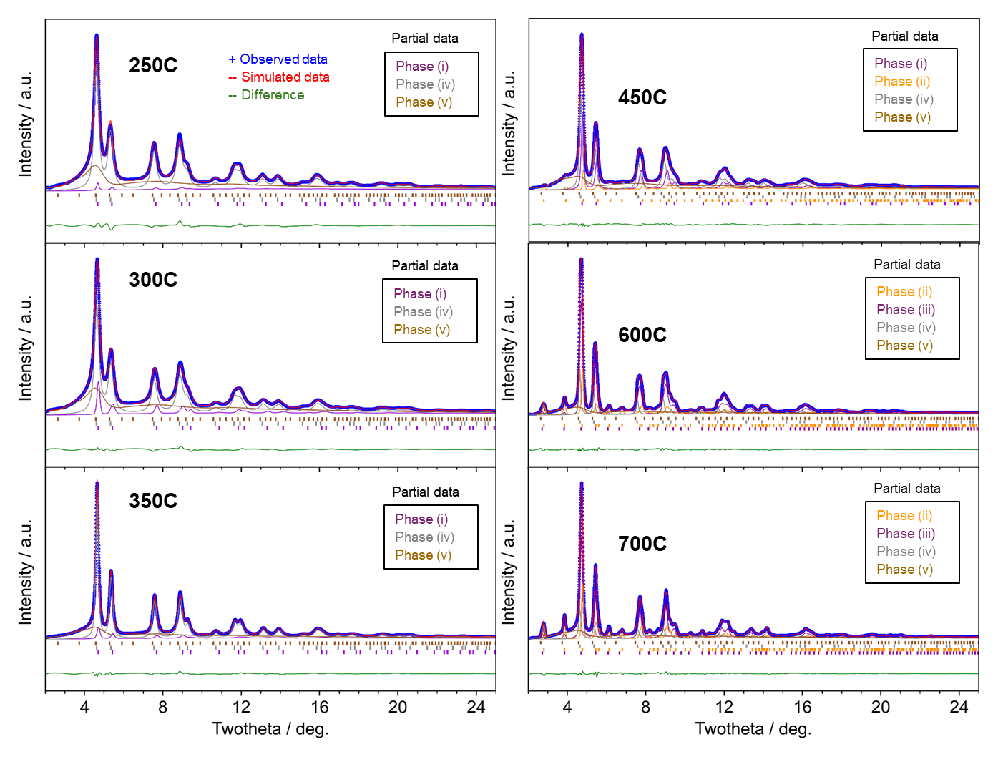
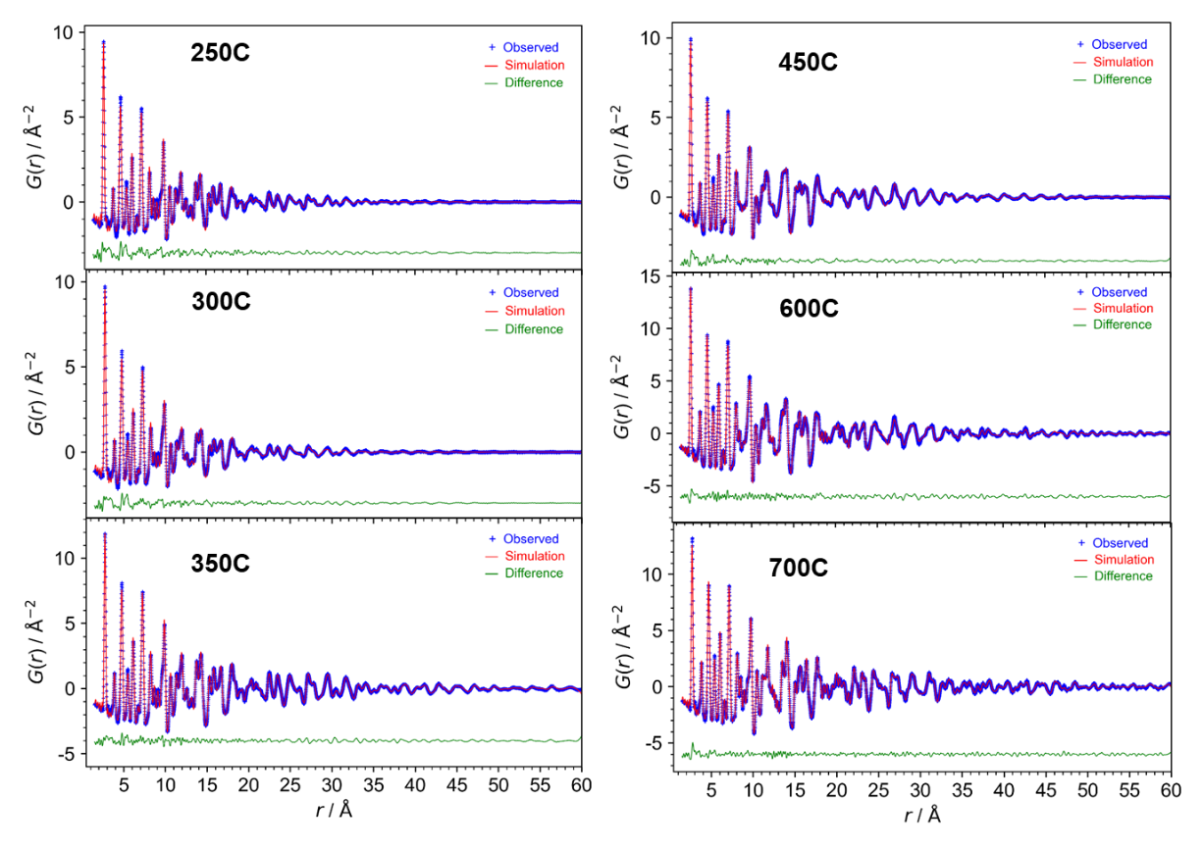
Figure S6 Rietveld refinement and PDF fitting results for PtCo catalysts annealed at different temperatures for 2 hours followed by acid treatment. (top) Total scattering patterns refined by the Rietveld method. Each partial contribution of the phases determined in Figure 4 of the main text, along with their hkl indices shown as vertical ticks, are displayed. (bottom) Corresponding PDF fitting results.

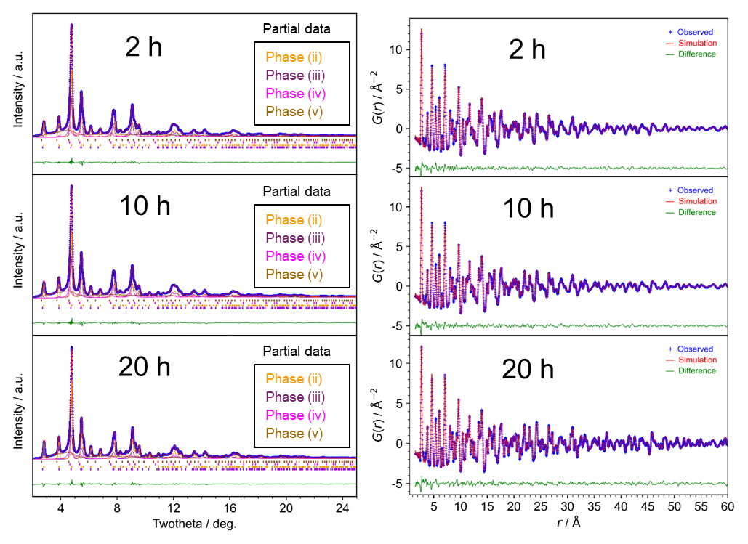Figure S7 Rietveld refinement and PDF fitting results for PtCo catalysts annealed at 700°C for different durations followed by acid treatment. (left) Total scattering patterns refined by the Rietveld method. Each partial contribution of the phases determined in Figure 4 of the main text, along with their hkl indices shown as vertical ticks, are displayed. (right) Corresponding PDF fitting results.

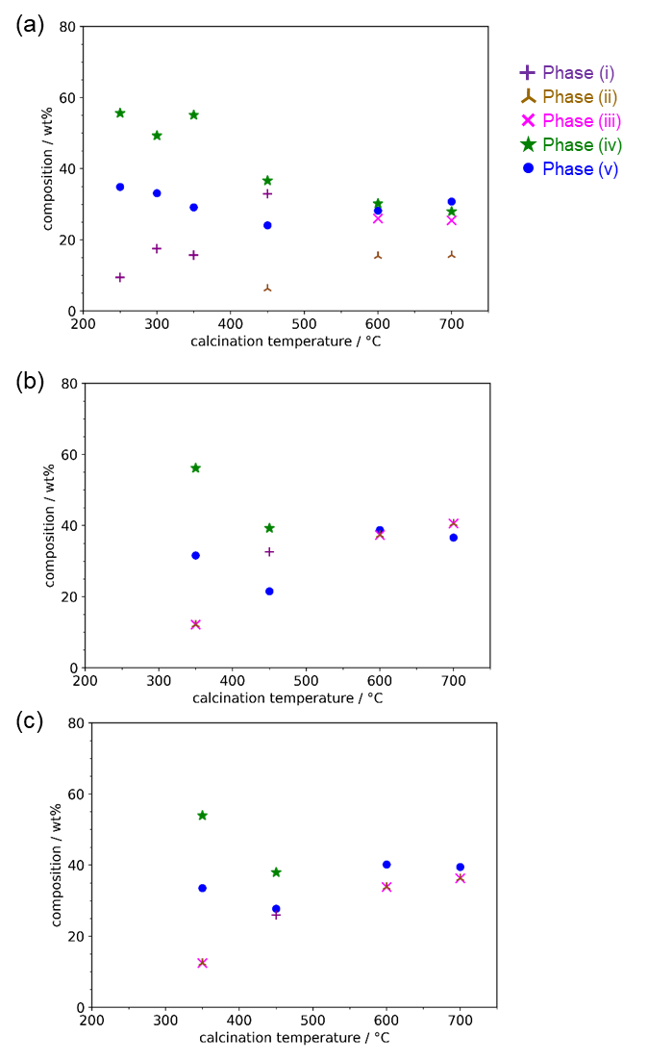
Figure S8 Phase fraction (wt%) obtained by the PDF fitting. The PtCo samples are annealed at different temperatures for (a) 2h, (b) 10 h, and (c) 20h, followed by acid treatment. Each contribution of the phases determined in Figure 4 of the main text
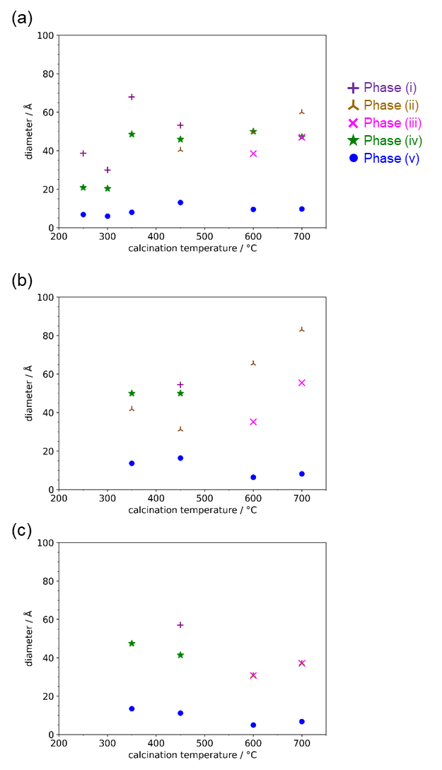
Figure S9 Domain size of PtCo catalysts as a function of annealing temperature. All samples were annealed for (a) 2h, (b) 10 h, and (c) 20h and subsequently treated with acid. Each contribution of the phases determined in Figure 4 of the main text

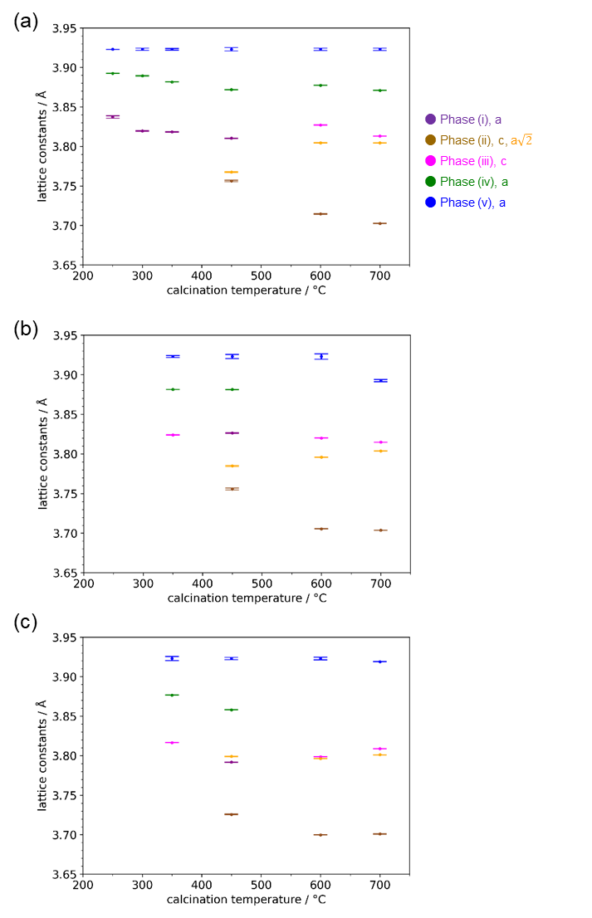
Figure S10 Lattice parameters of PtCo catalysts as a function of annealing temperature and time, as determined by PDF analysis. Each contribution of the phases determined in Figure 4 of the main text. The tetragonal phase (ii) is represented in a cubic lattice for clarity. The error bars represent the estimated standard deviations from the PDF analysis. All samples were annealed for (a) 2h, (b) 10 h, and (c) 20h and subsequently treated with acid.

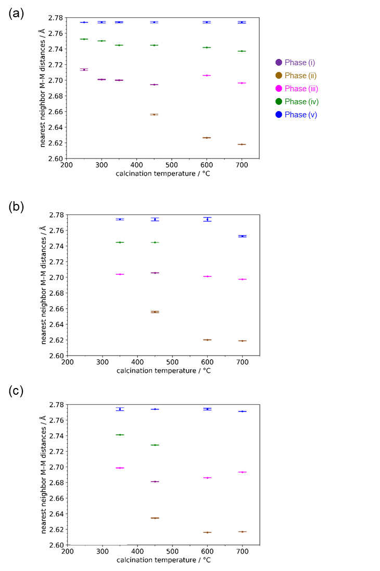
Figure S11 Shortest nearest-neighbor Pt-Pt distances in PtCo catalysts as a function of annealing temperature. All samples were annealed for (a) 2h, (b) 10 h, and (c) 20h and subsequently treated with acid. Each contribution of the phases determined in Figure 4 of the main text.

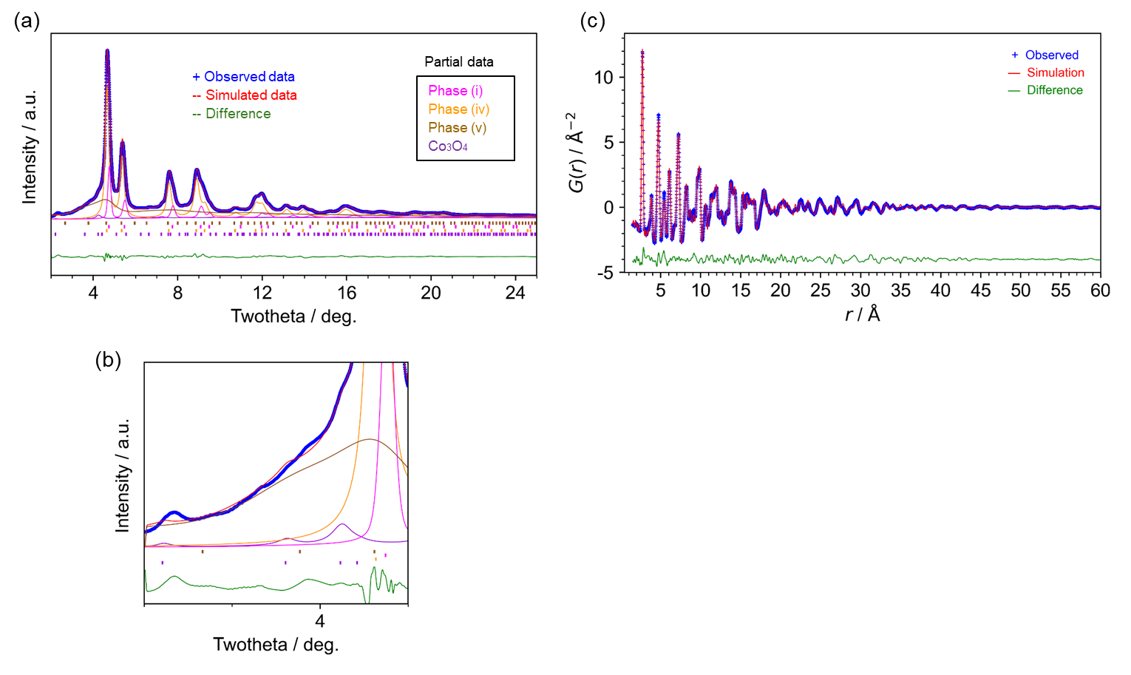Figure S12 Rietveld refinement and PDF fitting results for PtCo catalysts annealed at 350°C for 2 h without acid treatment. (a) Total scattering pattern refined by the Rietveld method. Each partial contribution of the phases determined in Figure 4 of the main text, along with their hkl indices shown as vertical ticks, are displayed. (b) Enlarged view of the low-angle region of the total scattering pattern. (c) Corresponding PDF fitting result.

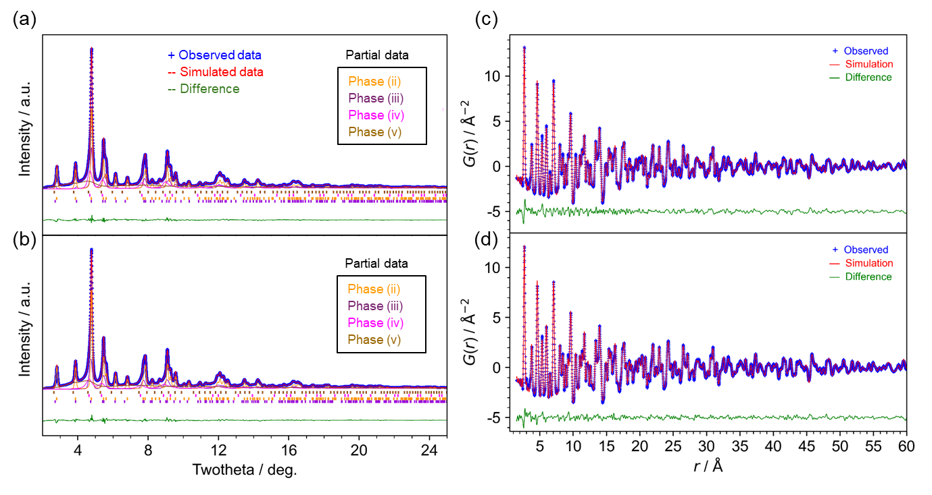Figure S13 Rietveld refinement and PDF fitting results for PtCo catalysts annealed at 700°C for 20 h with and without acid treatment. (a, b) Total scattering patterns refined by the Rietveld method for the samples (a) without and (b) with acid treatment. Each partial contribution of the phases determined in Figure 4 of the main text, along with their hkl indices shown as vertical ticks, are displayed. (c, d) Corresponding PDF fitting results for the samples (c) without and (d) with acid treatment.

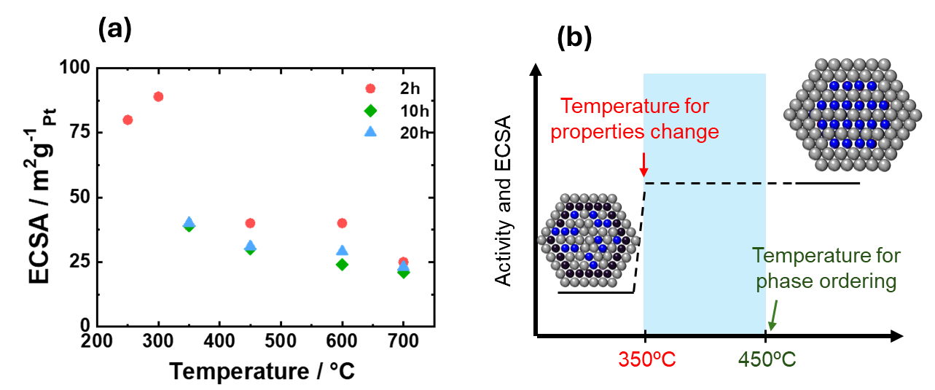

Figure S14. (a) The ECSA, of various catalysts treated at different thermal conditions, (b) Schematic illustration of the temperature gap between the onset of particle growth and the formation of the ordered phase in PtCo catalysts. The red arrow indicates the temperature (350°C) at which particle growth and changes in electrochemical properties are observed. The green arrow indicates the temperature (450°C) at which the ordered phase is detected by XRD and PDF analyses. The blue shaded region represents the temperature range where local structural changes, such as surface ordering or strain, may occur.

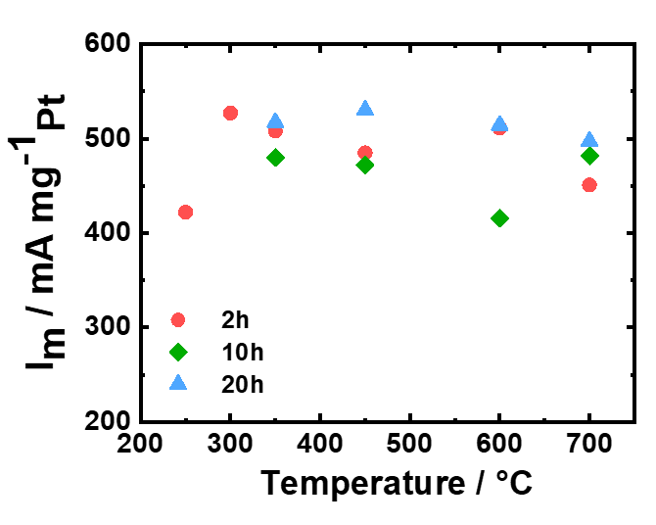

Figure S15. Mass activity at 0.9 V for the catalysts treated at different thermal conditions.

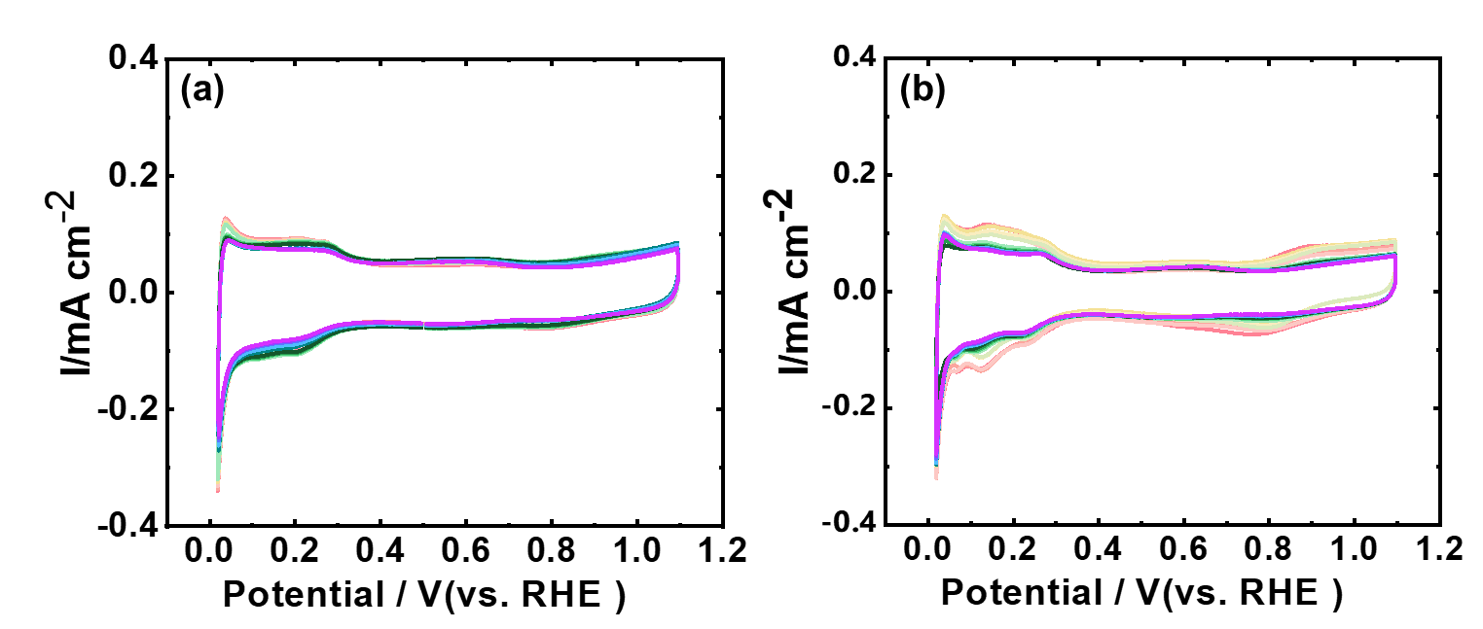

Figure S16. CVs curves for the (a) PtCo-700°C-10h-A and (b) PtCo-350°C-10h-A after various ADT cycles.

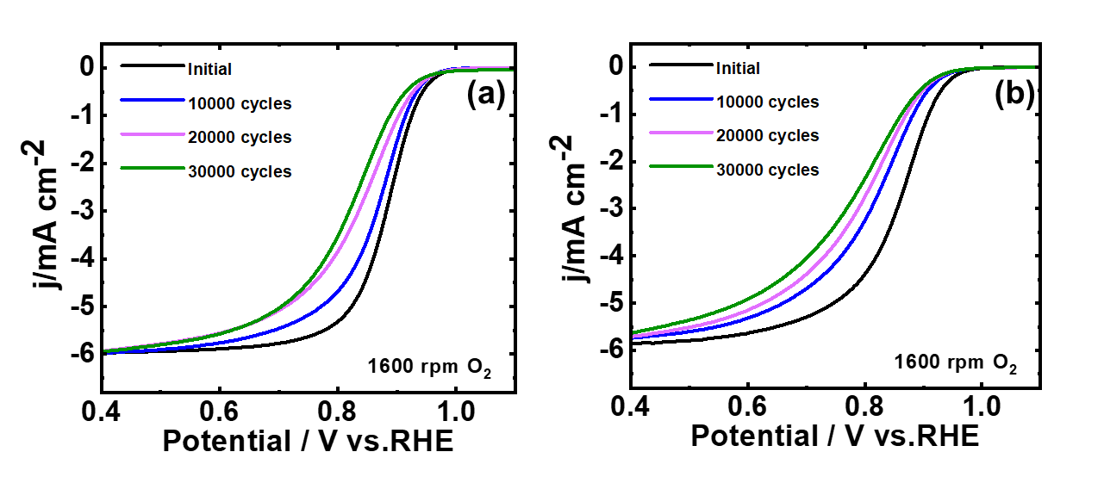

Figure S17. LSV curves for (a) PtCo-700°C-10h-A and (b) PtCo-350°C-10h-A catalysts before and after ADT cycles.

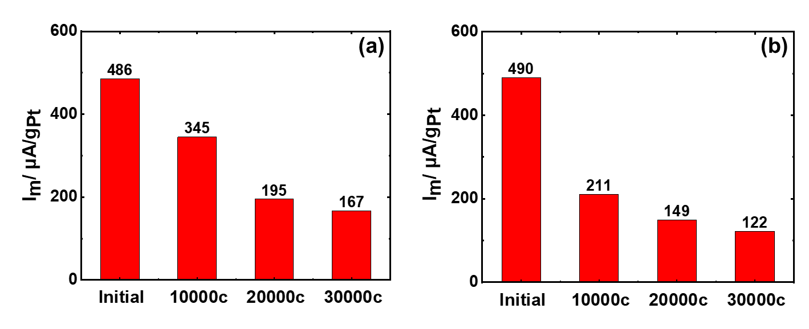
Figure S18. Bar diagram showing the mass activity for (a) PtCo-700°C-10h-A and (b) PtCo-350°C-10h-A catalysts before and after ADT cycles.

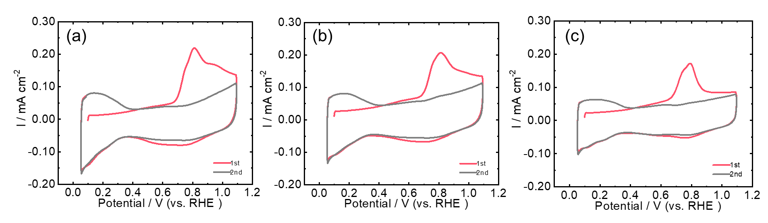
Figure S19. Electrochemical CO stripping measurement for PtCo-350°C-10h-A for (a) initial state, (b) after 10000 ADT cycles, and (c) after 20000 ADT cycles.

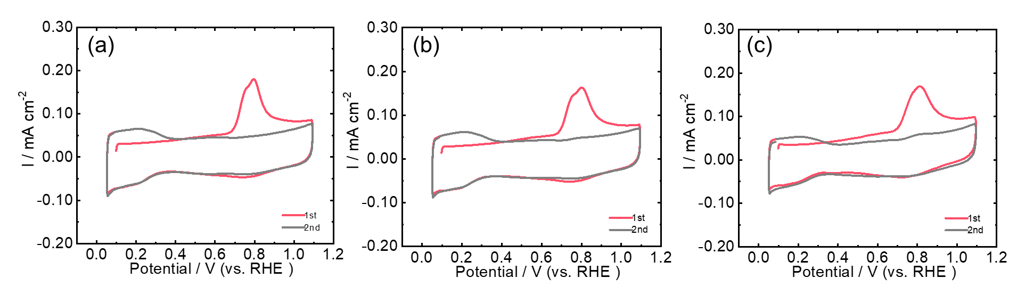
Figure S20. Electrochemical CO stripping measurement for PtCo-700°C-10h-A for (a) initial state, (b) after 10000 ADT cycles, and (c) after 20000 ADT cycles.

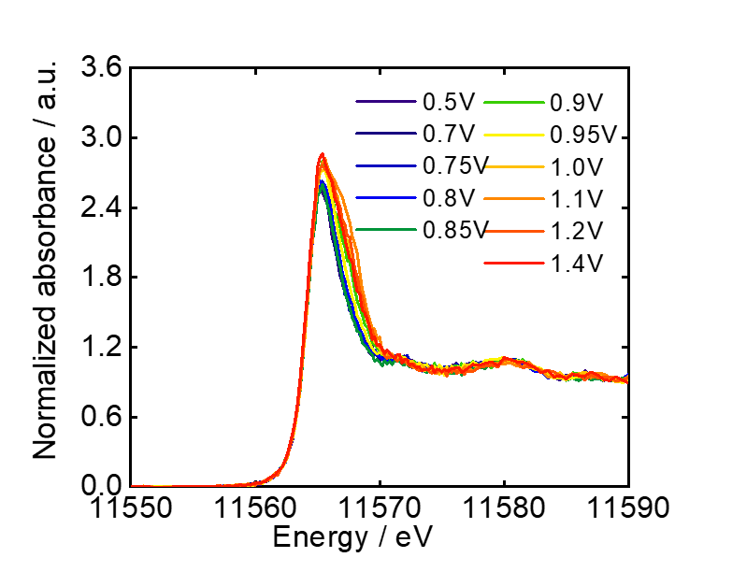
Figure S21. operando HERFD-Pt L₃-edge XAS analysis for PtCo-350°C-10h.

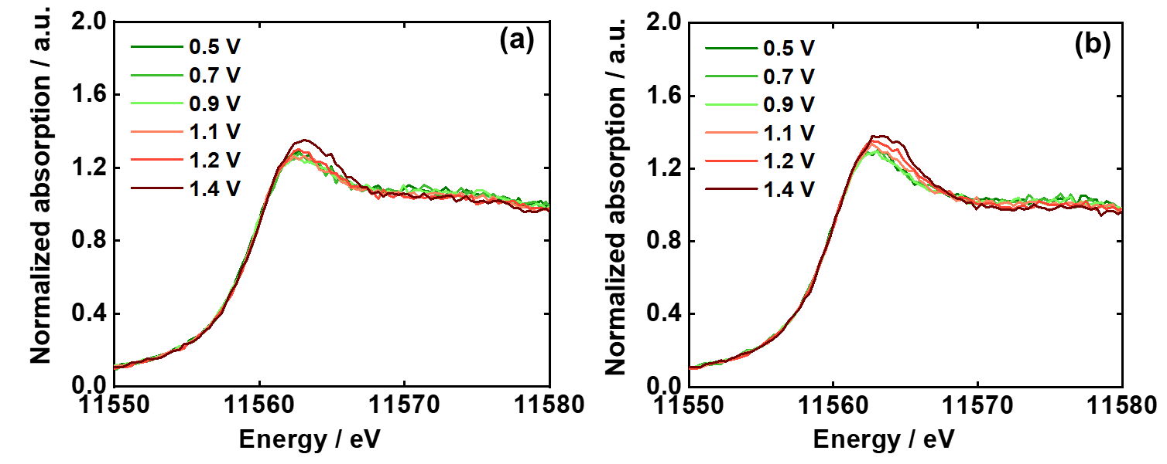

Figure S22. operando Pt L₃-edge XANES spectra at various polarization potentials for (a) PtCo-700°C-10h-A and (b) PtCo-350°C-10h-A catalysts.

Table S1. Chemical composition of PtCo alloy catalysts after acid treatment determined by ICP.
 | Pt wt% | Pt at% | Co at%
PtCo-350°C-2h-A | 13.11 | 81 | 19
PtCo-350°C-10h-A | 13.24 | 79 | 21
PtCo-350°C-20h-A | 13.34 | 77 | 23
PtCo-450°C-2h-A | 13.58 | 71 | 29
PtCo-450°C-10h-A | 13.92 | 73 | 27
PtCo-450°C-20h-A | 13.28 | 67 | 33
PtCo-600°C-2h-A | 14.16 | 66 | 34
PtCo-600°C-10h-A | 14.3 | 63 | 37
PtCo-600°C-20h-A | 15.06 | 60 | 40
PtCo-700°C-2h-A | 14.21 | 66 | 34
PtCo-700°C-10h-A | 14.54 | 63 | 37
PtCo-700°C-20h-A | 13.58 | 63 | 37
PtCo-250°C-2h-A | 12.46 | 95 | 5
PtCo-300°C-2h-A | 13.43 | 87 | 13

Table S2. Summary of ex-situ EXAFS results of the catalysts for the Pt L₃-edge.
 | Path | d/Å | CN | ΔE₀ | R/Å | σ²/ Å² | R
PtCo-350°C-2h-A | Pt-Pt | 2.712 | 5.3 | 5.983 | 2.726(5) | 0.005 | 1.9%
PtCo-350°C-2h-A | Pt-Co | 2.712 | 2.3 | 6.206 | 2.632(26) | 0.006 | 1.9%
PtCo-350°C-10h-A | Pt-Pt | 2.712 | 5.8 | 6.454 | 2.726(5) | 0.006 | 2.0%
PtCo-350°C-10h-A | Pt-Co | 2.712 | 2.6 | 7.225 | 2.631(25) | 0.009 | 2.0%
PtCo-350°C-20h-A | Pt-Pt | 2.712 | 5.3 | 5.934 | 2.721(5) | 0.007 | 4.8%
PtCo-350°C-20h-A | Pt-Co | 2.712 | 2.6 | 10.793 | 2.659(45) | 0.014 | 4.8%
PtCo-450°C-2h-A | Pt-Pt | 2.691 | 4.5 | 5.567 | 2.703(7) | 0.007 | 1.8%
PtCo-450°C-2h-A | Pt-Co | 2.648 | 2.1 | 11.314 | 2.658(26) | 0.009 | 1.8%
PtCo-450°C-10h-A | Pt-Pt | 2.691 | 4.1 | 6.247 | 2.711(5) | 0.006 | 1.6%
PtCo-450°C-10h-A | Pt-Co | 2.648 | 2.4 | 9.899 | 2.672(29) | 0.009 | 1.6%
PtCo-450°C-20h-A | Pt-Pt | 2.691 | 4.7 | 5.137 | 2.695(7) | 0.006 | 1.7%
PtCo-450°C-20h-A | Pt-Co | 2.648 | 3.5 | 8.871 | 2.638(15) | 0.009 | 1.7%
PtCo-600°C-2h-A | Pt-Pt | 2.691 | 4.8 | 6.814 | 2.703(2) | 0.005 | 0.2%
PtCo-600°C-2h-A | Pt-Co | 2.648 | 2.8 | 9.593 | 2.653(5) | 0.007 | 0.2%
PtCo-600°C-10h-A | Pt-Pt | 2.691 | 4.9 | 5.908 | 2.692(3) | 0.005 | 0.4%
PtCo-600°C-10h-A | Pt-Co | 2.648 | 3.8 | 8.764 | 2.643(6) | 0.007 | 0.4%
PtCo-600°C-20h-A | Pt-Pt | 2.691 | 4.8 | 5.423 | 2.684(4) | 0.005 | 0.5%
PtCo-600°C-20h-A | Pt-Co | 2.648 | 3.8 | 8.856 | 2.639(7) | 0.006 | 0.5%
PtCo-700°C-2h-A | Pt-Pt | 2.691 | 4.1 | 7.246 | 2.695(5) | 0.005 | 1.2%
PtCo-700°C-2h-A | Pt-Co | 2.648 | 4.0 | 11.581 | 2.657(13) | 0.006 | 1.2%
PtCo-700°C-10h-A | Pt-Pt | 2.691 | 4.4 | 6.455 | 2.694(3) | 0.004 | 0.4%
PtCo-700°C-10h-A | Pt-Co | 2.648 | 4.2 | 8.544 | 2.646(6) | 0.006 | 0.4%
PtCo-700°C-20h-A | Pt-Pt | 2.691 | 4.8 | 5.259 | 2.685(5) | 0.005 | 0.8%
PtCo-700°C-20h-A | Pt-Co | 2.648 | 4.1 | 8.572 | 2.642(9) | 0.007 | 0.8%
$S_{0}^{2}$ fixed at 0.9, where the $∆CN$ is less than 0.5, $∆σ^{2}$ is less than 0.01 from the least-squares fits by ARTEMIS
Table S3. Summary of ex-situ EXAFS results of the catalysts for the Co K-edge.
 | Path | d/Å | CN | ΔE₀ | R/Å | σ²/ Å² | R
PtCo-350°C-2h-A | Co-Pt | 2.711 | 9.4(5) | -11.750 | 2.632 | 0.009 | 1.2%
PtCo-350°C-2h-A | Co-Co | 2.711 | 2.6(5) | -17.169 | 2.542(20) | 0.009 | 1.2%
PtCo-350°C-10h-A | Co-Pt | 2.711 | 9.2(5) | -10.539 | 2.632(26) | 0.009 | 1.7%
PtCo-350°C-10h-A | Co-Co | 2.711 | 2.8(5) | -11.321 | 2.553(21) | 0.009 | 1.7%
PtCo-350°C-20h-A | Co-Pt | 2.711 | 9.1(5) | -10.965 | 2.659 | 0.009 | 1.1%
PtCo-350°C-20h-A | Co-Co | 2.711 | 2.9(5) | -11.550 | 2.540(17) | 0.009 | 1.1%
PtCo-450°C-2h-A | Co-Pt | 2.648 | 7.9(5) | -2.237 | 2.658 | 0.009 | 1.8%
PtCo-450°C-2h-A | Co-Co | 2.691 | 4.1(5) | -4.524 | 2.600(20) | 0.007 | 1.8%
PtCo-450°C-10h-A | Co-Pt | 2.648 | 7.2(5) | -5.118 | 2.672 | 0.008 | 0.7%
PtCo-450°C-10h-A | Co-Co | 2.691 | 4.8(5) | 8.622 | 2.737(29) | 0.016 | 0.7%
PtCo-450°C-20h-A | Co-Pt | 2.648 | 7.1(5) | -4.207 | 2.638 | 0.006 | 2.0%
PtCo-450°C-20h-A | Co-Co | 2.691 | 4.9(5) | 9.983 | 2.743(29) | 0.016 | 2.0%
PtCo-600°C-2h-A | Co-Pt | 2.648 | 7.1(5) | -3.629 | 2.653 | 0.006 | 1.7%
PtCo-600°C-2h-A | Co-Co | 2.691 | 4.9(5) | 9.964 | 2.754(32) | 0.014 | 1.7%
PtCo-600°C-10h-A | Co-Pt | 2.648 | 6.5(5) | -3.318 | 2.643 | 0.006 | 1.5%
PtCo-600°C-10h-A | Co-Co | 2.691 | 5.5(5) | 6.744 | 2.721(2) | 0.011 | 1.5%
PtCo-600°C-20h-A | Co-Pt | 2.648 | 6.4(5) | -3.318 | 2.639 | 0.005 | 1.3%
PtCo-600°C-20h-A | Co-Co | 2.691 | 5.6(5) | 6.744 | 2.749(22) | 0.015 | 1.3%
PtCo-700°C-2h-A | Co-Pt | 2.648 | 6.5(5) | -4.235 | 2.647 | 0.005 | 1.3%
PtCo-700°C-2h-A | Co-Co | 2.691 | 5.5(5) | 8.319 | 2.739(12) | 0.015 | 1.3%
PtCo-700°C-10h-A | Co-Pt | 2.648 | 4.8(5) | -4.168 | 2.646 | 0.004 | 1.0%
PtCo-700°C-10h-A | Co-Co | 2.691 | 7.2(5) | 3.321 | 2.686(9) | 0.009 | 1.0%
PtCo-700°C-20h-A | Co-Pt | 2.648 | 4.8(5) | -4.634 | 2.642 | 0.004 | 1.2%
PtCo-700°C-20h-A | Co-Co | 2.691 | 7.2(5) | 3.512 | 2.686(12) | 0.009 | 1.2%
$S_{0}^{2}$ fixed at 0.9, where the $∆CN$ is less than 0.5, $∆σ^{2}$ is less than 0.01 from the least-squares fits by ARTEMIS
Table S4. Phase fraction of PtCo catalysts annealed at 700°C for 20 h with and without acid treatment.
 | Phase (ii) | Phase (iii) | Phase (iv) | Phase (v)
After acid treatment | 21.107 | 16.061 | 30.206 | 32.626
Before acid treatment | 21.064 | 17.798 | 33.913 | 27.225

Table S5. Lattice parameters of PtCo catalysts annealed at 700°C for 20 h before and after acid treatment.
 | Phase (ii) |  | Phase (iii) |  | Phase (iv) | Phase (v)
 | c /Å | a /Å | c /Å | a /Å | a /Å | a /Å
After acid treatment | 3.69686 | 2.68477 | 3.83027 | 2.67418 | 3.87509 | 3.92309
Before acid treatment | 3.69459 | 2.68625 | 3.82087 | 2.64118 | 3.83811 | 3.89098
Note that We set the upper limit of the pFCC-Pt lattice parameter to be 3.9231Å, which is the one for pure Pt.

Table S6. Domain sizes of PtCo catalysts annealed at 700°C for 20 h with and without acid treatment.
 | Phase (ii) | Phase (iii) | Phase (iv) | Phase (v)
After acid treatment | 57.29664 | 16.94926 | 14.2217 | 4.93004
Before acid treatment | 56.33593 | 23.54757 | 12.25646 | 13.09178

