Supplementary Information for

Spin valve effect in junctions with a single ferromagnet

Fengrui Yao^{1,2*}, Volodymyr Multian^{1,2,3}, Kenji Watanabe⁴, Takashi Taniguchi⁵, Ignacio Gutiérrez-Lezama^{1,2}, and Alberto F. Morpurgo^{1,2*}

¹Department of Quantum Matter Physics, University of Geneva, 24 Quai Ernest Ansermet, CH-1211 Geneva, Switzerland
²Group of Applied Physics, University of Geneva, 24 Quai Ernest Ansermet, CH-1211 Geneva, Switzerland
³Advanced Materials Nonlinear Optical Diagnostics lab, Institute of Physics, NAS of Ukraine, 46 Nauky pr., 03028 Kyiv, Ukraine
⁴Research Center for Electronic and Optical Materials, National Institute for Materials Science, 1-1 Namiki, Tsukuba, 305-0044, Japan
⁵Research Center for Materials Nanoarchitectonics, National Institute for Materials Science, 1-1 Namiki, Tsukuba, 305-0044, Japan

*Correspondence: fengrui.yao@unige.ch; alberto.morpurgo@unige.ch

Experimental Section
The Fe₃GeTe₂ and CrBr₃ multilayers used in the experiments were prepared via micromechanical exfoliation of bulk crystals (purchased from HQ Graphene). The heterostructures h-BN/Graphene (Gr)/FGT/CrBr₃/Gr/h-BN were assembled using a dry pick-up and transfer technique with PDMS-PC stamps in the controlled environment of a N₂-filled glove box (H₂O < 0.1 ppm, O₂ < 0.1 ppm). To prevent air to pass between the h-BN encapsulation layer and the FGT crystal edge—potentially exposing the CrBr₃ multilayer to degradation— etching the h-BN encapsulation layer for direct FGT contact was avoided. Instead, separate graphite strips were used to connect the FGT crystal (as shown in Supplementary Fig. 2). Electrical connections to these graphite strips were established using edge contacts placed far from the FGT crystal, fabricated by means of electron beam lithography, reactive-ion etching, electron-beam evaporation (10 nm Cr followed by 50 nm Ar), followed by a lift-off process.
Systematic transport measurements were carried out in an Oxford Instruments cryostat equipped with a superconducting magnet and a Heliox insert. For data acquisition, custom-designed low-noise voltage bias and current measurement modules, in combination with digital multimeters, were employed.

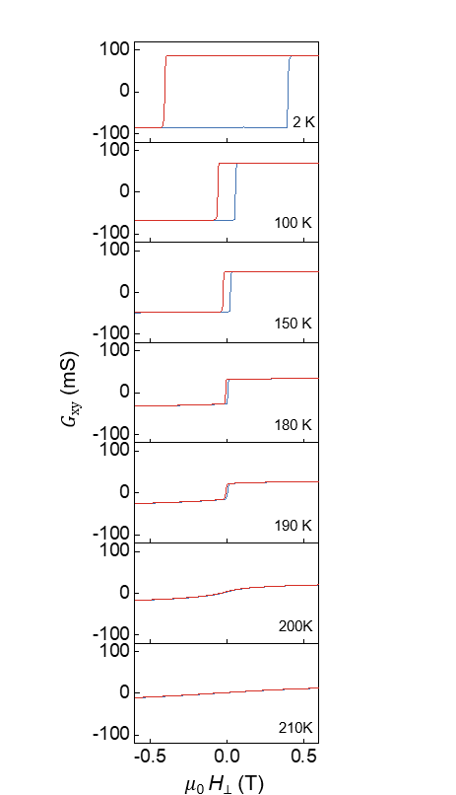
Fig. S1. Anomalous Hall effect in FGT. Hall conductance (G_{xy}​) measured in a Hall-bar device realized on an exfoliated FGT crystal approximately 10 nm thick measured at different values of temperature (see legend). The hysteresis in G_{xy}​​, originating from ferromagnetism, disappears above approximately 200 K, consistently with the expecetd Curie temperature (T_{c}​) of our FGT crystals.

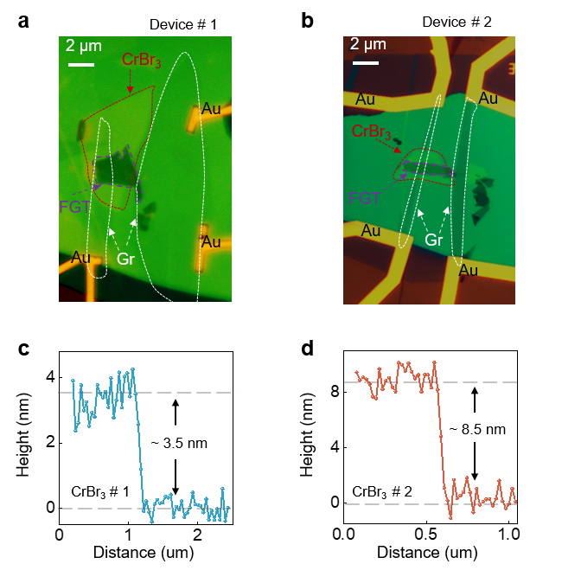
Fig. S2. Optical micrographs of FGT/CrBr₃/graphene (Gr) tunnel barrier devices. In our work we studied four different devices, and ananlyzed two of them in detail, quantiatively. a,b, optical micrographs of device #1 and #2. The measurements shown in the main text and Supporting Information Fig.S3 and Fig.S4 have been performed on device #1 (the CrBr₃ thickness is approximately 3.5 nm); data from device #2 (CrBr₃ thickness of 8.5 nm) are presented in the Supporting Information Fig.S5 and Fig.S6. c, d, Atomic force microscopy (AFM) heigth profiles of the exfoliated CrBr₃ layers obtained from measurements on device #1 and device #2, respectively.

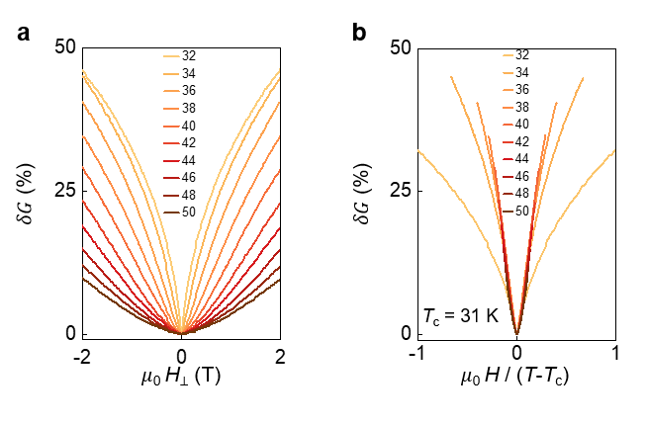
Fig. S3. Determination of the critical temperature (T_{c}) of CrBr₃. The critical temperature of the CrBr₃ layers employed to realize our devices can be determined reliably by plotting the magnetoconductance measured in the paramagnetic state as a function of μ₀H/(T−T_{c}) and fixing T_{c}, to make all curves collapse at low field. a, Magnetoconductance measured as a function of temperature, in the range between 32 K to 50 K in 2 K steps. b, When plotted as a function of μ₀H/(T−T_{c}), the magnetoconductance curves shown in panel a collapse onto a single curve at low field if T_{c}​ = 31K. In both panels a and b, curves of the same color correspond to measurements performed at the same temperature.

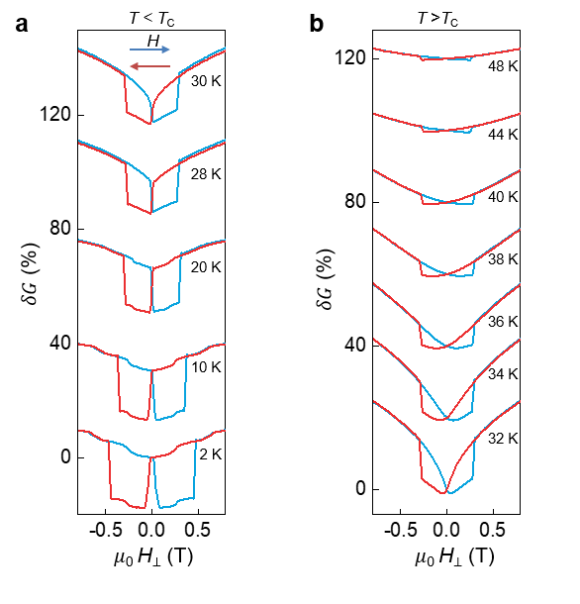
Fig. S4. Complete magnetoconductance curve for device #1. In the main text, we have discussed the magnetoconductance hysteresis associated to the spin vale effect, by looking at the quantity ${({δG}_{↓}-δG}_{↑}$) (i.e., the difference between the magnetoconductance measured when sweeping up and down the magnetic field). For completeness, here we show the full magnetoconductance curves measured for T < T_{c} (a) and T > T_{c} (b), from which the spin valve magnetoconductance ${({δG}_{↓}-δG}_{↑}$) is extracted. The blue (red) trace corresponds to measurements of the magnetoconductance done while sweeping up (down) the magnetic field (as indicated by the arrows in a). It is obvious from the data that the hysteresis persists for T > T_{c}, when CrBr₃ is paramagnetic.

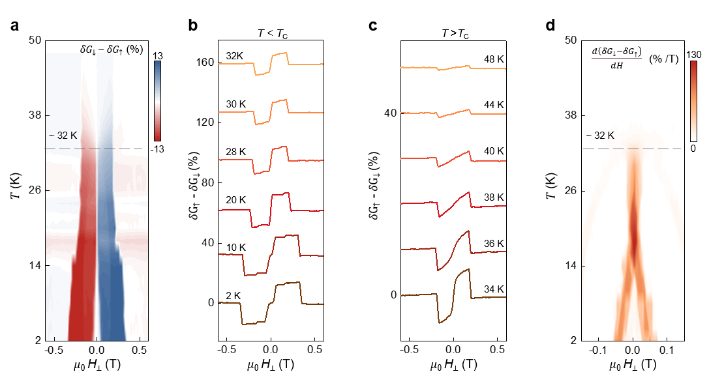
Fig. S5: Temperature-dependent spin-valve magnetoconductance in device #2. For completeness, we show data measured on device #2, in which the thickness of the CrBr₃ barrier is approximately 8.5 nm. a, Color map of the temperature-dependent spin-valve magnetoconductance ${({δG}_{↓}-δG}_{↑},$the difference of magnetoconductance measured when sweeping up or sweep down the applied magnetic field), showing its persistence even for T well above T_{c}. b, c, spin valve magnetoconductance below (​b) and above T_{c} (​c), with specific temperatures indicated in the legend. d, Color map of the temperature-dependent derivative of the hysteretic contribution to the magnetoconductance with respect to the magnetic field, (${d( {δG}_{↓ }\text{-} δG}_{↑})/dH$), which decreases significantly as T is increased above T_{c}​. All experimental observations made on device #2 are identical to the ones we reported for device #1 in the main text (a small difference in the critical temperature of CrBr₃ is observed, T_{c} = 32 K in device #2 and T_{c} = 31 K in device #1, probably because the CrBr₃ layer in device #2 is significantly thicker than in device #1).

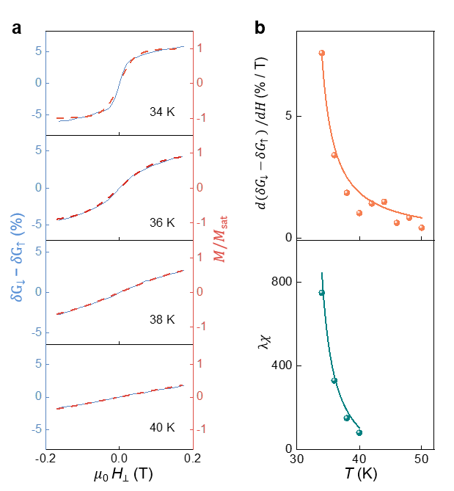
Fig. S6: Analysis of the spin valve effect in the paramagnetic state of CrBr₃ measured in device #2. a, Comparison of the spin-valve magnetoconductance (i.e., the hysteretic contribution to the magnetoconductance, blue curve) with the calculated magnetization (M/M_{sat}) in the paramagnetic state of CrBr₃ (red dashed line; in the comparison the quantity λχ is used as fitting parameter). b, Top panel: the symbols show the zero-field slope of hysteretic contribution to the magnetoconductance ${[\frac{d{(δG}_{↑}-{δG}_{↓})}{dH}]}_{H=0}$ plotted as a function of temperature. Bottom panel: the symbols show the temperature dependence of the $λχ$parameter extracted from the fits of the magnetoconductance hysteresis shown in panel (a). In both panels, the quantities exhibit the dependence expected from Curie-Weiss law (continuous orange and cyan lines in the top and bottom panels are fits to the experimental data). The overall behaviour is identical to that observed in device #1 discussed in the main text.

