Effect of strain-induced defects in GaN channel on two-dimensional carrier transport in AlGaN/GaN heterostructures

Masatomo Sumiya^{1,*} Yasutaka Imanaka², and Yoshitaka Nakano³
¹Electro-ceramics Group, National Institute for Materials Science, Tsukuba 305-0044, Japan
²High magnetic Field Group, National Institute for Materials Science, Tsukuba 305-0003, Japan
³Department of Electrical and Electronic Engineering, Chubu University, Kasugai, Aichi 487-8501, Japan
*Corresponding author’s E-mail address: SUMIYA.Masatomo@nims.go.jp

Abstract
To improve the mobility of two-dimensional electron gas (2DEG) in an AlGaN/GaN heterostructure grown by metalorganic chemical vapor deposition, we characterized the defect distribution around the interface with and without an AlN interlayer by the steady-state photocapacitance method under controlling the bias voltage and incident photon energy. For samples without the AlN interlayer, the defects in the GaN channel layer near the heterointerface were induced by the strain from the Al_{1-x}Ga_{x}N barrier depending on the AlN mol fraction. The density of strain-induced defects was markedly increased near the conduction band minimum to 1×10¹⁸ cm⁻³ peaked at a depth of ~10 nm from the heterointerface for the Al_{0.24}Ga_{0.76}N/GaN sample. The AlN interlayer was confirmed to suppress the formation of strain-induced defects. The carrier mobility evaluated by magneto transport measurements was also improved clearly in samples with the AlN layer because of the reduction in the density of strain-induced defects leading to remote 2DEG scattering. We have clarified the correlation between the density of strain-induced defects and the 2DEG mobility for a comprehensive understanding of the carrier transport in strained heterostructures.
High-electron mobility transistors (HEMTs) based on the Al_{x}Ga_{1-x}N/GaN system,, have been used as the preferred device for state-of-the-art communication systems operating simultaneously at high power levels and frequency bands. The formation of two-dimensional electron gas (2DEG) at wurtzite Al_{x}Ga_{1-x}N/GaN interfaces is enabled by the spontaneous and piezoelectric polarization. The most critical property determining the limit of operating frequency in HEMTs is the 2DEG mobility
The 2DEG mobility at Al_{x}Ga_{1-x}N/GaN heterointerfaces without an AlN interlayer grown by molecular beam epitaxy (MBE) in the early 2000s was around 100,000 cm²/Vs at low temperature, and the carrier transport exhibited Shubnikov–de Haas (SdH) oscillations, the integer quantum Hall effect (IQHE) ,, and the fractional quantum Hall effect (FQHE) under a high magnetic field. We optimized the growth conditions of metalorganic chemical vapor deposition (MOCVD) well enough to observe SdH oscillations from the AlGaN/InGaN alloying heterointerface,. Recently, we have realized the IQHE at 15 T of magnetic field from the Al_{0.06}Ga_{0.94}N/GaN heterointerface without an AlN interlayer (Sample A in Table I) grown by MOCVD (Fig. 1S). The 2DEG mobility at 1.8 K, however, was 10,000 cm²/Vs, much lower than the reported values obtained by MBE above.
An AlN interlayer as thin as ~1 nm has been often inserted at the interface between AlGaN and GaN grown by MOCVD as well as MBE,. Although the AlN interlayer was regarded to improve interface roughness, samples without the AlN interlayer exhibiting the IQHE must have a good interface structurally. We have reported that the temperature dependence of the 2DEG mobility represented the quick saturation of 18,000 cm²/Vs at around 100 K, although it was improved to a value higher than 2,000 cm²/Vs at room temperature by inserting an AlN interlayer. The scattering due to dislocation,, interface roughness,, and Coulomb potential in AlGaN has been suggested. However, the scattering factor that predominantly contributes to limiting the 2DEG mobility at low temperatures is still being argued.
The behaviors of 2DEG mobility would be attributed to the potential fluctuation at the interface. The Al_{x}Ga_{1-x}N barrier layer was pseudomorphically grown on the GaN channel layer, which induced the strain at the interface. It is assumed that the AlGaN barrier layer induces the potential fluctuation at the interface. Therefore, it is important to investigate how the variations near the heterointerface prepared under the systematically changed conditions affects the 2DEG carrier transport.
In this study, we studied how the parameters for fabricating the interface affects the heterostructure from the viewpoint of defect formation. We fabricated Al_{1-x}Ga_{x}N/GaN heterointerface samples having various AlN mol fractions with and without the AlN interlayer by MOCVD. The distribution of defects around the interface was characterized by the steady-state photocapacitance (SSPC) method at various bias voltages and incident photon energies. The carrier transport properties were evaluated by magneto transport measurements up to 15 T at 1.8 K. The correlation between the strain-induced defects and the 2DEG transport was analyzed with respect to the AlN mol fraction in the AlGaN barrier layer and the effect of the AlN interlayer to comprehensively understand 2DEG mobility.

Al_{1-x}Ga_{x}N/GaN heterostructure samples were grown on AlN template (~0.3 μm) /sapphire substrates by MOCVD as shown in the inset in Fig. 1(a). The GaN channel layer was grown under atmospheric pressure, and then the pressure was reduced to 200 Torr to grow the Al_{1-x}Ga_{x}N barrier layer. A compressive strain in-plane was applied to the GaN channel layer, and a- and c- lattice constants were 0.3180 nm and 0.5192 nm, respectively. The full-width at half maximum of the rocking curve of GaN the (0002) and the (1012) planes were 73–122 and 220–270 arcsec, respectively, corresponding roughly to a dislocation density of ~5×10⁸ cm⁻² . When the AlN interlayer was inserted, a trimethyl-Al (TMA) source was introduced into the MOCVD reactor 5–7 s before the growth of AlGaN.
The thickness of each layer and the AlN mol fraction in the Al_{x}Ga_{1-x}N sample structure were determined by simulating the measured X-ray diffraction (XRD) pattern of the (0002) plane as shown in Fig. 1(a). The sample structures and their properties are summarized in Table I. The surface observed by atomic force microscope (AFM) exhibited steps and terraces with no pits for Samples A–C. In the samples with an AlN mol fraction of 24 % in the AlGaN barrier, no marked difference caused by inserting the AlN interlayer was observed for Samples D and E, although several small pits were observed, as shown in Figs. 1(b) and 1(c). The 2DEG carrier densities were simulated by FETIS® in STR Japan Co., Ltd.

Table I List of sample structures determined by XRD simulation and their electrical properties determined from the behavior of R_{xx} and R_{xy} in high magnetic field at 1.8 K.
Sample | GaN (nm) | Al_{x}Ga_{1-x}N: Al comp. (%) / thickness (nm) | AlN interlayer (nm) | Simulated carrier density (cm⁻²) | Carrier density (cm⁻²) | Mobility at 1.8 K (cm²/Vs)
A | 880 | 6 / 45 | -* | 1.1×10¹² | 1.2×10¹² | 10,000
B | 830 | 6 / 60 | 0.4 | 2.3×10¹² | 2.7×10¹² | 15,000
C | 870 | 9 / 50 | - | 2.7×10¹² | 2.5×10¹² | 12,000
D | 920 | 24 / 24 | - | 8.9×10¹² | 8.6×10¹² | 17,000
E | 940 | 23 / 24 | 0.6 | 9.3×10¹² | 9.5×10¹² | 27,000
* No AlN layer was inserted intentionally between AlGaN and GaN.

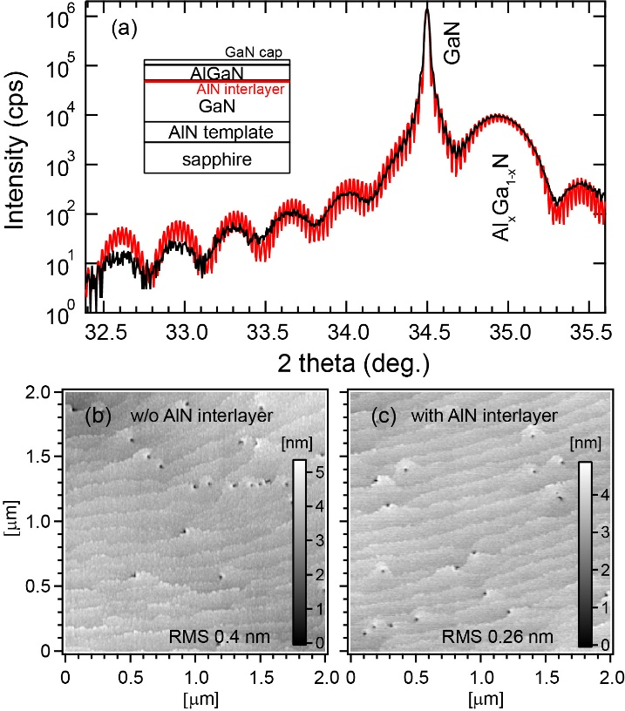

Fig. 1 (a) XRD 2theta-omega scan of the sample with Al_{x}Ga_{1-x}N/GaN heterostructure (solid line). The red line indicates the simulated XRD pattern taking the sample structure shown in the inset into account. AFM images of Samples (b) D and (c) E, respectively.

The defect distributions near the channel region were evaluated by the SSPC, method. Capacitance–voltage (C–V) and SSPC measurements were performed at a frequency of 100 kHz with an ac modulation level of 50 mV using a Hg probe system in a lateral dot-and-ring Schottky–barrier–diode (SBD) configuration. The Schottky metal dot was 514 μm in diameter. Capacitance–voltage measurements of typical n-type rectifying characteristics were carried out in the dark followed by SSPC studies, measuring the photocapacitance transients as a function of the incident photon energy from 0.78 eV (1600 nm) to 4.1 eV (300 nm). The SBDs were illuminated from the rear of the sapphire substrate with concentrated monochromatic light from a 250 W halogen lamp coupled with a high-resolution monochromator. The SSPC measurements were repeatedly performed while finely varying the bias voltage corresponding to the transition from the accumulation state to the pinch-off state, based on the C-V characteristics. The SSPC signal is defined as 2|N_{d}-N_{a}|△C/C₀, where △C was the total photocapacitance variation determined from the saturation value of the transients recorded at each incident photon energy and C₀ is the capacitance at the bias voltage before optical excitation under the assumption that the carrier density of |N_{d}-N_{a}| must be constant at the edge of depletion width during the C–V measurement. In each resulting SSPC spectrum, the total variation in the SSPC signal (maximum value minus minimum value) was interpreted as the total quantity of defect levels present in the depletion layer, and the relationship between the depletion layer width and the total amount of defect levels was estimated.
Ohmic Au/Ti electrodes were prepared on the sample (approximately 2×5 mm² in size) for the magnetoresistance (R_{xx}) and Hall resistance (R_{xy}) measurement at 1.8 K in the magnetic field up to 15 T. The mobility was estimated from the crossover magnetic field with R_{xx} and R_{xy}. The sheet carrier density was obtained by the Fourier transform analysis of SdH oscillations.
The secondary ion mass spectroscopy (SIMS) data were acquired with a PHI ADEPT-1010 using a Cs primary ion beam in the positive ion detection mode. The instrument conditions were optimized for depth resolution. Cross-sectional scanning transmission electron microscopy (STEM) was carried out for Samples D and E. by using Hitachi HD2700 AC-STEM system with an accelerating voltage of 200 kV.

Figure 2(a) shows the total defect density for the samples without the AlN interlayer from the SSPC spectra as shown in the inset as a function of AlN mol fraction in the Al_{x}Ga_{1-x}N barrier layer. Here, we focused on the variations in the number and level of defects, not on the origin of defects. The total defect density increased with the AlN mol fraction of the barrier layer.
Figure 2(b) shows the SSPC spectra for Al_{0.23}Ga_{0.77}N/GaN with the AlN interlayer and for Al_{0.24}Ga_{0.76}N/GaN without the AlN interlayer. The total defect density of Sample E was lower by two orders of magnitude than that of Sample D as plotted with the closed square in Fig. 2(a). The variation in the photon energy of spectra from 0.7 to 0.8 eV marked with the dot square exhibited a positive slope for Sample D, indicating the transition of electrons trapped at the defect level to the conduction band as represented with α’ in the schematic drawn in red in Fig. 2(b). There were many defects near the conduction band minimum (CBM) in Sample D. On the other hand, the variation in Sample E at the photon energies from 0.7 to 0.8 eV shows a negative slope, indicating the generation of holes in the valence band. The transition of electrons to the defect level from the valence band occurred as indicated by α in the schematic illustration drawn in black in Fig. 2(b). It was noted that the number of defects near the CBM of Sample E was much lower than that of Sample D. The variation in the photon energy of Sample E from 2.8 to 3.3 eV indicated by β exhibited a negative slope corresponding to the transition of electrons to the defect levels near the CBM from the valence band. It is considered that the defect levels near the CBM of Sample E were not occupied by the electrons.

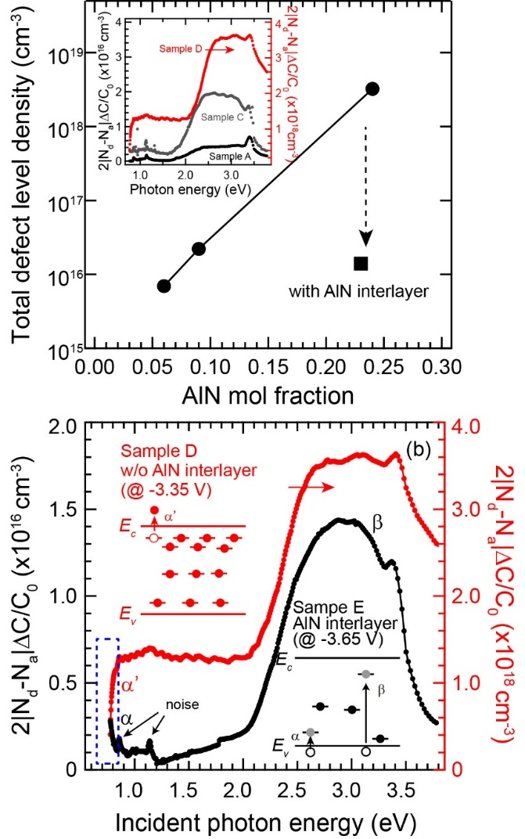

Fig. 2 (a) Relationship between total defect density and AlN mole fraction in Al_{x}Ga_{1-x}N barrier layer of samples without AlN interlayer (closed circles). The inset shows the SSPC spectra for Samples A: (depletion layer of 100 nm), C: (103 nm), and D: (47 nm). The closed square indicates the total defect density for Sample E. (b) SSPC spectra for Samples D (red) and E (black) at each bias voltage corresponding to depletion layer of 47 and 58 nm, respectively. The insets show the schematics indicating the defect distribution in the bandgap. The noise was caused by changing the filter used to cut the high-mode light.

Figure 3(a) shows the depth profiles of carrier density for Samples D and E evaluated by C–V measurement. The interface was defined at the position of the maximum of carrier density. Although the carrier density of Sample D exponentially decreased with the increase in the depth position, the total defect density peaked at a depth of ~10 nm from the interface as shown in Fig. 3(b). The defects were generated in the GaN channel.
The pressure in the MOCVD reactor was reduced to 200 Torr at 1040 ℃ after the growth of the GaN channel layer for the growth of the Al_{x}Ga_{1-x}N barrier layer. If defects on the surface of the GaN layer were generated owing to the desorption of Ga and/or N during the reduction in reaction pressure, the same defect density should have been detected at the interface regardless of the AlN mol fraction. However, the defect density of the samples without the AlN interlayer increased with an increase of AlN mol fraction as shown in Fig. 2. It is difficult to explain the reduction of defect due to the AlN interlayer in terms of the compositional fluctuation and the incorporation of impurities from SIMS analysis (Fig. 2S). We have considered that the defects in the GaN channel were induced by the compressed strain applied from the AlGaN barrier layer, according to our previous report of GaN film growth on the AlN template²⁰ and the literature indicating the presence of residual compressive strain in the GaN layer in the AlGaN/GaN heterostructure.. It was assumed that the strain propagating into the GaN layer must release the energy to form the defects, though there was no generation of crack and dislocation in GaN channel as discussed previously for the critical thickness of the pseudomorphical growth of AlGaN/GaN sample. The total defect density peaked in the region of the GaN channel near the heterointerface. It was noted that the total defect densities for both samples were almost same in the region deeper than 60 nm.

A large number of defects (1×10¹⁸ cm⁻³) near the CBM were localized in a very narrow range peaked at a depth of ~10 nm from the heterointerface for Sample D without the AlN interlayer as shown in Fig. 3(c). We supposed that the electrons were partially moved between 2DEG and the strain-induced defect levels near the CBM during the C–V measurement, because the capacitance of Sample D in the accumulated condition was slightly lower than that of Sample E (Fig. 3S(a)), and the responsiveness of the 2DEG carriers in Sample D was deteriorated in the high-frequency range (Fig. 3S(b)). This is the reason why the carrier density at the interface of Sample D estimated by C–V measurement was lower at the interface than that of Sample E in Fig. 3(a).
The defects were mostly induced at the heterointerface for Sample E owing to the large lattice mismatch to induce the defects at the interface of AlN/GaN. The surface morphology of AlN interlayer grown for 7 s on the GaN channel layer exhibited the fine and small grain structure (Fig. 4S). This surface structure must prevent the propagation of the strain energy, similar to the AlN/GaN multilayer inserted between the GaN film and the Si substrate. The total defect density for Sample E was highest at the interface. It gradually decreased by about two orders of magnitude with the increase of the depletion layer. The defect levels near the CBM were hardly detected in Sample E. Since the strain-induced defects near the VBM were lower than 1×10¹⁵ cm⁻³ as shown in Fig. 3(c), the defects induced in the heterointerface of Sample E mainly formed the defect levels in the middle of the bandgap. Thus, the defect distributions were clarified in the samples D and E with and without the AlN interlayer.

According to Ref. 26, the compressive stresses ranging between 0.34 and 1.7 GPa were deduced in the GaN channel with Al_{0.33}Ga_{0.67}N (20 nm) heterostructure. Horita et al. reported that the nitrogen displacement was caused by the displacement energy of 21.8 eV. The region around ~10 nm in GaN channel from the heterointerface without cracking and dislocation in Sample D must accumulated the strained energy enough to cause the nitrogen displacement. We speculated that the origin of the strain-induced defect could be caused by the nitrogen displacement (N_{I}) and its related nitrogen vacancy (V_{N}). The defect levels of (N_{I} (0/-) and (V_{N} (+/0)) were 0.98 eV and 0.13 eV from the CBM.²⁹ These energy levels of defects were consistent with the model proposed in Fig. 2(b) that there were many defects near the CBM for Sample D.

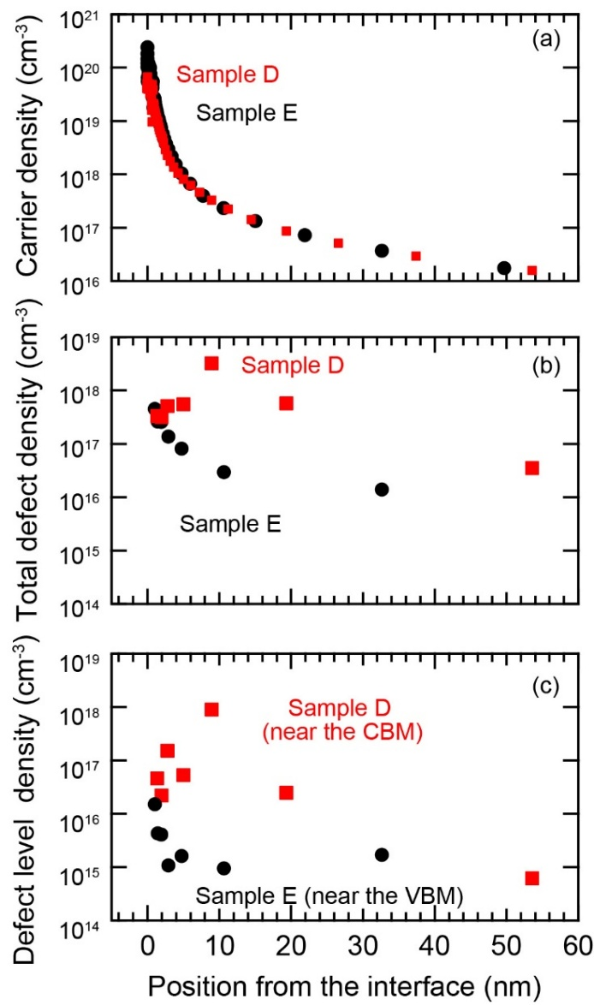

Fig. 3 (a) Carrier density evaluated by C–V measurement for Sample D (red) and Sample E (black). Position dependence from the heterointerface of (b) total defect density and (c) defect level density near the CBM and VBM for Samples D and E estimated in the range from 0.7 eV to 0.8 eV of SSPC spectra.

To understand the effect of the AlN interlayer on the carrier transport of the 2DEG, the mobility in all the samples was measured by detecting the behavior of R_{xx} and R_{xy} under a high magnetic field at 1.8 K. Both samples had the interface good enough to exhibit the SdH oscillations of R_{xx} regardless of the presence or absence of the AlN interlayer in Figs 4(a) and 4(b). The 2DEG carrier densities of Samples D and E were estimated to be 8.6×10¹² cm⁻² and 9.5×10¹² cm⁻², respectively, from the Fourier transform analysis of SdH oscillations. The obtained carrier density was almost identical to that of the simulated value. The mobility of Sample D without the AlN interlayer was 17,000 cm²/Vs. On the other hand, the mobility of Sample E with the AlN interlayer was improved to 27,000 cm²/Vs.
Figure 5 shows the HAADF images for Sample D and E. Although the AlN interlayer was confirmed in the dark region at the interface for Sample E (Fig. 5(b)), the heterointerface was very smooth for both samples. It was difficult to recognize any differences of interface roughness, alloy disorder and dislocation except for the AlN interlayer. Also, it was hard to detect the strain-induced defects for Sample D. Because the ratio of defect number to the matrix atoms was too small to be observed. Since both the band offset and the carrier density of Sample E were almost the same as those of the Sample D, the improvement in the mobility of Sample E was attributed to the AlN interlayer. The strain-induced defects in Sample D were distributed in the GaN channel remotely near the interface (~10 nm), as illustrated in the inset of Fig. 6. The defects near the CBM must play the role as Coulomb scattering 2DEG carriers similarly to the ionized impurities in a modulated doped AlGaAs/GaAs system. The AlN interlayer reduced not only the total defect density but also the number of defect levels near the CBM. Since the carrier scattering was suppressed, the 2DEG mobility of Sample E was consequently improved.

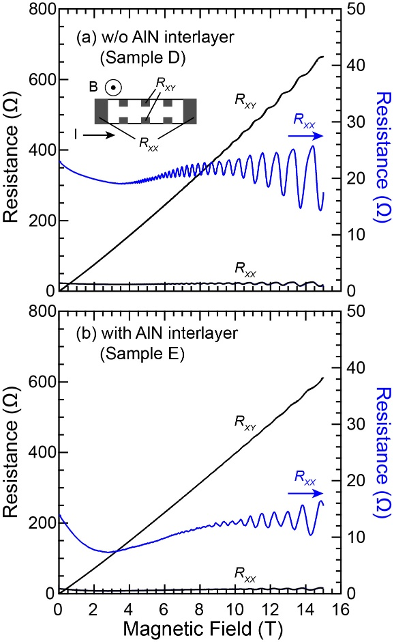

Fig. 4 Behavior of magnetoresistance (R_{xx}) and Hall resistance (R_{xy}) of 2DEG induced at the AlGaN/GaN heterointerface (a) Sample D and (b) Sample E. The expanded R_{xx} is plotted on the right axis.

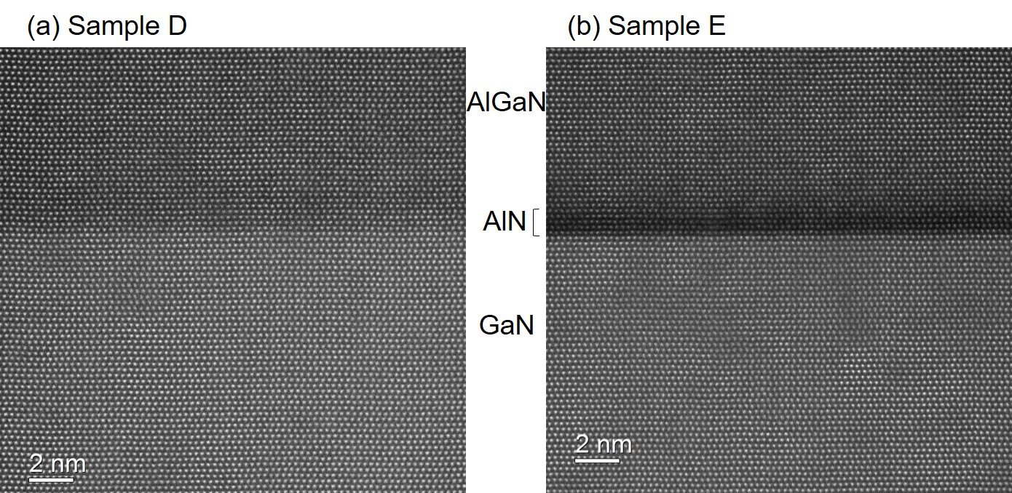
Fig. 5 HAADF images of the heterointerface for (a) Sample D and (b) E.

The relationship between 2DEG carrier density and mobility evaluated under a high magnetic field at 1.8 K is shown in Fig. 6. The Samples B and C had the heterointerface good enough to exhibit the SdH oscillation as shown in Fig. 5S, too. Regardless of the presence or absence of the AlN interlayer, the 2DEG mobility was increased by the screening effect with an increase in 2DEG carrier density. From the AlN interlayer viewpoint, it was confirmed that the 2DEG mobility was improved by inserting the AlN interlayer in both cases of high carrier density (Samples D and E) and low carrier density (Samples B and C). It was reasonable to conclude that the AlN interlayer suppressed the generation of strain-induced defect levels near the CBM, owing to the suppression of the propagation of the strain of the AlGaN barrier layer. Since the carrier transport at the interface will be modulated with respect to the strain, it is important to investigate various heterostructures for a deeper understanding of the 2DEG transport. Moreover, it is necessary to study whether the strain-induced defects affect the current collapse in HEMT devices.

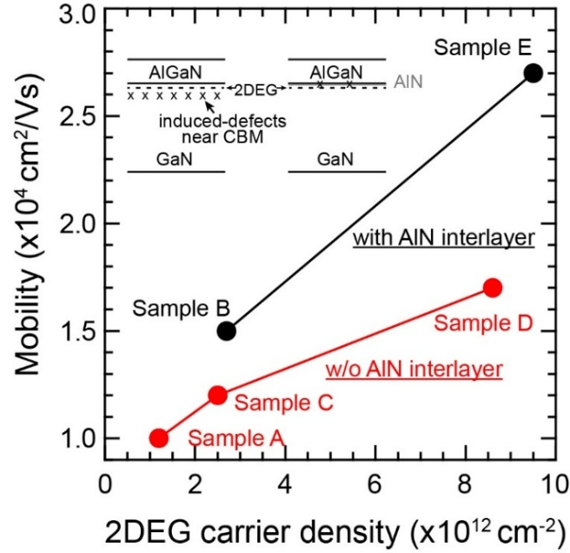

Fig. 6 Relationship between 2DEG carrier density and mobility at Al_{x}Ga_{1-x}N/GaN heterointerface with (black) and without (red) AlN interlayer grown by MOCVD. The inset shows the schematic illustration of the defect distribution and 2DEG for Samples D and E.

In summary, we studied the defect distributions around the heterointerfaces of MOCVD-Al_{1-x}Ga_{x}N/GaN samples which exhibited the SdH oscillation by C-V and SSPC measurements. With increasing AlN mol fraction in the Al_{x}Ga_{1-x}N barrier layer in the samples without the AlN interlayer, the defects near the CBM were induced in GaN channel near the interface due to the strain from the Al_{x}Ga_{1-x}N. The strain-induced defects were localized at a depth of ~10 nm from the interface for the Al_{0.24}Ga_{0.76}N/GaN sample. The AlN interlayer at the heterointerface suppressed the strain-induced defects remarkably. There were no marked differences in compositional fluctuations, the concentrations of impurities and the interface roughness in the samples with and without the AlN interlayer. It was confirmed that the 2DEG mobility measured by high magnetic field at 1.8 K was improved by inserting the AlN interlayer in both cases of high and low carrier densities. These results indicated that the strain-induce defects near the CBM were contributed to the remote 2DEG scattering, and that the AlN interlayer prevented the propagation of the strain from the AlGaN barrier layer to GaN channel layer at the heterointerface for understanding the carrier transport in the strained heterostructures.

Supplementary Material
See the supplementary material for further details on the qualities of samples and surface morphology of AlN interlayer.

Acknowledgement
The SIMS data and HAADF images were provided in collaboration with Eurofins EAG Laboratories. A part of this work was supported by High magnetic field characterization unit in National Institute for Materials Science (NIMS). The authors would like to thank Dr. T. Noda, NIMS for valuable discussions.

Refences

M. Asif Khan, J. N. Kuznia, J. M. Van Hove, N. Pan, and J. Carter, Appl. Phys. Lett. 60, 3027 (1992).
R. Gaska, J. W. Wang, A. Osinsky, Q. Chen, M. Asif Khan, A. O. Orlov, G. L. Snider, and M. S. Shur, Appl. Phys. Lett. 72, 707 (1998).
I. P. Smorchkova; C. R. Elsass; J. P. Ibbetson; R. Vetury; B. Heying; P. Fini; E. Haus; S. P. DenBaars; J. S. Speck; U. K. Mishra “Polarization-induced charge and electron mobility in AlGaN/GaN heterostructures grown by plasma-assisted molecular-beam epitaxy”, J. Appl. Phys. 86, 4520–4526 (1999)
M. Micovic, D. F. Brown, D. Regan, J. Wong, Y. Tang, F. Herrault, D. Santos, S. D. Burnham, J. Tai, E. Prophet, I. Khalaf, C. McGuire, H. Bracamontes, H. Fung, A. K. Kurdoghlian, A. Schmitz, “High Frequency GaN HEMTs for RF MMIC Applications”, Technical Digest - International Electron Devices Meeting, IEDM 7838337, 3.3.1 (2017).
A. F. Braña; C. Diaz-Paniagua; F. Batallan; J. A. Garrido; E. Muñoz; F. Omnes, “Scattering times in AlGaN/GaN two-dimensional electron gas from magnetoresistance measurements”, J. Appl. Phys. 88, 932–937 (2000)
E. Frayssinet, W. Knap, P. Lorenzini, N. Grandjean, J. Massies, C. Skierbiszewski, T. Suski, I. Grzegory, S. Porowski, G. Simin, X. Hu, M. Asif Khan, M. S. Shur, R. Gaska, D. Maude, ‘High electron mobility in AlGaN/GaN heterostructures grown on bulk GaN substrates’, Appl. Phys. Lett. 77, 2551–2553 (2000).
M. J. Manfra; K. W. Baldwin; A. M. Sergent; K. W. West; R. J. Molnar; J. Caissie, “Electron mobility exceeding 160,000 cm2/Vs in AlGaN/GaN heterostructures grown by molecular-beam epitaxy”, Appl. Phys. Lett. 85, 5394–5396 (2004)
M. J. Manfra; N. G. Weimann; J. W. P. Hsu; L. N. Pfeiffer; K. W. West; S. Syed; H. L. Stormer; D. V. Lang; S. N. G. Chu; G. Kowach; A. M. Sergent; J. Caissie; K. M. Molvar; L. J. Mahoney; R. J. Molnar W. Pan, “High mobility AlGaN/GaN heterostructures grown by plasma-assisted molecular beam epitaxy on semi-insulating GaN templates prepared by hydride vapor phase epitaxy”, J. Appl. Physics 92, 338–345 (2002)
Sumiya, M., Kindole, D., Fukuda, K., Yashiro, S., Takehana, K., Honda, T., Imanaka, Y. ‘Growth of AlGaN/InGaN/GaN Heterostructure on AlN Template/Sapphire’ Physica Status Solidi (B) Basic Research, 1900524, (2019).
Y.-W. Tan, J. Zhu, H. L. Stormer, L. N. Pfeiffer, K. W. Baldwin, and K. W. West, “Measurements of the Density-Dependent Many-Body Electron Mass in Two Dimensional GaAs/AlGaAs Heterostructures”, Phys. Rev. Lett. 94, 016405 (2005).
M. Miyoshi; H. Ishikawa; T. Egawa; K. Asai; M. Mouri; T. Shibata; M. Tanaka; O. Oda, “High-electron-mobility AlGaN/AlN/GaN heterostructures grown on 100-mm-diam epitaxial AlN/sapphire templates by metalorganic vapor phase epitaxy”, Appl. Phys. Lett. 85, 1710–1712 (2004)
I. P. Smorchkova; L. Chen; T. Mates; L. Shen; S. Heikman; B. Moran; S. Keller; S. P. DenBaars; J. S. Speck; U. K. Mishra, “AlN/GaN and (Al,Ga)N/AlN/GaN two-dimensional electron gas structures grown by plasma-assisted molecular-beam epitaxy”, J. Appl. Phys. 90 5196-5201 (2001).
Bashkatov, D.D., Malin, T.V., Mansurov, V.G., Protasov D. Y., Milakhin, D.S., Zhuravlev, K.S., “Effect of AlN Interlayer Thickness on 2DEG Parameters in AlGaN/AlN/GaN HEMT Structures”, IEEE 25th International Conference of Young Specialists on Micro/Nanotechnologies and Electron Devices (EDM) 120–125 (2024).
M. Sumiya, O. Goto, Y. Takahara, Y Imanaka, L. Sang, N Fukuhara, T. Konno, F. Horikiri, T. Kimura, A. Uedono, and H. Fujikura, “Fabrication of AlGaN/GaN heterostructures on HVPE-AlN/SiC templates for HEMTs application”, Jpn. J. Appl. Phys. 62, 085501 (2023).
M. J. Manfra; K. W. Baldwin; A. M. Sergent; R. J. Molnar; J. Caissie, “Electron mobility in very low density GaN/AlGaN/GaN heterostructures”, Appl. Phys. Lett. 85, 1722 (2004).
Yao Li and J. Zhang, ‘Study of electronic transport properties in AlGaN/AlN/GaN/AlGaN double-heterojunction transistor’, J. Appl. Phys. 126, 075707 (2019).
I. P. Smorchkova, C. R. Elsass, J. P. Ibbetson, R. Vetury, B. Heying, P. Fini, E. Haus, S. P. DenBaars, J. S. Speck, U. K. Mishra, “Polarization-induced charge and electron mobility in AlGaN/GaN heterostructures grown by plasma-assisted molecular-beam epitaxy”, J. Appl. Phys. 86 4520 (1999).
A. Asgari; M. Kalafi; L. Faraone, ‘Effects of partially occupied sub-bands on two-dimensional electron mobility in Al_{x}Ga_{1-x}N/GaN heterostructures’, J. Appl. Phys. 95, 1185 (2004).
L. Hsu and W. Walukiewicz, ‘Electron mobility in Al_{x}Ga_{1-x}N/GaN heterostructures’, Phys. Rev. B 56, 1520 (1997).
M. Sumiya, K. Fukuda, S. Yasiro, T. Honda, ‘Influence of thin MOCVD-grown GaN layer on underlying AlN template’ Journal of Crystal Growth 532, 125376 (2020).
H.-P. Lee, J. Perozek, L. D. Rosario and C. Bayram, ‘Investigation of AlGaN/GaN high electron mobility transistor structures on 200-mm silicon (111) substrates employing different buffer layer configurations’, Sci. Rep. 6, 37588 (2016).
A. Armstrong, A. Chakraborty, J. S. Speck, S. P. DenBaars, U. K. Mishra, S. A. Ringel, ‘Quantitative observation and discrimination of AlGaN- and GaN-related deep levels in AlGaN/GaN heterostructures using capacitance deep level optical spectroscopy’, Appl. Phys. Lett. 89, 262116 (2006).
Y. Nakano, M. Lozac’h, N. Matsuki, K. Sakoda, and M. Sumiya, ‘Photocapacitance spectroscopy study of deep-level defects in freestanding n-GaN substrates using transparent conductive polymer Schottky contacts, J. Vac. Sci. Technol. B 29, 023001 (2011).
https://www.eag.com/techniques/mass-spec/secondary-ion-mass-spectrometry-sims/
T. Sasaki, J. Nishizawa, and M. Esashi, ‘Deep levels and minority carrier lifetime in proton irradiated silicon pin diode’, J. Appl. Phys. 83 4069 (1998).
G. Martı́nez-Criado, A. Cros, A. Cantarero, O. Ambacher, C. R. Miskys, R. Dimitrov, M. Stutzmann, J. Smart, J. R. Shealy, ‘Residual strain effects on the two-dimensional electron gas concentration of AlGaN/GaN heterostructures’, J. Appl. Phys. 90, 4735 (2001).
S. Einfeldt; V. Kirchner; H. Heinke; M. Dießelberg; S. Figge; K. Vogeler; D. Hommel, J. Appl. Phys. 88, 7029 (2000).
H. Ishikawa, G.-Y. Zhao, N. Nakada, T. Egawa, T. Jimbo and M. Umeno, ‘GaN on Si Substrate with AlGaN/AlN Intermediate Layer’, Jpn. J. Appl. Phys. 38, 492 (1999).
M. Horita, T. Narita, T. Kachi, and J. Suda, ‘Nitrogen-displacement-related electron traps in n-type GaN grown on a GaN freestanding substrate’, Appl. Phys. Lett. 118, 012106 (2021).
K. Hirakawa and H. Sakaki, “Mobility of the two-dimensional electron gas at selectively doped n-type AlGaAs/GaAs heterojunctions with controlled electron concentrations”, Phys. Rev. B 33, 8291 (1986).

