Surface Stoichiometric Tuning for High-Efficiency and Light Illumination Stability in Sn-Pb Perovskite Solar Cells by PbBr₂ Wet Surface Treatment
Md. Abdul Karim‡, Yulu He‡, Wasif Islam Chowdhury, Md. Emrul Kayesh, Towhid H. Chowdhury, Shamim Ahmmed, Takeaki Sakurai *, Ashraful Islam*
M. A. Karim, Y. He, W. I. Chowdhury, M. E. Kayesh, T. H. Chowdhury, S. Ahmmed, A. Islam
Photovoltaic Materials Group,
Research Center for Energy and Environmental Materials (GREEN),
National Institute for Materials Science (NIMS),
Tsukuba 305-0047 Ibaraki, Japan.
Email: islam.ashraful@nims.go.jp

Y. He
Graduate School of Science and Technology,
University of Tsukuba,
Tsukuba, Ibaraki, 305-8573, Japan.

W. I. Chowdhury
School of Mechanical Engineering,
Purdue University,
West Lafayette, IN 47907, USA

T. Sakurai
Faculty of Pure and Applied Sciences, University of Tsukuba, Tsukuba, Ibaraki, 305-8577, Japan
Email: sakurai.takeaki.ft@u.tsukuba.ac.jp
‡Equally contributed

Abstract
Tin-lead (Sn-Pb) mixed perovskite solar cells (PSCs) are promising as bottom subcells in all-perovskite tandem solar cells, but the oxidation of Sn²⁺ remains challenging for long-term stability. This study reveals a compositional gradient in Sn–Pb perovskite films, where excess Sn ions accumulate at the surface, intensifying oxidation and recombination losses. To address this issue, we introduce a PbBr₂-TOAB wet surface treatment strategy during the fabrication of Sn–Pb perovskite films. X-ray photoelectron spectroscopy (XPS) analysis confirms that this treatment achieves more balanced Pb:Sn stoichiometry from ~4.36:1 to ~2.74:1, ensuring improved film quality and resistance to Sn²⁺ oxidation. The treatment strategy boosts the power conversion efficiency (PCE) of 21.61% (0.09 cm²), with an independently certified (from AIST) PCE of 19.12%, compared to 21.13% for control PSCs. Moreover, target larger PSCs (1 cm²) achieved an impressive PCE of 20.83%. The target PSCs show enhanced stability, retaining 80% of their initial PCE after 50 h of continuous light soaking. More importantly, encapsulated target PSCs maintain 95% of their initial PCE for 300 seconds under continuous illumination at maximum power point tracking (MPPT) conditions. Time-dependent PL examination confirms that PbBr₂-TOAB treatment significantly reduces ion migration, improving stability under light illumination.

- Introduction
Organic-inorganic perovskites have attracted significant interest as potential materials for photovoltaics application due to their superior photoelectric characteristics, including exceptional light absorption, flexible bandgap, excellent carrier mobility, and prolonged diffusion lengths.^{[1–4]} Power conversion efficiency (PCE) of lead (Pb) halide perovskite solar cells (PSCs) has seen remarkable progress in recent years. Since the first PSC achieved a modest PCE of 3.8% in 2009, single-junction PSCs have reached efficiencies exceeding 26%, getting closer the theoretical Shockley-Queisser (SQ) limit for single-junction solar cells.^{[5–7]} However, achieving or surpassing this limit remains a challenge due to losses associated with optical absorption, thermal effects, and charge recombination. ^{[8,9]}
All-perovskite tandem solar cells present a practical pathway to overcome this theoretical limitation through the integration of wide-bandgap (WBG) and narrow-bandgap (NBG) perovskites within a single architecture. Tin-lead (Sn-Pb) mixed perovskites having a bandgap at range 1.2-1.4 eV, are frequently employed as bottom cells in tandem configurations to achieve high efficiencies. ^{[10,11]} Recent improvements in Sn-Pb mixed PSCs have resulted in single-junction devices achieving efficiencies over 24%, while tandem architectures have reached record efficiencies of over 28%, outperforming single-junction devices. ^{[12–14]} However, the pursuit of higher efficiency and stability in Sn-Pb mixed PSCs remains a challenge owing to the rapid crystallization, the vulnerability of Sn²⁺ to oxidation, and detrimental ion migration.^{[15–18]} Research has revealed that SnI₂, a key material for fabracating Sn-Pb mixed perovskites, is susceptible to oxidation by solvents such as dimethyl sulfoxide (DMSO), widely used in perovskite fabrication.^{[19–22]} Additionally, the trace amounts of oxygen, in the ppm range, can oxidize Sn²⁺ in perovskite layers, leading to defect formation and reduced device performance.^{[23]}

Several strategies have been implemented to mitigate the oxidation of Sn²⁺ upto date in the Sn-Pb mixed perovskite. Metallic Sn was added to the perovskite precursors to reduce Sn⁴⁺ back to Sn²⁺ through a reaction with the metallic Sn.^{[24–26]} Additionally, SnF₂ is commonly employed as an antioxidant, serving a dual purpose by not only suppressing Sn²⁺ oxidation but also facilitating the controlled crystallization of the Sn-Pb mixed perovskite films.^{[27]} Moreover, antioxidants like hydroxybenzene sulfonic acid, formamidine sulfinic acid, ascorbic acid, and 4-fluorophenylhydrazine hydrochloride have also shown effectiveness in preventing oxidation in Sn-based PSCs.^{[28–31]} Despite significant progress in preventing Sn²⁺ oxidation within Sn-Pb perovskite layers through precursor additive innovations, the surface of perovskite films could be easily oxidized due to the present of huge amount of uncoordinated Sn²⁺. ^{[23,32,33]} The surface of these perovskite layers is highly prone to oxidation, even at low oxygen concentrations, particularly during the annealing stage of fabrication. Therefore, to inhibit the oxidation of Sn²⁺ on top surface of perovskite layers, chelating agents like ethylenediamine (EDA) and 3-hydroxy-2-methyl-4-pyrone (maltol) were used for the surface treatment.^{[23,34,35]} Post-treatment was unsuccessful in restoring the oxidized surface of Sn-Pb mixed perovskite layers because of its inability to reduce Sn⁴⁺ to Sn²⁺. The presence of Sn⁴⁺ on the surface cannot be removed, resulting in defect on the surface and reduced the stability of the final PSCs. Li et al. recently proposed a novel approach using diamine chelates that selectively bind with Sn atoms, effectively removing excess Sn from the film surface. This strategy suppressed Sn²⁺ oxidation and improved the Sn:Pb stoichiometric balance.^{[36]} However, achieving a balanced metallic cationic ratio on the surface remains a challenging and unresolved issue. Further research is required to address this unresolved problem effectively.
Herein, in this study, we introduced one potential strategy to balance the Sn:Pb ratio on the perovskite film surface using the wet surface treatment by lead bromide (II)-Tetraoctylammonium bromide (PbBr₂-TOAB) solution. Through the wet surface treatment process, the quantity of stable Pb²⁺ ions increased on the surface of perovskite layers, leading to less oxidation of Sn²⁺ and less I⁻ vacancy. XPS examination confirmed that more balanced Sn:Pb ratio on the target film surface compared to control film surface ensured lower surface defect and higher crystalline film. PL examination from both the back and surface side of films ensured the improved film quality. This enable a PCE of 21.61 % of target Sn-Pb PSCs with certified PCE of 19.12 % whereas control PSC shows PCE of 21.13 % for active area 0.09 cm². Moreover, larger target PSC with active area 1 cm² showed PCE of 20.83 %. Interestingly, the target PSCs exhibited stability under continuous light soaking and retained 80% of their initial PCE for 50 h. More importantly, target encapsulated PSCs maintained PCE of 95% of their initial PCE for 300 s when subjected to continuousillumination at maximum power point tracking (MPPT) conditions. Time-dependent PL examination confirms that PbBr₂-TOAB treatment significantly reduces ion migration, improving stability under light illumination.

- Results and Discussion
  - Design strategy
Perovskite layers are typically deposited via a spin-coating process combined with antisolvent dripping technique, followed by annealing on a hotplate to complete the crystallization, as illustrated in Figure 1 (a). However, during the annealing stage, Sn²⁺ ions within the perovskite films are highly prone to oxidation. This oxidation process can be accelerated with a low oxygen level, even when the fabrication process is carried out in a nitrogen-purged glovebox.
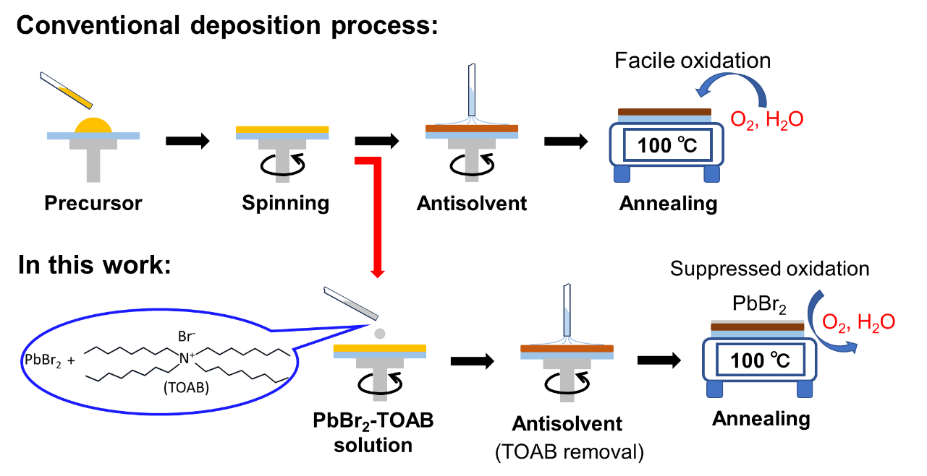Figure 1. Schematic representation of fabrication process for Sn-Pb mixed perovskite layers: (a) illustration of the conventional deposition process, (b) illustration of the deposition process used in this work.
(a)
(b)

To overcome this challenge, we introduced a new strategy involving wet surface treatment on the perovskite during the spin-coating process. By applying an oxidation-resistant material to the wet surface of the perovskite films, the oxidation of Sn²⁺ can be effectively suppressed. In this study, PbBr₂ was selected as the protective material due to its high resistance to oxidation. Moreover, PbBr₂ interacts with surface cations to form a Pb-based perovskite layer, which reinforces the perovskite surface and prevents Sn²⁺oxidation. It is widely known that PbBr₂ can dissolve in solvents like N,N-dimethylformamide (DMF) or dimethyl sulfoxide (DMSO); however, using these solvents would dissolve the spin-coated perovskite films entirely, leading to undesirable damage. On the other hand, solvents such as toluene (TL) and chlorobenzene (CB) do not dissolve the perovskite layer but are ineffective at fully dissolving PbBr₂. To overcome this limitation, we utilized tetraoctylammonium bromide (TOAB), which significantly improves the solubility of PbBr₂ in TL or CB. TOAB , illustrated in Figure 1(b), is an ammonium salt having four long alkyl chains, previously used extensively in the synthesis of CsPbBr₃ perovskite quantum dots.^{[37–39]} Figure 1(b) shows the schematic of the optimized surface treatment process, wherein PbBr₂-TOAB solution is drop-cast onto the spinning perovskite films before the antisolvent is added. TOAB, which remains on the film's surface without incorporating into the perovskite lattice, is subsequently removed by the antisolvent during the wet surface treatment. The integration of Pb²⁺ ions into the perovskite film, however, greatly enhances its resistance to oxidation by O₂ and H₂O during annealing. This approach demonstrates the viability of using PbBr₂-TOAB solutions in TL or CB for effective wet surface treatment on Sn-Pb mixed perovskite films. We have optimized the concentration of PbBr₂ for wet surface treatment and details discussed in the supporting information. We have found that 0.3 mg PbBr₂ wet surface treatment condition showed the best performance and showed better stability under light illumination among the different conditions, as shown in Figure S1 and Table S1.

2.2 Realizing the modifications to the top regions of perovskite films
We initiated our study with mixed Sn–Pb NBG perovskite with component of Cs_{0.1}FA_{0.6}MA_{0.3}Pb_{0.5}Sn_{0.5}I₃ (where MA represents methylammonium and FA denotes formamidinium), as reported in previous study.^{[27]} The fabricated perovskite films were treated with EDAI₂. To prepare the 1.8 M Sn–Pb perovskite precursor solution, the solvent DMF and DMSO were used in a 3:1 volume ratio. Additionally, 10 mol% tin fluoride (SnF₂), relative to SnI₂, and 2 mol% ammonium thiocyanate (NH₄SCN), relative to the total volume of the B-site precursor (SnI₂ + PbI₂), were incorporated. SnF₂ serves as an anti-oxidant, preventing the oxidation of Sn(II) ions, while thiocyanate salts facilitate perovskite crystal formation. This untreated perovskite layer was used as the “control”, while the PbBr₂-TOAB treated perovskite films were referred to as the “target”.

We prepared perovskite precursors with the composition Cs_{0.1}FA_{0.6}MA_{0.3}Sn_{0.5}Pb_{0.5}I₃, aiming for an ideal 50:50 ratio of Sn and Pb throughout the perovskite film. To mitigate Sn²⁺ oxidation during fabrication process, we introduced an excess of 10% SnF₂ relative to SnI₂, as reported in previous studies.^{[40–42]} This SnF₂ was found to accumulate at grain boundaries, interfaces, and top surfaces of the Sn–Pb mixed perovskite layers.^{[42,43]} It may change Sn:Pb ratio on the top surface of perovskite layer. The cationic competition between Sn²⁺ and Pb²⁺ cations during crystallization process altered the ratio of Sn:Pb at the top surface, resulting in an uneven distribution of the Sn and Pb ions.^{[44]} To justified the Sn:Pb ratio on perovskite film surface, we performed the X-ray photoelectron spectroscopy (XPS) for control perovskite films. The results revealed a Sn-rich compositional gradient, exhibiting a surface with the ratio of Sn:Pb of approximately ~4.36:1, as illustrated in Figure 2 (a) and Figure S2, S3. This Sn-rich gradient makes the interface particularly sensitive to Sn²⁺ oxidation. We deconvoluted the Sn-rich peak of control sample for XPS spectra of Sn3d_{5/2} and revealing that approximately 85.2 % of the Sn remained in the desired Sn²⁺ ions state, while around 14.8 % existed in the undesired Sn⁴⁺ ions state, as depicted in Figure 2(b) and Figure S4. The presence of Sn⁴⁺ ion is linked to p-type self-doping and an increased the density of defect states.^{[45,46]}

To maintain the ratio of Sn:Pb at the surface, we employed a wet surface treatment process by introducing PbBr₂ onto the perovskite layer. To verify the regions affected by this treatment, we performed XPS analysis for the target perovskite films. The presence of PbBr₂ on the Sn-Pb thin film top surface was confirmed by XPS analysis, as illustrated in Figure S5. The analysis revealed a reduction in the Sn:Pb ratio from approximately ~4.36:1 in the control films to ~2.74:1 in the target films (Figure 2(a)). Additionally, the PbBr₂ treatment suppressed Sn oxidation, with XPS indicating that 91.7% of Sn remained in the desired Sn²⁺ ions state and only 8.3% in the undesired Sn⁴⁺ ions state for XPS spectra of Sn3d_{5/2} (Figure 2(c), Figure S4). This reduction in Sn⁴⁺ suggests that the target perovskite layers are less susceptible to surface oxidation due to the higher concentration of Pb²⁺ ions. Notably, the peak position of Sn3d for the target films demonstrates a downshift to lower binding energies compared to the control films, as illustrate in Figure S2. While Sn3d binding energies typically increase with the substitution of Sn-I bonds by Sn-Br bonds (due to Br's higher electronegativity), the observed downshift of 0.3 eV in the target films indicates an increase the electron cloud density surrounding Pb²⁺, rather than Sn-Br bond formation.

The XPS spectra of the I3d and O1s levels for Sn-Pb mixed perovskite layers are depicted in Figure 2(d) and Figure (e), respectively. In the target perovskite films, the I3d peaks exhibited a notable increase in intensity, while the O1s peaks at 530.5 eV, associated with Sn-O bonding, showed a marked reduction. During annealing of Sn-Pb perovskite, the iodine associated with Sn, is susceptible to iodine vacancies, which provide a pathway for iodine ions migration, leading to damage the perovskite crystal lattice.^{[47]} The wet surface treatment of perovskite with PbBr₂-TOAB forms the Pb-based perovskite increases the amount of Pb-I bonding on the surface. This significantly reduces the iodine vacancies in the target film compared with the control film and enhances the iodine signal. However, despite the surface treatment being performed with a PbBr₂-TOAB solution in CB, the amount of Br⁻ ions on the surface remained very low, because we used very small amount of PbBr₂ (0.3 mg/mL), as shown in Figure S5. These findings indicate that the PbBr₂-TOAB surface treatment effectively prevented the formation of iodine vacancies and minimized the oxidation of Sn²⁺ on the perovskite film surface, as illustrated in Figure 2(f). The atomic ratios of X/(Sn+Pb), where X represents Sn, Pb, I, and O, on the top surface of control and target Sn-Pb thin films are summarized in Table S2.
(a)
(b)
(d)
(e)
(f)
(c)
Figure 2. (a) Atomic ratios of Sn and Pb on the surface of control and target Sn-Pb mixed perovskite thin films, as determined from XPS measurement. XPS spectra of Sn3d for (b) control and (c) target Sn-Pb mixed perovskite thin films top surface. XPS spectra of (d) I3d and (e) O1s level of perovskite top surface for control and target perovskite samples. The V_{O} represent oxygen vacancy. (f) Surface atomic ratios of I/(Pb+Sn) and O/(Pb+Sn) for control and target Sn-Pb mixed perovskite thin films, extracted via XPS measurement.

2.3 Enhanced perovskite films quality
We performed top-view scanning electron microscopy (SEM) imaging to examine the influence of PbBr₂ treatment on Sn-Pb mixed perovskite film surface. The target films exhibited slightly larger grains and fewer grain boundaries than the control films, contributing to a reduction in surface defects, as shown in Figure 3 (a, b). To reveal the surface roughness of the control and target perovskite films, the atomic force microscopy (AFM) was carried. The control films showed the root mean square surface roughness (R_{q}) of 35.7 nm, whereas the target film showed the R_{q} of 30.4 nm, as shown in Figure 3(c, d). AFM line scan analysis reveals that the height disparity between grain boundaries (GBs) and grain interiors (GIs) in the target perovskite film is considerably reduced compared to the control film (Figure 3(e)). The wet surface treatment and balance Sn:Pb ionic ratio effectively reduced the surface roughness and ensure the smoothing perovskite surface. The smooth surface reduced the surface defects and facilates efficient charge transportation.
Kelvin probe force microscopy (KPFM) was utilized to measure the potential contrast of control and target perovskite films. The potential contrast between GBs and GIs is notably greater in control film than in the target film (Figure 3(f, g)), suggesting that the control perovskite exhibit a deeper Fermi level at GBs, likely due to a higher defect density. This observation suggests that the target perovskite films ensure more balance Sn:Pb cationic ratio, which significantly decreases surface roughness and improves deep-level defect passivation at grain boundaries.
We have examined the cross-sectional SEM for control and target sample. Cross-sectional SEM analysis revealed that the perovskite/ETL interface in the target PSCs was similar to the control PSCs, indicates that PbBr₂-TOAB wet surface treatment does not effect on the perovskite layer and facilitates efficient charge transfer comparable to that of the control devices, as depicted in Figure S6. UV-vis absorbance spectra (Figure S7) confirmed that both control and target films shared similar optical properties, including the same bandgap of 1.26 eV. These results indicate that PbBr₂ did not intregrated into the bulk and didn’t affect its bandgap, as shown in Figure S7.
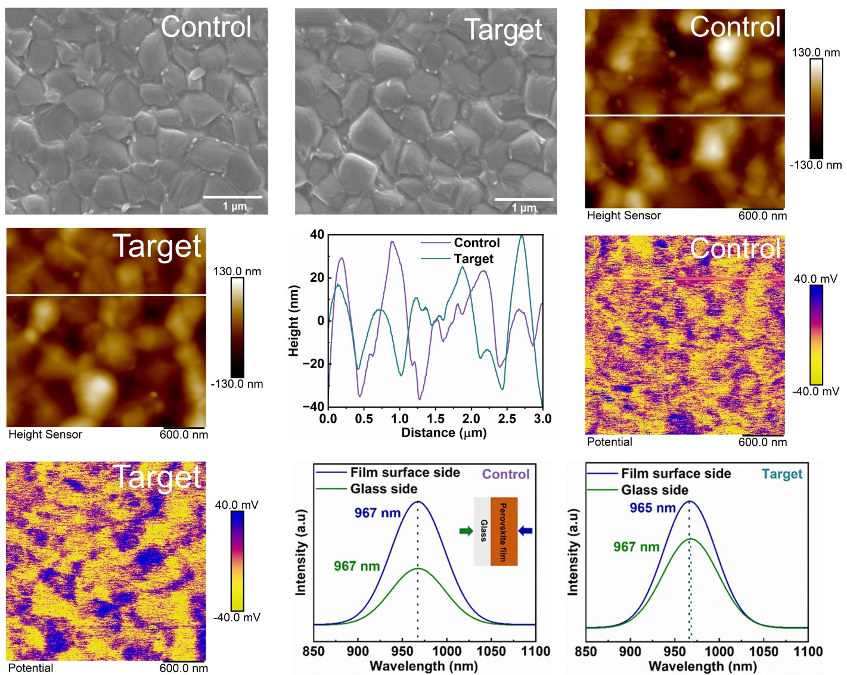
(a)
(b)
(c)
(d)
(e)
(f)
(g)
(h)
(i)
Figure 3. Top view SEM for (a) control and (b) target Sn-Pb perovskite thin films. AFM image of (c) control and (d) target Sn-Pb perovskite thin films. (e) Corresponding AFM line scans of control and target Sn-Pb perovskite thin films. KPFM images of (f) control and (g) target Sn-Pb perovskite thin films. The AFM and KPFM images have dimensions of 3 μm × 3 μm. PL spectra for (h) control and (i) target perovskite from film surface side and glass side excitation.
Photoluminescence (PL) spectroscopy was employed with excitation from both the glass side and the perovskite film surface side to investigate compositional variations at the surface of control and target samples, as depicted in Figure 3(h, i). For the control films, the emission wavelength remained consistent for both excitation modes, but a notable difference in PL intensity was observed. In contrast, the target films exhibited a significantly reduced PL intensity gap between the two excitation modes, suggesting enhanced composition uniformity and improved crystallinity across the bottom and top perovskite film surface. XPS analysis confirmed that PbBr₂ surface treatment during fabrication improved stoichiometry and reduced the Sn-rich environment on the surface. Moreover, the PL peak position was slightly blue-shifted due to the improve crystallinity with increased presence of stable Pb²⁺ ions on the surface and reduced surface defects. The perovskite crystallinity improvement was examined by X-ray diffraction (XRD) measurement, as illustrate in Figure S8. All XRD patterns exhibited identical characteristic peaks and peak positions, suggesting that PbBr₂ treatment didn’t alter the perovskite crystal structure because PbBr₂ didn’t intregrated into bulk of perovskite crystal. However, the peak intensity was increased for target sample in two main peak (100) and (200) plane and exhibited lower full width at half maxima (FWHM) value in the XRD patterns due to the improvement of uniformity and cryatallinity, as shown in Table S3.

2.4 Photovoltaic performance of Sn-Pb PSCs
We fabricated 1.26 eV Cs_{0.1}FA_{0.6}MA_{0.3}Pb_{0.5}Sn_{0.5}I₃ PSCs with the device structure p-i-n, as illustrated in Figure 4(a). The J-V curves of control and target PSCs in depicted in Figure 4(b) and their performances parameters are listed in Table S4. The control PSCs showed PCE of 21.13% in reverse scane, with a short-circuit current density (J_{SC}) of 32.0 mA/cm², an open-circuit voltage (V_{OC}) of 0.836 V, and a fill factor (FF) of 0.79. However, the target PSCs showed a slightly higher PCE 21.61% in reverse scane, with J_{SC}, V_{OC}, and FF values of 32.2 mA/cm², 0.839 V, and 0.80, respectively. The enhanced performance of the target PSCs is attributed to the improved uniformity of the Sn/Pb composition on the film surface. The forward and reverse scanned J-V of control and target PSCs are shown in Figure 4(c, d). The integrated external quantum efficiency (EQE) spectra are consistent with the current density values derived from the J-V measurements, as depicted in Figure 4(e). Moreover, the target PSCs exhibited higher reproducibility compared to the control devices, as shown in Figure 4(f). This improved reproducibility is likely due to the uniform composition in the target films, which reduces surface defects and enhances device performance. Utilizing the excellent reproducibility advantage, we fabricated large 1 cm² area PSCs, as shown in Figure 4(g). The large area PSC shows PCE of 20.83% in reverse scane direction, with J_{SC}, V_{OC}, and FF values of 32.4 mA/cm², 0.835 V, and 0.77, respectively.
A standard device physics analysis was conducted to evaluate the trap density reduction within the devices and at their interfaces. Dark J-V analysis was applied to investigate the reduction of surface defects on perovskite films and their subsequent impact on device properties, as shown in Figure S9(a). The target PSCs demonstrated a significantly lower leakage current compared to the control PSCs, suggesting the decrease in background trap densities at the interfaces and improved charge transport properties. Additionally, transient photovoltage (TPV) and transient photocurrent (TPC) measurements were performed to further understand charge recombination dynamics in both control and target PSCs. The TPV measurement was conduced in open-circuit condition and we used a biexponential decay function to calculate the decay charge carrier lifetime. The results revealed a delayed TPV decay in target PSCs (2.76 ms) compared to control PSCs (1.80 ms), as illustrated in Figure S9(b). This prolonged decay indicates an extended charge carrier lifetime and reduced recombination rates atthe interfaces of PSCs. Furthermore, TPC measurements showed a faster decay lifetime of 845 ns in target PSCs compared to 944 ns in control PSCs, reflecting enhanced charge transport properties, consistent with the TPV findings (Figure S9(c)).
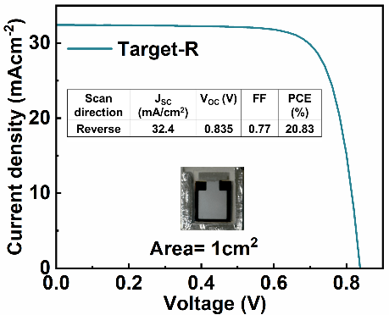
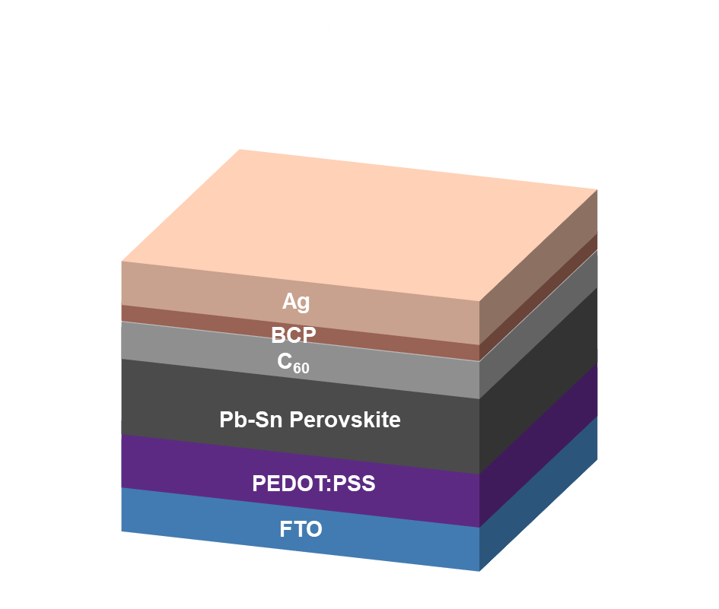
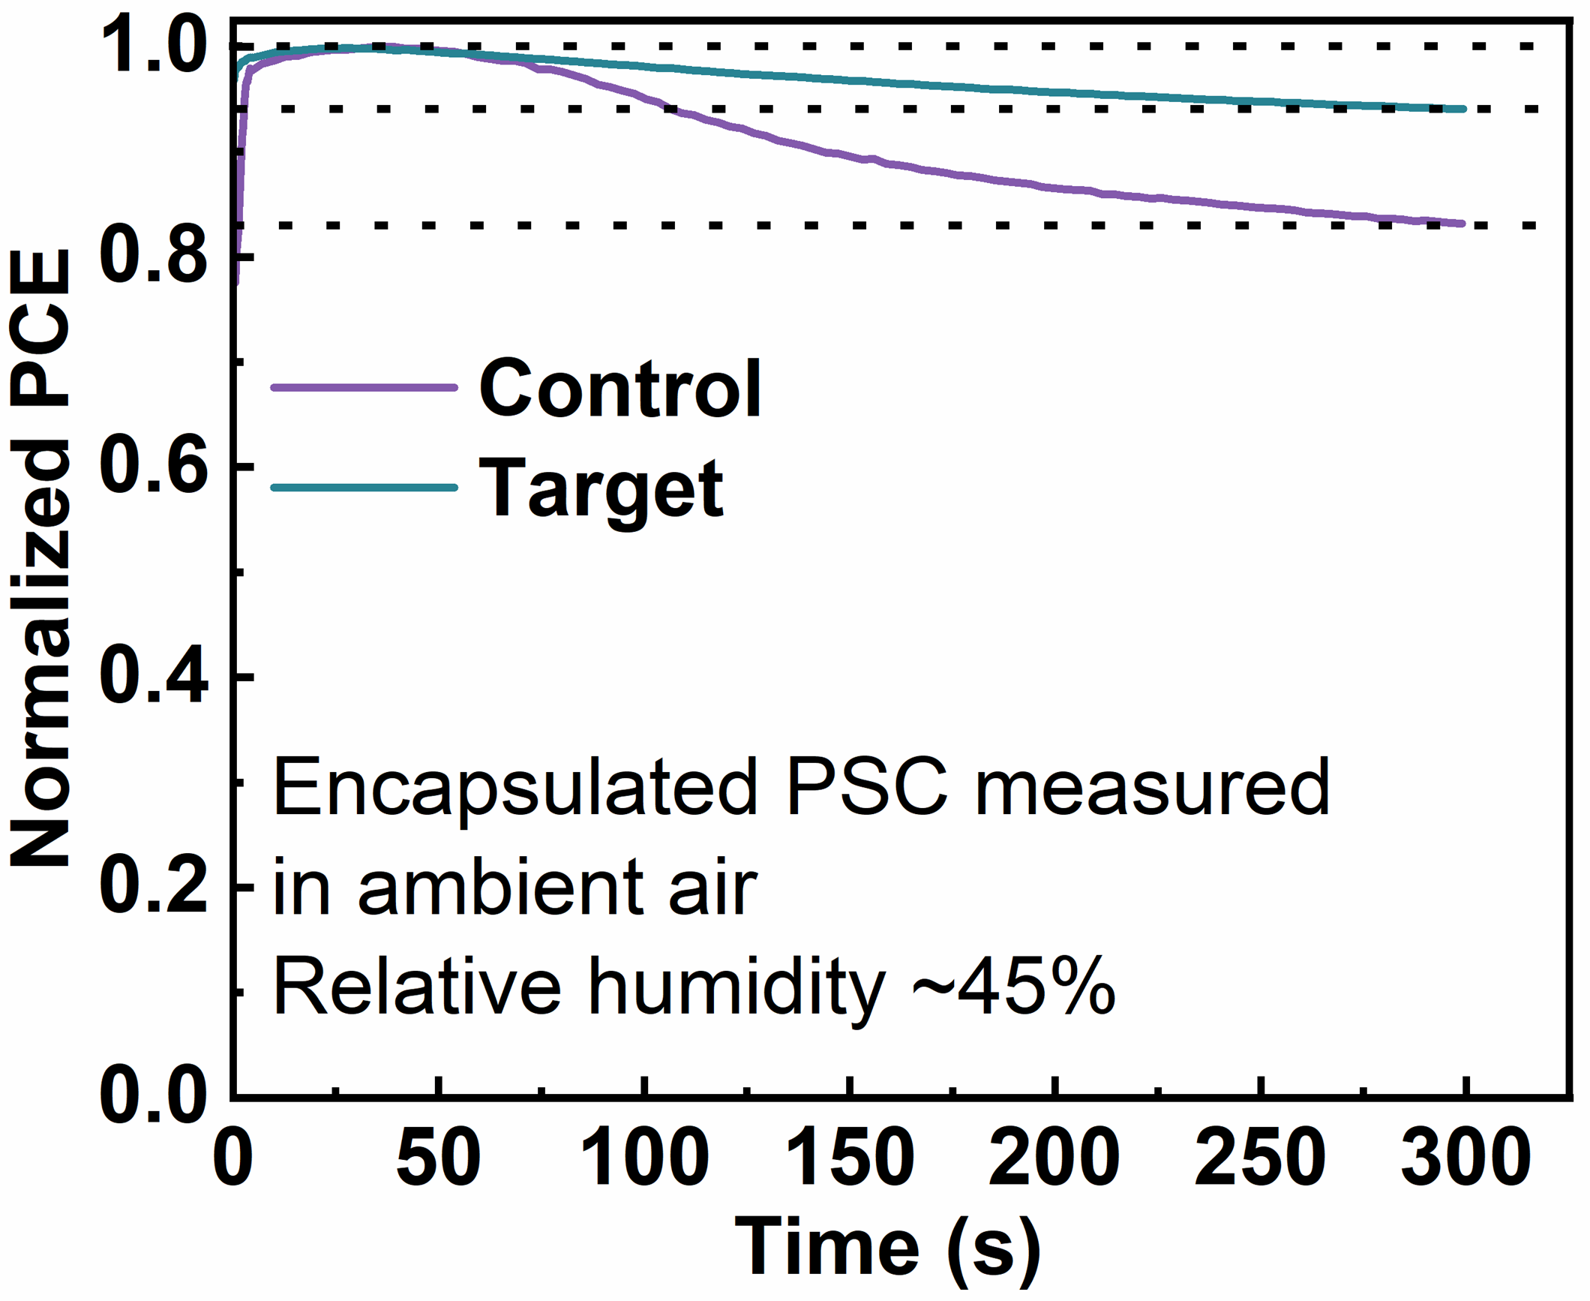
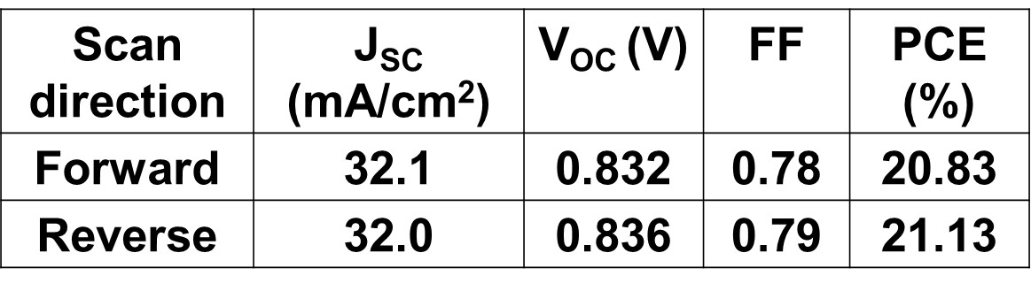
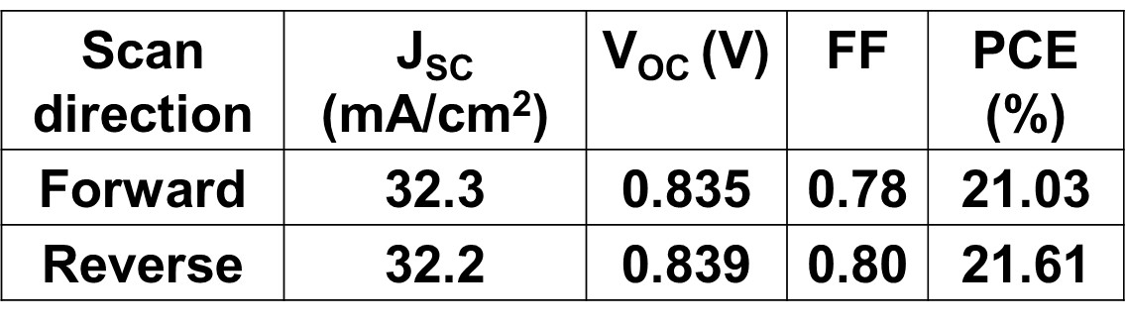
(a)
(b)
(e)
(f)
(h)
(c)
(d)
(g)
Figure 4. (a) The schematic representation of the Sn-Pb mixed PSCs structure. (b) The J-V curves for the control and target Sn-Pb mixed PSCs. Forward and reverse J-V curves for (c) control and (d) target PSCs. (e) EQE curves of Sn-Pb mixed PSCs for control and target PSCs. (f) Statistical analysis of device performance for control and target Sn-Pb PSCs, based on measurements of 15 cells per condition. The boxes indicate 25th (upper quartile) to 75th (lower quartile) percentiles. (g) J-V curves for target Sn-Pb mixed PSCs with active area 1cm² (h)MPPT stability test for control and target PSCs measured under 1 sun condition.
A stability test was performed for both control and target PSCs under continuous light illumination. The control PSCs demonstrated lower stability, with their PCE dropping to less than 30% of the initial PCE within 5 hours, as shown in Figure S10. In contrast, the target Sn-Pb mixed PSCs exhibited significantly improved stability, maintaining 80% of its initial PCE for approximately 50 hours. This enhanced stability is attributed to the balanced Sn:Pb stoichiometry achieved through PbBr₂-TOAB surface treatment. We further test the operation stability under 1 sun condition with maximum power point tracking (MPPT) system. Interestingly, the target PSCs maintained higher stability for up to 300 seconds under MPPT, confirming the positive impact of the PbBr₂-TOAB treatment on device stability, as shown in Figure 4(h). Moreover, water contact angle measurement confirmed that target Sn-Pb perovskite films showed higher hydrophobicity against water due to balanced Pb:Sn stoichiometry on top of the perovskite thin film surface, as detailed in Figure S11.
The target PSCs were also certified at the National Institute of Advanced Industrial Science and Technology (AIST) in Japan, achieving a stable, certified efficiency of 19.12% on a 0.0905 cm² aperture area, as detailed in Figure S12. The certification process was conducted after 5.2 minutes of MPPT and a total illumination time of 18.9 minutes, validated the quasi-steady-state efficiency. This certification demonstrates that the target PSCs operate consistently, with each I–V curve point measured under constant current (within 0.03% tolerance) and fixed applied voltage, highlighting their superior operational stability.

2.5 Mechanistic understanding of Sn-Pb PSCs stability
To understand the superior stability of the target PSCs under continuous light exposure, we performed time-dependent photoluminescence (PL) characterization to explore the degradation mechanisms in Sn-Pb mixed PSCs. PL is a widely utilized technique for studying degradation processes, such as phase segregation and ion migration, within perovskite layers, as it enables the direct detection of radiative recombination influenced by non-radiative recombination pathways.^{[48–51]} The degradation of PSCs is typically associated with defect formation, which alters both radiative and non-radiative recombination processes. Thus, time-dependent PL characterization provides valuable insights into the degradation dynamics of Sn-Pb PSCs.
A schematic presentation of the PL characterization setup is depicted in Figure S13. The measurements were conducted utilizing a confocal PL system, detecting PL spectra from the FTO glass side. Continuous 400 nm light illumination was applied for 30 minutes, and PL spectra were recorded every minute. The PL intensity of both control and target PSCs increased significantly during the initial 5 minutes of illumination, as illustration in Figure 5(a, b). However, after 5 minutes, the PL peak intensity of the control PSC began to decrease, while the target PSC maintained stable PL intensity throughout the measurement period. This behavior can be ascribed to the separation and transportation of photo-generated carriers to opposite electrodes due to the built-in electric field in PSCs, leading to initially low PL intensity. Over time, continuous illumination reduces the electric field due to charge accumulation at the electrodes, while trap-filling processes occur, allowing easier recombination of carriers and increased photon emission, as illustrated in Figure 5(c). For the control PSCs, the subsequent decrease in PL intensity suggests enhanced non-radiative recombination, likely caused by surface oxidation of Sn²⁺.

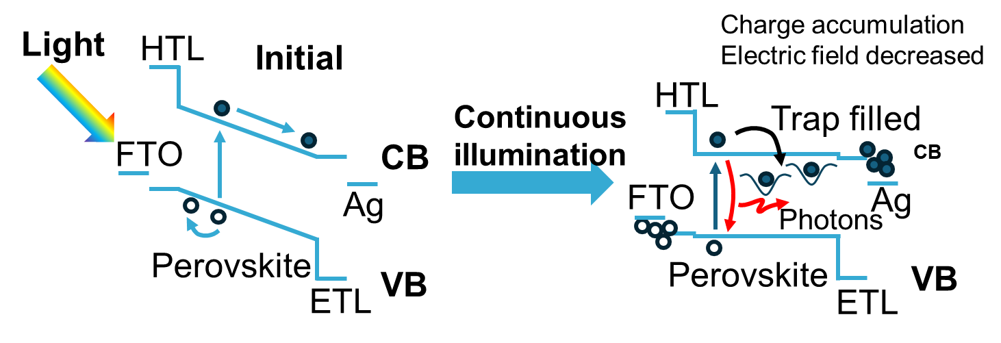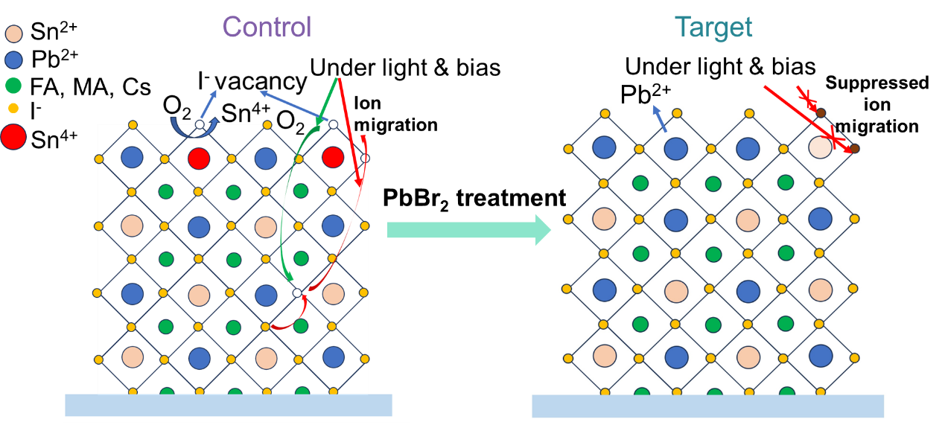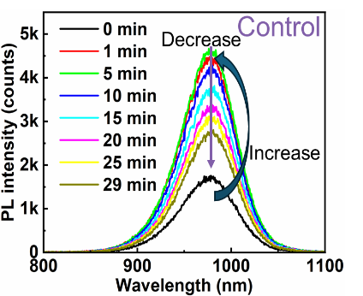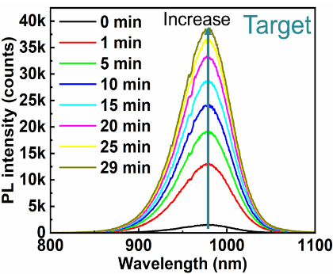
(c)
(d)
(a)
(b)
Figure 5. Time-dependent PL spectra of the (a) control and (b) target PSCs. (c) Mechanism of the increased PL peak of PSCs under continuous illumination. (d) Schematics of ion migration in Sn-Pb mixed control and target PSCs under continuous illumination.
Figure 5(d) illustrates the ion migration mechanism in control and target PSCs under continuous illumination. In control devices, Sn²⁺ oxidation generates iodine vacancies on perovskite film surface, facilitating ion migration under light exposure. This weakens the perovskite structure and promotes material decomposition. Residual oxygen on the surface can infiltrate through iodine vacancies, further oxidizing Sn²⁺ within the bulk perovskite, creating additional non-radiative recombination centers and reducing stability. Conversely, the PbBr₂-TOAB surface treatment applied to target PSCs introduces increased Pb²⁺ and I⁻ ions on the surface, effectively suppressing Sn²⁺ oxidation and iodine vacancies. This strengthens the perovskite surface, mitigates ion migration, and significantly enhances device stability under light illumination.

- Conclusions
In this work, we introduced a new strategy using a PbBr₂-TOAB solution to apply the wet surface treatment on Sn-Pb mixed perovskite layers. The wet surface treatment strategy increased the quantity of stable Pb²⁺ ions on the surface of the perovskite layer, suppressed the oxidation of Sn²⁺, and reduced the I⁻ ions losses . This strategy improved the Pb:Sn stoichiometric ratio from ~ 4.36:1 to ~2.74:1 for control to target film, respectively, confirmed by XPS measurements. This enable a PCE of 21.61 % for target Sn-Pb PSCs with certified (from AIST) PCE of 19.12 %, whereas control PSC shows PCE of 21.13 % for active area 0.09 cm². Moreover, larger target PSC with active area 1 cm² showed PCE of 20.83 %. Interestingly, the target PSCs exhibited stability under continuous light soaking and retained 80% of their initial PCE for 50 h. More importantly, target encapsulated PSCs maintained PCE of 95% of their initial PCE for 300 s when subjected to continuousillumination at maximum power point tracking (MPPT) conditions. Using time-dependent PL characterization, we found that the wet surface treatment strategy significantly suppressed the ion migration of Sn-Pb mixed PSCs under light illumination, leading to superior stability. We believe that this work open the door for wet surface treatment on Sn-Pb PSCs and will be the effective way to improve device performance and stability.
- Experimental Section
Experimental details are provided in the Supporting Information.
Supporting Information
Supplementary information can be accessed through the Wiley Online Library or from the author.
Acknowledgements
A.I. would like to thank the Japanese organizations "JSPS KAKENHI grant no. 22H02190" and "JST-ALCA-Next Program grant no. JPMJAN23B2" for the funds they have provided. Authors acknowledge the cooperation of Dr. Yasuhiro Shirai regarding the use of the PAIOS system for the EIS, TPC, and TPV measurements.

Conflicts of Interest
The authors state that there are no conflicts of interest.

Data Availability Statement
The data that support the findings of this study are available in the Supporting Information of this article.
Keywords
wet surface treatment, treatment strategy, stability, light illumination, perovskite solar cells

Reference
[1] J. Huang, Y. Yuan, Y. Shao, Y. Yan, Nat. Rev. Mater. 2017, 2, 17042.
[2] H. Min, D. Y. Lee, J. Kim, G. Kim, K. S. Lee, J. Kim, M. J. Paik, Y. K. Kim, K. S. Kim, M. G. Kim, T. J. Shin, S. Il Seok, Nature 2021, 598, 444.
[3] R. Azmi, E. Ugur, A. Seitkhan, F. Aljamaan, A. S. Subbiah, J. Liu, G. T. Harrison, M. I. Nugraha, M. K. Eswaran, M. Babics, Y. Chen, F. Xu, T. G. Allen, A. ur Rehman, C.-L. Wang, T. D. Anthopoulos, U. Schwingenschlögl, M. De Bastiani, E. Aydin, S. De Wolf, Science 2022, 376, 73.
[4] R. Lin, J. Xu, M. Wei, Y. Wang, Z. Qin, Z. Liu, J. Wu, K. Xiao, B. Chen, S. M. Park, G. Chen, H. R. Atapattu, K. R. Graham, J. Xu, J. Zhu, L. Li, C. Zhang, E. H. Sargent, H. Tan, Nature 2022, 603, 73.
[5] A. Kojima, K. Teshima, Y. Shirai, T. Miyasaka, J. Am. Chem. Soc. 2009, 131, 6050.
[6] Y. Zheng, Y. Li, R. Zhuang, X. Wu, C. Tian, A. Sun, C. Chen, Y. Guo, Y. Hua, K. Meng, K. Wu, C.-C. Chen, Energy. Environ. Sci. 2024, 17, 1153.
[7] W. Shockley, H. J. Queisser, J. Appl. Phys. 1961, 32, 510.
[8] J.-F. Guillemoles, T. Kirchartz, D. Cahen, U. Rau, Nat. Photonics. 2019, 13, 501.
[9] K. Wang, L. Zheng, Y. Hou, A. Nozariasbmarz, B. Poudel, J. Yoon, T. Ye, D. Yang, A. V. Pogrebnyakov, V. Gopalan, S. Priya, Joule 2022, 6, 756.
[10] M. T. Klug, R. L. Milot, J. B. Patel, T. Green, H. C. Sansom, M. D. Farrar, A. J. Ramadan, S. Martani, Z. Wang, B. Wenger, J. M. Ball, L. Langshaw, A. Petrozza, M. B. Johnston, L. M. Herz, H. J. Snaith, Environ. Sci. 2020, 13, 1776.
[11] A. Goyal, S. McKechnie, D. Pashov, W. Tumas, M. van Schilfgaarde, V. Stevanović, Chem. Materials 2018, 30, 3920.
[12] Y. Zhang, C. Li, H. Zhao, Z. Yu, X. Tang, J. Zhang, Z. Chen, J. Zeng, P. Zhang, L. Han, H. Chen, Nat. Commun. 2024, 15, 6887.
[13] R. Sun, P. Wang, T. Wang, L. Zhang, Z. Ge, L. Qiao, T. Ye, F. Li, W. Liu, Y. Wen, X. Yang, Nano. Lett. 2025, 25, 138.
[14] Y. Pan, J. Wang, Z. Sun, J. Zhang, Z. Zhou, C. Shi, S. Liu, F. Ren, R. Chen, Y. Cai, H. Sun, B. Liu, Z. Zhang, Z. Zhao, Z. Cai, X. Qin, Z. Zhao, Y. Ji, N. Li, W. Huang, Z. Liu, W. Chen, Nat. Commun. 2024, 15, 7335.
[15] X. Jiang, C. Li, X. Wang, C. Peng, H. Jiang, H. Bu, M. Zhu, H. Yin, B. He, H. Li, S. Pang, Z. Zhou, ACS Energy Lett. 2023, 8, 1068.
[16] J. Cao, H.-L. Loi, Y. Xu, X. Guo, N. Wang, C. Liu, T. Wang, H. Cheng, Y. Zhu, M. G. Li, W.-Y. Wong, F. Yan, Adv. Mater. 2022, 34, 2107729.
[17] H. Liu, L. Wang, R. Li, B. Shi, P. Wang, Y. Zhao, X. Zhang, ACS Energy Lett. 2021, 6, 2907.
[18] N. Yan, X. Ren, Z. Fang, X. Jiang, Z. Xu, L. Zhang, S. Ren, L. Jia, J. Zhang, Y. Du, D. Zhao, K. Zhao, S. Yang, S. (Frank) Liu, Adv. Funct. Mater. 2022, 32, 2201384.
[19] M. I. Saidaminov, I. Spanopoulos, J. Abed, W. Ke, J. Wicks, M. G. Kanatzidis, E. H. Sargent, ACS Energy Lett. 2020, 5, 1153.
[20] J. Pascual, G. Nasti, M. H. Aldamasy, J. A. Smith, M. Flatken, N. Phung, D. Di Girolamo, S.-H. Turren-Cruz, M. Li, A. Dallmann, R. Avolio, A. Abate, Mater. Adv. 2020, 1, 1066.
[21] C. Ge, B. Jiang, J. Zhu, P. Zhang, R. Ma, S. Yan, Z. Liu, A. Shaker, M. S. Salem, J. Luo, L. Xu, J. Yang, Z. Li, H. Song, C. Chen, J. Tang, Adv. Funct. Mater. 2024, 34, 2400075.
[22] Md. A. Karim, K. Matsuishi, T. H. Chowdhury, M. Abdel-Shakour, Y. He, A. Islam, ACS Appl. Energy Mater. 2022, 5, 15038.
[23] S. Hu, M. A. Truong, K. Otsuka, T. Handa, T. Yamada, R. Nishikubo, Y. Iwasaki, A. Saeki, R. Murdey, Y. Kanemitsu, A. Wakamiya, Chem. Sci. 2021, 12, 13513.
[24] R. Lin, K. Xiao, Z. Qin, Q. Han, C. Zhang, M. Wei, M. I. Saidaminov, Y. Gao, J. Xu, M. Xiao, A. Li, J. Zhu, E. H. Sargent, H. Tan, Nat. Energy. 2019, 4, 864.
[25] G. Kapil, T. Bessho, T. Maekawa, A. K. Baranwal, Y. Zhang, M. A. Kamarudin, D. Hirotani, Q. Shen, H. Segawa, S. Hayase, Adv. Energy Mater. 2021, 11, 2101069
[26] T. Jiang, Z. Chen, X. Chen, T. Liu, X. Chen, W. E. I. Sha, H. Zhu, Y. (Michael) Yang, Sol. RRL 2020, 4, 864.
[27] S. F. Hu, K. Otsuka, R. Murdey, T. Nakamura, M. A. Truong, T. Yamada, T. Handa, K. Matsuda, K. Nakano, A. Sato, K. Marumoto, K. Tajima, Y. Kanemitsu, A. Wakamiya, Environ. Sci. 2022, 15, 2096.
[28] Q. Tai, X. Guo, G. Tang, P. You, T. Ng, D. Shen, J. Cao, C. Liu, N. Wang, Y. Zhu, C. Lee, F. Yan, Angew. Chem. Int. Ed. 2019, 58, 806.
[29] K. Xiao, R. Lin, Q. Han, Y. Hou, Z. Qin, H. T. Nguyen, J. Wen, M. Wei, V. Yeddu, M. I. Saidaminov, Y. Gao, X. Luo, Y. Wang, H. Gao, C. Zhang, J. Xu, J. Zhu, E. H. Sargent, H. Tan, Nat. Energy 2020, 5, 870.
[30] X. Xu, C.-C. Chueh, Z. Yang, A. Rajagopal, J. Xu, S. B. Jo, A. K.-Y. Jen, Nano Energy 2017, 34, 392.
[31] Md. A. Karim, K. Matsuishi, Md. E. Kayesh, Y. He, A. Islam, ACS Appl. Mater. Interfaces 2023, 15, 45823.
[32] D. Luo, X. Li, A. Dumont, H. Yu, Z. Lu, Adv. Mater. 2021, 33, 2006004.
[33] S. Lv, W. Gao, Y. Liu, H. Dong, N. Sun, T. Niu, Y. Xia, Z. Wu, L. Song, C. Ran, L. Fu, Y. Chen, Energy Chem. 2022, 65, 371.
[34] S. Hu, J. Pascual, W. Liu, T. Funasaki, M. A. Truong, S. Hira, R. Hashimoto, T. Morishita, K. Nakano, K. Tajima, R. Murdey, T. Nakamura, A. Wakamiya, ACS Appl. Mater. Interfaces 2022, 14, 56290.
[35] H. Bi, Y. Fujiwara, G. Kapil, D. Tavgeniene, Z. Zhang, L. Wang, C. Ding, S. R. Sahamir, A. K. Baranwal, Y. Sanehira, K. Takeshi, G. Shi, T. Bessho, H. Segawa, S. Grigalevicius, Q. Shen, S. Hayase, Adv. Funct. Mater. 2023, 33, 2300089.
[36] C. Li, L. Chen, F. Jiang, Z. Song, X. Wang, A. Balvanz, E. Ugur, Y. Liu, C. Liu, A. Maxwell, H. Chen, Y. Liu, Z. Wang, P. Xia, Y. Li, S. Fu, N. Sun, C. R. Grice, X. Wu, Z. Fink, Q. Hu, L. Zeng, E. Jung, J. Wang, S. M. Park, D. Luo, C. Chen, J. Shen, Y. Han, C. A. R. Perini, J.-P. Correa-Baena, Z.-H. Lu, T. P. Russell, S. De Wolf, M. G. Kanatzidis, D. S. Ginger, B. Chen, Y. Yan, E. H. Sargent, Nat. Energy 2024, 9, 1388.
[37] K. Dave, Z. Bao, S. Nakahara, K. Ohara, S. Masada, H. Tahara, Y. Kanemitsu, R.-S. Liu, Nanoscale 2020, 12, 3820.
[38] S. Wei, Y. Yang, X. Kang, L. Wang, L. Huang, D. Pan, Inorg, Chem. 2017, 56, 2596.
[39] Y. Liu, S. Tang, J. Fan, E. Gracia-Espino, J. Yang, X. Liu, S. Kera, M. Fahlman, C. Larsen, T. Wågberg, L. Edman, J. Wang, ACS Appl. Nano Mater. 2021, 4, 1162.
[40] S. Gupta, D. Cahen, G. Hodes, Phy. Chem. C 2018, 122, 13926.
[41] J. Kurisinkal Pious, Y. Zwirner, H. Lai, S. Olthof, Q. Jeangros, E. Gilshtein, R. K. Kothandaraman, K. Artuk, P. Wechsler, C. Chen, C. M. Wolff, D. Zhao, A. N. Tiwari, F. Fu, ACS Appl. Mater. Interfaces 2023, 15, 10150.
[42] J. Zillner, H. Boyen, P. Schulz, J. Hanisch, N. Gauquelin, J. Verbeeck, J. Küffner, D. Desta, L. Eisele, E. Ahlswede, M. Powalla, Adv. Funct. Mater. 2022, 32, 2109649.
[43] Y. Zong, Z. Zhou, M. Chen, N. P. Padture, Y. Zhou, Adv Energy Mater 2018, 8, 1800997.
[44] Z. Zhang, J. Liang, Y. Zheng, X. Wu, J. Wang, Y. Huang, Y. Yang, Z. Zhou, L. Wang, L. Kong, K. M. Reddy, C. Qin, C.-C. Chen, Mater. Chem. A 2021, 9, 17830.
[45] L. Lanzetta, T. Webb, N. Zibouche, X. Liang, D. Ding, G. Min, R. J. E. Westbrook, B. Gaggio, T. J. Macdonald, M. S. Islam, S. A. Haque, Nat. Commun. 2021, 12, 2853.
[46] T. Leijtens, R. Prasanna, A. Gold-Parker, M. F. Toney, M. D. McGehee, ACS Energy Lett. 2017, 2, 2159.
[47] J. T. Wang, M. A. Uddin, B. Chen, X. J. Ying, Z. Y. Ni, Y. Zhou, M. Z. Li, M. R.Wang, Z. H.Y u, J. S. Huang, Adv. Energy Mater. 2023, 13, 2204115.
[48] S. G. Motti, J. B. Patel, R. D. J. Oliver, H. J. Snaith, M. B. Johnston, L. M. Herz, Nat. Commun. 2021, 12, 6955.
[49] Z. Wang, L. Zeng, T. Zhu, H. Chen, B. Chen, D. J. Kubicki, A. Balvanz, C. Li, A. Maxwell, E. Ugur, R. dos Reis, M. Cheng, G. Yang, B. Subedi, D. Luo, J. Hu, J. Wang, S. Teale, S. Mahesh, S. Wang, S. Hu, E. D. Jung, M. Wei, S. M. Park, L. Grater, E. Aydin, Z. Song, N. J. Podraza, Z.-H. Lu, J. Huang, V. P. Dravid, S. De Wolf, Y. Yan, M. Grätzel, M. G. Kanatzidis, E. H. Sargent, Nature 2023, 618, 74.
[50] W. Mao, C. R. Hall, S. Bernardi, Y. B. Cheng, A. Widmer-Cooper, T. A. Smith, U. Bach, Nat. Mater. 2021, 20, 55.
[51] J. Thiesbrummel, V. M. Le Corre, F. Peña‐Camargo, L. Perdigón‐Toro, F. Lang, F. Yang, M. Grischek, E. Gutierrez‐Partida, J. Warby, M. D. Farrar, S. Mahesh, P. Caprioglio, S. Albrecht, D. Neher, H. J. Snaith, M. Stolterfoht, Adv. Energy Mater. 2021, 11, 2101447.

