Li Plating/Stripping Efficiency in Ether-based Dilute Electrolyte for Anode-free Lithium Metal Batteries: Effect of Operating Potential Range on Subsequent SEI Layer Structure

Yushen Wang ^{1,2} and Hidenori Noguchi^{1,2}*

[1] Dr. Hidenori Noguchi, Yushen, Wang
Graduate School of Chemical Sciences and Engineering, Hokkaido University,
Sapporo 060-8628, Japan
[2] Dr. Hidenori Noguchi, Yushen, Wang
Center for Green Research on Energy and Environmental Materials (GREEN),
National Institute for Materials Science (NIMS),
Tsukuba 305-0044, Japan
*Corresponding Author E-mail: NOGUCHI.Hidenori@nims.go.jp

Abstract:
Anode-free lithium metal batteries (AFLMBs) are regarded as a promising candidate for next-generation batteries due to a great enhancement of energy density over lithium metal anode batteries. However, unstable solid-electrolyte interface (SEI) formation accompanied by lithium dendrite growth and electrolyte decomposition causes low Coulombic efficiencies. This study explores the effect of different operating potential ranges on SEI layer structure and further on Li plating/stripping efficiency in the dilute LiTFSI/TEGDME electrolyte in an AFLMB anode half-cell configuration. Cyclic voltammetry analyses reveal the existence of an “oxidative subsequent SEI” formation process (named as OSS) and the improved Li plating/stripping efficiency by blocking reaction OSS, which is further verified by quartz crystal microbalance analysis regarding the insight of such an improvement. XPS depth-profile analysis confirms the formation of the Li₂O- and lithium-sulfur compounds-based subsequent SEI layers when the OSS process is blocked, which guarantees the improved stability of Li plating/stripping. A hypothesis is proposed to discuss possible electrochemical reactions via OSS process by combining in situ surface-enhanced Raman spectroscopy analysis. These results together suggested the importance of adjusting operating potential range in a proper manner to achieve a better performance in Li plating/stripping in AFLMB configuration.

Introduction
To achieve a highly sustainable society, there is a rapidly growing demand for developing rechargeable batteries that deliver very high energy density and power density. Commercial Li-ion batteries (LIBs) cannot fulfill the demands for massive applications such as electric vehicles because they typically have an energy density of less than 250 Wh kg⁻¹.^{[1,2]} Li metal batteries (LMBs) show a great potential to substantially enhance energy density because the Li metal anode has a very low redox potential (-3.04 V vs. SHE) and a very high theoretical capacity (3860 mAh g⁻¹).^{[3–5]} However, thorny problems including Li dendrite formation and growth will cause the poor efficiency of Li plating/stripping and the danger of short-circuit. Although adding excess lithium can usually compensate for the consumed Li inventory, this will reduce the energy density advantage of LMBs and artificially extend the cycle life of the battery, disabling a correct evaluation of battery performance.^{[6]}
For the above reasons, anode-free Li-metal batteries (AFLMBs) are considered as a potential alternative to LMBs.^{[6–11]} An AFLMB is defined by removing the Li metal anode of LMB, and only a current collector such as copper is paired during cell assembly. In principle, Li resources are initially stored in the cathode, while during the first charging and discharging, Li⁺ will first deposit on the anode current collector as Li metal, then strip and intercalate back into the cathode. Since the initial plating of Li metal will automatically produce a “Li-metal anode” on the Cu surface, the behavior of the initial cycle usually differs significantly from that of the following cycles for an AFLMB.^{[6]} The most attractive feature of AFLMBs is the substantially reduced battery’s weight and volume, by which a great increase of energy density can be achieved. Additionally, there is no excess Li for an as-fabricated AFLMB and the performance is dependent on Li plating/stripping efficiency, which will enable a more realistic evaluation of capacity loss mechanisms.^{[6][12]} However, since an AFLMB does not have the host for deposited Li, the first charging may cause over 20% volume expansion.^{[13]} This will not only reduce the battery’s energy density but also lead to the mechanical breakage of the SEI (solid electrolyte interphase) layer.
A typical SEI layer consists of the reductive decomposition products of electrolyte but plays a role in suppressing further decomposition of electrolyte.^{[14,15]} In AFLMBs with copper metal as the current collector, there is a “native-SEI (N-SEI)” layer forming right after cell assembly, which is composed of some Cu oxides and electrolyte decomposition products.^{[16]} Moreover, an SEI layer forming after applying voltage but before the first Li plating and an SEI layer forming after the first Li stripping are defined as a “pre-SEI” layer and a “subsequent-SEI (s-SEI)” layer, respectively.^{[17]} Usually, Li plating/stripping will occur beneath the pre-formed N-SEI layer and pre-SEI layer, but if these surface layers are unstable and fragile, the distribution of plated Li will be inhomogeneous,^{[18]} causing the growth of Li dendrite and the isolated “dead Li” to penetrate the layers, followed by a reconstruction of s-SEI layers. This process opens a pathway of continuously consuming both Li and electrolyte, resulting in poor Coulombic efficiencies (hereafter CE).^{[19–21]} Therefore, the favorable SEI layers (i.e. N-SEI, pre-SEI, and s-SEI) should not only ensure fast Li⁺ conduction but also block further decomposition of electrolytes.
One of the important strategies to modulate SEI layer structure is electrolyte modification. There are some strategies for modifying electrolytes applied in AFLMBs, such as dual-salt electrolytes or highly-concentrated electrolytes.^{[7–10][22]} However, high concentration condition usually increases the viscosity (decreases the ionic conductivity) of electrolytes and is not a cost-effective route.^{[23]} Although the idea of using localized high-concentration electrolytes was proposed to solve such problems,^{[24]} it is always attractive and challenging to achieve decent performance under lean electrolyte condition.^{[10]} Operating potential range is another important factor that will influence SEI layer structures, and consequently, Li plating/stripping efficiency. Either too wide or too narrow potential range can have a negative impact on sustaining a stable SEI layer structure. It’s widely accepted that the SEI usually forms in the potential range of 0.2 ~ 1.0 V vs. Li/Li⁺, while studies mainly focused on the electrolyte reductive processes via electron-transfer from the anode,^{[25]} with less concerns on the subsequent oxidation processes at a relatively higher potential regime since such kinds of processes would be complicated depending on actual electrolyte conditions such as adding additives. Meanwhile, in the charging-discharging protocol in AFLMBs, adjusting the potential limit to achieve optimal performance is a common strategy.^{[26]} Usually, the charge-discharge at an anode is confined to low potential range to achieve high energy density of the full-cell. However, in a real situation, when the battery is working at high current density or is over-charged or over-discharged, the potential may fluctuate greatly and exceed the normal operating range, which can lead to the destruction of the SEI layer and the degradation of the battery performance. Moreover, the “cross-talk effect” (the crossover of side reaction products from cathode to anode) can change Li plating/stripping and SEI formation mechanism. Therefore, it’s necessary to study the properties and stability of SEI over a wider potential range by considering factors like the cross-talk effect, especially at higher potential, for the purpose of fully understanding the effect of electrolyte on the SEI layer structure at the anode side. To address this problem, a more careful investigation by the cyclic voltammetry (CV) method is necessary.
Tetraethylene glycol dimethyl ether (TEGDME) is an ether-based solvent with low volatility and a high degree of oxidation tolerance, and is commonly used in Li-oxygen batteries (LOBs).^{[27]} A previous study showed that TEGDME slightly decomposes at potentials above 3.8 V vs. Li/Li⁺ in the absence of oxygen and Li⁺ source.^{[28]} However, a stable SEI layer cannot be realized in TEGDME solvent-based electrolyte due to the continuous reaction with Li metal, resulting in the formation of a thick SEI layer, leading to low CE.^{[29,30]} But on the other hand, TEGDME may be a good candidate in regard to the mechanistic study of performance degradation and enhancement in a broad potential range for AFLMB since the difference in performance should be more evident when different conditions are applied. The combination of TEGDME with lithium bis(trifluoromethylsulfonyl)imide (LiTFSI) as Li salt, which is universally used in LOBs research. However, to the best of our knowledge, there is still no report on the application to AFLMB studies. Besides, due to the high degree of oxidation tolerance, TEGDME can naturally be used for this work to ensure a wide operating window to study the potential-dependent SEI formation in more detail.
In this work, we investigated the effect of operating potential range on SEI layer structure and further on Li plating/stripping efficiency in a Li||Cu half-cell (a model cell to study the anode side of AFLMBs) in the dilute (0.4 м) LiTFSI/TEGDME electrolyte, mainly through analyzing the conductivities, chemical compositions, and stability of the formed SEI layers on the Cu surface by combining several techniques including CV, quartz crystal microbalance (QCM) and X-ray photoelectron spectroscopy (XPS) depth-profile analysis, together with in situ surface-enhanced Raman spectroscopy (SERS), electrochemical impedance spectroscopy (EIS), reflectivity, and scanning electron microscopy (SEM) analysis.

Results and Discussion
Effect of Potential Range on Li Plating/Stripping Efficiency
CV measurements were conducted to investigate the electrochemical behaviors of electrolytes under different conditions. Figure 1(a) shows the 50-cycle CV curves by scanning positively to 3.2 V. The current of Li plating started to flow at around -0.1 V, and the current of Li stripping faded at ca. 0.3 ~ 0.5 V, depending on the cycle number. To clarify the SEI-related reactions, the electrochemical behaviors within the potential range of 0 ~ 3.2 V were carefully checked. Figure 1(b) shows the 1st-cycle CV curves under different potential ranges. A series of peaks in the range of 0 ~ 3.2 V were found during cathodic and anodic scans. The cathodic peak at 1.4 V was assigned to the reductive decomposition of electrolyte including TFSI– anions and TEGDME solvent.^{[31,32]} Gittleson et al. reported the CV curves of pure TEGDME on the glassy carbon working electrode, in which they observed a cathodic peak at around 1.5 V and an anodic peak above 4.0 V.^{[32]} The CV curves of TEGDME solvent on a Cu working electrode were also confirmed in this study, where the peak potential of the broad cathodic peak related to TEGDME reductive decomposition was around 1.4 V (see Figure S1(a)), similar as Gittleson’s result. Another cathodic peak at 1.1 V can be attributed to the reduction and lithiation reactions of Cu oxides. This can be proved by comparing the CV curves between using Cu plate and Au plate as working electrodes, where this peak was not observed in the case of using Au working electrode (Figure S1(b)). The chemical species on the surface of Cu substrate in this potential range may include Cu_{x}O, CuF₂, LiF, Li₂O, Li₂O₂, LiOH, etc.^{[16]} The broad cathodic peak at around 0.5 V in the 1st cycle was reported to result from the SEI formation reactions such as the reduction of Li₂CO₃ which was generated from the decomposition of electrolyte.^{[16]}
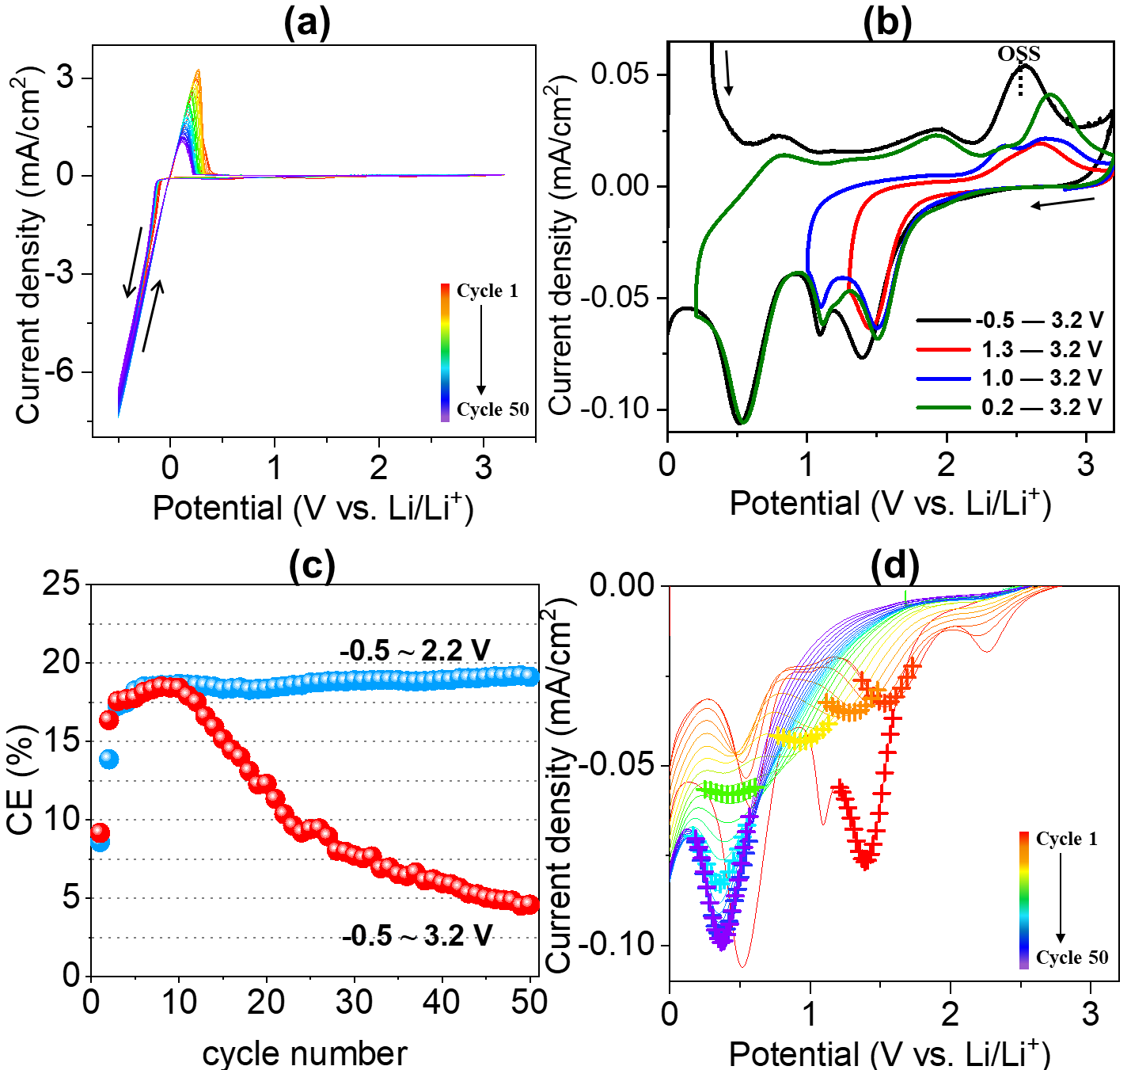

Figure 1. (a) The 50-cycle CV curves in the Li||Cu cell. Potential range: -0.5 ~ 3.2 V vs. Li/Li⁺, scan rate: 10 mV s⁻¹; (b) The enlarged area (0 ~ 3.2 V vs. Li/Li⁺) of the 1st-cycle CV curves under different potential ranges; (c) CE performance under two potential ranges (-0.5 ~ 3.2 V and -0.5 ~ 2.2 V vs. Li/Li⁺) up to 50 cycles; (d) The enlarged area (cathodic scans, 0 ~ 3.2 V vs. Li/Li⁺) of the 50-cycle CV curves. The reduction peaks corresponding to electrolyte reductive decomposition at selected cycles (cycle number: 1, 5, 10, 15, 20, 30, 40, and 50) were marked by cross symbols for a better understanding of peak variation.

During the first anodic scan, the corresponding oxidation processes of the abovementioned reduction reactions were confirmed. When CV was performed in the potential ranges of 1.0 ~ 3.2 V and 1.3 ~ 3.2 V, peaks at 2.4 V and 2.7 V indicating the correspondent oxidation processes of electrolyte reductive decomposition and reduction of Cu oxides, respectively, were observed. As soon as the pre-SEI layer was formed by scanning in the range of 0.2 ~ 3.2 V, two additional oxidation peaks at 0.8 V and 1.9 V during the anodic scan could be assigned to the oxidation reactions of pre-SEI components. However, if Li plating/stripping was involved, an oxidation current started to flow from 2.15 V and reached a maximum at 2.56 V. This reaction (hereafter denoted as “OSS”) was assigned to the oxidation of some pre-SEI components to form an s-SEI layer which occurred at a relatively higher potential. Because peak OSS appeared only when the Li plating/stripping process was also involved, it can be speculated that OSS originated not only from pre-SEI components, which were generated from electrolyte decomposition and Cu substrate reduction, but also from the Li plating/stripping process.
The calculated CE is shown in Figure 1(c). The overall CE (red circle) was less than 20%. In an AFLMB configuration, the CE value in the 1st cycle is generally lower than the follow-up cycles mainly due to the initial SEI formation process on the Cu surface.^{[17]} However, in the case of reaction OSS taking place, it’s notable that the CE value reached the maximum around the 10th cycle, then showed a non-stop degradation onward. The increase of CE in the initial 10 cycles should be due to the sudden and substantial growth of dendritic Li in the initial few cycles that penetrated the surface layer, therefore decreasing the thickness of surface layer, which instead favored the Li⁺ diffusion through the layer. This can be inferred by the result of optical reflectivity analysis, where the initial value of the normalized reflectance change (ΔR/R, the value of which is in proportion to the thickness of the SEI layer^{[33]}) in the follow-up cycles decreased when compared with the first cycle (Figure S2). This inference can be further supported by the EIS results which were fitted using the equivalent circuit in Figure S3. For the electrode-electrolyte interface with SEI, the interfacial resistance can be regarded as a combination of the SEI resistance (R_{SEI}) in the high-frequency region of the semicircle and the charge transfer resistance (R_{ct}) in the middle-frequency region of the semicircle. As indicated in Figure S3, the interfacial resistance became smaller from the 1st to the 5th cycle, indicating the formation of relatively thinner s-SEI layer with reduced resistance.^{[34]} As cycling proceeded, however, the increase of interfacial resistance was observed, indicating that more and more dendritic Li gradually increased the active surface area in contact with the electrolyte, facilitating undesirable reactions and generating electrochemically inactive “dead Li” in the subsequent cycling, which can be confirmed by the observation of the growth and accumulation of whisker-like lithium via SEM after 50 cycles (Figure S4). This process consumed more Li and electrolyte and ultimately led to a drop in the CE values.
To understand the function of OSS, the occurrence of reaction OSS was blocked by scanning the potential positively to 2.2 V without changing other conditions. Surprisingly, in contrast with the gradual decay of Li stripping current in the electrolyte without blocking reaction OSS, the Li plating/stripping proceed more stably with smaller Li plating current densities when OSS was blocked (Figure S5(a)), which could result in a smoother and denser Li morphology.^{[16]} Furthermore, a greatly stabilized CE was found in the prolonged 50 cycles (Figure 1(c), blue circle), with a relatively stabilized Li stripping capacity retention after 50 cycles (90%) compared with that in the case of scanning positively to 3.2 V (23%) (Figure S5(b)). Meanwhile, it’s notable that similar CE was achieved in the initial 10 cycles regarding these two scanning potential ranges, suggesting that reaction OSS did not contribute to enhancing CE values, on the contrary, it is highly likely to facilitate the construction of unstable SEI structure. To further grasp factors that affected the CE performance, a closer inspection of the CV peaks in the range of 0 ~ 3.2 V vs. Li/Li⁺ during cycling was carried out. Figure 1(d) and Figure S5(c) exhibits the enlarged view of 50-cycle CV curves scanning positively to 3.2 V and 2.2 V, respectively, with an emphasis on the behavior of electrolyte reductive decomposition reaction, and the cycling-dependent variation of the peak potentials and currents of the reaction obtained from CV is shown in Figure S5(d). When reaction OSS occurred, peak potential and current variation upon cycling were observed, suggesting the generation of multiple chemical species during the reconstruction of the SEI layer. Typically, the peak current of electrolyte reductive decomposition drastically increased, indicating a faster reaction kinetics.^{[8,9]} It was thereby inferred that this behavior should be induced by further decomposition of TEGDME solvent by deposited Li due to the formation of the electronic conductive s-SEI layer. Furthermore, the peak potential negatively shifted, indicating a higher potential polarization, which was induced by the formation of thick s-SEI layers resulting from huge electrolyte and Li consumption.^{[9]} Interestingly, the current did not increase monotonically but initially decreased to a minimum value in the 5th cycle, which was assumed to correlate with the observation of an unusual “turning point” in the 10th cycle in regard of CE values. On the other hand, blocking reaction OSS by scanning positively to 2.2 V did not improve the Li⁺ conductivity, instead the slightly larger interfacial resistance of s-SEI layers represented by the larger semicircles was observed in the EIS profile when compared with that without blocking reaction OSS by scanning positively to 3.2 V (Figure S6). Since the SEM image taken after 50 cycles in the case of blocking reaction OSS provided the evidence of the growth of columnar-like Li with a relatively smooth surface morphology (Figure S7), the possibility of severe dendritic Li growth was excluded. Therefore, this was rather caused by the formation of some inorganic species (LiF, Li₂CO₃, Li₂O, etc.) with poor ionic and electronic conductivity to passivate the SEI layer surface.^{[30]} However, it’s worth noting that such kind of passivated layer effectively can block the electronic tunneling to suppress the decomposition of electrolyte to a certain extent, as indicated by much smaller currents of electrolyte reductive decomposition (Figure S5(d)). Meanwhile, a reduction peak was newly detected at each cycle in the range of 1.0 ~ 1.5 V from ca. 20th cycle, presumably arising from an additional s-SEI layer formation process (Figure S5(c)). These results together could explain why CE performance became much more stable but was not enhanced when blocking reaction OSS (Figure 1(c)).
QCM test was performed by which the real-time change of mass and surface roughness of the SEI layer during CV cycling could be recorded. Figure 2(a)–(c) shows the CV curves as well as the potential dependences of Δm and ΔR during the 1st cycle. Here, resonant resistance ΔR is an indicator of the change in surface roughness, the increase of which causes energy loss, in turn elevating ΔR.^{[35]} Prior to the first Li plating, electrolyte decomposition and pre-SEI layer formation on the Cu surface induced the mass increase, while surface roughness did not change obviously (Figure 2(a)). The MPE (mass change per mol e⁻) values during this process, which can be calculated from the slope of the plot with Δm as a function of the passed charge, was close to 10. It was deemed to be a result of several electrochemical reactions that generated both dissolved products and deposited products, while the latter were mostly inorganic species, especially Li₂O which could be a product of the reductive decomposition of LiTFSI (Li₂O as one of the final products, MPE unknown),^{[36,37]} or the reduction of Cu oxides on the Cu surface (Cu_{x}O + 2Li → Li₂O + xCu),^{[16]} or even the reaction with trace oxygen in glove box (O₂ + 4Li⁺ + 4e– → 2Li₂O, MPE = 15).^{[38]} This could also suggest that TEGDME did not heavily decompose prior to the initial Li plating (also indicated by the weak reduction current shown in Figure S1(a)), since most of the decomposed fragments and derivatives of TEGDME have larger MPE values.^{[39,40]} This supports the commonly accepted heterogeneous SEI layer structure, namely inorganic inner SEI and organic outer SEI.^{[41,42]} During the first Li plating/stripping, one can observe a huge increase in both mass and surface roughness (Figure 2(b)). Such an increase can be attributed to the inhomogeneous distribution of plated Li metal causing dendrite growth and poor stripping efficiency of Li.^{[35]} After the first Li stripping, surface mass decreased monotonically due to the oxidation of deposited products generated during cathodic scanning (Figure 2(c)). It should be noted that, although the decrease of surface mass was observed in the process of OSS, the total mass change should be affected by a series of reactions, which would necessitate a combination of QCM with other techniques to precisely analyze OSS.

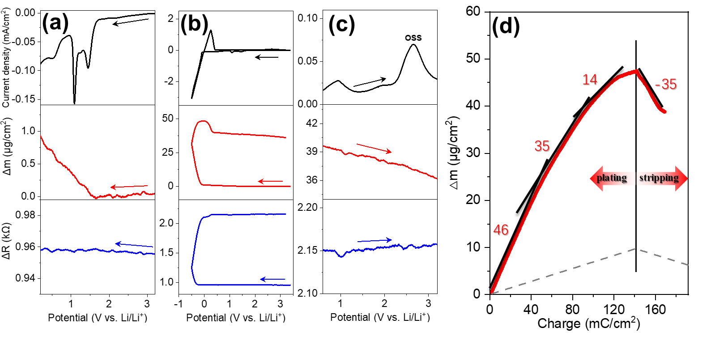

Figure 2. The potential dependences of current-density, Δm and ΔR during the 1st cycle with regard to (a) pre-SEI formation process, (b) Li plating/stripping process, and (c) OSS process; (d) The calculated MPE values during the first Li plating/stripping, measured in the potential range of -0.5 ~ 3.2 V. The black vertical lines separate Li plating region and Li stripping region. The dotted line with a theoretic MPE value of 7 indicates only Li plating/stripping occurs.

The MPE values during the first Li plating/stripping were calculated (Figure 2(d)). Multiple MPE values were obtained during Li plating, indicating multiple electrochemical processes.^{[36]} An extra film was formed during Li plating due to the reaction of plated Li metal with electrolyte as indicated by MPE values much larger than 7 (a value indicating only Li plating/stripping occurs).^{[43]} The possible surface species are the complicated organics from the decomposed TEGDME molecule and the organic Li salts from the reaction of Li metal with these organics, resulting in the overall MPE values around 50 ~ 80.^{[39,40]} The MPE values in the 10th and 20th cycles were also calculated (Figure 3(a)–(b)) to discuss the effect of blocking reaction OSS. When reaction OSS occurred, the MPE value during Li stripping was approaching 7 in the initial 10 cycles while it deviated from 7 afterward, as evidenced by an MPE value of -4 in the 20th cycle showing the increase of surface mass even during Li stripping, which is a signal of more undesired side reactions taking place. This result is in line with the variation of CE value and electrolyte reductive decomposition current shown in Figure 1(c)–(d). In sharp contrast, by blocking reaction OSS a more stable Li stripping process was achieved whose MPE value is closer to 7 either in the 20th cycle. Moreover, the accumulated Δm up to the 20th cycle is smaller than the electrolyte without blocking reaction OSS, indicating that the formed s-SEI layer at this stage has a relatively larger portion of inorganic species with smaller MPE values. In addition, the cycling-dependent ΔR behavior was studied and the results are shown in Figure 3(c)–(d). A direct comparison between these two potential ranges led to a conclusion that reaction OSS strongly induced the increase of surface roughness upon cycling. This further supported the observation of the surface morphology difference between “with OSS” and “without OSS” after cycling (Figure S4 and Figure S7). Therefore, it can be concluded that blocking reaction OSS led to the formation of relatively compact and mechanically strong SEI layers that suppress Li from growing into dendrites.
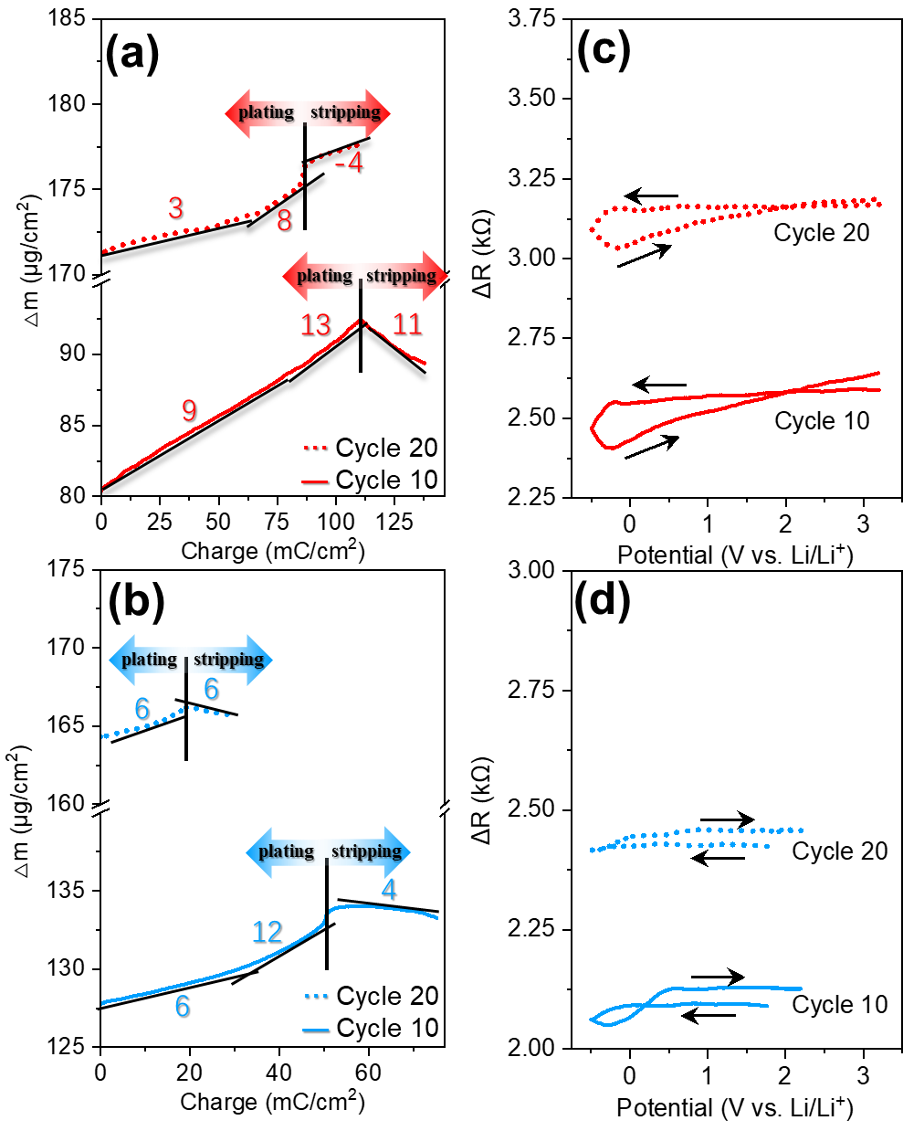

Figure 3. (a, b) The calculated MPE values at Li plating/stripping and (c, d) the potential dependences ΔR during the 10th and 20th cycles, measured in the potential range of (a, c) -0.5 ~ 3.2 V and (b, d) -0.5 ~ 2.2 V, respectively. The black vertical lines separate Li plating region and Li stripping region. The negative MPE values indicate the loss (or growth) of mass during Li plating (or stripping).

Effect of Potential Range on s-SEI Layer Compositions
The SEI layer compositions for the electrolyte with two scanning potential ranges were characterized using in-depth XPS analysis by Ar⁺ sputtering for 0, 5, and 10 min. Figure 4(a)–(d) shows the O 1s, S 2p, F 1s, and C 1s XPS spectra of the s-SEI layers formed at different periods of cycles on the Cu substrate in the respective electrolytes. In the O 1s spectra, two peaks were observed in both electrolytes: the one at 531.5 ~ 533 eV was assigned to –C–O–C– bonding corresponding to poly(ethylene oxide) ((CH₂–CH₂–O)_{n}⁻) or R–O–CO₂Li from the decomposition of TEGDME molecules, and the other at 534 ~ 535.5 eV was assigned to Li₂CO₃ (Figure 4(a)).^{[15][30]} In particular, a peak corresponding to Li₂O at 529 eV was observed when blocking reaction OSS. On the other hand, the existence of Li₂O₂ at 531 eV was observed while no Li₂O was detected regardless of the Ar⁺ sputtering depth when reaction OSS occurred. This may indicate that Li₂O was oxidized during the reaction OSS at each cycle.
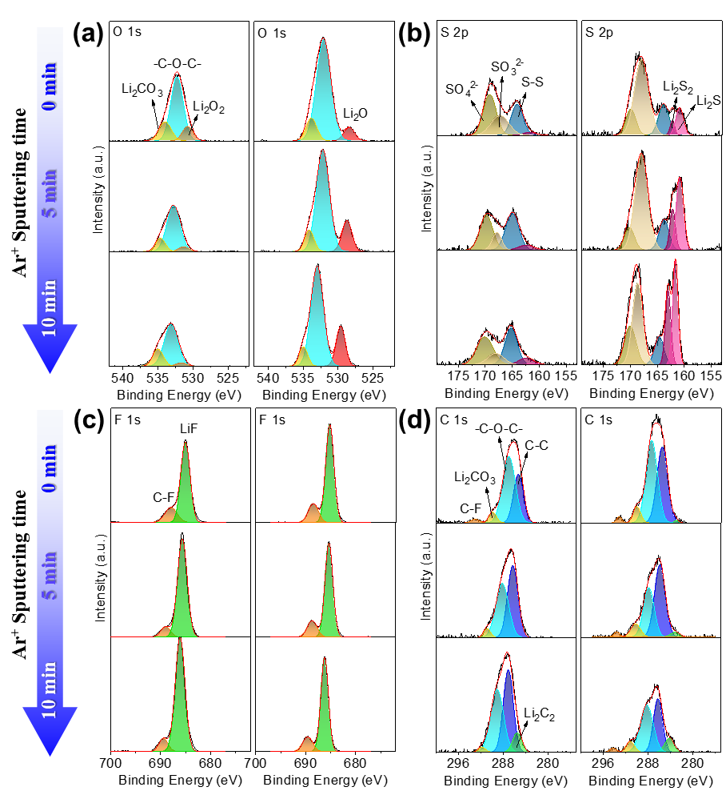
To further prove that, in situ SERS measurement was carried out at the potential before and after reaction OSS took place, respectively (Figure S8). Due to the overlap of the broad SERS band from Cu substrate, the existence of Li₂O (Raman shift: ca. 530 cm⁻¹)^{[44]} cannot be identified in this study. However, a Raman band near 700 cm⁻¹ was observed after reaction OSS occurred, which can be assigned to the O–Li–O stretching vibration of lithium superoxide (LiO₂).^{[45]} Another Raman band near 800 cm⁻¹ was also confirmed, which was considered to be the O–O stretching of lithium peroxide (Li₂O₂).^{[46,47]} Therefore, one can assure that Li₂O, one of the major SEI components formed prior to reaction OSS, was mostly oxidized during reaction OSS to Li₂O₂, which was further partially oxidized to LiO₂ on the electrode surface. In the LOB configuration, LiO₂ is known as an intermediate of Li₂O₂, a final product of the discharging process in the cathode.^{[48,49]} In general, the formation of Li₂O₂ from LiO₂ occurs either via a solution pathway or a surface pathway, depending on the donor number (DN) of solvent as well as overpotential.^{[50]} The use of low-DN TEGDME solvent^{[51]} will usually give rise to a surface pathway where LiO₂ is poorly dissolved in TEGDME, accumulating on the electrode surface and reducing to film-like Li₂O₂, which is associated with lower specific capacity.^{[52–55]} During anodic scanning, soluble LiO₂ was generated by the oxidation of Li₂O₂ in high-DN solvents but not in low-DN solvents such as TEGDME (instead, solid LiO₂ could form),^{[56–58]} enhancing the cycling stability in low-DN solvents than that in high-DN solvents.^{[56]} This could explain why LiO₂ was detected by SERS on the surface in our study.

Figure 4. (a) O 1s, (b) S 2p, (c) F 1s, and (d) C 1s depth profiling XPS spectra of the SEI layers regarding the two potential ranges (left graph: -0.5 ~ 3.2 V vs. Li/Li⁺, right graph: -0.5 ~ 2.2 V vs. Li/Li⁺) at different Ar⁺ sputtering times. The samples were prepared by disassembling Li||Cu cells after the 50th Li plating/stripping cycles.
The OSS process was further investigated via S 2p spectra as shown in Figure 4(b). When reaction OSS occurred, one can find the decreased peak intensities of lithium-sulfur compounds (Li₂S/Li₂S₂) and lithium sulfite (Li₂SO₃), and the increased peak intensities of lithium sulfate (Li₂SO₄), indicating that the oxidation of Li₂S/Li₂S₂/Li₂SO₃ towards Li₂SO₄ took place (see the left graph of Figure 4(b)). The existence of Li₂S/Li₂S₂ was due to the decomposition of LiTFSI salt, while these short-chain lithium polysulfides were reported to be capable to suppress Li dendrites growth, which could be directly connected to the improved CE performance of electrolyte without OSS.^{[59]} Meanwhile, the gradually faded peak of Li₂S/Li₂S₂ during cycling in the electrolyte without OSS suggested a retarded electrolyte decomposition, in agreement with CV results (see the right graph of Figure 4(b)). Furthermore, as shown in the F 1s spectra (Figure 4(c)), the intensity of LiF was almost the same in both electrolytes. Even though the LiF-rich SEI was commonly considered to be very effective in protecting Li,^{[60,61]} the existence of Li₂O and lithium-sulfur compounds was rather regarded as the major contributor to the improved Li plating/stripping efficiency in this work, similar as the previous reports.^{[59][62]}
In addition, the existence of the electronically poorly-conductive Li₂C₂ (lithium carbide)^{[63]} was confirmed on the inner SEI layer measured in both the electrolytes with and without OSS occurring, with a peak at 283 eV in the C 1s spectra shown in Figure 4(d). The difference between them is that when reaction OSS was blocked, the amount of Li₂C₂ gradually decreased but was still observed on the outermost SEI layer, while Li₂C₂ can only be detected on the inner SEI layer with the occurrence of OSS. Meanwhile, in situ SERS also detected Li₂C₂ via the C≡C stretching vibration mode at 1853 cm⁻¹, which was formed right after Li plating started (Figure S9(a)–(b)), similar as Schmitz et al.’s report that the presence of massively plated Li metal caused the formation of Li₂C₂ on the Li metal surface, whereas only a small portion of Li₂C₂ was found on the bare Cu surface after Li stripping.^{[64]} Therefore, the continuously existing Li₂C₂ during the initial two cycles indicated a poor Li stripping efficiency. Moreover, when reaction OSS occurred, the amount of deposited Li₂C₂ drastically decreased during a further cycling even at the stage where Li was deeply plated at -0.5 V vs. Li/Li⁺ (Figure S9(c)), indicating the severe loss of Li inventory which is consistent with the XPS result. By contrast, blocking reaction OSS can apparently suppress the degree of Li inventory loss, making it possible for the continuous existence of Li₂C₂ on the plated Li metal in the follow-up cycles (Figure S9(d)). Additionally, it’s worth stating that the aforementioned larger interfacial resistance of s-SEI layers when blocking reaction OSS (Figure S6) could therefore majorly originate from the continuous existence of Li₂C₂. Furthermore, the shift of atomic concentration percentage of the s-SEI composition at different depths of the s-SEI layers in regard of the two different potential ranges can be found in Figure S10. In the case of reaction OSS being involved, the apparent increase of C, O, F content and drop of Li content in the outer SEI layer proved the severe decomposition of electrolyte associated by the exhaustion of Li inventory. Without the interference of reaction OSS, the increase of C/O ratio from inner to outer SEI layers could be a clue of the heterogeneous SEI layer structure. Specifically, the existence of Li₂O- and lithium-sulfur compounds-based inner SEI layer was believed to contribute to the enhanced stability of the Li plating/stripping.

Proposed Model of SEI Components Variation during the 1st Cycle
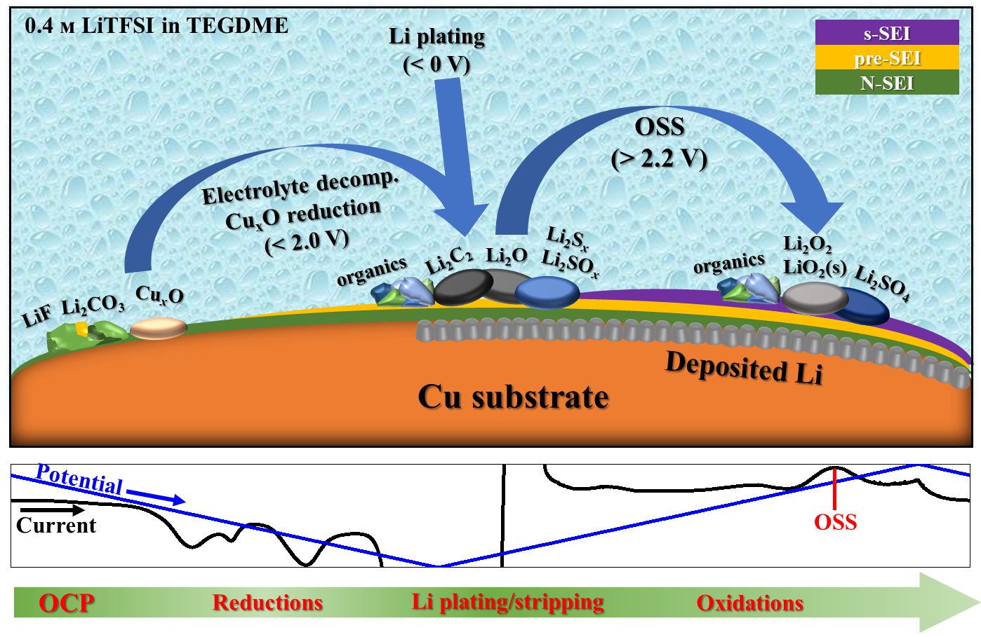
Based on above discussions, a model showing the possible major SEI components at each stage of the 1st cycle was proposed as shown in Figure 5. At OCP, the N-SEI layer includes species such as LiF, Li₂CO₃, and Cu oxides remaining on the Cu current collector.^{[16]} After electrolyte reductive decomposition, organic species from the decomposed TEGDME, lithium-sulfur compounds (Li₂S/Li₂S₂) from the decomposed LiTFSI, as well as Li₂O mainly from the reduction of Cu oxides, constituted the pre-SEI layer. Then, Li₂C₂ formed and deposited on the surface of plated Li metal, followed by a series of oxidations during reaction OSS, where species including Li₂O₂, solid-state LiO₂, and Li₂SO₄ were generated to construct the s-SEI layer, leading to the degradation of cell performance.

Figure 5. The proposed possible major SEI components at each stage (indicated by the bottom curves) of the 1st cycle.

Conclusion
In this study, 0.4 м LiTFSI in TEGDME as the dilute electrolyte applied in an AFLMB anode half-cell (Li||Cu) configuration was investigated by a series of electrochemical tests and compositional characterizations. Typically, the effect of SEI layer structure and composition on the performance of Li plating/stripping under two different operating potential ranges were discussed in detail. Blocking reaction OSS by applying a narrower potential range (up to 2.2 V vs. Li/Li⁺) resulted in the formation of Li₂O-, Li₂C₂-, and Li₂S/Li₂S₂-based s-SEI layers with the smaller surface roughness (i.e., less amount of dendritic and dead Li), enabling a more stable and efficient Li plating/stripping process, as verified by combining CV, QCM, XPS and SERS techniques. This study provided a viewpoint in evaluating the effect of SEI layers, especially the “pre-SEI” layer and “s-SEI” layer occurring in the potential region of 0 ~ 3.2 V vs. Li/Li⁺. Moreover, it demonstrated the possibility of effectively stabilizing Li plating/stripping efficiency even under lean electrolyte condition, although further efforts should be paid to enhance the CE values in case of using the lean electrolyte, such as adjusting the ratio of dual-salt system.^{[10]} In the future, more countermeasures targeted on up-regulating the composition and morphology caused by s-SEI layer formation process (i.e. reaction OSS), such as additives^{[6]} and dissolved gases^{[62]}, will also be discussed.

Experimental Section
Materials: Lithium-battery-grade LiTFSI (99.9%) and TEGDME (>98%) were purchased from Kishida Chemical Co., Ltd. and were used as received. Concentrated acetic (denoted as c-HAc) was purchased from Wako Pure Chemical Industries. 0.4 м LiTFSI in TEGDME as an electrolyte was prepared in an Ar-filled glovebox (H₂O < 0.5 ppm, O₂ < 0.2 ppm) for this study. The water content in these electrolytes was all less than 30 ppm by Karl-Fischer titration (model: CA-21, Mitsubishi Chemical Analytech Co., Ltd.).
Electrochemical Measurements: The electrochemical cell used in this study, unless specifically mentioned, was in a three-electrode configuration with the Cu foil (φ16 mm×0.2 mm in thickness, Cu≥99.96%, Takeuchi Metal Foil & Powder Co., Ltd.) as working electrode and Li ribbon (Sigma Aldrich, 99%) as counter and reference electrode. The Cu electrode was rinsed with c-HAc for 10 min and thoroughly dried by argon flow prior to the experiment.^{[65]} A fixed scanning rate of 10 mV s⁻¹ was applied in all electrochemical scanning. The CV measurements were conducted using the HZ-7000 system (Hokuto Denko Corporation) in the glovebox. A PTFE-made cell was used in the measurement. The CV curves were recorded within a fixed lower potential limit of -0.5 V vs. Li/Li⁺, and a variable upper potential limit. The CE of Li plating/stripping was calculated by the percentage of charges consumed during Li stripping in the charges consumed during Li plating. The EIS was investigated using Solartron 1255B (Ametek Scientific Instruments) over a frequency range from 100 kHz to 1 Hz with an AC perturbation voltage of 10 mV. A homemade two-electrode cell (working electrode: Cu foil, counter electrode: φ16 mm Li foil) was used for the measurement.
QCM measurement: The QCM measurements were carried out by the QCA-922 system (Seiko EG&G Co., Ltd.) linked with the HZ-7000 system. The frequency change on the working electrode surface can be converted into mass change by the Sauerbrey equation^{[66]} as shown in eq. (1),
$∆f=-\frac{2f_{0}^{2}}{A\sqrt{{ρ_{q}×μ}_{q }}}×∆m$ (1)
where f₀ and Δf are the fundamental resonant frequency and the change in frequency (Hz) respectively, Δm is the mass change (μg), A is the active electrode area deposited on the crystal (cm²), ρ_{q} is the density of quartz (2.648 g cm⁻³), and μ_{q} is the shear modulus of quartz (2.947 × 10¹¹ g cm⁻¹ s⁻²)). The f₀ and A values for the Cu quartz electrode used in this study are 9.04 MHz and 0.196 cm², respectively. Therefore, Δm on the crystal surface can be determined for a given Δf during a QCM experiment. A customized cell made of a PTFE bottom and a glass chamber was used. An AT-cut quartz crystal deposited by Cu thin film was used as working electrode. The QCM cell was kept for 30 min before each measurement to stabilize the open circuit potential (OCP), Δm and ΔR. During the CV scanning, the values of Δm and ΔR were simultaneously recorded.
Spectroscopic and Microscopic Characterization: The XPS depth profile was investigated with the VersaProbe II X-ray Photoelectron Spectrometer (ULVAC-PHI, Inc.) under ultra-high-vacuum condition using monochromatic Al Kα (1486.6 eV) as the X-ray source. Samples were loaded in a portable transfer vessel without exposure to air before moving to the XPS spectrometer. The surface of sample was sputtered by Ar⁺ bombardment with a parameter of 2 keV and 20 mA. The F 1s peak at 685.2 eV was used as a reference. The in situ SERS measurements were implemented in a super-dry room (water contents < 0.1 ppm) with a confocal microscope spectrometer (RamanTouch-VIS-NIR). The roughened Cu working electrode was prepared according to the previous work.^{[67]} A 785 nm laser was irradiated onto the roughen Cu surface through a quartz window with an exposure time of 10 s. The spectra were recorded during the CV scanning. Before recording the SERS spectra, the working electrode potential was kept constant for 3 min. The reflectivity measurement was carried out using the GRAPHTEC GL900 logger linked with the HAB-151A potentiostat/galvanostat (Hokuto Denko Corporation). A He-Ne laser beam (λ = 632 nm) was irradiated through the window at an incident angle of 40º, and the reflected light was detector by a Si photodiode detector. By detecting the variation of normalized reflectance change (ΔR/R), the changes in the thickness of an overlayer can be calculated. For the measurement, a homemade cell with a quartz window (φ35 mm) was fabricated. The SEM measurement (VE-8800, Keyence) were conducted in a super-dry room for the observation of the surface morphologies of SEI layers.

Supporting Information
Supporting Information is available from the Wiley Online Library or from the author.
Acknowledgements
The authors gratefully acknowledge the battery platform of NIMS for providing instruments.
Conflict of Interest
The authors declare no conflict of interest.
Data Availability Statement
The data that support the findings of this study are available from the corresponding author upon reasonable request.
Keywords
Anode-free lithium metal battery, TEGDME, Li plating/stripping efficiency, SEI layer structure

Reference
- G. Zubi, R. Dufo-López, M. Carvalho, G. Pasaoglu, Renewable Sustainable Energy Rev. 2018, 89, 292.
- Y. Ding, Z.P. Cano, A. Yu, J. Lu, Z. Chen, Electrochem. Energy Rev. 2019, 2, 1.
- D. Lin, Y. Liu, Y. Cui, Nat. Nanotechnol. 2017, 12, 194.
- X. Cheng, R. Zhang, C. Zhao, Q. Zhang, Chem. Rev. 2017, 117, 10403.
- W. Xu, J. Wang, F. Ding, X. Chen, E. Nasybulin, Y. Zhang, J. Zhang, Energy Environ. Sci. 2014, 7, 513.
- S. Nanda, A. Gupta, A. Manthiram, Adv. Energy Mater. 2021, 11, 2000804.
- J. Qian, B. D. Adams, J. Zheng, W. Xu, W. A. Henderson, J. Wang, M. E. Bowden, S. Xu, J. Hu, J. Zhang. Adv. Funct. Mater. 2016, 26, 7094.
- T. T. Beyene, H. K. Bezabh, M. A. Weret, T. M. Hagos, C. Huang, C. Wang, W. Su, H. Dai, B. Hwang, J. Electrochem. Soc. 2019, 166, A1501.
- T. T, Beyene, B. A. Jote, Z. T. Wondimkun, B. W. Olbassa, C. Huang, B. Thirumalraj, C. Wang, W. Su, H. Dai, B. Hwang. ACS Appl. Mater. Interfaces 2019, 11(35), 31962.
- R. Weber, M. Genovese, A. J. Louli, S. Hames, C. Martin, I. G. Hill, J. R. Dahn, Nat. Energy 2019, 4, 683.
- R. V. Salvatierra, W. Chen, J. M. Tour, Adv. Energy Sustainability Res. 2021, 2, 2000110.
- R. Rodriguez, K. E. Loeffler, R. A. Edison, R. M. Stephens, A. Dolocan, A. Heller, C. B. Mullins, ACS Appl. Energy Mater. 2018, 1(11), 5830.
- Z. Xie, Z. Wu, X. An, X. Yue, J. Wang, A. Abudula, G. Guan, Energy Storage Materials 2020, 32, 386.
- D. He, J. Lu, G. He, H. Chen, Frontiers in Chemistry 2022, 10, 916132.
- P. Verma, P. Maire, P. Novák, Electrochimica Acta 2010, 55, 6332.
- S. Menkin, C. A. O’Keefe, A. B. Gunnarsdóttir, S. Dey, F. M. Pesci, Z. Shen, A. Aguadero, C. P. Grey, J. Phys. Chem. C 2021, 125(30), 16719.
- C. Huang, B. Thirumalraj, H. Tao, K. N. Shitaw, H. Sutiono, T. T. Hagos, T. T. Beyene, L. Kuo, C. Wang, S. Wu, W. Su, B. Hwang, Nat. Commun. 2021, 12, 1452.
- A. M. Tripathi, W. Su, B. Hwang, Chem. Soc. Rev. 2018, 47, 736.
- N. Li, Y. Shi, Y. Yin, X. Zeng, J. Li, C. Li, L. Wan, R. Wen, Y. Guo, Angew. Chem., Int. Ed. 2018, 57, 1505.
- L. Li, S. Basu, Y. Wang, Z. Chen, P. Hundekar, B. Wang, J. Shi, Y. Shi, S. Narayanan, N. Koratkar, Science 2018, 359, 1513.
- A. C. Kozen, C. Lin, O. Zhao, S, Lee, G. W. Rubloff, M. Noked, Chem. Mater. 2017, 29, 6298.
- J. Alvarado, M. A. Schroeder, T. P. Pollard, X. Wang, J. Z. Lee, M. Zhang, T. Wynn, M. Ding, O. Borodin, Y. S. Meng, K. Xu, Energy Environ. Sci. 2019, 12, 780.
- B. Wu, C. Chen, L. H. J. Raijmakers, J. Liu, D. L. Danilov, R.A. Eichel, P. H. L. Notten, Energy Storage Materials 2023, 57, 508.
- T. T. Hagos, B. Thirumalraj, C. Huang, L. H. Abrha, T. M. Hagos, G. B. Berhe, H. K. Bezabh, J. Cherng, S. Chiu, W. Su, B. Hwang, ACS Appl. Mater. Interfaces 2019, 11(10), 9955.
- S. An, J. Li, C. Daniel, D. Mohanty, S. Nagpure, D. L. Wood III, Carbon 2016, 105, 52.
- M. Genovese, A. J. Louli, R. Weber, S. Hames, J. R. Dahn, J. Electrochem. Soc. 2018, 165(14), A3321.
- X. Gao, Y. Chen, L.R. Johnson, Z. P. Jovanov, P. G. Bruce, Nat. Energy 2017, 2, 17118.
- G. Horwitz, E. J. Calvo, L. P. Méndez De Leo, E. de la Llave, Phys. Chem. Chem. Phys. 2020, 22, 16615.
- J. Heine, P. Hilbig, X. Qi, P. Niehoff, M. Winter, P. Bieker, J. Electrochem. Soc. 2015, 162, A1094.
- S. Zhang, Z. Yin, Z. Wu, D. Luo, Y. Hu, J. You, B. Zhang, K. Li, J. Yan, X. Yang, X. Zhou, S. Zanna, P. Marcus, F. Pan, J. Światowska, S. Sun, Z. Chen, J. Li, Energy Storage Materials 2021, 40, 337.
- M. Tułodziecki, J. M. Tarascon, P. L. Taberna, C. Guéry. Electrochem. Commun. 2017, 77, 128.
- F. S. Gittleson, R. C. Sekol, G. Doubek, M. Linardi, A. D. Taylor. Phys. Chem. Chem. Phys. 2014, 16, 3230.
- K. Tamura, T. Kondo, K. Uosaki, J. Electrochem. Soc. 2000, 147, 3356.
- D. W. Kang, J. Moon, H. Y. Choi, H. C. Shin, B. G. Kim, J. Power Sources 2021, 490, 229504.
- K. Naoi, M. Mori, Y. Shinagawa, J. Electrochem. Soc. 1996, 143, 2517.
- K. S. Smaran, S. Shibata, A. Omachi, A. Ohama, E. Tomizawa, T. Kondo, J. Phys. Chem. Lett. 2017, 8, 5203.
- Y. Liu, P. Yu, Y. Wu, H. Yang, M. Xie, L. Huai, W. A. Goddard III, T. Cheng, J. Phys. Chem. Lett. 2021, 12, 1300.
- L. Wang, H. Noguchi, J. Phys. Chem. C 2022, 126, 11457.
- D. Aurbach, M. Mashkovich, J. Electrochem. Soc. 1998, 145, 2629.
- Y. Gao, H. Noguchi, K. Uosaki, ACS Energy Lett. 2023, 8, 1811.
- S. K. Heiskanen, J. Kim, B. L. Lucht, Joule 2019, 3, 2322.
- M. Ue, K. Uosaki, Current Opinion in Electrochemistry 2019, 17, 106.
- K. Kanamura, S. Shiraishi, Z. Takehara, Electrochemistry 1999, 67, 1264.
- S. Hy, F. Felix, J. Rick, W. Su, B. Hwang, J. Am. Chem. Soc. 2014, 136, 999.
- L. Andrew, J. Am. Chem. Soc. 1968, 90(26), 7368.
- Y. Qiao, S. Ye, J. Phys. Chem. C 2016, 120, 15830.
- Z. Peng, S. A. Freunberger, L. J. Hardwick, Y. Chen, V. Giordani, F. Barde, P. Novak, D. Graham, J. M. Tarascon, P. G. Bruce, Angew. Chem. Int. Ed. 2011, 50, 6351.
- P. G. Bruce, S. A. Freunberger, L. J. Hardwick, J. M. Tarascon, Nat. Mater. 2012, 11, 19.
- J. Lu, L. Li, J. B. Park, Y. Sun, F. Wu, K. Amine, Chem. Rev. 2014, 114, 5611.
- L. Johnson, C. Li, Z. Liu, Y. Chen, S. A. Freunberger, P. C. Ashok, B. B. Praveen, K. Dholakia, J. M. Tarascon, P. G. Bruce, Nat. Chem. 2014, 6, 1091.
- C. Laoire, S. Mukerjee, E. J. Plichta, M. A. Hendrickson, K. M. Abraham, J. Electrochem. Soc. 2011, 158, A302.
- Y. Qiao, S. Wu, J. Yi, Y. Sun, S. Guo, S. Yang, P. He, H. Zhou, Angew. Chem. Int. Ed. 2017, 56, 4960.
- B. M. Gallant, D. G. Kwabi, R. R. Mitchell, J. Zhou, C. V. Thompson, Y. Shao-Horn, Energy Environ. Sci. 2013, 6, 2518.
- C. M. Burke, V. Pande, A. Khetan, V. Viswanathan, B. D. McCloskey, PNAS 2015, 112, 9293.
- B. D. Adams, C. Radtke, R. Black, M. L. Trudeau, K. Zaghib, L. F. Nazar, Energy Environ. Sci. 2013, 6, 1772.
- Y. Wang, N. Lai, Y. Lu, Y. Zhou, C. Dong, Y. Lu, Joule 2018, 2, 2364.
- L. Luo, B. Liu, S. Song, W. Xu, J. Zhang, C. Wang, Nat. Nanotechnol. 2017, 12, 535.
- Z. Zhu, A. Kushima, Z. Yin, L. Qi, K. Amine, J. Lu, J. Li, Nat. Energy 2016, 1, 16111.
- W. Li, H. Yao, K. Yan, G. Zheng, Z. Liang, Y. Chiang, Y. Cui, Nat. Commun. 2015, 6, 7436.
- N. Xu, J. Shi, G. Liu, X. Yang, J. Zheng, Z. Zhang, Y. Yang, J. Power Sources Adv. 2021, 7, 100043.
- N. Aspern, G. V. Röschenthaler, M. Winter, I. Cekic-Laskovic, Angew. Chem. Int. Ed. 2019, 58, 15978.
- R. Haas, J. Janek, J. Electrochem. Soc. 2022, 169, 110527.
- N. Tian, Y. Gao, Y. Li, Z. Wang, X. Song, L. Chen, Angew. Chem. Int. Ed. 2016, 55, 644.
- R. Schmitz, R. A. Müller, R. W. Schmitz, C. Schreiner, M. Kunze, A. Lex-Balducci, S. Passerini, M. Winter, J. Power Sources 2013, 233, 110.
- K. Chavez, D. W. Hess. J. Electrochem. Soc. 2001, 148, G640.
- G. Sauerbrey, Z. Phys. 1959, 155, 206.
- A. Kudelski, M. J. Czachor, J. Bukowska, M. Dolata, A. Szummer, Journal of Molecular Structure 1999, 482-483, 245.
TOC

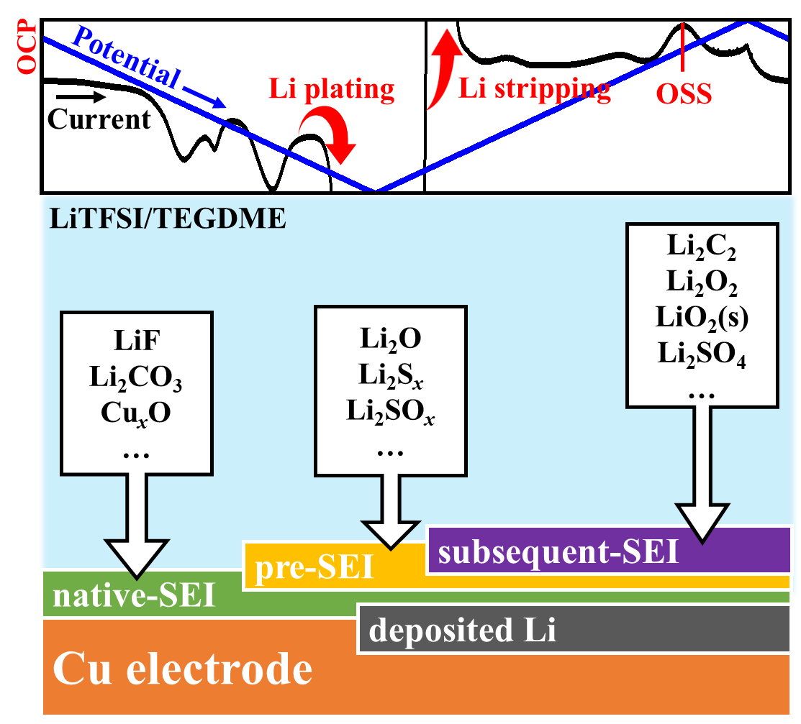

Except native-SEI and pre-SEI during the first cycle, the formation of Li₂O- and lithium-sulfur compounds-based subsequent-SEI in the first and subsequent cycles improves Li plating/stripping stability, while the OSS (oxidative subsequent SEI) formation process oxidizes these components to form an unstable subsequent-SEI.

