Supporting Information

Origin of Intrinsic Operational Instability in Organic Field-Effect Transistors with Aligned High-Mobility Donor-Acceptor Copolymer Active Layers

Kenji Sakamoto,*,† Kirill Bulgarevich,†,‡ ,§ Takeshi Yasuda,† Takeo Minari,† and Masayuki Takeuchi†,‡

† National Institute for Materials Science (NIMS), 1-1 Namiki, Tsukuba, Ibaraki 305-0044, Japan
‡ Faculty of Pure and Applied Sciences, University of Tsukuba, 1-1-1 Tennodai, Tsukuba, Ibaraki 305-8571, Japan
§ Present address: Center for Emergent Matter Science (CEMS), RIKEN, 2-1 Hirosawa, Wako, Saitama, 351-0198, Japan
* E-mail: SAKAMOTO.Kenji@nims.go.jp

S1. Additional Figures and Table Mentioned in theText

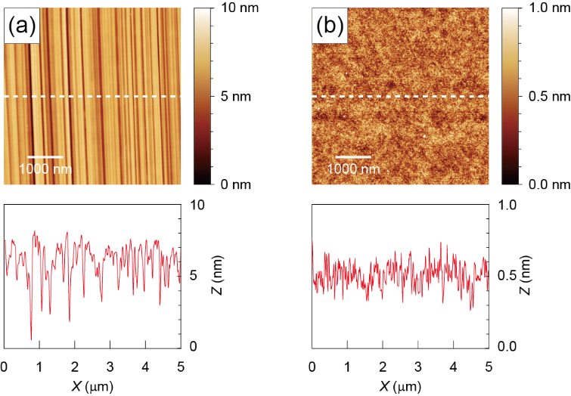
Figure S1. Typical atomic force microscope (AFM) images of (a) scratched and (b) unscratched SiO₂ gate dielectric surfaces. The RMS roughness of these surfaces is 1.2 nm and 0.14 nm, respectively.

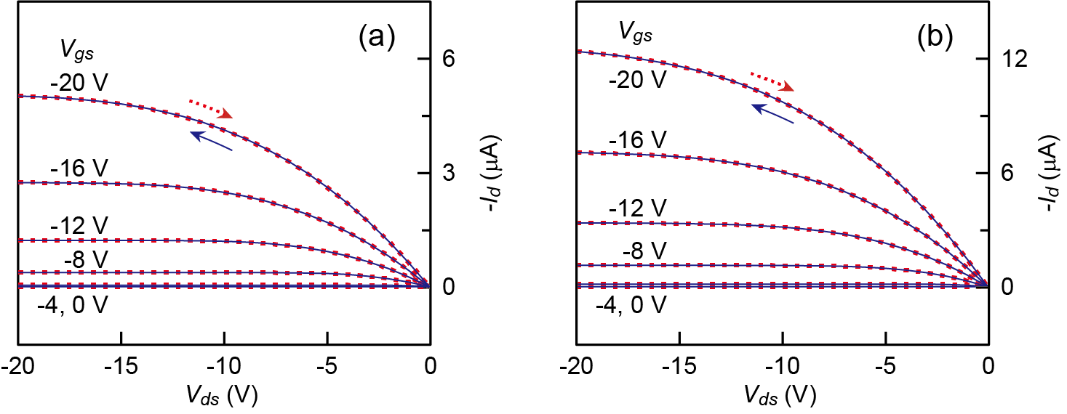
Figure S2. Typical output characteristics of (a) perpendicular and (b) isotropic PCDTPT-OFETs. The data in the forward and reverse sweeps are shown by the solid and dotted curves, respectively.

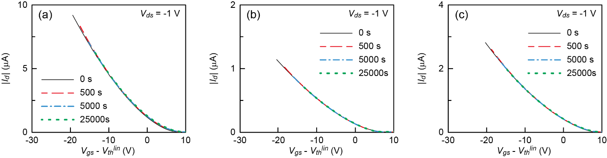
Figure S3. Linear transfer curves (forward sweep) of (a) parallel, (b) perpendicular, and (c) isotropic PCDTPT-OFETs after bias stress application (V_{gs} = -30 V and V_{ds} = -1 V) for 0, 5 × 10², 5 × 10³, and 2.5 × 10⁴ s. The horizontal axes are changed from V_{gs} to V_{gs} - V_{th}^{lin}.

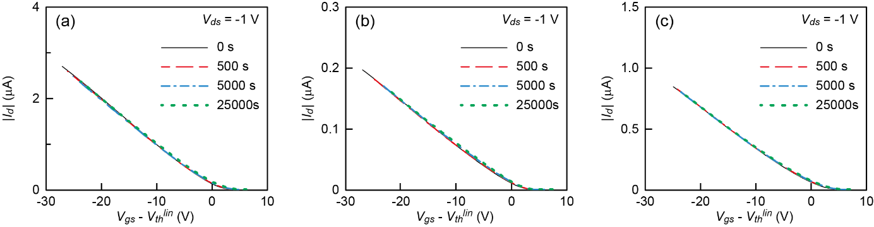
Figure S4. Linear transfer curves (forward sweep) of (a) parallel, (b) perpendicular, and (c) isotropic PBTTT-OFETs after bias stress application (V_{gs} = -30 V and V_{ds} = -1 V) for 0, 5 × 10², 5 × 10³, and 2.5 × 10⁴ s. The horizontal axes are changed from V_{gs} to V_{gs} - V_{th}^{lin}.

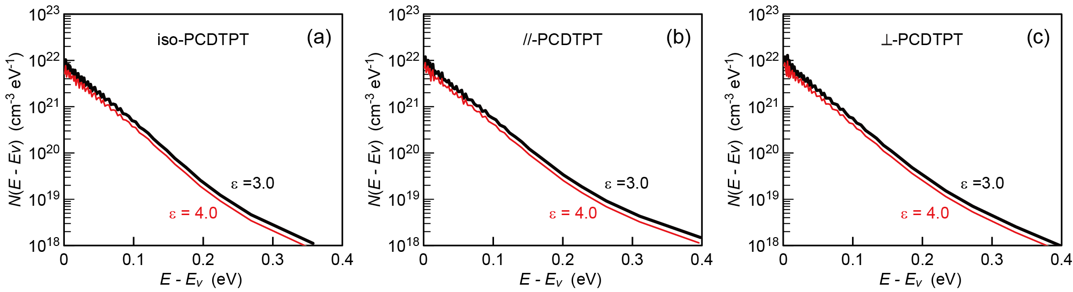
Figure S5. Interface trap DOS calculated by Grünewald’s method [-] assuming different relative permittivities of 3.0 (thick curves) and 4.0 (thin curves) for the PCDTPT active layer: (a) isotropic, (b) parallel, and (c) perpendicular PCDTPT-OFETs.

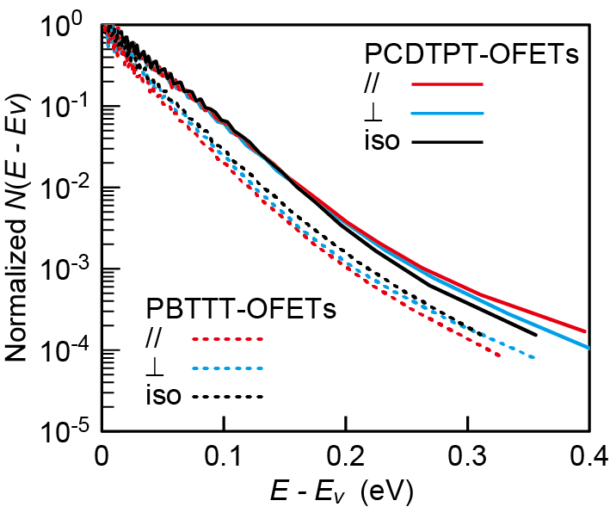
Figure S6. Normalized interface trap DOS of parallel (cyan), perpendicular (red), and isotropic (black) PCDTPT-OFETs (solod curves) and PBTTT-OFETs (dotted curves) before bias stress application.

Table S1. GIXD data for annealed PCDTPT and terrace-phase PBTTT-C12 films obtained from the literatures. The paracrystallinity g of annealed PCDTPT and terrace-phase PBTTT-C12 films was calculated using the data in the top and bottom rows.
Semiconductor  (Mw) | Coating condition^{a)} | X-ray k// | q_{z}(100)  Å⁻¹ | Δq_{z}(100)  Å⁻¹ | L_{z} ^{b)}  nm | q_{xy}(010)  Å⁻¹ | Δq_{xy}(010)  Å⁻¹ | L_{π-π} ^{b)}  nm | Ref.
PCDTPT  (72 kDa) | Blade-coating  20 mm/s  ungrooved  HMDS-SiO₂ | perp  para | 0.244  0.244 | 0.037  0.034 | 17  18 | 1.77  1.78 | 0.13  0.14 | 4.8  4.5 | []
PCDTPT  (78 kDa) | Drop-casting  Nano-grooved  DTS-SiO₂ | ⎯ | ⎯ | ⎯ | 13.3 ^{c)} | ⎯ | ⎯ | 4.6 ^{c)} | []
pBTTT-C12  (43 or 51 kDa) | Spin-coating  OTS-SiO₂ | ⎯ | 0.327 | 0.0082 | 77 | 1.694 | 0.057 | 11.0 | []
a) HMDS: hexamethyldisilazane, DTS: decyltricholosilane, and OTS: octyltrichlorosilane.
b) Coherence lengths, L_{z} and L_{π-π}, were obtained by Scherrer equation assuming the shape factor to be unity.
c) Average values read from Figure 5(b) in ref.8.

S2. Crystallinity (volume fraction of crystalline lamella structures) of Annealed PCDTPT and Terrace-Phase PBTTT-C16 Thin Films Formed on ODTS-Treated SiO₂ Surfaces without Nano-Grooves
Using an RIGAKU SmartLab X-ray diffractometer, out-of-plane and rocking scans of x-ray diffraction (XRD) were performed on annealed PCDTPT and terrace-phase PBTTT-C16 films formed on octadecytrichlorosilane (ODTS)-treated (hydrophobic) smooth SiO₂/Si(100) substrates (20 mm-square) by spin-coating. The hydrophobic surface areas of the samples prepared for XRD measurements were 15 mm-square for PCDTPT and 4 mm (height) × 15 mm (width) for PBTTT-C16. (The film formation of PBTTT-C16 was failed on 15 mm-square-patterned hydrophobic surfaces [,].) Figure S7a shows the out-of-plane XRD profiles of 13 nm-thick PCDTPT and 33 nm-thick PBTTT-C16 films acquired with a slit setting that limits the x-ray beam height to about 3 mm (slit setting 1). The film thickness was precisely determined by atomic force microscope (AFM: SII NanoTechnology L-Trace). The (h00) lamella reflection peaks were visible up to the second order for the annealed PCDTPT film, although (100) peak was distorted due to interference effect related to the film thickness. From the (200) peak position, the lamellar spacing (d-spacing, d_{z}) of PCDTPT was found to be 2.63 nm, which was consistent with a previously reported value [7]. For the terrace-phase PBTTT-C16 film, the (h00) lamella peaks were clearly observed up to the fourth order in our 2θ scanning range. The d-spacing determined from the (200) peak was 2.34 nm, agreeing with a previously reported value []. To examine the angular distribution of the lamella stacking direction around the substrate surface normal, the rocking scans at a fixed diffraction angle 2θ for the (200) reflection peak were performed. Both PCDTPT and PBTTT-C16 films showed sharp rocking curves whose breadths were close to the angular resolution of diffractometer, as shown in Figure S8. The resolution-limited rocking curves result from crystallites whose lamella stacking directions are perfectly oriented parallel to the surface normal. The perfect orientation must be induced by the lamellas in contact with the substrate surface [12,], because this is the only surface that can perfectly orient the lamella stacking direction to the surface normal. Thus, the observation of higher order peaks of the (h00) lamella reflection and resolution-limited rocking curves suggests that crystallites with high degree of edge-on local order and perfect lamella orientation grow from substrate surface for both annealed PCDTPT and terrace-phase PBTTT-C16 films. That is also supported by GIXD data reported previously [7,12,13].
Next, the crystallinity (volume fraction of crystalline lamella structures) of annealed PCDTPT spin-coated films is evaluated following the discussion by Wu et al. [7]. PBTTT-Cn films annealed at a liquid crystalline phase temperature, i.e. terrace-phase PBTTT-Cn films, can be considered nearly comprehensively crystalline throughout the film thickness [13,]. Thus, the reflection area intensity of the terrace-phase PBTTT-Cn films per unit film thickness can be used as a gauge of crystallinity under the assumption that the structure factors of both PCDTPT and PBTTT-Cn are similar. Figure S6b shows the magnified (200) reflection profiles of the 13 nm-thick PCDTPT and 33 nm-thick PBTTT-C16 films in a linear vertical scale, together with that of an annealed 20 nm-thick PCDTPT film. As these three profiles were measured with the same diffractometer slit setting (slit setting 1), their reflection intensities can be compared directly with each other. Here, one can notice that the reflection intensity and breadth of the 20 nm-thick PCDTPT film are almost equal to those of the 13 nm-thick one. (See Table S2.) This result suggests that perfectly oriented crystallites exist only near the substrate surface below 13 nm, regardless of the film thickness. Thus, the thickness of perfectly oriented crystallites must be known to evaluate the crystallinity of the PCDTPT film in the few-nanometer-thick region from the gate-dielectric interface where the charge carrier transport occurs. To accomplish that, the out-of-plane XRD profiles of 8, 13, and 20 nm-thick annealed PCDTPT films were measured. In this measurement, a diffractometer slit setting in which the x-ray beam height was ∼12 mm at the sample surface (slit setting 2) was adopted to ensure the sufficient diffraction intensity. The area intensity and integral breadth of the (200) reflection were plotted in Figure S6c as a function of the film thickness. (The corresponding XRD profiles are shown in Figure S9.) The increase of the integral breadth was obviously observed with decreasing film thickness from 13 nm to 8 nm. Since the integral breadth is related to the crystalline (ordered) domain size in the lamellar direction by Scherrer’s equation, this result shows that the thickness of perfectly oriented crystallites is constrained by the film thickness of 8 nm and remains constant for films thicker than 13 nm. Thus, it can be assumed that the crystallinity of the 8 nm-thick film is uniform over the entire film thickness. Under this assumption, the thickness of perfectly oriented crystallites was estimated to be 9 nm from the film thickness dependence of area intensity and 10 nm from that of integral breadth. These values give the upper limit of crystalline size in the lamellar direction. At the present stage, the crystallinity of annealed PCDTPT spin-coated films near the gate dielectric interface can be evaluated by comparing the area intensities of the (200) reflection per unit film thickness between the 8 nm-thick PCDTPT and 33 nm-thick terrace-phase PBTTT films. The ratio of area intensity per unit film thickness was: A_{PCDTPT}/A_{PBTTT} = (710/8)/(3120/33) = 0.94, indicating that the volume fraction of perfectly oriented crystallites near the gate dielectric interface is comparable between the annealed PCDTPT and terrace-phase PBTTT films. Since the above evaluation was conducted by using the (200) lamella reflection peak, to be exact, we found only that the volume fraction of perfectly oriented lamella structures was comparable between the annealed PCDTPT and terrace-phase PBTTT films. In high-molecular-weight (>50 monomer units) semicrystalline semiconducting polymers, pronounced disorder is known to exist in the π-stacking direction within lamellas [].

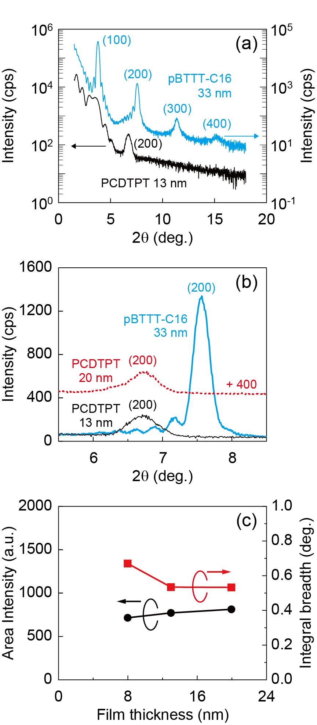
Figure S7. a) Out-of-plane XRD profiles of 13 nm-thick annealed PCDTPT and 33 nm-thick terrace-phase PBTTT-C16 films formed on smooth hydrophobic SiO₂/Si(100) substrates by spin-coating. b) Magnified (200) reflection profiles of 13 nm-thick, 20 nm-thick annealed PCDTPT and 33 nm-thick terrace-phase PBTTT-C16 films in linear vertical scale. c) Film thickness dependence of area intensity and integral breadth of the (200) refraction of annealed PCDTPT films. The XRD profiles in a,b) were acquired with slit setting 1. The area intensity and integral breadth were determined form the XRD profile acquired with slit setting 2.

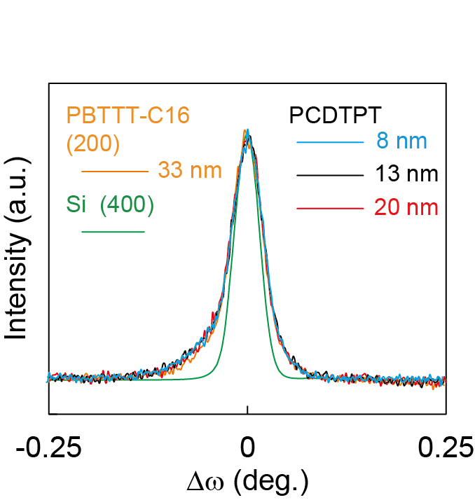
Figure S8. Normalized rocking curves of the (200) reflection peaks of the 8 nm, 13 nm, and 20 nm-thick annealed PCDTPT films and the 33 nm-thick terrace-phase PBTTT-C16 film. These films were formed on ODTS-treated SiO₂/Si(100) substrates. The full widths at half maximum (FWHM) are: 0.050° for the 8nm-thick PCDTPT film, 0.049° for the 13 nm-thick and 20 nm-thick PCDTPT films, and 0.047° for the 33 nm-thick PBTTT-C16 film. To indicate the angular resolution of diffractometer, a rocking curve of the (400) reflection peak of a Si(100) wafer is overlayed and its FWHM is 0.037°.

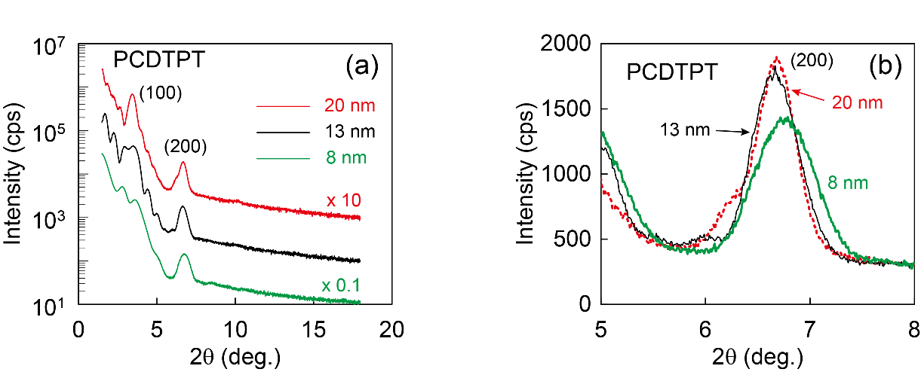
Figure S9. Out-of-plane XRD profiles of 8 nm-thick, 13 nm-thick, and 20 nm-thick annealed PCDTPT films formed by spin-coating on smooth SiO₂/Si(100) substrates: a) in a logarithmic vertical scale and b) in a linear vertical scale. These profiles were measured with slit setting 2 (beam height ~12 mm at the sample surface) to increase diffraction intensity.

Table S2. Summary of out-of-plane XRD characteristics of annealed PCDTPT and terrace-phase PBTTT-C16 films formed by spin-coating on ODTS-treated SiO₂/Si substrates without nano-grooves.
Semiconductor | Film thickness^{a)}  (nm) | 2θ (200)  (degree) | d_{z}  (nm) | Integral breadth  (degree) | Area intensity  (a.u.)
XRD slit setting 1 (x-ray beam height ~ 3 mm), x-ray source filament 1
PCDTPT ^{b)}  (76 kDa) | 20  13 | 6.73  6.72 | 2.63  2.63 | 0.51  0.48 | 102  92
PBTTT-C16 ^{c)} | 33 | 7.57 | 2.34 | 0.30 | 385
XRD slit setting 2 ( x-ray beam height ~ 12 mm), x-ray source filament 2
PCDTPT ^{b)}  (76 kDa) | 20  13  8 | 6.68  6.67  6.76 | 2.65  2.65  2.62 | 0.53  0.53  0.67 | 808  766  710
PBTTT-C16 ^{c)} | 33 | ⎯ | ⎯ | ⎯ | 3120 ^{d)}
- Measured by AFM.
- Hydrophobic area is 15 × 15 mm².
- Hydrophobic area is 4 (height) × 15 (width) mm².
- Since the PBTTT-C16 film cannot be measured with XRD slit setting 2 due to smaller length (4 mm) of the hydrophobic area in the beam height direction, this is an estimated value: 385 × (808+766) / (102+92) = 3120.

References

[] Grünewald, M.; Thomas, P.; Würtz, D. A Simple Scheme for Evaluating Field Effect Data, Phys. Status Solidi 1980, 100, K139–K143.
[] Weber, K.; Grünewald, M.; Fuhs, W.; Thomas, P. Field Effect in a-Si:H Films. Influence of Annealing and Light Exposure. Phys. Status Solidi B 1982, 110, 133-142.
[] Kalb, W. L.; Batlogg, B. Calculating the trap density of states in organic field-effect transistors from experiment: A comparison of different methods. Phys. Rev. B 2010, 81, 035327.
[] Kalb, W. L.; Meier, F.; Mattenberger, K.; Batlogg, B. Defect healing at room temperature in pentacene thin films and improved transistor performance. Phys. Rev. B 2007, 76, 184112.
[] Haneef, H. F.; Zeidell, A. M.; Jurchescu, O. D. Charge carrier traps in organic semiconductors: a review on the underlying physics and impact on electronic devices. J. Mater. Chem. C 2020, 8, 759-787.
[] Iqbal, H. F.; Ai, Q.; Thorley, K. J.; Chen, H.; McCulloch, I.; Risko, C.; Anthony, J. E.; Jurchescu, O. D. Suppressing bias stress degradation in high performance solution processed organic transistors operating in air. Nat Commun 2021, 12, 2352.
[] Wu, D.; Kaplan, M.; Ro, H. W.; Engmann, S.; Fischer, D. A.; DeLongchamp,D. M.; Richter, L. J.; Gann, E.; Thomsen, L.; McNeill, C. R.; Zhang, X. Blade Coating Aligned, High-Performance, Semiconducting-Polymer Transistors. Chem. Mater. 2018, 30, 1924-1936.
[] Tseng, H.-R.; Phan, H.; Luo, C.; Wang, M.; Perez, L. A.; Patel, S. N.; Ying, L.; Kramer, E. J.; Nguyen, T.-Q.; Bazan, G. C.; Heeger, A. J. High-Mobility Field-Effect Transistors Fabricated with Macroscopic Aligned Semiconducting Polymers. Adv. Mater. 2014, 26, 2993-2998.
[] Chabinyc, M. L.; Toney, M. F.; Kline,R. J.; McCulloch,I,; Heeney, M. X-ray Scattering Study of Thin Films of Poly(2,5-bis(3-alkylthiophen-2-yl)thieno[3,2-b]thiophene). J. Am. Chem. Soc. 2007, 129, 11, 3226-3237.
[] Bulgarevich, K.; Sakamoto, K.; Minari, T.; Yasuda, T.; Miki, K.; Takeuchi, M. Polymer-Based Organic Field-Effect Transistors with Active Layers Aligned by Highly Hydrophobic Nanogrooved Surfaces. Adv. Funct. Mater. 2019, 29, 1905365.
[] Bulgarevich, K.; Sakamoto, K.; Minari, T.; Yasuda, T.; Miki, K. Spatially Uniform Thin-Film Formation of Polymeric Organic Semiconductors on Lyophobic Gate Insulator Surfaces by Self-Assisted Flow-Coating. ACS Appl. Mater. Interfaces 2017, 9, 6237-6245.
[] Kline, R. J.; DeLongchamp, D. M.; Fischer, D. A.; Lin, E. K.; Richter, L. J.; Chabinyc, M. L.; Toney, M. F.; Heeney, M.; McCulloch, I. Critical Role of Side-Chain Attachment Density on the Order and Device Performance of Polythiophenes. Macromolecules 2007, 40, 7960−7965.
[] Himmelberger, S.; Dacuña, J.; Rivnay, J.; Jimison, L. H.; McCarthy-Ward, T.; Heeney, M.; McCulloch, I.; Toney, M. F.; Salleo, A. Effects of Confinement on Microstructure and Charge Transport in High Performance Semicrystalline Polymer Semiconductors. Adv. Funct. Mater. 2013, 23, 2091-2098.
[] DeLongchamp, D. M.; Kline, R.; Lin, E. K.; Fischer, D. A.; Richter, L. J.; Lucas, L. A.; Heeney, M.; McCulloch, I.; Northrup, J. E. High Carrier Mobility Polythiophene Thin Films: Structure Determination by Experiment and Theory. Adv. Mater. 2007, 19, 833-837.
[] Noriega, R.; Rivnay, J.; Vandewal, K,; Koch, F. P. V.; Stingelin, N,; Smith, P.; Toney, M. F.; Salleo, A. A general relationship between disorder, aggregation and charge transport in conjugated polymers. Nat. Mater. 2013, 12, 1038-1044.

