- National University of Science and Technology MISIS, Leninsky prospekt 4, Moscow 119049, Russia.
- National Institute for Materials Science (NIMS), International Center for Materials Nanoarchitectonics (WPI-MANA), Namiki 1-1, Tsukuba 305-0044, Japan.
- Graduate School of Pure and Applied Sciences, University of Tsukuba, 1-1-1 Tennodai, Tsukuba, Ibaraki, 305-8573, Japan
- Belgorod State University, Pobedy st. 85, Belgorod, 308015, Russia.
† Electronic Supplementary Information (ESI) available.
* Corresponding author. E-mail address: m154566@edu.misis.ru (A. Ivanova).
# These authors contribute equally to the paper.

ArXiv ID: 2004.14634

p-type SiGe-based composite produced by mechanical alloying and spark plasma sintering †
Alexandra Ivanova,^{a,*,#} Alexandra Khanina, ^{a,#} Margarita Golikova,ª Efim Argunov,ª Andrei Novitskii,^{b} Takao Mori,^{b,c} and Vladimir Khovaylo^{a,d}
We demonstrate a study on bulk SiGe-MnTe composites obtained via spark plasma sintering of mixed powders composed of SiGe that was fabricated by mechanical alloying and MnTe prepared via solid-state reaction. The presence of MnTe in the matrix of SiGe led to an increase in the electrical conductivity by ~50 % and decrease in the lattice thermal conductivity of the samples by ~28 %. Despite this, the Seebeck coefficient reduce from 252 μV K⁻¹ to 197 μV K⁻¹ at 1000 K. As a result, the peak zT of 0.75 was obtained for pristine Si₈₀Ge₂₀B₂, and 0.8 for Si₈₀Ge₂₀B₂ + 4 wt.% MnTe at 1000 K.

KEYWORDS: thermoelectric materials, composites, silicon germanium, inclusions, manganese telluride

Introduction
Thermoelectric materials are able to directly convert thermal energy into electricity and, therefore, are considered as promising candidates for waste energy recovery. The efficiency of such a conversion is determined by the so-called thermoelectric figure of merit zT = α²σT/(κ_{e} + κ_{l}), where α is the Seebeck coefficient, σ is the electrical conductivity, T is the absolute temperature, κ_{e} and κ_{l} are the electronic and lattice thermal conductivity, respectively.¹ Here sum of κ_{e} + κ_{l} is the total thermal conductivity κ. Thus, an efficient thermoelectric material should possess a high Seebeck coefficient and a low thermal conductivity. This allows the material to maintain a temperature gradient and hence generate more voltage. Also, thermoelectric material should possess a high electrical conductivity. This allows the generated voltage to be effectively converted into usable electrical energy. Separate control of the interdependent parameters α, σ and κ makes it possible to change the thermoelectric characteristics of the material in a wide range. Already known approaches such as nanostructuring^{2–4}, doping^{5,6}, modulation doping^{7,8}, texturing⁹ and chemical bonding engineering¹⁰ are used to achieve a higher power factor (PF = α²σ) and figure of merit zT of the material. However, in recent years, there has been special attention paid to an approach that involves creating a composite material based on semiconductor-insulator and semiconductor-semiconductor constituents.^{11–19} The properties of these composites can be tailored by adjusting the composition, microstructure, and morphology of the constituent materials. For example, the addition of an insulating phase to a semiconductor can reduce the thermal conductivity of the composite, leading to improved thermoelectric properties. Furthermore, the use of multiple semiconductor phases with different energy levels can improve the electrical conductivity and thermoelectric properties of the composite.²⁰ Overall, the creation of composites from different pairs of semiconductor-insulator and semiconductor-semiconductor materials provides an effective means of tailoring the properties of materials to meet specific requirements. This approach has significant potential for improving the performance of various technologies, including thermoelectric devices and electronic devices.
Thermoelectric materials based on SiGe solid solutions are among the most studied and most frequently used high-temperature compounds in practice.^{21–28} Back in 1965, Si-Ge thermoelectric modules were included in the power system of the SNAP-10A11 satellite and were used in radioisotope thermoelectric generators for NASA missions in deep space. SiGe-based thermoelectrics have high thermal and chemical stability at high temperatures. Therefore, they are suitable for device applications at high temperatures. There have been many research studies to improve thermoelectric characteristics of SiGe-based materials.^{29–36} Compositing has long been used in the field of thermoelectric and has been successfully implemented in materials based on silicon-germanium.^{28,33,35,37–43}
Among a large family of thermoelectric materials, binary compounds based on lead telluride and bismuth telluride were actively studied as early as the 1960s and 1970s. The toxicity of lead, which is part of thermoelectrics, prompted scientists to look for an alternative to these compounds, despite their high thermoelectric performance and prospects for use in devices. Among the stable binary compounds of manganese, only MnTe exhibits semiconductor properties.⁴⁴ Currently, there are many publications on the introduction of MnTe as a second phase into the system in order to optimize the thermoelectric properties.^{45,46} Thus, one can expect an increase in the value of zT for p-type SiGe/MnTe composites due to a decrease in thermal conductivity due to phonon scattering at the interface without loss of power factor. However, to the best of our knowledge, there have been no reports so far on composite thermoelectric materials based on the SiGe semiconductor matrix and MnTe chalcogenide inclusions.
In this paper, we present a thermoelectric composite based on a silicon-germanium matrix, which was obtained by mechanical alloying and spark plasma sintering of a mixture consisting of MnTe and B-doped SiGe powders.
Experimental
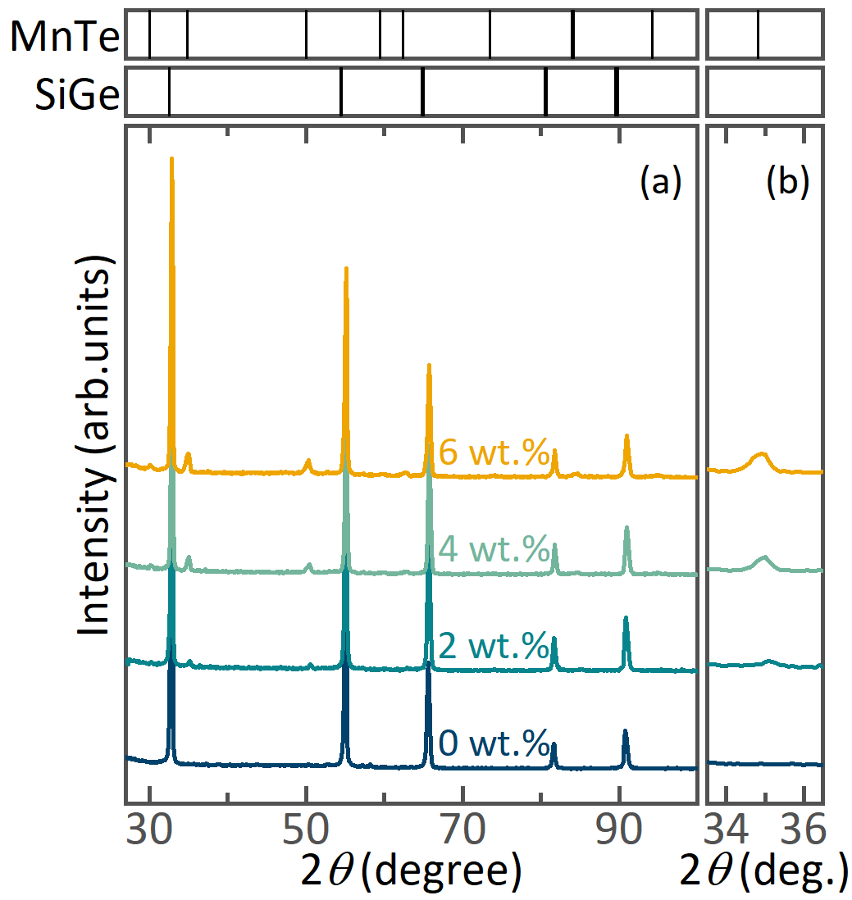
Figure 1. Powder XRD patterns of Si₈₀Ge₂₀B₂ + xMnTe (x = 0, 2, 4, 6 wt.%) samples after SPS and annealing. Part (b) shows an expanded view of the 2θ range between 33.5° to 36.5° in (a), highlighting the increase in the weighted fraction of MnTe. Bragg’s reflections for the SiGe and MnTe phases are indicated by ticks at the top of the figure.

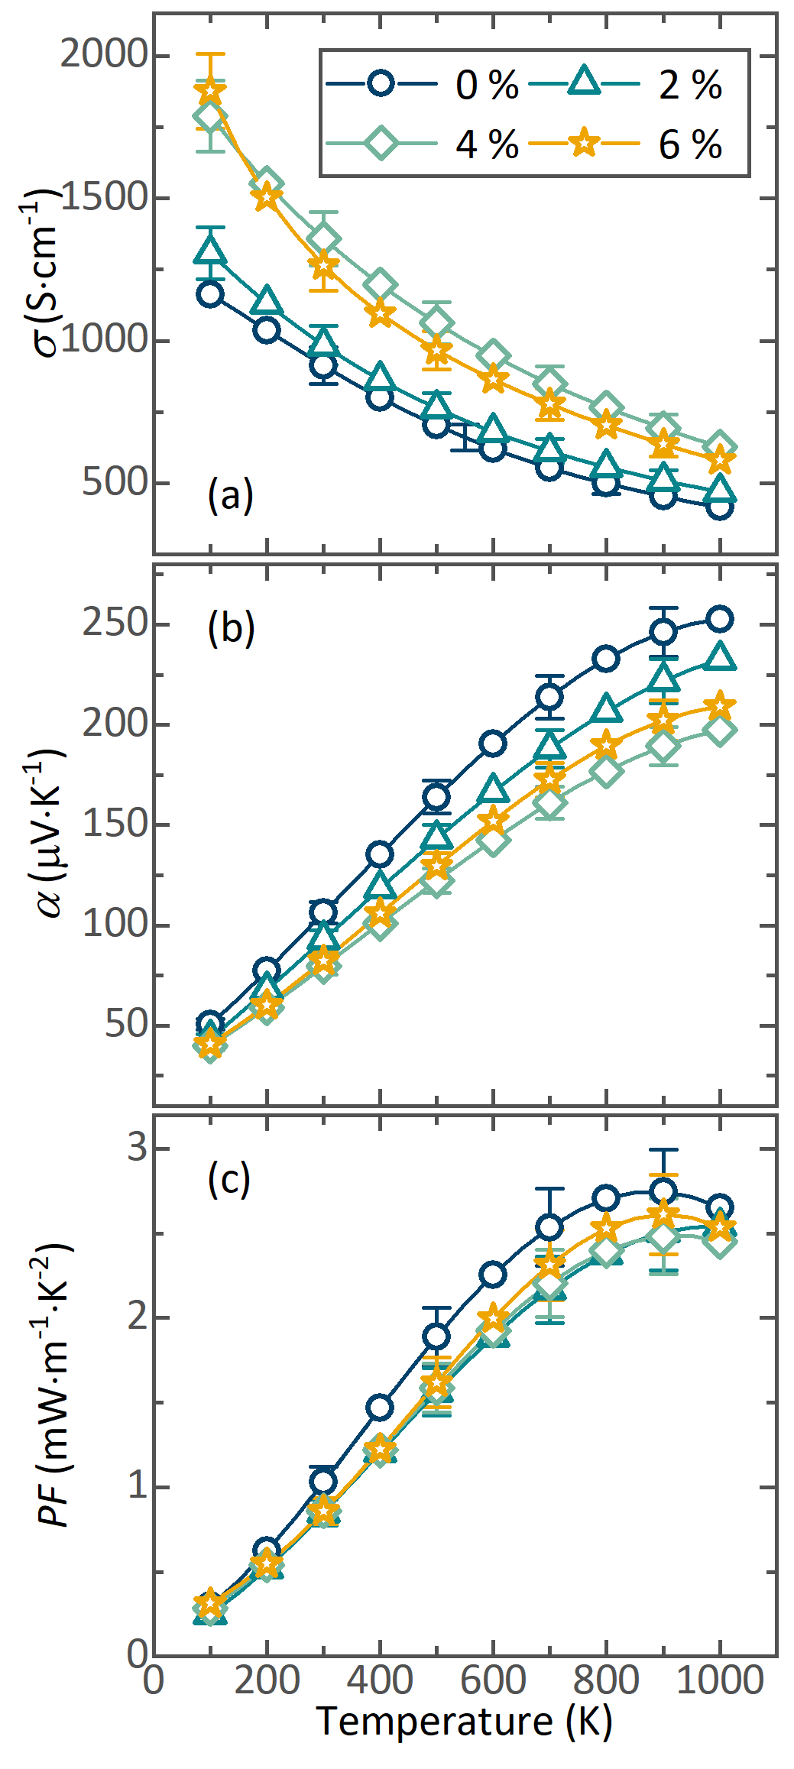
Figure 2. Temperature dependence of (a) the electrical conductivity, (b) the Seebeck coefficient, (c) the power factor for the Si₈₀Ge₂₀B₂ + xMnTe (x = 0, 2, 4, 6 wt.%) samples.
Synthesis. The Si₈₀Ge₂₀B₂ was produced using mechanical alloying via a ball-milling technique. The elemental Si (99.9%, powder), Ge (99.99%, chunks), and B (99.9%, powder) were weighed according to the desired stoichiometry and then ball milled in an argon atmosphere using 250 ml stainless-steel jars with 5 mm stainless-steel balls as the milling media, and the ball-to-powder ratio remained constant at 40:1. The milling was conducted at 700 rpm for 45 minutes. MnTe was prepared by a solid-state reaction. Mn (99.9%, flakes) and Te (99.999%, chunks) were ground in an agate mortar and cold-pressed into pellets, which were sealed in quartz tubes with argon atmosphere. The tubes were then heated to 1173 K at a rate of 5 K min⁻¹ and held for 50 hours before cooling to room temperature. The obtained MnTe was ground in an agate mortar. Finally, the MnTe powder and Si₈₀Ge₂₀B₂ powder were mixed in a high-energy SPEX 8000M ball mill (SPEX SamplePrep., USA) in an argon atmosphere for 30 min. In order to obtain bulk samples, the powders of Si₈₀Ge₂₀B₂ with varying amounts of MnTe (0%, 2%, 4% and 6 wt.%) were densified by spark plasma sintering using a SPS system (Labox650, Sinter Land, Japan) at 1373 K for 5 min under a pressure of 50 MPa with a 50 K min⁻¹ heating rate and free cooling. The compacted disc samples had a dimension of Ø 12.7 mm and ~2.5 mm height (Fig. S1). To reach the equilibrium state the synthesized samples were annealed for 2h at 1173 K under vacuum and characterized by a variety of experimental techniques.
Characterization. Powder X-ray diffraction (PXRD) data were collected using a DRON-4 diffractometer (IC Bourevestnik, Russia) with CoKα radiation (λ = 1.7902 Å) at room temperature. The morphology and chemical composition of the powders and bulk specimens were analyzed by scanning electron microscopy (SEM; Vega 3 SB, Tescan, Czech Republic) and energy dispersive X-ray spectroscopy (EDX; x-act, Oxford Instruments, UK). Consolidated pellets were cut into disc (Ø 12.7 × 1 mm²) for the thermal diffusivity measurements and bars (12.7 × 3 × 1 mm³) for the electrical transport properties measurements. The electrical conductivity, σ, and the Seebeck coefficient, α, were measured simultaneously by a four-probe and differential methods with in-house-built measuring device (Cryotel Ltd., Russia) in He atmosphere. The total thermal conductivity, κ, was calculated from the measured thermal diffusivity, χ, specific heat, C_{p}, and density d using the well-known relationship κ = χC_{p}d. The density of the samples was measured by the Archimedes principle. The specific heat Cp was calculated using the rule of mixtures, which is based on the assumption that the composite material behaves as a homogeneous material with properties that are a weighted average of its components. The rule of mixtures calculates the specific heat of a composite material based on the specific heat of the reinforcement (C_{p})_{r} and (C_{p})_{m} is that of the matrix, that calculated by the Debye model, and mass fraction f of each component C_{p} = f(C_{p})_{r}+(1-f)(C_{p})_{m}.⁴⁷ The thermal diffusivity was measured by the laser flash method using a MicroFlash LFA 457 (Netzsch, Germany) under continuous Ar flow. The combined uncertainly for all measurements involved in the zT calculation is 16 %.⁴⁸

Results and discussion
The obtained composites were identified with SiGe (PDF# 96-153-7803) and MnTe (PDF# 96-153-8216) phases, and no peaks other than those were observed (Fig. 1). The main peak of the MnTe phase increased as it’s nominal content in the composites increased (Fig. 1b). The relative densities of the samples ranged from 94.9 % to 99.4 %. SEM analysis revealed that all samples containing varying MnTe concentrations (Fig. S2a - d) consist of a SiGe alloy matrix with micron-sized MnTe precipitates. As the MnTe content increased, the size and density of the MnTe precipitates also increased. Additionally, the number of inclusions was observed to increase through EDX-maps (Fig. S3 – S6). The EDX analysis confirms good compatibility between the synthesized samples and their respective nominal elements. Furthermore, the EDX analysis revealed that the actual composition of the matrix is close to Si₈₀Ge₂₀, while that of the MnTe inclusions is 1:1. This is representative for all the samples, including similar morphologies among them. Although, some precipitations of the oxide phases were observed in the EDX mapping (Fig. S3 – S6). The EDX findings identified two distinct areas in composites, namely, dark gray regions and bright regions containing Si-Ge-O. That may be Si-Ge and Si-O precipitates, but any secondary phases not consistent with the XRD results discussed above. The differences in the composition of Si-Ge precipitates can be attributed to the fact that binary Si-Ge systems exhibit complete mutual solubility. It is worth noting that the production of SiGe was quite fast (45 minutes of grinding). Such a fast production of SiGe has a disadvantage in that there is an Fe amount of ground in the samples and also some oxidation processes of the reactants could occur at the same stage. Contamination of the powder with Fe, even in small quantities, can lead to changes in charge carrier concentration as well as affect other properties of the material. Depending on the conditions of Fe introduction into the SiGe matrix, the amphoteric Fe impurity can create deep donor or acceptor levels.
The electrical conductivity of the Si₈₀Ge₂₀B₂ + xMnTe (x = 0, 2, 4 and 6 wt.%) samples demonstrated a steady increase until x = 4 wt.%, after which it began to decline, with the decline possibly attributable to the significant level of heterogeneous Si-Ge distribution detected in the sample containing 6 wt.% MnTe (Fig. 2a). Despite this, the electrical conductivity of the samples with 4 and 6 wt.% MnTe was significantly higher than that of pristine SiGe. The electrical conductivity of all the samples displayed metallic behavior throughout the temperature range, which is consistent with what is expected for degenerate semiconductors.
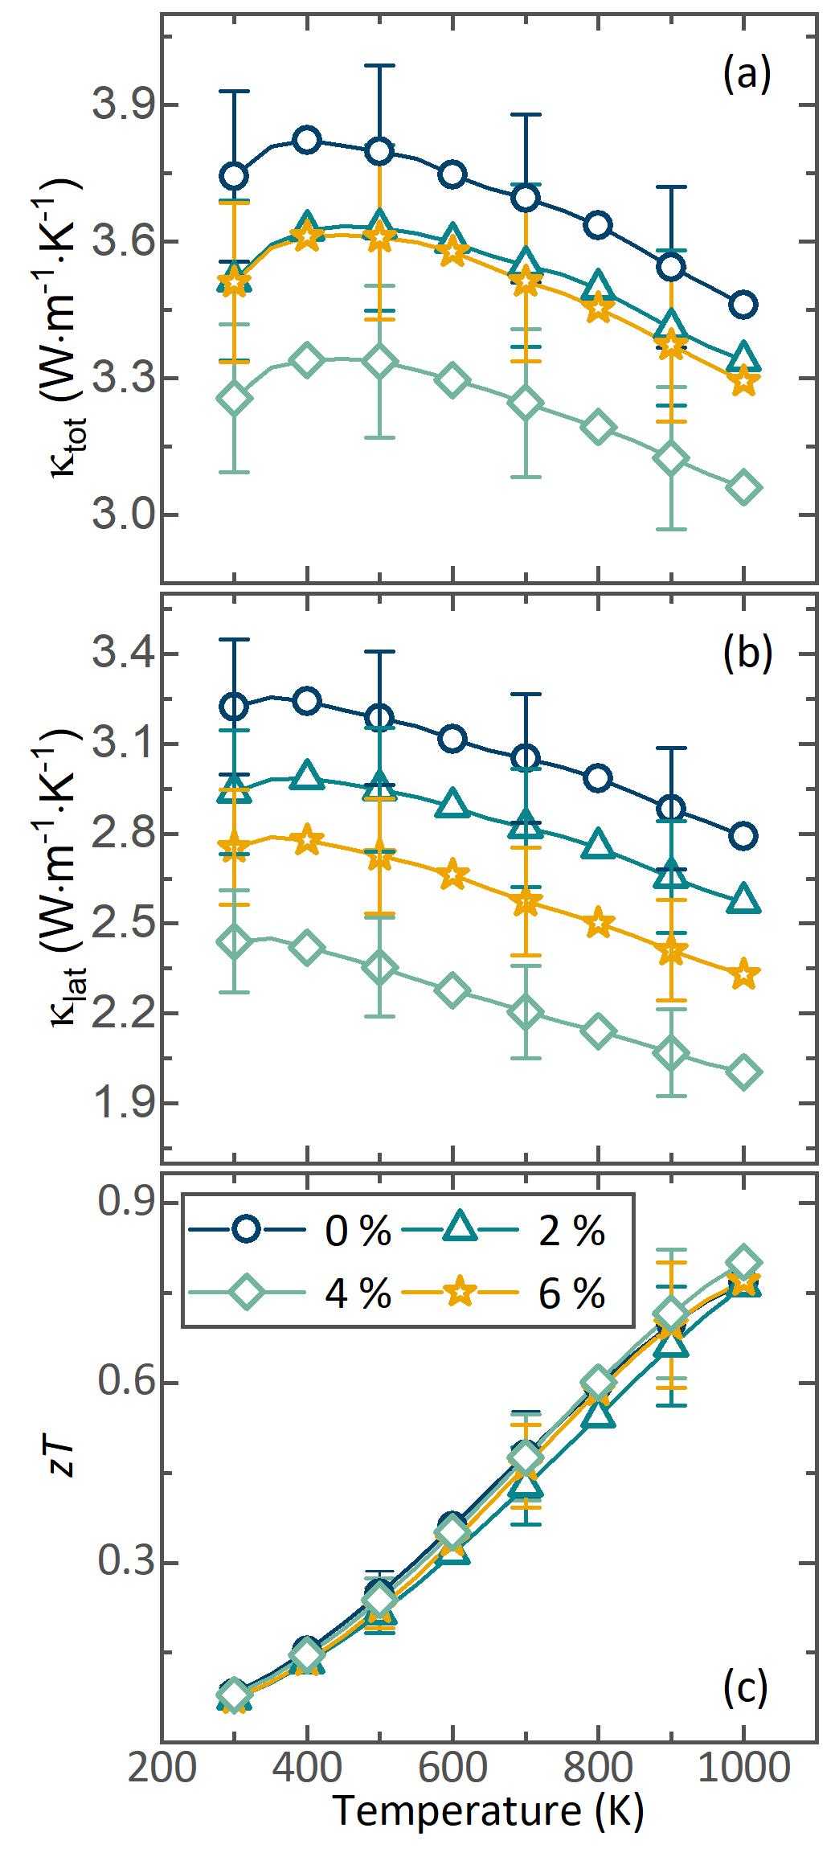
Figure 3. Temperature dependence of (a) the total thermal conductivity, (b) the lattice thermal conductivities, and (c) the figure of merit for the Si₈₀Ge₂₀B₂ + xMnTe (x = 0, 2, 4, 6 wt.%) samples.
All the samples exhibited a positive Seebeck coefficient, indicating that the majority of the charge carriers were holes (Fig. 2b). As expected for degenerate semiconductors, the Seebeck coefficient increased almost linearly with increasing temperature over the measured temperature range. The trend of the Seebeck coefficient was opposite that of electrical conductivity. Pristine Si₈₀Ge₂₀B₂ exhibited the maximum Seebeck coefficient α of 252 μVK⁻¹ at 1000 K while composites had α of 232 – 197 μVK⁻¹. This trend, similar to that of the electrical conductivity, may be attributed to an increase in the concentration of charge carriers.
Unfortunately, due to the trade-off between the electrical conductivity and the Seebeck coefficient, the power factor values for all samples were practically the same within the experimental error (Fig. 2c). The maximum power factor value achieved was ~2.6 mWm⁻¹K⁻² at 900 K, which is comparable to the power factor values reported previously by Wongprakarn et al. (2.3 mWm⁻¹K⁻² at 1073 K for Si₈₀Ge₂₀B₁)²⁸ and Li et al. (3.0 mWm⁻¹K⁻² at 860 K for Si_{79.5}Ge₂₀B_{0.5})²⁶.
The thermal conductivity of composites decreased with increased MnTe content (Fig. 3a). To obtain the lattice thermal conductivity, κ_{lat}, the electronic contribution, κ_{el}, was subtracted from the total thermal conductivity. The electronic thermal conductivity was estimated by the Wiedemann-Franz law: κ_{el} = LTσ, where L is the Lorenz number (Fig. S7). The Lorenz number was evaluated as a function of temperature based on the experimental values of the Seebeck coefficient within the framework of the effective mass model.⁴⁹ The sample with 4 wt.% MnTe had the lowest lattice thermal conductivity of 2 Wm⁻¹K⁻¹ at 1000 K which is 28 % lower than that for the pristine sample (Fig. 3b). The most possible reason is that the MnTe particles can enhance phonon scattering at grain boundaries of two phases and lead to a reduction in the lattice thermal conductivity. This is similar to other works, indicating composite formation is an effective way to decrease κ_{lat}.⁵⁰ Also, in the sample with 4 wt.% MnTe, another secondary phase was detected, which may be silicon oxide, which can serve as an additional source of phonon scattering.⁵¹ The lattice contribution dominated the total thermal conductivity (65-86%) for all the samples in the whole temperature range compared to the electronic part. In spite of the increase of κ_{el} due to increased σ, the κ_{lat} was reduced for all the samples, showing similar temperature dependence with κ_{tot}.
The zT of all the samples increased with increasing temperature (Fig. 3c). The zT value of the 4 wt.% MnTe sample was 7 % greater than pristine Si₈₀Ge₂₀B₂ sample, with a maximum zT of 0.8 at 1000 K. This small improvement in zT compared to the pristine sample was mainly due to the reduced lattice thermal conductivity. This obtained zT value and all results correlates well with previously published works (Fig. S8).
Conclusions
In summary, new composites of Si₈₀Ge₂₀B₂ + xMnTe (x = 0, 2, 4, 6 wt.%) were synthesized by mechanical alloying and solid-state reaction followed by spark plasma sintering. Such a fast method of production led to the formation of secondary phases, which could also affect the properties of the material, but the main contribution is the addition of MnTe. Due to the increase MnTe content, the thermal conductivity was effectively reduced by enhanced phonon scattering. The lattice thermal conductivity in the composite was reduced by 28%. Although κ_{tot} decreased, the decreased Seebeck coefficient offset the improvement κ_{tot}, thus zT not strongly improved. The maximum zT value of 0.8 was achieved at 1000 K in the Si₈₀Ge₂₀B₂ + 4 wt.% MnTe composite. The obtained zT value is comparable to those for another SiGe based composites and pristine SiGe samples.
Conflicts of interest
There are no conflicts to declare.
Acknowledgements
The study was carried out with financial support from the Russian Science Foundation (project no. 21-12-00405). TM and AN acknowledges support from JST Mirai JPMJMI19A1.
Notes and references

1. A. F. Ioffe, Semiconductor Thermoelements, and Thermoelectric Cooling, InfoSearch, London, 1957.
2. Nedunchezhian, A. S. A. et al. Enhancing the thermoelectric power factor of nanostructured ZnCo₂O₄ by Bi substitution. RSC Adv. 10, 18769–18775 (2020).
3. Ekren, D. et al. Enhancing the thermoelectric power factor of Sr_{0.9}Nd_{0.1}TiO₃ through control of the nanostructure and microstructure. J. Mater. Chem. A 6, 24928–24939 (2018).
4. Tayebi, L. et al. Thermal and Thermoelectric Properties of Nanostructured versus Crystalline SiGe. in 2012 IEEE Green Technologies Conference 1–4 (2012).
5. Venkatesh, Ch., Srinivas, V. & Rao, V. V. Enhancement in power factor values of Sn substituted Fe2 VAl Heusler alloys. AIP Conference Proceedings 1447, 1015–1016 (2012).
6. Joshi, G. et al. Enhancement in Thermoelectric Figure-Of-Merit of an N-Type Half-Heusler Compound by the Nanocomposite Approach. Advanced Energy Materials 1, 643–647 (2011).
7. Zebarjadi, M. et al. Power Factor Enhancement by Modulation Doping in Bulk Nanocomposites. Nano Lett. 11, 2225–2230 (2011).
8. Schäffler, F. Modulation doping in the Si/SiGe heterosystem. Phys. Scr. 1992, 178 (2007).
9. Wang, X. et al. Texturing degree boosts thermoelectric performance of silver-doped polycrystalline SnSe. NPG Asia Mater 9, e426–e426 (2017).
10. Liang, Z. et al. New insights into the effect of chemical bonding strength on thermoelectric performance and stability in YbMg2Bi2 toward practical thermoelectric applications. Materials Today Physics 28, 100858 (2022).
11. Han, S., Chen, S. & Jiao, F. Insulating polymers for flexible thermoelectric composites: A multi-perspective review. Composites Communications 28, 100914 (2021).
12. Huo, B. & Guo, C.-Y. Advances in Thermoelectric Composites Consisting of Conductive Polymers and Fillers with Different Architectures. Molecules 27, 6932 (2022).
13. Liu, Y. et al. Thermoelectric properties of semiconductor-metal composites produced by particle blending. APL Materials 4, 104813 (2016).
14. Snarskii, A. A., Sarychev, A. K., Bezsudnov, I. V. & Lagarkov, A. N. Thermoelectric figure of merit for bulk nanostructured composites with distributed parameters. Semiconductors 46, 659–665 (2012).
15. Yang, G. et al. Ultra-High Thermoelectric Performance in Bulk BiSbTe/Amorphous Boron Composites with Nano-Defect Architectures. Advanced Energy Materials 10, 2000757 (2020).
16. Yaprintsev, M. et al. Enhanced thermoelectric efficiency of the bulk composites consisting of “Bi2Te3 matrix” and “filler Ni@NiTe2 inclusions”. Scripta Materialia 194, 113710 (2021).
17. Biswas, K. et al. High-performance bulk thermoelectrics with all-scale hierarchical architectures. Nature 489, 414–418 (2012).
18. Zhao, W. et al. Superparamagnetic enhancement of thermoelectric performance. Nature 549, 247–251 (2017).
19. Zhou, Z. et al. Thermoelectric performance of SnTe with ZnO carrier compensation, energy filtering, and multiscale phonon scattering. Journal of the American Ceramic Society 100, 5723–5730 (2017).
20. Zhou, A. J. et al. Microstructure and thermoelectric properties of SiGe-added higher manganese silicides. Materials Chemistry and Physics 124, 1001–1005 (2010).
21. Thomas, R. et al. Melt spinning: A rapid and cost effective approach over ball milling for the production of nanostructured p-type Si80Ge20 with enhanced thermoelectric properties. Journal of Alloys and Compounds 781, 344–350 (2019).
22. Usenko, A. A. et al. Optimization of ball-milling process for preparation of Si–Ge nanostructured thermoelectric materials with a high figure of merit. Scripta Materialia 96, 9–12 (2015).
23. Bathula, S. et al. The role of nanoscale defect features in enhancing the thermoelectric performance of p-type nanostructured SiGe alloys. Nanoscale 7, 12474–12483 (2015).
24. Dismukes, J. P., Ekstrom, L., Steigmeier, E. F., Kudman, I. & Beers, D. S. Thermal and Electrical Properties of Heavily Doped Ge‐Si Alloys up to 1300°K. Journal of Applied Physics 35, 2899–2907 (1964).
25. Joshi, G. et al. Enhanced Thermoelectric Figure-of-Merit in Nanostructured p-type Silicon Germanium Bulk Alloys. Nano Lett. 8, 4670–4674 (2008).
26. Li, J., Han, J., Jiang, T., Luo, L. & Xiang, Y. Effect of Synthesis Procedure on Thermoelectric Property of SiGe Alloy. J. Electron. Mater. 47, 4579–4584 (2018).
27. Vining, C. B., Laskow, W., Hanson, J. O., Van der Beck, R. R. & Gorsuch, P. D. Thermoelectric properties of pressure‐sintered Si0.8Ge0.2 thermoelectric alloys. Journal of Applied Physics 69, 4333–4340 (1991).
28. Wongprakarn, S., Pinitsoontorn, S., Tanusilp, S. & Kurosaki, K. Enhancing thermoelectric properties of p-type SiGe alloy through optimization of carrier concentration and processing parameters. Materials Science in Semiconductor Processing 88, 239–249 (2018).
29. Basu, R. et al. Improved thermoelectric performance of hot pressed nanostructured n-type SiGe bulk alloys. J. Mater. Chem. A 2, 6922–6930 (2014).
30. Wang, X. W. et al. Enhanced thermoelectric figure of merit in nanostructured n-type silicon germanium bulk alloy. Applied Physics Letters 93, 193121 (2008).
31. Murugasami, R., Vivekanandhan, P., Kumaran, S., Suresh Kumar, R. & John Tharakan, T. Simultaneous enhancement in thermoelectric performance and mechanical stability of p-type SiGe alloy doped with Boron prepared by mechanical alloying and spark plasma sintering. Journal of Alloys and Compounds 773, 752–761 (2019).
32. R, M., P, V., S, K., R, S. K. & T, J. T. Synergetic enhancement of thermoelectric and mechanical properties of n-type SiGe-P alloy through solid state synthesis and spark plasma sintering. Materials Research Bulletin 118, 110483 (2019).
33. Wang, J. et al. Enhanced Thermoelectric Performance in n-Type SrTiO3/SiGe Composite. ACS Appl. Mater. Interfaces 12, 2687–2694 (2020).
34. Rouhani, P., Zamanipour, Z., Krasinski, J. S., Vashaee, D. & Tayebi, L. Enhancement of Doping Concentration in P-Type SiGe Thermoelectric Alloy with the Addition of CrSi2. in 2012 IEEE Green Technologies Conference 1–4 (2012).
35. Li, Y., Han, J., Xiang, Q., Zhang, C. & Li, J. Enhancing thermoelectric properties of p-type SiGe by SiMo addition. J Mater Sci: Mater Electron 30, 9163–9170 (2019).
36. Nong, J. et al. Ultra-low thermal conductivity in B2O3 composited SiGe bulk with enhanced thermoelectric performance at medium temperature region. J. Mater. Chem. A 10, 4120–4130 (2022).
37. Zamanipour, Z. & Vashaee, D. Enhancement in Thermoelectric Power Factor of SiGe-CrSi2 Composite Alloy. in 2012 IEEE Green Technologies Conference 1–3 (2012).
38. Lahwal, A. et al. Enhancing Thermoelectric Properties of Si80Ge20 Alloys Utilizing the Decomposition of NaBH4 in the Spark Plasma Sintering Process. Energies 8, 10958–10970 (2015).
39. Yang, X.-Y., Wu, J.-H., Ren, D.-D., Zhang, T.-S. & Chen, L.-D. Microstructure and thermoelectric properties of p-type Si80Ge20B0.6-SiC nanocomposite. 31, 997–1003 (2016).
40. Ahmad, S. et al. Boosting thermoelectric performance of p-type SiGe alloys through in-situ metallic YSi2 nanoinclusions. Nano Energy 27, 282–297 (2016).
41. Nozariasbmarz, A., Zamanipour, Z., Norouzzadeh, P., Krasinski, J. S. & Vashaee, D. Enhanced thermoelectric performance in a metal/semiconductor nanocomposite of iron silicide/silicon germanium. RSC Adv. 6, 49643–49650 (2016).
42. Bathula, S. et al. Enhancement in thermoelectric performance of SiGe nanoalloys dispersed with SiC nanoparticles. Phys. Chem. Chem. Phys. 19, 25180–25185 (2017).
43. Ahmad, S. et al. Enhanced thermoelectric figure-of-merit of p-type SiGe through TiO2 nanoinclusions and modulation doping of boron. Materialia 4, 147–156 (2018).
44. Szuszkiewicz, W., Dynowska, E., Witkowska, B. & Hennion, B. Spin-wave measurements on hexagonal $\mathrm{MnTe}$ of $\mathrm{NiAs}$-type structure by inelastic neutron scattering. Phys. Rev. B 73, 104403 (2006).
45. Zheng, Z. et al. Rhombohedral to Cubic Conversion of GeTe via MnTe Alloying Leads to Ultralow Thermal Conductivity, Electronic Band Convergence, and High Thermoelectric Performance. J. Am. Chem. Soc. 140, 2673–2686 (2018).
46. Tan, G. et al. Valence Band Modification and High Thermoelectric Performance in SnTe Heavily Alloyed with MnTe. J. Am. Chem. Soc. 137, 11507–11516 (2015).
47. Ashby, M. F. Chapter 11 - Designing Hybrid Materials. in Materials Selection in Mechanical Design (Fourth Edition) (ed. Ashby, M. F.) 299–340 (Butterworth-Heinemann, 2011).
48. Alleno, E. et al. Invited Article: A round robin test of the uncertainty on the measurement of the thermoelectric dimensionless figure of merit of Co0.97Ni0.03Sb3. Review of Scientific Instruments 86, 011301 (2015).
49. Franz, R. & Wiedemann, G. Ueber die Wärme-Leitungsfähigkeit der Metalle. Ann. Phys. Chem. 165, 497–531 (1853).
50. Ma, Y., Heijl, R. & Palmqvist, A. E. C. Composite thermoelectric materials with embedded nanoparticles. J Mater Sci 48, 2767–2778 (2013).
51. Wu, C.-F., Wei, T.-R., Sun, F.-H. & Li, J. Nanoporous PbSe-SiO 2 Thermoelectric Composites. Advanced Science 4, 1700199 (2017).

