Procrystalline Self-Assembly of Desymmetrized Pentaphenylcyclopentadiene
Donglin Li,^{‡1} Sota Seki,^{‡2} Atsushi Ishikawa,*³ Kenichiro Omoto,^{§2} Kazuma Yasuhara,^{2,4} Gwénaël Rapenne*^{2,5} and Shigeki Kawai*^{1,6}

¹Center for Basic Research on Materials, National Institute for Materials Science, 1-2-1, Sengen, Tsukuba, Ibaraki 305-0047, Japan.
²Division of Materials Science, Nara Institute of Science and Technology, 8916-5 Takayama, Ikoma, 630-0192, Japan.
³Department of Transdisciplinary Science and Engineering, School of Environment and Society, Tokyo Institute of Technology, 2-12-1 Ookayama, Meguro-ku, Tokyo, 152-8552, Japan
⁴Center for Digital Green-innovation, Nara Institute of Science and Technology, 8916-5 Takayama, Ikoma, Nara, 630-0192, Japan.
⁵CEMES, Université de Toulouse, CNRS, 29, rue Marvig, 31055 Toulouse, France
⁶Graduate School of Pure and Applied Sciences, University of Tsukuba, Tsukuba 305-8571, Japan.
‡ These authors contributed equally.
§ Current address: Division of Chemistry and Materials Science, Graduate School of Integrated Science and Technology, Nagasaki University, 1-14, Bunkyo-machi, Nagasaki, 852-8521, Japan.
E-mail: ishikawa.a.ai@m.titech.ac.jp, gwenael-rapenne@ms.naist.jp, KAWAI.Shigeki@nims.go.jp

Table of content

I. Experimental section
1. General synthetic methods page S2
2. Synthesis of the compounds page S2
a. 2,3,4,5-Tetraphenyl-1-(m-tolyl) cyclopenta-2,4-dien-1-ol (3a) page S2
b. [5-Bromo-1,2,3,4-tetraphenyl-5-(m-tolyl)]-cyclopenta-1,3-diene (4a) page S3
c. 1-(m-Fluorophenyl)-2,3,4,5-tetraphenylcyclopenta-2,4-dien-1-ol (3b) page S3
d. [5-Bromo-1,2,3,4-tetraphenyl-5-(m-fluorophenyl)]-cyclopenta-1,3-diene (4b) page S4

II. Additional STM images page S5

I. Experimental section
I.1. General synthetic methods
All commercially available chemicals were of reagent grade and were used without further purification. Acetic acid, chloroform, sodium chloride, sodium hydroxide, sodium sulfate, sodium hydrogenocarbonate, were purchased from FUJIFILM Wako Pure Chemical Corporation. Ammonium chloride, dichloromethane, ethylacetate, were purchased from Nacalaitesque. 3-Bromofluorobenzene, 3-bromotoluene, hydrogen bromide (30% in acetic acid), n-buthyllithium (ca. 15% in hexane) and tetraphenylcyclopentadienone (2) were purchased from TCI. Column chromatography was carried out on Wakosil® 60. Thin layer chromatography (TLC) was performed on TLC silica gel 60 F254 plates (Merck) with visualization by using ultraviolet irradiation (λ = 254, 365 nm). ¹H and ¹³C NMR spectra were recorded on JEOL FT-NMR JNM-ECX400P and JEOL FT-NMR JNM-ECX500 spectrometers. Residual solvent signals were used as internal reference for ¹H and ¹³C NMR. Chemical shifts (δ) are reported in ppm. Coupling constants (J) are given in Hz and the following abbreviations have been used to describe the signals: singlet (s); broad singlet (br. s); doublet (d); triplet (t); quadruplet (q); quintuplet (quint); multiplet (m). High‐resolution mass spectra (HRMS) were performed with a Waters GCT Premier spectrometer for desorption chemical ionization (DCI/CH₄), with a Waters Xevo G2 QTOF spectrometer for electrospray ionization (ESI), and with a Waters MALDI micro MX spectrometer for matrix-assisted laser desorption ionization (MALDI) (matrix: trans-2-[3-(4-tert-butylphenyl)-2-methyl-2-propenylidene]malono-nitrile DTCB).
I.2. Synthesis of the compounds

- 2,3,4,5-Tetraphenyl-1-(m-tolyl) cyclopenta-2,4-dien-1-ol (3-Me):
In a flame dried two-necked round bottom flask equipped with a stir bar, 3-bromotoluene 1-Me (383 μl, 3 mmol, 1.5 eq.) was added under N₂ at RT. Anhydrous THF (7.5 ml) was added and cooled down to -78°C and then, a 1.6 M solution of n-buthyllithium in n-hexane (1.3 ml, 2 mmol, 1 eq.) was added dropwise. The suspension was stirred for 30 minutes at -78 ℃ and a degassed solution of 2,3,4,5-tetraphenylcyclopenta-2,4-dienone 2 (769 mg, 2 mmol, 1 eq.) in anhydrous THF (23 ml) was added dropwise. The reaction was stirred 2h at -78°C before being neutralized by a saturated NH₄Cl aqueous solution (ca. 30 ml). After extraction with Et₂O, the combined organic phase was washed three times with water and once with brine. The organic solution was dried over Na₂SO₄, filtered and evaporated. The crude product was purified by silica gel column chromatography using n-hexane/CH₂Cl₂ (5/2 to 2/1) as eluant to afford 3-Me (590 mg, 61%). ¹H NMR (CDCl₃, 400 MHz, 293 K) δ (ppm): 7.33-7.19 (m, 2H), 6.85-7.10 (m, 7H), 6.96-7.06 (m, 14H), 2.43 (s, 1H), 2.27 (s, 3H, CH₃); ¹³C NMR (CDCl₃, 100 MHz, 293 K) δ (ppm): 148.0, 142.5, 140.1, 135.2, 134.0, 131.2, 130.0, 129.6, 128.6, 128.4, 127.8, 127.1, 127.0, 122.2, 21.9(CH₃); HR-MS (positive, ESI): Calcd for [C₃₆H₂₈O]⁺: 476.2140 Found: 476.2138

- [5-Bromo-1,2,3,4-tetraphenyl-5-(m-tolyl)]-cyclopenta-1,3-diene (4-Me)
3-Me (80 mg, 0.17 mmol, 1 eq.) and AcOH (3.1 ml) was added to the two-necked round bottom flask equipped with a stir bar and a reflux condenser. After heating to 60°C, 30 % HBr in AcOH (860 μl, 64%) was added dropwise. After cooling down to RT, water was added and the solution was neutralized with aqueous Na₂CO₃. The precipitate was filtered out and washed with water. The crude product was purified by silica gel column chromatography using n-hexane/CH₂Cl₂(5/1) as eluant to afford 4-Me as a yellow solid composed of a mixture of three regioisomers in a 1:1.5:1.5 ratio (53 mg, 58%). ¹H NMR (CDCl₃, 400 MHz, 293 K) δ (ppm): 7.46-7.49 (m, 7H), 7.22-7.25 (m, 10H), 6.88-7.16 (m, 82H), 6.71-6.77 (m, 7H), 2.26 (s, 3H, CH₃), 2.10 (s, 5.0H, CH₃), 2.06 (s, 4.5H, CH₃); ¹³C NMR (CDCl₃, 100 MHz, 293 K) δ (ppm): 148.5, 148.4, 148.3, 148.2, 148.0, 142.0, 142.0, 141.8, 141.7, 138.0, 137.3, 137.0, 136.8, 136.0, 135.7, 135.6, 134.9, 134.8, 134.6, 134.3, 134.0, 131.2, 130.9, 130.6, 130.5, 130.5, 130.2, 128.0, 127.9, 127.9, 127.8, 127.8, 127.8, 127.7, 127.6, 127.6, 127.5, 127.5, 127.3, 127.3, 127.2, 127.2, 124.3, 21.6, 21.5, 21.4; HR-MS (MALDI-TOF, positive, DCTB): Calcd. for [C₃₆H₂₇Br]⁺: 538.1296, Found: 538.1307.

- 1-(m-Fluorophenyl)-2,3,4,5-tetraphenylcyclopenta-2,4-dien-1-ol (3-F):
In a flame dried two-necked round bottom flask equipped with a stir bar, 1-bromo-3-fluorobenzene 1-F (220 μl, 2 mmol, 1.5 eq.) was added under N₂ at RT. Anhydrous THF (5 ml) was added and cooled down to -78°C and then, a 1.6 M solution of n-buthyllithium in n-hexane (1.7 ml, 2.7 mmol, 2 eq.) was added dropwise. The suspension was stirred for 30 minutes at this temperature and a degassed solution of 2,3,4,5-tetraphenylcyclopenta-2,4-dienone 2 (525 mg, 1.33 mmol, 1eq.) in anhydrous THF (23 ml) was added dropwise. The reaction was stirred 2h at -78°C before being neutralized by pouring a saturated NH₄Cl aqueous solution (ca. 20 ml). After extraction with Et₂O, the combined organic phase was washed three times with water and once with brine. The organic solution was dried over Na₂SO₄, filtered and evaporated. The crude product was purified by silica gel column chromatography using n-hexane/CH₂Cl₂ (5/2 to 2/1) as the eluant to afford 3-F (316 mg, 48%). ¹H NMR (MeOD-d⁴, 500 MHz, 293 K) δ (ppm): 7.36 (d, J= 8 Hz, 1H), 7.22-7.28 (m, 2H), 7.09-7.15 (m, 6H), 6.93-7.04 (m, 14H), 6.85 (dt, J= 2.5 and 8.4 Hz, 1H); ¹³C NMR (CDCl₃, 100 MHz, 293 K) δ (ppm): 164.3, 161.9, 147.5, 143.4, 143.3, 142.8, 134.8, 133.5, 130.0, 129.9, 129.9, 129.4, 127.9, 127.8, 127.2, 127.8, 127.2, 127.2, 120.7, 120.6, 114.0, 113.8, 112.5, 112.2, 89.7; ¹⁹F NMR (CDCl₃, 400 MHz, 293 K) δ (ppm): −122.69 (s, 1F); HR-MS (positive, ESI): Calcd for [C₃₅H₂₆FO]⁺: 481.1962 Found: 481.1967.

- [5-Bromo-1,2,3,4-tetraphenyl-5-(m-fluorophenyl)]-cyclopenta-1,3-diene (4-F)
3-F (127 mg, 0.26 mmol, 1 eq.) and AcOH (4.5 ml) was added to the two-necked round bottom flask equipped with a stir bar and a reflux condenser. After heating to 60°C, 30% HBr in AcOH (1.3 ml, 26 eq.) was added dropwise and stirred for 45 min. After cooling down to RT, water was added and the solution was neutralized with an aqueous solution of Na₂CO₃. The precipitate was filtered and washed with water. The crude product was purified by silica gel column chromatography using n-hexane/CH₂Cl₂(6/1) as eluant to afford 4-F (97 mg, 67%) as a yellow solid composed of a mixture of regioisomers in a 1:2.5:3 ratio. ¹H NMR (CDCl₃, 500 MHz, 293 K) δ (ppm): 7.45-7.48 (m,10H), 7.23-7.25 (m, 7H), 7.02-7.19 (m, 59H), 6.92-7.00 (m, 39H), 6.83 (ddt, J=0.8, 2.7, 8.6 Hz, 2H), 6.78 (ddt, J=0.8, 2.7, 8.6 HZ, 2H), 6.70-6.75 (m, 7H), 6.66 (qd, J=1.5, 2.4, 9.9 Hz, 2H).
¹³C NMR (CDCl₃, 100 MHz, 293 K) δ (ppm): 163.9, 163.4, 163.1, 161.5, 160.9, 160.7, 149.3, 148.7, 148.2, 147.9, 146.7, 142.7, 142.2, 141.6, 141.4, 140.5, 138.9, 138.8, 136.9, 138.8, 136.9, 136.8, 136.3, 136.2, 135.4, 134.4, 134.4, 134.3, 133.9, 133.8, 133.7, 130.4, 130.3, 130.0, 129.2, 128.8, 128.4, 128.5, 128.4, 128.0, 127.9, 127.7, 127.5, 127.4, 127.4, 127.3, 127.3, 127.2, 127.2, 126.3, 126.3, 125.9, 125.8, 123.0, 117.2, 117.0, 116.8, 115.1, 114.9, 114.7, 114.3, 114.1, 114.1, 113.9; ¹⁹F NMR (CDCl₃, 376 MHz, 293 K) δ (ppm): −112.45 (m, 1F), −113.40 (m, 2.4F), −113.65 (m, 3.1F); HR-MS (MALDI-TOF, positive, DCTB): Calcd. for [C₃₅H₂₄BrF]⁺: 542.1045, Found: 542.1063.
II. Additional STM images

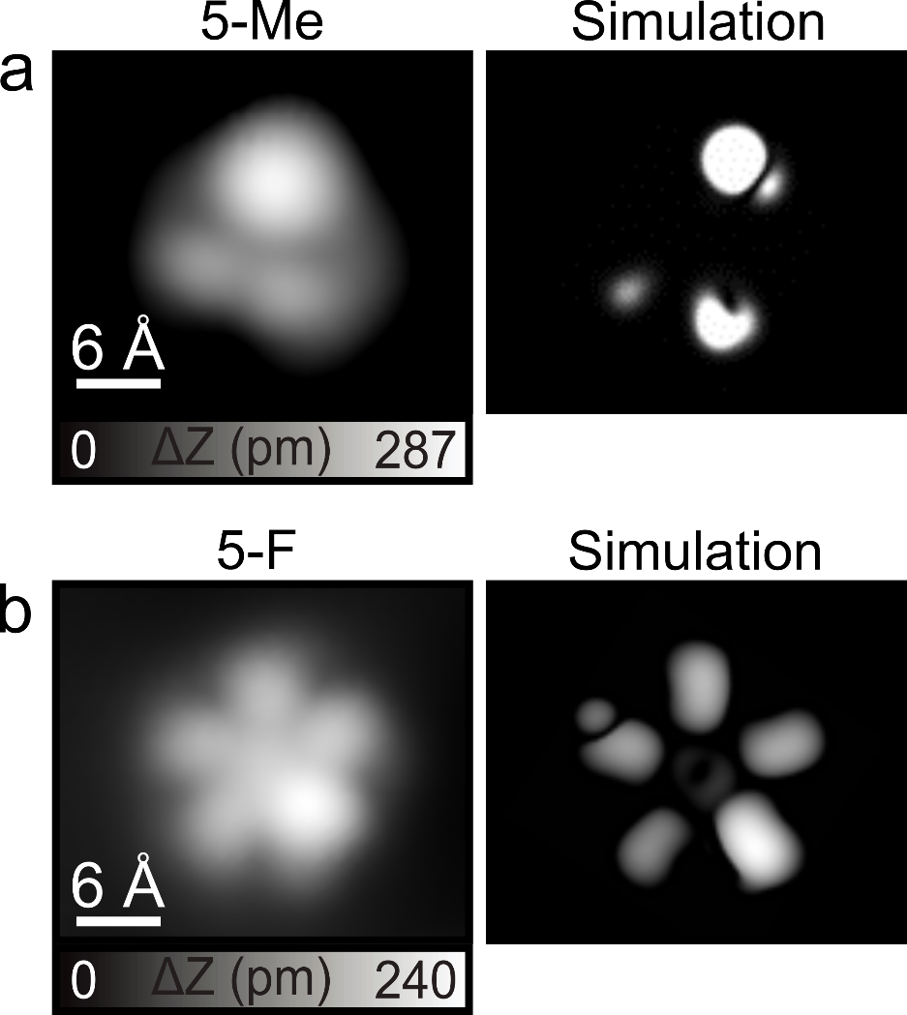
Figure S1. STM images of (a) 5-Me and (b) 5-F on the Au(111) surface, along with the corresponding simulated STM images based on their optimized structures.

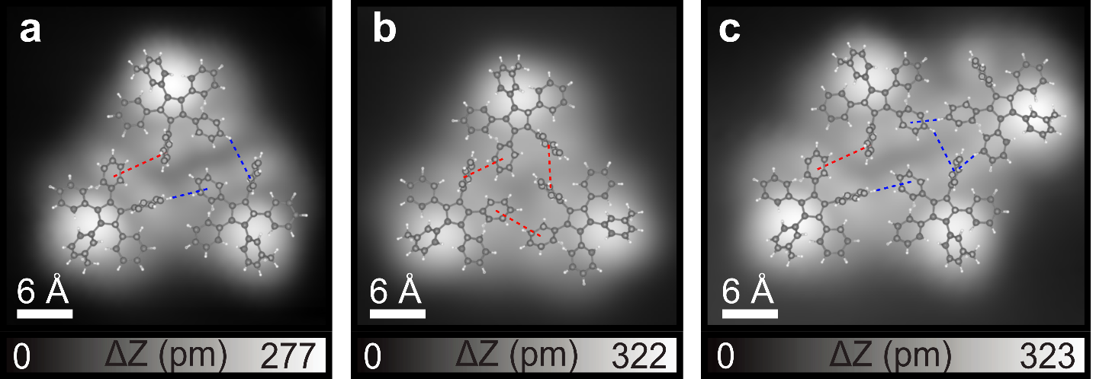
Figure S2. Close-up views of the asymmetric trimer, symmetric trimer, and tetramer with the calculated structural model of 5-Me superimposed. The π-π interactions and CH-π interactions are depicted by red and blue dashed lines, respectively. Structural model: H: white, C: gray.

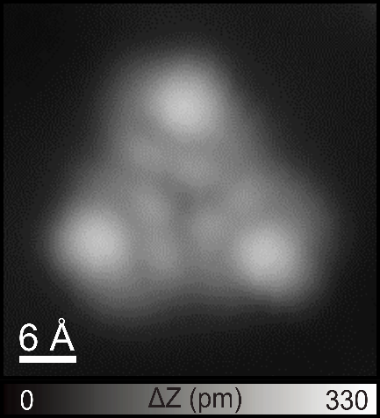
Figure S3. Another chirality of the trimer of 5-Me on Au(111). Scanning parameter: V = 0.2 V and I = 10 pA.

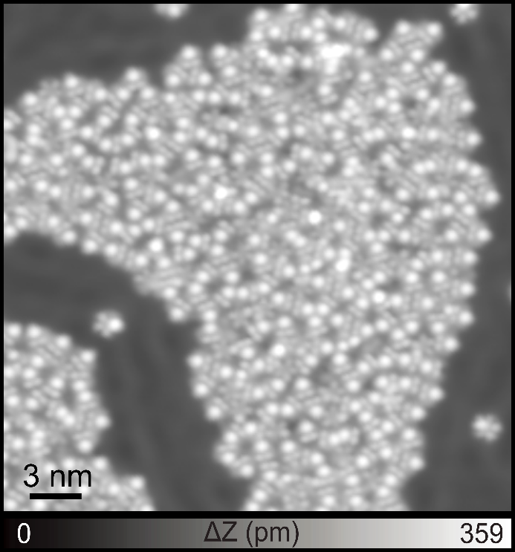
Figure S4. Close-packed island structure of 5-Me on the Au(111) surface showing the herringbone around the island. Scanning parameter: V = 0.2 V and I = 10 pA.

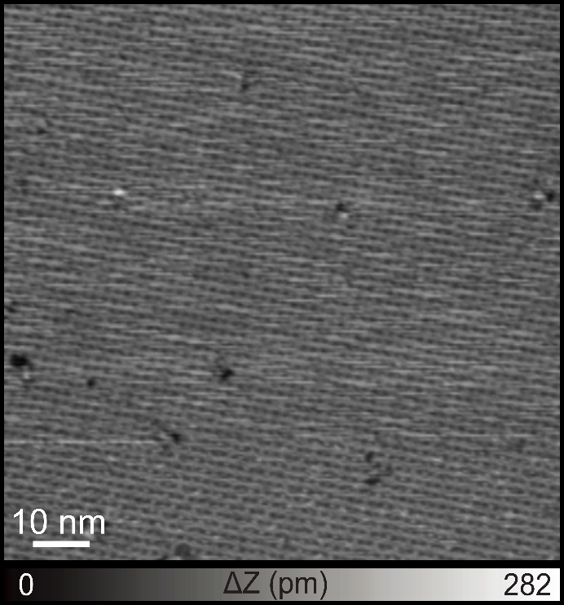
Figure S5. Large-scale STM image of 5-Me on the Ag(111) surface. Scanning parameter: V = 0.2 V and I = 10 pA.

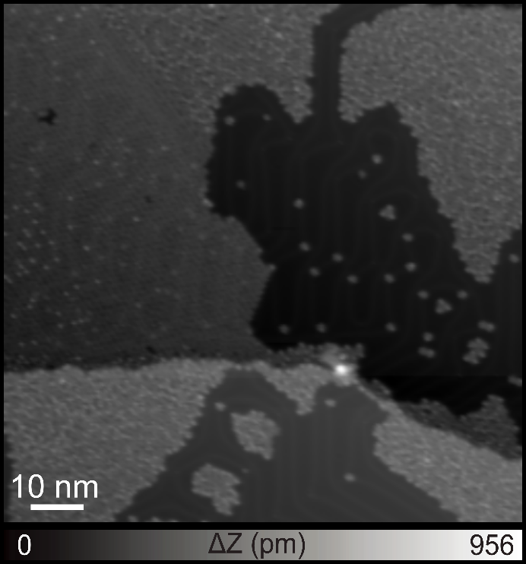
Figure S6. Large-scale STM image of 5-F on the Au(111) surface. Scanning parameter: V = 0.2 V and I = 10 pA.
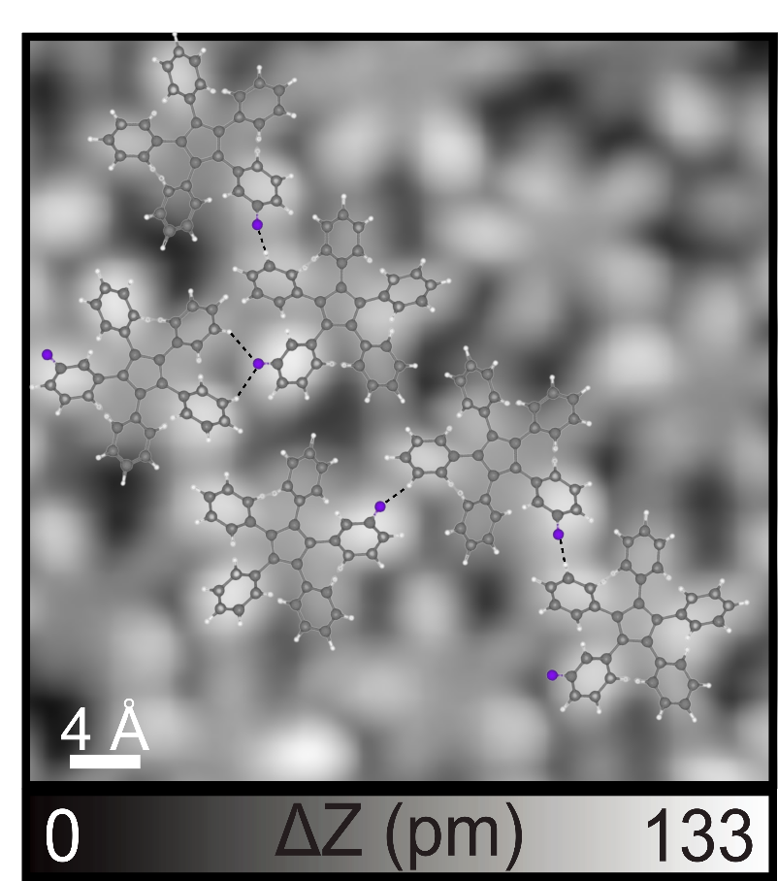
Figure S7. Close-up view of the phase I with the calculated structural model of star-shaped 5-F superimposed. The CH‧‧‧F interactions are depicted by black dashed lines. Structural model: H: white, C: gray, F: blue.

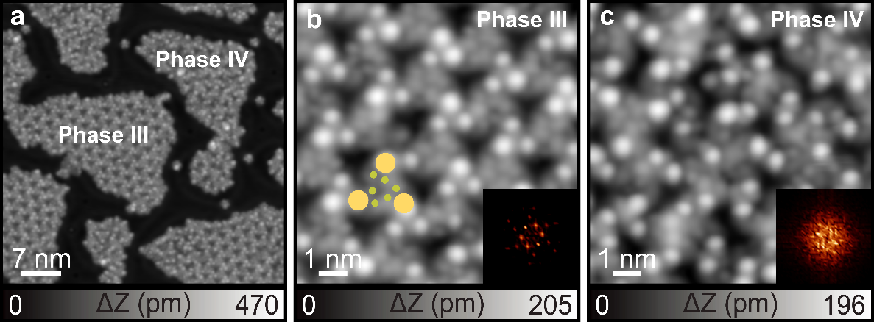
Figure S8. Phase transformation of 5-F self-assembled structures by annealing at 100 °C on Au(111). (a) Large-scale STM image of the new phases. (b, c) Close-up views of phase III and phase IV, respectively. Insets show corresponding 2D-FFT images. Scanning parameter: V = 0.2 V and I = 10 pA.

