Ultra-High-Resolution Thermometer Based on Diamond MEMS
Wen. Zhao¹, Tokuyuki Teraji¹, Satoshi Koizumi¹, Yasuo Koide¹, and Meiyong Liao¹
¹ Research Center for Electronics and Optical Materials, National Institute for Materials Science,
Namiki 1-1, Tsukuba, Ibaraki 305-0044, Japan
zhao.wen@nims.go.jp

Ultra-high precision and microscale or nanoscale spatial resolution show great potential for bio-calorimetry, optoelectronic sensing, electronic devices, and quantum science. MEMS-based thermometry offers great potential due to the microscale size, batch fabrication and facile integration with integrated circuits. However, the mainstream silicon MEMS thermometry suffer from the unlocked challenge of trade-off in sensitivity, temperature resolution and thermal noise, which hinder the advancements in sensing technology. One promising solution to break these limitations is to leverage the exceptional properties of single-crystal diamond (SCD) [1-3], such as excellent mechanical characteristics and low energy dissipation, enabling precise and advanced sensing applications.

In this work, we propose a high-quality (Q) factor micro thermometer based on SCD cantilevers (Fig. 1(a)), which was fabricated by smart-cut method [1]. We use higher-order-modes (HOMs) to have both high resolution and sensitivity for precise detection of subtle temperature variations ranging from 380 K to 6.5K. By operation at HOMs (Fig. 1(b)), the experimental resolution of 10 mK (facility limit) was identified and an estimated resolution of 100 µK and a noise equivalent temperature of 22 nK/Hz^{1/2} were achieved. The temperature resolution and noise level establish new global benchmarks in temperature sensors among MEMS sensors. This work underscores the versatility and transformative potential of the diamond MEMS resonator as an advanced platform for ultra-high-resolution temperature sensing.
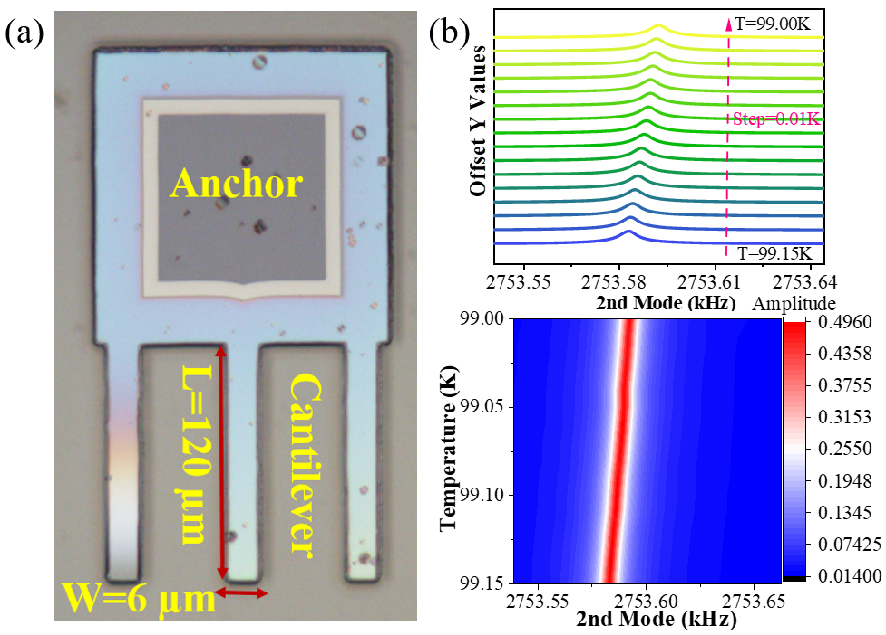

Figure 1 – (a) Optical image of single-crystal diamond MEMS resonators; (b) Frequency-temperature response and corresponding color-map for the second resonant mode.

References
[1] M. Liao et al, Adv. Mater. 2 (2010)5393.
[2] H. Sun, M. Liao et al, Phys. Rev. Lett. 125 (2020), 206802.
[3] W. Zhao, S. Koizumi, and M. Liao, IEEE Electron Dev. Lett. 45 (2024) 2268.

