Metal-Free, Single-Component White-Light Emission and Visible–Near-Infrared Whispering Gallery Mode Micro-Emitter
Barun Kumar Barman^{* 1, 2}, Keisuke Watanabe¹, Vijayakumar Balakrishnan,² Keiko Okano¹, Kenzo Deguchi⁴, Shinobu Ohki⁴, Kenjiro Hashi⁵, Atsushi Goto⁶, Tadaaki Nagao^{* 1, 3}
¹Research Center for Materials Nanoarchitectonics (MANA), National Institute for Materials Science (NIMS), Tsukuba, Ibaraki 305-0044, Japan
²Centre for Interdisciplinary Research (CIDR), SRM University - AP, Amaravati, Andhra Pradesh 522240, India
³Department of Condensed Matter Physics, Graduate School of Science, Hokkaido University Sapporo, Hokkaido 060-0810, Japan
⁴Advanced Engineering and Services Division, National Institute for Materials Science (NIMS), Tsukuba, Ibaraki 305-0003, Japan
⁵Center for Basic Research on Materials, National Institute for Materials Science (NIMS), Tsukuba, Ibaraki 305-0003, Japan
Email: barunkumar.b@srmap.edu.in, NAGAO.Tadaaki@nims.go.jp

Abstract: Single-component, metal-free white light emitters with integrated photonic functionalities are highly attractive for solid-state lighting and integrated photonic applications. Here, we report carbonized polymer microspheres that exhibit efficient single-component white light emission (WLE) together with excitation-tunable visible-to-near-infrared (VIS–NIR) whispering gallery mode (WGM) emission. The microspheres are synthesized via a hydrothermal crosslinking reaction between the natural peptide ε-poly-L-lysine and citric acid, yielding smooth spherical microcavities with bright cyan emission. Incorporation of ortho-phenylenediamine (OPD) during synthesis enables control over the internal structure and promotes the in situ formation of phenazine-like polycyclic aromatic hydrocarbon (PAH) domains. The extended π-conjugation of the PAHs enhances visible-light absorption, leading to emission spanning the visible to NIR spectral region. Upon ultraviolet excitation, the microspheres exhibit broadband single-component WLE arising from efficient intracavity energy transfer. The smooth spherical morphology and heterogeneous aromatic domains provide strong optical confinement and excitation wavelength dependent emission, resulting in amplified spontaneous emission mediated by WGM resonances. By varying the excitation wavelength, WGM-assisted emission spanning the entire VIS–NIR spectral region is achieved. This work introduces a rare-earth- and metal-free carbonized polymer microcavity platform that integrates WLE with tunable WGM amplification, offering new opportunities for multifunctional optoelectronic and photonic devices.
Keywords: Carbonized polymer microspheres; white light emission; microcavities; whispering gallery mode; near-infrared; amplified spontaneous emission
Introduction
White light-emitting materials play a central role in modern solid-state lighting, display technologies, and integrated photonic systems.¹⁻³ Conventional white light sources typically rely on multicomponent architectures, such as the combination of blue light–emitting diodes with rare-earth phosphors or multiple emitters spanning different spectral regions.^{4, 5} While effective, these approaches suffer from intrinsic limitations including spectral instability, color aging, complex fabrication processes, and reliance on rare-earth or heavy-metal elements.^{6, 7} As a result, the development of single-component, metal-free white light emitters has emerged as an important goal for next-generation optoelectronic and photonic applications.^{8, 9}
Carbon-based luminescent materials have attracted increasing attention as promising alternatives to traditional inorganic emitters due to their low toxicity, chemical stability, cost-effectiveness, and structural tunability.¹⁰⁻¹² In particular, carbon dots, polymer dots, and carbonized polymer systems have demonstrated excitation-dependent emission, high photostability, and broad spectral coverage.^{13, 14} However, achieving efficient single-component white light emission in solid-state systems remains challenging. Most reported systems require complex molecular design, multiple emissive centers, or external matrices, which limits their practical applicability.¹⁵ Furthermore, integration of white light emission with advanced photonic functionalities within a single material platform is still rarely achieved.
Optical microcavities provide a powerful strategy for enhancing and controlling light–matter interactions.¹⁶ Among various microcavity architectures, whispering gallery mode (WGM) resonators have attracted significant interest due to their high-quality factors (Q), strong optical confinement, and ability to support resonant feedback over a wide spectral range.^{17, 18} WGM microcavities have been widely explored for lasing, sensing, and nonlinear optics.¹⁹ Spherical microstructures with smooth surfaces are particularly advantageous, as they naturally support WGMs without the need for complex fabrication. Integrating broadband emitters within such microcavities offers a compelling route toward excitation-tunable and amplified emission across the visible and near-infrared (NIR) regions.
Incorporation of π-conjugated aromatic domains within carbonized polymer frameworks offers a promising pathway to extend absorption and emission into longer wavelengths. Polycyclic aromatic hydrocarbons (PAHs), in particular, possess extended π-conjugation that facilitates efficient light absorption and broad emission spanning the visible to NIR spectral region. During the in situ formed PAHs within a confined microcavity, these aromatic domains can act as multiple emissive centers and enable efficient energy transfer, which is essential for single-component white light generation. Moreover, the coexistence of heterogeneous emissive states within a smooth spherical microcavity can promote amplified spontaneous emission through WGM resonances.^{20, 21}
In this work, we address these challenges by developing a rare-earth- and metal-free carbonized polymer microcavity platform that integrates efficient single-component white light emission with excitation-tunable WGM-assisted emission across the visible to near-infrared region. The microspheres are synthesized via a hydrothermal crosslinking reaction between the natural peptide ε-poly-L-lysine and citric acid, producing smooth, spherical microcavities with intrinsic cyan emission. Introduction of ortho-phenylenediamine during synthesis enables precise control over the internal structure and promotes the in situ formation of phenazine-like PAH domains with extended π-conjugation. As a result, the engineered microspheres exhibit broadband white light emission under ultraviolet excitation, as well as excitation-wavelength-dependent amplified spontaneous emission mediated by whispering gallery modes.^{22, 23} This study demonstrates a multifunctional carbonized polymer microcavity system that unifies white light emission, optical confinement, and tunable photonic amplification within a single material. The results provide new insights into the design of metal-free photonic materials and open up opportunities for their application in solid-state lighting, optical communication, sensing, and integrated photonic devices.

Experimental Section:
Materials: ε-Polylysine (EPL, 25 wt.% in aqueous solution) was kindly supplied by NC Corporation. The polymer possessed an average degree of polymerization of 36 (36-mer) and a molecular weight of approximately 4600 g mol⁻¹. Citric acid monohydrate (CA) and o-phenylenediamine (PPD) were obtained from FUJIFILM Wako Pure Chemical Corporation and used as received without further purification.
Methods: Carbonized peptide microspheres (CPMs) were synthesized via a hydrothermal reaction using natural ε-poly-L-lysine (EPL) crosslinked with citric acid (CA). Briefly, CA (0.75 g) was dissolved in 21 mL of Milli-Q water under continuous stirring. Subsequently, 4 mL of an aqueous EPL solution (25 wt%) was added, and the resulting mixture was sonicated for 10 min to ensure homogeneity. The solution was then transferred into a Teflon-lined stainless-steel autoclave and subjected to hydrothermal treatment at 180 °C for 4 h. After cooling to room temperature, light-yellow products were obtained and denoted as YCPM. For OPD-incorporated samples, o-phenylenediamine (OPD; 0.1 g, 0.2 g) was added to the above reaction mixture prior to hydrothermal treatment, and the same experimental conditions were applied. After cooling, dark-yellow, gram-scale products were obtained and designated as WCPM-OPD1 and WCPM-OPD2, respectively. The solid products were collected from the bottom of the autoclave, washed several times with Milli-Q water and ethanol, and dried in a vacuum oven at 80 °C for 2 h. The resulting materials were subsequently used for characterization and further applications.

Characterization: The microstructure and physicochemical properties of the samples were systematically characterized using multiple analytical techniques. Surface morphology was examined by field-emission scanning electron microscopy (FE-SEM, Hitachi SU-8000) operated at an accelerating voltage of 5 kV after Pt sputter coating. Crystallographic analysis was performed by X-ray diffraction (XRD) using Cu Kα radiation on a RINT Ultima III (Rigaku Corporation). Surface chemical composition was investigated by X-ray photoelectron spectroscopy (XPS) with a PHI Quantera SXM equipped with an Al Kα source. Complementary structural analyse carried out by attenuated total reflection Fourier transform infrared (ATR-FTIR) spectroscopy using a Nicolet iS50. Diffuse reflectance UV–vis–NIR spectra were collected on a JASCO V-770 spectrometer. Steady-state photoluminescence (PL) and excitation spectra were recorded with a JASCO FP-8500DS, and absolute photoluminescence quantum yields were measured using a Hamamatsu C9920-02G. Single-microsphere emission and whispering-gallery-mode (WGM) characteristics were analyzed using a micro-photoluminescence (µ-PL) system (WITec alpha300) coupled to a Princeton Instruments Acton SP2300 and an Andor iDus DU-401A BR-DD-352. For optical measurements, YCPM and RCPM samples were dispersed in methanol by sonication for 5 min. The resulting suspension was drop-cast onto a quartz substrate and dried at 70 °C prior to µ-PL analysis of individual microspheres. A 50× objective lens (NA = 0.8, MPLFLN50×, Olympus Corporation) was used to locate isolated microspheres and determine their diameters (d). Excitation sources for µ-PL mapping and spectral measurements included a 355 nm pulsed diode laser and a 532 nm Nd:YAG laser. For near-infrared WGM emission studies, a 785 nm high-power single-frequency diode laser (XTRA system, TOPTICA Photonics AG) was employed. For fabrication of white-light-emitting (WLE) films, 20 mg of YCPM, WCPM-OPD1, and WCPM-OPD2 were dispersed in ~5 wt% poly vinyl alcohol (PVA) aqueous solution. Approximately 0.25 mL of the suspension was drop-cast onto a clean quartz substrate (2 × 1 cm²) and dried on a hot plate at 75 °C to obtain uniform emissive films.
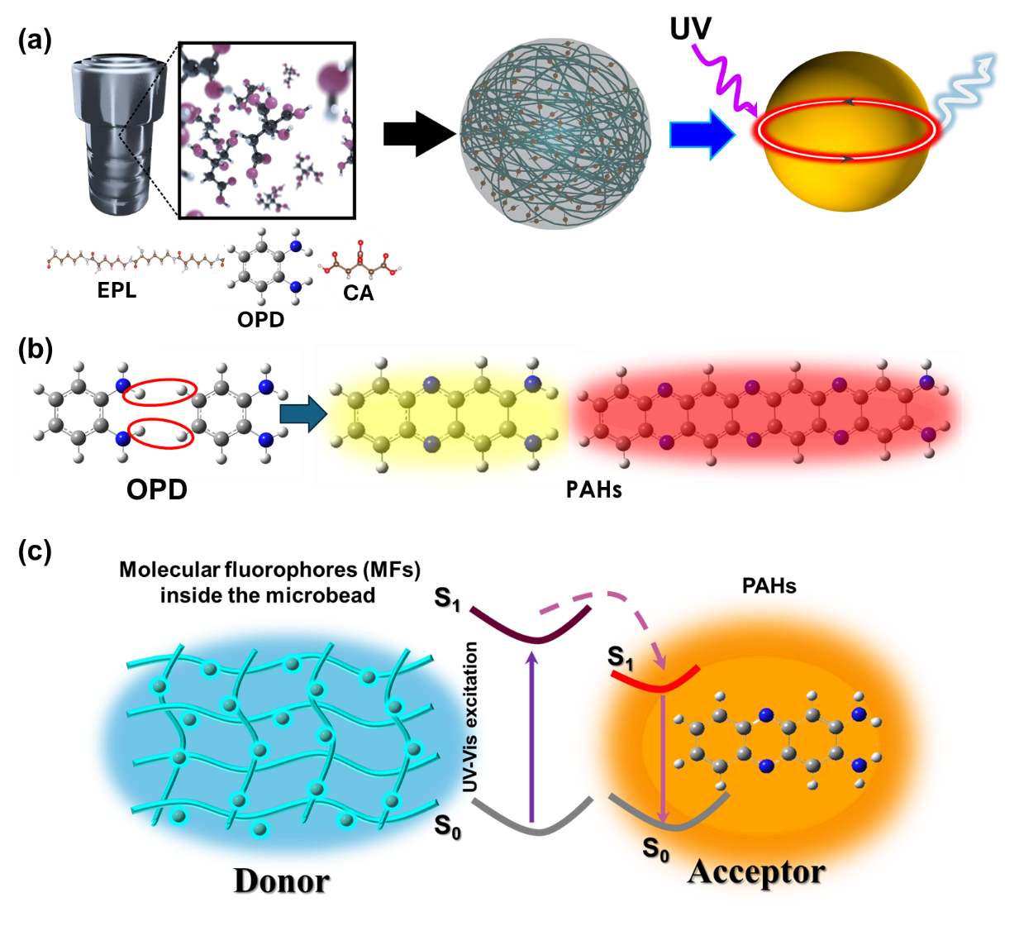
Results and Discussion
Figure 1. (a) Schematic presentation of in situ formed PAHs inside the microcavity, along with the corresponding WLE and WGM emission. (b) Proposed mechanism of the formation of polycyclic aromatic hydrocarbons (PAHs) via reactions involving OPD inside the microcavity. (c) Energy transfer mechanism of single component WLE from microbead to acceptor PAHs.

We developed a petrochemical-free, crosslinking-assisted inbuilt microcavity architecture composed of single-component WLE fluorescent carbonized polymer microspheres (WCPM-OPD1) via a hydrothermal reaction between natural peptide of EPL and CA in the presence of OPD (Figure 1a). During the hydrothermal process, the EPL and CA formed light-yellow colored CPMs (YCPMs) exhibited strong ultraviolet absorption accompanied by broad cyan emission under UV excitation.²⁴ In the presence of OPD, in situ formation of yellow-to-red-emissive polycyclic aromatic hydrocarbons (PAHs) within the microspherical architecture enabled efficient energy transfer inside the built-in microcavity, resulting in single-component WLE. This process simultaneously extended both the absorption and emission toward longer wavelengths (Figure 1b, c) and induced excitation-wavelength-dependent emission spanning the Vis–NIR region.²⁵ Owing to the intrinsic microcavity architecture and excitation-dependent emission characteristics, the emitted light is confined and resonantly amplified within individual microspheres due to WGMs emissions with color-adaptable optical resonances.

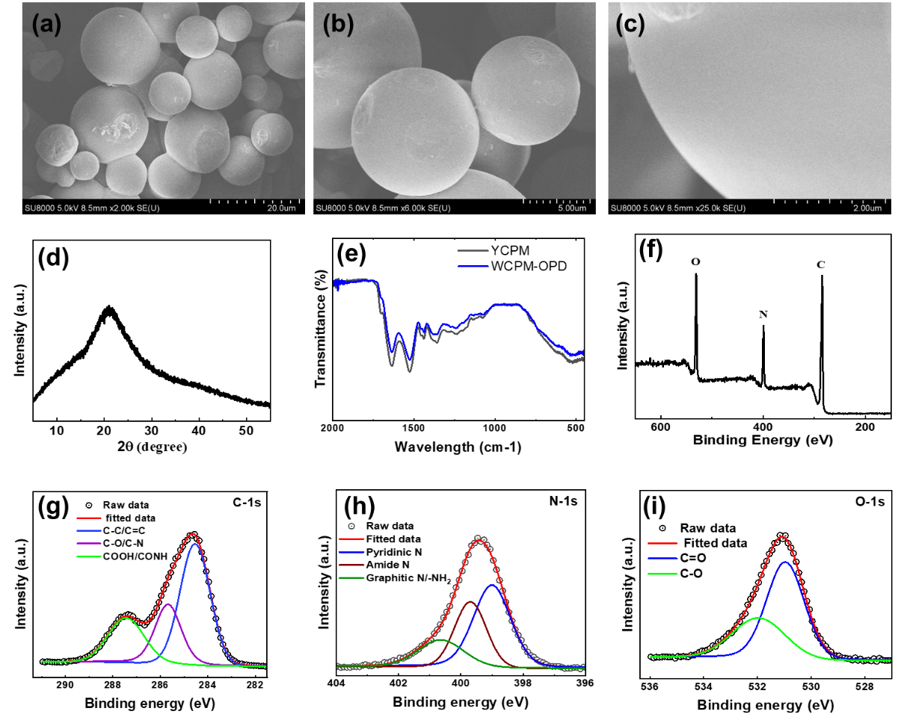
Figure 2. (a-c) Low- and high-magnification SEM images of WCPM-OPD1. (d) XRD pattern of WCPM-OPD1. (e) Comparison of FTIR spectra of YCPM and WCPM-OPD1. (f) XPS survey spectrum of WCPM-OPD1. (g-h) Deconvoluted high-resolution XPS (HRXPS) spectra of C 1s, N 1s, and O 1s for WCPM-OPD1.

The low and high magnification SEM images of WCPM-OPD1 and WCPM-OPD2 reveal well-defined microspherical morphologies with a size distribution of approximately 5–15 μm (Figure 2a, b and Figure S1), which is comparable to that of YCPM (Figure S2). High-magnification SEM images further indicate that the surfaces of the YCPM microspheres are smooth and uniform, a critical requirement for achieving efficient WGM–based optical resonances (Figure 2c).¹⁶ Powder X-ray diffraction (XRD) patterns exhibit a broad diffraction peak centered at 2θ ≈ 20°, characteristic of amorphous polymeric structures formed via the crosslinking reaction between EPL and CA (Figure 2d).²⁶ The ATR-FTIR spectra of YCPM and WCPM-OPD1 display nearly identical vibrational features, strongly suggesting that the fundamental microspherical framework originates from the EPL-CA crosslinked network, while the OPD-derived PAHs are confined within the microstructures (Figure 2e).¹⁰ The microspheres exhibit a high density of functional groups, including C–C, C–H, C–N, C–O, and C=O moieties. X-ray photoelectron spectroscopy (XPS) survey spectra were collected to determine the elemental composition of WCPM-OPD1, confirming the presence of carbon, nitrogen, and oxygen (Figure 2f). Quantitative analysis yields atomic percentages of 68.8% (C), 13.95% (N), and 19.25% (O). The HRXPS spectra were subsequently deconvoluted to elucidate the surface chemical states. The C 1s spectrum of WCPM-OPD1 comprises three components centered at 284.6 eV (C–C/C=C), 285.6 eV (C–O/C–N), and 287.6 eV (COOH/CONH) (Figure 2g).²⁷ The high-resolution N 1s spectrum exhibits three dominant peaks at 398.9, 399.9, and 400.9 eV, which can be attributed to pyridinic nitrogen, amide/amine nitrogen, and –NH₂/graphitic nitrogen species, respectively (Figure 2h).²⁸ Furthermore, the deconvoluted O 1s spectra of both CPM and WCPM display two prominent peaks at approximately 531 and 532 eV, corresponding to distinct oxygen-containing functional groups (Figure 2i).²⁹ Solid-state 13C and 15N NMR measurements were performed to further investigate the chemical environments and internal structure of the WCPM-OPD2 microspheres. The internal structure of WCPM-OPD2 was analysed by 13 C and 15 N solid-state NMR (ssNMR) as depicted in Figure S3 (a-c). In the 13C CP/MAS spectra, we observed an enhancement of the signals at about 29 and 39.5 ppm, which can be attributed to sp³-CH₂ groups, and a broad resonance at about 173 ppm, assigned to amide carbonyls, confirming the cross-linking between ─COOH groups from CA and ─NH₂ groups from EPL. The broad signals at 115–160 ppm are indicative of sp2-aromatic carbon species, suggesting in situ formation of PAH-like structures within the microcavities. The 15N spectrum shows a broad signals at ~200, 262, and 343 ppm assignable to graphitic, amide, pyridinic or primary amine N species, respectively. These ssNMR results are consistent with the formation of PAH and its role in the appearance of NIR emission in WCPM-OPD2.
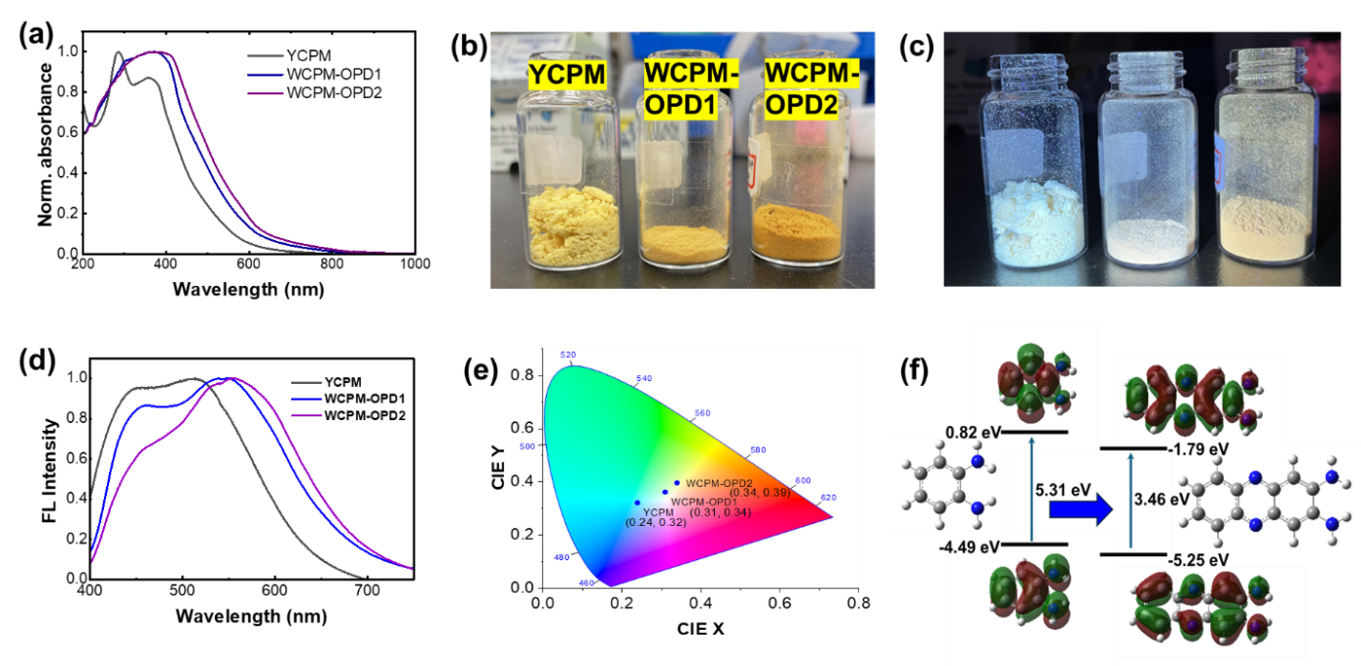
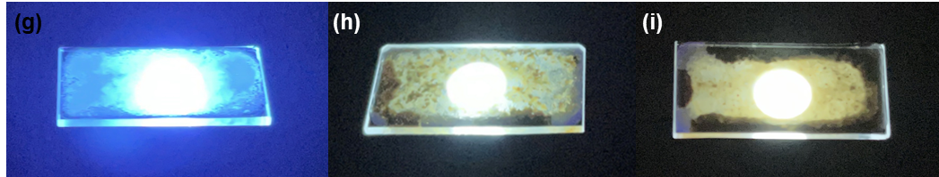
Figure 3. (a) UV–vis absorption spectra. (b, c) Photographs under daylight and UV irradiation (365 nm). (d) Fluorescence (FL) spectra under 360 nm excitation. (e) CIE chromaticity coordinates of YCPM, WCPM-OPD1, and WCPM-OPD2 microbeads. (f) DFT-calculated OPD-derived PAH nanostructures with corresponding HOMO–LUMO energy levels and band diagrams. (g-i) cyan, and WLE from the YCPM@PVA, WCPM-OPD1@PVA, and WCPM-OPD2@PVA based film on 365 nm UV LED light source.
Figure 3 show the optical properties and electronic structure of the microbeads. The UV–vis absorption spectrum of YCPM exhibits strong absorption in the UV region with extended absorption into the visible range, attributed to crosslinking-induced electronic coupling.^{24, 30} Upon incorporation of OPD at two different concentrations (0.04 M and 0.08 M) during the reaction, the absorption spectra progressively red-shift toward the visible region and extend into the near-infrared (NIR) region, indicating the formation of conjugated polycyclic aromatic hydrocarbon (PAH) domains within the microbeads.³¹ Photographs taken under daylight and UV irradiation (365 nm) (Figure 3b,c) demonstrate the emergence of single-component white-light emission (WLE) from WCPM-OPD1 and WCPM-OPD2 in contrast to YCPM, reflecting systematic compositional and structural modulation from YCPM to OPD-incorporated microbeads. The fluorescence (FL) spectra recorded under 360 nm excitation (Figure 3d) show competitive emission behaviour. YCPM exhibits bright cyan emission with peaks at ~460 nm, originating from citrazinic acid–based molecular fluorophores, and at ~ 510 nm, attributed to crosslinking-enhanced emission (CEE) mediated by heteroatoms (O and N).³² In contrast, in situ OPD incorporation leads to the formation of multiple emissive centers associated with heterogeneous π-conjugated PAH domains, resulting in extended emission from the yellow to NIR region. The spectral overlap of these emissive components under UV excitation produces broadband emission and enables single-component WLE from WCPM-OPD1 and WCPM-OPD2 with absolute photoluminescence quantum yields (PLQY) of approximately 15% and 8 %, respectively. The photoluminescence Excitation (PLE) spectra of WCPM-OPD1 also exhibit two absorption bands at 380 nm and 460 nm, corresponding to emission peaks at 460 nm and 550 nm, respectively (Figure S4). The emission colour evolution is quantitatively summarized by the CIE chromaticity coordinates (Figure 3e), confirming systematic colour tuning from cyan emission for YCPM (0.24, 0.32) to white-light emission for WCPM-OPD1 (0.31, 0.34) and WCPM-OPD2 (0.34, 0.39), indicative of direct single-component WLE.³³ Density functional theory (DFT) calculations (Figure 3f) further support the experimental observations, revealing OPD-derived PAH nanostructures with reduced HOMO–LUMO gaps from 5.41 to 3.46 eV.³⁴ The calculated energy band diagrams indicate enhanced electronic delocalization, accounting for the observed, red-shifted absorption and broadband emission behaviour. Figure 3g–i show cyan and WLE from YCPM@PVA, WCPM-OPD1@PVA, and WCPM-OPD2@PVA polymer composite films, respectively, under 365 nm UV LED excitation, demonstrating tenable emission colors and efficient down-conversion in solid-state film configurations.

Figure 4. (a) Comparative emission spectra of individual YCPM and WCPM-OPD1, OPD2 microbeads under 355 nm laser excitation, together with the corresponding μ-PL images. (b, c) Excitation-wavelength-dependent VIS-NIR emission behavior of a WCPM-OPD1 microbead using different laser excitations, with corresponding μ-PL images. (d) WGM mode yellow-to-red emission spectra of WCPM-OPD1 microbeads excited by a 532 nm laser. (inset shows FSR of WGM mode emission). (e) Diameter dependent WGM emission from WCPM-OPD1 microbeads with different diameters under 532 nm laser excitation, along with the corresponding μ-PL images. (f) Photostability of a single microbead under prolonged laser irradiation.

Figure 4a shows the emission properties of a single microbead of different sample and corresponding μ-PL. Under 355 nm excitation, individual WCPM-OPD1, 2 shows board visible light emission compared to the YCPM indication WLE emission from WCPM-OPD microbeads. The CIE coordinates also indicates corresponding WLE from the WCPM-OPD microbeads (Figure S5). Figure 4 b, c shows the excitation wavelength dependent emission from WCPM-OPD1 microbead by varying excitation wavelength by different excitation laser from 355 nm 470 nm, 532 nm, 785 nm which indicates broad emission from visible to NIR emission by changing the excitation wavelength. The emission of WCPM-OPD1 spanning the visible to near-infrared region is strongly excitation-wavelength dependent, indicating efficient multicolour luminescence arising from multiple emissive centers within a single microbead, attributed to the formation of diverse PAH species (Figure 4b).^{35, 36} Under 532 nm excitation, WCPM-OPD1 exhibits markedly enhanced yellow-to-red emission compared to YCPM, evidencing the generation of lower-energy emissive states induced by pyrazine-based PAHs (Figure 4c).³⁷ Notably, sharp and periodic resonance peaks emerge in the emission spectra of WCPM-OPD1 microbeads under edge excitation, originating from WGM resonances (Figure 4d). These resonances result from repeated total internal reflection (TIR) of internally generated photons along the microbead perimeter, leading to constructive interference at discrete wavelengths, consistent with light confinement observed in the μ-PL images.³⁸ Figure 4e shows the diameter dependent WGM emission and corresponding μ-Pl images. The linear dependence between λ²/Δλ and microbead diameter further confirms the WGM origin of the observed resonances (Figure S6).^{39, 40} The microbeads exhibit excellent photostability under prolonged laser irradiation, underscoring their suitability for practical photonic applications (Figure 4f).
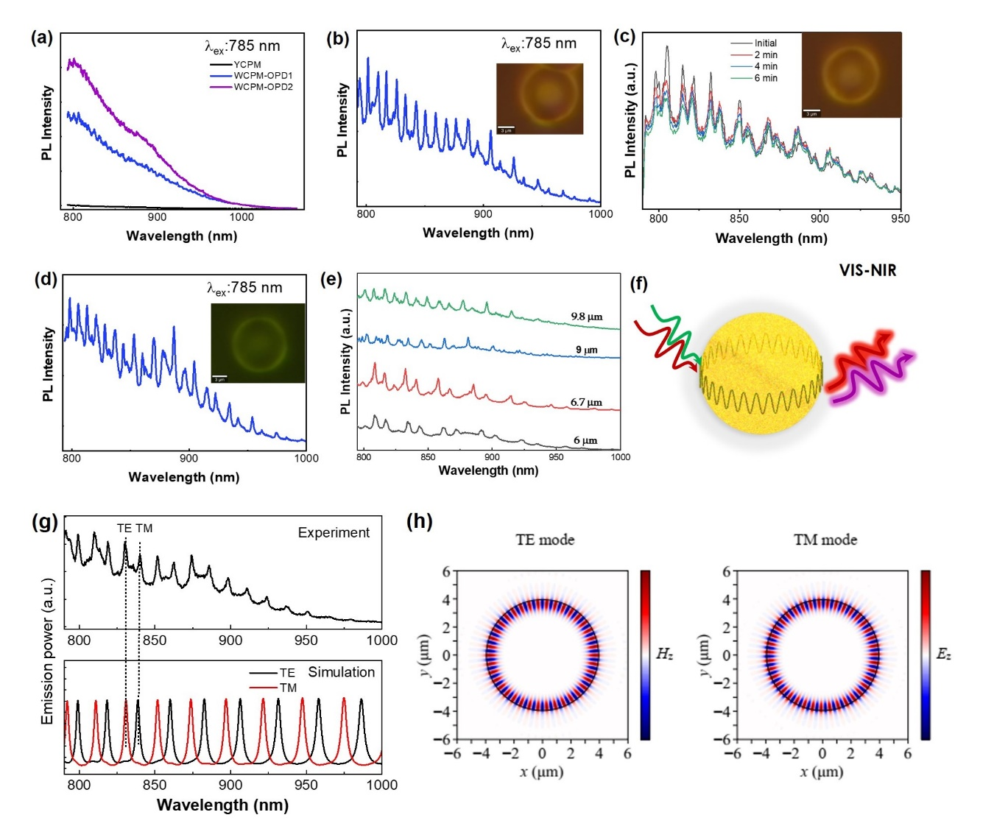Figure 5 a) comparison of NIR emission from the YCPM, WCPM-OPD1, WCPM-OPD2 microbeads. b) NIR WGM emission from a single WCPM-OPD1 microbead. (c) Stability of the microbeads under prolong 785 nm NIR laser excitation. Inset show optical image of the corresponding microbeads. (d) NIR WGM emission of WCPM2-OPD2. (e) diameter depended on NIR WGM emission. f) Schematic representation of VIS-NIR WGM emission. (g) Experimental (top) and simulated (bottom) WGM emission spectra at NIR wavelength region. (h) electromagnetic field distributions of TE and TM resonances in the NIR wavelength region.
Owing to the formation of extended π-conjugated PAHs domains within the microcavity, individual WCPM-OPD1 and 2 microbeads exhibit NIR emission under 785 nm excitation, as shown in Figure 5a with broad emission up to 1000 nm. Figure 5b displays the NIR whispering WGM emission spectrum from a single WCPM-OPD1 microbead, revealing well-resolved WGM resonant emission peaks in the NIR region. The photostability of the microbead under prolonged 785 nm laser irradiation with only slight intensity degradation (Figure 5c); the inset presents the corresponding optical image after excitation. The WCPM-OPD2 also shows WGM emission from individual microbeads by their edge excitation (Figure 5d). The WGM emission is strongly dependent on the diameter of the microbeads (Figure 5e). Figure 5f schematically illustrates the visible-NIR WGM emission mechanism. Upon optical excitation, the emitted light is confined within the spherical microcavity through continuous total internal reflection at the interface. This confined light undergoes constructive interference, giving rise to multiple high-quality resonant modes across the visible to NIR region. The WGM-assisted light confinement and corresponding field profiles at the NIR spectral region were simulated using the finite-difference time-domain (FDTD) method. The simulated WGM resonances in NIR wavelength regions, along with background emissions from 7.9-μm WCPM-OPD1 microbeads, were analyzed. The simulated spectra exhibit strong agreement with the experimentally measured emission spectra obtained under 785 nm laser excitation (Figure 5g). These results confirm the presence of both TE and TM modes within the microbeads due to the strong light confinement. Figure 5h shows the mode profiles at WGM resonance peaks showing the Hz field distribution for the TE mode and the Ez field distribution for the TM mode, respectively. These profiles highlight the fundamental TE and TM mode characteristics with a radial mode number of 1. The spectral mode separation of simulated spectra also varies non-uniformly with cavity size due to the diameter-dependent shift in the optical path length, which alters the modal dispersion characteristics for each WGM family. The variation in optical path lengths (microcavity diameter) for TE and TM modes naturally leads to differences in mode separation, resulting in nonuniform spectral spacing of the resonant peaks (Figure S7). As the microbead diameter increases in both the experiment and simulated spectra (Figure 5e and Figure S7), the effective optical path length becomes longer, leading to a reduction in the FSR, consistent with the inverse relationship between FSR and cavity size (Figure S8). By varying the excitation wavelength, different emissive states are preferentially activated, enabling multimode resonant emission with tuneable spectral characteristics.
Conclusion
In summary, we have developed a rare-earth- and metal-free CPM architecture that enables efficient single-component WLE together with excitation-tunable WGM–assisted photonic behavior spanning the visible to NIR wavelength region. The smooth spherical microspheres, synthesized via a hydrothermal crosslinking reaction of natural peptide EPL and small molecules CA, act as intrinsic optical microcavities while hosting heterogeneous emissive states. Controlled incorporation of ortho-phenylenediamine induces the in situ formation of phenazine-like polycyclic aromatic hydrocarbon domains with extended π-conjugation, leading to broadband emission and effective energy transfer within a single material system. The coexistence of WLE, excellent photostability, and amplified spontaneous emission governed by WGM resonances highlights the multifunctionality of this platform. This work provides a versatile strategy for integrating lighting and photonic functionalities in metal-free materials and offers a promising pathway toward sustainable solid-state lighting, optical encoding, sensing, and integrated photonic devices.
Acknowledgements
This work was financially supported by the JSPS-Kakenhi research grant (grant number 24K17589). Authors acknowledge Dr. K. Shinozaki, for fruitful discussions and budgetary supports from Japan Aerospace Exploration Agency (JAXA).
Reference
1. S. Pimputkar, J. S. Speck, S. P. DenBaars and S. Nakamura, Nature photonics, 2009, 3, 180-182.
2. E. F. Schubert and J. K. Kim, Science, 2005, 308, 1274-1278.
3. S. Reineke, F. Lindner, G. Schwartz, N. Seidler, K. Walzer, B. Lüssem and K. Leo, Nature, 2009, 459, 234-238.
4. P. Pust, P. J. Schmidt and W. Schnick, Nature materials, 2015, 14, 454-458.
5. N. C. George, K. A. Denault and R. Seshadri, Annual Review of Materials Research, 2013, 43, 481-501.
6. S. Ye, F. Xiao, Y. Pan, Y. Ma and Q. Zhang, Materials Science and Engineering: R: Reports, 2010, 71, 1-34.
7. L.-X. Guo, Y.-B. Xing, M. Wang, Y. Sun, X.-Q. Zhang, B.-P. Lin and H. Yang, Journal of Materials Chemistry C, 2019, 7, 4828-4837.
8. W. Zhao, Z. He and B. Z. Tang, Nature Reviews Materials, 2020, 5, 869-885.
9. X. D. Chen, W. Xin, W. S. Jiang, Z. B. Liu, Y. Chen and J. G. Tian, Advanced Materials, 2016, 28, 2563-2570.
10. S. N. Baker and G. A. Baker, Angewandte Chemie International Edition, 2010, 49, 6726-6744.
11. S. Y. Lim, W. Shen and Z. Gao, Chemical Society Reviews, 2015, 44, 362-381.
12. S. Zhu, J. Zhang, S. Tang, C. Qiao, L. Wang, H. Wang, X. Liu, B. Li, Y. Li and W. Yu, Advanced Functional Materials, 2012, 22, 4732-4740.
13. C.-S. Wang, L. Wei, C. Fu, X.-H. Wang and C.-J. Wang, Organic letters, 2021, 23, 7401-7406.
14. S. Tao, S. Lu, Y. Geng, S. Zhu, S. A. Redfern, Y. Song, T. Feng, W. Xu and B. Yang, Angewandte Chemie International Edition, 2018, 57, 2393-2398.
15. F. Yuan, T. Yuan, L. Sui, Z. Wang, Z. Xi, Y. Li, X. Li, L. Fan, Z. a. Tan and A. Chen, Nature communications, 2018, 9, 2249.
16. K. J. Vahala, nature, 2003, 424, 839-846.
17. D. Armani, T. Kippenberg, S. Spillane and K. Vahala, Nature, 2003, 421, 925-928.
18. B. K. Barman, K. Watanabe and T. Nagao, Advanced Optical Materials, 2025, 13, 2500822.
19. F. Vollmer and S. Arnold, Nature methods, 2008, 5, 591-596.
20. B. K. Barman, D. Hernández-Pinilla, T. D. Dao, K. Deguchi, S. Ohki, K. Hashi, A. Goto, T. Miyazaki, K. K. Nanda and T. Nagao, ACS Applied Materials & Interfaces, 2024, 16, 22312-22325.
21. B. K. Barman, H. Yamada, K. Watanabe, K. Deguchi, S. Ohki, K. Hashi, A. Goto and T. Nagao, Advanced Science, 2024, 11, 2400693.
22. B. K. Barman, K. Okano, K. Deguchi, S. Ohki, K. Hashi, A. Goto and T. Nagao, ACS Sustainable Chemistry & Engineering, 2022, 10, 16125-16138.
23. B. K. Barman, D. Hernández‐Pinilla, O. Cretu, J. Kikkawa, K. Kimoto and T. Nagao, Advanced Science, 2024, 11, 2407090.
24. S. Tao, C. Zhou, C. Kang, S. Zhu, T. Feng, S.-T. Zhang, Z. Ding, C. Zheng, C. Xia and B. Yang, Light: Science & Applications, 2022, 11, 56.
25. K. Jiang, S. Sun, L. Zhang, Y. Lu, A. Wu, C. Cai and H. Lin, Angewandte chemie, 2015, 127, 5450-5453.
26. S. Tao, T. Feng, C. Zheng, S. Zhu and B. Yang, The journal of physical chemistry letters, 2019, 10, 5182-5188.
27. V. Balakrishnan, V. R. Soma, S. G. Chidambaram and N. A. L. Flower, Journal of Materials Chemistry C, 2025, 13, 16210-16231.
28. V. Balakrishnan, M. R. Kirubalan, A. S. Rajendran, S. G. Chidambaram, V. R. Soma and N. A. Little Flower, ACS Applied Optical Materials, 2024, 3, 188-204.
29. G. Zhou, C. Xu, W. Cheng, Q. Zhang and W. Nie, Journal of analytical methods in chemistry, 2015, 2015, 467242.
30. Y. Wang and A. Hu, Journal of Materials Chemistry C, 2014, 2, 6921-6939.
31. W. Zhang, Y. Liu, G. Lu, Y. Wang, S. Li, C. Cui, J. Wu, Z. Xu, D. Tian and W. Huang, Advanced Materials, 2015, 2923-2929.
32. Y. Song, S. Zhu and B. Yang, RSC advances, 2014, 4, 27184-27200.
33. H. Li, Z. Kang, Y. Liu and S.-T. Lee, Journal of materials chemistry, 2012, 22, 24230-24253.
34. E. Clar, Journal, 1972.
35. S. Qu, X. Wang, Q. Lu, X. Liu and L. Wang, Angewandte Chemie-International Edition, 2012, 51, 12215.
36. S. Zhu, Q. Meng, L. Wang, J. Zhang, Y. Song, H. Jin, K. Zhang, H. Sun, H. Wang and B. Yang, Angewandte Chemie International Edition, 2013, 52.
37. F. Ehrat, S. Bhattacharyya, J. Schneider, A. Löf, R. Wyrwich, A. L. Rogach, J. K. Stolarczyk, A. S. Urban and J. Feldmann, Nano letters, 2017, 17, 7710-7716.
38. A. N. Oraevsky, Quantum electronics, 2002, 32, 377-400.
39. C. Lam, P. T. Leung and K. Young, Journal of the Optical Society of America B, 1992, 9, 1585-1592.
40. K. Hola, Y. Zhang, Y. Wang, E. P. Giannelis, R. Zboril and A. L. Rogach, Nano Today, 2014, 9, 590-603.

