Observation of Fluctuation Spin Hall Effect in Low-resistive Antiferromagnet
Chi Fang^{1,2}‡, Caihua Wan^{1,7}‡, Xiaoyue Zhang^{3,5}, Satoshi Okamoto⁴, Tianyi Ma^{1,3}, Jianying Qin^{1,3}, Xiao Wang¹, Chenyang Guo¹, Jing Dong¹, Guoqiang Yu^{1,7}, Zhenchao Wen⁶, Ning Tang⁵, Stuart S. P. Parkin², Naoto Nagaosa⁹, Yuan Lu^{3*}, Xiufeng Han^{1,7,8*}
¹Beijing National Laboratory for Condensed Matter Physics, Institute of Physics, University of Chinese Academy of Sciences, Chinese Academy of Sciences, Beijing 100190, China
²Max Planck Institute of Microstructure Physics, Halle (Saale) 06120, Germany
³Université de Lorraine, CNRS, Institut Jean Lamour, UMR 7198, campus ARTEM, 2 Allée André Guinier, 54011 Nancy, France
⁴Materials Science and Technology Division, Oak Ridge National Laboratory, Oak Ridge, TN 37831, USA
⁵State Key Laboratory of Artificial Microstructure and Mesoscopic Physics, School of Physics, Peking University, Beijing 100871, China
⁶National Institute for Materials Science (NIMS), Tsukuba, Ibaraki 305-0047, Japan
⁷Songshan Lake Materials Laboratory, Dongguan, Guangdong 523808, China
⁸Center of Materials Science and Optoelectronics Engineering, University of Chinese Academy of Sciences, Beijing 100049, China
⁹RIKEN Center for Emergent Matter Science (CEMS), Wako, 351-0198, Japan.
ABSTRACT: The spin Hall effect (SHE) can generate a pure spin current by an electric current, which is promisingly used to electrically control magnetization. To reduce power consumption of this control, a giant spin Hall angle (SHA) in the SHE is desired in low-resistivity systems for practical applications. Here, critical spin fluctuation near the antiferromagnetic (AFM) phase-transition in Chromium is proved as an effective mechanism to create an additional part of SHE, named as fluctuation spin Hall effect (FSHE). The SHA is significantly enhanced when temperature approaches the Néel temperature (T_{N}) and has a peak value of -0.36 near T_{N}. This value is higher than the room-temperature value by 153% and leads to a low normalized power consumption among known spin-orbit torque (SOT) materials. This study demonstrates the critical spin fluctuation as a prospective way of increasing SHA and enriches the AFM material candidates for spin-orbitronic devices.
KEYWORDS: Spin Hall effect, Spin Fluctuation, Antiferromagnet, Chromium, low power devices

Introduction
The spin Hall effect utilizes spin-orbit coupling to convert a longitudinal charge current $j_{c}$ into a transverse pure spin current $j_{s}$. Owing to the electrical controllability on magnetization by spin-orbit torque (SOT), the SHE shows promising applications in magnetic random-access memory (MRAM)¹⁻³, programmable logic devices^{4,5} and microwave nano-oscillators⁶. SHA ($θ_{SH}$) defined as the ratio between spin Hall conductivity $σ_{SH}$ and longitudinal conductivity $σ$ is a parameter characterizing the efficiency of transforming a charge current to a spin current. Companied by the factor of high $σ$, $θ_{SH}$ is the key factor to reduce writing power and achieve high efficiency of SOT devices⁷. Thus, it is appealing to develop materials and/or explore physics to improve $θ_{SH}$ in low-resistive systems^{8,9}.
The microscopic mechanisms behind the SHE can be categorized into three pictures, the intrinsic one due to the nontrivial Berry curvatures of electronic band structures and the other two extrinsic ones, the side-jump (sj) and skew-scattering (ss) mechanisms⁸. Inspired by the mechanisms, several effective means have been explored to enhance the SHA, such as adopting heavy elements¹⁰⁻¹⁵, electronic structure engineering¹⁶⁻¹⁸, doping^{7,19,20}, interface decoration²¹ and superlattice stacking²².
Distinguished from the SHE in normal metals, here, the fluctuation spin Hall effect (FSHE) is merely relevant to the extrinsic mechanisms since only fluctuation of spin lattice activated thermally is involved, which can evidence the significance of the extrinsic mechanisms to the overall SHE. FSHE is attributed to the combinations of several individual scattering processes between conduction electrons and local spins as explained in Discussion, instead of a single process accounting for the SHE. These involved local spins are needed to stay correlated within a certain correlation length as shown in Figure 1a, which thus makes the FSHE process temperature-sensitive, especially at the critical point of phase change.
Recently, critical spin fluctuation in magnetically-ordered systems at their magnetic phase transition temperatures T_{C} was reported to nontrivially result in an elevated $θ_{SH}$ by intensifying interaction of delocalized electrons with local spins in ferromagnets²³⁻²⁵¹. For antiferromagnets, Saglam et al.²⁶ evidenced that spin fluctuation of the antiferromagnetic FeMn at its Néel temperature increased $θ_{SH}$ of the Ni₈₀Fe₂₀/FeMn/W trilayer in a spin-pumping experiment. Frangou et al.²⁷ and Xiao et al.²⁸ addressed the key role of spin fluctuation in enhancement of transmission parameter of ferromagnet (FM)/IrMn interface near T_{N}. Although without direct experimental evidence on the contribution to bulk SHE from AFM spin fluctuation, these magnetic systems have clearly hinted the significant role of spin fluctuations to the enhanced SHE phenomenally; however, all the above systems contain interfaces with ferromagnetic films, which lack the simplicity to highlight the bulk SHE from possibly entangled interfacial effects such as the spin mixing conductance, spin memory loss and magnetic proximity effects. An elaborately designed AFM system without any FM/AFM interfaces can promisingly provide a clearer platform to investigate the influence of spin fluctuations on the bulk SHE.
Among antiferromagnets, polycrystalline Cr has already shown sizable $θ_{SH}$ from -0.051 to -0.09 and low resistivity as a candidate SOT source²⁹⁻³¹. Here, we furthermore choose the epitaxial Cr single crystalline films sandwiched by MgO as the AFM material to uncover the FSHE originating from the influence of spin fluctuations on the SHE near its T_{N}. A large $θ_{SH}$ of -0.36 at T = 225 K is demonstrated by measuring inverse spin Hall effect (ISHE) and direct spin Hall effect (DSHE) with the spin Hall tunneling spectrum (SHTS) method for the Cr/MgO/Fe MTJs. The spin Hall resistivity followed a clear power law with T in consistent with the modeled one in FSHE.
Results
Chromium is an itinerant antiferromagnet with collinear spin sublattices and a simple body-centered cubic (bcc) structure. T_{N} of bulk Cr is 311 K and lowerable by reducing thickness. A single 10-nm Cr was deposited on MgO (001) and fabricated into the 4-Probe Bar to determine the T_{N} of Cr. As shown in Figure 1b, the resistivity ρ gained an extra enhancement due to the disorder-induced scattering via spin fluctuation near T_{N}^{32,33}. The differential resistivity ρ respective to T, i.e., ($dρ/dT$) captured this enhancement clearly. As T>212 K, $dρ/dT$ maintained stable platform with a small slope. From 212 K to lower T, $dρ/dT$ began to acquire an extra slope because spin fluctuation scattering was switched on in this case. With further lowering T and freezing the AFM structure, after a peak at 150 K, $dρ/dT$ finally approached to a smaller but stable value due to the decrease in magnon density. This behavior, similar with Ref. 33, indicated T_{N} of Cr was ~212 K. This value is near T_{N}=235 K of the epitaxial 50 nm Cr as reported³³.
To investigate the SHE in Cr, the SHTS setup^{34,35} was adopted. High-quality epitaxial stacks Cr(t)/MgO(2.3)/Fe(10)/Au(5 nm) (t =7, 10, 25, 50 nm) were deposited on MgO (001) substrates by the molecular beam epitaxial growth as shown in Figure 1c (also SI-I). The Fe layer was used as a spin-polarizer of charge current and the Cr layer functioned as a spin-analyzer to convert a spin current into a transverse voltage via the ISHE. Figure 1d and its inset show the magnetic hysteresis loops as the magnetic field H applied along the in-plane [110]_{MgO}, [100]_{MgO} and out-of-plane [001]_{MgO} directions by vibrating sample magnetometer (VSM). The loops verified the in-plane easy-axis along the [110]_{MgO} direction. This epitaxial relation contributed to the born magnetic easy-axis of Fe and the AFM ordering of Cr along the [110]_{MgO} direction owing to the magnetocrystalline anisotropy.
The raw stacks were fabricated into 6$×$6 μm² MTJs with one top electrode and three bottom ones (Figure 2a) with standard ultraviolet lithography and ion-beam etching process. The junction is surrounded by oxide SiO₂ or Al₂O₃ to isolating top electrode and bottom electrodes. Before measurement, a magnetic field cooling along [110]_{MgO} to align spin moment in Cr with magnetization in Fe, i.e., M_{Fe}. For detecting the ISHE as shown in Figure 2b, an ac current J was injected between Electrodes 1 and 3 (Figure 2b inset) with amplitude of 20-50 μA and frequency of 8.3 Hz by Keithley 6221 and voltage is detected with a lock-in amplifier SR830 as samples placed in fixed magnetic field and temperature conditions. Only the first harmonic signals are picked-up to disentangle with any thermoelectric artifacts. A preamplifier SR560 is used to improve signal-to-noise ratio. As the M_{Fe} stayed along [110]_{MgO}, the injected current was spin-polarized along [110]_{MgO} before electrons tunneled through the MgO barrier and entered into Cr. SHE in Cr led to the transverse scattering of the tunneling spin current along the [$\overline{1}$10]_{MgO} direction so that an electric field between Electrode 2 and 4 was built as $V_{ISHE}∝θ_{SH}\left(j_{s}×s\right)$. $j_{s}(s$) indicates the flowing direction of the spin current along the film normal (spin-polarized direction determined by M_{Fe}). When H was in-plane and parallel or antiparallel to [110]_{MgO}, $\left(j_{s}×s\right)$ as well as ($dV_{ISHE}/dJ$) reached its positive or negative maximum whose absolute value was $R_{ISHE}$. When the H direction fixed, $R_{ISHE}$ measured in Cr had the same (opposite) sign as in Ta (Pt), indicating Cr has a negative $θ_{SH}$. This observation accorded with the previous reports^{29,30,34}.
To observe the FSHE, we performed the SHTS measurement at different T from 50 K to 300 K with an interval of 25 K. The extracted $R_{ISHE}$ values were plotted in Figure 2d. Below the critical point 212 K, $R_{ISHE}$ increased rapidly as elevating T. Above 212 K, $R_{ISHE}$ was reduced as increasing T further. T_{max} where $R_{ISHE}$ was maximized was almost identical to T_{N}. This enhancement behavior in the temperature dependence is also observed in other samples (SI-II). To eliminate any possible contributions from the spin transport artifacts in Fe, we also adopted the direct spin Hall effect (DSHE)³⁵ setup for the same device (Figure 2c). In the DSHE measurement, a current was applied between Electrode 2 and 4, which produced a spin accumulation at the Cr/MgO interface. A DSHE voltage $V_{DSHE}$ was then detected by the Fe electrode because of the spin accumulation at the Cr/MgO interface. The magnitude of $V_{DSHE}$ is then proportional to M_{Fe}^{36,37}. $V_{DSHE}$ and thus $R_{DSHE}={\left(dV_{DSHE}/dJ\right)}_{max}$ across the MTJ was collected between Electrode 1 and 3 to evaluate the SHE (Figure 2c inset). In this setup, no current flowed through the Fe layer, so $V_{DSHE}$ had no chances to be involved with any magnetotransport artifacts in Fe. The T-dependence of $R_{DSHE}$ also showed an enhancement around 200 K, coinciding with the ISHE result. Both T-dependence indicated an enhancement of SHE near T_{N} of Cr, which was attributed to the enhanced fluctuation of local spins near T_{N} as quantitively analyzed below.
For the same spin polarizer and setup, ($dV_{ISHE}/dJ$) depends on intrinsic properties of the spin analyzer material, which enables the SHTS to characterize spin Hall materials²⁶. To qualify the enhancement, we calculated $θ_{SH}$ at different T. $θ_{SH}$ can be deduced from Equation (1) given by Liu et al.³⁵.
$R_{ISHE}={\left(\frac{dV_{ISHE}}{dJ}\right)}_{max}=\frac{θ_{\text{SH}}Pρ}{w}⋅\frac{λ_{\text{s}}}{t}⋅\tanh{(}t/2λ_{\text{s}})$ (1)
where P denotes the spin polarization of FM layer, $λ_{\text{s}}$ is the spin diffusion length of Cr, t and w is the thickness and channel width of Cr layer, respectively. Thus, given the $R_{ISHE}$ values and other parameters, one can estimate $θ_{SH}$ of the Cr layer. To estimate $θ_{SH}$, $λ_{\text{s}}$^{29,30,38} is required and could be derived by fitting:
${wtR}_{ISHE}/(Pρ)=θ_{\text{SH}}λ_{\text{s}}tanh{(}t/2λ_{\text{s}})=A(t)$ (2)
We used the parameters at 300 K to figure out $λ_{\text{s}}$=20.03±1.84 nm (Figure 2e). With this temperature-insensitive $λ_{\text{s}}$, $θ_{\text{SH}}$ could be calculated from the equation (1). For instance, the peak value of averaged $R_{ISHE}$ = 2.74 ± 0.59 mΩ at 225 K of the sample shown here and two more samples (SI-II), P = 0.71 calibrated by the saturation magnetization M_{S} for single crystal Fe/MgO electrode³⁹(SI-I), w = 10 μm, t = 10 nm and ρ = 21.93 μΩ·cm(SI-I and II), so we have |$θ_{\text{SH}}$| = 0.36 ± 0.08. Likely, average |$θ_{\text{SH}}$| = 0.14±0.02 at 300 K. And the |$θ_{\text{SH}}$| in 10 nm Cr device shown here equals to 0.56 ± 0.03 at 200 K and 0.17± 0.03 at 300 K (Figure 2f), whose uncertainty is given by the linear fitting of two resistance platforms(SI-II). The 300 K value is comparable to but higher than the literature values³¹ of -0.051 to -0.09, probably due to no magnetic interface influences here. Moreover, spin fluctuation near T_{N} caused a remarkable SHA enhancement by 153% at 225 K compared to 300 K. The 225 K value has already been comparable to that of heavy metals⁴⁰, inferring Cr can function as an efficient SOT source.
Besides, the Cr film has relatively low resistivity of about 30 μΩ·cm at room temperature, nearly one order of magnitude lower than ~190 μΩ·cm of the β-phase Ta¹⁰ and 100-300 μΩ·cm of the β-phase W¹⁵ systems, which can further improve its energy-efficiency. We adopted the normalized power consumption⁴¹ P_{N} =$ρ/θ_{SH}^{2}$ to evaluate Cr as a SOT material. As shown in Figure 3, Cr has relative low power consumption among reported ones. The P_{N} = 163 µΩ·cm of Cr at 200 K is already as low as comparable to that of topological insulators in the category of the largest spin Hall angle known to date. The detail P_{N} values of other materials are listed in SI-III normalized with assuming same FM and device parameters and thickness of NM within their own λ_{s}. These merits, the large SHA and low resistivity, persist below or around the Néel temperature, which facilitates the use of Cr as a SOT channel material in spin-orbitronics.
Discussion
In theory, taking spin fluctuation near the Curie temperature (T_{C}) into account, Kondo first developed a theory to explain the anomalous Hall effect in ferromagnets⁴¹. It is further generalized to account for the SHE and ISHE by considering the short-range spin-spin interaction⁴³ and the long-range dynamical correlation among localized moments⁴⁴. Okamoto et al.⁴⁴ derived spin Hall conductivity $σ_{SH}^{sj}$ and $σ_{SH}^{ss}$, which predicts the nontrivial SHA enhancement around the ferromagnetic quantum critical point due to the critical spin fluctuations. For the AFM spin fluctuation, while the individual scattering processes $F_{0,1}$, $F_{2}$ and $F_{3}$ (defined in Ref. 44 and schematically shown in Figure 4a) remain the same as the ferromagnetic case, the microscopic mechanisms of the side-jump and skew-scattering contributions (Figure 4a) to the FSHE require further developments⁴⁵ (SI-IV). Schematically, the microscopic details of the two mechanisms consist of three scattering processes: the $F_{0,1}$ process contributes 180º back-scattering of antiparallelly polarized conduction electrons (yellow arrow) with local spins (green arrow); the $F_{2}$ and $F_{3}$ processes result in transverse scattering of electrons depending on the polarization of local spins and scattered electron spins, respectively³². Thus, the sequential scattering due to the $F_{0,1}$ and $F_{2}$ ($F_{3}$) processes gives rise to the transverse spin current, leading to the side-jump (skew-scattering) mechanism in FSHE. Temperature is involved in FSHE processes by two ways: (1) the more dynamical spins, functioning as the local scattering centers, are activated with the increase in T toward the ordering temperature as shown in Figure 1a, and (2) the correlation length ξ between the dynamically-activated local spins increases as T approaches the ordering temperature from above, both of which favors the sequential happening of the $F_{0,1}$ and $F_{2}$ ($F_{3}$) processes in a higher probability. Specifically, one would then expect a clear enhancement of the SHE in an antiferromagnetic system around its Néel temperature at which the correlation length diverges. This hypothesis motivated us to experimentally study the influence of AFM spin fluctuations on the bulk FSHE in the clean Cr/MgO/Fe MTJs by the clear SHTS method, which is also instructive to develop the correspondingly theories on mechanisms of SHE.
To examine the mechanism of the observed SHE, the scaling relation between spin conductivity $σ_{SH}$ and conductivity $σ$ of Cr is plotted in Figure 4b. The scaling relation does not simply follow $σ_{SH}∝constant$ for the side-jump or intrinsic mechanism or $σ_{SH}∝σ$ for the skew-scattering mechanism. A clear transition point emerges around T_{N} rather than a gradual crossover behavior⁴⁶.
Equation (1) showed the main contributing factor to the enhanced $R_{ISHE}$ was $θ_{\text{SH}}$ρ, the spin Hall resistivity. Normally both spin polarization P (SI-I) and the term of $\frac{λ_{\text{s}}}{t}⋅\tanh{(}t/2λ_{\text{s}})$ (SI-II) maintain stable or decrease slightly and monotonically as T increases⁴⁷⁻⁴⁹. The P contribution is calibrated by the M_{s} and the $λ_{\text{s}}$ is kept same as the 300 K value which could at most introduce 2% overestimation of $θ_{\text{SH}}$ or $σ_{SH}$ as $λ_{\text{s}}$ may increases as T decreases. Consequently, these two terms could not account for the significantly rising $R_{ISHE}$ before T_{N}. In Figure 4c we show the T-dependence of |$θ_{\text{SH}}$ρ|. When the skew scattering provides the dominant contribution to the SHE, |$θ_{\text{SH}}$ρ|=|$σ_{SH}/σ^{2}$| serves as an indicator of the SOC strength suggested in Ref. 44. |$θ_{\text{SH}}$ρ| followed a $T^{3.47}$ power law at low T<T_{max} (SI-V). Though it appears similar to the predicted $T^{10/3}$behavior of FM, AFM should have different power laws in theory (SI-IV). Note the $F_{0,1}$ and $F_{2}$ ($F_{3}$) processes also take place in AFM; their co-operational way is different from FM. The long-range dynamical correlation length among localized spins which determines the probability of sequential occurrence of the $F_{0,1}$ and $F_{2}$ ($F_{3}$) processes differ between AFM and FM. These factors jointly result in a different T-power law in Cr from the 10/3 law of the FM critical fluctuation. When considering AFM spin fluctuation, the Kondo model could be generalized to give $σ_{SH}^{ss}/σ^{2}∝ T^{6}$ for the skew-scattering mechanism and $σ_{SH}^{sj}/σ^{2}∝ T^{2}+αT^{4}$for the side-jump mechanism (SI-IV, also see Ref. 50), where $α$ is a constant deduced from the T-dependence of ρ (SI-V). Both models could give a good fit to the experimental data, as shown in Figure 4c; however, the side-jump mechanism gives a higher fitting confidence, which may more possibly dominate the FSHE here.
Above T_{N}, the AFM spin texture of Cr is no longer stable. On the other hand, the electron-phonon and electron-electron interactions that weakly depend on spins gradually dominate the T-dependence of momentum relaxation process with a T⁵ law^{51,52} and T² law⁵³, respectively. These spin-irrelevant processes contribute more to momentum-relaxation scatterings than the spin fluctuation mechanism. As a natural result, $θ_{\text{SH}}$ρ inclined to decrease gradually.
Conclusion
In conclusion, we investigated the bulk spin Hall angles and its temperature dependence of Cr in Cr/MgO/Fe fully epitaxial MTJs without a direct contact between Cr and Fe. Critical spin fluctuation enhancement of $θ_{\text{SH}}$ to -0.36 in Cr by 153% near T_{N} = 212 K than 300 K was observed. The dependence of $θ_{\text{SH}}$ρ on T before T_{N} was experimentally measured and fitted with the modeled T- dependence of the AFM spin fluctuation. This effective mechanism of increasing spin Hall angles can be instructive to design antiferromagnets with much larger spin Hall angles and low resistivity, and further advance AFM applications in SOT devices.

ASSOCIATED CONTENT
Sample preparation and characterization; Original data of ISHE and DSHE with in-plane field, ISHE and DSHE with out-of-plane field, ISHE with different Cr thickness or measuring current, Exaction of R_{ISHE} or R_{DSHE}, Data from other devices, Shunting factor and Temperature dependence of spin Hall conductivity; Normalized Power Consumption; Theoretical consideration on the SHE by AFM spin fluctuation; Theoretical consideration on the SHE by AFM spin fluctuation; Fitting details of resistivity and spin Hall resistivity
AUTHOR INFORMATION
Corresponding Author
* Yuan Lu, yuan.lu@univ-lorraine.fr
* Xiufeng Han, xfhan@iphy.ac.cn
Author Contributions
‡These authors contributed equally.
C. F. and C. W. conceived and designed the experiment. S. O. and N. N. provided the theoretical analysis. Y. L., X. Z., T. M. and J. Q. grew the single crystal films. C. F., X. W., C. G. and J. D. carried out the VSM and TEM characterization. C. F. and C. W. fabricated the devices and conducted the electrical measurement. G. Y., Z. W., N. T., S. S. P. P. and N. N. gave suggestions on the experiments and modeling. Y. L., X. H. supervised this study. All authors discussed the results and prepared the manuscript.
Notes
The authors declare no competing financial interest. The data that support the findings of this study are available from the corresponding author upon reasonable request.

ACKNOWLEDGMENT
This work was supported by the National Key Research and Development Program of China (MOST) (Grant No. 2021YFB3601302), the National Natural Science Foundation of China (NSFC) (Grant Nos. 51831012, 51620105004, and 11974398), the Strategic Priority Research Program (B) of Chinese Academy of Sciences (CAS) (Grant Nos. XDB33000000). C. H. Wan appreciates financial support from the Youth Innovation Promotion Association, CAS (Grant No. 2020008). The research by S.O. was supported by the U.S. Department of Energy, Office of Science, Basic Energy Sciences, Materials Sciences and Engineering Division. N.N. was supported by JST CREST Grant Number JPMJCR1874, Japan, and JSPS KAKENHI Grant number 18H03676. Y. Lu acknowledges the support of the joint French National Research Agency (ANR)-National Natural Science Foundation of China (NSFC) SISTER Project (Grants No. ANR-11-IS10-0001 and No. NNSFC 61161130527), ANR FEOrgSpin project (Grant No. ANR-18-CE24-0017), ANR SIZMO2D project (Grant No. ANR-19-CE24-0005) and ICEEL SHATIPN projects. The sample growth was performed using equipment from the platform TUBE-Davm funded by FEDER (EU), ANR, the Region Lorraine and Grand Nancy.

REFERENCES
(1) Yu, G.; Upadhyaya, P.; Fan, Y.; Alzate, J. G.; Jiang, W.; Wong, K. L.; Takei, S.; Bender, S. A.; Chang, L.-T.; Jiang, Y.; et al. Switching of perpendicular magnetization by spin-orbit torques in the absence of external magnetic fields. Nat. Nanotechnol. 2014, 9 (7), 548
(2) Fukami, S.; Zhang, C.; DuttaGupta, S.; Kurenkov, A.; Ohno, H. Magnetization switching by spin-orbit torque in an antiferromagnet-ferromagnet bilayer system. Nat. Mater. 2016, 15 (5), 535
(3) Oh, Y.-W.; Baek, S.-H. C.; Kim, Y. M.; Lee, H. Y.; Lee, K.-D.; Yang, C.-G.; Park, E.-S.; Lee, K.-S.; Kim, K.-W.; Go, G.; et al. Field-free switching of perpendicular magnetization through spin-orbit torque in antiferromagnet/ferromagnet/oxide structures. Nat. Nanotechnol. 2016, 11 (10), 878
(4) Wan, C.; Zhang, X.; Yuan, Z.; Fang, C.; Kong, W.; Zhang, Q.; Wu, H.; Khan, U.; Han, X. Programmable Spin Logic Based on Spin Hall Effect in a Single Device. Adv. Electron. Mater. 2017, 3 (3), 1600282
(5) Wang, X.; Wan, C.; Kong, W.; Zhang, X.; Xing, Y.; Fang, C.; Tao, B.; Yang, W.; Huang, L.; Wu, H.; et al. Field-Free Programmable Spin Logics via Chirality-Reversible Spin-Orbit Torque Switching. Adv. Mater. 2018, 30 (31), 1801318
(6) Liu, L.; Pai, C.-F.; Ralph, D. C.; Buhrman, R. A. Magnetic Oscillations Driven by the Spin Hall Effect in 3-Terminal Magnetic Tunnel Junction Devices. Phys. Rev. Lett. 2012, 109 (18), 186602
(7) Zhu, L.; Ralph, D. C.; Buhrman, R. A. Highly Efficient Spin-Current Generation by the Spin Hall Effect in Au_{1-x}Pt_{x}. Phys. Rev. Appl. 2018, 10 (3), 031001(R)
(8) Sinova, J.; Valenzuela, S. O.; Wunderlich, J.; Back, C. H.; Jungwirth, T. Spin Hall effects. Rev. Mod. Phys. 2015, 87 (4), 1213
(9) Hoffmann, A. Spin Hall Effects in Metals. Ieee Transactions on Magnetics 2013, 49 (10), 5172-5193
(10) Liu, L.; Pai, C.-F.; Li, Y.; Tseng, H. W.; Ralph, D. C.; Buhrman, R. A. Spin-Torque Switching with the Giant Spin Hall Effect of Tantalum. Science 2012, 336 (6081), 555-558
(11) Gomez, J. E.; Tedlla, B. Z.; Alvarez, N. R.; Alejandro, G.; Goovaerts, E.; Butera, A. Spin transport parameters in Ni₈₀Fe₂₀/Ru and Ni₈₀Fe₂₀/Ta bilayers. Phys. Rev. B 2014, 90 (18), 184401
(12) Ando, K.; Takahashi, S.; Harii, K.; Sasage, K.; Ieda, J.; Maekawa, S.; Saitoh, E. Electric manipulation of spin relaxation using the spin Hall effect. Phys. Rev. Lett. 2008, 101 (3), 036601
(13) Liu, L.; Moriyama, T.; Ralph, D. C.; Buhrman, R. A. Spin-Torque Ferromagnetic Resonance Induced by the Spin Hall Effect. Phys. Rev. Lett. 2011, 106 (3), 036601
(14) Guo, G. Y.; Murakami, S.; Chen, T. W.; Nagaosa, N. Intrinsic spin Hall effect in platinum: First-principles calculations. Phys. Rev. Lett. 2008, 100 (9), 096401
(15) Pai, C.-F.; Liu, L.; Li, Y.; Tseng, H. W.; Ralph, D. C.; Buhrman, R. A. Spin transfer torque devices utilizing the giant spin Hall effect of tungsten. Appl. Phys. Lett. 2012, 101 (12),
(16) Wu, H.; Zhang, P.; Deng, P.; Lan, Q.; Pan, Q.; Razavi, S. A.; Che, X.; Huang, L.; Dai, B.; Wong, K.; et al. Room-Temperature Spin-Orbit Torque from Topological Surface States. Phys. Rev. Lett. 2019, 123 (20), 207205
(17) Han, J.; Richardella, A.; Siddiqui, S. A.; Finley, J.; Samarth, N.; Liu, L. Room-Temperature Spin-Orbit Torque Switching Induced by a Topological Insulator. Phys. Rev. Lett. 2017, 119 (7), 077702
(18) Mellnik, A. R.; Lee, J. S.; Richardella, A.; Grab, J. L.; Mintun, P. J.; Fischer, M. H.; Vaezi, A.; Manchon, A.; Kim, E. A.; Samarth, N.; et al. Spin-transfer torque generated by a topological insulator. Nature 2014, 511 (7510), 449
(19) Gradhand, M.; Fedorov, D. V.; Zahn, P.; Mertig, I. Spin Hall angle versus spin diffusion length: Tailored by impurities. Phys. Rev. B 2010, 81 (24), 245109
(20) Niimi, Y.; Morota, M.; Wei, D. H.; Deranlot, C.; Basletic, M.; Hamzic, A.; Fert, A.; Otani, Y. Extrinsic Spin Hall Effect Induced by Iridium Impurities in Copper. Phys. Rev. Lett. 2011, 106 (12), 126601
(21) Qiu, X.; Narayanapillai, K.; Wu, Y.; Deorani, P.; Yang, D.-H.; Noh, W.-S.; Park, J.-H.; Lee, K.-J.; Lee, H.-W.; Yang, H. Spin–orbit-torque engineering via oxygen manipulation. Nat. Nanotechnol. 2015, 10 (4), 333-338
(22) Zhu, L.; Li, J.; Zhu, L.; Xie, X. Boosting Spin-Orbit-Torque Efficiency in Spin-Current-Generator/Magnet/Oxide Superlattices. Phys. Rev. Appl. 2022, 18 (6), 064052
(23) Wei, D. H.; Niimi, Y.; Gu, B.; Ziman, T.; Maekawa, S.; Otani, Y. The spin Hall effect as a probe of nonlinear spin fluctuations. Nat. Commun. 2012, 3 (1), 1058
(24) Ou, Y. X.; Ralph, D. C.; Buhrman, R. A. Strong Enhancement of the Spin Hall Effect by Spin Fluctuations near the Curie Point of Fe_{x}Pt_{1-x} Alloys. Phys. Rev. Lett. 2018, 120 (9), 097203
(25) Wu, P.-H.; Qu, D.; Tu, Y.-C.; Lin, Y.-Z.; Chien, C. L.; Huang, S.-Y. Exploiting Spin Fluctuations for Enhanced Pure Spin Current. Phys. Rev. Lett. 2022, 128 (22), 227203
(26) Saglam, H.; Zhang, W.; Jungfleisch, M. B.; Sklenar, J.; Pearson, J. E.; Ketterson, J. B.; Hoffmann, A. Spin transport through the metallic antiferromagnet FeMn. Phys. Rev. B 2016, 94 (14), 140412(R)
(27) Frangou, L.; Oyarzun, S.; Auffret, S.; Vila, L.; Gambarelli, S.; Baltz, V. Enhanced Spin Pumping Efficiency in Antiferromagnetic IrMn Thin Films around the Magnetic Phase Transition. Phys. Rev. Lett. 2016, 116 (7), 077203
(28) Wang, X.; Wan, C.; Liu, Y.; Shao, Q.; Wu, H.; Guo, C.; Fang, C.; Guang, Y.; Yang, W.; He, C.; et al. Spin transmission in IrMn through measurements of spin Hall magnetoresistance and spin-orbit torque. Phys. Rev. B 2020, 101 (14), 144412
(29) Du, C. H.; Wang, H. L.; Yang, F. Y.; Hammel, P. C. Systematic variation of spin-orbit coupling with d-orbital filling: Large inverse spin Hall effect in 3d transition metals. Phys. Rev. B 2014, 90 (14), 140407(R)
(30) Qu, D.; Huang, S. Y.; Chien, C. L. Inverse spin Hall effect in Cr: Independence of antiferromagnetic ordering. Phys. Rev. B 2015, 92 (2), 020418(R)
(31) Baltz, V.; Manchon, A.; Tsoi, M.; Moriyama, T.; Ono, T.; Tserkovnyak, Y. Antiferromagnetic spintronics. Rev. Mod. Phys. 2018, 90 (1), 015005
(32) Sawabu, M.; Ohashi, M.; Ohashi, K.; Miyagawa, M.; Kubota, T.; Takanashi, K. The electrical resistivity of epitaxially deposited chromium films. J. Phys.: Conf. Ser. 2017, 871, 012002
(33) Mattson, J.; Brumitt, B.; Brodsky, M. B.; Ketterson, J. B. Magnetotransport studies of epitaxial Cr thin films. J. Appl. Phys. 1990, 67 (9), 4889-4891
(34) Fang, C.; Wan, C. H.; Yang, B. S.; Qin, J. Y.; Tao, B. S.; Wu, H.; Zhang, X.; Han, X. F.; Hoffmann, A.; Liu, X. M.; et al. Determination of spin relaxation times in heavy metals via second-harmonic spin injection magnetoresistance. Phys. Rev. B 2017, 96 (13), 134421
(35) Liu, L. Q.; Chen, C. T.; Sun, J. Z. Spin Hall effect tunnelling spectroscopy. Nat. Phys. 2014, 10 (8), 561
(36) Jedema, F. J.; Filip, A. T.; van Wees, B. J. Electrical spin injection and accumulation at room temperature in an all-metal mesoscopic spin valve. Nature 2001, 410 (6826), 345-348
(37) Takahashi, S.; Maekawa, S. Spin injection and detection in magnetic nanostructures. Phys. Rev. B 2003, 67 (5), 052409
(38) Bass, J.; Pratt, W. P. Spin-diffusion lengths in metals and alloys, and spin-flipping at metal/metal interfaces: an experimentalist’s critical review. J. Phys. Condens. Matter. 2007, 19 (18), 183201
(39) Parkin, S. S. P.; Kaiser, C.; Panchula, A.; Rice, P. M.; Hughes, B.; Samant, M.; Yang, S. H. Giant tunnelling magnetoresistance at room temperature with MgO (100) tunnel barriers. Nat. Mater. 2004, 3 (12), 862-867
(40) Han, X.; Wang, X.; Wan, C.; Yu, G.; Lv, X. Spin-orbit torques: Materials, physics, and devices. Appl. Phys. Lett. 2021, 118 (12), 120502
(41) Shao, Q. M.; Li, P.; Liu, L. Q.; Yang, H.; Fukami, S.; Razavi, A.; Wu, H.; Wang, K.; Freimuth, F.; Mokrousov, Y.; et al. Roadmap of Spin-Orbit Torques. Ieee Transactions on Magnetics 2021, 57 (7), 800439
(42) Kondo, J. Anomalous Hall Effect and Magnetoresistance of Ferromagnetic Metals. Progress of Theoretical Physics 1962, 27 (4), 772-792
(43) Gu, B.; Ziman, T.; Maekawa, S. Theory of the spin Hall effect, and its inverse, in a ferromagnetic metal near the Curie temperature. Phys. Rev. B 2012, 86 (24), 241303(R)
(44) Okamoto, S.; Egami, T.; Nagaosa, N. Critical Spin Fluctuation Mechanism for the Spin Hall Effect. Phys. Rev. Lett. 2019, 123 (19), 196603
(45) Wölfle, P.; Ziman, T. Theory of record thermopower near a finite temperature magnetic phase transition in IrMn. Phys. Rev. B 2021, 104 (5), 054441
(46) Onoda, S.; Sugimoto, N.; Nagaosa, N. Quantum transport theory of anomalous electric, thermoelectric, and thermal Hall effects in ferromagnets. Phys. Rev. B 2008, 77 (16), 165103
(47) Miyazaki, T.; Tezuka, N. Giant magnetic tunneling effect in Fe/Al2O3/Fe junction. J. Magn. Magn. Mater. 1995, 139 (3), L231
(48) Yakata, S.; Ando, Y.; Miyazaki, T.; Mizukami, S. Temperature dependences of spin-diffusion lengths of Cu and Ru layers. Jpn. J. Appl. Phys., Part 1 2006, 45 (5A), 3892
(49) Isasa, M.; Villamor, E.; Hueso, L. E.; Gradhand, M.; Casanova, F. Temperature dependence of spin diffusion length and spin Hall angle in Au and Pt. Phys. Rev. B 2015, 91 (1), 024402
(50) Okamoto, S.; Nagaosa, N. Critical enhancement of the spin Hall effect by spin fluctuations. 2023, arXiv: 2308.09636.
(51) Bloch, F. For electric Resistance law at low Temperatures. Z. Phys. 1930, 59 (3-4), 208-214
(52) Ziman, J. M. Electrons and Phonons: The Theory of Transport Phenomena in Solids; Oxford University Press, 2001.
(53) Baber, W. G. The contribution to the electrical resistance of metals from collisions between electrons. Proc. R. Soc. A 1937, 158 (A894), 0383-0396

Figure
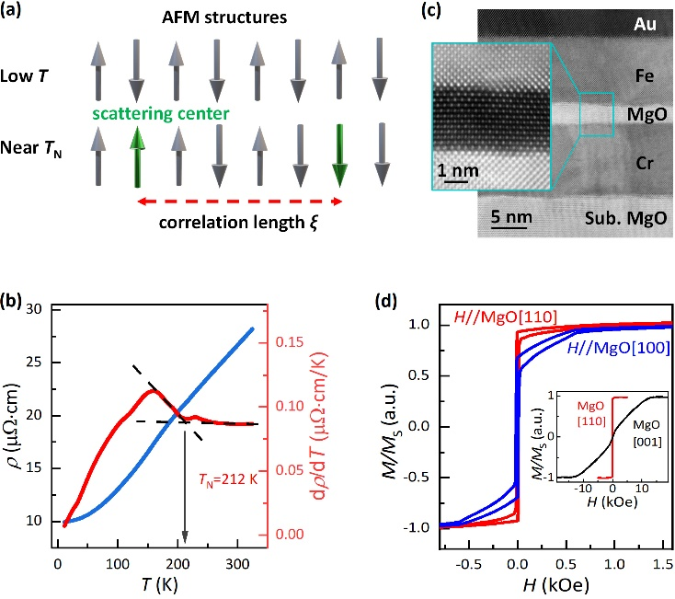
Figure 1. Spin Fluctuation in Single crystal Cr stacks. (a) Correlation length $ξ$ of antiferromagnetic materials. The grey arrows are the magnetic spins forming the AFM order. Green arrows act as the scattering centers activated by spin fluctuation. The $ξ$ represents the correlation length within which the scattering centers can antiparallelly correlate with each other. The $ξ$ becomes divergent with T approaching T_{N} from low temperatures. (b) The temperature dependence of resistivity (blue line) and its differential with respect of T (red line) in 10 nm Cr. The T_{N} is determined as 212 K. Black dash lines are guide for eyes. (c) High resolution cross-sectional transmission electron microscope (HRXTEM) pattern of the junction. Flat interfaces are indicated. Inset: Black field image of the region near MgO barrier. Epitaxy relation was well defined globally throughout the sample. Cr and Fe lattices grew along the MgO [001] direction. (d) Magnetic hysteresis loop of Cr/MgO/Fe/Au films with external magnetic field along [110]_{MgO} (red, also noted as in-plane) and [100]_{MgO} (blue). Inset: [001]_{MgO} (black, also noted as out-of-plane) and reproduction of [110]_{MgO} to show the in-plane easy axis of Fe layer.
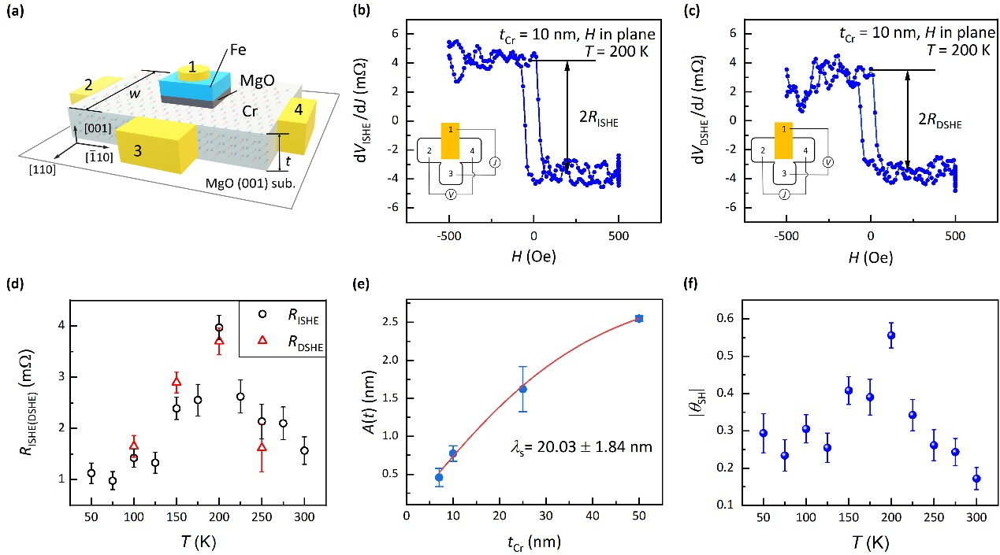
Figure 2. Detection of FSHE with ISHE and DSHE set-up. (a) Device schematic diagram of fabricated MTJ devices. (b) ISHE and (c) DSHE in 10 nm Cr with in-plane magnetic field along MgO [110] at 200 K. Inset: Measurement schematic diagram of ISHE with current J loaded between electrode 1 and 3 and $V_{ISHE}$ collected between electrode 2 and 4 and DSHE with exchanging the source and measure meters. $R_{ISHE(DSHE)}$ represented the saturated value of$dV_{ISHE(DSHE)}/dJ$. (d) Critical spin fluctuation enhanced $R_{ISHE}$ (black circles) and $R_{DSHE}$ (red squares) resistance in MTJ device. The magnitude of 2$R_{ISHE(DSHE)}$ is given by the difference between intercepts of linear fitting of two resistance platform and the error bar is given by the standard error of the linear fitting. (e) Thickness dependence of the factor A(t). Red line is the fitting result following Equation (2). (f) Temperature dependence of SHA.

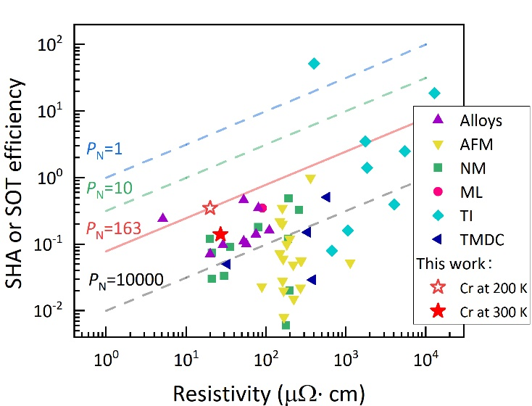
Figure 3. Summary of normalized power consumption P_{N} in SOT materials. Resistivity $ρ$ and magnitude of SHA or SOT efficiency $θ_{SH}$ are two key parameters of P_{N}. Dash or Solid lines represent the contour lines of P_{N} =$ρ/θ_{SH}^{2}$ = 1 (blue dash line), 10 (green dash line), 163(Same level as this work, red solid line) and 10000 (grey dash line) µΩ·cm. The data points are from Cr in this work (open red star at 200 K and solid red star at 300 K) and published works on NMs (Non-magnetic metals, green squares), MLs (Insert- or multi-layers, pink circle), Alloys (purple up-triangles), AFMs (Antiferromagnets, yellow down-triangles), TIs (Topological insulators, light blue diamonds) and TMDCs (Transition-metal dichalcogenide, dark blue left-triangles). The values of $ρ,θ_{SH}$and P_{N} are listed in table in SI-III.

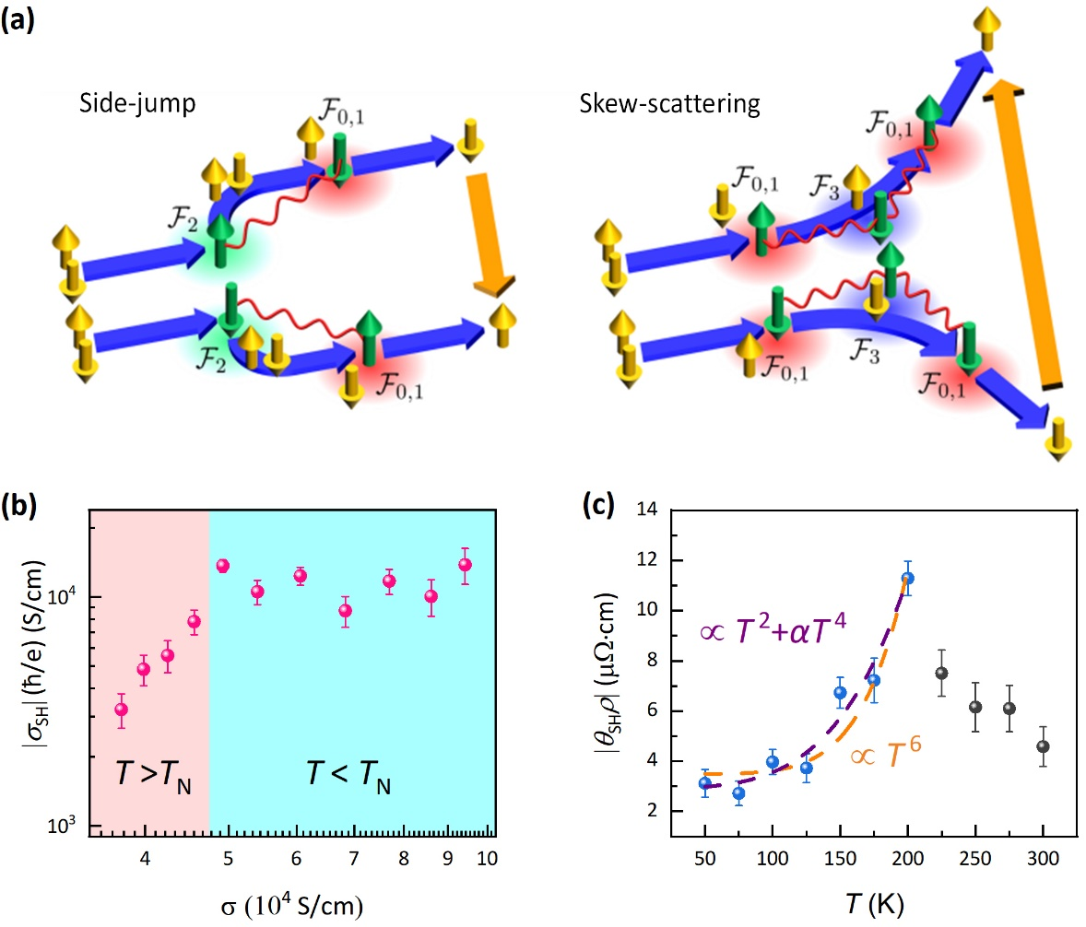
Figure 4. Fluctuation Spin Hall effect in Cr. (a) Antiferromagnetic spin fluctuation. Spin current (orange allows) is caused by AFM spin fluctuation. Yellow arrows are conduction electron spins, and green arrows are local spins. In the $F_{2(3)}$ scattering processes, the deflected direction of scattered electrons depends on the direction of the local spins (the conductive electron spins), combining $F_{0,1}$ to form the side-jump-type (skew-scattering-type) contribution to σ_{SH}. The red wavy curves represent the propagators of AFM spin fluctuation, which relates to the correlation length. (b) Scaling relation between conductivity and spin Hall conductivity. Scaling law is different below(blue shadow) and above(pink shadow) T_{N}. (c) Temperature dependence of product of SHA and resistivity. Orange dash line shows the fitting result of $σ_{SH}^{sj}/σ^{2}∝ T^{2}+αT^{4}$ with the adjusted R² (coefficient of determination) = 0.95. Purple dash line shows the fitting result of the $σ_{SH}^{ss}/ σ^{2}∝ T^{6}$with the adjusted R² = 0.89.
The table of contents

Chromium is a low-resistivity antiferromagnet. By investigation on inverse and direct spin Hall effects’ temperature dependence, the Spin Hall angle is found significantly increased near the Néel temperature (T_{N}). It peaked at -0.36 at 225 K near T_{N}, higher than room-temperature by 153% and comparable to Ta and W. This enhancement matches well with the modeled antiferromagnetic spin fluctuation effect and results in a low power consumption as a spin-orbitronic material.

