Frequency stability improvement of single-crystal diamond cantilever utilizing higher-order-mode excitation
Wen Zhao*, Guo Chen, Zhaozong Zhang, Satoshi Koizumi, and Meiyong Liao*

¹Research Center for Electronics and Optical Materials, National Institute for Materials Science, Namiki 1-1, Tsukuba, Ibaraki 305-0044, Japan

Email) zhao.wen@nims.go.jp, meiyong.liao@nims.go.jp

Abstract

Enhancing the resonance stability of microelectromechanical systems (MEMS) resonator is critically important for achieving high-resolution performance in advanced sensing applications. Higher-order mode resonance yields a greater product of resonance frequency and quality factor and enables high-speed sensing. In this work, we show that higher-order-modes actuation enhances the frequency stability of single-crystal diamond MEMS cantilever resonator. This approach offers a promising strategy to develop highly precise MEMS sensors.

Keyword—Diamond, MEMS, Higher-order modes, Allan deviation.

Introduction

Microelectromechanical system (MEMS), due to the microscale size, low-power consumption, high sensitivity, and facile integration with electrical circuits has been emerging as the next-generation technology for physical, chemical to biological sensing applications such as force, magnetic field, temperature, gas, and mass sensors etc. [1-5]. Diamond holds outstanding mechanical, electronic, and thermal properties, such as the highest Young’s modulus, an ultra-wide bandgap energy, the highest thermal conductivity, and non-existence of solid surface oxides [6-10]. These properties enable MEMS resonators fabricated from diamond higher resonance frequencies and Q factors than other semiconductors. We demonstrated that single-crystal diamond (SCD) MEMS sensors provided high reliability for high-temperature magnetic sensors [11] and high mass sensitivity in studying surface mass adsorption/desorption on semiconductor surface for semiconductor devices [12, 13].
The ultimate sensing performance, such as sensitivity and resolution, of SCD MEMS resonant sensors based on the shift of the resonance frequency, is limited by noise generated by instruments and measurements environments [14]. Frequency stability, characterized by tracking frequency fluctuation over time, serves as a key indicator of quantifying the interference and noise to the MEMS resonator and directly impacts the overall measurement precision [15]. Current strategies to enhance frequency stability involve the amplifying dynamic response [16, 17], improving the signal-to-noise ratio (SNR) [18, 19], as well as inducing internal resonance through nonlinear vibration[20]. However, each method has its own limitations, such as high-applied voltages and high demands in fabrication. On the other hand, the sensing capability of a MEMS resonator is intricately linked to the resonance frequency and quality (Q) factor [21], which determine the response sensitivity and resolution. In addition, the thermomechanical noise limited frequency stability of a MEMS resonator is inversional to the resonance frequency and Q factor. We have shown that the product of resonance frequency and Q factor could be markedly improved by operating diamond resonator at higher-order mode.[22]
To precisely realize the ultimate resolution of the SCD MEMS resonant-type sensors, the investigation of the frequency stability at different resonance modes is in demand. In this work, we primarily demonstrate a significant reduction in the minimal relative frequency shift and an enhancement in frequency stability of micro-diamond resonator-based cantilever beams by utilizing the higher-order mode actuation approach.

Device Characterization

The single-crystal diamond MEMS cantilever resonators were fabricated by smart-cut method [23] . The fabricated cantilevers had a featured dimensions of 6 µm in width, 170 µm in length, and 1.7 µm in thickness. A schematic of the experimental setup for measuring the resonance properties is shown in Fig. 1. To characterize the out-of-plane resonance frequency spectra, a laser Doppler vibrometer (LDV) was utilized, and the SCD cantilevers were actuated using radio frequency (RF) signal sourced from a lock-in amplifier. A phase lock loop (PLL) was also utilized to assess the frequency stability by continuously tracking the frequency fluctuation over time. The frequency stability was analyzed based on the theory of Allan derivation. All measurements were carried out in a high-vacuum chamber, maintained at a pressure below 10⁻⁴ Pa and at room temperature, to minimize air damping effects. The laser spot was positioned at the tip of the microbeam to maximize the signal-to-noise ratio[16].
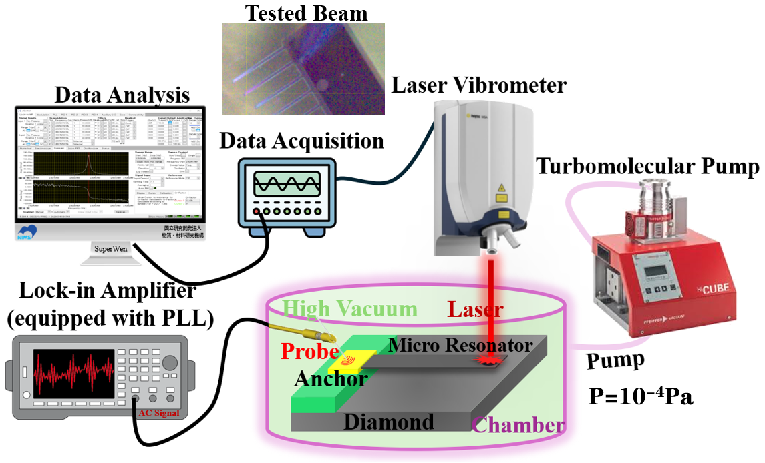
Fig.1 Schematic of measurements setup for measuring the resonance frequency of the SCD MEMS cantilever.

The resonance mode spectra were experimentally acquired by sweeping the excitation frequency around the first three resonance modes under varying RF signal amplitudes (AC actuation voltages), as illustrated in Fig. 2. The measured resonance frequencies of the out-of-plane vibration motion are f₁=174.894 kHz, for the 1st mode, f₂=1087.301 kHz, for the 2nd mode, and f₃=3018.438 kHz, for the 3rd mode, respectively. These frequencies are consistent with the Euler-Bernoulli theory
$f_{n}=k_{n}\frac{t}{L^{2}}\sqrt{\frac{E}{ρ}}$ (1)
where n refers to the vibration mode number, f_{n} is the resonance frequency, k₁ = 0.162, k₂ = 1.012, and k₃ = 2.835. E, L, t, and ρ represent the Young’s modulus, cantilever length, thickness, and mass density, respectively. The quality factors of the first three resonance modes are Q₁=14696, Q₂=11409, and Q₃=8261, which were calculated by the ratio of the resonance frequency to the full-width at the half maximum (FWHM) of the resonance frequency spectra. A slight reduction in Q factors is observed for the higher-order modes. However, the product of the resonance frequency and Q factor increases as the mode order rises. The vibration amplitude grows linearity with respect to the actuation voltage. This enhancement positively impacts the overall sensing performance of micro resonators, as the thermomechanical noise characterized by the Allan deviation${ σ}_{\text{A}}^{th}$ is determined by the product of resonance frequency and Q factor (f Q) as [21]
(2)
where f₀ is the resonance, δ f₀(τ_{A}) is the spectrum density of frequency fluctuations over the resulting filter bandwidth. In our case, although a slight decrease in Q factor is observed, the overall f Q product value increases with the mode orders, providing favourable conditions for high-resolution sensor performance.
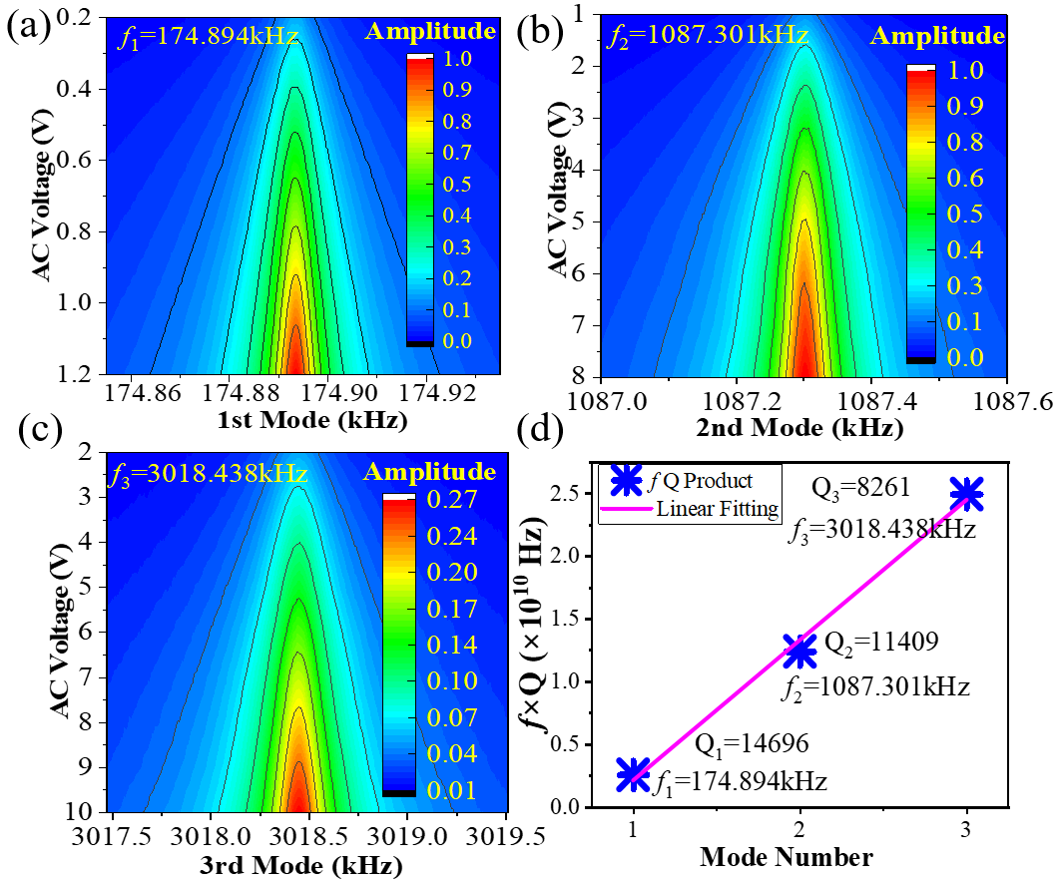
Fig.2 Resonance amplitude as a variation of RF signal amplitude (AC volage) (a) 1st mode, (b) 2nd mode, and (c) 3rd mode. (d) Product of resonance frequency and Q factor of the first three modes. The Q factors were calculated by Lorentz fitting the resonance frequency spectra and Q factor is independent on AC voltage.

Frequency Stability

The Allan deviation was measured under a closed-loop configuration by monitoring frequency fluctuations over a 5-minute interval using a lock-in amplifier. A fixed sampling rate of 1799 samples per second (Sa/s) was employed for all the measurements. Fig.3 illustrates the Allan derivation for the 1st resonance mode at the band width (BW) =1Hz and 400Hz. The Robin model confirms that the signal-to-noise ratio (SNR) can be modulated by adjusting the applied AC voltage. A clear order-of-magnitude reduction in σ(τ) is observed when operating at lower bandwidths [24]. Both the detection noise (lower detection time<0.1s) and thermochemical noise dominate in the system with a lower BW. However, increasing the bandwidth causes the crossover between detection noise and thermomechanical noise to occur at a smaller value of the integration time τ. Besides, the larger BW can result in vanish of detection noise from the facilities [10]. The reduction in bandwidth leads to a significant improvement in the minimum detection limit. The minimal detection, in the case of BW=1Hz, reaches σ(τ) =2.6×10⁻⁸, for the 1st mode. In addition, saturation of the minimum detection limit occurs at elevated AC voltages as a result of pull-in nonlinearity, caused by contact with the substrate.
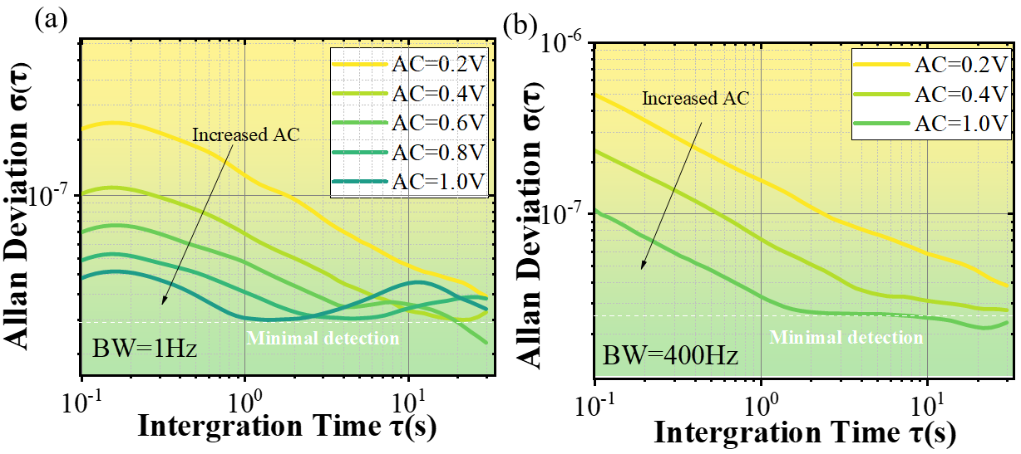
Fig.3 Actuation amplitude effects on Allan derivation for the fundamental modes, (a) BW=1Hz and (b) BW=400Hz.
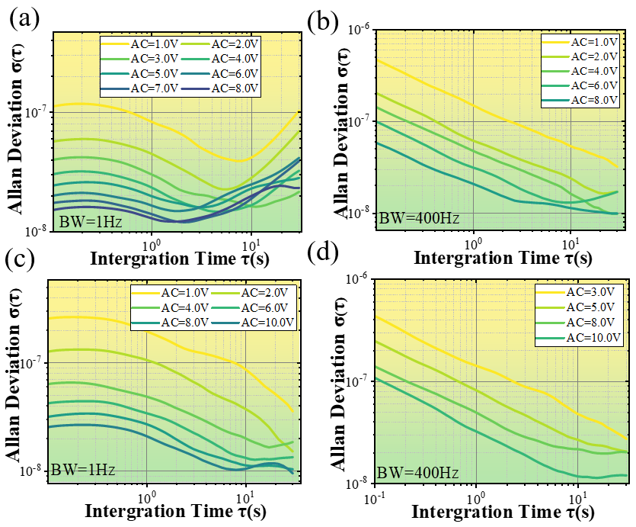
Fig.4 AC voltage effects of varying noise on Allan derivation for higher order modes. (a) BW=1Hz and (b) BW=400Hz, for 2nd mode; (c) BW=1Hz, (d) BW=400Hz for the 3rd mode.

We conducted the same Allan analysis for the higher order modes (i.e.2nd and 3rd), as disclosed in Fig.4. The obtained results indicate that the minimal detection value can be manually tuned by both BW and AC voltage. Clearly, a higher AC voltage clearly leads to better frequency stability in the resonators as a result of improved signal-to-noise ratio. Notably, As the PLL bandwidth increases, thermomechanical noise gradually becomes the dominant factor over detection noise in the progression of the Allan deviation. The minimal detection value can be highly enhanced by increasing the AC voltage. At BW= 1Hz, the minimal detection value can reach σ(τ) =1.21×10⁻⁸ for the 2nd mode, while σ(τ) =1.01×10⁻⁸ for the 3rd mode. To enable a fair comparison of σ(τ) across different vibration modes, the signal-to-noise ratio (SNR) was kept constant for all modes. As shown in Fig. 5, the higher-order modes exhibit a markedly lower minimal detection value compared to the fundamental mode.
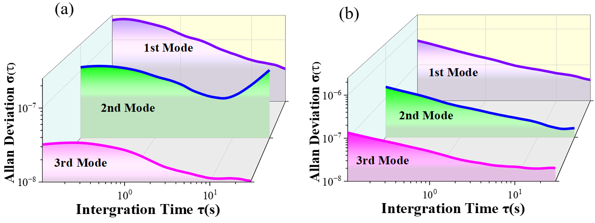
Fig.5 Results of Allan derivation measured with the same signal-to-noise ratio in the frequency response for the first three modes at various bandwidths (a) BW=1Hz, (b) BW=400Hz.

The improved minimum σ(τ) favors improving the resolution of a MEMS resonator-type sensor. For example, for a resonant MEMS mass sensor, the minimum detectable mass (Δm) can be written as Δm/2m=Δf/f₀ [25], where m is mass of cantilever, Δf is frequency shift induced by a change of cantilever mass, f₀ is the resonance frequency. For the same cantilever beam, the mass m remains the same for different modes. Therefore, utilizing higher-order modes with elevated resonance frequencies can improve the sensitivity to mass changes, thereby improving the minimum detectable mass. For the cantilever in this study, by transitioning from the first to the third mode, the mass resolution is significantly enhanced—from 0.66 ag down to 0.15 ag—exceeding prior benchmarks of 1.4 ag [26]. The high-order mode resonances open an avenue for enhancing the minimal detection capability and sensing resolution in MEMS sensors without shrinking the device dimensions.

Conclusions
In summary, we investigated the resonance frequency stability of higher-mode resonance of SCD resonators. It was observed that frequency stability improved with increasing mode order, which in turn led to enhanced sensitivity and a lower minimum detectable quantity. Therefore, higher-order mode operation of diamond MEMS resonators holds strong potential for enabling advanced, high-resolution sensing.

Acknowledgments

This work was supported by JSPS KAKENHI (No. Grant Number 24KF0085, 24H00287, 22K18957), the 3rd period of ministerial Strategic Innovation Promotion Program (SIP) "Ultimate Diamond" (Funding agency: NIMS) and ARIM (JPMXP1224NM5055) sponsored by the Ministry of Education, Culture, Sports, and Technology (MEXT) of Japan.

Declaration of Competing Interest

The authors declare that they have no known competing financial interests or personal relationships that could have appeared to influence the work reported in this paper.

References
[1] V. Qaradaghi, A. Ramezany, S. Babu, J.B. Lee, S. Pourkamali, Nanoelectromechanical Disk Resonators as Highly Sensitive Mass Sensors. IEEE Electron Device Letters, 39 (2018) 1744-1747.
[2] W. Zhao, F. Khan, N. Alcheikh, M.I. Younis, High Performance Micro Resonators-Based Sensors Using Multimode Excitation. IEEE Electron Device Letters, 43 (2022) 1732-1735.
[3] P. Martha, N. Kadayinti, V. Seena, CMOS-MEMS Accelerometer With Stepped Suspended Gate FET Array: Design & Analysis. IEEE Transactions on Electron Devices, 68 (2021) 5133-5141.
[4] Y. Okamoto, H. Ryoson, K. Fujimoto, T. Ohba, Y. Mita, On-Chip CMOS-MEMS-Based Electroosmotic Flow Micropump Integrated With High-Voltage Generator. Journal of Microelectromechanical Systems, 29 (2020) 86-94.
[5] W. Zhao, N. Alcheikh, S.B. Mbarek, M.I. Younis, Multi-functional resonant micro-sensor for simultaneous magnetic, CO2, and CH4 detection. Journal of Applied Physics, 132 (2022).
[6] J.G. Rodriguez-Madrid, G.F. Iriarte, J. Pedros, O.A. Williams, D. Brink, F. Calle, Super-High-Frequency SAW Resonators on AlN/Diamond. IEEE Electron Device Letters, 33 (2012) 495-497.
[7] C.E. Nebel, CVD diamond: a review on options and reality. Functional Diamond, 3 (2023) 2201592.
[8] M. Salman, G.M. Klemencic, S. Mandal, S. Manifold, L. Mustafa, O.A. Williams, S.R. Giblin, Quantitative analysis of the interaction between a dc SQUID and an integrated micromechanical doubly clamped cantilever. Journal of Applied Physics, 125 (2019).
[9] W. Zhao, S. Koizumi, M. Liao, P-channel MOSFETs on phosphorous-doped n-type diamond. IEEE Electron Device Letters, (2024).
[10] Z. Zhang, G. Chen, K. Gu, S. Koizumi, M. Liao, Effect of defects on Q factors of single-crystal diamond MEMS resonators. Functional Diamond, 3 (2023) 2221280.
[11] Z. Zhang, W. Zhao, G. Chen, M. Toda, S. Koizumi, Y. Koide, M. Liao, On‐chip diamond MEMS magnetic sensing through multifunctionalized magnetostrictive thin film. Advanced Functional Materials, 33 (2023) 2300805.
[12] N. Oi, S. Okubo, I. Tsuyuzaki, A. Hiraiwa, H. Kawarada, Over 1 A Operation of Vertical-Type Diamond MOSFETs. IEEE Electron Device Letters, 45 (2024) 1554-1557.
[13] K. Gu, Z. Zhang, G. Chen, J. Huang, Y. Koide, S. Koizumi, W. Zhao, M. Liao, Oxygen-termination effect on the surface energy dissipation in diamond MEMS. Carbon, 225 (2024) 119159.
[14] P. Sadeghi, A. Demir, L.G. Villanueva, H. Kähler, S. Schmid, Frequency fluctuations in nanomechanical silicon nitride string resonators. Physical Review B, 102 (2020) 214106.
[15] M. Sansa, E. Sage, E.C. Bullard, M. Gély, T. Alava, E. Colinet, A.K. Naik, L.G. Villanueva, L. Duraffourg, M.L. Roukes, Frequency fluctuations in silicon nanoresonators. Nature nanotechnology, 11 (2016) 552-558.
[16] W. Zhao, R.T. Rocha, N. Alcheikh, M. I.Younis, Dynamic response amplification of resonant microelectromechanical structures utilizing multi-mode excitation. Mechanical Systems and Signal Processing, 196 (2023) 110347.
[17] N. Jaber, S. Ilyas, O. Shekhah, M. Eddaoudi, M.I. Younis, Multimode excitation of a metal organics frameworks coated microbeam for smart gas sensing and actuation. Sensors and Actuators A: Physical, 283 (2018) 254-262.
[18] M. Cheng, W. Yan, D. Zhang, X. Liu, L. He, M. Xu, Q. Yao, Frequency stability of new energy power systems based on VSG adaptive energy storage coordinated control strategy. Energy Informatics, 7 (2024) 54.
[19] T. Manzaneque, M.K. Ghatkesar, F. Alijani, M. Xu, R.A. Norte, P.G. Steeneken, Resolution limits of resonant sensors. Physical Review Applied, 19 (2023) 054074.
[20] R. Almog, S. Zaitsev, O. Shtempluck, E. Buks, Noise Squeezing in a Nanomechanical Duffing Resonator. Physical Review Letters, 98 (2007) 078103.
[21] Y. Qiao, A. Elhady, M. Arabi, E. Abdel-Rahman, W. Zhang, Thermal noise-driven resonant sensors. Microsystems & Nanoengineering, 10 (2024) 90.
[22] G. Chen, Z. Zhang, K. Gu, L. Sang, S. Koizumi, M. Toda, H. Ye, Y. Koide, Z. Huang, M. Liao, Higher-order resonance of single-crystal diamond cantilever sensors toward high f‧Q products. Applied Physics Express, 17 (2024) 021001.
[23] M. Liao, Progress in semiconductor diamond photodetectors and MEMS sensors. Functional Diamond, 1 (2022) 29-46.
[24] S.K. Roy, V.T.K. Sauer, J.N. Westwood-Bachman, A. Venkatasubramanian, W.K. Hiebert, Improving mechanical sensor performance through larger damping. Science, 360 (2018) eaar5220.
[25] T.A. Efimov, E.A. Rassolov, B.G. Andryukov, T.S. Zaporozhets, R.V. Romashko, Calculation of Resonant Frequencies of Silicon AFM Cantilevers. Journal of Physics: Conference Series, 1439 (2020) 012006.
[26] J. Verd, A. Uranga, G. Abadal, J.L. Teva, F. Torres, J. LÓpez, F. PÉrez-Murano, J. Esteve, N. Barniol, Monolithic CMOS MEMS Oscillator Circuit for Sensing in the Attogram Range. IEEE Electron Device Letters, 29 (2008) 146-148.

