Supporting information for
Site-selective Creation of Blue Emitters in Hexagonal Boron Nitride
Haidong Liang^{1,2,} ‡,*, Yuan Chen^{2,} ‡, Leyi Loh^{3, ‡}, Nicholas Lin Quan Cheng², Dmitrii Litvinov^{3,4}, Chengyuan Yang^{1,2}, Yifeng Chen^{2,5}, Zhepeng Zhang², Kenji Watanabe⁷, Takashi Taniguchi⁸, Maciej Koperski^{3,4}, Su Ying Quek^{2,3,5}, Michel Bosman³, Goki Eda^{2,5,6, *}, Andrew Anthony Bettiol^{1,2,*}

¹ Centre for Ion Beam Applications (CIBA), Department of Physics, National University of Singapore, Singapore 117542, Singapore
² Department of Physics, National University of Singapore, Singapore 117551, Singapore
³Department of Materials Science and Engineering, National University of Singapore, 117575, Singapore
⁴ Institute for Functional Intelligent Materials, National University of Singapore, Singapore, 117544, Singapore
⁵Centre for Advanced 2D Materials, National University of Singapore, 117542, Singapore
⁶Department of Chemistry, National University of Singapore, 117543, Singapore
⁷Research Centre for Functional Materials, National Institute for Materials Science, Tsukuba 305-0044, Japan
⁸International Centre for Materials Nanoarchitectonics, National Institute for Materials Science, Tsukuba 305-0044, Japan

‡These authors contributed equally. * Authors to whom correspondence should be addressed. Electronic mail: haidong@nus.edu.sg, g.eda@nus.edu.sg, a.bettiol@nus.edu.sg

Figure S1. More Details of the irradiation conditions in Figure 1. The schematic of the irradiation points. The overall scan size is 36×36 µm, with 2048×2048 pixels. The patterned points have three different sizes: 53 nm×53 nm (3×3 pixels), 106 nm×106 nm (6×6 pixels) and 159 nm×159 nm (9×9 pixels), as marked in different columns in the figure. Each row are irradiated with different dwell times: from 1 s/pixel to 10 ms pixel (top to bottom), as marked in the figure. The irradiation current is 2 pA, hence the highest fluence for the spots is 1.25×10⁷ ions/pixel, and ~1×10⁹ ions/spot (9× 9 pixels), and the lowest fluence for the spots is 1.25×10⁵ ions/pixel, and ~4.5×10⁶ ions/spot (6× 6 pixels).
Using electron beam irradiation, a huge fluence will be needed to create the blue emission, which is very time consuming, for example, 1000 s per spot irradiated spot with a current of 10 nA.¹ The fluence is 6.25×10¹³ ions/spot to create a emission point. However, when using high energy He⁺ ions, we can create the point blue emission with less than 1s per spot with a current of 2pA. A fluence of 4.5×10⁶ ions/spot can already make a clear emission point (Figure 1), which is with a fluence of over 10⁷ times less than the electron irradiation.
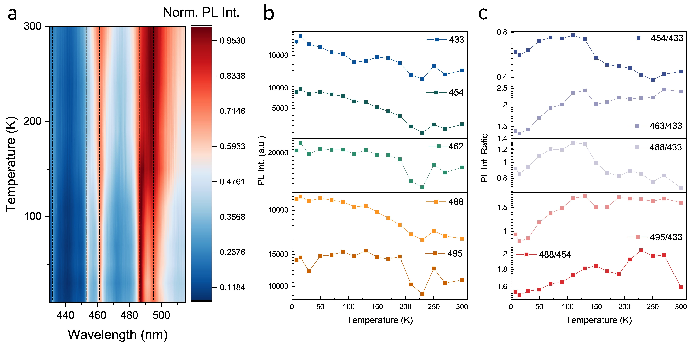
Figure S2. Temperature dependent results and analysis. (a) Temperature dependent PL spectra of the irradiated hBN. (b) The intensities of the emissions as a function of temperature. (c) The ratios of the emission peaks as a function of temperature.
Comparing the PL intensity ratio of different emission peaks as a function of temperature (Figure S2c), we observe that the ratio of 454 nm and 488 nm peaks to the 433 nm peak both exhibit a decrease with increasing temperature, while the ratio of 462 nm and 495 nm peaks to the 433 nm peak exhibit an increase with increasing temperature. This suggests that the 462 nm and 495 nm emissions are the PSB of the 433 nm emission, while the 454 nm and 488 nm emissions are not. Instead, there is an increase ratio of 488 nm emission comparing to the 454 nm emission, which suggests that the 488 nm emission is the PSB of the 454 nm emission. Both two sets of PSBs are consistent with our expectations from the correlation analysis.
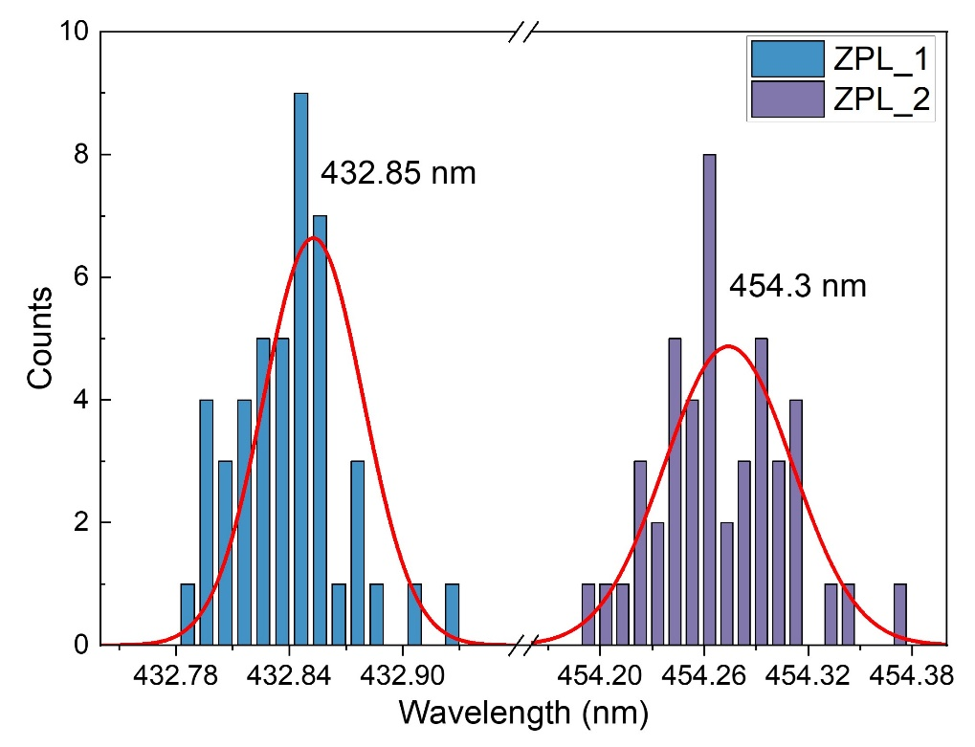
Figure S3. A statistical analysis of the two ZPL wavelengths, fitted with Gaussian functions.
A statistical analysis is carried out about the ZPL wavelengths at around 433 nm and 454 nm collected at different emission points, as shown in Figure S3. The first ZPL (marked as ZPL_1 in Figure S3, or B1 in the main text) ranges from 432.8 to 432.94 nm and can be fitted with a peak at 432.85 nm exhibiting an inhomogeneous broadening of ~0.053 nm. The second ZPL (marked as ZPL_2 in Figure S3, B2 in the main text) ranges from 454.2 to 454.38 nm and can be fitted with a peak at 454.3 nm showing a width of ~0.074 nm.
Table S1. Detailed Debye-Waller and Huang-Rhys factors of B1 and B2 with different irradiation fluences.
Parameters  Emitters | Debye–Waller factor for B1 | Huang-Rhys factor for B1 | Debye–Waller factor for B2 | Huang-Rhys factor for B2
SQ1 | 0.081 | 2.511 | 0.271 | 1.305
SQ2 | 0.106 | 2.238 | 0.263 | 1.336
SQ3 | 0.126 | 2.073 | 0.247 | 1.396
SQ4 | 0.193 | 1.646 | 0.214 | 1.542
SQ5 | 0.204 | 1.588 | 0.204 | 1.588

We notice that the spectra of the irradiated squares (SQ1-5 in Figure 2b) with different irradiation fluences are not the same, they exhibit different Debye-Waller factors. Table S1 shows the different Debye-Waller and Huang-Rhys factors in SQ1-5. In Table 1 in the main text, we are using an average value of the Debye-Waller factor and a calculated Huang-Rhys factor according to the average Debye-Waller factor.
Figure S4. Full spectrum at 4K with fitting of all the ZPLs and PSBs. The dot line is the normalized PL spectrum of the irradiated hBN. The solid lines are lorenrz fitted emission peaks. There are two ZPLs at around 433 nm and 454 nm shown with black solid lines, marked as ZPL1 (B1) and ZPL2 (B2) in the figure. Following ZPL1, there is an acoustic PSB, marked as PSB10 and three phonon replicas shown with blue solid lines, marked as PSB11, PSB 12 and PSB13 in the figure. Following ZPL2, there are two phonon replicas shown with red solid lines, marked as PSB21 and PSB22.
In the main text, we mainly focus on the wavelength rang between 400 nm and 500 nm since our topic is blue emitters in hBN. However, we also noticed that there are peaks at around 530 nm. With spacial correlation as described in Figure 2d, we can determin additional peaks at around 530 nm also to be the PSBs of B1 and B2, as shown in Figure S4. Larger energy separation is consistent with multi-phonon replicated resonances (1×, 2× and 3× the energy of optical phonon).
Figure S5. Thickness of the samples. (a) Optical microscope image of the full sample shown in Figure 1 and 2. (b) Atomic force microscopic (AFM) image of the sample in (a) showing the thickness. (c, d) Optical microscope images of other irradiated hBN samples. (e-g) AFM images of the samples in (c, d) showing the thicknesses. (h) PL spectra of different samples with different thicknesses.
We have measured many different irradiated hBN samples with different thicknesses from tens of nm to several µm. Their PL spectra are showing same emission peaks with same relative intensities.
Figure S6. PL spectra of hBN flakes on different substrates irradiated using different energies and ions.
Both proton and helium ion beam irradiation can create the blue emissions in hBN on different substrates. This might suggest that the blue emissions are from an internal vacancy or intercalant defects.
Figure S7. Stability of the blue emitters. (a) Room temperature PL spectra of the irradiated hBN at different time with a continuous 405 nm laser excitation with laser power of 200 µW. (b) Peak intensity of the blue emitters in (a) evolutions with time. (c) Time dependent PL spectra of the blue emitters at 4K.
There is a quenching of the blue emissions both at room temperature and 4K at the beginning of the laser excitation. However, the emission peak wavelengths and relative intensity remains constant. At 4K, we can clearly see that except the quenching at the beginning of the measurement, the PL spectra show no dangling of the wavelength, and become stable after about 20 minutes.

Figure S8. Different distributions of the blue emitters and $V_{B}^{-}$. (a) Microscope image of a patterned irradiated hBN flake using 1.6MeV He⁺. There are squares and points. The top square and two rows of points have been irradiated with a fluence of 6E16. The top second squares and next two rows of points have been irradiated with a fluence of 3E16, and then 1E16, 5E15, 3E15, 1E15, 3E14 to the bottom square and two rows of points. (b) Blue emission PL map of the irradiated hBN flake in (a). (c) PL spectra of the pristine and irradiated squares with different fluences, excited by 405 nm laser. (d) PL spectra of 4 points marked in (a) and (b), excited by 405 nm laser. They are labelled as ‘point1’: an irradiated point in the first row, with a fluence of 6E16, ‘centre1’ an unirradiated point in centre of four irradiated points, close to ‘point1’, ‘point6’: an irradiated point in the 11th row, with a fluence of 1E15, ‘centre6’: an unirradiated point close to ‘point6’. (e) ODMR spectrum of the $V_{B}^{-}$ spin defects in the 3E16 square. (f) $V_{B}^{-}$ PL map of the same hBN flake, excited by 532 nm laser. (g) PL spectra of the pristine and irradiated squares, excited by 532 nm laser. (h) PL spectra of 4 points marked in (a) and (b), excited by 532 nm laser. All fluences are in units of ions/cm².
Both the blue emissions and the $V_{B}^{-}$ spin defects² are created by high energy He⁺ irradiation. However, the distributions of the two emissions are a slightly different. For the $V_{B}^{-}$ spin defects, the PL intensity increases up to the highest irradiation fluence 6E16, as shown in Figure S8g. It means in this fluence range, the He⁺ irradiation can continue to create more $V_{B}^{-}$ spin defects without significant damage to the overall crystal lattice. However, for the blue emissions, the PL intensity increases with fluence up to 3E15, and then decreases with increasing fluence, as shown in Figure S8c. When the fluence is over 1E16 ions/cm², the blue emissions spread beyond the irradiation area. For example, the unirradiated point ‘centre1’ marked in Figure S8a is giving the same blue emissions as the irradiated points and squares, as shown in Figure S8d. However, if it is excited by 532 nm laser, the same point does not exhibit any emission from $V_{B}^{-}$ spin defects as shown in Figure S8h. This is consistent with our assumption that the blue emissions are from B_{int} and N_{int}. While for $V_{B}^{-}$ spin defects, the boron vacancies are confined to the irradiate region only. The knocked-out boron and nitrogen atoms can propagate through the crystal, and the B_{int} and N_{int} would spread out of the irradiated region, when the irradiation fluence is high.
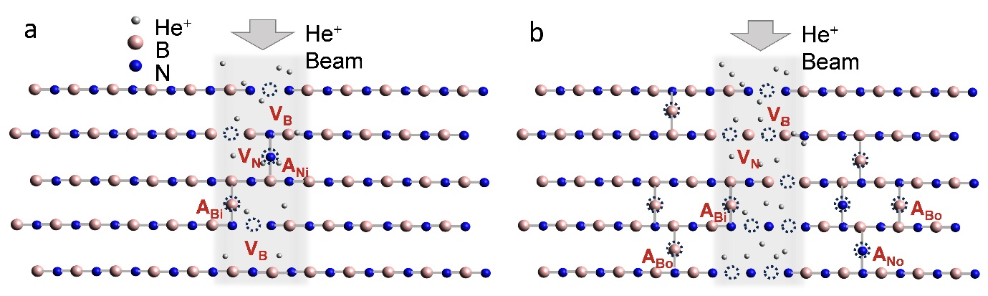
Figure S9. Schematic of the ion irradiation on hBN with different fluences. (a) Low fluence irradiation makes vacancies and adatoms only within the irradiation area. (b) High fluence irradiation makes many vacancies and adatoms within and outside the irradiation area.
As discussed earlier, we suspect that the adatoms are the origin of the blue emissions. The schematic shown in Figure S9 further illustrate this. When the irradiation fluence is low, only a few of vacancies are created, such as V_{B} and V_{N}. During the same time, some adatoms also form at surrounding positions which is within the irradiation area. Hence the blue emissions are confined within the irradiation area, such as SQ5 in Figure 1c. When the irradiation fluence is high, lots of vacancies are created, while many of the atoms are knocked out and some may travel across the lattice till outside the irradiation area and form adatoms. Because of too many vacancies created within the irradiation area, adatoms decrease in the area since there are not many atoms left for the adatoms to stay at. Hence the intensity of blue emissions decreases within the irradiation area, and is even less than the surrounding area, such as SQ1 in Figure 1c.

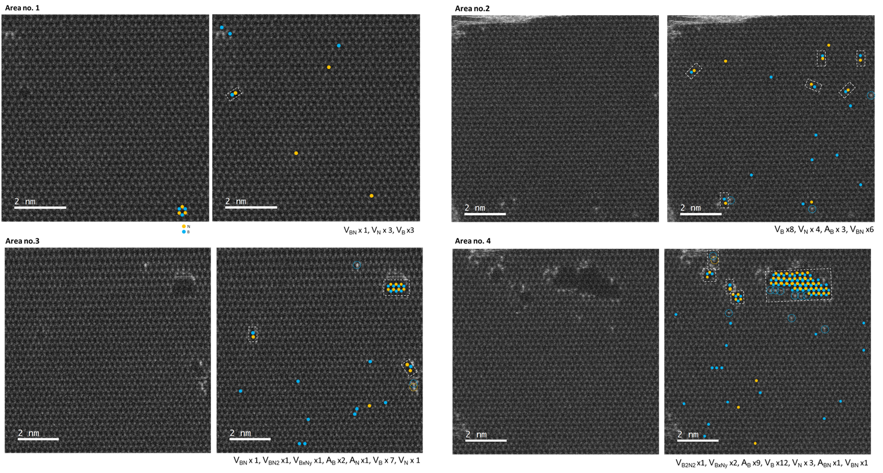
Figure S10. HAADF-STEM images of 4 typical areas across the proton-irradiated hBN multilayer. For each area, as-imaged (left panel) and the same image with defects denoted (right panel) of a large-area HAADF-STEM image. Blue circle represents B atoms and yellow circle represents N atoms. In the right panels, filled circles denote missing atoms and dashed unfilled circles denote additional atoms (e.g., adatoms and intercalants).
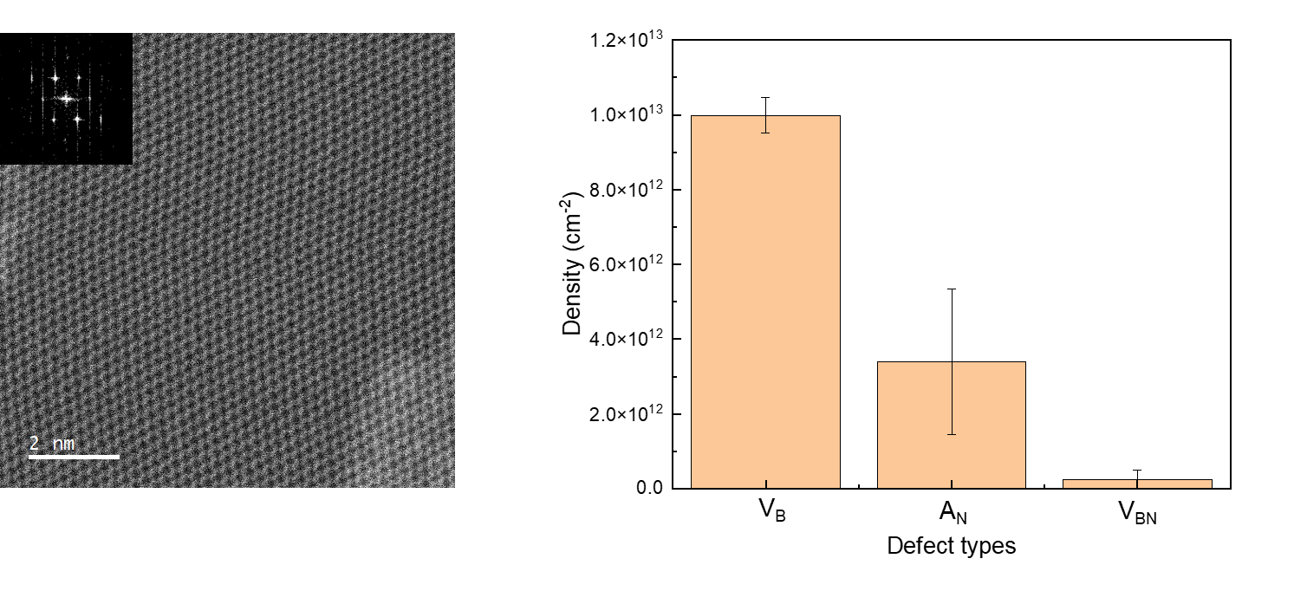
Figure S11. Defect analyses of pristine (unirradiated) hBN layers. HAADF-STEM image of a typical unirradiated hBN layers with FFT shown on the top left corner of the image (left panel). Statistics of defect structures observed in several samples. Standard error for each defect type is also shown (right panel).
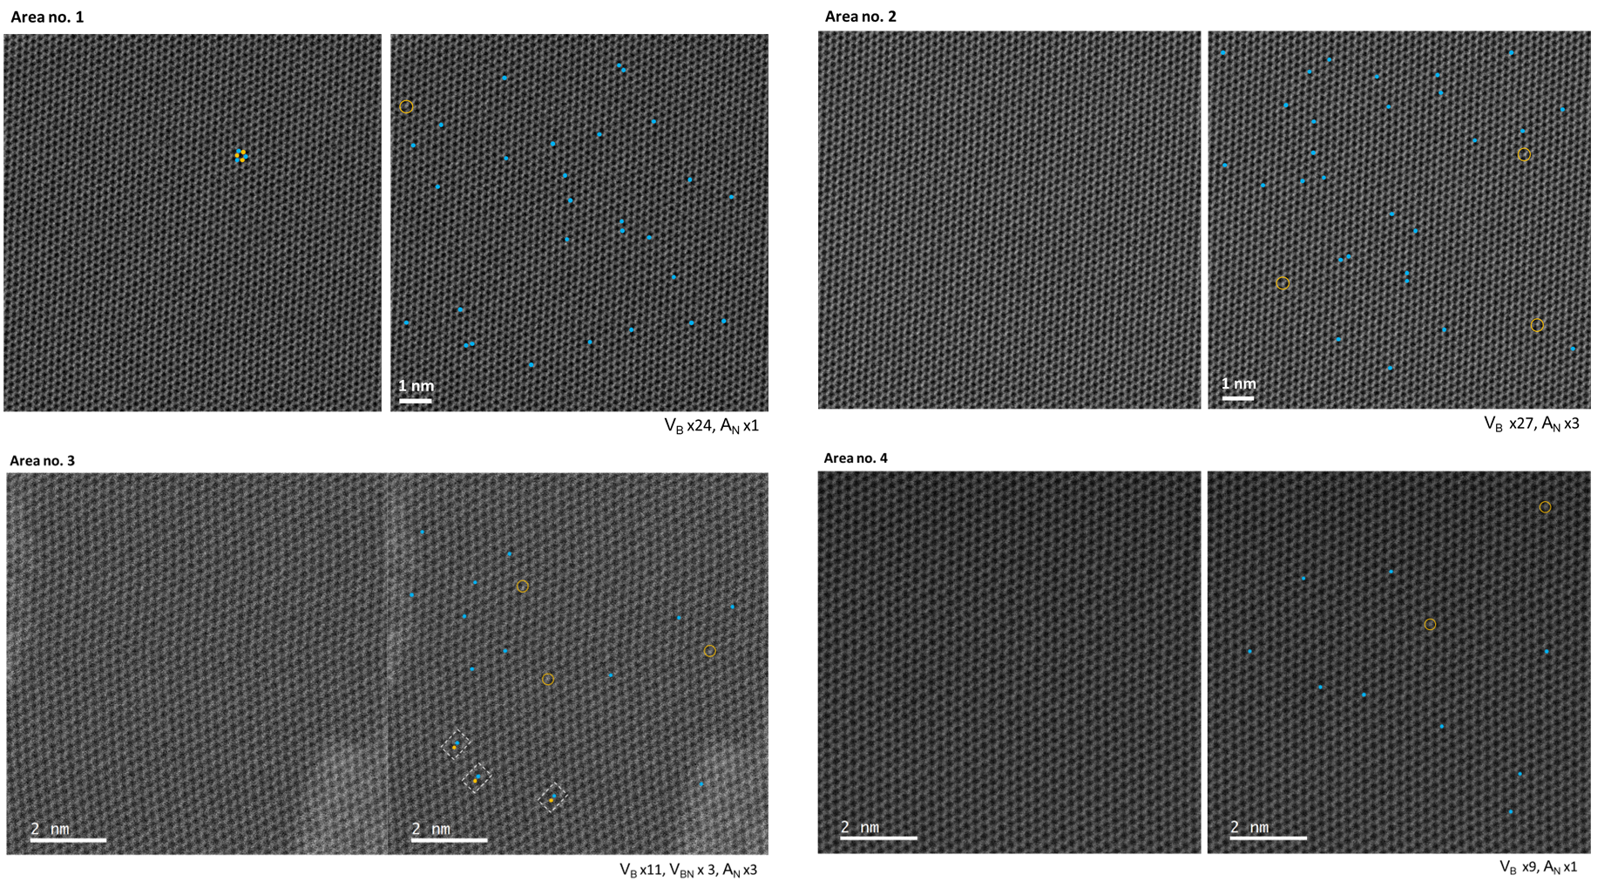
Figure S12. HAADF-STEM images of 4 typical areas across the pristine (unirradiated) hBN multilayer. For each area, as-imaged (left panel) and the same image with defects denoted (right panel) of a large-area HAADF-STEM image. Blue circle represents B atoms and yellow circle represents N atoms. In the right panels, filled circles denote missing atoms and dashed unfilled circles denote additional atoms (e.g., adatoms and intercalants).

References
(1) Fournier, C.; Plaud, A.; Roux, S.; Pierret, A.; Rosticher, M.; Watanabe, K.; Taniguchi, T.; Buil, S.; Quélin, X.; Barjon, J.; Hermier, J. P.; Delteil, A. Position-Controlled Quantum Emitters with Reproducible Emission Wavelength in Hexagonal Boron Nitride. Nat. Commun. 2021, 12 (1), 1–6. https://doi.org/10.1038/s41467-021-24019-6.
(2) Gottscholl, A.; Kianinia, M.; Soltamov, V.; Orlinskii, S.; Mamin, G.; Bradac, C.; Kasper, C.; Krambrock, K.; Sperlich, A.; Toth, M.; Aharonovich, I.; Dyakonov, V. Initialization and Read-out of Intrinsic Spin Defects in a van Der Waals Crystal at Room Temperature. Nat. Mater. 2020, 19 (5), 540–545. https://doi.org/10.1038/s41563-020-0619-6.

