Influence of thin MOCVD-grown GaN layer on underlying AlN template

Masatomo Sumiya¹, Kiyotaka Fukuda^{1,2}, Shuhei Yasiro^{1,2}, and Tohru Honda²

¹ Wide-gap semiconductor group, National Institute for Materials Science, Tsukuba, 305-0044, Japan
² Department of Electric Engineering and Electronics, Graduate School of Engineering, Kogakuin University, Hachioji, Tokyo 192-0015, Japan

Corresponding author’s email: SUMIYA.Masatomo@nims.go.jp

Abstract

We have studied the direct growth of a GaN film on an AlN template/sapphire substrate by metalorganic chemical vapor deposition. It was found that the GaN layer causes marked deformation of the underlying AlN template at the initial growth. The intensity of x-ray diffraction from AlN drops by a factor of 5 and the full widths at half maximum of the rocking curves of the on- and off-axis planes are increased from 50 to 300 arcsec. With increasing GaN growth time, these values gradually recover, and the crystalline quality of the GaN film is improved. No alloy formation is observed at the interface between AlN and GaN. An AlN template on a sapphire substrate seems to act as a buffer layer, adjusting the lattice constant to improve the crystallinity of the direct grown GaN. Compared with a GaN film grown on a sapphire substrate, GaN grown directly on an AlN template forms a smoother surface with better crystalline quality in a shorter growth time, and at a lower temperature with fewer nonradiative defects in the band gap.
1. Introduction
AlN is very important for growing III-V nitride films. A low temperature (LT) thin AlN layer grown on a substrate annealed in H₂ ambient relaxes the difference in the lattice constant to obtain a Ga-face (+c) GaN film with a smooth surface by metalorganic chemical vapor deposition (MOCVD). GaN deposited at lower temperatures plays the same role as a buffer layer. Fuke et al. attempted to nitride the surface of c-sapphire by flowing NH₃ gas at 1000 ºC to obtain an AlN layer, which was expected to act as a buffer layer. However, i such nitridation was unsuccessful, and only N-face (-c) GaN with a hexagonal facetted surface, similar to the surface morphology before the LT-AlN buffer layer, was obtained. We systematically studied LT buffer layers deposited with various thicknesses and annealed under various conditions from the viewpoint of polarity., The role of the buffer layer is not only to relax the lattice constant but also to convert the polar direction of GaN growth on a c-sapphire substrate from –c to +c polarity., The structure of AlN/GaN multilayers on a Si (111) substrate makes it possible to grow GaN on a Si substrate, which has a large lattice mismatch and thermal expansion coefficient., Furthermore, an AlN intermediate layer during GaN growth and the insertion of thin AlN layer at the interface of p-GaN are likely to stop propagation of the dislocations. These functions are effective for AlN layers with thickness on the order of 1-10 nm.
A thicker AlN layer (~1 μm) was grown on c-sapphire substrate by MOCVD, and a GaN film grown on the AlN layer had a lower dislocation density. An AlGaN layer for an ultraviolet light-emitting diode (UV-LED) was prepared on an AlN template on c-sapphire. Recently, a more efficient UV-LED was demonstrated on a sputtered AlN template/c-sapphire substrate in which grain boundaries were annealed at ~1400 ºC. Thus, since an AlN template has often been used for growing III-V nitride devices, it is important to study how a GaN film can be grown on a thick AlN template.
As reported in this letter, we have grown GaN films directly on a thick AlN template on sapphire substrate by MOCVD. By comparison with a GaN film grown conventionally on a sapphire substrate using an LT-buffer layer, we have studied the variation of the AlN template from the initial growth of GaN. We discuss the advantage of an AlN template with respect to the crystalline quality, the structure of the valence band maximum and the defect levels in the band gap evaluated by photothermal deflection spectroscopy (PDS). It was found that the AlN template is complementarily changes with the thickness of the GaN layer, similarly to the role of a buffer layer, to improve GaN films at lower temperatures with a shorter growth time.

2. Experiments
2.1 Growth of GaN on AlN template
We used Al-face (+c polarity) AlN templates with a thickness of 0.4 μm grown by hydride vapor phase epitaxy on a sapphire substrate (SCIOCS Co. Ltd). The a- and c-lattice constants were 0.3099 nm and 0.499 nm, respectively. The full widths at half maximum (FWHMs) of the ω(0002) and ω(1014) rocking curves evaluated by x-ray diffraction (XRD) were 39 arcsec and 69 arcsec, respectively. The root mean square (RMS) surface roughness of the as-received AlN templated obtained by atomic force microscopy (AFM) was 2.8 nm. The AlN template was introduced into the MOCVD apparatus, and it was annealed in H₂ (8 slm), N₂ (2 slm) and NH₃ (10 slm) gas flows under atmospheric pressure by ramping the temperature from room temperature to 930 ºC for 9 min. The surface of the AlN template was changed by annealing to a structure containing small islands as shown in Fig. 1. The RMS roughness of the annealed AlN template was 2.6 nm, almost the same as that of the as-received template. After waiting for 2 min to stabilize the temperature at 930 ºC, trimethyl gallium was supplied to the reactor to grow GaN film directly on the AlN template without using an LT buffer layer. GaN growth was carried out for various times from 60 sec to 1 h with a growth rate of 2.5 μm/h. When the GaN film was grown on the sapphire substrate, it was grown at 970 ºC after depositing an LT GaN buffer layer at 490 ºC.
2.2 Characterization
The alignment in the x-ray diffraction (XRD) system used in this study was adjusted to obtain the maximum value of the (0002) plane of GaN. The lattice constant c was estimated from the diffraction of the (0002) plane. From the peak position of the reciprocal space mapping (RSM) of (1014), the a-lattice constant was evaluated. The FWHM of the rocking curves of ω(0002) and ω(1014) was also evaluated.
The defects in the band gap and the structure near the valence band maximum were characterized by PDS. A PDS signal is detected if the relaxation processes of the photo-excited carriers are exothermic. Since relaxation processes occur through various paths near the band edge, the PDS signal contains information on the Urbach energy and the defect levels acting as nonradiative centers in the band gap.,, In the PDS system, the sample surface was irradiated at normal incidence with a chopping frequency of 11 Hz by monochromatic light generated using a Xe lamp as a pumping source. Pump light from 350 nm to 800 nm was focused to a size of 1 mm × 10 mm on a sample surface through a cylindrical lens. A semiconductor laser (633 nm) used as a probe (diameter: ~0.1 mm) was passed across the sample surface in parallel. The laser probe was deflected according to the thermal energy generated from the nonradiative recombination of electrons excited by the pump light. Details of the PDS system are described elsewhere.¹⁷

3. Results and discussion
3.1 Variation of AlN template
Figures 2 and 3 show the XRD properties obtained from the 2θ -ω scan of (0002) and the RSM reciprocal space mapping of (1014) for the samples. Figure 2(a) shows the diffraction pattern of the (0002) plane of the AlN template when GaN films were grown for various times. Although the peak position shifted slightly to a higher angle after the annealing, the intensity was almost the same. However, when the GaN film was grown only for 30 sec, the intensity of the diffracted pattern of AlN was markedly decreased and the peak position was shifted to a higher angle. The growth of GaN for 100 sec minimized the intensity. This reduction was also observed in the XRD measurement that the alignment was adjusted to obtain the maximum value of the (0002) plane of AlN. The growth direction of GaN was not tilted but along that of AlN template. No diffraction peak from AlGaN was observed in the XRD. Also, we investigated the structural variation of the AlN template and the diffusion at the interface by cross-sectional energy dispersive x-ray spectroscopy. There was no clear evidence of the formation of AlGaN layer.
Figure 2(b) shows the dependence of the area of the AlN (0002) and (1014) peaks of the diffraction pattern on the growth time of GaN. Although the intensity dropped from the initial growth until 100 sec, the intensity gradually recovered with the further growth of GaN. The a-lattice constant of the AlN template tended to increase with the growth time as shown in Fig. 2(c), whereas the c-lattice constant remained almost the same. The FWHM of ω(0002) and ω(1014) markedly increased to 300 arcsec after 100 sec of growth as shown in Fig. 3(a). Therefore, the marked decrease in the diffraction intensity is mainly caused by the increased FWHM. Assuming that the coverage of GaN islands is related to the deformation of the AlN template, the GaN islands in the initial growth induce part of the in-plane tensile strain in the AlN template. As a result, the variation of the FWHM is considerable in the initial growth. After the growth of GaN film for 1200 sec, the FWHM value of the (0002) rocking curve for the AlN template recovered to a value lower than 100 arcsec (Fig. 3(b)). Note that the crystalline quality of the AlN template systematically changed with the growth time of the GaN film.

3.2 Surface morphology of GaN on AlN template
Figure 4 shows AFM images of GaN films grown on AlN templates for various times. The surface of the AlN template in the initial growth of GaN was covered with islands taking place randomly as shown in Fig. 4(a) and 4(b). The area of the AlN template on which GaN nucleation occurred was expected to be partially strained at the AlN/GaN interface. Indeed, the a-lattice constant of the AlN template slightly increased from 0.3099 nm to 0.3101 nm after 30 sec of GaN growth. On the other hand, owing to the gradual release of compressive strain from the AlN template, the a-lattice constants for the GaN layer gradually increased from 0.3179 nm to 0.3182 nm. Both layers mutually deformed each other according to the changes in the lattice constant. The AlN template seems to act as a buffer layer to adjust the lattice constant complementarily.
As a result of the formation of many islands and the coalescence of nuclei, the surface of AlN was mostly covered with a GaN film as shown in Fig. 4. Images of areas marked with dashed red squares in Fig 4(b) to 4(f) are shown in Fig. 4(B) to 4(F), respectively. Despite the sub-nm roughness, small dark pits with a density of 10⁹ cm⁻² were observed in the initial growth. Although the dark pits were still observed after further growth of the GaN layer, their density was reduced to 4.8x10⁸ cm⁻² after the growth for 1200 sec (0.84 μm). Since the pits reflects dislocations, the number of dislocations was one order of magnitude lower than that of GaN grown conventionally on a c-sapphire substrate.

3.3 Comparison between PDS spectra of GaN films on sapphire substrate and AlN template
Figure 5(a) shows the PDS spectra of GaN films grown for various times on c-sapphire substrate. The PDS spectrum of the annealed buffer layer exhibits no clear drop at the incident photon energy corresponding to the band gap. Large structural disorder at the VBM and many defects in the band gap are induced by growth. With increasing thickness of the GaN film, the PDS intensity in the band gap gradually decreases. This intensity, however, is still higher than that on the AlN template in Fig. 5(b), indicating larger non-radiative defects in the band gap for the GaN film on sapphire substrates. Indeed, the intensity of yellow luminescence from these GaN films was lower than that from the film grown on the AlN template as shown in the inset.
With increasing thickness of the GaN film on the sapphire substrate, the Urbach energy, which is defined as the inverse slope of the PDS signals from 3.4 eV to 3.3 eV, gradually decreased. On the other hand, the Urbach energy for the GaN films on the AlN template was evaluated to be almost 30 meV, independent of the thickness in Fig. 5(b). Figure 6 shows the Urbach energy and the FWHM values of the (0002) rocking curve for the GaN films on sapphire substrates and the AlN template as a function of growth time. The FWHM values for the GaN films on AlN templates quickly recovered, with the Urbach energy lower that in the initial growth. Reflecting the lower RMS roughness and the higher crystalline quality of the AlN template, a GaN film with a mirror surface was obtained after 5-10 min of growth as shown in Fig. 3. Because of the higher RMS roughness of the annealed GaN LT buffer layer was so rough (72 nm), a longer growth time (20 min) was required to obtain a mirror surface for the GaN film on the sapphire substrate.
When we grew a GaN layer using an LT buffer layer on the AlN template, the FWHM values of the (0002) rocking curve was 172 arcsec comparable to that of GaN grown conventionally on the sapphire substrate at 970 ºC. Also, when we grew GaN directly on the AlN template at 970 ºC, the FWHM values of rocking curve was 115 arcsec slightly worse than that of the GaN on AlN template at 930 ºC (100 arcsec). The AlN template has the advantage of acting as a buffer layer to deform complementarily in the initial GaN growth. A GaN film with higher crystalline quality can be grown directly on the template without using an LT buffer layer in a shorter growth time and at lower temperature.

4. Conclusion
We have studied the thickness dependence of GaN grown directly on an AlN template at a high temperature. It was found that the crystalline properties of the AlN template was complementarily changed so that it acted as a buffer layer with both its lattice constant and rocking curve changing in the initial growth. Compared with a GaN film on a sapphire substrate using an LT buffer layer, the GaN grown directly on the AlN template had smoother surface and better crystalline quality, which were achieved in a shorter growth time and at a lower temperature.

Acknowledgement
This study was partly supported by JSPS KAKENHI (Grant No. 16H06424) and the MEXT “Program for Research and Development of Next-Generation Semiconductor to Realize Energy Saving Society”.
Figure captions
Fig. 1 AFM images of AlN template (a) as-received and (b) annealed in H₂, N₂ and NH₃ ambient under atmospheric pressure for 11 min at 930 ºC.

Fig. 2 (a) ω−2θ scan of AlN templates on which GaN films were grown for various times. (b) Diffraction peak areas of (0002) and (1014) planes of AlN template and (c) variation of a- and c-lattice constants of AlN templates as a function of GaN growth time.

Fig. 3 FWHM values of (a) AlN template and (b) GaN film as a function of GaN growth time.

Fig. 4 (a) AFM image (5 μm x 5 μm) of annealed LT-GaN buffer layer. (b) - (h) AFM images of GaN films grown on AlN templates for various times as indicated in each image. (B) - (F) Expanded area images observed to detect fine structure on the smooth surface of each GaN film.

Fig. 5 PDS spectra of (a) GaN films grown on sapphire substrates using LT GaN buffer layer and (b) those directly grown on AlN templates for various growth times. The inset shows the PL spectra measured at room temperature for GaN films grown for 20 min on sapphire (blue) and an AlN template (red).

Fig. 6 Growth time dependence of Urbach energy (closed symbols) and the FWHM values of (0002) (open circles) and (1014) rocking curves (open triangles) for GaN films grown conventionally on sapphire substrates (blue) and directly on AlN templates (red).

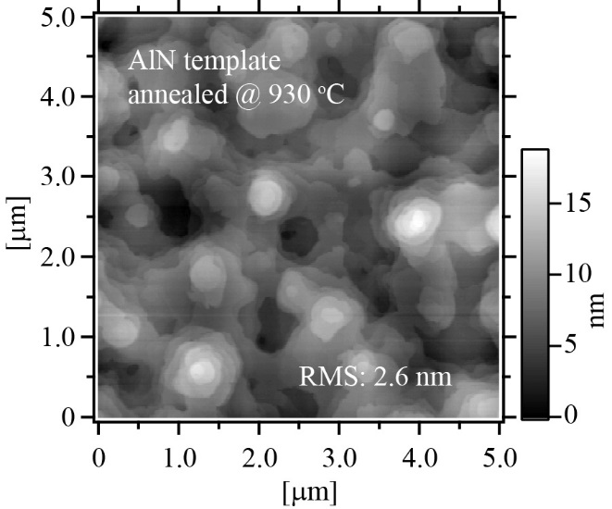

Fig. 1

M. Sumiya et al.

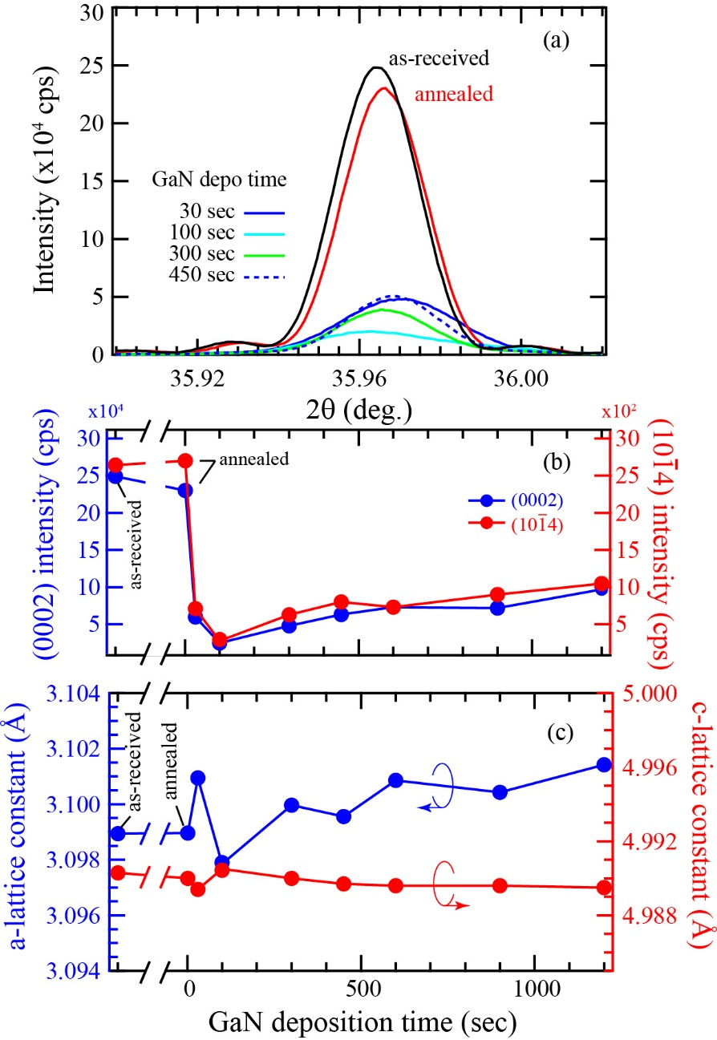

Fig. 2

M. Sumiya et al.

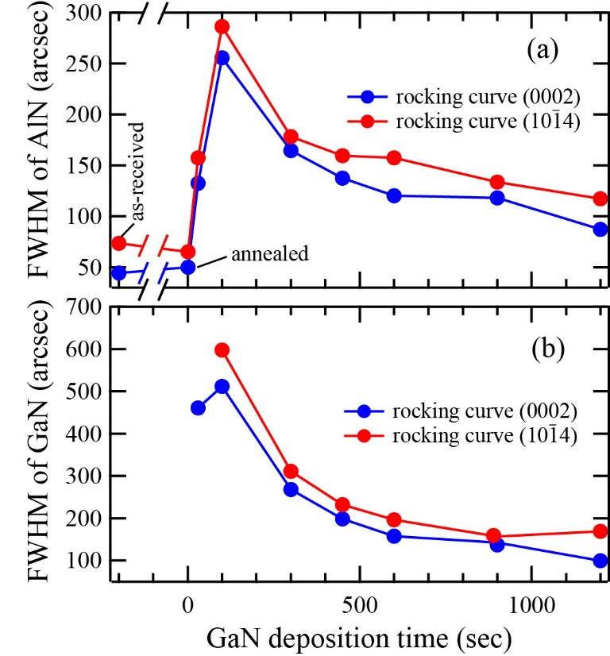

Fig. 3

M. Sumiya et al.

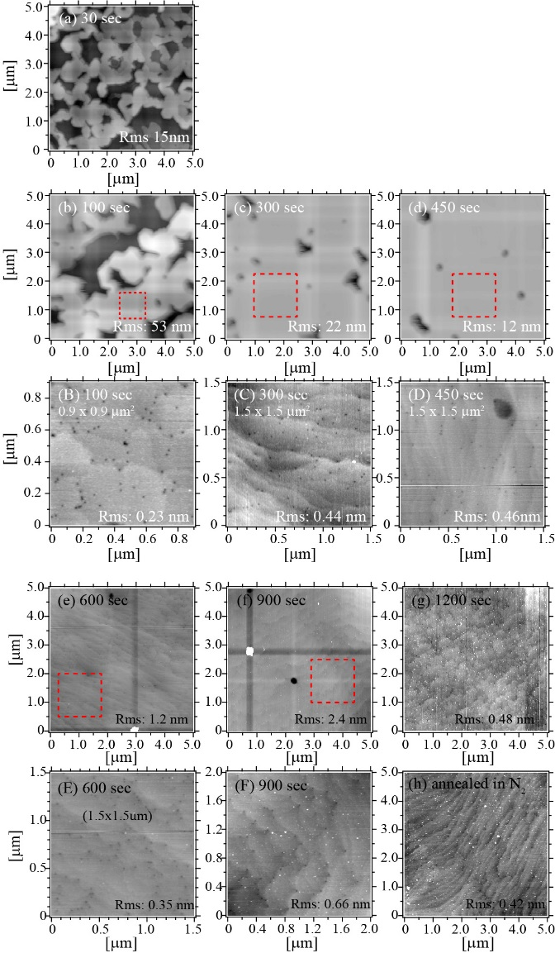

Fig. 4

M. Sumiya et al.

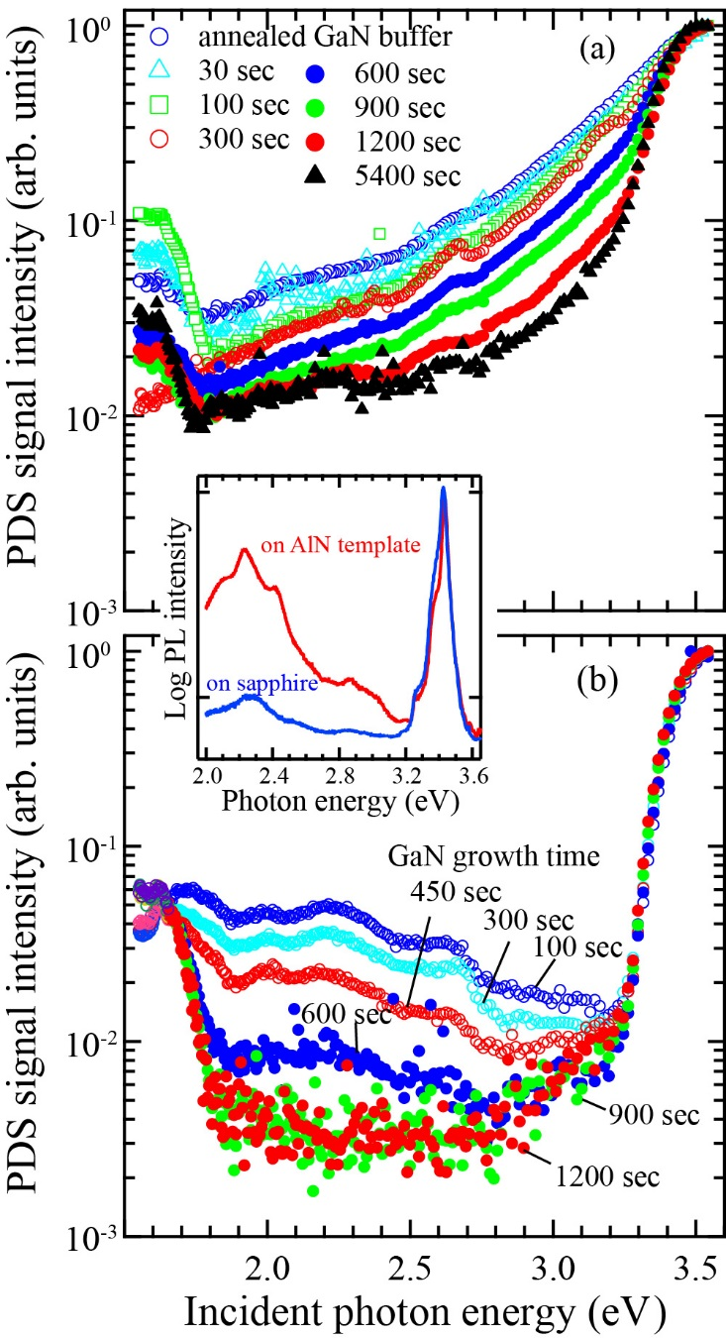

Fig. 5

M. Sumiya et al.

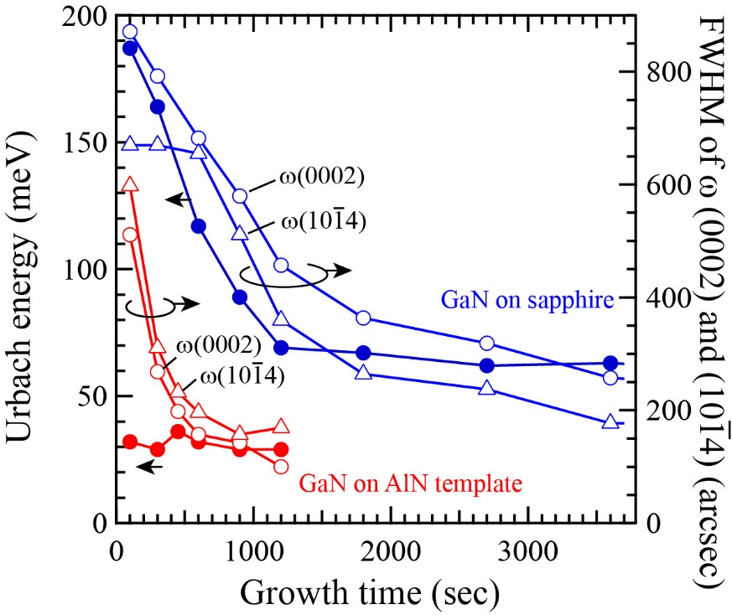

Fig. 6

M. Sumiya et al.
References

H. Amano, N. Sawaki, I. Akasaki, and Y. Toyoda, Appl. Phys. Lett. 48, (1986) 353.
S. Nakamura, Jpn. J. Appl. Phys. 30 (1991) L1705.
S. Fuke, H. Teshigawara, K. Kuwahara, Y. Takano, T. Ito, M. Yanagihara, and K. Ohtsuka, J. Appl. Phys. 83, (1998) 764.
T. Ito, M. Sumiya, Y. Takano. K. Ohtsuka, S. Fuke, Jpn. J. APpl. Phys. 38 (1999) 649.
M. Sumiya, N. Ogusu, Y. Yotsuda, M. Itoh, S. Fuke, T. Nakamura, S. Mochizuki, T. Sano, S. Kamiyama, H. Amano, and I. Akasaki, J. Appl. Phys. 93 (2003) 1311.
M. Sumiya, T. Ohnishi, M. Tanaka, I. Ohkubo, M. Kawasaki, M. Yoshimoto, H. Koinuma K. Ohtsuka and S. Fuke, Appl. Phys. Lett. 75, (1999) 674
M. Sumiya and S. Fuke, MRS Internet J. of Nitride Semicond. Res. 9, (2004) 1-32.
A. Krost and A. Dadger, Phys. Status. Solidi a 194 (2002) 361.
M. Sumiya, Y. Kamo, N. Ohashi, M. Takeguchi, Y. U. Heo, H. Yoshikawa, S. Ueda, K. Kobayashi, T. Nihashi, M. Hagino, T. Nakano, and S. Fuke, Appl. Surf. Sci. 256, (2010) 4442.
A. Kikuchi, T. Yamada, S. Nakamura, K. Kusakabe, D. Sugihara, and K. Kishino, Mat. Sci. Eng. B 82 (2001) 12.
L. Sang, M. Liao, N. Ikeda, Y. Koide, M. Sumiya Appl. Phys. Lett. 99, (2011) 031115.
M. Sakai, H. Ishikawa, T. Egawa, T. Jimbo, M. Umeno, T. Shibata, K. Asai, S. Sumiya, Y. Kuraoka, M. Tanaka, and O. Oda, J. Crys. Growth 244 (2002) 6.
D. Morita, A. Fujioka, T. Mukai and M. Fukui, Jpn. J. Appl. Phys. 46 (2007) 2895.
S. Fujikawa, T. Taknao, Y. Kondo, and H. Hirayama, J. Light&Vis. Env. 32, (2008) 83.
N. Susilo, S. Hagedorn, D. Jaeger, H. Miyake, U. Zeimer, C. Reich, B. Neuschulz, L. Sulmoni, M. Guttmann, F. Mehnke, C. Kuhn, T. ernicke, M. Weyers, and M. Kneissl, Appl. Phys. Lett. 112 (2018) 041110.
H. Miyake, G. Nishio, S. Suzuki, H. Hiramatsu, H. Fukuyama, J. Kaur, and N. Kuwano, Appl. Phys. Express 9 (2016) 025501.
M. Sumiya, S. Ueda, K. Fukuda, Y. Asai, Y. Cho, L. Sang, A. Uedono , T. Sekiguchi, T. Onuma, and T. Honda, Appl. Phys. Express 11, (2018) 021002.
W. B. Jackson, N. M. Amer, A. C. Boccara and D. Fournier, Appl. Opt. 20 (1981) 1333.
G. D. Cody, J. Non-Crsyt. Solids 141, (1992) 3.
O. Ambacher, W. Rieger, P. Ansmann, H. Angerer, T.D. Moustakas and M. Stutzmann, Sol. State. Comm. 97 (1996) 365.

