Near-vertical plasma-free HCl gas etching on (011) β-Ga₂O₃
Takayoshi Oshima* and Yuichi Oshima
Research Center for Electronic and Optical Materials, National Institute for Materials Science, Tsukuba, Ibaraki 305-0044, Japan
*E-mail: OSHIMA.Takayoshi@nims.go.jp

We investigated non-plasma HCl-gas etching properties on (011) β-Ga₂O₃, which is an attracting surface orientation allowing pit-free homoepitaxy. The etching occurred selectively in window regions of a patterned SiO₂ mask, and resulting side-etched structures were dependent on the in-plane directions of the window edges. Particularly, the side etching markedly reduced when the windows aligned with the [01$\overline{\text{1}}$] direction due to the formation of (100)-faceted sidewalls. Although the (100) sidewalls were slightly tilted from the surface normal by 6.5°, their surfaces were flat and free of plasma damage. Therefore, the crystallographic etching could be a promising microfabrication process on (011) β-Ga₂O₃.

Recently, β-Ga₂O₃ has emerged as an ultrawide-bandgap semiconductor, offering a promising solution for cost-effective, high-performance power devices.¹⁾ Its large bandgap (4.4 eV and higher²⁾) enables power devices to operate at high voltages while reducing on-resistance, thereby facilitating the production of low-loss compact devices. The availability of melt growth techniques for synthesizing single crystals permits the production of low-defect-density (~10³ cm⁻²) wafers,³⁾⁴⁾⁵⁾⁶⁾⁷⁾ with sizes now reaching up to 6 inches, compatible with standard semiconductor processing equipment. Additionally, the use of halide vapor phase epitaxy (HVPE)—a high-purity, high-speed epitaxy method—enables the growth of lightly-doped (~10¹⁶ cm⁻³) thick homoepitaxial layers suitable for voltage-sustaining layers in power devices.⁸⁾⁹⁾¹⁰⁾ The high thermal stability of β-Ga₂O₃ also allows for the use of ion implantation to conduct selective-area donor doping,¹¹⁾ simplifying the device fabrication process. With all these advantages combined, β-Ga₂O₃ shows greater promise than other wide-bandgap and ultrawide-bandgap semiconductors for the realization of next-generation power devices. However, some critical issues remain and must be addressed to advance the development of β-Ga₂O₃ devices.
The substrate orientation has been one of the key issues and still need to be explored. From the viewpoint of homoepitaxy, not only the growth rate but also the epitaxial structure and surface morphology are influenced by the substrate plane. To date, (100), ($\overline{\text{2}}$01), (010), and (001) substrates have been commercialized for β-Ga₂O₃ studies. The (100) and ($\overline{\text{2}}$01) substrates are unsuitable for homoepitaxy because twinning occurs due to the double positioning of adatoms.¹²⁾¹³⁾ Single-domain homoepitaxy is feasible on the (010) and (001) substrates. However, streaky grooves (line-shaped pits) along the [010] direction and dot-like hillocks appear on the (001) and (010) substrates, respectively.⁸⁾⁹⁾¹⁴⁾¹⁵⁾ In such a situation, Goto et al. recently reported the effect of substrate orientation on homoepitaxial growth using various orientation substrates, spanning from the (001) plane to the (010) plane around the [100] axis.¹⁵⁾ They revealed that a smooth homoepitaxial surface without pits and hillocks can be achieved on the (011) substrate, as the (011) plane is nearly parallel to the dislocations that generate surface pits. Since flat epitaxial layers do not necessitate chemical mechanical polishing for device applications, the (011) plane is considered a promising substrate orientation. However, research on the (011) plane is still in early stages, with only a limited number of publications to date.¹⁶⁾¹⁷⁾ Further research from a variety of perspectives is required to evaluate the validity of this orientation substrate.
In this study, we investigated the emerging crystallographic gas etching properties on (011) β-Ga₂O₃. Crystallographic gas etching allows for anisotropic etching based on the differences in surface energy densities of crystal facets. In the case of β-Ga₂O₃, planes with lower surface energy densities, especially the lowest-surface-energy-density (100) plane,¹⁸⁾ form etched structures due to their higher chemical stability. In contrast to plasma-based dry etching, crystallographic etching proceeds without plasma excitation, thereby providing etched surfaces free from plasma damage and therefore preferred for use in device applications. To date, hydrogen environment anisotropic thermal etching,¹⁹⁾²⁰⁾²¹⁾ forming gas etching,²²⁾ HCl gas etching,²³⁾²⁴⁾²⁵⁾²⁶⁾ Ga flux etching,²⁷⁾²⁸⁾²⁹⁾ and triethylgallium gas etching³⁰⁾³¹⁾ have been demonstrated on (010), (001), and ($\overline{\text{1}}$02) substrates. Their etching properties, particularly the in-plane side-etch behavior, are approximately similar regardless of the method although etching with Ga species (Ga flux etching and triethylgallium gas etching) is not precisely categorized as gas etching but Ga metal etching. Conversely, they are strongly dependent on the substrate orientation. Thus, we considered that an investigation on the (011) plane from the perspective of crystallographic etching would contribute for the evaluation of this orientation substrate. For the comparison to the results on other planes, we chose the HCl gas etching method that were performed on (010), (001), and ($\overline{\text{1}}$02) substrates.²³⁾²⁵⁾²⁶⁾
The HCl gas etching experiment on the (011) plane was conducted as follows. A 0.13-μm-thick SiO₂ layer was deposited on the surface of a (011) Sn-doped β-Ga₂O₃ single crystal substrate with a carrier density of 4.2×10¹⁸ cm⁻³ (Novel Crystal Technology, Inc.) by plasma-enhanced chemical vapor deposition. The layer was patterned using standard laser lithography and CHF₃-plasma dry etching to form rectangular, radial-line, and striped windows. The dimensions of the rectangular window were as large as 100×150 μm². The radial-line windows were composed of 36 line-shaped windows with a width of 0.7 μm, arranged in 10° increments starting from the [01$\overline{\text{1}}$] direction. It is important to note that the [01$\overline{\text{1}}$] direction is parallel to the intersection line between the (011) and (100) planes. Striped windows were aligned with the [01$\overline{\text{1}}$] direction; while the mask and window widths were 1.4 and 5.6 μm, respectively. The SiO₂-masked substrate was introduced in a laboratory-made halide vapor-phase etching system to perform selective area etching in a flow of a gas mixture of HCl (> 99.999% pure) and N₂ (dew point < −110°C) with a HCl partial pressure of 62.5 Pa at 1038°C for 10 min under atmospheric pressure. These etching conditions are the same as those of the HCl gas etching experiments on (010), (001), and ($\overline{\text{1}}$02) substrates.²³⁾²⁵⁾²⁶⁾ The vertical etch rate was 0.30 μm min⁻¹, which was obtained by measuring the depth of the etched depression in the rectangular window using a stylus profiler. Other etched structures under the radial-line and striped windows were observed using scanning electron microscopy (SEM). For the etched trenches under the striped window, the cross section was also exposed and observed using a focused ion beam milling and SEM hybrid system. Note that the SiO₂ mask was not removed for all the measurements.
First, in-plane anisotropy of side etching was characterized through SEM observation of trenches under the radial-line windows, as shown in Fig. 1. The side-etched regions under the mask were visible due to a sufficiently high electron beam acceleration voltage of 10 kV [Fig. 1(a)].²³⁾ The side-etch length, which we define as the distance between a window edge and an end of the side-etched region, was dependent on the in-plane direction. By measuring the side-etch lengths on both sides of the windows, the in-plane dependence of the side-etch rate was visualized in polar coordinates [Fig. 1(b)]. The approximate two-fold rotational symmetry pattern was roughly similar to that obtained on the (010) substrate,²⁵⁾ which is consistent with the fact that the (011) plane is tilted by only 28.3° around the [100] axis with respect to the (010) plane. Side etching was substantially suppressed in the two opposite directions perpendicular to the [01$\overline{\text{1}}$] direction, where etched sidewalls with (100) facets should be formed as in the case on the other orientation substrates.²³⁾²⁵⁾²⁶⁾ The side-etch rates were as small as 10 nm min⁻¹ for the [01$\overline{\text{1}}$]×011* direction and 15 nm min⁻¹ for the [0$\overline{\text{1}}$1]×011* direction, where “×” and “*” represent the cross product and reciprocal lattice vector, respectively. The non-negligible etch-rate difference may be attributed to a slight tilting of the (100) plane by 6.5° from the surface normal²³⁾ and/or their 180°-rotated crystal lattice structures.²²⁾ Since the minimized side etching feature is preferable for practical device processing, we focused on etched trenches along the [01$\overline{\text{1}}$] direction.
Well-defined trenches with (100)-faceted sidewalls were successfully obtained under striped windows aligned with the [01$\overline{\text{1}}$] direction, as shown in Fig. 2. The trench width was almost the same as the window width due to the very small side etch rates [Fig. 2(a)]. While, the trench sidewalls exhibited smooth surfaces with some steps [Figs. 2(b) and 2(c)]. These steps probably be generated due to the subtle misorientation of the trench direction and would be eliminated by carefully adjusting the in-plane alignment in the lithography process. In contrast, the etched bottom surface was rough, which is reminiscent of that observed on the (010) substrate.²⁵⁾ Decreasing the process temperature could reduce the roughness,²²⁾ but this is a topic for future studies.
The near vertical (100)-faceted sidewalls were confirmed through cross-sectional observation, as shown in Fig. 3. The trench profile was comprised of a pair of tilted (100) sidewalls and a rough bottom plane [Fig. 3(a)]. The positive and negative tapered sidewalls were found to be parallel with one another, exhibiting a tilt angle of 8° with respect to the surface normal. This measured angle agrees with the calculated value of 6.5° [Fig. 3(b)], thereby confirming that the sidewalls were formed with (100) facets. The slight angle difference of ~2° can be attributed to deviations in the holder normal direction with respect to the (011) plane and the directions of Ga and electron beams of the FIB-SEM system. The aspect ratio, defined as the etched depth divided by the side etching length just under the mask, reached 30 for the [01$\overline{\text{1}}$]×011* direction side and 20 for the [0$\overline{\text{1}}$1]×011* direction side, respectively, which are higher than those of the HCl-gas etched trenches with (100)-faceted sidewalls on (010), (001), and ($\overline{\text{1}}$02) substrates.²³⁾²⁵⁾²⁶⁾ The near-vertical, high-aspect-ratio etched profiles indicate that HCl gas etching could be a viable microfabrication technique on (011) substrates.
In summary, we performed HCl gas etching on a SiO₂-masked (011) β-Ga₂O₃ substrate to investigate the etching properties. As in the case with other orientation substrates, (100) facets appeared as smooth etched sidewalls with minimized sidewall etch rates when the window direction was [01$\overline{\text{1}}$]. In addition, the sidewalls were nearly vertical because the (100) plane is tilted by 83.5° degrees with respect to the (011) plane. These crystallographic etching features suggest that the (011) orientation substrate is well-suited for microfabrication using HCl gas etching, and potentially other non-plasma gas etching methods mentioned above.

Acknowledgments
This work was supported by the Nanofabrication and Electron Microscopy Units in NIMS, as well as the Advanced Research Infrastructure for Materials and Nanotechnology in Japan of the Ministry of Education, Culture, Sports, Science and Technology (JPMXP1224NM5062). Additionally, financial support was provided by the TEPCO Memorial Foundation, and the KAKENHI Grant-in-Aid for Scientific Research (B), JP24K01368, of the Japan Society for the Promotion of Science.

References
1) K. Sasaki, Appl. Phys. Express 17, 090101 (2024).
2) T. Onuma, S. Saito, K. Sasaki, T. Masui, T. Yamaguchi, T. Honda, and M. Higashiwaki, Jpn. J. Appl. Phys. 54, 112601 (2015).
3) E.G. Víllora, K. Shimamura, Y. Yoshikawa, K. Aoki, and N. Ichinose, J. Cryst. Growth 270, 420 (2004).
4) A. Kuramata, K. Koshi, S. Watanabe, Y. Yamaoka, T. Masui, and S. Yamakoshi, Jpn. J. Appl. Phys. 55, 1202A2 (2016).
5) Z. Galazka, R. Uecker, D. Klimm, K. Irmscher, M. Naumann, M. Pietsch, A. Kwasniewski, R. Bertram, S. Ganschow, and M. Bickermann, ECS J. Solid State Sci. Technol. 6, Q3007 (2017).
6) Y. Ueda, T. Igarashi, K. Koshi, S. Yamakoshi, K. Sasaki, and A. Kuramata, Jpn. J. Appl. Phys. 62, SF1006 (2023).
7) A. Yoshikawa, V. Kochurikhin, T. Tomida, I. Takahashi, K. Kamada, Y. Shoji, and K. Kakimoto, Sci. Rep. 14, 14881 (2024).
8) H. Murakami, K. Nomura, K. Goto, K. Sasaki, K. Kawara, Q.T. Thieu, R. Togashi, Y. Kumagai, M. Higashiwaki, A. Kuramata, S. Yamakoshi, B. Monemar, and A. Koukitu, Appl. Phys. Express 8, 015503 (2015).
9) Y. Oshima and T. Oshima, Semicond. Sci. Technol. 38, 105003 (2023).
10) K. Goto, K. Konishi, H. Murakami, Y. Kumagai, B. Monemar, M. Higashiwaki, A. Kuramata, and S. Yamakoshi, Thin Solid Films 666, 182 (2018).
11) K. Sasaki, M. Higashiwaki, A. Kuramata, T. Masui, and S. Yamakoshi, Appl. Phys. Express 6, 086502 (2013).
12) A. Fiedler, R. Schewski, M. Baldini, Z. Galazka, G. Wagner, M. Albrecht, and K. Irmscher, J. Appl. Phys. 122, 165701 (2017).
13) T.S. Ngo, D.D. Le, J. Lee, S.-K. Hong, J.-S. Ha, W.-S. Lee, and Y.-B. Moon, J. Alloys Compd. 834, 155027 (2020).
14) T. Nishikawa, K. Goto, H. Murakami, Y. Kumagai, M. Uemukai, T. Tanikawa, and R. Katayama, Jpn. J. Appl. Phys. 62, SF1015 (2023).
15) K. Goto, H. Murakami, A. Kuramata, S. Yamakoshi, M. Higashiwaki, and Y. Kumagai, Appl. Phys. Lett. 120, 102102 (2022).
16) B. Chen, W. Mu, Y. Liu, P. Wang, X. Ma, J. Zhang, X. Dong, Y. Li, Z. Jia, and X. Tao, CrystEngComm 25, 2404 (2023).
17) S. Sdoeung, Y. Otsubo, K. Sasaki, A. Kuramata, and M. Kasu, Appl. Phys. Lett. 123, 122101 (2023).
18) S. Mu, M. Wang, H. Peelaers, and C.G. Van de Walle, APL Mater. 8, 091105 (2020).
19) Y. Ooe, Y. Kawasaki, Y. Moriya, D. Ito, and A. Kikuchi, in 3rd Int. Work. Gall. Oxide Relat. Mater. (2019).
20) Y. Yamazaki, M. Tomoaki, A. Takeki, and A. Kikuchi, in 4th Int. Work. Gall. Oxide Relat. Mater. (2022).
21) S. Sato, T. Momma, T. Aikawa, and A. Kikuchi, in 5th Int. Work. Gall. Oxide Relat. Mater. (2024).
22) T. Oshima, R. Togashi, and Y. Oshima, Sci. Technol. Adv. Mater. 25, 2378683 (2024).
23) T. Oshima and Y. Oshima, Appl. Phys. Lett. 122, 162102 (2023).
24) Y. Oshima and T. Oshima, Jpn. J. Appl. Phys. 62, 080901 (2023).
25) T. Oshima and Y. Oshima, Appl. Phys. Express 16, 066501 (2023).
26) T. Oshima and Y. Oshima, Appl. Phys. Lett. 124, 42110 (2024).
27) N.K. Kalarickal, A. Fiedler, S. Dhara, H.-L. Huang, A.F.M.A.U. Bhuiyan, M.W. Rahman, T. Kim, Z. Xia, Z.J. Eddine, A. Dheenan, M. Brenner, H. Zhao, J. Hwang, and S. Rajan, Appl. Phys. Lett. 119, 123503 (2021).
28) S. Dhara, N.K. Kalarickal, A. Dheenan, S.I. Rahman, C. Joishi, and S. Rajan, Appl. Phys. Lett. 123, 023503 (2023).
29) T. Kim, C. Joishi, Z. Xia, N.K. Kalarickal, C. Selcu, T. Back, J. Ludwick, and S. Rajan, AIP Adv. 13, 075119 (2023).
30) A. Katta, F. Alema, W. Brand, A. Gilankar, A. Osinsky, and N.K. Kalarickal, J. Appl. Phys. 135, 075705 (2024).
31) N. Das, F. Alema, W. Brand, A. Katta, A. Gilankar, A. Osinsky, and N.K. Kalarickal, ArXiv 2408.05824 (2024).

Figures
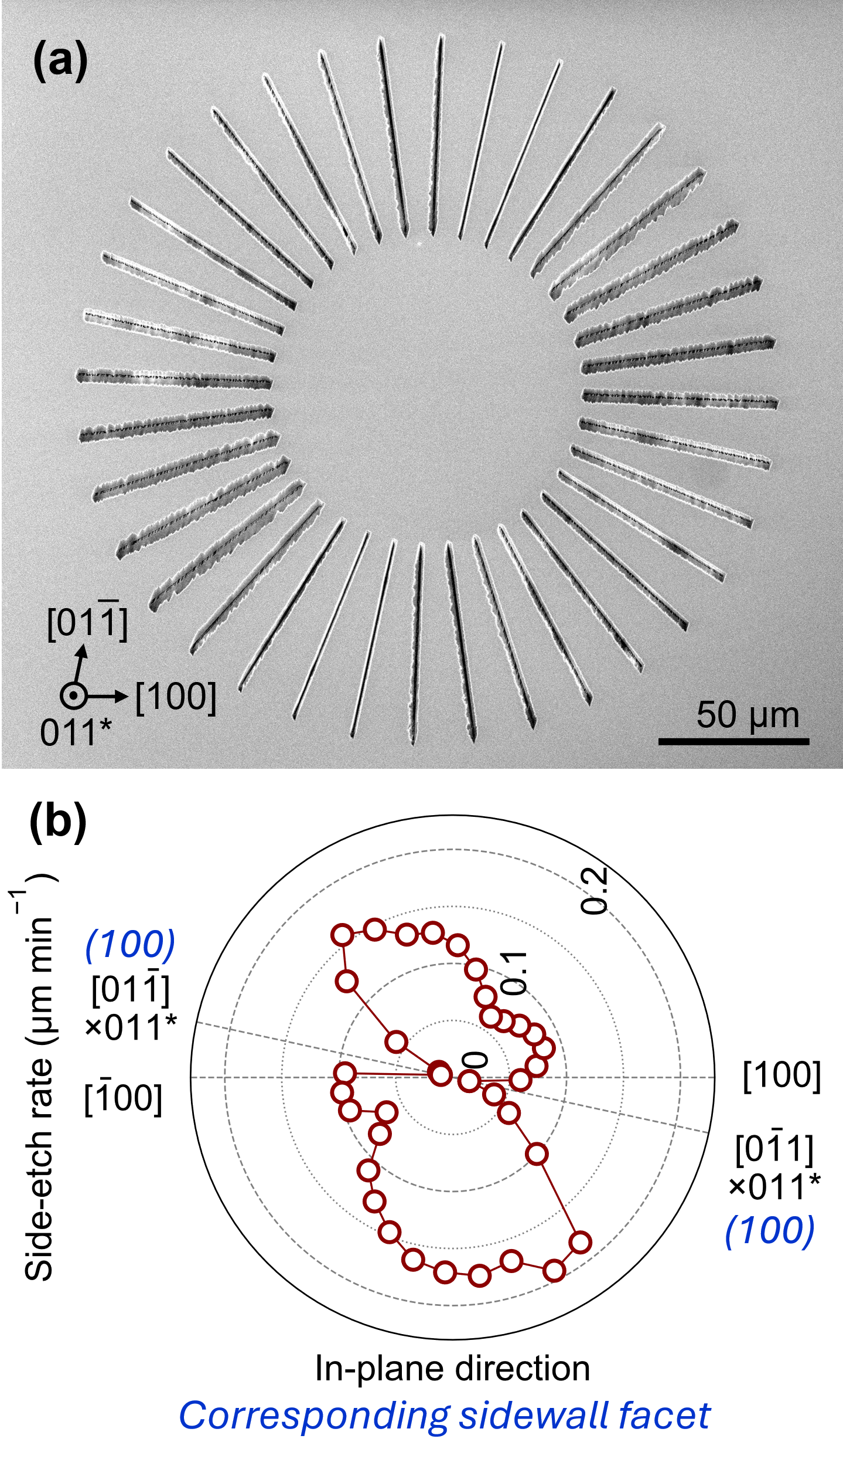
Fig. 1. (a) Plain-view scanning microscopy image of etched trenches under radial-line windows on (011) β-Ga₂O₃. The image was recorded at an acceleration voltage of 10 kV. The magnified images are also provided in the supplementary material. (b) Polar plot of side-etch rates perpendicular to the radial-line windows shown in (a). Note that the solid lines connecting the data points serve as a guide for the eye.
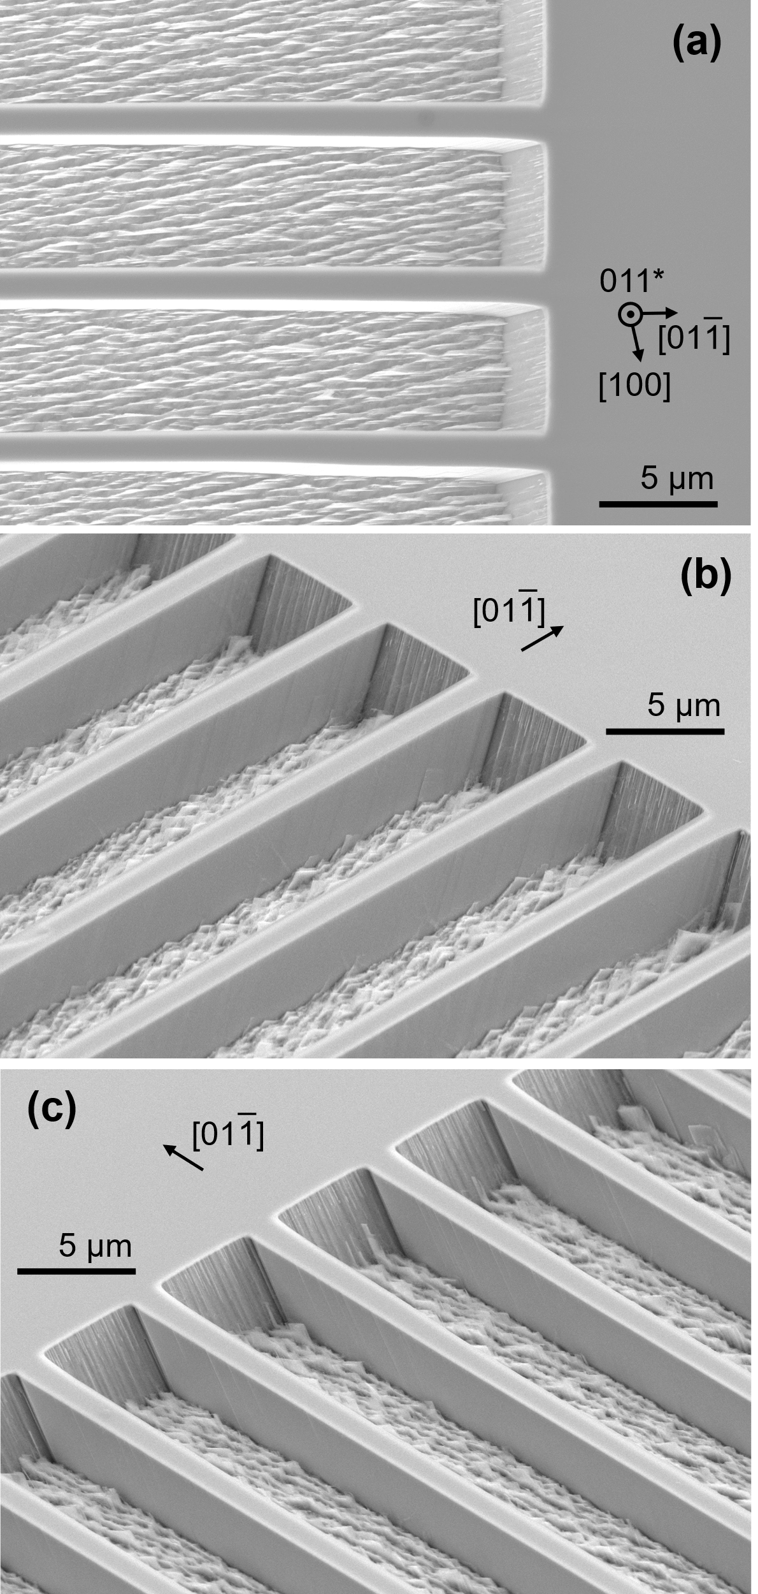
Fig. 2. (a) Plain-view and (b), (c) 54°-tilted-view scanning microscopy images of etched trenches under striped windows aligned with the [01$\overline{\text{1}}$] direction on (011) β-Ga₂O₃. The images were taken under an acceleration voltage of 10 kV.

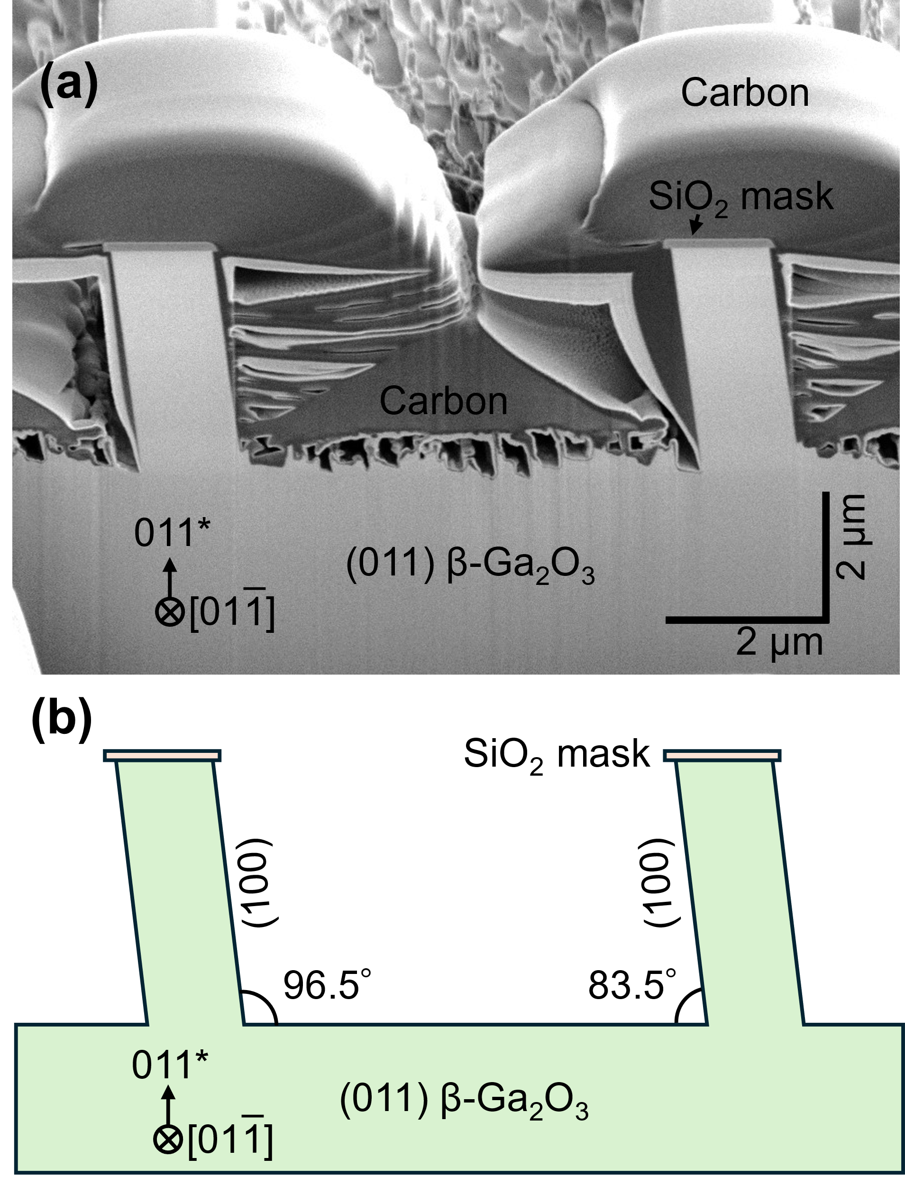
Fig. 3. (a) 54°-tilted-view cross-sectional scanning microscopy image of the etched trenches under the striped windows shown in Fig. 2. The image was obtained at acceleration voltage of 2 kV. The carbon deposit was a protective layer for the focused-ion-beam milling process. It should be noted that the vertical and lateral scales on the cross section differ due to the tilted observation. (b) Cross-sectional schematic illustrated based on (a). In this schematic, the vertical-to-horizontal aspect ratio is unity. The angles were calculated using the lattice parameters of β-Ga₂O₃.

