Evaluation of coupling currents in MgB₂ wire under rotating magnetic field using numerical analysis

Satsuki Okumura, Yutaka Terao, Member, IEEE, Hiroyuki Ohsaki, Member, IEEE, and Akihiro Kikuchi

Abstract—In this paper, the authors performed a numerical analysis of AC loss when a rotating magnetic field was applied to the MgB₂ wire. The H-φ formulation was used for the finite element analysis. AC losses include coupling losses, hysteresis losses, and eddy current losses. The AC losses were calculated when the contact resistivity and contact length were changed. The rotational frequencies were 25 Hz and 50 Hz, and the maximum magnetic flux density amplitude was 0.01 T. As a result, it was revealed that the coupling loss was inversely proportional to the contact resistance. It was also revealed that the coupling loss was proportional to the square of the contact length. These trends can be understood from the theoretical formula for coupling loss.

Index Terms—AC loss, Coupling loss, MgB₂ wire, Rotating magnetic field, three-dimensional FEM-based on analysis.

I. INTRODUCTION
I
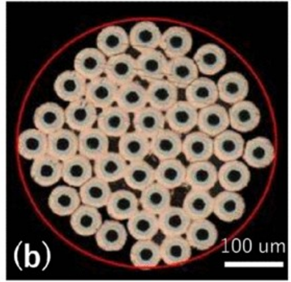
Fig. 1 Ultra-fine multi-core MgB₂ wire [6]
N recent years, solving environmental and energy problems has become urgent, with the International Energy Agency's Net Zero by 2025 announcement in 2021 and the industry demanding technological innovations that reduce greenhouse gas emissions [1]. Especially in the transportation and energy fields, developing high-efficiency, high-power-density rotating machines have been actively pursued.
The potential of superconducting rotating machines to address these challenges is immense. With their zero electrical resistance, superconductors can significantly reduce copper loss in the field winding. The air-core structure of a superconducting rotating machine leads to lower iron loss than a conventional rotating machine. Moreover, superconductors have a higher current density than copper, which can reduce the weight of the windings. This all points to the potential for superconducting rotating machines to achieve higher efficiency and power density. The prospect of fully superconducting rotating machines (FSRMs) with superconducting field winding and armature winding is fascinating. We focus on FSRMs using REBCO wire for the field winding and MgB₂ wire for the armature winding [2].
A rotating magnetic field is applied to the armature winding, which generates AC losses. AC losses include coupling losses, hysteresis losses, and eddy current losses. It is very important to understand the magnitude and causes of this AC loss in detail in the development of FSRM. There are some research groups employing the measurement of MgB₂ AC losses using the colorimetric method [3] and the mechanical method [4]. The authors have been studying and constructing an AC loss measurement system for MgB₂ SC coils under a rotating magnetic field [5].
MgB₂ wires that reduce AC losses are also being actively developed. NIMS has succeeded in developing the world's thinnest superconducting wire, an ultra-fine MgB₂ wire with an overall diameter of 15 μm [6] (see Fig. 1). This structure can reduce losses. Insulating each individual wire reduces coupling losses, but it is not possible to insulate each wire individually from the protection. It is necessary to consider the degree of coupling. In this research, we developed a method for the loss mechanism of MgB₂ wire by three-dimensional FEM based on analysis, including the effect of superconductivity.

II. Numerical Analysis

A. H-φ formulation
The H-φ formulation has recently attracted attention as a method for solving electromagnetic problems in superconductivity. Fig. 2 shows the analysis domain. Region $Ω_{w}$ and $Ω_{air}$ are the wire and the air region, respectively. The H-φ formulation solves the full vector H in region $Ω_{w}$, where currents can exist, and only the magnetic scalar potential φ in region $Ω_{air}$, which is current-free.
In region $Ω_{w}$, the governing equation is the H formulation expression, given by
$$∇×\left(ρ∇×H\right) = -μ_{0}\frac{dH}{dt}$$
where H is the magnetic field, ρ is the magnetic resistivity, $μ_{0}$
is the vacuum magnetic permeability. The resistivity ρ is nonlinear in the case of superconductors, and given by
$$ρ=\frac{E_{c}}{J_{C}(B)}{\left(\frac{\left|J\right|}{J_{C}(B)}\right)}^{n-1}$$
where $J_{C}$ is the field-dependent local critical current density, $E_{C}$ is the critical current criterion, and n is a material parameter.
In region $Ω_{air}$, the governing equation is the φ formulation expression, given by
$$∇∙∇φ=0$$
We constrain the calculation results for region $Ω_{w}$ and region $Ω_{air}$ on the boundary Γ.

B. Geometry
Fig. 3 shows the model's appearance, and Tables 1 and 2 show its specifications. The shape is modeled after the NIMS shape, but the size uses original values ​​for numerical analysis. The black, orange, and yellow areas are MgB₂, the base material, and the contact area, respectively. The wires are in contact by sharing a thin film between them. Coupling loss is calculated by performing a one-twist pitch calculation.

TABLE I
Material specification
Parts | Scale
Critical current criterion $E_{C} [V/m]$ | $$1.0×{10}^{-4}$$
Critical current density $J_{C} [V/{m^{2}}]$ | $$1.0×{10}^{9}$$
N value | 50
Resistance of Base matrix $ρ_{base} [Ωm]$ | $$1.0×{10}^{-8}$$
Contact resistance $ρ_{con.}[Ωm]$ | $$1.0×{10}^{-8}\sim$$

TABLE II
Geometry
Parts | Scale
Radius of MgB2 $R_{SC} [μm]$ | 31.5
Radius of base material $R_{base} [μm]$ | 50.0
Width of contact place $R_{con.} [μm]$ | 9.0
1st Radius $R_{1} [μm]$ | 110
2nd Radius $R_{2} [μm]$ | 213
Twist pitch $L_{tp} [mm]$ | 24.0
Length of model $H [mm]$ | 24.0
Radius of Air $R_{air} [mm]$ | 1.0

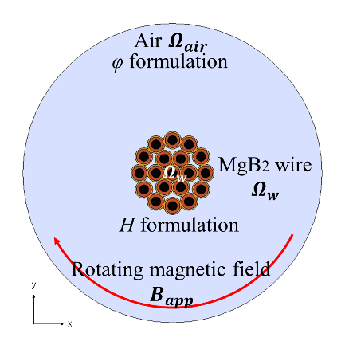
Fig. 2 The analysis domain of H-φ formulation
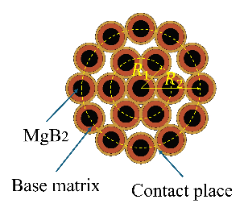 | 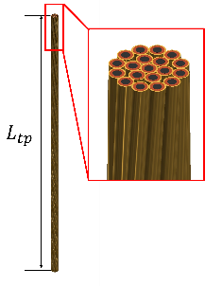
- Cross-section view | - 3D model
Fig. 3 Model geometry
 | 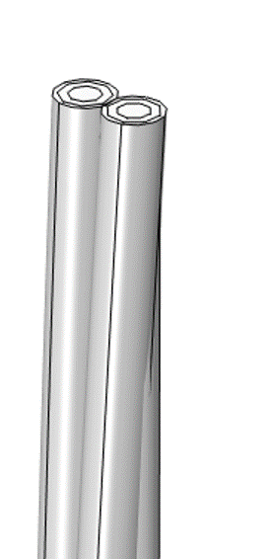
- Cross-section view | - 3D model
Fig. 4 Geometry when two filaments are connected

III. The relationship between the contact resistivity and losses

A. Condition
As shown in Fig. 4, we consider the condition where two wires arranged on a radius $R_{1}$ are connected with contact resistance. Calculations were performed by changing the contact resistivity from $1.0×{10}^{-8} Ωm$ to $1.0×{10}^{-7} Ωm$. There are two rotational frequencies: 25Hz and 50Hz. The maximum magnetic flux density amplitude $B_{max}$ is 0.01T.

B. Results
As shown in Fig. 5 (a) and (b), when the contact resistance is large, the coupling current does not flow easily, and the current density in the base matrix decreases. This reduces the self-magnetic field, as shown in Fig. 6 (a) and (b), and the effective current density in the superconductor decreases.
Fig. 7 shows the relationship between contact resistivity and hysteresis loss. The theoretical formula for hysteresis loss $W_{h}$ is given by equation (4) [7].
$$W_{h}=\frac{32}{3π}fλB_{max}J_{C}R_{SC}Ω(η)$$
where $f \left[Hz\right], λ, B_{max} \left[T\right], J_{C} \left[A/{m^{2}}\right] and R_{SC} \left[m\right]$ are the frequency, packing factor, applying magnetic flux density amplitude, critical current density under $B_{max}$, and MgB₂ filament diameter, respectively. As the contact resistance increased, the hysteresis loss decreased slightly. As can be seen from Fig. 5 and 6, the larger the contact resistance, the smaller the magnetic flux density applied to the superconductor and the current density of the superconductor. Therefore, it can be said that the hysteresis loss becomes smaller according to the
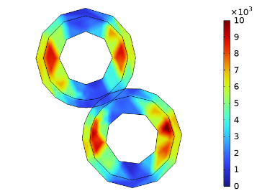 | 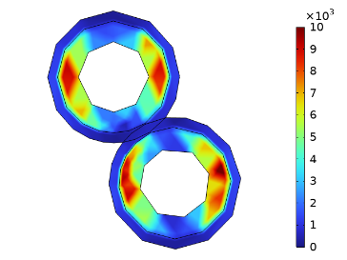
(a) The contact resistivity is 2$.0×{10}^{-8} Ωm$. | (b) The contact resistivity is $1.0×{10}^{-7} Ωm$.
Fig. 5 The current density in the base matrix
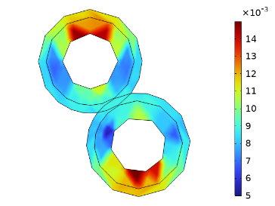 | 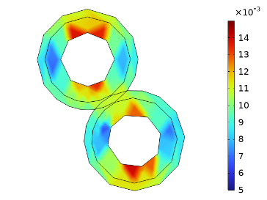
(a) The contact resistivity is 2$.0×{10}^{-8} Ωm$. | (b) The contact resistivity is $1.0×{10}^{-7} Ωm$.
Fig. 6 The magnetic flux density in the base matrix
theoretical formula.
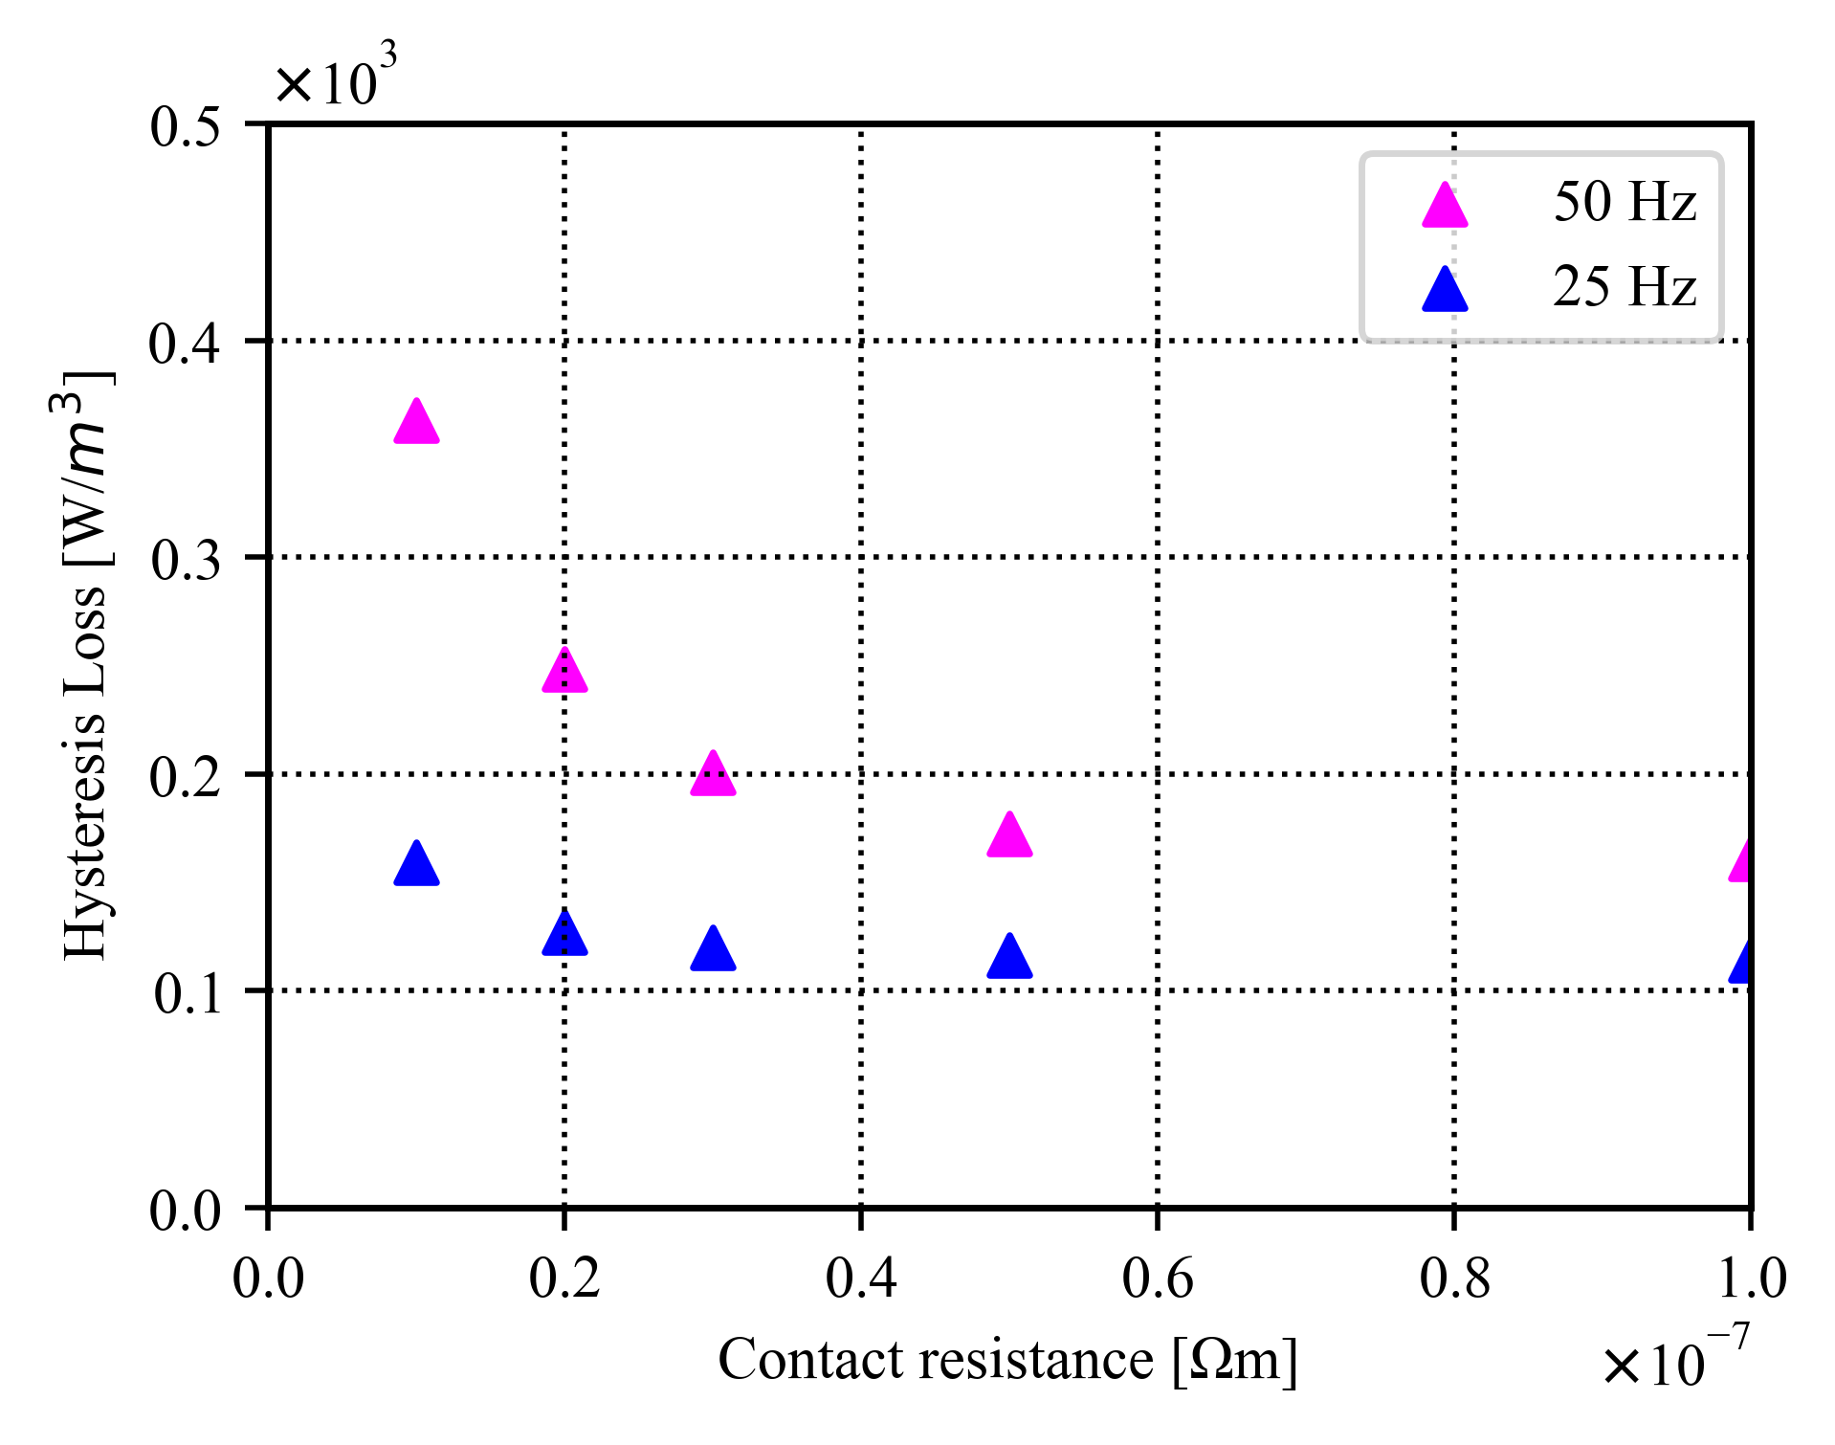
Fig. 7 The relationship between contact resistivity and hysteresis loss. The magenta triangular dots and blue triangular dots are the results for 50Hz and 25Hz, respectively.
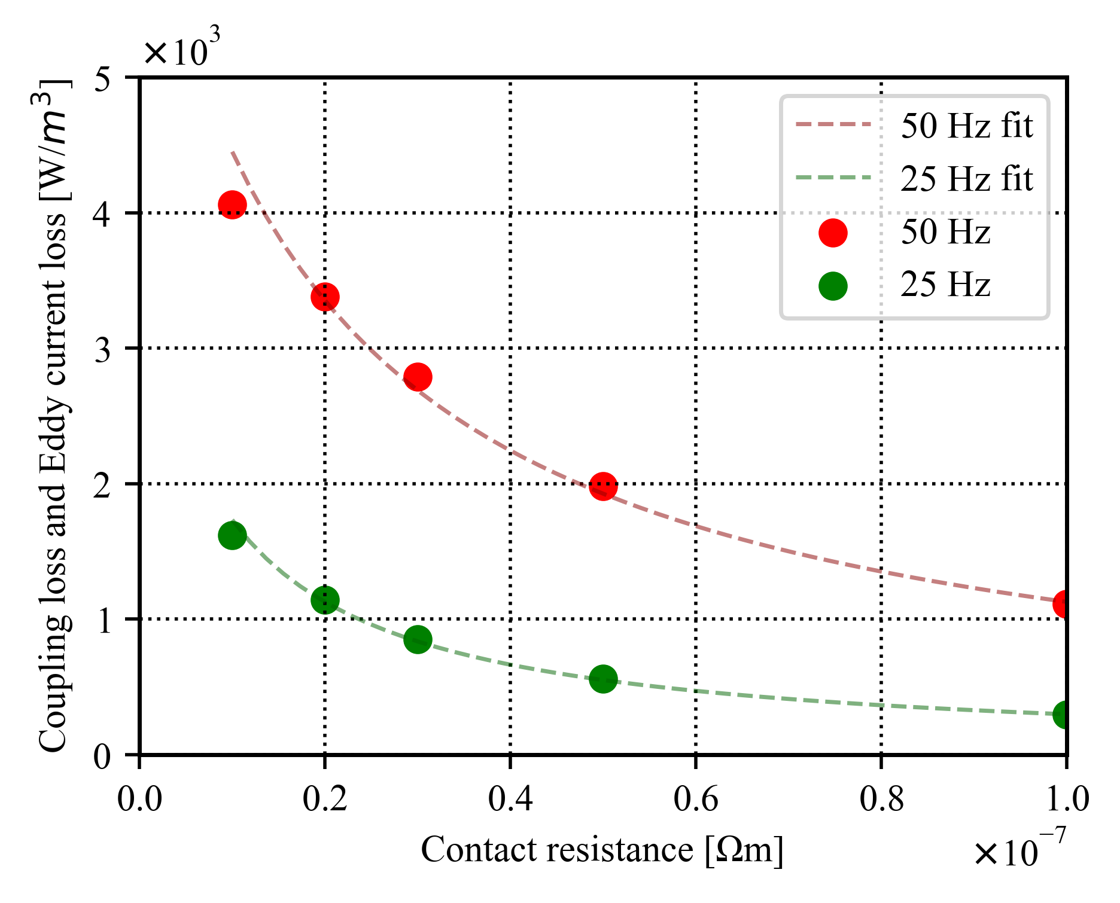
Fig. 8 The relationship between contact resistivity and coupling loss. The red dots and green dots are the results for 50 Hz and 25 Hz, respectively. The dashed lines are the respective fitting functions.
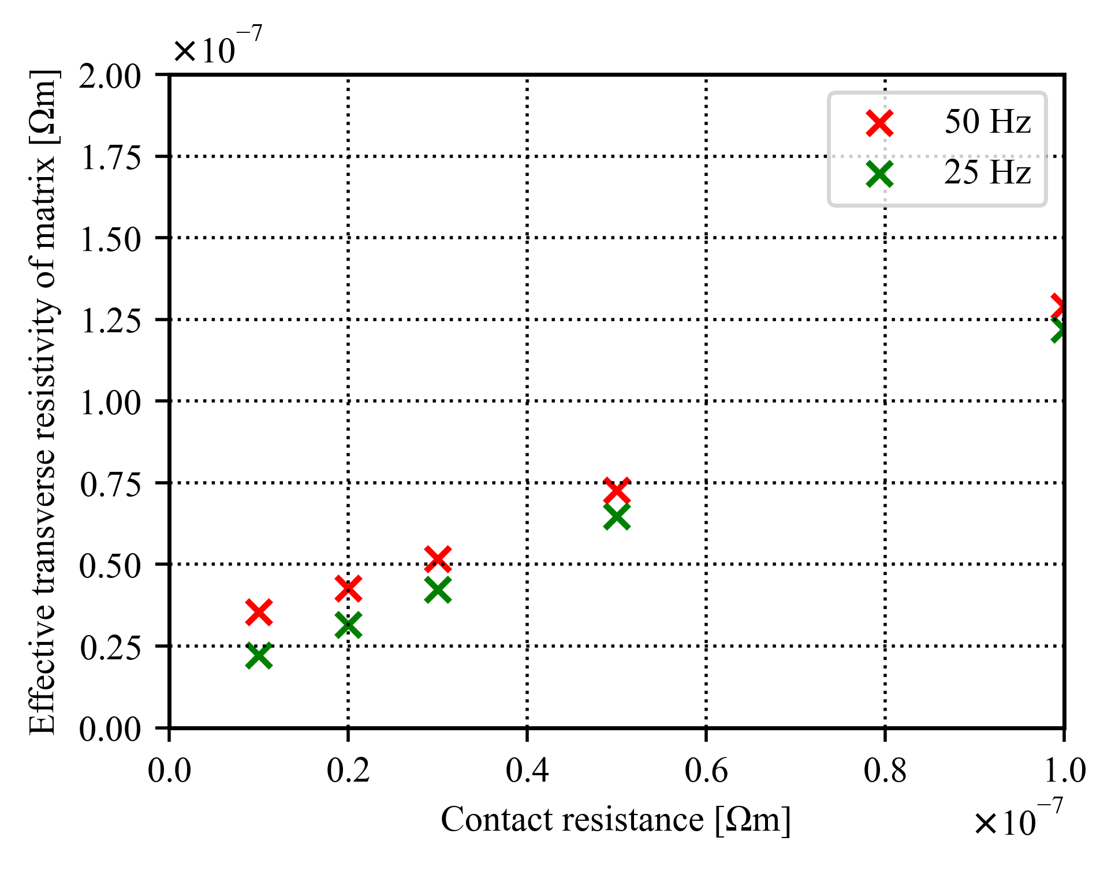
Fig. 9 The relationship between contact resistance and effective transverse resistivity. The red dots and green dots are the results of 50 Hz and 25 Hz, respectively.
Fig. 8 shows the relationship between contact resistivity and coupling loss. As the contact resistivity increases, the coupling loss decreases. The theoretical formula for coupling loss is given by equation (5) [7].
$$W_{c}=\frac{1}{2ρ_{e}}{\left(fB_{max}L_{tp}\right)}^{2}\left(1+η^{2}\right)$$
where $ρ_{e} [Ωm]$ is the effective transverse resistivity. The coupling loss equation can be fitted well to a function with the transverse resistivity as a variable. Fig. 9 shows the relationship between contact resistance and effective transverse resistivity. The contact resistivity and effective transverse resistivity change linearly. Because the resistivity for current flowing in the cross-sectional direction is connected in series, the effective transverse conductivity increases linearly as the contact resistivity increases. Therefore, the coupling loss is inversely proportional to the contact resistivity. The hysteresis loss is much smaller than the coupling loss.

IV. The relationship between the contact length and losses

A. Condition
We consider the case where two MgB₂ wires arranged on a radius $R_{1}$ are in contact at both ends of the twist pitch at the coupling length (see Fig. 10 (a)). The coupling length is L, shown in Fig. 10 (b). When the coupling length is 0 mm, they are entirely separated, and when the coupling length is 12 mm, they are coupled at the full twist pitch length (24 mm). The coupling length was changed from 0 mm to 12 mm. The contact resistivity was $1.0×{10}^{-7} Ωm$, and the rotational frequencies were 25Hz and 50Hz. The maximum magnetic flux density was 0.01T.
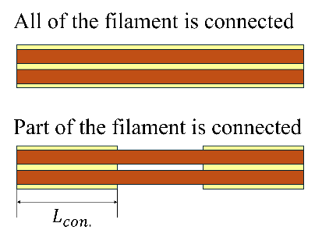 | 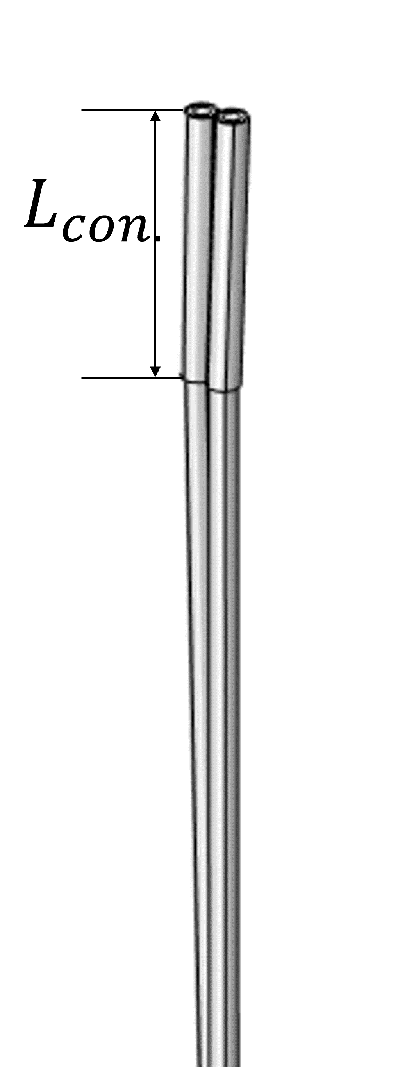
(a) Cross-section view | (b) 3D model
Fig. 10 Geometry when two filaments are connected

B. Results
Fig. 11 shows the relationship between contact length and losses. The magenta triangular dots and blue triangular dots are the hysteresis loss results for 50Hz and 25Hz, respectively. The red dots and green dots are the coupling loss results for 50 Hz and 25 Hz, respectively. The dashed lines are the respective fitting functions.
The hysteresis loss does not change regardless of the contact length. Since the size of the superconducting wire does not change, the loss does not change. The higher the frequency, the greater the loss, which is consistent with the theoretical formula for hysteresis loss.
The longer the contact length, the greater the loss. It fits well to a function proportional to the square of the contact length.
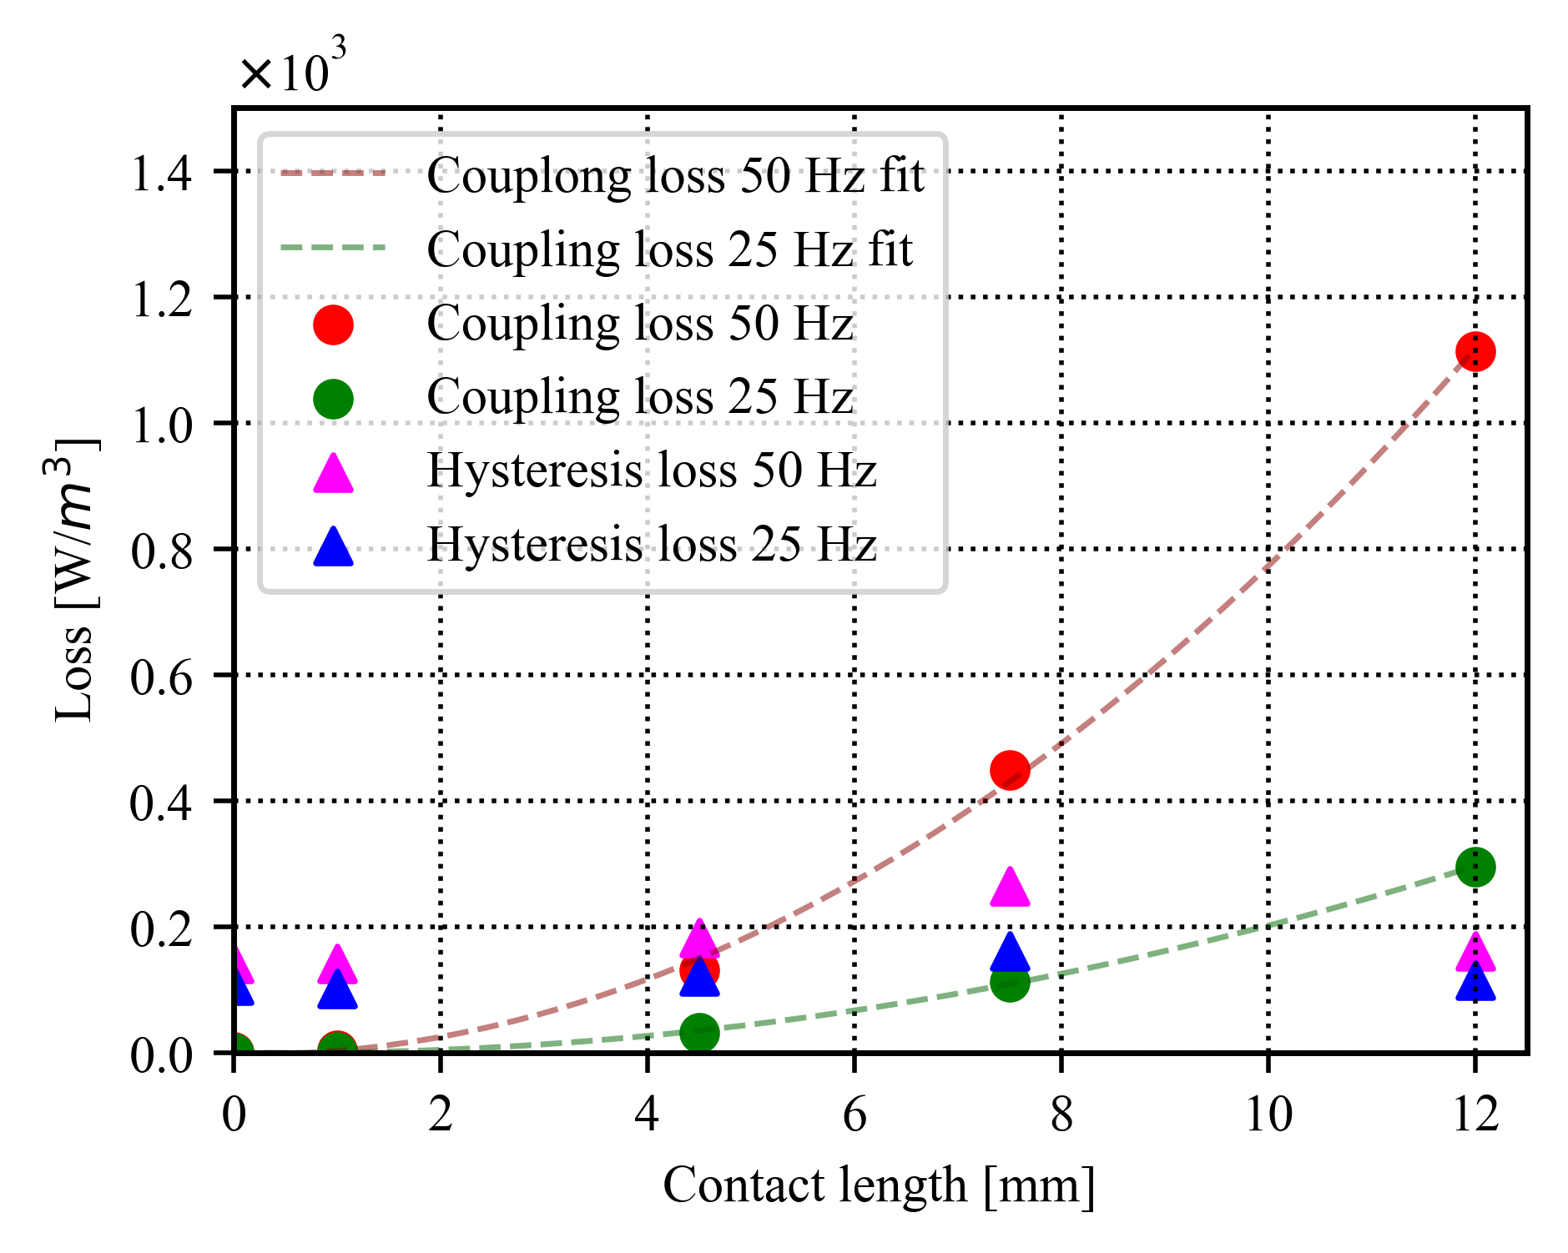
Fig. 11 The relationship between contact length and losses. The magenta triangular dots and blue triangular dots are the hysteresis loss results for 50Hz and 25Hz, respectively. The red dots and green dots are the coupling loss results for 50 Hz and 25 Hz, respectively. The dashed lines are the respective fitting functions.
In the case of 50 Hz, when the coupling length is shorter than 4.5 mm, the hysteresis loss is bigger than the coupling loss, but when the coupling length is longer than 4.5 mm, the coupling loss is bigger. In the case of 25 Hz, the loss switches when the coupling length is around 7.5 mm.

V. Conclusion
We performed a three-dimensional numerical analysis of AC loss when a rotating magnetic field was applied to the MgB₂ wire. The H-phi method was used for the finite element analysis. The AC loss was calculated when the contact resistivity and contact length were changed. The rotational frequencies were 25 Hz and 50 Hz, and the maximum magnetic flux density amplitude was 0.01 T. When the contact resistivity was $1.0×{10}^{-7} Ωm$, and the rotational frequency was 50 Hz, the hysteresis loss was $1.6×{10}^{2} W/{m^{3}}$, and the coupling loss was $1.1×{10}^{3} W/{m^{3}}$. These values ​​are in good agreement with the values ​​calculated from the theoretical formula. When the contact length was 1 mm, the contact resistivity was $1.0×{10}^{-7} Ωm$, and the rotational frequency was 50 Hz, the hysteresis loss was $1.4×{10}^{2} W/{m^{3}}$, and the coupling loss was $0.5 W/{m^{3}}$. It was revealed that the coupling loss was inversely proportional to the contact resistance. It was also revealed that the coupling loss was proportional to the square of the contact length. These trends can be understood from the theoretical formula for coupling loss.
While obtaining the above results, it is necessary to calculate the AC loss of MgB₂ wire with various parameters such as twist pitch, transfer, and number of filaments. In addition, it is necessary to establish a numerical analysis model for the coil shape. Since it is difficult to converge the numerical analysis for multi-core wires, it is necessary to devise a calculation method.

References
- "Net zero by 2050. A roadmap for the global energy sector", Sep. 2024, [online] Available: https://www.iea.org/reports/net-zero-by-2050.
- Y. Terao, W. Kong, H. Ohsaki, H. Oyori and N. Morioka, "Electromagnetic design of superconducting synchronous motors for electric aircraft propulsion," IEEE Trans. Appl. Supercond., vol. 28, no. 4, Apr. 2018.
- T. Balachandran, Y. Zhao, S. Sirimanna, J. Xiao, and K. S. Haran, “Designing and Commissioning an Experimental Setup to Evaluate AC Losses in Superconductors Under Transverse Rotating Fields,” IEEE Trans. Appl. Supercond., vol. 33, no. 5, Aug. 2023.
- Y. Terao, Y. Iwata, Y. Takagi, S. Fuchino and H. Ohsaki, " AC loss measurement of MgB 2 superconducting coils under rotating magnetic field ", IEEE Trans. Appl. Supercond., vol. 32, no. 6, Sep. 2022.
- Y. Terao, H. Nakamura, S. Okumura, S. Fuchino, H. Ohsaki, “AC Loss of MgB2 Superconducting Coils With Alternating Transport Current in Rotating Magnetic Field,” IEEE Trans. Appl. Supercond., vol. 33, no. 5, Aug. 2023.
- A. Kikuchi, Y. Iijima, H. Kumakura, M. Yamamoto, M. Kawano, M. Otsubo, “Development of the Ultrafine MgB2 Superconducting Wires and Flexible Cables,” IEEE Trans. Appl. Supercond., vol. 34, no. 3, May. 2024.
- T. Balachandran, D. Lee, N. Salk and K. S. Haran, "A fully superconducting air-core machine for aircraft propulsion", IOP Conf. Ser.: Mater. Sci. Eng., vol. 756, no. 1, Mar. 2020.

Satsuki Okumura, Yutaka Terao, and Hiroyuki Ohsaki are with the Graduate School of Frontier Sciences, The University of Tokyo, Kashiwa, Chiba 277-0882, Japan (e-mail: okumura.satsuki21@ ae.k.u-tokyo.ac.jp; nakamura.haruka22@ae.k.u-tokyo.ac.jp; ohsaki@k.u-tokyo.ac.jp). Akihiro Kikuchi is with the National Institute for Materials Science (NIMS), Tsukuba, Ibaraki 305-0028, Japan (e-mail: kikuchi.akihiro@nims.go.jp). Color versions of one or more of the figures in this article are available online at http://ieeexplore.ieee.org

