Influence of Ge to the formation of defects in epitaxial Mg₂Sn_{1-x}Ge_{x} thermoelectric thin films
Kenneth Magallon Senados^{1,2}, Mariana S. L. Lima^{1,2}, Takashi Aizawa², Isao Ohkubo², Takahiro Baba^{1,2}, Akira Uedono¹, Takeaki Sakurai¹*, and Takao Mori^{1,2}*
¹Graduate School of Pure and Applied Sciences, University of Tsukuba, 1-1-1 Tennodai, Tsukuba, Ibaraki 305-8573, Japan
²Research Center for Materials Nanoarchitectonics (MANA), National Institute for Materials Science (NIMS), Tsukuba, Ibaraki 305-8573, Japan
E-mail: MORI.Takao@nims.go.jp, sakurai.takeaki.ft@u.tsukuba.ac.jp

Defect formation in epitaxial Mg₂Sn_{1-x}Ge_{x} thermoelectric thin films grown via molecular beam epitaxy (MBE) was studied. We examined the defect formations and structures using cross-sectional transmission electron microscopy and positron annihilation spectroscopy. The defect formation tends to be influenced by Ge incorporation into the Mg₂Sn matrix phase of epitaxial thin films. Mg vacancies (V_{Mg}) were identified as point defects, primarily concentrated in the film's mid-layer, where growth was most extensive. In films with higher Ge composition, stacking faults were observed. The concentration of vacancy-type point defects decreased with increasing Ge concentration, which suggested that the vacancy atoms formed from increasing chemical pressure, ((The following part meaning is not clear, also too long sentence probably caused this. Please check--->))accompanied by the increment of the Ge content that would have otherwise been vacancy, might have participated in the formation of stacking faults. The high concentration of vacancy-type defects resulted in the lowest thermal conductivity, demonstrating their significance as effective phonon scattering centers in epitaxial thermoelectric films.
1. Introduction
The pursuit of miniaturized thermoelectric (TE) devices custom-tailored for Internet of Things (IoT) applications based on thin films is attracting scientific interest due to its compatibility with miniaturization and integration with IoT.¹⁻³⁾ Unlike bulk TE materials, thermoelectric thin films are compact and lightweight,⁴⁾ making them suitable for micro-machines and miniature devices like micro-power generators and micro-sensors.⁵⁾ The strategic incorporation of these thermoelectric films into IoT devices introduces the prospect of harnessing and converting internally generated waste heat into a utilizable source of electrical energy. However, despite significant progress, the realization of practical thermoelectric devices for IoT applications still faces challenges, particularly in its conversion efficiency.

Defect engineering within thermoelectric thin films is emerging as a key in optimizing their performance for IoT applications. Defects in thermoelectric materials, both inherent and engineered, can significantly impact both the electronic and thermal properties of TE materials, showing great potential for zT enhancement.⁷⁻⁸⁾((please add: J. Shuai, Y. Sun, X. Tan, and T. Mori, Small, 16, 1906921 (2020), Z. Liu, N. Sato, W. Gao, K. Yubuta, N. Kawamoto, M. Mitome, K. Kurashima, Y. Owada, K. Nagase, C.H. Lee, J. Yi, K. Tsuchiya, and T. Mori, Joule, 5, 1196-1208 (2021).)) Defects encompasses a variety of structural and chemical irregularities, including vacancies,⁹⁾ dislocations,¹⁰⁾ grain boundaries,¹¹⁾ nanocavity, and microcrack.¹²⁾ The influence of defects in thermoelectrics is multifaceted, as it can either enhance or hinder electronic and thermal transport, depending on factors such as defect type, concentration, and distribution((please add: Zihang Liu and Takao Mori, “Nanostructured bulk thermoelectric materials for energy harvesting”, in System-Materials Nanoarchitectonics, ed. Y. Wakayama and K. Ariga (Springer), 199-231, 2022.)). Certain defects can also be introduced intentionally, especially after the material has been exposed to irradiation, implantation, or plastic deformation.^{13,14)} Doping and alloying stand as fundamental approaches for introducing defects, while alternative methods encompass electron irradiation, plasma treatment, and ion implantation.⁷⁾ The introduction of defects can enhance TE performance by reducing lattice thermal conductivity through additional phonon scattering by lattice defects. Therefore, understanding the formation of defects in TE thin films holds great importance in optimizing their performance for IoT applications.

Among the TE materials, Mg₂X (X = Si, Sn, Ge) has the potential as a low-cost and environmentally friendly material for IoT applications, which can operate at mid-temperatures between 300 K and 800 K.¹⁵⁻¹⁸⁾ In the undoped Mg₂X systems, previous studies have revealed that intrinsic defects are easily formed and that these defects are the origin of the majority of its conduction type. Liu et al. have shown in their first-principles calculation that interstitial Mg (I_{Mg}) and Mg vacancies (V_{Mg}) will be the dominant defects with relatively low formation energy in the Mg₂X system. I_{Mg} defects act as donor sites and V_{Mg} defects act as acceptor sites.¹⁹⁾ In the previous study, epitaxial Mg₂Sn_{1-x}Ge_{x} films with improved power factor in the room temperature range were successfully fabricated on sapphire substrates using MBE, and the applicability to a miniaturized TE device has also been demonstrated.^{20,22,23)} A strong p-type characteristic for all temperature ranges was observed, which could help develop p-type Mg-based thermoelectric materials. It was suggested that along with the improved p-type behavior, incorporating Ge increases the defects in the Mg site by chemical pressure.²⁰⁾ However, the presence of these defects in the epitaxial film is not yet investigated.

Although we generally observe intrinsic point defects like the Mg vacancy (V_{Mg}) in the bulk Mg₂Sn material,²⁴⁾ which act as scattering centers to reduce thermal conductivity and consequently enhance thermoelectric (TE) performance, we still lack a comprehensive understanding of how point defects form in epitaxial Mg₂Sn films that contain Ge. In this work, we investigated the influence of Ge composition on the formation of defects in Mg₂Sn_{1-x}Ge_{x} thin films. It was found that the films contain Mg vacancy, dislocation cores, and stacking faults as defects. Our findings indicate that as the Ge composition increases, vacancy-type point defects in the films decrease. Furthermore, a high concentration of these vacancy-type defects effectively lowers the total thermal conductivity.

Part of this work was published as an extended abstract for the International Conference on Solid State Devices and Materials (SSDM) 2023.²⁵⁾ Here, we discuss in detail the formation of defects in Mg₂Sn_{1-x}Ge_{x} thin films and how it could promote the improvement of its thermoelectric properties.

2. Experimental methods
Mg₂Sn_{1-x}Ge_{x} epitaxial thin films were grown using a Molecular Beam Epitaxy (MBE) system (Eiko, EV-500) under vacuum conditions of 10⁻⁶ – 10⁻⁷ Pa on sapphire (0001) substrates, which were cleaned ultrasonically in acetone and subsequently heated at $1000 ℃$ for 1 h in the MBE chamber before growth.^{20,26)} Mg₂Sn_{1-x}Ge_{x} films with varying Ge composition (0<x<0.2) were prepared using a Mg flux rate of ~12.0-15.0 atoms∙s⁻¹∙nm⁻², Sn flux rate of 1.3-1.6 atoms∙s⁻¹∙nm⁻², and Ge flux rate of 0.08-0.3 atoms∙s⁻¹∙nm⁻². The nominal compositions of Sn and Ge were calculated from these flux rates. Elemental magnesium (>99.95%), tin (>99.999%), and germanium (>99.999%) metals were evaporated using conventional effusion cells at $370-410 ℃$ for Mg, $1100-1120 ℃$ for Sn and $1050-1150 ℃$ for Ge. The substrate temperatures and the deposition times were fixed at $380 ℃$ and 30 minutes, respectively. Additional information on the prepared Mg₂Sn_{1-x}Ge_{x} films is described in the previous report.²⁰⁾ The film thicknesses were measured using a surface profiler system (Bruker Dektak 6M). Nano-scale structural evaluation inside the films was performed using a transmission electron microscope (TEM; JEM-ARM200F, JEOL) at 200kV acceleration voltage with a magnification accuracy of ±3%. X-ray pole figures were obtained by using Rigaku SmartLab X-Ray diffractometer. The thermal conductivities were measured along the cross-plane by a pico-second time-domain thermoreflectance (TD-TR) apparatus in a front-heating/front-detection configuration (Netzsch-Geratebau GmbH) where a 100-nm-thick Pt thin film was deposited using DC sputtering on top of the film as a reflection layer. ²⁷⁻²⁹⁾ A 1550 nm wavelength pumping pulse laser with a frequency of 20 MHz and a 775 nm wavelength probe laser was used to detect the thermoreflectance signal. The signal was fitted using the mirror image method and the thermal diffusion was determined. The thermal conductivity was obtained by $κ=λ∙d∙C_{p}$, where $λ$ is the thermal diffusion, d is density, and $C_{p}$ is heat capacity in constant pressure of Mg₂Sn.³⁰⁾ Vacancy-type defects in the films were probed using positron annihilation spectroscopy. Details regarding the measurements involving positron annihilation³¹⁻³³⁾ and additional information on the measurement are described elsewhere.³⁴⁻³⁵⁾

3. Results and discussion
3.1 Nano-scale structural evaluation by TEM
Figure 1(a) shows a cross-sectional TEM image with a low magnification of a pristine Mg₂Sn film grown on sapphire(0001) substrates. In the cross-sectional image, light and dark grey regions were observed and assigned R1, R2, and R3. Fast Fourier transforms (FFTs) of the regions R1 and R2 in Figure 1(a) are shown in Figures 1(b) and 1(c). R1 (lighter colored region) reveals the diffraction pattern of a cubic Mg₂Sn phase.
On the other hand, the darker regions shown in R2, contain parallel Moiré patterns. The areas showing the Moiré patterns show a variation in pattern sizes and were estimated to be around 20 – 40 nm. In TEM observations, Moiré patterns arise from the wave-like nature of electrons and their interaction with the material’s crystal lattice. When a highly energetic beam passes through the crystal, it diffracts, forming an intricate diffraction pattern. Defects within the crystal such as vacancies, dislocations, or other irregularities in atomic spacing cause local perturbations in the electron wave patterns. These perturbations may coincide with the periodicity of the electron detectors or imaging grid, leading to constructive interference and the emergence of Moiré patterns in the recorded TEM image. In this scenario, when V_{Mg} is found within the crystal, it causes a reduction in the lattice constant. Therefore, the observation of the parallel Moiré patterns is expected to be likely caused by the stacking of Mg₂Sn single crystals containing V_{Mg}.^{24,38)} In the FFT of the R2 region depicted in Figure 1(c), the diffraction pattern of a single-crystal region (indicated by white circles) with extra spots around the fundamental diffraction pattern is observed. These extra spots are due to the parallel Moiré patterns.
A third region, R3, encompassing the Moiré pattern region R2, and a wider region is also selected. Figure 1(d) shows the inverse FFT (IFFT) image generated from its diffraction pattern identical to that of Figure 1(c). In the IFFT image transformed from the extra spots, edge dislocations (marked by a symbol in yellow) in the interference fringes were observed. These edge dislocations are usually formed owing to being triggered by the presence of point defects such as vacancies.
The presence of edge dislocations can lead to notable lattice distortions, resulting in the obvious formation of strain fields around them. These strain fields are expected to enhance phonon scattering, contributing to increased phonon scattering strength.³⁶⁾ To measure the strain, the geometric phase analysis (GPA) algorithm was implemented.³⁷⁾ Figure 1(e) shows the GPA result of region R3. High-strain areas (in yellow) were observed in the vicinity of the edge dislocations, indicating that strain fields are induced and exist around these regions.
Low magnification TEM images for Mg₂Sn_{0.95}Ge_{0.05} and Mg₂Sn_{0.88}Ge_{0.12} epitaxial thin films were shown in Figures 1(f) and 1(g), respectively. Similar light and dark grey regions were observed with the pristine Mg₂Sn TEM image. However, the average size of the Moiré patterns in Mg₂Sn_{0.95}Ge_{0.05} slightly decreases to around 20 – 30 nm, which may suggest that the average distance between the V_{Mg} point defects is shortened. On the other hand, the Mg₂Sn_{0.88}Ge_{0.12} film showed larger sizes of Moiré patterns, overlapping Moiré patterns, and the presence of stacking faults. At the high Ge composition, an increase in chemical pressure caused by the substitution of Ge to Sn sites may present additional defects. High-density dislocations may also be responsible for the formation of stacking faults. In the density functional theory (DFT) calculations of Mg₂Sn and Mg₂Ge systems, Liu et al. also showed the possibility of X atoms occupying Mg vacancies to form X_{Mg} antisite defects that coexist with Mg vacancies.¹⁹⁾ The formation energy of antisite Ge_{Mg} is comparable to those with Mg vacancies. At a high Ge composition, Ge_{Mg} may also form, disrupting the local atomic configuration, which can contribute to the formation of stacking faults. These defects may be formed to enhance the relaxation of the stress in the single-crystalline films.
X-ray pole figures of the Mg₂Sn_{0.88}Ge_{0.12} thin film were obtained and are shown in Figure 2. The pole figures show that the antiphase minor domain: ${[11\overline{2}]}_{{Mg}_{2}Sn}∥ {[10\overline{1}0]}_{sapphire}$ coexists with the major domain. Small stacking faults during the film growth may cause the antiphase domain in the pole figures, which supports the presence of stacking faults. This is consistent with the TEM image of the Mg₂Sn_{0.88}Ge_{0.12} thin film (Figure 1(g)). The presence of these stacking faults in the pole figure was also observed previously in epitaxial Mg₂Sn thin film samples.²⁶⁾

3.2 Positron Annihilation Spectroscopy
Positron annihilation spectroscopy (PAS) is a valuable method for investigating vacancy-related imperfections in crystalline solids. This technique offers insights into the quantity and nature of point defects and vacancies, which is particularly beneficial for comprehending defects in TE materials.^{13,42,43)} Fundamentally, when a positron enters a material, it diffuses into the material and annihilates against an electron emitting γ-rays. By measuring the energy distribution of the annihilation γ-rays and the lifetime of positrons in the material, vacancy-type defects can be detected. In the present work, we use a monoenergetic positron beam to study the effects of Ge incorporation on the vacancy-type defects in the Mg₂Sn_{1-x}Ge_{x} epitaxial thin films.
Figure 3 shows the sharpness (S) parameter of the Mg₂Sn_{1-x}Ge_{x} films as a function of incident positron energy (E). The fitted results (S-E curves) of the experimental data are also shown. The average thickness of the films measured is around 200 nm. The upper horizontal axis displays the mean implantation depth of positrons. For all the measured samples, a high S value is recorded at E < 7 keV due to positron annihilation in the Mg₂Sn_{1-x}Ge_{x} film. The results indicated that there was a depth distribution of vacancy-type defects in the Mg₂Sn_{1-x}Ge_{x} films, which might be V_{Mg} as found in the TEM images. The S value around E = 4 keV increases as the Ge composition x in Mg₂Sn_{1-x}Ge_{x} decreases from $x=0.2$ to $x=0.05$. This position is located around 50 – 100 nm. Probably, most of the vacancy type defects are concentrated in the mid-layer of the film where the film growth was most extensive. For $x=0$, the increasing S value effect disappears, which means that the pristine Mg₂Sn film in our samples does not contain V_{Mg} higher than that of the film with 5% Ge composition.
The S-E curves in Figure 3 have four regions. The derived depth distributions of S are shown in Figure 4. The S value is high in the 50 – 100 nm region while low in the 100 – 200 nm region which is a similar behavior for all the measured samples. The results of positron annihilation spectroscopy measurements show that the number of vacancy type defects was low near the interface with the sapphire substrate and high in the mid-layer area of increased film thickness near the surface, where more thin film growth has progressed. Due to the difference in thermal expansion coefficients, the mid-layer of the films may experience different stress compared with near the substrate interface. This stress results from the constraints imposed by the substrate and can either promote or hinder the formation of vacancy-type defects. Typically, a thin film and its substrate generally have different thermal expansion coefficients, so stress is produced during temperature changes occurring in the growth and cooldown processes. In the initial stage of epitaxial growth, the lattice match growth may occur and therefore compressive stress exists in the film. When the film grows thicker, it recovers its natural lattice constant by introducing misfit dislocations. During cooldown, the compressive stress near the substrate is relaxed. At the same time, the intermediate mid-layers of the film experience tensile stress because of the large difference of thermal expansion coefficient between the film and the substrate. Tensile stress can promote the formation of vacancy-type defects by stretching the lattice and facilitating the atom migration out of the lattice positions. In contrast, compressive stress can have the opposite effect by hindering atom mobility, making vacancy-type defect formation less likely near the interface with the sapphire substrate and high in the mid-layer area of increased film thickness near the surface.
Figure 5 shows the S parameter versus the Ge composition obtained from simultaneous coincidence Doppler broadening (CDB) profiles measured at $E=3.1$ keV for the Mg₂Sn_{1-x}Ge_{x} films. An increase in the S parameter indicates an increment in the vacancy concentration. This suggested that the number of vacancy-type defects decreased with increasing the Ge composition. The number of defects reached the highest at around 5% Ge composition. Decreasing vacancy concentration may be due to the formation of stacking faults at higher Ge compositions, as observed in Figure 1 (g), which include the vacancies. The increase in chemical pressure at higher Ge composition can result in the formation of stacking faults leading to a decrease in the number of vacancies which can happen when the formation of a stacking fault involved the rearrangement of atoms to fill vacancies. The atoms that would have been otherwise vacancies may have participated in the formation of stacking faults, reducing the number of vacancies in the crystal. Also, the high Ge composition can introduce lattice strain, which can affect the formation and diffusion mobility of vacancies. In this case, lattice strain caused by the substitution of Ge at Sn sites may act as a barrier that hinders the formation of vacancies, making it more difficult for them to diffuse through the crystal lattice, resulting in a decrease in vacancy concentration with increasing Ge composition.

3.2 Thermal Conductivity
Figure 6 shows the room-temperature thermal conductivities of the Mg₂Sn_{1-x}Ge_{x} films. The RT thermal conductivities closely resemble the values documented for bulk Mg₂Sn, indicating that the film thickness has minimal impact on this property.³⁹⁻⁴⁰⁾ The elevated values can be ascribed to the epitaxial quality of the films, as they function as singular crystals.⁴¹⁾ The RT total thermal conductivity of the films decreases with increasing Ge composition accompanied by the increase of the band gap of the material,²⁰⁾ where the electronic contribution of thermal conductivity decreases, and to the increased phonon scattering with increasing atomic mass contrast due to Sn substitution by Ge. The film at 5% Ge composition which has the highest concentration of V_{Mg} recorded a much lower total thermal conductivity than the other films.
The total thermal conductivity$κ_{total}$ in Mg₂Sn is the sum of electronic $(κ_{el})$, bipolar $(κ_{bip})$, and lattice $(κ_{lat})$ contributions. The inset in Figure 6 is the calculated electronic contribution which shows a decrease of $κ_{el}$ with increasing x. The electronic contribution is represented by LσT, where L is the Lorenz number and σ is the electrical conductivity.⁴⁴⁾ The decrease in $κ_{el}$ is attributed to the decrease in conductivity of the films with increasing Ge composition and its band gap value, as reported in the previous paper.¹⁹⁾ As for the bipolar contribution, the Seebeck coefficient at room temperature of the samples shows a robust p-type behavior where the effects of the bipolar behavior in undoped Mg₂Sn has been suppressed with Ge incorporation.²⁰⁾ This suggests that the bipolar contribution is decreased with Ge incorporation, and we can estimate that the bipolar contribution only plays a minor role. The lattice contribution on the other hand can be influenced by various phonon scattering processes such as Umklapp processes, phonon scattering by point defects and dislocations, etc. Among them, the positron annihilation spectra apparently indicated that the scattering by point defects has a strong influence specially for the film at 5% Ge which also has the highest vacancy concentration. A similar observation was reported by Saito et al. whereby a reduction of thermal conductivity was effectively induced by point defects in single crystal Mg₂Sn.²⁴⁾ Thus, the vacancy-type defects in the Mg₂Sn_{1-x}Ge_{x} films can be an effective phonon scattering center to achieve significantly lower the $κ_{total}$. On the other hand, controlling the formation of point defects, dislocations, and stacking faults in the films is still difficult to infer. Further investigation is necessary for achieving much lower $κ_{total}$, and for understanding phonon-defect interactions.

4. Conclusions
Epitaxial thin films of Mg₂Sn_{1-x}Ge_{x} with varying Ge composition x $(0<x<0.2)$ were grown on sapphire(0001) substrates using MBE, and the defect formation was studied. The results of positron annihilation spectroscopy suggest that increasing the Ge composition leads to decreased vacancy formation, where some of the vacancies may have participated in the formation of stacking faults due to the higher Ge composition. Depth distribution of S suggests that vacancy-type defects are primarily found in the mid-layer of the film where film layer growth was most extensive. The vacancy-type defects might act as effective phonon scattering centers to achieve lower total thermal conductivity. The knowledge of the defect in thermoelectric thin films would influence further improvement of the thermoelectric performance of thin films by point defect engineering.

Acknowledgments
This study is supported by JST Mirai grant no. JPMJMI19A1. The first author also acknowledges the Japanese Government for providing financial assistance to conduct this work through Monbukagakusho (MEXT) Scholarship. Thanks to Takanobu Hiroto for the assistance in obtaining the x-ray pole figures.
References
- H. Xie, Y. Zhang, and P. Gao, Micromachines. 14, 13 (2023).
- N. Nandihalli, C.-J. Liu, and T. Mori, Nano Energy 78, 105186 (2020).
- M. Haras and T. Skotnicki, Nano Energy 54, 461-476 (2018).
- I. Petsagkourakis, K. Tybrandt, X. Crispin, I. Ohkubo, N. Satoh, and T. Mori, Sci. Technol. Adv. Mater. 19 (2018).
- X. Chen, Z. Zhou, Y.-H. Lin, and C. Nan, J. Materiomics. 6, 494-512, (2020).
- A. Yadav, PC Deshmukh, K. Roberts, NM Jisrawi, and SR Valluri, J. Phys. Commun. 3, 105001 (2019).
- Y. Zheng et al., Chem. Soc. Rev. 50, 9022 (2021).
- Z. Li, C. Xiao, H. Zhu, and Y. Xie, J. Am. Chem. Soc. 138, 14810-14819 (2016).
- Z.-G. Chen, X. Shi, K.-D. Zhao, and J. Zou, Prog. Mater. Sci. 97, 2830346 (2018).
- M. Hong, Z.-G. Chen, S. Matsumura, and J. Zou, Nano Energy 50, 785-793 (2018).
- X. Meng et al., Adv. Energy Mater. 7, 1602582 (2017).
- C. Chen, F. Giovannelli, and F. Delorme, Ceram. Int. 44, 21794-21799 (2018).
- R. Burcea et al., ACS Appl. Energy Mater. 5, 11025-11033 (2022).
- D.K. Seo, J. H. Kim, J.H. Kim, and H. K. Cho, Surf. Interface Anal. 44, 1519-1521 (2012).
- R. Santos, S.A. Yamini, and S.X. Dou, J. Mater. Chem. A 6, 3328-3341 (2018).
- G. Murtaza et al., Mater. Sci. Semicon. Proc. 40, 429-435 (2015).
- Q. Zhang, et al. Phys. Chem. Chem. Phys. 16, 23576-23583 (2014).
- Y. Zhu, J. Li, B. Duan, Y. Li, P. Zhai, and P. Li, J. Mater. Sci.: Mater. Electron. 28, 9535-9541 (2017).
- X. Liu, L. Xi, W. Qui, J. Yang, T. Zhu, X. Zhao, and W. Zhang, Adv. Electron. Mater. 2, 1500284 (2016).
- M. S. L. Lima, T. Aizawa, I. Ohkubo, T. Sakurai, and T. Mori, Jpn. J. Appl. Phys. 60, SBBF06 (2021).
- J. de Boor, T. Dasgupta, U. Saparamadu, E. Müller, and Z. F. Ren, Mater. Today Energy 4, 105 – 121 (2017).
- I. Ohkubo, M. Murata, M. S. L. Lima, T. Sakurai, Y. Sugai, A. Ohi, T. Aizawa, and T. Mori, Mater. Today Energy 28, 101075 (2022).
- I. Ohkubo, M. Murata, A. Ohi, M. S. L. Lima, T. Sakurai, T. Aizawa, and T. Mori, Appl. Phys. Lett. 122, 243901 (2023).
- W. Saito, K. Hayashi, J. Dong, J. Li, and Y. Miyazaki, Sci. Rep. 10, 2020 (2020).
- K. M. Senados, T. Aizawa, I. Ohkubo, T. Baba, A. Uedono, T. Mori, and T. Sakurai, Ext. Abstr. Solid State Devices and Materials, 2023, p. 785.
- T. Aizawa, I. Ohkubo, M. S. L. Lima, T. Sakurai, and T. Mori, J. Vac. Sci. Technol. A 37, 61513 (2019).
- W. Gao, Z. Liu, T. Baba, Q.Guo, D. Tang, N. Kawamoto, E. Bauer, N. Tsujii, and T. Mori, Acta Mater. 200, 848 (2020)
- Y. Kakefuda, K. Yubuta, T. Shishido, A. Yoshikawa, S. Okada, H. Ogino, N. Kawamoto, T. Baba, and T. Mori, APL Mater. 5, 126103 (2017).
- T. Baba, N. Taketoshi, and T. Yagi, Jpn. J. Appl. Phys. 50, 11RA01 (2011).
- B. C. Gerstein, P. L. Chung, and G. C. Danielson, J. Phys. Chem. Solids 27, 1161 (1966).
- R. Krause-Rehberg, H.S. Leipner, Positron Annihilation in Semiconductors, Solid-State Sciences. Vol. 127, Springer-Verlag, Berlin 1999.
- F. Tuomisto, and I. Makkonen, Rev. Mod. Phys. 85, 1583 (2013).
- A. Uedono, S. Ishibashi, N. Oshima, R. Suzuku, Jpn. J. Appl. Phys. 52, 08JJ02 (2013).
- A. Uedono et al., J. Appl. Phys. 127, 054503 (2020).
- A. Uedono, S. Ishibashi, K. Tenjinbayashi, T. Tsuttsui, K. Nakahara, D. Takamizu, and S. F. Chichibu, J. Appl. Phys. 111, 014508 (2012).
- Z.-G. Chen, X. Shi, L.-D. Zhao, J. Zou, Prog. Mater. Sci. 97, 283-346 (2018).
- M. J. Hÿtch,, E. Snoeck, and R. Kilaas, Ultramicroscopy 74, 131–146 (1998).
- K. Hayashi, JSAP Rev. 220403 (2022).
- H. Y. Chen, N. Savvides, T. Dasgupta, C. Stiew, and E. Mueller, Phys. Status Solidi A 207, 2523 (2010).
- N. Savvides and H. Y. Chen, J. Electron. Mater. 39, 2136 (2010).
- M. S. L. Lima, T. Aizawa, I. Ohkubo, T. Baba, T. Sakurai, and T. Mori, Appl. Phys. Lett. 119, 254101 (2021).
- H. F. He, X. F. Li, Z. Q. Chen, Y. Zheng, D. W. Yang, and X. F. Tang, J. Phys. Chem. C 118, 22389 – 22394 (2014).
- Z. Li, C. Xiao, S. Fan, Y. Deng, W. Zhang, B. Ye, and Y. Xie, J. Am. Chem. Soc. 137, 6587 – 6593 (2015).
- H. S. Kim, Z. M. Gibbs, Y. Tang, H. Wang, and G. J. Snyder, APL Mater. 3, 041506 (2015).
- W. Saito et al., ACS Appl. Energy Mater. 4, 5123-5131 (2021)
- Y. Jiang, J. Dong, H.L. Zhuang, et al., Nat. Commun. 13, 6087 (2022).

Figure Captions
Fig. 1. (a) Cross-section low-magnification transmission electron microscope (TEM) image of the Mg₂Sn film grown on Al₂0₃ substrates. (b) Fast Fourier transform (FFT) pattern of the single-crystal region marked as the R1 region in (a). (c) FFT pattern of the Moiré pattern region marked as R2 in (a). (d) Filtered inverse FFT image of the R3 region using the bright spots and extra spots of the FFT pattern similar in (c). Dislocations are marked in yellow and inset is magnified image of the yellow dashed region. (e) Geometric phase analysis (GPA) image of the R3 region in (a). Cross-section low magnification TEM image of (f) Mg₂Sn_{0.95}Ge_{0.05} and (g) Mg₂Sn_{0.88}Ge_{0.12} films.

Fig. 2. X-ray pole figures of (a) Al₂O₃{104} and (b) Mg₂Sn_{0.88}Ge_{0.12}{220}

Fig. 3. S parameter as a function of the incident photon energy E for Mg₂Sn_{1-x}Ge_{x} (0 < x < 0.2). Solid curves are fit to the experimental data.

Fig. 4. Depth distribution of S-value obtained by analyzing S-E curve,

Fig. 5. Coincidence doppler broadening (CDB) measurements at E = 3.1 keV.

Fig. 6. Total thermal conductivity at room temperature.

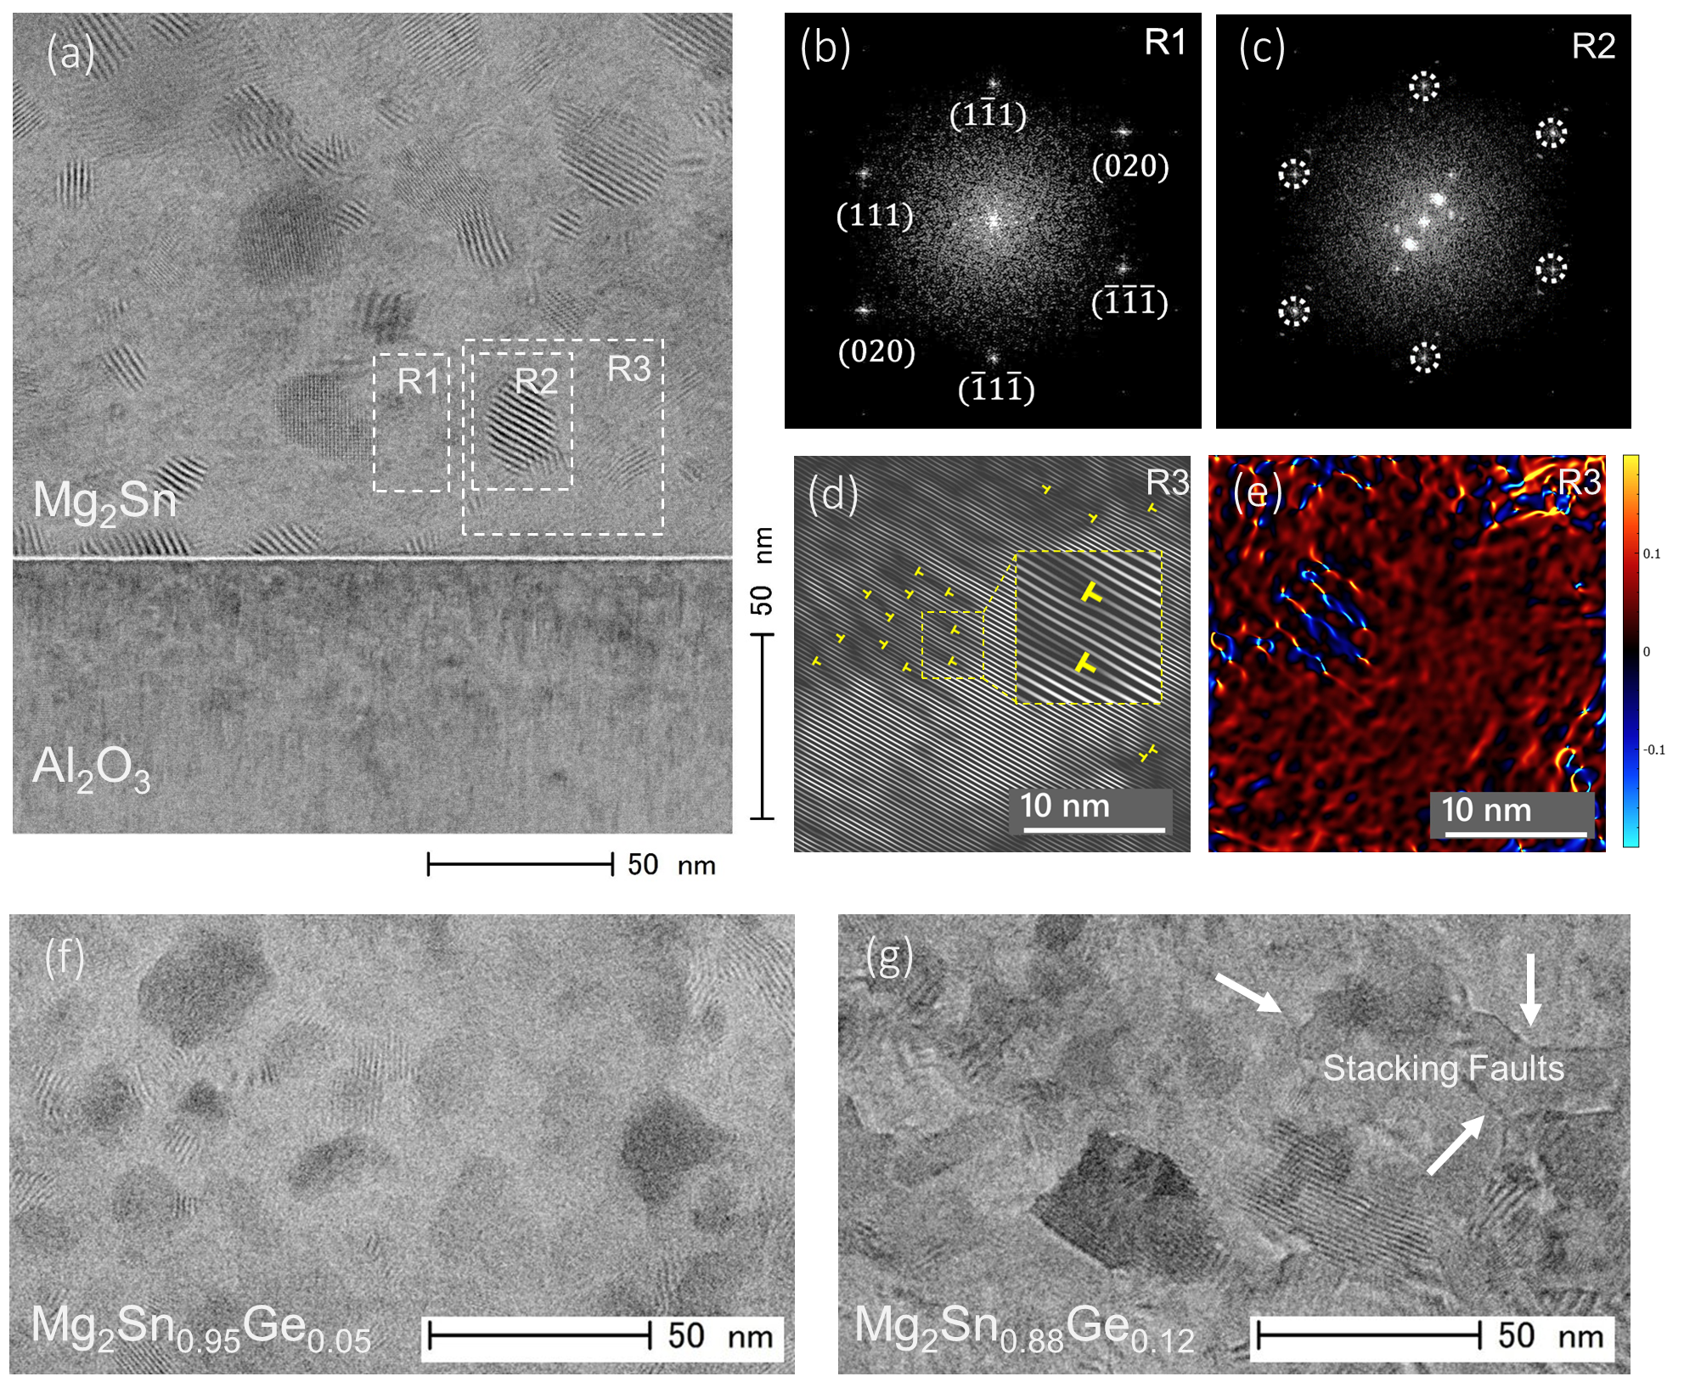
Fig.1.

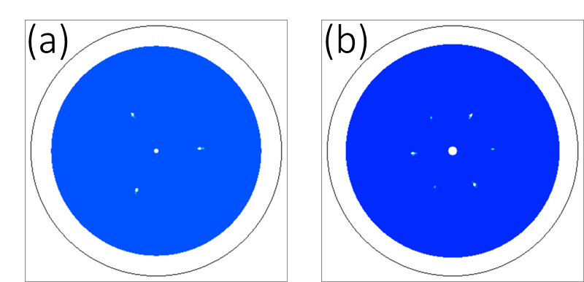
Fig.2.

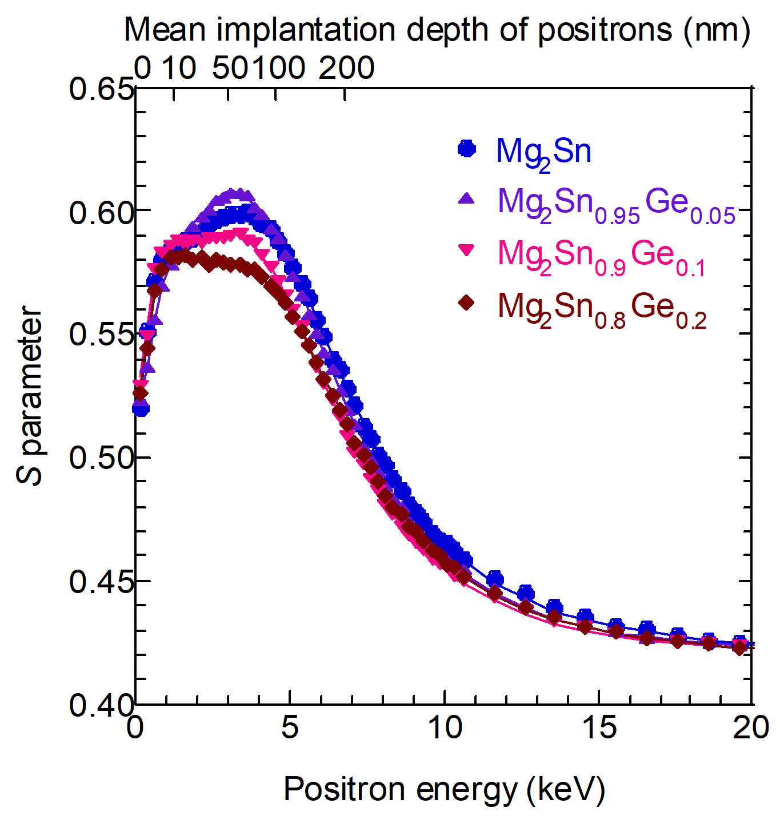

Fig.3.

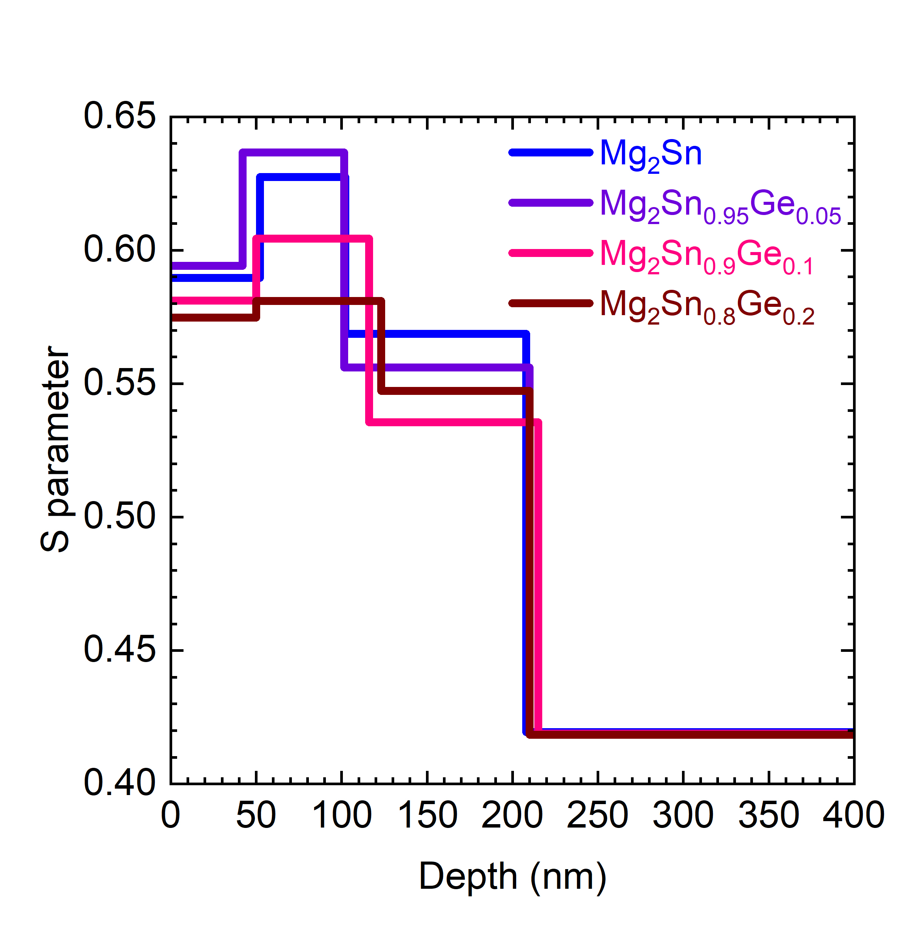
Fig. 4.
Fig. 5.

Fig.6.

