Spectroscopic Infrared Photothermal Converters Using Uniaxially Oriented NiAl Superalloy Films with Metal-Insulator-Metal Strip Arrays

Phuoc Toan Tran^{1,2}, Thien Duc Ngo^{1,2}, Andrea Ruiz-Perona^{1,2}, Hai Dang Ngo^{1,2}, Keisuke Watanabe¹, Hiroshi Harada^{1,3} and Tadaaki Nagao^{1,2,*}

P. T. Tran, T. D. Ngo, A. Ruiz-Perona, H. D. Ngo, K. Watanabe, H. Harada, T. Nagao
¹Research Center for Materials Nanoarchitectonics (MANA), National Institute for Materials Science (NIMS), Tsukuba, Ibaraki 305-0044, Japan
P. T. Tran, T. D. Ngo, A. Ruiz-Perona, H. D. Ngo, T. Nagao
²Department of Condensed Matter Physics, Graduate School of Science, Hokkaido University, Sapporo, Hokkaido 060-0808, Japan
H. Harada
³Emeritus Researcher, National Institute for Materials Science (NIMS), Tsukuba, Ibaraki 305-0047, Japan
E-mail: NAGAO.Tadaaki@nims.go.jp

Funding: ((Please include all funding sources including grant numbers))
Keywords: ((3–7 keywords, not capitalized, plural, separated by commas, no full stop))

This study reports the fabrication of “smooth and continuous” nickel-aluminum (NiAl) superalloy films deposited via direct-current sputtering using a two-step deposition method. The process involves an initial film deposition with in situ heating, followed by a subsequent room-temperature deposition and post-annealing at 928 K. This two-step deposition yields NiAl films with exceptionally smooth surface morphology, achieving a root mean squared roughness as low as ~1.4 nm. To demonstrate the benefits of this approach, we fabricate a mid-infrared device incorporating NiAl–Al₂O₃–NiAl trilayers with an NiAl strip array on top. The NiAl films, self-organized in the (110) orientation, are patterned using laser direct writing followed by reactive ion etching. As designed by our electromagnetic design, the fabricated infrared absorbers exhibit strong resonant absorption and tunability, which can be controlled by adjusting the periodicity, width, and thickness of the top NiAl strips. To assess the impact of our proposed deposition methods, we compare single-step NiAl films deposited with in situ heating to the new two-step NiAl films, both of which are used as the bottom and top layers in the trilayer devices. The latter method exhibits lower background noise in both absorption and thermal emission spectra, achieving excellent spectral selectivity.

1. Introduction
Refractory materials such as molybdenum (Mo) [1], tungsten (W) [2], and titanium nitride (TiN) [3, 4] have been proposed for plasmonic applications involving high temperatures. However, these materials undergo significant oxidation when exposed to elevated temperatures in oxygen-rich environments. Nickel-based superalloys incorporating titanium (Ti), tantalum (Ta), and tungsten are widely used as primary constituents in turbine blades and vanes for jet engines [5]. These alloys develop a surface oxide layer that serves to mitigate further oxidation and excessive heating. Intermetallic nickel-aluminum (NiAl) has emerged as a promising alternative owing to its advantageous properties, including a high melting point [6], exceptional hardness, low density (5.90 g/cm³) [7], and notable thermal and electrical conductivity. This material exhibits remarkable oxidation resistance at high temperatures in air, attributed to the formation of a protective alumina layer on its surface [8]. These characteristics make NiAl a suitable candidate for energy applications operating under extreme thermal conditions.
While extensive research has been conducted on the formation of high-quality single-crystal NiAl [9], further studies are necessary to explore lower-dimensional materials capable of achieving uniaxial thin films with optimal surface orientation and high crystallinity. Investigations into NiAl have expanded to include various configurations, such as thin films composed of shape memory alloys [10] and hybrid materials where NiAl functions as an underlying layer [11]. Several synthesis methods have been employed for NiAl film deposition, including magnetron sputtering [12], electron beam evaporation [13], chemical vapor deposition [14], and molecular beam epitaxy [15]. Among these, sputter deposition is particularly advantageous owing to its compatibility with complementary metal-oxide-semiconductor (CMOS) technology, precise controllability, and suitability for large-scale manufacturing. However, previous studies have reported significant limitations associated with non-stoichiometric NiAl films. These issues arise because aluminum and nickel sources are often deposited independently, leading to the formation of non-uniform multilayer films with a Ni_{x}Al_{y} component ratio, where x ≠ y and neither is equal to 1. In a prior study, we demonstrated the stoichiometric and uniaxial growth of NiAl thin films on silicon substrates [16]. These films were sputtered from a single NiAl alloy target at temperatures of ⩾ 744 K. Within the class of superalloys, NiAl is distinguished by its high melting point (1911 K), which presents challenges in growing highly oriented bulk crystals.
In our study, a method was developed to produce high-crystallinity uniaxial NiAl thin films at significantly lower temperatures than their melting point. The optimized in situ heating sputtering deposition temperature, referred to as in situ-NiAl, was determined to be 889 K. The optical properties of these sputtered NiAl films were highly favorable, with figure-of-merit values approaching those of single-crystal films. Additionally, the films exhibited superior crystallinity and large grain sizes. However, they also displayed significant porosity and roughness, likely caused by the expansion of secondary grains, which increases pressure at the grain boundaries. To address these limitations, we further investigated methods to enhance the performance of NiAl films. This study presents the fabrication of exceptionally smooth NiAl films on Si(100) substrates using a post-annealing technique at elevated temperatures (⩾776 K). The structural, morphological, and optical properties of these films were examined in the context of their potential applications in high-temperature optical systems. To achieve optimal optical performance, a hybrid approach was employed combining in situ heating sputtered deposition with post-annealing to fabricate composite NiAl films, referred to as post-annealed hybrid-temperature-sputtered (PHTS) NiAl films. This approach has broad practical implications, particularly for photothermal applications such as radiative heating and photothermal catalysis under elevated temperatures.
NiAl superalloy films have demonstrated significant potential in various applications, particularly in radiative heat transfer and thermal absorption within specific devices. Plasmonic perfect absorbers (PAs) have garnered increasing attention over the past 15 years owing to their ability to selectively absorb infrared radiation within specific spectral ranges. According to Kirchhoff's law of thermal radiation, the emissivity of an object at thermal equilibrium is equal to its absorptivity [17]. Consequently, a PA can function as an efficient thermal emitter, selectively radiating energy within designated wavelengths. While most wavelength-selective thermal emitters are constructed from metallic structures, only those based on gold (Au) and platinum (Pt) have demonstrated long-term stability under ambient air conditions [18]. In general, metal-based emitters are incompatible with high-temperature environments containing oxygen or water vapor, leading to oxidation and performance degradation. Yokoyama et al. reported a thermal emitter based on molybdenum that remained operational up to 1273 K under vacuum conditions [1]. However, when exposed to air at 873 K, the emitter underwent oxidation and structural damage. In previous studies, Dao et al. successfully fabricated thermal emitters using aluminum (Al) and indium tin oxide (ITO) [19,20]. These emitters exhibited a broad range of wavelength tunability and functioned effectively in ambient air. However, aluminum begins to melt at temperatures exceeding 573 K, and ITO undergoes significant optical degradation above 673 K. Alternative materials, such as titanium-based oxides and nitrides, exhibit broad plasmonic resonances. However, these materials are susceptible to corrosion at temperatures exceeding 650 K. NiAl films, by contrast, offer superior thermal and chemical stability, rendering them well-suited for deployment in gaseous environments and liquid-phase applications. This stability provides advantages for their use in various high-temperature photonic applications, including spectroscopic infrared light sources in non-dispersive infrared gas sensors, drying furnaces, thermophotovoltaics, and plasmon-enhanced vibrational spectroscopy.
In this study, we present the use of combined NiAl (comb.-NiAl) films in photonic applications owing to their exceptional properties, including high metallicity, strong infrared optical response, and robust thermal and mechanical stability at elevated temperatures. NiAl thin films were initially deposited onto commercially available Si(100) wafers via direct-current (DC) magnetron sputtering at a high substrate temperature of 889 K. Following cooling, an additional thin layer of NiAl was deposited at ambient temperature. The entire NiAl film stack then underwent post-annealing at 928 K. The structural and optical properties of these materials were systematically analyzed using microscopic and spectroscopic techniques to evaluate their suitability for photothermal applications. Nanopatterned arrays were fabricated using laser writing lithography in combination with plasma etching and oxygen plasma ashing techniques, employing top-layer comb.-NiAl films. A comparable NiAl film served as the lower mirror, exhibiting distinct optical responses and loss characteristics. The hybridization between surface lattice resonances and strip surface plasmon resonances was found to depend on polarization, and the spectral tunability of this hybridization was demonstrated by adjusting the periodicity of the nanostructure. To further highlight the performance of comb.-NiAl films, we fabricated devices with identical structural compositions, replacing the top and bottom layers with in situ-NiAl films. This study investigates the influence of surface morphology in both in situ-NiAl and comb.-NiAl films on the dual-band spectral selectivity and background absorption of the fabricated devices.

2. Results and Discussion
2.1. Crystal structure and surface morphology of the post-annealing NiAl films
The NiAl alloy exhibits a body-centered cubic (bcc) structure with a lattice constant of 2.88 Å. This structure follows a CsCl-type lattice arrangement and belongs to the Pm-3m space group. In this configuration, aluminum atoms occupy the center of the unit cell, while nickel atoms are positioned at the corners [21]. Figure 1a illustrates the X-ray diffraction (XRD) patterns of NiAl films grown at temperatures ranging from 298 to 967 K. All samples exhibited a cubic structure characterized by the Pm-3m space group (PDF #44-1188). NiAl samples produced at room temperature displayed two dominant crystallographic orientations: (100) and (110). However, as the post-annealing temperature increased from 776 to 928 K, the diffraction patterns revealed a prominent and well-defined peak with a (110) orientation at an approximate 2θ angle of 44.7°. This peak closely resembled the diffraction pattern observed in the (110)-cut single-crystal reference sample depicted in Figure 1b. Additionally, four minor peaks corresponding to orientations (100), (111), (200), and (210) were observed at angles of 31.2°, 55.5°, 65.0°, and 73.9°, respectively. At ambient temperature, NiAl exhibits significant intrinsic antiphase boundary energy. The (100) orientation is recognized as a "hard" orientation in both polycrystalline and single-crystal forms, whereas the (110) orientation is generally considered a "soft" orientation. Initially, the molecule favors alignment along the (100) crystallographic plane, while other orientations are thermodynamically less stable under ambient conditions. Elevated temperatures during post-annealing facilitate atomic movement, allowing stress relaxation and increasing the entropy contribution to the free energy. This increase is attributed to mild disorder at grain boundaries, resulting from minor orientations [22]. The observed enhancement of the (110) peak suggests an increase in interplanar spacing, which can be attributed to the transition from compressive stress to tensile stress during annealing [23,24]. Strain stress arises from surface contraction due to the removal of defects (e.g., interstitials or vacancies), whereas compressive stress may result from lattice mismatch between the silicon substrate and the NiAl film. This mismatch is caused by differences in thermal expansion coefficients or by the observed increase in crystalline grain size [25]. Higher annealing temperatures promote atomic diffusion into more favorable structural positions, enhance film orientation along the c-axis, and reduce crystalline defects [26,27]. The interaction between neighboring abnormal grains drives the grain size distribution from bimodal to unimodal, as larger grains consume smaller ones. These grains also influence mechanical properties by limiting force transmission, recovering deformation upon unloading, and dissipating energy through stress-strain hysteresis [28]. However, at a post-annealing temperature of 967 K, there is an increase in the (100) orientation and, notably, in the (200) and (210) orientations. While (110) remains the dominant orientation, its intensity decreases compared to other annealing temperatures.
In NiAl crystal growth, the (110) orientation frequently emerges as the preferred growth direction over (100) and (111). This preference results from an intricate relationship between thermodynamics, kinetics, and crystallography. Thermodynamically, surface energy γ plays a critical role in determining orientation preference [29]. According to the Wulff construction principle, which minimizes total free energy G = G_{bulk} + γA, where A is the surface area, it is often found that γ₁₁₀ < γ₁₀₀ and γ₁₁₀ < γ₁₁₁ in NiAl. Consequently, the (110) orientation is more thermodynamically favorable because it lowers the total free energy of the system. The Gibbs–Thomson effect, which explains how smaller crystals have higher melting points due to increased surface energy, may also favor the (110) orientation in terms of nucleation kinetics. If the nucleation barrier ΔG∗ is lower for (110) than for (100) and (111), the nucleation rate increases according to I = I₀exp(−∆G*/kT), where I₀​ is the pre-exponential factor, k is Boltzmann's constant, and T is temperature [30]. From a kinetic perspective, the (110) orientation often exhibits higher atomic attachment (R_{a}​) and detachment (R_{d}​) rates, with the net growth rate (R = R_{a} − R_{d}) typically greater for (110). This accelerates overall growth kinetics. Additionally, adatom diffusion may be more energetically favorable on (110) surfaces due to a lower activation barrier (E_{a}), described by R ∝ D exp(−E_{a}/kT), where D is the diffusion coefficient. A lower E_{a}​ for (110) enables faster diffusion, facilitating step-flow growth mechanisms and higher overall growth rates. Crystallographically, the (110) orientation in NiAl often exhibits favorable lattice matching with common substrates used in epitaxial growth. This reduces lattice strain (ε = |a_{NiAl} − a_{substrate}|/a_{substrate}), a key factor for high-quality crystal growth [31]. The (110) orientation may also support more favorable dislocation dynamics due to a lower critical stress σ_{critical}​ required for dislocation motion, represented by dρ/dt = K(σ − σ_{critical}), where ρ is dislocation density, K is a kinetic constant, and σ is applied stress. In summary, the (110) orientation is favored owing to three key advantages: thermodynamic stability through lower surface energy, superior kinetic properties through higher attachment/detachment rates and lower diffusion barriers, and beneficial crystallographic attributes such as optimal lattice matching and favorable dislocation behavior [32]. Together, these factors make (110) the preferred orientation for NiAl crystal growth, demonstrating how a combination of physical principles and mathematical models governs crystallographic orientation preferences [33].

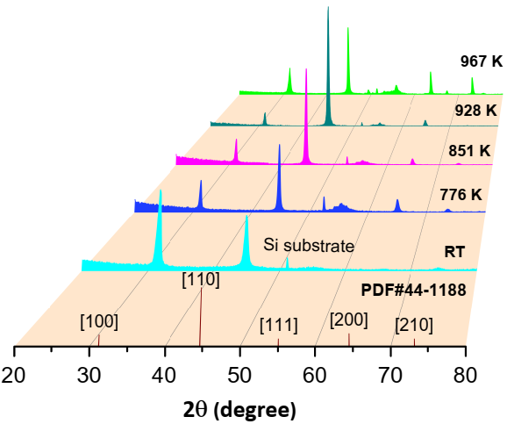  a) | 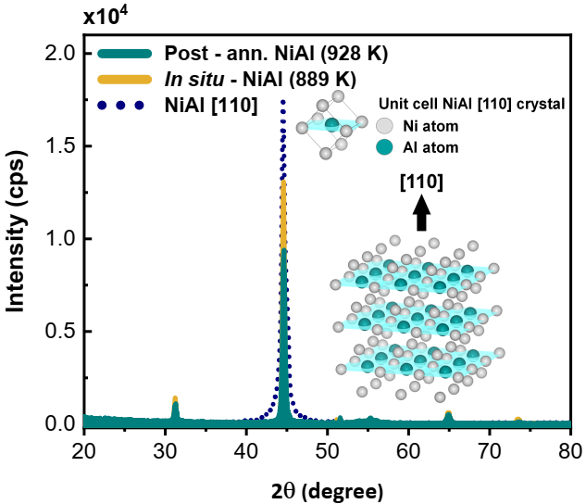  b)
Figure 1. (a) X-ray diffraction pattern of NiAl films on Si (100) substrates at different post-annealing temperatures. Standard diffraction pattern of NiAl (PDF#44-1188) at the bottom; (b) XRD comparison of a post-annealing NiAl film at 928 K (dark cyan-filled solid curve) with an in situ heating sputtered NiAl film at 889 K (yellow-filled solid curve) and a (110)-cut single crystal NiAl represented by navy-dot curve. Inset: unit cell and crystal structure of NiAl with an aluminum atom at the center and surrounding nickel atoms.

Figure 2 presents the surface morphologies of the NiAl films. All films exhibited a uniform and continuous structure when deposited on Si(100) substrates. The grain size of NiAl on the silicon substrate increased with higher annealing temperatures. As the annealing temperature was raised to 776 K and 851 K, an observable increase in grain size occurred, while the film morphology maintained its continuity. At elevated temperatures, reaching a maximum of 928 K, the degree of crystallinity improved, and grain formation was enhanced. Annealing at 928 K effectively reduced residual stresses in the NiAl film. This process also resulted in a significant increase in grain size, contributing to the formation of thin films with a smooth surface texture [34]. At 967 K, individual grains became increasingly discernible. At this temperature, minuscule pores formed, and secondary grains developed and expanded, leading to increased pressure at grain interfaces [35]. The average grain size was determined using the Scherrer equation applied to the XRD patterns. Figure 2e illustrates a porous morphology characterized by the aggregation of larger grains from smaller grains [36]. A notable increase in grain size was observed as the annealing temperature increased from room temperature to 776 K. Significant morphological changes were detected at higher temperatures, particularly at 928 K, where the grain size reached a maximum of 25.66 nm. This finding suggests that NiAl films annealed at this temperature exhibited the most well-defined crystalline structure. Cross-sectional analysis provides a clear visualization of the structural transformation of the film body before and after heat treatment at different temperatures. The growth mode transitioned from tightly packed grain boundary columns at room temperature, 776 K, and 851 K to a more compact and refined columnar structure at 928 K. Figure 2e presents a cross-sectional view of a NiAl film annealed at 967 K, revealing a broad columnar structure with a diverse range of orientations. Figure 2f–h show the AFM images illustrating the surface morphologies of the NiAl films at three distinct temperatures: ambient temperature, 928 K, and 967 K. The root-mean-square roughness (R_{RMS}) values of these samples were 6.4, 1.4, and 12.1 nm, respectively. These values exhibited a similar pattern to the XRD and scanning electron microscopy (SEM) results.

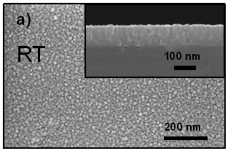 | 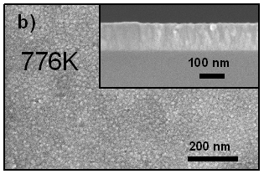 |  | 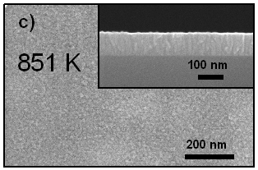
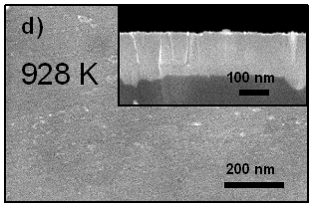 |  | 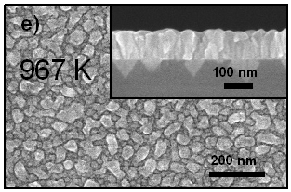
h)
f)
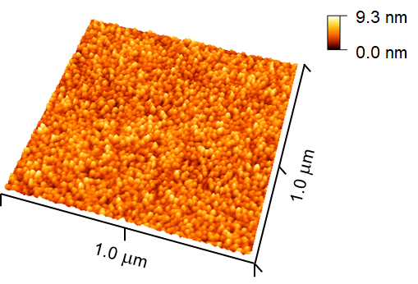  RT | 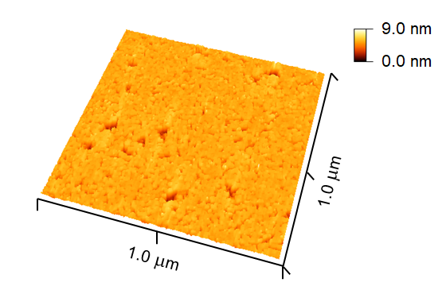  928 K  g) | 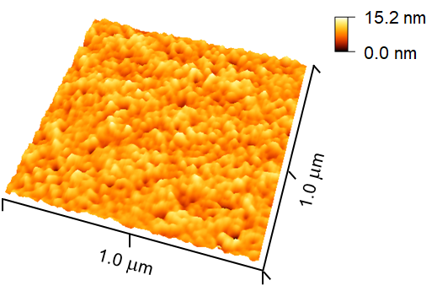  967 K
Figure 2. Morphology (top and cross-view) of DC sputtered NiAl films deposited at (a) room temperature (grain size 13.19 nm) and then post-annealing at elevated temperatures (b) 776 K (grain size 20.96 nm), (c) 851 K (grain size 21.84 nm), (d) 928 K (grain size 25.66 nm) and (e) 967K (grain size 22.57 nm) on silicon substrates. Grain size was taken from the XRD analysis showing reasonable agreement with the SEM result. Atomic force microscopic images (f); (g) and (h) displayed in three-dimensional style. The root mean squared roughness (R_{RMS}) were approximately 6.4 nm, 1.4 nm and 12.1 nm, respectively.

2.2 Optical properties of the post-annealing NiAl films comparable to comb.-NiAl films
Dielectric functions (permittivities) of the NiAl films prepared in this study were obtained through spectroscopic ellipsometry across wavelengths ranging from 0.3 to 20 µm (Figure 3). All samples exhibited crossover points (ε₁ = 0) between 0.58 and 0.75 µm. In the UV–visible region, the films behaved as dielectric materials, while in the near-infrared (NIR) to mid-infrared (MIR) region, they demonstrated strong metallicity. For comparison, Figure 3 presents the permittivities of the sputtered NiAl films, NiAl single crystals, and other refractory metals. As shown in Figure 3a, the real part ε₁ of the permittivity approached that of single-crystal NiAl as the annealing temperature increased, indicating enhanced metallicity. Notably, the permittivity of the NiAl film annealed at 928 K surpassed that of in situ-heated sputtered NiAl films. The imaginary part ε₂ of the complex permittivity for the 928 K-annealed film was lower than that of the single crystal, signifying reduced optical loss. This reduction in loss could be attributed to the presence of undefined particles observed in SEM images of the polished surface, likely residual polishing powders, which contribute to carrier scattering. The figure of merit (FOM), defined as −ε₁/ε₂, serves as an indicator of a material’s suitability for plasmonic applications and is plotted in Figure 3c for comparison with gold (Au) [37], a standard plasmonic material. The FOM of the NiAl film sputtered at room temperature was relatively low due to its weak metallicity. However, both the 928 K-annealed and comb.-NiAl films exhibited significantly higher FOM values, surpassing those of conventional refractory materials such as molybdenum (Mo) [38] and tungsten (W) [39] up to 2.0 µm. Additionally, they demonstrated a much higher FOM than titanium nitride (TiN) [40] and sputtered lanthanum hexaboride (LaB₆) [41]. The comb.-NiAl film exhibited the highest FOM, closely approaching that of NiAl single crystals at approximately 2.0 µm and even exceeding the in situ-heated sputtered film at longer wavelengths. Consequently, comb.-NiAl films exhibited a stronger plasmonic response than conventional refractory materials such as Mo, W, TiN, and LaB₆, making them promising candidates for advanced plasmonic and photonic applications.

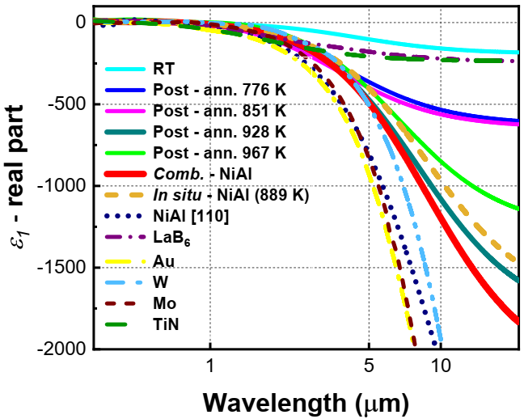  a) | 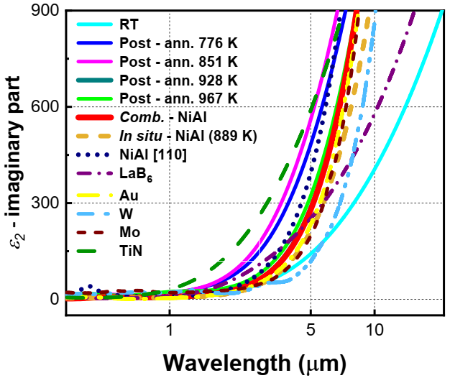  b)
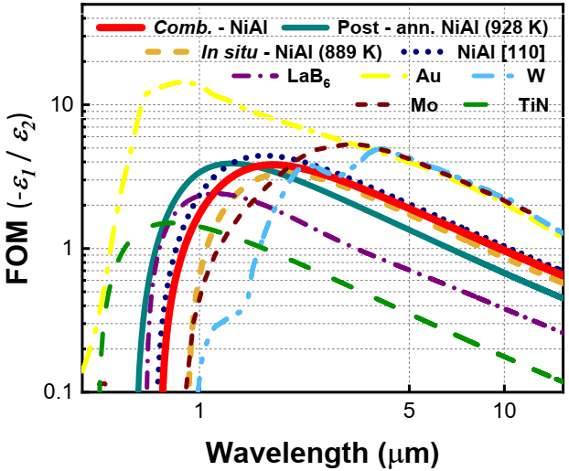

c)
Figure 3. Comparison of the measured complex permittivities and figure of merit (FOM) −ε₁/ε₂ of the NiAl films post-annealed at different temperatures against in situ-heating sputtered NiAl film, NiAl single crystal, Au, W, Mo, and TiN. (a) Real part; (b) imaginary part and (c) FOM in the wavelength range 0.3–15.0 μm.

Having compared the FOMs of the materials, we next focus on their electrical properties, specifically the plasma frequency and damping rate, which offer further insight into their metallic behavior and suitability for various applications. The plasma frequency provides valuable insight into the material’s electron dynamics and metallic behavior. The plasma frequency and damping rate values in this study were obtained from ellipsometry fitting using the Drude-Lorentz model. The available plasma frequency and damping rate values of other metals were collected from the literatures. Our results show that the selected plasma frequency and damping rate of the NiAl-based films range from 6.84 to 9.31 eV, which is comparable to those of conventional metals such as Au (8.45 eV), NiAl single crystal (7.49 eV), W (13.22 eV), Mo (7.46 eV), and TiN (9.66 eV). Additionally, the damping rate of the NiAl-based films is in the range of 0.13 - 0.35 eV, while the damping rates of other metals range from 0.05 - 0.12 eV, which is suitable for plasmic converter applications.

Overall, the plasma frequency and damping rate of the NiAl-based films in this study are comparable to those of other metals, evidencing its Drude metallic nature as well as good plasmonic response with substantially low loss. This suggests that NiAl-based films could be used as a promising material to overcome the bottlenecks of conventional metals, especially for high-temperature applications, where their thermal stability and surface polarizability are of particular importance.

2.3 Electromagnetic simulation of the comb.-NiAl infrared devices
This study employs a metal-insulator-metal (MIM) structure to assess the performance of NiAl (110) films in infrared device applications. Figure 4a,b illustrates the fabrication of the NiAl-MIM thermal emitter and its schematic representation. The Al₂O₃ insulating layer and bottom NiAl layer were both fixed at 0.2 µm in thickness after the optimization process. The fixed thickness of 0.2 µm for Al₂O₃ insulating layer provides strong resonance intensities for both M1 and M2 modes with reasonable deposition time, whereas the bottom NiAl with 0.2 µm is optically thick enough to suppress residual transmission. These optimized resonant peak intensities are achieved by tuning the height (h) and width (w) of the NiAl strip resonators varied across samples. By adjusting the periodicity (p) and width, the resonant frequencies were effectively tuned. At a given wavelength λ, the absorption A of the NiAl-based infrared absorber (NiAl-IA) follows A_{(λ)} = 1 – R_{(λ)} – T_{(λ)} – S_{(λ)}, where R_{(λ)}, T_{(λ)}, and S_{(λ)} represent the reflection, transmission, and scattering, respectively. Because the thick bottom NiAl layer blocks transmission and scattering is negligible, this simplifies to A_{(λ)} = 1 – R_{(λ)}. The spectral response of the infrared absorber was simulated using the rigorous coupled-wave analysis (RCWA) method. The periodicity of the NiAl strip resonators was set to p = 4.26 µm and 5.74 µm, with h = 0.15 µm and 0.4 µm, and w = 2.2 µm and 2.0 µm, respectively, as shown in Figure 4b. Under normal incidence, the NiAl-IA device exhibited two primary resonant bands. The first, M1, appeared at shorter wavelengths (4.35 µm and 5.75 µm), while the second, M2, was observed at longer wavelengths (7.75 µm and 8.0 µm) with higher absorptivity. By adjusting the periodicity from 4.26 µm to 5.74 µm, the absorber selectively captured corresponding wavelengths, suggesting that resonance mechanisms such as surface lattice resonance or Rayleigh–Wood anomalies drive the response. The M1 and M2 modes likely correspond to confined surface plasmon resonances within the individual strips, operating at fundamental and third-order modes [42]. Figure 4c compares the predicted wavelength-selective properties of the fabricated infrared absorber with those of a conventional blackbody-type broadband absorber. According to Kirchhoff’s law, these absorbers are expected to exhibit strong thermal emission characteristics [43]. To analyze their thermal emission properties, a precisely temperature controlled external hot plate was applied to the bottom NiAl layer, acting as a back reflector, to heat the devices. Emission spectra were measured using a Fourier transform infrared (FTIR) spectrometer. Unlike blackbody emitters, which radiate over a broad wavelength range within the mid-infrared (MIR) region, the NiAl-MIM emitter selectively emits infrared light at specific wavelengths. This spectral selectivity enhances molecular excitation at target wavelengths, potentially leading to selective evaporation, as illustrated in the right panel of Figure 4c.

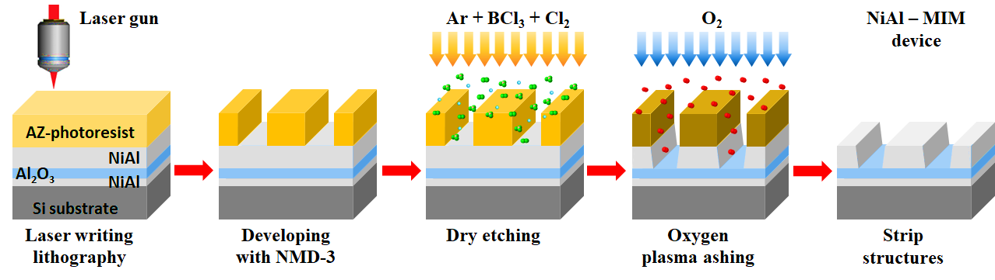
b)
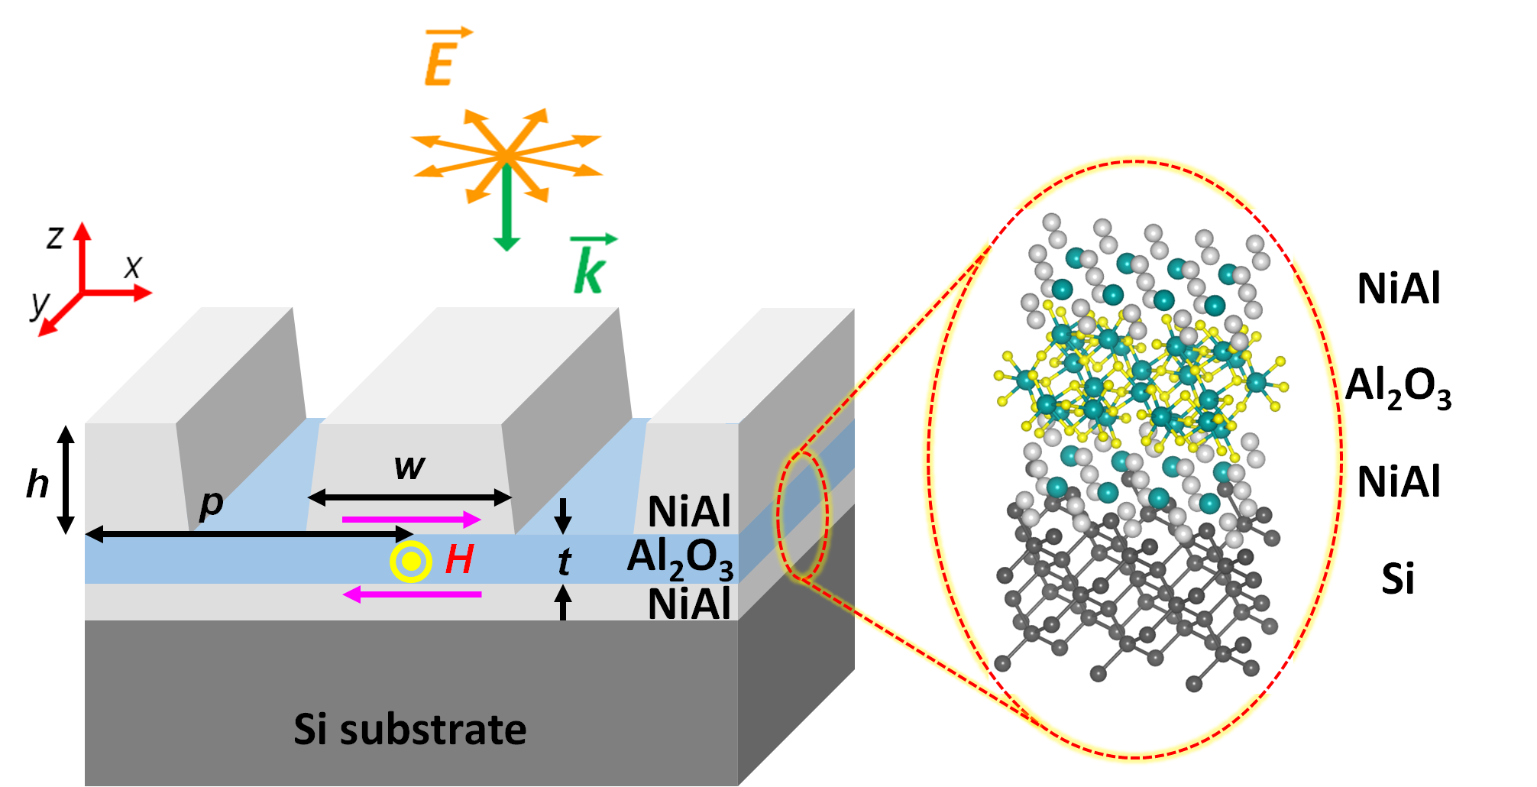

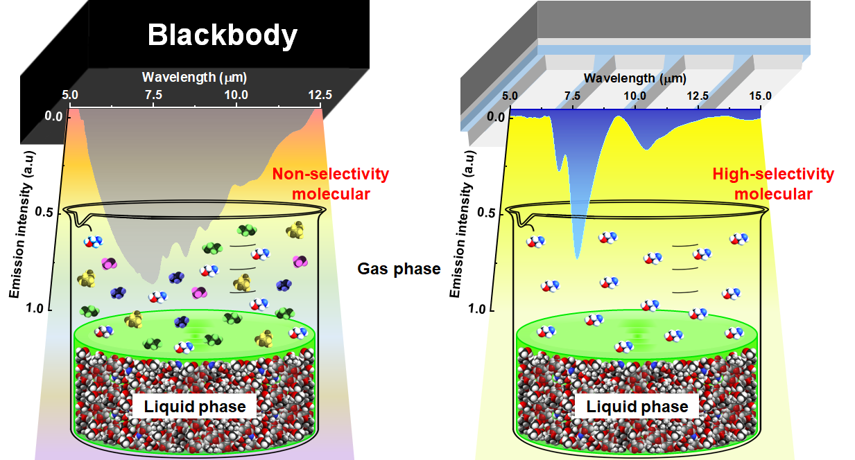
c)

Figure 4. (a) Fabrication process of a NiAl infrared absorber (NiAl-IA) (from left to right) consists of laser lithography, development, dry etching with gas compound of Ar, BCl₃ and Cl₂, and oxygen plasma ashing. The photoresist layer (yellow) was coated on NiAl thin film (light grey), which was deposited on Al₂O₃-NiAl layered films on silicon substrate (dark grey). The remaining photoresist layer after the lithography process helped define the strip structures combined with the dry etching; (b) Schematic of MIM resonators consisting of NiAl strips, an Al₂O₃ insulator, and a NiAl bottom layer (back reflector). The incident electromagnetic fields propagate along the Z-axis and the unpolarized electric field is distributed in XY ($\vec{E}$) plane; (c) a schematic of the comparison between the spectral feature of black-body type emitter device and the fabricated thermal emitter.

2.4. Tuning the spectral feature of absorption and thermal emission of comb.-NiAl –based IAs
Based on the designed device structure, two NiAl-based infrared absorbers (NiAl-IAs) were successfully fabricated: S1 with geometrical parameters p = 4.26 µm, w = 2.2 µm, h = 0.15 µm, and t = 0.2 µm, and S2 with p = 5.74 µm, w = 2.0 µm, h = 0.4 µm, and t = 0.2 µm. Figure 5a-d displays SEM images of the fabricated devices, with top views in Figure 5a,b and cross-sectional views in Figure 5c,d. The precisely structured NiAl strip arrays confirm successful fabrication, aligning with the electromagnetic design in Figure 4b. These images further validate the feasibility of producing centimeter-scale NiAl microstructure devices, as depicted in Figure 4a. In the NiAl-IA system, incident electromagnetic waves interact resonantly with a surface lattice mode, facilitated by the periodicity of the structure. This resonance results in a strong absorption peak at a wavelength approximately matching the periodicity. Perfect absorption is achieved through a strong interaction between the gap plasmon polariton in the bottom NiAl layer and the incident light. This coupling is enhanced by the image charge induced in the bottom NiAl mirror, effectively forming a damping channel. Broader absorption modes resemble magnetic resonances observed in MIM metamaterials, attributed to localized surface plasmons confined within the strips. Figure 5e,f presents absorptivity measurements, confirming two prominent resonant absorption bands in both MIM absorbers, closely aligning with simulation results. For the device with a periodicity of 4.26 µm, the absorption bands at 4.35 µm (M1) and 8.0 µm (M2) exhibit absorption intensities of 84% and 78%, respectively. Mode M1 results from a combination of the MIM device’s third-order magnetic mode and the surface lattice resonance induced by periodicity, while resonant mode M2 originates from the fundamental magnetic resonance. When the periodicity is increased to 5.74 µm, the broad magnetic resonance shifts to 7.75 µm (M2) with an absorptivity of 82%, while a sharp absorption band (M1) at 5.75 µm exhibits a high absorptivity of 84% due to surface lattice resonance. To investigate the impact of crystallinity, two NiAl-IA MIM devices were fabricated using an in situ-heating sputtered NiAl film and a comb.-NiAl film. As observed in Figure 5e,f the latter exhibits a lower background absorption, attributed to its smoother surface and larger grain size compared to the in situ-heating sputtered film. The root mean square roughness (R_{RMS}) values indicate that the comb.-NiAl film has superior surface flatness and more coherent grain alignment, making it behave more like a perfect conductor than the sputtered film. Consequently, it reduces carrier scattering, thereby minimizing the baseline in the absorption spectra.
The spectral selectivity of NiAl-based infrared absorbers (NiAl-IAs) makes them highly suitable for practical applications such as gas detection via non-dispersive infrared (NDIR) sensors and selective evaporation of organic solvents using spectroscopic infrared drying furnaces. The NiAl-IA emitter exhibits strong absorption at 7.75 µm and 8.0 µm, corresponding to prominent bands in the fingerprint region. These bands are associated with the stretching vibrations of functional groups such as carboxylic acids, alcohols, phenols, amines, phosphoramide, oxidized nitrogen functions, and silicon functions [44]. Specifically, the absorption at 7.75 µm corresponds to the C–O stretching vibrations in carboxylic acids, alcohols, and phenols [44], enabling the emitter with p = 4.26 µm to evaporate aromatic compounds such as aniline, 1,2,3,4-tetrahydroquinoline, and N,N-dimethylaniline [45–47]. Similarly, the absorption at 8.0 µm corresponds to the C–N, P=O, N–O (aromatic), and Si–CH₃ stretching vibrations in amines, phosphoramides, and silicon-based compounds [44], making the emitter suitable for evaporating cyclohexanone and cyclohexanol [48,49]. Additionally, our NiAl-IA exhibits absorption at 4.35 µm, allowing efficient absorption within the fingerprint region. This wavelength corresponds to P–N bending vibrations in phosphorus compounds such as phosphine, Si–H stretching in silicon compounds such as silane [44]. It is noteworthy that N-Methyl-2-Pyrrolidone (NMP) exhibits an absorption band at 4.35 µm, originating from the C=O stretching vibrations in esters, aldehydes, and ketones [50]. Figure 5g,h illustrates the relationship between resonance wavelength and the vertical dimension of NiAl strips in the NiAl-IA system. The M1 mode at 4.26 µm exhibits a slight red shift with increasing strip height, whereas the M1 mode at 5.74 µm and the M2 mode show minimal dependence on height, except when h is on the same scale as the resonant wavelength. Increasing the strip height shifts the resonance wavelength due to surface lattice resonance, while geometric irregularities introduce a slight reduction in absorption intensity. To achieve sharp and strong absorption bands at specific resonant wavelengths, fabrication parameters of NiAl resonators were fine-tuned. Figure 5i presents the thermal emission spectrum of the NiAl-MIM emitter, alongside a reference blackbody spectrum for comparison. The blackbody reference material used in our experiment consisted of an iron-oxide-based blackbody paint. Unlike a broadband blackbody emitter, the NiAl-MIM exhibits a distinct dual-band spectral signature, confirming its spectral selectivity. This selective emission significantly reduces unwanted thermal radiation, improving energy efficiency in infrared heating by focusing thermal emission at desired resonant wavelengths [51].

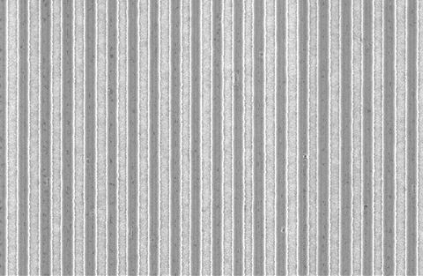  10.0 μm  (a)  S1 | 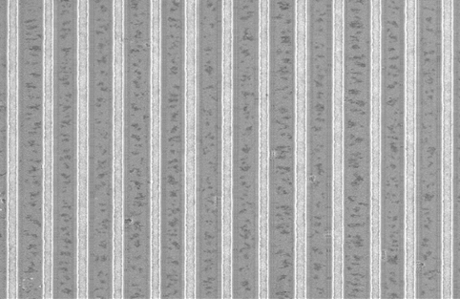  10.0 μm  (b)  S2
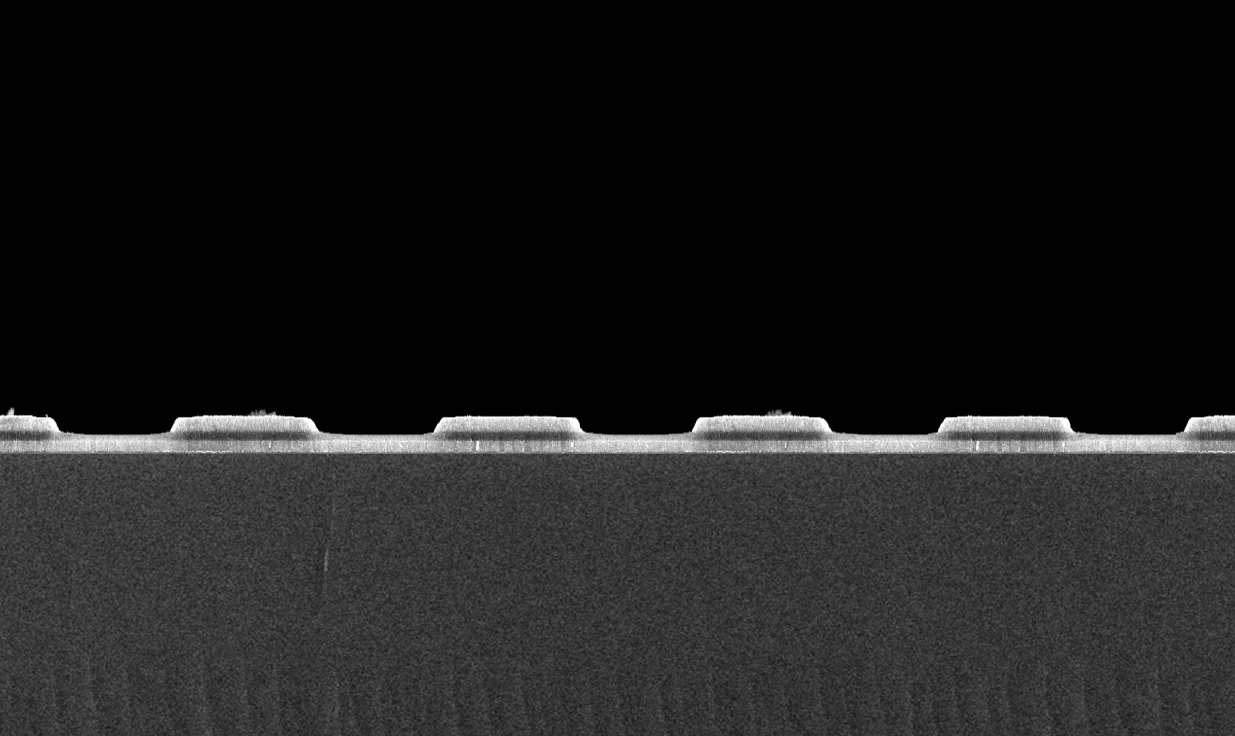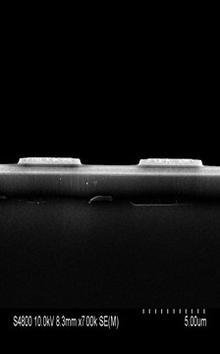  5.0 μm  (c) | 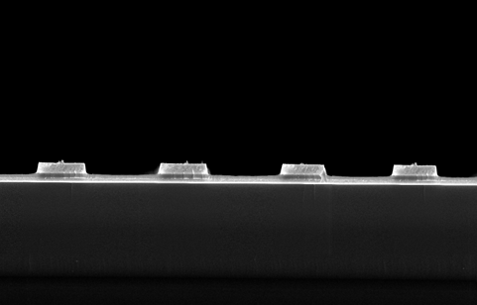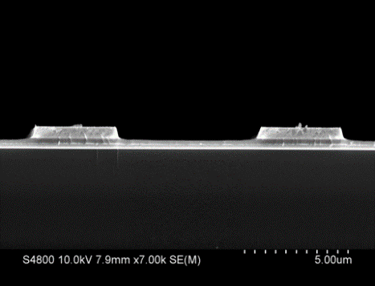  5.0 μm  (d)
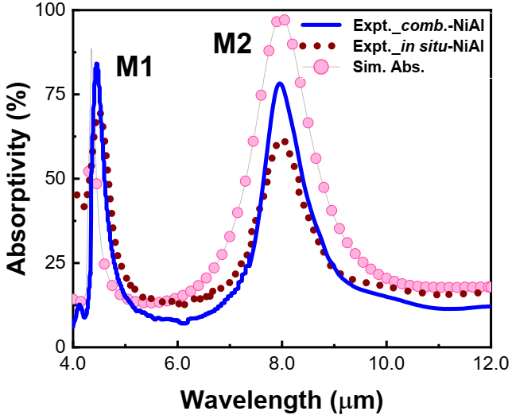  (e) | 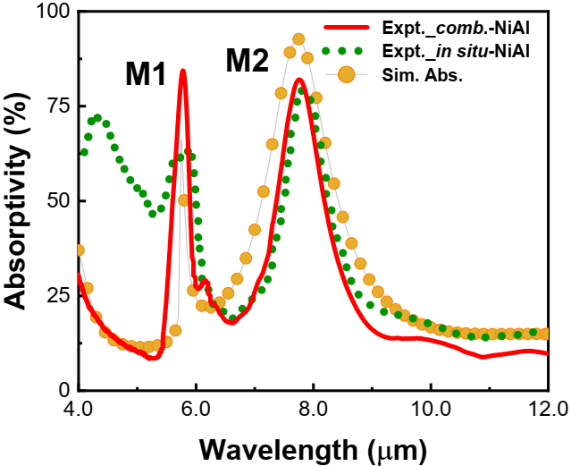  (f)
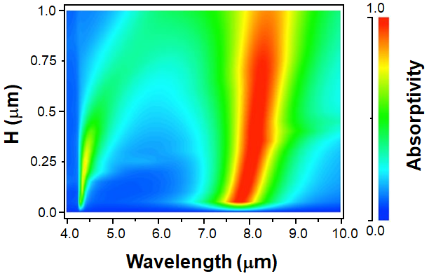  (g)  M1  M2 | 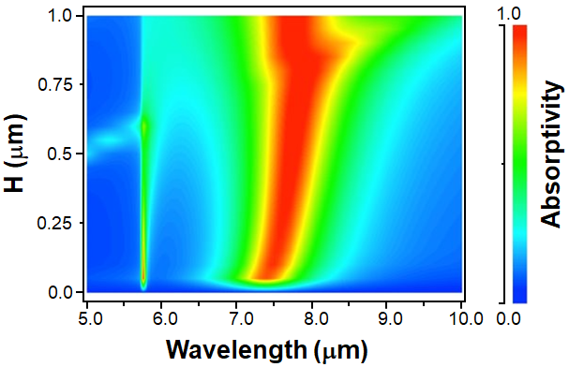  (h)  M1  M2
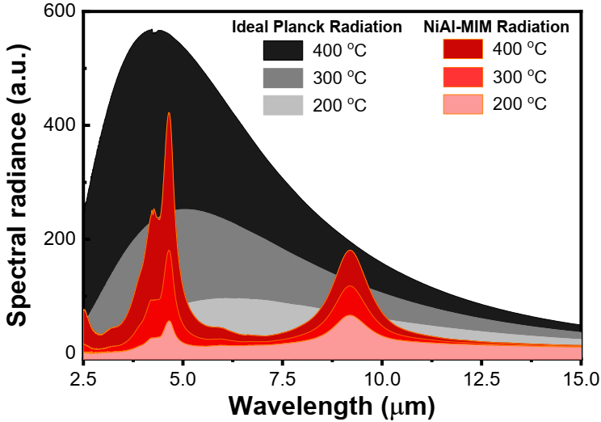
(i)
Figure 5. SEM images (top-view and cross-sectional view) of two fabricated emitter devices configured by trilayered NiAl – Al₂O₃ – NiAl with the NiAl infrared absorber having designs of (a); (c) p = 4.26 µm; w = 2.2 µm; h = 0.15 µm (left, S1), and (b); (d) p = 5.74 µm; w = 2.0 µm; h = 0.4 µm (right, S2); (e) and (f) Simulated reflectance (pink and orange filled circles) and experimental absorptivity (blue solid and red solid curves based on comb.-NiAl film; brown dot and green dot curves based on in situ-heating sputtered NiAl film) of NiAl-MIM with schematic illustration of infrared light with electric field vector perpendicular to the plane of strips; (g) and (h) The dependence of resonance wavelengths on the NiAl strip periodicities in the NiAl-IA of S1 and S2; (i) The spectral emissivity curves for sample NiAl-MIM and black-body reference are represented in red and black spectra, respectively.
3. Conclusions
An MIM infrared device was fabricated using high-crystallinity NiAl films, grown through a combination of in situ-heating sputtering and post-annealing techniques. The NiAl film was initially deposited on a substrate at 889 K, followed by the deposition of an additional thin NiAl layer and post-annealing at 928 K. This process resulted in a smooth surface morphology with a low surface roughness of 1.4 nm. The deposited film exhibited uniaxial growth along the (001) orientation, large grain sizes, and a flat-top surface morphology. The dielectric functions demonstrated metallic behavior beyond 0.58 µm, particularly in the region of 0.75–2.5 µm. The optical figure of merit in both the NIR and MIR regions was found to be superior to that of in situ-heating sputtered NiAl and conventional refractory materials such as Mo, W, TiN, and LaB₆. Additionally, we successfully designed and fabricated MIM NiAl-based infrared absorbers featuring two absorption bands arising from the surface lattice resonance in the periodic NiAl strip array and the surface plasmon confinement within the top NiAl strips due to finite-size effects. The spectral properties of these absorbers can be tuned by adjusting the periodicity and width of the strips, while the absorption intensity remains stable within specific wavelength ranges. These results suggest that NiAl films hold significant promise as photothermal transducers, particularly for dual-band infrared plasmonic sensors and thermal emitters. Their adjustable absorption characteristics and superior optical properties make them highly suitable for applications requiring precise infrared control.

4. Methods
NiAl films were fabricated by sputtering onto Si(100) substrates (i-Miller, Shibaura Mechatronics Corporation) using a high-purity (99.9%) NiAl alloy target (75 mm diameter, 6 mm thickness) from Furuuchi Chemical, Japan. The p-type Si(100) substrates (10 Ω·cm resistivity, 1 mm thickness) underwent sequential ultrasonic cleaning in acetone, ethanol, and isopropyl alcohol for 5 minutes each. The sputtering chamber was maintained at a base pressure of ~2.3×10⁻⁵ Pa to remove residual gases. A DC power of 200 W was applied, and high-purity argon gas (20 m³/s) was introduced to achieve a working pressure of 0.51 Pa. Deposition was performed at room temperature (298 K), followed by post-annealing at temperatures ranging from 776 K to 967 K.
X-ray diffraction (XRD, SmartLab, Rigaku, Japan) using Cu Kα radiation (λ = 1.5425 Å) provided crystallographic data. Surface morphology and roughness were analyzed using scanning electron microscopy (SEM, Hitachi S-4800) and atomic force microscopy (AFM, Multimode Nanoscope IIIA, Bruker, USA) in tapping mode with a Si cantilever (SI-DF20, Hitachi Hightech). Spectroscopic ellipsometry (SENTECH Instruments GmbH, Berlin, Germany) was used to measure complex permittivity from deep UV to far-infrared using a Drude–Lorentz model with three Lorentz oscillators.
The optimized post-annealed NiAl films were combined with in situ-NiAl films for enhanced performance, following methods reported in [16]. Dielectric function data were utilized in numerical simulations to determine device geometry. The metal-insulator-metal (MIM) structure of NiAl–Al₂O₃–NiAl was fabricated by first depositing a 0.18 μm in situ-NiAl film at 889 K onto Si(100) substrates. After rapid cooling to room temperature, an additional 0.02 μm NiAl layer was deposited, followed by post-annealing at 928 K for 1 hour. The resulting comb.-NiAl film was cooled, and a 0.2 μm Al₂O₃ insulating layer was applied via RF sputtering (450 W, 0.54 Pa, 20 m³/s Ar flow). The comb.-NiAl deposition process was repeated with thicknesses of 0.15 μm and 0.4 μm. A control sample without post-annealing was also prepared.
Patterning was performed using spin-coating AZ-5214E negative resist (MicroChemicals GmbH, Germany) at 6000 rpm for 60 s, followed by baking at 90°C for 3 min. Laser writing (μPG 101, HEIDELBERG Instruments, 405 nm) defined the pattern, after which the samples underwent reversal baking (120°C, 20 s), UV flood exposure (60 s), and development with NMD-3 (30 s). The developed samples were rinsed with deionized water and dried with nitrogen gas. Unwanted NiAl strips and residual resist were removed using reactive ion etching (ULVAC CE-300I) with an Ar (5 sccm), BCl₃ (10 sccm), and Cl₂ (5 sccm) gas mixture (0.2 Pa, RF power 100 W, RF bias 80 W, etching rate 0.2 nm/s). Oxygen plasma ashing (Mory PB-600, 300 W) was then performed. SEM was used to inspect the strip structures.
The complete fabrication process is illustrated in Figure 4. Resonance characteristics of the microstructures were analyzed using Fourier-transform infrared spectroscopy (FTIR, Thermo Scientific Nicolet iS50). Linearly unpolarized incident light was used, with the electric field vector ($\vec{E}$) perpendicular to the strips. Each sample measured 1×1 cm², and the incident beam was normal to the surface. NiAl infrared absorbers (NiAl-IAs) and blackbody control samples were heated on a plate, and their emission spectra were analyzed using an FTIR spectrometer (Thermo Nicolet NEXUS 670). Emitted radiation was collected and directed into the FTIR spectrometer using concave metal-coated mirrors.

Acknowledgements
The authors thank the staff of the Namiki Foundry and Dr. Naoki Furuhata for their technical assistance.

Data Availability Statement
The data that support the findings of this study are available from the corresponding author upon reasonable request.

Received: ((will be filled in by the editorial staff))
Revised: ((will be filled in by the editorial staff))
Published online: ((will be filled in by the editorial staff))

References
1. T. Yokoyama, T. D. Dao, K. Chen, S. Ishii, R. P. Sugavaneshwar, M. Kitajima, and T. Nagao, "Spectrally selective mid‐infrared thermal emission from molybdenum plasmonic metamaterial operated up to 1000 °C," Adv. Opt. Mater. 4(12), 1987–1992 (2016).
2. I. Celanovic, N. Jovanovic, and J. Kassakian, "Two-dimensional tungsten photonic crystals as selective thermal emitters," Appl. Phys. Lett. 92(19), (2008).
3. S. Ishii, R. P. Sugavaneshwar, and T. Nagao, "Titanium nitride nanoparticles as plasmonic solar heat transducers," J. Phys. Chem. C Nanomater. Interfaces 120(4), 2343–2348 (2016).
4. Ø. S. Handegård, H. D. Ngo, R. P. Sugavaneshwar, T. A. Doan, F. Naoki, S. Otani, and T. Nagao, "Epitaxial growth mechanism of high-crystallinity lanthanum hexaboride (001) thin films on silicon (001) by electron beam deposition," Appl. Phys. Express 13(5), 055504 (2020).
5. K. Kawagishi and H. Harada, "High Temperature Oxidation Properties of Next Generation Ni-base Superalloys," Mater. Jpn. 52(9), 445–449 (2013).
6. R. D. Noebe, R. R. Bowman, and M. V. Nathal, "Physical and mechanical properties of the B2 compound NiAl," Int. Mater. Rev. 38(4), 193–232 (1993).
7. R. Darolia, W. Walston, and M. Nathal, "Nial Alloys for Turbine Airfoils," Superalloys 1996 (Eighth International Symposium) (1996).
8. Z. Zhang, L. Li, and J. C. Yang, "γ-Al2O3 thin film formation via oxidation of β-NiAl(1 1 0)," Acta Mater. 59(15), 5905–5916 (2011).
9. B. R. Mcdonnell, R. T. Pascoe, G. F. Hancock, and C. W. A. Newey, "The growth of single crystals of the intermediate phases NiAl and Ni3Al," J. Mater. Sci. 2(4), 365–370 (1967).
10. V. Myagkov, L. Bykova, S. Zharkov, and G. Bondarenko, "Formation of NiAl Shape Memory Alloy Thin Films by a Solid-State Reaction," Diffus. Defect Data Pt. B 138, 377–384 (2008).
11. Li-Lien Lee, D. Laughlin, and D. Lambeth, "NiAl underlayers for CoCrTa magnetic thin films," IEEE Trans. Magn. 30(6), 3951–3953 (1994).
12. G. Lucadamo, K. Barmak, and C. Michaelsen, "Characterization of reactive phase formation in sputter-deposited Ni/Al multilayer thin films using TEM," Proc. annu. meet. Electron Microsc. Soc. Am. 54, 1000–1001 (1996).
13. Z. Yu, D.D. Hass, H.N.G. Wadley, " NiAl bond coats made by a directed vapor deposition approach," Materials Science and Engineering A 394, 43–52 (2005).
14. Y. Zhang, W. Y. Lee, J. A. Haynes, I. G. Wright, K. M. Cooley, and P. K. Liaw, "Synthesis and cyclic oxidation behavior of a (Ni, Pt) Al coating on a desulfurized Ni-base superalloy," Metall. Mater. Trans. A 30(10), 2679–2687 (1999).
15. M. Weckwerth, C. Hung, Y. Pao, and J. Harris, "Epitaxial growth of thick pseudomorphic NiAl metal films on GaAs by migration enhanced epitaxy," J. Cryst. Growth 150, 1150–1153 (1995).
16. P. T. Tran, H. D. Ngo, T. D. Ngo, and T. Nagao, "Uniaxially oriented nickel aluminum superalloy films sputtered with in situ heating," Appl. Phys. Express 14(8), 087001 (2021).
17. L. Peng, "Absorption and emission properties of photonic crystals and metamaterials," (2007).
18. M. Diem, T. Koschny, and C. M. Soukoulis, "Wide-angle perfect absorber/thermal emitter in the terahertz regime," Phys. Rev. B Condens. Matter Mater. Phys. 79(3), (2009).
19. T.D. Dao, K. Chen, S. Ishii, A. Ohi, T. Nabatame, M. Kitajima, and T. Nagao, "Infrared Perfect Absorbers Fabricated by Colloidal Mask Etching of Al-Al₂O₃-Al Trilayers," ACS Photonics 2(7), 964-970 (2015).
20. T.D. Dao, A. T. Doan, D. H. Ngo, K. Chen, S. Ishii, A. Tamanai, and T. Nagao, "Selective thermal emitters with infrared plasmonic indium tin oxide working in the atmosphere," Opt. Mater. Express, 9(6), 2534-2544 (2019).
21. A. Taylor, N. J. Doyle, "Further studies on the nickel-aluminium system. I. β-nial and δ-ni₂al₃ phase fields," 5(3), 201-209 (1972).
22. T. Nagao, J. Sadowski, M. Saito, S. Yaginuma, Y. Fujikawa, T. Kogure, T. Ohno, Y. Hasegawa, S. Hasegawa, and T. Sakurai, "Nanofilm Allotrope and Phase Transformation of Ultrathin Bi Film on Si(111)-7×7," Phys. Rev. Lett. 93(10), (8 2004).
23. J. Ni, J. Li, J. Jian, J. He, H. Chen, X. Leng, and X. Liu, "Recent studies on the fabrication of multilayer films by magnetron sputtering and their irradiation behaviors," Coatings 11(12), 1468 (2021).
24. R. Feng, K. An, and P. K. Liaw, "Fatigue behavior and mechanisms of high-entropy alloys," High Entropy Alloys & Materials (2022).
25. A. Moridi, H. Ruan, L. C. Zhang, and M. Liu, "Residual stresses in thin film systems: Effects of lattice mismatch, thermal mismatch and interface dislocations," Int. J. Solids Struct. 50(22–23), 3562–3569 (2013).
26. D. Padilla Rueda, J. M. Vadillo, and J. J. Laserna, "Effects of post-growth thermal annealing on room temperature pulsed laser deposited ZnO thin films," J. Phys. Conf. Ser. 687, 012028 (2016).
27. Y. Y. Kim, C. H. An, H. K. Cho, J. H. Kim, H. S. Lee, E. S. Jung, and H. S. Kim, "High-temperature growth and in-situ annealing of MgZnO thin films by RF sputtering," Thin Solid Films 516(16), 5602–5606 (2008).
28. T. Kusama, T. Omori, T. Saito, S. Kise, T. Tanaka, Y. Araki, and R. Kainuma, "Ultra-large single crystals by abnormal grain growth," Nat. Commun. 8(1), (2017).
29. L. Wang, K. C. Lai, L. Huang, J. W. Evans, and Y. Han, "Low-index surface energies, cleavage energies, and surface relaxations for crystalline NiAl from first-principles calculations," Surf. Sci. 695(121532), 121532 (2020).
30. F. C. Meldrum and C. O’Shaughnessy, "Crystallization in confinement," Adv. Mater. 32(31), (2020).
31. J. Humphreys, G. S. Rohrer, and A. Rollett, "Computer modeling and simulation of annealing" in Recrystallization And Related Annealing Phenomena, (3rd Edition), 569–604 (2017).
32. J. Humphreys, G. S. Rohrer, and A. Rollett, "The structure and energy of grain boundaries," in Recrystallization and Related Annealing Phenomena (3rd Edition), 109–143 (2017).
33. K. C. Lai, Y. Han, P. Spurgeon, W. Huang, P. A. Thiel, D.-J. Liu, and J. W. Evans, "Reshaping, intermixing, and coarsening for metallic nanocrystals: Nonequilibrium statistical mechanical and coarse-grained modeling," Chem. Rev. 119(11), 6670–6768 (2019).
34. Z.-H. Hong, S.-J. Lin, T.-H. Fang, and S.-F. Hwang, "Effect of thermal annealing on the stress and morphology of deposited nanofilms analyzed using molecular dynamics," Surf. Coat. Technol. 205(13–14), 3865–3871 (2011).
35. J. Humphreys, G. S. Rohrer, and A. Rollett, "Grain Growth Following Recrystallization," in Recrystallization and Related Annealing Phenomena (3rd Edition), 375–429 (2017)
36. S. Ur, P. Nash, and G. Higgins, "Grain growth and secondary recrystallization in mechanically alloyed NiAl," Scr. Mater. 34(1), 53–59 (1996).
37. R. L. Olmon, B. Slovick, T. W. Johnson, D. Shelton, S. H. Oh, G. D. Boreman, and M. B. Raschke, "Optical dielectric function of gold," Phys. Rev. B: Condens. Matter Mater. Phys. 86(23), (2012).
38. M. A. Ordal, R. J. Bell, R. W. Alexander, L. A. Newquist, and M. R. Querry, "Optical properties of Al, Fe, Ti, Ta, W, and Mo at submillimeter wavelengths," Appl. Opt. 27(6), 1203 (1988).
39. A. D. Rakić, A. B. Djurišić, J. M. Elazar, and M. L. Majewski, "Optical properties of metallic films for vertical-cavity optoelectronic devices," Appl. Opt. 37(22), 5271 (1998).
40. R. P. Sugavaneshwar, S. Ishii, T. D. Dao, A. Ohi, T. Nabatame, and T. Nagao, "Fabrication of Highly Metallic TiN Films by Pulsed Laser Deposition Method for Plasmonic Applications," ACS Photonics 5(3), 814–819 (2017).
41. P. T. Tran, T. D. Ngo, H. D. Ngo, Ø. S. Handegård, and T. Nagao, "Metal-insulator-metal strip spectroscopic infrared photothermal absorber based on uniaxially oriented plasmonic lanthanum hexaboride films," Opt. Express 30(21), 38630–38642 (2022).
42. T. D. Dao, K. Chen, and T. Nagao, "Dual-band in situ molecular spectroscopy using single-sized Al-disk perfect absorbers," Nanoscale 11(19), 9508–9517 (2019).
43. T. Inoue, M. De Zoysa, T. Asano, and S. Noda, "Realization of narrowband thermal emission with optical nanostructures," Optica 2(1), 27 (2015).
44. P. R. Griffiths, "The handbook of infrared and Raman characteristic frequencies of organic molecules," Vib. Spectrosc. 4(1), 121 (1992).
45. M. Mukherjee, B. Bandyopadhyay, P. Biswas, and T. Chakraborty, "Amine inversion effects on the IR spectra of aniline in the gas phase and cold inert gas matrixes," Indian J. Phys. Proc. Indian Assoc. Cultiv. Sci. (2004) 86(3), 201–208 (2012).
46. O. Y. Gutiérrez, A. Hrabar, J. Hein, Y. Yu, J. Han, and J. A. Lercher, "Ring opening of 1,2,3,4-tetrahydroquinoline and decahydroquinoline on MoS2/γ-Al2O3 and Ni–MoS2/γ-Al2O3," J. Catal. 295, 155–168 (2012).
47. M. Rodrı́guez, I. Garcı́a-Moreno, O. Garcı́a, and R. Sastre, "Polymerisation kinetics photoinduced by derivatives of 4-nitroaniline in the presence of N , N -dimethylaniline studied by Real-Time IR spectroscopy," Polymer (Guildf.) 41(21), 7871–7875 (2000).
48. V. Fridman, "Dehydrogenation of cyclohexanol on copper-containing catalysts II. The pathways of the cyclohexanol dehydrogenation reaction to cyclohexanone on copper-active sites in oxidation state Cu⁰ and Cu⁺," J. Catal. 222(2), 545–557 (2004).
49. I. León, R. Montero, A. Longarte, and J. A. Fernández, "IR mass-resolved spectroscopy of complexes without chromophore: Cyclohexanol·(H₂O)n, n = 1–3 and cyclohexanol dimer," J. Chem. Phys. 139(17), (2013).
50. K. Sundmacher, A. Górak, M. Kraume, and G. Wozny, "Integrated chemical processes with liquid multiphase systems," Chem. Eng. Sci. 115, 1–2 (2014).
51. T. D. Ngo, T. P. Tran, H. D. Ngo, and T. Nagao, "A simultaneous material‐device optimization for plasmonic devices: A combined ab initio and electromagnetic simulation for photothermal transducers," Adv. Opt. Mater. 10(23), 2201320 (2022).

