Received 00th January 20xx,
- Research Center for Materials Nanoarchitectonics (MANA), National Institute for Materials Science (NIMS), 1-2-1 Sengen, Tsukuba, 305-0047, Japan.
- Graduate School of Chemical Sciences and Engineering, Hokkaido University, Sapporo, 060-0814, Japan.
- Department of Physics, Chuo University, 1-13-27 Kasuga, Bunkyo, Tokyo 112-8551, Japan.
- CNRS–Saint-Gobain–NIMS, IRL3629, Laboratory for Innovative Key Materials and Structures, National Institute for Materials Science, 1-1 Namiki, Tsukuba, Ibaraki 305-0044, Japan.
† Footnotes relating to the title and/or authors should appear here.
Electronic Supplementary Information (ESI) available: [details of any supplementary information available should be included here]. See DOI: 10.1039/x0xx00000x
Accepted 00th January 20xx
DOI: 10.1039/x0xx00000x

Rational Ligand Design for Enhanced Carrier Mobility in Self-Powered SWIR Photodiode based on Colloidal InSb Quantum Dots
Subhashri Chatterjee, ^{a,b}, Kazuhiro Nemoto, ª Hong-Tao Sun ª and Naoto Shirahata *^{a,b,c,d}
Solution-processed colloidal III-V semiconductor quantum dot photodiodes (QPDs) have potential applications in short-wavelength infrared (SWIR) imaging due to their tunable spectral response range, possible multiple-exciton generation, operation at 0-V bias voltage and low-cost fabrication and are also expected to replace lead- and mercury-based counterparts that are hampered by reliance on restricted elements (RoHS). However, the use of III-V CQDs as photoactive layers in SWIR optoelectronic applications is still a challenge because of underdeveloped ligand-engineering for improving the in-plane conductivity of the QD assembled film. Here we report on ligand engineering of InSb CQDs to enhance the optical response performance of self-powered SWIR QPDs. Specifically, by replacing the conventional ligand (i.e., oleylamine) with sulfide, the interparticle distance between the CQDs was shortened 5.0 ± 0.5 nm to 1.5 ± 0.5 nm, leading to improved carrier mobility for high photoresponse speed to SWIR light. Furthermore, the use of sulfide ligands resulted in a low dark current density (~nA/cm²) with improving an EQE of 18.5 %, suggesting its potential for use over toxic-based infrared image sensors.
1. Introduction
Short-wave infrared (SWIR) cameras and photodiodes are in high demand due to their photodetection capability in many critical futuristic applications from night-vison, emergent bio-imaging, food technology to remote sensing, light detection-ranging (LIDAR) and optical communication technologies.[1-4] In recent imaging applications in the optoelectronics industry, high dark or leakage currents in photodiodes can trigger serious failures due to high external voltages or thermal noise.[5] However, self-powered photodiodes do not require an external voltage source and can detect light with low power consumption.[5-7] Most commercially available infrared detectors rely on epitaxially grown III-V and HgCdTe-based photodetectors, which require complex growth processes such as molecular beam epitaxy (MBE) and metal organic chemical vapor deposition (MOCVD), resulting in high production costs and many manufacturing steps.[8] Therefore, there is an urgent need to develop optical absorbers to easily fabricate SWIR photodetectors and improve device performance.
Solution-processed colloidal quantum dots (CQD)-based photodetectors have received considerable attention due to their wavelength specific sensing, high sensitivity and low-cost manufacturing processes [9-13], furthermore, it can be integrated with readout integrated circuits (ROIC) and signal processing circuits at a lower cost. Until now, CQDs, which contain lead (Pb), cadmium (Cd), and mercury (Hg) as constituent elements, have been widely studied as photoactive materials for self-powered SWIR photodetectors [14-21], but the Restriction of Hazardous Substances Directive (RoHS) restricts these elements due to their high environmental-toxicity.
To circumvent the toxicity issues, CQDs of III-V semiconductors and ternary CQDs such as indium arsenide (InAs), indium arsenide phosphide (InAs_{1-x}P_{x}) and indium antimonide (InSb) have attracted significant attention as alternative light absorbers for NIR to SWIR light sensing.[22-28] InAs-based QPD has achieved external quantum efficiency (EQE) of ~37% in self-powered mode, mostly in the NIR region 950 nm. InAs_{1-x}P_{x}-based QPDs have been reported to show EQEs of 5%, 5% and 1% at SWIR wavelengths of 1140, 1270, 1400 nm at -4 V of bias voltage, respectively. These papers motivated the development of QPDs that use indium antimony (InSb) CQDs as optical absorption layers for SWIR light detection.
Bulk InSb, one of the direct bandgap semiconductors (0.17 eV at 300 K), has a large exciton Bohr radius (~60 nm) and exhibits the highest room temperature electron mobility (~78000 cm²/ V·s) and small exciton binding energy (0.5 meV) of any compound semiconductor.[29] Colloidal synthesis routes for InSb CQDs have been developed over the past decade, but no significant progress has been made as photoactive layers for SWIR applications. Possible reasons could be defect-rich surface trapping the carriers, poor carrier mobility in the CQD film or low carrier dissociation probability.[30] To address the drawback of low carrier mobility, in our previous work we replaced the long molecular chain that is the terminal ligand of InSb CQDs with InBr₃ molecules and demonstrated the first InSb-based SWIR QPD that can operate at 0V, [26] but encountered difficulties such as a high dark current density, a low external quantum efficiency and a slow response times in the second scale.
Herein, we report the effect of a sulfide capping ligand on the interparticle distance between adjacent InSb CQDs, dramatically improving the carrier mobility of the optically active layer compared to capping with bromide, a common atomic ligand. The sulfide -capped InSb-based QPDs successfully convert optical signals to electrical signals with self-powered photodiode characteristics even with 0 V attributes, along with a low dark current (~10⁻⁹ A) which further implies its advantage for future application.
2. Results and discussion
We started the synthesis by considering concentration of super hydride (SH) as a reducing agent and a molecular ratio of In/Sb precursors to suppress oxidation of resulting CQDs during synthesis and formation of metallic antimony which were difficulties to solve.[26,30-32] The optimized volume ratio of oleylamine (OLA) as solvent with SH was 5.2 (see Experimental section, ESI†). Scheme 1 (see ESI†) illustrates a size separation procedure that involves four-step centrifugation to narrow the size distribution of CQDs. Samples obtained in each step are labelled as A, B, C and D.

2.1 Characterization of OLA-capped InSb QDs

We performed several experiments to confirm the synthesis of high-crystalline, non-oxidized colloidal InSb QDs. Analysis of the powder X-ray diffraction (XRD) patterns shown in Figure 1a confirms that samples A-D are pure phase zinc flint structures, without any secondary phases present. The diffraction peaks centered at 2θ = 23.8°, 39.3° and 46.3° are characteristic of (111), (220) and (311) planes, respectively. The broad peak at 21.52° can be attributed to the excess amounts of organics remaining in the sample D.[33] The diffraction peaks broadened with incremental addition of methanol as antisolvent in the centrifugation process, suggesting the decrease in average diameter of QDs. Figure 1b and 1c show the representative X-ray photoelectron spectroscopic (XPS) spectra corresponding to the core levels of In3d and Sb3d, respectively. Panel (b) shows the chemical bonding state in which In is bound to Sb and not to oxygen, consistent with the literature.[26] In the Panel (c), the overlapped XPS spectra of Sb3d and O1s core levels were deconvoluted as dotted line. Sb 3d5/2 and Sb 3d3/2 peaks were assigned to In-Sb bond at binding energies of 528.2 eV and 537.6 eV.[34-35] Besides, the absence of a peak at 540.4 eV indicates that there is no Sb-O component. Inductively coupled plasma mass spectrometric (ICP-OES) study confirmed an In:Sb ratio of 1:1. These structural analyses indicated that the stoichiometric InSb QDs having high crystalline degree and no surface oxidation were synthesized as the SH concentration in the feed solution was increased.
HR-TEM images of the samples A, B, C and D are shown in Figures S2, S1d, 1d and S1a, respectively. In common with all samples, the QDs having spherical in shape were isolated and dispersed without aggregation, suggesting that their surfaces are terminated with OLA molecules. The estimated diameters were 17 ± 2.9 nm, 8.7 ± 1.2 nm, 4.8 ± 0.7 nm and 2.6 ± 0.4 nm for the samples A, B, C and D, respectively. The centrifugation process with stepwise addition of methanol allowed fractionation of the mother sample into a relatively narrow polydispersity (standard deviation, σ = ~25-27%) sub-ensemble.

2.2 Optical properties of OLA-capped InSb QDs

Optical properties were investigated to understand the relationship between QD size and optical bandgap. The NIR absorption spectrum of samples C is presented in Figure 1e while the spectra for samples B and D are shown in Figures S1b and S1e. In these spectra, the excitonic peak energy positions are not clear but we can see humps as a shoulder at around 845 nm, 1100 nm and 1450 nm for samples B, C and D, respectively. This is probably due to the semi-ensemble size polydispersity of the InSb QDs in the σ = 25-27% range, consistent with the literature.[36] As will be discussed in the latter of this paragraph, the hump shape becomes more obscured as a shoulder in the region of smaller QD size. On the other hand, no characteristic peak was observed in sample A, even though the diameter of the QDs is considerably smaller than the Bohr radius of the bulk exciton. Indeed, the appearance of the first excitonic peak in absorbance spectrum is limited in the literature to cases where the diameter of the QD is smaller than 7 nm. [30,36-37] It is plausible that the observed absence of an excitonic peak may be attributed to the broader size distribution of CQDs, resulting in a weakened quantum confinement effect compared to smaller CQDs. (Figure S2, see ESI†). Tauc plots from which optical bandgap energy can be determined are shown in the inset of Figures 1e, S1b and S1e for each sample. The estimated values were 0.86 eV, 1.22 eV and 1.60 eV for the 8.7-nm, 4.8-nm and 2.6-nm diameter QDs, respectively. To facilitate a quantitative comparison of size-dependent bandgaps, our experimental data were plotted along with reported values and theoretical relationship calculated by effective mass approximation (EMA, see Figure S3).[37] The calculated EMA model indicates that the bandgap increases slowly in the range of QD diameters larger than 6 nm but increases rapidly in the range of QD diameters smaller than 5 nm. For the d < 5nm, even relatively small size deviations can cause a large shift in photon energy of exciton absorption, yielding a spectral broadening. In other words, the σ = 25-27% of standard deviation is too large to generate the distinct exciton peaks in the absorption spectra for the samples C and D. Conversely, for QDs larger than 8 nm in diameter (i.e., sample B), the band gap variation with QD size is small. Thus, the standard deviation of σ = 25-27% is small enough to produce a distinctly shaped hump implying exciton absorption. Now, bandgap calculated with EMA showed overestimated trend compared to bandgap attributed from experimental values in the 2-6 nm size regime. Similar trends with InSb CQDs have been reported before.[36-37] Possible mechanisms are underestimated leakage of the wave functions into adjacent mediums or beyond the band structure Γ and the dependency of 1/R of coulomb interaction which has been ignored during EMA calculation.[36-37,39-40]
Photoluminescence (PL) spectra of the samples B, C and D are shown in Figures S1c, 1f and S1f, respectively. As expected from the prediction of EMA, PL spectral peak position was varied from 1015 nm to 1445 nm by tuning the diameter of QDs from 2.6 ± 0.4 nm to 4.8 ± 0.7 nm. Such a large Stokes shift between the excitonic absorption and PL peak is commonly observed for InSb QD and discussed resulting from the presence of internal defect states or polydispersity of CQDs in the system.[41] PL spectra of the samples B and C were observed at room temperature, but the spectral intensity became weak for smaller in size of QD. Although the limited wavelength range of the SWIR detector did not allow us to detect the exact PL peak in sample B, it is particularly noteworthy that the 8.7-nm QDs showed for the first time the potential to be emitters with PL peaks at wavelengths longer than 1600 nm (see Figure S1f).

2.3 Ligand exchange of OLA with sulfide ions

In a typical synthesis, long-chain organic acids or bases attached to CQD surface as ligands aid the homogeneous growth of nanocrystals and stabilize the CQDs in organic solvent.[42-43] However, such ligands probably hinder the long-range charged carrier transport in CQD assemblies, yielding the reduced device performance of QPD.[44] Towards device design and development of QPDs, the exchange of long ligands allows widespread choice of materials to improve performance where charge carrier transport/transfer plays a major role.[45] It is expected that the in-plane carrier mobility of light-absorbing layer can be improved by shortening interparticle distance in CQD assemblies, leading to the improved performance of device such as responsivity, EQE and photoresponse time. In this work, Na₂S was treated to exchange with OLA ligands immobilized on InSb CQDs. Inorganic chalcogenides small ligand sulfide has been chosen because of its longer stability, low ionization energy donor for III-V semiconductors.[46] Details of ligand engineering is explained in Experiment section (see ESI†).
During synthesis of the InSb CQDs, OLA ligands were attached with cation (In³⁺) as L-type ligand.[47] Ligand exchange can be described as nucleophilic substitution at the metal site, while in the polar solvent anions has less solubility than cations. To exchange the OLA ligands to sulfide ones, the standard two-phase transfer protocol was performed. Briefly, in the post-synthesis step, OLA-capped InSb CQD dissolved in n-octane were vigorously mixed with the formamide (FA) solution of Na₂S. As the reaction happens over few minutes, CQDs were completely transferred from n-octane phase (top layer) to FA phase (bottom layer) as shown in Figure 2a and 2b, where chalcogenide ligands are favoured for electro statical stabilization.[48]
Next, changes in surface chemical property of CQDs before and after the Na₂S treatment were characterized with combination of attenuated total reflection Fourier transform infrared (ATR-FTIR) spectroscopy and XPS. Figure 2c shows ATR-FTIR spectrum of the OLA-capped InSb CQDs which demonstrates strong absorption bands in aliphatic C–H stretching region between 2850 and 2960 cm⁻¹ and C–H bending/scissoring region between 1350 and 1500 cm⁻¹.[49] The C-H signatures disappeared after treating with Na₂S whereas a single peak was observed at 1653 cm⁻¹ which is attributed to DMF-complex.[50] XPS spectrum of S 2p core level after Na₂S treatment demonstrates the appearance of the peak cantered at 161 eV, indicating the formation of sulfide-capped CQDs by ligand exchange (Figure 2d).[51] Due to air-exposure of the sample during transfer to XPS instrument, sulfate peak appear at binding energy at 168.8 eV (see Figure S4 (a), ESI†). Although, cationic complex Na⁺ could not be washed out as XPS spectra gave the appearance at binding energy 1070.6 eV (see Figure S4 (b), ESI†). Additionally, possible bonding of disulfide was also analysed by XPS and raman spectroscopy. On the basis of previous literature, presence of disulfide bond can be substantiated from XPS peak at binding energy 164 eV and raman spectra peak at 520 to 530 wavenumber (cm⁻¹) range. Although, the formation of disulfide bond is facile upon using sulfide as capping agent, however, we were unable to detect the presence of the disulfide from raman spectra (see Figure S4 (c), ESI†) and in XPS spectra (see Figure 2d). While, in the Figure S4 (c) peak depicts in 188 wavenumber (cm⁻¹) assigned to InSb CQD.[26]
To elucidate an effect of sulfide-termination on the interparticle distance of CQDs in the photoactive layer, we measured the grazing-incidence small-angle X-ray diffraction (GI-XRD) patterns of OLA-, sulfide- and bromide-capped InSb CQDs (see Figures 2e and S5), respectively. Halides, a famous atomic ligand family, have been widely used to terminate the surface of CQDs for enhancing charge carrier transport in CQD solids, [14,26,52] and bromide was served as a standard in this work. For accuracy of comparison, we used a same sample that consists of OLA-capped CQDs having a mean diameter of 5.5 ± 0.5 nm. The diffraction peak of OLA-capped QDs occurred at 2θ = 0.85°, whereas diffraction peaks were shifted to 2θ = 0.98° and 1.2° for bromide-capped and sulfide-capped counterparts, respectively (See Figure S5). The estimated value of interparticle distance of CQDs (edge-to-edge of CQDs) was reduced from 5.0 ± 0.5 nm (for OLA-capping) to 1.5 ± 0.5 nm (for sulfide capping). It is worth noting that the interparticle distance of the sulfide-capped QD solid was significantly shorter than that of the bromide-capped counterpart (2.6 ± 0.3 nm). Furthermore, for the sulfide-capped CQD solid, the peak broadened as the peak-to-valley ratio decreased, suggesting an increase in packing density of the CQDs.[23] Transmission electron microscopy (TEM) revealed the reduction of interdot distance which indicate the successful exchange of ligands of InSb CQDs, while the sizes of nanocrystal’s are unchanged after ligand exchange. HR-TEM images of several report on sulfide-capped QDs form closed vicinity with neighbours after ligand exchange, although the inter-dot distances are hardly mentioned and discussed.[30,51,53-57] In this report, the decrease in interparticle distance was confirmed by HR-TEM observation as shown in Figure 2f and 2g, shows similar trend with previous reports. Additional TEM images of before and after ligand exchange was shown in Figure S6 for samples. In the sample before treatment with Na₂S, the CQDs were dispersed and isolated from each other, keeping the interparticle distance constant, as expected. In contrast, the CQDs were aggregated in the sample after exchanging the OLA with sulfide ligand. This was an unexpected and interesting observation result. Because even termination of CQDs with bromide (a typical atomic ligand) does not allow the agglomeration and the interparticle is kept constant.[26] To quantitatively understand the difference in CQD interaction between bromide and sulfide ligands quantitatively, we measured the zeta potential of both samples of QDs highly dispersed in DMF. As shown in Figure 2h, the sulfide-capped InSb CQDs in DMF solution showed a -4 mV of zeta-potential, nearly equal to electrically neutral. On the other hand, the value of zeta potential of the bromide-capped InSb CQDs in DMF solution was +20 mV as shown in Figure 2i. Such a large difference in zeta potential suggests that the steric repulsion on CQD surface for sulfide-capped InSb CQDs is much weaker than bromide-capped counterpart, resulting in the difference in dispersion behaviours of CQD solids observed by HR-TEM and GI-XRD.
Figure 2j and S7 shows an NIR absorption spectrum of a sulfide-capped CQD solid in film form and solution form in DMF respectively. A broad clear excitonic characteristics around 1100 nm was observed. We confirmed that the relationship between bandgap and size was retained. Possible reason of the broad peak character might be due to the agglomeration of the CQDs.

2.4 Fabrication of self-powered QDP for SWIR sensing

DMF ink of the sulfide-capped InSb CQDs was used to fabricate SWIR photodiodes. The sample C was chosen as a photoactive material. The resultant InSb-QPD was compared with the bromide-capped counterpart to explore the effect of shortened interparticle distance on device performance. An ultraviolet photoelectron spectroscopic (UPS) spectrum of the spin-coated sulfide-capped InSb CQD film shown in Figure 3a demonstrates the low and high binding-energy cutoff region which were 0.82 eV and 16.6 eV respectively. As the work function is calculated by the difference in energy between the secondary electron cutoff and the excitation photon energy (hʋ= 21.22 eV), the highest occupied molecular orbital (HOMO) value was estimated to be 5.44 eV. Using the magnitude of bandgap of the sample C (E_{g} = 1.22 eV) the lowest unoccupied molecular orbital (LUMO) value was estimated to be 4.22 eV. The Fermi energy level was estimated to be 4.62 eV. The proposed energy level diagram under a zero applied bias was depicted in Figure 3b. The HOMO and LUMO values of PEDOT:PSS and ZnO films were referred to the values reported in the previous paper.[26] A typical cross-sectional scanning electron microscopic (SEM) image and EDS mapping shown in Figure 3c and S8 demonstrates 20-nm thick ZnO and 10-nm thick PEDOT:PSS layers. The sulfide-capped InSb CQD layer has a thickness of 130 nm and its surface was rough at nanoscale because they were beginning to aggregate in DMF. The photoactive area of the QPD was approximately 0.04 cm².
Device performances of the QPDs, where sulfide-capped InSb QDs served as a photoactive layer, measured at room temperature in ambient air are summarized in Figures 3d-h and 4. The representative photocurrent-voltage characteristics (I-V) shown in Figure 3d were obtained using the sample C and measured under dark conditions (no illumination) and light illumination of different wavelength ranging between 1000 nm and 1500 nm while the photon power density of the incident light was fixed at 1 mW/cm². Photocurrent generated greater than dark current indicated that the device responded to light and are also dependent of wavelength of incident light. The highest photocurrent was achieved under 1100 nm wavelength light. Device responsivity and EQE are figure of merit of photodiode devices. The photoresponsivity (R) is defined as equation (1):[58]

R = (I_{light}-I_{dark})/P_{in}A (1)
where Ilight, Idark, Pin, and A are photocurrent, dark current, incident light density, and active device area, respectively. EQE is defined as the number of free electrons recovered by the device's external circuitry per photon incident on the device, and expressed by equation (2):[59]

EQE = hcR/eλ (2)
where h is Planck’s constant, c is velocity of light.
Figures 3e and 3g show the values of EQE and R at 0 V, which proves the self-powered operation of the QPD. The highest values of EQE and R for the QPD operated at 0 V with 1100-nm light at a power density of 1 mW/cm² power density were 1.32 % and 0.012 A/W, respectively. As expected, EQE and R of the photodiode were enhanced when bias voltage is applied to the device as shown in Figures 3f and 3h. Similar enhancement was observed at other incident light wavelengths. The best values of EQE and R under 1100 nm at -1 V were 18.52 % and 0.18 A/W, presented in Table S1 (See ESI†).
Figure 4a shows I-V characteristics of the InSb-QPD on a logarithmic scale when the incident light optical power density at 1100 nm was varied between 1.0 and 4.0 mW/cm². It was particularly noted that a dark current density was as low as 3.8 nA cm⁻² and 70 µA cm⁻² at 0 V and -1 V, which were 3.5- and 3.15-times lesser than those of bromide-capped InSb QPD device, leading to the enhanced EQE and responsivity. Further, the dark current density of InSb QPD was also compared with InGaAs commercial Hamamatsu Photonics photodiodes, where our devices show similar range (~nA cm⁻²) of dark current density with commercial one even in room temperature (RT).[60] The current device also shows less dark current compare to recent solution processed QPD reports. [27, 61]
Recently, for QPD devices it has been discussed that dark current density of QPD is sensitive to both the trap density and the impurity levels within the host material's energy bandgap and trap density.[23] That is, a lower trap density and impurity energy level work as structural parameters to cause lower dark current and higher EQE. In this study, the UPS measurement of sulfide-capped CQDs showed 0.06 eV intrinsic behaviour than bromide-capped counterparts, which is one of the possible reasons for decrease in dark current (see Figure S9, ESI†). Therefore, InSb QPDs have lower dark currents due to lower doping, resulting in lower trap density.
The photocurrent density was dependent of optical power density of the incident light. With increasing optical power density, photocurrent density increases up to 850 µA/cm² at 4 mW/cm². Figure 4b displays the short circuit current and photocurrent at -1 V, whereas V_{oc} of the QPD is shown in Figure 4c with different intensity of light. It shows a linear increase which further implies the general work function of a photodiode, R² values has been mentioned in the figures. Figure 4d shows the enhanced intensity of photoresponse with increasing optical power density of incident light. A typical result of the time response curves is shown in Figure 4e, where a quick and reproducible photocurrent responses and good cycling stabilities were observed at 0 V and 0.1 V of bias voltage. Furthermore, the response profile exhibits that the measured rise time (τ_{r}: from 10% to 90% the saturated value) and fall time (τ_{f}: from 90% to 10% of the saturated value) are ~200 msec and ~200 msec at 0 V of bias voltage. These values were 2.75 and 4.5 times smaller than those of bromide-capped InSb CQD-based QPD [26]. Such improvement was also observed under white light irradiation even at very high optical power density (80 mW/cm²), especially in the fall time of the QPD (see Figure S10, ESI†). Despite conducting measurements encompassing the photoresponse and I-V characteristics of the devices under ambient atmospheric conditions at room temperature, and subjecting several devices to prolonged exposure to ambient atmosphere for a duration ranging from 30 to 45 days, it was noteworthy to observe that, even after prolonged exposure to air, the devices retained their photoresponse speed (See S11, ESI† Information). Specific detectivity (D*) was calculated by assuming shot noise as primary contributor to the of noise of the photodiode, as InSb is a low bandgap material. [62] D* of Na₂S treated InSb QPDs were 4 x 10¹⁰ Jones (Jones = cm Hz^{1/2} W⁻¹) at -1 V under wavelength of 1100 nm (Figure S12, ESI†, light intensity = 1 mW/cm²).

There are two possible reasons why device performance was improved by replacing the OLA ligand with a sulfide ligand. First, the in-plane carrier mobility of QD solids is enhanced by using sulfide-capped CQDs. For evidence, we prepared multiple hole-only devices and electron-only devices with both the ligands as shown in Figure S13 (see ESI†) and best values shown in Figure S14 (see ESI†) for estimated the carrier mobility and carrier trap density. The devices with bromide-capped InSb CQDs were used as a standard. The trap filled limit voltage (V_{TFL}) shows almost consistent values by repeating in multiple devices as summarized in Table S1 (see ESI†), while the error bar was plotted in Figure S15 (see ESI†). The estimated carrier mobility and trap density from space charged limited current (SCLC) and trap-filled regime are summarized in Table 1. This quantitative analysis showed that capping with sulfide ligands improved carrier mobility by a factor of 1.6 for electrons and 1.8 for holes. Furthermore, the sulfide-ligand reduced the carrier trap density by a factor of 1.57 for electrons and 1.47 for holes. In addition to the reduction of carrier traps, the improved carrier mobility between the QDs, especially due to the sulfide ligands, contributed to the improved device performance. Second, the HOMO-LUMO level of sulfide-capped InSb CQDs was shifted to higher energy values, resulting in a favourable energy band for better charge transport. The HOMO value of the sulfide-capped InSb CQD layer has been shifted to 5.44. It eventually decreases the energy barrier between the valence band maximum (VBM) of the photoactive layer concerning VBM of HTL layer PEDOT:PSS, which may increase build-in-potential (V_{bi}), enable better hole transportation, and improve the V_{oc}.[63-64] Thus, by improving the electron blocking with better hole extraction,[65] it suppressed the dark current and resulted the faster photoresponse. Using the photoresponse speed 3-dB bandwidth of the photodiode was calculated from the relation: Bandwidth (BW) = 0.35/t_{r}, where tr is the rise time of the photodiode.[66] BW of the sulfide-capped QPD was 63 Hz, whereas BW of the bromide-capped QPD was 20 Hz. Compared to recent InSb QPDs, our devices exhibit slower photoresponse speed [61,67], but demonstrate improved EQE at -1 V, exceeding recent reports at 1100 nm with very low current density (Table S1, see supporting information). Despite advancements in surface oxidation mitigation and protective shell application over InSb CQDs, comprehensive enhancement of all relevant figure of merits remains elusive, highlighting the complex underlying mechanisms. Significant room for refinement in InSb QPDs persists, particularly in enhancing photoresponse speed, EQE and other metrices. We propose achieving this through formulating selective ligand engineering, adopting core-shell, CQD size dependent QPD performance with mono distribution, exploring modifications in the device structure, fabrication of refined film formation by using a polypropylene filter (ppf) to narrow down the size distribution and eliminate agglomerated CQDs and studying temperature dependent I-V characteristics can be conducted to comprehend interfacial defects, particularly aimed at mitigating dark current at short-circuit and bias conditions.
Conclusions
We have modified the synthesised route to achieve pure InSb CQDs with easily available bromide precursors which eventually ascribed no surface oxidation on QD surface. Additionally, size selective precipitation procedure helps to achieve narrower size distribution. Optical properties and bandgap were varied from 840 nm to 1450 nm with 1.6 eV to 0.86 eV, while photoluminescence was achieved from 1015 nm and 1440 nm for QD size 2.6 nm and 4.8 nm respectively. Post-synthesis ligand engineering with sulfide-ligand performed to improve the mobility and trap density of the QD surface, which eventually improve the charge transfer between the adjacent CQDs. Due to having less trap density sulfide-capped InSb QPD film achieves very low dark current (~ 3.8 nA cm⁻²) which is very competitive among commercial- and solution-processed- SWIR photodiodes. Further sulfide-capped InSb thin films shows very high carrier mobility which could be applicable vastly for SWIR fast sensing in future. Further, fabricated sulfide-capped InSb QPD responded 5.5 ms in ambient atmosphere as self-powered photodiode and achieves 18.5% EQE at under 1100 nm. The fast response with promising figure of merit shows the potential to substitute Pb-, Hg- and As-free quantum dots for SWIR sensing. Further improvement in-terms of EQE and photoresponse speed are possible by reducing trap density, improving band alignment, and increasing carrier extraction within the QPD structure.
Author Contributions
S.C. and N.S. designed research; S.C. performed synthesis and characterization of QDs, and device fabrication and evaluation; K.N. operated UPS and SEM. S.C., K.N., H.S. and N.S. discussed the results, and S.C. and N.S. wrote the paper.
Conflicts of interest
There are no conflicts to declare.
Acknowledgements
We would like to thank to Dr. Takeo Ohsawa at NIMS for UPS measurements, Dr. Hiroyuki Yamada and Yuka Hara at for technical support of SEM observation, Dr. Akio Iwanade and Dr. Tatsuya Suzuki for ICP-OES analysis and Dr. Thi Kim Ngan Nguyen for technical support of zeta-potential analyzer. This work was financially supported by JSPS KAKENHI Grant-in-Aid for Scientific Research (B) (Grant No. 21H01910 and Grant No. 21H01743). A part of this work was supported by "Advanced Research Infrastructure for Materials and Nanotechnology in Japan (ARIM)" of the Ministry of Education, Culture, Sports, Science and Technology (MEXT). Proposal Number JPMXP12 23NM5220.
References

- Hansard, Miles, Seungkyu Lee, Ouk Choi, and Radu Patrice Horaud. Time-of-flight cameras: principles, methods and applications. Springer Science & Business Media, 2012.
- Barve, Ajit V., Sang Jun Lee, Sam Kyu Noh, and Sanjay Krishna. "Review of current progress in quantum dot infrared photodetectors." Laser & Photonics Reviews 4, no. 6 (2010): 738-750.
- Rauch, Tobias, Michaela Böberl, Sandro F. Tedde, Jens Fürst, Maksym V. Kovalenko, Günter Hesser, Uli Lemmer, Wolfgang Heiss, and Oliver Hayden. "Near-infrared imaging with quantum-dot-sensitized organic photodiodes." Nature Photon. 3, no. 6 (2009): 332-336.
- Shin, Dongeek, Feihu Xu, Dheera Venkatraman, Rudi Lussana, Federica Villa, Franco Zappa, Vivek K. Goyal, Franco NC Wong, and Jeffrey H. Shapiro. "Photon-efficient imaging with a single-photon camera." Nature Commun. 7, no. 1 (2016): 12046.
- Qiao, Hui, Zongyu Huang, Xiaohui Ren, Shuhua Liu, Yupeng Zhang, Xiang Qi, and Han Zhang. "Self‐powered photodetectors based on 2D materials." Adv. Opt. Mater. 8, no. 1 (2020): 1900765.
- Wang, Zhong Lin. "Self‐powered nanosensors and nanosystems." (2012): 280-285.
- Huang, X.; Yamada, H.; Sun, H. -T. and Shirahata, N. “Solution-Processed UV Photodiodes Based on Cs₂Ag_{0.35}Na_{0.65}InCl₆ Perovskite Nanocrystals. ACS Appl. Nano Mater. ASAP article
- Franzosi, P., G. Salviati, F. Genova, A. Stano, and F. Taiariol. "On the location of the misfit dislocations in InGaAs/InP mbe single heterostructures." Mater. Lett. 3, no. 11 (1985): 425-428.
- McDonald, Steven A., Gerasimos Konstantatos, Shiguo Zhang, Paul W. Cyr, Ethan JD Klem, Larissa Levina, and Edward H. Sargent. "Solution-processed PbS quantum dot infrared photodetectors and photovoltaics." Nature Mater. 4, no. 2 (2005): 138-142.
- Konstantatos, Gerasimos, Jason Clifford, Larissa Levina, and Edward H. Sargent. "Sensitive solution-processed visible-wavelength photodetectors." Nature Photon. 1, no. 9 (2007): 531-534.
- Konstantatos, Gerasimos, Ian Howard, Armin Fischer, Sjoerd Hoogland, Jason Clifford, Ethan Klem, Larissa Levina, and Edward H. Sargent. "Ultrasensitive solution-cast quantum dot photodetectors." Nature 442, no. 7099 (2006): 180-183.
- Li, Ning, Paramasivam Mahalingavelar, Jarrett H. Vella, Dong-Seok Leem, Jason D. Azoulay, and Tse Nga Ng. "Solution-processable infrared photodetectors: Materials, device physics, and applications." Mater. Sci. Eng.: R: Rep. 146 (2021): 100643.
- Xu, Qiwei, Lingju Meng, Kaustubh Sinha, Farsad I. Chowdhury, Jun Hu, and Xihua Wang. "Ultrafast colloidal quantum dot infrared photodiode." ACS Photon. 7, no. 5 (2020): 1297-1303.
- Vafaie, Maral, James Z. Fan, Amin Morteza Najarian, Olivier Ouellette, Laxmi Kishore Sagar, Koen Bertens, Bin Sun, F. Pelayo García de Arquer, and Edward H. Sargent. "Colloidal quantum dot photodetectors with 10-ns response time and 80% quantum efficiency at 1,550 nm." Matter 4, no. 3 (2021): 1042-1053.
- He, Jungang, Keke Qiao, Liang Gao, Haisheng Song, Long Hu, Shenglin Jiang, Jie Zhong, and Jiang Tang. "Synergetic effect of silver nanocrystals applied in PbS colloidal quantum dots for high-performance infrared photodetectors." Acs Photon. 1, no. 10 (2014): 936-943.
- Saran, Rinku, Muhammad N. Nordin, and Richard J. Curry. "Facile fabrication of PbS nanocrystal: C60 fullerite broadband photodetectors with high detectivity." Adv. Funct. Mater. 23, no. 33 (2013): 4149-4155.
- Tang, Yicheng, Feng Wu, Fansheng Chen, Yi Zhou, Peng Wang, Mingsheng Long, Wenjia Zhou et al. "A Colloidal‐Quantum‐Dot Infrared Photodiode with High Photoconductive Gain." Small 14, no. 48 (2018): 1803158.
- Rastogi, Prachi, Audrey Chu, Tung Huu Dang, Yoann Prado, Charlie Gréboval, Junling Qu, Corentin Dabard et al. "Complex optical index of HgTe nanocrystal infrared thin films and its use for short wave infrared photodiode design." Adv. Opt. Mater. 9, no. 10 (2021): 2002066.
- Hou, Bo, Felix Cosmin Mocanu, Yuljae Cho, Jongchul Lim, Jiangtao Feng, Jingchao Zhang, John Hong et al. "Evolution of local structural motifs in colloidal quantum dot semiconductor nanocrystals leading to nanofaceting." Nano Lett. 23, no. 6 (2023): 2277-2286.
- Pak, Sangyeon, Yuljae Cho, John Hong, Juwon Lee, Sanghyo Lee, Bo Hou, Geon-Hyoung An et al. "Consecutive junction-induced efficient charge separation mechanisms for high-performance MoS2/quantum dot phototransistors." ACS Appl. Mater. Interf. 10, no. 44 (2018): 38264-38271.
- He, Li, Hongzhen Su, Zhengping Li, Hong Liu, and Wenzhong Shen. "Multiple Function Synchronous Optimization by PbS Quantum Dots for Highly Stable Planar Perovskite Solar Cells with Efficiency Exceeding 23%." Advanced Functional Materials 33, no. 17 (2023): 2213963.
- Sun, Bin, Amin Morteza Najarian, Laxmi Kishore Sagar, Margherita Biondi, Min‐Jae Choi, Xiyan Li, Larissa Levina et al. "Fast Near‐Infrared Photodetection Using III–V Colloidal Quantum Dots." Adv. Mater. 34, no. 33 (2022): 2203039.
- Xia, Pan, Bin Sun, Margherita Biondi, Jian Xu, Ozan Atan, Muhammad Imran, Yasser Hassan et al. "Sequential Co‐Passivation in InAs Colloidal Quantum Dot Solids Enables Efficient Near‐Infrared Photodetectors." Adv. Mater. 35, no. 28 (2023): 2301842.
- Leemans, Jari, Vladimir Pejović, Epimitheas Georgitzikis, Matthias Minjauw, Abu Bakar Siddik, Yu‐Hao Deng, Yinghuan Kuang et al. "Colloidal III–V Quantum Dot Photodiodes for Short‐Wave Infrared Photodetection." Adv. Sci. 9, no. 17 (2022): 2200844.
- He, Miao, Zhuhua Xu, Si-Wei Zhang, Meng Zhang, Chengcheng Wu, Baohua Li, Jingzhou Li et al. "Colloidal InSb Quantum Dots/Organic Integrated Bulk Heterojunction for Fast and Sensitive Near‐Infrared Photodetectors." Adv. Photon. Res. 3, no. 4 (2022): 2100305.
- Chatterjee, Subhashri, Kazuhiro Nemoto, Batu Ghosh, Hong-Tao Sun, and Naoto Shirahata. "Solution-Processed InSb Quantum Dot Photodiodes for Short-Wave Infrared Sensing." ACS Appl. Nano Mater. 6, no. 17 (2023): 15540-15550.
- Muhammad, Dongsun Choi, Darshan H. Parmar, Benjamin Rehl, Yangning Zhang, Ozan Atan, Gahyeon Kim et al. "Halide‐Driven Synthetic Control of InSb Colloidal Quantum Dots Enables Short‐Wave Infrared Photodetectors." Advanced Materials 35, no. 46 (2023): 2306147.
- Wang, Zan, Fenghua Liu, Yunjiao Gu, Yigu Hu, and Weiping Wu. "Solution-processed self-powered near-infrared photodetectors of toxic heavy metal-free AgAuSe colloidal quantum dots." Journal of Materials Chemistry C 10, no. 3 (2022): 1097-1104.
- Goldbery, Y. A. Handbook Series on Semiconductor Parameters; Levinshtein, M., Rumyantsev, S., Shur, M., Eds.; World Scientific: London, 1996; Vol.1, pp 191−213.
- Zhao, Tianshuo, Nuri Oh, Davit Jishkariani, Mingliang Zhang, Han Wang, Na Li, Jennifer D. Lee et al. "General synthetic route to high-quality colloidal III–V semiconductor quantum dots based on pnictogen chlorides." J. Am. Chem. Soc. 141, no. 38 (2019): 15145-15152.
- Hnida, K. E., S. Bäßler, J. Mech, K. Szaciłowski, R. P. Socha, M. Gajewska, K. Nielsch, M. Przybylski, and G. D. Sulka. "Correction: Electrochemically deposited nanocrystalline InSb thin films and their electrical properties." J. Mater. Chem. C 7, no. 21 (2019): 6475-6475.
- Crisp, Ryan W., Gianluca Grimaldi, Luca De Trizio, Wiel H. Evers, Nicholas Kirkwood, Sachin Kinge, Liberato Manna, Laurens DA Siebbeles, and Arjan J. Houtepen. "Selective antimony reduction initiating the nucleation and growth of InSb quantum dots." Nanoscale 10, no. 23 (2018): 11110-11116.
- Calvin, Jason J., Tierni M. Kaufman, Adam B. Sedlak, Michelle F. Crook, and A. Paul Alivisatos. "Observation of ordered organic capping ligands on semiconducting quantum dots via powder X-ray diffraction." Nature Commun. 12, no. 1 (2021): 2663.
- Copperthwaite, R. G., O. A. Kunze, J. Lloyd, J. A. Neely, and W. Tuma. "Surface analysis of InSb by x-ray photoelectron spectroscopy (XPS)." Zeitschrift für Naturforschung A 33, no. 5 (1978): 523-527.
- Garbassi, F. "XPS and AES study of antimony oxides." Surf. Interf. Anal. 2, no. 5 (1980): 165-169.
- Busatto, Serena, Mariska de Ruiter, Johann TBH Jastrzebski, Wiebke Albrecht, Valerio Pinchetti, Sergio Brovelli, Sara Bals, Marc-Etienne Moret, and Celso de Mello Donega. "Luminescent colloidal InSb quantum dots from In-situ generated single-source precursor." ACS Nano 14, no. 10 (2020): 13146-13160.
- Liu, Wenyong, Angela Y. Chang, Richard D. Schaller, and Dmitri V. Talapin. "Colloidal insb nanocrystals." J. Am, Chem. Soc. 134, no. 50 (2012): 20258-20261.
- Chukwuocha, Ephrem O., Michael C. Onyeaju, and Taylor ST Harry. "Theoretical studies on the effect of confinement on quantum dots using the brus equation." (2012).
- Efros, Al L., and M. Rosen. "Quantum size level structure of narrow-gap semiconductor nanocrystals: Effect of band coupling." Phys. Rev. B 58, no. 11 (1998): 7120.
- Allan, G., and C. Delerue. "Confinement effects in PbSe quantum wells and nanocrystals." Phys. Rev. B 70, no. 24 (2004): 245321.
- Gull, Sehrish, M. Haris Jamil, Xiuwen Zhang, Hoi‐sing Kwok, and Guijun Li. "Stokes shift in inorganic lead halide perovskites: Current status and perspective." Chem. Open 11, no. 3 (2022): e202100285.
- Murray, Christopher B., Cherie R. Kagan, and Moungi G. Bawendi. "Synthesis and characterization of monodisperse nanocrystals and close-packed nanocrystal assemblies." Ann. Rev. Mater. Sci. 30, no. 1 (2000): 545-610.
- Nag, Angshuman, Hao Zhang, Eric Janke, and Dmitri V. Talapin. "Inorganic surface ligands for colloidal nanomaterials." Zeitschrift für Physikalische Chemie 229, no. 1-2 (2015): 85-107.
- Nemoto, Kazuhiro, Junpei Watanabe, Hiroyuki Yamada, Hong-Tao Sun, and Naoto Shirahata. "Impact of coherent core/shell architecture on fast response in InP-based quantum dot photodiodes." Nanoscale Adv. 5, no. 3 (2023): 907-915.
- Wang, Wenran, Meng Zhang, Zhenxiao Pan, Gill M. Biesold, Shuang Liang, Huashang Rao, Zhiqun Lin, and Xinhua Zhong. "Colloidal Inorganic Ligand-Capped Nanocrystals: Fundamentals, Status, and Insights into Advanced Functional Nanodevices." Chem. Rev. 122, no. 3 (2021): 4091-4162.
- Schubert, E. Fred. Doping in III-V semiconductors. E. Fred Schubert, 2015.
- Owen, Jonathan. "The coordination chemistry of nanocrystal surfaces." Science 347, no. 6222 (2015): 615-616.
- Chen, Peter E., Nicholas C. Anderson, Zachariah M. Norman, and Jonathan S. Owen. "Tight binding of carboxylate, phosphonate, and carbamate anions to stoichiometric CdSe nanocrystals." J. Am. Chem. Soc. 139, no. 8 (2017): 3227-3236.
- Shirahata, Naoto, Tsuyoshi Hasegawa, Yoshio Sakka, and Tohru Tsuruoka. "Size‐Tunable UV‐Luminescent Silicon Nanocrystals." Small 6, no. 8 (2010): 915-921.
- Ren, Ying-Ke, Shi-Dong Liu, Bin Duan, Ya-Feng Xu, Zhao-Qian Li, Yang Huang, Lin-Hua Hu, Jun Zhu, and Song-Yuan Dai. "Controllable intermediates by molecular self-assembly for optimizing the fabrication of large-grain perovskite films via one-step spin-coating." J. Alloys Comp. 705 (2017): 205-210.
- Van Oversteeg, Christina HM, Freddy E. Oropeza, Jan P. Hofmann, Emiel JM Hensen, Petra E. De Jongh, and Celso de Mello Donega. "Water-dispersible copper sulfide nanocrystals via ligand exchange of 1-dodecanethiol." Chem. Mater. 31, no. 2 (2018): 541-552.
- Tang, Jiang, Kyle W. Kemp, Sjoerd Hoogland, Kwang S. Jeong, Huan Liu, Larissa Levina, Melissa Furukawa et al. "Colloidal-quantum-dot photovoltaics using atomic-ligand passivation." Nature Mater. 10, no. 10 (2011): 765-771.
- Zhang, Haitao, Bo Hu, Liangfeng Sun, Robert Hovden, Frank W. Wise, David A. Muller, and Richard D. Robinson. "Surfactant ligand removal and rational fabrication of inorganically connected quantum dots." Nano Letters 11, no. 12 (2011): 5356-5361.
- Lin, Qianglu, Hyeong Jin Yun, Wenyong Liu, Hyung-Jun Song, Nikolay S. Makarov, Oleksandr Isaienko, Tom Nakotte et al. "Phase-transfer ligand exchange of lead chalcogenide quantum dots for direct deposition of thick, highly conductive films." Journal of the American Chemical Society 139, no. 19 (2017): 6644-6653.
- Nag, Angshuman, Maksym V. Kovalenko, Jong-Soo Lee, Wenyong Liu, Boris Spokoyny, and Dmitri V. Talapin. "Metal-free inorganic ligands for colloidal nanocrystals: S2–, HS–, Se2–, HSe–, Te2–, HTe–, TeS32–, OH–, and NH2–as surface ligands." Journal of the American Chemical Society 133, no. 27 (2011): 10612-10620.
- Xu, Fan, Luis Felipe Gerlein, Xin Ma, Chelsea R. Haughn, Matthew F. Doty, and Sylvain G. Cloutier. "Impact of different surface ligands on the optical properties of PbS quantum dot solids." Materials 8, no. 4 (2015): 1858-1870.
- Wang, Ruili, Yuequn Shang, Pongsakorn Kanjanaboos, Wenjia Zhou, Zhijun Ning, and Edward H. Sargent. "Colloidal quantum dot ligand engineering for high performance solar cells." Energy & Environmental Science 9, no. 4 (2016): 1130-1143.
- Xie, Yu, Maogang Gong, Tejas A. Shastry, Jessica Lohrman, Mark C. Hersam, and Shenqiang Ren. "Broad‐Spectral‐Response Nanocarbon Bulk‐Heterojunction Excitonic Photodetectors." Adv. Mater. 25, no. 25 (2013): 3433-3437.
- Lee, Jae Woong, Do Young Kim, and Franky So. "Unraveling the gain mechanism in high performance solution‐processed PbS infrared PIN photodiodes." Adv. Funct. Mater. 25, no. 8 (2015): 1233-1238.
- InGaAs PIN photodiode, Hamamatsu photonics, www.hamamatsu.com
- Zhang, Yangning, Pan Xia, Benjamin Rehl, Darshan H. Parmar, Dongsun Choi, Muhammad Imran, Yiqing Chen et al. "Dicarboxylic Acid‐Assisted Surface Oxide Removal and Passivation of Indium Antimonide Colloidal Quantum Dots for Short‐Wave Infrared Photodetectors." Angewandte Chemie (2024): e202316733.
- Sarasqueta, G., Choudhury, K. R., Subbiah, J., & So, F. (2011). Organic and inorganic blocking layers for solution‐processed colloidal PbSe nanocrystal infrared photodetectors. Advanced Functional Materials, 21(1), 167-171.
- Ma, Fei, Yang Zhao, Jinhua Li, Xingwang Zhang, Haoshuang Gu, and Jingbi You. "Nickel oxide for inverted structure perovskite solar cells." J. Ener. Chem. 52 (2021): 393-411.
- Afzal, Amir Muhammad, In-Gon Bae, Yushika Aggarwal, Jaewoo Park, Hye-Ryeon Jeong, Eun Ha Choi, and Byoungchoo Park. "Highly efficient self-powered perovskite photodiode with an electron-blocking hole-transport NiOx layer." Sci. Rep. 11, no. 1 (2021): 169.
- Zhu, Hugh Lu, Jiaqi Cheng, Di Zhang, Chunjun Liang, Claas J. Reckmeier, He Huang, Andrey L. Rogach, and Wallace CH Choy. "Room-temperature solution-processed NiO x: PbI2 nanocomposite structures for realizing high-performance perovskite photodetectors." ACS Nano 10, no. 7 (2016): 6808-6815.
- Saran, Rinku, and Richard J. Curry. "Lead sulphide nanocrystal photodetector technologies." Nature Photon. 10, no. 2 (2016): 81-92.
- Peng, Lucheng, Yongjie Wang, Yurong Ren, Zhuoran Wang, Pengfei Cao, and Gerasimos Konstantatos. "InSb/InP Core–Shell Colloidal Quantum Dots for Sensitive and Fast Short-Wave Infrared Photodetectors." ACS nano (2024).

Table 1. Summary of the carrier mobility and carrier trap density calculated from SCLC from electron-only and hole-only device.

Ligand | E-only device µ_{e} (cm²V⁻¹S⁻¹) | H-only device µ_{h} (cm²V⁻¹S⁻¹) | Electron only N_{t} (carrier number/cm³) | Hole only N_{t} (carrier number/cm³)
Bromide | 0.012 | 0.01 | 9.3 × 10¹¹ | 1 × 10¹²
Sulfide | 0.02 | 0.018 | 5.9 ×10¹¹ | - × 10¹¹

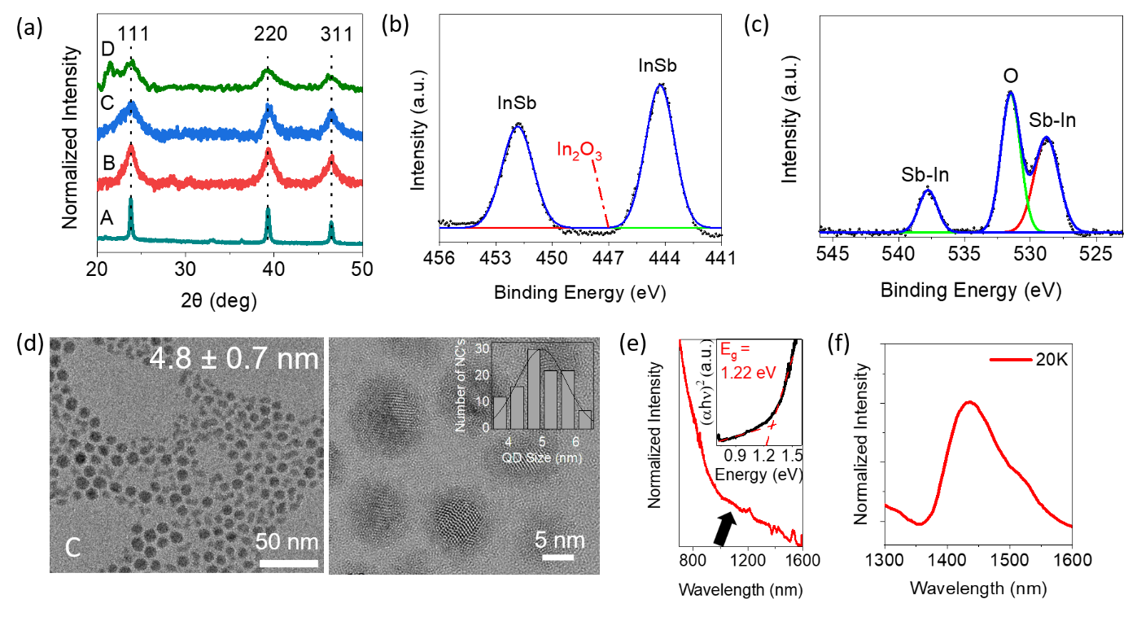
Figure 1. (a) Powder XRD patterns of the products prepared with different centrifugation process; detailed scheme has been added in supporting information Scheme 1. XPS spectra in (b) In 3d and (c) Sb 3d core levels of the sample C, fitted with Gaussian function. (d) HR-TEM images of the sample C with the size distribution profile in the inset. (e) Room-temperature NIR absorption spectrum of the sample C dispersed in TCE. (f) PL spectra of the sample C when the sample temperature was 20K.

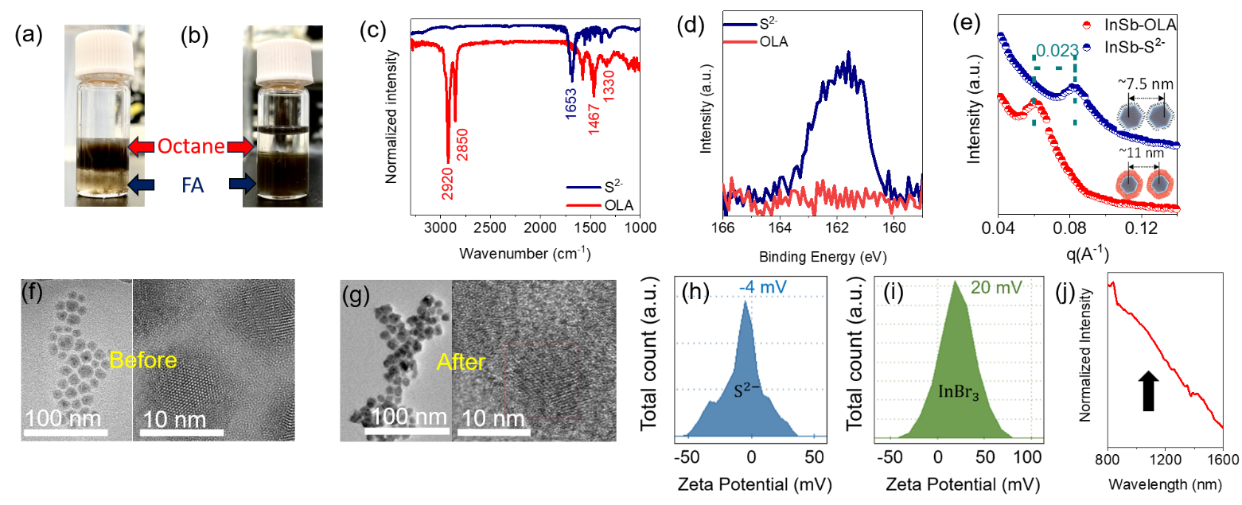
Figure 2. Photographs of phase change (a) before and (b) after sulfide ligand exchange. (c) ATR-FTIR spectra of OLA-capped InSb CQDs before and after sulfide ligand exchange. (d) XPS S2p spectra of OLA-capped CQD before and after sulfide ligand exchange. (e) Low angle GIXRD spectra of InSb CQDs with OLA and sulfide-capped ligand. HR-TEM images of (f) OLA- and (g) Sulfide-capped InSb CQDs. Zeta potentials of InSb CQDs (approx. 2~3 mg/ml in DMF) capped with (h) sulfide and (i) bromide ligands. (j) Optical absorption spectrum of sulfide-capped InSb CQD in thin-film form.

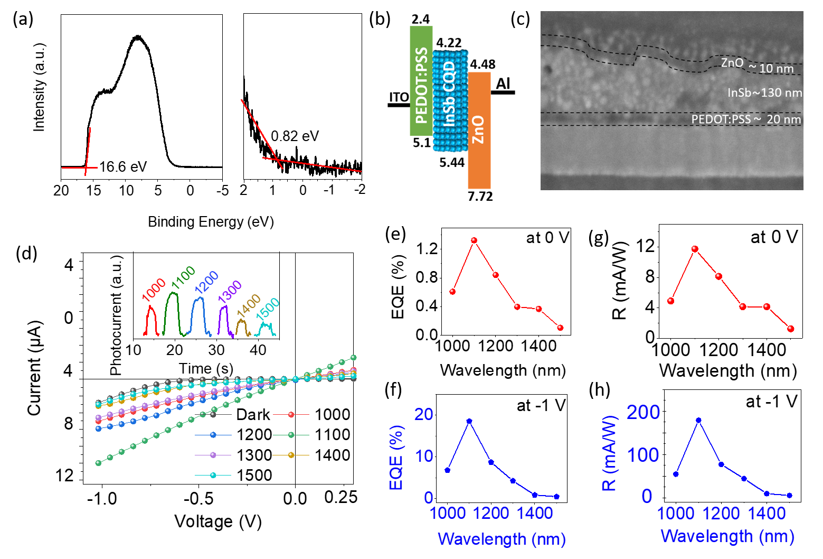
Figure 3. (a) UPS spectra of sulfide-capped InSb CQD with high-and low-binding energy cutoff region was determined. (b) Energy band diagram of the QPD at no bias condition. (c) A typical cross-sectional SEM image of the QPD stack. (d) I-V characteristic of the QPD in linear form under different SWIR wavelength of light, inset shows the photoresponse of the QPD under different wavelength of SWIR light. (e) and (f) shows the EQE of the QPD, whereas (g) and (h) shows the Responsivity of the QPD under 0 and -1 V, respectively.

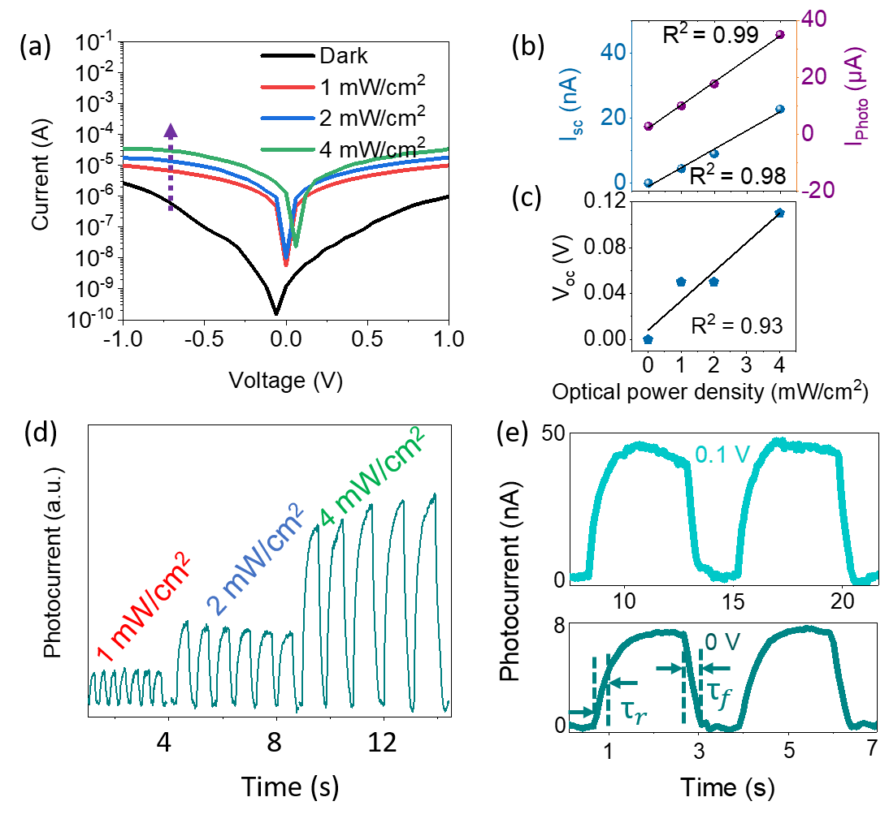
Figure 4. (a) Logarithmic I-V characteristic of QPD under 1100 nm with different optical light intensity. Optical illumination intensity dependent (b) I_{sc}, I_{photo} (-1 V) and (c) V_{oc} values (linear fit) of the QPD. (c) Photoresponse of the QPD under different light intensity of 1100 nm light. (d) Photoresponse of the QPD under 0 and 0.1 V.

Supporting Information
1. Materials and Methods
1.1 Reagents and Materials: Indium (III) bromide (99.999% trace metal basis), Lithium triethylborohydride (LiEt₃BH, 1.0 M solution in THF), Dioctyl ether (DOE), Formamide (>99.5%), N,N-dimethylformamide (anhydrous, 99.8%), Sodium sulfide, Butylamine (BTA) were purchased from Sigma-Aldrich. Antimony (III) bromide (99.9%), Toluene (99.5%, Deoxydized, 1-ppm<O₂, 10-ppm<H₂O), Hexane (99.6%, Deoxidized, 1-ppm<O₂, 10-ppm<H₂O), Methanol (99.8%, Deoxydized, 1-ppm<O₂, 10-ppm<H₂O), Ammonium acetate (AA) and Tetrachloroethylene (TCE) were purchased from Fujifilm WAKO chemical corp. Oleylamine (OLA, 80-90%) was purchased from Kanto-Kagaku.
1.2 Preparation of precursor solution: 0.22 mmol (0.078 g) of InBr₃ and 0.2 mmol (0.071 g) of SbBr₃ were dissolved together in 10 mL OLA, which was preliminarily degassed in vacuum overnight, in a rubber stopper plastic sealed glass bottle inside of a glovebox filled with Ar. Then the sealed glass bottle was heated overnight at 50° C on top of an oil bath.
1.3 Preparation of reducing agent solution: 2.5 mL of LiET₃BH (Super-hydride, SH) solution was mixed with 2.5 mL of DOE, which was preliminarily degassed under vacuum overnight, in a 25 mL two-neck flask connected to an air-free Schlenk line, followed by evacuation at room temperature overnight to remove THF, yielding DOE solution of SH. Because SH is highly reactive and sensitive to air, we treated SH in a controlled glove box where water and oxygen were kept below 1 ppm.
1.4 Synthesis of OLA-capped InSb QD and Size selective precipitation: InSb QDs were synthesised by hot-injection method by following our previously reported method with modification with the amount of precursor and reaction solvent.¹ First 6.5 ml of degassed OLA was injected in a three-neck flask under continuous Ar flow. Then the temperature was increased up to 240°C. Soon after reaching the reaction temperature 2.5 ml of SH solution was added in OLA, within 1 min solution becomes yellow. After waiting for 5 mins, 6.5 ml of precursor solution was injected drop-by-drop. Upon injection of precursor, solution turns darked brown. Then the solution was kept at the same condition for 45 mins to complete the reaction. After completion of reaction heater was removed and solution was mixed with super hydrated Toluene.
A schematic image of size separation was shown in Scheme 1. The solution mixture was separated in two centrifuge tubes capped with the septa for further separation. In the first set centrifugation was performed for 5 min at 8000 rpm which yielded black precipitated samples (sample A) and with dark brown supernatant. Further 2 ml of methanol was added in the solution and centrifuged for 10000 rpm for 10 mins to obtain sample B. This cycle of addition of methanol (4 ml and 5 ml) and centrifugation was repeated further to separate two more samples C and D.
1.5 Sulfide ligand exchange procedure: Solution process ligand exchange was followed with modification of the report by Kagan et. al.² InSb CQDs dissolve in octane at 30 mg/mL were mixed with 20 mg/ml of Na₂S in Formamide (FA) (solution mixing ratio is 1 ml:1 ml). Then the solution was vortex for 10 min and CQD phase was changed from octane to FA. Then centrifuge at 4000 rpm for 5 mins to precipitate. After discarding the transparent solution 1 ml super hydrated Hexane was added and vortex for 5 mins and then centrifuged again at 4000 rpm for 5 mins to precipitate, this step has been done one more time. Then precipitated sample was dissolved in 1 ml of super hydrated Hexane and 1 ml of super hydrated Methanol was added and centrifuged at 6000 rpm for 10 mins to get the exchanged ligand sample. After 2 hr. of drying in a vacuum, the sample was dissolved in Butalamine (BTA) + anhydrous N,N-dimethylformamide (DMF) in a ratio of 2:1 for fabrication at a concentration of 100 mg/mL.
1.6 Device Fabrication Process: ITO-coated glass substrate was cleaned with sonication in acetone, ethanol and IPA for 15 min each and transfer to VUV Ozone cleaner chamber (Ushio Inc., Japan, UER20-172V; λ= 172 nm and 10 mW/cm²). The substrate was further cleaned for 30 min under continuous flow of N₂ under pressure of 10³ Pa.
First, spin coating of PEDOT : PSS was performed at 3500 rpm for 35 sec, then dried on top of hot plate for 15 min at 120°C. Then, ligand exchanged InSb CQD of 90 mg/ml Sulfide-capped in BTA+DMF solution was spin coated at 1000 rpm for 60 sec. Then QD layer was dried on hot plate for 20 min at 80°C. This step was repeated for 10 times to thicken the CQD layer. After that ZnO was spin-coated on top of QD layer at 2500 rpm for 45 sec. Further the layer was dried by following heat treatment for 15 min at 120°C. Top electrode of Aluminium was deposited by thermal evaporation with a shadow mask by tuning the current with controlling the evaporation by 3-4 Å/s range.
1.7 Material Characterization: X-ray powder diffractometer Mini-Flex 600, Rigaku, Japan was used for XRD measurement. V-770 spectrophotometer (JASCO, Japan) was used for measuring optical absorption spectra for both solution and thin film form. 200 kV JEM 2100 manufactured by JEOL Ltd was used to capture HR-TEM images of QDs. IRAffinity-1S manufactured by Shimadzu was used to acquire ATR-FTIR spectra. XPS sample was prepared in glovebox by spin coating QD layer in Si substrate, while the sample handling process was on air before transferring to XPS system. XPS was measured by Quantum-2000 by ULVAC Faye Corp using AlKα (E = 1486.6 eV) radiation. The X-ray source was operated at 50 W and 15 kV. The core-level signals were obtained at a photoelectron take-off angle of 45° (with respect to the sample surface). The BE scales were referenced to 285.0 eV as determined by the locations of the maximum peaks on the C 1s spectra of hydrocarbon, associated with an adventitious contamination. Ultraviolet photoelectron spectroscopic (UPS) spectra were measured by SigmaProbe (Thermo Fisher Scientific, USA).
1.8 ICP-OES Sample Preparation: The whole of sample was transferred into a quartz beaker, and then 5mL of H₂SO₄ and a few drops of HNO₃ were added. The sample was decomposed by heating until white smoke is occurred. After cooling, the solution was poured into a 100 mL of volumetric flask and 10 mL of 20 mg/L Mn standard solution was added into the flask as internal standard for ICP-OES. 20 mL of HCl was added into this flask and the solution was diluted to the marked line with Milli-Q water.
1.9 SWIR Device Characterization: All devices were characterized at room temperature in ambient air. The data for the photocurrent density−voltage (J−V) characteristics were obtained using Keithley 2425 source meter. A 400 W halogen lamp (W-M10UN, BUNKOUKEIKI, Co., Ltd., Japan) equipped with a monochromator and a 300 W Xenon lamp were used for illumination. Power density of the incident light was measured using PD-300IR (Ocean Photonics, Co. Ltd., Japan). In the J-V measurement, three devices on one glass substrate were measured individually and each device was characterized under SWIR light irradiation (1000 – 1500 nm) and under dark conditions without light. The results for responsivity were obtained on a home-built setup using a same incident light. The anode and cathode of the device were connected to a 1 GΩ load resistor and connected to a DS-5624A oscilloscope (Iwatsu Electric Co., Ltd) to record the modulation changes of the photovoltage under open circuit conditions. The frequency response of the photocurrent was displayed as a fast Fourier transform by the oscilloscope. The response time was calculated using the rise and fall times between 0.1 and 0.9, with the background of the waveform displayed on the oscilloscope as 0 and the maximum photocurrent as 1.
References
- Chatterjee, Subhashri, Kazuhiro Nemoto, Batu Ghosh, Hong-Tao Sun, and Naoto Shirahata. "Solution-Processed InSb Quantum Dot Photodiodes for Short-Wave Infrared Sensing." ACS Applied Nano Materials (2023).

- Zhao, Tianshuo, Nuri Oh, Davit Jishkariani, Mingliang Zhang, Han Wang, Na Li, Jennifer D. Lee et al. "General synthetic route to high-quality colloidal III–V semiconductor quantum dots based on pnictogen chlorides." Journal of the American Chemical Society 141, no. 38 (2019): 15145-15152.

Scheme S1. Schematic representation of the post-synthesis size selection procedure to reduce the polydispersity from the initial ensemble.

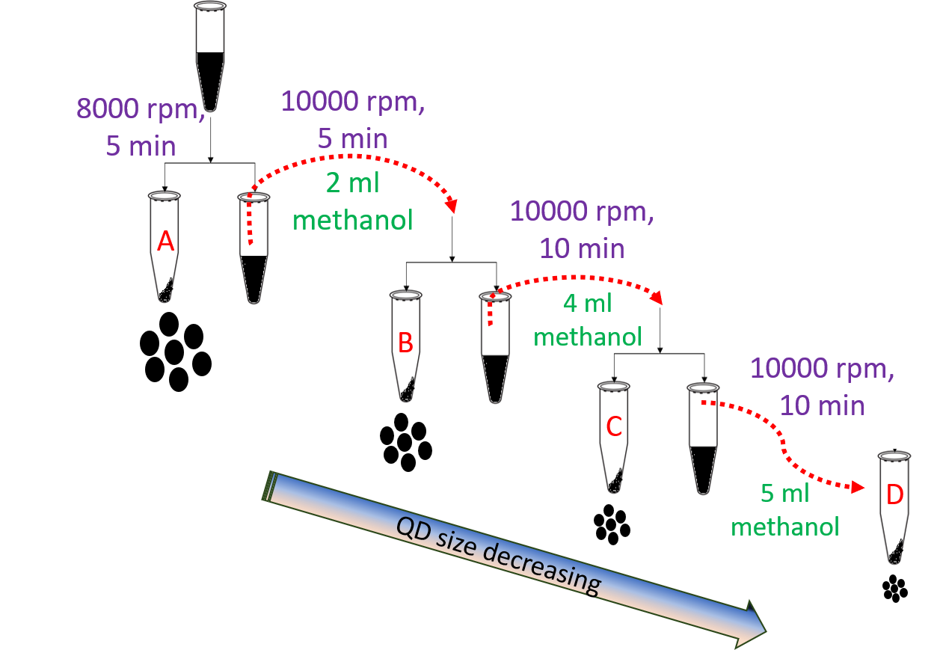
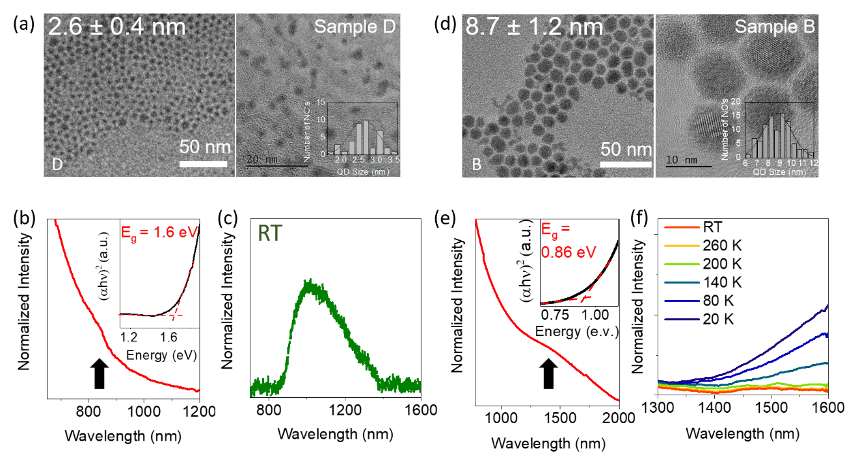
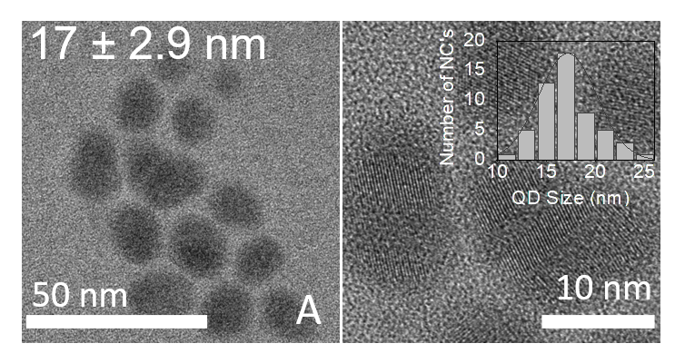
Figure S1. (a) HR-TEM photograph, (b) NIR absorption spectrum and (c) room temperature PL spectrum of the sample D of OLA-terminated InSb CQDs. (d) HR-TEM photograph, (e) NIR absorption spectrum and (f) temperature-dependent PL spectra of the sample B of OLA-terminated InSb CQDs.

Figure S2. HR-TEM photograph, the enlarged HR-TEM image and size distribution of the sample A of OLA-capped InSb CQDs.

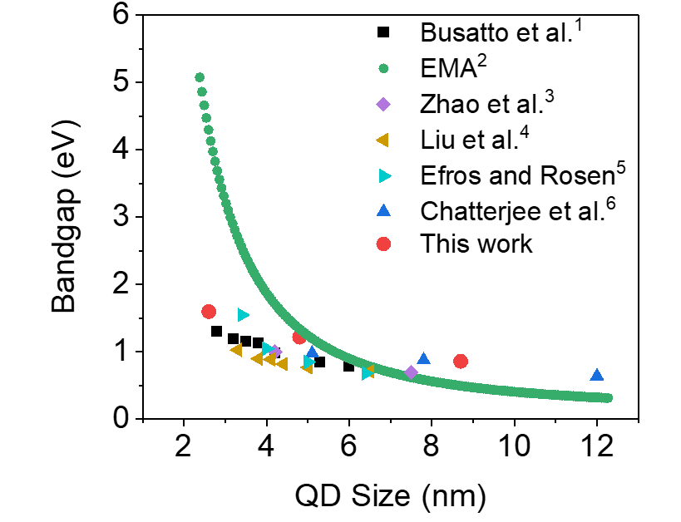
Figure S3. Bandgap energies (E_{g}) plotted versus diameters of InSb CQDs reported in literatures. The solid curve shows the theoretical relationship between the values of E_{g} and CQD diameter using effective mass approximation (EMA):
$$E_{g}= E_{g0}+ \frac{h^{2}}{{8m_{0 }R}^{2}}\left(\frac{1}{m_{e}^{*}}+ \frac{1}{m_{h}^{*}}\right)$$
where E_{g0} is the bulk bandgap energy, R is the radius of QD, $m_{e}^{*}$ (= 0.25m₀) and $m_{h}^{*}$ (= 0.014m₀) are electron and hole effective masses, respectively.²

References
- Busatto, Serena, Mariska de Ruiter, Johann TBH Jastrzebski, Wiebke Albrecht, Valerio Pinchetti, Sergio Brovelli, Sara Bals, Marc-Etienne Moret, and Celso de Mello Donega. "Luminescent colloidal InSb quantum dots from In-situ generated single-source precursor." ACS nano 14, no. 10 (2020): 13146-13160.
- Chukwuocha, E. O.; Onyeaju, M. C.; Harry, T. S. T. Theoretical Studies on the Effect of Confinement on Quantum Dots Using the Brus Equation. World J. Cond. Matt. Phys. 2012, 2, 96-100.
- Zhao, Tianshuo, Nuri Oh, Davit Jishkariani, Mingliang Zhang, Han Wang, Na Li, Jennifer D. Lee et al. "General synthetic route to high-quality colloidal III–V semiconductor quantum dots based on pnictogen chlorides." Journal of the American Chemical Society 141, no. 38 (2019): 15145-15152.
- Liu, Wenyong, Angela Y. Chang, Richard D. Schaller, and Dmitri V. Talapin. "Colloidal insb nanocrystals." Journal of the American Chemical Society 134, no. 50 (2012): 20258-20261.
- Efros, Al. L.; Rosen, M. Quantum Size Level Structure ofNarrow-Gap Semiconductor Nanocrystals: Effect of Band Coupling. Phys. Rev. B: Condens. Matter Mater. Phys.1998,58, 7120−7135.
- Chatterjee, Subhashri, Kazuhiro Nemoto, Batu Ghosh, Hong-Tao Sun, and Naoto Shirahata. "Solution-Processed InSb Quantum Dot Photodiodes for Short-Wave Infrared Sensing." ACS Applied Nano Materials (2023).

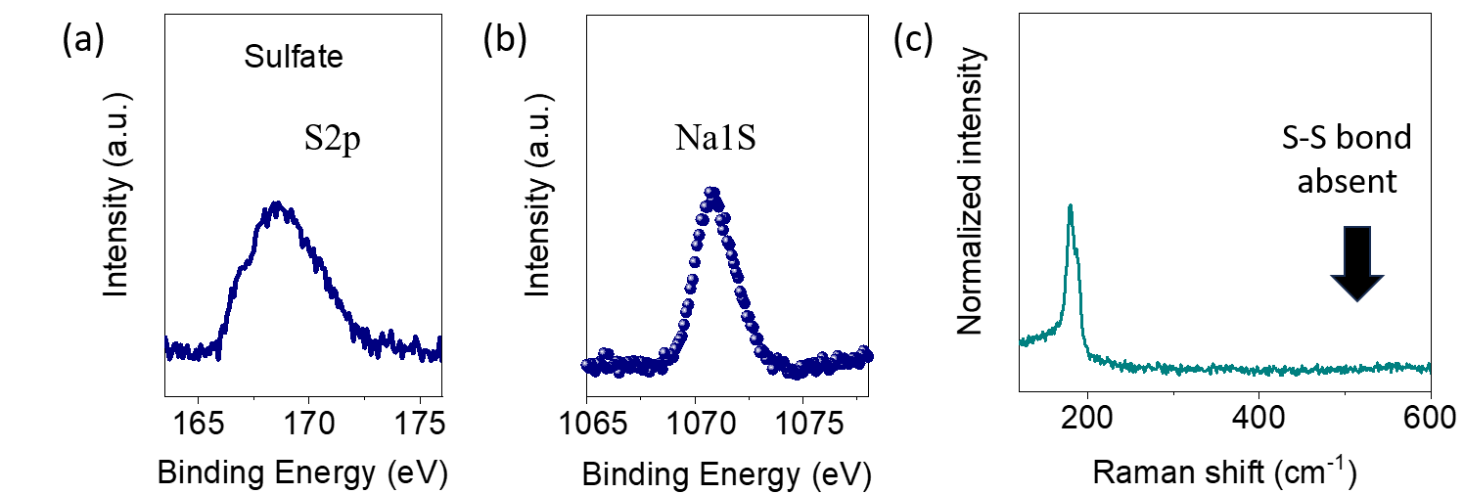

Figure S4. XPS spectra of sulfide capped InSb CQD of (a) S2p (b) Na1S region. (c) Raman spectra of sulfide capped InSb CQD.

Grazing Incident X-ray diffraction (GIXRD) measurement:
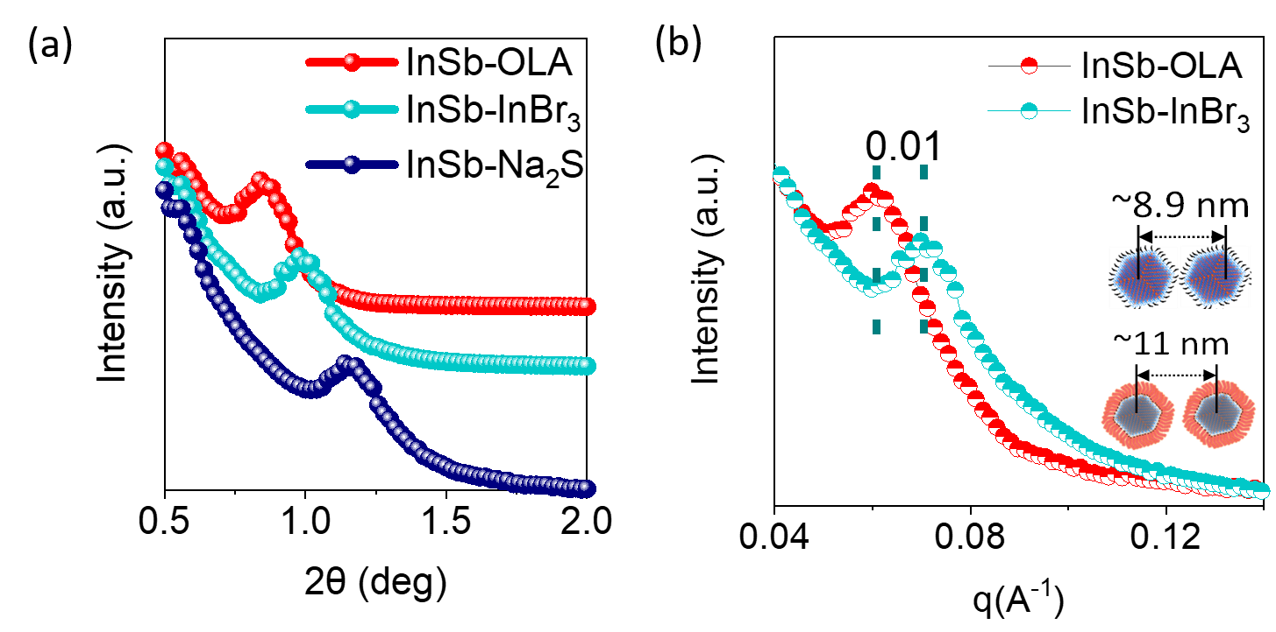
Figure S5. GI-XRD data of InSb with OLA-, bromide-, and sulfide-capped CQDs in 2θ. (b) q values of InSb CQD films with OLA and bromide ligands.

Sample preparation: InSb QD in DMF with concentration of 80 mg/ml was spin coated on top of Si substrate with 500 rpm for 30 sec, followed by heat treatment at 120 °C for 15 min.
2θ value was converted with Braggs formula:¹
$q=4π/λ(sinθ)$
Here, λ = 1.54 Å, 2θ is the scattering angle.
Here, d is Particle-to-particle distance calculated from following formula:¹
$$d=2π/q$$
Adjacent distance between particle (edge-to-edge of particle) was calculated by following formula:¹
$$D=2R-d$$
Here, R is average diameter of QDs.
Reference:
- Wan, Yanfen, Nicolas Goubet, Pierre-Antoine Albouy, Nicolas Schaeffer, and Marie-Paule Pileni. "Hierarchy in Au nanocrystal ordering in a supracrystal: II. Control of interparticle distances." Langmuir 29, no. 44 (2013): 13576-13581.

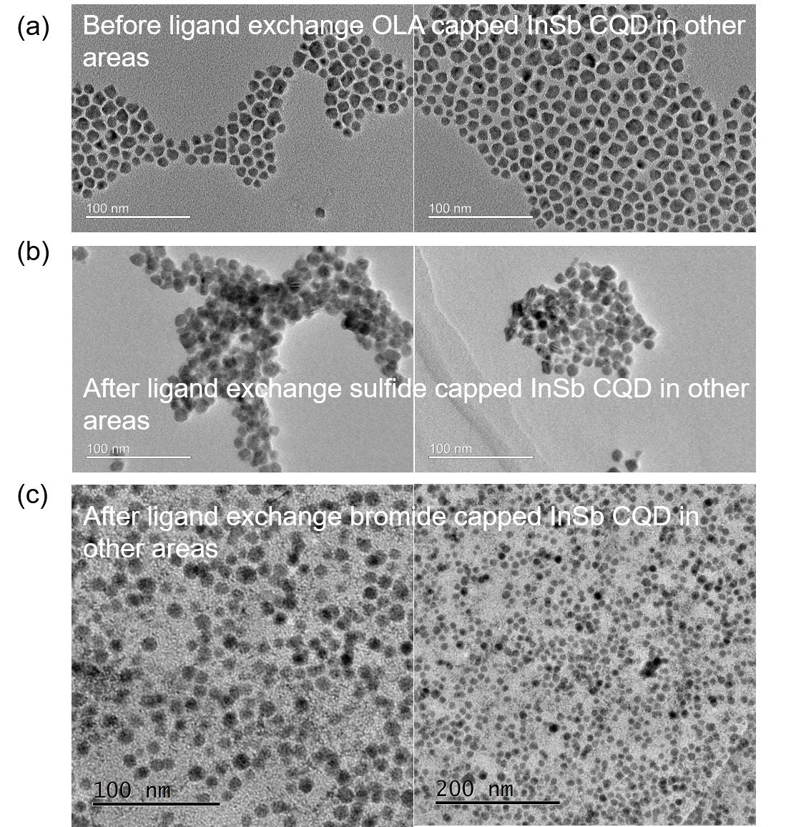
Figure S6. HR-TEM images in other areas of InSb CQD (a) before (OLA capped), (b) after (sulfide capped) and (c) after (bromide capped) ligand exchange.

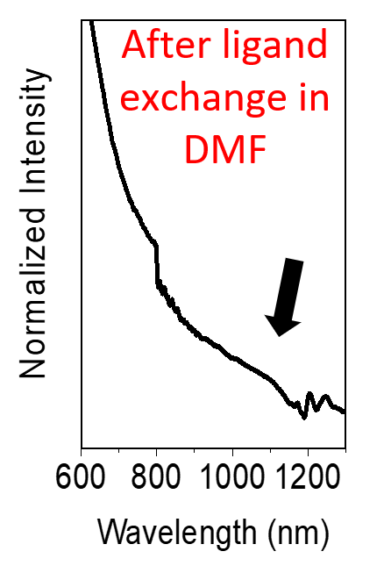
Figure S7. Absorption spectra of the Na₂S treated CQD in DMF solution.

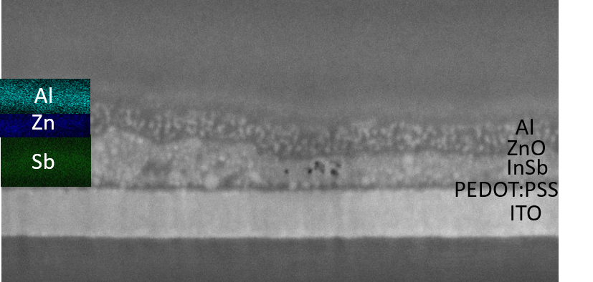

Figure S8. Cross-sectional SEM and EDS mapping of the QPD.

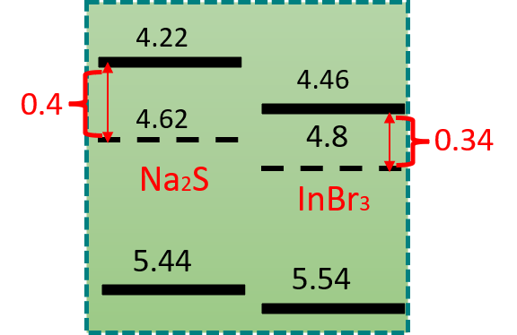

Figure S9. Energy band diagram of InSb CQD terminated with sulfide or bromide ligand depicted by the results obtained from UPS measurement.
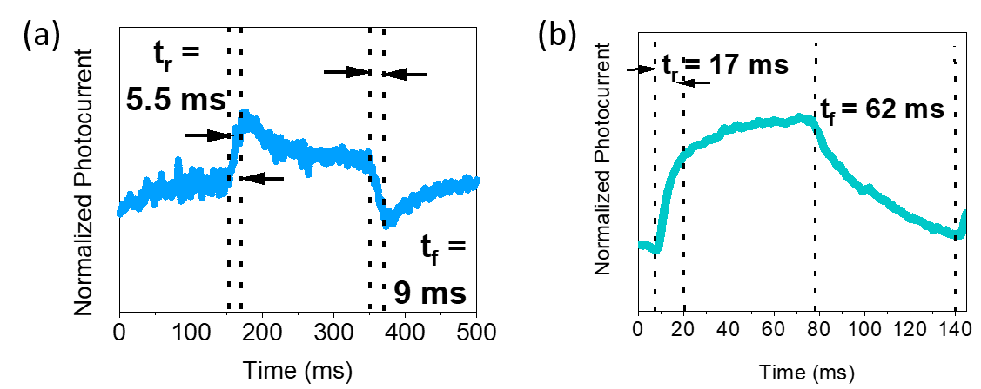
Figure S10. Normalized photocurrent response of the QPDs with (a) sulfide- and (b) bromide-capped InSb CQDs under white light illumination with an optical power density of 80 mW/cm².

NOTE:
The sulfide-capped QPD’s rise and fall time were approximately 5.5 ms and 9 ms at 0 V, whereas bromide-capped QPD’s rise and fall time were approximately 17 ms and 62 ms at 0 V. The rise and fall time of the sulfide-capped QPD responded 3.0 and 6.8 times faster than those of bromide-capped QPD.

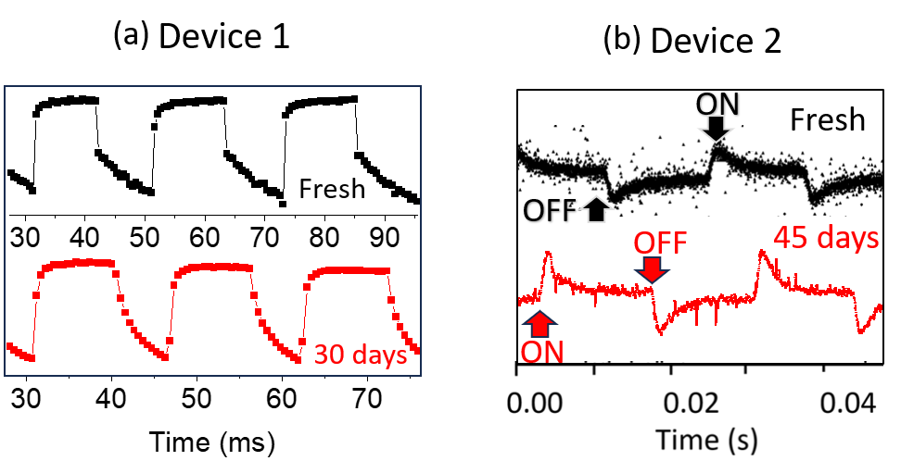

Figure S11. (a) and (b) multiple Na₂S treated QPD’s fresh devices were subjected to air exposure for a duration of 30 to 45 days at room temperature, conducted in a non-cleanroom environment.

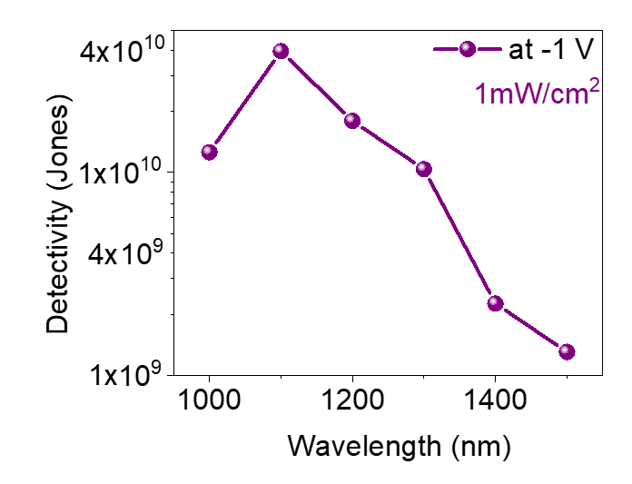
Specific Detectivity (D* in Jones):
$$D^{*}= \frac{R}{\sqrt{\frac{2eI_{dark}}{A}}}$$
Figure S12. Specific detectivity at -1 V of different wavelength under a constant light intensity of 1 mW/cm².

The Space-Charge-Limited-Current (SCLC):
The SCLC model was carried out to calculate estimated electron and hole mobility and trap density of InSb QD with bromide- and sulfide-capped ligands. Figure S5 shows the I-V curve of electron-only and hole-only devices. Mott-Gurney formula was used to calculate carrier mobility:¹⁻³
$$J=\frac{9}{8}ε_{r}ε_{0}μ\frac{V^{2}}{d^{3}}$$
Where J is the current density, Ɛ_{r} and Ɛ₀ are the relative dielectric constant of InSb in bulk and the permittivity of free space, respectively. µ is the field independent carrier mobility, d is the thickness of the QD layer. Here, Ɛ_{r} and Ɛ₀ are set to be 16.8 and 8.85×10⁻¹⁴ F cm⁻¹⁷. The thickness of QD films is about 100 nm.
N_{t} is the carrier trap density of the thin film has been calculated by the following formula:³⁻⁴
$$V_{TFL}=\frac{eN_{t}d^{2}}{2ε_{r}ε_{0}}$$
Here, e represents elementary charge, V_{TFL} known as trap filled limit voltage. V_{TFL} can be describes as the transit point between two regions: ohmic region (I ∝ V), trap-filled limit region (TFL region).
Fabrication procedure: ZnO layer was spin coated with 2500 rpm for 45 sec. After that substrate was dried on top of hot plate at 120 ºC for 15 min. PEDOT: PSS layer was spin coated with 5000 rpm for 35 sec, followed by heat treatment at 120 ºC for 15 min. QD layer was spin coated at 1000 rpm for 60 sec, followed by heat treatment at 80 ºC for 20 min. This process was repeated for 10 times to thicken the layer.
References
- Röhr, Jason A., and Roderick CI MacKenzie. "Analytical description of mixed ohmic and space-charge-limited conduction in single-carrier devices." Journal of Applied Physics 128, no. 16 (2020).
- Chiang, Chien-Hung, and Chun-Guey Wu. "Bulk heterojunction perovskite–PCBM solar cells with high fill factor." Nature Photonics 10, no. 3 (2016): 196-200.
- Hsiao, Kai-Chi, Meng-Huan Jao, Bo-Ting Li, Ting-Han Lin, Stan Hsueh-Chung Liao, Ming-Chung Wu, and Wei-Fang Su. "Enhancing efficiency and stability of hot casting p–i–n perovskite solar cell via dipolar ion passivation." ACS Applied Energy Materials 2, no. 7 (2019): 4821-4832.
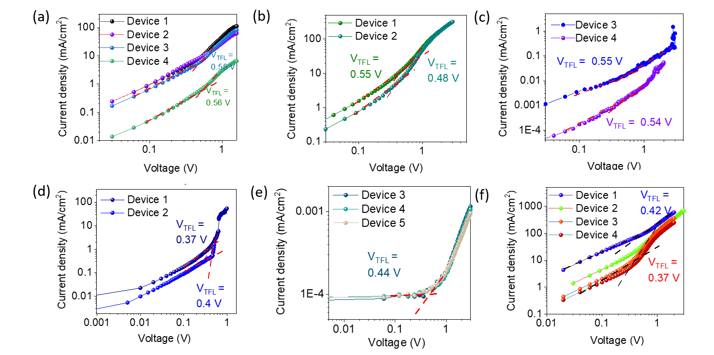
- Heo, Jin Hyuck, Myoung Sang You, Min Hyuk Chang, Wenping Yin, Tae Kyu Ahn, Sang-Ju Lee, Shi-Joon Sung, Dae Hwan Kim, and Sang Hyuk Im. "Hysteresis-less mesoscopic CH₃NH₃PbI₃ perovskite hybrid solar cells by introduction of Li-treated TiO2 electrode." Nano Energy 15 (2015): 530-539.
Figure S13. (a) The hole only devices PEDOT:PSS/InSb-InBr₃, (b) and (c) the electron only devices ZnO/InSb-InBr₃/ZnO devices. (d) and (e) is hole only devices PEDOT:PSS/InSb-Na₂S, (f) electron only devices ZnO/InSb-Na₂S/ZnO.

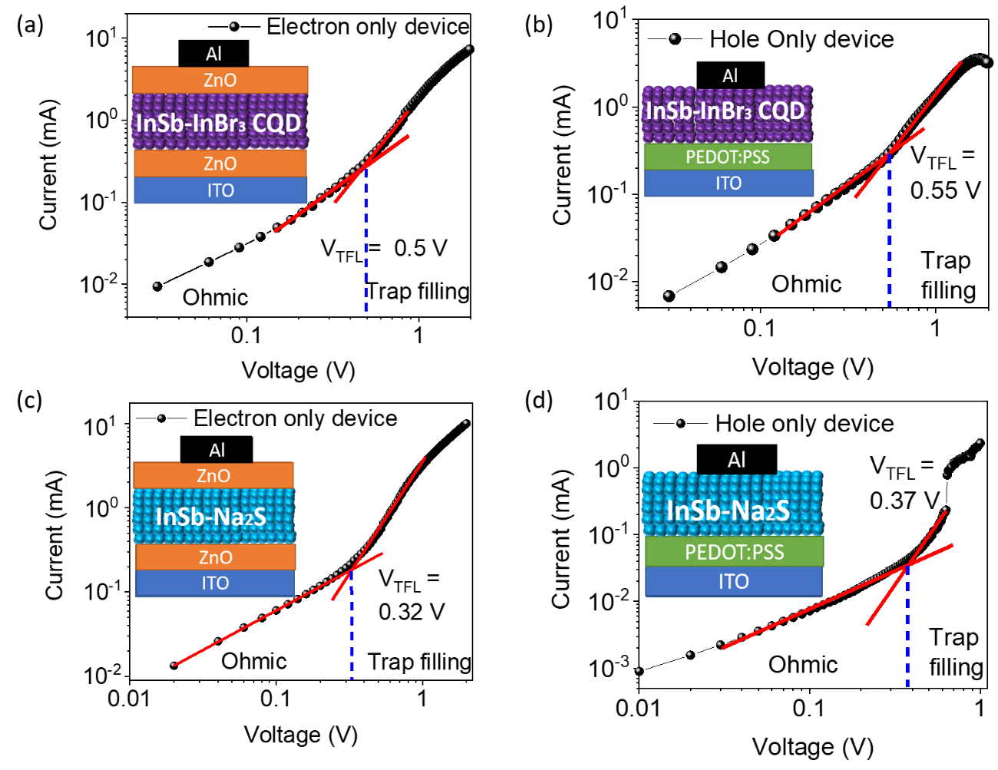
Figure S14. (a) and (c) The electron mobility from ZnO/InSb-InBr₃/ZnO and ZnO/InSb-Na₂S/ZnO devices respectively. (b) and (d) The hole mobility from PEDOT: PSS/InSb-InBr₃ and PEDOT: PSS /InSb-Na₂S devices respectively.

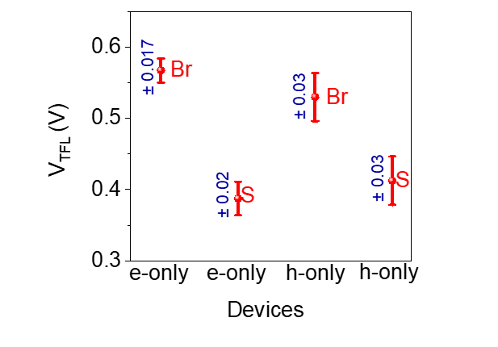
Figure S15. Error bar of V_{TFL}(V) values of four type devices with standard deviation.

Table S1. Summary of the device performances for nontoxic SWIR photodetectors (1-2 µm) based on InSb CQDs. PT: Phototransistor, PC: Photoconductor, PD: Photodiode, R: Responsivity, EQE: Equivalent quantum efficiency, T: Response time and λ: Incident-light wavelength.

Photoactive material | Device type | Ligand | R  (A/W) | EQE  (%) | λ  (µm) | T  (sec) | Reference
InSb | PT | K₂S, K₂Te | ------ | ------ | ------ | ------ | 1
InSb | PC | Na₂S | ------ | ------ | ------ | ------ | 2
InSb:PCBM:poly-TPD | PT | OLA | 4×10⁻⁵ | ------ | 1, 1.2, 1.4 | 0.08 | 3
In(P)As | PD | MPD | 0.031(-3V)  0.029(-3V)  0.007(-3V) | 5(-4V)  5(-4V)  1(-4V) | 1.14  1.27  1.4 | 1.2×10⁻⁶, 8.9×10⁻⁶ at -3 V under 100 mW/cm² white LED | 4
InSb | PD | InBr₃ | 0.098(-1V)  8×10⁻⁴(0V) | 10.1(-1V)  0.008(0V) | 1.2 | 0.55 at 0 V under 1,2 and 4 mW/cm² SWIR from Halogen lamp | 5
InSb | PD | TBAX + MAX | - | 75(1V) | 1.2 | 7.3μ and 5.4μ | 6
InSb/InAs  (Core-Shell) | PD | Mn₂Se₂ | 0.078 | 11.4  6.3 | 1.37  1.52 | - | 7
InSb | PD | MA  + TBAI | 0.28 | 25 (-1V) | 1.4 | 5.6μ at -1V | 8
InSb/InP  (Core-Shell) | PD | InI₃ | - | 25(-2V)  15(1.5V)  12(-1.5V) | 1.24  1.3  1.42 | 7 ×10⁻⁸ | 9
InSb | PD | Na₂S | 0.18(-1V)  12×10⁻³(0V) | 18.52(-1V)  1.3(0V) | 1.1 | 0.2 at 0 V under 1,2 and 4 mW/cm² SWIR Halogen lamp  0.005 and 0.009 at 0V under 80 mW/cm² white light Xenon lamp | This work

References

- Liu, Wenyong, Angela Y. Chang, Richard D. Schaller, and Dmitri V. Talapin. "Colloidal insb nanocrystals." J. Am, Chem. Soc. 134, no. 50 (2012): 20258-20261.
- Zhao, Tianshuo, Nuri Oh, Davit Jishkariani, Mingliang Zhang, Han Wang, Na Li, Jennifer D. Lee et al. "General synthetic route to high-quality colloidal III–V semiconductor quantum dots based on pnictogen chlorides." J. Am. Chem. Soc. 141, no. 38 (2019): 15145-15152.
- He, Miao, Zhuhua Xu, Si-Wei Zhang, Meng Zhang, Chengcheng Wu, Baohua Li, Jingzhou Li et al. "Colloidal InSb Quantum Dots/Organic Integrated Bulk Heterojunction for Fast and Sensitive Near‐Infrared Photodetectors." Adv. Photon. Res. 3, no. 4 (2022): 2100305.
- Leemans, Jari, Vladimir Pejović, Epimitheas Georgitzikis, Matthias Minjauw, Abu Bakar Siddik, Yu‐Hao Deng, Yinghuan Kuang et al. "Colloidal III–V Quantum Dot Photodiodes for Short‐Wave Infrared Photodetection." Adv. Sci. 9, no. 17 (2022): 2200844.
- Chatterjee, Subhashri, Kazuhiro Nemoto, Batu Ghosh, Hong-Tao Sun, and Naoto Shirahata. "Solution-Processed InSb Quantum Dot Photodiodes for Short-Wave Infrared Sensing." ACS Appl. Nano Mater. 6, no. 17 (2023): 15540-15550.
- Muhammad, Dongsun Choi, Darshan H. Parmar, Benjamin Rehl, Yangning Zhang, Ozan Atan, Gahyeon Kim et al. "Halide‐Driven Synthetic Control of InSb Colloidal Quantum Dots Enables Short‐Wave Infrared Photodetectors." Advanced Materials 35, no. 46 (2023): 2306147.
- Seo, Haewoon, Hyeong Ju Eun, Ah Yeong Lee, Hang Ken Lee, Jong H. Kim, and Sang‐Wook Kim. "Colloidal InSb Quantum Dots for 1500 nm SWIR Photodetector with Antioxidation of Surface." Advanced Science 11, no. 4 (2024): 2306439.
- Zhang, Yangning, Pan Xia, Benjamin Rehl, Darshan H. Parmar, Dongsun Choi, Muhammad Imran, Yiqing Chen et al. "Dicarboxylic Acid‐Assisted Surface Oxide Removal and Passivation of Indium Antimonide Colloidal Quantum Dots for Short‐Wave Infrared Photodetectors." Angewandte Chemie 136, no. 8 (2024): e202316733.
- Peng, Lucheng, Yongjie Wang, Yurong Ren, Zhuoran Wang, Pengfei Cao, and Gerasimos Konstantatos. "InSb/InP Core–Shell Colloidal Quantum Dots for Sensitive and Fast Short-Wave Infrared Photodetectors." ACS nano (2024).

Table S2. Summary of the carrier mobility and carrier trap density calculated from SCLC from electron-only and hole-only device.

Ligand | Number of devices | E-only device V_{TFL} (V) | h-only device V_{TFL} (V)
InBr₃ | 1  2  3  4
  0.55
  0.48
  0.55
  0.54
  0.57
  0.59
  0.55
  0.56
Na₂S | 1  2  3  4  5
  0.42
  0.39
  0.37
  0.37
  -----
  0.37
  0.4
  0.44
  0.44
  0.44

