Analysis of In_{x}Ga_{1–x}N growth rate in atmospheric-pressure metal-organic vapor phase epitaxy: Insights into incorporation and desorption processes of GaN and InN for precise growth control
Masataka Imura¹*, Takanobu Hiroto², Takaaki Mano¹, Yuri Itokazu³, and Masafumi Jo⁴
¹ Research Center for Electronic and Optical Materials, National Institute for Materials Science (NIMS), 1-1, Namiki, Tsukuba, Ibaraki 305-0044, Japan
² Research Network and Facility Services Division, NIMS, 1-2-1, Sengen, Tsukuba, Ibaraki, 305-0047, Japan
³ BEAM Technologies Inc., 9-3, Nibancho, Chiyoda-ku, Tokyo, 102-0084, Japan
⁴ Cluster for Pioneering Research, RIKEN, 2-1 Hirosawa, Wako, Saitama 351-0198, Japan
*Email: Imura.masataka@nims.go.jp
We grew GaN/In_{x}Ga_{1–x}N superlattices (SLs) on GaN/sapphire substrates by atmospheric-pressure metal-organic vapor phase epitaxy (MOVPE) and determined the In_{x}Ga_{1–x}N growth rate using high-resolution X-ray diffraction analysis. The use of SL structures substantially reduced the influence of strain relaxation, phase separation, and mixed 2D/3D growth modes, enabling reliable extraction of the effective GaN and InN growth rates within the alloy. By maintaining identical temperature, pressure, and gas-flow balance, we precisely estimated the individual growth rates and proposed a model that explicitly separates incorporation and desorption processes. For low In composition (x_{In} < 0.25), the GaN and InN rates exhibit negligible mutual interaction and depend solely on temperature under constant pressure and flow balance. The model successfully predicts In_{x}Ga_{1–x}N growth rates using independent incorporation and desorption terms, and its applicability is confirmed for In vapor-phase ratios < 0.7 and sufficiently high V/III ratios, while limitations are identified under excess-In or low-temperature conditions. These results provide practical guidelines for optimizing MOVPE growth, contributing to the efficient design of active and SL layers for high-power light-emitting diodes and green laser diodes.

I. Introduction

The low-In composition regime of In_{x}Ga_{1–x}N (typically x_{In} < 0.25) plays a critical role in nitride optoelectronics.¹⁾ High-quality quantum wells (QWs) and superlattices (SLs) in this regime are indispensable for ultraviolet-to-green light-emitting diodes (LEDs) and laser diodes (LDs),^{2,3)} and emerging nitride-based quantum-cascade and intersubband devices that demand precise control of layer thickness and alloy composition.⁴⁻⁶⁾ However, realizing such structures with high uniformity and crystallinity remains a major challenge. Metal-organic vapor phase epitaxy (MOVPE) is the predominant growth method owing to its scalability and compatibility with device fabrication.⁷⁾ Nevertheless, growth control in the low-In regime still largely relies on empirical parameter tuning.

In this composition range, the growth rate is governed by the competition between incorporation of group-III species from precursor decomposition and their desorption at elevated temperatures.⁸⁾ These processes are highly sensitive to precursor flow, substrate temperature, and reactor pressure, which are often coupled in non-trivial ways. Additional complexity arises from the large lattice mismatch between GaN and InN, the presence of a miscibility gap, and the weak In–N bond energy, all of which promote In desorption and narrow the growth window.⁹⁻²¹⁾ While numerous thermodynamic,^{22,23)} reaction-pathway,²⁴⁾ and kinetic models^{25,26)} have been proposed, they typically involve many fitting parameters and reactor-specific assumptions, thereby limiting their predictive applicability to practical MOVPE processes.

To overcome these limitations, accurate evaluation of the respective growth rates of GaN and InN within the In_{x}Ga_{1–x}N alloy is essential. However, conventional X-ray diffraction (XRD) analysis using single-layer In_{x}Ga_{1–x}N films is strongly affected by composition gradients, phase separation, and strain relaxation, making it difficult to separate the contributions of GaN and InN even in the low-In regime.²⁵⁻²⁷⁾ In addition, growth parameters such as pressure and gas-flow balance are strongly interdependent, and systematic studies that vary one parameter while keeping others strictly constant have been limited. As a result, apparently contradictory behaviors—such as increases in x_{In} under both reduced- and high-pressure MOVPE,²⁸⁻³¹⁾ or increases in x_{In} with higher flow rate of Ga source precursor or faster GaN growth even at fixed vapor-phase ratio^{18,32-34)}—have been reported. This interdependence makes it difficult for existing growth models to decouple incorporation and desorption processes, leaving the origin of observed changes in x_{In}—whether arising from enhanced incorporation or suppressed desorption—unclear.

In this study, we address this gap by growing GaN/In_{x}Ga_{1–x}N SLs under carefully controlled MOVPE conditions and analyzing them using high-resolution XRD.³⁵⁾ The use of SL structures enables the reliable extraction of effective GaN and InN growth rates. Based on these results, we propose a phenomenological model that captures the competition between incorporation and desorption, delineate its range of validity, and demonstrate its practical relevance for designing high-quality low-In In_{x}Ga_{1–x}N QWs and SLs.

II. Experimental methods

Growth was performed in a horizontal-flow MOVPE reactor (Taiyo Nippon Sanso, model SR2328HT-RR) with a three-layer quartz flow channel and face-up 2-inch wafer configuration (Fig. 1 (a)). Substrates rotated at 10 rpm throughout the growth. Temperature was measured by a thermocouple placed close to the substrate and controlled via a PID feedback loop. Group-III precursors and NH₃ were fed through the middle and bottom channels, respectively; the top flow suppressed convection and stabilized near-surface flow. Reactor pressure was maintained at 100 kPa, and the top/middle/bottom flow rates were fixed to minimize hydrodynamic effects on growth.
A 2.8-µm-thick GaN template was first grown on 2-inch c-plane sapphire at 1100 °C using a low-temperature GaN buffer.³⁶⁾ The full-width at half-maximum values of X-ray rocking curve for GaN 002 and 102 reflections were ≈ 200 and 250 arcsec, respectively. Trimethylgallium (TMGa) and NH₃ were used with H₂ carrier; top/middle/bottom flows were 10/7/7 slm. To evaluate the growth rate at x_{In} < 0.25, we fabricated six-period GaN/ In_{x}Ga_{1–x}N SLs (Fig. 1 (b)). Each In_{x}Ga_{1–x}N layer was limited to a thickness of 2–3 nm, which confines possible composition gradients within this narrow thickness range and thereby substantially suppresses their influence compared with single, thicker In_{x}Ga_{1–x}N layers. This thin-well design also helps to suppress lattice relaxation and mixed 2D/3D growth modes. The GaN barrier layers with thicknesses of 2–11 nm were inserted to maintain clear structural periodicity, and the use of six SL periods was intended to enhance the diffraction intensity and improve the reliability of the XRD analysis by providing well-defined satellite peaks.
Triethylgallium (TEGa), trimethylindium (TMIn), and NH₃ were used with N₂ carrier during SL growth, since N₂ suppresses In desorption compared with H₂. The reactor pressure and top/middle/bottom flows were kept at 100 kPa and 13/3/8.5 slm, and the growth temperature was set to 700, 740, or 790 °C. TMIn was supplied only during the alloy step, while TEGa and NH₃ were continuous; this pulsed TMIn supply suppressed background In incorporation during GaN growth. We varied the V/III ratio, V/III ≡ f_{N}/(f_{Ga}+f_{In}), and the vapor-phase ratio, VR ≡ f_{In}/(f_{Ga}+f_{In}). Hereafter, f_{Ga}, f_{In}, and f_{N} denote the molar flow rates of TEGa, TMIn, and NH₃, respectively. The model was constructed from data obtained at 700–790 °C, V/III = 3000–11000, and VR < 0.7, conditions that allow a precise assessment of the temperature dependence. To clarify applicability limits, we also show growth results at 600 °C, V/III ≈ 1000, and VR ≥ 0.7.

High-resolution XRD (Rigaku SmartLab) was employed to investigate the structural properties of SLs. The setup consisted of Cu Kα rotating anode (45 kV, 200 mA), Ge(220) two-bounce monochromator, HyRes220 analyzer, and HyPix-3000 detector. After alignment using sapphire reflections, reciprocal-space maps (RSMs) were acquired to verify the strain states. Symmetric 2θ–ω scans were then fitted by dynamical simulation (see Appendix A for details). In GaN/In_{x}Ga_{1-x}N SLs, the satellite-peak spacing and fringe profiles depend strongly on the total period thickness and the average optical contrast between the layers. Therefore, the GaN barrier thickness, In_{x}Ga_{1-x}N well thickness, and x_{In} were determined by the simulation, from which the growth rates were calculated using the applied growth time. The detailed MOVPE growth conditions, XRD fitting results, and growth rates are summarized in Appendix Table I. Atomic force microscopy (AFM, Hitachi High-Tech SPI3800Ne) was used to examine the surface morphology, confirming smooth surfaces without indications of relaxation-induced roughening and verifying that the growth proceeded predominantly in a 2D mode.
III. Results
A. Structural integrity of GaN/In_{x}Ga_{1–x}N SLs

Figure 2 (a) displays the representative symmetric 2θ–ω scan profiles around the GaN 002 reflection for GaN/In_{0.24}Ga_{0.76}N SL. The profile exhibits well-defined satellite peaks and interference fringes over a wide angular range, demonstrating good periodicity of the SL structures. Neither excessive broadening nor pronounced asymmetry are observed, indicating that large-scale phase separation is negligible. Figure 2 (b) shows the RSM image around the asymmetric GaN 105 reflections of the same sample. The SL satellite peaks are aligned at nearly the same Q_{x} / 2π value (≈ 3.625 nm⁻¹) as the GaN peak, indicating that the in-plane lattice constant of the SL is constrained by the underlying GaN and that no significant in-plane relaxation is observed within the experimental resolution. Figure 3 shows the AFM image of the same sample. The image revealed well-defined step–terrace features. While hexagonal V-pits attributable to threading dislocations were observed (≈ 8 × 10⁸ cm⁻²), the surface morphology indicates that mixed 2D/3D growth modes are not evident within the experimental resolution, and that the SL growth proceeded predominantly in a stable 2D mode.

These results demonstrate that the present GaN/In_{x}Ga_{1–x}N SL with x_{In} < 0.25 possess sufficient structural uniformity and crystalline quality to allow quantitative analysis based on dynamical diffraction simulations. Moreover, all other SLs grown under the investigated conditions for establishing the growth model exhibited similar RSM, XRD, and AFM characteristics, showing no significant indications of phase separation, strain relaxation, or mixed 2D/3D growth modes within the experimental resolution. This structural consistency across the sample set supports the validity of the subsequent composition and growth-rate analyses.

B. Estimating GaN and In_{x}Ga_{1–x}N growth rates

Based on the structurally validated GaN/In_{x}Ga_{1–x}N SLs described above, we next analyze the growth rates of the GaN and In_{x}Ga_{1–x}N layers using dynamical diffraction simulations. To examine whether TMIn supply affects GaN growth, GaN/In_{x}Ga_{1–x}N SLs were grown with GaN barrier growth times of 30 and 60 s, while all other growth parameters were kept constant. From the symmetric 2θ–ω profiles (Fig. 4), the GaN growth rate was first determined from the satellite peak spacing. Next, with this GaN rate fixed, the alloy growth rate and x_{In} were obtained by dynamical fitting of the XRD profiles. From these two steps, it was confirmed that the GaN growth rate and the GaN growth rate within the alloy are essentially identical, indicating that the influence of TMIn supply on GaN growth is negligible. Subsequently, using this fixed GaN rate, dynamical fitting of the XRD profiles was employed to determine the individual GaN and InN growth rates within the alloy, as summarized in Table II. Thickness errors correspond to ≈1% in growth rate across all samples. Therefore, in the following analyses, the GaN growth rate was assumed to be identical to that inside the In_{x}Ga_{1–x}N layer during fitting.

C. Dependence on precursor flows and temperature

We now examine how the effective GaN and InN growth rates depend on precursor flow rates and growth temperature. This analysis provides direct insight into the kinetic processes governing incorporation and desorption in GaN/In_{x}Ga_{1–x}N growth and forms the basis for the growth-rate model discussed below.

Figure 5 plots the GaN and InN growth rates vs f_{Ga} and f_{In} at 700, 740, and 790 °C. Varying f_{N} at fixed f_{Ga} and f_{In} did not change either rate, showing independence from V/III under fixed pressure/flow balance. Each rate increases linearly with its own group-III flow and extrapolates to a non-zero intercept, indicating that the present growth is likely governed by mass transport in the gas phase rather than by surface reaction kinetics.³⁷⁾ This behavior is consistent with typical atmospheric-pressure MOVPE growth,³⁸⁾ where the overall growth rate is often limited by the diffusion of precursors through the boundary layer above the substrate. Therefore, we interpret the slope as an incorporation efficiency γ_{i} (including transport and crystallization), and the intercept magnitude as the desorption rate δ_{i−N}, independent of f_{i}. This leads to
$$\begin{aligned}{GR}_{i-N}=f_{i}γ_{i}-δ_{i-N} (i=Ga, In)\#\left(1\right)\end{aligned}.$$
Fitting GaN and InN independently shows negligible mutual interaction, and under constant pressure and flow balance, both rates depend only on temperature. Notably, although a single InN layer does not grow under these conditions, the InN constituent in In_{x}Ga_{1–x}N (x < 0.25) does grow without significant coupling to GaN.

Figures 6 (a) and (b) show the temperature dependence of γ and δ. With increasing temperature, γ_{Ga} slightly increases while δ_{GaN} remains nearly constant; in contrast, γ_{In} decreases strongly and δ_{InN} rises. Consequently, GaN growth rate increases slightly with temperature, whereas InN growth rate decreases. The suppression of x_{In} at all temperatures arises from the combination of small γ_{In} and relatively large δ_{InN}. An Arrhenius analysis gives an activation energy of ≈0.49 eV for InN desorption (Fig. 6 (c)).

D. Behavior beyond the standard range
1) High vapor-phase ratio (VR ≥ 0.7)

At fixed f_{Ga} while increasing f_{In} (VR ≥ 0.7), the InN rate shows a pronounced loss of efficiency (Fig. 7). Since the δ_{InN} depends on the temperature under constant pressure/flow balance, the γ_{In} decreases strongly with high TMIn flow. AFM (Fig. 8) reveals coalescence of V-pits into irregular depressions and a transition to island-like 3D growth. We attribute this behavior to transient In-metal condensation near dislocations and subsequent partial evaporation, which enlarge pits and drive the growth-mode transition. Because the growth mode changes under such excess-In conditions, the fundamental assumptions of the model no longer hold, and predictive fitting becomes invalid.

2) Low temperature and low V/III

At 600 °C (V/III 3000–11000, VR < 0.7), the SL satellites are present; however, interference fringes are blurred (Fig. 9 (a)), and RSM indicates relaxation and composition fluctuation (Fig. 9 (b)). These features suggest that crystallinity is degraded by insufficient surface diffusion and enhanced local segregation/phase separation, making it difficult to accurately estimate the growth rates. As a result, rigorous discussion of whether the model applies under these conditions is not possible.

For MQWs designed for 520 nm emission, samples with V/III ≈ 1000 exhibited severe brown discoloration and negligible UV-excited luminescence, whereas V/III ≈ 8000 showed clear green emission (see Supplementary Fig. S1). Because the low-V/III samples exhibit severely degraded emission properties, they are not relevant for improving LED and LD performance. Therefore, we do not provide further model-based discussion for the low-V/III regime.

IV. Discussion
A. Advantages of the present model

Equation (1) enables prediction of GaN and InN growth rates from f_{Ga} and f_{In}, providing design-level control of layer thickness and x_{In} (up to ≈0.24) in In_{x}Ga_{1–x}N and GaN/In_{x}Ga_{1–x}N SLs. For a given temperature, the parameters (γ_{i}, δ_{i−N}) can be determined from only a few growth runs at VR < 0.7, greatly improving optimization efficiency and reproducibility for device fabrication. Importantly, the parameters are physically meaningful and can be independently discussed.

It should be noted that the individual In_{x}Ga_{1–x}N and GaN layer thicknesses employed in this study fall within the range commonly used for GaN/ In_{x}Ga_{1–x}N quantum wells in LEDs and LDs. In the present work, however, these structures are intentionally treated as short-period SLs from the viewpoint of dynamical XRD analysis. This choice is not intended to propose a novel device architecture. Rather, the repetition of multiple GaN/In_{x}Ga_{1–x}N periods enhances satellite-peak intensity and improves the uniqueness and robustness of the fitting, enabling reliable separation and quantitative extraction of the effective GaN and InN growth rates—an analysis that is difficult to achieve using a single quantum well of comparable thickness. At the same time, employing thickness ranges relevant to practical quantum wells ensures that the extracted growth parameters and the resulting growth-rate model remain directly applicable to device-oriented GaN/In_{x}Ga_{1–x}N heterostructures.¹⁾

Previous studies have often interpreted the increase of x_{In} with the GaN growth rate as evidence that a higher f_{Ga} either enhances In incorporation or suppresses InN desorption.^{18,32-34)} Our results, however, imply that these conventional interpretations should be reconsidered. The observed trend can instead be rationalized by the negative growth-rate intercept associated with InN desorption, which becomes dominant in the kinetically limited regime. As f_{Ga} increases, the relative contribution of the desorption term decreases, giving the appearance of improved In incorporation or reduced desorption loss. Once the net InN incorporation exceeds the desorption rate, x_{In} approaches a saturation value determined by γ_{In}/γ_{Ga}. Similarly, literature reports of both positive and negative pressure dependences of x_{In} can be explained by confounding effects of flow balance. Maintaining constant pressure together with fixed flow balance is essential to isolate kinetic effects. Under such conditions, pressure-dependence studies can be interpreted within Eq. (1) to distinguish enhanced In incorporation from suppressed InN desorption.²⁸⁻³¹⁾

B. Relation to previous models

Equation (1) separates incorporation and desorption with minimal, validated parameters and remains robust across a broad process window. In contrast, Fu et al. expressed the rate as

$$\begin{aligned}GR=f_{i}γ_{i}\#\left(2\right)\end{aligned}$$
with parasitic and high-temperature losses embedded in γ_{i}.²⁵⁾ While this captures slope changes, it cannot reproduce the negative intercept, and it conflates incorporation and desorption. Hu et al. used coupled relations

$$\begin{aligned}x_{In}=\frac{P_{In}η_{In}}{P_{In}η_{In}+P_{Ga}η_{Ga}}, GR=(P_{In}η_{In}+P_{Ga}η_{Ga})D\#\left(3-4\right)\end{aligned}$$
where D is a proportionality constant depending on reactor size, converting the unit from Pa to nm/min, η_{In} and η_{Ga} are incorporation efficiencies, and P_{In} and P_{Ga} are the partial pressures of In and Ga sources.²⁶⁾ This gives a quantitative framework, but parameters are strongly coupled, again obscuring independent treatment of desorption. Thermodynamic approaches clarify driving forces but omit explicit kinetics; adding NH₃ decomposition efficiency improves fits but fails at very high temperatures where NH₃ partial pressure becomes negligible.^{22,23)} Reaction-path models describe plausible chemistry yet lack a clear quantitative mapping from source flows to growth rates.²⁴⁾

C. Applicability limits

While Eq. (1) successfully describes growth in the low-x_{In} regime, the model assumptions break down under certain conditions. At high vapor-phase ratios (VR ≥ 0.7), AFM revealed a transition from step–terrace to island-like 3D growth, caused by transient In-metal condensation and partial evaporation near dislocations. Because the growth mode changes, the basic premise of independent incorporation and desorption no longer applies. At low temperature (600 °C), insufficient surface diffusion and enhanced segregation/phase separation led to relaxation and composition fluctuations, complicating reliable extraction of growth rates. Under such conditions, rigorous discussion of model validity is not possible. Finally, at very low V/III ratios, samples exhibited severe surface degradation and negligible luminescence, which precludes their use for device applications. As high-efficiency emission is a prerequisite for LEDs and LDs, detailed model-based analysis of this regime is not meaningful. Thus, the model is valid for x_{In} < 0.25 under well-controlled pressure and flow balance, VR < 0.7, and sufficiently high V/III ratios, but becomes unreliable when growth transitions to 3D, when surface diffusion is inadequate.

V. Conclusion

In this work, we systematically investigated the growth of In_{x}Ga_{1–x}N with low x_{In} (< 0.25) using GaN/In_{x}Ga_{1–x}N SLs grown by atmospheric-pressure MOVPE. By employing SL structures, we substantially suppressed the effects of phase separation, strain relaxation, and mixed 2D/3D growth modes, enabling reliable extraction of the effective GaN and InN growth rates within the alloy. The results show that the GaN and InN contributions can be independently separated and described by a phenomenological model that explicitly incorporates both incorporation and desorption processes. This model successfully predicts the In_{x}Ga_{1–x}N growth rate within the applicable regime, with physically meaningful parameters that can be independently evaluated. Importantly, under constant pressure and flow balance, the GaN and InN rates depend only on temperature. The model is valid for x_{In} < 0.25 under well-controlled pressure and flow balance, VR < 0.7, and sufficiently high V/III ratios. It breaks down under excess In supply (VR ≥ 0.7) and low temperature (600 °C), where growth-mode transitions or insufficient surface diffusion occur. These findings provide a practical framework for efficient growth optimization and reliable design of In_{x}Ga_{1–x}N active and SL layers, thereby contributing to improved performance of high-power LEDs and the realization of green LDs.

Supplementary Material
See the supplementary material for Fig. S1 showing the optical properties of GaN/In_{x}Ga_{1–x}N QW structures designed for 520 nm emission.

Acknowledgements
This work was supported by JSPS KAKENHI (Grant-in-Aid for Scientific Research (B), Grant Number JP25K01297). Additional support was provided by the Ministry of Defense, Japan under the “Security Technology Research Promotion Program” (Project ID: 25142611), and by the New Energy and Industrial Technology Development Organization (NEDO) under the “Deep-Tech Startup Support Fund / International Joint R&D Program” (Project ID: 24017480).

Appendix A

The XRD simulations used in this study were performed using a dynamical multilayer diffraction model based on the Takagi–Taupin equations.³⁹⁾ This approach accounts for multiple scattering, refraction, absorption, and wavefield coupling, all of which are essential for accurately reproducing the intensities and fringe structures observed in strained GaN/In_{x}Ga_{1-x}N SLs.

A1. Structural model and treatment of the In_{x}Ga_{1-x}N alloy layer

In the dynamical simulations, each In_{x}Ga_{1-x}N well was treated as an effective uniform alloy layer whose material parameters were obtained by linear interpolation between those of GaN and InN according to Vegard’s law. As shown in Sec. III.A, the RSMs confirmed that all wells remained pseudomorphically strained to the GaN barriers; therefore, the in-plane lattice constant was fixed to that of GaN. The out-of-plane lattice constant was determined using the linear elastic relation, such that the Takagi–Taupin calculations required only the final strained lattice parameters a and c.

To describe the In_{x}Ga_{1-x}N alloy as a mixture of GaN and InN components, the total well thickness was expressed as

$$\begin{aligned}t_{{In}_{x}{Ga}_{1-x}N}=t_{InN}+t_{GaN}\#\left(A1\right)\end{aligned}$$
, where the t_{InN} and t_{GaN} do not represent actual sublayers but the effective GaN and InN contributions within the ternary alloy. The x_{In} is therefore given by

$$\begin{aligned}x_{In}=\frac{t_{InN}}{t_{InN}+t_{GaN}}=\frac{{GR}_{InN}}{{GR}_{InN}+{GR}_{GaN}}\#\left(A2\right)\end{aligned}$$
, where the right-hand expression follows from viewing the alloy as being formed from the relative incorporation rates of the InN and GaN components. In the XRD fitting, only $t_{{In}_{x}{Ga}_{1-x}N}$ and x_{In} were treated as independent parameters, while t_{GaN} and t_{InN} followed from the above relations.

A2. Fitting procedure and software cross-validation

The simulated diffraction curves were fitted to the measured symmetric 2θ–ω profiles by minimizing the sum of squared differences using a genetic algorithm.⁴⁰⁾ In GaN/In_{x}Ga_{1-x}N SLs, the satellite-peak spacing and fringe profiles depend strongly on the total period thickness and the average optical contrast between the layers. Consequently, the GaN barrier thickness, In_{x}Ga_{1-x}N well thickness, and x_{In} of In_{x}Ga_{1-x}N have correlated effects on the simulated diffraction profile. In general, fitting with three correlated parameters involve a certain degree of ambiguity. However, by fitting the diffraction profiles over a wide angular range including higher-order satellite peaks, the solution space is significantly constrained, thereby improving the reliability and uniqueness of the extracted structural parameters.

As shown in Sec. III.B, the growth rates of GaN barrier and In_{x}Ga_{1-x}N well were nearly identical. Therefore, we introduce the following constraint as Eq. (A3) and perform constrained fitting:

$$\begin{aligned}\frac{t_{GaN barrier}}{T_{GaN barrier}}=\frac{t_{{In}_{x}{Ga}_{1-x}N} (1-x_{In})}{T_{{In}_{x}{Ga}_{1-x}N}}\#\left(A3\right)\end{aligned}$$
, where T_{GaN barrier} and $T_{In_{x}Ga_{1-x}N}$represent the growth times of the GaN barrier and the In_{x}Ga_{1-x}N well, respectively. Under this constraint, the only independent fitting parameters are $t_{In_{x}Ga_{1-x}N}$and x_{In}, while the remaining layer thicknesses and growth rates are determined accordingly.

From the RSMs, the in-plane and out-of-plane lattice constants of the GaN underlying layers grown on sapphire substrates were experimentally evaluated to be a = 3.185 Å and c = 5.190 Å, respectively. Structural models for the XRD simulations were constructed using these experimentally determined lattice constants, and the resulting fitted structural parameters were found to be indistinguishable, within the experimental uncertainty discussed in this study, from those obtained using bulk GaN lattice constants. Accordingly, for consistency, all fitting results presented in this work were obtained using the bulk GaN lattice constants (a = 3.1893 Å and c = 5.1851 Å).¹⁾

A3. Representative fitting results

To illustrate the validity and robustness of the constrained two-parameter fitting scheme adopted in this study, representative fitting results are presented in this section. Figures 10 (a) – (c) show representative symmetric 2θ–ω scan profiles of GaN/In_{x}Ga_{1-x}N SLs with different In compositions, together with the corresponding dynamical diffraction fits obtained using the two-parameter constrained fitting approach described in Secs. A1 and A2. In this scheme, only the total In_{x}Ga_{1-x}N well thickness $t_{In_{x}Ga_{1-x}N}$and the x_{In} were treated as independent fitting parameters, while the effective GaN and InN contributions within the alloy layer were uniquely determined through Eqs. (A1)–(A3). As shown in Figs. 10, the experimental profiles (solid lines) are well reproduced by the simulated curves (dotted lines) over a wide angular range, including higher-order satellite peaks and interference fringes. This close agreement demonstrates that the constrained fitting scheme captures the essential structural parameters of the GaN/In_{x}Ga_{1-x}N SLs without degradation of fitting quality. The extracted structural parameters obtained from the two-parameter constrained fitting are summarized in Table III.

Figures 11 (a), (b) and (c) present representative results of the same samples obtained using an unconstrained three-parameter fitting scheme, in which GaN barrier thickness, In_{x}Ga_{1-x}N well thickness, and x_{In} were treated as independent fitting parameters. The corresponding fitted parameters are summarized in Table IV. As shown in Figs. 11, the unconstrained three-parameter fitting also reproduces the experimental diffraction profiles reasonably well. The resulting structural parameters are generally consistent, within the experimental uncertainty, with those obtained from the two-parameter constrained fitting. This agreement confirms that the constrained fitting scheme does not introduce systematic bias into the extracted parameters. At the same time, the unconstrained three-parameter fitting exhibits increased parameter correlation and reduced numerical stability, particularly at x_{In} > 0.20. Therefore, while the three-parameter fitting was performed as a reference, the two-parameter constrained fitting was adopted throughout this study to ensure reliable and robust evaluation of growth rates and compositions in GaN/In_{x}Ga_{1-x}N SLs.

A4. Software cross-validation

Furthermore, to confirm that the extracted structural parameters did not depend on software-specific implementations, the analysis was independently performed using Rigaku SmartLab Studio II and Bruker LEPTOS. For identical input conditions, both programs produced fitted parameters that agreed within the experimental uncertainty when the constrained fitting scheme was applied, demonstrating that the results originate from the underlying physical model rather than software-dependent artifacts.

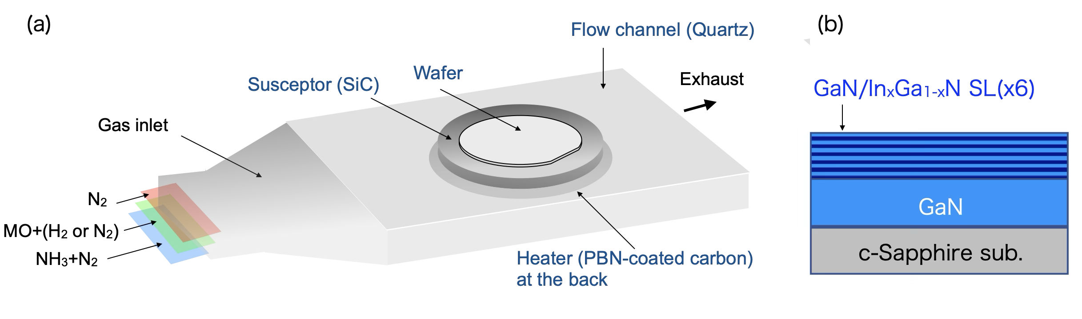
Figure 1. Schematics of (a) three-layer flow channel and (b) six-period GaN/In_{x}Ga_{1–x}N SL structure.

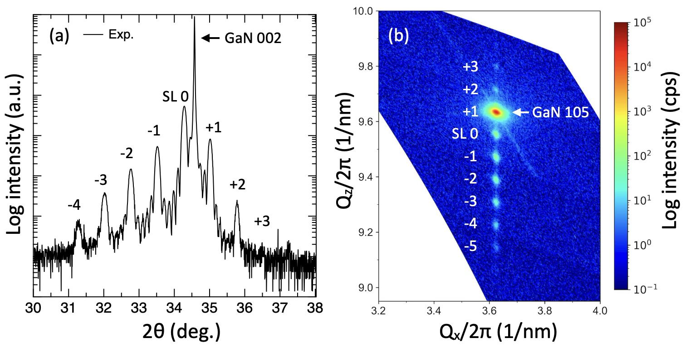

Figure 2. Structural characterization of a representative GaN/In_{0.24}Ga_{0.76}N SL grown at 700 ℃. (a) Symmetric 2θ–ω scan profiles around the GaN 002 reflection, exhibiting well-defined satellite peaks and interference fringes, indicative of good structural periodicity. (b) RSM around the GaN 105 reflection, indicating in-plane lattice coherence without significant relaxation.

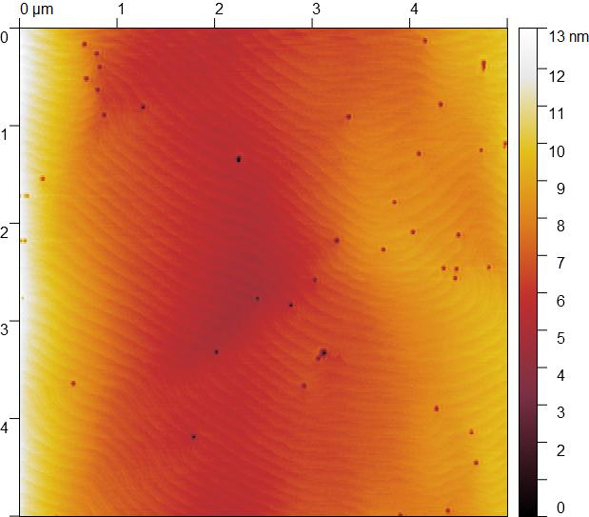

Figure 3. AFM images for GaN/In_{0.24}Ga_{0.76}N SL grown at 700 °C. Step-terrace morphology suggests predominantly 2D growth, while hexagonal V-pits (≈50 nm) correspond to threading dislocations.

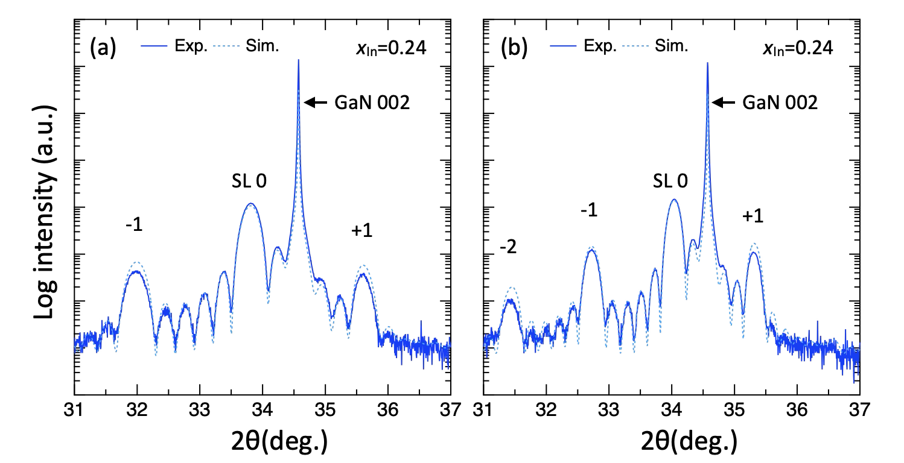

Figure 4. Symmetric XRD 2θ–ω profiles of GaN/In_{x}Ga_{1−x}N SLs with GaN barrier growth times of (a) 30 and (b) 60 s. Experimental data (solid lines) and simulated fittings (dotted lines) are compared. The x_{In} represents the In composition in the In_{x}Ga_{1−x}N layer. From satellite spacing, the GaN growth rate was determined as 4.30 nm/min. Fits with GaN thickness fixed yield In_{x}Ga_{1−x}N thickness and x_{In}.

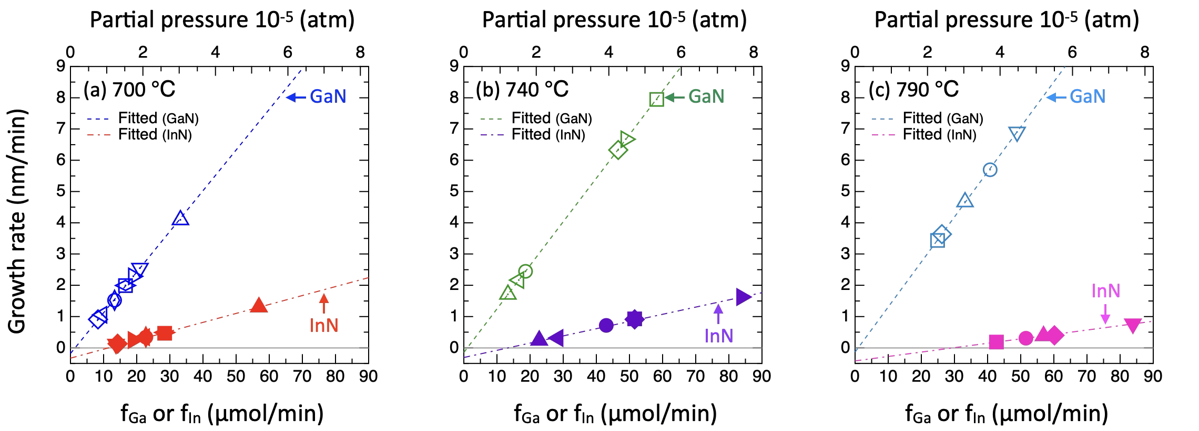

Figure 5. Growth rates of GaN and InN in GaN/In_{x}Ga_{1−x}N SLs as functions of f_{Ga} and f_{In} at (a) 700, (b) 740, and (c) 790 °C. Open symbols represent GaN, while filled symbols represent InN. The top axis of the graphs shows the partial pressure of supply-gas source material. Dashed lines indicate linear fittings based on Eq. (1). Each rate increases linearly with its own group-III flow and extrapolates to a nonzero intercept, associated with desorption.

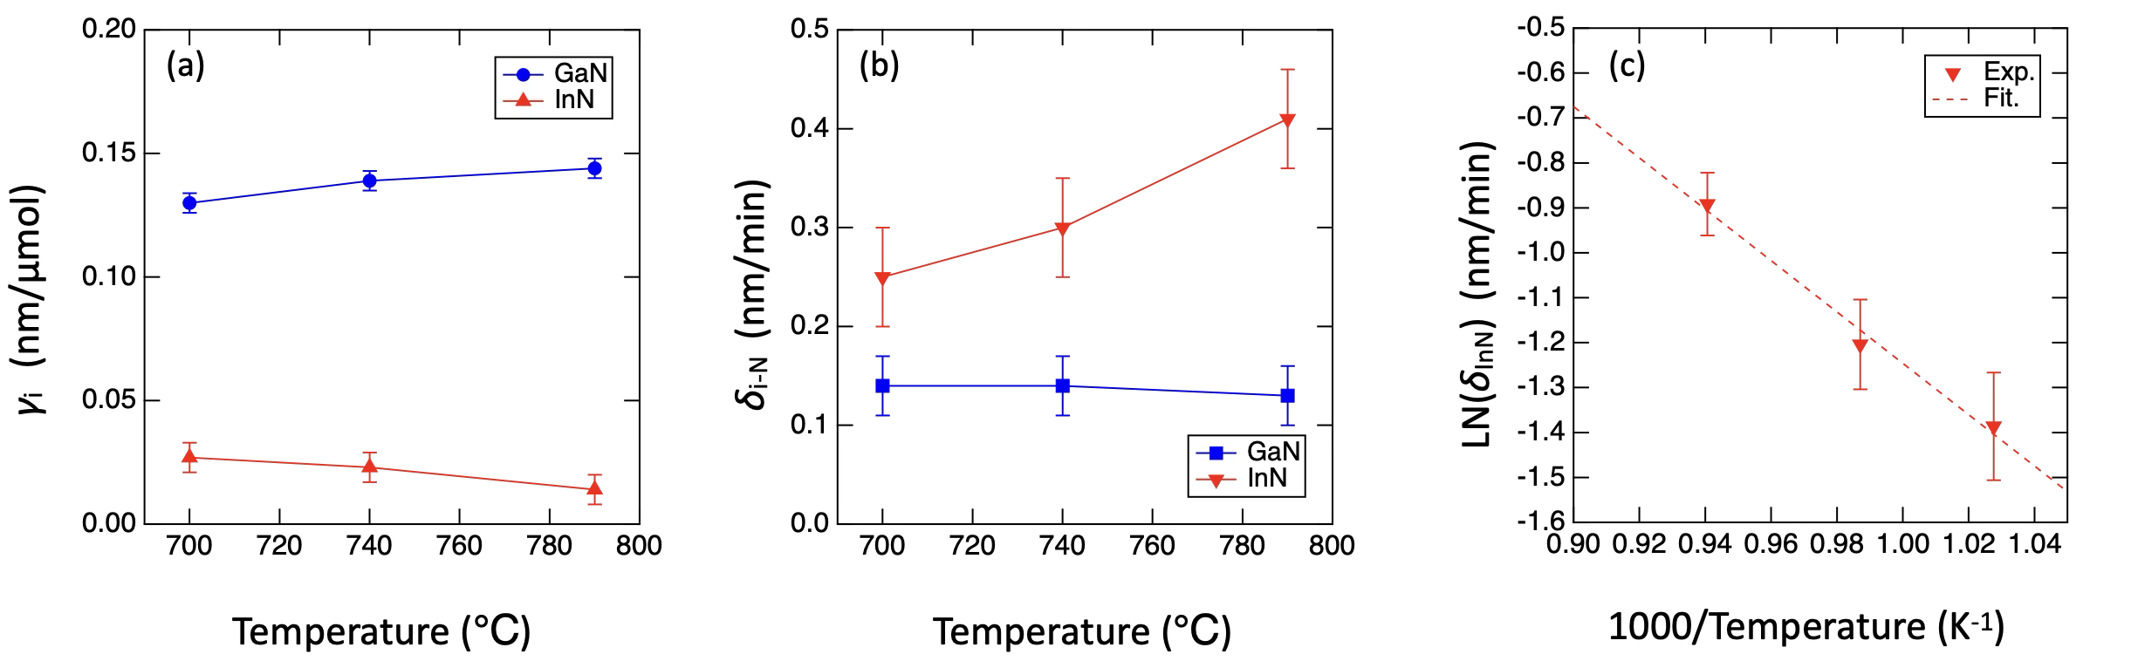

Figure 6. (a) Incorporation efficiency (γ_{Ga}, γ_{In}) and (b) desorption rate (δ_{GaN}, δ_{InN}) as functions of growth temperature. (c) Arrhenius plot of the InN desorption rate, yielding an activation energy of ≈0.49 eV.

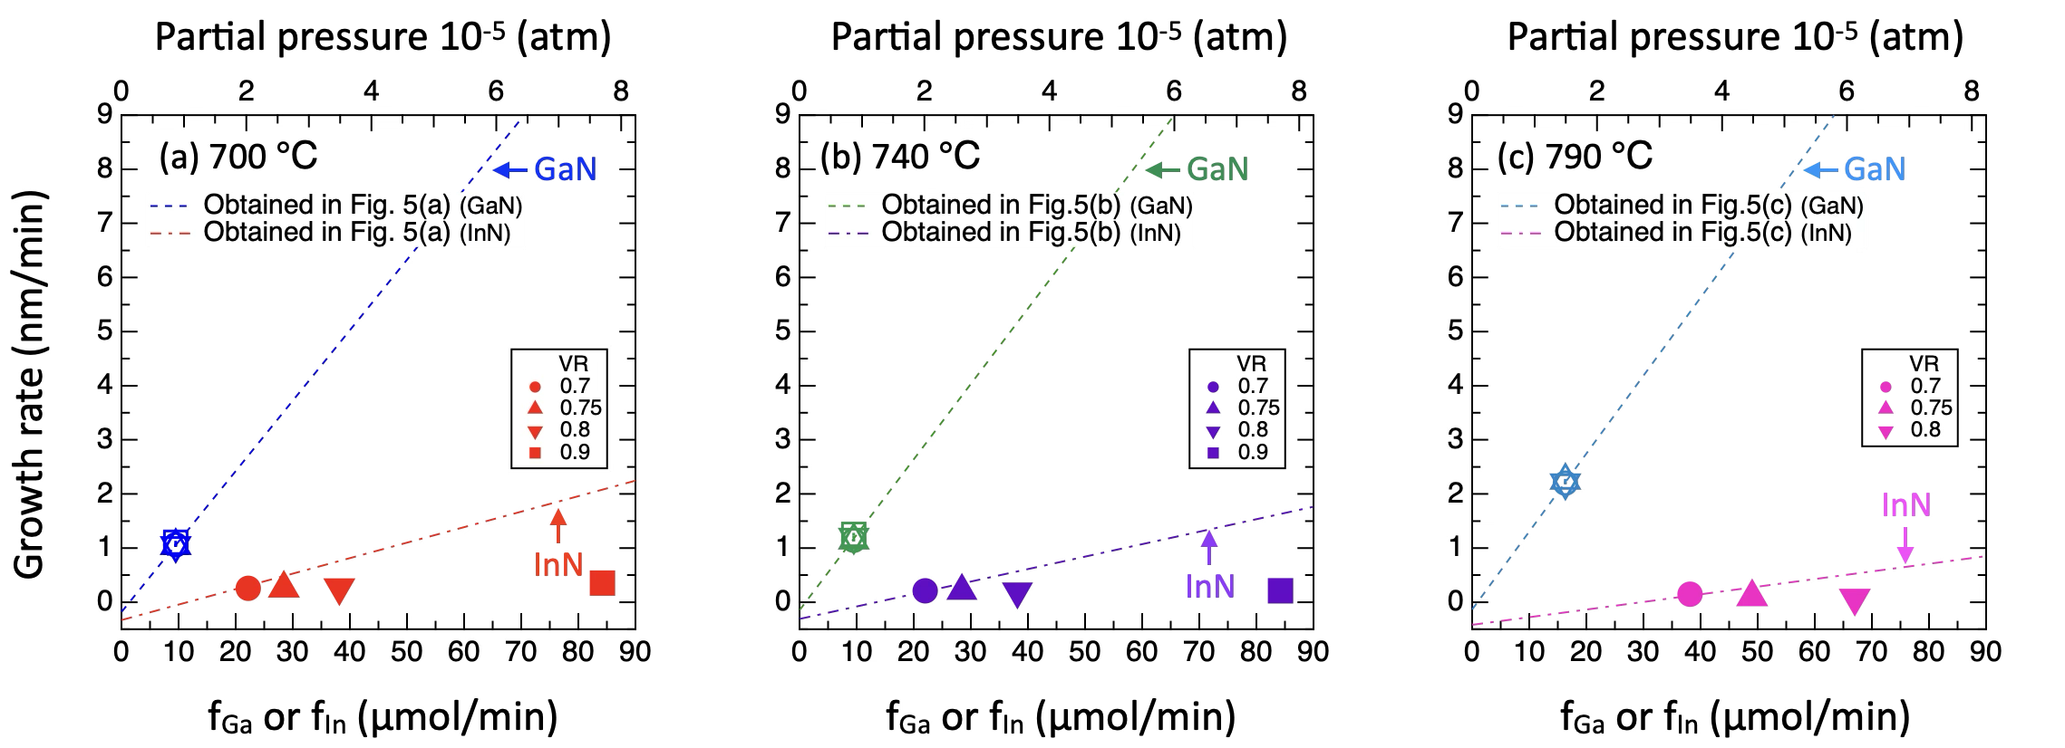

Figure 7. Growth rates of GaN and InN in GaN/In_{x}Ga_{1−x}N SLs as a function of f_{In} at fixed f_{Ga}: (a) 700 °C, (b) 740 °C, and (c) 790 °C. Open symbols denote GaN, while filled symbols denote InN. Solid lines correspond to the fits obtained in Fig. 5. At high vapor-phase ratios (VR ≥ 0.7), γ_{In} drops markedly, indicating breakdown of the model. The top axis shows the partial pressure of the supplied group-III source gases.

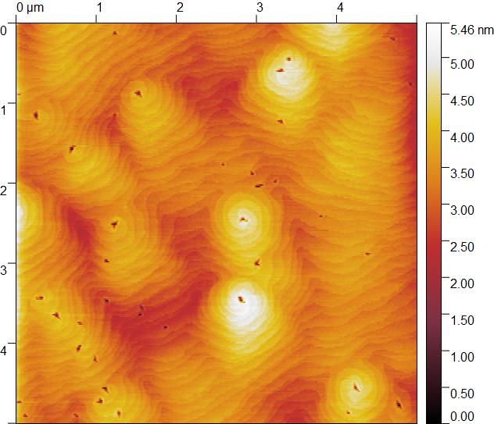

Figure 8. AFM image of GaN/In_{x}Ga_{1−x}N SLs grown under high vapor-phase ratios (VR ≥ 0.7), showing coalescence of pits and transition to three-dimensional island-like growth. Step–terrace morphology is replaced by irregular depressions and island-like features, attributed to transient In condensation and partial evaporation.

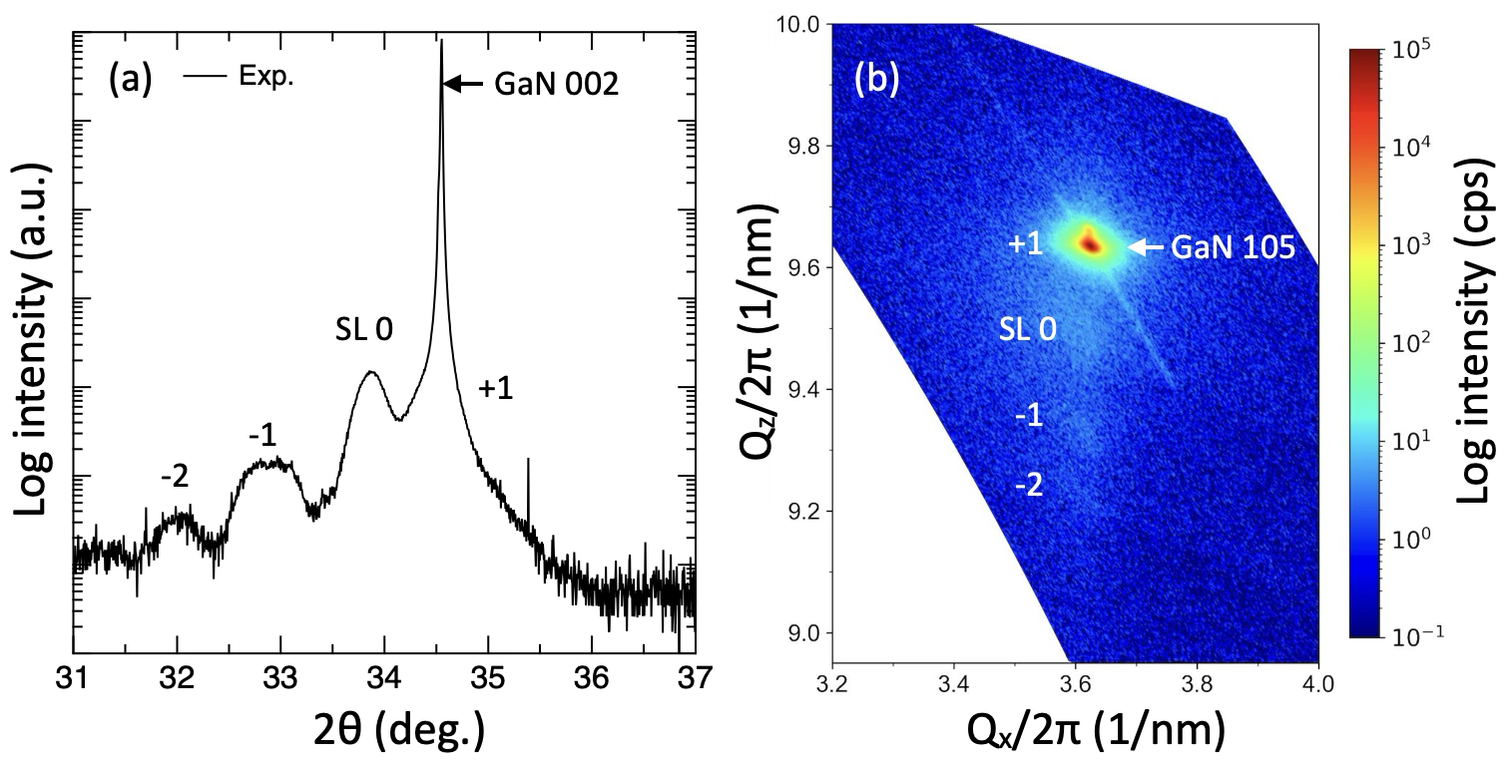
Figure 9. Structural characterization of a representative GaN/In_{x}Ga_{1-x}N SL grown at 600 °C with V/III = 3000–11000 and VR < 0.7. (a) Symmetric 2θ–ω scan profiles around the GaN 002 reflection. (b) RSM around the GaN 105 reflection. Fringes are blurred, indicating composition fluctuation, while the RSM shows relaxation.

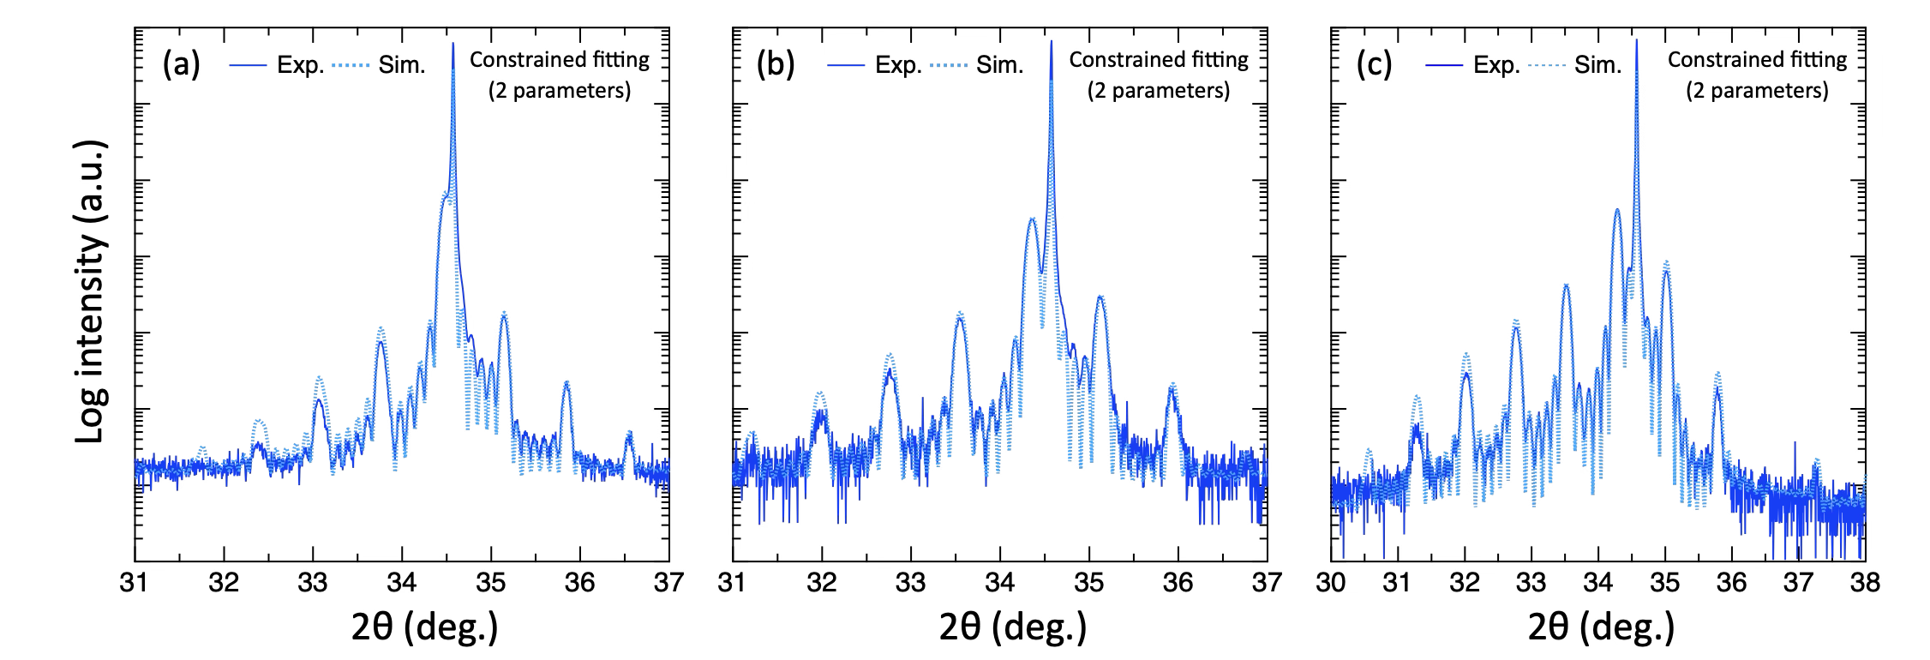

Figure 10. Representative symmetric 2θ–ω scan profiles of GaN/In_{x}Ga_{1−x}N SLs together with dynamical diffraction simulation results obtained using the constrained two-parameter fitting scheme. Panels (a)–(c) correspond to samples with different In compositions. Experimental data are shown as solid lines, and simulated curves are shown as dotted lines. The simulations reproduce the experimental profiles well over a wide angular range, including higher-order satellite peaks and interference fringes, demonstrating the validity and robustness of the constrained fitting approach. The fitted structural parameters obtained from these profiles are summarized in Table III.

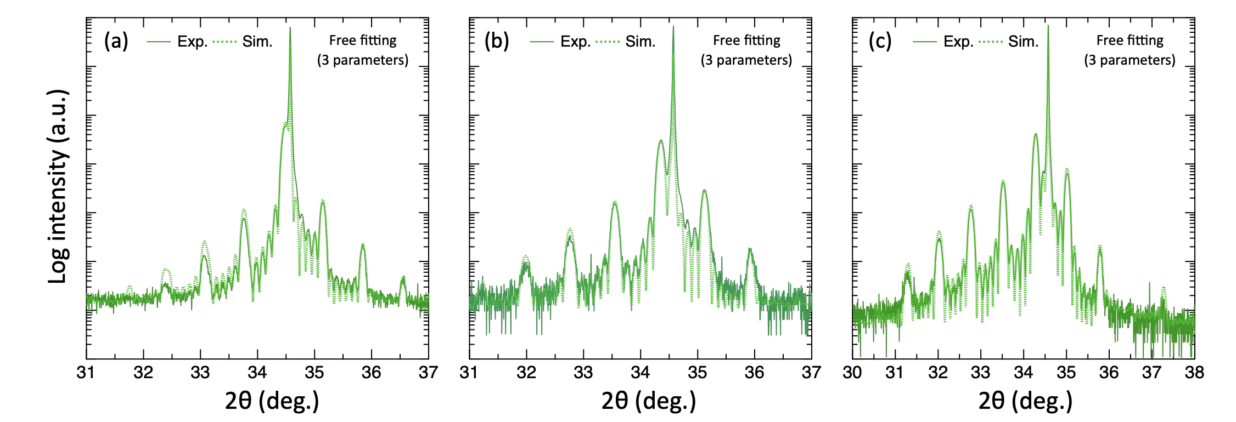

Figure 11. Representative symmetric 2θ–ω scan profiles of GaN/In_{x}Ga_{1−x}N SLs together with dynamical diffraction simulation results obtained using the unconstrained three-parameter fitting scheme. Panels (a)–(c) correspond to the same samples as in Fig. 10. Experimental data are shown as solid lines, and simulated curves are shown as dotted lines. The overall agreement with the experimental profiles is comparable to that obtained with the constrained fitting, indicating consistency between the two approaches within the experimental uncertainty. The fitted structural parameters obtained from these profiles are summarized in Table IV.

Table I. Summary of MOVPE growth conditions and XRD fitting results for GaN/In_{x}Ga_{1-x}N SLs. The sample names (A–D) in this table correspond to those presented in Chapters A–D of Section III (Results).
*Units of time, f_{i}, and thickness are sec, μmol/min, and nm, respectively.
During In_{x}Ga_{1-x}N growth, the same f_{Ga} and f_{N} values as in GaN growth were used.
f_{i} (i = Ga, In, N): molar flow rate; V/III: V/III ratio; VR: In vapor-phase ratio; x_{In}: In composition; t_{GaN (or InN)}: thickness of GaN (or InN) in the alloy.
Sample | T_{g} | Growth conditions |  |  |  |  |  |  |  | XRD fitting results
Sample | T_{g} | GaN |  |  |  | In_{x}Ga_{1-x}N |  |  |  | GaN | In_{x}Ga_{1-x}N
Sample | T_{g} | Time | f_{Ga} | f_{N} (×10⁻³) | V/III | Time | f_{In} | V/III | VR | Thickness | Thickness | x_{In} | t_{GaN} | t_{InN}
A | 700 | 139 | 33 | 357 | ~10800 | 30 | 61 | ~4000 | 0.65 | 9.57 | 2.72 | 0.241 | 2.06 | 0.66
B1 | 700 | 30 | 35 | 357 | ~10800 | 30 | 57 | ~4000 | 0.63 | 2.15 | 2.81 | 0.237 | 2.14 | 0.67
B2 | 700 | 60 | 35 | 357 | ~10800 | 30 | 57 | ~4000 | 0.63 | 4.28 | 2.82 | 0.241 | 2.14 | 0.68
C1.1 | 700 | 139 | 33 | 357 | ~10800 | 30 | 57 | ~4000 | 0.63 | 9.48 | 2.70 | 0.242 | 2.05 | 0.65
C1.2 | 700 | 247 | 21 | 357 | ~17000 | 54 | 14 | ~10000 | 0.40 | 10.51 | 2.38 | 0.045 | 2.27 | 0.11
C1.3 | 700 | 284 | 19 | 357 | ~19000 | 60 | 19 | ~9000 | 0.50 | 10.82 | 2.56 | 0.098 | 2.31 | 0.25
C1.4 | 700 | 277 | 17 | 357 | ~22000 | 60 | 28 | ~8000 | 0.63 | 9.19 | 2.46 | 0.190 | 1.99 | 0.47
C1.5 | 700 | 277 | 17 | 179 | ~11000 | 60 | 28 | ~4000 | 0.63 | 9.19 | 2.46 | 0.190 | 1.99 | 0.47
C1.6 | 700 | 332 | 13 | 286 | ~22000 | 72 | 23 | ~8000 | 0.63 | 8.43 | 2.24 | 0.183 | 1.83 | 0.41
C1.7 | 700 | 332 | 13 | 143 | ~11000 | 72 | 23 | ~4000 | 0.63 | 8.43 | 2.24 | 0.183 | 1.83 | 0.41
C1.8 | 700 | 395 | 9 | 357 | ~38000 | 99 | 22 | ~11000 | 0.70 | 6.98 | 2.30 | 0.243 | 1.74 | 0.56
C1.9 | 700 | 554 | 8 | 179 | ~22000 | 120 | 14 | ~8000 | 0.63 | 8.41 | 2.09 | 0.129 | 1.82 | 0.27
C2.1 | 740 | 53 | 58 | 357 | ~6000 | 15 | 52 | ~3000 | 0.47 | 7.00 | 2.24 | 0.103 | 2.01 | 0.23
C2.2 | 740 | 94 | 49 | 357 | ~7000 | 20 | 84 | ~3000 | 0.63 | 10.45 | 2.77 | 0.196 | 2.22 | 0.54
C2.3 | 740 | 86 | 47 | 357 | ~8000 | 19 | 52 | ~4000 | 0.53 | 9.09 | 2.25 | 0.126 | 1.97 | 0.28
C2.4 | 740 | 238 | 19 | 357 | ~19000 | 51 | 43 | ~6000 | 0.70 | 9.72 | 2.72 | 0.227 | 2.10 | 0.62
C2.5 | 740 | 277 | 17 | 357 | ~22000 | 60 | 28 | ~8000 | 0.63 | 10.00 | 2.48 | 0.128 | 2.17 | 0.32
C2.6 | 740 | 332 | 13 | 286 | ~22000 | 72 | 23 | ~8000 | 0.63 | 9.46 | 2.34 | 0.124 | 2.05 | 0.29
C3.1 | 790 | 94 | 49 | 357 | ~7000 | 20 | 84 | ~3000 | 0.63 | 10.82 | 2.56 | 0.100 | 2.30 | 0.26
C3.2 | 790 | 112 | 41 | 357 | ~9000 | 24 | 52 | ~4000 | 0.56 | 10.60 | 2.42 | 0.052 | 2.29 | 0.12
C3.3 | 790 | 139 | 33 | 357 | ~11000 | 30 | 57 | ~4000 | 0.63 | 10.82 | 2.53 | 0.076 | 2.33 | 0.19
C3.4 | 790 | 162 | 26 | 357 | ~14000 | 35 | 60 | ~4000 | 0.70 | 9.81 | 2.37 | 0.099 | 2.13 | 0.23
C3.5 | 790 | 185 | 25 | 357 | ~14000 | 40 | 43 | ~5000 | 0.63 | 10.60 | 2.42 | 0.052 | 2.29 | 0.13
D1.1 | 700 | 426 | 9 | 357 | ~37700 | 122 | 22 | ~11000 | 0.70 | 7.54 | 2.68 | 0.197 | 2.16 | 0.53
D1.2 | 700 | 434 | 9 | 357 | ~37700 | 125 | 28 | ~9000 | 0.75 | 7.56 | 2.71 | 0.197 | 2.18 | 0.53
D1.3 | 700 | 435 | 9 | 357 | ~37700 | 126 | 38 | ~7000 | 0.80 | 7.58 | 2.74 | 0.206 | 2.18 | 0.57
D1.4 | 700 | 452 | 9 | 357 | ~37700 | 134 | 84 | ~4000 | 0.90 | 7.88 | 2.95 | 0.242 | 2.24 | 0.71
D2.1 | 740 | 426 | 9 | 357 | ~37700 | 121 | 22 | ~11000 | 0.70 | 8.13 | 2.73 | 0.155 | 2.31 | 0.42
D2.2 | 740 | 434 | 9 | 357 | ~37700 | 124 | 28 | ~9000 | 0.75 | 8.30 | 2.81 | 0.155 | 2.37 | 0.43
D2.3 | 740 | 435 | 9 | 357 | ~37700 | 126 | 38 | ~7000 | 0.80 | 8.75 | 2.95 | 0.142 | 2.53 | 0.42
D2.4 | 740 | 452 | 9 | 357 | ~37700 | 120 | 84 | ~4000 | 0.90 | 9.47 | 2.93 | 0.143 | 2.51 | 0.42
D3.1 | 790 | 270 | 16 | 357 | ~22000 | 60 | 38 | ~7000 | 0.70 | 9.90 | 2.35 | 0.064 | 2.20 | 0.15
D3.2 | 790 | 270 | 16 | 357 | ~22000 | 60 | 49 | ~5000 | 0.75 | 9.95 | 2.31 | 0.043 | 2.21 | 0.10
D3.3 | 790 | 270 | 16 | 357 | ~22000 | 60 | 67 | ~4000 | 0.80 | 10.13 | 2.34 | 0.038 | 2.25 | 0.09

Table II. Summary of XRD fitting results for GaN/In_{x}Ga_{1-x}N SLs. The GaN and InN growth rates inside the alloy were extracted through a three-step fitting procedure (see footnotes). Thickness errors correspond to ≈1% in growth rate.

*GR: growth rate (nm/min)
Step | Sample | GR_{GaN} | GR_{InGaN} | x_{In} | GR_{GaN in alloy} | GR_{InN in alloy} | Period thickness/time
1 | B1 | b - a = 4.30 |  |  |  |  | 9.98
1 | B2 | b - a = 4.30 |  |  |  |  | 14.28
2 | B1 | 4.30 (fixed) | 5.74 | 0.240 | 4.36 | 1.41 | 10.04
2 | B2 | 4.30 (fixed) | 5.74 | 0.246 | 4.32 | 1.42 | 14.34
3 | B1 | 4.29 (identical) | 5.62 | 0.237 | 4.29 (identical) | 1.34 | 9.91
3 | B2 | 4.28 (identical) | 5.64 | 0.241 | 4.28 (identical) | 1.36 | 14.21

Footnotes
Step (1): The GaN growth rate was determined from the satellite peak spacing.
Step (2): With this GaN rate fixed, the alloy growth rate and x_{In} were obtained by dynamical fitting.
Step (3): Assuming that the GaN growth rate inside the alloy is identical to that of pure GaN, the alloy growth rate was then used to extract the individual GaN and InN growth rates.

Table III. Structural parameters and growth rates of GaN/In_{x}Ga_{1−x}N SLs extracted from the constrained two-parameter dynamical diffraction fitting shown in Fig. 10. The total In_{x}Ga_{1−x}N well thickness and x_{In} were treated as independent fitting parameters, while the effective GaN and InN contributions were derived based on the alloy model. Further details are provided in Table I.

*Units of time (T), thickness (t), and growth rate (GR) are sec, nm, nm/min, respectively.
 | Growth time |  | XRD fitting results |  |  |  |  | Estimating GR
Sample | T_{GaN} | T_{InGaN} | t_{GaN} | t_{InGaN} | x_{In} | t_{GaN in alloy} | t_{InN in alloy} | GR_{GaN} | GR_{GaN in alloy}
C3.1 | 94 | 20 | 10.82 | 2.56 | 0.100 | 2.3 | 0.26 | 6.91 | 6.91
C1.4 | 277 | 60 | 9.19 | 2.46 | 0.190 | 1.99 | 0.47 | 1.99 | 1.99
A | 139 | 30 | 9.57 | 2.72 | 0.242 | 2.06 | 0.66 | 4.13 | 4.13

Table IV. Structural parameters and growth rates of GaN/In_{x}Ga_{1−x}N SLs obtained from the unconstrained three-parameter dynamical diffraction fitting shown in Fig. 11. The GaN barrier thickness, In_{x}Ga_{1−x}N well thickness, and x_{In} were treated as independent fitting parameters. The listed values correspond to the same samples as in Fig. 10 and are provided for comparison with the constrained fitting results.

*Units of time (T), thickness (t), and growth rate (GR) are sec, nm, nm/min, respectively.
 | Growth time |  | XRD fitting results |  |  |  |  | Estimating GR
Sample | T_{GaN} | T_{InGaN} | t_{GaN} | t_{InGaN} | x_{In} | t_{GaN in alloy} | t_{InN in alloy} | GR_{GaN} | GR_{GaN in alloy}
C3.1 | 94 | 20 | 10.78 | 2.60 | 0.099 | 2.34 | 0.26 | 6.88 | 7.03
C1.4 | 277 | 60 | 9.02 | 2.68 | 0.180 | 2.20 | 0.48 | 1.95 | 2.20
A | 139 | 30 | 9.29 | 3.00 | 0.221 | 2.34 | 0.66 | 4.01 | 4.67

References
1) I. Vurgaftman and J. R. Meyer, J. Appl. Phys. 94, 3675 (2003).
2) S. Nakamura, T. Mukai, and M. Senoh, Jpn. J. Appl. Phys. Pt. 2 30, L1998 (1991).
3) S. Nakamura, M. Senoh, S. Nagahama, N. Iwasa, T. Yamada, T. Matsushita, Y. Sugimoto, and H. Kiyoku, Appl. Phys. Lett. 69, 4056 (1996).
4) G. Chen, X. Q. Wang, X. Rong, P. Wang, F. J. Xu, N. Tang, Z. X. Qin, Y. H. Chen, and B. Shen, Sci. Rep. 5, 11485 (2015).
5) A. Y. Song, R. Bhat, A. A. Allerman, J. Wang, T. Y. Huang, C. E. Zah, and C. F. Gmachl, Appl. Phys. Lett. 107, 132104 (2015).
6) D. H. Mudiyanselage, D. W. Wang, Y. J. Zhao, and H. Q. Fu, J. Appl. Phys. 131, 210901 (2022).
7) S. Irvine and P. Capper, Metalorganic Vapor Phase Epitaxy (MOVPE): Growth, Materials Properties, and Applications (Wiley, 2019).
8) S. Nakamura, S. Pearton, and G. Fasol, The Blue Laser Diode: The Complete Story (Springer, Berlin, 2000).
9) F. K. Yam and Z. Hassan, Superlattice Microst 43, 1 (2008).
10) A. K. Tan, N. A. Hamzah, M. A. Ahmad, S. S. Ng, and Z. Hassan, Mat Sci Semicon Proc 143, 106545 (2022).
11) N. Yoshimoto, T. Matsuoka, T. Sasaki, and A. Katsui, Appl. Phys. Lett. 59, 2251 (1991).
12) T. Matsuoka, J. Cryst. Growth 124, 433 (1992).
13) I. H. Ho and G. B. Stringfellow, Appl. Phys. Lett. 69, 2701 (1996).
14) J. Adhikari and D. A. Kofke, J. Appl. Phys. 95, 6129 (2004).
15) B. P. Burton, A. van de Walle, and U. Kattner, J. Appl. Phys. 100, 113528 (2006).
16) B. N. Pantha, J. Li, J. Y. Lin, and H. X. Jiang, Appl. Phys. Lett. 93, 182107 (2008).
17) G. T. Thaler, D. D. Koleske, S. R. Lee, K. H. A. Bogart, and M. H. Crawford, J. Cryst. Growth 312, 1817 (2010).
18) S. Keller, B. P. Keller, D. Kapolnek, A. C. Abare, H. Masui, L. A. Coldren, U. K. Mishra, and S. P. DenBaars, Appl. Phys. Lett. 68, 3147 (1996).
19) N. Duxbury, U. Bangert, P. Dawson, E. J. Thrush, W. Van der Stricht, K. Jacobs, and I. Moerman, Appl. Phys. Lett. 76, 1600 (2000).
20) G. Durkaya, M. Buegler, R. Atalay, I. Senevirathna, M. Alevli, O. Hitzemann, M. Kaiser, R. Kirste, A. Hoffmann, and N. Dietz, Physica Status Solidi a-Applications and Materials Science 207, 1379 (2010).
21) Y. S. Chen, C. H. Liao, C. T. Kuo, R. Tsiang, and H. C. Wang, Nanoscale Research Letters 9, 334 (2014).
22) A. Koukitu, N. Takahashi, T. Taki, and H. Seki, Jpn. J. Appl. Phys. 35, L673 (1996).
23) K. Onabe, Jpn. J. Appl. Phys. 58, SC1038 (2019).
24) K. Ohkawa, F. Ichinohe, T. Watanabe, K. Nakamura, and D. Iida, J. Cryst. Growth 512, 69 (2019).
25) S. F. Fu, C. H. Cheng, F. W. Lee, S. Y. Chen, B. W. Liao, W. C. Chou, W. K. Chen, and W. C. Ke, ECS J. Solid State Sci. Technol. 5, P335 (2016).
26) N. Hu, G. Avit, M. Pristovsek, Y. Honda, and H. Amano, Appl. Phys. Lett. 121, 082106 (2022).
27) X. Guo, H. Wang, D. S. Jiang, Y. T. Wang, D. G. Zhao, J. J. Zhu, Z. S. Liu, S. M. Zhang, and H. Yang, Chinese Physics B 19, 106802 (2010).
28) D. J. Kim, Y. T. Moon, K. M. Song, I. W. Lee, and S. J. Park, J Electron Mater 30, 99 (2001).
29) R. A. Oliver, M. J. Kappers, C. J. Humphreys, and G. A. D. Briggs, J. Cryst. Growth 272, 393 (2004).
30) D. Iida, K. Nagata, T. Makino, M. Iwaya, S. Kamiyama, H. Amano, I. Akasaki, A. Bandoh, and T. Udagawa, Appl. Phys. Express 3, 075601 (2010).
31) Y. T. Zhang, Y. H. Liu, T. Kimura, M. Hirata, K. Prasertusk, S. Y. Ji, R. Katayama, and T. Matsuoka, Physica Status Solidi C: Current Topics in Solid State Physics, Vol 8, No 2 8, 482 (2011).
32) S. Keller, B. P. Keller, D. Kapolnek, U. K. Mishra, S. P. DenBaars, I. K. Shmagin, R. M. Kolbas, and S. Krishnankutty, J. Cryst. Growth 170, 349 (1997).
33) R. A. Oliver, M. J. Kappers, C. J. Humphreys, and G. A. D. Briggs, J. Appl. Phys. 97, 013707 (2005).
34) R. Hashimoto, J. Hwang, S. Saito, and S. Nunoue, Phys. Status Solidi C 10, 1529 (2013).
35) M. A. Moram and M. E. Vickers, Rep. Prog. Phys. 72, 036502 (2009).
36) S. Nakamura, Jpn. J. Appl. Phys. Pt. 2 30, L1705 (1991).
37) F. Kaess, S. Mita, J. Q. Xie, P. Reddy, A. Klump, L. H. Hernandez-Balderrama, S. Washiyama, A. Franke, R. Kirste, A. Hoffmann, R. Collazo, and Z. Sitar, J. Appl. Phys. 120, 105701 (2016).
38) A. Ishibashi, H. Takeishi, M. Mannoh, Y. Yabuuchi, and Y. Ban, J Electron Mater 25, 799 (1996).
39) W. J. Bartels, J. Hornstra, and D. J. W. Lobeek, Acta Crystallogr A 42, 539 (1986).
40) A. Ulyanenkov and S. Sobolewski, J Phys D Appl Phys 38, A235 (2005).

