Data-Driven Development of Magnetic Materials
A. Bolyachkin, H. Sepehri-Amin, T. Ohkubo
National Institute for Materials Science, Tsukuba, 305-0047, Japan

Abstract
The concept of material informatics is becoming more advanced and prospective in research on magnetic materials. This can be evidenced by several successful recent studies utilizing different tools of machine learning and demonstrating new opportunities in the field of permanent magnets, magnetocaloric materials, and magnetic recording in hard disk drives. This trend is also promoted by the intensive accumulation of scientific data, growth of computational performance and the progress with algorithms. This report presents our recent progress on implementing machine learning into two different studies: the development of rare-earth free Fe₂P-type magnetocaloric compounds for cryogenic applications, and high-throughput characterization of FePt granular media for heat-assisted magnetic recording.

- Introduction
Data science and machine learning (ML) have been intensively implemented into research on magnetic materials nowadays⁽¹⁾. They can efficiently address a wide range of tasks: summarizing available empirical results via data mining^{(2),(3)}, advanced image processing^{(4),(5)}, high-throughput optimization⁽⁶⁾, variety of classification and regression problems^{(7),(8)}, etc. Usually, data-driven study of a material starts with formulating descriptors for its samples (feature vectors) as well as targets for predictions. Then a dataset of samples is collected, a ML model is selected, optimized and trained on the dataset. In addition, the obtained predictive model can be combined with an optimization routine, e.g., Bayesian optimization⁽⁹⁾, to form an active learning loop. A statistically robust dataset is the key component in this research pipeline, that is why ML is especially beneficial in long-standing issues for which extensive data have been accumulated already or can be simulated, e.g., with DFT, atomistic, micromagnetic approaches or others. Some examples of recent data-driven development of magnetic materials are: the discovery of giant magnetocaloric effect in HoB₂⁽¹⁰⁾, the improvement of hysteretic properties in hot-extruded Nd-Fe-B magnets⁽⁹⁾, realizing coercivity in the SmFe₁₂-based compounds⁽¹¹⁾, etc. Below two other studies are given as representative cases for the data-driven strategy of developing magnetic materials. The first is the development of rare-earth free Fe₂P-type magnetocaloric compounds for cryogenic applications assisted by ML on the experimental dataset⁽³⁾. The second one demonstrates fast magnetometry-based characterization of FePt granular media realized with ML on the synthetic dataset of TEM image based micromagnetic simulations^{(7),(12)}.

- ML-assisted development of Fe₂P-type magnetocaloric compounds
Magnetic refrigeration is a promising environment-friendly technology with a potentially higher efficiency than those of conventional gas compression systems⁽¹³⁾. However, its industrial realization for room temperature applications is hindered by either modest performance of existing magnetocaloric materials or high content of costly rare earth elements in their compositions. Magnetic refrigeration could be more prospective in the cryogenic temperature range, e.g., for the liquefaction of H₂ or natural gases, medical transportation, etc. A candidate material for cryogenic magnetic refrigeration should pass through multi-objective optimization aiming at tuning transition temperature, increasing magnetocaloric effect (MCE) and the reduction of thermal hysteresis – such a task can be addressed with ML. Here we revisited Fe₂P-based magnetocaloric compounds to explore their potential for cryogenic applications⁽³⁾.
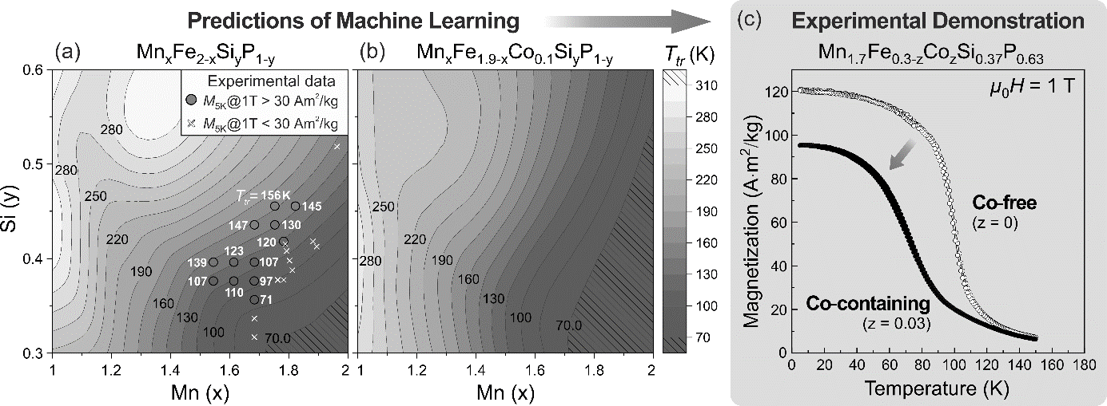
A dataset containing 560 samples of Fe₂P-based compounds was collected from articles available in Scopus, and composition-based features were used to evaluate the phase transition temperature (T_{tr}). It was shown that metallic elements such as Mn, Fe, and Co have the highest importance to tune T_{tr} along with nonmetallic P, Si, and Ge. Hence, within the compositional space of Mn_{x}Fe_{2-x}P_{y}Si_{1-y}, an artificial neural network was employed to predict the T_{tr} with an appropriate mean absolute error of 20 K (Fig. 1a). Guided by the neural network, we synthesized 43 additional samples to enrich the dataset in the cryogenic region and improve the accuracy of predictions. New experimental data and corresponding T_{tr} are shown in Fig. 1a with dots – obtained transition temperatures agreed well with the predicted ones. Note that one of the challenges for the Fe₂P-type system while reducing T_{tr} by Si decrease or Mn increase is the formation of antiferromagnetic ordering instead of the ferromagnetic one (crosses in Fig. 1a) that results in dropping magnetization and MCE consequently. ML revealed that substitution of Fe with Co can expand the region exhibiting cryogenic MCEs (Fig. 1b) so that the substantial magnetization reduction can be avoided. In experiments following by the ML insights, transition temperatures of Mn_{1.7}Fe_{0.3-x}Co_{x}P_{1-y}Si_{y} compounds were successfully reduced to a new temperature range of 73–97 K (Fig. 1c). In particular, the Curie temperature for the Mn_{1.7}Fe_{0.27}Co_{0.03}P_{0.63}Si_{0.37} compound is 60 K which is the lowest T_{c} yet reported for (Mn,Fe)₂(P,Si) compounds. Magnetic entropy changes (ΔS_{M}) of 11.5 and 7.5 J/kgK at 5 T were obtained for the rare-earth-free Mn_{1.7}Fe_{0.3}P_{0.63}Si_{0.37} and Mn_{1.7}Fe_{0.27}Co_{0.03}P_{0.63}Si_{0.37} compounds. Ascribed to a low thermal hysteresis of 1.2 K, a large reversible adiabatic temperature change (ΔT_{ad}) of 1.8 K was obtained for the Mn_{1.7}Fe_{0.3}P_{0.63}Si_{0.37} compound. However, further increase of both ΔS_{M} and ΔT_{ad} of Fe₂P-based compounds by alloy design and hysteresis engineering are still needed. These results revealed new potential of the rare-earth-free Fe₂P-type magnetocaloric material for the cryogenic magnetic refrigeration.
Fig. 1 Colormaps of the transition temperatures T_{tr} for (a) Mn_{x}Fe_{2-x}P_{1-y}Si_{y} and Mn_{x}Fe_{1.9-x}Co_{0.1}P_{1-y}Si_{y} (b) compounds predicted by the artificial neural network. Several experimental points are illustrated using dots and crosses. (c) Temperature dependencies of magnetization for Co-free and Co-containing (z = 0.03) Mn_{1.7}Fe_{0.3-z}Co_{z}P_{0.63}Si_{0.37} samples under an applied magnetic field of 1 T.⁽³⁾

- Evaluation of nanodefects and magnetic anisotropy in FePt granular media
Hard disk drives with conventional perpendicular magnetic recording have already reached the limit of 1.1-1.4 Tb/in² for the areal density of data storage. To go beyond that, heat-assisted magnetic recording (HAMR) has been proposed which idea is to use local heating by laser in order to reduce substantially the switching field of high-anisotropy nanograins down to the level that is appropriate for writing a bit. The key media material for HAMR realization is L1₀-ordered FePt granular thin films. To reach the areal density of 4 Tb/in², that is the current industrial goal, an accurate nanostructure control of the media is required including grain size, nanodefects, and crystallographic texture. Recently, we developed a micromagnetic model of FePt-X films that was capable to replicate the actual microstructure including its features based on TEM images from top-view observations of the films and cross-sectional ones (Fig. 2a)⁽¹²⁾. Using the model, micromagnetic approximation of experimental hysteresis loops was carried out to estimate magnetic and microstructural parameters. The approximation was accurate, but it was time-consuming due to incorporated grid-search method. To overcome that, machine learning was applied to predict rapidly the following targets: the parameters of magnetic anisotropy and volume fractions of {111} twinned variants, grains with in-plane c-axis ([200] misorientation) and disordered grains (Fig. 2b). These defects are the most detrimental to the coercivity and switching field distribution, or the signal to noise ratio for magnetic recording.
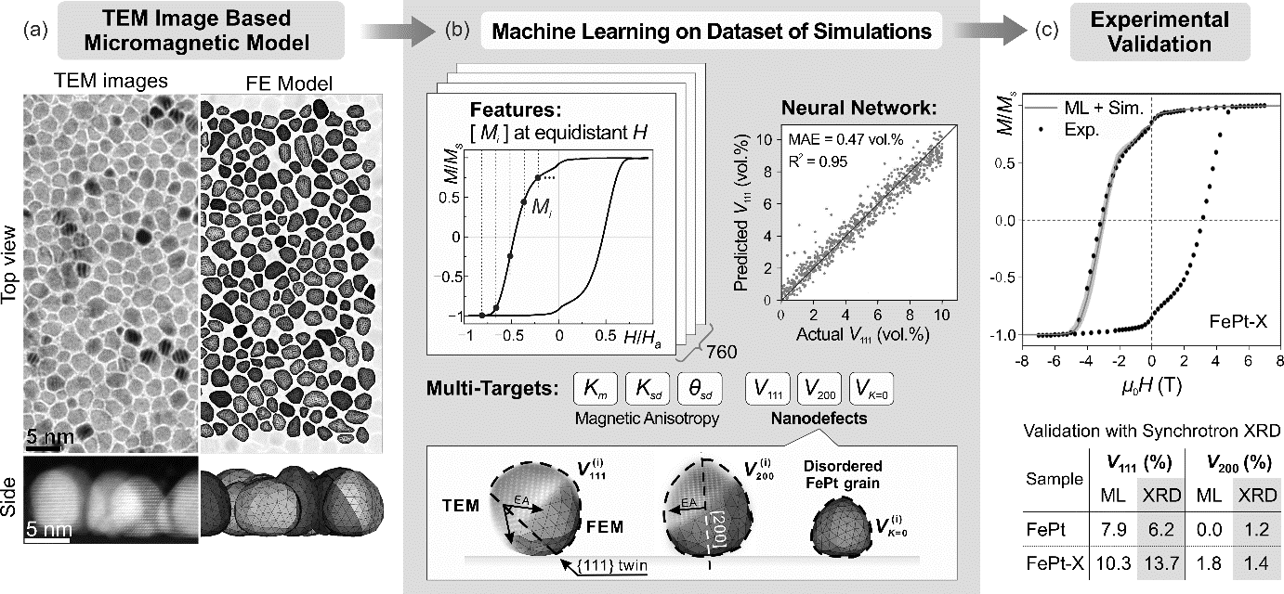
The dataset of simulated out-of-plane demagnetization curves M(H) was collected with the variation of magnetic and microstructural parameters using the TEM image-based micromagnetic model of FePt HAMR media. List of magnetizations [M_{i}] interpolated at fixed equidistant magnetic fields were considered as feature vectors describing each hysteresis loop. Independent neural networks were trained on the developed dataset. We achieved low mean absolute errors of predicting all the targets and performed experimental validation of the neural networks on the FePt-X nanogranular thin film. Predicted volume fractions V₁₁₁ and V₂₀₀ were in good agreement with those estimations by synchrotron XRD (Fig. 2c; bottom). Obtained list of parameters for the FePt-X film was used to simulate its demagnetization curve, which was in compliance with experimentally measured one (Fig. 2c; top). This study demonstrates the applicability of machine learning approach for evaluating the parameters in real FePt-X granular films through rapid ML-assisted magnetometry-based characterization. It can be implemented in nanostructural optimization of the FePt-X HAMR media towards industrial realization of improved areal density of data storage toward 4 Tb/in².
Fig. 2 (a) Finite element model of FePt granular media constructed based on TEM images. (b) Details of machine learning performed on the dataset of simulated out-of-plane hysteresis loops. Independent neural networks were trained to predict the following targets: mean magnetic anisotropy constant (K_{m}; predictive performance is shown), its standard deviation (K_{sd}), standard deviation of easy axis inclination angle (θ_{sd}), volume fractions of {111} variants (V₁₁₁), in-plane misoriented grains (V₂₀₀) and disordered ones (V_{K=0}). (c) Experimental hysteresis loop of the FePt-X film (black dots) and the simulated one with predicted parameters (red line) as well as the experimental validation of V₁₁₁ and V₂₀₀ by synchrotron XRD.^{(7),(12)}

- Conclusions
Data-driven approach offers wide opportunities in research on magnetic materials. Each of demonstrated studies can be remarkably extended by further integration with machine learning and the improvement of prepared datasets. For instance, TEM images are the main sources of microstructural data for FePt thin films – the images can be efficiently segmented by a deep learning model and processed with computer vision algorithms. It can substantially boost collecting sophisticated datasets consisting of microstructural features, details of sputtering, and magnetic properties. The last ones can be evaluated using the developed ML-assisted processing of hysteresis loops. Launching active learning on such datasets can approach the optimization of FePt HAMR media toward the desired areal density of 4 Tb/in². Active learning can benefit further multi-objective optimization of Fe₂P-type magnetocaloric compounds improving their magnetocaloric performance not only for the cryogenic temperature range but also for room temperatures.

- References
- G. Katsikas, C. Sarafidis, J. Kioseoglou, Phys. Status Solidi B 258, 2000600, (2021).
- J.C. Callum, J. Apoorv, M.C. Jacqueline, Chem. Mater. 33, 7217, (2021).
- J. Lai et al., Acta Mater. 232, 117942, (2022).
- A.K. Choudhary et al., Mater. Charact. 186, 111790, (2022).
- M. Gusenbauer et al., Npj Comput. Mater. 6, 89, (2020).
- D.N. Nguyen, H. Kino, T. Miyake, H.C. Dam, MRS Bull. 48, (2023).
- E. Dengina, A. Bolyachkin, H. Sepehri-Amin, K. Hono, Scripta Mater. 8, 114797, (2022).
- N. Kulesh et al., IEEE Trans. Magn. 58, 7100105, (2022).
- G. Lambard et al., Scripta Mater. 209, 114341, (2022).
- P.B. Castro et al., NPG Asia Mater. 12, 35, (2020).
- X. Tang et al., Scripta Mater., 200, 113925, (2021).
- A. Bolyachkin et al., Acta Mater. 227, 117744, (2022).
- V. Franco et al., Prog. Mater. Sci. 93, 112, (2018).

