Suppressing Formation of Zn-Mn-O Phases by In-Situ Ti Decoration of MnO₂ for Long Lifespan MnO₂-Zn Battery

Qiaohui Duanª, Yiyi Zhengª, Yu Zhouª, Shuyu Dongª, Calvin Kuª, Patrick H.-L. Sitª, Denis Y. W. Yu ^{b}*

ª School of Energy and Environment, City University of Hong Kong, 83 Tat Chee Avenue, Kowloon, Hong Kong S.A.R.
^{b} Research Center for Energy and Environmental Materials (GREEN), National Institute for Materials Science, Tsukuba, Ibaraki, Japan

* Corresponding author
Email: yu.denis@nims.go.jp
Address: Namiki 1-1, Tsukuba, Ibaraki-ken, Japan 305-0044

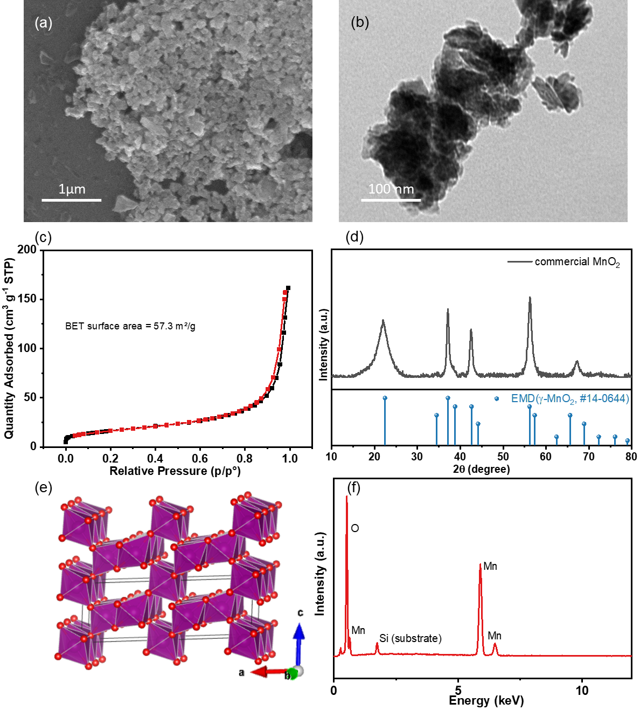Figure S1. The ball-milled commercial EMD nano particles used as active material: (a) SEM image, (b) TEM image, (c) BET surface area, (d) XRD pattern, (e) crystal structure, (f) SEM EDX spectrum.

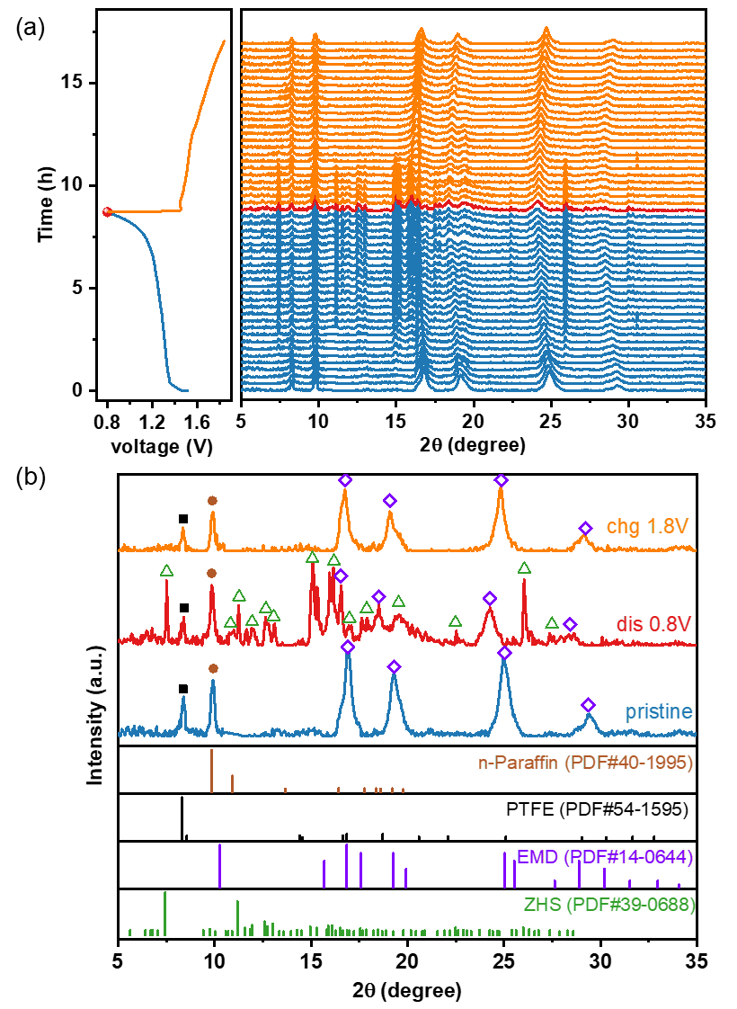
Figure S2. (a) In-situ XRD profiles and (b) selected XRD patterns of EMD in Figure 1a.

Note S1.
The average mass loading of EMD is 1.5 mg cm⁻², and the electrode disc with 16 mm diameter has an area of 2 cm⁻². Since the molecular weight of MnO₂ is 87 g mol⁻¹, the total number of moles of Mn in the cathode is:
$$1.5 mg {cm}^{-2}×2 {cm}^{2}÷87 g {mol}^{-1}=0.0345 mmol$$
The increased amount of dissolved Mn²⁺ in the 0.2 ml electrolyte after 1st discharge is:
$$30 mM×0.2 ml=0.006 mmol$$
The percentage of Mn dissolved from the EMD active material after 1st discharge = 0.006/0.0345 = 17.4%.
Since Mn dissolution is a 2e⁻ transfer reaction with a total capacity of 616 mAh g⁻¹, therefore, the contributed capacity from Mn dissolution is
$$616 mAh{ g}^{-1}×17.4\%=107.2 mAh{ g}^{-1}$$
As the total 1st discharge capacity is 250 mAh g⁻¹, about 107.2 mAh g⁻¹/250 mAh g⁻¹ = 42.8% of the initial discharge capacity is contributed by Mn dissolution.

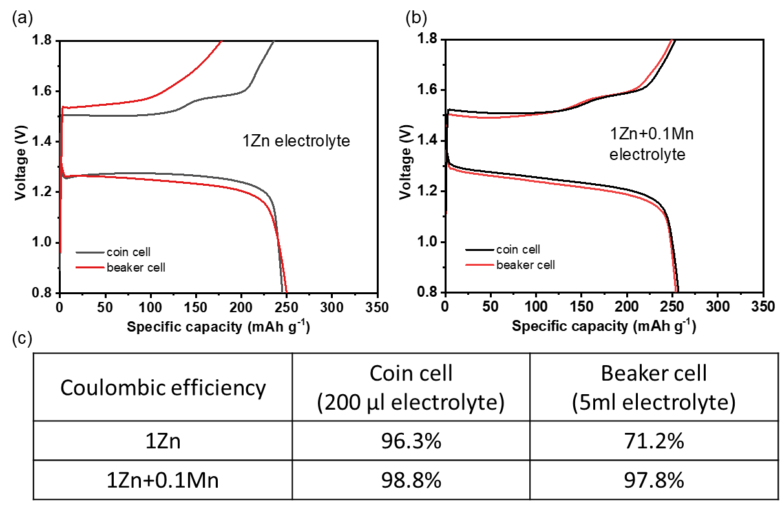
Figure S3. The 1st cycle voltage profiles of the coin cell (electrolyte amount: 200 μl) and beaker cell (electrolyte amount: 5 ml) using (a) 1M ZnSO₄ electrolyte and (b) 1M ZnSO₄ + 0.1M MnSO₄ electrolyte; (c) their Coulombic efficiency comparison.

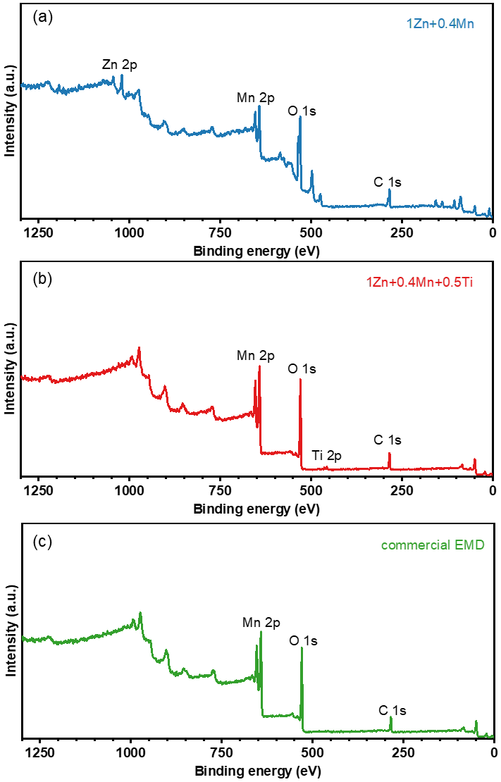
Figure S4. XPS full spectra of EMD electrodeposited in (a) 1Zn+0.4Mn electrolyte, (b) 1Zn+0.4Mn+0.5Ti electrolyte, and (c) commercial EMD.

Table S1. Atomic percentage of each element in the electrodeposited EMD on CNT electrode after charging in different electrolytes.
Element | Atomic % (deposited in 1Zn+0.4Mn electrolyte) | Atomic % (deposited in 1Zn+0.4Mn+0.5Ti electrolyte)
O | 73 | 65
Mn | 22 | 32
Zn | 5 | <1
Ti | <1 | 3
S | <1 | <1

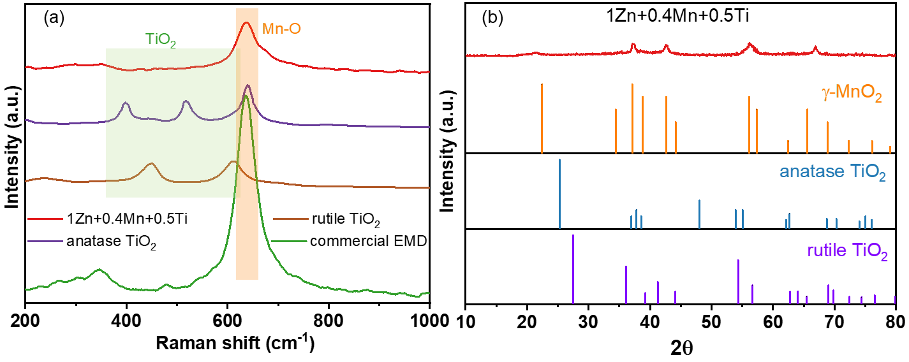
Figure S5. (a) Raman and (b) XRD patterns of the EMD electrodeposited in 1Zn+0.4Mn+0.5Ti electrolyte comparing with the two most common TiO₂ phases (anatase TiO₂ and rutile TiO₂).

Table S2. Atomic percentage of each element in the electrodeposited EMD in 1Zn+0.4Mn+0.5Ti electrolyte before and after immersing in 0.5M NaSO₄ overnight for ion exchange.
Element | 1Zn+0.4Mn+0.5Ti | 1Zn+0.4Mn+0.5Ti  After 0.5M NaSO₄ immersion
O | 65 | 71
Mn | 32 | 25
Ti | 3 | 4
Na | <1 | <1

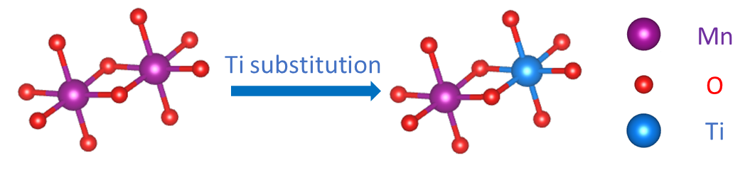
Figure S6. Illustration of Ti decoration in the EMD structure.

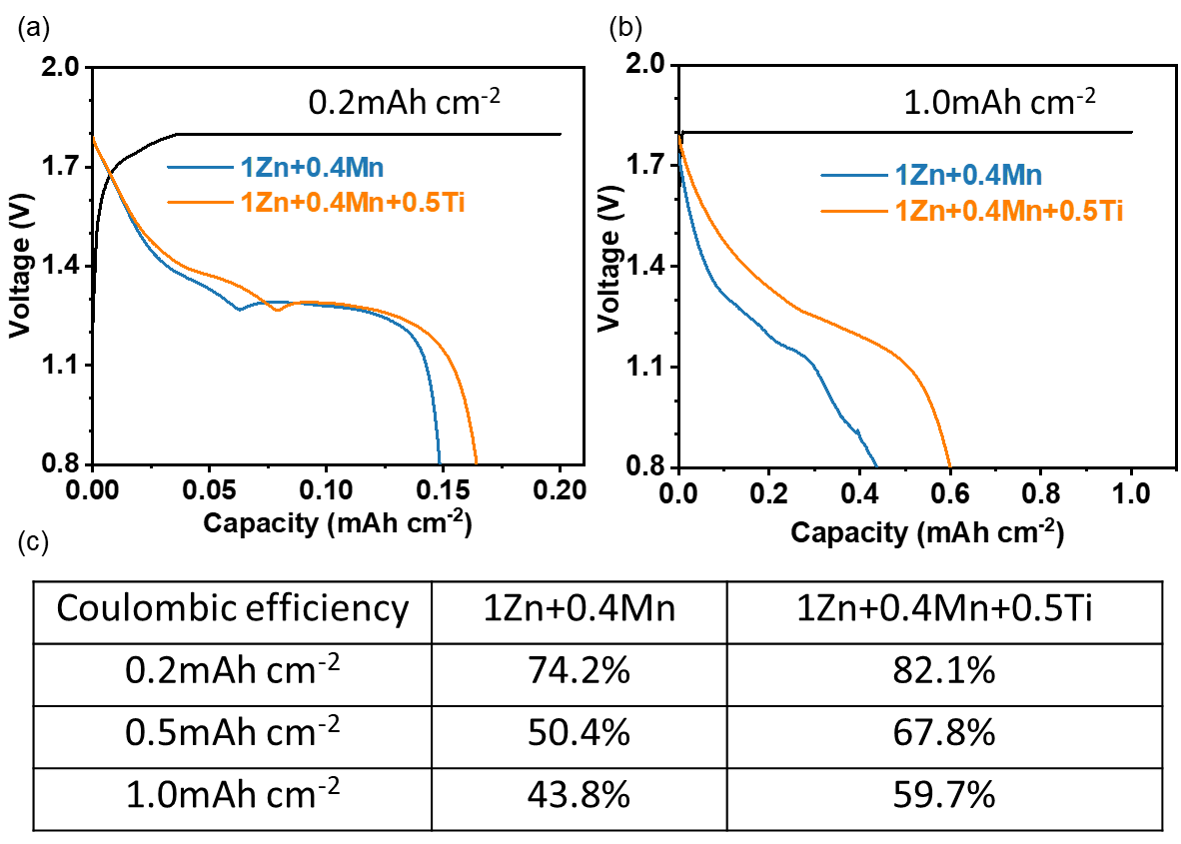Figure S7. The voltage profiles of the electrodeposition tests with charge capacity limit of (a) 0.2 mAh cm⁻² and (b) 1.0 mAh cm⁻²; (c) comparison of the Coulombic efficiency of the electrodeposition tests with different capacity limits.

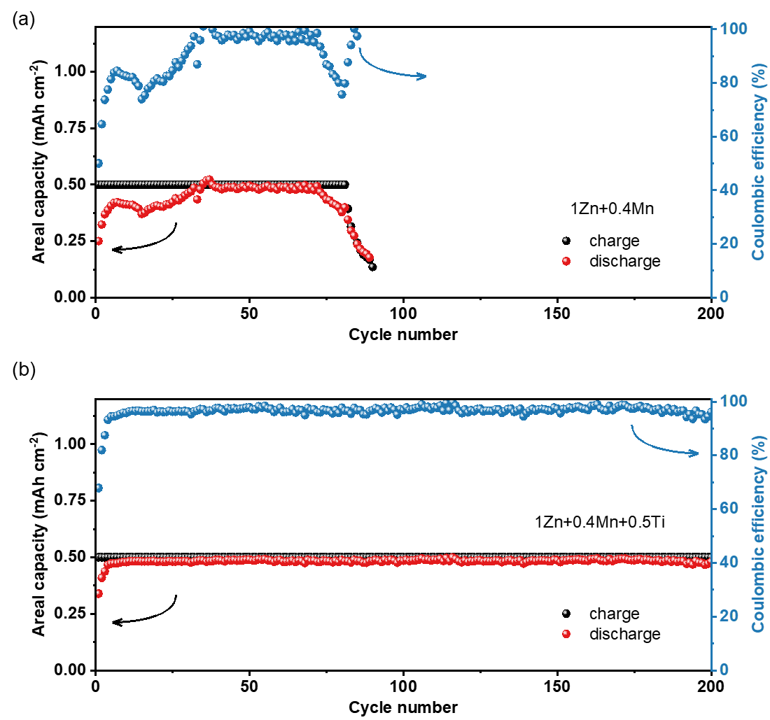
Figure S8. Cycle performances of the CNT-Zn cells with electrolyte of (a) 1Zn+0.4Mn, (b) 1Zn+0.4Mn+0.5Ti with a fixed areal charge capacity of 0.5 mAh cm⁻² and discharge current of 0.05 mA cm⁻².

Table S3. Ionic conductivity and pH of the electrolytes.
Electrolyte | Ionic conductivity (mS cm⁻¹) | pH
1Zn | 25.2 | 4.71
1Zn+0.1Mn | 28.0 | 4.64
1Zn+0.1Mn+0.5Ti | 28.7 | 2.03

Figure S9. Cycle stability comparison of the 1Zn+0.1Mn, 1Zn+0.1Mn+0.5Ti, and 1Zn+0.1Mn with the pH adjusted to 2.10 (close to pH of 1Zn+0.1Mn+0.5Ti) with H₂SO₄.

Figure S10. Charge-discharge profiles of KB cathode without EMD at a low current of 0.3 mA.

Table S4. Cycle performance comparison with the recent literatures.
Design | Current rate (A g⁻¹) | Capacity after cycles (mAh g ⁻¹) | Cycle number | Reference
Cu-MnO₂ | 3 | 151 | 1000 | [1]
IER membrane | 1 | 215 | 300 | [2]
IER membrane | 5 | 75 | 900 | [2]
C@PODA/MnO₂ | 0.5 | 192 | 600 | [3]
C@PODA/MnO₂ | 2 | 137 | 2000 | [3]
Rescue of dead MnO₂ | 1 | 177 | 600 | [4]
K_{0.27}MnO₂·0.54H₂O | 3 | 84 | 1000 | [5]
H⁺/NH₄⁺ co-insertion | 4 | 115 | 4000 | [6]
Co-Mn₃O₄ | 2 | 103 | 1100 | [7]
MnO₂/KB | 5 | 90 | 3000 | [8]
Ca-MnO₂ | 3.5 | 101 | 5000 | [9]
Bi₂O₃/MnO₂ | 1 | 190 | 1000 | [10]
MnO₂@AEPA | 0.5 | 223 | 200 | [11]
MnO₂@AEPA | 1 | 142 | 1700 | [11]
defect rich β-MnO₂ | 1 | 171 | 800 | [12]
Increase top voltage cut-off | 0.1 | 305 | 300 | [13]
Increase top voltage cut-off | 1 | 100 | 6000 | [13]
Ce(SO₄)₂ additive | 1 | 130 | 1000 | [14]
K⁺-intercalated δ-MnO₂ | 3 | 190 | 1000 | [15]
TiOSO₄ additive | 1.5 | 230 | 1500 | this work
TiOSO₄ additive | 4.8 | 92 | 10000 | this work

Figure S11. Cycle performance of the cells with different electrolytes at a low current density of 300 mA g⁻¹.

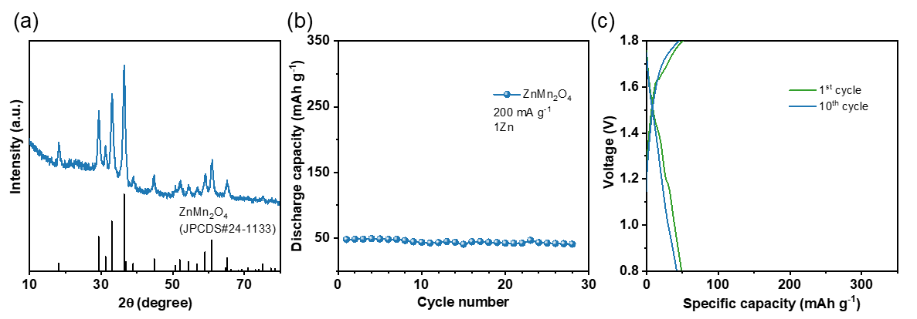
Figure S12. (a) XRD profile of ZnMn₂O₄; (b) cycle performance of ZnMn₂O₄ electrode in 1Zn electrolyte and (c) the corresponding voltage profiles.

Figure S13. Comparison of cycle performance of the EMD electrode in electrolytes with different amount of TiOSO₄ additive with 0.1M Mn²⁺ added.
Figure S14. Comparison of cycle performance of the pre-doped EMD and the in-situ Ti-decorated EMD without Mn²⁺ addition.

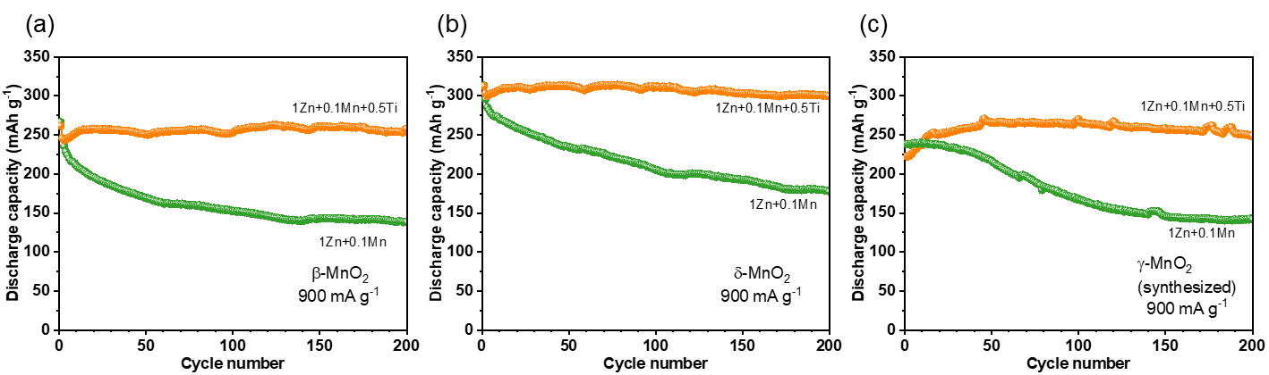Figure S15. Cycle performances of the other MnO₂ polymorphs using TiOSO₄ electrolyte additive: (a) β-MnO₂, (b) δ-MnO₂, (c)γ-MnO₂ (synthesized).

References
[1] J. Zhang, W. Li, J. Wang, X. Pu, G. Zhang, S. Wang, N. Wang, X. Li, Engineering p-Band Center of Oxygen Boosting H⁺ Intercalation in δ-MnO₂ for Aqueous Zinc Ion Batteries, Angewandte Chemie International Edition 62 (2023) e202215654.
[2] Y. Wu, J. Zhi, M. Han, Z. Liu, Q. Shi, Y. Liu, P. Chen, Regulating proton distribution by ion exchange resin to achieve long lifespan aqueous Zn-MnO₂ battery, Energy Storage Materials 51 (2022) 599–609.
[3] Y. Zhao, R. Zhou, Z. Song, X. Zhang, T. Zhang, A. Zhou, F. Wu, R. Chen, L. Li, Interfacial Designing of MnO₂ Half-Wrapped by Aromatic Polymers for High-Performance Aqueous Zinc-Ion Batteries, Angewandte Chemie International Edition 61 (2022) e202212231.
[4] H. Yang, W. Zhou, D. Chen, J. Liu, Z. Yuan, M. Lu, L. Shen, V. Shulga, W. Han, D. Chao, The origin of capacity fluctuation and rescue of dead Mn-based Zn–ion batteries: a Mn-based competitive capacity evolution protocol, Energy & Environmental Science 15 (2022) 1106–1118.
[5] L. Liu, Y.-C. Wu, L. Huang, K. Liu, B. Duployer, P. Rozier, P.-L. Taberna, P. Simon, Alkali ions pre-intercalated layered MnO₂ nanosheet for zinc-ions storage, Advanced Energy Materials 11 (2021) 2101287.
[6] S. Wang, Z. Yuan, X. Zhang, S. Bi, Z. Zhou, J. Tian, Q. Zhang, Z. Niu, Non-metal ion co-insertion chemistry in aqueous Zn/MnO₂ batteries, Angewandte Chemie 133 (2021) 7132–7136.
[7] J. Ji, H. Wan, B. Zhang, C. Wang, Y. Gan, Q. Tan, N. Wang, J. Yao, Z. Zheng, P. Liang, J. Zhang, H. Wang, L. Tao, Y. Wang, D. Chao, H. Wang, Co^{2+/3+/4+}-regulated electron state of Mn-O for superb aqueous zinc-manganese oxide batteries, Advanced Energy Materials 11 (2021) 2003203.
[8] X. Yang, Z. Jia, W. Wu, H.-Y. Shi, Z. Lin, C. Li, X.-X. Liu, X. Sun, The back-deposition of dissolved Mn²⁺ to MnO₂ cathodes for stable cycling in aqueous zinc batteries, Chemical Communications 58 (2022) 4845–4848.
[9] T. Sun, Q. Nian, S. Zheng, J. Shi, Z. Tao, Layered Ca_{0. 28}MnO₂· 0.5 H₂O as a high performance cathode for aqueous zinc-ion battery, Small 16 (2020) 2000597.
[10] Q. Duan, Y. Wang, S. Dong, D. Y. W. Yu, Facile electrode additive stabilizes structure of electrolytic MnO₂ for mild aqueous rechargeable zinc-ion battery, Journal of Power Sources 528 (2022) 231194.
[11] X. Xiao, L. Zhang, W. Xin, M. Yang, Y. Geng, M. Niu, H. Zhang, Z. Zhu, Self-Assembled Layer of Organic Phosphonic Acid Enables Highly Stable MnO₂ Cathode for Aqueous Znic Batteries, Small (2024) 2309271.
[12] J. Zheng, C. Qin, C. Chen, C. Zhang, P. Shi, X. Chen, Y. Gan, J. Li, J. Yao, X. Liu, J. Cheng, D. Sun, H. Wan, H. Wang, Ostwald ripening mechanism-derived MnOOH induces lattice oxygen escape for efficient aqueous MnO₂–Zn batteries, Journal of Materials Chemistry A 11 (2023) 24311–24320.
[13] Y. Liu, Z. Qin, X. Yang, J. Liu, X.-X. Liu, X. Sun, Voltage induced lattice contraction enabling superior cycling stability of MnO₂ cathode in aqueous zinc batteries, Energy Storage Materials 56 (2023) 524–531.
[14] G. Lai, P. Ruan, X. Hu, B. Lu, S. Liang, Y. Tang, J. Zhou, Dynamic compensation of MnOOH to mitigate the irregular dissolution of MnO₂ in rechargeable aqueous Zn/MnO₂ batteries, Journal of Materials Chemistry A 11 (2023) 15211–15218.
[15] J. Yang, G. Yao, Z. Li, Y. Zhang, L. Wei, H. Niu, Q. Chen, F. Zheng, Highly Flexible K-Intercalated MnO₂/Carbon Membrane for High-Performance Aqueous Zinc-Ion Battery Cathode, Small 19 (2023) 2205544.

