Construction of Active and Stable Photoelectrodes via Complementary Coupling of Two-dimensional Narrow- and Wide-Bandgap Nanosheets
Takaaki Taniguchi,^{1)*} Leanddas Nurdiwijayanto,¹⁾ Nobuyuki Sakai,¹⁾ Hong Pang,¹⁾ Renzhi Ma,¹⁾ Hiroki Nishijima,²⁾ Takayoshi Sasaki¹⁾
- Research Center for Materials Nanoarchitectonics (MANA), National Institute for Materials Science (NIMS), 1-1 Namiki, Tsukuba, Ibaraki 305-0044, Japan
- Electrification & Environment Material Engineering Division, TOYOTA Motor Corporation, 1 Toyota-cho, Toyota, Aichi, 471-8572, Japan
Correspondence and requests for materials should be addressed to Takaaki Taniguchi
(email: taniguchi.takaaki@nims.go.jp)

ABSTRACT. Heteroassembly of chemically exfoliated nanosheets (NSs) has been explored to produce functional two-dimensional materials for a wide range of applications in electronic and energy devices. In this study, the molecular-scale assembly approach is extended to construct visible-light active and stable photoelectrodes consisting of narrow- and wide-bandgap semiconductor units, i.e., MoS₂ and Ti_{0.87}O₂ NSs, which contribute with complementary roles to the performance of the photoelectrodes. As a visible–light response element, 2H phase MoS₂ NSs possessing high crystallinity were electrochemically exfoliated from a MoS₂ crystal and functionalized via interface modification, yielding an absorbed photon-to-electron conversion efficiency that was two orders of magnitude higher than that of previously studied defective MoS₂ NSs synthesized via Li intercalation. Furthermore, the controlled interfacial coupling between corrodible MoS₂ NSs and a chemically stable, visible-light transparent Ti_{0.87}O₂ NS coating resulted in the enhanced photoelectrode durability due to the hole tunneling ability inherent to ultra-thin insulating oxide layers. Therefore, the visible-light responsivity of MoS₂ and the chemical stability of Ti_{0.87}O₂ NSs were complementary combined in the interface-engineered heteroassembly system. This photoelectrode design can be expected to be applicable to other combinations of visible–light active narrow-bandgap and corrosion–protective wide-bandgap NS units compatible with various reaction systems.

1. Introduction
Vertical heterojunctions of atomically or molecularly thin crystals, such as van der Waals heterostructures,¹⁻² serve as a platform to access emergent physical phenomena and functional materials. In particular, two-dimensional (2D) nanoarchitectures built up of chemically exfoliated nanosheets (NSs) have been developed in the nanochemistry field.³⁻⁴ To date, various inorganic layered crystals, including metal oxides,⁵ hydroxides,⁶ chalcogenides,⁷⁻⁸, and carbide⁹⁻¹⁰ have been exfoliated into their monolayer or few-layer forms via the soft chemical approach, which is triggered by intercalation or ion-exchange reactions. The surface charges of the resulting colloidal NSs enable their electrostatic integration into desired 2D heterostructures with a wide range of applications in functional devices. For example, we employed electrically insulating metal oxide NSs to produce artificial ferroelectric (Ca₂Nb₃O₁₀/LaNb₂O₇)₃¹¹ and multiferroic [(Ti_{0.8}Co_{0.2}O₂)₂/Ca₂Nb₃O₁₀]₂/(Ti_{0.8}Co_{0.2}O₂)₂¹² superlattices with electronic and electromagnetic proximity coupling, respectively. Besides, electrochemically active NSs of NiFe layered hydroxides,¹³⁻¹⁴ MnO₂,¹⁵⁻¹⁶ and TiNbO₅¹⁷ were coupled with electrically conducting NSs of graphene, 2D RuO₂, and 2D transition metal carbides (MXenes), resulting in accelerated ionic and charge transfer through the heterointerfaces.
Herein, the intriguing heteroassembly route is extended to the construction of tailor-made photoelectrodes composed of narrow- and wide-bandgap nanosheets. As the first building unit of the 2D heteroassembly, 2H phase MoS₂ NSs were selected as a visible–light responsive unit. Transition metal dichalcogenides (TMDCs) based on Mo, W, Sn, Zr, Hf, Pd, and Pt are characterized by narrow bandgaps (1.5–2.5 eV) as well as well-situated valence band maximum (VBM) and conduction band minimum (CBM) for essential processes such as hydrogen evolution, oxygen evolution, carbon dioxide reduction, and nitrogen fixation.¹⁸ Despite their attractive features, research on photocatalysts based on ultrathin TMDCs has been mostly limited to computational studies¹⁹⁻²³ because the synthesis of NSs with sufficient quality is a challenging task. In fact, photoanodes with MoS₂ or WS₂ NSs synthesized using common alkali metal–intercalation methods followed by a thermally driven phase transition from a metastable metallic 1T phase to a semiconducting 2H phase yield very small values of absorbed photon-to-electron conversion efficiency (APCE) below 0.2% in both water and sulfite oxidation reactions,²⁴⁻²⁵ although the metallic 1T phase TMDC NSs are suitable as electrocatalysts and co-catalysts.²⁶⁻²⁷ A recently developed electrochemical (EC) exfoliation technique based on bulky amine intercalation could overcome this issue,^{8, 28} as the EC exfoliation of TMDCs directly yields NSs featuring high crystallinity and a defect density as low as that of TMDC crystals obtained using state-of-the-art vacuum deposition methods. The successful application of EC-exfoliated TMDC NSs to various electronic devices including transistors,²⁹ photosensors,³⁰, light-emitting devices³¹, and superconducting circuits³² have motivated us to investigate their use as practical photoactive units in NS-based photoelectrodes for solar-to-chemical energy conversion.
As the second building unit of the 2D heteroassembly, we introduced titania NSs to enhance the durability of the corrodible MoS₂ NS photoelectrode under operation in aqueous electrolyte solutions. The proposed role is different from conventional uses of wide-bandgap oxide NSs as UV–active components in photocatalysts³³⁻³⁹ and photodetectors.⁴⁰⁻⁴¹ This idea is based on the following knowledge: (1) the preparation of titania nanocoatings via atomic layer deposition (ALD) is a promising approach to stabilize the photoelectrochemical properties of semiconductor materials susceptible to corrosion, such as Si and GaAs.⁴²⁻⁴³ In principle, chemically stable ALD oxide nanocoatings prevent direct access of corrosive components to the unstable semiconductors while allowing the diffusion of photogenerated holes to the solid–liquid interface via tunneling⁴² or leaking.⁴³ (2) We have recently developed a metal oxide NS coating to protect stainless steel (SUS) against chemical corrosion with a comparable or even superior inhibition efficiency to that of ALD ceramic nanocoatings with a thickness of a few nanometers.⁴⁴ (3) Ti_{0.87}O₂ NSs are transparent in the visible region due to their large bandgap (3.8 eV). In addition, they are expected to exhibit lower VBM than that of MoS₂, as an exfoliation-induced 2D quantum effect deepens VBM as compared to that of anatase titania.³³ Owing to these chemical and physical properties, Ti_{0.87}O₂ NSs would meet the requirements for a corrosion-protective hole transport (CPHT) layer, potentially allowing the development of a greener and cost-effective solution-processing of hole-transport heterojunction for semiconductor protection alternative to ALD.
In this study, the validity of our material design is proved through a series of proof-of-concept experiments. Briefly, EC-exfoliated 2H phase (EC-2H) MoS₂ NSs with high crystallinity yield APCE values two orders of magnitude higher than those achieved by defective MoS₂ NSs synthesized via Li intercalation for sulfite oxidation reactions. The formation of a heterojunction with Ti_{0.87}O₂ NSs enhances the durability of the resulting EC-2H MoS₂ photoelectrode owing to its CPHT ability. In addition, the obtained experimental results emphasize that such intrinsic/interactive properties of these semiconducting NSs arise only when the 2D interfaces are adequately controlled.
2. Results and discussion
2.1. Activation of MoS₂ photoanode via crystal and interface engineering
Tetraheptylammonium (THA) was cathodically intercalated in a natural MoS₂ crystal. A deep greenish colloid was obtained after ultrasonic exfoliation followed by removal of unexfoliated flakes via centrifugation (Figure 1a). The ultraviolet–visible (UV–vis) absorption spectra of a diluted colloid exhibited three exciton bands at 420, 620, and 680 nm, which are characteristic of a semiconducting 2H phase (Figure 1a).⁴⁵ The absorption edge wavelength was observed at ca. 700 nm, which is shifted to the shorter wavelength side compared to that of bulk MoS₂ (ca. 1200 nm) due to the quantum effect (Figure S1). Next, EC-2H MoS₂ NSs were deposited on a SiO₂/Si substrate via layer-by-layer (LbL) electrostatic self-assembly using the MoS₂ colloid and an aqueous solution containing polydiallyldimethylammonium (PDDA) as a counter polycation of negatively charged MoS₂ NSs. Atomic force microscopy (AFM) observation showed that one-cycle deposition yielded a rather uniform coating (Figure 1b). A coverage of ca. 85% was obtained by an analysis of an optical microscope image of the same sample (Figure S2). The as-deposited NSs with a lateral size of ca. 0.5–2 μm exhibited a rough surface structure (Figure 1c), indicating the presence of surface organic species stemming from the fabrication process. It was also found that the addition of PVP in the exfoliation process was necessary to obtain a stable NS sol, indicating a surfactant role. Thus, the surface organic layer resolved by AFM should be PVP. The surfaces could be efficiently cleaned by rinsing with N,N-dimethylformamide (DMF). The nominal height of the rinsed NSs was ca. 1.5–2 nm (Figure 1d), which corresponds to a thickness of two to three layers of a MoS₂ slab (0.64 nm).
One-cycle deposition of EC-2H MoS₂ NSs was applied on an indium tin oxide (ITO)–coated quartz glass substrate to fabricate photoelectrodes. Sulfite oxidation using a Na₂SO₃ solution was selected as a model reaction to assess the charge separation efficiency of the EC-2H MoS₂ photoelectrode for solar-driven hydrogen evolution in an aqueous system. The as-fabricated MoS₂ photoelectrode produced a very small photocurrent of ca. 0.5 μA/cm² under visible light irradiation (>410 nm) in the potential sweep measurement (Figure 2a), indicating the occurrence of predominant recombination of photogenerated electron and hole pairs probably due to an extrinsic deterioration caused by heavy defects or adsorbed organics. To overcome this issue, the as-fabricated MoS₂ photoelectrodes were annealed at 450 °C under H₂/Ar flow, resulting in ca. 200~800- fold enhancement of the photocurrent density when compared at the same measured potentials (Figure 2b). As shown in the APCE vs. excitation wavelength plot (Figure 2c), the photocurrent was generated upon exposure to visible light below 700 nm. The two peaks at 625 and 650 nm agreeing with the exciton bands in the UV–vis absorption spectra suggest efficient electron and hole separation from the excitons. The APCE reached maximum values of 15%–20% below 650 nm, which are approximately 200 times higher than those of a previously reported photoelectrode based on thermally converted 2H phase (TC-2H) MoS₂ NSs obtained from Li-exfoliated 1T phase (Li-1T) MoS₂ NSs. ²⁴
In-plane synchrotron X-ray diffraction (XRD) and Raman spectroscopy were employed to reveal the relationship of the obtained photocurrent with the crystallinity, interface state, and electronic state of the MoS₂ NSs. Figure 3a shows the wide-angle in-plane XRD patterns of EC-2H MoS₂ NSs deposited on SiO₂/Si substrates before and after annealing as well as those of Li-1T MoS₂ and TC-2H MoS₂ NSs as references. The peaks in the XRD patterns of the EC-2H MoS₂ NSs can be indexed as intraplane hk reflections of the 2H phase of a hexagonal system with the refined cell parameter of a = 0.3161(2) nm. Annealing had no influence on the peak angles and broadness (Figure 3b), which allowed ruling out the improved purity and crystallinity of the 2H phase as the reason for the enhanced photocurrent after annealing. The XRD pattern of the TC-2H MoS₂ NSs was also consistent with a pure 2H phase; however, the reflection peaks were broader than those of the EC-2H MoS₂ NSs. This broadening could originate from the similarly broad reflection peaks of the Li-1T MoS₂ precursor. The overall lateral sheet sizes of the EC-2H MoS₂ NSs and Li-1T MoS₂ NSs were larger than the sub-μm scale (Figure 3c). Moreover, individual NSs should comprise a single crystalline domain, according to the literature.^{8, 46} Therefore, the broadening of the reflections of the Li-1T MoS₂ and TC-2H MoS₂ NSs was not due to a crystallite-size effect but to a microstrain effect stemming from a high defect density.⁴⁷ Control photoanodes fabricated with TC-2H MoS₂ NSs were found to produce a limited photocurrent of less than 0.05 mA/cm² (Figure 3d), even though the number of deposition cycles and annealing conditions were adjusted to improve the photoresponse. Thus, pre-existing defects in the Li-1T MoS₂ NSs were retained after the phase transformation because of the insufficient thermal driving force for their elimination. In addition, relatively large dark current densities were observed, indicating the presence of electrochemically driven carrier conduction paths probably through defect states. These results indicate that the EC-2H MoS₂ NSs exhibit high crystallinity suitable for an efficient photogenerated carrier separation.
Figure 3e shows the Raman spectra of EC-2H MoS₂ NSs deposited on a SiO₂/Si substrate before and after annealing, which display the E¹_{2g} mode due to out-of-plane vibrations at ∼384 cm⁻¹ and the doubly degenerate A_{1g} mode due to in-plane vibrations at ∼404 cm⁻¹ of the 2H phase MoS₂. ⁴⁸ The annealing process caused a blueshift of the A_{1g} band and an increase in its intensity relative to the E¹_{2g} band. These spectral changes are attributable to a decrease in excess electrons in the conduction band.⁴⁸ In principle, the EC intercalation of a THA⁺ cation simultaneously injects an electron into a MoS₂ slab from the electrode to maintain charge neutrality. Accordingly, the spectral changes caused by annealing should be accompanied by decomposition of the electron-donating organic species. The difference between the A_{1g} and E¹_{2g} peak positions of ca. 20 cm⁻¹ after annealing indicates the presence of bilayer or trilayer MoS₂ slabs in an individual NS, ⁴⁹ which is in line with the AFM observation and referred study by Lin et al.⁸
XPS was used to verify the validity of the proposed mechanism responsible for the enhanced photocurrent after annealing. Figure 4a shows the Mo 3d and S 2p XPS spectra of EC-2H MoS₂ NSs deposited on a SiO₂/Si substrate before and after annealing. No change in positions, widths, and relative intensities of each detected peak revealed no alternation in the nominal valence of Mo⁴⁺ by annealing. As shown in Figure 4b, the N 1s peak becomes undetectable after annealing, while the Mo 3p3/2 peak remains unchanged. The former result proved thermal decomposition of nitrogen-containing organics used for the synthesis and deposition of EC-2H MoS₂ NSs. Also, the peaks attributable to C-N and sp³ carbon bonds derived from these organics almost disappeared after annealing (Figure 4c). Assuming that most of the PVP adsorbed on the surface of MoS₂ NSs was removed by washing with DMF as indicated by the AFM observation, the disappearance of the peaks from C-N and sp³ carbon bonds suggests that the PDDA present at the interface was thermally decomposed, which could allow the direct attachment of MoS₂ NSs to the substrate surface.
From a thermodynamic point of view, electron doping in a semiconductor induces upward band bending at the surface/electrolyte interface. Therefore, the reduced n-type carrier concentration by annealing is expected to suppress the outward diffusion of photogenerated holes to the solution side, thereby reducing photocurrents. This implies that an opposite effect promoting carrier separation is involved by annealing. As a candidate, we propose that the electrically insulating PDDA monolayer accommodated at the MoS₂/ITO interface could block the transfer of photogenerated electrons to the ITO side, resulting in a very low photocurrent due to carrier recombination. The experimental results show that the possible issue was solved by the interface modification induced by annealing.
2.2. Photoelectrochemical instability of MoS₂ photoanode and stabilization via ALD nanocoating
The above results suggest that semiconducting TMDC NSs can be utilized as photoactive units owing to their electron–hole separation ability, which could be further enhanced via superior crystal and interface engineering. In addition, heterometal doping,⁴⁹ introduction of strain,⁵⁰⁻⁵¹ and formation of heterojunctions^{18, 52} of TMDC NSs could be effective band tuning strategies to enhance the photoelectrode performance. However, the considerable photoelectrochemical instability of the EC-2H MoS₂ photoanode needed to be solved before organizing TMDC units into sophisticated photoactive layers. As shown in Figure 5a, the chronoamperometry measurement at 1.2 V vs. RHE resulted in a substantial decrease in photocurrent density under continuous light irradiation for 2 h, whereas no noticeable decrease was observed after ten scans of potential sweep measurement (Figure 2b). Specifically, the photocurrent density increased during the first several minutes of irradiation and then decreased continuously. Thus, some initial photoelectrochemical modifications of the MoS₂ layer should be involved to activate photoanodes made of EC-2H MoS₂ NSs. Then, the photoelectrochemical corrosion could be more pronounced with increasing light exposure time, continuously decreasing in the photocurrent density. Mapping of surface elemental distribution by Auger electron spectroscopy (AES) detected a strong carbon signal from the sample produced after annealing (Figure S3), indicating that carbon-based contaminants, probably produced from the thermal decomposition of organic species, covered the MoS₂ surface. The carbon signal weakened after the durability test for 2 h, while the Mo and S signals enhanced. These results suggest that the removal of surface contaminants may be related to the activation of the MoS₂ surface at the early stage in the durability test. At the same time, the retention of MoS₂ layer on the substrate after the durability test excludes the possibility of the detachment of the NSs from the substrate to cause the observed photocurrent degradation. The mechanism of such an initial activation of the photocurrent, as well as the subsequent inactivation, will be further investigated in the next study. Note that such an initial increase was also observed for other samples, as will be discussed later.
The stabilization strategy using a CPHT layer was introduced to improve the durability of the MoS₂ NS-based photoanode. We began with a standard ALD technique since the effectiveness of a CPHT layer on TMDC-containing photoelectrodes had not been examined yet. In this investigation, 3 nm- and 10 nm- titania layers were deposited on an annealed MoS₂ layer using the established ALD conditions (Figure 5b). According to transmission electron microscopy (TEM) observations (Figure 5c), an amorphous titania coating with a thickness of ca. 3 nm was formed as designed. The amorphous titania-coated EC-2H MoS₂ photoanode delivered a stable photocurrent of 0.31 mA/cm² after irradiation for 2 h, which is approximately ten times larger than that obtained using the bare EC-2H MoS₂ photoanode (Figure 5d). The chronoamperometry curve of the EC-2H MoS₂ photoanode with the 10 nm ALD coating showed a stable but very small photocurrent, where the value was ca. 5 μA/cm² (Figure S4). The result implies that the 10 nm thick oxide film could provide an excessively high tunneling barrier for the photogenerated holes in MoS₂ NSs. We note that the 10 nm thickness is sufficiently thin to function as a CPHT layer if the hole-leaking is a predominant mechanism.⁴³ Thus, the ALD titania nanocoating stabilizes the TMDC-based photoelectrode according to the hole tunneling principle (Figure 5e).
2.3. Stabilization of MoS₂ photoanode via heteroassembly of Ti_{0.87}O₂ NS units
Next, we examined whether the Ti_{0.87}O₂ NSs function as a CPHT unit. Figure 6a displays an estimated band diagram of Ti_{0.87}O₂ and MoS₂ NSs. The CBM and VBM of Ti_{0.87}O₂ NS are referred from our previous study.³³ On the other hand, the band diagram of MoS₂ NS was experimentally obtained from the optical bandgap and flat-band potential of a EC-2H MoS₂ photoelectrode (Figure S5), where the CBM and VBM are roughly consistent with theoretical and experimental values of monolayer and few-layer MoS₂ previously reported.⁵³⁻⁵⁵ According to the band diagram, these NSs form a type–Ⅰ heterojunction and the VBM of Ti_{0.87}O₂ NS locates the deeper energy side of that of MoS₂ NS. Thus, it is expected that photoexcited holes in a MoS₂ NS can pass a Ti_{0.87}O₂ NS by the tunneling mechanism.
First, EC-2H MoS₂ NSs were deposited on an ITO substrate via one-cycle deposition followed by annealing at 450 °C under H₂/Ar flow. Subsequently, one-cycle deposition of Ti_{0.87}O₂ NSs on the MoS₂ layer was conducted (Figure 6b). AFM observation showed that the overall deposition of submicron-sized Ti_{0.87}O₂ NSs on the MoS₂ NSs (Figure 6c and Figure S6) . The cross-sectional TEM image revealed that the one-cycle deposition produced a 2–3 nm-thick nanocoating composed of bilayer or trilayer Ti_{0.87}O₂ NSs (Figure 6d and Figure S7), which was consistent with the coating thickness obtained in our previous study after a one-cycle deposition on a SUS substrate with the same deposition conditions.⁴⁴ However, despite the construction of the designed heterostructure, the sample yielded a similar photocurrent degradation rate to that of the uncoated MoS₂ photoelectrode in the durability test (Figure 6e), revealing no corrosion-protection effect from the Ti_{0.87}O₂ NSs. This could be due to a weak coupling between the Ti_{0.87}O₂ and MoS₂ layers with intervening PDDA, allowing direct access of electrolyte species onto the MoS₂ surface through interfacial diffusion.
To validate this hypothesis, an additional annealing was performed at 350 °C under Ar flow after depositing the Ti_{0.87}O₂ NSs to remove the PDDA between the MoS₂ and Ti_{0.87}O₂ NSs (Figure 7a). The second annealing temperature was selected based on the thermal stability of multilayered Ti_{0.87}O₂ NS films on Si and quartz glass substrates up to 400 °C in air.⁵⁶ Such a two-step annealing slightly enhanced the photocurrent density after photoirradiation for 60 min (Figure 7b), indicating the positive effect of the interface engineering. Subsequently, two and three deposition cycles of Ti_{0.87}O₂ NSs on annealed EC-2H MoS₂ followed by annealing at 350 °C were conducted to vary the thickness of the resulting oxide NS coating. The second deposition cycle resulted in a decrease in the slope of the photocurrent degradation, possibly indicating that the MoS₂ area that remained exposed after the first Ti_{0.87}O₂ deposition was covered after the second deposition. However, the third deposition did not alter the amperometry curve considerably, and the coating reached a thickness of 10 nm (Figure 7c and Figure S8). Most likely, the electrolyte could diffuse to the MoS₂ surface through the coating composed of multiple Ti_{0.87}O₂ NS layers, although the interface densification resulting from the second annealing could slow down the diffusion kinetics. This could be related to the slow increase in photocurrent density observed after turning on the light.
Next, to further improve the stabilization ability of the Ti_{0.87}O₂ coating, the heterostructures obtained via one-cycle deposition of Ti_{0.87}O₂ NSs on non-annealed EC-2H MoS₂ NSs were subjected to one-step annealing at 450 °C under H₂/Ar flow. As a result, the most remarkable improvement in durability induced by Ti_{0.87}O₂ coating was achieved. Figure 8a shows the chronoamperometry curves of the photoanodes based on a Ti_{0.87}O₂/MoS₂ heterostructured photoelectrode fabricated by the abovementioned one-step annealing process. In contrast to the previous Ti_{0.87}O₂/MoS₂ heterostructures, the photocurrent was effectively stabilized by one-cycle deposition of Ti_{0.87}O₂ NSs, retaining a photocurrent density of 0.26 mA/cm² after 2 h of durability test. Besides, a similar initial drop of photocurrent density to that of bare MoS₂ was observed, suggesting the presence of uncoated MoS₂ parts that were quickly corroded. The photocurrent peak at around 5 min was considerably weakened after the second deposition of Ti_{0.87}O₂ NSs, likely due to an increased coverage, whereas the double increased coating thickness suppressed the hole tunneling, thus decreasing the stable photocurrent density after the durability test (0.17 mA/cm²). In addition, unlike the two-step annealing process, the third deposition cycle significantly lowered the photocurrent density, indicating a further raised barrier for hole diffusion through the Ti_{0.87}O₂ NS coating. The observed dependency on the deposition cycle number, i.e., coating thickness, can be interpreted that the tunneling-based CPHT ability is more plausible than the hole-leaking-based one.
The in-plane XRD patterns of the Ti_{0.87}O₂/MoS₂ photoelectrodes before and after annealing showed the hk diffraction peaks of the 2H phase MoS₂ and lepidocrocite phase titania along with those of the ITO substrate (Figure 8b), revealing that neither thermal decomposition of Ti_{0.87}O₂ NSs into rutile or anatase titania nanocrystals nor formation of impurity compounds due to thermal reactions between MoS₂ and Ti_{0.87}O₂ NSs occurred at the given annealing condition. The relative intensities of the 20 reflection of Ti_{0.87}O₂ to the 20 reflection of MoS₂ linearly increased with the deposition cycle number of Ti_{0.87}O₂ NSs (Figure S9), ensuring the successive increase in coating thickness according to the LbL deposition principle. In addition, cross-sectional TEM and TEM–energy-dispersive X-ray (EDX) spectroscopy images of EC-2H MoS₂ photoelectrodes with Ti_{0.87}O₂ nanocoating produced via one-cycle deposition revealed that the heterostructures were maintained after 2 h of durability test (Figure 8c). These XRD and TEM analyses confirmed the role of Ti_{0.87}O₂ nanocoating as a CPHT layer.
However, a chronoamperometric measurement extended to 12 h showed that one-cycle LbL deposition of Ti_{0.87}O₂ resulted in a decreased current density after 4 h (Figure S10), indicating that the currently available anticorrosion effect is not yet sufficient to provide long-term stability. On the other hand, the three-cycle LbL deposition of Ti_{0.87}O₂ suppressed the decrease in current density, while the current density was lowered due to the increased hole diffusion barrier. Thus, an improved quality of the oxide NS-based CPHT coating is necessary for practical applications. The EC-2H MoS₂ photoelectrodes protected by 3 nm-thick ALD coating and Ti_{0.87}O₂ NS coating prepared via one-cycle deposition retained current densities of 0.31 and 0.26 mA/cm², respectively, after 2 h of durability test. The fact that similar stabilization degrees were obtained with similar coating thicknesses confirms that the coating thickness is one of the dominant factors in determining the hole tunneling ability of titania layers. Accordingly, using spin-coating⁵⁷ or single-drop⁵⁸ techniques to produce neat-tiling monolayer films with a coverage higher than 95% could improve simultaneously the hole tunneling and corrosion inhibition. Oxide NS-based CPHT nanocoatings would be effective in stabilizing not only TMDC but also other unstable semiconductor photoelectrodes including Si. Furthermore, the availability of diverse oxide NSs with similar chemical stability and wide bandgaps to those of Ti_{0.87}O₂ but with different chemical compositions, crystal structures, electronic states, and unit cell thicknesses, such as TaO₃, Nb₃O₈, TiNbO₅, Ti₂NbO₇, and Ca₂Nb₃O₁₀, La₂Ti₃O₁₀, and LaNb₂O₇,⁵⁹ will allow investigating other factors determining the hole permeability in addition to the coating thickness. Such investigations to expand the combination of photoactive materials and anticorrosive NSs would not only reveal the scope of this photochemical corrosion protection technique, but also the anticorrosion mechanism that has not yet been established. Finally, it is noted that heterojunctions of semiconducting TMDC and insulating metal oxide nanosheets serve as potential components in a wide range of electronic and optical devices. The importance of interfacial engineering highlighted in the present study will be informative for exploring heteroassembly routes to desired 2D TMDC/oxide systems.
3. Conclusion
We developed a strategy for the construction of visible-light active and stable photoelectrodes based on the combination of narrow-bandgap TMDC and wide-bandgap oxide NSs. First, a superior charge separation efficiency was achieved using EC-exfoliated MoS₂ NSs, highlighting the importance of crystal and interface engineering in the functionalization of semiconducting TMDC NSs as photoactive units in photoelectrode systems. Subsequently, we found that Ti_{0.87}O₂ NSs strongly coupled with MoS₂ NSs played an expected CPHT role to enhance photoelectrode durability. Overall, this study provides a practical approach and guideline to develop tailor-made photoelectrodes constructed with narrow- and wide-bandgap NSs. Extending this design to other processes and 2D materials could pave the way toward a greener, cost-effective, visible-light-active, and long-lived photoelectrodes.
4. Experimental Section
4.1 Electrochemical exfoliation of MoS₂: MoS₂ crystals were exfoliated via an electrochemical approach according to a previously reported procedure. ⁸ Briefly, intercalation of THA⁺ into 2D MoS₂ crystals as a cathode in acetonitrile (5 mg/mL) was performed by applying a negative bias of −8 V for 60 min. During the intercalation, the MoS₂ crystals expanded voluminously to a fluffy structure, indicating the successful intercalation of THA⁺ into the MoS₂ galleries. The as-intercalated crystals were further sonicated in a 0.2 M PVP/DMF solution for a few hours to assist the exfoliation process, resulting in a greenish dispersion of MoS₂ NSs. The as-exfoliated dispersion was washed and redispersed with IPA three times to remove the remaining PVP and other impurities. Finally, the ink dispersion was collected after centrifuging at 5000 rpm to separate unexfoliated crystals. An elemental analysis with inductively coupled plasma atomic emission spectroscopy indicated that the yield of stable dispersed MoS₂ NSs was roughly estimated to be around 10% in weight with respect to the quantity of the initial single-crystal precursor.
4.2 Exfoliation of MoS₂ via Li intercalation: The Li-exfoliation of MoS₂ was conducted according to our previous report.⁴³ First, MoS₂ crystals (~1 g) were treated with 50 mL hydrazine (N₂H₄) under refluxing conditions at 130 °C for 24 h to expand the crystals. The expanded crystals were washed with water and ethanol, then dried at 120 °C overnight. The resulting crystals were reacted with a hexane-based solution of n-butyllithium (~2.5 mol equivalent of the MoS₂) in an Ar-filled dry box. The Li_{x}MoS₂ product was collected by filtration and washed with hexane to remove excess lithium. Exfoliation was achieved by sonicating the Li_{x}MoS₂ in water for 1 h. The mixture was centrifuged at 2000 and 12000 rpm to separate unexfoliated crystals and to remove small flakes, respectively. The Li content of the final suspension was adjusted to Li/MoS₂ = 1 by adding an appropriate amount of LiOH solution.
4.3 Synthesis of Ti_{0.87}O₂ NSs: Ti_{0.87}O₂ NSs were synthesized by exfoliating the parent potassium titanate precursor, K_{0.8}Ti_{1.73}Li_{0.27}O₄, according to a previous report.⁶⁰ K₂CO₃, TiO_{2,} and Li₂CO₃ precursors (molar ratio = 0.4:1.73:0.135) were mixed and calcined at 1000 °C. The obtained K_{0.8}Ti_{1.73}Li_{0.27}O₄ powders were acid-treated with 1 M HCl to obtain the protonic form H_{1.07}Ti_{1.73}O₄·H₂O, which was then treated with aqueous tetrabutylammonium (TBA) hydroxide solutions at an equivalent TBA⁺/H⁺ ratio under reciprocal shaking at 180 rpm for seven days.
Fabrication of LbL film: The obtained dispersion containing EC-2H MoS₂ NSs was adjusted at 1 mg/mL with IPA for LbL deposition. SiO₂/Si and ITO/quartz glass substrates were precleaned with UV/O₃ to remove any organic impurities and turn the surface hydrophilic. The substrates were primed with an aqueous PDDA solution (100 g/L, pH 9.1) for 5 min to render the surface positively charged, followed by washing with a copious amount of water and drying under a N₂ gas stream. The PDDA-modified substrate was then dipped in the MoS₂ dispersion for another 5 min, washed with DMF and IPA, and then washed with water and dried using the same procedure. Ti_{0.87}O₂ NSs were deposited using the same procedure and then washed with water and dried under a N₂ gas stream.
Annealing of LbL film: The substrate with MoS₂ NS layer was annealed using a tube furnace under 5% H₂/Ar or Ar flow with a flow rate of 100 ccm. A quartz tube with a length of 50 cm and an inner diameter of 2.5 cm was used for annealing. The outlet and inlet of the quartz tube were connected by plastic tubes with an inner diameter of 0.5 cm.
4.4 Characterizations: The morphology of the NSs was evaluated using a tapping-mode AFM (Asylum Research MFP-3D Family) with a Si-tip cantilever. The coverage of 1-cycle LbL deposition of MoS₂ NSs was conducted from an image analysis. In this analysis, an optical microscope image of a MoS₂ NS-coated SiO₂/Si substrates was converted to a grayscale image using Photoshop software (Figure S2a and S2b). The grayscale values in the image were divided into four ranges corresponding to uncovered and covered regions with 1 layer, 2 layers, and 3 or more MoS₂ NS layers and the histogram of the grayscale values for the entire image was produced (Figure S2c). The above image analysis was performed using Image J software. Finally, the histogram curve was separated into four peaks corresponding to the above four regions, and the relative values of peak areas were calculated as the area ratio of each region. Raman spectra were measured using a laser confocal Miro-Raman microscope (Tokyo Instruments, Nanofinder FLEX) equipped with a 532 nm excitation laser and a laser spot size of ca. 1 μm in diameter focused on the sample surface with a 100× objective lens. The Raman signals were detected using an electron-multiplying CCD detector with a grating of 2400 groove/mm. In-plane XRD measurements of the NSs were performed with synchrotron X-ray radiation (Photon Factory BL-6C of the High-Energy Accelerator Research Organization, KEK-PF) at a wavelength of 0.11994 nm and a constant incident angle of 0.16°. UV–vis spectra of the LbL film and colloid were recorded with a Shimadzu SoildSpec-3700i DUV. MoS₂ power, denoted as bulk MoS₂, used for the measurement of diffuse reflectance spectra was purchased from Kojundo Chemical Lab, Japan. XPS analysis was performed using a PHI-5000 VersaProbe Ⅱ (ULVAC-PHI) instrument with a monochromatic Al Kα source(1486.6 eV) at a take-off angle of 45° with respect to the surface, corresponding to a measurement area of ca. 1.4 × 0.1 mm2 . The spectra were calibrated to the O 1s binding energy at 532.4 eV (Figure S11).
4.5 Photoelectrochemical measurements: LbL-fabricated MoS₂ films on ITO/quartz glass substrates (measured active area = 1 cm²) were used as photoelectrodes. Linear scanning voltammetry and chronoamperometry data were recorded using a three-electrode system (Gamry electrochemical station, 1010E) with a MoS₂ film, platinum coil, and Ag/AgCl (3 M KCl) electrode as the working, counter, and reference electrodes, respectively. A 0.25 M Na₂SO₃ aqueous solution was used as the electrolyte. The potentials reported in this work were generally converted to the reversible hydrogen electrode (RHE). For RHE conversion, following equation was used. E(RHE) = E(Ag/AgCl) + E⁰(Ag/AgCl) + 0.059 × pH. In this equation, E(Ag/AgCl) is the observed potential while experiments were performed using Ag/AgCl (3 M KCl) reference electrode. E⁰(Ag/AgCl) is the potential of Ag/AgCl (3 M KCl) versus normal hydrogen electrode (NHE), i.e., 0.197 V. The measured pH value of a 0.25 M Na₂SO₃ solution was 0.97. The photoelectrochemical studies were conducted under an applied voltage ranging from 0.8 to 1.25 V vs. RHE at a scan rate of 10 mV/s. A 300 W Xe lamp (Asahi Spectra MAX303) equipped with a UV cut-off filter at 410 nm was used as the light source. The wavelength dependent photon conversion efficiencies of the photoelectrodes were estimated under illumination with a filtered Xe light source (Asahi Spectra LAX-103) with a full-width half-maximum band of ca. 10 nm. The incident photon power was recorded using an USHIO spectroradiometer USR-45. The measurement was conducted under a scanned illumination from 780 to 400 nm with 20 nm steps while the photocurrent was recorded at 1.1 V vs. RHE. The flat-band potential was measured with the same system, while the UV cut-off filter was used in this case.
Supporting Information
UV–vis absorption spectra of bulk MoS₂. Optical microscope and AES elemental mapping images of MoS₂ films. Chronoamperometry curve of ALD titania-coated MoS₂ photoelectrode. Tauc plots, flat-band potential, and band positions of MoS₂ NS. AFM image of Ti_{0.87}O₂ NSs. Cross-sectional TEM images of titania-NS coated MoS₂ films. Plots of peak area of the T20 and M20 peaks of titania-NS coated MoS₂ films. O 1s XPS spectra of a MoS₂ film. Chronoamperometry curves of ALD titania-coated MoS₂ photoelectrodes.
Acknowledgments
This work was partly supported by the World Premier International Research Center Initiative (WPI), MEXT, Japan, JSPS KAKENHI Grant Numbers JP21H01769, Japan and JST CREST, Grant Number JPMJCR22B1, Japan. The in-plane XRD measurements were performed under the approval of the Photon Factory Program Advisory Committee (Proposal No. 2022G501).

References
1. Geim, A. K.; Grigorieva, I. V. Van der Waals heterostructures. Nature 2013, 499, 419-425.
2. Novoselov, K. S.; Mishchenko, A.; Carvalho, A.; Castro Neto, A. H. 2D materials and van der Waals heterostructures. Science 2016, 353, aac9439.
3. Taniguchi, T.; Nurdiwijayanto, L.; Ma, R.; Sasaki, T. Chemically exfoliated inorganic nanosheets for nanoelectronics. Appl. Phys. Rev. 2022, 9, 021313.
4. Ma, R.; Sasaki, T. Two-Dimensional Oxide and Hydroxide Nanosheets: Controllable High-Quality Exfoliation, Molecular Assembly, and Exploration of Functionality. Acc. Chem. Res. 2015, 48, 136-143.
5. Osada, M.; Sasaki, T. Exfoliated oxide nanosheets: new solution to nanoelectronics. J. Mater. Chem. 2009, 19, 2503-2511.
6. Ma, R.; Liu, Z.; Li, L.; Iyi, N.; Sasaki, T. Exfoliating layered double hydroxides in formamide: a method to obtain positively charged nanosheets. J. Mater. Chem. 2006, 16, 3809-3813.
7. Joensen, P.; Frindt, R. F.; Morrison, S. R. Single-layer MoS₂. Mater. Res. Bull. 1986, 21, 457-461.
8. Lin, Z.; Liu, Y.; Halim, U.; Ding, M.; Liu, Y.; Wang, Y.; Jia, C.; Chen, P.; Duan, X.; Wang, C.; Song, F.; Li, M.; Wan, C.; Huang, Y.; Duan, X. Solution-processable 2D semiconductors for high-performance large-area electronics. Nature 2018, 562, 254-258.
9. Alhabeb, M.; Maleski, K.; Anasori, B.; Lelyukh, P.; Clark, L.; Sin, S.; Gogotsi, Y. Guidelines for Synthesis and Processing of Two-Dimensional Titanium Carbide (Ti₃C₂T_{x} MXene). Chem. Mater. 2017, 29, 7633-7644.
10. Naguib, M.; Mochalin, V. N.; Barsoum, M. W.; Gogotsi, Y. 25th Anniversary Article: MXenes: A New Family of Two-Dimensional Materials. Adv. Mater. 2014, 26, 992-1005.
11. Li, B.-W.; Osada, M.; Ozawa, T. C.; Ebina, Y.; Akatsuka, K.; Ma, R.; Funakubo, H.; Sasaki, T. Engineered Interfaces of Artificial Perovskite Oxide Superlattices via Nanosheet Deposition Process. ACS Nano 2010, 4, 6673-6680.
12. Li, B.-W.; Osada, M.; Ebina, Y.; Ueda, S.; Sasaki, T. Coexistence of Magnetic Order and Ferroelectricity at 2D Nanosheet Interfaces. J. Am. Chem. Soc. 2016, 138, 7621-7625.
13. He, Y.; Jia, L.; Lu, X.; Wang, C.; Liu, X.; Chen, G.; Wu, D.; Wen, Z.; Zhang, N.; Yamauchi, Y.; Sasaki, T.; Ma, R. Molecular-Scale Manipulation of Layer Sequence in Heteroassembled Nanosheet Films toward Oxygen Evolution Electrocatalysts. ACS Nano 2022, 16, 4028-4040.
14. Ma, W.; Ma, R.; Wang, C.; Liang, J.; Liu, X.; Zhou, K.; Sasaki, T. A Superlattice of Alternately Stacked Ni–Fe Hydroxide Nanosheets and Graphene for Efficient Splitting of Water. ACS Nano 2015, 9, 1977-1984.
15. Xiong, P.; Ma, R.; Sakai, N.; Sasaki, T. Genuine Unilamellar Metal Oxide Nanosheets Confined in a Superlattice-like Structure for Superior Energy Storage. ACS Nano 2018, 12, 1768-1777.
16. Wang, Y.; Liu, L.; Wang, Y.; Qu, J.; Chen, Y.; Song, J. Atomically Coupled 2D MnO₂/MXene Superlattices for Ultrastable and Fast Aqueous Zinc-Ion Batteries. ACS Nano 2023, 17, 21761-21770.
17. Lu, X.; Shi, Y.; Tang, D.; Lu, X.; Wang, Z.; Sakai, N.; Ebina, Y.; Taniguchi, T.; Ma, R.; Sasaki, T.; Yan, C. Accelerated Ionic and Charge Transfer through Atomic Interfacial Electric Fields for Superior Sodium Storage. ACS Nano 2022, 16, 4775-4785.
18. Yang, R.; Fan, Y.; Zhang, Y.; Mei, L.; Zhu, R.; Qin, J.; Hu, J.; Chen, Z.; Hau Ng, Y.; Voiry, D.; Li, S.; Lu, Q.; Wang, Q.; Yu, J. C.; Zeng, Z. 2D Transition Metal Dichalcogenides for Photocatalysis. Angew. Chem., Int. Ed. 2023, 62, e202218016.
19. Singh, D.; Gupta, S. K.; Sonvane, Y.; Kumar, A.; Ahuja, R. 2D-HfS₂ as an efficient photocatalyst for water splitting. Catal. Sci. Technol. 2016, 6, 6605-6614.
20. Li, Y.; Li, Y. L.; Sa, B.; Ahuja, R. Review of two-dimensional materials for photocatalytic water splitting from a theoretical perspective. Catal. Sci. Technol. 2017, 7, 545-559.
21. Li, Y.; Li, Y.-L.; Araujo, C. M.; Luo, W.; Ahuja, R. Single-layer MoS₂ as an efficient photocatalyst. Catal. Sci. Technol. 2013, 3, 2214-2220.
22. Xia, C.; Xiong, W.; Du, J.; Wang, T.; Peng, Y.; Li, J. Universality of electronic characteristics and photocatalyst applications in the two-dimensional Janus transition metal dichalcogenides. Phys. Rev. B: Condens. Matter 2018, 98, 165424.
23. Liu, X.; Zhao, Y.-M.; Zhang, X.; Wang, L.; Shen, J.; Zhou, M.; Shen, L. Data-Driven Discovery of Transition Metal Dichalcogenide-Based Z-Scheme Photocatalytic Heterostructures. ACS Catal. 2023, 13, 9936-9945.
24. Pesci, F. M.; Sokolikova, M. S.; Grotta, C.; Sherrell, P. C.; Reale, F.; Sharda, K.; Ni, N.; Palczynski, P.; Mattevi, C. MoS₂/WS₂ Heterojunction for Photoelectrochemical Water Oxidation. ACS Catal. 2017, 7, 4990-4998.
25. King, L. A.; Zhao, W.; Chhowalla, M.; Riley, D. J.; Eda, G. Photoelectrochemical properties of chemically exfoliated MoS₂. J. Mater. Chem. A 2013, 1, 8935-8941.
26. Ding, Q.; Meng, F.; English, C. R.; Cabán-Acevedo, M.; Shearer, M. J.; Liang, D.; Daniel, A. S.; Hamers, R. J.; Jin, S. Efficient Photoelectrochemical Hydrogen Generation Using Heterostructures of Si and Chemically Exfoliated Metallic MoS₂. J. Am. Chem. Soc. 2014, 136, 8504-8507.
27. Voiry, D.; Salehi, M.; Silva, R.; Fujita, T.; Chen, M.; Asefa, T.; Shenoy, V. B.; Eda, G.; Chhowalla, M. Conducting MoS₂ Nanosheets as Catalysts for Hydrogen Evolution Reaction. Nano Lett. 2013, 13, 6222-6227.
28. Zheng, J.; Zhang, H.; Dong, S.; Liu, Y.; Tai Nai, C.; Suk Shin, H.; Young Jeong, H.; Liu, B.; Ping Loh, K. High yield exfoliation of two-dimensional chalcogenides using sodium naphthalenide. Nat. Commun. 2014, 5, 2995.
29. Gao, X.; Yin, J.; Bian, G.; Liu, H.-Y.; Wang, C.-P.; Pang, X.-X.; Zhu, J. High-mobility patternable MoS₂ percolating nanofilms. Nano Res. 2021, 14, 2255-2263.
30. Ma, Y.; Shao, X.; Li, J.; Dong, B.; Hu, Z.; Zhou, Q.; Xu, H.; Zhao, X.; Fang, H.; Li, X.; Li, Z.; Wu, J.; Zhao, M.; Pennycook, S. J.; Sow, C. H.; Lee, C.; Zhong, Y. L.; Lu, J.; Ding, M.; Wang, K.; Li, Y.; Lu, J. Electrochemically Exfoliated Platinum Dichalcogenide Atomic Layers for High-Performance Air-Stable Infrared Photodetectors. ACS Appl. Mater. Interfaces 2021, 13, 8518-8527.
31. Rangnekar, S. V.; Sangwan, V. K.; Jin, M.; Khalaj, M.; Szydłowska, B. M.; Dasgupta, A.; Kuo, L.; Kurtz, H. E.; Marks, T. J.; Hersam, M. C. Electroluminescence from Megasonically Solution-Processed MoS₂ Nanosheet Films. ACS Nano 2023, 17, 17516-17526.
32. Li, J.; Song, P.; Zhao, J.; Vaklinova, K.; Zhao, X.; Li, Z.; Qiu, Z.; Wang, Z.; Lin, L.; Zhao, M.; Herng, T. S.; Zuo, Y.; Jonhson, W.; Yu, W.; Hai, X.; Lyu, P.; Xu, H.; Yang, H.; Chen, C.; Pennycook, S. J.; Ding, J.; Teng, J.; Castro Neto, A. H.; Novoselov, K. S.; Lu, J. Printable two-dimensional superconducting monolayers. Nat. Mater. 2021, 20, 181-187.
33. Sakai, N.; Ebina, Y.; Takada, K.; Sasaki, T. Electronic Band Structure of Titania Semiconductor Nanosheets Revealed by Electrochemical and Photoelectrochemical Studies. J. Am. Chem. Soc. 2004, 126, 5851-5858.
34. Shibata, T.; Sakai, N.; Fukuda, K.; Ebina, Y.; Sasaki, T. Photocatalytic properties of titania nanostructured films fabricated from titania nanosheets. Phys. Chem. Chem. Phys. 2007, 9, 2413-2420.
35. Sakai, N.; Kamanaka, K.; Sasaki, T. Modulation of Photochemical Activity of Titania Nanosheets via Heteroassembly with Reduced Graphene Oxide. Enhancement of Photoinduced Hydrophilic Conversion Properties. J. Phys. Chem. C 2016, 120, 23944-23950.
36. Ida, S.; Kim, N.; Ertekin, E.; Takenaka, S.; Ishihara, T. Photocatalytic Reaction Centers in Two-Dimensional Titanium Oxide Crystals. J. Am. Chem. Soc. 2015, 137, 239-244.
37. Nurdiwijayanto, L.; Wu, J.; Sakai, N.; Ma, R.; Ebina, Y.; Sasaki, T. Monolayer Attachment of Metallic MoS₂ on Restacked Titania Nanosheets for Efficient Photocatalytic Hydrogen Generation. ACS Appl. Energy Mater. 2018, 1, 6912-6918.
38. Yi, D.; Lu, F.; Zhang, F.; Liu, S.; Zhou, B.; Gao, D.; Wang, X.; Yao, J. Regulating Charge Transfer of Lattice Oxygen in Single-Atom-Doped Titania for Hydrogen Evolution. Angew. Chem., Int. Ed. 2020, 59, 15855-15859.
39. Ida, S.; Sato, K.; Nagata, T.; Hagiwara, H.; Watanabe, M.; Kim, N.; Shiota, Y.; Koinuma, M.; Takenaka, S.; Sakai, T.; Ertekin, E.; Ishihara, T. A Cocatalyst that Stabilizes a Hydride Intermediate during Photocatalytic Hydrogen Evolution over a Rhodium-Doped TiO₂ Nanosheet. Angew. Chem., Int. Ed. 2018, 57, 9073-9077.
40. Matsuzaki, K.; Taniguchi, T.; Matsumoto, Y.; Hara, M. Effects of gas molecules on an ultraviolet photodetector with a single-layer titania nanosheet. Appl. Phys. Lett. 2015, 106, 033104.
41. Li, S.; Zhang, Y.; Yang, W.; Liu, H.; Fang, X. 2D Perovskite Sr₂Nb₃O₁₀ for High-Performance UV Photodetectors. Adv. Mater. 2020, 32, 1905443.
42. Chen, Y. W.; Prange, J. D.; Dühnen, S.; Park, Y.; Gunji, M.; Chidsey, C. E. D.; McIntyre, P. C. Atomic layer-deposited tunnel oxide stabilizes silicon photoanodes for water oxidation. Nat. Mater. 2011, 10, 539-544.
43. Nurdiwijayanto, L.; Ma, R.; Sakai, N.; Sasaki, T. Stability and Nature of Chemically Exfoliated MoS₂ in Aqueous Suspensions. Inorg. Chem. 2017, 56, 7620-7623.
44. Nurdiwijayanto, L.; Nishijima, H.; Miyake, Y.; Sakai, N.; Osada, M.; Sasaki, T.; Taniguchi, T. Solution-Processed Two-Dimensional Metal Oxide Anticorrosion Nanocoating. Nano Lett. 2021, 21, 7044-7049.
45. Splendiani, A.; Sun, L.; Zhang, Y.; Li, T.; Kim, J.; Chim, C.-Y.; Galli, G.; Wang, F. Emerging Photoluminescence in Monolayer MoS₂. Nano Lett. 2010, 10, 1271-1275.
46. Wu, J.; Peng, J.; Zhou, Y.; Lin, Y.; Wen, X.; Wu, J.; Zhao, Y.; Guo, Y.; Wu, C.; Xie, Y. Solution Processing for Lateral Transition-Metal Dichalcogenides Homojunction from Polymorphic Crystal. J. Am. Chem. Soc. 2019, 141, 592-598.
47. Taniguchi, T.; Nurdiwijayanto, L.; Sakai, N.; Tsukagoshi, K.; Sasaki, T.; Tsugawa, T.; Koinuma, M.; Hatakeyama, K.; Ida, S. Revisiting the two-dimensional structure and reduction process of graphene oxide with in-plane X-ray diffraction. Carbon 2023, 202, 26-35.
48. Chakraborty, B.; Bera, A.; Muthu, D. V. S.; Bhowmick, S.; Waghmare, U. V.; Sood, A. K. Symmetry-dependent phonon renormalization in monolayer MoS₂ transistor. Phys. Rev. B: Condens. Matter 2012, 85, 161403.
49. Li, S.; Hong, J.; Gao, B.; Lin, Y.-C.; Lim, H. E.; Lu, X.; Wu, J.; Liu, S.; Tateyama, Y.; Sakuma, Y.; Tsukagoshi, K.; Suenaga, K.; Taniguchi, T. Tunable Doping of Rhenium and Vanadium into Transition Metal Dichalcogenides for Two-Dimensional Electronics. Adv. Sci. 2021, 8, 2004438.
50. Conley, H. J.; Wang, B.; Ziegler, J. I.; Haglund, R. F., Jr.; Pantelides, S. T.; Bolotin, K. I. Bandgap Engineering of Strained Monolayer and Bilayer MoS₂. Nano Lett. 2013, 13, 3626-3630.
51. Castellanos-Gomez, A.; Roldán, R.; Cappelluti, E.; Buscema, M.; Guinea, F.; van der Zant, H. S. J.; Steele, G. A. Local Strain Engineering in Atomically Thin MoS₂. Nano Lett. 2013, 13, 5361-5366.
52. Su, T.; Shao, Q.; Qin, Z.; Guo, Z.; Wu, Z. Role of Interfaces in Two-Dimensional Photocatalyst for Water Splitting. ACS Catal. 2018, 8, 2253-2276.
53. Li, M.; Li, J.; Jin, Z. Synergistic effect of MoS₂ over WP photocatalyst for promoting hydrogen production. J. Solid State Chem. 2020, 288, 121419.
54. Opoku, F.; Govender, K. K.; van Sittert, C. G. C. E.; Govender, P. P. Role of MoS₂ and WS₂ monolayers on photocatalytic hydrogen production and the pollutant degradation of monoclinic BiVO₄: a first-principles study. New J. Chem. 2017, 41, 11701-11713.
55. Yuan, Y.-J.; Ye, Z.-J.; Lu, H.-W.; Hu, B.; Li, Y.-H.; Chen, D.-Q.; Zhong, J.-S.; Yu, Z.-T.; Zou, Z.-G. Constructing Anatase TiO₂ Nanosheets with Exposed (001) Facets/Layered MoS₂ Two-Dimensional Nanojunctions for Enhanced Solar Hydrogen Generation. ACS Catal. 2016, 6, 532-541.
56. Fukuda, K.; Ebina, Y.; Shibata, T.; Aizawa, T.; Nakai, I.; Sasaki, T. Unusual Crystallization Behaviors of Anatase Nanocrystallites from a Molecularly Thin Titania Nanosheet and Its Stacked Forms: Increase in Nucleation Temperature and Oriented Growth. J. Am. Chem. Soc. 2007, 129, 202-209.
57. Matsuba, K.; Wang, C.; Saruwatari, K.; Uesusuki, Y.; Akatsuka, K.; Osada, M.; Ebina, Y.; Ma, R.; Sasaki, T. Neat monolayer tiling of molecularly thin two-dimensional materials in 1 min. Sci. Adv. 2017, 3, e1700414.
58. Shi, Y.; Osada, M.; Ebina, Y.; Sasaki, T. Single Droplet Assembly for Two-Dimensional Nanosheet Tiling. ACS Nano 2020, 14, 15216-15226.
59. Ma, R.; Sasaki, T. Nanosheets of oxides and hydroxides: Ultimate 2D charge-bearing functional crystallites. Adv. Mater. 2010, 22, 5082-5104.
60. Sasaki, T.; Kooli, F.; Iida, M.; Michiue, Y.; Takenouchi, S.; Yajima, Y.; Izumi, F.; Chakoumakos, B. C.; Watanabe, M. A Mixed Alkali Metal Titanate with the Lepidocrocite-like Layered Structure. Preparation, Crystal Structure, Protonic Form, and Acid−Base Intercalation Properties. Chem. Mater. 1998, 10, 4123-4128.

Figures and captions
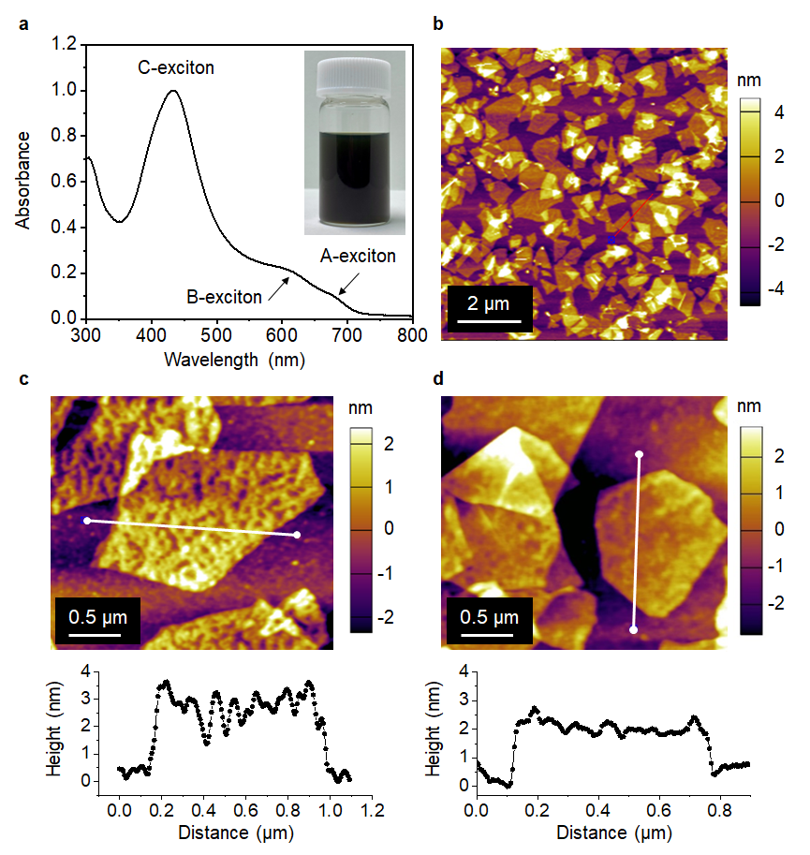
Figure 1. Electrochemical exfoliation and layer-by-layer (LbL) deposition of MoS₂ nanosheets (NSs). (a) Photograph of a colloidal dispersion of electrochemically exfoliated 2H MoS₂ NSs (EC-2H MoS₂ NSs) and UV–vis absorption spectra of a diluted colloidal dispersion. (b) AFM image of EC-2H MoS₂ NSs deposited on a SiO₂/Si substrate via a one-cycle LbL deposition. AFM images and corresponding height profiles for LbL-deposited EC-2H MoS₂ NSs on a SiO₂/Si substrate (c) before and (d) after washing with DMF.

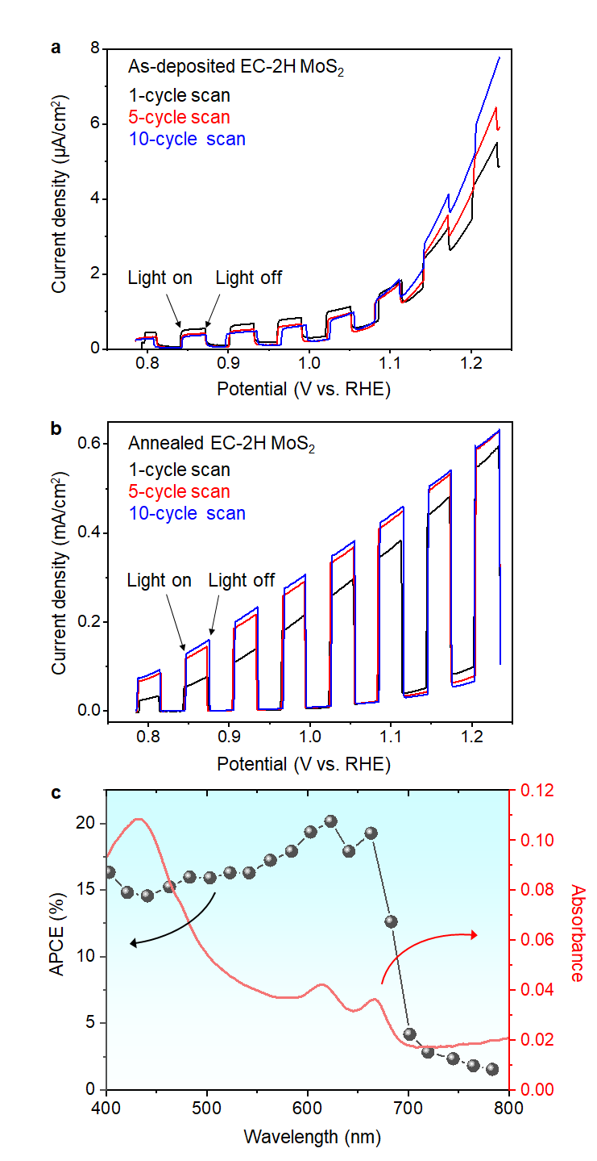
Figure 2. Electrochemical properties of MoS₂ nanosheet (NS)–based photoelectrodes. Current–potential curves of electrochemically exfoliated 2H MoS₂ NS (EC-2H MoS₂ NS) photoanode under visible light irradiation (a) before and (b) after annealing; the plots obtained at the first, fifth, and tenth scans are displayed. (c) Excitation-dependent APCE values and UV–vis absorption spectra of the annealed EC-2H MoS₂ NS photoanode.
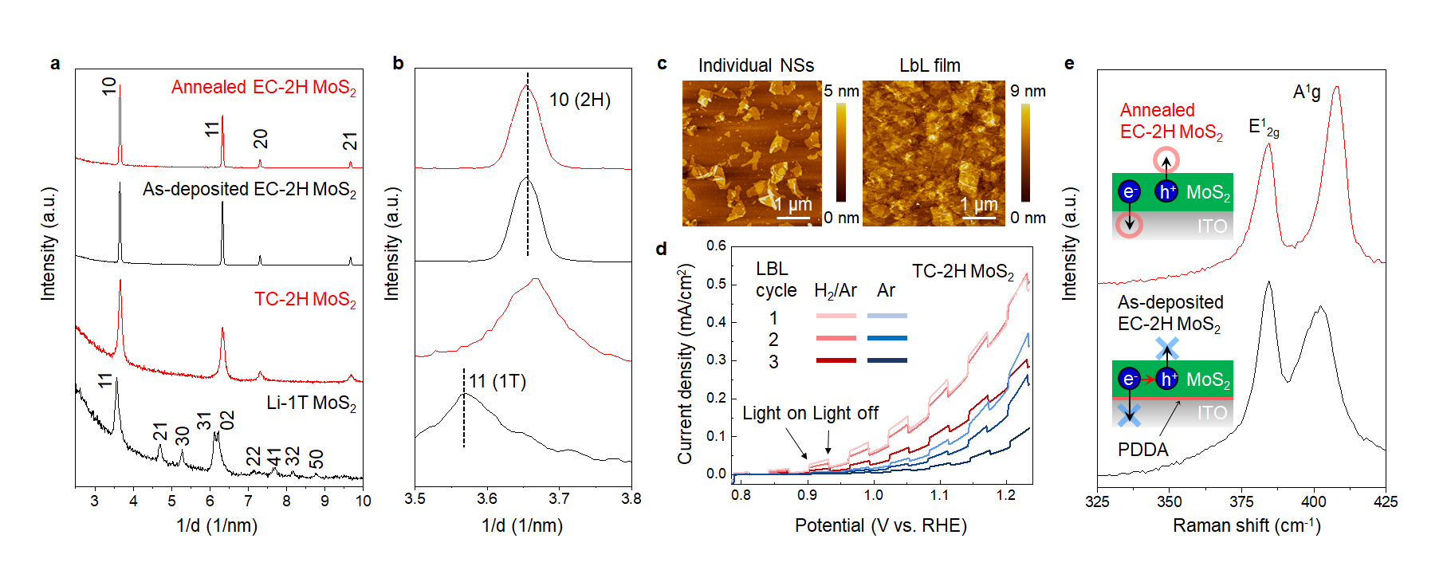Figure 3. Activation mechanism of electrochemically exfoliated 2H MoS₂ nanosheets (EC-2H MoS₂ NSs). (a) Wide-angle and (b) selected-angle in-plane XRD patterns of EC-2H, Li-exfoliated 1T phase (Li-1T), and thermally converted 2H phase (TC-2H) MoS₂ NSs deposited on SiO₂/Si substrates before and after annealing. (c) AFM images of Li-1T MoS₂ NSs deposited on a SiO₂/Si substrate. (d) Current–potential curves of TC-2H MoS₂ photoanode obtained via one-, two-, and three-cycle deposition annealed at 450 °C under Ar or H₂/Ar flow; the plots obtained at the tenth scans are displayed. (e) Raman spectra of EC-2H MoS₂ NSs deposited on a SiO₂/Si substrate before and after annealing. The inserted scheme corresponds to the proposed charge separation and recombination processes before and after annealing.

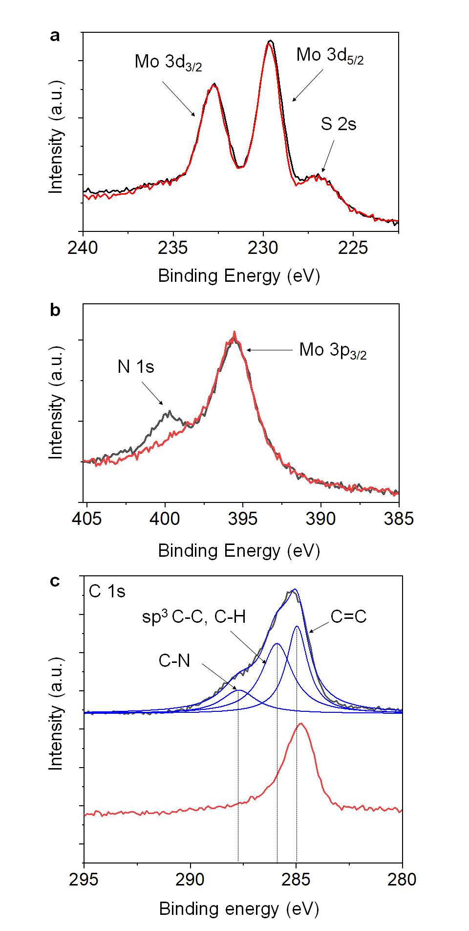
Figure 4. XPS analysis of electrochemically exfoliated 2H MoS2 (EC-2H MoS₂) deposited on SiO₂/Si substrates. (a) Mo 3d, (b) N 1s and Mo 3p_{3/2}, and (c) C 1s XPS spectra. The black and red curves were taken from EC-2H MoS₂ before/after annealing, respectively.

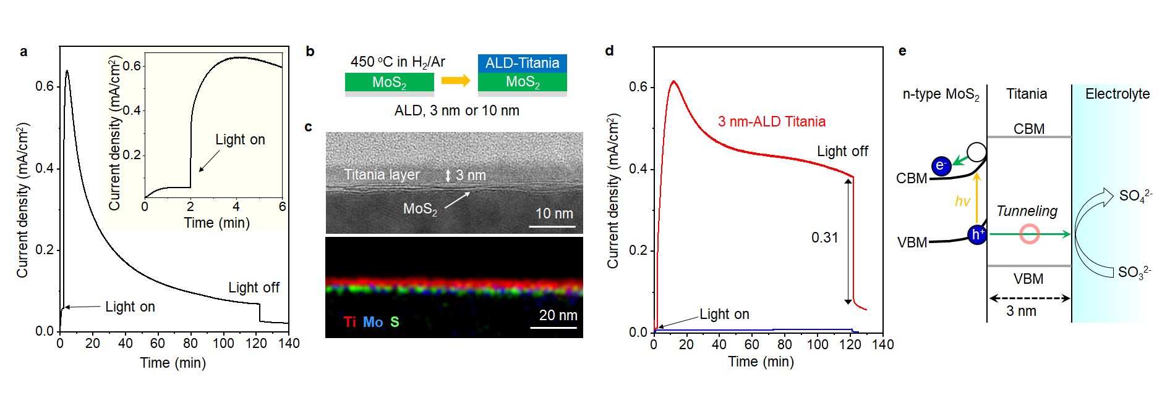
Figure 5. Instability of electrochemically exfoliated 2H MoS₂ (EC-2H MoS₂) photoelectrode and improvement via ALD coating. (a) Chronoamperometry curve of a bare EC-2H MoS₂ photoelectrode measured at 1.2 V vs. RHE. (b) Preparation scheme. (c) Cross-sectional bright-field TEM and TEM–EDX elemental mapping images of 3 nm-thick ALD-titania coated EC-2H MoS₂ photoelectrodes. (d) Chronoamperometry curve of 3 nm- and 10 nm-thick ALD-titania coated EC-2H MoS₂ photoelectrodes measured at 1.2 V vs. RHE. (e) Proposed electron–hole diffusion paths of ALD-titania coated MoS₂.

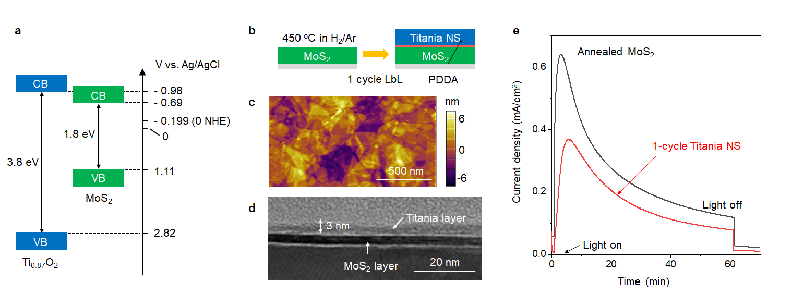
Figure 6. Deposition of Ti_{0.87}O₂ NSs on electrochemically exfoliated 2H MoS₂ (EC-2H MoS₂) photoelectrodes. (a) Energy diagram of EC-2H MoS₂ and Ti_{0.87}O₂ NSs. (b) Preparation scheme, (c) AFM image, (d) cross-sectional bright-field TEM image, and (e) chronoamperometry curve of EC-2H MoS₂ photoelectrodes after one-cycle deposition of Ti_{0.87}O₂ NSs measured at 1.2 V vs. RHE.

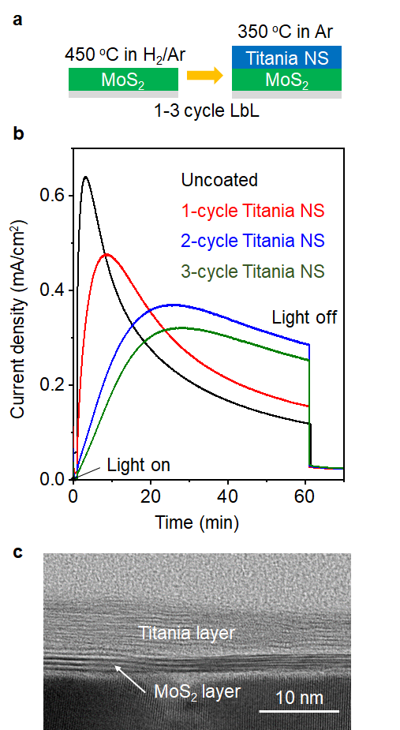
Figure 7. Stabilization of Ti_{0.87}O₂ nanosheet (NS)–deposited electrochemically exfoliated 2H MoS₂ (EC-2H MoS₂) photoelectrodes fabricated via two-step annealing process. (a) Preparation scheme of the two-step annealing process. (b) Chronoamperometry curves of EC-2H MoS₂ photoelectrodes before and after one-, two-, and three-cycle deposition of Ti_{0.87}O₂ NSs followed by annealing at 350 °C under Ar flow. The measurements were conducted at 1.2 V vs. RHE. (c) Cross-sectional bright-field TEM image of EC-2H MoS₂ photoelectrodes after three-cycle deposition of Ti_{0.87}O₂ NSs followed by annealing at 350 °C under Ar flow.

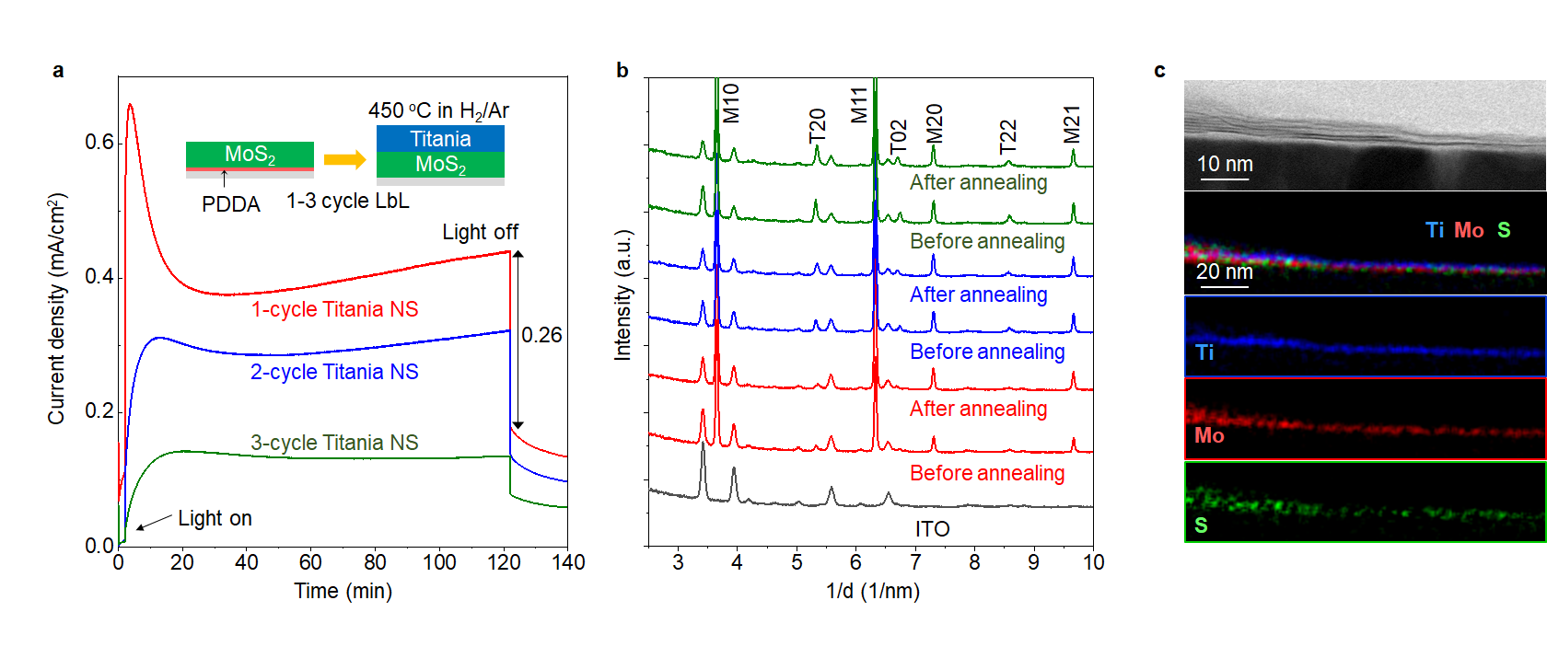
Figure 8. Stabilization of Ti_{0.87}O₂ nanosheet (NS)–deposited electrochemically exfoliated 2H MoS₂ (EC-2H MoS₂) photoelectrodes fabricated via one-step annealing process. (a) Chronoamperometry curve of Ti_{0.87}O₂ NS–deposited EC-2H MoS₂ photoelectrodes fabricated via one-step annealing at 450 °C under H₂/Ar flow. The measurements were conducted at 1.2 V vs. RHE. The preparation scheme is inserted in the figure. (b) In-plane XRD patterns of Ti_{0.87}O₂ NS–deposited EC-2H MoS₂ photoelectrodes before and after one-step annealing. The red, blue, and green lines correspond to the samples with one-, two-, and three-cycle Ti_{0.87}O₂ NS–deposited EC-2H MoS₂ photoanodes, respectively. Intraplane hk reflections from the 2H phase MoS₂ and lepidocrocite Ti_{0.87}O₂ are labeled as M (hk) and T (hk), respectively, while reflections from the substrate are unlabeled. (c) Cross-sectional bright-field TEM and TEM–EDX elemental mapping images of one-cycle Ti_{0.87}O₂ NS–deposited EC-2H MoS₂ photoanode after photoelectrode operation for 2 h.

TOC
