Narrow-Band Emitting Phosphor Na₂Cs₂Sr(B₉O₁₅)₂:Eu²⁺ Discovered from Local Structure Similarity with Sulfate Phosphor
Shota Takemuraª, Yukinori Koyama^{b}, Takayuki Nakanishi^{c}, Shiro Funahashi^{c}, Naoto Hirosaki^{c}, Hidekazu Ikeno^{d}, and Takashi Takeda*^{c}
a. Department of Chemistry, School of Science and Technology, Kwansei Gakuin University, Sanda, Hyogo, 669-1330, Japan.
b. Research and Services Division of Materials Data and Integrated System, National Institute for Materials Science, Tsukuba, Ibaraki, 305-0044, Japan.
c. Luminescent Materials Group, National Institute for Materials Science, Tsukuba, Ibaraki, 305-0044, Japan.
d. Department of Materials Science, Graduate School of Engineering, Osaka Metropolitan University, Sakai, Osaka, 599-8570, Japan.
Corresponding Author
Takashi Takeda, TAKEDA.Takashi@nims.go.jp

ABSTRACT
Narrow-band emitting phosphors are required to improve performance of phosphor-converted light-emitting diodes. Here, we found a new narrow-band emitting phosphor Na₂Cs₂Sr(B₉O₁₅)₂:Eu²⁺ using the local structure similarity with a known narrow-band emitting phosphor. In a 2D scatter plot of the structure dissimilarity between the local structures, Sr site in Na₂Cs₂Sr(B₉O₁₅)₂ was located near the Ba site of the known narrow-band emitting sulfate phosphor BaSO₄:Eu²⁺ with a distorted local structure. We synthesized Na₂Cs₂Sr(B₉O₁₅)₂:Eu²⁺ and characterized the luminescence properties by microspectroscopy. Na₂Cs₂Sr(B₉O₁₅)₂:Eu²⁺ has a violet luminescence peaked at approximately 417 nm and the narrow full width at half maximum is narrow as 26 nm (1497 cm⁻¹).
TOC GRAPHICS
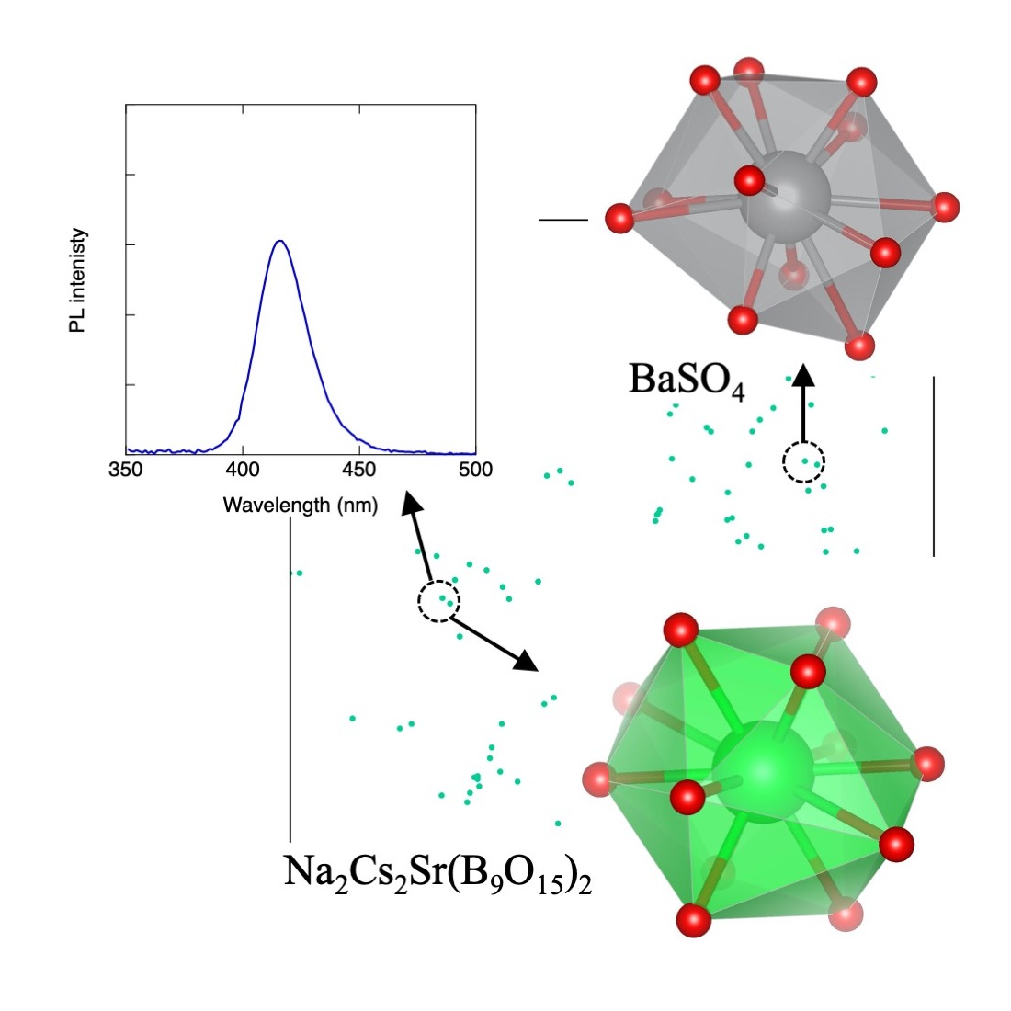
KEYWORDS
Photoluminescence, Crystal structure, t-SNE visualization, Materials informatics, Microspectroscopy

Phosphor-converted light-emitting diodes (pc-LEDs) composed of phosphors and blue LEDs have realized white light with high efficiency and been applied to general lighting and the backlight of liquid crystal display (LCD).^{1,2} The emission properties of phosphors (peak wavelength and full width at half maximum (FWHM)) dominates the spectra of pc-LEDs. To enlarge the color gamut of the display, narrow-band emitting phosphors are necessary.³ Commercial narrow-band emitting phosphors for backlighting are β-SiAlON:Eu²⁺ (Si_{6-x}Al_{z}O_{z}N_{8-z}:Eu²⁺) as a green phosphor⁴⁻⁶ and K₂SiF₆:Mn⁴⁺ as a red phosphor.⁷ An even wider color gamut is necessary to satisfy the BT.2020 standard for 8K televisions. Therefore, much narrower-band emitting phosphors are required.
Because the 5d−4f emission of Eu²⁺ has allowed transition probability and the ground state ⁸S_{7/2} is degenerated with almost no splitting, the emission shows a single peak. Eu²⁺ is suitable as an luminescent center for a narrow-band emitting phosphor. A very narrow-band red emission was observed in the nitride phosphor SrLiAl₃N₄:Eu²⁺.⁸ This phosphor has a UCr₄C₄-type crystal structure⁹, and the local structures of the Sr-sites, which are the substitution sites for Eu²⁺, are similar to a cubic structure. Triggered by the discovery of SrLiAl₃N₄:Eu²⁺, UCr₄C₄-type structure with a cube-like local structure has attracted much attention and new narrow-band emitting nitride, oxynitride, oxide phosphors have been discovered (SrMg₃SiN₄:Eu²⁺, CaLiAl₃N₄:Eu²⁺, Sr[Li₂Al₂O₂N₂]:Eu²⁺, RbLi(Li₃SiO₄)₂:Eu²⁺, RbNa(Li₃SiO₄)₂:Eu²⁺, CsKNaLi(Li₃SiO₄)₄:Eu²⁺).¹⁰⁻¹⁵
It is empirically known that the FWHM of the emission spectrum relates to the local structure around Eu²⁺ in the phosphor. However, the FWHM cannot be explained by ligand-field theory and the ideal local structure with the narrowest FWHM remains theoretically unknown. Data-driven approaches are applied to the exploration of new narrow-band emitting phosphors. Crystal structures having a local structure similar to a local structure of known narrow-band emitting phosphors have been selected from the structure database. Kim et al. selected crystal structures having cube-like local structures by qualitatively screening the crystal structures in Inorganic Crystal Structure Database (ICSD)¹⁶ using cubic structure as a reference local structure.¹⁷. To expand the search area and efficiently discover new phosphors, it is necessary to adopt various local structures as a reference local structure and quantitatively evaluate the similarity between local structures.
We proposed a quantitative dissimilarity measure of local structures in inorganic crystals using the Wasserstein distance, which is often used in data science.¹⁸ In this method, the local structure is defined as a geometric polyhedron consisting of the central ion and its surrounding ligands. The obtained Wasserstein distance between local structures indicates the minimum deformation to change the local polyhedral structure into the other local polyhedral structure. The smaller the Wasserstein distance value, the more similar the structures. We applied this method to the reference local structure of the Ba-site having the flat rectangular structure in BaSi₂O₂N₂:Eu²⁺ (λ_{em} = 535 nm, FWHM = 1920 cm^{–1})¹⁹ and discovered new narrow-band emitting phosphor K₂ZnP₂O₇ :Eu²⁺. The K₂ZnP₂O₇ :Eu²⁺ particle showed blue emission peak at approximately 440 nm with a narrow FWHM of 30 nm (1549 cm⁻¹).²⁰ The flat rectangular structure is on the extension of a cube-like structure. They can be viewed as high symmetry structures. On the other hand, the narrow-band emission is observed from the distorted local structure and the local structure with different coordination number. In the present study, we applied this method to the local structure of the sulfate phosphor BaSO₄:Eu²⁺ as shown in Figure 1(a) and found new narrow-band emitting phosphor Na₂Cs₂Sr(B₉O₁₅)₂:Eu²⁺.
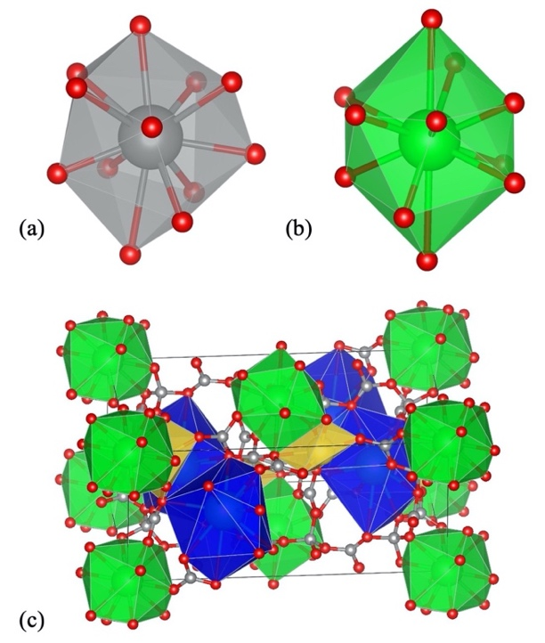
Figure 1. (a) Local structure of the Ba site of BaSO₄. (b) Local structure of the Sr site of Na₂Cs₂Sr(B₉O₁₅)₂. (c) Crystal structure of Na₂Cs₂Sr(B₉O₁₅)₂. Green, Blue, yellow polyhedra are SrO₁₂, CsO₁₂, and NaO₆, respectively. Gray spheres are B, and red spheres are O.

BaSO₄:Eu²⁺ shows narrow-band emission (λ_{em} = 375 nm, FWHM = 1693cm⁻¹).²¹ Eu²⁺ occupies the Ba site in the crystal structure and is coordinated by twelve oxygen atoms. The Ba-O interatomic distances range from 2.790 Å to 3.314 Å and the Ba site has Cs symmetry. The distorted polyhedron is largely different from a cuboctahedron, which has the highest symmetry among the 12-coordinated structure and can be viewed as a representative. Oxide, oxynitride, nitride phosphors are practical LED phosphors. As reference materials, it is not necessary to limit to those materials. Any materials can be reference candidates if they have narrow-band Eu²⁺ emission. Using this structure as a reference local structure, we extracted similar local structures from crystal structures in the ICSD. Some compositions (i.e. metallic compounds) are excluded because they are not suitable as host material. To extract a local structure from a crystal structure, it is necessary to determine the coordination number. The coordination numbers were determined using the CrystalNN method.²² The compositions in which automatic acquisition of the coordination number is difficult are also excluded (i.e. partially occupied crystal structures).
As the substitution site for Eu²⁺, alkali metal (Na, K, Rb, Cs), alkaline-earth metal (Ca, Sr, Ba), rare earth (Y, La, Lu) are selected since the ionic radius of Eu²⁺ is close to those of those ions. From the remaining ionic crystals, 12 coordinated local structures consisting of the central ion and ligands were extracted. The number of extracted local structures are following (Na:98, K:456, Rb:331, Cs:681, Ca:81, Sr:344, Ba:1018, Y:4, La:112, Lu:4). The Wasserstein distance was calculated for all pairs using the SciPy package.²³ Then we visualized the distributions of all the local structures as a scatterplot on a 2-dimensional (2D) plane using the t-distributed stochastic neighbor embedding (t-SNE) method.²⁴ The procedure detail is shown in the previous paper.^{18,20}
Figure 2 shows the scatterplot of all data. Each data point indicates one local structure. If several local structures are extracted from one crystal structure, several points regarding the crystal structure are shown in the scatterplot.

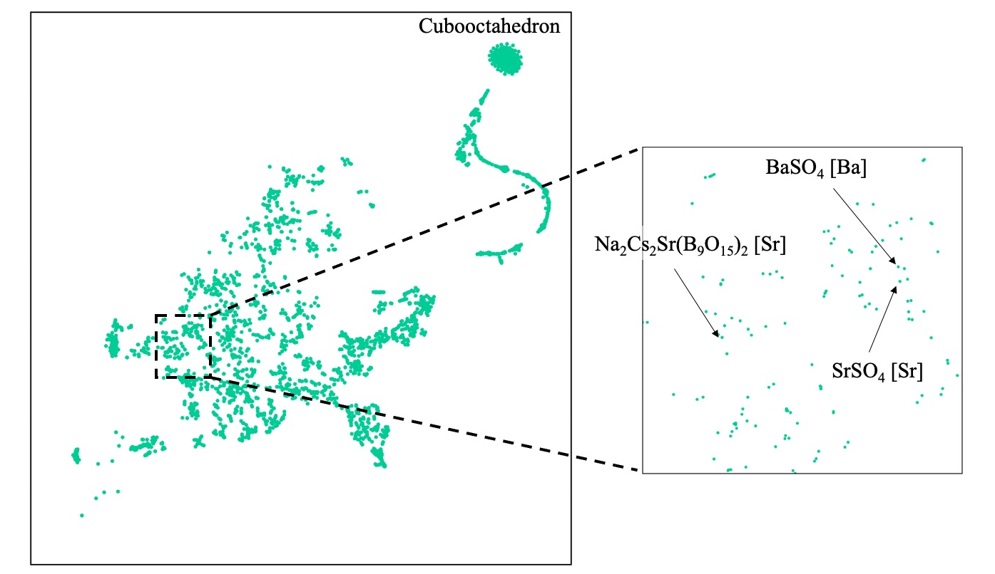
Figure 2. 2D t-SNE plot of 12 coordinated local structures.

At upper right, cuboctahedral structures cluster together. The region in the neighborhood of the reference local structure the Ba site of BaSO₄ is magnified. Because the local structure of the Ba site of BaSO₄ and the Sr site of SrSO₄ are almost identical, they are so closely pointed. Although many points are situated near the Ba site of BaSO₄, most of the crystals having those local structures contain transition metal, radioactive element or toxic element, and they are unsuitable for Eu²⁺ phosphor hosts. On the other hand, the same chemical species occupies several crystallographically different sites in a crystal structure in some crystals. They were also excluded to avoid emission broadening by overlapping from multiple Eu²⁺ sites. The crystal having single substitutional site for Eu²⁺ is preferred for narrow-band emission except for the case multiple sites are resemble as in SrLiAl₃N₄:Eu²⁺.

After eliminating these points, we found the Sr site of Na₂Cs₂Sr(B₉O₁₅)₂ borate²⁵ is positioned near the Ba site. Although there are three possible substitution sites (Na, Cs, Sr) for Eu²⁺ in the structure, Eu²⁺ will preferentially occupy the Sr site from the similarity of ionic radii between Sr²⁺ (r^{VIII} = 1.26 Å) and Eu²⁺ (r^{VIII} = 1.25 Å ).²⁶ The local structure of the Sr site and crystal structure of Na₂Cs₂Sr(B₉O₁₅)₂ are shown in Figure 1b and 1c. Different from the characteristic local structures like cube, it is rather difficult to visually judge the similarity between the Ba site in BaSO₄ and the Sr site in Na₂Cs₂Sr(B₉O₁₅)₂. The quantitative similarity evaluation is very useful. We selected Na₂Cs₂Sr(B₉O₁₅)₂ as a host material for Eu²⁺ narrow-band emitting phosphor.
Na₂Cs₂Sr(B₉O₁₅)₂:Eu²⁺ was synthesized by a solid-state method. Although Na₂Cs₂Sr(B₉O₁₅)₂ was recognized from the powder X-ray diffraction pattern of the powder product, it was contaminated with large amount of impurity phases as illustrated in Figure S1. PL spectrum of the powder product showed narrow violet emission peaked at 417 nm and FWHM of 26 nm (1497 cm⁻¹) excited by 290 nm as illustrated in Figure S2. As the product was a mixture, it is not clear that the observed luminescence is due to Na₂Cs₂Sr(B₉O₁₅)₂:Eu²⁺. Therefore, a violet luminescent particle as shown in Figure 3 was picked up and its crystal structure and PL properties were analyzed.^{27,28}

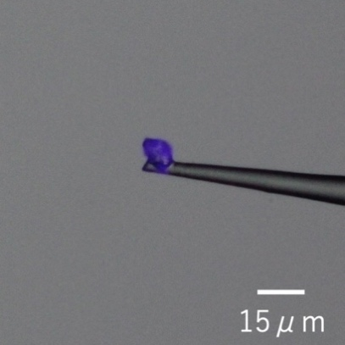
Figure 3. Single particle of the Na₂Cs₂Sr(B₉O₁₅)₂:Eu²⁺ phosphor emitting violet color under UV irradiation.

Single crystal XRD analysis of the particle showed that the crystal structure has a monoclinic unit cell with a=8.4804(3) Å, b=8.5380(3) Å, c=17.2077(5) Å, β=92.487(3)° and P2₁/c space group (No.14). The refined structural parameters are shown in Tables S1 and S2, and they are in good agreement with the literature.²⁵ The emission and excitation spectra of the Na₂Cs₂Sr(B₉O₁₅)₂:Eu²⁺ particle are shown in Figure 4a.
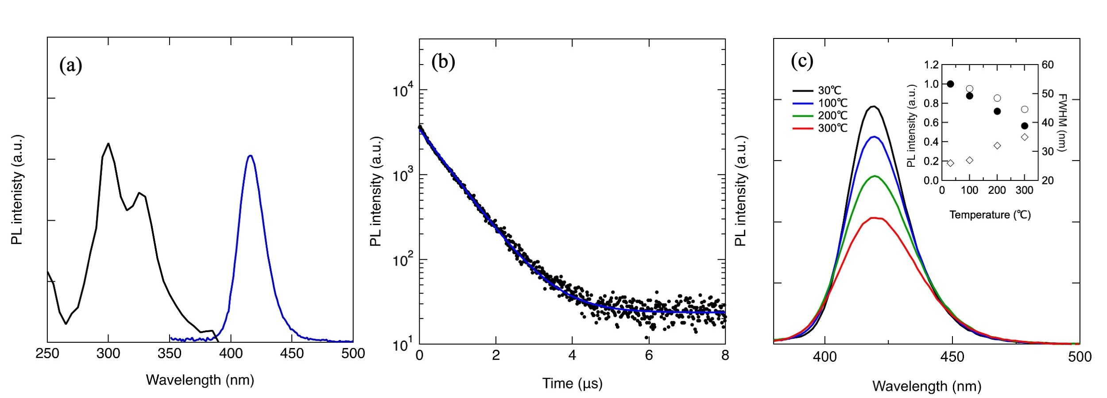
Figure 4. (a) Emission (blue line, λ_{ex} = 297 nm) and excitation (black line, λ_{em} = 417 nm) spectra from a single particle of Na₂Cs₂Sr(B₉O₁₅)₂:Eu²⁺. (b) Observed (black dot) and fitted (blue line) decay curves of one Na₂Cs₂Sr(B₉O₁₅)₂:Eu²⁺ particle upon exciting with 345 nm pulsed light. (c) Temperature dependence of the emission spectra of one Na₂Cs₂Sr(B₉O₁₅)₂:Eu²⁺ particle excited by 370 nm light. The peak intensity (filled circle), integrated intensity (open circle) and FWHM (open square) are shown in the inset.

The emission spectrum had a peak at approximately 417 nm with a FWHM of 26 nm (1497 cm⁻¹). The emission spectrum of the particle was same with the powder result. The narrow-band violet emission is derived from Na₂Cs₂Sr(B₉O₁₅)₂:Eu²⁺. The excitation spectrum spanned from 280-350 nm. The luminescence decay was measured as shown in Figure 4b. It was well fitted by one exponential and background. The decay time was 0.73 μs and corresponds to Eu²⁺ 5d -4f emission. Both narrow-band emission and single exponential decay support that the narrow-band violet emission is due to the single Eu²⁺ site.
The temperature dependence of luminescence is important because the temperature of LED increases during the operation. The temperature dependence of the emission spectra, peak in-tensity and integrated intensity are shown in Figure 4c. The peak intensity decreased with temperature and the peak intensity at 100 °C, 200 °C and 300 °C were 88 %, 72 % and 57 % of the intensity of RT, respectively. In the integrated intensity, they were 95 %, 85 % and 74 % of RT at 100 °C, 200 °C and 300 °C, respectively. While, the FWHM gradually increased with temperature.
In conclusion, we extracted Na₂Cs₂Sr(B₉O₁₅)₂ from ICSD as a host crystal of the Eu²⁺ narrow-band emitting phosphor based on quantitative evaluation of dissimilarity between local structures using the Ba site of BaSO₄ as the reference local structure. From the powder product, we found a violet luminescent Na₂Cs₂Sr(B₉O₁₅)₂:Eu²⁺ particle. It had luminescence peak at approximately 417 nm with the FWHM of 26 nm (1497 cm⁻¹). The FWHM is comparable to other reported well-known UCr₄C₄-type narrow-band emitting phosphors. We used a distorted coordination structure as a reference local structure. By adopting other local structure of known narrow-band emitting phosphor as a reference local structure, new narrow-band phosphor will be discovered. Here we focus on the local structure of the substitution site for Eu²⁺. The emission spectrum is not only determined by the local structure. Other physical/chemical and geometrical parameters can be additional parameters for the discovery of narrow-band emitting phosphors.

EXPERIMENTAL METHODS
Starting materials of NaHCO₃ (Aldrich, 99.7%), Cs₂CO₃ (Kojundo Chemical, 5N), SrCO₃ (Aldrich, 3N), Eu₂O₃ (Shin-etsu Chemical, 3N) and H₃BO₃ (FUJIFILM Wako Pure Chemical, 99.5%) were mixed at a Na:Cs:Sr:Eu:B ratio of 2:2:0.95:0.05:18. The mixture was fired in air at 600 °C and fired again in a tube furnace at 600 °C for 5 hours under a reducing atmosphere (5% H₂/N₂). The product was characterized by powder XRD (Rigaku, Smartlab, Cu Kα₁ radiation) and powder spectrofluorometer (JASCO, FP8600).
The single crystal XRD data of the particle were collected using a diffractometer (Rigaku, XtaLab Synergy-R-custom) with Mo Kα radiation (λ = 0.71073 Å). The data were integrated and corrected for absorption using CrysAlisPro. The crystal structure was solved and refined with SHELX.^{29,30} The excitation and emission spectra of the particle were obtained using a spectrometer (Otsuka electronics, MCPD7700) through a microscope (Olympus, BX51M) under excitation of 150 W Xenon light (Otsuka electronics, QE2100). To obtain the temperature dependence of emission spectrum, the temperature of the particle was controlled from room temperature to 300 °C by a heater stage (Linkam Scientific Instruments, THMS600). The luminescence decay was measured by a streak camera (Hamamatsu Photonics, C14831-110) under excitation of a 365 nm pulsed laser through a microscope (Olympus, BX51M).

ASSOCIATED CONTENT
Supporting Information.
XRD pattern and PL spectrum of the powder product, Crystallographic Data and Atomic Coordinates, Occupancies, and Isotropic Atomic Displacement Parameters of Na₂Cs₂SrB₁₈O₃₀:Eu²⁺

Notes
The authors declare no competing financial interests.

ACKNOWLEDGMENT
This work was supported by JST, the Core Research for Evolutional Science and Technology [JPMJCR19J2].

REFERENCES
- K. Bando, K.; Noguchi, Y.; Sakamoto, K.; Shimizu, Y. Development and Application of High-Brightness white LEDs, in: Tech. Digest. Phosphor Res. Soc. 264th Meeting, November 29, 1996.
- Nakamura, S.; Fasol, G. The Blue Laser Diode: GaN Based Light Emitters and Lasers; Springer, 1997.
- Xie, R. J.; Hirosaki, N.; Takeda, T. Wide color gamut backlight for liquid crystal displays using three-band phosphor-converted white light-emitting diodes. Appl. Phys. Express 2019, 2, 022401.
- Hirosaki, N.; Xie, R. J.; Kimoto, K. Characterization and properties of green-emitting β-SiAlON:Eu²⁺ powder phosphors for white light-emitting diodes. Appl. Phys. Lett. 2005, 86, 211905.
- Wang, Z.; Ye, W.; Chu, I. H.; Shyue, P. O. Elucidating Structure–Composition–Property Relationships of the β-SiAlON:Eu²⁺ Phosphor. Chem. Mater. 2016, 28, 8622-8630.
- Brgoch, J.; Gaultois, M. W.; Balasubramanian, M.; Page, K.; Hong, B. C.; Seshadri R. Local structure and structural rigidity of the green phosphor β-SiAlON:Eu²⁺. Appl. Phys. Lett. 2014, 105, 181904.
- Takahashi, T.; Adachi, S.; Mn⁴⁺-Activated Red Photoluminescence in K₂SiF₆ Phosphor. J. Electrochem. Soc. 2008, 155, E183-E188.
- Pust, P.; Weiler, V.; Hecht, C.; Tücks, A.; Wochnik, A. S.; Henß, A. K.; Wiechert, D.; Scheu, C.; Schmidt, P. J.; Schnick, W. Narrow-band red-emitting Sr[LiAl₃N₄]:Eu²⁺ as a next generation LED-phosphor material. Nat. Mater. 2014, 13, 891-896.
- Behrens, R. K.; Jeitschko, W. Monatsh. Chem. 1987, 118, 43-50.
- Schmiechen, S.; Schneider, H.; Wagatha, P.; Hecht, C.; Schmidt, P. J.; Schnick, W. Toward New Phosphors for Application in Illumination-Grade White pc-LEDs: The Nitridomagnesosilicates Ca[Mg₃SiN₄]:Ce³⁺, Sr[Mg₃SiN₄]:Eu²⁺, and Eu[Mg₃SiN₄]. Chem. Mater. 2014. 26, 2712-2719.
- (11) Pust, P.; Wochnik, A. S.; Baumann, E.; Schmidt, P. J.; Wiechert, D.; Scheu, C.; Schnick, W. Ca[LiAl₃N₄]:Eu²⁺-A Narrow-Band Red- Emitting Nitridolithoaluminate. Chem. Mater. 2014, 26, 3544-3549.
- Gregor J. Hoerder , Markus Seibald , Dominik Baumann , Thorsten Schröder , Simon Peschke ,Philipp C. Schmid , Tobias Tyborski , Philipp Pust , Ion Stoll , Michael Bergler , Christian Patzig ,Stephan Reißaus , Michael Krause , Lutz Berthold , Thomas Höche , Dirk Johrendt , Huppertz Hubert, Sr[Li₂Al₂O₂N₂]:Eu²⁺ - A high performance red phosphor to brighten the future, Nat. Commun. 2019, 10, 1824.
- Zhao, M.; Liao, H.; Ning, L.; Zhang, Q.; Liu, Q.; Xia, Z. Next-Generation Narrow-Band Green-Emitting RbLi(Li₃SiO₄)₂:Eu²⁺ Phosphor for Backlight Display Application. Adv. Mater. 2018, 30, 1802489.
- Liao, H.; Zhao, M.; Zhou, Y.; Molokeev, M. S.; Liu, Q.; Zhang, Q.; Xia, Z. Polyhedron Transformation toward Stable Narrow-Band Green Phosphors for Wide-Color-Gamut Liquid Crystal Display. Adv. Funct. Mater. 2019, 29, 1901988.
- Wang, W.; Tao, M.; Liu, Y.; Wei, Y.; Xing, G.; Dang, P.; Lin, J.; Li, G. Photoluminescence Control of UCr₄C₄‑Type Phosphors with Superior Luminous Efficiency and High Color Purity via Controlling Site Selection of Eu²⁺ Activators. Chem. Mater. 2019, 31, 9200-9210.
- Inorganic Crystal Structure Database (ICSD), FIZ Karlsruhe GmbH, Germany.
- Kim, M.; Singh, S. P.; Lee, J.; W.; Izawa, T.; Kim, D.; Yun, B.; Yoon, C.; Park, W. B.; Sohn, K. S. Identification of a narrow band red light-emitting phosphor using computational screening of ICSD: its synthesis and optical characterization. J. Alloy. Compd. 2019, 774, 338-346.
- Takemura, S.; Takeda, T.; Nakanishi, T.; Koyama, Y.; Ikeno, H.; Hirosaki, N. Dissimilarity measure of local structure in inorganic crystals using Wasserstein distance to search for novel phosphors. Sci. Technol. Adv. Mater. 2021, 22, 185-193.
- Li, Y. Q.; Delsing, A. C. A.; de With, G.; Hintzen, H. T. Luminescence Properties of Eu²⁺-Activated Alkaline-Earth Silicon-Oxynitride MSi₂O_{2-δ}N_{2+2/3δ} (M = Ca, Sr, Ba): A Promising Class of Novel LED Conversion Phosphors. Chem. Mater. 2005, 17 , 3242-3248.
- Takemura, S.; Koyama, Y.; Nakanishi, T.; Funahashi. S.; Hirosaki, N.; Ikeno, H.; Takeda, T. Narrow-band phosphor K₂ZnP₂O₇:Eu²⁺ discovered using local structure similarity, Scr. Mater. 2022, 215, 114686.
- William M. Yen, Marvin J. Weber, Inorganic Phosphors, CRC Press, 2004
- Zimmermann, N. E. R.; Jain, A. Local structure order parameters and site fingerprints for quantification of coordination environment and crystal structure similarity. RSC Adv. 2020, 10, 6063-6081.
- Virtanen, P.; Gommers, R.; Oliphant T. E.; Haberland, M.; Reddy, T.; Cournapeau, D.; Burovski, E.; Peterson, P.; Weckesser, W.; Bright, J.; van der Walt, S. J.; Brett, M.; Wilson, J.; Millman, K. J.; Mayorov, N.; Nelson, A. R. J.; Jones, E.; Kern R.; Larson E.; Carey, C. J.; Polat, İ.; Feng Y.; Moore, E. W.; VanderPlas, J.; Laxalde, D.; Perktold, Josef.; Cimrman, R.; Henriksen, I.; Quintero, E. A.; Harris, C. R.; Archibald, A. M.; Ribeiro, A. H.; Pedregosa, F.; van Mulbregt, P.; SciPy 1.0 Contributors. Scipy 1.0: fundamental algorithms for scientific computing in python. Nat. Methods. 2020, 17, 261-272.
- van der Maaten, L.; Hinton, G. Visualizing Data using t-SNE. J. Mach. Learn. Res. 2008, 9, 2579-2605.
- Chen, X.; Wu, L.; Wang, K.; Chang, X.; Xiao, W. Synthesis and Characterization of a New Quaternary Borate Na₂Cs₂Sr(B₉O₁₅)₂ with the unprecedented [B₉O₁₉]¹¹⁻ group, notation of 3 x (3:2d + T). J. Alloys Compd. 2015, 623, 157–163.
- Shannon, R., Revised Effective Ionic Radii and Systematic Studies of Interatomic Distances in Halides and Chalcogenides. Acta Crystallogr., Sect. A 1976, 32, 751-767.
- Hirosaki, N.; Takeda, T.; Funahashi, A.; Xie, R. J. Discovery of New Nitridosilicate Phosphors for Solid State Lighting by theSingle-Particle-Diagnosis Approach. Chem. Mater. 2014, 26, 4280-4288.
- Takeda, T.; Hirosaki, N.; Funahashi, A.; Xie, R. J. Narrow-Band Green-Emitting Phosphor Ba₂LiSi₇AlN₁₂:Eu²⁺ with High Thermal Stability Discovered by a Single Particle Diagnosis Approach. Chem. Mater. 2015, 27, 5892-5898.
- Sheldrick G. M. SHELXT - Integrated space-group and crystal-structure determination. Acta Cryst. 2015, A71, 3-8.
- Sheldrick G. M. Crystal structure refinement with SHELXL. Acta Cryst. 2015, C71, 3-8.

