Supplementary Material

Unveiling the Effects of Sb or Bi doping on Lattice Strain and Raman spectra in Mg₂Si Single Crystals
Kosuke Shimano¹, Shunya Sakane¹, Takehiro Ota², Kenichiro Takakura², Motoharu Imai³, and Haruhiko Udono^{1*}
¹ Graduate School of Science and Engineering, Ibaraki University, 4-12-1 Nakanarusawa, Hitachi, Ibaraki 316-8511, Japan
² National Institute of Technology (KOSEN), Kumamoto College, Koshi, Kumamoto 861-8081, Japan
³ National Institute for Materials Science (NIMS), 1-2-1 Sengen, Tsukuba, Ibaraki
305-0047, Japan
*E-mail: udono@vc.ibaraki.ac.jp

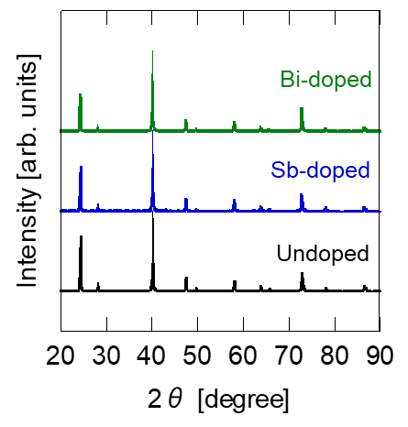
Fig. S1. XRD patterns for undoped, Sb-doped (2%) and Bi-doped (2%) Mg₂Si, showing the full range of diffraction peaks.

Table S1. Rietveld Refinement Results for Sb-doped (2%) Sample
Parameter | Value | Remark
R_{wp} | 14.3% | Weighted profile R-factor
R_{p} | 10.7% | Profile R-factor
R_{exp} | 7.5% | Expected R-factor
χ² | 3.64 | Goodness of fit
S | 1.91 | R_{wp} / R_{exp}
a | 6.3586Å | Lattice constant

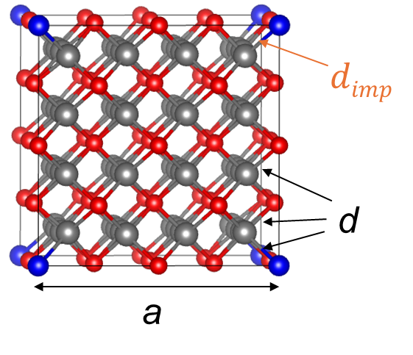
Fig. S2. Definition of parameters in the supercell of Mg₂Si. “a” denotes the overall lattice length, “d” denotes the bond length between neighbors, and “$d_{imp}$” denotes the bond length between the impurity and its nearest neighbors. Red spheres represent Si atoms, gray spheres represent Mg atoms, and blue spheres represent impurity atoms. The crystal structure visualization was generated using VESTA.*

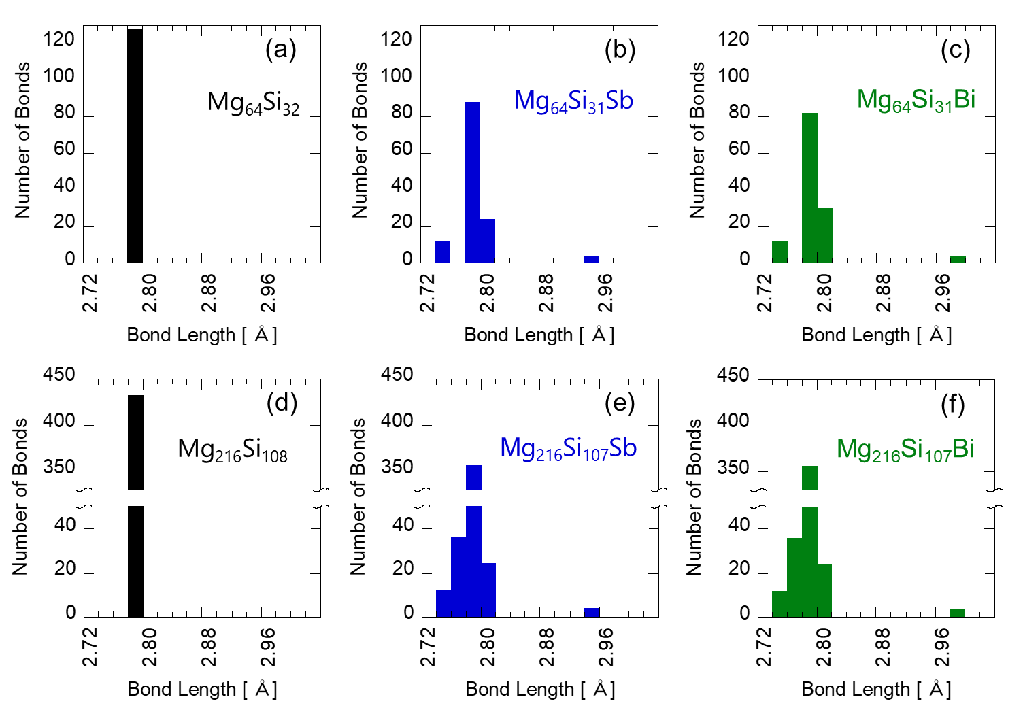
Fig. S3. Histogram of bond lengths “d.” Black represents undoped, blue represents Sb-doped, and green represents Bi-doped. (a)-(c) 2×2×2 supercell, (d)-(f) 3×3×3 supercell.

* K. Momma and F. Izumi, "VESTA 3 for three-dimensional visualization of crystal, volumetric and morphology data," J. Appl. Crystallogr., 44, 1272 (2011).

