Mode Ⅰ–Governed Fracture Energy and Maximum Normal Traction of a CFRP Rod
Yuta Tobataª*, Kimiyoshi Naito^{a,b} and Jonathon Tanksª
ª Research Center for Structural Materials, Polymer Matrix Hybrid Composite Materials Group, National Institute for Materials Science (NIMS), 1-2-1 Sengen, Tsukuba, Ibaraki 305-0047, Japan
^{b} Tohoku University, Department of Aerospace Engineering 6-6-01, Aramaki Aza Aoba, Aoba-ku, Sendai, Miyagi, 980-8579, Japan
Email: yuta.tobata@community.isunet.edu

Abstract
This study develops a double cantilever beam test by using a specific fixture for measuring the representative critical energy release rate of rigid composite rods. Carbon fiber reinforced epoxy composite rod was used for the evaluation. Finite element analysis applying Cohesive Zone Model was used to estimate the relationship between load and displacement. In addition, for verifying the effect of specimen width on the measurement, the representative critical energy release rate was estimated and compared with reference to the crack length measured from the center or outer tip of the crack . The numerical results showed close value to that of experiment. This suggests that an effective representative critical energy release rate can be measured by the proposed method.
Key word
Double Cantilever Beam (DCB), Carbon fiber reinforced Polymer (CFRP), Rod

- Introduction
Steel cables and bars with high tensile strength have been used as reinforcement materials for concrete in conventional bridges and buildings. However, ferrous materials corrode galvanically due to ion permeation in concrete. Thus, carbon fiber (CF)–reinforced composite (CFRP) rods have been considered as an alternative due to being unsusceptible to galvanic corrosion. Many studies have investigated the strength, fracture strain, and elastic modulus of CFRP rods using longitudinal tensile tests [1-3]. These studies reported that the tensile strength and elastic modulus of CFRP rods are comparable to those of steel-based reinforcing materials. Additionally, the chemical stability of carbon fiber means CFRP rods also have superior tensile strength compared to composite rods reinforced with aramid, glass, and basalt fibers in air [4,5] and alkaline environments [6,7].
Ezzeldin et al. investigated the fracture process during tensile testing [3]. Their results showed that the CFRP rods exhibited longitudinal crack propagation between fibers before total failure. A similar fracture phenomenon was also reported by Damiani et al. [8]. However, these results deny the expectation of well-known mode Ⅰ crack propagation behavior, horizontal propagation. Therefore, it is necessary to consider and represent the longitudinal crack propagation behavior aiming for the damage tolerance analysis of macro structure using CFRP rods.
One of useful numerical approaches for representing crack propagation is
cohesive zone model (CZM) [9-14]. The CZM is a method used to represent the kinetic interaction of interface meshes during delamination following a traction–separation law.
One of the traction–separation laws is bilinear law, which is mainly expressed by the critical energy release rate and maximum traction [12]. Papas et al. and Li et al. measured the maximum traction of laminated composites [15,16]. The representative critical energy release rate of basalt/thermoplastic composite rods was investigated in a previous study [17]. The study evaluated the value as separation energy SE_{ⅠC} by conducting a modified DCB test artificially introducing crack into rods and estimated the relation between crack length and cube root of compliance by beam theory.
However, verification of modified method seems to be insufficient for proving its effectiveness. Referring the case of laminates, ASTM D5528 and JIS K7086 recommend to make specimens with enough dimension of the width (20-25 mm). The dimension is thought to sustain the effect of plane stress, and to make stable crack shape, which enables to effectively assume straight crack shape. This assumption allows to evaluate the valid crack propagation area and critical energy release rate. In the case of rods, however, the effect of plane stress possibly affect the calculation of the representative propagation area because of the short width of specimen, while the previous study did not study its geometry effect. In addition, the method fixing specimens to tensile testing machine by bending and grabbing cantilever beams as conducted in the previous study is not applicable for CFRP rods because of its rigidity. A new attachment method is required using fixtures, and verification of its effectiveness.
This study proposed a newly developed method evaluating the representative critical energy release rate for rigid rods. The energy release rate is measured by a modified double cantilever beam test using specific fixtures. For verifying the effectiveness of the proposed method, finite element analysis applying CZM was conducted to estimate the short width effect of a rod on the measurement of the representative critical energy release rate.

2. Materials and Methods
2.1. Materials
Commercial single-wire CFCC rods (Tokyo Rope International Co., Ltd., Japan) were prepared as it used to make the CFRP rod samples. This material is produced by injection molding. Epoxy (EP) resin was used as the matrix. CFCC comprises two layers (CF and polyethylene (PE) fiber), which can affect longitudinal fracture and thus interfere with assessment of the maximum traction and fracture energy of the CFRP rod itself [18]. Therefore, the PE fiber layer was peeled off by hand. Finally, we obtained carbon fiber reinforced epoxy composite (CF/EP) rods as shown in Fig. 1. The diameter of the CFRP rods was 4.5 mm.

2.2. Testing method
Fig. 2 shows the appearance of a modified DCB test specimen and setting. A notch 40 mm long was machined in the center of the specimen using a diamond hole saw with 0.1 mm thickness. Three replicate specimens were prepared for each condition. In our previous study, the upper and lower beams of the DCB specimen were formed by hand bending [17]. However, the CFRP rods have a high longitudinal modulus and are brittle, which makes it difficult to bend and fix the samples to the tensile testing machine (EZ-LX, Shimadzu Co., Ltd., Japan). Thus, aluminum tabs were adhered to the top and bottom surfaces of the rod (Araldite RT30, Nichiban Co., Ltd., Japan). The crosshead was moved until a 4-mm displacement was reached; the crosshead was held for 5 min and then unloaded to 5 N. Afterward, loading→crosshead holding→unloading processes were repeated to increase the maximum displacement by 1 mm in each cycle. The crosshead displacement speed was 1 mm/min. Crack lengths were measured at a linear distance from the end of the rod with a digital microscope (VHX-6000, Keyence Co., Ltd., Japan) during holding.
The longitudinal Young’s modulus, E_{L}, was measured using a tensile testing method in a previous study [17, 19]. Steel pipes (diameter: 20 mm; length: 200 mm) were fixed on the top and bottom of a 500-mm long CFRP rod with an expansion agent (Bristar, Taiheiyo Materials Corporation Co, Japan). Three replicate specimens were prepared. Tensile tests were performed using a universal testing machine (AGX-V, Shimadzu Co., Ltd., Japan) with 1 mm/min crosshead speed. Strain was measured using an extensometer (TRViewX, Shimadzu Co., Ltd., Japan). E_{L} was obtained from the slope of the linear section of the stress–strain curve and was calculated to be 154 ± 10 GPa.
Four replicate specimens were also prepared to measure the transverse tensile modulus E_{T} (Fig. 3). Glass fiber–reinforced plastic (GFRP) jigs were glued on the top and bottom of the CFRP rods (3M™ Scotch-Weld™ Epoxy Adhesive DP460, 3M Co.). A marker and a 5-mm long strain gauge (KFGS-5-120-C1-11, Kyowa Electronic Instrument Co, Japan) were attached to measure the rod displacement. The load was applied with a tensile testing machine (EZ-LX, SHIMADZU Co., Ltd., Japan). The crosshead displacement speed was set at 1 mm/min.

2.3. The FEA model
A 3D one-half axi-symmetrical FEM model of the DCB specimen was created (Fig. 4) using ANSYS mechanical 2022 R1. The Z- and Y-axes were the load and rod length directions, respectively, and the direction of X-axis was orthogonal to that of the Z- and Y-axes. A 100-mm long rod with a radius of 4.5 mm was placed at the center of the model. Aluminum tabs directly bonded with the rod. Three different half tab’s length L_{f} models (3.75 mm, 7.5 mm, and 11.25 mm) were created to verify the effect of the jig dimensions on the estimation of the relation between crack length and cube root of compliance (Fig. 4(a)). The load was applied to the center line of the upper tab in the Z-direction as shown in Fig. 4(b). Remote displacement support was also fixed to the same line so that it does not move in the X and Y direction. The center line of the lower tab was fixed. Since a half-cut model was used, a frictionless support was provided in the X-direction of the cross section. A slit was placed as a notch at the center of the model to be parallel to the X–Y plane. Three different crack length (a) models were created (a=40 mm, 44 mm, and 48 mm) for estimating the relationship between crack length and cube root of compliance. The contact surfaces between double cantilever beams and between tabs were defined as frictionless (Fig.4(b)). The CZM adapted bilinear [11,21] to the interface elements in front of the notch. The augmented Lagrangian algorithm was also adapted to the area. In the bilinear CZM model, inter-laminar stiffness is automatically defined by the algorithm so that intrusion between both contact surfaces is minimized. Thereby, the relation between traction and interface displacement can be defined only by the maximum traction and fracture energy. These parameters were referred from the experimental results (Table 1). A four-node two-dimensional isoparametric element was used in the analysis. Refinement mesh control was adapted to the contact area between a rod and tabs. In addition, the mesh control was also applied to the front region of CZM in 10 mm length. Match control was conducted to the nodes of the contact area applying CZM.

3. Results and Discussion
3.1. Transverse mechanical properties
Fig. 5 shows the observation image of the transverse tensile test specimen after the final failure. When the CFRP rod was finally detached, fibers still adhered to the upper and lower jigs. Fiber bridging was also observed.

The marker distance can be expressed by the following equation:
$∆u_{total}=∆u_{rod}+∆u_{jig}+∆u_{adh}$, | (1)
where Δu_{rod}, Δu_{jig}, and Δu_{adh} are the displacements of the rod, jig, and adhesive, respectively. The thickness of the adhesive is considered negligibly small compared to the distance between the markers and the rod. Therefore, by dividing the displacement Δu_{rod} of the rod by its representative length (diameter D), the strain of the rod was calculated from the following equations:
$$ε_{rod}=\frac{∆u_{total}- ∆u_{jig}}{D}$$ | (2)
$$∆u_{jig}=ε_{jig}∙L_{jig}$$ | (3)
Here, ε_{jig} represents the average value measured by the strain gauges attached to each surface of the GFRP jigs, and L_{jig} represents the length of the section between the markers, except that of the exposed portion of the rod (48 mm). Stress was calculated by dividing the applied load by the representative cross-sectional area (rod-center cross section) using the following equation:
$σ=P/DL_{rod}$, | (4)
where P is the load, and L_{rod} is the rod length (20 mm).
The relationship between stress and strain is shown in Fig. 6. The relationship was almost linear until the stress reached its maximum. Furthermore, cracks did not seem to propagate. Therefore, the apparent transverse modulus E_{T} of the rod was determined by calculating the average slope of the stress–strain curve. E_{T} was measured as 2.6 ± 0.2 GPa. Since delamination did not occur at the GFRP jigs and adhesive interface (Fig. 5), the maximum traction σ_{nt,max} of the rod was considered equal to the maximum stress, which was measured to be 16 ± 3 MPa.

3.2. The DCB test
3.2.1. Load–displacement relationship
Fig. 7(a) shows a typical load–displacement diagram obtained from the DCB test. The relation was nonlinear with increasing displacement. Fig. 7(b) shows the typical relation taken from the second and third cycle. In the begging, the load increased linearly with increasing displacement. However, above a certain load, it showed a nonlinear behavior (32 N). Hereinafter, we call the load “nonlinear start load P_{NL}”. The applied load decreased while the crosshead was held after the maximum displacement. Fig. 7(c) and 7(d) show the in-situ observation images at the crack tip. At point A (7.0 mm) in Fig. 7(b), the relationship between load and displacement is linear, but at point B (7.5 mm), the relationship is nonlinear due to the crack propagation. The crack also had a little inclination to the longitudinal central axis, which may cause over-estimation of the representative fracture energy (Fig. 7(d)). Despite the ductile deformation, the maximum load actually started to show rapid increase when displacement exceeded 9 mm. This is why, hereafter, the load-displacement relation was measured until the displacement reaches 9 mm.

3.2.2. Relationship between crack length and compliance
The relationship between the crack length a and the cube root of compliance C^{1/3} is shown in Fig. 8 with hollow circle plots. C is calculated from the slope of the linear section of the load–displacement curve. The results showed a linear relationship, which can be expressed by the least square method:
$$C^{1/3}=1.0 a+ 0.012$$ | (5)

3.2.3 Separation energy SE_{ⅠC}

In general, the small E_{T} of the rods may cause large deformation during the DCB tests. Therefore, previous studies have defined SE_{ⅠC} as the apparent critical energy release rate [17, 22]. SE_{ⅠC} will be equal to the critical energy release rate if no large deformation occurs. SE_{ⅠC} is expressed by the following Equation [17]:
${SE}_{IC}= \frac{{P_{NL}}^{2}}{2D}\left(3{A_{1}}^{3}a^{2}+6{A_{1}}^{2}A_{0}a+3{A_{1}A_{0}}^{2}\right)$, | (6)
where a is the crack length, and A₁ [×10⁻³/(m²N)^{1/3}] and A₀ [(m/N)^{1/3}] are the experimental constants (A₁ = 1.0, A₀ = 0.012) obtained from Equation (5). P_{NL} is the nonlinear relation start load. Thus, SE_{ⅠC} was calculated to be 1.7 ± 0.5 kJ/m².

3.3. Numerical analysis
3.3.1. Estimation of shear modulus G
Fig. 9 presents the results of the relationship between load and displacement by linear FEA. The material properties are shown in Table 1. The relation showed linear at each crack length conditions. Thereby, compliance was calculated from the slope of the relation.

As a result, the relation between crack length and cube root of compliance was obtained as shown with square plots in Fig. 8. The relation was also estimated by the following equations derived from beam theory (single dotted line in Fig. 8) as conducted in the previous study [17,20]:
$$C^{1/3}=\sqrt[3]{\frac{2}{3E_{L}I}}a+\sqrt[3]{\frac{2}{3E_{L}I}}xd$$ | (7)
$$I=\frac{d^{4}(9π^{2}-64)}{1152π}$$ | (8)
$$x=\sqrt{\frac{1}{15.3}\left(\frac{E_{T}}{G}\right)}{\left[3-2{\left(\frac{Γ}{1+Γ}\right)}^{2}\right]}^{1/2}$$ | (9)
$$Γ=\frac{1}{0.85}\frac{\sqrt{E_{L}E_{T}}}{G}$$ | (10)
where d is the rod diameter, and G is the shear modulus. These estimations showed close inclination. However, the predicted compliance from beam theory was apparently higher than that from FEA over the crack length. For verifying this reason, geometry effects of tabs were investigated by creating models with different tab length (L_{f}). The estimated relations between crack length and cube root of compliance were presented with solid circle, square and rhombic plots in Fig. 8. Decrease of L_{f} represented closer relation to that predicted from beam theory. Consequently, the reason of the higher compliance of beam theory seems to derive from the ignorance of the tabs geometry, particularly the distribution of the tensile loading along the longitudinal rod axis. Therefore, it is necessary to consider real geometry for obtaining the correct relation. In the previous studies [17], shear modulus was estimated by fitting the relation between crack length and compliance. By following this method, shear modulus was estimated to be 0.4 GPa by FEA. Consequently, the relation can be obtained by the least square method:
$$C^{1/3}=1.3 a+ 0.008$$ | (11)

3.3.2. Prediction of crack propagation behavior
Crack propagation behavior was investigated by CZM. The traction–separation law was assumed to be bilinear [11,21]. Table 1 shows the CZM parameters used in the analysis. The maximum traction σ_{nt,max} was obtained from the transverse tensile tests. SE_{IC} was obtained from the DCB tests.
Fig. 10(a) presents a relation between load-displacement curve and crack propagation behavior under the monotonic tensile loading. The relation became nonlinear with increasing displacement. Fig 10(b) and (c) depict normal tensile stress distribution at point A (12N) and B (23 N) respectively. In previous study, crack tip geometry was successfully predicted by referring the distribution [23]. Thereby, this study also predicted the crack geometry as well. In Fig. 10(b), high normal stress areas (red color) were found not only at the front but also at the rear region as indicated with arrows “X”. It seems that some area still bonds. In Fig. 10(c), however, only one high stress area was found as indicated with an arrow. These contours suggest that the formation of crack front geometry totally finished when the applied load reaches P_{NL}.
Fig. 11(a) and (b) describe the load-displacement curve under loading and unloading test of 34 N unload P_{unload} model. The relation showed nonlinear after the load reached 16 N. In unloading, the nonlinear relation was also found. In reloading, P_{NL} is apparently higher than that of the first cycle (16 N). This reason seems to be due to the unstable initial crack shape (slit shape). Fig. 11(c) and (d) presents the crack tip positions in loading and reloading at the P_{unload}. These figures apparently shows crack propagation. Considering P_{unload} is smaller than P_{NL} of reloading, crack propagation should not occur during reloading. Actually, the relation between load and displacement in reloading showed linear until the load reached P_{unload}. Consequently, the crack seems to propagate during the first loading and unloading, and causes a nonlinear load-displacement relation. In other words, the initial crack shape (slit) is thought to cause premature start of crack propagation as shown in Fig. 10(b). This is why it is necessary to refer the load-displacement relation in reloading for evaluating SE_{ⅠC}. As a result, we obtained P_{NL} as described in Table 2.

3.3.3. Short width effect of rods on evaluating SE_{IC}
According to ASTM D5528, the width of specimen is recommended to be 20-25 mm for providing stable stress distribution near the crack tip. However, in this study, the dimension is only 4.5 mm. This geometry possibly causes the large dispersion of measured critical energy release rate affected by the plane stress field near the surface. To elucidate this effect, the crack geometry was predicted by CZM.
Fig. 12 presents normal tensile stress distribution around the crack tip at P_{NL} of reloading with reference to P_{unload}. These contours show curves where crack front projects in center as the leading edge and recedes to the outside. The reason of the crack geometry seems to be due to the dominant in-plane strain field near the center. Front (center) and rear (outside) crack edge lines varied within 0.5 mm. Consequently, we obtained some range of the propagated crack length a’ as described in Table2. Substituting P_{NL} and a’ in Table 2 and Eq. (11) into Eq. (6) provided SE_{ⅠC} (1.79±0.08 kJ/m²: Front line; 1.84±0.09 kJ/m²: Back line). These values were apparently close to the experimental results. In addition, the variation of SE_{ⅠC} in the crack front positions is no more than 3%. Therefore, it is thought that the proposed testing method is effective for measuring the representative fracture energy of the rod shape materials. The previous evaluation method limited the materials that can be fixed to those with low elastic modulus and ease of bending [17]. Hence, the method proposed in this study will encourage to measure SE_{IC} of any composite rod materials.

4. Conclusion

This study newly proposed the evaluation method of the apparent critical energy release rate (defined as separation energy SE_{IC} in this study), for a rigid composite rod (carbon fiber-reinforced epoxy composites) by double cantilever beam test using a specific fixture corresponding to the curved geometry of the rod. Finite element analysis applying CZM was also conducted for verifying effectiveness of the measured SE_{IC} .
The double cantilever beam test showed that the relationship between crack length and compliance can be expressed as a linear approximation. From this relationship, SE_{IC} was determined to be 1.7 kJ/m².

The CZM analysis estimated SE_{IC}, considering the effect of the small width of a rod causing curved geometry of the crack tip. The numerical results showed not only close value to that of experiment but also small dispersion of SE_{IC}. This suggests the effectiveness of proposed method in this study.

Declaration of competing interest The authors declare that they have no known competing financial interests or personal relationships that could have appeared to influence the work reported in this paper.

Acknowledgements This research was promoted by COI program "Construction of next-generation infrastructure using innovative materials ~Realization of safe and secure society that can coexist with the Earth for centuries~ supported by Japan Science and Technology Agency (JST) Grant Number JPMJCE1315.

Data Availability Data sharing not applicable to this article as no datasets were generated or analyzed during the current study.

ORCID
Yuta Tobata https://orcid.org/0000-0003-0730-5934
Kimiyoshi Naito https://orcid.org/0000-0002-3334-4876
Jonathon Tanks https://orcid.org/0000-0002-0232-8240

Reference
[1] Benmokrane B, Xu H, Nishizaki I, Aramid and carbon fibre-reinforced plastic prestressed ground anchors and their field application. Can J Civ Eng 1997; 24: p 698-985.
[2] Zhang B, Benmokrane B, Chennouf A, Mukhopadhyaya P, A. El-Safty, TENSILE BEHAVIOR OF FRP TENDONS FOR PRESTRESSED GROUND ANCHOR. J Compos for Const 2001; 5(2).
[3] Sayed-Ahmed E Y, Shrive N G, A new steel anchorage system for post-tensioning applications using carbon fibre reinforced plastic tendons. Can J Civ Eng 1998; 25: p 113–127.
[4] Benmokrane B, Zhang B, Chennouf A, Tensile properties and pullout behaviour of AFRP and CFRP rods for grouted anchor applications. Const Build Mater 2000; 14: p 157-170.
[5] Quagliarini E, Monni F, Lenci S, Bondioli F, Tensile characterization of basalt fiber rods and ropes: A first contribution. Const Build Mater 2012; 34: p 372-380.
[6] Guo F, Al-Saadi S, Singh R K, Zhao X L, Durability of fiber reinforced polymer (FRP) in simulated seawater sea sand concrete (SWSSC) environment. Corros Sci 2018; 141: p 1-13.
[7] Li Y L, Zhao X L, Singh R K, Mechanical properties of seawater and sea sand concrete-filled FRP tubes in artificial seawater. Const Build Mater 2018; 191(10): p 977-993.
[8] Damiani M, Quadrino A, Nistico N, FRP Cables to prestress RC beams: State of the art vs. a split wedge anchorage system. Buildings 2021; 11, 209.
[9] Barenblatt G I, The mathematical theory of equilibrium cracks in brittle fracture. Adv Appl Mech 1962; 17(1): p 55-129.
[10] Dugdale D S, Yielding of steel sheets containing slits. J Mech Phys Solids 1960; 8(2): p 100-104.
[11] Needleman A, A continuum model for void nucleation by inclusion debonding. J appl Mech 1987; 54(3): p 525-531.
[12] Alfano G, Crisfield M A, Finite element interface models for the delamination analysis of laminated composites: mechanical and computational issues. Int J Numer Methods Eng 2001; 50: p 1701-1736.
[13] Borst R D, Numerical aspects of cohesive-zone models. Eng Fract Mech 2003; 70(14): p 1743-1757.
[14] González C, Lorca J L, Mechanical behavior of unidirectional fiber-reinforced polymers under transverse compression: Microscopic mechanisms and modeling. Compos Sci Tech 2007; 67: p 2795-2806.
[15] Pappas G, Bostsis J, Intralaminar fracture of unidirectional carbon/epoxy composite: experimental results and numerical analysis. Int J Solids and Struct 2016; 85: p 114–112.
[16] Li W, Tang C L, Jiang Z, Huang P, A general strength model for fiber bundle composites under transverse tension or interlaminar shear. Compos A 2019; 121: p 45-55.
[17] Tobata Y., Naito K., Tanks J, Investigation of a critical separation criterion for mode I-Governed fracture of basalt fiber/polypropylene rods via a modified double cantilever beam test. Compos Struct 2022; 279: 114778.
[18] Tanks J D, Sharp S R, Harris D K, Kinetics of in-plane shear degradation in carbon/epoxy rods from exposure to alkaline and saline environments. Compos B 2017; 110: p 204-212.
[19] Tanks J, Naito K, Ueda H, Characterization of the Static, Creep, and Fatigue Tensile Behavior of Basalt Fiber/Polypropylene Composite Rods for Passive Concrete Reinforcement. Polymers 2021; 13(18): 3136.
[20] Williams J G, The fracture mechanics of delamination tests. J Strain Anal Eng Des 1989; 24(4): 207–214.
[21] Material model – Bilinear Behavior, 4.12.1.2., ANSYS, Mechanical APDL Theory Reference release 18.2
[22] Ogawa Y, Naito K, Harada K, Oguma H, Evaluation of crack growth behaviors under Mode I static loading for two-part polyurethane adhesives. Int J Adhes 2022; 117: 103172.
[23] Tobata Y, Naito K, Tanks J, Direct measurement and verification of cohesive zone model parameters for basalt/PP rods using the transverse tensile test and virtual double cantilever beam test. Polym Compos 2023; 44(2): p 954-962.

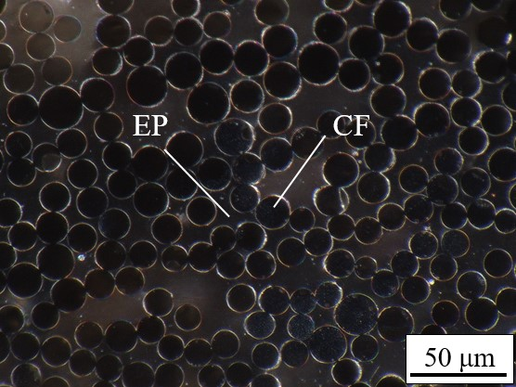
Fig. 1 Cross-sectional image of the CFCC sample

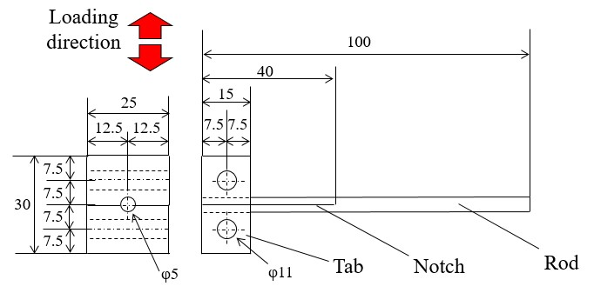
- Dimension of specimen
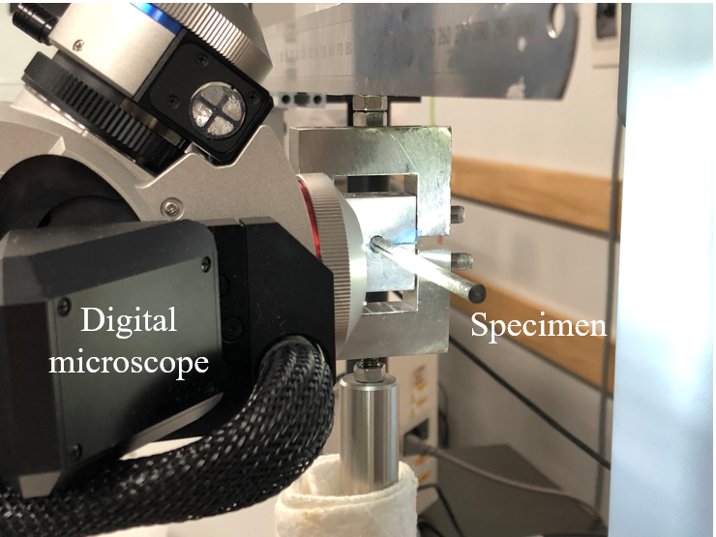
(b) Appearance of test setting
Fig. 2 Test setting of modified DCB test
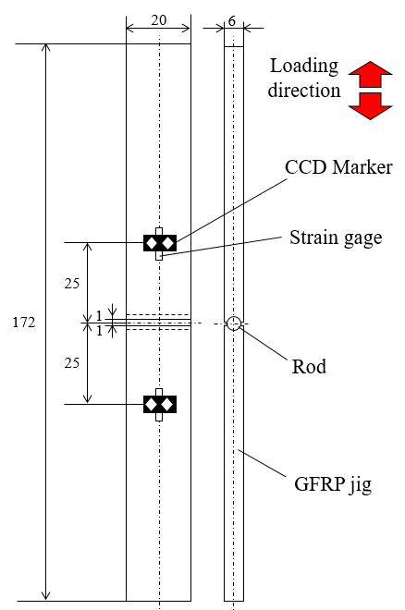 | 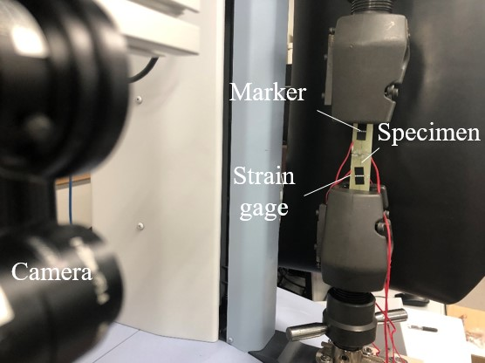
(a) Dimension | (b) Appearance of test setting
Fig. 3 Transverse tensile test setting

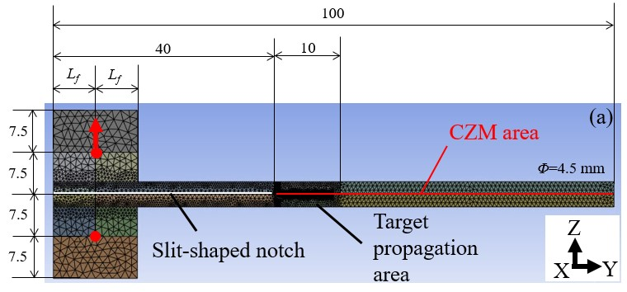
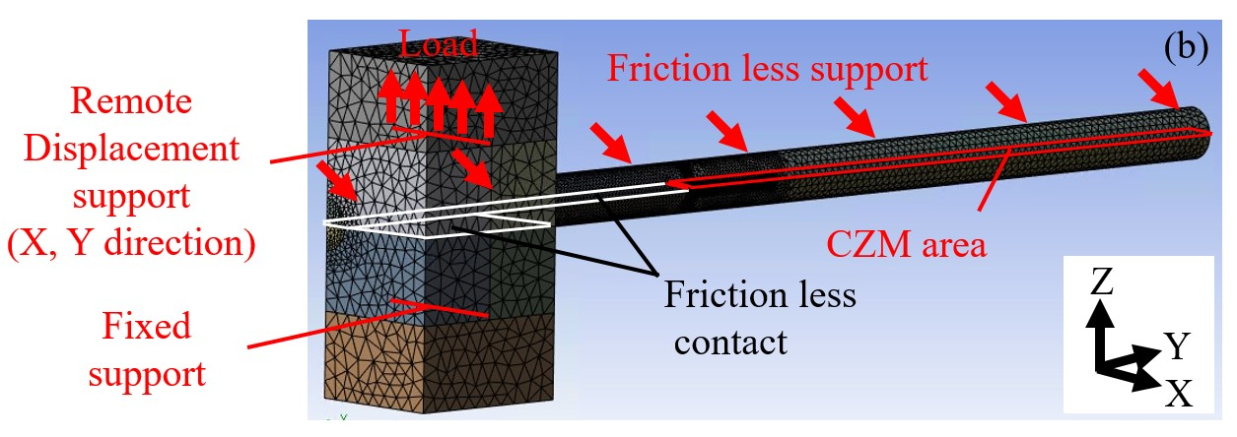
Fig. 4 The FEM material model (a) front view (b) back view

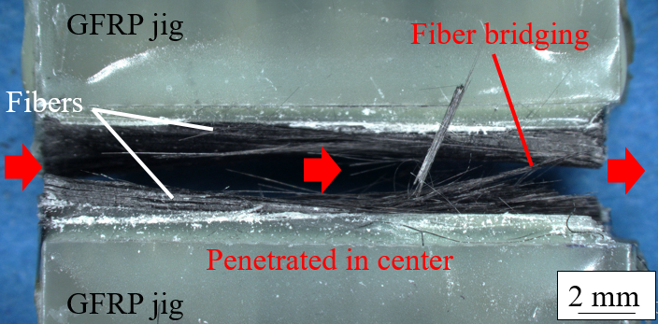
Fig. 5 Digital microscope surface image of the transverse tensile test specimen after fracture

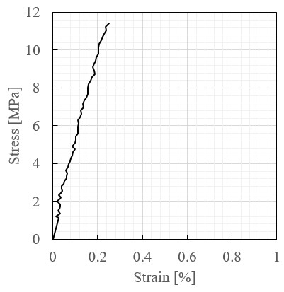
Fig. 6 Stress–strain curve of the transverse tensile test

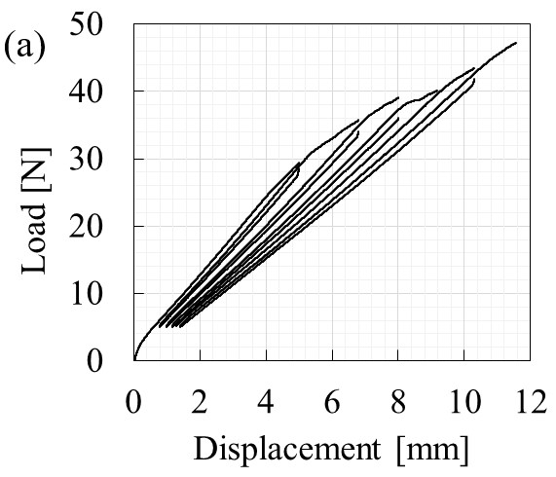 | 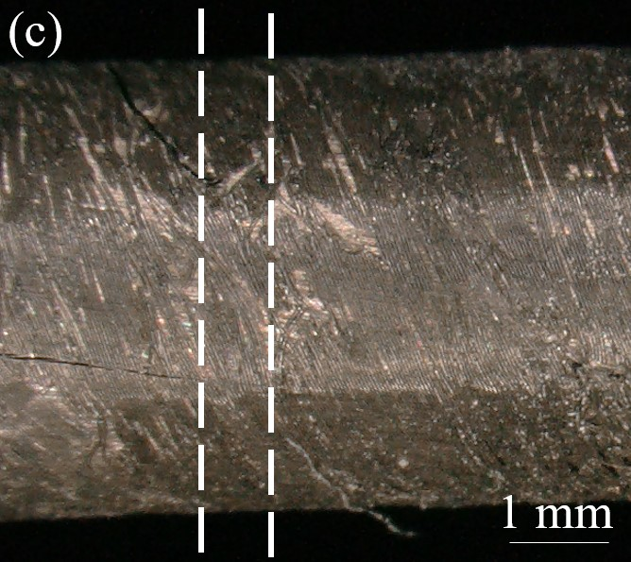
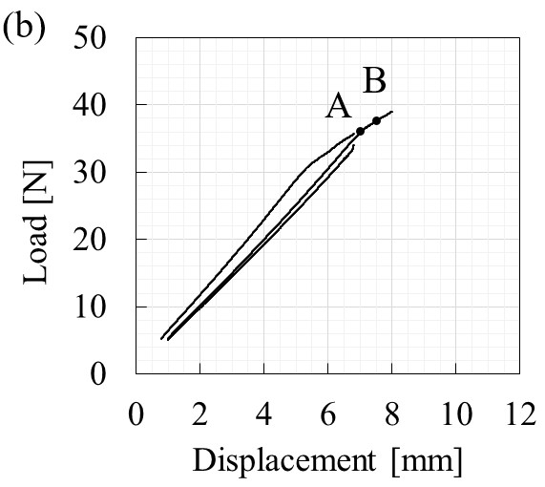 | 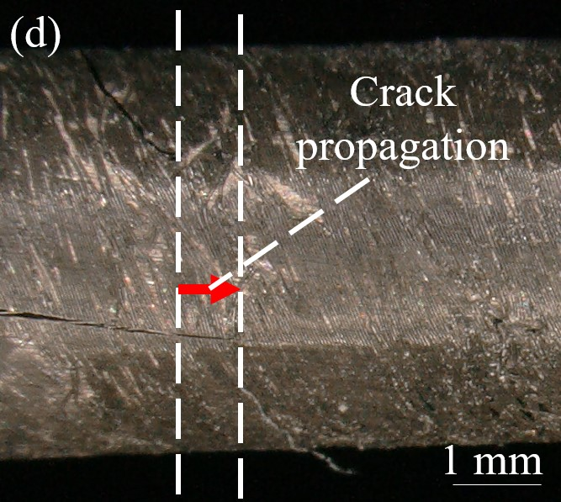
Fig. 7 Typical relationship between the load–displacement curve and crack propagation: (a) Load–displacement curve of all cycles. (b) Load–displacement curve of second and third cycles. (c) In-situ observation image taken at Point A (7.0 mm). (d) In-situ observation image taken at Point B (7.5 mm)

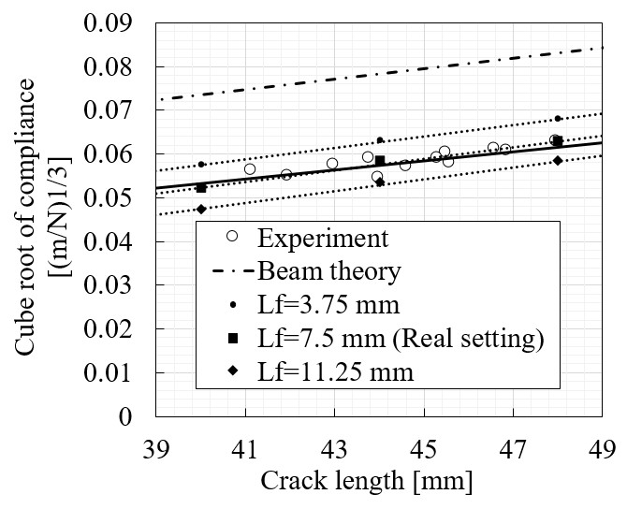
Fig. 8 Relationship between crack length and cube root of compliance

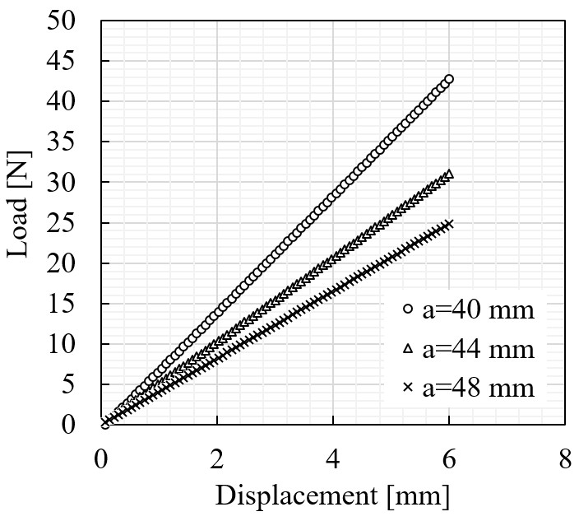
Fig. 9 Relationship between load and displacement estimated by linear finite element analysis

Table 1 Mechanical properties of the FEA
CFCC rod | E_{X} [GPa] | 154
CFCC rod | E_{Y,} E_{Z}[GPa] | 2.6
CFCC rod | G_{XY} ,G_{YZ} ,G_{XZ} [GPa] | 0.4
CFCC rod | ν_{X}, ν_{Y}, ν_{Z} [GPa] | 0.3
CFCC rod | σ_{nt,max} [MPa] | 16
CFCC rod | G_{ⅠC} [kJ/m²] | 1.7
Al tab | E [GPa] | 71
Al tab | ν [GPa] | 0.33

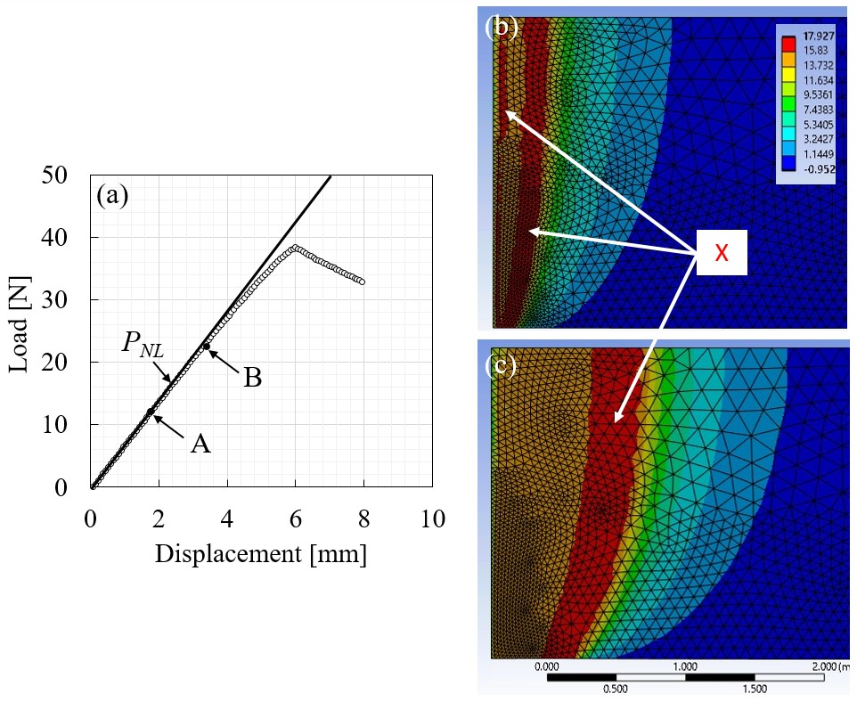
Fig. 10 Relationship between load–displacement curve and crack propagation behavior under monotonic tension predicted by FEA applying CZM (a) Load-displacement curve (b) Normal tensile stress distribution at point A (12 N) (c) Normal tensile stress distribution at point B (23 N)

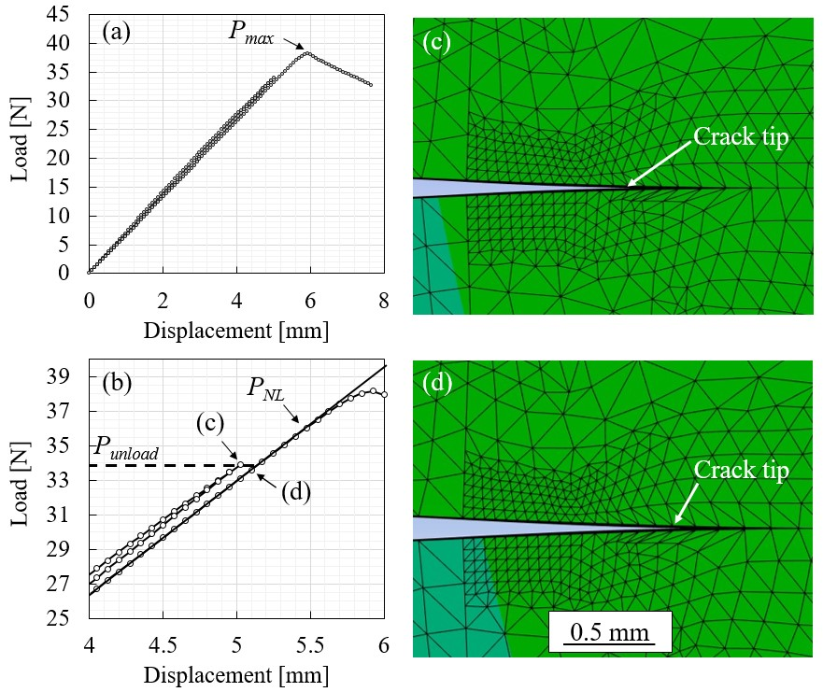
Fig. 11 Relationship between cyclic load–displacement curve and crack propagation behavior predicted by FEA applying CZM (a) Load-displacement curve (b) Magnified image of the load-displacement curve around the P_{unload}. (c) Crack propagation behavior around P_{unload} in the first cycle (c) Crack propagation behavior around P_{unload} in the second cycle
Table 2 Properties obtained by FEA to calculate SE_{ⅠC}
 | P_{unload} [N]
 | 31 | 34 | 36
P_{NL} [N] | 36 | 37 | 37
Propagated crack length a' [mm] | 41.5-42.0 | 42.0-42.5 | 42.8-43.3

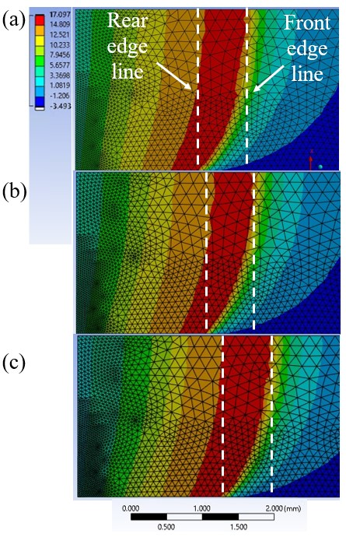
Fig. 12 Normal tensile stress distribution at P_{NL} of each cycle of P_{unload} (a) 31 N (b) 34 N (c) 36 N

