Amyloid-β can form fractal antenna-like networks responsive to electromagnetic beating & wireless signaling
Komal Saxena^{1,2}, Marielle Aulikki Wälti,³ Pushpendra Singh,^{2,4} Pathik Sahoo², Subrata Ghosh⁵, K. S. Daya^{1*}, Roland Riek^{3*}, and Anirban Bandyopadhyay^{2*}
¹Microwave Physics Laboratory; Department of Physics and Computer Science, Dayalbagh Educational Institute, Dayalbagh, Agra-282005, Uttar Pradesh, India.
²National Institute for Materials Science, International Center for Materials Nanoarchitectronics, MANA; and Center for Advanced Measurement and Characterization, RCAMC; 1-2-1 Sengen, Tsukuba, Ibaraki-3050047, Japan.
³Department of Chemistry and Applied Biosciences, ETH Zurich, Vladimir-Prelog-Weg 2, 8093 Zurich, Switzerland
⁴Department of Physics, Amity University, Kant Kalwar, Jaipur, Rajasthan, India
⁵CSIR North East Institute of Science & Technology, Chemical Science & Technology Division, Jorhat-785006, Assam, India
Abstract:
The degraded product of the amyloid precursor protein Aβ and its aggregated fibrils are associated with Alzheimer’s disease. Clathrin protein coats the deposits into vesicles, sort & carry the cargo to the destination, thus, cleans the neural network. Why Clathrin fails to arrest the rapid aggregation is debated. Here, we demonstrate that in contact with a hexagonal-close-packed organic substrate, the Aβ(1-42) fibrils form an electromagnetically responsive fractal superstructure. Using two independent experimental techniques with microwave and laser spectroscopy, we have discovered the electric pulse generating ability (i.e. beating/interference) of the Aβ-fractal networks that fine-tune the Clathrin-mediated disassembly by inducing step-by-step morphogenesis. Fractal antenna network has multiple communication modes; beating is essential to disassemble it. Rapid multi-scale synthesis of antenna-network only in the presence of a typical geometric shape is unprecedented. Our finding shades light on how brain deposits could suddenly outsmart the natural brain cleansing and how we could bypass the rapid propagation of Alzheimer’s.

Keywords: Alzheimer's, Electromagnetic treatment, Amyloid Beta, Clathrin light chain, CLC, Clathrin heavy chain, CHC, Fractal, Microwave, Fabry Perot interferometry.
*Correspondence should be addressed to RR roland.riek@phys.chem.ethz.ch , KSD dayask@gmail.com AB anirban.bandyo@gmail.com

Introduction:
The amyloid beta peptide Aβ, a protease degradation product of the amyloid precursor protein (APP) forms the amyloid fibrils that drives pathological, insoluble, and sticky amyloid-beta plaque, causing Alzheimer’s disease (AD)¹. Aβ fibrils arrange as tubular and paired helical filament-type structure.² Helical symmetry is known as key to a robust self-assembler³⁻⁵ that could organize complex superstructures⁶ from nano-scale to visible centimeters scale. A 10⁶ order growth is often associated with polymorphism, whose molecular origin is C3 symmetry implemented in a $π-$network.⁷ Fibril’s nucleation-dependent polymerization⁸ follows scale free geometries globally, but local variations^{4,9} are profound even in the fibrillar protofilaments.^{10,11} Consequently, the high-resolution cryo-TEM and solid-state NMR¹²⁻¹⁴ showed multiple environment-dependent polymorphisms, $-$reminiscent of a chameleon-like character.^{3,5} Geometry-environment relation of the entangled Aβ fibrils inside the plaques in vivo in Alzheimer’s demand a multi-mode communication.^{9,15} Origin of multi-route pathogenesis that has made Alzheimer's fatally infectious within the brain¹⁶ may lie in its polymorphism²⁻¹⁵ by which the fibrils can trigger a rapid^{8,17} replication⁵ in wide brain regions. The nucleation thereof appears to be an extremely slow process^{18, 19,} but once a ‘seed’ is generated,⁸ the ‘crystallization’²⁰ process appears fatally rapid via multi-channel communication.
Based on the mechanistic nucleation-based polymerization, researchers tried developing a holistic method of disintegrating Aβ plaques or stop their replication. Different approaches like removal of Aβ fibrils or reduce the number of soluble Aβ^{21,22} are not promising yet. Potential drugs turn ineffective on humans even after successful clinical trials on animals.^{23,24} Immunotherapy thereby provides specific targeting against plaques, but it is only able to mitigate progressive plaque burden and prevent further aggregation without improvement in cognition.^{25,26} Non-invasive electromagnetic (EM) therapy²⁷⁻²⁹ is new hope, but why it works is extremely controversial. Our group designed and synthesized nano-engineered intelligent drugs for wireless EM destruction of plaques³⁰⁻³¹, and explored scale-free electromagnetic resonance properties of tubulin, microtubule and its bundle³²⁻³⁴, $-$a key constituent of the plaques. Exposure to a low-frequency EM field (< 300 Hz) increases the risk of Aβ accumulation³⁵. Especially, low level and short term (7-10 days) exposure of microwave at 900 MHz cell phone frequency does not affect cognitive performance.³⁶ However, the same 900 MHz EM exposure on genetically modified Alzheimer’s mice for a longer period (7–9 months) reduced the Aβ deposits and reversed some of the symptoms of AD.^{27, 28} Long term exposure of 1950 MHz for eight months prevented AD in transgenic mice²⁹. Clinical trials of electromagnetic treatment³⁷ show positive results. Despite many experimental evidences of electromagnetically controlled manipulation of Aβ structures²⁷⁻³⁷, there is probably no study of the electromagnetic behavior on the Aβ fractal-like structures²⁻¹⁵. Our experiments reveal here that dilution of Aβ(1-42) and contact of a hexagonal close packed organic substrate naturally triggers the formation of a fractal-antenna-like network. It makes Aβ sensitive to the electromagnetic probes and interference causes pulsed oscillations (beating), which may shed light on the origin of the proposed electromagnetic response and morphogenesis of Aβ plaques in wide brain regions of AD and AD mice.
Clathrin transfers the nutrients within and outside the cells, identifying and deforming the targeted protein, and in eliminating the cell debris by endocytosis and exocytosis³⁸. Here, we present two experimental techniques that independently show the time-dependent disintegration processes of Aβ fibrils by Clathrin light chain (CLC and Clathrin heavy chain (CHC. Their combinatorial role is revisited here using He-ion imaging of time-dependent disintegration of Aβ fibrils. The study reveals that CLC disintegrates Aβ aggregates and CHC alter the structural functionality of Aβ aggregates. The CLC and CHC mixture accelerates the disintegration. During the disassembly of the Aβ fractals, the transmitted power through Aβ and CLC interacting regions revealed spontaneous pulsed oscillations (beating). A self-beating type Fabry-Perot interferometer was customized to observe how fractal feature triggers frequency shifts and increases the frequency bandwidth.
Consequently, entire Aβ fractal-network charges and scatters photons like a conducting surface when shined at 630 nm laser. Addition of both CLC and CHC to the Aβ-fractal network turns it less attenuating, as a 2D sheet of antenna folds into a vesicle. The laser beam reads the beating frequencies when Aβ aggregates interact with two distinct chains of CLC and CHC. If Aβ aggregates cause toxic neuropathological conditions, microwave-induced beating could assist in fine-tuning the CHC-CLC roles in building Clathrin coated pits and the disassembly of plaques.
Result & Discussions:
In a healthy brain, the Aβ peptide aggregates found in a soluble form (oligomers) are continuously cleaned and removed. However, based on the amyloid hypothesis^{39,} the persistent, sticky, and insoluble aggregation of Aβ peptides into plaques materializes directly or indirectly via tau aggregation. For example, synaptic dysfunction, resulting in disruption of signaling between neurons, leading to cell death and the onset of brain shrinkage (compare Figures 1a and 1b). Finally, it leads to progressive dementia & death. Multiple reports on plaques suggest that at the molecular scale, the amyloids form a hierarchical helix², i.e., a helical molecular assembly adopts an additional twist, just like microtubule, DNA, and other bio-filaments. Helical structures are widely used to build antennas. By serendipity, we discovered that on the HOPG like hexagonal close packed surface, a drop of Aβ(1-42) solution forms fractal structure (SI Figure S1). However, if the same Aβ solution, is dropped on a metallic (Au) or a semiconducting surface (Si), then a well-known random mess of plaque fibers appear³⁰. The polymeric surface plays a significant role in lowering the nucleation induction time and growing the crystal faster⁴⁰. The HOPG surface prefers orienting the nanostructure along certain crystal faces^{41, 42} Templating is fundamental to HOPG.
The schematic of Figure 1c shows the fractal structures grown on graphene flakes, and the corresponding He-ion microscopic image is shown below. When CLC and CHC are added to the solution containing flakes, Clathrin coated pit are formed by morphogenesis of the fractal network. It is zoomed in the central image of the schematic of Fig. 1c, enlarged in Figure S1. Finally, these pits fold into vesicles that float and disappear; thus, the area of the pit decreases significantly. A part of the decreased pit area is shown in Figure 1c. The CLC folds the membrane, and CHC joins to build a lattice made of a hexagon and a pentagon, before covering the membrane deposit into a Clathrin coated vesicle. In this work, we investigate the pit to vesicle transformation intricately, making an effort to distinguish the roles of CLC and CHC. In the living environment, two chains work together. In vitro, we could emulate hypothetical situations and monitor the pure systemic response, unlike in vivo.
We pumped the fractal network at around 500 MHz. Then observed beating response at 1000 times higher frequency range using the characterization set up shown in Figure 1d. Normally, beating happens at much lower than the participating signals (~kHz range, here), then why do we place a detector at much higher frequencies? If antenna like fractal structure resonates at frequency υ1 and after a change in its structural symmetry resonates at frequency υ2, two signals interfere. If values of two frequencies are close, an additional pulse signal (with a frequency υ1- υ2) propagates, this is termed as beating signal. Figure 1e shows the Fabry-Perot interferometer, which amplifies the subtle difference in pHz laser signal by 10⁵ times. If shined material shifts laser for microseconds, the output beating signal in the MHz range is inevitable. Measured beating frequencies were repeating as a function of time for all samples. So, we optically pumped the sample during disintegration and monitored pit to vesicle conversion with high sensitivity. These two setups described in Figures 1d and 1e together act as a dual-mode characterization. In one, we monitor molecular scale beating, which reflects the conformational change of fibrils/networks in the presence of CLC and or CHC. In the other (Figure 1e), we monitor orbital level energy exchanges between CHC, CLC, and the helical amyloid fiber. These two methods probe the same event while bringing out two fundamentally different physical aspects.
Live visualization of temporal disintegration of Aβ
The size of Aβ fibrils has been observed from a few nm to hundreds of μm using various techniques⁷⁻¹¹. The star-like structure of fibril aggregates in the 700-nm dimension range is reported by Han et al. using TEM.⁹ Further, DaSilva et al.²⁶ and Gelinas et al.⁴³ captured the images of Aβ distribution in μm scale using a Coolsnap digiting camera mounted to a Zeiss, Axioscope 2 Plus microscope. On the HOPG surface under the He-ion microscope, we found the fractal-antenna like structures of Aβ fibrils of lengths ranging from ∼1 nm to ∼300 μm (SI Figure S1). The structures are strikingly similar to the antenna we find on our mobile phones. High-resolution images and XPS spectrum show a composition of C, H, O which confirmed tubular and paired helical filaments of Aβ fibrils (and no buffer or salt products). Cross-shaped (×) assembly of the paired helical filament of fibrils of different lengths exhibits self-affinity (unequal size-variation in different directions) and self-similarity (object similar to a part of itself). In the living body, graphene-like hexagonal close packing (HCP) materials are abundant, e.g., cell membranes and microtubule surface. By varying the substrate, Aβ fibrils density, and the batch of materials, our data (included in error bar) indicate that the reported random mess of fibrils is due to the surface condition at which the peptide aggregates⁴⁴.

Figure 2 demonstrates the time-dependent dissociation of AβFibril made a cluster of antenna networks. The first column of Figure 2 shows the starting pre-treatment configuration of Aβ(1-42) in the He-ion microscope. The second column shows the additive material, and the third to sixth columns describe a time-lapse of Aβ vesicalization post-treatment. Lapsed time is noted top-right of each figure. The disassembly of Aβ fractal networks were studied in the presence of three elements: (i) CLC (Figure 2a, first row), (ii) sequential treatment of Aβ networks with CHC and CLC (Figure 2b and 2c, second and third row) and (iii) addition of a pre-mixture of CLC and CHC to Aβ fractals (Figure 2d, fourth row). During these transitions, we made sure that the He-ion beam is not exposed to Aβ fractals for longer than 15 seconds. Observations were made at regular time intervals, after 300 seconds of Clathrin addition, which was decided based on the strength of interaction of Clathrin with Aβ fractals. For CLC, observations were made every 20 seconds (Figure 2a), and for CHC, the time interval was 30 seconds (Figure 2b). As reported in the literature describing "pit to vesicle" conversion, the CLC converts Aβ fibrils by folding or geometric morphogenesis of the entire fractal network into a vesicle, as shown in Figure 2a. The rightmost structure of the first row in Figure 2a is the vesicle, which under physiological normal condition forms in vivo, can be easily transported or further disintegrated into smaller vesicles (100 nm-200 nm). The gradual folding of 2D fractal composed of Aβ(1-42) into a hollow spherical shell suggests that during rounding up, the fractal structure dissolves into the perfectly curved upper surface of the sphere, to pinch it off the deposition site. When mixed with CHC, the fractal Aβ network converted into a flake or leaf-like structure (Figure 2b). With time, this flake remained a 2D sheet but changed the organization into different forms. The regularity of the fractal type structure is then broken. The diameter of branches increased from 50 nm to 100 nm, i.e., by 100%, possibly via the addition of CHC, while unlike CLC, the CHC is incapable of building vesicle or pit.

These results resemble the consequences of a similar study⁴⁵, where they have mentioned the obligatory role of CLC for maintaining the triskelion shape (C3 symmetry⁷) and the formation of globular assembly in the absence of CHC. The CHC widened the Aβ branches by 300% after 390 seconds and turned the entire antenna network into a curved flake. As we add CLC in the Aβ flake, the disintegration (the third row of Figure 2c) converts the flake into a nearly hexagonal structure. The time-lapse events for the morphogenesis of flakes show that CLC neutralizes the folding of flake initiated by CHC. This should not happen because CLC is extremely efficient in converting Aβ fractals into a vesicle. When we premix CHC and CLC together in a solution and as 150-180 nm-sized small spheres of Clathrin (CLC+CHC) came into contact with nearly 100 times larger network of Aβ, the hexagonal disk forms again after 300 seconds of mixing and quickly disintegrates within 35 seconds. The conversion of Aβ networks into a hexagonal disc is a unique transformation of CHC+CLC to fold the flat 2D geometry into a solid 3D sphere, as we see in the last images of Figures 2c and 2d. Once the Aβ network forms, adding the mixture of CHC+CLC in any combination or in any sequence fails to convert the pit into a vesicle. Then, Aβ was added further into the mixture of CLC+CHC, and the transformations followed Figure 2d steps.

Figure 2 indicates that if the physical environment is not conducive to CHC+CLC, the only possible treatment route via CHC+CLC would be neutralizing the CHC and canalizing a singular CLC vesicalization, as observed in Figure 2a. It is now imperative to learn how one could artificially communicate with the CHC+CLC combo so that they are instructed meticulously to follow Figure 2a path and not Figure 2b, 2c, and 2d. It is a challenging proposition because in vivo, both the proteins would be co-produced and be co-active.
Spontaneous emergent communication in two distinct time domains:
Since the 1930s, microwave or nanosecond resonant oscillations of proteins are studied regularly⁴⁶. Literature is rich with the oscillation of protein manifested in THz range, whereas the oscillations of larger biomolecule made from proteins manifest in MHz to GHz range^{34, 47, 48}. Repeatedly we observed that if we pump a protein at a particular electromagnetic frequency, e.g., in the kHz domain, the ripple oscillations are triggered in a very wide range of electromagnetic frequencies. For example, Gramse et. al.⁴⁹ measured the near field dipole mobility of the protein-membrane in the frequency range from 3 kHz to 10 GHz, when the signal from 3 kHz to 120 MHz was applied to the sample. Similarly, for studying the spectral response of the Aβ aggregates, here we apply 500 MHz excitations, and Aβ responded from 100 Hz to 6 GHz range. The spectral power density of Aβ aggregates decreased to ~14 pW on mixing with CLC. Due to beating, the transmission power is further reduced to ~5 pW with time. Using a high-resolution frequency window, transmission through the material was captured simultaneously in the entire frequency range for 30 minutes to monitor interactions with Clathrin chains. To avoid unwanted external EM exposure, we kept the solutions inside a multi-layered EM shield kept inside a specially built Faraday cage covered with military-grade EM-absorbing 7-layer composite sheet (SI Figure S2). The schematic and the actual diagram of our experimental setup are shown in Figure 3a. The 3D plot of the average transmitted power spectra of the CLC+Aβ network is shown in Figure 3b. It depicts a gradual decline in the transmitted power through the CLC+Aβ network for 30 minutes. There we two distinct signal bursts from the sample. First ten minutes and the second eighteen minutes after adding CLC with the Aβ network, we find two strong transmissions of the electromagnetic signal through the sample in the two frequency domains (kHz and the 4-GHz range). Since the Aβ network consists of multiple domains of Aβ fibrillar network, each local segment has upper and a lower limits of filament lengths and similarly a distinct band of frequencies. Fibril’s resonance frequency is a function of the spiral’s length, pitch, and diameter, similar to a helical antenna used widely.
In order to investigate the nature of beating or pulsed oscillations, we plot the raw power response of buffer, Aβ fibrils, CLC, and Aβ fibrils + CLC (SI Figure S3a). Then normalized the response with respect to the buffer response (SI Figure S3b). Finally, we zoomed the temporal response at two different frequency ranges (0-1 GHz, SI Figure 3c; and 4.2 GHz to 4.9 GHz, SI Figure 3d). The linear slope of diminishing resonance peaks of the fractal antenna like network suggests a methodical structural change. The 500 MHz input excitation has led to the GHz oscillations by the antenna-like network, such amplification of frequencies is not common in the biomaterial studies. The probe frequency of 500 MHz is primarily chosen from the study on transcranial EM treatment against Alzheimer's disease (AD), where the anti-Aβ aggregation, mitochondrial enhancement, and enhancement in neuronal activity on AD transgenic mice have been observed at 900 MHz frequency.²⁸
The shift in frequency was carefully monitored (SI Table 1). No considerable change in the excitation frequency suggests that the material did not undergo a major change in its dielectric property. The structural symmetry changes but not the dielectric constant. It means oscillation due to the pure form of the material, as found in the initial phase, is retained. After that, upon interaction with CLC, a decrease in the transmitted power of Aβ networks is observed in Figure 3c. It can be attributed to an increase in the sample’s impedance or the dielectric constant. The increase of dielectric constants is primarily due to a decline in the orientational polarization of the molecular entities.⁵⁰ We cannot theoretically simulate the entire fractal structure if we build it using molecules. Therefore, we created a simplified molecular scale version of the fractal antenna network in the CST theoretical simulator and then solved the Maxwell equations to find the electromagnetic resonance band, as shown in Figure 3d. The resonance frequencies at the molecular scale (nm) are 10000 times higher than its fractal network scale (mm-cm). This is expected as longer wavelength fits a larger cavity. The bottom panel of Figure 3d shows the ratio of resonance frequencies obtained theoretically (red) and experimentally (black). The comparison shows a similarity, the ratio of frequencies is around 1. The difference between resonance frequencies for theory and experiments is also similar. Therefore, under electromagnetic pumping, Aβ fibrils have a higher orientational polarization suggesting that one could use electromagnetic pumping in vivo as a treatment in AD to modify CLC activation if fractal antenna-like structures form in the neural network.
The measured excitation peaks of CLC+Aβ network mixture with respect to the buffer at different frequencies are tabulated in SI table 2. Even in table 2, we notice that the transmitted power oscillates. Periodicity confirms the modulation of beating frequency during structural change or morphogenesis (see Figure 2). Therefore, a gradual decline in the response suggests a further disassembly of Aβ networks, when it is pumped at 500 MHz. A part of its resonance energy is transformed into the resonance energy for the elementary spirals of fibrils.
Cooperative beating in laser interferometry:
The microwave spectra were not sensitive to resolve the infinitesimal frequency variations. To analyze the disintegration further, EM antenna was attached to a self-beating type Fabry Perot interferometer. It is a spectrometer since an attached piezo resonator changes the wavelength of the transmission signal to extract several structural symmetries of the antenna-like network as distinct resonance peaks. The schematic and actual setup of the experiment is given in Figure 4a. One of the cavity mirrors was connected to a piezo resonator driven by applying a 10 V at 100 Hz ramp signal, and the intensity of transmitted field and the beating frequency were measured through a photodiode connected to an oscilloscope. Figure 4b shows the measured transmitted field strength. Voltage-time responses of Aβ network, CLC, CHC, and all their possible combinations are also shown in the SI Figure S5a and S5b.
Interestingly, the measured electric field for the Aβ network sample was equal and opposite to the laser reference values. It indicates a highly conducting surface of the Aβ network (SI Figure S1), which acts as a strong reflector or a scatterer. The average transmitted field strengths through the CLC and CHC were positive, with an average value ~100 mV. However, the mixture of CLC+Aβ network and CHC+Aβ network also gave negative and attenuated transmitted field strengths indicating the presence of strong scatterers. The He-ion images of Aβ network indicate that the randomly aggregated ∼1 nm to ∼300 μm fractal-like short chains (SI FigureS1) can potentially act as scatterer for the 630.9 nm wavelength laser. However, Aβ aggregates in the presence of CLC and CHC together had a positive field strength. The CHC and CLC have been shown earlier to clean brain protein deposits by acting in a complementary manner, $-$as demonstrated here too by in vitro measurements (Figure 2).
Here, communication refers to the propagation of a band of frequencies to trigger further self-assembly of fibrils into a new antenna-like net. Figure 5a-d shows that the measured beating frequencies change with time. The plots are a communication profile during morphogenesis of the fractal structures of Aβ through proteins like Clathrin. In Figure 5e, the beat frequency reduces on adding the CLC to the Aβ network. It indicates an increased electrical path length, or the medium is getting denser. The differential shift plots in Figures 5f and 5g reveals the tuning of communication. Figure 5f shows that when CHC is added to the Aβ networks, the beat frequency increases. It indicates the complementary material properties of CLC and CHC. Figure 5g shows a decrease in the beat frequency shifting of the CLC+CHC mixture on adding to Aβ fibril-made antenna-like network. Such a shift in vivo means, CLC and CHC communication could eventually be tuned by electromagnetic waves applied externally to alter or/and control the process of morphogenesis from the fractal network to a vesicle.
Conclusion:
Aβ(1-42) fibrils helical symmetry shares energy with HOPG or graphene surface but not with the Si(111) surface that is HCP at the atomic scale. Molecular scale preference suggests a geometric match, and surface energy triggers the vibrational resonance for the spontaneous formation of the antenna network. Experiments demonstrate that CHC binds the functional specificity of the fractal network while CLC disrupts the structural conformation. Based on these findings, if Aβ causes Alzheimer's via plaques formation, the plaques may adsorb the electromagnetic excitation at 500 MHz as shown by in vitro measurement on Aβ fibrils. Furthermore, in vitro measurements show that the addition of CLC and CHC in concert with electromagnetic stimulation may disaggregate the plaques in vivo. The measurement of Aβ fibrils with a self-heterodyne Fabry Perot interferometer setup revealed beating or pulsating signal generation ability of Aβ networks for the first time. i.e., a network can communicate wirelessly by creating ordered signals from noise. Communication via electric field showed that highly charged conducting surface of Aβ networks turns strong scatterer of light at 630 nm. Beating frequencies ensures that CLC and CHC interact with Aβ differently. If in vivo, the Aβ fibrils build the network like a fractal antenna, it would respond to multiple input frequencies⁵¹. If produced in the presence of cell membrane or microtubule (HCP) highly polar fractal structure of Aβ can be a potential source of EM radiations, transmitting different frequencies depending on the length distribution in a domain. Other fractal networks such as the tau filaments may cause dynamic changes in the property of neurons leading to tauopathy or inter-neuronal functional signaling.^{53,54} Therefore, it appears that understanding the wireless signaling of Aβ fractal structure can give deeper insight to address the question 'what triggers what?' between tau proteins and Aβ.

Materials and methods:
Visualization of extracellular interaction of Aβ, mediated through CLC and CHC using Helium ion microscope: Fractal assembly of Aβ and its interaction with CLC, CHC, and their mixture were imaged by He-ion microscope (Figure 2). To confirm its fractal structure, we made a film of 20 μl of pure Aβ (no buffer is added) on a highly ordered pyrolytic graphite surface (HOPG) several times and observed them. Highly smooth layered poly-crystal surface with rich adsorption and high stability up to 500°C in the air and 2000-3000°C in a vacuum makes the HOPG substrate favorable to biological material. A 20μl solution of Aβ was mixed with 20 μl each of CLC, CHC, or both to study the time-dependent disintegration of Aβ as shown in Figure 2. High-resolution images of them are taken by setting it up at 30kV acceleration voltage and 0.2pA ion beam current.
Experiment at microwave frequency to detect the response of Aβ with CLC and CHC - Figure 3a shows the microwave set up to study the spectral response of Aβ in the GHz region when pumped in with 500 MHz signal using ADF4351 (35 MHz to 4.4 GHz) signal generator. The cylindrical sample holder of diameter 0.5 mm and length 1mm was kept inside the cylindrical shielded cavity and then a Faraday cage for shielding the external ambient electromagnetic radiations. Electromagnetic signals were pumped through a Hertzian probe, and the response of the sample was measured using the spectrum analyzer (NWT 6000 25MHz – 6GHz) from 100 MHz to 6 GHz. The precaution was taken to perfectly align the probes of the transmitter (signal generator) and the receiver (spectrum analyzer) at a coupling distance of ∼1 mm along the longitudinal axis of cylindrical cavity, every time sample was loaded. Power spectrum response of the buffer, Aβ, CLC and Aβ with CLC was measured. 60 μl of sample was loaded in all the cases; CLC and Aβ solutions were taken in 1:2 ratio (Protein solution (1mg/mL) containing 20 mM tris-HCL buffer, pH 8.0, 10% glycerol, 0.2 mM PMSF and 100 mM NaCl). The power spectrum of Aβ and CLC was also measured time resolver (for 30 minutes) to study the interaction response at the microwave frequency range. Data was stored via serial communication. By considering the buffer reading as a reference, responses of all samples were normalized.
Experiment at microwave frequency using Fabry-Perot interferometer set up - Interaction of Aβ with CLC and CHC was also studied at optical frequencies using Fabry-Perot interferometer. The schematic and the experimental setup are shown in Figure 4a. The setup consists of an HP5517C laser head operating at 632 nm, an optical confocal cavity, a photodiode for signal transducing, and a digital oscilloscope for output measurement. The laser head was positioned at the focal plane of the collimating lens. The optical confocal cavity was assembled with a pair of mirrors (mirror 1: >99.5%@633-594nm, mirror 2: anti-reflective AR@633nm) of 7.5 mm diameter each placed 45 mm apart (RoC). The rear mirror was connected to a piezo-disc driven by 10V at 100 Hz ramp signal. The optical signal transmitted from the rear mirror of the optical cavity was transduced to electrical signals using a highly sensitive PIN diode (BPW34) in reverse bias. The signal from the diode was fed to a digital oscilloscope. The 60 μl of the sample was taken in a quartz cuvette, which was kept next to the laser head. Measurements were performed at room temperature (25˚C). Change in electrical potential when Aβ interacts with CLC, CHC, and both is shown in Figure 4b.
Preparation of Amyloid: Disease relevant Alzheimer’s beta (1-42) amyloid was prepared under the conformation-specific monoclonal antibody library of the CGG laboratory. For Protein expression, the plasmid construct containing an N-terminal His-tag followed by a solubility tag (NANP)²² was inserted in Escherichia coli. Additionally, purification was performed based on the method described⁵⁰. The peptide was produced according to the labeling scheme; uniformly 13C, 15N-labeled peptide for the resonance assignment and collection of molecular restraints for the structure calculation by adding ¹³C- and ¹⁵N-labeled peptide in a ratio of 1:1. Further, ¹³C- and ¹⁵N monomers were diluted in unlabelled peptides in a ratio of 1:3.
For fibrillization, the lyophilized material was added to 10 mM NaOH using a sonication bath (three times for 30-sec sonication with 50–60% power, interrupted by 1 min cooling on ice). Further, it was ultra-centrifuged for 1 h at 126,000×g for removing the large aggregates. In order to obtain polymorphism, 100 mM phosphate buffer (pH 7.4) was added to the 150 μM recombinant Aβ (1-42) sample at 37˚C and gently shaking this solution resulted in the fibrillization process.¹³.

References:

- Canter, R.G., Penney, J. & Tsai, L. H. The road to restoring neural circuits for the treatment of Alzheimer's disease. Nature 539, 187-196 (2016).
- Ferrari, A., Hoerndli, F., Baechi, T., Nitsch, R.M. & Götz, J. β-Amyloid induces paired helical filament-like tau filaments in tissue culture. J. Biol. Chem. 278, 40162-40168 (2003).
- Kollmer, M. et al. Cryo-EM structure and polymorphism of Aβ amyloid fibrils purified from Alzheimer's brain tissue. Nat.Commun.10, 1-8 (2019).
- H. Yagi, T. Ban, K. Morigaki, H. Naiki & Y. Goto. Visualization and Classification of Amyloid β Supramolecular Assemblies. Biochemistry, 46, 15009–15017(2007)..
- Greenwald, J. & Riek, R. Biology of amyloid: structure, function, and regulation. Structure 18, 1244-1260 (2010).
- Ghosh S., Dutta M., Ray K., Fujita D. & Bandyopadhyay A., A simultaneous one pot synthesis of two fractal structures via swapping two fractal reaction kinetic states, Phys. Chem. Chem. Phys. 18, 14772-14775(2016).
- Dorca Y., Matern J., Fernández G., Sánchez L. C₃‐Symmetrical π‐Scaffolds: Useful Building Blocks to Construct Helical Supramolecular Polymers. Isr. J. Chem. 59, 869-880 (2019)..
- Harper, J.D., Lieber, C.M. & Lansbury Jr, PT Atomic force microscopic imaging of seeded fibril formation and fibril branching by the Alzheimer's disease amyloid-β protein. Chem.Biol.4, 951-959 (1997).
- Han, S. et al. Amyloid plaque structure and cell surface interactions of β-amyloid fibrils revealed by electron tomography. Sci. Rep. 7, 43577 (2017).
- Serpell L. C., Sunde M., Benson M. D., Tennent G. A., Pepys M. B., Fraser P. E. The protofilament substructure of amyloid fibrils. J. Mol. Biol. 300, 1033-1039 (2000).
- Harper J., Wong S., Lieber C., Lansbury P. Observation of metastable Aβ amyloid protofibrils by atomic force microscopy. Chem. Biol. 6, 119-125 (1997)..
- Riek R. & Eisenberg D. S. The activities of amyloids from a structural perspective; Nature, 539, 227–235 (2016)
- Walti, M.A., Ravotti, F., Arai, H., Glabe, C.G., Wall, J.S., Böckmann, A., Güntert, P., Meier, B.H. and Riek, R. Atomic-resolution structure of a disease-relevant Aβ (1-42) amyloid fibril. Proc. Natl. Acad. Sci. 113, E4976-E4984, (2016)
- Petkova A. T., Ishii Y., Balbach J. J., Antzutkin O. N., Leapman R. D., Delaglio F., & Tycko R.. A structural model for Alzheimer's β-amyloid fibrils based on experimental constraints from solid state NMR. Proc. Natl. Acad. Sci., 99 16742-1674 (2002).
- Schmit, J.D., Ghosh, K. & Dill, K. What drives amyloid molecules to assemble into oligomers and fibrils? Biophys .J. 100, 450-458 (2011).
- Braak, H. & Braak, E. Neuropathological stageing of Alzheimer-related changes. Acta Neuropathol.82, 239–259 (1991).
- Eimer, W.A. et al. Alzheimer's disease-associated β-amyloid is rapidly seeded by herpesviridae to protect against brain infection. Neuron 99, 56-63 (2018).
- Frieden, C. Protein aggregation processes: in search of the mechanism. Protein Science 16, 2334-2344 (2007).
- Lomakin, A., Chung, D.S., Benedek, G.B., Kirschner, D.A. & Teplow, D.B. On the nucleation and growth of amyloid beta-protein fibrils: detection of nuclei and quantitation of rate constants. Proc. Natl. Acad. Sci 93, 1125-1129 (1996).
- Yu, Q., Zhang, Q., Liu, J., Li, C. & Cui, Q. Inductive effect of various seeds on the organic template-free synthesis of zeolite ZSM-5. CrystEngComm 15, 7680-7687 (2013).
- Doody, R. S. et al. Phase 3 trials of solanezumab for mild-to-moderate Alzheimer's disease. New Engl. J. Med. 370, 311-321 (2014).
- Sevigny, J. et al. The antibody aducanumab reduces Aβ plaques in Alzheimer's disease. Nature 537, 50-56 (2016).
- Karran, E. & Hardy, J. A critique of the drug discovery and phase 3 clinical programs targeting the amyloid hypothesis for Alzheimer's disease. Annals Neurol. 76, 185-205 (2014).
- Servick, K. Another major drug candidate targeting the brain plaques of Alzheimer's disease has failed. What's left. Science 10.1126/science.aax4236 (2019).
- Schenk, D. et al. Immunization with amyloid-β attenuates Alzheimer-disease-like pathology in the PDAPP mouse. Nature 400, 173-177 (1999).
- DaSilva, K.A., Brown, M.E., Westaway, D. &McLaurin, J. Immunization with amyloid-β using GM-CSF and IL-4 reduces amyloid burden and alters plaque morphology. Neurobiol. Dis. 23, 433-444 (2006).
- Dragicevic, N. et al. Long-term electromagnetic field treatment enhances brain mitochondrial function of both Alzheimer's transgenic mice and normal mice: a mechanism for electromagnetic field-induced cognitive benefit? Neurosci. 185, 135-149 (2011).
- Arendash, GW et al. Electromagnetic field treatment protects against and reverses cognitive impairment in Alzheimer's disease mice. J. Alzheimer's dis. 19, 191-210 (2010).
- Ji Jeong, Y. et al. 1950 MHz electromagnetic fields ameliorate Aβ pathology in Alzheimer's disease mice. Curr. Alzheimer Res.12, 481-492 (2015).
- Ghosh, S. et al. Resonant oscillation language of a futuristic nano-machine-module: eliminating cancer cells & Alzheimer Aβ plaques. Curr. Top. Med. Chem. 15, 534-541 (2015).
- Ghosh, S. et al. In-vivo & in-vitro toxicity test of molecularly engineered PCMS: A potential drug for wireless remote controlled treatment. Toxicol. Rep. 5, 1044-1052 (2018).
- Sahu, S., Ghosh, S., Fujita, D. & Bandyopadhyay, A. Live visualizations of single isolated tubulin protein self-assembly via tunneling current: effect of electromagnetic pumping during spontaneous growth of microtubule. Sci. Rep.4, 7303 (2014).
- Sahu, S. et al. Atomic water channel controlling remarkable properties of a single brain microtubule: correlating single protein to its supramolecular assembly. Biosens. Bioelectron. 47, 141-148 (2013).
- Komal Saxena, Pushpendra Singh, Pathik Sahu, Satyajit Sahu, Subrata Ghosh, Kanad Ray, Daisuke Fujita and Anirban Bandyopadhyay; Fractal, scale free electromagnetic resonance of a single brain extracted microtubule nanowire, a single tubulin protein and a single neuron, Fractal and Fractional, 4, 11(2020). https://doi.org/10.3390/fractalfract4020011..
- Sobel, E. et al. Occupations with exposure to electromagnetic fields: a possible risk factor for Alzheimer's disease. Amer. J. Epidemiol. 142, 515-524 (1995).
- Sienkiewicz, Z.J., Blackwell, R.P., Haylock, R.G., Saunders, R.D. & Cobb, B.L. Low‐level exposure to pulsed 900 MHz microwave radiation does not cause deficits in the performance of a spatial learning task in mice. Bioelectromagnetics 21, 151-158 (2000).
- Arendash, G. et al. A Clinical Trial of Transcranial Electromagnetic Treatment in Alzheimer's Disease: Cognitive Enhancement and Associated Changes in Cerebrospinal Fluid, Blood, and Brain Imaging. J. Alzheimer's Dis.71, 57-82 (2019).
- Schmid, S.L. Clathrin-coated vesicle formation and protein sorting: an integrated process. Annu. Review Biochem. 66, 511-548 (1997).
- Selkoe DJ, Hardy J. The amyloid hypothesis of Alzheimer's disease at 25 years. EMBO Mol Med. 2016; 8),595-608. Published 2016 Jun 1. doi:10.15252/emmm.201606210
- Diao Y., Myerson A. S., Hatton T. A. & Trout B. L. Surface design for controlled crystallization: the role of surface chemistry and nanoscale pores in heterogeneous nucleation. Langmuir 27, 5324–5334 (2011).
- Takenaka Y., Miyaji H., Hoshino A., Tracz A., Jeszka J. K. & Kucinska I. Interface structure of epitaxial polyethylene crystal grown on HOPG and MoS₂ substrates. Macromolecules 37, 9667–9669 (2004).
- Kim D. W., Kim S. J., Choi H. O. & Jung H.‐T. Epitaxial crystallization behaviors of various metals on a graphene surface. Adv. Mater. Interfaces, 3, 1500741 (2016). DOI: 10.1002/admi.201500741
- Gelinas, D.S., DaSilva, K., Fenili, D., George-Hyslop, P.S. & McLaurin, J. Immunotherapy for Alzheimer's disease. Proc. Natl Acad. Sci. 101, 14657-14662 (2004).
- Silvia Campioni, Guillaume Carret, Sophia Jordens, Lucrèce Nicoud, Raffaele Mezzenga, and Roland Riek; The Presence of an Air–Water Interface Affects Formation and Elongation of α-Synuclein Fibrils; J. Am. Chem. Soc. 136, 2866-2875 (2014); DOI: 10.1021/ja412105t.
- Chu, D.S., Pishvaee, B. & Payne, GS. The light chain subunit is required for clathrin function in Saccharomyces cerevisiae. J. Biol. Chem. 271, 33123-33130 (1996).
- Zein, I., Wyman, J. Studies on the dielectric constant of protein solutions. J. Biol. Chem. 76,443–476 (1931).
- Fröhlich, H. Long-range coherence and energy storage in biological systems. Int.J. Quant. Chem.2, 641–649 (1968).
- Saxena, K., Kumar, M., Daya, KS & Bandyopadhyay, A. Detection of Milimeter Wave Properties of Beta Amyloid using Dielectric Filled Truncated Cylindrical Waveguide. In 2019 URSI Asia-Pacific Radio Science Conference (AP-RASC) IEEE, 1-4 (2019).
- Gramse, G., Schönhals, A. & Kienberger, F. Nanoscale dipole dynamics of protein membranes studied by broadband dielectric microscopy. Nanoscale 11, 4303-4309 (2019).
- Harris, F.E. & Alder, B.J., Dielectric polarization in polar substances. J. Chem. Phys. 2, 1031-1038, (1953).
- Krzysztofik, W.J., Fractals in Antennas and Metamaterials Applications. Fractal Analysis-Applications in Physics, Engineering and Technology, F. Brambila (ed.), Published by INTECH Open Science, Rijeka, Croatia, Print ISBN, 978-953 (2017).
- https://newsnetwork.mayoclinic.org/discussion/mayo-clinic-researchers-find-way-to-prevent-accumulation-of-amyloid-plaque-a-hallmark-of-alzheimers-disease/
- Walti, M.A., Orts, J., Vögeli, B., Campioni, S. and Riek, R. Solution NMR Studies of Recombinant Aβ (1-42): From the Presence of a Micellar Entity to Residual β‐Sheet Structure in the Soluble Species. ChemBioChem 16,.659-669, (2015).

Figure 1:
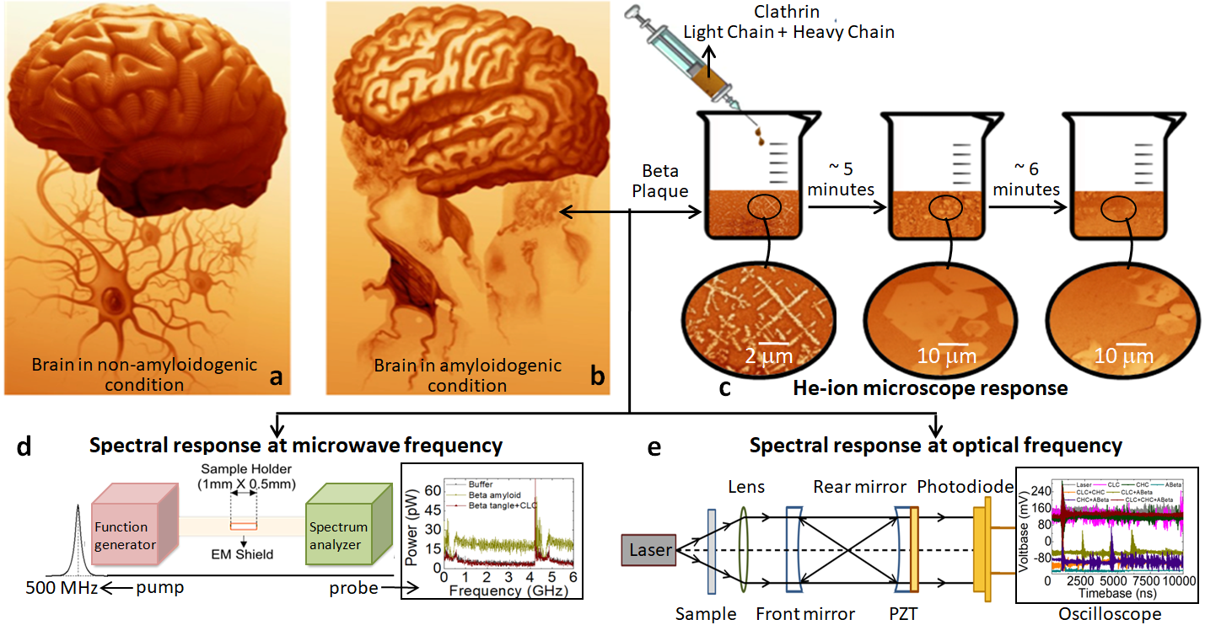
Figure 1: Schematic for the disintegration of Aβ and experimental set ups: (a). & (b). The difference in neural networks in the brain under the non-amyloidogenic and the amyloidogenic conditions (re-created images⁵²) is reflected in the shrinking brain. (c). Schematic view of Clathrin-mediated in-vitro disintegration protocols of Aβ (extracellular conditions), along with the images of antenna-like network captured using a He-ion microscope (enlarged in Figure S1). (d). Schematic of experimental set up for a microwave study. Measuring cavity is the dotted box in the middle where the time-lapse spectral response of Aβ+CLC is measured. Spectrum analyzer (green, right) operates from 100 Hz to 6 GHz while Aβ structure is pumped at 500 MHz (pink, left; 10³ orders gap between pump and probe). Inset shows transmitted power spectra (S21) as a function of frequency. (e). The experimental set up (modified Fabry Perot interferometer) for measuring the spectral responses (current flash in diode is the spectral response shown in the inset) of Aβ, Clathrin, and their combinations using a monochromatic optical laser, 633 nm (ThorLabs commercial set up).

Figure 2:
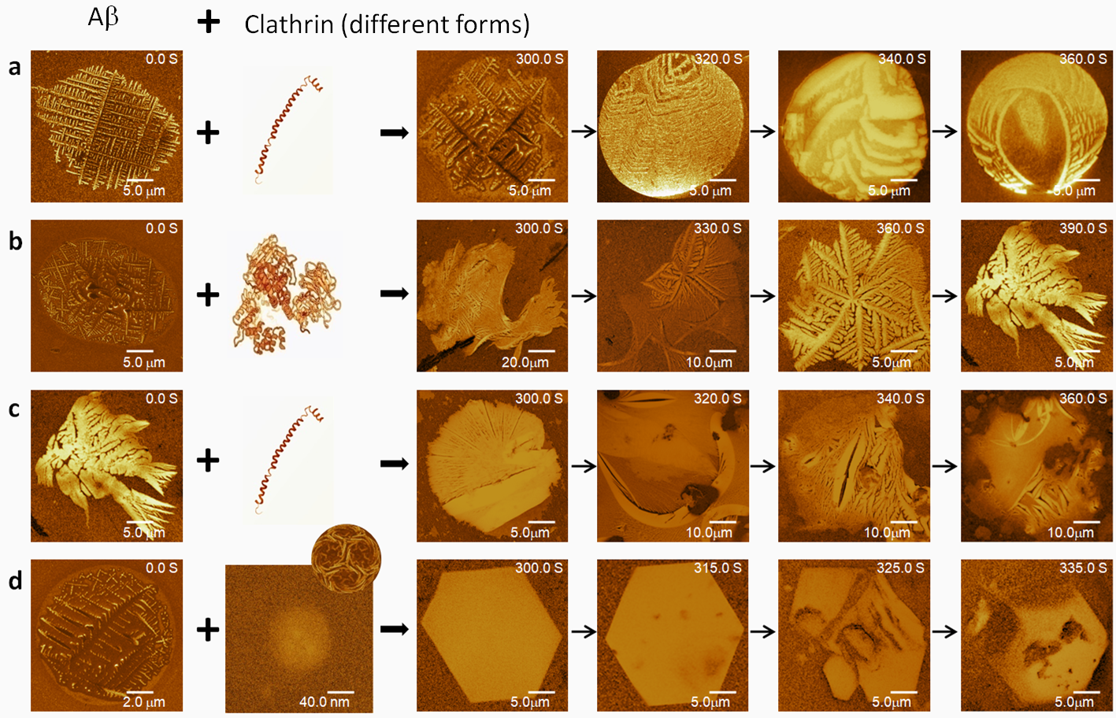
Figure 2: He-ion microscopic visualization of the influence on the Aβ state by the presence of Clathrin Light Chain (CLC) and Clathrin Heavy Chain (CHC): For all images 30 kV acceleration voltage and 0.2 pA ion beam current was kept fixed in the He-ion microscope. (a). The Aβ plaque was mixed with CLC, and the process of disintegration was studied after 300 sec. of adding CLC into the Aβ sample time-resolved, at a regular interval of 20 sec. with dwell time varying from 10 μs at 300 sec. to 0.5 μs at 360 sec. (b). The disintegration of Aβ with CHC from 300 sec. after mixing at a regular time interval of 30 sec. with a dwell time of 30 μs. (c). Disintegrated Aβ with CHC in step (b) was mixed with CLC and was imaged after 300 sec. at an interval of 20 sec. (d). Images of the dissociation of Aβ when mixed with CLC and CHC of mixing at a regular interval of 15 sec. The spherical shape of the CLC and CHC combination is shown in the second image from the left in panel (d). Scale bars are noted in the respective images.

Figure 3:
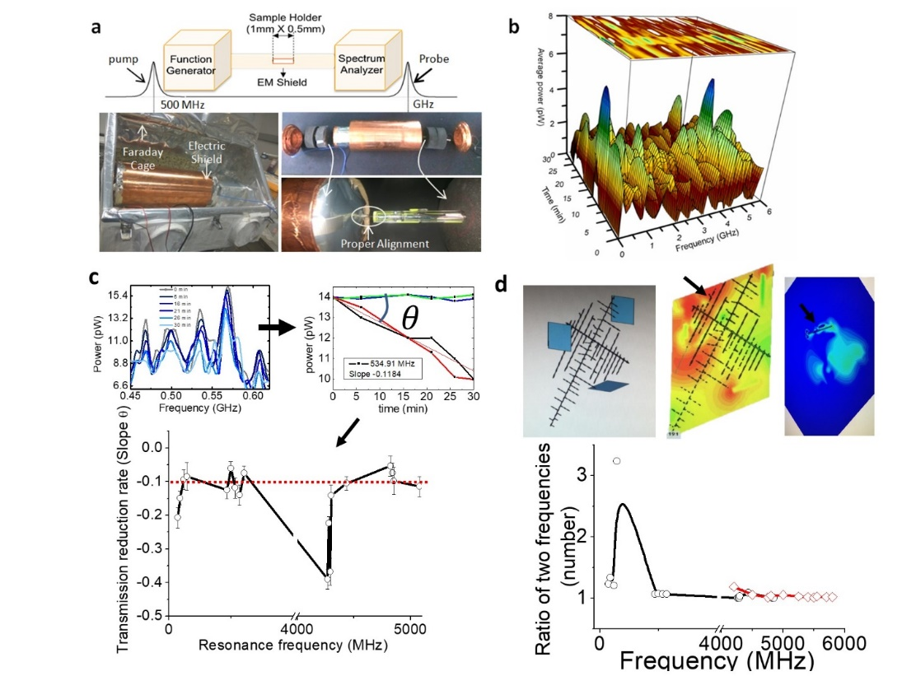
Figure 3: Monitoring Aβ fractal degradation in situ at microwave frequencies: Theoretical simulation of fractal structure’s antenna properties: (a). Schematic and the actual experimental setup. A cylindrical waveguide loaded with a cylindrical sample holder has the radius of 0.5 mm with 1mm in length 1mm. The waveguide was electromagnetically shielded and was placed inside a faraday cage. A plot shows that pump and probe frequencies are separated by 10³ orders. (b). Time lapse of average peak power in the frequency range from 0 to 6 GHz when Aβ fractal structure on HOPG is mixed with CLC. (c) The transmission spectrum of the mixture as a function of time, six plots (top left) show a small section of the entire spectrum. For a particular resonance peak at 534.91 MHz, we plotted two independent experiments. The pure Aβ sample is plotted with blue and green, while the CLC + Aβ mixture’s transmission power loss across the cavity is plotted with red and black. The bottom-most panel shows slopes of temporal degradation as a function of time for different resonance frequencies. A red line depicts a threshold limit, the resonance frequencies below that line are considered for checking theoretical simulations in panel d. See Figure S3 online for details. (d) The top layer of the panel has three sub-panels. The molecular-scale spiral structure of Aβp is built in the CST simulator, connected to three ports (leftmost). Electric field distribution at resonance (4000 GHz) in the central panel. To the extreme right, the magnetic resonance energy distribution at the same frequency (4000 GHz) is plotted. The bottom row has one panel. The black plot shows the ratio of two neighboring resonance frequencies in the MHz (<5000MHz) range, adopted from Figure 3c (bottom). The red plot is a similar ratio of neighboring frequencies in the theoretical resonance spectrum derived from the molecular Aβ antenna-like structure. The red plot is a molecular structure. Hence the resonance frequencies are reduced by 10³ times.

Figure 4:
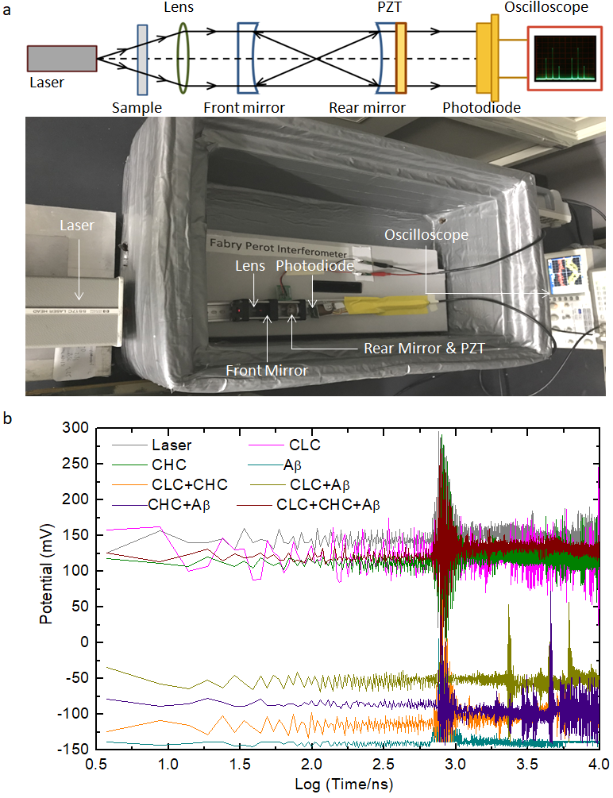
Figure 4: Monitoring Aβ fractal degradation in situ at microwave frequencies at optical frequencies: (a). Schematic and real photograph of the experimental setup of a Fabry-Perot interferometer using 632.99 nm He-Neon, a continuous wave laser head at two frequencies (HP5517C). The sample is placed between the laser head and the collimating lens. The cavity length is 45 mm equal to the RoC of the front and rear mirror. The rear mirror of the Fabry-Perot Cavity is attached with a PZT biased with a 10 V ramp at 100 Hz. Optical signals are transduced into electrical voltage signals using a PIN photodiode (BPW 34) connected to an oscilloscope. (b). The measured change in PIN voltage for Aβ, CLC, and CHC are recorded for background data. Similar effects due to the interaction of Aβ with CLC, CHC, both were measured at 632.99 nm laser light. Color codes are noted in inset.

Figure 5.
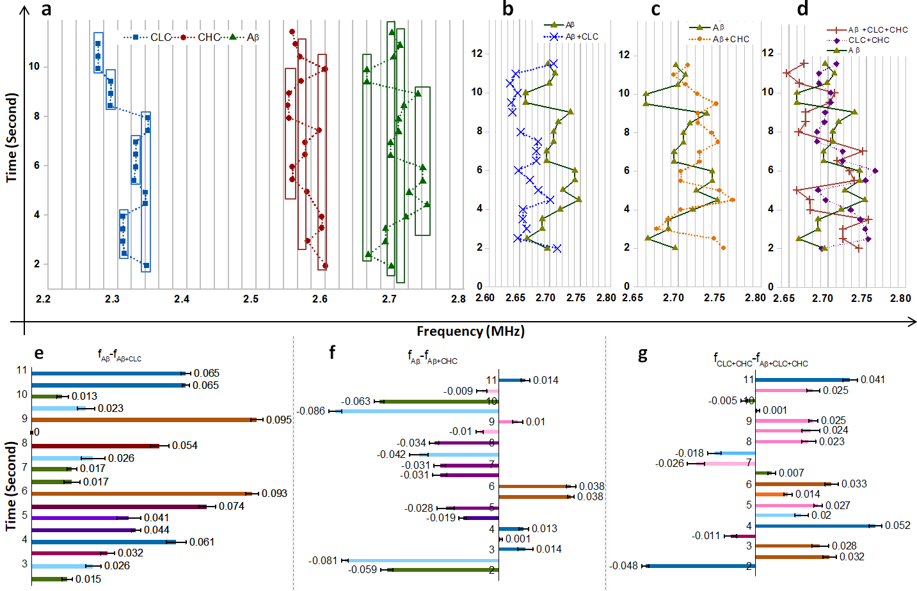
Figure 5: Repeating frequencies as a function of time and frequency-shift during Clathrin-mediated disintegration of Aβ. (a). Frequencies repeat in a quantized manner as a function of time in the FFT spectrum for CLC, CHC, and Aβ. (b). Quantized changes in time for the repeating frequencies of Aβ mixed with CLC. (c). Shift in frequency and repeating frequencies as a function of time when Aβ was mixed with CHC. The error bar was calculated from five independent experiments. (d). Change in frequency of Aβ mixed with CLC and CHC both, for the time repeating frequencies of CLC + CHC mixture. For all shifts, negative changes are to the left, positive changes are to the right. Panels (e) and (f). The shift in time repeating frequencies of Aβ+ CLC, and Aβ+ CHC concerning the Aβ frequencies. (g). The shift in frequencies of Aβ mixed with both CLC and CHC to Aβ.

Supporting online materials

Amyloid-β can form fractal antenna-like networks responsive to electromagnetic beating & wireless signaling

Komal Saxena^{1,2}, Marielle Aulikki Wälti,³ Pushpendra Singh,^{2,4} Pathik Sahoo², Subrata Ghosh⁵, K. S. Daya^{1*}, Roland Riek³, and Anirban Bandyopadhyay^{2*}
¹Microwave Physics Laboratory; Department of Physics and Computer Science, Dayalbagh Educational Institute, Dayalbagh, Agra-282005, Uttar Pradesh, India.
²National Institute for Materials Science, International Center for Materials Nanoarchitectronics, MANA; and Center for Advanced measurement and Characterization, 1-2-1 Sengen, Tsukuba, Ibaraki-3050047, Japan.
³Department of Chemistry and Applied Biosciences, ETH Zurich, Vladimir-Prelog-Weg, 8093 Zurich, Switzerland
⁴Department of Physics, Amity University, Kant Kalwar, Jaipur, Rajasthan, India
⁵CSIR North East Institute of Science & Technology, Chemical Science & Technology Division, Jorhat-785006, Assam, India

*Correspondence should be addressed to RR roland.riek@phys.chem.ethz.ch , KSD dayask@gmail.com AB anirban.bandyo@gmail.com

Supporting figure S1:
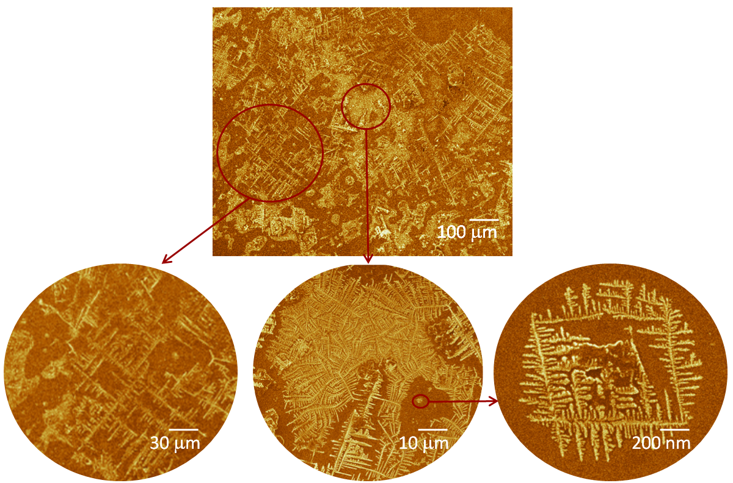
Figure S1: He-ion microscopic images for the fractal structure of Aβ fibrils on HOPG at multiple length scales from ∼1 nm to ∼300 μm. Three different domains are zoomed to suggest that actual fibrils that forms the elementary structures are ~10 nm.

Supporting figure 2:

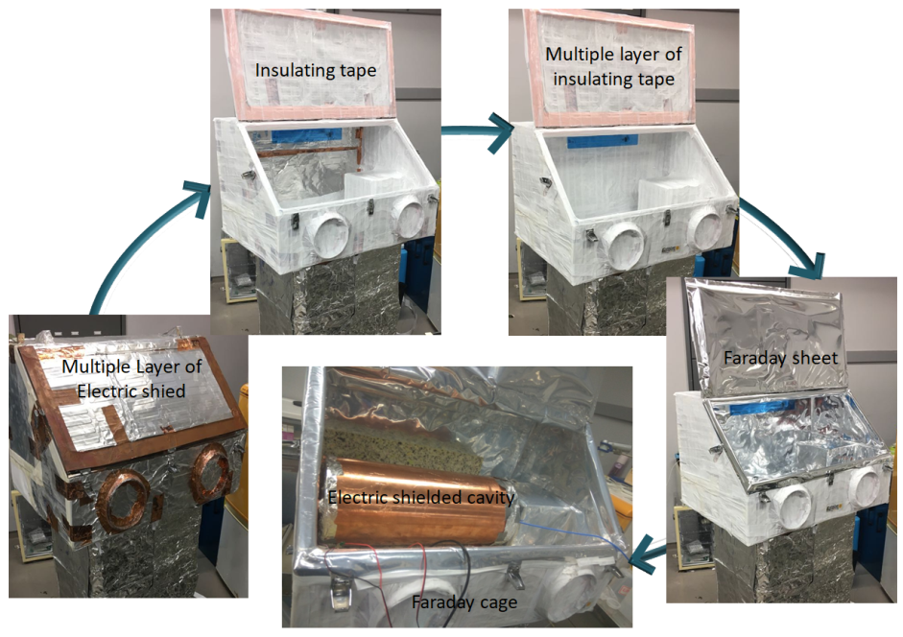
Figure S2: Our initial setup was made of two layers repeated multiple times. One layer sensitive to electromagnetic, the other layer sensitive to magnetic burst absorption. Tiny circular metallic rings to absorb magnetic signal bursts. Stepwise construction of the Faraday cage, which was built from multiple layers of conducting sheets separated by insulating sheets. It prevents the unwanted EM radiation to enter inside the Faraday cage. Finally, we have attached a composite materials sheet made of seven layers of distinct metals, together, the sheet absorbs major frequency domains of electromagnetic signal where we carry out our measurement.

Supporting igure 3:
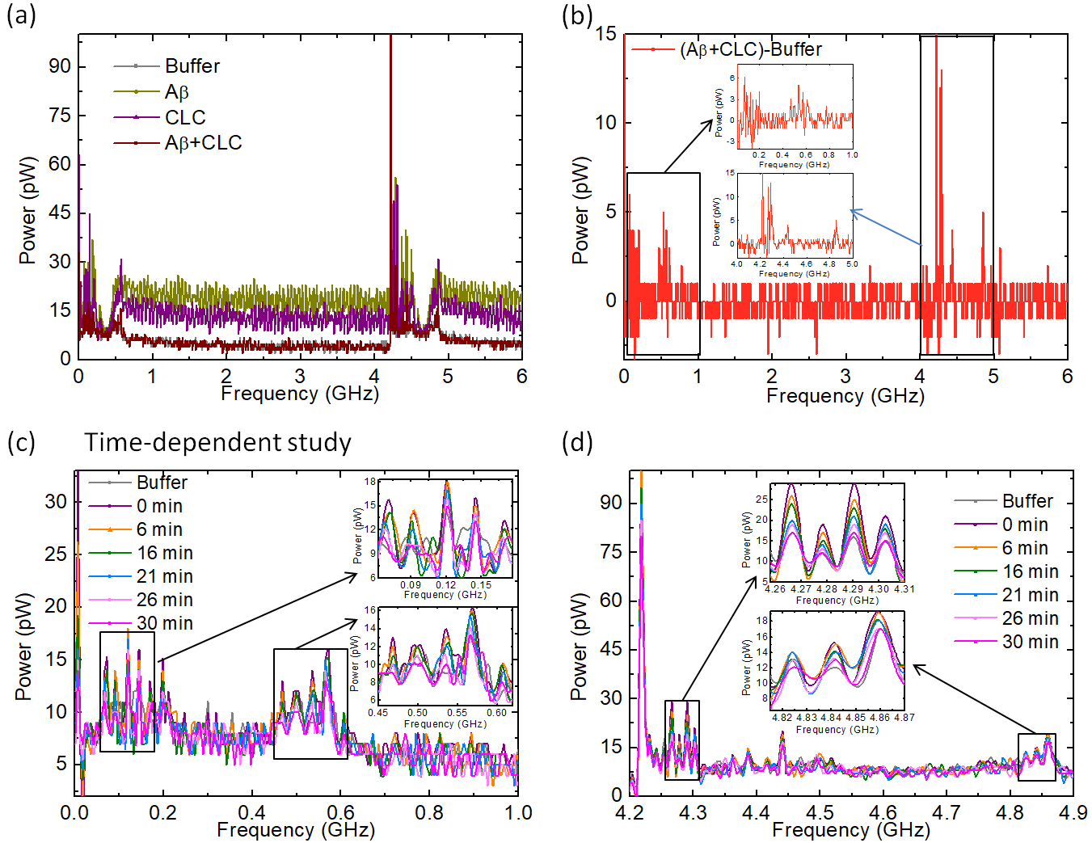
Figure S3: (a) Transmitted power spectra for the buffer (control), Aβ, CLC and their interaction in the microwave frequency region from 100 Hz to 6 GHz. Buffer solution is detailed in Methods section. (b) Calibrated graph of the CLC+Aβ mixture with respect to the buffer. (c) Power spectral response of Aβ+CLC with time for 30 minutes in the frequency range from 100 Hz to 1.0 GHz and panel (d) in the frequency range from 4.0 GHz to 5.0 GHz. The peaks that are tuned by varying the density of Aβ are considered as the real response from the protein structure. Density variation isolates peaks of Aβ. In contrast, the spectral peaks with random intensity variations are considered noise (see Figure 3c for details).

Supporting Figure 4.
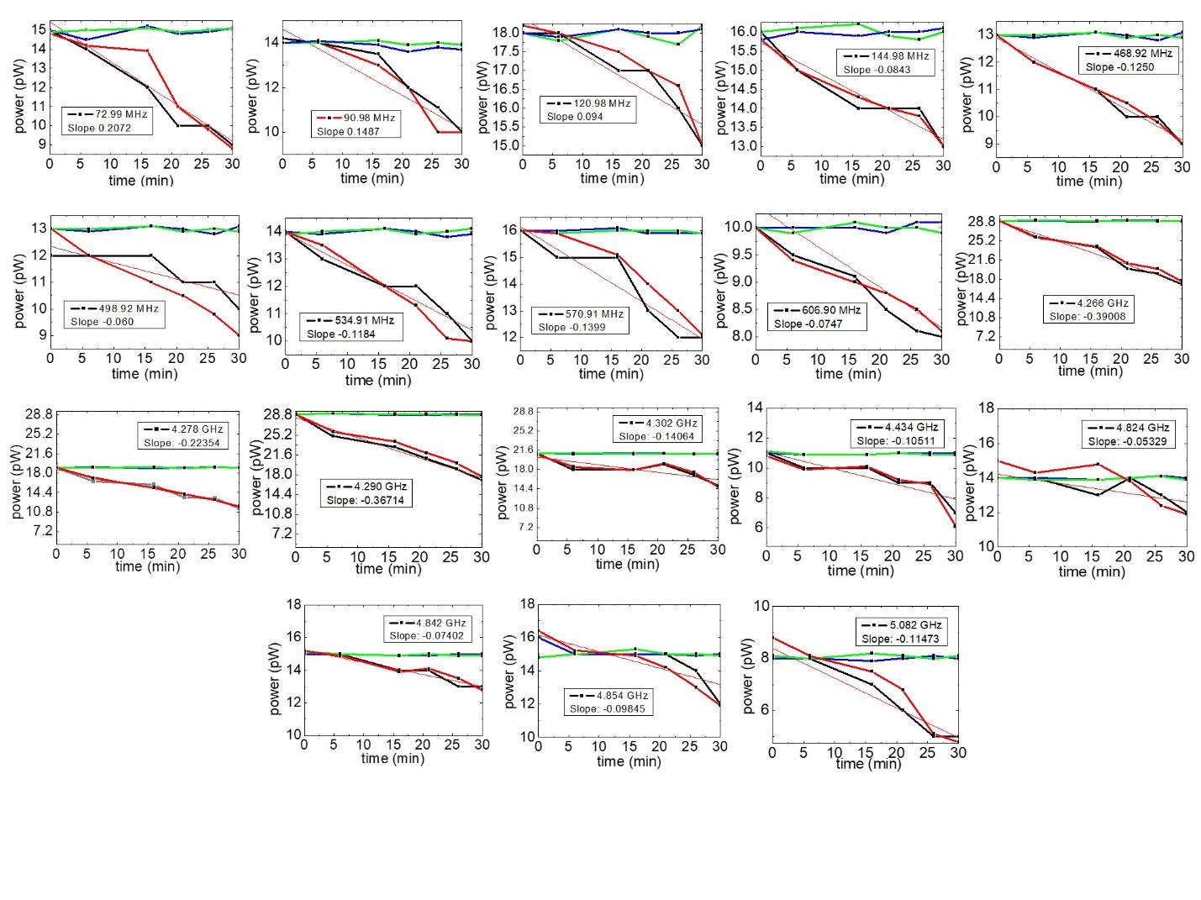
Figure S4: The rate of change in transmitted power at each excitation peak of CLC+Aβ. This data is plotted from Figure S3. Please find the summary of this result in Figures 3b and 3c.

Supporting figure S5:
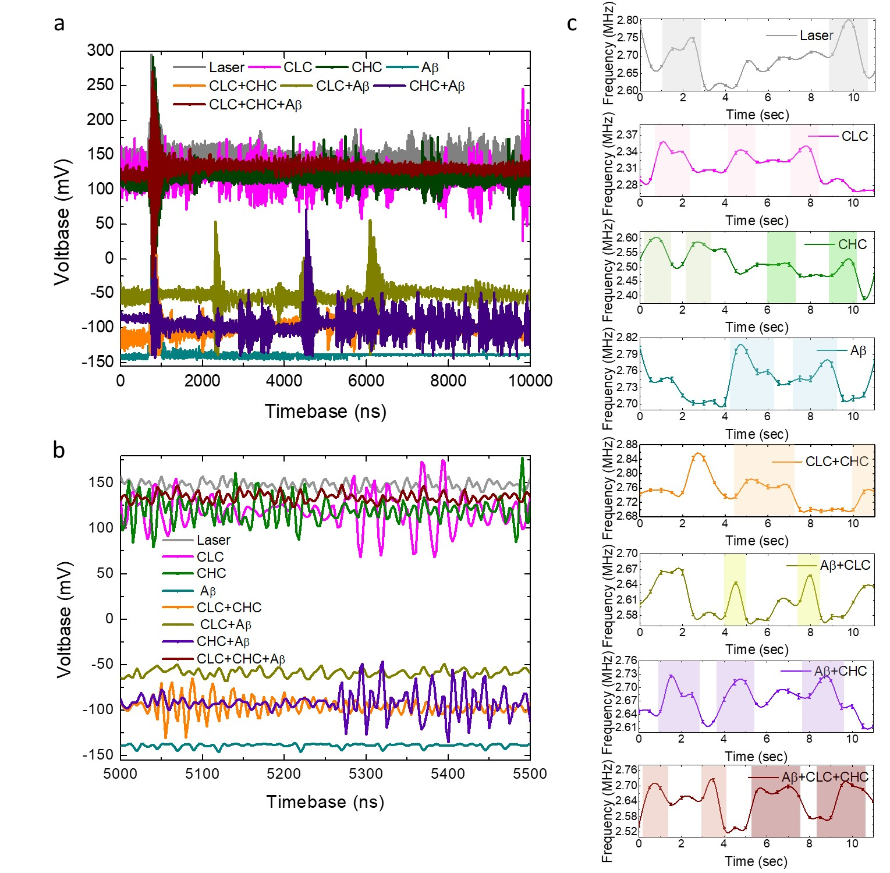
Figure S5: Panels (a) and (b) voltage-time responses of Aβ, CLC, CHC, and all possible combinations as a function of timebase using the measured by Fabry-Perot interferometer setup. (c) Repetition in dominating frequencies of different samples for five independent measurements (Aβ, CLC, CHC, and their possible combinations), which were extracted from the FFT spectrum measured by an oscilloscope. Error bar is calculated from the variations of spectral responses for five independent experiments, carried out, keeping all conditions intact.

Supporting Table 1. Excitation frequencies of Aβ and Aβ+CLC with their powers
Excitation frequency | 5.070 GHz | 5.082 GHz | 12 MHz | Power (pW) Corresponding to excitation frequency | 22 | 8 | 14
Excitation frequency | 4.848 GHz | 4.854 GHz | 6 MHz | Power (pW) Corresponding to excitation frequency | 26 | 16 | 10
Excitation frequency | 4.830 GHz | 4.842 GHz | 12.00 MHz | Power (pW) Corresponding to excitation frequency | 28 | 15 | 13
Excitation frequency | 4.812 GHz | 4.824 GHz | 12.00 MHz | Power (pW) Corresponding to excitation frequency | 23 | 14 | 9
Excitation frequency | 4.428 GHz | 4.434 GHz | 6.00 MHz | Power (pW) Corresponding to excitation frequency | 22 | 11 | 11
Excitation frequency | 4.308 GHz | 4.302 GHz | 6.00 MHz | Power (pW) Corresponding to excitation frequency | 52 | 21 | 31
Excitation frequency | 4.284 GHz | 4.290 GHz | 6.00 MHz | Power (pW) Corresponding to excitation frequency | 56 | 29 | 27
Excitation frequency | 4.272 GHz | 4.278 GHz | 6.00 MHz | Power (pW) Corresponding to excitation frequency | 32 | 19 | 13
Excitation frequency | 4.260 GHz | 4.266 GHz | 6.00 MHz | Power (pW) Corresponding to excitation frequency | 31 | 29 | 2
Excitation frequency | 600.900 MHz | 606.900 MHz | 6.00 MHz | Power (pW) Corresponding to excitation frequency | 23 | 10 | 13
Excitation frequency | 564.91 MHz | 570.910 MHz | 6.00 MHz | Power (pW) Corresponding to excitation frequency | 27 | 16 | 11
Excitation frequency | 534.910  MHz | 534.910  MHz | No Change | Power (pW) Corresponding to excitation frequency | 26 | 14 | 12
Excitation frequency | 486.92 MHz | 498.920 MHz | 12.00 MHz | Power (pW) Corresponding to excitation frequency | 22 | 12 | 10
Excitation frequency | 468.920 MHz | 468.920 MHz | No change | Power (pW) Corresponding to excitation frequency | 23 | 13 | 10
Excitation frequency | 150.98 MHz | 144.980 MHz | 6.00 MHz | Power (pW) Corresponding to excitation frequency | 39 | 16 | 23
Excitation frequency | 126.980 MHz | 120.980 MHz | 6.00 MHz | Power (pW) Corresponding to excitation frequency | 30 | 18 | 12
Excitation frequency | 78.99 MHz | 90.980 MHz | 11.99 MHz | Power (pW) Corresponding to excitation frequency | 26 | 14 | 12
Excitation frequency | 72.990  MHz | 72.990 MHz | No change | Power (pW) Corresponding to excitation frequency | 30 | 15 | 15
Excitation frequency | Aβ | Aβ+ CLC | Shift in frequency | Power (pW) Corresponding to excitation frequency | Aβ | Aβ + CLC | Power changes
Supporting Table 2. Rate of change in power at different excitation frequencies of CLC+Aβ
5.082 GHz | -0.11473 | 3
4.854 GHz | -0.09845 | 4
4.842 GHz | -0.07402 | 2
4.824 GHz | -0.05329 | 2
4.434 GHz | -0.10511 | 4
4.302 GHz | -0.14064 | 6
4.290 GHz | -0.36714 | 12
4.278 GHz | -0.22354 | 7
4.266 GHz | -0.39008 | 12
606.900 MHz | -0.07476 | 2
570.910 MHz | -0.1399 | 4
534.910  MHz | -0.11843 | 4
498.920 MHz | -0.0607 | 2
468.920 MHz | -0.12509 | 4
144.980 MHz | -0.08438 | 3
120.980 MHz | -0.0940 | 3
90.980 MHz | -0.14878 | 4
72.990 MHz | -0.20725 | 6
Excitation frequency | Rate of power changes | Change in peak power (pW) over a period of 30 minutes

