Three-Dimensional Bonding Anisotropy of Bulk Hexagonal Metal Titanium Demonstrated by High Harmonic Generation
^{1,2*}Ikufumi Katayama, ³Kento Uchida, ¹Kimika Takashina, ¹Akari Kishioka, ¹Misa Kaiho, ¹Satoshi Kusaba, ¹Ryo Tamaki, ¹Ken-ichi Shudo, ^{1,4}Masahiro Kitajima, ⁵Ngo Duc Thien, ^{5,6}Tadaaki Nagao, ^{1,2}Jun Takeda, ³Koichiro Tanaka, and ^{7*}Tetsuya Matsunaga

*Corresponding authors: Ikufumi Katayama (katayama-ikufumi-bm@ynu.ac.jp),
Tetsuya Matsunaga (matsunaga.tetsuya@jaxa.jp)

¹ Department of Physics, Graduate School of Engineering Science, Yokohama National University, 79-5 Tokiwadai, Hodogaya, Yokohama 240-8501, Japan
² Semiconductor and Quantum Integrated Electronics Research Center (SQIE), Institute for Multidisciplinary Sciences, Yokohama National University, 79-5 Tokiwadai, Hodogaya, Yokohama 240-8501, Japan
³ Department of Physics, Graduate School of Science, Kyoto University, Kitashirakawa-Oiwakecho, Sakyo, Kyoto 606-8501, Japan
⁴ LxRay Co. Ltd., 3-28-22 Koshienguchi, Nishinomiya, Hyogo 663-8113, Japan
⁵ Research Center for Materials Nanoarchitectonics (MANA), National Institute for Materials Science (NIMS), 1-1 Namiki, Tsukuba, Ibaraki 305-0044, Japan
⁶ Department of Condensed Matter Physics, Hokkaido University, Kita 10, Nishi 8, Kita-ku, Sapporo, Hokkaido 060-0810 Japan
⁷ Institute of Space and Astronautical Science, Japan Aerospace Exploration Agency, 3-1-1 Yoshinodai, Sagamihara, Kanagawa 252-5210, Japan

Abstract
High harmonic generation (HHG) in solid-state materials is an emerging field of photonics research that can unveil the detailed electronic structure of materials, bond strengths and scattering processes of electrons. Although HHG in semiconducting and insulating materials has been intensively investigated both experimentally and theoretically, metals have rarely been explored because the strong screening effect of high-density free electrons is considered to significantly weaken the HHG signal. Here, we investigated HHG upon infrared excitation in bulk hexagonal metal titanium (Ti), a typical building block for practical light structural materials. By analyzing the polarization dependence, the approach revealed the three-dimensional (3D) anisotropy in the electronic states. The results demonstrated the potential of HHG spectroscopy for characterizing 3D bonding anisotropy in metallic systems that are of fundamental importance for designing light and strong structural materials.

Two-sentence summary
High harmonics generation (HHG) is a promising way of investigating electronic structures and anisotropy in materials. The authors demonstrated observation of HHG in simple structural material, hexagonal metal titanium, and experimentally clarified the anisotropy in the electronic states from the polarization dependence.

Introduction
Metals are fundamental building blocks of materials needed by society, supporting infrastructure, protecting mobilities and devices, and conducting energy through electric current¹. Therefore, the physical properties of metals have been extensively investigated with various physical, electrical, magnetic and spectroscopic techniques. More than a century of experimental and theoretical investigations has accumulated extensive knowledge about the electronic band structures, mechanical properties and other physical properties of simple metals. However, the microscopic origins of macroscopic physical properties are often poorly understood because of the polycrystallinity and composition complexity of practical materials designed to enhance the mechanical properties^{2,3}.

To investigate the connection between the microscopic electronic states and macroscopic physical properties⁴, diagnostic tools are needed to investigate the crystal orientation and electronic bonding anisotropy. However, conventional methods for characterizing electronic structure, such as photoelectron spectroscopy, electron microscope and X-ray spectroscopy, either require large facilities or ultrahigh vacuum conditions. In addition, metals with a complex composition are difficult to model even with sophisticated ab initio calculations because they lack periodicity in the crystal structure⁴. Therefore, a simple experimental method that can investigate and reveal the electronic structure and anisotropy is strongly desired.

Recently, high harmonic generation (HHG) has attracted increasing attention⁵⁻¹² because it can reveal information on the detailed electronic structure of materials even under ambient conditions¹³⁻²⁰. By applying intense infrared laser pulses, a nonlinear current or polarization at higher frequencies is induced that reflects the detailed band structure of the material^{11,21-29}. Harmonics of more than tenth order can be observed because of the strong nonlinearity of electronic states in materials²¹. The HHG response reflects the extreme light-matter interaction in lightwave-driven systems, whose mechanisms have been intensively researched ^{25,30-32}. However, in bulk metals, HHG has rarely been observed because the strong screening effect of the electric field is considered to weaken the nonlinear interactions necessary for HHG generation inside a material. If HHG in bulk metals could be observed as in two-dimensional metallic systems^{33,34}, the nonlinear dynamics of electrons and electronic states could be analyzed, providing important information for understanding the physical properties of metals and characterizing the electronic states, including the anisotropy.

To demonstrate the capabilities of HHG, we investigated the bulk hexagonal metal titanium (Ti)³⁵. Ti is an important material for infrastructure and mobility applications. The low atomic number of Ti makes it light yet high strength. Ti is also biocompatible and so can be used in medical applications, such as dentistry and artificial bones. However, the anisotropic nature of single crystal Ti makes it difficult to process into a desired shape. Impurity doping with some metals is known to relax the anisotropic properties and improve the mechanical properties.³⁶ However, the mechanism of the compositional dependence is still unclear because most theories used to describe the mechanical properties rely on spherical atomic models³⁷ and cannot account for subtle changes in the bonding anisotropy due to changes in the electronic states.

Here, we investigated HHG in Ti crystals by applying infrared pulses. As a result, we observed 3rd and 5th order harmonic signals while reducing the decrease in HHG due to less screening at infrared frequency. The polarization dependence of HHG in domains with various crystallographic orientations showed distinct 3D anisotropy of the electronic states. The results were compared to an analysis using a nonlinear susceptibility tensor and simulation using ab initio calculations, which indicated a dominant contribution from the nonlinear intraband current inside the band structure. Because the HHG intensity is expected to be higher along the direction with larger band dispersion, it can be used for characterizing the bonding strength (or bandwidth) along the direction of polarization. The results demonstrated the usefulness of HHG spectroscopy for characterizing the anisotropy of electronic states and mechanical properties.

Results and Discussion
Figure 1(a) shows a schematic of the experimental procedure. Mid-infrared (MIR) pulses (4.8 μm, 0.258 eV) were applied to a polished surface of polycrystalline Ti to measure the HHG response. The frequency of the infrared pulses was chosen to be slightly higher than the damping constant of the free carriers to enhance the signal intensity of HHG in the metallic material. The calculated band structure of Ti showed that there were four bands that constituted Fermi surfaces (Fig. 1(b)). Linear infrared spectroscopy (Supplementary Figure 1) revealed the Drude-Lorentz nature of the dielectric dispersion, with resonant frequencies of the Lorentz dispersions in the infrared and near-infrared regions (see Supplementary Note 1). Inverse pole figure maps of the samples measured with electron back-scattered diffraction spectroscopy (EBSD, Fig. 1(c)) showed there were several domains of different crystal orientations with a large domain size of more than 30×30 μm². Thus, by measuring different domains in the polycrystalline samples, we were able to investigate the polarization and intensity dependence of HHG from various 3D directions. Details of the experiments are summarized in the Methods section. The formation of large single-crystal domains in the sample was crucial for observing the 3D bonding anisotropy in Ti using HHG.

Figure 1(d) shows spectra of observed 3rd and 5th harmonics from the ac domain indicated in sample B in Fig. 1(c). The polarization dependence of the HHG intensity for ab and ac surfaces is presented in the polar plot, which clearly shows the anisotropy of the generated HHG. To clarify the origins of the HHG, we first measured the fluence dependence of the 3rd and 5th harmonics (Fig. 2). The results demonstrated that the shapes of the polar plots varied for different excitation fluence for both the 3rd and 5th harmonics. The ratio of the signal at the polarization parallel to the a-axis to that parallel to the c-axis was higher at larger excitation fluence, indicating contributions from higher-order nonlinear components than the relevant harmonic order.

For phenomenological analysis, we decomposed the signal at each excitation fluence with the tensor components of the effective 3rd and 5th order nonlinear polarizations in the hexagonal crystal symmetry. Although the observed signals of HHG included higher order contributions, the crystal symmetry still restricted the polarization dependence, and therefore the 3rd and 5th order nonlinear susceptibilities could be used to provide information on the anisotropy in the electronic states at that fluence. There were four and seven non-zero and independent tensor components for the 3rd and 5th order harmonics in Ti, respectively (see Supplementary Note 2)^{38,39}. The obtained fluence dependence of the nonlinear polarizations (HHG intensities) are shown in Fig. 2(c). Note that overall agreement with the experimental results of the polarization dependence in Fig. 2(b) indicates the usefulness of considering nonlinear polarizabilities, even though the obtained values of nonlinear polarization showed clear fluence dependence (Fig. 2(c)) different from the power-law⁴⁰. The deviation from the power-law may reflect contributions from the higher-order polarization, absorption saturation, and the temperature change at high fluence.

In metals, the intraband current is expected to be the main component contributing to HHG because of the high density of conductive electrons. To model this contribution, we used the band structure from the ab initio calculations shown in Fig. 1(b) and considered four bands that cross the Fermi energy for simulation. The band structure was fitted to a Fourier expansion as follows:
$$E_{n}\left(k\right)=\sum_{i}{A_{ni}\cos{k∙a_{i}}}. (1)$$
where $a_{i}$ represents atomic positions in the lattice taken to satisfy the crystal symmetry, $k$ is the wavevector and $A_{ni}$ is the amplitude of the corresponding Fourier component $i$ for band $n$³⁴. The induced current $J$ was calculated by shifting the electron distribution by an amount $∆K\left(t\right)$:
$$∆K\left(t\right)=eA\left(t\right)/ℏ, (2)$$
where $A\left(t\right)$ is the vector potential, $e$ is the charge of a single electron and $ℏ$ is the reduced Planck’s constant³⁴.
$$J\left(A\left(t\right)\right)=\sum_{n}{\iiint{dk} ev_{g}\left(k\right)f\left(E_{n}\left(k-K\left(t\right)\right), T\right)} (3)$$
Here, $v_{g}\left(k\right)$ is the group velocity at point $k$ and $f\left(ε, T\right)$ is the Fermi-Dirac distribution function at energy $ε$ and temperature $T$. The induced current calculated by the summation of contributions from the four bands as a function of the incident polarization angle are plotted in Fig. 3 for comparison with the experimental data shown in Fig. 2.

We also considered the boundary conditions for the input and output light fields because Ti possesses optical anisotropy, as summarized in Supplementary Note 1. First, the input MIR pulse was reflected depending on the incident polarization due to the anisotropic reflectance. Assuming that the linear response to the input field strength can be represented as a first order approximation⁴¹, this effect can be simulated by using the measured reflectance of Ti at the incident energy of 0.258 eV. The 3rd and 5th order polarizations are also affected by similar reflectance at higher frequencies of 0.77 eV and 1.29 eV, respectively. Thus, the emitted $n$th-order nonlinear signal $S_{n}$ can be expressed as follows:
$$S_{n}∝{\left|r_{n}\int{dt J\left(r_{MIR}A_{in}\left(t\right)\right)e^{-inω_{0}t}}\right|}^{2} (4)$$
where $ω_{0}$ is the angular frequency of the applied MIR pulses, $r_{n}≡\left|2/{\left({\tilde{n}}_{n}+1\right)}\right|$ and $r_{MIR}≡\left|{2{\tilde{n}}_{MIR}}/{\left({\tilde{n}}_{MIR}+1\right)}\right|$ are the amplitude reflectance of the $n$th-order nonlinear polarization and the MIR pump pulses, respectively, with ${\tilde{n}}_{MIR}$ and ${\tilde{n}}_{n}$ representing the complex linear refractive indices at the incident MIR frequency and at the frequency of the output $n$th-order nonlinear polarization, respectively. The phases of the reflectance were ignored for simplicity. The resultant maximum shift of the Fermi surface at 0.78 TW cm⁻² was estimated to be 26% of the Brillouin zone, which may be larger than the actual amount of shift due to the omission of electron scattering. Further details of the calculation can be found in the Methods section.

Figure 3 summarizes the calculated results of HHG due to the intraband current. The band structure of the four bands that crossed the Fermi surface are shown in Fig. 3(a). We also calculated the polarization dependence of the 3rd and 5th harmonics for ab and ac planes for different excitation fluence (Fig. 3(b)). The overall tendency for stronger HHG along the c-axis was well reproduced by the simulation. The relatively strong HHG signal along the a-axis excitation at higher fluence was also consistent with the experimental results shown in Fig. 2. From these results, we concluded that HHG in Ti is mainly generated from the intraband current of conductive electrons, although we neglected the contributions from electron-electron scattering and interband transitions. Some differences in the shape of the polar plot, especially at 60° from the a-axis for the 5th harmonics, may be explained by the latter omissions. Additional contributions from interband transitions to the HHG can be inferred from the band structure because the photon energy of the 3rd and 5th harmonics was high enough to induce band-to-band transitions, as shown by the arrows in Fig. 3(a) (see Supplementary Note 3).

Finally, we investigated various domains in the samples shown in Fig. 1(c) to demonstrate the possibility of characterizing the 3D anisotropy of HHG and the electronic states. Figure 4 shows the results of the polarization dependence observed for different domains. The patterns of the polarization dependence clearly depended on the domain orientation. The solid lines in the figure show the simulated values using the effective nonlinear susceptibilities calculated from the data shown in Fig. 2. The close correlation between the simulated polarization dependence and experimental data shows that the 3D anisotropy of HHG in Ti can be described by the effective nonlinear susceptibilities. The obtained 3D plot of HHG shown in the top left corner of Fig. 4 indicates a higher HHG intensity for the polarization parallel to the c-axis. Some asymmetric deviations observed in the experimental results mostly originate from the experimental imperfections between the horizontal and vertical polarizations in the experimental setup.

In the future, this method could be a promising approach for investigating correlations between the anisotropic electronic states and the mechanical properties. Electronic anisotropy of doped metallic materials, e.g., solid-solution strengthening alloys and high-entropy alloys can also be investigated if the crystal domains can be larger than the MIR spot sizes. These types of materials usually possess higher strength than non-doped materials and are often used as structural materials. For example, an aluminum-doped Ti alloy has been used in the aerospace industry to fabricate fuel tanks, fasteners and impellers in rocket engines. Although the doping elements⁴² can be modified for each type of component, the associated changes in the mechanical properties are often difficult to estimate because both the parent element and doping elements need to be considered. The excitation energy dependence of HHG and its polarization dependence at higher harmonics could also provide further details of the electronic anisotropy relevant to the band structure and the relationship to the mechanical properties⁴²⁻⁴⁴.

Conclusion
In summary, we investigated HHG from crystalline Ti, and evaluated the polarization dependence of HHG for various crystal orientations. From simulations and fitting of the effective nonlinear susceptibility tensor, we showed that the intraband acceleration of conduction electrons induced by infrared pulses plays an important role in generating the HHG signal but with some contribution from interband transitions. The method can provide information on the 3D electronic anisotropy, and therefore HHG can be a promising tool for investigating the origins of mechanical properties in various structural materials. Further, the HHG observation in bulk metals could expand the applicability of HHG spectroscopy to other important metallic systems, e.g., magnetic metals, heavy fermion systems and superconducting materials, in addition to structural materials.

Methods

Experimental details
A Ti:sapphire regenerative amplifier was employed with center wavelength of 800 nm, output power of 7 W and repetition rate of 1 kHz. The output was used to pump two optical parametric amplifiers (OPAs), and the difference frequencies of the outputs of the OPAs were used to generate MIR pulses with an output power of 6 mW and photon energy of 0.258 eV. The MIR pulses were focused on the sample surface with reflective objective mirrors after dispersion compensation. The intensity and polarization of the pump pulse were tuned by changing the angles of two polarizers after a quarter waveplate. We also confirmed that similar results of polarization dependence were obtained by rotating the sample instead of changing the polarization of incident excitation pulses. The emitted 3rd and 5th harmonics were directed to a spectrometer equipped with a charge-coupled device (CCD) camera: a silicon CCD camera was used for the 5th harmonics, whereas an InGaAs camera was used for the 3rd harmonics. Wavelength and sensitivity corrections were applied for the spectrometer and camera system. The polarization dependence of the sensitivity is within 10% of the signal that do not significantly modify the results shown in this paper. The integrated intensities from spectra of the 3rd and 5th harmonics were plotted in polar plots.

Sample A was prepared with a floating zone method and Sample B was annealed at 1000℃ for four weeks after melt-solidification process to ensure that the crystal domain size was larger than the spot size of the MIR pump pulses. The crystal orientation of each observed domain was analyzed using a scanning electron microscope (JSM-7100F, JEOL Corp.) equipped with an EBSD system (OIM, TSL Solutions Corp.). The 3 mm X 3 mm single crystalline domain with c axis 78º tilted from the surface normal (grown by the same method as that used for sample A) was used to investigate the linear anisotropy of the optical constants. The obtained data are presented in the Supplementary Figure 1. Anisotropic reflectance was evaluated using a Fourier transform infrared spectrometer (VERTEX-80v, Bruker Corp.) equipped with a microscope (Hyperion, Bruker Corp.) and ellipsometer (SENresearch Family SE 850 DUV, SENTECH GmbH).

Simulation of HHG in Ti
The band structure of hexagonal close-packed (hcp) Ti (Fig.1(b) and 3) was calculated from ab initio density-functional theory (DFT) with a standard projector-augmented wave (PAW) method using the Vienna ab initio simulation package (VASP)^{45,46}. Plane waves were used up to a cut-off kinetic energy of 500 eV⁴⁷. A unit cell of the hexagonal reciprocal momentum space was divided into Γ-centered 20×20×16 $k$ points with equal separation. Each band was fitted to a cosinusoidal expansion with hexagonal symmetry using Eq. (1). In this fitting, we only considered vector components where the positions of the atoms were within a distance of 7 times the lattice constant $a$ of Ti.

To calculate the HHG, the Fermi Sea was shifted by an amount $∆K$ in the Brillouin zone and the induced current was calculated and integrated in the whole three-dimensional Brillouin zone for each $∆K$ value and direction. We first calculated the $∆K$ dependence of the induced current and used these data for simulating the HHG. The MIR pump pulses were modeled with a Gaussian-sinusoidal function with a pulse duration of 100 fs and the induced current was estimated by considering the estimated wavevector shift of Eq. (2). The calculated waveforms of the induced current were Fourier transformed and plotted as a function of frequency. The intensities of the 3rd and 5th order responses were extracted from the spectra to determine the polarization dependence. We ignored changes of the electron distribution function (electronic temperature and chemical potential) in the $k$-space for simplicity. The reflection losses of the induced nonlinear polarization were calculated using Eq. (4).

Acknowledgement
Th authors thank Prof. Shunsuke Sato of the University of Tsukuba for helpful discussions. This work was supported by JSPS KAKENHI (grant numbers JP-22K18322, 22H01820, 17H06124, 21H05017, and 22K03484), the Cooperative Research Project of Research Center for Biomedical Engineering, the Research Project of the Light Metal Educational Foundation, Japan, and the Frontier Research Grant of the Japan Institute of Metals and Materials.

Figure 1
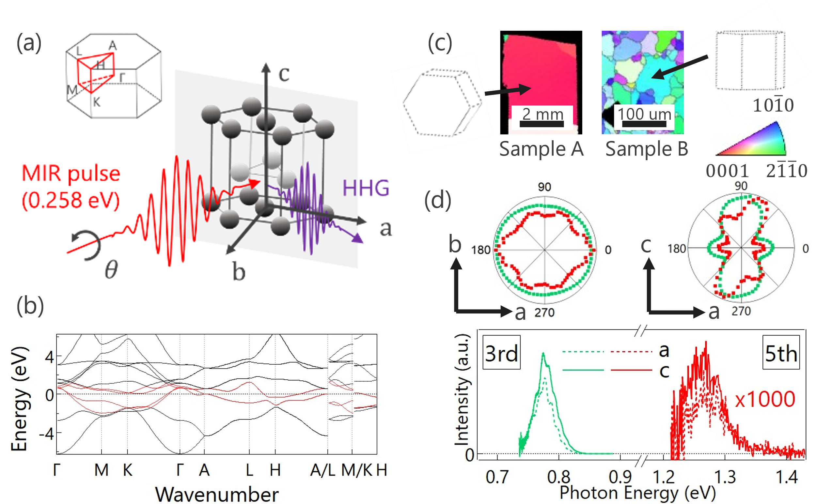
Figure 1: High harmonic generation in Ti single crystals. (a) Schematic of the experiment. Mid-infrared (MIR) pulses were shone on the Ti surface to generate high harmonics from various crystal orientations. The shape of the 1st Brillouin zone and high-symmetry points are indicated. (b) Calculated band structure of hexagonal Ti. Red curves indicate the bands that cross the Fermi level. (c) Inverse pole figure map of Ti samples. Hexagonal prisms indicate the orientations of the domains denoted by the arrows. Different colors correspond to the orientations indicated in the bottom right corner. (d) Polarization dependence of the observed 3rd (green) and 5th (red) harmonics of the MIR pulses (0.258 eV) at the indicated domains of sample A and B shown in (c). The bottom graph shows spectra of the harmonic signals. The pump fluence of the measurement was 0.84 TW cm⁻² for 3rd harmonics and 0.79 TW cm⁻² for 5th harmonics.

Figure 2
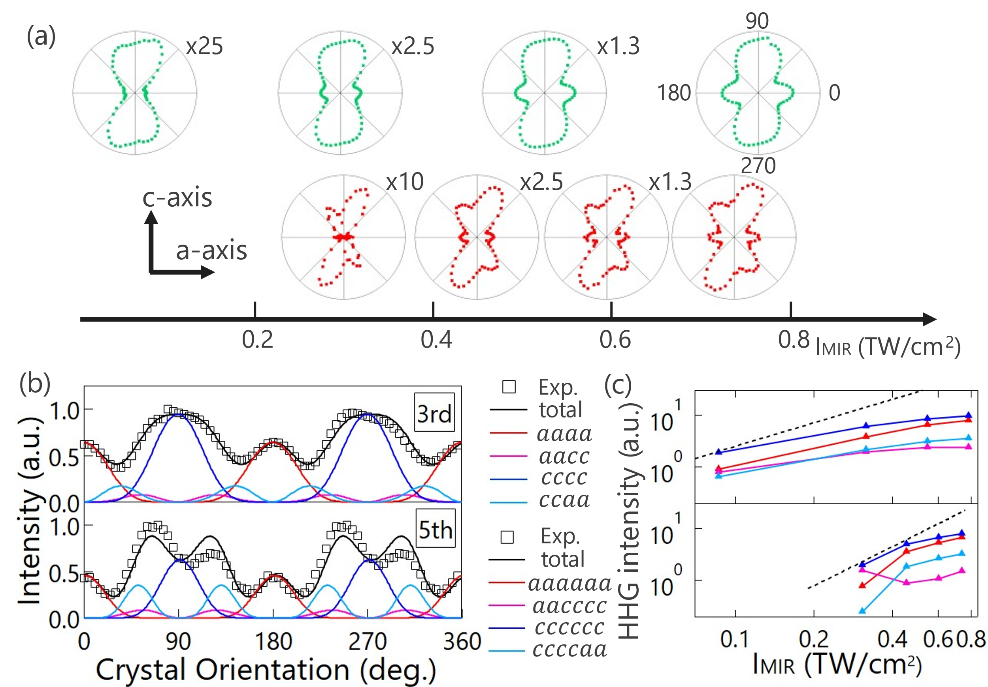Figure 2: Fluence dependence of HHG obtained for sample B (ac plane). (a) Polarization dependence of 3rd (green) and 5th (red) harmonics in hexagonal Ti. The polar plots are normalized to highlight changes in the polarization dependence. The horizontal positions of the plots correspond to the fluence of incident MIR pulses. (b) 3rd and 5th order nonlinear susceptibilities of the indicated tensor components plotted as a function of the polarization direction. Black squares show the experimental results of the data shown in (a) at the highest excitation fluence. The colored lines represent the tensor components of the 3rd and 5th order nonlinear susceptibilities. (c) Fluence dependence of HHG intensity from each tensor component. The different colors used to represent the data are the same as those in (b). Black dashed lines indicate the power laws of the 3rd and 5th order harmonics in the perturbation regime.

Figure 3
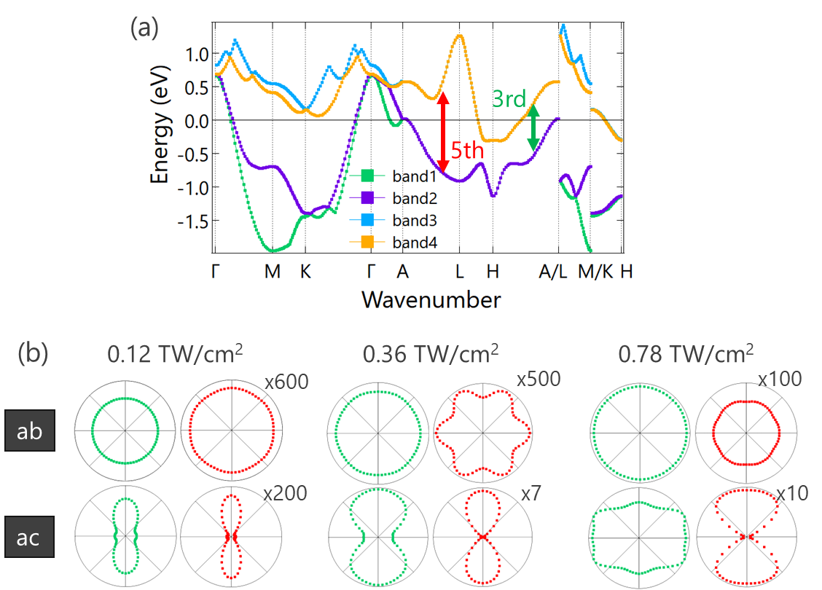
Figure 3: Simulated polarization dependence of 3rd and 5th order harmonics based on the intraband current in the calculated band structure. (a) Four electronic bands that cross the Fermi level were used in the calculation. Double sided arrows indicate the energy scales of 3rd and 5th harmonics in the band structure. (b) Calculated polarization dependence of the 3rd (green circles) and 5th (red circles) harmonics for three different excitation fluences. The upper row shows the simulation for the ab plane surface, whereas the lower row shows that for the ac plane surface. Normalization factors used to show the polarization dependence are indicated.

Figure 4
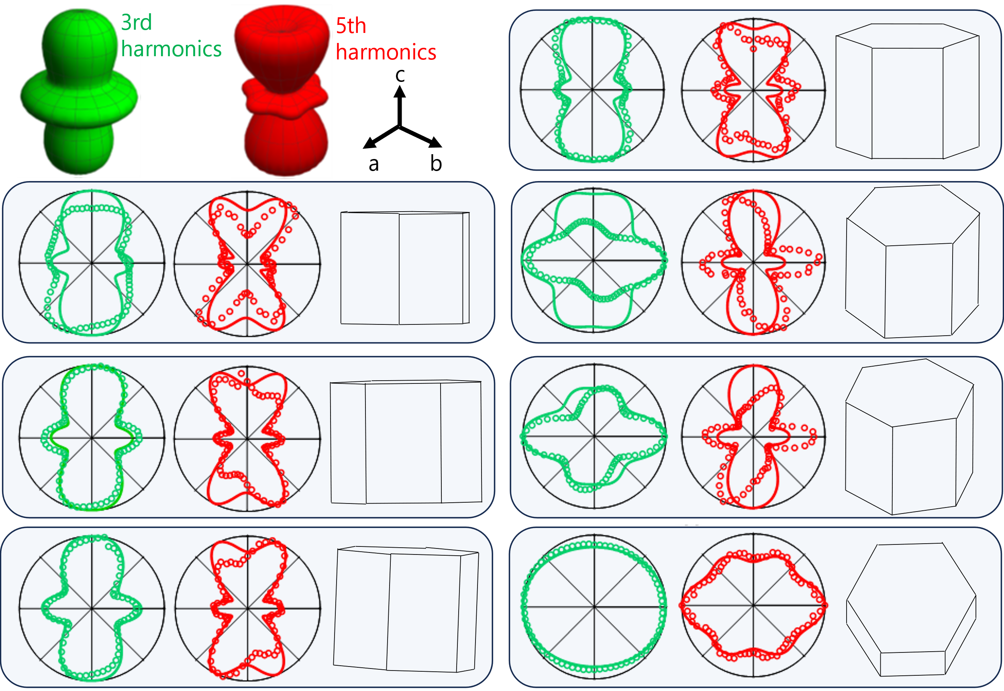
Figure 4: Comparison of the polarization dependence for various domains with different crystallographic orientations. The HHG are observed at excitation fluences ranging from 0.33 to 0.78 TW cm⁻². Green data and curves indicate the experimental results and simulations with effective nonlinear susceptibilities for 3rd order harmonics, whereas red data and curves are those for 5th order harmonics. Hexagonal prisms indicate the crystallographic orientations of the measured domains. Green and red 3D objects at the top-left corner are the simulated 3D anisotropy of HHG using the nonlinear susceptibilities obtained from the data shown in Fig. 2 at the maximum excitation fluence. All the data are normalized to show the orientational dependence clearly, although the excitation fluences are slightly different for different domains.
Data availability statement
Data sets generated during the current study are available from the corresponding author on reasonable request.

Code availability statements
Calculation codes used during the current study are available from the corresponding author on reasonable request.

'Author Contributions
I.K., K.U., J.T., Ko.T., and T.M. conceived this research project. T.M. provided samples. I.K., K.U., Ki.T, A.K., Mi.K, S.K., N.D.T., and T.N. carried out the optical measurements. I.K., Ki.T., A.K., R.T., and K.S. made calculations. All the authors analyzed and discussed the data and contributed to writing the manuscript.

Competing interests
The authors declare no competing interests.

References
- Ghimire, S. et al. “Observation of high-order harmonic generation in a bulk crystal.” Nature Physics 7, 138-141 (2011).
- Hohenleutner, M. et al. “Real-time observation of interfering crystal electrons in high-harmonic generation,” Nature 523, 572-575 (2015).
- Luu, T. T. et al. “Extreme ultraviolet high-harmonic spectroscopy of solids,” Nature 521, 498–502 (2015).
- Hassan, M. Th. et al. “Optical attosecond pulses and tracking the nonlinear response of bound electrons,” Nature 530, 66-70 (2016).
- You, Y. S., Reis, D. A. and Ghimire, S. “Anisotropic high-harmonic generation in bulk crystals,” Nature Physics 13, 345-349 (2016).
- Lanin, A. A., Stepanov, E. A., Fedotov, A. B. and Zheltikov, A. M. “Mapping the electron band structure by intraband high-harmonic generation in solids,” Optica 4, 516-519, (2017).
- Yoshikawa, N., Tamaya, T. and Tanaka, K. “High-harmonic generation in graphene enhanced by elliptically polarized light excitation,” Science 356, 736-738 (2017).
- Ghimire, S. and Reis, D. A. “High-harmonic generation from solids.” Nature Physics 15, 10-16 (2019).
- Bhaduri, A. “Mechanical Properties and Working of Metals and Alloys.” Vol. 264 (Springer Nature Singapore Pte. Ltd., 2018).
- Wei, S. et al. “Natural-mixing guided design of refractory high-entropy alloys with as-cast tensile ductility,” Nature Materials 19, 1175-1181 (2020).
- Pei, Z. et al. “Theory-guided design of high-entropy alloys with enhanced strength-ductility synergy,” Nature Communications 14, 2519 (2023).
- Zhou, W., Sahara, R. and Tsuchiya, K. “First-principles study of the phase stability and elastic properties of Ti-X alloys (X = Mo, Nb, Al, Sn, Zr, Fe, Co, and O),” Journal of Alloys and Compounds 727, 579-595 (2017).
- Liu, H. et al. “High-harmonic generation from an atomically thin semiconductor,” Nature Physics 13, 262-265 (2017).
- Imasaka, K., Kaji, T., Shimura, T. and Ashihara, S. “Antenna-enhanced high harmonic generation in a wide-bandgap semiconductor ZnO,” Optics Express 26, 21364-21374 (2018).
- Cheng, B. et al. “Efficient terahertz harmonic generation with coherent acceleration of electrons in the Dirac semimetal Cd₃As₂,” Physical Review Letters 124, 117402 (2020).
- Sanari, Y. et al. “Role of virtual band population for high harmonic generation in solids.” Physical Review B 102, 041125 (2020).
- Goulielmakis, E. and Brabec, T. “High harmonic generation in condensed matter,” Nature Photonics 16, 411-421 (2022).
- Jimenez-Galan, A. et al. “Orbital perspective on high-harmonic generation from solids,” Nature Communications 14, 8421 (2023).
- Yue, L. and Gaarde, M. B. “Characterizing anomalous high-harmonic generation in solids,” Physical Review Letters 130, 166903 (2023).
- Sekiguchi, F. et al. “Enhancing high harmonic generation in GaAs by elliptically polarized light excitation,” Physical Review B 108, 205201 (2023).
- Schubert, O. et al. “Sub-cycle control of terahertz high-harmonic generation by dynamical Bloch oscillations.” Nature Photonics 8, 119-123 (2014).
- Vampa, G. et al. “Theoretical analysis of high-harmonic generation in solids,” Phys. Rev. Lett. 113, 073901 (2014).
- Vampa, G. et al. “Linking high harmonics from gases and solids,” Nature 522, 462-464 (2015).
- Ndabashimiye, G. et al. “Solid-state harmonics beyond the atomic limit,” Nature 534, 520-523 (2016).
- Tamaya, T., Ishikawa, A., Ogawa, T. and Tanaka, K. “Diabatic mechanisms of higher-order harmonic generation in solid-state materials under high-intensity electric fields,” Physical Review Letters 116, 016601 (2016).
- Langer, F. et al. “Symmetry-controlled temporal structure of high-harmonic carrier fields from a bulk crystal,” Nature Photonics 11, 227–231 (2017).
- Lakhotia, H. et al. “Laser picoscopy of valence electrons in solids,” Nature 583, 55-59 (2020).
- Kuehn, W. et al. “Coherent ballistic motion of electrons in a periodic potential,” Physical Review Letters 104, 146602 (2010).
- Uzan-Narovlansky, A. J. et al. “Observation of light-driven band structure via multiband high-harmonic spectroscopy,” Nature Photonics 16, 428-432 (2022).
- Tamaya, T., Ishikawa, A., Ogawa, T. and Tanaka, K. “Diabatic mechanisms of higher-order harmonic generation in solid-state materials under high-intensity electric fields,” Physical Review Letters 116, 016601 (2016).
- Yoshikawa, N. et al. “Interband resonant high-harmonic generation by valley polarized electron–hole pairs,” Nature Communications 10, 3709 (2019).
- García-Cabrera, A. et al. “Topological high-harmonic spectroscopy,” Communications Physics 7, 28 (2024).
- Korobenko, A. et al. “High-harmonic generation in metallic titanium nitride,” Nature Communications 12, 4981 (2021).
- Takeda, K. S. et al. “Ultrafast electron-electron scattering in metallic phase of 2H−NbSe₂ probed by high harmonic generation.” Physical Review Letters 132, 186901 (2024).
- Froes, F. H. “TITANIUM: Physical Metallurgy Processing and Applications,” (ASM International, 2015).
- Williams, J. C., Baggerly, R. G. & Paton, N. E. “Deformation behavior of HCP Ti-Al alloy single crystals,” Metallurgical and Materials Transactions A 33, 837-850 (2002).
- Anderson, P. M. H., J. P.; Lothe, J. “Theory of Dislocation.” (Cambridge University Press, 2017).
- Zavelishko, V. I., Martynov, V. A., Saltiel, S. M. and Tunkin, V. G. “Optical nonlinear fourth- and fifth-order susceptibilities,” Soviet Journal of Quantum Electronics 5, 1392 (1975).
- Boyd, R. W. “Nonlinear Optics.” 3rd ed. edn, (Academic Press, 2008).
- Seres, J. et al. “Probing nonperturbative third and fifth harmonic generation on silicon without and with thermal oxide layer,” Journal of Optics 25, 105501 (2023).
- Juergens, P. et al. “Linking high-harmonic generation and strong-field ionization in bulk crystals,” ACS Photonics 11, 247-256 (2024).
- Jhi, S.-H., Ihm, J., Louie, S. G. and Cohen, M. L. “Electronic mechanism of hardness enhancement in transition-metal carbonitrides,” Nature 399, 132-134 (1999).
- Johnson, K. L. “Contact mechanics.” (Cambridge University Press, 1985).
- Ohmura, T., Sekido, K., Tsuzaki, K. and Zhang, L. “Effects of lattice defects on indentation-induced plasticity initiation behavior in metals,” Journal of Materials Research 27, 1742-1749 (2012).
- Kresse, G. and Hafner, J. “Ab initio molecular dynamics for liquid metals.” Physical Review B Condensed Matter 47, 558-561 (1993).
- Kresse, G. and Furthmüller, J. “Efficiency of ab-initio total energy calculations for metals and semiconductors using a plane-wave basis set,” Computational Materials Science 6, 15-50 (1996).
- Kresse, G. and Joubert, D. “From ultrasoft pseudopotentials to the projector augmented-wave method,” Physical Review B 59, 1758-1775 (1999).

