Supplemental Information for
”Long-range modulation of skyrmion population by local current injection”

Sneha Yadav^{1, 2}, Satoshi Sugimoto², Sandip Chatterjee¹, Kazuhito Tsukagoshi³ and Shinya Kasai²
¹Department of Physics, Indian Institute of Technology (BHU), Varanasi 221005, India
²Research Center for Magnetic and Spintronic Materials, National Institute for Materials Science, 1-2-1 Sengen, Tsukuba 305-0047, Japan
³International Center for Materials Nanoarchitectonics (WPI-MANA), National Institute for Materials Science, 1-1 Namiki, Tsukuba, Ibaraki, 305-0044, Japan

*Corresponding author: Shinya.Kasai@nims.go.jp

Supplementary Note 1: Micromagnetic simulations for collective skyrmion dynamics
The numerical calculations for nonlinear skyrmion dynamics are carried out by using the open source micromagnetic code, the ﬁnite difference package MuMax3. The motions of the spins are calculated by solving Landau-Lifshitz-Gilbert equation,;
$\frac{∂m}{∂t}=-γ\left[m×H_{eff}+αm×\left(m×H_{eff}\right)\right]+T$, (1)
Here $m$ denotes the normalized free-layer magnetization and $M_{s}m=M$ with the saturation magnetization $M_{s}(=3.0×{10}^{5} A/m)$. $γ(=1.76×{10}^{11} Hz/T)$ is the gyromagnetic ratio, and $α(=0.01)$ is the Gilbert damping constant. The effective field $H_{eff}=-\frac{1}{μ_{0}M_{s}}\frac{δE}{δm}$ is described with the total magnetic energy $E$ as;
$E=\int_{V}{\left\{A{\left(∇m\right)}^{2}-μ_{0}M∙H_{ext}-\frac{μ_{0}}{2}M∙H_{demag}-K_{1}{\left(\hat{z}∙m\right)}^{2}+D\left[m_{z}\left(∇∙m\right)-\left(m∙∇\right)m_{z}\right]\right\}d^{3}r}$. (2)
The first term exhibits the exchange energy contribution characterized by the exchange stiffness constant $A(=1.0×{10}^{-11} J/m)$. The second term is the Zeemen energy contribution applied under out-of-plane field $μ_{0}H_{ext}=0.4 T$. Following the third demagnetization field $H_{demag}$ contribution, the fourth and fifth terms denote the perpendicular magnetic anisotropy (PMA) energy with $K_{1}(=0.92×{10}^{5} J/m^{3})$, and the Interfacial Dzyaloshinskii-Moriya energy with $D(=1.1×{10}^{-3} J/m^{2})$. The driving force is counted by the spin-polarized current contribution given by $T=\left(γℏPJ/2eM_{s}\right)m×\left(m×p\right)$ in Eq.(1), where $p$ is the spin polarizer vector, $ℏ$ is the Dirac constant, $e$ is the elementary charge, $P(=0.2)$ is the spin polarization, $J$ and $d$ are the current density and the thickness of the ferromagnetic layer, respectively.
We use 300×300×1 finite size two-dimensional system with the periodic boundary condition as a downsizing analogy of our experimental sub-μm skyrmion system to save computing capacity. Robust quantitative discussions would be difficult at this downsizing condition due to underestimations of dipolar interaction and/or domain deformation. Nevertheless, our simulation would be helpful to get a certain qualitative insight inherited at chiral nature of skyrmion textures, common with experimental setups. The initial skyrmion state is obtained as relaxed state from the randomly distributed magnetization. To access the nonlinear nature of skyrmions, disordered system is prepared by introducing the random particle sites with 5% area concentration, where the local PMA constants $K_{1,imp}$ are enlarged to $K_{1,imp}={10∙K}_{1}$.
Figure S1 summarizes simulation results of the current-induced spin dynamics at the disordered and the control non-disordered ($K_{1,imp}=K_{1}$) skyrmion systems. The snapshot of the net magnetization distribution in Fig. S1(a) include distorted and nonuniform skyrmion allocations as natures of the nonlinear excitation. Most importantly, the strong nonuniform magnetization contrast between separated skyrmions indicates the propagation of spin wave between separated skyrmion sites. The effects of such spin wave mediations distinctively appear in the dynamic properties of the skyrmion driving. This appears in the time evolution of the total energy as the abrupt jump to the positive sign around $t\sim 0.4 ns$ despite negative Neel skyrmion textures as shown in Fig. S1(b). These results indicate that the net magnetization dynamics are dominantly described free from solid skyrmion driving, but the spin wave propagation with coexistence of skyrmions. Uniquely to these disordered systems, the average velocity scale $v$ of the individual skyrmion notably differs from the conventional particle type driving as shown Fig. 1S(c). The non-disordered skyrmions show almost linear increase with current density to $ο\left(v\right)≫100 m/s$, then reach to breakdown region of the skyrmion texture above $j>5×{10}^{11}A/m^{2}$. On the other hand, almost one order slow driving velocity $ο\left(v\right)\sim 10 m/s$ is obtained at the similar current density for the disordered skyrmions with keeping a linear relation up to $ο(j)\sim {10}^{12}A/m^{2}$. The Fourier spectra in Fig. 1S(d) catch clear signs of the spin wave excitation appeared as sharp peaks around $f=2.3\sim 3.5GHz$ although no characteristic structure is obtained at the non-disordered skyrmion system. Such spin wave excitation, distortion of skyrmion texture, partial segregations, and slow driving dynamics are distinctive characteristics for so-called collective skyrmion system introduced by Koshibae et al., providing a convincing insight for our experimental observations.
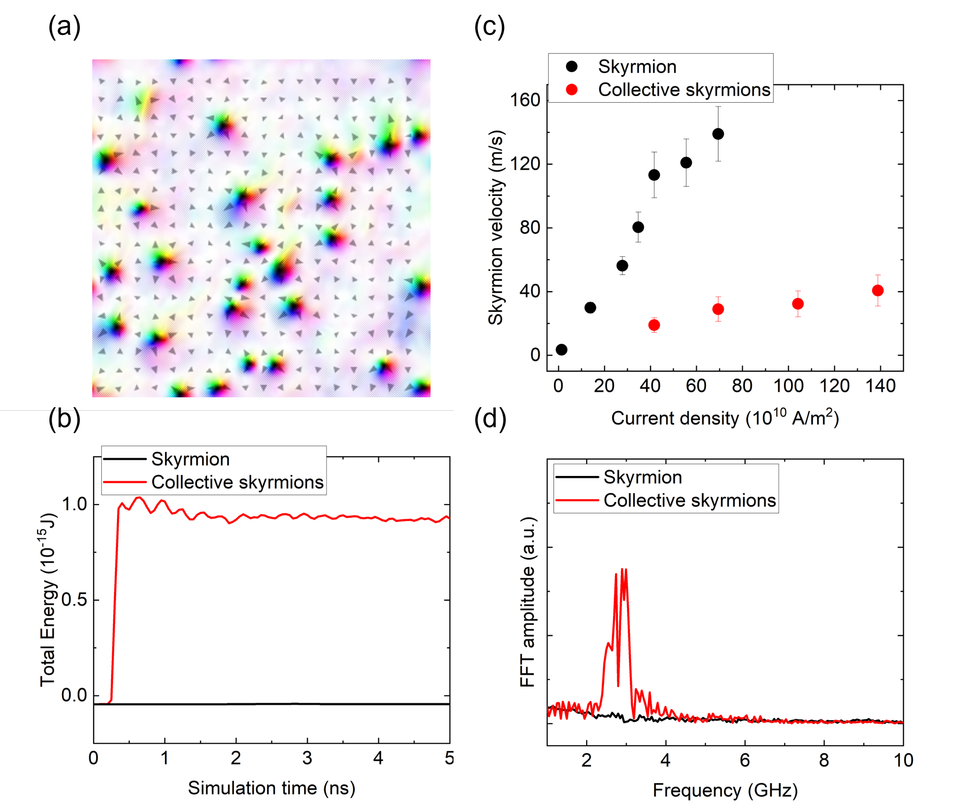
FIG. S1. Micromagnetic simulations of the current-induced dynamics for the disordered ($K_{1,imp}={10∙K}_{1}$) and the non-disordered ($K_{1,imp}=K_{1}$) skyrmion systems. (a) Snapshot of the disordered skyrmion dynamics at $t=19.6 ns$, (b) time development of total energy, (c) Current amplitude dependencies of the skyrmion velocities, and (d) Fourier spectra for both calculation conditions. The driving current amplitude for (a), (b), and (d) is set to $J=6.9×{10}^{11}A/m^{2}$. The solid black (red) line for (b), (c), and (d) indicates the non-disordered (disordered) skyrmion system, respectively.

Supplementary Note 2: Micromagnetic simulations for local current injection
The effects of the local current injection are also simulated using the micromagnetic calculation. Simulation methodologies, material parameters, and disorder design are common with Supplementary Note 1. We use same a downsizing analogy same manner with Supplementary Note 1, 600×300×1 finite size two-dimensional system designed into a hall bar with $1.2μm$ in its length and $500 nm$ in its width, connected to $150 nm$ width hall port. The constant driving current is designed to flow only along this hall port as an analogy with experimental conditions, and calculations are continued up to 25 ns at maximum to compare with the experimental conditions. In addition to the basic current-induced spin polarization torque, a thermal gradient propagating from the injection port is introduced for a consideration of the current-induced Joule heating contributions. A Gaussian thermal profile $T\left(x\right)=∆T_{0}e^{-\frac{x^{2}}{2σ^{2}}}$ is designed where $∆T_{0}$ denotes the maximum temperature increment and $σ$ scales the variance of thermal propagation length from the hall port.
Figure S2(a)-(d) presents snapshots of simulated skyrmion morphologies with a local current $j_{2}(=5.9×{10}^{11} A/m^{2})$ injection at $t=0.0ns$, $5.1 ns$, $t=10.2 ns$, and $t=23.0 ns$ from the initial state, respectively. The random and uniform skyrmion distribution (Fig. S2(a)) is quickly modulated within a few nanoseconds; fast driving and annihilation/nucleation at the injection port bring about a continuous supply of skyrmions from the left side, forming a “skyrmion blockade” enclosure by red doted square (Fig. S2(b)). This skyrmion blockade is subsequently attacked by further supply of new skyrmions from the injection port and gradually drifts into the neighbouring main wire region, assisted by the finite thermal gradient. In this process, bottom part of blockade (red doted square) is intensively affected, attributed to the finite skyrmion Hall angle and spin wave following annihilation at the right bottom edge of the main wire (red enclosure area). As a result, partial collapse at this blockade allows invasion of new skyrmions into the main wire (Fig. S2(c)). These series of annihilation/nucleation including displacement processes accompany the spin wave emission, which acts as an attractive force between different skyrmions, hence, initially isolated skyrmions (identified black circle (i)) gradually approach to such high-density blockade area with time evolution. Eventually, more than 20 ns after the first application, most skyrmions are distinctively localized to the bottom part of the main wire with following skyrmion Hall manner even without no current flows there (Fig. S2(d)). Since this local current-induced modulation includes skyrmion segregation by spin wave, the timescale of skyrmion displacement is much slower than direct current-induced driving, estimated as$ο\left(v\right)=1\sim 10 m/s$ at average.
A control simulation of local current injection is presented in Fig. S2(e), where no impurity is designed under the same conditions as Fig. S2(a)-(d). This impurity free system also forms a “skyrmion blockade” but with less density without skyrmion nucleation from impurity sites. Further, such blockade would be barely affected by continuous current application for more than 10 ns due to the lack of spin wave mediated skyrmion-skyrmion interaction. This interaction-less morphology also appears at much separated skyrmions in the main wire. Therefore, the disorder of skyrmion system could be the essence of global modulation by local current injection.
We note that these simulations are designed as downsized analogies due to the limitations of our computing facilities. Since our sub-μm scale skyrmion bubbles are more dominantly affected by surface magnetostatic energy, the experimental time and spatial scales would be much different from the calculation results in Fig. S2. Nevertheless, simulated multiple series of the nonlinear processes and contribution of the local heating could be one of the feasible roots for the long-range modulations distinctive to our experiments.
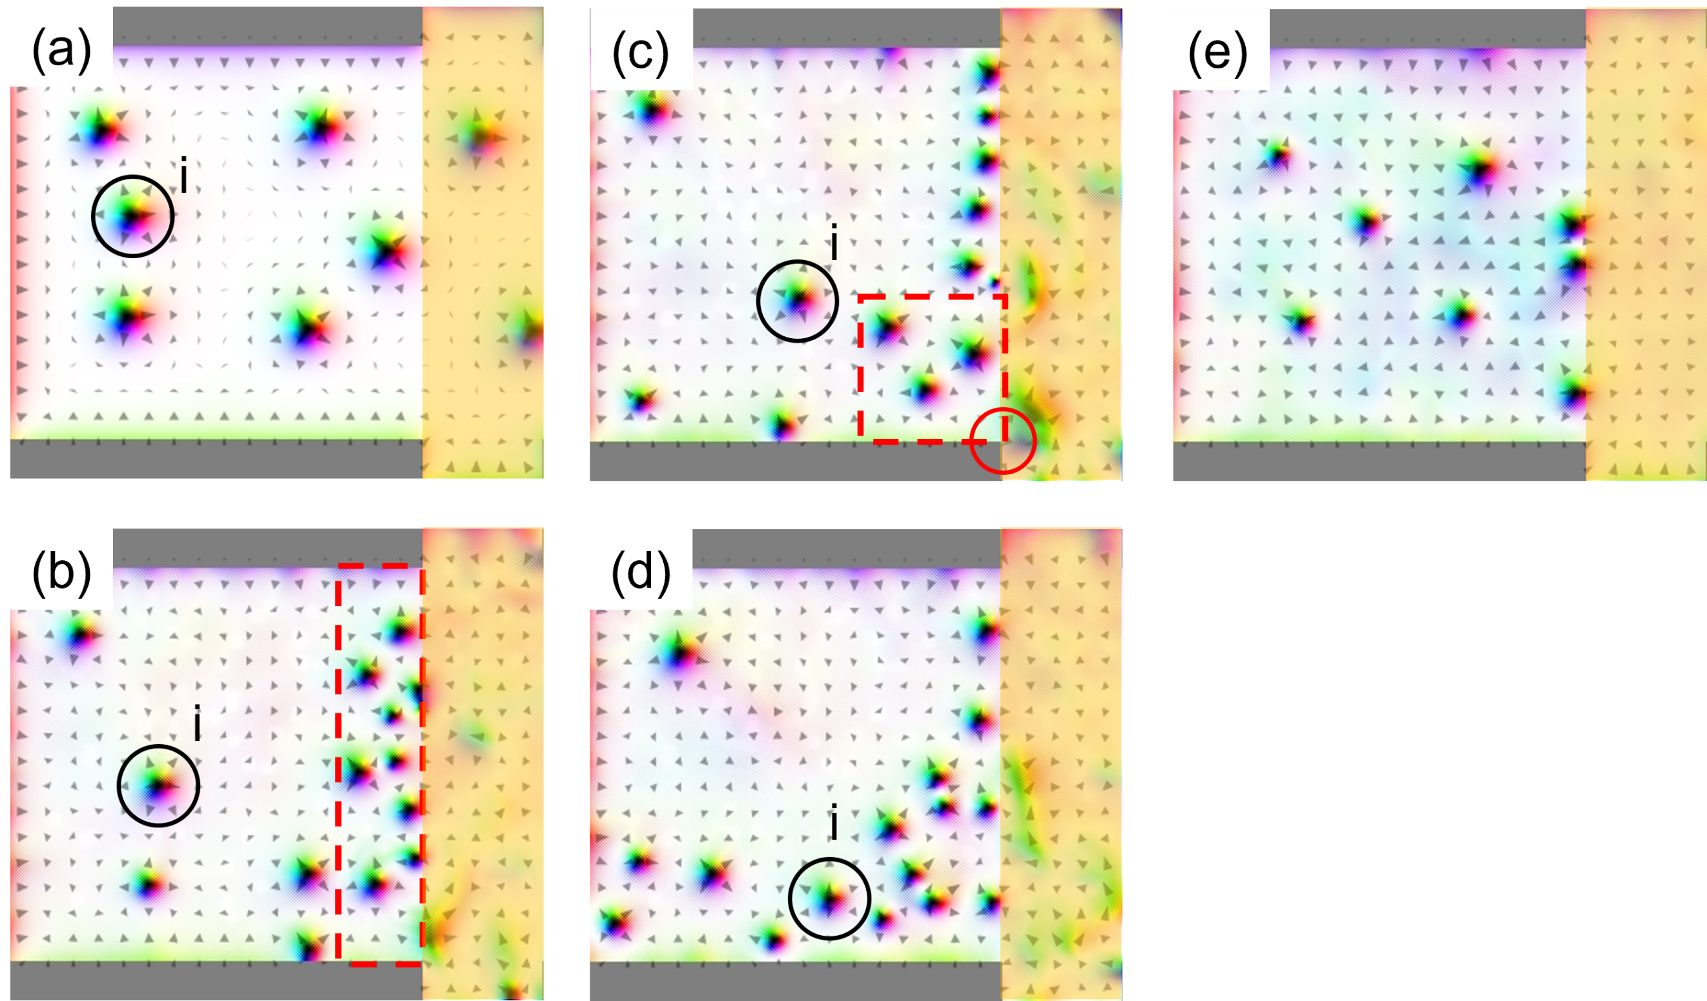
FIG. S2. Snapshots of micromagnetic simulations of the local current injection with finite thermal gradient with $j_{2}=5.9×{10}^{11} A/m^{2}$, $∆T_{0}=50 K$, and $σ=300 nm$, at (a) $t=0.0 ns$, (b) $5.1 ns$, (c) $10.2 ns$, and (d) $t=23.0 ns$ from the initial state, respectively. (e) A control simulation of impurity-free skyrmion system at $5.1 ns$. The orange highlighted areas indicate current-flowing region in each calculation.

Supplementary Note 3: Effects of the current-induced Joule heating and the magnetic field on counting skyrmion numbers
Since the threshold behaviour and selective skyrmion population are observed under application of relatively large current density ($ο\left(j_{1,2}\right)\sim {10}^{10\sim 11} A/m^{2}$), control results estimations are provided to evaluate feasible contributions of current induced the Joule heating and the magnetic field on skyrmion population demonstrations.
The effect of the Joule heating is first discussed by checking current polarity contributions to the actual imaging processes. Figure S3 indicates MOKE images at skyrmion population with opposite global current j₁ = $3.1×{10}^{10} A/m^{2}$ ($-3.1×{10}^{10} A/m^{2}$) under fixed local current $j_{2}(5.0×{10}^{10} A/m^{2})$. The localized skyrmion textures appear almost fully symmetric with respect to the horizontal direction with 0~3 skyrmion number difference using the typical particle analysis conditions, enough to conclude very minor contributions of the Joule heating, especially for our counting.
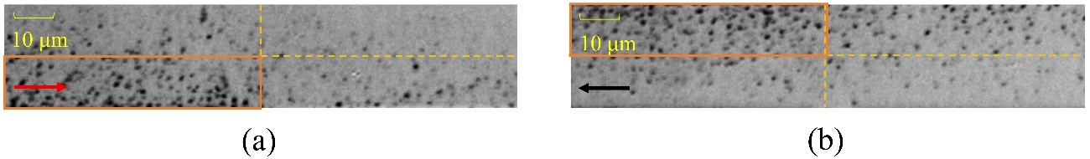FIG.S3. Current polarity dependence of skyrmion population with ($j_{1},j_{2}$)$=(±3.1×{10}^{10} A/m^{2},5.0×{10}^{10} A/m^{2})$ at an applied magnetic field of -11 Oe, respectively.
The effect of the current-induced magnetic field by the local current injection is roughly estimated by the simple Biot–Savart approximation as $H(r)=\left(\frac{I}{2πr}\right)A/m$. For current densities on the order of 10¹¹ A/m² with a total conductive thickness below 10 nm, the average field on the main wire is approximated as enough below ~1 mT, significantly smaller to modulate skyrmion stabilization and/or density in our multilayer samples. Moreover, such magnetic-field-driven contribution reflects device geometry, hence it appears totally with a different scale between global and local current applications; the corresponding field is applied on the whole experimental part in the former, while the very local application is speculated in the latter. Nevertheless, as is clear in all single current injection results in Fig.2(a)-(c) and Table 1 in the main text, only very minor differences are confirmed between global and local injection, especially for skyrmion counting process, indicating enough minor contributions of the current-induced magnetic field.

References

A. Vansteenkiste, J. Leliaert, M. Dvornik, M. Helsen, F. Garcia Sanchez, and B. Van Waeyenberge, AIP Adv. 4, 107133(2014).
L. D. Landau, and E. M. Lifshitz, Phys. Z. Sowietunion 8, 153 (1935).
T. L. Gilbert, Phys. Rev. 100,1243 (1955).
W. Koshibae, and N. Nagaosa, Sci. Rep. 8, 6328 (2018).

