Ammonia cracking catalyzed by Ni nanoparticles confined in the framework of CeO₂ support

Hiroshi Mizoguchi, ^{1,§, *} Yuta Osawa, ^{1,§} Masato Sasase,² Naoki Ohashi,³ Masaaki Kitano,² and
Hideo Hosono^{1, 2, *}

¹Research Center for Materials Nanoarchitectonics (MANA),
National Institute for Materials Science (NIMS)
1-1 Namiki, Tsukuba, Ibaraki 305-0044, Japan

²MDX Research Center for Element Strategy, International Research Frontiers Initiative,
Tokyo Institute of Technology, 4259 Nagatsuta, Midori-ku, Yokohama 226-8503, Japan

³Research Center for Electronic and Optical Materials,
National Institute for Materials Science (NIMS)
1-1 Namiki, Tsukuba, Ibaraki 305-0044, Japan

§These authors contributed equally to this work,
*Corresponding author footnote: MIZOGUCHI.Hiroshi@nims.go.jp, hosono@mces.titech.ac.jp

Abstract
For the extraction of hydrogen from ammonia (NH₃) at low temperatures, we have investigated the Ni-based catalysts fabricated by the thermal decomposition of RNi₅ intermetallics (R = Ce or Y). The interconnected microstructure formed via phase separation between the Ni catalyst and the resulting oxide supporter was observed to evolve via the low-temperature thermal decomposition of RNi₅. The resulting Ni/CeO₂ nanocomposite exhibited a superior catalytic activity of ~25% at 400 ℃ for NH₃ cracking. The interlocking of Ni nanoparticles with the CeO₂ framework was attributed to the high catalytic activity. The growth of Ni nanoparticles was prevented by this interconnected microstructure, in which the Ni nanoparticles incorporated nitrogen owing to the size effect, whereas Ni does not commonly form nitrides. To the best of our knowledge, this is a unique example of a microstructure enhancing catalytic NH₃ cracking.
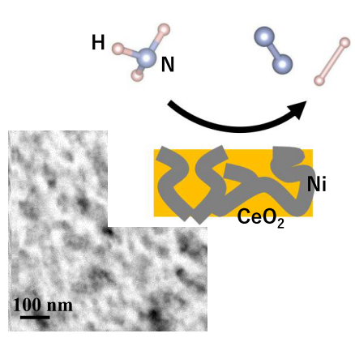
TOC figure

Hydrogen is one of the secondary energies and also works as an energy carrier. To realize environmentally friendly hydrogen economy, technologies for the storage, transportation, and stationary/mobile applications must be established.¹ Liquid ammonia (NH₃) such as compressed gaseous hydrogen and liquid hydrogen, is one of the candidates for hydrogen carriers. However, the method of extracting hydrogen from NH₃ at low temperature has not yet been established.² ³ ⁴ ⁵ The cracking reaction of NH₃ is endothermic with ΔH₂₉₈ = 46.1 kJ/mol and proceeds at high temperature and low pressure. In spite of the theoretical cracking fraction of 98 % at 400 ℃ under 1 atm, the reaction does not occur without the aid of catalysts (see equilibrium value in Fig. 1). The activity of these catalysts shows a volcano-type trend in the periodic table with the apex of Ru.⁶ While Ru exhibits excellent properties for this reaction, ² ⁷ there are two drawbacks. One is the unstable price of Ru. The other is its low abundance, which cannot meet social demands, because Ru is extracted only as a byproduct of platinum or palladium mining. Thus, finding new catalysts among cheaper transition metals (TMs) has been highly desired. Among them, many efforts have been devoted to Ni, which has a relatively high activity.⁵ These efforts are classified into two approaches. One is to maintain its small particle size to increase the surface area.⁸ The other is to improve the supporter including its electron-donating power to activate Ni-based catalysts.⁹ ¹⁰ Here, we report a novel approach to maintaining the large surface area of Ni nanoparticles by forming the characteristic microstructure via phase separation from the oxide supporter. RNi₅ binary intermetallics (IMs) are chosen among the Ni-based catalysts (R = Ce or Y).
The starting materials were Ni (Koujundo Chemical Lab., 99.9%), Y (Rare Metallic, 99.9%), Ce (Rare Metallic, 99.9%), Ni(NO₃)₂・6H₂O (Wako, 99.9%), Y₂O₃ (Rare Metallic, 99.9%), and CeO₂ (ITEC, 99.9 %, 10±3 nm particle size). RNi₅ was prepared from a stoichiometric mixture of R and Ni by arc melting on a water-cooled Cu hearth in high-purity Ar atmosphere. For the synthesis of 5 mol%Ni/RO_{x} powders as references, Ni was loaded with a RO_{x} supporter by the impregnation method using Ni(NO₃)₂-6H₂O as described in the literature.¹¹ To realize the ultrarefinement of grains into catalysts, the powders were mechanically milled. Ten steel balls each with a diameter of 10 mm and weighing ~1 g were placed in a planetary ball mill apparatus (PL-7, Fritsch, Germany) and milled at 300 rpm for 7 h. NH₃ cracking was performed in a fixed-bed plug-flow silica glass reactor (6 mm I.D.) placed in a furnace. Sixty milligrams of catalyst powder was placed on the silica wool in the reactor. Pure NH₃ was allowed to flow at a rate of 10–30 mL min⁻¹ through a mass flow controller. A mass flow meter behind the reactor monitors the change in flow rate caused by NH₃ cracking, which was converted into a conversion ratio mathematically. Effluent gases were also analyzed using an online gas chromatograph (GC-8A, Shimadzu, Japan) equipped with thermon-3000+KOH Sunpak columns and thermal conductivity detector. The synthesized materials were identified by powder X-ray diffraction (XRD; Miniflex II, Rigaku, Japan) using Cu K_{α} radiation. Crystallite size (CS) and strain were evaluated using a Halder–Wagner method¹² from XRD peak broadening. The hydrogen or nitrogen contents of the catalysts were estimated by thermal desorption spectroscopy (TDS). Ni surface area was determined by CO pulse chemisorption (BELCAT-A, Bel, Japan) at 50 °C using a He flow of 30 mL min⁻¹ and pulses of 0.03 mL (9.51% CO in He). Prior to dispersion analysis, the catalysts were treated with flowing H₂ (10 mL min⁻¹) at 300 °C for 120 min and then with flowing Ar (10 mL min⁻¹) at 300 °C for 60 min to remove adsorbed H atoms from the reduced catalysts. A stoichiometry of Ni/CO = 1 was assumed to calculate the metal dispersion. The morphology of the obtained powder was examined by SEM (TM3000, Hitachi, Japan). Scanning transmission electron microscopy (STEM) and high-angle annular dark-field scanning transmission electron microscopy (HAADF-STEM) images were captured using a Jeol JEM-ARM 200F equipped with an EDX detector operating at 200 kV. To obtain cross-sectional STEM images, the prepared samples were cut to a thickness of 70 nm using a focused ion beam (JIB-4601F, Jeol, Japan) with a liquid gallium ion source. Here, a Peltier cooled sample stage (~223 K) was used to prevent damage to the samples.
Heat treatment in NH₃ is often used for nitridation, with which a strong reducing atmosphere is realized. Although we investigated the catalytic activity for various Ni-based IMs, most of the IMs underwent thermal decomposition in NH₃. There were IMs showing no thermal decomposition, such as Ni₃Al, Ni₃Si, and NiTi. However, these materials commonly show no catalytic activities. On the other hand, a sample exhibiting high activity tends to undergo thermal decomposition to form metallic Ni particles. Thus, it is key to designing new catalysts to induce the decomposition of the IMs at the nanoscale level. Among the R–Ni systems, we focused on RNi₅ compounds because of their higher Ni content and paid attention to R = Ce or Y owing to its lower work function. Fig. 1 shows the catalytic activity of RNi₅. Oxidation treatment at 350 and 500 ℃ in air for 0.5 h was performed for R = Ce and Y, respectively, in order to enhance the decomposition of RNi₅. This oxidation treatment markedly improved the catalytic activities of RNi₅. The activity increased from zero at ~250 ℃ to 80 and 90 % at 500 ℃ for R = Ce and Y, respectively. Note also that the activities of R = Ce and Y at 400 ℃ are 22 and 26%, respectively. These activities were much higher than those of the 5% Ni/RO_{x} catalysts prepared by the impregnation method. The apparent activation energy (79.3 kJ/mol) for R = Ce was calculated from the Arrhenius plot in the temperature range of 340–400 ℃. As will be described later, Ni particles were formed by the thermal decomposition of RNi₅ in NH₃. The preparation process is shown in scheme 1. The generated Ni phase is primarily responsible for the catalytic reactions. Fig. S1a in Supporting Information (S. I.) shows the time dependence of catalytic activity. The activity of Ni/CeO₂ at 500 ℃ decreased from 75 to 65%. Fig. S1b in S.I. also shows the gasflow dependence of catalytic activity. Now, we compare the obtained activities with those reported in the literature.⁵ Among many reports, catalysts with relatively high activity are listed in Table S1 in S.I. The activities depend highly on experimental conditions including temperature or WHSV. The obtained activities values (22–26% at 400 ℃) are comparable to those of Ni-based catalysts (e.g., Ni/CaNH), which show the highest activities previously reported. ¹⁰ ¹³
The obtained catalysts were characterized to elucidate the origins of their activities. Figs. 2a and 2b show powder XRD patterns of RNi₅ (R= Ce and Y, respectively). CeNi₅ is decomposed into Ni/NiO/CeO₂ by oxidation treatment at 350 ℃. (Fig. 2a(1)). After NH₃ treatment, Ni/NiO/CeO₂ is converted into 5Ni/CeO₂ through the reduction of NiO (Fig. 2a(2)). That is, as shown in Fig. S2 in S. I., the microstructure of the catalyst is controlled by the insertion/deinsertion of oxygen. This result reminds us of the hydrogenation–disproportionation–desorption–recombination process (HDDR) using hydrogen.¹⁴ Hydrogen is often used for controlling the microstructure to invade into metals and to bring about hydrogen embrittlement. The IMs such as CeNi₅ do not absorb hydrogen well at ~1 atm.¹⁵ Expecting the use of oxygen, which has strong oxidation ability at low temperatures for decomposition, we attempted the low-temperature thermal decomposition of IMs by selective oxidation.¹⁶ Note that NiO is not formed from metallic Ni powder by the same oxidation treatment in air at 350 ℃. This difference is tentatively attributed to the chemical reactivity of Ni increased by the added Ce with low electronegativity. As shown in Fig. 2, the diffraction peaks corresponding to metallic Ni formed by RNi₅ decomposition show peak broadening with the Lorentzian shape. This broadening was attributed to the CS of the formed Ni particles. Table 1 shows the CSs evaluated from the diffraction peak broadening. An example of the Halder–Wagner plot is shown in Fig. S3 in S. I.. The small CS of 10(1) nm of Ni particles was due to the thermal decomposition of CeNi₅. (The CS did not depend on the presence/absence of oxidation treatment.) Fig. 3a shows a SEM image of CeNi₅ (after NH₃ treatments), revealing the inhomogeneous dispersion of the size of particles. As shown in the HAADF image of the Ni/CeO₂ nanocomposite in Fig. 3b, the nanocomposite has the characteristic microstructure. The composition ratio of Ni/Ce was determined as 5 by EDX, and the Ce part of the microstructure showed the electron diffraction derived from CeO₂ having the fluorite-type crystal structure. Si derived from contamination by the silica wool was also confirmed; for now, however, we do not know the effect of the Si contamination. Figs. 3c and 3d show the HAADF–STEM image and EDX mapping images of the region, respectively. The Ni/CeO₂ phase separation with interconnectivity at the scale of 10–20 nm order is induced not by spinodal decomposition, but by nucleation of CeO_{x} via oxygen-insertion. The number of surface active sites was estimated from CO adsorption to be 4.62 × 10²⁰ and 1.64 × 10²⁰ for Ni/CeO₂ and Ni/YO_{1.5,} respectively. Hence, the turnover frequencies of Ni/CeO₂ and Ni/YO_{1.5} were 133 h⁻¹ and 420 h⁻¹ at 400 ℃ and WHSV of 10000 mL g⁻¹ h⁻¹, respectively. TDS measurements provide H or N content information (Fig. S4 in S. I.). Note that the obtained chemical composition of the Ni/CeO₂ catalyst, (CeO₂)(Ni₅N_{0.45})H_{0.01} indicates the formation of NiN_{0.09}. The EDX measurement of TEM images also suggests the formation of NiN_{0.03} in the phase separation region.¹⁷ The Ni/YO_{1.5} catalyst did not contain a large amount of N or H, and it showed a TDS spectrum shape different from that of Ni/CeO₂. These results indicate an uptake of nitrogen by Ni nanoparticles in Ni/CeO₂, whereas metallic Ni was not found to commonly form nitrides. Next, we attempted to realize the ultrarefinement of grains of Ni particles by ball milling (BM), in order to investigate the effect of CS. Fig. S5 in S.I. shows the catalytic activity over the Ni catalysts fabricated by BM. Table 1 also shows the variation of CS caused by NH₃ treatments. The following three findings were obtained: (a) Milling gave rise to 28(4) nm CS of Ni powder. (b) After NH₃ treatments, the CS increased to 76(2) nm, and the catalytic activity reached only 10% at 500 ℃. (c) The addition of only 20 mol% supporter prevented the increase in CS upon heating, and the catalytic activity reached ~60% at 500 ℃. We found that the small CS of Ni particles enhances chemical reactions with ammonia. The thermal decomposition of Ni-based IMs is a convenient method of forming Ni nanoparticles. The ultrarefined microstructure is maintained by the oxide supporter. There are no reports about the catalytic NH₃ cracking reactions enhanced by the characteristic microstructure of Ni-based catalysts, to the best of our knowledge. We will briefly mention the results of YNi₅. The Ni/YO_{1.5} catalyst partially had the microstructure of phase separation, although the volume fraction of the interconnected microstructure was not large. We were unable to find characteristic features of the microstructure, from STEM observations.
First, we discuss the uptake of N by Ni nanoparticles. According to the literature, (a) Ni₃N forms via the nitridation of Ni by NH₃. However, the synthesis of a large batch is impossible.¹⁸ (b) For the synthesis of bulk Ni₃N, supercritical NH₃ is used.¹⁹ (c) Ni₄N forms via the nitridation of Ni thin films at 400 ℃ in NH₃.²⁰ These reports suggest the possible uptake of N by the surfaces of particles through NH₃ treatments, although we did not find XRD peaks derived from NiN_{0.09} in Ni/CeO₂ because of the small volume fraction of the nitride. This phenomenon means that the position of Ni in a volcano plot shifts slightly to increase its chemical reactivity with nitrogen. How can we interpret the effect of CS on catalytic NH₃ cracking through chemical bonding? It has been interpreted historically as the modulation of the Ni d band through chemical bonding.²¹ As a surface expands owing to the shortage of lattice energy, the bandwidth of the late TM d band decreases, leading to both a deeper shift in Fermi energy (E_{F}) and an increase in the density of states at E_{F}. Thus, an increase in the volume fraction of the surface increases the adsorption energy of NH₃. Finally, we briefly discuss the origins of small CS attributed to IM decomposition. The phase separation with interconnectivity formed by the thermal IM decomposition is key to maintaining the CS of Ni nanoparticles. Another origin is the large difference in the characteristics of the crystal structure between CeNi₅ and metallic Ni. CeNi₅ possesses the CaCu₅-type crystal structure. This large difference between the Ni₅ sublattice in CeNi₅ and the FCC lattice of Ni prevents the emergence of Ni from CeNi₅ at 500 ℃. The phase separation with interconnectivity has also been reported in the literature.²² The thermal decomposition of YNi into Ni/ YO_{1.5} was utilized for the preparation of a methane-reforming catalyst. The microstructure derived from the phase separation between the metallic catalyst and the oxide supporter seems to be a common product of the thermal decomposition of IMs via selective oxidation. The interconnected phase separation between the catalyst and the supporter is key to designing state-of-the art catalysts.
In summary, we have investigated the Ni-based catalysts fabricated by the low temperature thermal decomposition of RNi₅ intermetallics (R = Ce or Y). (1) The Ni/CeO₂ nanocomposite prepared by thermal decomposition of CeNi₅ exhibited a superior catalytic activity of ~25% at 400 ℃ for NH₃ cracking. (2) The interconnected microstructure formed via phase separation between the Ni catalyst and the resulting oxide supporter was observed. (3) The interlocking of Ni nanoparticles with the CeO₂ framework was attributed to the high catalytic activity. (4) The growth of Ni nanoparticles was prevented by this interconnected microstructure, in which the Ni nanoparticles incorporated nitrogen owing to the size effect, whereas Ni does not commonly form nitrides.

Acknowledgements We thank Drs. Y. Matsushita (NIMS), M. Miyazaki, and R. Wang (Tokyo Institute of Technology) for experimental support. This work was supported by "Advanced Research Infrastructure for Materials and Nanotechnology in Japan (ARIM)" of the Ministry of Education, Culture, Sports, Science and Technology (MEXT). Proposal Number JPMXP1223NM5382. This work was supported by a Grant-in-Aid for Scientific Research (No. 22H02172) from the Japan Society for the Promotion of Science (JSPS).

Supporting Information: Time or WHSV dependance of the conversion in NH₃ cracking, phase diagram, Halder-Wagner plot, TDS spectra, and the effect of ball milling in NH₃ cracking.
References
1. Al Ghafri, S. Z. S.; Munro, S.; Cardella, U.; Funke, T.; Notardonato, W.; Trusler, J. P. M.; Leachman, J.; Span, R.; Kamiya, S.; Pearce, G.; Swanger, A.; Rodriguez, E. D.; Bajada, P.; Jiao, F.; Peng, K.; Siahvashi, A.; Johns, M. L.; May, E. F., Hydrogen Liquefaction: A Review of the Fundamental Physics, Engineering Practice and Future Opportunities. Energy & Environ. Sci. 2022, 15 (7), 2690-2731.
2. Schüth, F.; Palkovits, R.; Schlögl, R.; Su, D. S., Ammonia as a Possible Element in an Energy Infrastructure: Catalysts for Ammonia Decomposition. Energy & Environ. Sci. 2012, 5 (4), 6278-6289.
3. Bell, T. E.; Torrente-Murciano, L., H₂ Production via Ammonia Decomposition Using Non-Noble Metal Catalysts: A Review. Top. Catal. 2016, 59 (15-16), 1438-1457.

4. Lamb, K. E.; Dolan, M. D.; Kennedy, D. F., Ammonia for hydrogen storage; A Review of Catalytic Ammonia Decomposition and Hydrogen Separation and Purification. Int. J. Hydrogen Energy 2019, 44 (7), 3580-3593.
5. Lucentini, I.; Garcia, X.; Vendrell, X.; Llorca, J., Review of the Decomposition of Ammonia to Generate Hydrogen. Ind. & Eng. Chem. Res. 2021, 60 (51), 18560-18611.
6. Boisen, A.; Dahl, S.; Norskov, J.; Christensen, C., Why the Optimal Ammonia Synthesis Catalyst is not the Optimal Ammonia Decomposition Catalyst. J. Catal. 2005, 230 (2), 309-312.
7. Kishida, K.; Kitano, M.; Sasase, M.; Sushko, P. V.; Abe, H.; Niwa, Y.; Ogasawara, K.; Yokoyama, T.; Hosono, H., Air-Stable Calcium Cyanamide-Supported Ruthenium Catalyst for Ammonia Synthesis and Decomposition. ACS Appl. Energy Mater. 2020, 3, 6573-6582.
8. Liu, H.; Wang, H.; Shen, J.; Sun, Y.; Liu, Z., Preparation, Characterization and Activities of the Nano-Sized Ni/SBA-15 Catalyst for Producing CO_{x}-free Hydrogen From Ammonia. Appl. Catal. A: General 2008, 337 (2), 138-147.
9. Yu, P.; Wu, H.; Guo, J.; Wang, P.; Chang, F.; Gao, W.; Zhang, W.; Lin, L.; Chem, P., Effect of BaNH, CaNH, Mg₃N₂ on the Activity of Co in NH₃ Decomposition Catalysis. J. Energy Chem. 2020, 46, 16-21.
10. Ogasawara, K.; Nakao, T.; Kishida, K.; Ye, T.; Lu, Y.; Abe, H.; Niwa, Y.; Sasase, M.; Kitano, M.; Hosono, H., Ammonia Decomposition over CaNH-Supported Ni Catalysts via an NH²⁻-Vacancy-Mediated Mars-van Krevelen Mechanism. ACS Catal. 2021, 11, 11005-11015.
11. Okura, K.; Okanishi, T.; Muroyama, H.; Matsui, T.; Eguchi, K., Ammonia Decomposition over Nickel Catalysts Supported on Rare-Earth Oxides for the On-Site Generation of Hydrogen. ChemCatChem 2016, 8 (18), 2988-2995.
12. Halder, N.; Wagner, C., Separation of Particle Size and Lattice in Integral Breadth Measurements. Acta Cryst. 1966, 20, 312-313.
13. Zheng, W.; Zhang, J.; Ge, Q.; Xu, H.; Li, W., Effects of CeO₂ Addition on Ni/Al₂O₃ Catalysts for the Reaction of Ammonia Decomposition to Hydrogen. Appl. Catal. B: Environ. 2008, 80 (1-2), 98-105.
14. Takeshita, T., Some Applications of Hydrogenation-Decomposition-Desorption-Recombination (HDDR) and Hydrogen-Decrepitation (HD) in Metals Processing. J. Alloys Comp. 1995, 231 (1-2), 51-59.
15. Mizoguchi, H.; Park, S. W.; Hosono, H., A View on Formation Gap in Transition Metal Hydrides and Its Collapse. J. Am. Chem. Soc. 2021, 143 (30), 11345-11348.
16. Rapp, R. A., Kinetics Microstructures and Mechanism of Internal Oxidation - Its Effect and Prevention in High Temerature Alloy Oxidation. Corrosion 1965, 21, 382-401.
17. The accurate content of N is difficult to determine, because of light element. In the fabrication process of TEM specimen, the use of ultrasonic process must also enhance desorption of N.
18. Juza, M.; Sachsze, W., Zur Kenntnis des Systems Nickel/Stickstoff. Z. Anorg. Allgem.Chem. 1943, 251, 201-212.
19. Leineweber, A.; Jacobs, H.; Hull, S., Ordering of Nitrogen in Nickel Nitride Ni₃N Determined by Neutron Diffraction. Inorg. Chem. 2001, 40 (23), 5818-22.
20. Nagakura, S.; Otsuka, N.; Hirotsu, Y., Electron State of Ni₄N Studied by Electron Diffraction. J. Phys. Soc. Jpn. 1973, 35, 1492-1495.
21. Eastman, D. E.; Himpsel, F. J.; van der Veen, J. F., Photoemission Studies of Surface Core‐Level Shifts and Their Applications. J. Vac. Sci. Tech. 1982, 20 (3), 609-616.
22. Shoji, S.; Peng, X.; Imai, T.; Murphin Kumar, P. S.; Higuchi, K.; Yamamoto, Y.; Tokunaga, T.; Arai, S.; Ueda, S.; Hashimoto, A.; Tsubaki, N.; Miyauchi, M.; Fujita, T.; Abe, H., Topologically Immobilized Catalysis Centre for Long-Term Stable Carbon Dioxide Reforming of Methane. Chem. Sci. 2019, 10 (13), 3701-3705.

Table 1. CSs of Ni estimated from XRD peak broadening. No predominant strain was found.
Catalyst | CS of Ni (nm)  before NH₃ treatment | CS of Ni (nm)  after NH₃ treatment
CeNi₅ | - | 10(1)
YNi₅ | - | 7.8(9)
Ni BM | 28(4) | 76(2)
(Ni BM) + CeO₂ | 15(2) | 80(10)
(Ni + CeO₂)BM | 9(1) | 18(1)

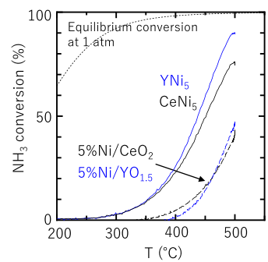
Fig. 1. Temperature dependence of conversion in NH₃ cracking over various Ni-based catalysts at a weight hourly space velocity (WHSV) of 10000 mL_{NH3} g_{cat}⁻¹ h⁻¹, RNi₅ with oxidation treatment (R = Ce or Y) (solid line), reference Ni–based catalysts prepared by impregnation method (dashed line), and calculated thermodynamically equivalent values (dotted line).

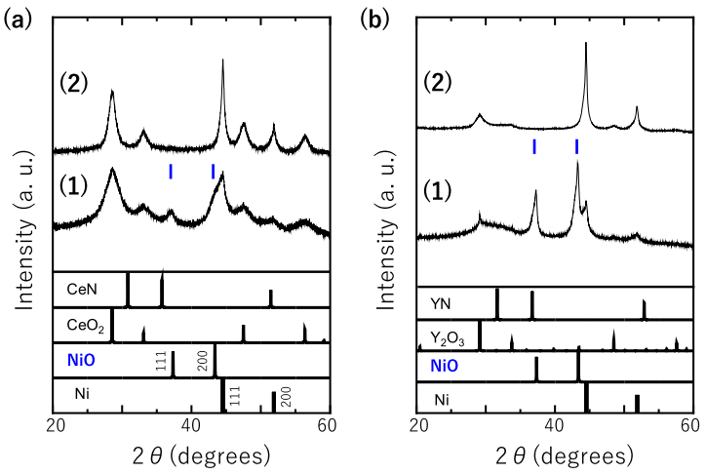
Fig. 2. Powder XRD patterns of RNi₅ catalyst (R = Ce (a) or Y (b)).
(1) RNi₅ with oxidation treatment. (2) After NH₃ treatment.

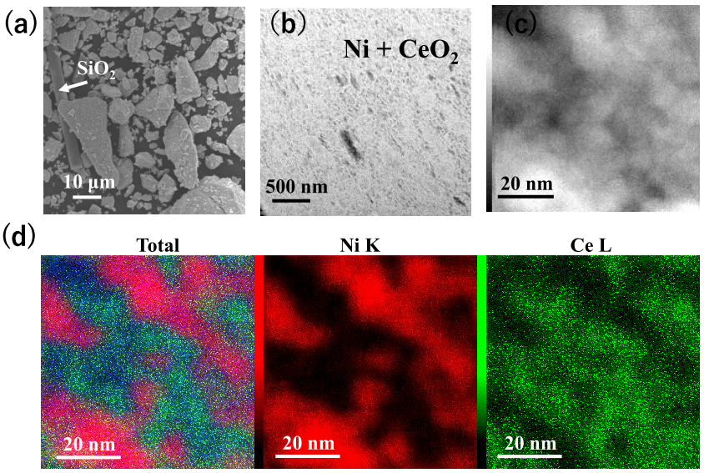
Fig. 3 Micro- and nanostructures of Ni/CeO₂ catalyst. (a) SEM image of Ni/CeO₂ particles.
(b) HAADF image of Ni/CeO₂ nanocomposite. (c) High-magnification HAADF–STEM image.
(d) The red and green areas in the EDX mapping images correspond to Ni and CeO₂, respectively.
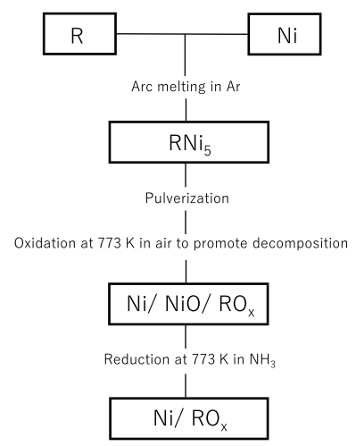
Scheme 1. Flowchart for preparing Ni/ RO_{x} catalysts.

