How Does Microtubular Network Assists in Determining the Location of Daughter Nucleus: Electromagnetic Resonance as Key to 3D Geometric Engineering
Pushpendra Singh^{1,2}, Komal Saxena³, Parama Dey⁴, Pathik Sahoo², Kanad Ray¹ and Anirban Bandyopadhyay^{2*}

¹Amity University Rajasthan, Kant Kalwar, NH-11C, Jaipur, Rajasthan- 303002, India.
²National Institute for Materials Science, Advanced Key Technologies Division, 1-2-1 Sengen, Tsukuba, Ibaraki-3050047, Japan.
3Research Center for Advanced Measurement and Characterization/Nano Characterization Field/Surface Characterization Group
4Research Center for Materials Nanoarchitectonics (MANA)/Nanomaterials Field/Functional Chromophores Group

Abstract: The first life form, a zygote cell finds precisely the 3D direction to divide & to locate its daughter cell by sensing the environment far outside its cell boundary. The programming begins at a sub-molecular level of a pair of centrioles via an unknown mechanism, eventually regulating the intricate geometries of a large-scale architecture that catalogs a trillion sets of coordinates for managing a trillion cells. Here we propose that a centriole splits the electric and the magnetic parts of an infra-red electromagnetic wave available as noise in the cells, then clocks the electric field in a circle & clocks the magnetic field radially to build a global positioning sensor. But, the magnetic clock works only if the centrioles are perpendicular. Using geometric constraints, a centriole builds a spherical coordinate system that senses the relative orientation of the centrioles of neighboring cells. Their relative orientation assembles a network of a doublet of triplet clocks that decides the left-right symmetry, symmetric and asymmetric cell division, and a role of geometry in decision making. The proposed global positioning system of a centriole was experimentally verified using a new dielectric resonance imaging technology in the 3D matrices of hippocampal neuron & a HeLa cell which is a universal tool to see live how a cell decides the future coordinates of its daughter cells.

Keywords: Centriol, cell division, Sperm axoneme, systems biology, Polarization, Electromagnetic resonance.

*Correspondence should be addressed to Anirban Bandyopadhyay, anirban.bandyo@gmail.com, and anirban.bandyopadhyay@nims.go.jp

I. Introduction:

A tissue requires its cells growing in a particular direction, change the direction, divide asymmetrically, as required by the organs. If not, the organization of intricate geometries of an advanced life form would not sustain. A zygote in a mother’s womb is already programmed for the final cellular structure, it would build (Cabernerd et al, 2010). The program is unknown, but the key element is identified (Feldman, J. L., 2007). Nine triplets of microtubule nanowire form a barrel-shaped structure, centriole. During a cell division, it should divide once, and only once (Tsou M. F., Stearns T.; 2006), ensuring that the centriole calculates the position & orientation of the next daughter before it divides. Centrioles sense the neighboring organelles, or the environment, even sense the substrate and orient perpendicular to it (Vorobjev and Chentsov, 1982). External environment internally transforms the cells via centriol’s position and orientation (Tang and Marshall, 2012). Since a spindle decides the position and the orientation of cell cleavage during a cytokinesis (Oliferenko et al., 2009), a centrosome reorients with the filaments synchronously to fine tune a cellular growth in various ways.

Here is a short review. The centrosome moves near the neurite that grows into an axon (Zmuda and Rivas, 1998). Defects in the spindle orientation lead to a small brain size (Fish et al 2006). Skin’s stratified cell layers are generated by an asymmetric cell division, the spindles are aligned by the centrosome positioning (Lechler & Fuchs, 2005). Several organs, blood vessels, lung, and kidney develop epithelial tubes which branch into a complex network, an oriented cell division regulates such a morphogenesis of epithelial tissues (Sato K, 2015). Regardless of the direction of blood flow, the centrioles of the blood vessels of epithelial cells are oriented towards the heart, as if the heart is a satellite and all the blood vessels are signal receivers (Kiosses et al 1997). The breaking of left-right symmetry in the mammalian embryos is driven by the direction of fluid flow through the mechanosensory cilia (Hirokawa et al 2009). Similarly, the flow of urine is sensed in the kidney, as the orientation of centrioles allows sensing the direction of a strain. The angular separation (90º) between the mother and the daughter centrioles changes directing the tail of sperms (Juneja S. C., 2005). Embryos undergo a dramatic change in shape and symmetry during their early growth, in all instances, the polarization of the centrioles shift significantly (Tang & Marshall, 2012). In a stem cell research, reorientation of the mitotic spindle (Fuchs et al., 2004; Spradling et al., 2001) plays a crucial role in the centrosome positioning and orientation (see details online). Three factors, segregation activity, cortical cell polarity, and mitotic spindle orientation, operate together to influence the daughter cell fate (E. B. Dewey, 2015) via symmetric and asymmetric division (Morin, X. 2011).

A program to pre-decide the 3D orientation of cells prior to a cell division is not required if all daughter cells arrange in a single lattice, i.e. then the centrosome is not essential (Calarco–Gillam P. D., 1983). It is theoretically proposed that the geometry of a cellular cavity is changed (Laan et al, 2012) to shift a centrosome to the central location of the modified cavity. Often, in reality, this is found not to be true. The entire plane of a tissue builds up an intrinsic polarity, namely a planar cell polarity, PCP (Bayly R., Axelrod J. D. 2011). The centrosome is moved to a precise location with a proper orientation by microtubule and actin filaments (Piel et al 2000). The challenge is to unveil a sensor to precisely determine the need for a global event when all the neighboring cells coordinate beyond their boundaries & then find a mechanism to relocate the centrioles internally. However, the process varies from cell to cell so much so that it inhibits drawing a general mechanism on how a sub-cellular event could influence a global event.

A large-scale construction program in the centriole positioning system has to be written as a minor shift in the 3D angular orientation, but how, no proposal is made thus far. Centriole’s triplets are tilted by 40º with the longitudinal axis of the cylinder (Figure 1a). Therefore, in a centriole, a longitudinal force would naturally trigger a helical flow of an input field. Some researchers argue that it is a pure mechanical interaction of various components that decide to orient the centrioles perpendicularly (Tanenbaum M. E. & Medema R. H. (2010); Dinarina A, (2009)). To build an integrated proposal, we limit our study to the various kinds of microtubule assemblies, especially fractal structures, where a property originating at the sub-cellular scale could extrapolate operation in a scale-free manner up to the physical limit of biological body.

Here we have comparatively studied five fractal microtubule assemblies, centriole, sperm axonemes of Sciara coprophila and three gall midge fly to show that they split the electric and the magnetic parts of an electromagnetic field at the specific resonance frequencies and rotate the two fields locally at two different sites. For all five assemblies, the fractal design sets an open/close path to get the desired split & form THz clocks. The spontaneous formation of non-chemical infra-red clocks was tested in real 3D cellular matrices, for neurons, HeLa cells and finally in three cases where there is no centriole, it sets the energy traps far outside the physical boundary of a component with an extreme precision. Our 3D cell culture & dielectric resonance imaging together is a universal tool to unravel various bio-system engineering. Earlier, a bio-rhythm meant only for chemical rhythms or clocking, now electromagnetic rhythms enable sensing the distant neighbors locally & editing the neighbor’s coordinates & orientation therefrom. If we edit one type of rhythm with another, —say, the circadian clock is edited by a THz wireless clock, then not just designing new molecular infra-red sensors/antenna as a drug, but one could use wireless fields directly for the medical treatment in the future.

II. Theoretical study design:

A. Asymmetric treatment of an electromagnetic wave: Currently the magnetic study of biomaterials is limited to applying a high magnetic field forcing the spins to align. However, even without a high magnetic field (~10⁴T, Agrawal et al., 2013), heartbeat, breathing naturally generate the waves of low magnetic fields (10⁻¹⁰T). Mostly a wavelike flow of magnetic field is generated in two ways, by asymmetrically treating an electromagnetic field or by a periodic flow of ions. The topology of the structures could regulate the beating of charges and generate a wavelike flow of magnetic field, (Welch et al., 2012; Wang et al., 2015; Henke et al., 1981). In the optical vortex studies, by manipulating the surface topology electric and magnetic parts are interfered separately (Nye, J. F., 2017). If biomaterials invented a technology to isolate electric and magnetic parts activate the separate regions of a biomaterial, initiate a typical dynamic flow of fields, then, it would open the route to wirelessly regulate a biological phenomenon (Kim, D.-H. et al, 2010). While the quest for a pure magnetic wave continues as magnetic vortex around a solid-state defect site (Im, M.-Y. et al; 2012), here, the studied biomaterials are non-magnetic.

B. The electric field prefers a closed loop, the magnetic field prefers a spiral in/out: If we have a hollow dielectric sphere, outside, the dipolar fields due to electric and magnetic parts are identical, the electric moments are simply changed by the magnetic moments in its mathematical expression. However, inside, the electric and magnetic moments reverse their sign (see details online). In a dielectric resonator antenna ($λ/{\sqrt{ϵ}}$), the piecewise linear distribution of elementary dipoles often varies the potential (Richtmeyer, 1939; Long et al., 1983) with LogQ, not Q²/r (Q=charge). Here, in a standalone non-conducting material, the reflecting boundary is not present. So, a closed loop flows the energy of a static electric or magnetic field which forms a virtual feedback loop. That ensures a periodic oscillation, but with a difference. In the above formulation, we find that the electric moment affects 1/3 but magnetic moments affect 2/3 as the values change in a topological space, a 2/3rd variation leads to a spiral behavior. We investigate the possibility of a spiral flow below.

If we consider any spiral or fractal path to be a sum of a repeated local symmetry, e.g. an array of discs, the lensing of electromagnetic wave (just like a lens focuses the light beam) (Choi and Howell, 2015) are possible. A lensing leads to the concentration of magnetic flux in a particular direction. An array of dielectric resonators acts as a stack of disks, then, the charge does not vary as LogQ, rather, we get $e\left(z\right)=e^{+}e^{ikz}+e^{-}e^{-ikz}$, $k=ω/e\sqrt{με}$.There have been extensive studies on the LogQ distribution of charge, but the studies on the spiral distribution of charge is scarce. It is useful because when an electromagnetic wave passes through such a medium, several waveforms packs within a very small angular width, the phenomenon is triggered by an array of resonators (here our elementary resonators are microtubule), which even could lead to a phase discontinuity or singularity (Yu et al., 2011). Then, we find that a part of the transverse component contributes to the longitudinal component. In other words, $B_{z}=\frac{i}{k_{c}}\left(\frac{∂E_{x}}{∂y}-\frac{∂E_{y}}{∂x}\right)=\frac{i}{k_{c}}e\left(z\right).∇_{t}×\vec{E_{t}}$. This is a topological factor that adds to $Pi≠Mi, when r<R$ factor described above. Thus, not just that distribution of charge regulates electric field, it treats the magnetic field distribution differently. While electric field prefers closed loops along the transverse, the magnetic field prefers a longitudinal spatial distribution, i.e. radial in/out which is a key for an effective lensing. At resonance, the oscillating field is replaced by a static field say H₀, then, $H_{eff}=k(H_{0}-ω/γ)$, at resonance $H_{0}=ω/γ$ and the angle of rotation or phase $θ=γH_{1}t$.

C. Rebuilding the microtubule assemblies for electromagnetic resonance study: The difference with the conventional studies
In the conventional dielectric resonator studies, a single geometric shape is used to mimic a giant bio-material, hence, the simulated results deliver only a few fundamental resonance frequencies. Here, sub-nanometer alfa-helices is built first to make a single tubulin protein & then several such proteins are used to build the microtubule (Figure 1a), nine such triplets of microtubules are arranged to build a centriole (Kitagawa et al., 2011). A pair of SAS-6 proteins form a dimer, nine such dimers form an oligomer, nine such oligomers form a spoke of a wheel using Bld12p protein. The SAS-6, Bld12p proteins were also created in CST from scratch like a tubulin protein. We use a nanosized cylinder, sphere, and elementary curved 3D geometric shapes as dielectric and cavity resonators to recreate the biological structures, brick by brick, from 2nm to 500nm. Our bottom-up integration delivers a large number of resonance frequencies & a composition of dielectric constants as a function of the resonance frequency. We kept the polarization properties of microtubule intact as observed in the experiments, since, adding polarity to the cells is a fundamental feature of biological systems (Witte and Bradke, 2008). The microtubules are tilted 40º in a centriole, we included this twist in our model. Finally, two centrioles orient such that vector direction is additive, we also preserve this.

D. Theoretical simulation protocol: Centriole assemblies as a wireless coordinate system:
The theoretically built microtubules are assembled in CST to create the following components (Balanis, 2005; Dallai, 2014; Lanzavecchia et al., 1991; Gomes et al. 2012; Zhang and Hua, 2017): axoneme of three gall midge fly, axoneme of Sciara coprophila, centriol and cilia & flagella. Inside a cilium and a flagellum, the microtubules are arranged in a characteristic pattern known as the 9x2 + 2, called axoneme (Figure 2). When a pair of centrioles make a centrosome, a single centriol triggers a doublet of microtubules (not triplet) growing cilium, often recognized as cell antenna (Ishikawa, and Marshall, 2011). However, how long would it grow is a mystery, though we know the mechanism (Zheng et al., 2016). We simulated the electromagnetic resonance spectrum, the electric and the magnetic field distribution at resonance frequencies for all the five assemblies by shifting the location of the source (called port) that pumps energy and the sink at various parts on the microtubule assemblies. By shifting the location of ports, we optimized for the maximum electric and magnetic resonant response. This was essential to underpin whether the clocking direction of fields, i.e. the direction of field intensity change as we change the phase from 0º to 360º is real, not a simulation artifact caused by a selective placement of the measuring probe in the simulator. Only the most interesting port compositions are reported here in Figure 2 and Figure 3. Key features of four assemblies are (i) A pair of sheets of microtubule spirally rotating outwards, rotating clockwise (Sciara Coprophila); (ii) a single sheet of microtubule rotating anti-clockwise and a separate small part of the same sheet rotating clockwise. It is a fusion of two rotations in opposite directions in a single structure but in two different parts of the structure (midge fly I). (iii) A complete fusion of clockwise and anti-clockwise spirals (midge fly II). (iv) A singular clockwise spiral (midge fly III). Centriol has a spiral embedded in it. Therefore, our study explores both clockwise and anti-clockwise spiral features in the microtubule assemblies. All these data and explanations are detailed online (Figure S1 and Figure S2). Both Centriol and Axoneme transmit signals in the THz frequency range, near the infrared region, this is consistent with the previous NIR resonance studies (Albrecht-Buehler G. 1994; Albrecht-Buehler G. 1998). We have especially looked into the 5-6THz domain because at room temperature ~300K, such thermal noises are available. We studied the 3D distribution of fields & the phase modulation in details for those peaks which splits (Figure 1b) & triggers a phase-modulated energy transmission across the structure & neighboring systems in the THz frequency domain. Clocking of THz beats happen at MHz frequencies, i.e. picosecond clocks are integrated by microsecond clocks (Figure 3c).

III. Experimental methods for centriole’s global positioning system:

Advanced 3D cell systems enable us to bridge the gap between a classical 2D cell culture and in vivo animal models. We use a 3D cellular matrix to confirm the proposed 3D global positioning system of a centriole. Using cultured HeLa cells & embryogenic hippocampal neuron cells in a 3D matrix we have experimentally verified the centriole’s spherical coordinate system proposed in Figure 3. In a culture dish 1mm x 1mm x 1mm, we pump the electromagnetic signals at resonance frequencies and observe the cellular growth of HeLa cells and the assembly formation of neurons in a separate 3D matrix. Extracellular Cell Matrix (ECM) Gel from Engelbreth-Holm-Swarm murine sarcoma is used to build a 3D cellular matrix. ECM has a protein concentration of 8-12 mg/mL, containing laminin as a major component, collagen type IV, heparin sulfate proteoglycan, entactin, and other minor components. We add collagen type IV to the ECM gel to increase the polymerization. The gel is thawed overnight at 2-8°C and dispensed to a multiwall plate using a plate and pipettes that are pre-cooled to 2-8°C. The gel was diluted up to twofold with 2-8ºC Dulbecco Modified Eagles Medium, along with the neuron embryogenic cells (Lonza Inc) or the HeLa cells before the gel mixture is added to the plate. The product converts into a gel within 5 minutes at 20ºC. For prolonged manipulations, the work was conducted below 10ºC. Since we culture the cells inside a matrix, we add the cells to the gel prior to plating at a density of 3-4 x 10⁴ cells per mL.

We observe the 3D matrix using scanning dielectric microscopy, SDM (Ghosh et al 2016), which captures a frozen 3D structure carrying the signature how centrioles are deciding about placing the daughter post cell division, or neighboring neurons. SDM is different from fluorescent imaging (Lana, L, 2012), here we do not use a fluorescent molecule, the material resonates to emit an electromagnetic signal, visible to our scanner. Thus, any subtle change in the orientation of a centriole by 0.01º in a 3D matrix is detected by a change in the resonance frequency in the dielectric image. Since a change in an angle or the position of a centriole is estimated by a change in the frequency not intensity, thus, the position is measured with a negligible detection error. Any change in the centriole orientation is revealed in the dielectric image of the 3D matrix made of HeLa cell or neuron. We monitor the coordinates of the daughter centriole of HeLa cell, or neuron cell by monitoring the dielectric resonance image. A time series of images reveal a one to one correspondence between the resonance frequency and the directivity of a system of centrioles. In 15 sets of 3D matrices, we have monitored the centrioles of three pairs of cells or six cells and observed the origin of clockwise and anticlockwise twist of the cells as shown in the Figures 4, 5.

IV. Results and discussion:
A. A generic feature of resonance for the five microtubule assemblies:

Figure 2 has five columns, each represents a microtubule assembly. From top to bottom, we present the raw data of 3D electric and magnetic field distributions at resonance frequencies noted in the plot. Here, for each structure, the 3D raw data of the field distribution are provided, the video files are available online for all five elementary structures. These five structures explicitly prove the hypothesis proposed above that the geometry of biomaterials enables splitting the electromagnetic wave into magnetic and electric parts, the schematic in the lowest raw reveals the split protocol adopted by a typical microtubule assembly. For the axoneme of Midge fly III, we see that the magnetic field distributes in the structure in the form of a pair of teardrops facing each other, while the electric field tries to form a closed loop. In the axoneme of Sciara coprophila, the electric field forms a closed loop and another loop is incomplete, but the trend is visible. While the magnetic field is spiraling like an "S" shape. Structure 3 is axoneme of midge fly I, here we find that electric field has formed a pair of teardrop loop, not a solid oscillating spiral of a teardrop. For the centriole, the electric field forms a closed circular loop while the magnetic field spirals out from the center and spirals in from the external boundary.

Figure 3a and Figure 3b left panels to summarize the resonance bands for five microtubule assemblies when the energy supply port is on the top and at the sides respectively. Midge fly II and Midge fly III has a strong polar radiance (Figure 2, see online videos, Figure S1, Figure S2 online). It means they select a particular direction and pump out the resonance energy. While the axonemes of Sciara coprophila and midge fly I radiate a very low power, we studied other four assemblies as control, because it is evident now that only a pure geometry enables radiating the resonant energy in all three directions for centriole. Moreover, it is unique radial wheel of SAS-6, Bld12p proteins that distinct centrioles from other assemblies. We have plotted the change in the field density distribution of the electric and magnetic part at a particular electromagnetic resonance frequency in Figure 3a (port at the top) and Figure 3b (port at the bottom). The field distributions for a centriole are plotted at a gap of 20º phase difference from 0º to 360º. We observed that the magnetic clocking is absent in a centriole if the applied electromagnetic field is longitudinal (Figure 3a). If applied perpendicularly, the clock returns (Figure 3b). Thus, the direction of energy input is also a key.

We have summarized the distinct flow of electric and magnetic field in Figure 3c. The % of area change shows that the magnetic field blinks radially from center while the electric field moves along the perimeter of the centriole. The time period for rotation is around microseconds, thus, the clocking of fields is much slower than the THz resonance. During clocking, the SAS-6 and Bld12p protein made linear part of the centriole absorbs energy and releases it, along the diameter, the magnetic field oscillates periodically as shown in Figure 3d. We have created an active surface on the centriole as shown in the plot Figure 3e and estimated the combined potential for the three kinds of centriole clocks observed in Figure 3c and Figure 3d. It provides a spatial 3D field distribution at the junction between the two centrioles. Three domains on a 3D prolate shape would get equal angular distribution (120º) of radiation all over, an essential requirement for forming the spindle. In a centriole, the electric field clocks around its cylindrical surface but the magnetic field radiates in/out to/from the center, while the axonemes build pure clockwise or anti-clockwise rhythms of electric and magnetic fields.

B. Study of a pair of centriole assemblies: The spherical coordinate system: The electric and the magnetic field distribution on the common circular area between a pair of centrioles is plotted in the Figure 4a. Two centrioles facing each other at various angles as shown in Figure 4b edit the 3D distribution of electric and magnetic fields at their junction. In the Figure 4a, the circular area at the junction between two centrioles acting as a 3D cavity develops a dark region with null fields that moves linearly along the diameter of the circle. The linear movement of the silent domain follows the linear movement of centrioles relative to each other as outlined in the Figure 4b. Thus, we get the linear parameter r for setting a spherical coordinate system, (r,θ,Φ). The other two angular parameters θ and Φ are also read from the 3D plot. The peak of the magnetic field (green) surrounding the silent domain in Figure 4a changes the intensity of the peak proportional to the relative angular changes between a pair of centrioles, hence we get θ. A pair of peaks around a silent point undergoes a relative rotation if we rotate one centriole keeping the other static. A 360º planar rotation of a pair of peaks represents Φ. We have explained the three parameters using a schematic in Figure 4c. To understand θ and Φ imagine the white dot at the junction between the pair of centrioles shown in panel a is hold at a fixed location, but the relative angular position of one centriole relative to another is changed. This is understood if one keeps the lower centriole of panel b fixed and rotates the upper centriole along the surface of the cone shown in panel Figure 4c. Then the angular width of cone is Φ, the angular rotation of the cone along its central axis is θ. The three parameters, the motion of a silent domain, the intensity of the magnetic field and the rotation of a pair of peaks constitute the spherical coordinate system (r, θ, Φ) respectively (Figure 4d).

C. Triplet of cells: How left-right symmetry and directivity of coupled cells is born: In Figure 5a we extend the spherical coordinate system to a triplet of cells scenario, to detect the origin of left-right symmetry. Three cells P, R and Q have a pair of centrioles each, just prior to a cell division and a subtle change in their relative orientation changes the directivity of the cells plotted in Figure 5c as if each centriole act as a clock in an architecture of clocks demonstrated in Figure 5b. In Figure 3a, 3b, THz resonance is obvious, however, the most important part is that spatial distribution of THz field at resonance follows a completely different frequency in the MHz domain as shown in Figure 3c. However, the integration of clocks from picoseconds to microseconds, it not that direct, there is a bridging clock at GHz, we reported such protein clocks earlier (Ghosh et al, 2015). The geometry of clocks shown in Figure 5b undergoes a switching behavior during cellular growth, changing the directivity of emitted energy as shown in Figure 5c, we carry out 3D cell culture of neuron and HeLa cells to confirm such switching.

D. A review of the spherical coordinate system: The cross section of Figure 4a between a pair of centrioles is advanced to the cross section between a pair of cells in Figure 4c and that very cross section is plotted here in Figure 5a for three pair of cells (P1-P2), (Q1-Q2) and (R1-R2), i.e. total six cells (or just prior to cell division how three cells P, Q and R would look like). The rotational direction is plotted from the experimental observation of 18 assembly of HeLa cells where it shows that the lines connecting (P1-P2), (Q1-Q2) and (R1-R2) gets a momentum from the center of the circle, a vortex like effect was noted. However, discovery of a new phenomenon requires not just observation but a control to switch the phenomenon off, or restricting it with a defined parameter. Figure 5c is such a proposition & Figure 5d,e are experimental evidences supporting the theoretical finding.

E. 3D cell matrix study: experimental results: We synthesized two types of 3D cellular matrices, following the methods described in the experimental section above. First, the neuron cells and second the HeLa cells. In the Figure 5d,e we present the dielectric resonance images of the neuron cells and the HeLa cells as they grow (Ghosh et al., 2016). We observe the centriole position & the orientation when the HeLa cell divides (18 case study) and the embryogenic hippocampal neuron cell decides where to grow its axon (23 case study). Dielectric image is a 2D resonance frequency map of a living cell’s components without adding any chemical marker or making a physical contact, identifies each component and its dynamics in the vibration map. The orientation of centrioles as suggested in the Figure 5a determines the clocking directions for both the types of cells (see the arrow, Figure 5d,e). We have detected the magnetic field (10⁻⁹ Tesla) connecting the centrioles across the cell boundaries, using a magnetic particle doped atomic resolution sensor in the dielectric scanner (Agrawal et al., 2016). It confirms that the spherical coordinate system of a centriole is driven by a magnetic field induced far distant coupling. The red colors in the dielectric images (red = 2.5 THz) of Figure 5d,e directly depicts the orientation and the location of the centriole. This is why both in Figure 5d and Figure 5e we find that the centrioles or red patches of all participating cells are at their border, as if they are directing where the daughter cell or an axon would grow. The electromagnetic field damps in a fluid, but an isolated magnetic field could wirelessly couple the distant elements without damping (Sunand and Akyildiz; 2009). Consequently, the cells separated by 300μm could reorient each other’s centriole.

The electric vector lies in the plane with the centriole surface, it interacts more with the surface electrons than the magnetic field, we get , $B_{z}=\frac{i}{k_{c}}\left(\frac{∂E_{x}}{∂y}-\frac{∂E_{y}}{∂x}\right)=\frac{i}{k_{c}}e\left(z\right).∇_{t}×\vec{E_{t}}$. The relative geometry of centrioles is such that the electric vector is reduced, the electromagnetic wave changes its electrical nature to a magnetic one. Isolating the magnetic part of an electromagnetic wave in an integrated cellular system is the key to a global positioning sensor proposed here. 3D cell matrix is noisy, our ultimate confirmation requires a live imaging of Figure 5a, where we should see three cells and six centers orienting relative to each other. We are still hunting for the luck to see such three cells with six centriole pairs at the right moment for a long time.

F. Electromagnetic resonance is nearly a century old: Electromagnetic resonance of the proteins and their complexes have been measured since the 1930s. Microtubule's resonance does survive inside the axon of a neuron (Ghosh et al., 2016; Sahu et al., 2014; 2013a, 2013b), and it regulates the neuron firing (Agrawal et al., 2016). Therefore, in the living system, the key component of a centriol and an axoneme is itself an electromagnetic resonator. The 3D cell matrix study in Figure 5d,e argues that nature uses resonance in structuring the core of a neuron or a sperm cell. A microtubule assembly is not just a skeleton as believed thus far; they are designed to produce clocking or periodic oscillations, known for decades. Possibly, that makes the centrosome an infra-red sensor (Albrecht-Buehler G. 1994), and the microtubule is called a nerve of the cell (Albrecht-Buehler G. 1998). Global positioning by the centrioles have a molecular origin and that requires a more rigorous investigation in the future.
V. Conclusion:

Isolated magnetic field harvested from noise spreads outside, interacts with the neighbor’s fields to find the future location of a daughter cell. The notion of a fixed perpendicular orientation of centrioles is now replaced with a variable orientation (r, θ, Φ) that edits a magnetic clock. By shifting that magnetic field locally, a centriole could maximize or minimize the field elsewhere at far. Clockwise and anti-clockwise rotations of fields are one of the key mysteries in the left-right asymmetry, essential for adding a complexity to the cellular growth. The selection of a particular clocking direction has a geometric origin. The fractal symmetry of five microtubule assembled structure regulates the “time” not just within, but also in the assembly of its final structure. All the structures modulate the phase, manage the interference induced fields outside their physical boundary, remain coupled. A shift in the local orientation governs their global energy exchange. Finally, inside a solid physical structure, the rhythmic non-chemical oscillation pervades, —ionic biorhythms for a longer time scales do not stop at the millisecond's domain, but continue to operate deep inside via electromagnetic oscillations of the functional groups—thus covering a wide space & time ranges. Spatial isolation enables the bio-systems to create possibly a chain of clocks, wherein they use ions for running the slower clocks and use the electrons for operating the faster clocks.

Supporting online materials: Eight video files of all eight classes of simulations are now uploaded as supporting online videos.
Longitudinal mode: (i) Axoneme of Midge fly 162.88 THz; (ii) Axoneme of Sciara Coprophila 142.98 THz; (iii) Centriol.
Transverse mode: (i) Axoneme of Midge fly, 77.5 THz; (ii) Axoneme of Midge fly, 80 THz; (iii) Axoneme of Midge fly, 83 THz; (iv) Axoneme of Sciara Coprophila; (v) Centriol.
Acknowledgment: Authors acknowledge the Asian office of Aerospace R&D (AOARD) a part of United States Air Force (USAF) for the Grant no. FA2386-16-1-0003 (2016–2019) on the electromagnetic resonance-based communication and intelligence of biomaterials.
References:

- Agrawal l et al (2016) Inventing atomic resolution scanning dielectric microscopy to see a single protein complex operation live at resonance in a neuron without touching or adulterating the cell. Journal of integrative neuroscience 15 (04): 435-462.
- Albrecht-Buehler G (1994) Cellular infrared detector appears to be contained in the centrosome. Cell Motil Cytoskeleton 27(3):262-71.
- Albrecht-Buehler G (1998) Altered drug resistance of microtubules in cells exposed to infrared light pulses: are microtubules the "nerves" of cells? Cell Motil Cytoskeleton. 40(2):183-92.
- Agrawal M, Vasyuchka VI, Serga A A, Karenowska AD, Melkov GA, Hillebrands B (2013) Direct Measurement of Magnon Temperature: New Insight into Magnon-Phonon Coupling in Magnetic Insulators. Phys. Rev. Lett. 111: 107204 (1-5).
- Albrecht-Buehler G. (1994) Cellular infrared detector appears to be contained in the centrosome. Cell Motil Cytoskeleton 27(3):262-71.
- Bayly R, Axelrod JD (2011) Pointing in the right direction: new developments in the field of planar cell polarity. Nat. Rev. Genet. 12: 385–391.
- Balanis CA (2005) Antenna Theory: Analysis and Design, Wiley-Interscience, New York.
- Blachon S, Cai X, Roberts KA, Yang K, Polyanovsky A, Church A, Avidor-Reiss T (2009) A proximal centriole-like structure is present in Drosophila spermatids and can serve as a model to study centriole duplication. Genetics 182 (1): 133-44.
- Blachon S, Khire A, Avidor-Reiss T (2014) The origin of the second centriole in the zygote of Drosophila melanogaster. Genetics 197(1): 199-205.
- Cabernard C, Prehoda K E, Doe C Q (2010) A spindle-independent cleavage furrow positioning pathway. Nature 467: 91–94.
- Calarco–Gillam PD, Siebert MC, Hubble R, Mitchison T, Kirschner M (1983) Centrosome development in early mouse embryos as defined by an autoantibody against pericentriolar material. Cell 35: 621–629.
- Choi JS, Howell JC (2015) Paraxial full-field cloaking. Opt. Express 23 (12): 15857-15862.
- Dewey EB, Taylor DT, Johnston CA (2015) Cell Fate Decision Making through Oriented Cell Division. J. Dev. Biol. 3(4): 129-157.
- Dinarina et al (2009) Chromatin shape the mitotic spindle. Cell 138 (3): 502-13.
- Dallai R (2014) Overview on spermatogenesis and sperm structure of hexapoda. Arthropod Struct Dev. 43(4): 257-90.
- Fish JL, Kosodo Y, Enard W, Pääbo S, Huttner WB (2006) Aspm specifically maintains symmetric proliferative divisions of neuroepithelial cells. Proc. Natl. Acad. Sci. 10438–10443 10.1073/pnas.0604066103
- Funch et al (2004) Zebrafish reveals different and conversed features of vertebrate neuroglobin gene structure expression pattern and ligand binding. The Journal of Biological Chemistry 279(23): 24116-24122.
- Gomes LF, Badke JP, Zama U, Dolder H, Lino-Neto J (2012) Morphology of the male reproductive system and spermatozoa in centris Fabricius, 1804 (Hymenoptera: Apidae, Centridini). Micron 43: 695- 704.
- Ghosh S, Sahu S, Agrawal L, Shiga T, Bandyopadhyay A (2016) Inventing a co-axial atomic resolution patch clamp to study a single resonating protein complex and ultra-low power communication deep inside a living neuron cell. J. Int. Neuro.15 (4): 403-433.
- Hirokawa N, Tanaka Y, Okada Y (2009) Left-right determination: involvement of molecular motor KIF3, cilia, and nodal flow. Cold Spring Harb. Perspect. Biol. 1, a000802 10.1101/cshperspect.a000802
- Henke W, Selzle HL, Lin SH, Schlag EW (1981) Effect of collision and magnetic field on quantum beat in biacetyl. Chem. Phys. Lett. 77(3): 448-451.
- Im MY et al (2012) Symmetry breaking in the formation of magnetic vortex states in permalloy nanodisk. Nature Communications. doi: 10.1038/ncomms1978.
- Ishikawa H, Marshall WF (2011) Ciliogenesis: building the cell’s antenna. Nature reviews. Molecular cell biology 12: 222-234.
- Jessica L F, Stefan G, Wallace F M (2007)The Mother Centriole Plays an Instructive Role in Defining Cell Geometry. PLoS Biology 5(6): 1284-1297.
- Kim DH et al (2010) Biofunctionalized magnetic-vortex microdiscs for targeted cancer-cell destruction. Nature materials 9(2): 165–71.
- Kitagawa D, Vakonakis I, Olieric N, Hilbert M, Keller D, Olieric V, Bortfeld M, Erat, MC, Flückiger I, Gönczy P, Steinmetz MO (2011) Structural basis of the 9-fold symmetry of centrioles. Cell 144 (3): 364–375.
- Kiosses WB, McKee NH, Kalnins VI (1997) The distribution of centrosomes in endothelial cells of the rat aorta and inferior vena cava. Artery 22: 251–265.
- Lechler T, Fuchs E (2005) Asymmetric cell divisions promote stratification and differentiation of mammalian skin. Nature 437: 275–280.
- Laan L, Pavin N, Husson J, Romet–Lemonne G, Van DM, López MP, Vale RD, Jülicher F, Reck–Peterson SL, Dogterom M (2012) Cortical dynein controls microtubule dynamics to generate pulling forces that position microtubule asters. Cell 148: 502–514.
- Lanzavecchia S, Dallai R, Bellon PL, Afzeliuss BA (1991) The sperm tail of a gail midge and its microtubular arrangement studies by two strategies of image analysis(cecidomyiidae, dipteral, insecta). Journal of structural Bio. 107: 65-75.
- Lana L (2012) STED Microscopy with Optimized Labeling Density Reveals 9-Fold Arrangement of a Centriole Protein. Biophysical J. 102(12): 2926-2935.
- Morin X, Bellaïche Y (2011) Mitotic Spindle Orientation in Asymmetric and Symmetric Cell Divisions during Animal Development. Developmental Cell 21(1): 102-119.
- Nye JF (2017) The life-cycle of Riemann–Silberstein electromagnetic vortices. Journal of Optics 19(11) Nye, J. F. (2017). The life-cycle of Riemann–Silberstein electromagnetic vortices. Journal of Optics, 19(11), 115002. doi:10.1088/2040-8986/aa8c41.
- Oliferenko S, Chew TG, Balasubramanian MK (2009) Positioning cytokinesis. Genes Dev. 23: 660–674.
- Piel M, Meyer P, Khodjakov A, Rieder CL, Bornens M (2000) The respective contributions of the mother and daughter centrioles to centrosome activity and behavior in vertebrate cells. J. Cell Biol. 149: 317–330.
- Richtmeyer RD (1939) Dielectric Resonator. Journal of Applied Physics 10 (6): 391-398.
- Sato K, Hiraiwa T, Maekawa E, Isomura A, Shibata T, Kuranaga E (2015) Left–right asymmetric cell intercalation drives directional collective cell movement in epithelial morphogenesis. Nat. Commun. 6: 10074.
- Subhash C J, Jan MVD (2005) A mouse model of familial oligoasthenoteratozoospermia. Human Reproduction 20(4): 881-93.
- Spradling A, Drummond- BD, Kai T (2001) Stem cells find their niche. Nature: 414(6859): 98-104.
- Sahu S, Ghosh S, Fujita D, Bandyopadhyay A (2014) Live visualizations of single isolated tubulin protein self-assembly via tunneling current: effect of electromagnetic pumping during spontaneous growth of microtubule. Scientific Reports 4: 7303 (1- 9).
- Sahu S, Ghosh S, Ghosh B, Aswani K, Hirata K, Fujita D, Bandyopadhyay A (2013a) Atomic water channel controlling remarkable properties of a single brain microtubule: correlating single protein to its supramolecular assembly. Biosensors and Bioelectronics 47: 141–8.
- Sahu S, Ghosh S, Hirata K, Fujita D, Bandyopadhyay, A (2013b) Multi-level memory switching properties of a single brain microtubule. Appl. Phys. Lett. 102 (12): 123701 (1-4).
- Tsou MF, Stearns T (2006) Mechanism limiting centrosome duplication to once per cell cycle. Nature 442(7105): 947-51.
- Tang N, Marshall W F (2012) Centrosome positioning in vertebrate development. J Cell Sci 125(21): 4951–4961.
- Tenenbaum ME, Medema RH (2010) Mechanism of centrosome separation and bipolar spindle assembly. Dev Cell 19(6): 797-806.
- Vorobjev IA, Chentsov Y (1982) Centrioles in the cell cycle. I. Epithelial cells. J. cell biology 93(3): 938-49.
- Welch DR, Genoni TC, Thoma C, Bruner N, Rose DV, Hsu SC (2012) Simulation of Magnetic Field Generation in Unmagnetized Plasmas via Beat-Wave Current Drive. Phys. Rev. Lett. 109:225002.
- Wang R, Zhang C, Zhang B, Liu Y, Wang X, Xiao M (2015) Magnetic dipolar interaction between correlated triplets created by singlet fission in tetracene crystals. Nat. Commun. 6: 8602 (1 -6).
- Witte H, Bradke F (2008) The role of the cytoskeleton during neuronal polarization. Curr Opin Neurobiol. 18 (5): 479-87.
- Yu N, Genevet P, Kats MA, Aieta F, Tetienne, JP, Capasso F, Gaburro Z (2011) Light propagation with phase discontinuities: generalized law of reflection and refraction. Science 334 (6054): 333-337.
- Zmuda JF, Rivas RJ (1998) The Golgi apparatus and the centrosome are localized to the sites of newly emerging axons in cerebellar granule neurons in vitro. Cell Motil. Cytoskeleton 41: 18–38.
- Zhang BB, Hua BZ (2017) Spermatogenesis and sperm structure of Neopanorpa lui and Neopanorpa lipingensis (Mecoptera: Panorpidae) with phylogenetic considerations. Arthropod systematics& Phylogeny 75(3): 373-386.
- Zheng X et al (2016) Molecular basis for CPAP- tubulin interaction in controlling centriolling centriolar and ciliary length. Nat Commun 16: 11874 (1-13).
- Zhi S. Ian FA (2009) Underground Wireless Communication using Magnetic Induction. IEEE Communications Society subject matter experts for publication in the IEEE ICC 2009 proceedings 978-1-4244-3435-0/09/$25.00 ©2009 IEEE.

Figure caption:
Figure 1: a. Schematic of a centriole. Out of its 27 microtubules, one is zoomed below. Cross section of microtubule (pdb file, which was replicated in CST) is shown to the right along with the tubulin protein (pdb structure). b. Splitting & clocking of electric and magnetic field as a biomaterial is pumped an electromagnetic signal of a suitable frequency.

Figure 2: Five columns for five microtubule assemblies. First row is the device structures of Centriol, Sperm axoneme of Sciara Corprophila, and that of Midge fly (I), (II), (III) are shown (1), (2), (3), (4), and (5) respectively, individually by putting the energy supply source from the side, transverse mode set up. Second row is the magnetic field (upper panel) and electric (lower panel) distribution along the detailed structures reported at resonance frequencies -153.7THz, 77.5THz, 80.0THz, 83.0 THz, 77.5 THz. Third row exhibits four realistic structures: sperm axoneme; 1 - Centriole, 2 - Sciaracoprophila, 3 - Midge fly (I), and 4- midge fly (III). The red lines indicate the magnetic field lines (clocking path) while the black lines depict the electric field lines. Detailed field line patterns of electric and magnetic of a structure are depicted in the lower half of each panel.

Figure 3: The resonance spectra S11 (reflectance) for all five structures are shown in panel a and panel b where the energy supply ports are kept below the vertical column structure for panel a and one side of the column for panel b. Both panels use the same color codes as noted by color of the texts of materials names. The spatial energy distribution at the resonance peaks as a function of phase for Centriol (153.1 THz, black) are plotted for both panel a and panel b to their right. The sperm axoneme of Sciara Coprophila (77.5 THz, red), and midge fly (I, II & III) (80THz (green III); 83THz (pink II) and 77.5THz, purple I) are depicted in supporting online materials. M=magnetic, E=Electric field, the corresponding phase is noted below each plot, the arrow denotes the highest energy density point. Simulation detail - Used software = CST, Used solver =Time domain solver, Boundary condition = open space, simulation frequency range = 50 - 150 THz, Port dimension = 7.9 x 30 nm², Magnetic and electric field distribution scale at resonant frequency = 153.1 THz. b. For longitudinal mode, the resonance peak for centriol 185.49 THz (blue). The right panel shows electric and magnetic field distribution, the simulation frequency range = 0 – 500 THz, port dimension = 600 x 600 nm². c. From magnetic field distribution of panel a (right), percent % of area covered by high intensity field from the center of the structure (red) is plotted. From electric field distribution of panel a (right) the angular position of maximum intensity is plotted (blue). d. From electric field distribution of panel a (right), the linear domain along the centriole diameter where the intensity is maximum is plotted, how it flips between limiting angular range. e. Magnetic field distribution (normalized to one) on the circular surface (200nm diameter) of a centriole at the junction between a pair of centrioles. The plane of measurement is located 40nm above the centriole top surface.

Figure 4: a. Normalized electric (red) and magnetic (green) field distribution on a cross sectional area (diameter 200 nm), for the six consecutive relative orientations of a pair of centrioles shown in the panel b (start second from left). A white line is drawn along the diameter with a white ball marker that follows the darkest black region, i.e. weakest field domain. A similar red ball movement in panel b shows one to one correspondence. b. Theoretical models of a pair of centrioles built in CST, which were simulated to acquire the simulated electric and magnetic field distribution of panel a. c. The mechanism of changing two angular parameters θ and Φ is shown in a pair of spherical coordinates formed between two distinct cells. Each cell is represented with a pair of centrioles, their cross section is now new r, represented by a new sphere. There is a blue cone indicator on which the centrioles are placed at two different angular parameters θ and Φ, both the cone and the sphere have the same r. d. A generalized spherical coordinate system.

Figure 5: a. Switching between left-right symmetry is shown for a cell using two schemes. Six pairs of centrioles from three cells P, Q and R, the center of centriole pairs is connected using a line. The directions of daughters follow an extrapolation of this line in Figure 5d. b. The THz clocking of electromagnetic field for all six pairs of centriols (orange) run by much slower GHz clocks (green), which integrates into a MHz clock (pink). The nested clocks are shown as a schematic. c. The switching of directivity of a system as we physically move HeLa cells in Figure 5d---2, it is experimental verification of the schematic demonstrated in Figure 5a. 1-2-3 clockwise and 4-5 are anti-clockwise. d. Dielectric resonance images of HeLa cells, scale bar 80μm. e. Microscopic image of embryogenic hippocampal neuron cells. For image 1, corresponding dielectric resonance image is given below. Scale bar for first three images of the column (1,1 and 2) is 80 μm, for the last image (3) scale bar is 60μm. Panel d,e have a common color code for dielectric imaging, its discrete coloring as noted in between two panels.

Figure 1:
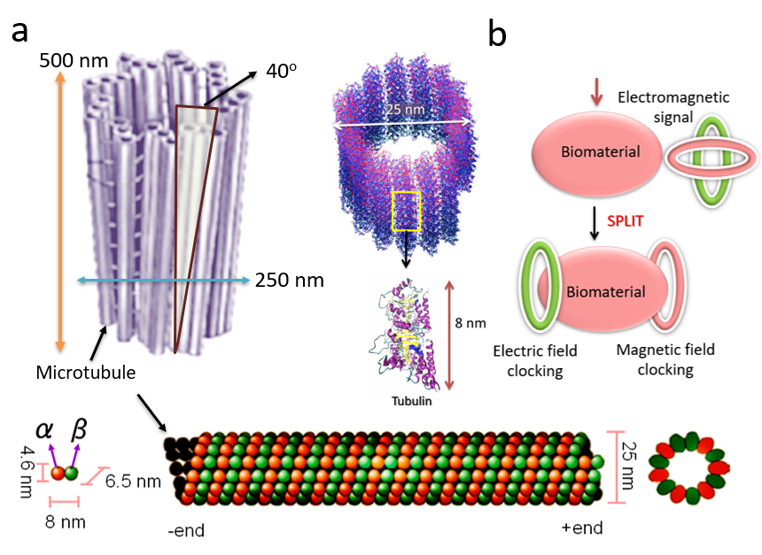

Figure 2

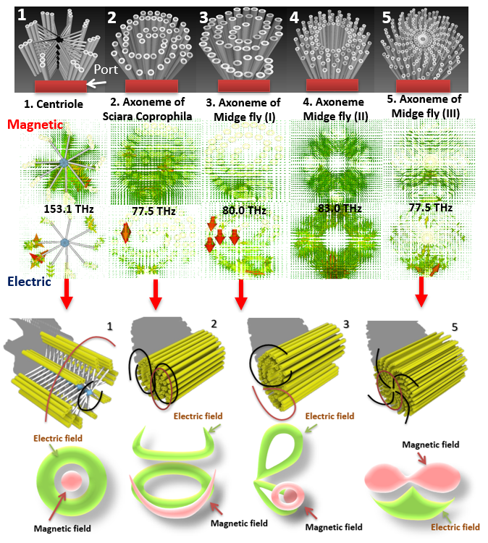

Figure 3

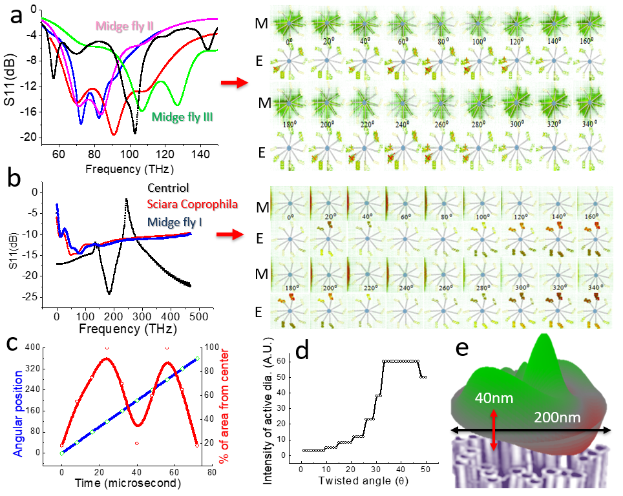

Figure 4

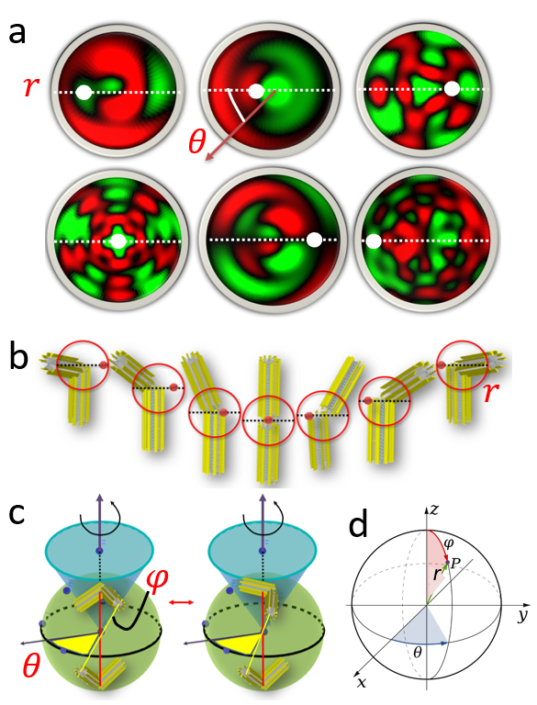

Figure 5.
