Supporting Information

Cellulose-Fueled Extracellular Electron Transfer in Termite Gut Microbes

Xiao Deng^{a,#} and Akihiro Okamoto^{a,b,c,d}

ªResearch Center for Macromolecules and Biomaterials, National Institute for Materials Science, Namiki 1-1, Tsukuba, Ibaraki 305-0044, Japan
^{b}Graduate School of Chemical Sciences and Engineering, Hokkaido University, Kita 13, Nishi 8, Kita-ku, Sapporo 060-8628, Japan
^{c}Graduate School of Science and Technology, University of Tsukuba, 1-1-1 Tennodai, Tsukuba, 305-8577, Japan
^{d}Research Center for Autonomous Systems Materialogy, Institute of Science Tokyo, 4259 Nagatsuta-cho, Midori-ku, Yokohama, Kanagawa 226-8501, Japan

#Address correspondence to Xiao Deng: deng.xiao@nims.go.jp

This file includes
10 Supporting Figures
2 Supporting Tables

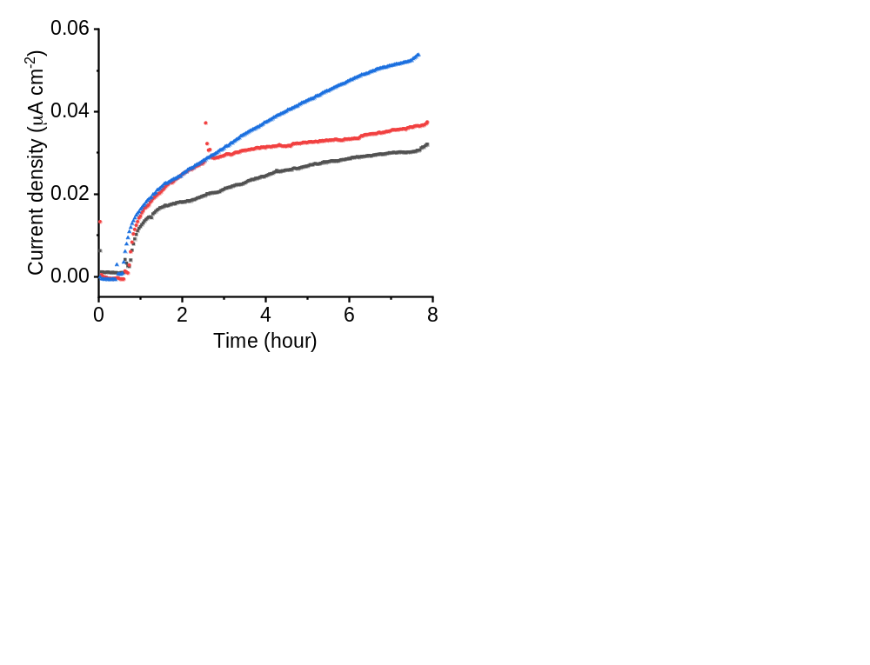
Figure S1. Anodic current production by CT1112 cells on a +0.4 V (vs SHE)-poised electrode over 8 h prior to NAD⁺/NADH measurement.
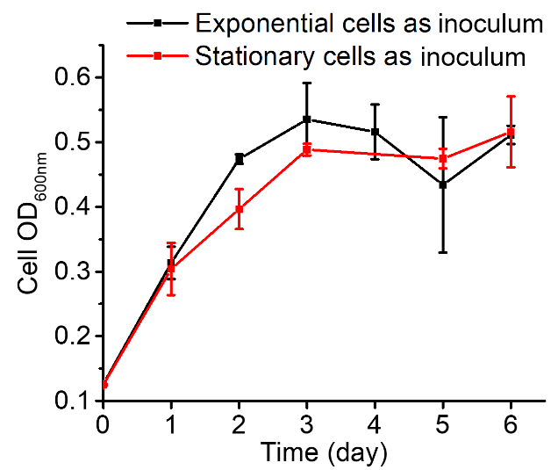
Figure S2. Growth curve of CT1112 cells in medium containing cellobiose as the electron donor, using exponential- or stationary-phase cells as the inoculum at a concentration of 3%.
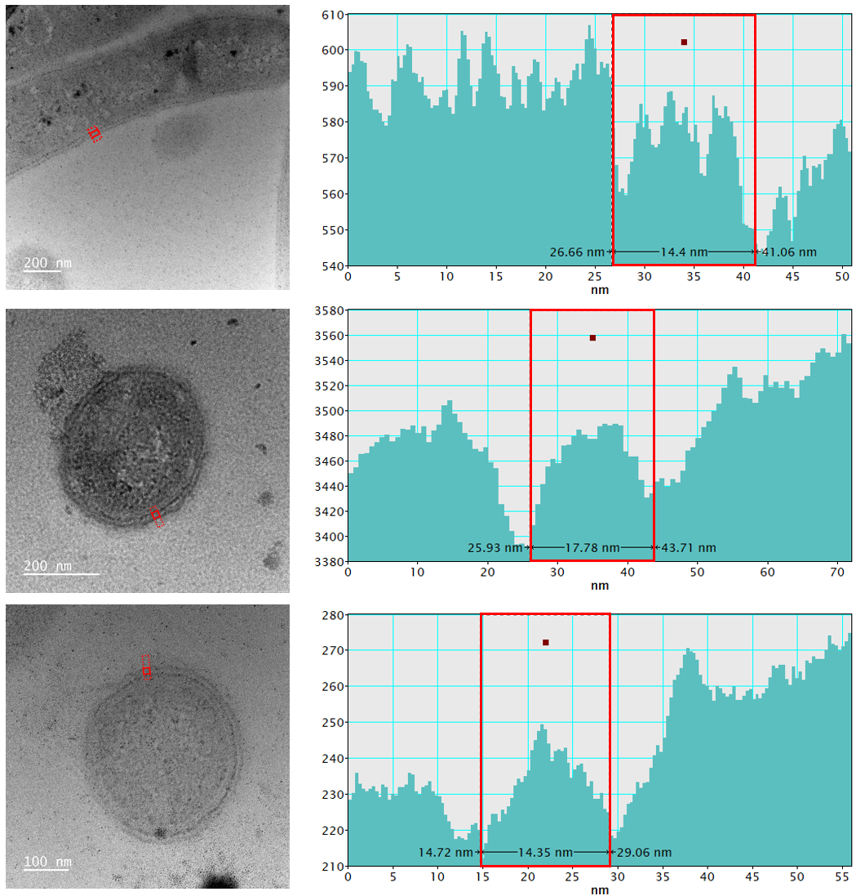
Figure S3. Transmission Electron Microscopy (TEM) images of ultrathin sections of exponential-phase CT1112 cells used for cell wall thickness measurements. Sections were contrasted using heavy-metal staining (EM stainer, Nisshin EM, Japan) after being mounted on TEM grids. Line profiles across the cell wall are shown; the y-axis represents electron transmission intensity.
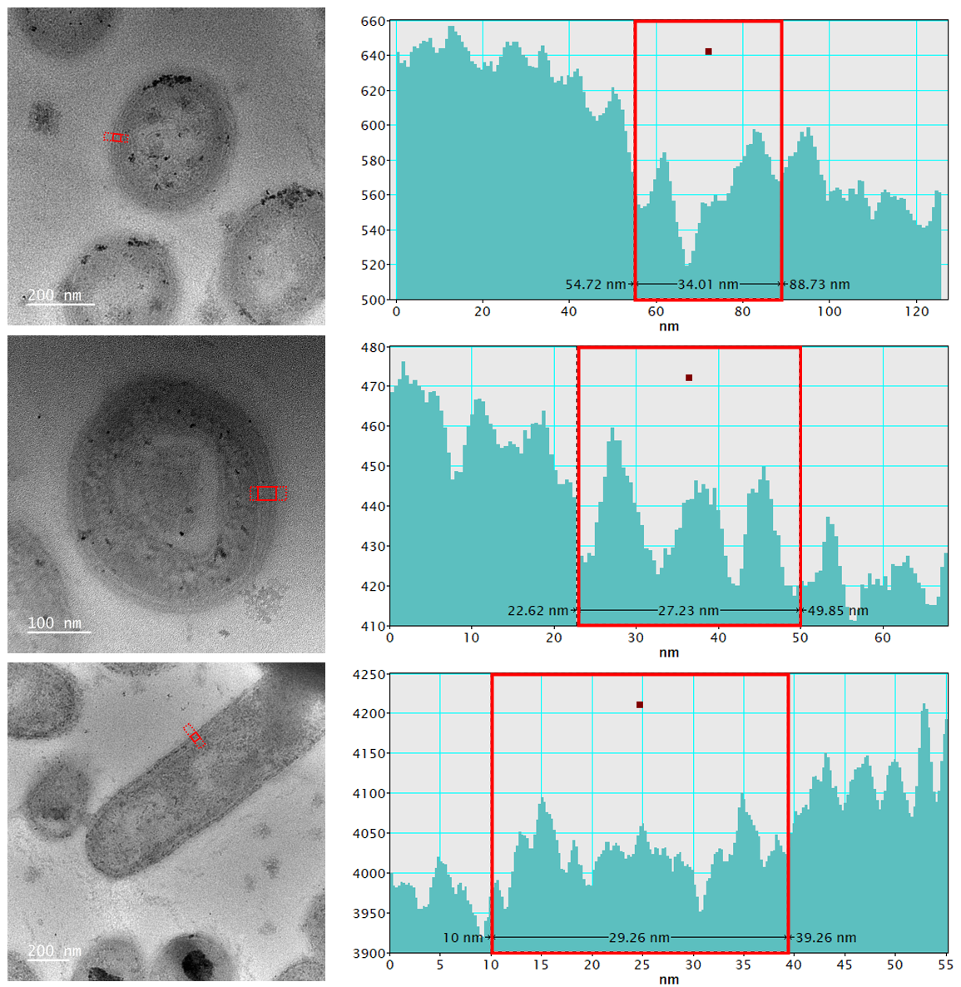
Figure S4. Transmission Electron Microscopy (TEM) images of ultrathin sections of stationary-phase CT1112 cells used for cell wall thickness measurements. Sections were contrasted using heavy-metal staining (EM stainer, Nisshin EM, Japan) after being mounted on TEM grids. Line profiles across the cell wall are shown; the y-axis represents electron transmission intensity.
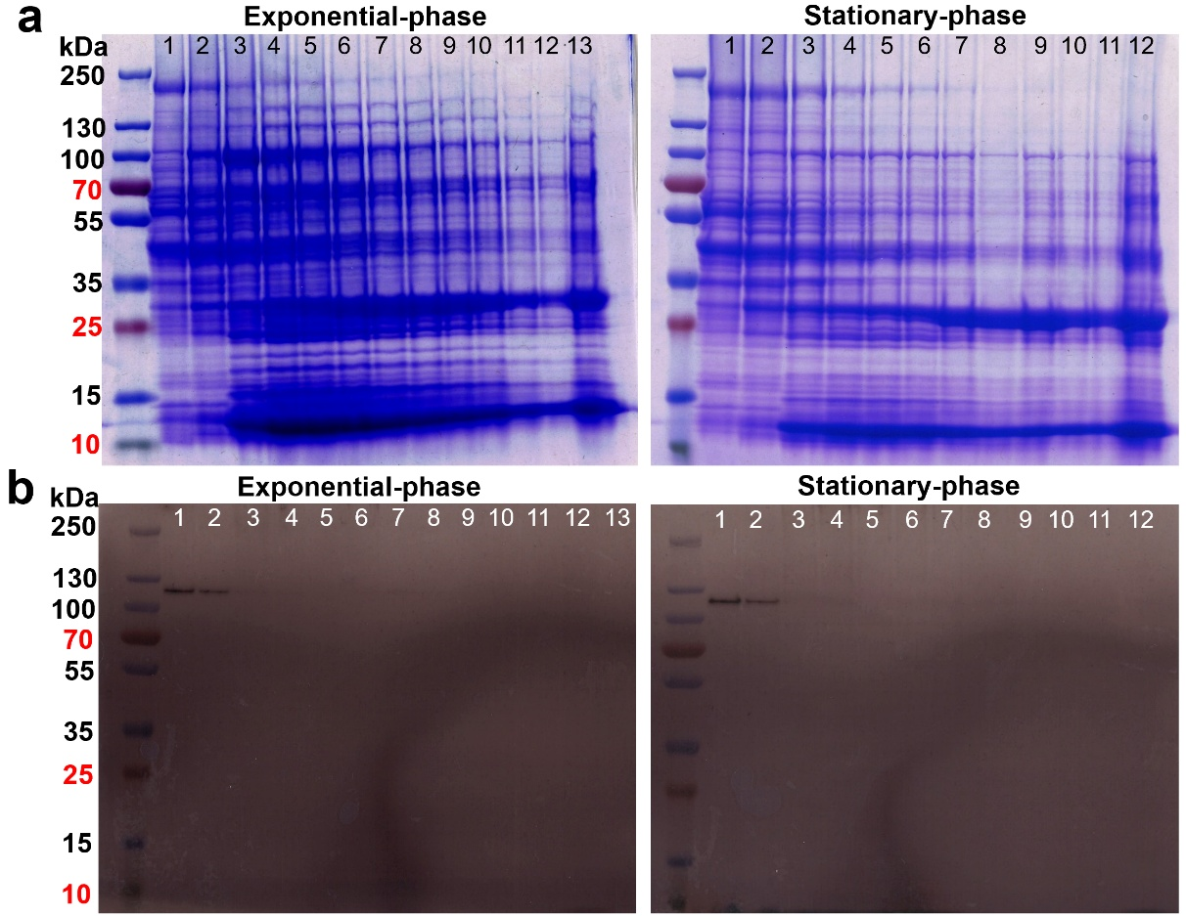
Figure S5. Sodium dodecyl sulfate-polyacrylamide gel electrophoresis (SDS-PAGE) analysis of membrane fractions isolated from exponential- and stationary-phase CT1112 cells. (a) Coomassie Brilliant Blue (CBB)-stained gel showing total proteins. (b) 3,3′-diaminobenzidine (DAB)-stained gel for detection of redox-active proteins. Lanes 1–13 and lanes 1–12 correspond to fractions sequentially collected from the top to the bottom of a sucrose density gradient following ultracentrifugation.
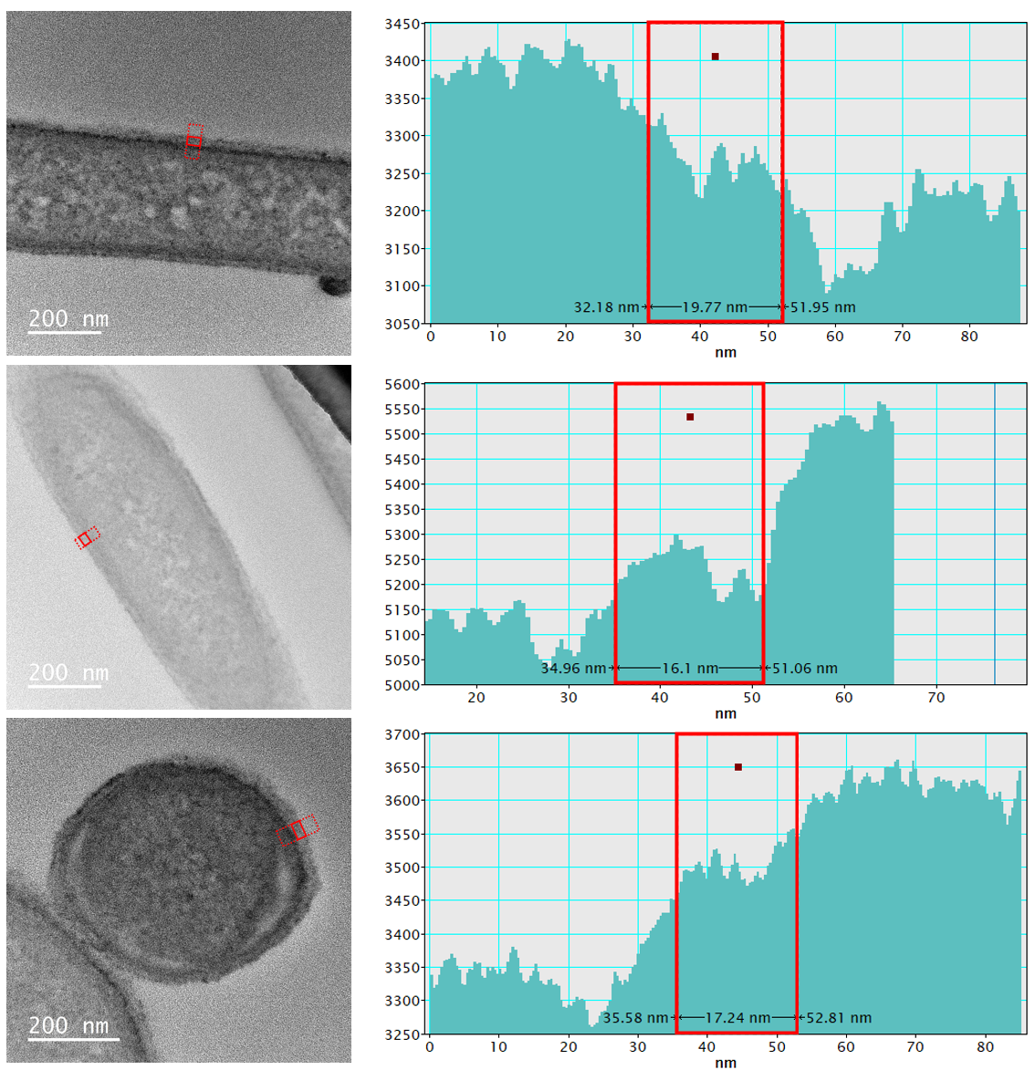
Figure S6. Transmission Electron Microscopy (TEM) images of ultrathin sections of 3,3′-diaminobenzidine (DAB)-stained exponential-phase CT1112 cells. Positive DAB staining was performed on intact cells prior to sectioning. Line profiles across the cell wall are shown; the y-axis represents electron transmission intensity.
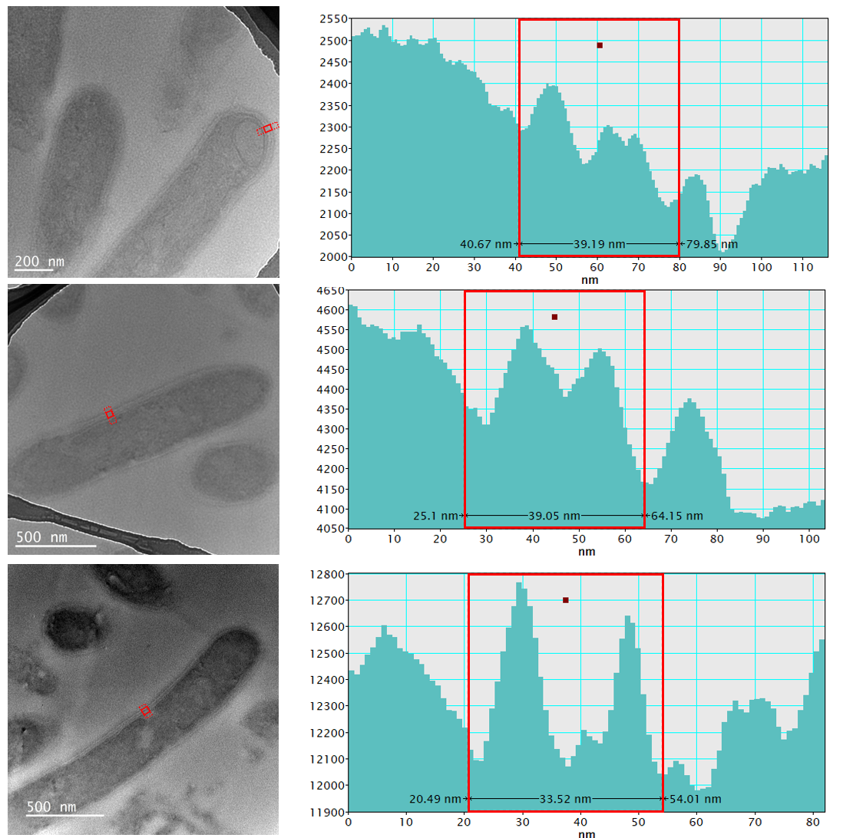
Figure S7. Transmission Electron Microscopy (TEM) images of ultrathin sections of 3,3′-diaminobenzidine (DAB)-stained stationary-phase CT1112 cells. Positive DAB staining was performed on intact cells prior to sectioning. Line profiles across the cell wall are shown; the y-axis represents electron transmission intensity.
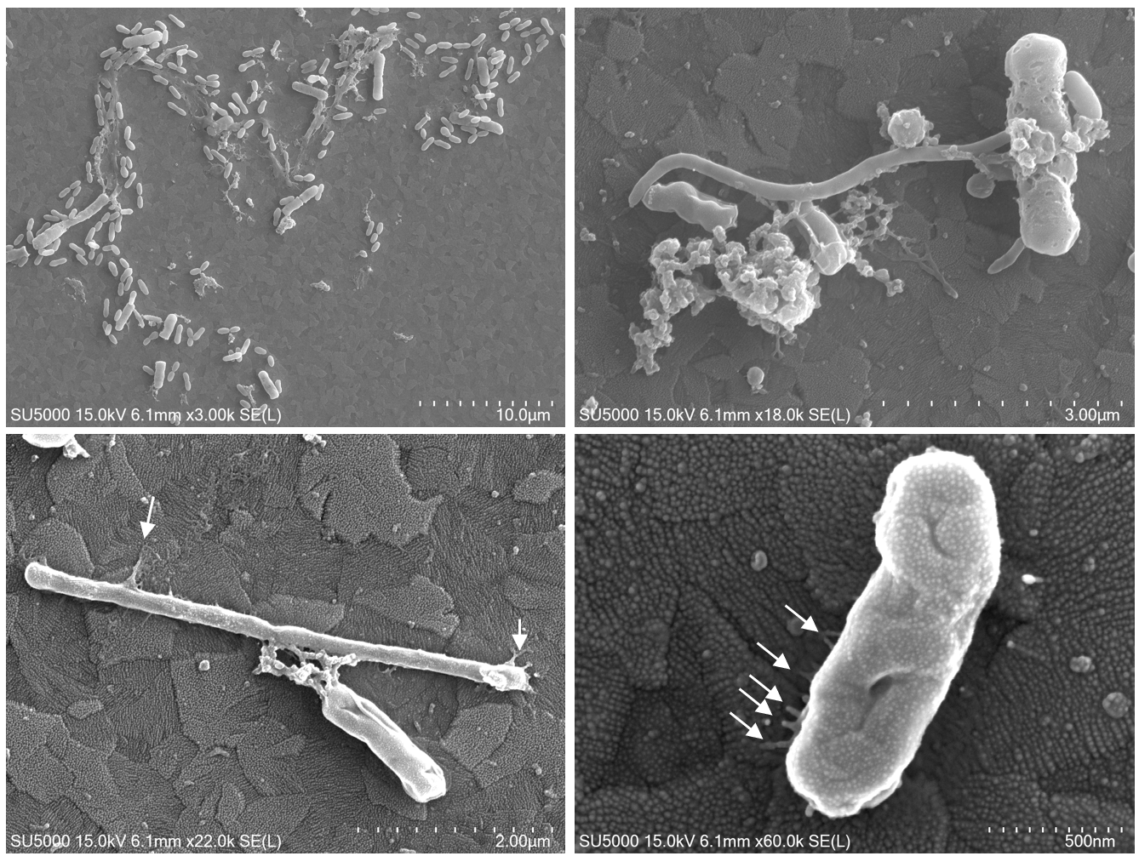
Figure S8. Scanning electron microscopy images of termite gut microbes attached to the indium-tin-doped oxide (ITO) electrode surface after 26 days of electrochemical operation at 0.4 V vs. SHE. Arrows indicate appendages extending from cells to the electrode surface.

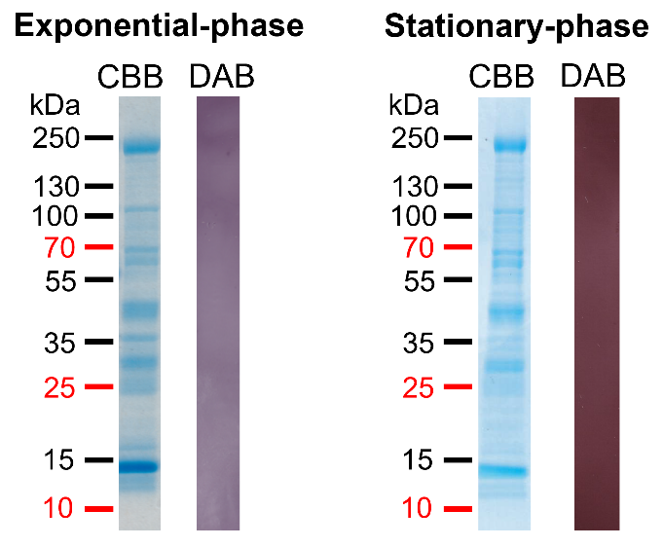
Figure S9. Sodium dodecyl sulfate-polyacrylamide gel electrophoresis (SDS-PAGE) analysis of cell wall fractions isolated from exponential- and stationary-phase CT1112 cells. Gels were stained with Coomassie Brilliant Blue (CBB) to visualize total proteins or with 3,3′-diaminobenzidine (DAB) in the presence of H₂O₂ to detect redox-active proteins. No redox-active proteins were detected in the extracted cell wall fractions from either growth phase.
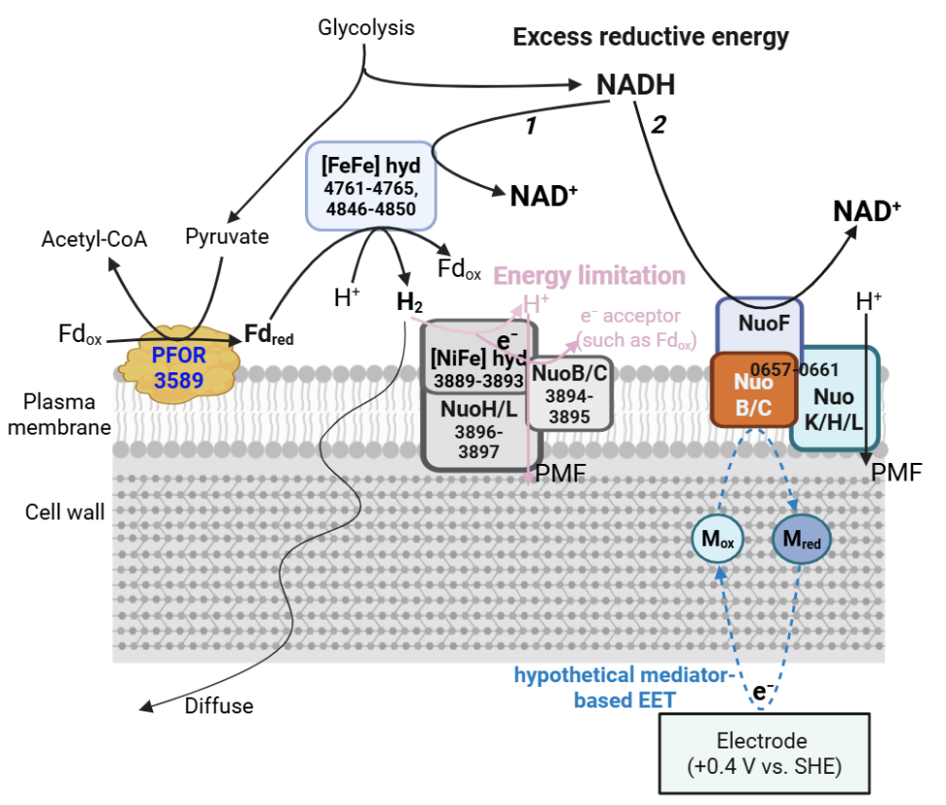
Figure S10. Proposed pathways for the dissipation of excess reducing equivalents in CT1112 cells mediated by extracellular electron transfer (EET). In the first pathway, an electron-bifurcating [FeFe] hydrogenase co-oxidizes NADH and reduced ferredoxin generated by pyruvate:ferredoxin oxidoreductase, coupling their oxidation to proton reduction and H₂ production. In the second pathway, a partial Complex I–like module comprising NuoF, NuoB/C, and membrane-associated NuoK/H/L subunits is depicted. Genes required for ubiquinone or menaquinone biosynthesis are absent from the genome, and electrons downstream of NuoF and NuoB/C are proposed to be directed toward alternative intracellular or extracellular electron carriers. Gene numbers correspond to the original locus tags listed in Table S2.
Table S1. List of proteins predicted to localize to the cell wall by PSORTb.
Accession | Old locus | Definition
WP_004623389.1 | CTER_0134 | metallophosphoesterase
WP_004623558.1 | CTER_0192 | S-layer homology domain-containing protein
WP_004623504.1 | CTER_0219 | S-layer homology domain-containing protein
WP_004623596.1 | CTER_0300 | RHS repeat-associated core domain-containing protein
WP_004623839.1 | CTER_0472 | TlpA family protein disulfide reductase
WP_004623838.1 | CTER_0486 | PA14 domain-containing protein
WP_004623934.1 | CTER_0624 | cadherin-like beta sandwich domain-containing protein
WP_004624115.1 | CTER_0758 | peptide ABC transporter substrate-binding protein
WP_004624285.1 | CTER_0768 | ABC transporter substrate-binding protein
WP_004624102.1 | CTER_0795 | S-layer homology domain-containing protein
WP_004624205.1 | CTER_0847 | nickel ABC transporter substrate-binding protein
WP_004624365.1 | CTER_0945 | Ig-like domain-containing protein
WP_004624385.1 | CTER_0978 | peptide ABC transporter substrate-binding protein
WP_004624482.1 | CTER_0980 | S-layer homology domain-containing protein
WP_004624333.1 | CTER_0988 | S-layer homology domain-containing protein
WP_004624627.1 | CTER_1153 | alpha amylase family protein
WP_004624699.1 | CTER_1212 | polysaccharide lyase family 8 super-sandwich domain-containing protein
WP_004625007.1 | CTER_1462 | non-ribosomal peptide synthetase
WP_004624947.1 | CTER_1539 | family 16 glycoside hydrolase
WP_004624793.1 | CTER_1546 | ABC transporter substrate-binding protein
WP_004625360.1 | CTER_1685 | peptide ABC transporter substrate-binding protein
WP_004625253.1 | CTER_1735 | S-layer homology domain-containing protein
WP_004625424.1 | CTER_1914 | Kelch repeat-containing protein
WP_004625560.1 | CTER_1991 | stage II sporulation protein D
WP_004625505.1 | CTER_2004 | BslA/BslB family hydrophobin
WP_004625584.1 | CTER_2005 | S-layer homology domain-containing protein
WP_004625847.1 | CTER_2258 | SpoIID/LytB domain-containing protein
WP_004625833.1 | CTER_2340 | ABC transporter substrate-binding protein
WP_004625969.1 | CTER_2432 | S8 family serine peptidase
WP_004625966.1 | CTER_2476 | family 10 glycosylhydrolase
WP_004625909.1 | CTER_2496 | carboxypeptidase regulatory-like domain-containing protein
WP_004626119.1 | CTER_2515 | TlpA family protein disulfide reductase
WP_004626370.1 | CTER_2615 | S-layer homology domain-containing protein
WP_004626772.1 | CTER_2895 | ABC transporter substrate-binding protein
WP_004627197.1 | CTER_3247 | glycoside hydrolase family 15 protein
WP_004627771.1 | CTER_3346 | N-acetylmuramoyl-L-alanine amidase
WP_004627621.1 | CTER_3349 | leucine-rich repeat domain-containing protein
WP_004627742.1 | CTER_3425 | Hsp20/alpha crystallin family protein
WP_004627583.1 | CTER_3427 | C40 family peptidase
WP_004627720.1 | CTER_3428 | N-acetylmuramoyl-L-alanine amidase family protein
WP_004627811.1 | CTER_3499 | S-layer homology domain-containing protein
WP_004627864.1 | CTER_3509 | S-layer homology domain-containing protein
WP_004627862.1 | CTER_3516 | S-layer homology domain-containing protein
WP_004628048.1 | CTER_3655 | S-layer homology domain-containing protein
WP_004628138.1 | CTER_3683 | bifunctional metallophosphatase/5'-nucleotidase
WP_004628256.1 | CTER_3815 | RHS repeat-associated core domain-containing protein
WP_004628317.1 | CTER_3822 | S-layer homology domain-containing protein
WP_004628323.1 | CTER_3848 | S-layer homology domain-containing protein
WP_004628742.1 | CTER_4060 | InlB B-repeat-containing protein
WP_004628865.1 | CTER_4067 | S-layer homology domain-containing protein
WP_004628806.1 | CTER_4085 | S-layer homology domain-containing protein
WP_004628995.1 | CTER_4087 | HYR domain-containing protein
WP_004629405.1 | CTER_4403 | Ig-like domain-containing protein
WP_004629526.1 | CTER_4441 | carbohydrate-binding domain-containing protein
WP_004629908.1 | CTER_4535 | S-layer homology domain-containing protein
WP_004629729.1 | CTER_4595 | N-acetylmuramoyl-L-alanine amidase
WP_004629625.1 | CTER_4675 | peptidoglycan-binding protein
WP_004629583.1 | CTER_4707 | family 10 glycosylhydrolase
WP_004630225.1 | CTER_4729 | S-layer homology domain-containing protein
WP_004629636.1 | CTER_4905 | S-layer homology domain-containing protein
WP_004630736.1 | CTER_5200 | RHS repeat-associated core domain-containing protein
WP_004631143.1 | CTER_5361 | carbohydrate-binding protein
WP_004623279.1 | CTER_5516 | N-acetylmuramoyl-L-alanine amidase family protein
WP_004623286.1 | CTER_5566 | COG1361 S-layer family protein

Table S2. Genes encoding redox-active proteins potentially involved in redox balancing in CT1112. Asterisks (*) denote gene products predicted to localize to the cytoplasmic membrane.
Locus tag | Gene | Annotation | Proposed function
CTER_0018 | nuoB | NADH-quinone oxidoreductase subunit NuoB
CTER_0657 | nuoC | NADH-quinone oxidoreductase subunit C | - Nuo-like subunits potentially involved in NADH oxidation.  - The genome lacks genes for (mena)quinone biosynthesis, suggesting the absence of a quinone pool.  - Downstream electrons may be routed toward EET or diverted to an unknown electron carrier.
CTER_0658 | nuoF | hydrogenase 4 subunit F
CTER_0659 |  | hypothetical protein
CTER_0660 | nuoH | respiratory chain complex I subunit 1 family protein
CTER_0661 | nuoB | hydrogenase 4 subunit B
CTER_3889 | hypB | hydrogenase nickel incorporation protein HypB | - Membrane-bound H₂-oxidizing [NiFe] hydrogenase with H⁺-translocating subunits
*CTER_3890 |  | trimeric intracellular cation channel family protein
CTER_3891 | hypA | hydrogenase maturation nickel metallochaperone HypA
CTER_3892 |  | 4Fe-4S binding protein
CTER_3893 | hycE2 | nickel-dependent hydrogenase large subunit
CTER_3894 | nuoC | NADH-quinone oxidoreductase subunit C
*CTER_3895 | nuoB | NADH-quinone oxidoreductase subunit B family protein
*CTER_3896 | nuoH | respiratory chain complex I subunit 1 family protein
*CTER_3897 | nuoL | NADH-quinone oxidoreductase subunit L
CTER_4761 |  | NADH-dependent [FeFe] hydrogenase, group A6 | - Multilocus electron-bifurcating, H₂-evolving [FeFe] hydrogenase for H₂ production.  - This cluster may enable the cell to dissipate excess reducing equivalents as H₂.
CTER_4762 | nuoF | NADH-quinone oxidoreductase subunit NuoF
CTER_4763 |  | (2Fe-2S) ferredoxin domain-containing protein
CTER_4764 |  | ATP-binding protein
CTER_4765 | nuoE | [FeFe] hydrogenase
CTER_4846 |  | [Fe-Fe] hydrogenase large subunit C-terminal domain-containing protein
CTER_4847 |  | (2Fe-2S) ferredoxin domain-containing protein
CTER_4848 |  | [FeFe] hydrogenase, group A
CTER_4849 | nuoF
CTER_4850 |  | complex I 24 kDa subunit family protein

