Selective area growth of β-Ga₂O₃ by HCl-based halide vapor phase epitaxy
Takayoshi Oshima¹* and Yuichi Oshima¹
¹Research Center for Functional Materials, National Institute for Materials Science, Tsukuba, Ibaraki 305-0044, Japan
E-mail: OSHIMA.Takayoshi@nims.go.jp

We demonstrated selective area growth of β-Ga₂O₃ by HCl-based halide vapor phase epitaxy on SiO₂-masked (001) and (010) β-Ga₂O₃ substrates. Perfect growth selectivity was achieved under the presence of HCl etching gas in addition to the growth precursors. In both substrate cases, (100) facet dominated the grown shapes owing to its smallest surface energy density. High-aspect-ratio structures having (100) sidewall facets were observed for the stripe windows along [010] and [001] directions on the (001) and (010) substrates, respectively. These structures may be applicable to trenches and fins used for β-Ga₂O₃-based power devices.

Since melt-grown high-quality single crystal substrates have been available from the dawn of β-Ga₂O₃ power electronics,^{1–3)} device-quality films have been used to fabricate prototype devices from the early period.⁴⁾ Initial metal-semiconductor field-effect transistors,⁵⁾ Schottky barrier diodes (SBD),⁶⁾ metal-oxide-semiconductor field-effect transistors (MOSFETs),⁷⁾ and modulation-doped field-effect transistors⁸⁾ were all fabricated using the high-quality homo- and hetero-epitaxial films grown on the β-Ga₂O₃ substrates by molecular beam epitaxy (MBE)^{6,9–11)}. Later, chemical vapor deposition (CVD) methods such as halide vapor phase epitaxy (HVPE),¹²⁾ tri-halide vapor phase epitaxy (THVPE),¹³⁾ metal-organic chemical vapor deposition (MOCVD),¹⁴⁾ low pressure chemical vapor deposition (LPCVD)¹⁵⁾, and mist chemical vapor deposition¹⁶⁾ have joined to grow thick and large-area films, which permit to design vertical high-voltage devices capable of mass production. Now such CVD methods have been commonly chosen to produce drift and channel layers of vertical SBDs^{17–20)} and MOSFETs^{21,22)} with kV-class reverse breakdown voltages.
Although CVD technologies of β-Ga₂O₃ have markedly progressed, selective area growth (SAG) or epitaxial lateral overgrowth (ELO) has rarely been attempted owing to the availability of single crystal substrates with low dislocation densities on the order of 10³ cm⁻²²³⁾. To the best of our knowledge, SAG of β-Ga₂O₃ has only been performed very recently just to define the areas of a heavily-doped contact layer.²⁴⁾ However, polycrystalline β-Ga₂O₃ nucleated on the mask, meaning insufficient selectivity, and the details of the SAG have not been clarified yet. The situation is quite different from that of metastable α-Ga₂O₃, one of the polymorphs of Ga₂O₃,²⁵⁾ where the dislocation density in a hetero-epitaxial film on isostructural sapphire substrate is so high on the order of 10¹⁰ cm⁻²²⁶⁾ that ELO is necessary to improve the crystal quality.^{27–31)}
However, SAG or ELO of β-Ga₂O₃ is still attractive as fabrication processes of various structures. Aside from the dislocation reduction, SAG/ELO has known to have various applications such as epitaxial lift-off^{32,33)}, formation of desired facet structures,³⁴⁾ fabrication of layered device structures on the vertical facets,^{35,36)} formation of edge terminations,³⁵⁾ embedding polysilicon gates,^{37,38)} metal gates,³⁹⁾ and layered dielectrics,⁴⁰⁾ and device isolation⁴¹⁾. Thus, SAG/ELO can be one of the state-of-the-art fabrication processes for β-Ga₂O₃ power devices. Therefore, further research on the SAG/ELO of β-Ga₂O₃ is required to understand its behavior and to explore potential applications.
In this study, we demonstrated the SAG of β-Ga₂O₃ on SiO₂-masked β-Ga₂O₃ single crystal substrates to elucidate the SAG behavior. Our systematic experiments revealed that the shape of SAG β-Ga₂O₃ were strongly dominated by (100) facets, and it was possible to fabricate high-aspect-ratio SAG β-Ga₂O₃ structures with flat sidewalls. The structures were very similar to the trenches and fins made by using reactive ion etching (RIE) techniques on β-Ga₂O₃ power devices^{18–22,42)}.
Patterned SiO₂ masks were prepared on β-Ga₂O₃ (001) and (010) substrates. These epi-ready substrates (10×15 mm²) were manufactured by Novel Crystal Technology, Inc. using edge-defined film-fed growth technique²³⁾. After the SPM (sulfuric acid and hydrogen peroxide mixture) degreasing process, an amorphous SiO₂ layer (0.1-μm thick) was deposited on the substrate surface by plasma-enhanced CVD using tetraethoxysilane (TEOS) as the precursor. Then, radial-line- and stripe-patterned windows were opened in the mask by conventional photolithographic patterning and buffered hydrofluoric acid etching, followed by complete removal of the residual photoresist by acetone and subsequent oxygen plasma ashing process. Radial lines were patterned every 10° (36 lines in total), and their widths were ~1.2 μm. The directions of the stripes were set along [010] and [001] for (001) and (010) substrates, respectively, and their window/mask widths were ~1.2/3.3 μm.
SAG of β-Ga₂O₃ was performed in a lab-made HCl-based HVPE system under the atmospheric pressure. O₂ (>99.99995% pure) and GaCl precursors were separately supplied with partial pressures of 1.25 and 0.125 kPa, respectively to the substrate in a growth zone of the horizontal quartz reactor heated at 1040 °C. Here, the substrate was vertically held at the center of the rotating substrate holder (the substrate surface was perpendicular to the horizontal gas flow direction). The GaCl precursor was synthesized upstream in the reactor by the chemical reaction of Ga metal (>99.99999% pure) and HCl gas (>99.999% pure) at 820 °C. Additional HCl gas was supplied with a partial pressure of 0.25 kPa directly to the growth zone to avoid parasitic gas-phase reaction²⁹⁾ and to suppress nucleation on the mask. These gases were carried by purified N₂ gas (dew point < -110 °C). The growth time was 15 min. The same growth conditions were used for both (001) and (010) substrates. We also performed growth without the use of additional HCl gas (other growth parameters were the same as those described above) to clarify the effect of the HCl etching gas on the growth selectivity.
The shapes of the SAG β-Ga₂O₃ were characterized by scanning electron microscopy (SEM). Ga focused ion milling was utilized to expose the cross section of the SAG β-Ga₂O₃ on the stripe-patterned windows for SEM observation. Carbon surface protective layer was deposited on the sample in prior to the milling process.
To achieve perfect growth selectivity, introduction of HCl gas to the growth zone in addition to the growth precursors was indispensable in our HVPE system. Figure 1 compares the mask surfaces after the growth with and without the HCl gas supply. When HCl was supplied, no deposition was found around the window, indicating perfect growth selectivity [See Fig. 1(a)]. Polycrystalline deposition on the mask was observed only when the position was away from the window by approximately 100 μm or more. In contrast, when HCl gas was not supplied, the mask surface was completely covered with micron-scale polycrystalline crystallites with random orientations even in the vicinity of the window, meaning no growth selectivity [See Fig. 1(b)]. The contrasting results clearly show the effect of the HCl etching gas, which suppressed the nucleation on the mask surface to permit SAG.
To understand the in-plane orientation dependence of SAG behavior, we first characterized the shapes of the SAG β-Ga₂O₃ on the radial-line patterns, as shown in Fig 2. Clear facet structures with smooth sidewalls were observed only when the patterned line directions were close to [010] and [001] on (001) and (010) substrates, respectively. When the line direction slightly deviated from [010] or [001], stepped sidewalls appeared. However, each sidewall was still parallel to [010] or [001]. Taking the in-plane and out-of-plane crystallographic orientations into account, the sidewalls should be (100) facets. This facet formation is reasonable because (100) has the lowest surface energy density in β-Ga₂O₃ crystal. In general, growth rate of each facet is proportional to the corresponding surface energy density to construct an anisotropic facetted morphology (Wulff construction).⁴³⁾ The calculated unrelaxed and relaxed surface energies are 0.60 and 0.34 Jm⁻² for (100)B, 1.39 and 0.85 Jm⁻² for (100)A, which compare with 2.37 and 1.17 Jm⁻² for (001)B, 2.98 and 1.95 for (001)A, 2.52 and 1.67 Jm⁻² for (010), respectively (Note that “A” and “B” indicate different surface terminations for the respective planes).⁴⁴⁾ Regarding other in-plane directions, growth behaviors were quite different between (001) and (010) substrates. On the (001) substrate, when the line direction largely deviated from [010], polycrystal grains with random orientations appeared instead of epitaxially grown SAG stripes [See Fig. 2(a)]. The reason for this drastic change in the growth mode is unclear at the moment, but the strong anisotropy of β-Ga₂O₃ crystal should be responsible. On the (010) substrate, when the line direction deviated largely from [001], the density of macro steps increased to maximize (100) facet area, leading to zig-zag shaped sidewalls [See Fig. 2(b)]. However, no polycrystal grains were observed. The extraordinary (100) facet domination on both substrates suggest that the line direction should be parallel to the intersection of (100) and the substrate surface to obtain SAG β-Ga₂O₃ with smooth (100)-faceted sidewalls. In the cases of (001) and (010) substrates, the directions correspond to [010] and [001], respectively.
To further investigate the SAG β-Ga₂O₃ with (100)-faceted sidewalls, we focus on the SAG stripe arrays. Figure 3 shows SAG β-Ga₂O₃ on the stripe windows along [010] and [001] on (001) and (010) substrates, respectively. Here, the SEM images were taken so that the end portion of the stripes are visible for the clear appearance of the three-dimensional structures. In both plane cases, all the sidewalls of the SAG stripes were (100) facets. The difference in substrate planes was reflected to the heights and widths of the stripes, which are related to vertical and lateral growth rates, respectively. The stripes on the (010) substrate were much taller and narrower than those on the (001) substrate [Compare Fig. 3(a) and 3(b)]. As described above, there is no clear difference of surface energy densities of (010) and (001) to explain the vertical growth difference in the present work. However, the surface energy densities can be different in different chemical/physical growth environment through the modification of microscopic surface structure. Indeed, the growth rate order for the two substrate planes depends on the growth methods. For example, the homoepitaxial growth rate on (010) is greater than that on (001) in the cases of MBE⁶⁾ and LPCVD⁴⁵⁾, while opposite result has been reported in the case of Cl₂-based HVPE⁴⁶⁾. Taking these facts into consideration, it is likely that the growth environment of the HCl-HVPE affected the microscopic surface structure to allow much faster growth on (010). Particularly, the existence of H₂ or HCl could make the drastic difference between HCl-based HVPE and Cl₂-based HVPE. Note that it has been reported that the growth rate on (001) showed sharp drop when the miscut angle Δ_{b} is close to zero probably because of the decrease of surface step density.⁴⁶⁾ However, the (001) growth rate is still greater than that on (010) by a factor of ~2.5 even at the growth rate minimum at Δ_{b} = 0°. Therefore, this miscut effect cannot directly explain the faster growth rate on (010) in the present work. On the other hand, the smaller growth rate of (100) sidewalls on the (010) substrate should be explained from the viewpoint of kinetic effect. A reasonable explanation is that most of the precursors are consumed for the high-speed vertical growth at the top part of the stripes and the precursor delivery to the sidewalls was limited.
Cross-sectional observation of the stripes revealed more detailed information on vertical and lateral growth. Figure 4 shows the cross-sectional structures of the SAG β-Ga₂O₃ stripes that are discussed in the previous paragraph. For better understanding, corresponding cross-sectional schematics are illustrated in Fig. 5. Inclined lower-aspect-ratio and vertically-extended higher-aspect-ratio stripes were observed on (001) and (010) substrates, respectively. The inclination angles of the sidewalls of a stripe on the (001) substrate were approximately 104° from the substrate surface, which is consistent with a face angle between (001) and (100) (β = 103.7°)⁴⁷⁾. Regarding these inclined stripes, we found that the lateral growth rate was asymmetric between [100] and [100]. The lateral growth rate along [100] was 2–4 times faster than that along [100] though corresponding (100) and (100) sidewall facets are crystallographically equivalent. The reason for the different lateral growth rates is likely to be related to the inclination but the detailed mechanism is still unknown. To compare the aspect ratios of the stripes on these two substrates, vertical growth heights (V) and lateral overgrowth lengths (L) were measured on the SEM images and the V/L ratios were calculated. The results are summarized in Table I. The V/L was as high as 2.1–11 for the (001) substrate, and the value further increased drastically to 72–84 for the (010) substrate as a result of the extreme growth anisotropy.
Finally, let us discuss potential applications of the high-aspect-ratio structures as trenches and fins. The trench and fin structures have recently been incorporated to the designs of high-voltage SBDs^{18–20,48)} and MOSFETs^{21,22,42,49)} to achieve normally-off operation or enhance breakdown voltages. Since the first demonstration of lateral FinFETs,⁴⁹⁾ all these high-aspect-ratio structures have been fabricated by RIE. However, post-treatment is necessary to remove RIE damage on the sidewalls that affects channel mobility.^{22,50,51)} Besides, some of their sidewall profiles are positively tapered possibly due to immature process conditions.^{19,20)49)} Such drawbacks of RIE never happen in the case of the SAG-based fabrication process, which can form damage-free sidewalls with flat facetted surface. Instead, lateral overgrowth inevitably occurs during SAG, particularly on the (001) substrate. Therefore, mask edges are buried at the bottom of the sidewalls to act like a current aperture that hinders vertical current flow. Since there is such a trade-off for this novel SAG trench/fin fabrication process, evaluation of actual device performance is required to verify the expected advantages of the SAG strategy, which should be our future work.
In summary, we have achieved SAG of β-Ga₂O₃ on (001) and (010) β-Ga₂O₃ substrates by HCl-based HVPE in the presence of additional HCl gas. β-Ga₂O₃ stripes with (100)-faceted flat sidewalls were formed only when the window directions were parallel to [010] and [001] on (001) and (010) substrates, respectively owing to the remarkable stability of the (100) facets. In these specific window directions, high-aspect-ratio arrays with smooth and plasma-damage-free faceted sidewalls were obtained. These results encourage further studies on the SAG of β-Ga₂O₃ as a novel fabrication process of fins and trenches.
Acknowledgments
The authors thank Prof. H. Murakami at the Tokyo University of Agriculture and Technology for valuable discussions regarding HVPE. The preparation of SiO₂ patterned masks and the characterization of SAG β-Ga₂O₃ islands were performed at the Namiki Foundry and the Nanofabrication Platform (Project No. 21-223 and 21N048, respectively) in the National Institute for Material Science (NIMS).

References
1) E.G. Víllora, K. Shimamura, Y. Yoshikawa, K. Aoki, and N. Ichinose, J. Cryst. Growth 270, 420 (2004).
2) H. Aida, K. Nishiguchi, H. Takeda, N. Aota, K. Sunakawa, and Y. Yaguchi, Jpn. J. Appl. Phys. 47, 8506 (2008).
3) Z. Galazka, R. Uecker, K. Irmscher, M. Albrecht, D. Klimm, M. Pietsch, M. Brützam, R. Bertram, S. Ganschow, and R. Fornari, Cryst. Res. Technol. 45, 1229 (2010).
4) M. Higashiwaki and G.H. Jessen, Appl. Phys. Lett. 112, 060401 (2018).
5) M. Higashiwaki, K. Sasaki, A. Kuramata, T. Masui, and S. Yamakoshi, Appl. Phys. Lett. 100, 013504 (2012).
6) K. Sasaki, A. Kuramata, T. Masui, E.G. Víllora, K. Shimamura, and S. Yamakoshi, Appl. Phys. Express 5, 035502 (2012).
7) M. Higashiwaki, K. Sasaki, T. Kamimura, M. Hoi Wong, D. Krishnamurthy, A. Kuramata, T. Masui, and S. Yamakoshi, Appl. Phys. Lett. 103, 123511 (2013).
8) E. Ahmadi, O.S. Koksaldi, X. Zheng, T. Mates, Y. Oshima, U.K. Mishra, and J.S. Speck, Appl. Phys. Express 10, 071101 (2017).
9) T. Oshima, N. Arai, N. Suzuki, S. Ohira, and S. Fujita, Thin Solid Films 516, 5768 (2008).
10) T. Oshima, T. Okuno, N. Arai, Y. Kobayashi, and S. Fujita, Jpn. J. Appl. Phys. 48, 070202 (2009).
11) T. Oshima, Y. Kato, N. Kawano, A. Kuramata, S. Yamakoshi, S. Fujita, T. Oishi, and M. Kasu, Appl. Phys. Express 10, 035701 (2017).
12) H. Murakami, K. Nomura, K. Goto, K. Sasaki, K. Kawara, Q.T. Thieu, R. Togashi, Y. Kumagai, M. Higashiwaki, A. Kuramata, S. Yamakoshi, B. Monemar, and A. Koukitu, Appl. Phys. Express 8, 015503 (2015).
13) K. Ema, K. Sasaki, A. Kuramata, and H. Murakami, J. Cryst. Growth 564, 126129 (2021).
14) G. Wagner, M. Baldini, D. Gogova, M. Schmidbauer, R. Schewski, M. Albrecht, Z. Galazka, D. Klimm, and R. Fornari, Phys. Status Solidi 211, 27 (2014).
15) S. Rafique, L. Han, M.J. Tadjer, J.A. Freitas, N.A. Mahadik, and H. Zhao, Appl. Phys. Lett. 108, 182105 (2016).
16) H. Nishinaka, T. Nagaoka, Y. Kajita, and M. Yoshimoto, Mater. Sci. Semicond. Process. 128, 105732 (2021).
17) K. Konishi, K. Goto, H. Murakami, Y. Kumagai, A. Kuramata, S. Yamakoshi, and M. Higashiwaki, Appl. Phys. Lett. 110, 103506 (2017).
18) W. Li, Z. Hu, K. Nomoto, Z. Zhang, J.-Y. Hsu, Q.T. Thieu, K. Sasaki, A. Kuramata, D. Jena, and H.G. Xing, Appl. Phys. Lett. 113, 202101 (2018).
19) W. Li, K. Nomoto, Z. Hu, D. Jena, and H.G. Xing, IEEE Electron Device Lett. 41, 107 (2020).
20) F. Otsuka, H. Miyamoto, A. Takatsuka, S. Kunori, K. Sasaki, and A. Kuramata, Appl. Phys. Express 15, 016501 (2022).
21) Z. Hu, K. Nomoto, W. Li, N. Tanen, K. Sasaki, A. Kuramata, T. Nakamura, D. Jena, and H.G. Xing, IEEE Electron Device Lett. 39, 869 (2018).
22) W. Li, K. Nomoto, Z. Hu, T. Nakamura, D. Jena, and H.G. Xing, in 2019 IEEE Int. Electron Devices Meet. (IEEE, 2019), pp. 12.4.1-12.4.4.
23) A. Kuramata, K. Koshi, S. Watanabe, Y. Yamaoka, T. Masui, and S. Yamakoshi, Jpn. J. Appl. Phys. 55, 1202A2 (2016).
24) A. Bhattacharyya, S. Roy, P. Ranga, D. Shoemaker, Y. Song, J.S. Lundh, S. Choi, and S. Krishnamoorthy, Appl. Phys. Express 14, 076502 (2021).
25) R. Roy, V.G. Hill, and E.F. Osborn, J. Amer. Chem. Soc. 74, 719 (1952).
26) K. Kaneko, H. Kawanowa, H. Ito, and S. Fujita, Jpn. J. Appl. Phys. 51, 020201 (2012).
27) Y. Oshima, K. Kawara, T. Shinohe, T. Hitora, M. Kasu, and S. Fujita, APL Mater. 7, 022503 (2019).
28) R. Jinno, N. Yoshimura, K. Kaneko, and S. Fujita, Jpn. J. Appl. Phys. 58, 120912 (2019).
29) Y. Oshima, K. Kawara, T. Oshima, M. Okigawa, and T. Shinohe, Semicond. Sci. Technol. 35, 055022 (2020).
30) K. Kawara, T. Oshima, M. Okigawa, and T. Shinohe, Appl. Phys. Express 13, 115502 (2020).
31) K. Kawara, Y. Oshima, M. Okigawa, and T. Shinohe, Appl. Phys. Express 13, 075507 (2020).
32) Y. Oshima, T. Eri, M. Shibata, H. Sunakawa, K. Kobayashi, T. Ichihashi, and A. Usui, Jpn. J. Appl. Phys. 42, L1 (2003).
33) M. Schreck, M. Mayr, M. Weinl, M. Fischer, and S. Gsell, Diam. Relat. Mater. 101, 107606 (2020).
34) M. Funato, K. Hayashi, M. Ueda, Y. Kawakami, Y. Narukawa, and T. Mukai, Appl. Phys. Lett. 93, 021126 (2008).
35) J. Wang, G. Yu, H. Zong, Y. Liao, W. Lu, W. Cai, X. Hu, Y.-H. Xie, and H. Amano, Appl. Phys. Lett. 118, 212102 (2021).
36) J. Wang, Y.-H. Xie, and H. Amano, IEEE Electron Device Lett. 42, 1370 (2021).
37) J.A. Friedrich and G.W. Neudeck, IEEE Electron Device Lett. 10, 144 (1989).
38) W.A. Klaasen and G.W. Neudeck, IEEE Trans. Electron Devices 37, 273 (1990).
39) P.A. Badoz, D. Bensahel, L. Guérin, C. Puissant, and J.L. Regolini, Appl. Phys. Lett. 56, 2307 (1990).
40) T. Hamaguchi, N. Fuutagawa, S. Izumi, M. Murayama, and H. Narui, Phys. Status Solidi 213, 1170 (2016).
41) Nobuhiro Endo, K. Tanno, A. Ishitani, Y. Kurogi, and H. Tsuya, IEEE Trans. Electron Devices 31, 1283 (1984).
42) Z. Hu, K. Nomoto, W. Li, L.J. Zhang, J.-H. Shin, N. Tanen, T. Nakamura, D. Jena, and H.G. Xing, in 2017 75th Annu. Device Res. Conf. (IEEE, 2017), pp. 1–2.
43) B.N. Bryant, A. Hirai, E.C. Young, S. Nakamura, and J.S. Speck, J. Cryst. Growth 369, 14 (2013).
44) S. Mu, M. Wang, H. Peelaers, and C.G. Van de Walle, APL Mater. 8, 091105 (2020).
45) S. Rafique, M.R. Karim, J.M. Johnson, J. Hwang, and H. Zhao, Appl. Phys. Lett. 112, 052104 (2018).
46) K. Goto, H. Murakami, A. Kuramata, S. Yamakoshi, M. Higashiwaki, and Y. Kumagai, Appl. Phys. Lett. 120, 102102 (2022).
47) S. Geller, J. Chem. Phys. 33, 676 (1960).
48) K. Sasaki, D. Wakimoto, Q.T. Thieu, Y. Koishikawa, A. Kuramata, M. Higashiwaki, and S. Yamakoshi, IEEE Electron Device Lett. 38, 783 (2017).
49) K.D. Chabak, N. Moser, A.J. Green, D.E. Walker, S.E. Tetlak, E. Heller, A. Crespo, R. Fitch, J.P. McCandless, K. Leedy, M. Baldini, G. Wagner, Z. Galazka, X. Li, and G. Jessen, Appl. Phys. Lett. 109, 213501 (2016).
50) H.-K. Lee, H.-J. Yun, K.-H. Shim, H.-G. Park, T.-H. Jang, S.-N. Lee, and C.-J. Choi, Appl. Surf. Sci. 506, 144673 (2020).
51) B. Feng, T. He, G. He, X. Zhang, Y. Wu, X. Chen, Z. Li, X. Zhang, Z. Jia, G. Niu, Q. Guo, Z. Zeng, and S. Ding, Appl. Phys. Lett. 118, 181602 (2021).

Figure Captions
Figure 1 (Single column)
Surface SEM images of the mask area in the vicinity of the windows after the growth (a) with and (b) without additional HCl gas supply.

Figure 2 (Two column)
Top- and tilted-view SEM images (0° and 50° from the sample normal, respectively) of SAG β-Ga₂O₃ on the radial-line-patterned mask on (a) (001) and (b) (010) substrates.

Figure 3 (Two column)
Top- and tilted-view SEM images (0° and 50° from the sample normal, respectively) of SAG β-Ga₂O₃ on the stripe-patterned mask on (a) (001) and (b) (010) substrates.

Figure 4 (Two column)
Tilted-view SEM images (50° from the sample normal) of cross-sectional structures of the SAG β-Ga₂O₃ on the stripe-patterned mask on (a) (001) and (b) (010) substrates. The darker contrast deposition near the cross sections are carbon surface protective layers. Note that different scales should be used to measure vertical and lateral lengths on the cross sections. The “g” label in (b) indicates a reciprocal-lattice vector.

Figure 5 (Single column)
Schematic cross sections of the SAG β-Ga₂O₃ on (a) (001) and (b) (010) substrates observed in Figs 4(a) and 4(b), respectively. Asterisk (*) in (b) refers the reciprocal-lattice.

Table I. V, L, and V/L of SAG β-Ga₂O₃ stripes with (100)-faceted sidewalls on (001) and (010) substrates.
 | V (μm) | L (μm) | V/L
on (001) | 2.3–2.9 | 1.2–1.0 for [100]  0.3–0.6 for [100] | 2.1–3.0 for [100]  3.5–11 for [100]
on (010) | 9.4–8.7 | ~0.1 | 72–84

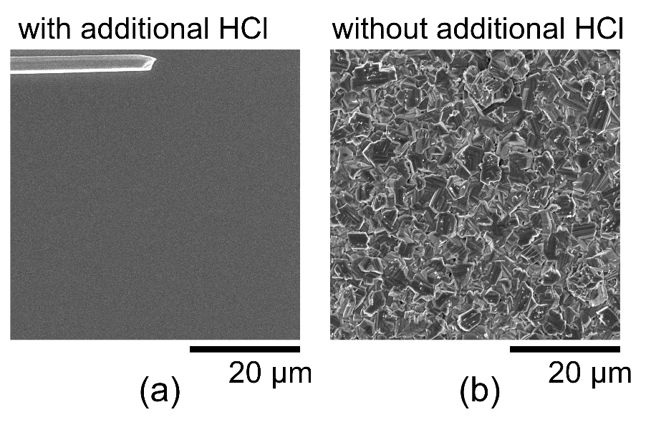

Fig. 1. (Single column)

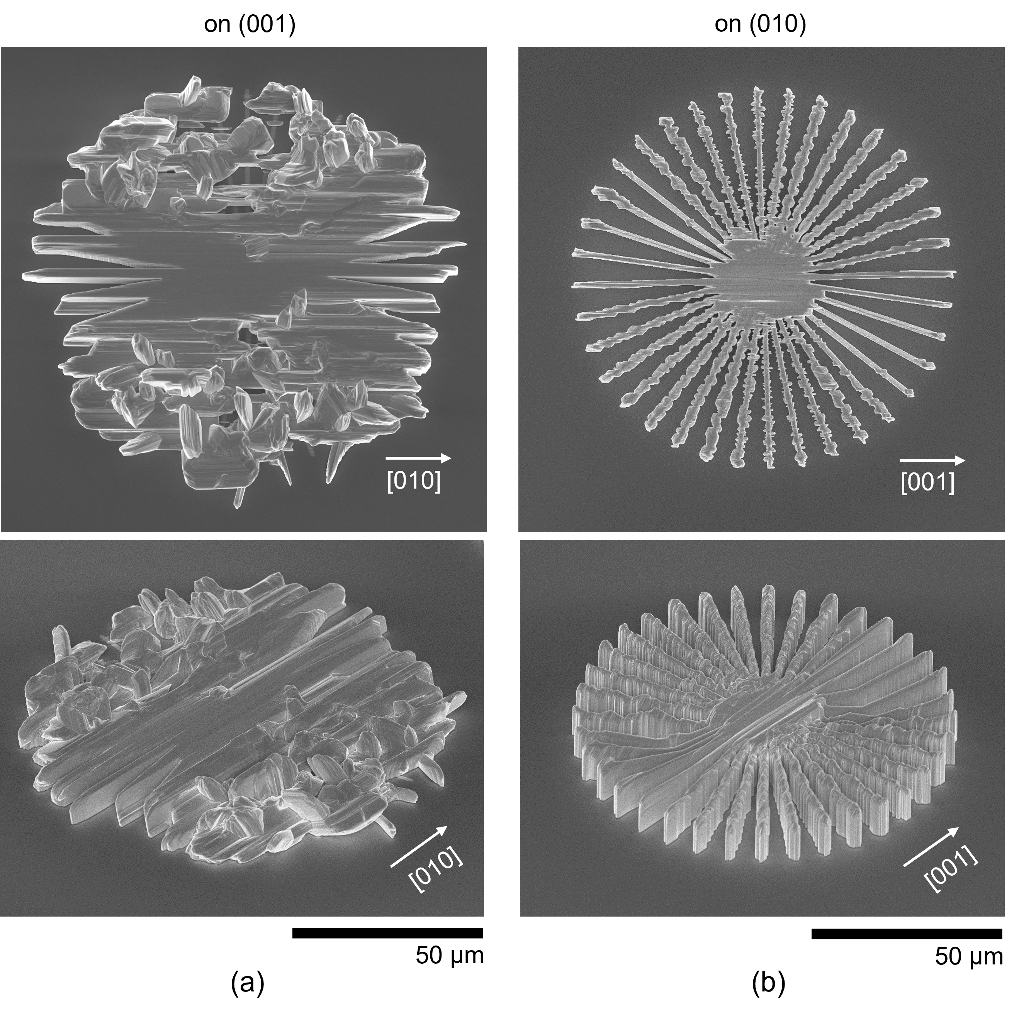

Fig. 2. (Two column)

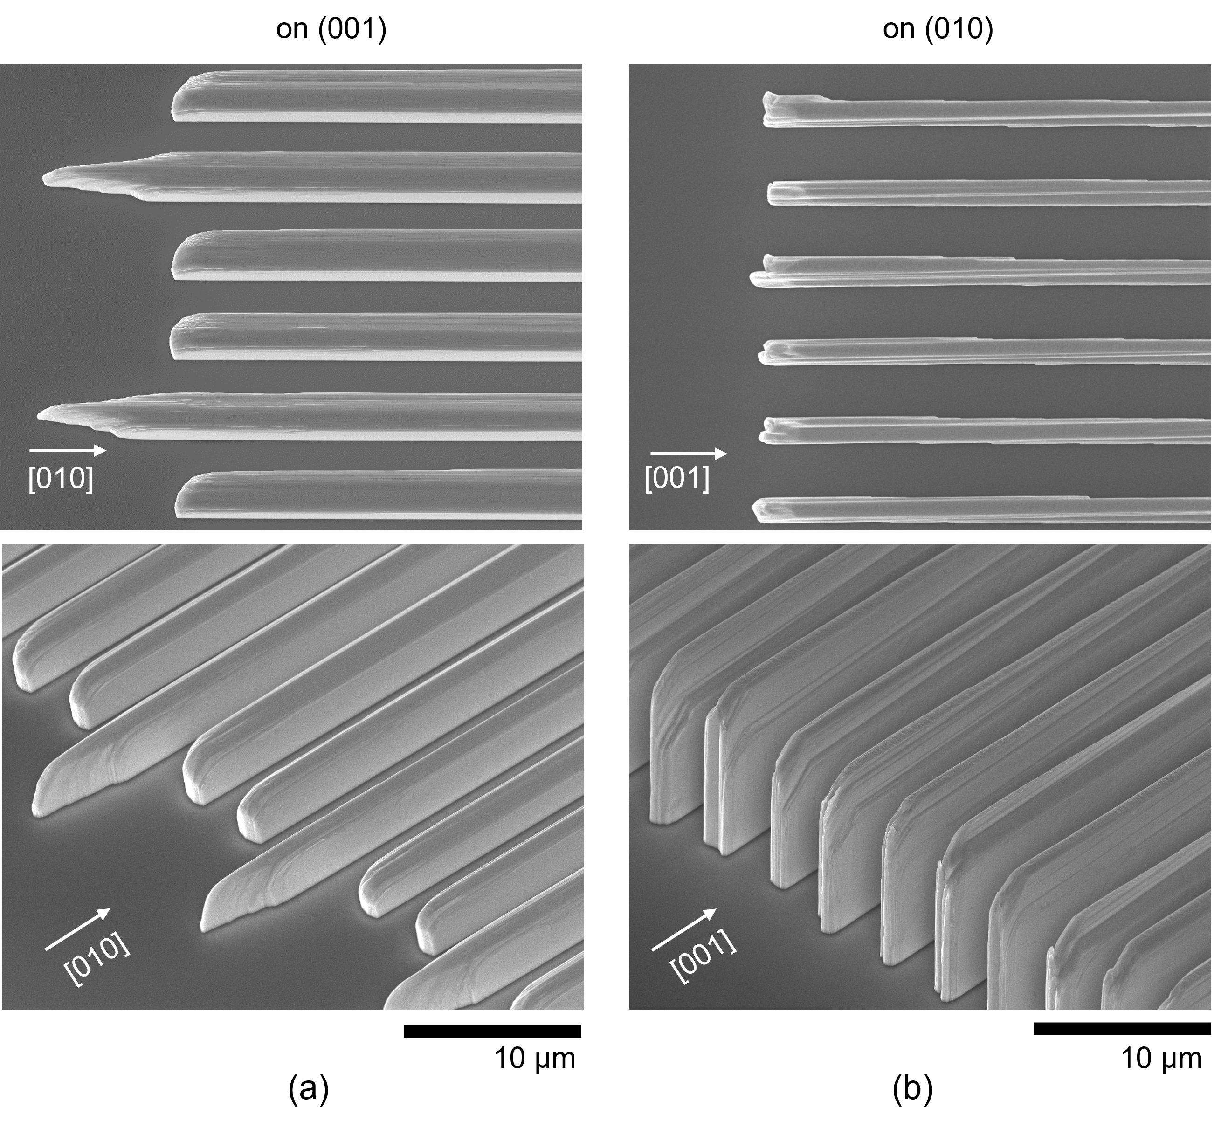

Fig. 3. (Two column)

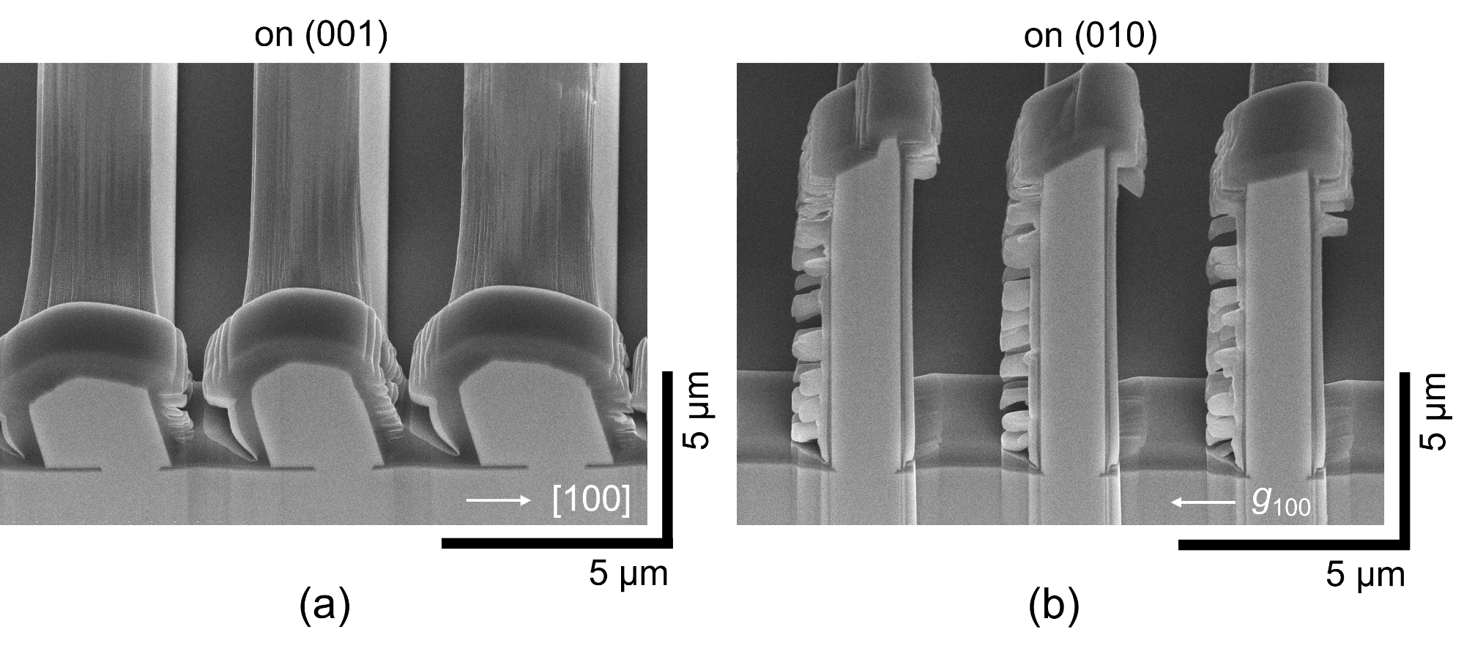

Fig. 4. (Two column)

Fig.5. (Single column)

