Technical Report
Effect of cristobalite on the response to indentation
in potassium-fluorrichterite glass-ceramics

Keitaro HIRAOKA¹, Gaku OKUMA³, Akihisa TAKEUCHI⁴, Masayuki UESUGI⁴, Yuki SADA⁴, Ken-ichi KATSUMATA², Atsuo YASUMORI², and Kei MAEDA²

¹ Department of Mechanical and Aerospace Engineering, Faculty of Science and Technology, Tokyo University of Science, 2641 Yamazaki, Noda, Chiba 278–8510, Japan.
² Department of Materials Science and Technology, Faculty of Advanced Engineering, Tokyo University of Science, 6–3–1 Niijuku, Katsushika-Ku, Tokyo 125–8585, Japan.
³ Research Center for Structural Materials, National Institute for Materials Science (NIMS), 1-2-1 Sengen, Tsukuba, Ibaraki 305-0047, Japan.
⁴ Japan Synchrotron Radiation Research Institute, JASRI/SPring-8, Kouto 1-1-1, Sayo, Hyogo 679-5198, Japan.

Glass-ceramics containing potassium-fluorrichterite (KNaCaMg₅Si₈O₂₂F₂) as the primary crystalline phase are known for their high bending strength and fracture toughness. It is also recognized that cristobalite precipitates in the commercial product as a secondary phase. This study investigated the response to indentation to identify the effect of cristobalite in potassium-fluorrichterite glass-ceramics with a chemical composition similar to that of the commercial product. The results revealed that the addition of 0.79 wt% Li₂O promoted the precipitation of cristobalite during heat treatment at temperatures up to 1000 °C. A distinct volume change associated with the α–β phase transition of cristobalite was observed at approximately 200 °C. Vickers indentation tests indicated that hardness decreased with the growth of potassium-fluorrichterite crystals and further declined with the precipitation of cristobalite. The glass-ceramics containing both potassium-fluorrichterite and cristobalite exhibited permanent, hemispherical surface deformation in ball indentation tests. Synchrotron radiation X-ray computed tomography revealed the formation of microcracks in the cristobalite-containing glass-ceramics. It was suggested that the microcracks generated by stresses arising from the cristobalite phase transition led to the deformation and consequently contributed to the ductile behavior of the material. The findings of this study are expected to provide valuable insights into the microstructural design of cristobalite-containing glass-ceramics with enhanced mechanical performance.

Keywords : Glass-ceramics, Cristobalite, Fluorrichterite, Indentation, Microcrack
[Received Month DD, YYYY; Accepted Month DD, YYYY]

1. Introduction
Glass-ceramics are produced by the precipitation of crystals within glass through heat treatment, resulting in exceptional properties that cannot be achieved with glass alone.^{1,2)} This versatility has led to a wide range of applications, including in the home (such as cookers, stoves, and fire windows), healthcare (including dental restorations and bioactive materials for bone replacement), astronomy (for telescope mirrors), electronics (such as circuit boards, electronic packaging, and hard disk drives), as well as in construction, coatings, and sealants.²⁾
One of the significant advantages of glass-ceramics is their superior fracture toughness compared to traditional glass products.³⁾ The propagation of cracks can be suppressed by the crystalline phases in glass-ceramics through various mechanisms, such as crack deflection,^{4,5)} crack bridging,⁶⁾ crack trapping, and bowing,⁷⁾ resulting in increased fracture toughness.
Among various glass-ceramics, the one that precipitates potassium-fluorrichterite (KNaCaMg₅Si₈O₂₂F₂) as its primary crystalline phase is renowned for its high bending strength, fracture toughness, and excellent thermal shock resistance.^{3,8)} Due to these advantages, this material has been developed for use in tableware.⁹⁾ Several glass compositions have been studied including a stoichiometric composition of potassium-fluorrichterite¹⁰⁾ and a multi-alkali containing composition¹¹⁾. The composition and crystallization process of commercial products are well-documented in the literature.^{8,9)} The precursor glass contains an excess of silica compared to stoichiometric potassium-fluorrichterite to optimize forming capability of the precursor glass.⁸⁾ Consequently, the final product contains a cristobalite phase in addition to the primary crystalline phase of potassium-fluorrichterite.
Cristobalite, one of the polymorphs of SiO₂ minerals, is known to exhibit a phase transition from the α (low) phase to the β (high) phase at temperatures ranging from 200 ºC to 270 ºC^{12,13)}, with a volume change as significant as 2.8%.¹⁴⁾ Due to this substantial volume change, fused silica products can experience fracture issues caused by the stress generated during α‒β transition of cristobalite that has devitrified within the products.¹⁵⁾ Numerous studies have been conducted to investigate the kinetics of cristobalite formation from fused silica.¹⁶⁻¹⁹⁾
However, it is also known that the residual stress in the glass-ceramics body can enhance its fracture toughness if the precipitation of cristobalite is well-controlled.¹⁴⁾ We recently studied glass-ceramics containing cristobalite, along with xonotlite and CaF₂.²⁰⁾ Our findings indicated that the material exhibited ductile (“quasi-plastic” ²¹⁾) behavior similar to that of glass-ceramics containing mica^{22,23)} or hexagonal CaAl₂Si₂O₈ crystals²⁴⁾. These glass-ceramics demonstrate permanent deformation even when subjected to a blunt indenter, such as a ball indenter, similar to metallic materials. The deformation is caused by microcracks generated under indentation. Since mica and hexagonal CaAl₂Si₂O₈ crystals²⁵⁾ possess a layered structure with cleavage planes, microcracks are easily generated by the stress field induced by indentation. In the case of cristobalite containing glass-ceramics, microcracks arise from the stress caused by the volume change during the α‒β transition of cristobalite²⁰⁾.
Although fracture toughness (K_{IC}) is a parameter used to describe the strength of materials, it primarily indicates resistance to crack propagation under tensile stress. Therefore, it serves as a good indicator of resistance to fracture in bending modes and thermal shock. In contrast, in situations such as impact fractures, the ductile behavior of materials plays a crucial role in determining resistance to fracture, as deformation can absorb energy that would otherwise contribute to breaking the materials. However, no information on potassium-fluorrichterite glass-ceramics has been provided to date.
In light of these considerations, the aim of this study is to identify the effect of cristobalite precipitation in potassium-fluorrichterite glass-ceramics on ductile behavior, to optimize the material's mechanical properties for a wide range of applications. For this purpose, we present the results of indentation tests conducted on the glass-ceramics, both with and without cristobalite precipitation, using Vickers and ball indenters.

2. Experimental Procedure
2-1 Sample preparation and characterization
The glass compositions used in this study are listed in Table 1. Two model glass compositions, derived from commercial productions documented in the literature⁸⁾ were employed. These compositions contain the same concentration of the components as the commercial products that form the potassium-fluorrichterite crystalline phase (SiO₂, Na₂O, K₂O, MgO, CaO, and F), along with minor amounts of Al₂O₃ and Li₂O (Glass-A). Li₂O was not included in Glass-B to assess its effect on the crystallization. The reagents SiO₂ (>99.9%), Al₂O₃ (>99.99%), Na₂CO₃ (>99.8%), K₂CO₃ (>99.5%), MgO (>98%), CaF₂ (>98%), and Li₂CO₃ (>99.0%) (all from FUJIFILM Wako Pure Chemical Corporation) were used as raw materials. The mixture of raw materials to produce 35 g of glass was placed in an alumina crucible and calcined at 700 ºC for 1 hour to desorb CO₂, then melted at 1400 °C for 1 hour. The molten glass was poured onto a brass plate preheated to 300 °C. The bulk glass was immediately transferred to an electric furnace preheated to 550 °C, where it was held for 1 hour before being slowly cooled to room temperature (1°C/min). The resulting glass samples were cut and subjected to heat treatment for crystallization. DTA measurements were performed on powdered glass (< 75 μm) in a nitrogen atmosphere using a NETZSCH STA 449F5 Jupiter instrument, with a heating rate of 10 ºC/min. Since the crystalline phase evolution in this system is well studied in the previous works ^{8,10)}, two temperatures of 1000 ºC and 1100 ºC were selected for the crystallization in this study to ensure the precipitation of potassium-fluorrichterite. Glass-A was heat-treated at 1000 ºC, while Glass-B underwent heat treatment at both 1000 ºC and 1100 ºC for 5 hours (with a heating rate of 5 ºC/min and a cooling rate of 1 ºC/min). The crystallized glasses after heat treatment were designated as GC-A-1000, GC-B-1000, and GC-B-1100, respectively. The crystalline phases in the glass-ceramics were identified using powder X-ray diffraction (XRD; XRD-6100, Shimadzu). The thermal expansion of the two samples, GC-A-1000 and GC-B-1000, was measured using a Rigaku Thermoplus TMA8310 at a heating rate of 5 ºC/min.

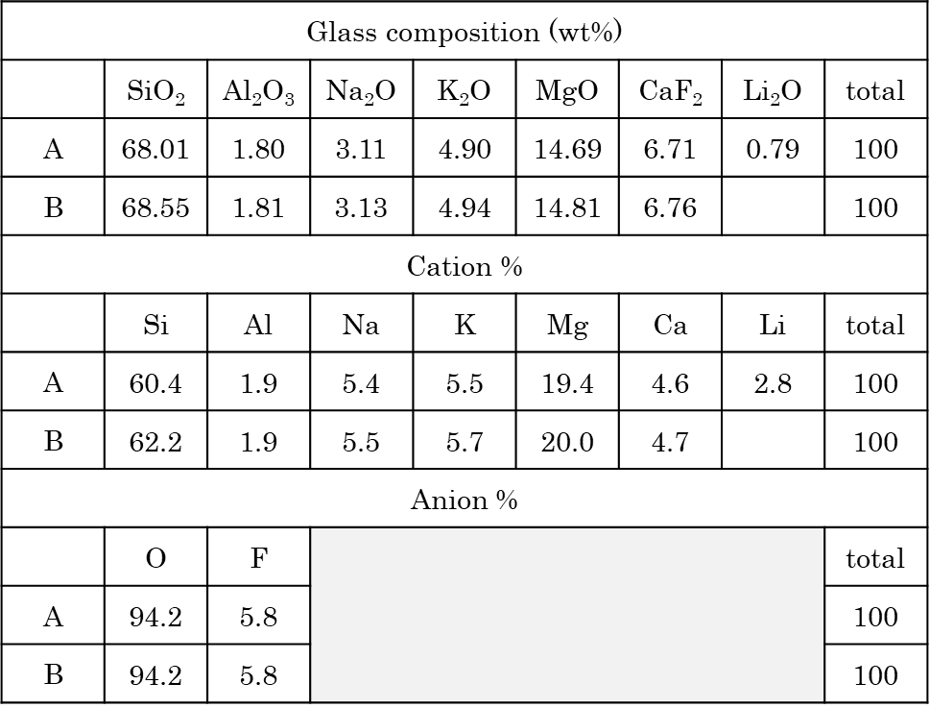
Table 1 Glass compositions in this study.

2-2 Indentation test
Indentation tests were conducted on the polished surfaces of the glass-ceramics using a Vickers hardness tester (HMVG20, Shimadzu) and a Rockwell hardness tester (HR-430R, Mitsutoyo). For the Vickers indentation, the test was performed at a load of 19.62 N. The imprints, associated cracks, and the microstructure of the glass-ceramics were observed using scanning electron microscopy (SEM; Gemini SEM 360, Carl Zeiss Microscopy) equipped with energy dispersive X-ray spectroscopy (EDX; XFlash SVE 6, Bruker). The crystal width distribution was evaluated using 30 crystals from the SEM image. A ball indentation test was conducted at 294 N using a tungsten carbide ball indenter with a diameter of Φ = 1/16 inch (1.59 mm). Since the depth of indenter penetration was insufficient to calculate the hardness number, this study focused solely on evaluating the depth and microstructural changes in the subsurface caused by the indenter. The circular imprints left on the surface were examined using a laser confocal microscope (KEYENCE, VK-X3000). The damage zone under the indentation of GC-A-1000 was analyzed using multi-scale X-ray computed tomography (CT) at SPring-8 (BL20XU). ^{26,27)} The sample was machined into a cylindrical shape, with imprints from the ball indentation remaining on the surface. The complete image was obtained using micro-CT mode, while a detailed image of the area under indentation was captured using nano-CT mode. CT reconstruction was performed with homemade software based on the convolution back-projection method. Cross-sectional 2D images were processed from the CT images using Fiji Image-J. The voxel size in an arbitrary slice of the CT was 0.493 μm/voxel in micro-CT mode and 0.0313 μm/voxel in nano-CT mode, respectively.

3. Results and Discussion
3-1 Phase Identification and thermal expansion behavior
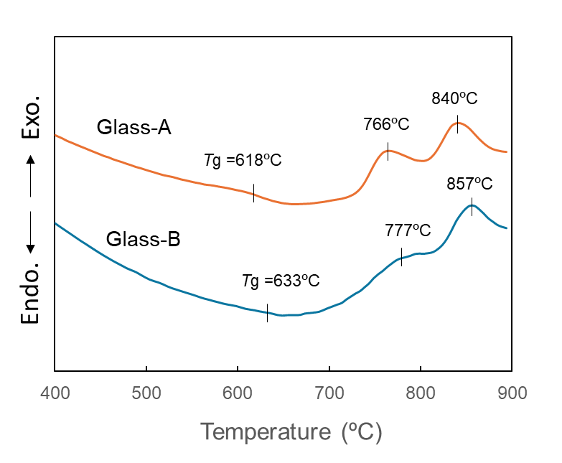
Figure 1 shows the DTA traces of Glass-A and Glass-B. The glass transition temperature (Tg) and crystallization temperature of Glass-A were observed 11‒17 ºC lower than those of Glass-B. Therefore, it was revealed that the addition of Li₂O into glass lowered the viscosity of the glass and promoted crystallization.
Fig. 1 DTA traces of parent glass samples.

Figure 2 presents the X-ray diffraction (XRD) results of three glass-ceramic samples. The precipitation of potassium-fluorrichterite was observed in all samples. Additionally, cristobalite was found to precipitate in the GC-A-1000 sample. Cristobalite did not precipitate even at 1100 ºC in Glass-B (GC-B-1100). Therefore, it was revealed that the addition of Li₂O was required for the precipitation of cristobalite. The thermal expansion curves for GC-A-1000 and GC-B-1000 are illustrated in Fig. 3. While the GC-B-1000 sample exhibited linear expansion, a distinct jump in the expansion curve, attributed to the α‒β transition of cristobalite, was observed for GC-A-1000 at approximately 200 ºC. Although the α‒β transition of pure cristobalite typically occurs between 200-270 ºC^{12,13)}, it was observed at a lower temperature in the glass-ceramic samples analyzed in this study. Although the reason of this is not clear yet, the addition of a small amount of Al₂O₃ to the precursor glass may have contributed to a lower purity of cristobalite due to the substitution of Al for Si at the lattice sites.²⁸⁾
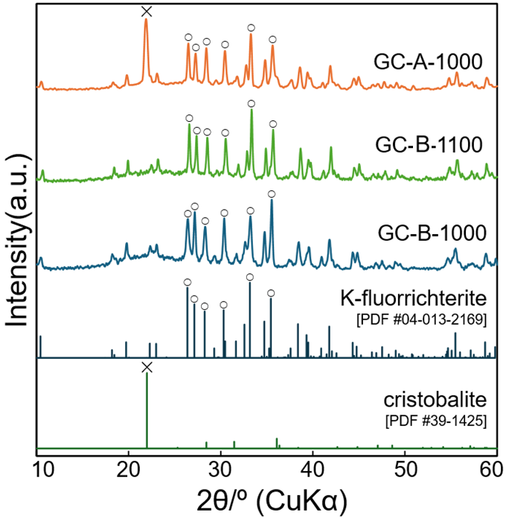
Fig. 2 XRD results of glass-ceramic samples.
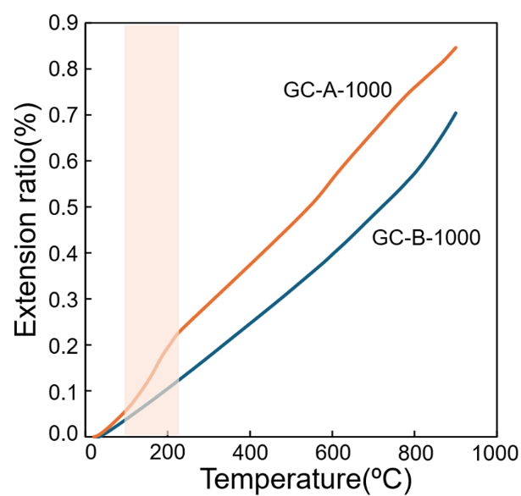
Fig. 3 Thermal expansion curves of glass-ceramic samples.

3-2 Vickers indentation
Figure 3 displays images of the imprints and cracks following Vickers indentation for three glass-ceramic samples. Radial (or half-penny ²⁹⁾) cracks, which typically occur in glassy materials, are evident in all samples. Notably, significant crack deflection is observed in GC-A-1000 and GC-B-1100, while the cracks in GC-B-1000 traveled almost straight. The interlocking microstructure of rod-shaped potassium-fluorrichterite, previously documented in studies ^{8, 31)}, is clearly visible in both GC-A-1000 and GC-B-1100, (see Fig. 4, FE-SEM image). The EDX mapping of GC-A-1000, illustrated in Fig. 5, further indicates that the white area in the SEM image corresponds to potassium-fluorrichterite crystals, as magnesium is concentrated in this region.³⁰⁾ Consequently, the crack deflection is attributed to the potassium-fluorrichterite crystals that developed significantly due to the increased crystallization temperature in GC-B-1100 or the addition of Li₂O in GC-A-1000, in comparison to GC-B-1000. The Vickers hardness of each sample is presented in Table 2. Comparing GC-B-1000 and GC-B-1100, the hardness decreased as the potassium-fluorrichterite crystals increased in size (see Fig. 4, size distribution of crystals). However, in GC-A-1000, where cristobalite precipitated, the hardness further diminished despite the fact that the potassium-fluorrichterite crystals were smaller than those in GC-B-1100. This indicates that the hardness also decreased with the precipitation of cristobalite.

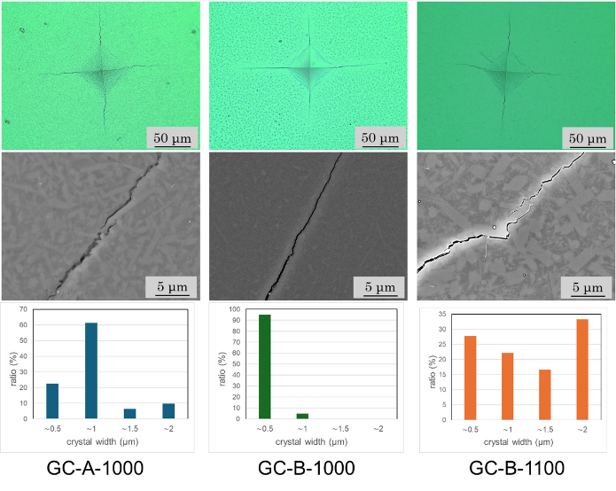
Fig. 4 Observation of imprints and cracks by Vickers Indentation. Upper: Optical microscope images. Middle: SEM images. Lower: Size distribution of crystals.
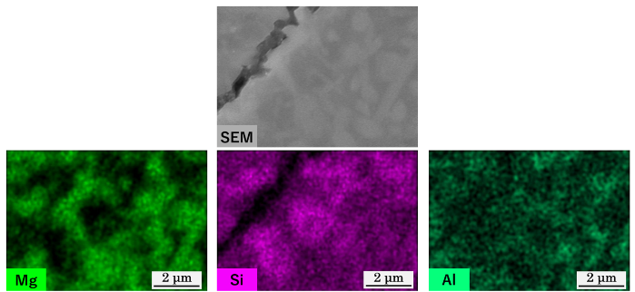
Fig. 5 EDX mapping of GC-A-1000.
Table 2 Vickers Hardness of each sample.

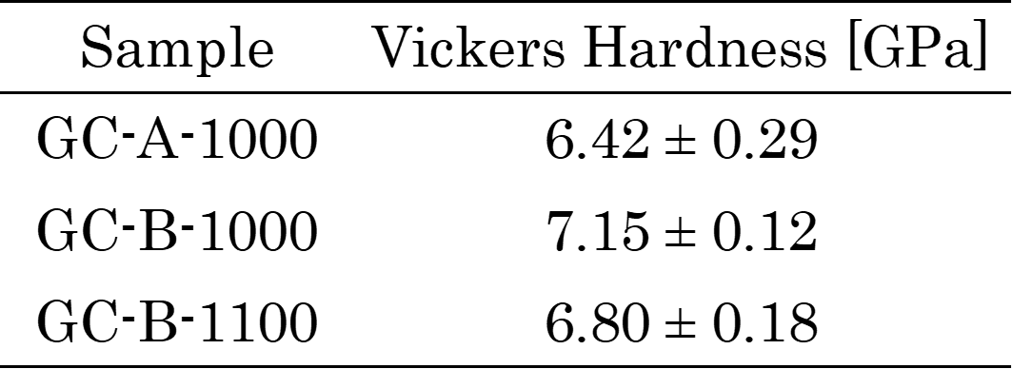

3-3 Ball indentation
The results of indentation using a ball indenter are presented in Fig. 6. While only a ring crack was observed on the surface of the GC-B-1000 sample, a distinct depression is evident in the GC-A-1000 and GC-B-1100 samples. The depression in the GC-A-1000 sample is deeper and exhibits a rounded shape (approximately 2.0 μm), whereas the GC-B-1100 sample displays a shallower and rectangular shape (approximately 1.2 μm). These findings suggest that the larger size of potassium-fluorrichterite promotes plastic deformation behavior, and the precipitation of cristobalite further enhances this effect, which corresponds to the results of the Vickers indentation test. The internal microstructure and the cross-sectional images of the indentations in GC-A-1000, captured using X-ray micro-CT, are presented in Fig. 7. A cone crack was observed beneath the indentation, along with numerous cavities within the GC-A-1000 material. These cavities were distributed throughout the entire sample, indicating that they formed prior to the indentation during the crystal growth process. The cavities can be visualized on the polished surface of the glass-ceramics using an optical microscope, as illustrated in Fig. 8. In contrast, these cavities were not present in GC-B-1100 (see Fig. 8, right), suggesting that the cavities in GC-A-1000 resulted from the precipitation of cristobalite.
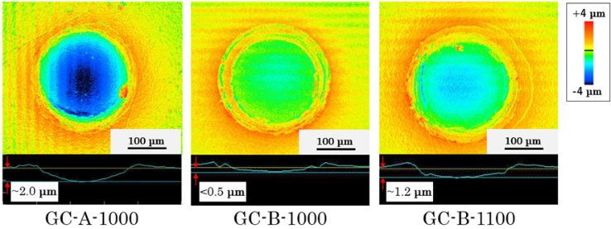
Fig. 6 Images of imprints left by a ball indenter (r = 0.794 mm) at a load of 294 N observed using a laser confocal microscope.

To identify the cavities more clearly, nano-CT observation was conducted in the central region of the imprint, approximately 80 μm deep from the surface (point A in Fig. 7). Figure 9 presents the results, revealing that the observed features were aggregated microcracks rather than pores. From a vertical perspective, it was noted that the microcracks bridged each aggregation of microcracks. The microcracks extended horizontally, exhibiting the behavior similar to that observed in previous studies.²⁰⁾ Based on these observations, it is suggested that the aggregation of microcracks was generated by the α‒β transition of
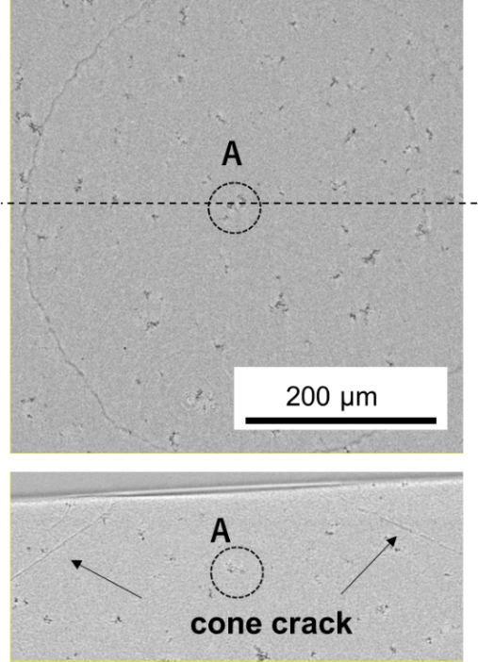

Fig. 7 Horizontal cross-sectional view (top) and vertical cross-sectional view of GC-A-1000 sample by X-ray micro-CT. Dotted line in top picture indicates the location of the vertical cross-section.
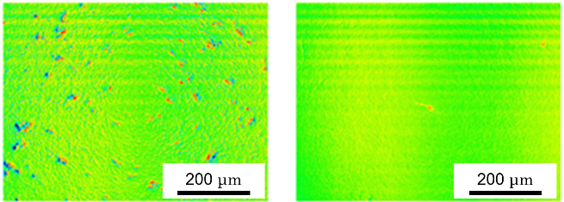
Fig. 8 Optical microscope images of polished surface of GC-A-1000 (left) and GC-B-1100 (right).

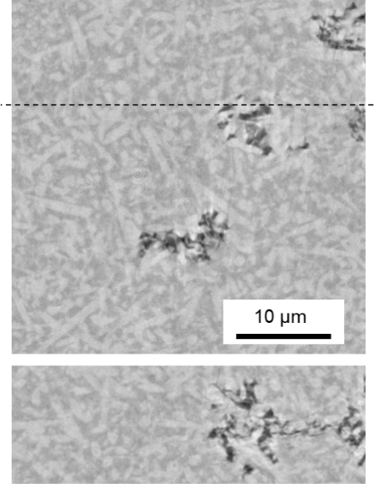

Fig. 9 Horizontal cross-sectional view (top) and vertical cross-sectional view (bottom) of GC-A-1000 sample by X-ray nano-CT. Dotted line in the top picture indicates the location of the vertical cross-section.
cristobalite and contributed to the ductile behavior of GC-A-1000. However, since GC-A-1000 also exhibited cone cracks characteristic of elastic materials, it is proposed that GC-A-1000 exists in a transition region between elastic and ductile behavior. It is expected that the ductile behavior can be enhanced by adjusting the quantity, size, and morphology of cristobalite. Therefore, further investigations involving a wider range of glass compositions and heat treatment conditions are necessary to clarify the effects of cristobalite and to achieve improved performance of the glass-ceramics for various applications.

4. Conclusion
The indentation tests of glass-ceramics containing potassium-fluorrichterite and cristobalite were conducted using laboratory-synthesized samples with compositions similar to those found in commercial products. The results indicated that the addition of Li₂O promoted the precipitation of cristobalite, which resulted in a decrease in Vickers hardness. Ball indentation tests revealed that cristobalite enhanced the ductile behavior of the material. This finding provides new insights into the application of potassium-fluorrichterite glass-ceramics.

5. Acknowledgement
Synchrotron radiation X-ray CT at SPring-8 was performed with the approval of JASRI (Grant No. 2024B1002). The authors thank Mr. Takahumi Kawano in National Institute for Materials Science for his assistance in operating X-ray CT at SPring-8. This study was conducted in collaborative laboratory between AGC Inc. and Tokyo University of Science. The authors thank AGC Inc. for their kind support and advice.

6. References
- J. Deubener et al., J. Non-Cryst Solids, 501, 3–10 (2018).
- T. Honma, K. Maeda, S. Nakane and K. Shinozaki, J. Ceram. Soc. Jpn., 130, 545–551 (2022).
- Q. Fu, G. H. Beall and C. M. Smith, MRS Bull., 42, 220–225 (2017).
- K. T. Faber and A. G. Evans, Acta Metall. 31, 565–576 (1983).
- K. T. Faber and A. G. Evans, Acta Metall. 31, 577–584 (1983).
- P. F. Becher, J. Am. Ceram. Soc. 74, 255–269 (1991).
- F. C. Serbena, I. Mathias, C. E. Foerster, and E. D. Zanotto, Acta Mater. 86, 216–228 (2015).
- G. H. Beall, J. Non-Cryst. Solids, 129, 163–173 (1991).
- “SiO₂–MgO–CaO–(R+)₂O–F (Amphibole)” in Glass ceramic Technology 3rd ed., Ed. by H. Hölland and G. H. Beall, Wiley, pp. 132–135.
- M. Mirsaneh, I. M. Reaney, P. V. Hatton, and P. F. James, J. Am. Ceram. Soc., 87, 240–46 (2004).
- E. M. A. Hamzawy and S. A. M. Abdel-Hameed, Ceram. Int., 35, 2139–2144 (2009).
- Polymorphism in Introduction to Ceramics Second Edition, Ed. by W. D. Kingery et al., John Wiley & Sons, Inc., (1976), pp. 81–87.
- D. M. Hatch and S. Ghose, Phys. Chem. Minerals, 17, 554–562 (1991).
- A. Hungera, G. Carl, A. Gebhardt, and C. Rüssel, J. Non-Cryst. Solids, 354, 5402–5407 (2008).
- R. C. Breneman and J. W. Halloran, J. Am. Ceram. Soc. 98, 1611–1617 (2015).
- L. Y. Wang and M. H. Hon, Ceram. Int., 21 187–93 (1995).
- X. M. Li, X. W. Yin, L. T. Zhang, and S. S. He, J. Non-Cryst. Solids, 354 3254–3259 (2008).
- A. Kazemi, M. A. Faghihi-Sani, and H. R. Alizadeh, J. Eur. Ceram. Soc., 33, 3397–3402 (2013).
- R. C. Breneman, and J. W. Halloran, J. Am. Ceram. Soc. 97, 2272–2278 (2014).
- D. Saito, S. Kanno, A. Yasumori, and K. Maeda, J. Ceram. Soc. Jpn., 132, 541–547 (2024).
- B. R. Lawn, J. Am. Ceram. Soc. 81, 1977–1994 (1998).
- B. R. Lawn, N. P. Padture, H. Cait, and F. Guiberteau, Science, 263, 1114–1116 (1994).
- H. Cai, S. M. Kalceff, and B. R. Lawn, J. Mater. Res. 9, 762–770 (1994).
- K. Maeda et al., J. Am. Ceram. Soc. 106, 7440–7448 (2023).
- K. Akatsuka, A. Yasumorib, and K. Maeda, Mater. Lett. 242, 163–165 (2019).
- A. Takeuchi, K. Uesugi, M. Uesugi, F. Yoshinaka and T. Nakamura, Microsc. Microanal., 24, 106–107 (2018).
- A. Takeuchi, K. Uesugi, M. Uesugi, H. Toda, K. Hirayama, K. Shimizu, K. Matsuo and T. Nakamura, Rev. Sci. Instrum., 92, 023701 (2021).
- D. E. Damby et al., J. Appl. Crystallogr. 47, 1205–1215 (2014).
- R. F. Cook and G. M. Pharr, J. Am. Ceram. Soc., 73, 787–817 (1990).

Caption List
Fig. 1 DTA traces of parent glass samples.
Fig. 2 XRD results of glass-ceramic samples.
Fig. 3 Thermal expansion curves of glass-ceramic samples.
Fig. 4 Observation of imprints and cracks by Vickers Indentation. Upper: Optical microscope images. Middle: SEM images. Lower: Size distribution of crystals.
Fig. 5 EDX mapping of GC-A-1000.
Fig. 6 Images of imprints left by a ball indenter (r = 0.794 mm) at a load of 294 N observed using a laser confocal microscope.
Fig. 7 Horizontal cross-sectional view (top) and vertical cross-sectional view of GC-A-1000 sample by X-ray micro-CT. Dotted line in top picture indicates the location of the vertical cross-section.
Fig. 8 Optical microscope images of polished surface of GC-A-1000 (left) and GC-B-1100 (right).
Fig. 9 Horizontal cross-sectional view (top) and vertical cross-sectional view (bottom) of GC-A-1000 sample by X-ray nano-CT. Dotted line in the top picture indicates the location of the vertical cross-section.

