Supplementary Material for: Theoretical Study of Lattice Dynamics Effect on Damping Constant of FePt at Finite Temperature
Ivan Kurniawan^{a,b}, Yoshio Miura^{a,c,}, Guangzong Xingª, Terumasa Tadanoª, Kazuhiro Hono^{a,b}
ª Research Center for Magnetic and Spintronics Materials, National Institute for Materials Science (NIMS), 1-2-1 Sengen, Tsukuba 305-0047, Japan
^{b} Graduate School of Science and Technology, University of Tsukuba, Tsukuba 305-8577, Japan
^{c} Center for Spintronics Research Network (CSRN), Graduate School of Engineering Science, Osaka University, Machikaneyama 1-3, Toyonaka, Osaka 560-8531, Japan
S.1 Scattering rate dependence on damping with different number of k-points
In order to confirm the qualitative feature of the scattering rate dependence of the damping constant, we checked for primitive cell L1₀-FePt with various number of k-points as shown in the FIG. S1. It is important to note that the typical nonmonotonic behavior of damping which correspond to the conductivity-like (intraband) followed by resistivity-like (interband) by increasing of scattering rate is already obtained with $20×20×20$ k-points mesh. Since the finite temperature effect is included by constructing $2×2×2$ supercell to create “snapshots” with displaced atoms, the k-point mesh may be considered to be half of that of a primitive cell. Therefore, $10×10×10$ k-points mesh is deemed sufficient for our supercell computation.
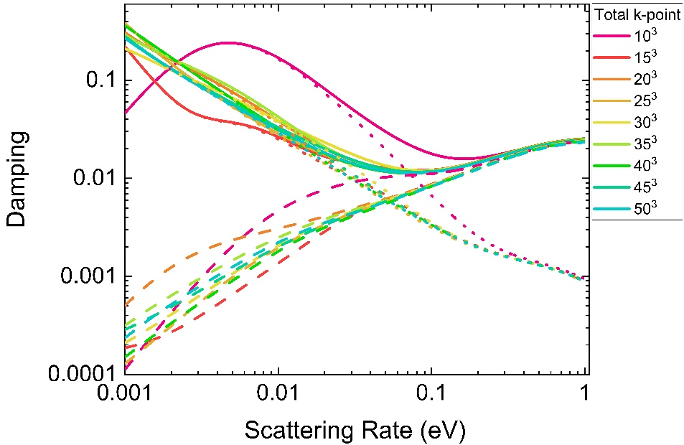
FIG. S1. The scattering rate dependence of damping on primitive L1₀-FePt cell with variation of number k-points. The solid line, dotted line, and dashed line correspond to the total, intraband, and interband damping, respectively.
S.2 Estimation of temperature dependence of damping constant at $4×4×4$ supercell
In the $2×2×2$ supercell, we calculate the damping constant $α^{2×2×2}\left(T,i\right)$ for every snapshot $i$ at each temperature $T$ as follow
$$α^{2×2×2}\left(T,i\right)=\frac{g}{πM_{s}}\sum_{k}{W_{k}\sum_{nn^{'}}{{\left|Γ_{nn^{'}}^{-}(k)\right|}^{2}\frac{δ(T)}{{(E_{F}-ε_{nk}^{2×2×2}(T,i))}^{2}+{\left[δ\left(T\right)\right]}^{2}}\frac{δ(T)}{{(E_{F}-ε_{n'k}^{2×2×2}(T,i))}^{2}+{\left[δ\left(T\right)\right]}^{2}}}}$$
where ${\left|Γ_{nn^{'}}^{-}(k)\right|}^{2}$ correspond to the matrix element which depends on the number of bands and k-point considered in the calculation, $δ(T)$ is the temperature-dependent scattering rate, and $ε_{nk}^{2×2×2}(T,i)$ is the band energy. Therefore, the damping at each temperature can be defined as averaged value over number of snapshots $N$.
$$α^{ 2×2×2}(T)=\frac{1}{N}\sum_{i=1}^{N}{α^{ 2×2×2}(T,i)}$$
Since the required time to calculate matrix element ${\left|Γ_{nn^{'}}^{-}\left(k\right)\right|}^{2}$ will grow on number of atoms (supercell size), direct evaluation of $α^{ s×s×s}\left(T\right)$ with $s>2$ would be difficult. Hence, by assuming that the change in ${\left|Γ_{nn^{'}}^{-}(k)\right|}^{2}$ due to atomic displacements is less significant than the change in $ε_{nk}^{s×s×s}(T,i)$, we indirectly evaluated the effect of the supercell size on the damping constant by introducing the $β^{s×s×s}\left(T,i\right)$ parameter defined as
$$β^{s×s×s}\left(T,i\right)=\sum_{k}{W_{k}\sum_{nn^{'}}{\frac{δ(T)}{{(E_{F}-ε_{nk}^{s×s×s}(T,i))}^{2}+{\left[δ\left(T\right)\right]}^{2}}\frac{δ(T)}{{(E_{F}-ε_{n'k}^{s×s×s}(T,i))}^{2}+{\left[δ\left(T\right)\right]}^{2}}}}$$
In principle, $β^{s×s×s}\left(T,i\right)$ are easier to evaluate because it only requires the information of band energy $ε_{nk}^{s×s×s}(T,i)$ for every snapshot at each temperature with the respective $s×s×s$ supercell, which is the direct result of ab-initio calculation. Similarly, we can also define the averaged value of $β^{s×s×s}\left(T\right)$ as follows:
$$β^{s×s×s}\left(T\right)=\frac{1}{N}\sum_{i=1}^{N}{β^{s×s×s}\left(T,i\right)}$$
Thus, expected value of damping on the $4×4×4$ supercell can be approximated as:
$$α^{ 4×4×4}\left(T\right)≈α^{ 2×2×2}(T)×\frac{β^{4×4×4}\left(T\right)}{β^{2×2×2}\left(T\right)}$$
In addition, we can directly calculate the root-mean-square deviation (RMSD) of varied damping value as the error bar of the damping calculation for $2×2×2$ supercell.
$$RMSD(α^{ 2×2×2}\left(T\right))=\sqrt{\frac{\sum_{i=1}^{N}{{\left(α^{ 2×2×2}(T,i)-α^{ 2×2×2}(T)\right)}^{2}}}{N}}$$
On the other hand, we also indirectly estimate the error bar of the damping calculation for $4×4×4$ supercell.
$$RMSD\left(α^{ 4×4×4}\left(T\right)\right)≈RMSD(β^{ 4×4×4}\left(T\right))×\frac{{ α}^{ 2×2×2}\left(T\right)}{β^{ 2×2×2}\left(T\right)}$$
In order to do this, first we need to define the RMSD of the $β^{s×s×s}\left(T\right)$
$$RMSD(β^{ s×s×s}\left(T\right))=\sqrt{\frac{\sum_{i=1}^{N}{{\left(β^{ s×s×s}(T,i)-β^{ s×s×s}(T)\right)}^{2}}}{N}}$$
Thus, we can plot the calculated $α^{ 2×2×2}(T)$ and error bars $RMSD(α^{ 2×2×2}\left(T\right))$ together with the estimated value $α^{ 4×4×4}(T)$ and error bar $RMSD(α^{ 4×4×4}\left(T\right))$. Since that RMSD is “root-mean-square-deviation”, its positive value will represent the variation without any error cancellation in the calculated Gilbert damping. As shown in the FIG. S2., the considerable effect of the supercell size on the value of damping was observed only at the low temperature (75 K), where the scattering rate $δ(T)$ is relatively small and the dominant contribution to the Lorentzian function comes mainly from the band energies. However, as the temperature rises, the influence of the scattering rate becomes more dominant in the Lorentzian function, making the influence of the supercell size on the damping value less significant. These results demonstrate that our initial choice of using the $2×2×2$ supercell is adequate to incorporate the essential effect of the phonon excitation at high temperatures.
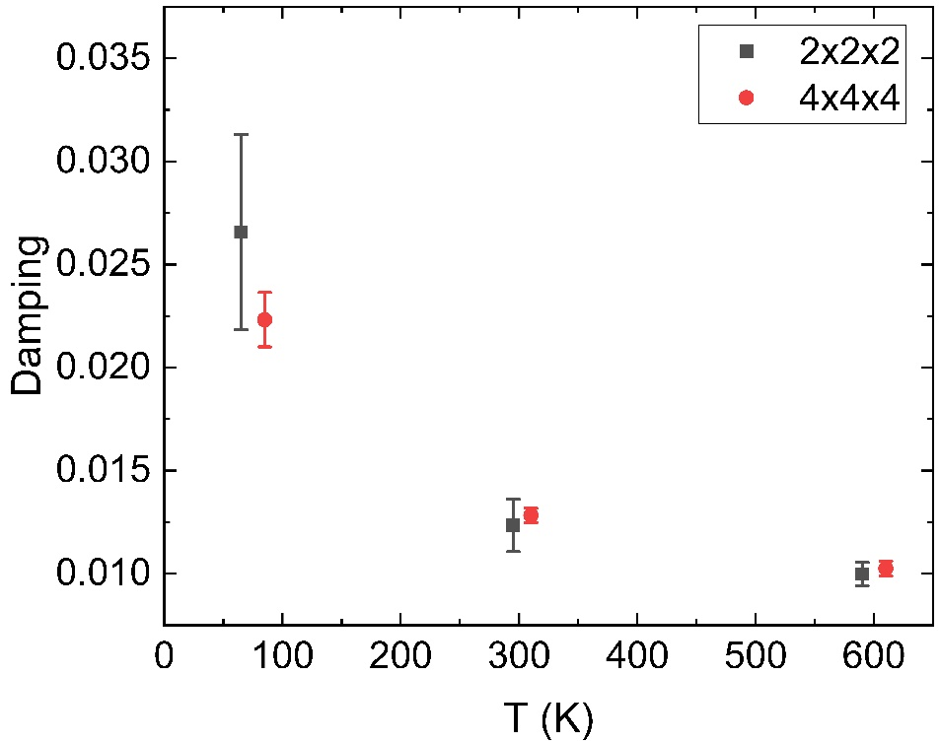
FIG. S2. Temperature dependence of damping with different supercell size. Error bar correspond to the $RMSD(α^{ 2×2×2}\left(T\right))$ and $RMSD(α^{ 4×4×4}\left(T\right))$ for $2×2×2$ and $4×4×4$ supercell, respectively.
S.3 Contribution of cross-term between spin-conserving and spin-flip part
In order to verify our assumption to separate the contribution of spin-conserving and spin-flip term and neglect the cross-term part, we directly calculate scattering rate dependence of the total damping, spin-flip term, spin-conserving term, and cross-term part of FePt at ground state as shown in the FIG. S3. We have confirmed that cross-term is much smaller than spin-conserving and spin-flip contribution, which justifies our analysis to directly separate the contribution into spin-flip and spin-contribution.
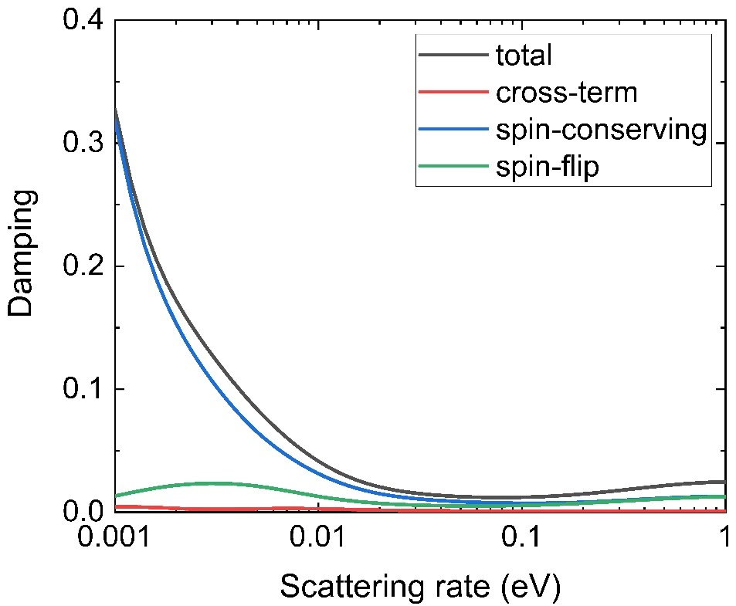
FIG. S3. Scattering rate dependence of total damping and cross-term between spin-flip and spin-conserving part.

Corresponding author: miura.yoshio@nims.go.jp

