Fine-Tuning of the Sequential Self-Assembly of Entangled Polyhedra by Exploiting the Side-Chain Effect
Yuya Domoto,*^{[a]} Ren Nakabayashi,^{[a]} Tasuki Tsurumi,^{[a]} Kidai Yamamoto,^{[b]} Hironobu Hayashi,^{[c]} Yosuke Nakamura,^{[a]} Makoto Fujita^{[b,d]}
This article is dedicated to Prof. Takayuki Kawashima on the occasion of his 77th birthday.
[a] Prof. Dr. Y. Domoto, R. Nakabayashi, T. Tsurumi, Prof. Dr. Y. Nakamura
Division of Molecular Science, Graduate School of Science and Technology
Gunma University
1-5-1 Tenjin-cho, Kiryu-shi, Gunma 376-8515 (Japan)
E-mail: domoto@gunma-u.ac.jp
[b] K. Yamamoto, Prof. Dr. M. Fujita
Tokyo College, U-Tokyo Institutes for Advanced Study (UTIAS)
The University of Tokyo
Mitsui Link Lab Kashiwanoha 1, FS CREATION, 6-6-2 Kashiwanoha, Kashiwa-shi, Chiba 277-0882 (Japan)
[c] Dr. H. Hayashi
Center for Basic Research on Materials, National Institute for Materials Science (NIMS)
1-2-1 Sengen, Tsukuba-shi, Ibaraki 305-0047 (Japan)
[d] Prof. Dr. M. Fujita
Division of Advanced Molecular Science
Institute for Molecular Science, National Institutes of Natural Sciences
5-1 Higashiyama, Myodaiji-cho, Okazaki-shi, Aichi 444-8787 (Japan)

Supporting information for this article is given via a link at the end of the document.

Abstract: The control of the sequential self-assembly processes of highly entangled (Ag₃L₂)_{n} (n = 2,4,6,8) and Ag₂₁L₁₂ coordination polyhedra using side-chain effects was studied via the introduction of linear or branched side chains into the tripodal ligands. In addition to changes in the intermediate polyhedral species affording the multi- pathway process, disruption of the kinetic control of the sequential self-assembly was observed, thus demonstrating the utility of steric control for the construction of 3D-entangled molecular materials on the 5 nm scale with high molecular complexity.
Introduction
Sequential self-assembly of nanostructures is an attractive topic toward molecular complexity^{[1-3]} as a potential source of sophisticated functions with dynamic properties. Particularly, multi-step interconversion of coordination polyhedra has recently emerged based on responsive behaviors of metal coordination centers, enabling global or partial structural changes of the three-dimensional frameworks.^{[4,5]} In this context, we have recently developed a process for the hierarchical self-assembly of (M₃L₂)_{n} polyhedra (L = 1; M = Ag(I) or Cu(I)) with highly entangled frameworks (Figure 1).^{[6-8]} In those structures, we found that acetylene π-coordination cooperatively works with conventional metal···pyridyl coordination,^{[9]} uniting the (originally) interlocked components in one molecule with a highly complex 3D framework.
One of characteristic aspects of the (M₃L₂)_{n} series is the stepwise conversion of the 3-5-nm-scale polyhedral frameworks upon anion exchange with nitrate, where the entangled motifs^{[10]} are completely changed or partly edited in parallel (Figure 1a).^{[6b,8]} During our screening, a slight change in the number of equivalents of the nitrate ion led to obvious changes in the assembled structures, as confirmed by an NMR study. Anion templation is known to be effective at the formation and dynamic interconversion of polyhedral and related cage-shaped cationic complexes,^{[11]} while (i) stability of the M₃L₂ subunit holding a counter anion, (ii) steric demand of the encapsulated anion, and (iii) role as the additional coordination donor mainly affected in our previous systems. These observations led us to suspect that the same ligand framework could potentially undergo a wide range of assembly processes, even once huge polyhedra have been formed, via adjustment of the conditions. Finely tuned entangled motifs are expected to induce unique properties, as inspired by natural proteins having entangled motifs exist in their large 3D structures and affect their molecular functions.^{[12]} The behavior of these artificial materials as dynamic systems has rarely been explored, except for a few examples of reversible single-step interconversions.^{[13]}
With the aim of finely manipulating the assembly pathway, we describe here the control of the self-assembly of the polyhedra using an even more simple parameter than the nitrate stoichiometry, i.e., the side-chain effects on the surface of the polyhedral frameworks. The steric effect is one of the most fundamental factors used to control the pathways and outcomes of organic synthetic reactions. Kinetic control, derived from the introduction of bulky functional groups, affects the reaction rate, while thermodynamic effects often govern which structure is obtained as the most stable product. While various types of steric control during the construction of nanoscale molecules via coordination self-assembly has also been explored^{[14,15]}, we herein focus on the steric effects realized by tuning the peripheral moieties apart from the metal centers. The advanced methodology, which combines anion templation and side chain effects, can be expected to provide access to the precise control of the synthesis of artificial molecular systems incorporated within 3D entangled molecular materials.^{[16,17]}
Results and Discussion
Synthesis
To evaluate the impact of the steric effects of the ligands on the assembly of the (M₃L₂)_{n} polyhedra, different types of side chains were introduced onto the arms of the tris-3-pyridyl triarylmethane framework (Figure 1b). Besides the steric factors, the current design of the side chains would affect the solubility of the assembled complexes and the coordination ability of acetylene and pyridyl donors confined in the regulated nanospace, both of which compose the side chain effects on the selection of the products. Ligands 2–4 were prepared via the threefold Sonogashira coupling of triiodinated triarylmethane where the arm alkynes have a 3-pyridyl terminus, followed by deprotection of the methoxymethyl groups and condensation with carboxylic acids equipped with either linear or branched side chains (for details, see the SI). Ligand 5, equipped with diethylene glycol chains, has already been reported in our previous work.^{[7a]}
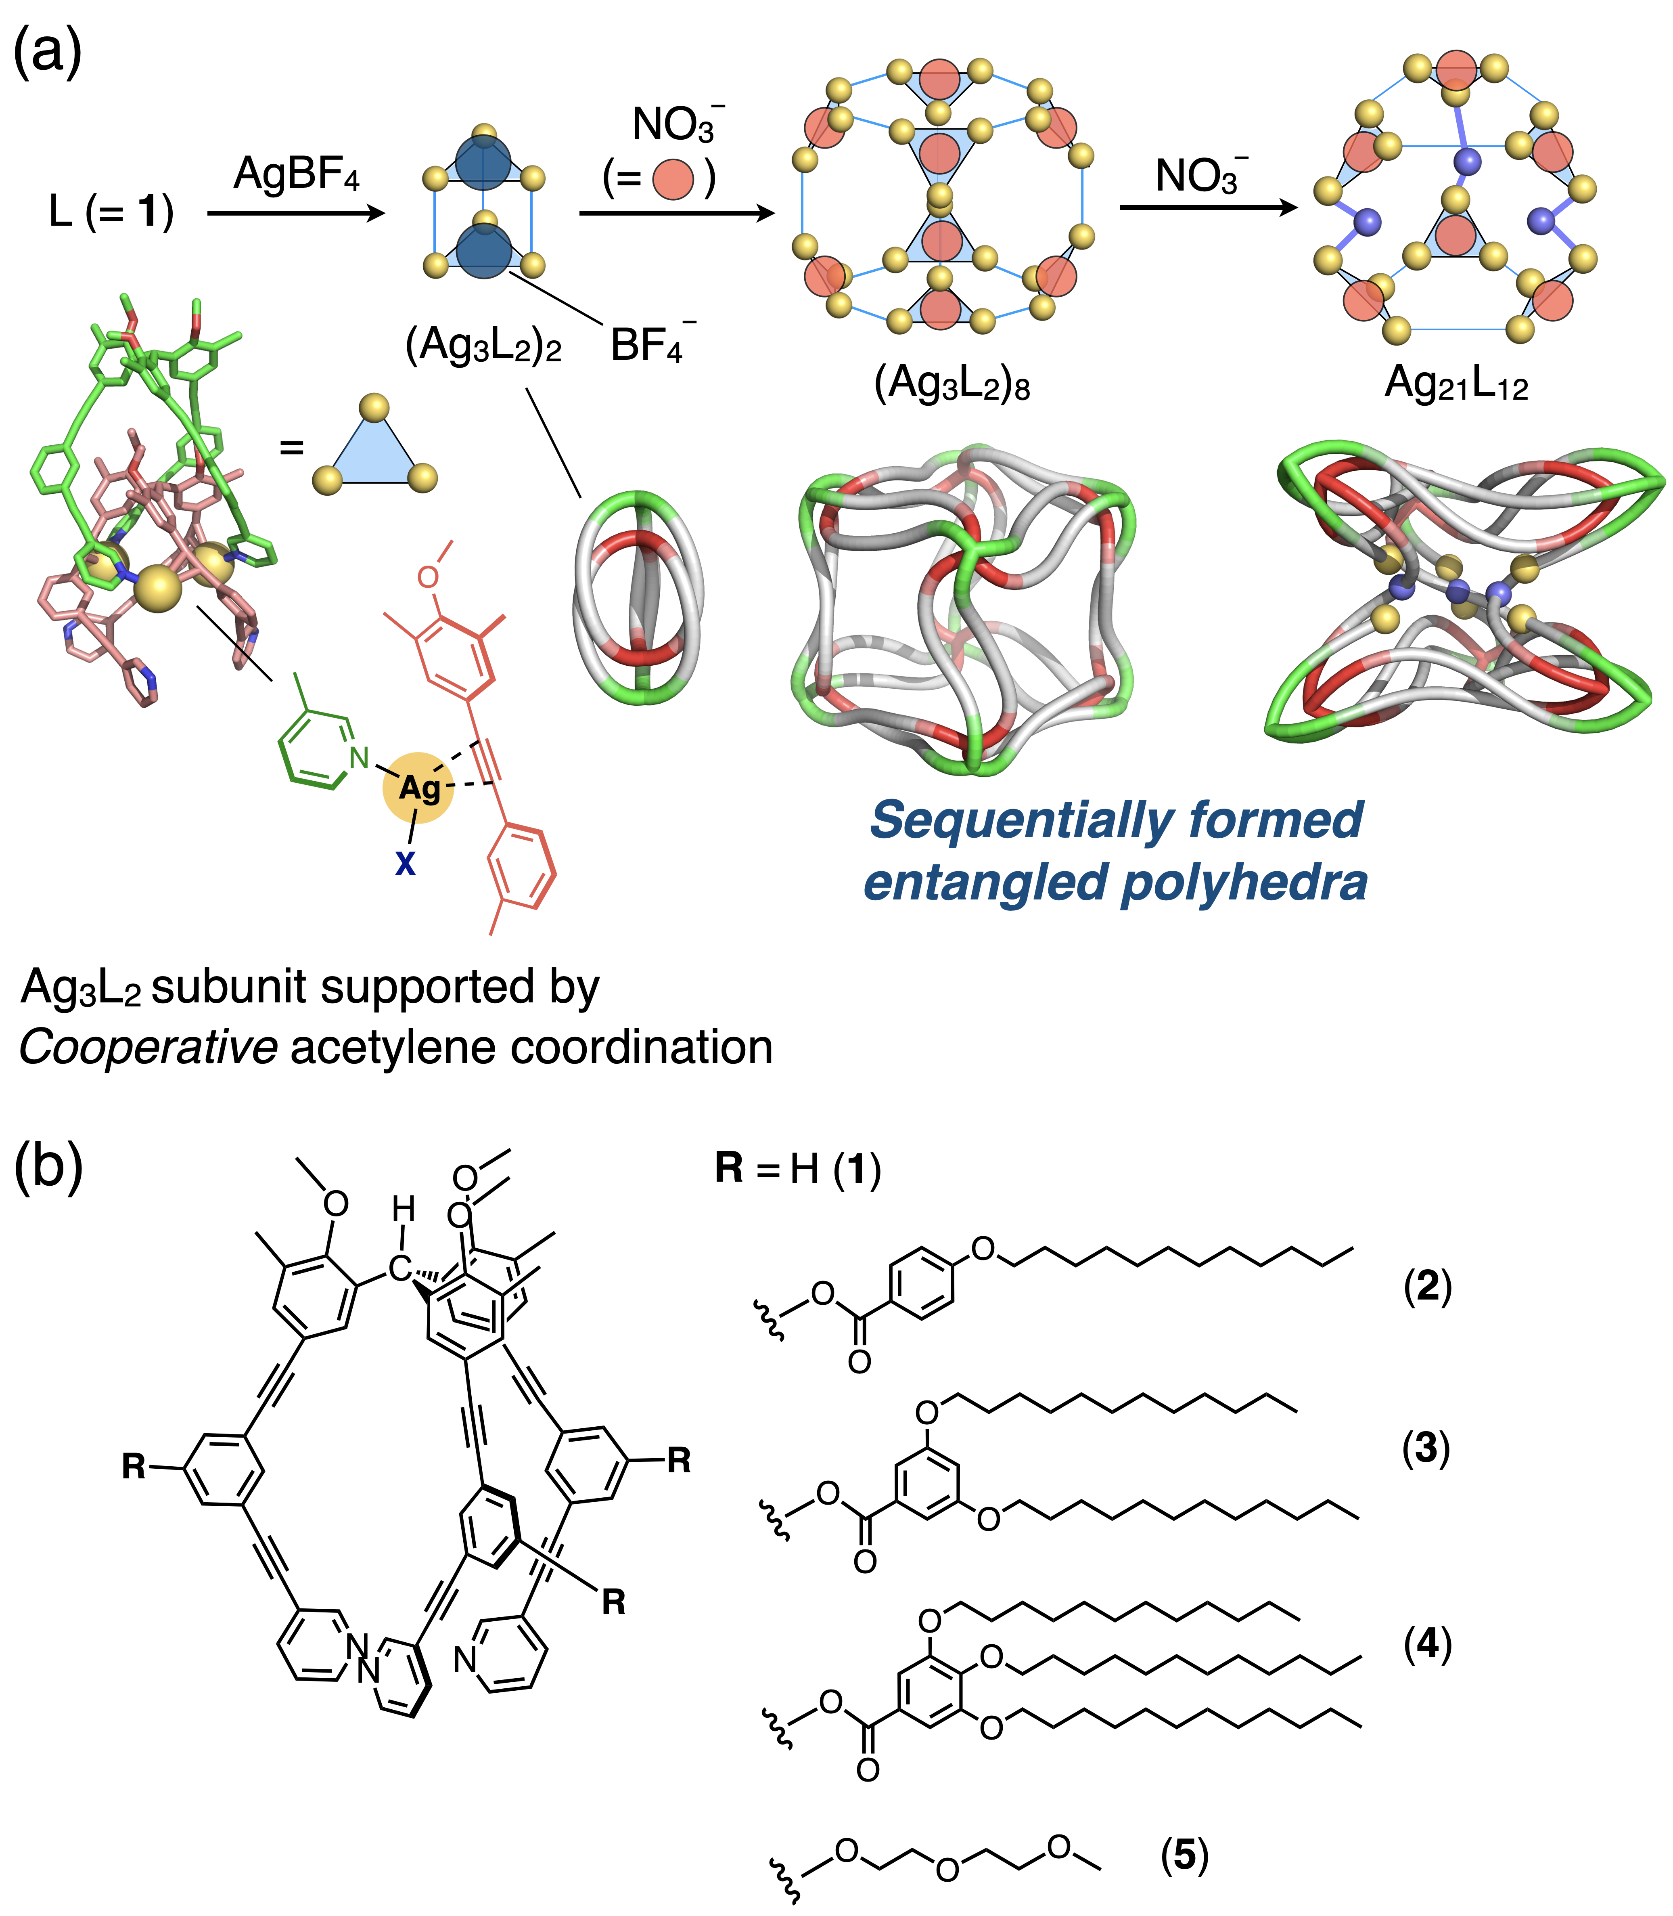Figure 1. (a) Schematic representation of the self-assembly of the (Ag₃L₂)₂ cage and its interconversion into the (Ag₃L₂)₈ and Ag₂₁L₁₂ polyhedra upon anion exchange in CD₃NO₂.^{[6b,8]} The entangled structures for each entangled polyhedron are shown below, while the acetylene π-coordination connecting the components is omitted for clarity. (b) Chemical structures of ligands 1,^{[6a]} 2–4, and 5^{[6a]} used in this study.
Controlled intermediate polyhedra upon interconversion
As previously reported, the complexation of the original ligand 1 with AgBF₄ affords (Ag₃L₂)₂ in CD₃NO₂, which transforms to cubic (Ag₃L₂)₈ and Ag₂₁L₁₂ upon sequential addition of the nitrate anion.^{[6b,8]} Additionally, the conversion of prismatic (Ag₃L₂)₆ to Ag₂₁L₁₂ is also observed in THF-d₈. To exclude the influence of the solvent effect on the assembly pathway, all experiments in this study, with the exception of the control, were conducted in CDCl₃/CD₃OD (97:3).
To confirm that the self-assembly works as previously determined, formation of the smallest complex, i.e. (Ag₃L₂)₂, using the ligands equipped with the side chains was firstly examined. Ligand 2 was treated with silver trifluoromethanesulfonate (AgOTf; 1.5 eq., 3.75 mM) in CDCl₃/CD₃OD (97:3). After the mixture had been heated (50 °C, 30 min), ¹H diffusion ordered spectroscopy (DOSY) NMR showed the formation of a single species (D = 2.5 × 10⁻¹⁰ m² s⁻¹ at 294 K). The splitting of the ¹H signals into two sets also supported the assembly of the (Ag₃L₂)₂ cage (Figure 2a and S7), because of the presence of two different chemical environments for the ligands (inner and outer) in the entangled structures of the cage framework. This behavior is also observed in ¹³C NMR signals (Figure 2c and S8), identical to that reported for the corresponding complex where L = 1.^{[6a]} Unfortunately, attempts to complete a single X-ray analysis of the complex have been unsuccessful because of the crystals degraded rapidly upon X-ray irradiation due to physical fragility that appears to result from the introduction of long alkyl chains surrounding the (Ag₃L₂)₂ skeleton.

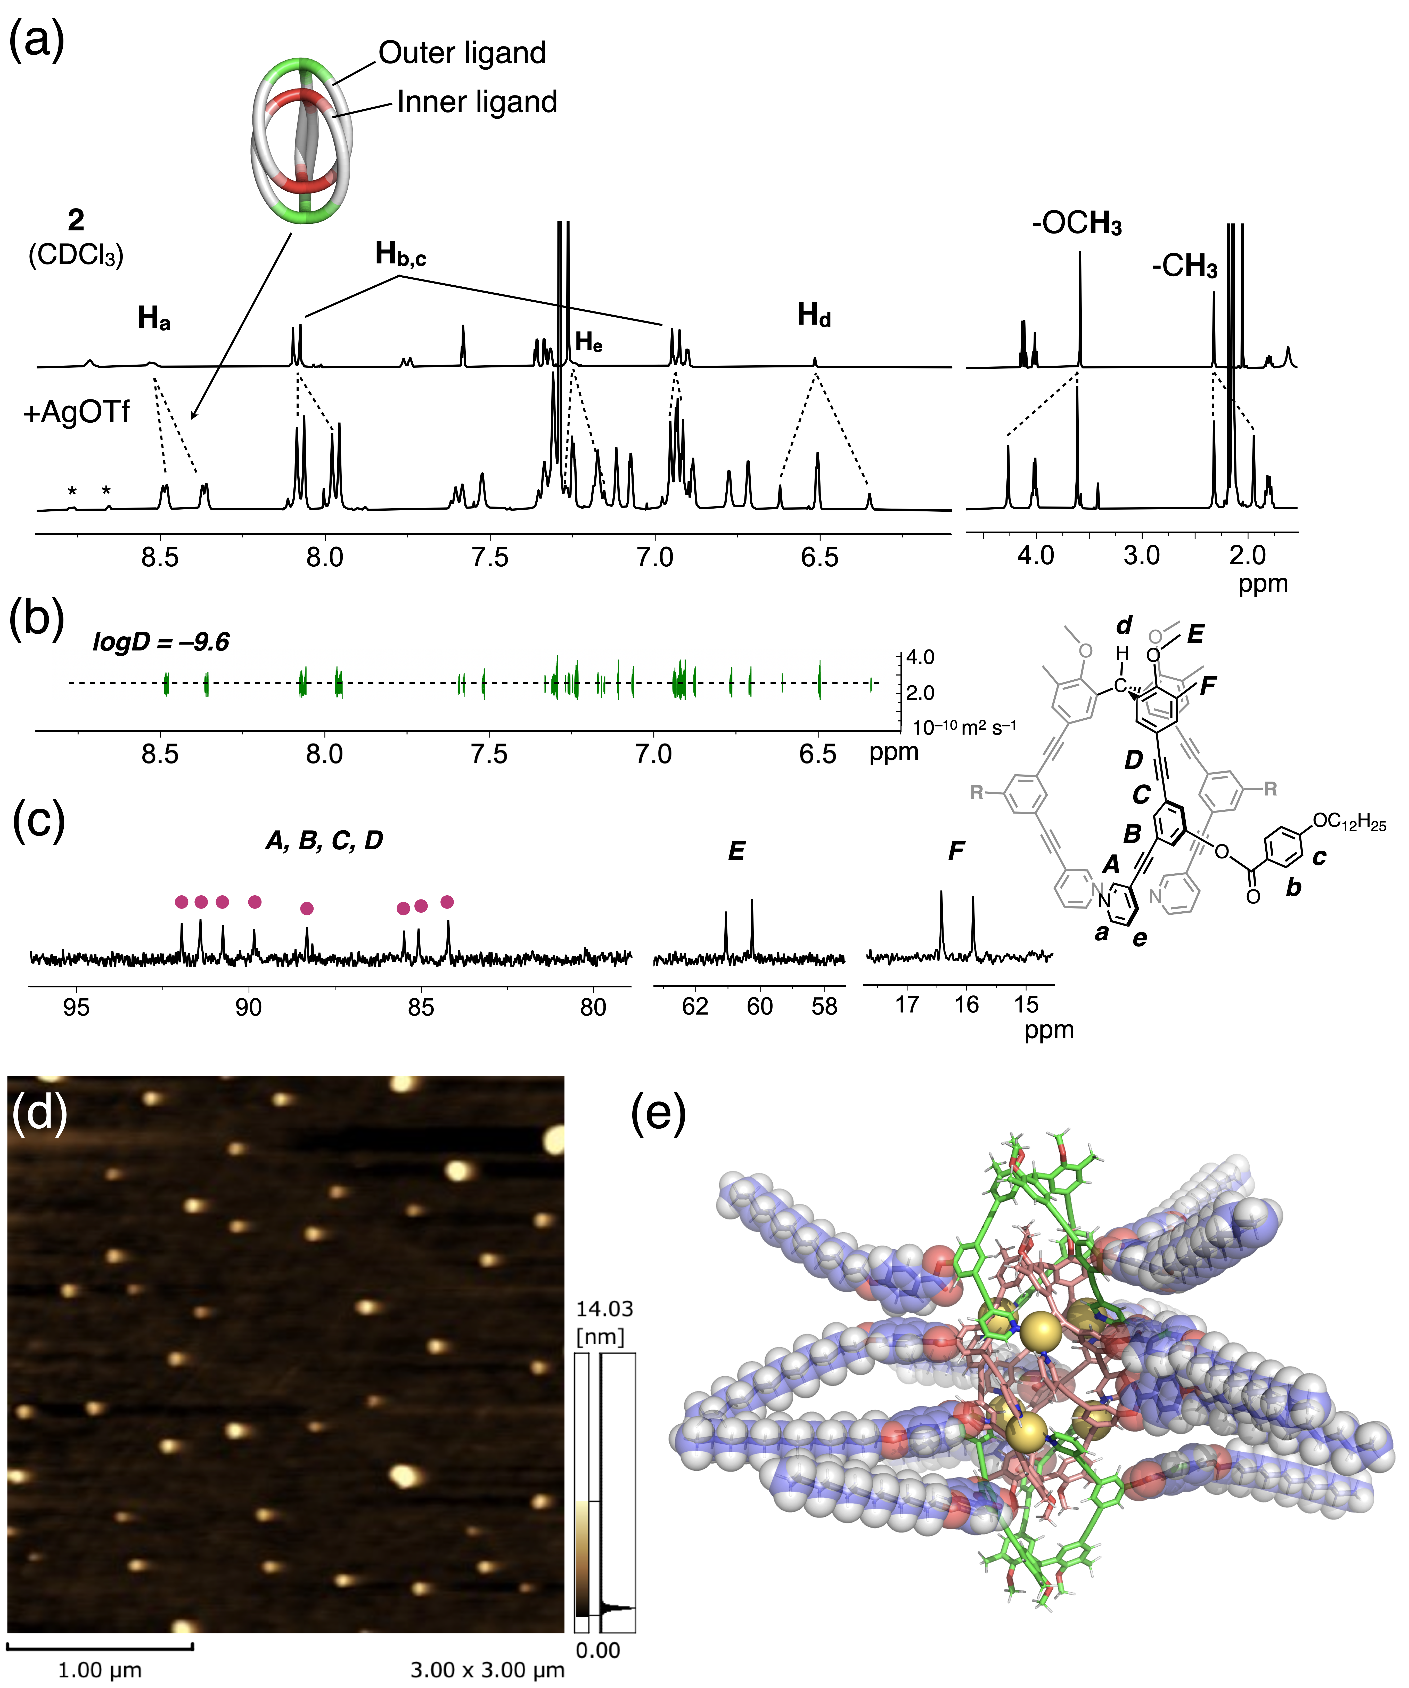
Figure 2. (a) ¹H NMR spectral change (400 MHz, 290 K) of ligand 2 upon the addition of AgOTf (1.5 eq.) in CDCl₃/CD₃OD (97:3). Signals marked with an asterisk (*) could be derived from the free ligand partially coordinated to the Ag(I) ion. (b) ¹H DOSY spectrum of (Ag₃L₂)₂ (L = 2) (294 K). (c) Partial ¹³C NMR spectrum (151 MHz, 294 K) of the (Ag₃L₂)₂ cage (L = 2) (d) AFM image of (Ag₃L₂)₂ (L = 2). See Figure S1 for cross-sectional analysis. (e) Optimized structure of (Ag₃L₂)₂ (L = 2) using MM calculation. Encapsulated counter anions are omitted for clarity.
As further support, atomic force microscopy (AFM) was performed on mica surface. AFM imaging initially gave severely aggregated forms, likely due to enhancement by hydrophobic side chains surrounding the polyhedral framework. Finally, a spin-coating technique treating the casted samples with nitromethane revealed the observation of relatively well-dispersed objects with a height of 6–11 nm (Figure 2d and S1), considering the approximate estimated size of the complex (see the molecular-mechanics (MM) model in Figure 2e). In the current case, however, the complete conversion to the (Ag₃L₂)₂ cage did not occur according to the NMR study. This is probably due to the steric hinderance of the side chains as indicated from the MM model, destabilizing the polyhedral framework under thermodynamic equilibrium. This is also supported by the case of the more bulky ligand 3, which indicated lower conversion to (Ag₃L₂)₂ upon the complexation with AgOTf (1.5 eq.) (Figure S5).
Furthermore, when ligand 2 was treated with AgBF₄ (3.0 eq., 7.5 mM)^{[18]} in CDCl₃/CD₃OD (97:3), a different self-assembly pathway was observed (Figure 3a). After the mixture had been heated (50 ºC, 30 min), the resulting ¹H NMR spectrum showed the formation of tetrahedral (Ag₃L₂)₄,^{[19]} as identified by the characteristic shifts of the pyridyl α-proton H_{a} and the benzene proton H_{b} (Figure 3b and S11)^{[20]}, which showed smaller diffusion coefficient (D = 1.7 × 10⁻¹⁰ m² s⁻¹ at 294 K, Figure 3c) in comparison with that of the (Ag₃L₂)₂ cage. Additional support for this structure is provided by the splitting of the aliphatic (-CH₃ and -OCH₃) signals corresponding to the inner and outer ligands (Figure S6a,b).^{[6a,7b]} This is clearly different from the result observed in case of ligand 1, which forms a larger prismatic (Ag₃L₂)₆ structure under the same conditions.^{[6a]} Under these conditions, ligand 3 (Figure S16a) forms a similar structure to ligand 2, a tendency that can be explained by the decreased stability of the (M₃L₂)₆ framework due to steric congestion around the metal centers.
Moreover, the interconversion from tetrahedral (Ag₃L₂)₄ to cubic (Ag₃L₂)₈ and Ag₂₁L₁₂, which has previously only been possible from (Ag₃L₂)₂ (or prismatic (Ag₃L₂)₆ to Ag₂₁L₁₂), was observed upon addition of tetramethylammonium nitrate (TMANO₃, 2.0 eq.) at room temperature when using either ligand 2 or 3 (Figure 3d-h, S6c-f, and S16b).^{[21]} Supportively, AFM observations using the spin-coating technique with diluted complex solutions revealed relatively dispersed objects with heights ranging from 7 to 13 nm for (Ag₃L₂)₄, (Ag₃L₂)₈, and Ag₂₁L₁₂, respectively (Figure 4 and S2–S4), while it was to some extent inevitable that partially decomposed species is observed along with the desired complex. Ag₂₁L₁₂ was found to be the thermodynamically most stable structure after anion exchange, regardless of the starting precursor.
The steric effect of the bulkiest ligand, 4, upon the complexation adopting trifluoromethane sulfonate (OTf⁻) as a counter anion is also worth noting. While (Ag₃L₂)₂ is mainly formed with ligands 2 or 3 by mixing with AgOTf, as previously mentioned, a ¹H NMR analysis showed that (Ag₃L₂)₂ (L = 4) is only formed as a minor product (Figure S17). Upon lowering the temperature to –20 ºC, the (Ag₃(4)₂)₂ cage with a severely crowded side-chain region (Figure S17a) became the main product, although the completion of the assembly could not be confirmed (Figure S17b). Consequently, in this case, the addition of nitrate ions did not result in a straightforward interconversion.
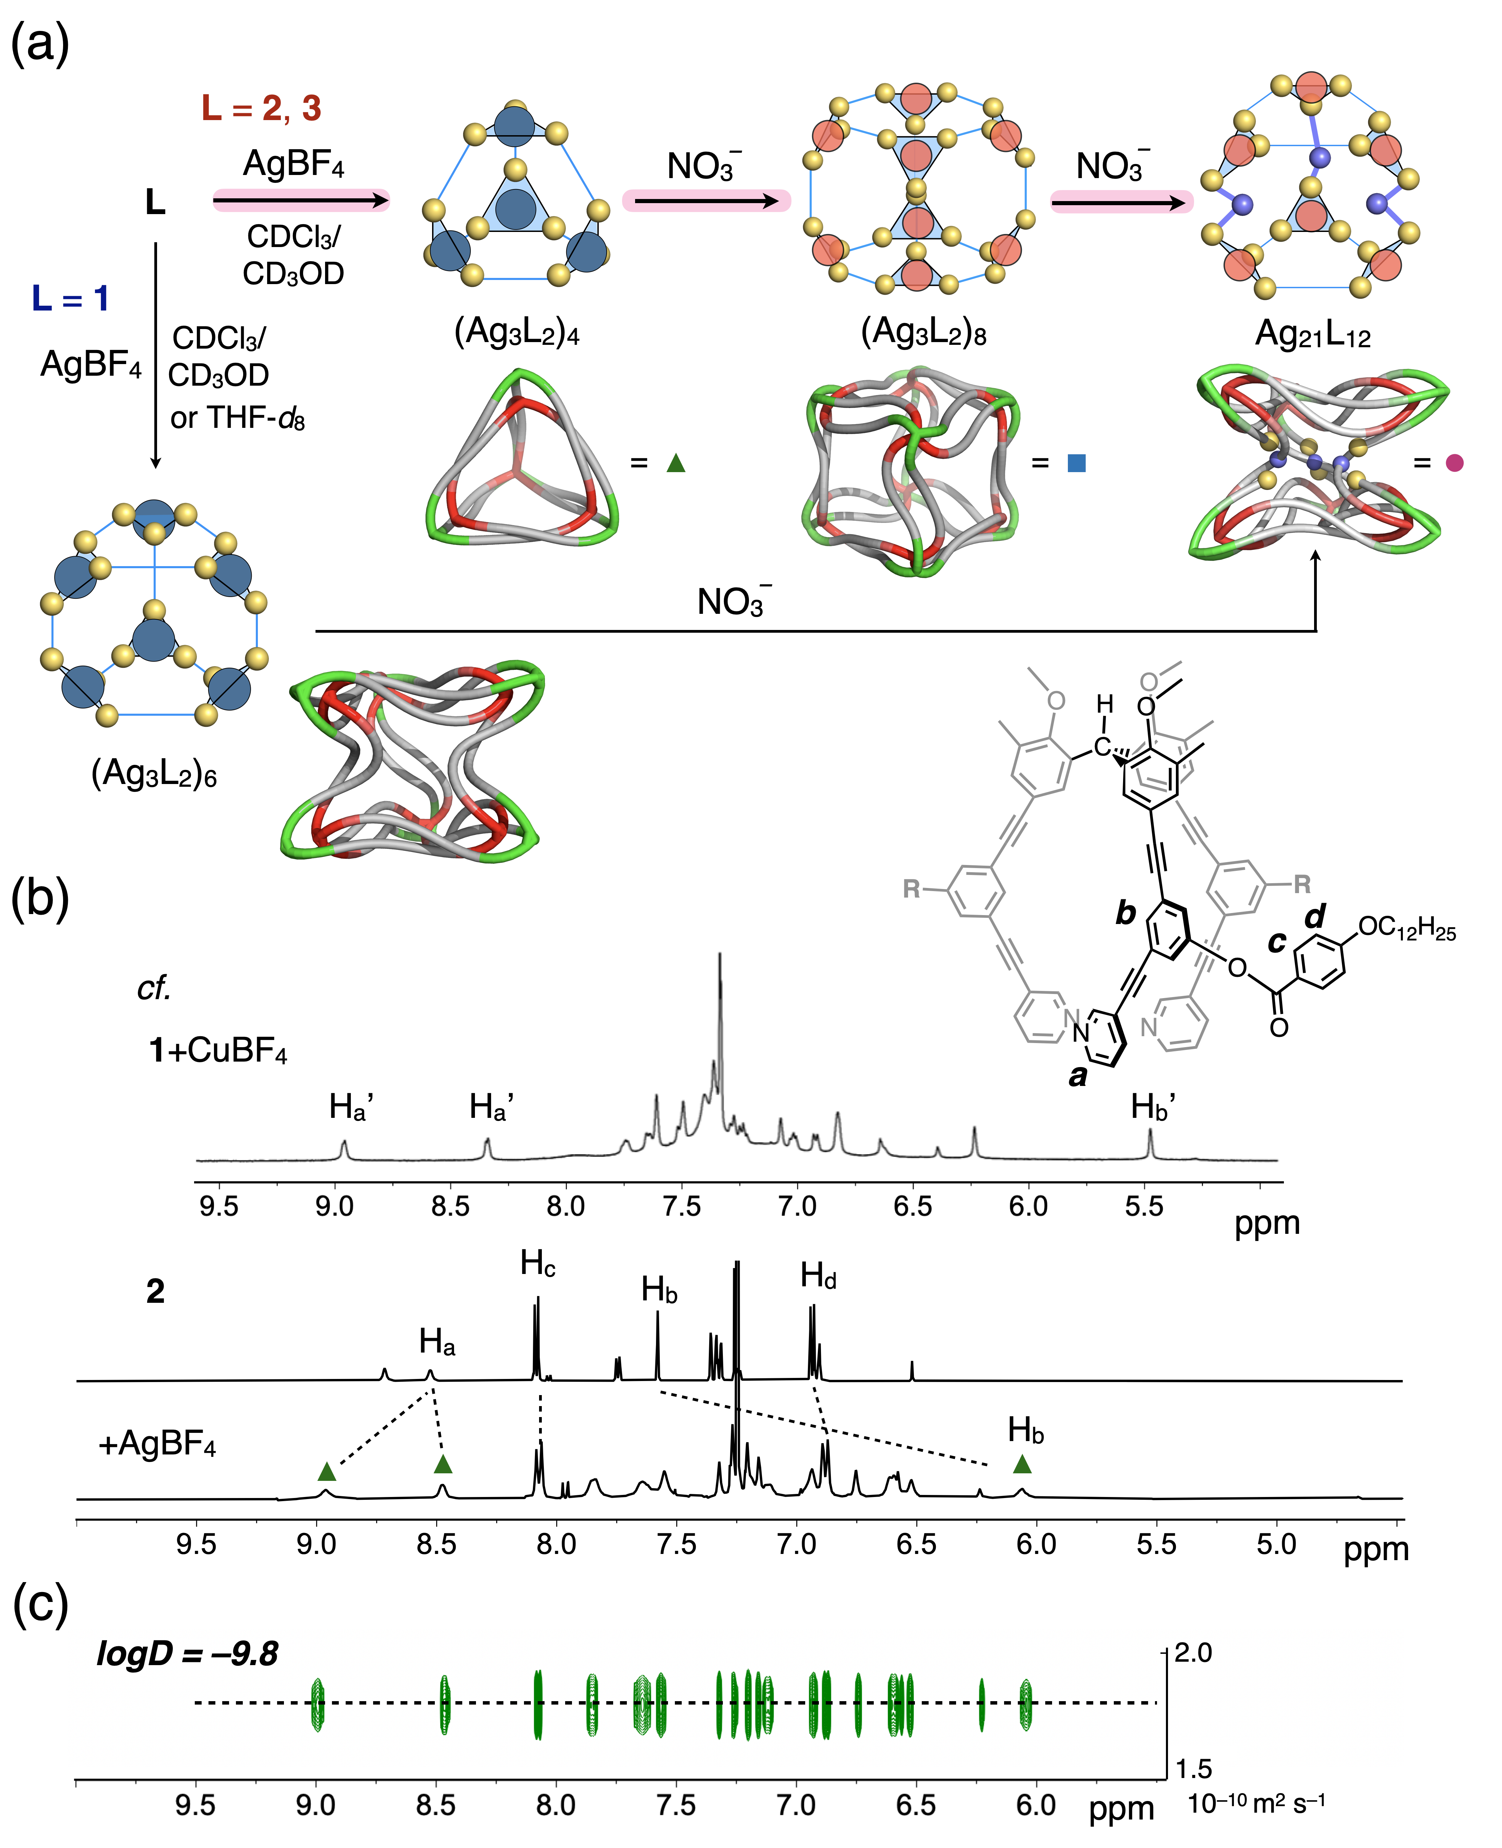
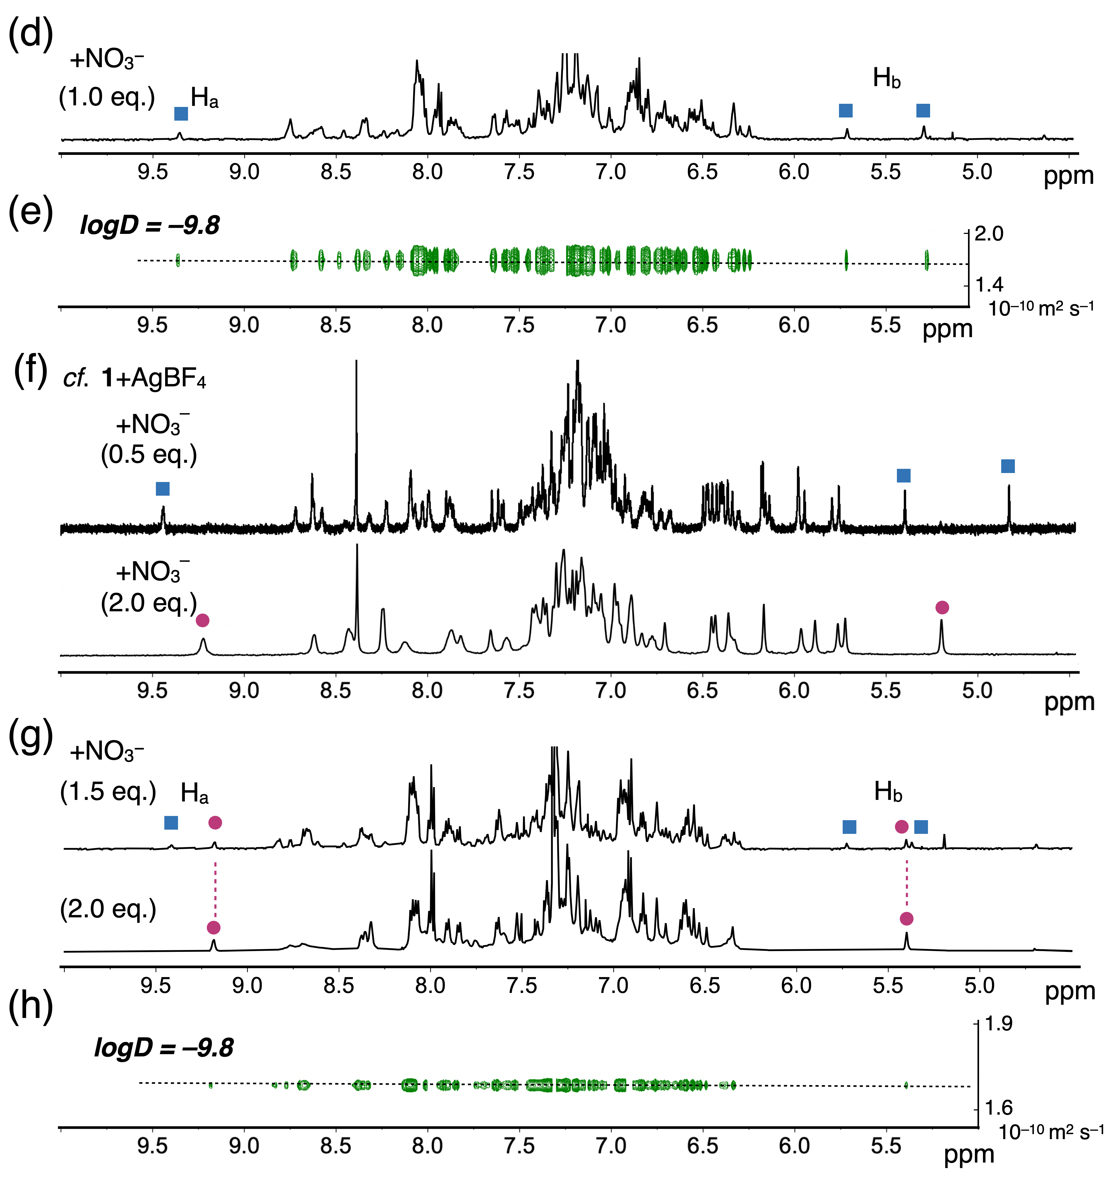
Figure 3. Self-assembly of various entangled polyhedra and changes in ¹H NMR spectra (400 MHz) observed for ligand 2 and its self-assembled complexes. (a) Self-assembly pathway of 2 and 3 with AgBF₄ followed by nitrate-induced interconversion in CDCl₃/CD₃OD (97:3). The self-assembly of 1 was previously reported.^{[8]} (b) ¹H NMR spectra of ligand 2 (solvent: CDCl₃) and the (Ag₃(2)₂)₄ tetrahedron (CDCl₃/CD₃OD (97:3)). For comparison, ¹H NMR spectra of (Cu₃(1)₂)₄ (CD₃NO₂) was shown.^{[6a]} (c) ¹H DOSY spectrum of (Ag₃(2)₂)₄ (294 K). (d) ¹H NMR spectrum of the (Ag₃(2)₂)₈ cube (CDCl₃/CD₃OD (97:3)). (e) ¹H DOSY spectrum of (Ag₃(2)₂)₈ (294 K). (f) Interconversion of an (Ag₃(1)₂)₈ cube (blue squares) into Ag₂₁(1)₁₂ concave polyhedron (pink circles) upon sequential anion exchange in CD₃NO₂ (300 K), shown for comparison.^{[8]} (g) Interconversion of (Ag₃(2)₂)₄ into (Ag₃(2)₂)₈ (blue squares) and Ag₂₁(2)₁₂ (pink circles) upon sequential anion exchange. (h) ¹H DOSY spectrum of Ag₂₁(2)₁₂ (294 K).
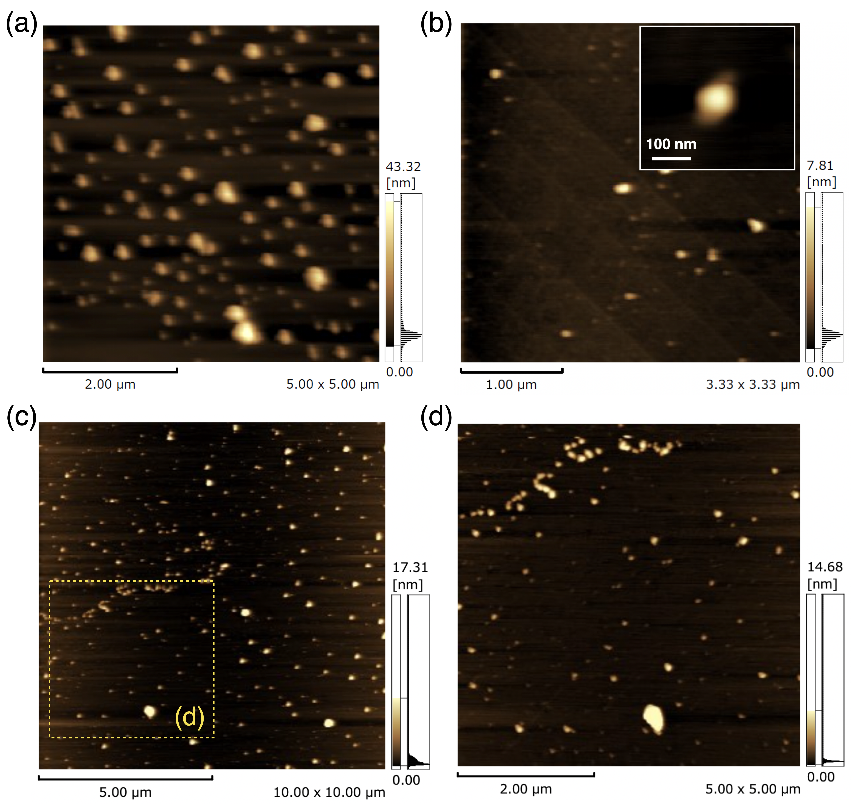
Figure 4. AFM images of (a) (Ag₃(2)₂)₄, (b) (Ag₃(2)₂)₈, and (c,d) Ag₂₁(2)₁₂. The original complex solutions were diluted with nitromethane/n-hexane, nitromethane/dichloromethane, and chloroform, respectively to achieve dispersed forms on mica. For cross-sectional analyses, see Figures S2–S4.
As described above, the intermediate polyhedral frameworks in the self-assembly process are regulated by slightly changing the steric demand of the side chains. Concomitantly, the entangled motifs of the assemblies also change, e.g., from the tetrahedral condensation of trefoil knot-like motifs^{[10a]} in (Ag₃L₂)₄ to the prismatic hybridization of trefoil knots and Solomon-link-like motifs^{[10b]} in (Ag₃L₂)₆. Control over the molecular entanglements via steric factors offers a new way to synthesize desired entangled 3D structures chosen from a pool of potentially possible topologies.
Suspension effect upon the self-assembly
Steric control also induces a unique ‘suspension effect’ upon the self-assembly of the (Ag₃L₂)₆ prism (Figure 5). Considering the reduced solubility of the ligand and the resulting assembly at low temperature, ligand 5 with enhanced solubility was used here. When ligand 5 was treated with AgBF₄ (2.0 eq.) in CDCl₃/CD₃OD (97:3) (50 ºC, 30 min), the predominant formation of (Ag₃L₂)₆ was observed using ¹H NMR spectroscopy (Figure S18), and no difference with respect to the structure formed using ligand 1 was observed.^{[6a]} However, when the complexation was conducted at 3 ºC, the formation of the smaller polyhedra (Ag₃L₂)₂ and (Ag₃L₂)₄ was observed (Figure 6a). After the reaction mixture was maintained at 3 ºC for 20 h, no interconversion to the larger (Ag₃L₂)₆ prism was observed, which stands in contrast to the case of 1, where a slow conversion to (Ag₃L₂)₆ is seen over 20 h (Figure S19).
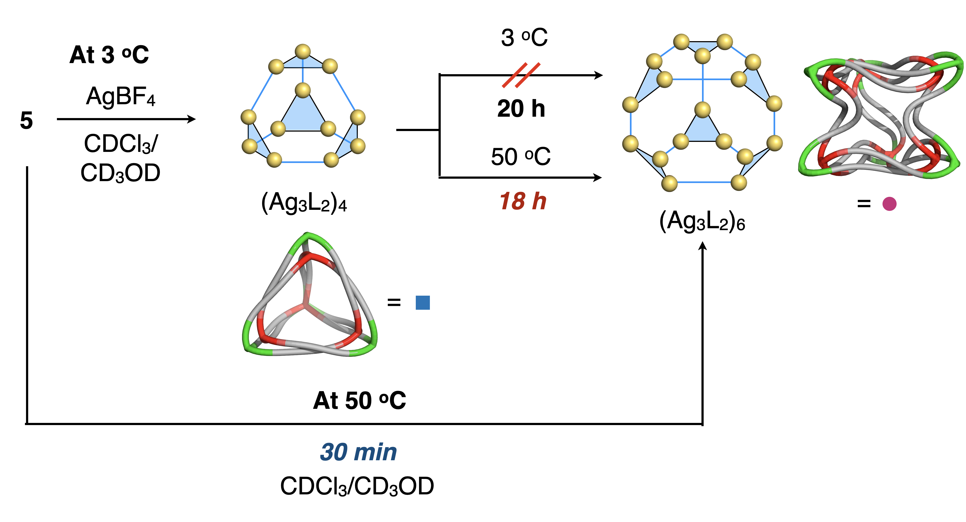
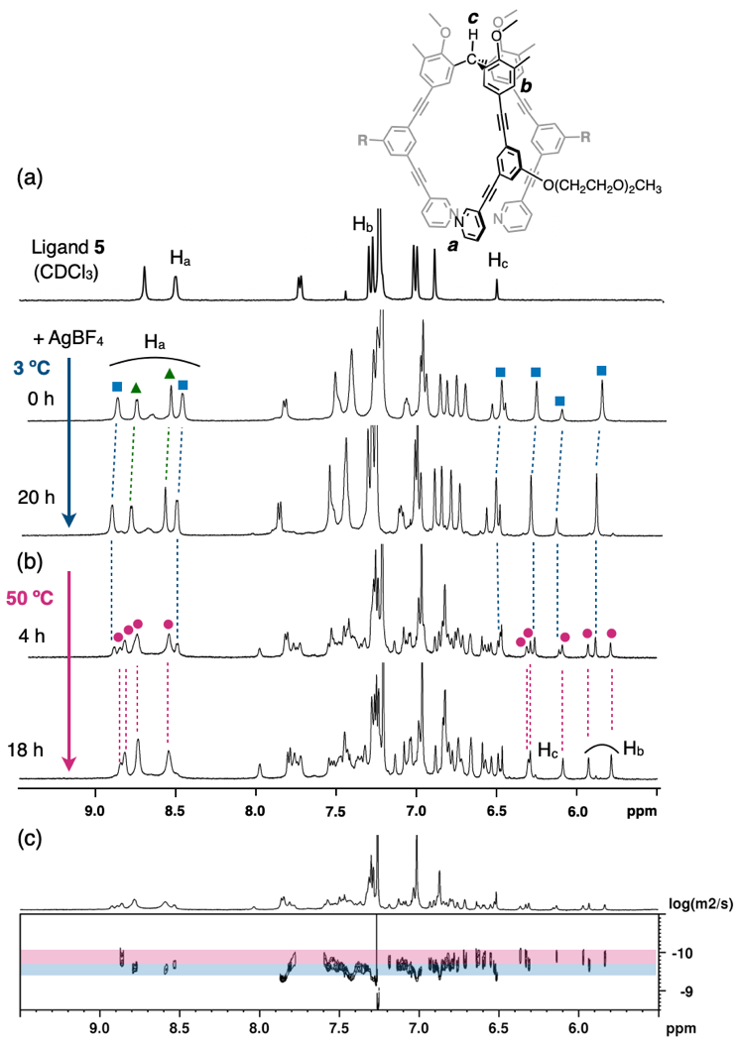
Figure 5. Schematic representation of the self-assembly of 5 with AgBF₄ in CDCl₃/MeOD (97:3).
Figure 6. Change in the ¹H NMR spectra (500 MHz) during the self-assembly of ligand 5 with AgBF₄. a) Formation of an intermediate (Ag₃(5)₂)₄ tetrahedron (blue squares) at 3 ºC (NMR at 0 ºC, CDCl₃/MeOD (97:3)). The indicated by-product (green triangles) is possibly the smaller (Ag₃(5)₂)₂ cage. b) Slower conversion to the (Ag₃(5)₂)₆ prism (pink circles) at 50 ºC. c) DOSY spectrum taken during the assembly of (Ag₃(5)₂)₄ and (Ag₃(5)₂)₆ (25 ºC).
More surprisingly, the conversion from (Ag₃L₂)₄ to (Ag₃L₂)₆ took much longer (18 h; Figures 6b and 6c) at 50 ºC, as compared to the more straightforward heating conditions described above. Such a drastic decrease of the conversion rate is reasonable considering the steric hinderance imparted by the dispersed side chains on the completely fixed polyhedral framework, which must be accessed by the additional ligand units upon interconversion. If sequential assembly is performed at higher temperatures, both partially formed unstable intermediates and the completed polyhedra will probably coexist in the system.^{[22]} Thus, interconversion to the final product proceeds relatively smoothly by reaction of such intermediates with the additional metal–ligand species. To confirm this hypothesis, the self-assembly process in solvents with lower polarity was examined. In THF-d₈, the simultaneous formation of (Ag₃L₂)₄ and (Ag₃L₂)₆ was observed using ¹H NMR spectroscopy (Figure S20a). Meanwhile, an assembly process that only gives (Ag₃L₂)₆ was found even at 3 ºC in toluene-d₈ (Figure S20b). These results are consistent with the steric effects caused by the hydrophilic side chains, which will be less significant in hydrophobic solvents due to the folding of the chains at the area close to the polyhedral framework. This allows the relatively easy access of new ligand units to the polyhedral backbone, thus facilitating the conversion to larger assemblies. In addition, the approximate degree of congestion of the side chains at a triangle face of tetrahedral (Ag₃L₂)₄ (1.38 groups/nm² based on X-ray studies and MM) is relatively high compared to that of a square face of prismatic (Ag₃L₂)₆ (1.06 groups/nm²) (Figure S21). Therefore, (Ag₃L₂)₄ might become relatively unstable under conditions where the side chains are folded and packed around the framework. The low-temperature experiments clarified a process of the sequential self-assembly toward a large, complex polyhedral skeleton via a less stable intermediate consisting of a common structural factor or subunit (i.e., Ag₃L₂), similar to the protein folding involved with metastable intermediates.^{[23]}

Conclusion
In summary, we demonstrated the use of positive steric effects to exert control over the reaction pathways, reaction outcomes, and the kinetic behavior of the self-assembly of entangled polyhedra. Large nanocages can be obtained from a pool of metastable intermediates with topologically feasible isomers as products.^{[24,25]} However, the molecular entanglement in these processes still requires further investigation and understanding. The present results indicate a new way to tailor the synthesis of artificial nanoscale molecules with unexplored 3D entangled topologies that we believe will offer fascinating structural backbones for future nanomaterials.
Supporting Information
The authors have cited additional references within the Supporting Information.^{[26-28]}
Acknowledgements
This research was supported by JSPS KAKENHI grants 22K05076 (to Y.D.), 24K01576 (to H.H.), and 19H05461 (to M.F.). Y.D. gratefully acknowledges financial support from the Noguchi Institute, the Kumagai Foundation for Science and Technology, and the Takahashi Industrial and Economic Research Foundation. The NMR measurements were partly performed at the Center for Instrumental Analysis of Gunma University. We would like to thank Dr. Masahiro Abe for support with the NMR measurements.
Keywords: Self-assembly • Entanglements • Coordination polyhedra • Interconversion • Acetylene
[1] T. Schnitzer, G. Vantomme, ACS Cent. Sci. 2020, 6, 2060-2070.
[2] a) S. Pullen, J. Tessarolo, G. H. Clever, Chem. Sci. 2021, 12, 7269-7293; b) S. Hiraoka, Isr. J. Chem. 2019, 59, 151-165.
[3] a) T. Zhang, L.-P. Zhou, X.-Q. Guo, L.-X. Cai, G.-F. Sun, Nat. Commun. 2017, 8, 15898; b) D. A. Roverts, B. S. Pilgrim, G. Sirvinskaite, T. K. Ronson, J. R. Nitschke, J. Am. Chem. Soc. 2018, 140, 9616-9623; c) W. Drozdz, A. Ciesielski, A. R. Stefankiewicz, Angew. Chem. Int. Ed. 2023, 62, e202307552; d) T. Abe, N. Sanada, K. Takeuchi, A. Okazawa, S. Hiraoka, J. Am. Chem. Soc. 2023, 145, 28061-28074.
[4] S. Saha, I. Regeni, G. H. Clever, Coord. Chem. Rev. 2018, 374, 1-14.
[5] a) F. J. Rizzuto, J. R. Nitschke, Nat. Chem. 2017, 9, 903-908; b) K. Wu, T. K. Ronson, L. Goh, W. Xue, A. H. Heard, P. Su, X. Li, M. Vinkovic, J. R. Nitschke, J. Am. Chem. Soc. 2023, 145, 11356-11363.
[6] a) Y. Domoto, M. Abe, T. Kikuchi, M. Fujita, Angew. Chem. Int. Ed. 2020, 59, 3450-3454; b) Y. Domoto, M. Abe, M. Fujita, J. Am. Chem. Soc. 2021, 143, 8578-8582.
[7] a) Y. Domoto, M. Abe, K. Yamamoto, T. Kikuchi, M. Fujita, Chem. Sci. 2020, 11, 10457-10460; b) Y. Domoto, K. Yamamoto, S. Horie, Z. Yu, M. Fujita, Chem. Sci. 2022, 13, 4372-4376.
[8] Y. Domoto, M. Abe, G. R. Genov, Z. Yu, M. Fujita, Angew. Chem. Int. Ed. 2023, 62, e202303714.
[9] Y. Domoto, M. Fujita, Coord. Chem. Rev. 2022, 466, 214605.
[10] a) S. D. P. Fielden, D. A. Leigh, S. L. Woltering, Angew. Chem. Int. Ed. 2017, 56, 11166-11194; b) W.-X. Gao, H.-J. Feng, B.-B. Guo, Y. Lu, G.-X. Jin, Chem. Rev. 2020, 120, 6288-6325; c) Z. Ashbridge, S. D. P. Fielden, D. A. Leigh, L. Pirvu, F. Shcaufelberger, L. Zhang, Chem. Soc. Rev. 2022, 51, 7779-7809; d) R. S. Forgan, J.-P. Sauvage, J. F. Stoddart, Chem. Rev. 2011, 111, 5434-5464; e) F. Schaufelberger, Commun. Chem. 2020, 3, 182.
[11] a) S. Tashiro, Y. Yamada, L. A. Kringe, Y. Okajima, M. Shionoya, J. Am. Chem. Soc. 2024, doi: 10.1021/jacs.4c11583; b) A. Walther, I. Regeni, J. J. Holstein, G. H. Clever, J. Am. Chem. Soc. 2023, 145, 25365-25371; c) S. Guo, W.-W. Zhan, F.-L. Yang, J. Zhou, Y.-H. Duan, D. Zhang, Y. Yang, Nat. Commun. 2024, 15, 5628.
[12] a) W. R. Taylor, Compt. Biol. Chem. 2007, 31, 151-162; b) N. C. H. Lim, S. E. Jackson, J. Phys.: Condens. Matter 2015, 27, 354101; c) M. Piejko, S. Niewieczerzal, J. I. Sulkowska, Isr. J. Chem. 2020, 60, 713-724; d) J. I. Sulkowska, Curr. Opin. Struct. Biol. 2020, 60, 131-141.
[13] a) J. L. Algar, J. A. Findlay, J. D. Evans, D. Preston, Angew. Chem. Int. Ed. 2022, 61, e202210476; b) L.-L. Dang, X. Gao, Y.-J. Lin, G.-X. Jin, Chem. Sci. 2020, 11, 8013-8019; c) H.-J. Feng, W.-X. Gao, Y.-J. Lin, G.-X. Jin, Chem. Eur. J. 2019, 25, 15687-15693; d) L.-X. Cai, D.-N. Yan, P.-M. Cheng, J.-J. Xuan, S.-C. Li, L.-P. Zhou, C.-B. Tian, Q.-F. Sun, J. Am. Chem. Soc. 2021, 143, 2016-2024; e) H.-N. Zhang, H.-J. Feng, Y.-J. Lin, G.-X. Jin, J. Am. Chem. Soc. 2023, 145, 4746-4756; f) L.-L. Dang, T.-T. Zhang, T. Chen, Y. Zhao, X. Gao, F. Aznarez, L.-F. Ma, G.-X. Jin, Angew. Chem. Int. Ed. 2023, 62, e202301516.
[14] a) J. Fan, J. W. Bats, M. Schmittel, Inorg. Chem. 2009, 48, 6338-6340; b) M. Schmittel, M. L. Saha, J. Fan, Org. Lett. 2011, 13, 3916-3919.
[15] a) R. Zhu, W. M. Bloch, J. J. Holstein, S. Mandal, L. V. Schäfer, G. H. Clever, Chem. Eur. J. 2018, 24, 12976-12982; b) D. Luo, X. Wang, C. Yang, X. Zhou, D. Li, J. Am. Chem. Soc. 2018, 140, 118−121; c) G. Cecot, M. T. Doll, O. M. Planes, A. Ramorini, R. Scopelliti, F. Fadaei-Tirani, K. Severin, Eur. Inorg. Chem. 2019, 2972-2976; d) E. O. Bobylev, D. A. Poople III, B. des Bruin, J. N. H. Reek, Chem. Sci. 2021, 12, 7696-7705; e) B. Chen, J. J. Holstein, A. Platzek, L. Schneider, K. Wu, G. H. Clever, Chem. Sci. 2022, 13, 1829-1834; f) H. Yu, Z. Guo, N. Han, J. Shi, X. Jiang, Q. Bai, Z. Zhang, P. Wang, M. Wang, Cell Rep. Phys. Sci. 2023, 4, 101631; g) G. Wang, Q. Bai, H. Liu, Z. Li, Z. Jiang, Z. Zhang, Y. Li, P. Wang, Inorg. Chem. 2023, 62, 6537-6543; h) S. Watanabe, M. Yamashina, E. Tsurumaki, S. Toyota, ChemistryEurope, 2023, 1, e202300047; i) H. Zhu, T. K. Ronson, K. Wu, J. R. Nitschke, J. Am. Chem. Soc. 2024, 146, 2370-2378.
[16] a) T. Castle, M. E. Evans, S. T. Hyde, New J. Chem. 2008, 32, 1484-1492; b) G. Hu, X.-D. Zhai, D. Lu, W.-Y. Qiu, J. Math. Chem. 2009, 46, 592-603; c) S. T. Hyde, M. E. Evans, Proc. Natl. Acad. Sci. 2022, 119, e2110345118; d) M. O’Keeffe, M. M. J. Treacy, Acta Cryst. 2020, A76, 611-621.
[17] a) J. Martí-Rujas, A. Famulari, Angew. Chem. Int. Ed. 2024, 63, e202407626; b) Y. Wang, Y. Zhang, Z. Zhou, R. T. Vanderlinden, B. Li, B. Song, X. Li, L. Cui, J. Li, X. Jia, J. Fang, C. Li, P. J. Stang, Nat. Commun. 2020, 11, 2727; c) Y.-W. Zhang, S. Bai, Y.-Y. Wang, Y.-F. Han, J. Am. Chem. Soc. 2020, 142, 13614-13621; d) X.-R. Wu, S.-Q. Wu, Z.-K. Liu, M.-X. Chen, J. Tao, O. Sato, H.-Z. Kou, Nat. Commun. 2024, 15, 3961.
[18] Possibly due to the steric hinderance of the side chains, the use of an excess of the Ag(I) salt (originally 1.5 eq.) was required to complete the self-assembly.
[19] The formation of a discrete (Cu₃L₂)₄ tetrahedron in solution has been reported previously (for details, see: ref. 6a), while the (Ag₃L₂)₄ species had only been observed previously in an infinitely networked co-crystal structure (for details, see: ref. 7a).
[20] There exist two different chemical environments for ligand 2 in the (Ag₃L₂)₄ backbone derived from the inner and outer ligands respectively, thus another signal H_{b} should be at 7-8 ppm.
[21] (Ag₃L₂)₈ and Ag₂₁L₁₂ show twelve and six independent signals for H_{a} (and H_{b}) respectively, according to the symmetry of their polyhedral frameworks as explained in ref. 6b) and 7). Here, one or two of them are used for discussion.
[22] M. Yoneya, T. Yamaguchi, S. Sato, M. Fujita, J. Am. Chem. Soc. 2012, 134, 14401-14407.
[23] a) K. Kuwajima, PROTEINS: Struct., Funct., Genet. 1989, 6, 87-103; b) D. Preston, J. E. Barnsley, K. C. Gordon, J. D. Crowley, J. Am. Chem. Soc. 2016, 138, 10578-10585; c) D. Fujita, H. Yokoyama, Y. Ueda, S. Sato, M. Fujita, Angew. Chem. Int. Ed. 2015, 54, 155-158.
[24] a) S. Hiraoka, S. Takahashi, H. Sato, Chem. Rec. 2021, 21, 443-459; b) T. K. Piskorz, V. Martí-Centelles, T. A. Young, P. J. Lusby, F. Duarte, ACS Catal. 2022, 12, 5806-5826; c) A. Tarzia, K. E. Jelfs, Chem. Commun. 2022, 58, 3717-3730; d) E. Benchimol, B.-N. Nguyen, T. K. Ronson, J. R. Nitschke, Chem. Soc. Rev. 2022, 51, 5101-5135.
[25] a) S.-C. Li, L.-X. Cai, M. Hong, Q. Chen, Q.-F. Sun, Angew. Chem. Int. Ed. 2022, 61, e202204732; b) R. G. Siddique, K. S. A. Arachchige, H. A. AL-Fayaad, J. D. Thoburn, J. C. McMurtie, J. K. Clegg, Angew. Chem. Int. Ed. 2022, 61, e202115535; c) K. Wu, T. K. Ronson, L. Goh, W. Xue, A. W. Heard, P. Su, X. Li, M. Vinkovic, J. R. Nitschke, J. Am. Chem. Soc. 2023, 145, 11356-11363.
[26] H. Komatsu, W. Oi, K. Naritani, K. Takaishi, M. Uchiyama, A. Muranaka, H. Maeda, Chem. Eur. J. 2013, 19, 6956-6960.
[27] I. Buzzacchera, Q. Xiao, H. Han, K. Rahimi, S. Li, N. Y. Kostina, B. J. Toebes, S. E. Wilner, M. Möller, C. Rodriguez-Emmenegger, T. Baumgart, D. A. Wilson, C. J. Wilson, M. L. Klein, V. Percec, Biomacromolecules 2019, 20, 712-727.
[28] S. Zhang, H.-J. Sun, A. D. Hughes, B. Draghici, J. Lejnieks, P. Leowanawat, A. Bertin, L. O. De Leon, O. V. Lulikov, Y. Chen, D. J. Pochan, P. A. Heiney, V. Percec, ACS Nano 2014, 8, 1554-1565.

Table of Contents

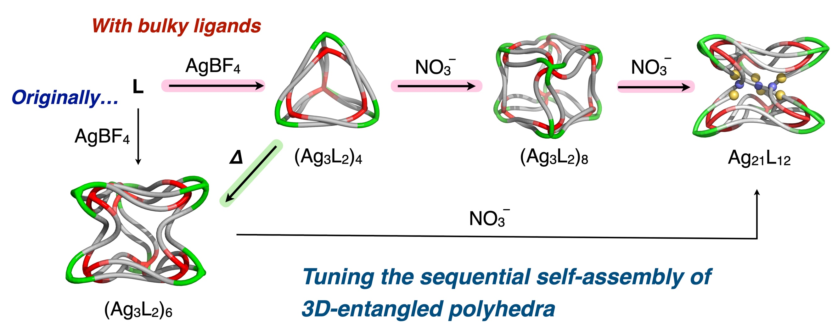
The control of the sequential self-assembly processes of highly entangled coordination polyhedra on the ~5 nm scale using side-chain effects was studied via the introduction of linear or branched side chains into the tripodal ligands. In addition to changes in the intermediate polyhedral species affording the multi-pathway process, disruption of the kinetic control of the sequential self-assembly was observed.
Institute and/or researcher Twitter usernames: @YDChem2022, @gunma_uni_ad

