Gravity-Assisted Infiltration Enables a Spatially Extended and Dynamically Stable Multi-Phase Interface in Air Cathodes for Practical Lithium–Air Batteries
Wenfeng Cui^{1,2,3}, Qifa Gao³, Guangxu Xu^{1,2,3}, Hang Yin^{1,3}, Wipakorn Jevasuwan², Sadaki Samitsu¹, Misa Hazutani¹, Naoki Fukata^{2,3}*, Jie Tang^{1,3}*

¹ National Institute for Materials Science, 1-2-1 Sengen, Tsukuba 305-0047, Ibaraki, Japan;
² National Institute for Materials Science, 1-1-1 Namiki, Tsukuba 305-0044, Ibaraki, Japan;
³ Graduate School of Pure and Applied Sciences, University of Tsukuba, 1-1-1 Tennodai,
Tsukuba 305-0006, Ibaraki, Japan

Email: TANG.Jie@nims.go.jp and FUKATA.Naoki@nims.go.jp

Abstract
Li–air batteries (LABs) have attracted considerable attention as next-generation energy-storage systems because of their exceptionally high theoretical energy density. However, their practical application remains limited by the difficulty of sustaining an effective multi-phase interface (MPI), where Li⁺, O₂, and e⁻ converge to drive the reversible formation and decomposition of discharge products. Herein, we report a simple and scalable gravity-assisted infiltration (GAI) strategy for fabricating air cathodes, in which catalysts are distributed throughout the gas diffusion layer (GDL) framework. This architecture enables continuous Li⁺/O₂/e⁻ transport pathways and establishes a spatially extended and stable MPI across the cathode thickness, while remaining binder-free and operating with reduced electrolyte demand. As a result, LABs with the GAI cathode deliver lower overpotentials and longer cycling (＞300 cycles) at 0.25 mA cm⁻² with a limited capacity of 0.50 mA h cm⁻², while still exhibiting superior performance at a high cathode loading of 3.0 mg cm⁻². In situ EIS/DRT/DCT and TOF-SIMS reveal stable interfacial evolution and a mechanism shift toward nucleation-preferred discharge-product formation across the cathode thickness, evidencing a spatially extended and dynamically stable MPI. The resulting LABs also achieve a high full discharge/charge capacity of ~ 24 mA h cm⁻², enhanced low temperature (−20 ℃) mass-transport capability and improved high temperature (60 ℃) stability. In addition, scaled-up pouch cells demonstrate stable long-term cycling (＞100 cycles), efficient heat dissipation, and high energy density (798.80 Wh kg⁻¹). This work provides a practical air cathode design principle for developing high energy density metal–air batteries.

Key Words: Li–air batteries, air cathode structure, extended multiple-phase interface, gravity-assisted infiltration, nucleation-preferred mechanism, wide temperature range.

- Introduction
With the urgent demand for high energy density storage systems, lithium-air batteries (LABs) have emerged as a promising next-generation energy storage technology because of their exceptionally high theoretical energy density of up to ~3500 Wh kg⁻¹.^{[1–5]} Nevertheless, the practical application of LABs remains hindered by limited capacity, large overpotentials, short cycle life, and insufficient adaptability to wide temperature ranges.^{[4,6–9]} Notably, these issues do not arise solely from insufficient intrinsic catalytic activity of the catalyst or the decomposition of electrolyte, but are fundamentally governed by the establishment and maintenance of the multi-phase interface (MPI) within the cathode.^{[9–11]} The MPI, where Li⁺ from the liquid phase (electrolyte), O₂ from the gas phase, and electrons (e⁻) supplied by the solid cathode must effectively converge at the reaction interface, is essential for the sustained formation of solid discharge products. While charging, the effective MPI is still required to maintain e⁻ transport for the reversible decomposition of discharge products. However, as discharge proceeds, insulating discharge products (Li₂O₂, LiOH and Li₂CO₃, etc.) accumulate and progressively impede mass transport, causing the active MPI to shrink and finally deactivate.^{[10,12–14]} During charging, the product-passivated interface inhibits the maintenance and reactivation of the effective MPI, leading to sluggish product decomposition, elevating overpotentials, and accelerating cycling degradation.^{[9,10]}
However, in conventional cathodes, the catalyst slurry is applied on only one side of the gas diffusion layer (GDL), resulting in an architecture that is limited for the establishment and long-term maintenance of the MPI.^{[9,10]} First, the catalyst is unevenly distributed throughout the conductive framework GDL and is mainly localized near the coated surface, which hinders the formation of a continuous MPI network across the cathode thickness. Second, the presence of binders reduces the e⁻ transport and partially blocks the pore channels originally available for gas diffusion, thus constraining the spatial extent of the MPI.^{[15–17]} In addition, to ensure a sufficient supply of Li⁺, conventional cathodes usually rely on a high electrolyte volume to improve wettability, but excessive electrolyte inevitably lengthens the O₂ diffusion pathways in the liquid phase, thereby impeding O₂ transport to the MPI and restricting the effective region.^{[10,18,19]}
To address these issues, substantial research efforts have been made in catalyst design, pore structure engineering, and electrolyte optimization. Tang and co-workers improved the conductivity by introducing reduced graphene oxide (rGO) to construct more efficient e⁻ transport pathways, thereby facilitating product decomposition.^{[6]} Zhou et al. demonstrated that the incorporation of Super P effectively mitigated cathode passivation, leading to lower overpotentials and extended cycle life (＞80 cycles).^{[20]} Liu’s group improves O₂ diffusion by engineering pores within the catalytic layer, the assembled LABs achieved a high areal capacity of 17.49 mA h cm⁻².^{[21]} Yong-Mook Kang and co-workers developed a freestanding three-dimensionally (3D) porous Cu cathode via a sophisticated template-assisted fabrication route, and then integrated to cathode with carbon paper as GDL. The resulting cathode architecture effectively promoted gas diffusion, exhibit 3.038 times longer cycle life than Cu foam.^{[22]} Akihiro Nomura et al. reported a freestanding CNT sheet cathode with enhanced storage space for discharge products, delivering an areal capacity of 12 mA h cm⁻². By introducing GDLs on both sides of the CNT sheet to provide additional expansion space, the capacity could be further markedly increased.^{[23]} Zhou’s group constructed a cross-linked gel-type air cathode (SWNT/IL CNG) using an ionic-liquid electrolyte, enabling the synergistic transport of Li⁺ and O₂. As a result, this design achieved a low overpotential of ~ 1.07 V while simultaneously improving the capacity, rate capability, and reversibility of Li–O₂ batteries.^{[24]} Although substantial efforts have been devoted to the above aspects, most reported studies have mainly focused on only one or two of them, whereas considerable effort into the establishment of a spatially extended and dynamically stable MPI throughout both discharge and charge processes remains rare.^{[9,10,24]} Moreover, from a practical application perspective, the high performance cathode architectures reported in the above studies often rely on complex fabrication processes, additional frameworks, large inactive volumes, or excessive electrolyte addition, thereby sacrificing practical energy density and scalable manufacturability. Therefore, the development of a cathode architecture that can simultaneously establish and stably maintain a spatially extended MPI, while also satisfying practical requirements such as reduced electrolyte usage, simple fabrication, and a thin, lightweight configuration, is crucial for enhancing the capacity and energy density of metal–air batteries.
In this work, we developed a simple and scalable gravity-assisted infiltration (GAI) strategy to prepare cathode. Compared with the conventional cathode, the GAI cathode enables a 3D distribution of catalyst throughout the GDL framework, and provides more open gas diffusion pathways, faster e- transport, and low electrolyte requirement (40 μL). It also features a binder-free, thin profile of 130 μm. Owing to this unique architecture, the GAI cathode is able to establish a more continuous Li⁺/O₂/e⁻ co-transport network along the cathode thickness, enabling the MPI to extend from one side of the cathode to the other and thereby effectively expanding and spatially stabilizing the MPI region. LABs assembled with GAI cathode exhibit lower overpotentials and longer cycle life of over 300 cycles at a current density of 0.25 mA cm⁻² with a limited capacity of 0.5 mA h cm⁻², while still delivering superior performance under a high loading condition of 3.0 mg cm⁻². In situ EIS/DRT/DCT analyses and TOF-SIMS further reveal that the formation of discharge products follows a nucleation-preferred mechanism rather than growth-preferred, with nucleation occurring throughout the cathode thickness, which behavior supports a spatially extended and dynamically stable MPI. The resulting LABs exhibit a high full discharge/charge capacity of ~ 24 mA h cm⁻² at a current density of 0.125 mA cm⁻². In addition to the excellent room temperature performance, the GAI cathode also exhibits improved electrochemical performance under both low (−20 °C) and high temperature (60 °C) conditions. A further scaled-up pouch cell demonstrates a high energy density of 798.80 Wh kg⁻¹ and excellent heat dissipation ability. This work proposes a pioneering and scalable strategy for constructing advanced air cathode architectures, and provides a new design principle for the practical realization of high energy density metal–air batteries.
- Results and Discussion
2.1 Characterization of cathodes structure
Figure 1a and 1e illustrate the different preparation processes of LABs cathodes. As shown in Figure 1a, the gravity-assisted infiltration (GAI) cathode was fabricated through a simple, binder-free process, in which suspended catalyst particles infiltrated into the gas diffusion layer (GDL) framework under gravity, were retained along the carbon fibers, and formed a three-dimensional (3D) distribution throughout the GDL. In contrast, the slurry-cast layer (SCL) cathode was fabricated via conventional slurry-based method (Figure 1e), in which the active materials were mixed with polymer binder to form a slurry and then applied onto the GDL to form a dense catalyst layer.
Surface and cross-sectional SEM images (Figure 1b-c, f-g) reveal distinct architecture and catalyst distributions. For GAI cathode, the surface SEM (Figure 1b) exhibits a loose and porous surface, while cross-sectional SEM and EDS mapping (Figure 1c) shows that the catalyst (MnO-rGO) is distributed throughout the 3D porous framework of the GDL, resulting in a total cathode thickness of ~133.80 μm. In contrast, as shown in Figure 1f-g, the SCL cathode displays a dense catalyst layer predominantly on one side of the GDL with limited penetration into the substrate, resulting in a larger total thickness of ~184.76 μm.
X-ray computed tomography (X-ray CT) was further employed to visualize the 3D architecture of the cathodes (Figure 1d, h). The sample photos were shown in Figure S1. In the gray-scale CT images, the pore space and active materials are represented by different grayscale intensities. For the GAI cathode (Figure 1d), the catalyst-containing phase is observed throughout the porous GDL framework, qualitative consistent with the cross-sectional SEM/EDS results showing deep catalyst infiltration. Meanwhile, the pore space is distributed along the carbon fibers and remains highly open, indicating a well-preserved porous network. In contrast, for the SCL cathode (Figure 1h), the catalyst layer is mainly aggregated on one side of the GDL (corresponding to the bright contrast region), leading to a markedly thicker overall cathode structure.

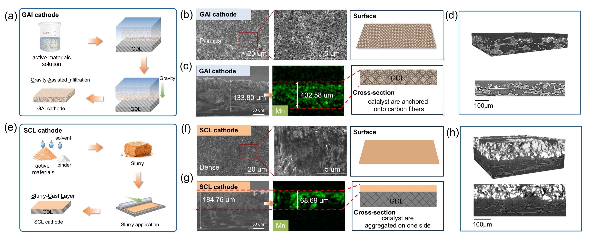
Figure 1. The characterization of different cathodes. (a) Schematic illustration of GAI cathode. Scanning electron microscopy (SEM) images of (b) surface and (c) cross-sectional for GAI cathode. (d) X-ray computed tomography (X-ray CT) image of GAI cathode. (e) Schematic illustration of SCL cathode. SEM images of (f) surface and (g) cross-sectional for SCL cathode. (h) X-ray CT image of SCL cathode.

2.2 Characterization of the Multiple phase reaction interface (MPI)
Figures 2a-b display the dynamic wetting behavior of the GAI, SCL cathodes toward the aprotic electrolyte (1.0 M LiTFSI-TEGDME). On the GAI cathode (Figure 2a), the electrolyte droplet rapidly spread from an initial contact angle of 25° to 13° within 10 s, evidencing efficient wetting and infiltration of the GAI configuration. In contrast, the SCL cathode (Figure 2b) displayed a much larger initial contact angle of 92°, with almost no change after 10 s (90°) or even after 30 s (Figure S2). These results indicate that the GAI cathode enables rapid establishment of electrolyte contact across the cathode framework, whereas the SCL cathode exhibits limited wettability, thereby restricting electrolyte access to internal catalytic sites.
Figures 2c-d further reveal a pronounced difference in the evolution of O₂ bubble adhesion in O₂-saturated electrolyte. On the GAI cathode (Figure 2c), the O₂ bubble was rapidly released from the cathode-electrolyte interface within 500 ms. By contrast, the O₂ bubble remained stably adhered to the SCL cathode (Figure 2d), and was still retained on the surface even after 10 s (Figure S3). This distinct interfacial behavior suggests that the GAI cathode enables rapid gas renewal and more efficient O₂ exchange at interface, whereas the SCL cathode is unfavorable for O₂ replenishment and interfacial transport, thereby contributing to the sluggish ORR/OER kinetics.^{[3,25–27]}
Furthermore, as illustrated in Figures 2e-f, the distinct wetting-O₂ evolution behavior of the two cathodes is expected to result in markedly different Li⁺ and O₂ transport characteristics. When electrolyte drop on the cathode (Figure 2e), the GAI cathode can sustain a more uniform wetting state, allowing the electrolyte to penetrate more deeply throughout the cathode thickness and thereby ensuring broader Li⁺ transport to the catalytic surface. In contrast, the limited wettability of the SCL cathode likely leaves a substantial fraction of the catalyst particles insufficiently wetted, restricting Li⁺ transport to only part of the active sites. During gas diffusion (Figure 2f), the GAI cathode maintains more open pore pathways, enabling more efficient O₂ penetration into the cathode and more continuous participation in the electrochemical reaction. By comparison, O₂ is unevenly distributed across the thickness of the SCL cathode, with a higher concentration near the air side (GDL side) and progressively lower concentration along the thickness, thereby limiting effective O₂ diffusion to only a fraction of the catalyst sites. In addition, an efficient e⁻ conduction network is also critical for ORR/OER process.^{[28]} As illustrated in Figure 2g, the catalyst particles in the GAI cathode are distributed and anchored onto the carbon fibers-based conductive framework of the GDL, thereby establishing a continuous e⁻ transport network. In contrast, for the SCL cathode, only the regions close to direct contact with the GDL possess relatively efficient e⁻ conduction, whereas the regions farther away from suffer from insufficient e⁻ supply. Consequently, the GAI cathode can simultaneously realize more continuous Li⁺ transport, broader O2 diffusion, and more effective e⁻ conduction, thereby constructing a more integrated Li⁺/O₂/e⁻ transport network within the cathode.
Based on the superior electrolyte wetting behavior of the GAI cathode, we further optimized the electrolyte volume to minimize transport limitations while avoiding the loss of cell-level energy density associated with excessive electrolyte. To amplify diffusion-related transport differences, the EIS measurement window was extended down to 15 °C (40-15 °C), where mass-transport limitations become more significant. The impedance responses were further analyzed using the distribution of capacitance times (DCT) method. LABs assembled with 80, 40, and 20 μL of electrolyte were examined, as shown in Figures 2h-j.
When the electrolyte volume is 80 μL (Figure 2h), the LABs exhibits a pronounced increase in EIS impedance at low temperature (20-15°C), accompanied by significant changes in the diffusion-related DCT peaks, indicating severely deteriorated mass transport. These results indicate that an excessive electrolyte volume forms a relatively thick electrolyte film on the catalyst surface (the inset figure of Figure 2h), forcing O₂ to dissolve into the liquid phase and diffuse through tortuous liquid-filled pathways before reaching the active sites, thereby markedly aggravating diffusion limitations. When the electrolyte volume is optimized to 40 μL (Figure 2i), the diffusion-related DCT peaks remained relatively stable with decreasing temperature, with only a moderate increase in impedance was observed at low temperature. This increase is more reasonably attributed to the intrinsic kinetic suppression associated with decreasing temperature, rather than transport or diffusion limitation as the primary cause.^{[4,6,29–32]} These results indicate that, under this condition, the GAI cathode is covered by a thin yet continuous electrolyte film that ensures sufficient Li⁺ support while maintaining efficient O₂ diffusion through open pore pathways (the inset figure of Figure 2i). When the electrolyte volume was further reduced to 20 μL (Figure 2j), the LABs displayed high EIS impedance over the entire temperature range, indicating an insufficiently wet state. Under such conditions, the catalytic sites cannot be sufficiently wetted by electrolyte, resulting in hindered Li⁺ transport and consequently pronounced transport limitations. Therefore, 40 uL provides a more favorable balance between Li⁺ transport, O₂ diffusion and e⁻ conduction in the GAI cathode.
Collectively, the results in Figures 2a-j indicate that the key advantage of the GAI cathode lies not simply in enhanced wetting, diffusion, or e⁻ conduction, but in its ability to establish a more favorable multiple-phase interfacial (MPI) state within the cathode. As illustrated in Figure 2k, an effective MPI in LABs requires simultaneous access of Li⁺, O₂, and e⁻ to catalytic sites through the liquid, gas, and solid phases, respectively, with electronically connected discharge products additionally contributing during charge. Above results suggest that the most favorable interfacial configuration is achieved not under excessive electrolyte flooding, nor under insufficient wetting, but when a thin yet continuous electrolyte film coexists with open gas-diffusion pathways and a well-connected electronic network.^{[33]} Under this condition, Li⁺ transport is maintained without sacrificing O₂ accessibility, thereby enabling a spatially extended and effectively utilized MPI throughout the cathode framework.
On this basis, Figure 2l generalizes the GAI concept into a practical cathode design strategy for LABs. An effective cathode architecture should maximize the spatial extent and utilization of the MPI while minimizing structural and gravimetric penalties arising from excessive electrolyte, pore-blocking inactive components, and binder-derived additional mass. In this context, the GAI strategy is advantageous because it promotes catalyst distribution within the conductive GDL framework without constructing a dense binder-rich overlayer, thereby preserving open pore pathways for gas transport while maintaining sufficient electrolyte access and electronic connectivity. This design simultaneously reduces transport resistance, avoids unnecessary inactive weight, and improves the effective utilization of catalytic sites, all of which are essential for enhancing cell-level energy density in practical LAB systems.^{[21,34–36]}

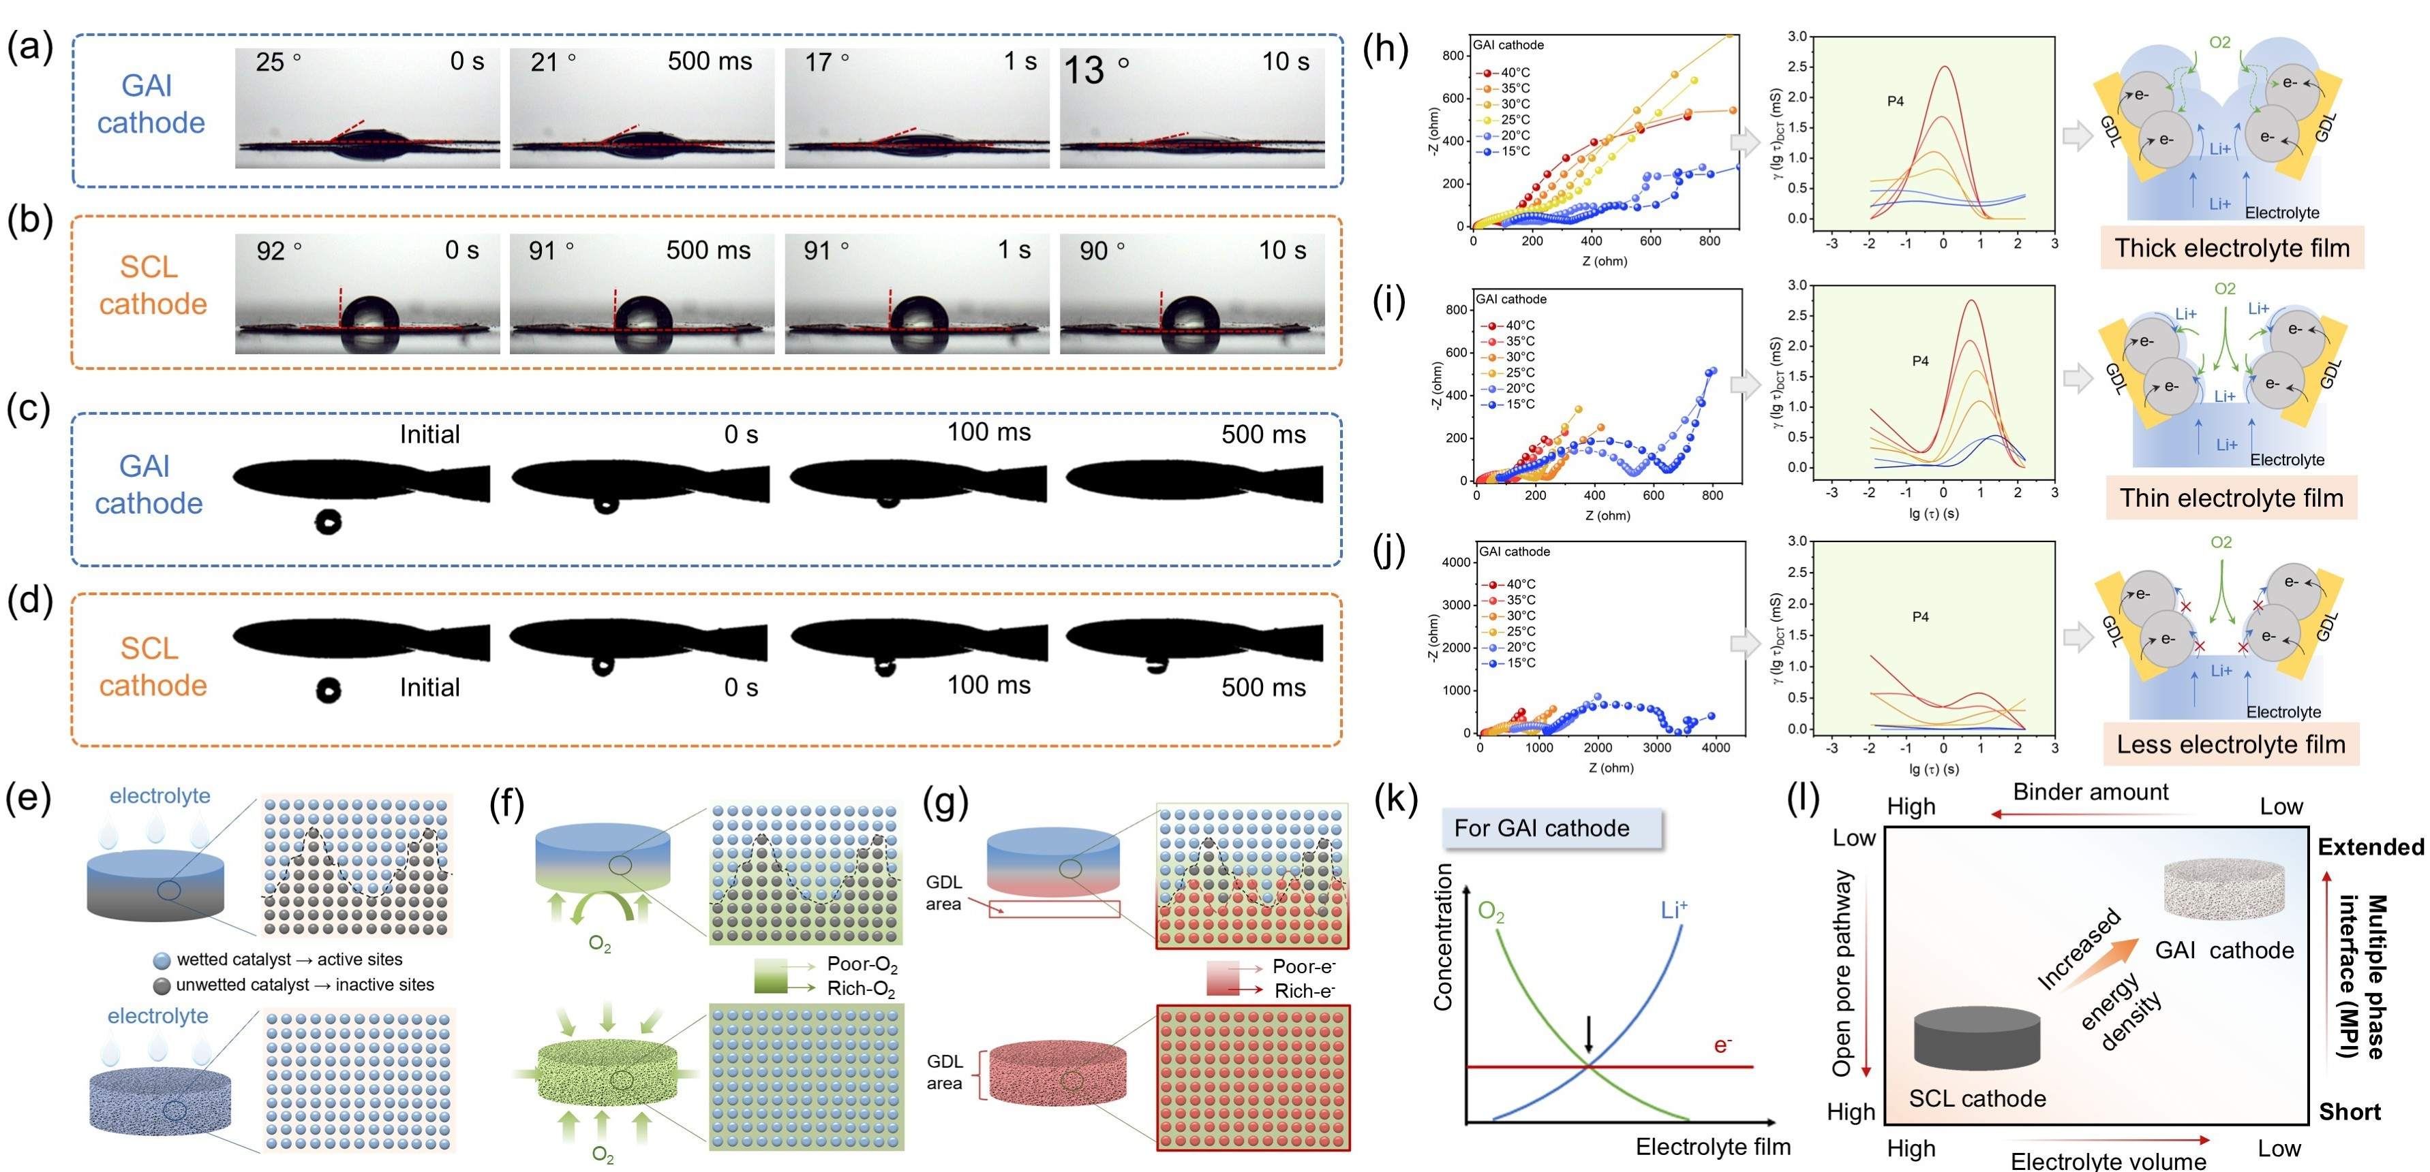
Figure 2. Characterization of the multiple phase interface (MPI) for cathodes. Dynamic contact angle of (a) the GAI cathode and (b) the SCL cathode. O₂ bubbles adhesion behavior evolution on the surface of (c) the GAI and (d) the SCL cathode in O₂-saturated 1.0 M LiTFSI-TEGDME electrolyte. The schematic diagram of (e) electrolyte wetting, (f) O₂ diffusion and (g) e⁻ transfer on the cathodes. The electrochemical impedance spectroscopy (EIS), corresponding distribution of capacitance times (DCT) analysis and illustration for LABs with (h) 80 uL, (i) 40 uL and 20 uL electrolyte. (k) Balance between O₂ transport and Li⁺ support across the electrolyte film. (l) The effects of electrolyte volume, binder, open pore pathway and MPI on energy density.

2.3 The electrochemical performance and kinetic analyses of LABs with GAI, SCL cathodes
To evaluate the electrochemical performance of LABs, galvanostatic cycling was conducted in ambient air with a relative humidity of 40-45 RH%. Figure 3a-c and 3f-h compare the representative discharge/charge profiles of LABs with GAI cathodes (Figure 3a-c) and SCL cathodes (Figure 3f-h) under different operating conditions. At 0.25 mA cm⁻² with a fixed areal capacity of 0.5 mA h cm⁻² (Figure 3a and 3f), the GAI cathode-based LABs exhibited a smaller and more stable discharge-charge voltage gap over 300 cycles, whereas the SCL cathode shows progressively increased overpotentials and failed within 120 cycles. When the current density and area capacity was increased to 0.75 mA cm⁻² and 1.50 mA h cm⁻², respectively (Figure 3b and 3g), the GAI cathode-based LABs still maintained relatively stable overpotentials, while the SCL cathode-based LABs rapidly deteriorated and failed after only 42 cycles. To further demonstrate the influence of cathode architecture at high loading, the loading was increased from 1.0 to 3.0 mg cm⁻², as shown in Figure 3c and 3h. The GAI cathode exhibited a two-step charging process, consisting of a dominant low potential region at ~3.0 V followed by a secondary region at ~4.0-4.2 V. In contrast, the SCL cathode displayed a consistently raised charge platform from ~4.0 to 4.4 V, indicating a larger charging overpotential. Under high loading conditions, the difference between the two cathodes became more evident. These results show that the advantages of the GAI cathode structure become increasingly pronounced as the transport demand is increased.
Differential capacity analyses further quantify these charging/discharging characteristics. Figure 3d-e and 3i-j collected the corresponding dQ/dV curves for the GAI and SCL cathodes, respectively. As shown in Figure 3d and 3i, dQ/dV discharge peaks (ORR) at ~2.9 V and ~2.7 V are consistent with the two discharge platforms observed in Figure 3c and 3h. For dQ/dV charging curves (Figure 3e and 3j), GAI cathode (Figure 3e) shows a significant and sharp OER peak centered at a relatively low potential of ~3.0 V, accompanied by minor peaks at ~4.0-4.2 V, in agreement with the segmented charging process in Figure 3c. In contrast, SCL cathode (Figure 3j) displayed broadened OER peaks in a high-potential region (~4.0-4.4 V), corresponding to the consistently raised charge platform in Figure 3h. The higher ORR and lower OER potential peaks of GAI cathode suggest that the excellent reversible ability of the formation and decomposition of discharge products under kinetically more favorable conditions. The lower ORR and broader high-potential OER peaks of SCL cathode demonstrate that the transport-related polarization was increased and more interfacial oxidation was hindered.
The cycling results summarized in Figure 3k further show that the structural advantage of the GAI cathode is translated into markedly improved durability under all tested conditions. More importantly, the performance gap becomes increasingly pronounced as the current density, areal capacity, and cathode loading are increased. Meanwhile, the GAI based LABs also exhibited consistently higher round-trip efficiency than SCL based LABs under all tested conditions (Figures S4-S6). Additional long cycle and round trip efficiency data at an aerial capacity of 1.25 mA h cm⁻² and a current density of 0.25 mA cm⁻² further support the superior reversibility of the GAI-based LABs (Figures S7-S8).
To further probe the kinetic difference during the discharge/charge processes, EIS measurements were performed on LABs assembled with a high-loading cathode mass of 3.0 mg cm⁻². The EIS spectra were further analyzed using the distribution of relaxation times (DRT) and the distribution of capacitance times (DCT) to decouple overlapping electrochemical processes.^{[6,37,38]} As shown in Figure 3l-n and 3p-r, four characteristic peaks (P1-P4) are observed, which can be attributed to solid-solid contact resistance, Li+ transport across the SEI (solid electrolyte interface), interfacial charge transfer resistance at the catalytic surface, and diffusion/mass transport resistance within the porous electrode, respectively.^{[6,32,37–40]}
For the GAI cathode (Figure 3l-n), the impedance spectra remained relatively stable during cycling (Figure 3l), with the overall impedance staying around ~175 Ω. The corresponding DRT curves (Figure 3m) showed that the P1-P3 peak areas remained low and nearly unchanged, suggesting stable interfacial contact and charge transfer kinetics. The DCT profiles (Figure 3n) also remained the comparatively high and stable peaks intensity, which means the preserved transport pathways and sustained O₂ diffusion within the GAI cathode. These results indicate that GAI architecture can maintain robust interfacial kinetics even after repeated cycles. In contrast, LABs assembled with SCL cathode showed pronounced impedance growth from ~250 Ω to ~400 Ω upon cycling (Figure 3o). The DRT analysis (Figure 3p) revealed a substantial increase in the P3 areas, indicating increasingly hindered interfacial charge transfer. Meanwhile, the DCT curves (Figure 3q) showed a significantly decreased P4 intensity, consistent with the solid products accumulation and diffusion pathways blockage.
Overall, the DRT/DCT analyses show that the GAI cathode preserves more stable interfacial kinetics and transport pathways throughout cycling, whereas the SCL cathode undergoes progressive charge-transfer and transport limitations. This distinction is fully consistent with the electrochemical results described above and supports that the superior cycling stability of the GAI cathode arises from its ability to maintain the spatially extended and dynamically stable MPI during repeated discharge/charge cycling.

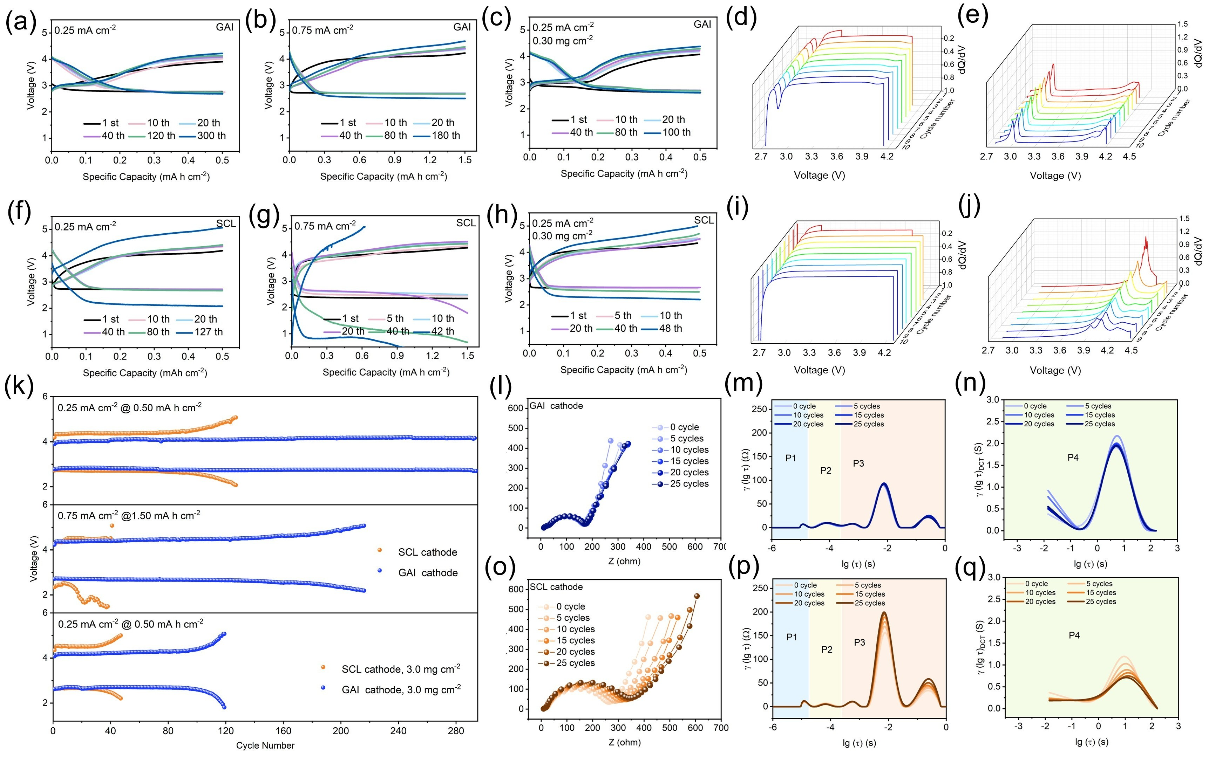
Figure 3. Electrochemical performance and kinetic analyses of LABs with different cathodes. With GAI cathode: representative discharge/charge profiles for a loading of 1.0 mg cm⁻² at (a) 0.25 mA cm⁻² @ 0.5 mA h cm⁻² and (b) 0.75 mA cm⁻² @ 1.5 mA h cm⁻², and (c) for a high loading of 3.0 mg cm⁻² at 0.25 mA cm⁻² and 0.5 mA h cm⁻². The selected dQ/dV curves for (d) discharge and (e) charge. With SCL cathode: representative discharge/charge profiles for a loading of 1.0 mg cm⁻² at (f) 0.25 mA cm⁻² @ 0.5 mA h cm⁻² and (g) 0.75 mA cm⁻² @ 1.5 mA h cm⁻², and (h) for a high loading of 3.0 mg cm⁻² at 0.25 mA cm⁻² and 0.5 mA h cm⁻². The selected dQ/dV curves for (i) discharge and (j) charge. (k) Long cycle performance of LABs at different current density and different loading mass. (l) electrochemical impedance spectroscopy (EIS) data, (m) distribution of relaxation times (DRT) and (n) distribution of capacitance times (DCT) curves for LABs with GAI cathode during cycle process. (o) EIS data, (p) DRT and (q) DCT curves for LABs with SCL cathode during cycle process.

2.4 Cathode structure-dependent electrochemical behavior
Figure 4a and 4j schematically summarize the distinct dynamic formation process of discharge products in LABs with GAI and SCL cathodes, respectively, while Figures S9-10 illustrate the corresponding decomposition process. Figure 4b and 4k compare the full discharge/full charge profiles (2.0-4.5 V) of LABs with GAI and SCL cathodes over a wide current density range. The GAI based LABs (Figure 4b) exhibited high discharge/charge capacity of 24.75/23.58 mA h cm⁻² with a Coulombic efficiency (CE) of 98.8% at current density of 0.125 mA cm⁻², and maintained high capacities over the entire tested current densities, while also exhibiting markedly improved rate tolerance. Even as the current density increased to 0.30 mA cm⁻², the GAI cathode retained appreciable capacities (10.08/9.70 mA h cm⁻²) with consistently high CEs above 86%. In contrast, the SCL cathode (Figure 4k) showed much lower full discharge/charge capability and rapid capacity decay with increasing current density, with the capacity falling to below 1.0 mA h cm⁻² at 0.30 mA cm⁻². These results highlight the markedly improved full discharge/full charge capability and superior rate tolerance of that the GAI based LABs relative to the SCL based LABs. Such performance differences are assistant with their distinct abilities of the two cathodes to establish and maintain a spatially extended and dynamically stable MPI during discharge and charge. Because LAB cathodes involve not only gas, liquid, and solid reactants but also an evolving solid discharge-product phase, their electrochemical behavior is highly sensitive to how the MPI is spatially established and dynamically maintained.
To further probe the discharge/charge kinetics, in situ EIS was conducted at 0.125 mA cm⁻² with a limited capacity of 3.0 mA h cm⁻², and the diffusion/transport evolution on cathode was further evaluated using DCT analysis (Figures 4c-f and 4l-o;). The corresponding EIS and DRT results are provided in Figure S11. During discharge, the GAI cathode showed a stable impedance evolution together with a progressively decreased charge transfer resistance (Figure S11a-c). DCT profiles (Figure 4c-d) showed gradual increase peaks intensity, indicating a decreased diffusion/mass transfer resistance. This result suggests that the diffusion/mass transfer in the GAI cathode is not hindered by the product formation, but instead remains accessible and even be progressively activated during discharge. During charging, the impedance and deconvoluted kinetic responses remained largely stable (Figure S11d-f), suggesting that product decomposition proceeds without severe deterioration of interfacial contact or charge transport pathways. Notably, the DCT (Figure 4e-f) exhibit cyclical variation, which can be attributed to the charging process does not proceed through a static reaction interface. Instead, local reaction pathways appear to undergo repeated interruption and reactivation, likely reflecting transient contact loss and re-establishment between the decomposing discharge product and electronically/ionically accessible regions of the cathode.^{[37]} This further implies dynamic stable of pathways during oxidation and O₂ evolution in GAI cathode. Above signatures are consistent with the establishment and maintenance of spatially extended and dynamically stable MPI, which allows the discharge reaction expands from local toward a more volumetric regime, thereby reducing the local reaction flux and concentration polarization per unit active area while suppressing rapid pore clogging. Correspondingly, the resistance to the discharge products decomposition is also alleviated.
In contrast, the SCL cathode showed simultaneous deterioration in interfacial, charge transport and diffusion responses during discharge (Figures S11g-i and Figure 4l-m). During charging, no appreciable recovery was observed, indicating persistent transport limitation and hindered product decomposition. These behaviors exhibited that the limited MPI in the SCL cathode leads to persistent passivation during discharge and inefficient MPI re-establishment during charge.
GITT further indicates (Figure S12) that the GAI cathode exhibits lower polarization with a minor increase during operation compared with the SCL cathode, further demonstrates the critical role of cathode structure regulation in governing LABs performance.^{[28,41,42]}
Figure 4g and 4p show the morphologies of the discharged products formed at 3.0 mA h cm⁻² on the GAI and SCL cathode, respectively. The discharge products formed on the GAI cathode exhibit a fine, thin, film-like morphology (Figure 4g), SCL cathode exhibits large, thick toroidal shape (Figure 4p). Figures S13-14 present a series of SEM images that further clarify the morphological evolution of the discharge products on GAI and SCL cathode. XRD patterns (Figure S15) reveal that the main discharge products are LiOH, accompanied by a minor amount of Li₂O₂. GAI cathode shows much weaker diffraction intensity and SCL cathode exhibits high intensity crystallite peaks. The product size and morphology are determined by the number of nucleation sites and the mass transport rate.^{[3]} For GAI cathode, catalyst is anchored on carbon fibers, and the stable thin liquid film maintains balanced Li⁺/O₂ transport, forming a continuous e⁻/Li⁺/O₂ transport network, thus increasing the number of nucleation sites. Because these sites compete with one another during product precipitation, the local deposition flux at each individual site is reduced,^{[3]} which helps sustain reactant supply and suppress localized overgrowth. As a result, the discharge products preferentially form as fine, thin film-like deposits. The film-like products grow conformally with the catalyst, enhance conformal contact with the electronically conductive framework and distribute more uniformly across the reaction interface, thereby reducing interfacial and transport resistances, delaying pore clogging and surface passivation, and improving the kinetics of electrochemical decomposition during charging (Figure S16a).^{[43,44]}
In contrast, for the SCL cathode, the catalyst layer is densely aggregated and distributed on one side across the cathode thickness, leading to highly heterogeneous electrolyte wetting and electronic network. This confines the reaction to limited regions and promotes the formation of bulky, thick, toroid-like discharge products. Toroid-like discharge products typically exhibit higher crystalline and larger dimensions. They more readily passivate the cathode surface during discharge and is more difficult to decompose during charging (Figure S16b),^{[10,45]} thereby resulting in higher resistance and poorer reversibility. Overall, these results indicate that the nucleation-preferred reaction mechanism formed on the GAI cathode (Figure 4h), and typical bulk-shaped discharge products randomly grown on the SCL cathode surface, formed by a growth-preferred reaction mechanism (Figure 4q).
Time-of-flight secondary ion mass spectrometry (TOF-SIMS) depth profiling combined with 3D reconstruction revealed distinctly different deposition distributions in the two cathodes. The total sputtering depth for both cathodes was comparable (~9 μm in Figure S17), ensuring a fair comparison of the depth profiles. For the GAI cathode (Figure 4i), characteristic secondary ion signals of OH⁻, LiO₂⁻, and Li₂O⁻ exhibited a deep-penetrating 3D distribution, while the product signals of the SCL cathode (Figure 4r) were mainly concentrated on one side.
Collectively, the distinct product morphologies and deposition distributions suggest that the GAI cathode favors a more nucleation-preferred and spatially distributed discharge pathway, whereas the SCL cathode tends toward a growth-preferred with localized deposition. This difference is consistent with the more spatially extended and dynamically stable MPI established in the GAI architecture,^{[10,45]} which provides broader and more continuous Li⁺/O₂/e⁻ access throughout the cathode and thereby distributes the reaction over a larger cathode volume. Under such conditions, the association rates of oxygen-containing species were elevated, promoting a higher nucleation rate of discharge products. This results in the electrochemical pathway of discharge products being more nucleation-preferred rather than growth-preferred.^{[10,45]} As a result, the discharge products formed on the GAI cathode remain thinner, finer, and more 3D distributed. These features facilitate their subsequent electrochemical decomposition and help suppress polarization growth. In contrast, the limited MPI in the SCL cathode promotes localized deposition, interfacial passivation, and less efficient product decomposition.

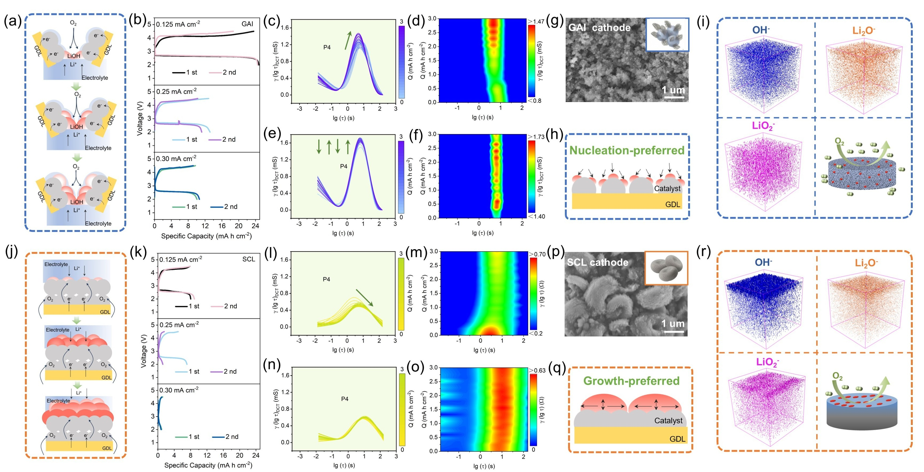
Figure 4. Cathode structure-dependent electrochemical behavior and multiscale characterization of discharge products in LABs. (a) Proposed dynamic processes of discharge products formation on GAI based LABs. (b) The full discharge/charge ability for GAI based LABs at different current density. (c,d) In situ DCT analysis and contour plots during discharge for GAI based LABs at 0.125 mA cm⁻². (e,f) In situ DCT analysis and contour plots during charge for GAI based LABs at 0.125 mA cm⁻². (g) The SEM image of discharge products at 3.0 mA h cm⁻² for the GAI cathode. (h) The discharge products formation mechanism for GAI cathode. (i) Three-dimensional (3D) distributions of OH⁻, LiO₂⁻, and Li₂O⁻ constructed from TOF-SIMS depth scan of the discharged GAI cathode (analysis area is 50 × 50 μm²). The insert schematically illustrates the 3D distribution of discharge products. (j) Proposed dynamic processes of discharge products formation on SCL based LABs. (k) The full discharge/charge ability for SCL based LABs at different current density. (l,m) In situ DCT analysis and contour plots during discharge for SCL based LABs at 0.125 mA cm⁻². (n,o) In situ DCT analysis and contour plots during charge for SCL based LABs at 0.125 mA cm⁻². (p) The SEM image of discharge products at 3.0 mA h cm⁻² for the SCL cathode. (q) The discharge products formation mechanism for SCL cathode. (r) Three-dimensional distributions (3D) of OH⁻, LiO₂⁻, and Li₂O⁻ constructed from TOF-SIMS depth scan of the discharged SCL cathode (analysis area is 50 × 50 μm²). The insert schematically illustrates the 3D distribution of discharge products.
2.5 Structure-dependent electrochemical behavior under wide temperature range
Reliable operation of LABs under both low and high temperature conditions is crucial.^{[4,6–8,29]} Therefore, we performed electrochemical tests on LABs assembled with different cathode structures at −20 °C and 60 °C to elucidate structure-optimization routes toward stable cycling performance. Figures 5a-b show the selected capacity-voltage curves at −20 °C (1.0 M LiTFSI-THF as electrolyte). The GAI cathode exhibits a stable discharge platform (~2.5 V) and retains the characteristic two-step charging behavior observed in Figure 3 at room temperature. In contrast, the SCL cathode exhibits a decreased discharge platform (<2.0 V) and progressively rising charge voltage (>5.0 V). Consistently, Figure 5c shows markedly improved cycling durability for the GAI based LABs (>155 cycles), whereas the SCL based LABs suffer from continuously increasing overpotential and fail within ~70 cycles (2.0-5.0 V as the discharge-charge failure voltages). To elucidate the low-temperature limitation, in situ EIS was performed at −20 °C. As shown in Figure 5d, the GAI based LABs exhibit nearly unchanged impedance spectrum when the discharged capacity increases from Qdis = 0 to 0.5 mA h cm⁻², whereas the SCL based LAB shows pronounced impedance evolution, particularly in the low-frequency region. The DCT analysis (Figure 5e) further quantifies the low-frequency contribution.
At Qdis=0 mA h cm⁻², the GAI cathode already exhibits a smaller low-frequency peak area than the SCL cathode, indicating a lower diffusion-related resistance. Upon discharge to Qdis = 0.5 mA h cm⁻², the low-frequency contribution of the GAI cathode changes only slightly, whereas that of the SCL cathode increases markedly. These results indicate that the GAI architecture sustains stable mass transport and efficient multiphase reaction kinetics at −20 °C, highlighting its robustness against temperature-aggravated transport limitations. While the SCL cathode becomes increasingly transport limited. Subsequently, temperature variation tests were performed during discharge/charge process, as shown in Figure 5f-g, the GAI cathode exhibits significantly improved voltage stability than the SCL cathode, reflecting the superior ability of GAI architecture to maintain more stable multiphase reaction kinetics under temperature variation.
In contrast to low-temperature operation, which is primarily limited by aggravated transport polarization, high-temperature cycling introduces a distinct failure mode dominated by redox mediator (RM) shuttle and thermally accelerated side reactions.^{[4,6,7,46–49]} Under such conditions, suppressing I⁻/I₃⁻ shuttle while maintaining an effective cathode-side RM concentration are essential for stable high-temperature operation. Instead of the traditional method that directly dissolve LiI in the electrolyte,^{[48–50]} which both dilutes the cathode-side LiI concentration at the cathode and facilitates Li anode corrosion, we applied a cathode pre-loading strategy. As shown in Figure 5g, a LiI solution was dropped onto the cathode prior to LABs assembly.
Figure 5h shows the long cycle performance of the LABs at 60 °C. The GAI based LABs maintain lower charge/discharge overpotentials and a markedly longer cycle life (>140 cycles), whereas the SCL based LABs sustain low polarization for only ~4 cycles before a rapid overpotential increased, indicating rapid loss of active iodide at the cathode due to shuttle.^{[46]} The subsequent sharp potential drop after ~30 cycles for the SCL-based LABs further suggests severe Li anode corrosion. Optical photographs of the disassembled LABs (Figure S18) confirm that the separator remains wet, excluding electrolyte evaporation as the primary cause. To identify the origin of the rapid overpotential rise, in situ EIS and DRT analyses were conducted at 60 °C for a representative early cycle (the 4th cycle) before severe degradation (Figure 5i-j). As shown in Figure 5i, GAI based LABs shows only minor impedance changes with the charged capacity, whereas the SCL based LABs shows a dramatic increase in impedance. DRT decomposition (Figure 5j) reveals a sharp increase in contact resistance (P1) and a pronounced rise in SEI-related resistance (P2) for the SCL based LABs, which demonstrates the severe Li anode corrosion and ultimately leads to battery failure. SEM images of the Li surface at the 4th cycle (Figure S19) further corroborate this corrosion. The overpotential growth plots (Figure 5k) consistently indicate rapid I⁻/I₃⁻ induced Li corrosion in the SCL based LABs, while the GAI architecture effectively restrains iodide shuttle, enhances RM retention at the cathode, and thereby prolongs stable cycling at high temperature.
Overall, these results demonstrate that the GAI cathode provides an effective structure design for wide-temperature LAB operation. At low temperature, this architecture effectively mitigates the growth of diffusion-related impedance and the aggravated polarization arising from coupled limitations in gas, ion, and e⁻ transport, thereby sustaining a stable voltage platform. At high temperature, it effectively confines and retention LiI at the cathode, suppressing the shuttle effect and thereby prolonging the effective lifetime of RM, reducing the overpotential, and alleviating the parasitic reactions on the Li anode. Therefore, the GAI cathode offers an effective structural lever to simultaneously overcome low-temperature interfacial transport limitations and high-temperature RM shuttle, resulting in markedly enhanced electrochemical stability and durability over a wide temperature window compared with the SCL cathode.

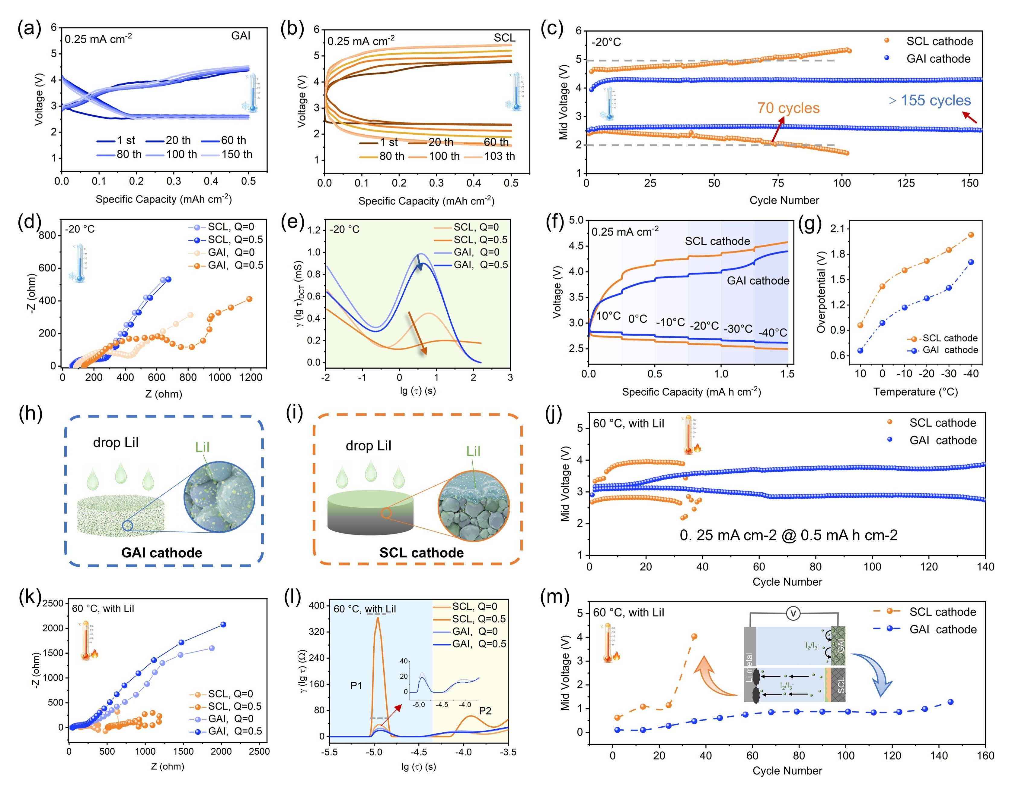
Figure 5. Electrochemical performance and kinetic analyses of LABs under wide temperature range. (a-b) The selected discharge/charge curves and (c) cycle performance at −20 °C with the current density of 0.25 mA cm⁻² and limited capacity of 0.50 mA h cm⁻². (d) The EIS date and (e) corresponding DCT analysis for LABs at different capacity. (f) The discharge and charge voltage profiles of LABs at various temperatures. (g) The corresponding overpotentials at different temperatures. (h) The schematic diagram of pre-loading LiI on the cathode. (i) The cycle performance at 60 °C with the current density of 0.25 mA cm⁻² and limited capacity of 0.50 mA h cm⁻². (j) The EIS date and (k) corresponding DRT analysis for LABs at different capacity. (l) The overpotential plots, and insert figures are iodine state in LABs during cycle process.

2.6 Structure-dependent electrochemical behavior on pouch LABs
Based on the performance of coin-type LABs, the amplified pouch LABs were constructed to demonstrate the beneficial effects of the cathode architecture on electrochemical performance. As shown in Figure 6a, the pouch LABs (cathode/anode size are 3.0 * 3.0 cm) were assembled in a stacked cathode–separator–anode (single layer), and stacked cathode–separator–anode–separator–cathode configuration (double layers). Notably, the cycling performance was conducted with a single layer pouch LABs to evaluate intrinsic stability of each cathode independently, avoiding interference between cathodes.^{[51]} As shown in Figure 6b-d, cycling stability were performed with a current density of 0.3 mA cm⁻² and limited capacity of 1.5 mA h cm⁻² (13.5 mA h) (RH range of 40–45%). The pouch LABs with GAI cathode (Figure 6b) exhibited a low and stable overpotential, which can normally operate over 100 cycles (1000 hours), demonstrating that the superior cycling stability of the GAI cathode maintained upon scaling up from coin-type to pouch LABs. By comparison, the pouch LABs with SCL cathode (Figure 6c) showed a rapid increase in overpotential, with the discharge and charge plateaus shifting to 2.0 and 5.0 V, respectively, after only 20 cycles. When the current density was increased to 0.5 mA cm⁻², the GAI pouch LABs still sustained stable operation for 80 cycles, whereas the SCL based LABs exhibited severe voltage instability and accelerated electrochemical degradation during cycling. Even at a high cathode loading of 3.0 mg cm⁻² (Figure S20), the GAI based pouch LABs continued to exhibit a more stable overpotential than the SCL cathode, further confirming the advantage of the GAI cathode under practical operating conditions. Notably, to avoid interference of Li corrosion, the cycling durability of pouch cells was conducted by employing a thicker Li foil, as shown in Figure S**.
The full discharge ability of pouch LABs was shown in Figure 6h. At a current density of 0.10 mA cm⁻² (RH range of 50–60%), the LABs with GAI cathode exhibit an impressive discharge capacity of 798.80 mA h cm⁻² (248.71 mA h), which is more than 4.80 times higher than that of the batteries with the SCL cathode (166.50 mA h cm⁻², 73.49 mA h). As shown in Figure 6i, GAI based pouch LABs exhibit a lower corn body weight due to its binder-free and less electrolyte characterization, would contributing to lower costs and higher energy density for potential applications. Table S1 provides detailed parameters for the pouch cell components. When calculated based on the core body of the cell (anode, cathode, separator, and electrolyte), the energy density of GAI based pouch LABs could reach a high value of 798.80 Wh kg⁻¹, whereas the pouch LABs with the SCL cathode only delivers 166.50 Wh kg⁻¹, highlighting the advantage of the GAI cathode in promoting the cell energy density. Figure 6j collected the energy densities of published pouch Li–O₂/Li–air batteries reported in the recent years, the GAI based LABs in this work exhibit a higher energy density than the most of reports.^{[52–57]}
To demonstrate the effect of cathode structure on the thermal response of pouch cells, continuously increasing currents were applied to the pouch cells (Figure 6k). The corresponding infrared thermography (Figure 6l-m) reveals distinct temperature evolution behaviors for cells with GAI and SCL cathodes, respectively. For the GAI based pouch LABs (Figure 6l), the surface temperature remains low and constant, stabilizing at ~25.7 °C during the stepwise current increase. In contrast, the SCL based pouch LABs (Figure 6m) exhibits a pronounced temperature rise, increasing from ~26.3 °C to 27.6 °C and further to 29.2 °C upon current increased, accompanied by more distinct localized heating. These results indicate that the GAI cathode enables a more homogeneous current distribution and more efficient heat dissipation, whereas the SCL cathode is prone to localized current crowding, which can be attributed to the non-uniform ionic/electronic transport pathways and a less efficient heat dissipation architecture.
Figure 6n exhibits a stable discharge platform under repeated bending-releasing cycles (0°-180°). Powering a LED stably when the single layer battery at different bending state (Figure 6o). As shown in Figure 6p, two pouch LABs with double layers could power a smart phone, and two pouch LABs with single layer could support an electronic building block such as piano (shown in Video S1), which demonstrate the practical feasibility of the GAI based pouch LABs for powering portable electronics.

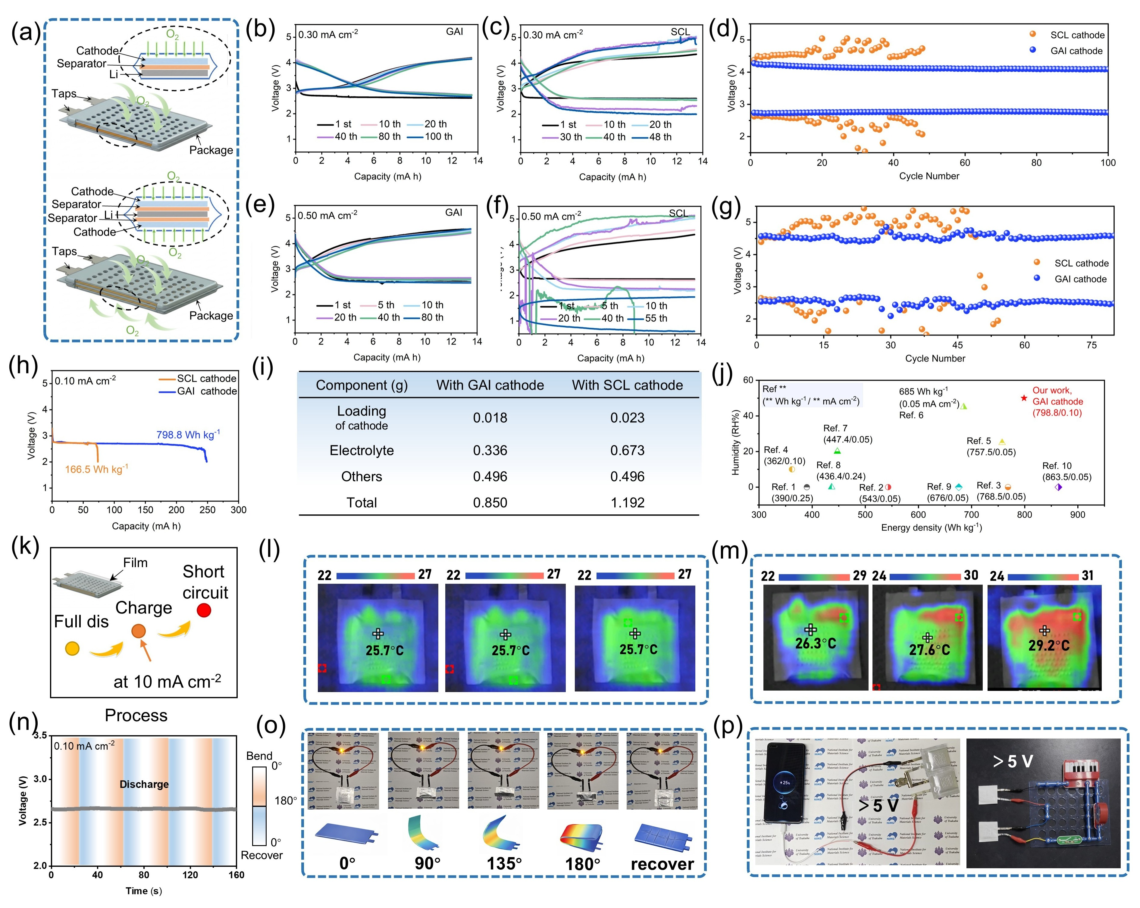
Figure 6. Electrochemical performance and practical applications of pouch LABs. (a) Schematic illustration of the component stacking method in pouch LABs. The electrochemical performance of pouch LABs with GAI and SCL cathodes at 0.30 mA cm⁻² with a capacity limit of 1.5 mA h cm⁻²: selected discharge/charge profiles for (b) GAI, (c) SCL, and (d) the corresponding cycling performance. The electrochemical performance at 0.50 mA cm⁻² with a capacity limit of 1.5 mA h cm⁻²: selected discharge/charge profiles for (e) GAI, (f) SCL, and (g) the corresponding cycling performance. (h) The full discharge curves of pouch LABs with a current density of 0.10 mA cm⁻². (i) The component parameters in the pouch LABs. (j) Comparison of the energy densities of published pouch Li–O₂/Li–air batteries reported in the recent years.^{[52–57]} (k) The current increased process for pouch LABs. (l, m) The corresponding infrared thermal imaging results of GAI, SCL cathode, respectively. (n) Discharge curve of the pouch LABs under dynamic bending and releasing. (o) Photograph of pouch LABs lighting an LED at different bending angles and in the released state. (p) The practical application of pouch LABs powering a smart phone (＞5 V) and a small electronic piano (＞5 V).

3. Conclusion
In summary, a simple and scalable gravity-assisted infiltration (GAI) method was developed to construct a cathode that the catalyst anchored on the carbon fiber and 3D distributed throughout the GDL framework. The resulting architecture, which enables continuous Li⁺/O2/e⁻ transport pathways and establishes a spatially extended and dynamically stable MPI, while also being binder-free and operable under reduced electrolyte demand. As a result, LABs assembled with GAI cathode exhibit low overpotential, prolonged cycling durability over 300 cycles at 0.25 mA cm⁻² and 0.50 mA h cm⁻², while continuing to show pronounced performance advantages at a high loading condition of 3.0 mg cm⁻². In situ EIS/DRT/DCT analyses, together with TOF-SIMS, further reveal thickness-direction, nucleation-preferred discharge-product formation mechanism, evidencing the spatially extended and dynamically stable MPI enabled by the GAI architecture. The resulting LABs deliver a high reversible areal capacity of approximately 24 mA h cm⁻². Beyond their excellent room-temperature performance, the GAI cathode also shows improved low-temperature diffusion kinetics at −20 °C, and enhanced structural and electrochemical stability at 60 °C. Furthermore, scaled-up pouch LABs achieve stable cycle performance over 100 cycles, effective heat dissipation, and a high energy density of 798.80 Wh kg⁻¹, demonstrating its potential in safety and application. This work provides a scalable cathode design strategy for the practical development of high energy density LABs and other metal–air batteries.

Declaration of Competing Interest
The authors declare that they have no known competing financial interests or personal relationships that could have appeared to influence the work reported in this paper.
Acknowledgment
This work was financially supported by the NIMS Electron Microscopy Analysis Station, the Nanostructural Characterization Group, and by the NIMS Microstructural Characterization Platform as a program of the “Nanotechnology Platform” of the Ministry of Education, Culture, Sports, Science and Technology (MEXT), Japan; Word Premier International Research Center Initiative (WPI), MEXT, Japan; This achievement was supported by JST SPRING, Grant Number JPMJSP2124.

Appendix A. Supplementary data
Supplementary data to this article can be found online at XXXXXX.

Reference
[1] S. Wu, J. Yi, K. Zhu, S. Bai, Y. Liu, Y. Qiao, M. Ishida, H. Zhou, Adv. Energy Mater. 2017, 7, 1601759.
[2] Z.-Z. Shen, S.-Y. Lang, C. Zhou, R. Wen, L.-J. Wan, Adv. Energy Mater. 2020, 10, 2002339.
[3] Z. Zhang, X. Xiao, X. Zhu, P. Tan, Electrochem. Energy Rev. 2023, 6, 18.
[4] W. Cui, C. Ma, X. Lei, Y. Lv, Q. Zhang, W. Guan, X. Liu, Journal of Power Sources 2023, 577, 233264.
[5] J. Wu, J. Shi, Z. Li, M. Li, K. Pan, Y. Dou, Y. Tian, Z. Zhang, Z. Zhou, Angew. Chem. 2025, 137, e202507660.
[6] W. Cui, J. Tang, G. Xu, H. Yin, W. Jevasuwan, N. Fukata, Composites, Part B 2026, 312, 113331.
[7] C. Ma, W. Cui, X. Liu, Y. Ding, Y. Wang, InfoMat 2022, 4, e12232.
[8] C. Ma, W. Cui, Q. Zhang, C. Yao, S. Zhou, M. Watanabe, K. Ueno, Y. Ding, X. Liu, Adv. Funct. Mater. 2026, 36, e15760.
[9] L. Lyu, W. Fan, J. Shen, D. Lee, Q. Wang, J. Chung, Y.-M. Kang, ACS Energy Lett. 2026, 11, 1538.
[10] S. Cho, H. Jung, M. Park, L. Lyu, Y.-M. Kang, ACS Energy Lett. 2024, 9, 2848.
[11] Nano Energy 2023, 117, 108922.
[12] A. Dunst, V. Epp, I. Hanzu, S. A. Freunberger, M. Wilkening, Energy Environ. Sci. 2014, 7, 2739.
[13] O. Gerbig, R. Merkle, J. Maier, Adv. Mater. 2013, 25, 3129.
[14] S. Lau, L. A. Archer, Nano Lett. 2015, 15, 5995.
[15] J. Power Sources 2013, 243, 899.
[16] J. K. Papp, J. D. Forster, C. M. Burke, H. W. Kim, A. C. Luntz, R. M. Shelby, J. J. Urban, B. D. McCloskey, J. Phys. Chem. Lett. 2017, 8, 1169.
[17] A. Riaz, K.-N. Jung, W. Chang, K.-H. Shin, J.-W. Lee, ACS Appl. Mater. Interfaces 2014, 6, 17815.
[18] J. Read, K. Mutolo, M. Ervin, W. Behl, J. Wolfenstine, A. Driedger, D. Foster, J. Electrochem. Soc. 2003, 150, A1351.
[19] F. Wang, X. Li, ACS Appl. Mater. Interfaces 2018, 10, 26222.
[20] S. Yang, Y. Qiao, P. He, Y. Liu, Z. Cheng, J. Zhu, H. Zhou, Energy Environ. Sci. 2017, 10, 972.
[21] C. Yao, X. Lei, C. Ma, Q. Zhang, X. Liu, Y. Ding, Small 2023, 19, 2301846.
[22] G. Hyun, M. Park, G. Bae, J. Chung, Y. Ham, S. Cho, S. Jung, S. Kim, Y. M. Lee, Y.-M. Kang, S. Jeon, Adv. Funct. Mater. 2023, 33, 2303059.
[23] A. Nomura, K. Ito, Y. Kubo, Sci. Rep. 2017, 7, 45596.
[24] T. Zhang, H. Zhou, Angew. Chem. (Int. Engl.) 2012, 51, 11062.
[25] W.-B. Tu, L.-N. Song, S. Liang, Y. Wang, Y. Sun, H.-F. Wang, J.-J. Xu, Adv. Energy Mater. 2025, 15, 2404946.
[26] Nano Energy 2019, 56, 92.
[27] J. Power Sources 2018, 379, 219.
[28] W.-H. Ryu, F. S. Gittleson, J. Li, X. Tong, A. D. Taylor, Nano Lett. 2016, 16, 4799.
[29] B. Liu, W. Xu, J. Zheng, P. Yan, E. D. Walter, N. Isern, M. E. Bowden, M. H. Engelhard, S. T. Kim, J. Read, B. D. Adams, X. Li, J. Cho, C. Wang, J.-G. Zhang, ACS Energy Lett. 2017, 2, 2525.
[30] J.-B. Park, J. Hassoun, H.-G. Jung, H.-S. Kim, C. S. Yoon, I.-H. Oh, B. Scrosati, Y.-K. Sun, Nano Lett. 2013, 13, 2971.
[31] X. Zhou, Y. Zhou, L. Yu, L. Qi, K.-S. Oh, P. Hu, S.-Y. Lee, C. Chen, Chem. Soc. Rev. 2024, 53, 5291.
[32] Electrochim. Acta 2021, 396, 139261.
[33] A. Kube, F. Bienen, N. Wagner, K. A. Friedrich, Adv. Mater. Interfaces 2022, 9, 2101569.
[34] Z. Yan, L. Wang, H. Zhang, X. He, Adv. Energy Mater. 2024, 14, 2303206.
[35] N. Misaghian, M. A. Sadeghi, E. Roberts, J. Gostick, J. Electrochem. Soc. 2022, 169, 100549.
[36] T. O. Life, Small 2023, 2300452.
[37] J. Chen, E. Quattrocchi, F. Ciucci, Y. Chen, Chem 2023, 9, 2267.
[38] Energy Storage Mater. 2023, 63, 103007.
[39] L. Nagy, H. S. Üneri, M. Á. Kordován, T. Nagy, Á. Kuki, D. Nyul, P. Pál, Z. Erdélyi, M. Zsuga, S. Kéki, J. Electrochem. Soc. 2024, 171, 40509.
[40] S.-T. Ko, Z. Ma, C. Gonsalves, K. A. Salazar, S. Mellado, C. C. Tan, T. Lin, T. Aoki, C. C. Mi, L. Kong, J. Mater. Chem. A 2026, 14, 7421.
[41] Y. Liu, B. Li, Z. Cheng, C. Li, X. Zhang, S. Guo, P. He, H. Zhou, Journal of Power Sources 2018, 395, 439.
[42] L.-N. Song, L.-J. Zheng, X.-X. Wang, D.-C. Kong, Y.-F. Wang, Y. Wang, J.-Y. Wu, Y. Sun, J.-J. Xu, J. Am. Chem. Soc. 2024, 146, 1305.
[43] Y. Zhang, J. Ma, Z. Zhuang, A. Huang, S. Zhang, W. Zhai, Y. Yu, Q. Peng, H. Xiao, C. Nan, C. Chen, ACS Catal. 2024, 14, 18851.
[44] H. Yan, W.-W. Wang, T.-R. Wu, Y. Gu, K.-X. Li, D.-Y. Wu, M. Zheng, Q. Dong, J. Yan, B.-W. Mao, J. Am. Chem. Soc. 2023, 145, 11959.
[45] C. Prehal, S. Mondal, L. Lovicar, S. A. Freunberger, ACS Energy Lett. 2022, 7, 3112.
[46] Y. He, L. Ding, J. Cheng, S. Mei, X. Xie, Z. Zheng, W. Pan, Y. Qin, F. Huang, Y. Peng, Z. Deng, Adv. Mater. 2023, 35, 2308134.
[47] M. Song, D. Zhu, L. Zhang, X. Wang, R. Mi, H. Liu, J. Mei, L. W. M. Lau, Y. Chen, J. Solid State Electrochem. 2014, 18, 739.
[48] M. Tułodziecki, G. M. Leverick, C. V. Amanchukwu, Y. Katayama, D. G. Kwabi, F. Bardé, P. T. Hammond, Y. Shao-Horn, Energy Environ. Sci. 2017, 10, 1828.
[49] G. Leverick, M. Tułodziecki, R. Tatara, F. Bardé, Y. Shao-Horn, Joule 2019, 3, 1106.
[50] W.-J. Kwak, D. Hirshberg, D. Sharon, H.-J. Shin, M. Afri, J.-B. Park, A. Garsuch, F. F. Chesneau, A. A. Frimer, D. Aurbach, Y.-K. Sun, J. Mater. Chem. A 2015, 3, 8855.
[51] X. Zhang, G. Zhang, H. Yu, N. Wang, Z. Guo, F. Dang, Adv. Funct. Mater. 2026, 36, e06249.
[52] S. Matsuda, E. Yasukawa, T. Kameda, S. Kimura, S. Yamaguchi, Y. Kubo, K. Uosaki, Cell Rep. Phys. Sci. 2021, 2, DOI 10.1016/j.xcrp.2021.100506.
[53] J. Power Sources 2010, 195, 4332.
[54] J. Energy Chem. 2020, 45, 74.
[55] Z.-W. Li, Y.-L. Liang, J. Wang, J.-M. Yan, J.-W. Liu, G. Huang, T. Liu, X.-B. Zhang, Adv. Energy Mater. 2024, 14, 2304463.
[56] A. Kondori, M. Esmaeilirad, A. M. Harzandi, R. Amine, M. T. Saray, L. Yu, T. Liu, J. Wen, N. Shan, H.-H. Wang, A. T. Ngo, P. C. Redfern, C. S. Johnson, K. Amine, R. Shahbazian-Yassar, L. A. Curtiss, M. Asadi, Science 2023, 379, 499.
[57] H. Lee, D. J. Lee, M. Kim, H. Kim, Y. S. Cho, H. J. Kwon, H. C. Lee, C. R. Park, D. Im, ACS Appl. Mater. Interfaces 2020, 12, 17385.

