Observation of Plasmon Energy Gain for Emitted Secondary Electron in vacuo
Bo Da^{1,2*}, Jiangwei Liu³, Yoshitomo Harada², Nguyen T. Cuong^{4,5}, Kazuhito Tsukagoshi⁵, Jin Hu⁶, Lihao Yang⁷, Zejun. Ding^{7†}, Hideki Yoshikawa^{1,2‡}, Shigeo Tanuma²
¹Research and Services Division of Materials Data and Integrated System, National Institute for Materials Science, 1-1 Namiki Tsukuba, Ibaraki 305-0044 Japan
²Research Center for Advanced Measurement and Characterization, National Institute for Materials Science, 1-2-1 Sengen, Tsukuba, Ibaraki 305-0047, Japan
³Research Center for Functional Materials, National Institute for Materials Science, 1-2-1 Sengen, Tsukuba, Ibaraki 305-0047, Japan
⁴International Center for Young Scientists, National Institute for Materials Science, 1-1 Namiki Tsukuba, Ibaraki 305-0044 Japan
⁵International Center for Materials Nanoarchitectonics, National Institute for Materials Science (WPI-MANA), Tsukuba, Ibaraki 305-0044, Japan
⁶Department of Physics and Institute for Nanoscience and Engineering, University of Arkansas, Fayetteville, Arkansas 72701, USA
⁷Department of Physics, University of Science and Technology of China, Hefei, Auhui 230026, P.R. China.
Corresponding Author
*e-mail: DA.Bo@nims.go.jp
†e-mail: Zjding@ustc.edu.cn
‡e-mail: YOSHIKAWA.Hideki@nims.go.jp

ABSTRACT
Plasmon gain by core-level electrons or elastic electrons observed in past studies seems to be of no practical value in material characterization, mainly because of their ultra-low signal intensities. Nevertheless, in the emission spectra of Au samples, we have observed plasmon gain in secondary electrons. The electrons gain energy from surface plasmons after escaping from the surface, and thereby only carry surface-plasmon information in the vacuum above the surface. Because the intensity of the emitted SEs is strong, rivalling that of core-level or elastic electrons, the observed phenomenon has in practice the potential to image directly in space the surface plasmon near but exterior to the metal surface.
TOC GRAPHICS
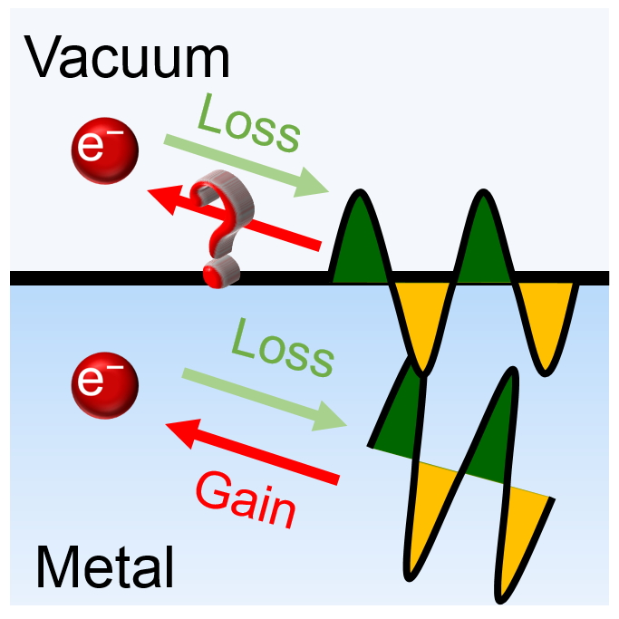

When electrons move inside or near a solid, energetic electrons transferring part of their energy to the conduction electrons in well-defined quanta from their collective oscillations [1,2,3] are present everywhere. However, in contrast, energetic electrons gaining energy quanta from plasmons when they both interact are rare despite being a natural occurrence. Nonetheless, in both cases, the information of the material under study, especially of plasmons excited inside or near the target material, may be encoded in the kinetic energy of emitted electrons once losing/gaining energy to/from a plasmon. It is therefore surprising that this plasmon gain has not garnered much attention in applications of electron-based surface-analysis techniques such as Auger electron spectroscopy (AES), X-ray photoelectron spectroscopy (XPS), and electron energy loss spectroscopy (EELS), whereas plasmon loss has played since its discovery an essential role in the interpretation of measured spectra obtained by above techniques.
More than 40 years ago, plasmon gain for core-level electrons was first observed by Jenkins and Chung [4], who suggested a satellite peak observed on the high energy side of the 60 eV Cu Auger peak was caused by outgoing electrons in Auger electron emissions gaining energy from pre-existing plasmon quanta, i.e., “extrinsic” plasmon produced in outgoing electrons scattering. Later on, AES or XPS studies on a wide range of materials including Al [5,6], Mg [7,8], Na [7,8], Mg₂Cu [9], and Mg-Cd alloys [10] together with theoretical verification [11] clearly supported plasmon gains by energetic electrons within the solids analogous to typical plasmon losses.
Apart from the core-level electrons, elastic electrons also gain energy quanta from plasmons under specific circumstances. Schilling and Raether [12] first observed this plasmon gain for elastic electrons from pre-established surface plasmons in a reverse process to the well-known surface plasmon loss. In their work, energy spectra of electrons reflected from very smooth liquid Indium surfaces at grazing incidence include a satellite on the higher energy side of the elastic peak at the exact energy corresponding to plasmon gains for Indium. This result clearly demonstrated that once an elastic electron appears at the right place (i.e., within the effective range of a pre-existing surface plasmon) and at the right time (i.e., within the lifetime of a pre-existing surface plasmon), there is a probability of gaining energy of one surface plasmon quantum from the interaction with a surface plasmon.
Regardless of plasmon gain for core-level or elastic electrons, their possibility is positively related to the core-level or elastic electron beam intensity, when a sufficient number of surface plasmons are present. Because of the generally low intensity of core-level or elastic electrons in the reflected electron spectra, the signal intensity of plasmon gain is, of course, even lower and therefore shows little prospect in any foreseeable future in probing plasmon information of materials that outrival traditional EELS techniques based on plasmon loss.
As plasmons can transfer energy to the core-level electrons and elastic electrons, a transfer of energy to secondary electrons (SEs) should therefore also occur. In most of the reflected electron spectra, the intensity of SEs emitted from the surface is generally several orders of magnitude higher than for core-level electrons or elastically reflected electrons and also has a much lower flight speed, indicating a greater possibility and longer time to interact with the plasmons that are present. However, while plasmon gain for SEs has long been predicted, it has not been detected because the SEs emitted at low energies generally display no identifiable spectral feature in the reflected electron spectra; hence, such features should not appear even upon gaining a quantum of plasmon energy. In this instance, if the plasmon gain of the emitted SEs is exactly the same as those of the core-level and elastic electrons, we should observe no distinctive feature related to plasmon gain.
In this work, we propose a new mechanism of plasmon gain for the emitted SEs that could form a spectral feature above the vacuum level in a reflected electron spectrum, and then verify it in experiments using a polycrystalline Au sample. One unique characteristic of plasmon gain is that it only occurs in a vacuum above the surface of a medium, therefore, it could be employed to probe surface plasmon near but external to the metal. This unique ability was demonstrated using a graphene/Au system, by which quantitative data on the attenuation of the surface plasmons of Au using a graphene layer was obtained. In considering the ultra-strong signal intensities of SEs that rival those of the core-level or elastic electrons, the plasmon gain observed has the potential to become an alternative tool in the direct imaging in space of the near-field electric field distribution on the metal surface, similar to the well-developed photon-induced near-field electron microscopy [13].
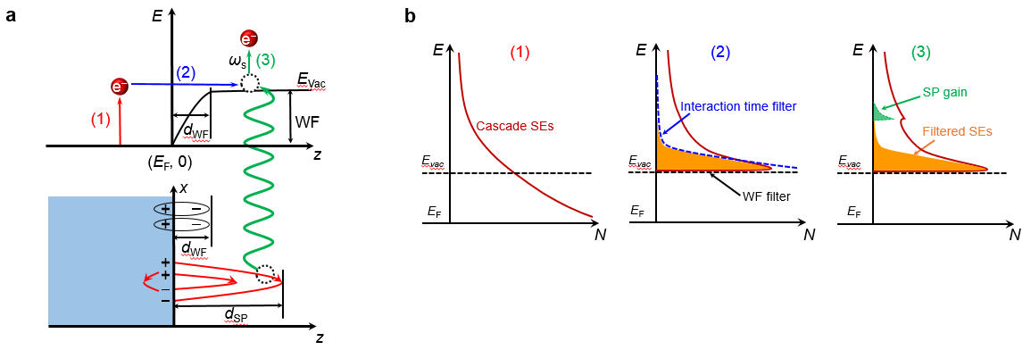
Figure 1. (a) Schematic of plasmon gain in SE emissions. The effective distances of the work function (Figure S1 and Supplementary Note 1 in the Supporting Information) and surface plasmons are denoted d_{WF} and d_{SP}, respectively. The three steps of plasmon gain: (1) excitation of SEs, (2) emission of SEs and (3) plasmon gains marked using different colors and numbered. (b) Excited SEs energy distribution and its composition in each step. For the entire process, ordinary excited SEs mainly contributed by conventional energy loss are plotted (red line). In steps 2 and 3, those SEs that hold potential to promote observable plasmon gain features (colored orange) lie under the interaction time line (see text) truncated by the work function line. In step 3, emitted SEs that have gained a quantum of energy from the surface plasmon are colored in green.
We first propose a possible mechanism for plasmon gain that could produce observable signals of plasmon gain for emitted SEs. An observable plasmon gain peak may appear in the reflected electron spectra [Fig. 1a] with the participation of the work function in the SE emission process. When the primary electron beam interacts with the sample, the energetic electrons may lose energy and excite the solid-state electrons as SEs. These excited SEs may produce the next generation SEs when they interact with the sample, giving rise to a cascade of slow electrons. In this instance, most of these excited SEs are centralized near E_{F} because of cascade effects [step (1) in Fig. 1b]. Once the energy of these excited SEs exceeds the work function of the solid, they overcome the work function and escape over the surface barrier. With the presence of the surface barrier (work function), most of these escaped SEs are centralized near the vacuum level [step (2) in Fig. 1b]. Furthermore, these SEs move slowly increasing the possibility of gaining an energy quantum from pre-existing surface plasmon because of their longer interaction time in the effective surface plasmon area. Therefore, only SEs emitted with energies similar to that of the work function and screened out by the “work function filter” and “interaction time filter” have the potential to promote a spectral feature above the vacuum level in the spectrum related to the surface plasmon of the sample [step (3) of Fig. 1b]. Unlike the previously discovered plasmon gain for core-level and elastic electrons, plasmon gain for SEs may lead to observable features in a spectrum and occurs only in vacuum several angstroms away from the sample surface. Another aspect that should be noted is that the proposed plasmon gain for the SEs process, in which the excited plasmon transfers its energy to energetic SEs, is different in essence from the SEs excitation process involving plasmon decay observed by Werner et al. [14–16], in which the excited plasmon transfers its energy to the solid-state electrons.
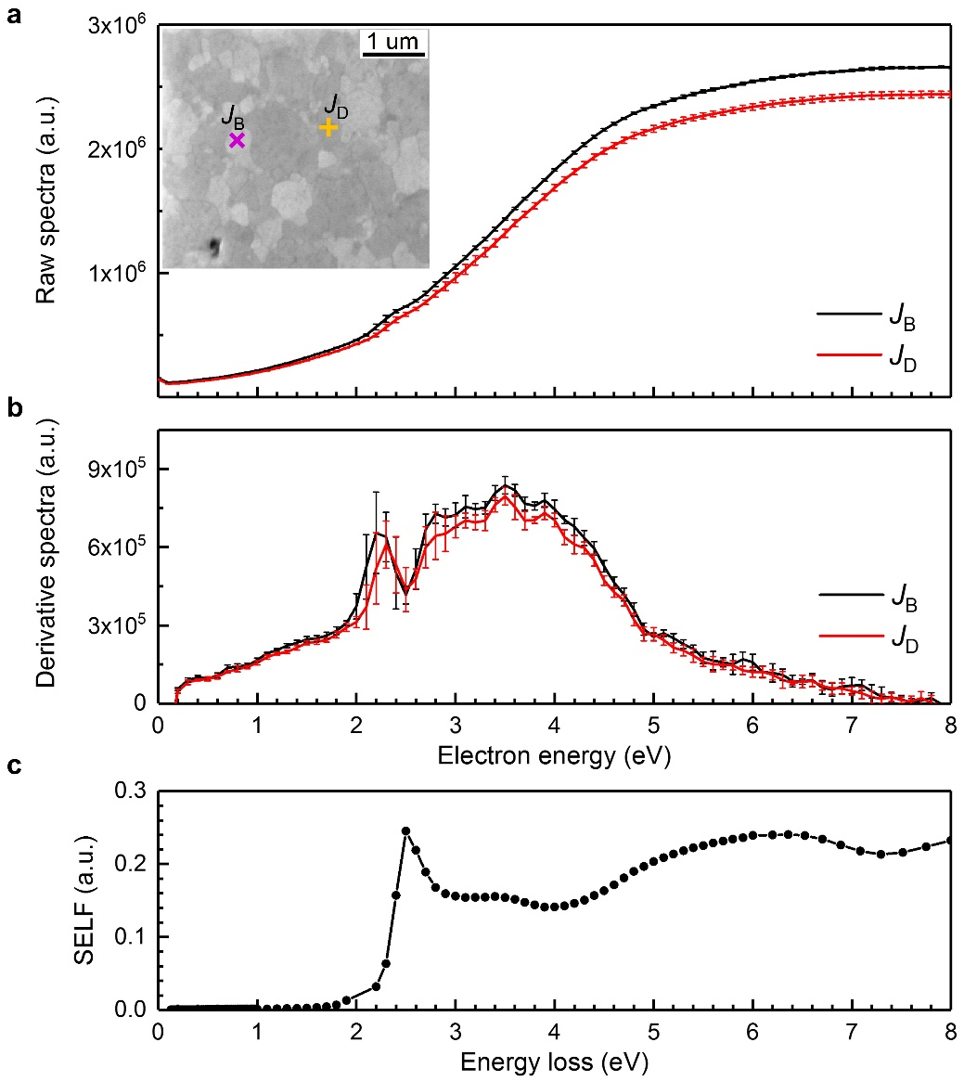
Figure 2. (a) Two SE current densities, J_{B} and J_{D}, were measured at the bright and dark regions, respectively, on a polycrystalline Au sample using a cylindrical mirror analyser in EN(E) mode. Each SE spectrum is an average of eight independent measurements in the energy range 0–8 eV in steps of 0.1 eV with an incident electron energy of 10 keV. The standard deviation for each measurement is presented as an error bar. The bright and dark regions are marked in the scanning electron microscopy image (inset). Two typical measurement sites for J_{B} and J_{D} are also marked (pink cross and yellow plus sign, respectively. (b) Corresponding derivative spectra for J_{B} and J_{D}. (c) Surface energy loss function (SELF) of Au calculated based on the dielectric function of bulk Au [23].
To verify the above hypothesis, the plasmon gain phenomenon was investigated using Au samples because the plasmon energy for Au is about 2.3 eV. Once the plasmon gain occurs, the corresponding signals located at ~2.3 eV do not overlap with the cascade SE peaks of Au at 4–12 eV [17]. Previous surface plasmon resonance studies on Au nanostructured substrates [18,19] and Au nanoparticles [20,21] show that the nanostructured Au surface provides a large number of surface plasmons generally with short lifetimes whereas a flat Au surface provides a small number of surface plasmons with long lifetimes. As the present gain mechanism require both large numbers and long lifetimes for surface plasmons, we used a polycrystalline Au film composed of alternating micro- and nano-scale micronized single-phase grains with flat top (Figure S2 in the Supporting Information) to achieve the right balance of number and lifetime of excited surface plasmons. From the scanning electron microscopy (SEM) image (Fig. 2a, inset), two types of SE spectra were measured by selecting incident positions on the center of bright Au grains and dark Au grains, respectively (Figure S3 and Supplementary Note 2 in the Supporting Information). The SEM contrast between these two types of Au gains were partly caused by their slightly different crystallographic orientations (<4º) and relatively different levels in crystal quality. The corresponding SE spectra, J_{B} and J_{D}, measured with an incident electron energy of 10 keV, and their derivatives were plotted (Fig. 2). In both J_{B} and J_{D}, we observe fuzzy spectral features in the Au surface plasmon energy at ~2.3 eV. Furthermore, these features generate a significant peak in the corresponding derivative spectra (Fig. 2b). For comparison, the typical surface plasmon loss of Au represented by the energy loss function, Im{−1/(ε+1)} [22] is also given (Fig. 2c), where ε is the bulk dielectric function of Au [23]. Obviously, the plasmon gain peaks for Au observed in the raw SE spectra and their derivative spectra occur at the exact energies corresponding to one quantum of surface plasmon energy observed in the surface energy loss function of Au. This result is clear evidence that the observed spectral feature at ~2.3 eV in the SE spectra of Au originates from the unusual plasmon gain mentioned above.
One remarkable feature is that we have quantitatively analyzed the intensity of the plasmon gain peak in the measured SE spectra, as well as the sample crystallinity around the electron beam landing position, and found that there is a significant positive correlation between the plasmon gain intensity and the local sample crystallinity (Figure S4 in the Supporting Information). This result experimentally verifies that Au grains with higher crystal quality can produce surface plasmons with longer lifetimes, and thereby give rise to a stronger plasmon gain intensity, which is useful in Au sample preparation.
Because bright and dark types of Au grains possess relatively different levels of crystal quality, which strongly affects the lifetime of the excited surface plasmon as well as the length it runs along the surface, the J_{B} and J_{D} spectra therefore contain different proportions of plasmon gain contributions while maintaining similar proportions of conventional energy loss contributions (Fig. 2a). Hence, the difference between J_{B} and J_{D}, i.e., the difference spectra, J_{B−D}, contain more stable and significant plasmon gain signals because of a larger proportion of offset from the conventional energy loss contribution compared with the plasmon gain contribution. Furthermore, those plasmon gain signals in J_{B−D} can be used as a probe to investigate the attenuation of the surface plasmon of Au by covering nanomaterial layer using the overlayer method [24], in which the nanomaterial is transferred onto the present Au sample.
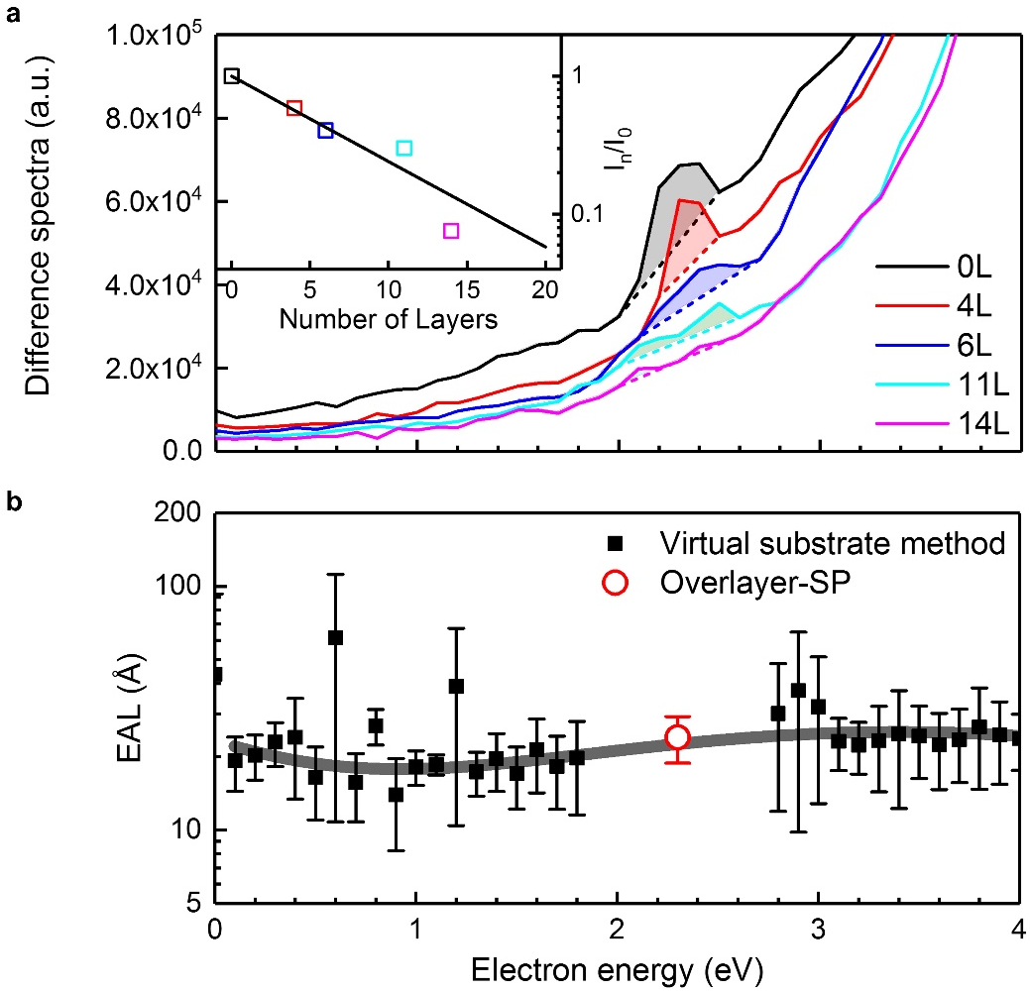
Figure 3. (a) Difference spectra for n-layer graphene/gold (n = 0, 4, 6, 11 and 14) with an incident electron energy of 10 keV. The corresponding peaks in plasmon gain are highlighted in color. Inset: log-normal plot of the plasmon gain peak intensity attenuation vs number of graphene sheet layers with fitted line with slope exp(–nd₀/λ_{SP}), where d₀ is the thickness of graphene (0.335 nm) and λ_{SP} quantifies the attenuation of the plasmon gain; the best-fit result is 25.1 Å. (b) Effective attenuation length (EAL), λ_{EAL}, for graphene determined by the virtual substrate method [25] are presented in the energy range of 0–4 eV together with the attenuation of plasmon gain, quantified by λ_{SP} at 2.3 eV.
Here, graphene as a representative nanomaterial was investigated using the plasmon gain signals (Figure S5 and Figure S6 in the Supporting Information). The peaks assigned to the gain of a surface plasmon quantum of Au (Fig. 3a) is highlighted in difference spectra for few-layer graphene on Au. After transferring graphene sheets on top of a Au substrate, the energy gain peak for graphene sheets with very few layers (4L) first becomes narrow because of the change in dielectric environment of the surface plasmon of Au, and then broadens as the layer number continuously increases through the attenuation of the Au surface plasmon by the graphene layer (Figure S7 in the Supporting Information). These energy gain peaks exhibit different behaviors compared with common energy loss peaks; for instance, the peaks measured from graphene sheets broaden for both higher and lower energies with increasing layer number. Furthermore, the intensity of these peaks decreases exponentially with increasing graphene-sheet number through the spatial extent of the surface plasmon in a covered dielectric layer. An unambiguous exponential dependence with a small deviation is observed for the intensity ratio of I_{n} (n-layer graphene measurement) to I₀ (bare Au substrate), from which the attenuation of surface plasmons, λ_{SP}, by graphene sheets was estimated using λ_{SP} = −(nd₀)/(ln I_{n}/I_{n}∙cosθ), where d₀ is the thickness of graphene (0.335 nm) and θ the emission angle. The resulting λ_{SP}’s at ~2.3 eV were plotted (Fig. 3b) together with the effective attenuation length (λ_{EAL}) of monolayer graphene, λ_{EAL}, measured using the virtual substrate method [25] for comparison. Although the λ_{EAL} values of monolayer graphene are absent in the energy range around 2.3 eV because of the influence from surface plasmons in the underlying Au substrate, it is still clear that λ_{SP} for graphene is broadly in line with λ_{EAL} for graphene. This result is not surprising because the essence of plasmon attenuation and the electron-wave attenuation in a solid is similar to electromagnetic-wave attenuation, and therefore they possess similar values. This agreement provides further support for the proposed mechanism of plasmon gain.
Indeed, plasmon gain was hinted at in a theoretical study of electron–solid interaction based on the dielectric response theory (Supplementary Note 3 in the Supporting Information). Electron inelastic scattering cross-sections are introduced to describe the possibility of a moving electron losing energy; they are positive although negative values do appear for an outgoing trajectory within a certain distance on the vacuum side of the sample [26]. Because a positive cross-section represents energy being transferred from electron to plasmon, then naturally, a negative cross-section suggests plasmon gain.
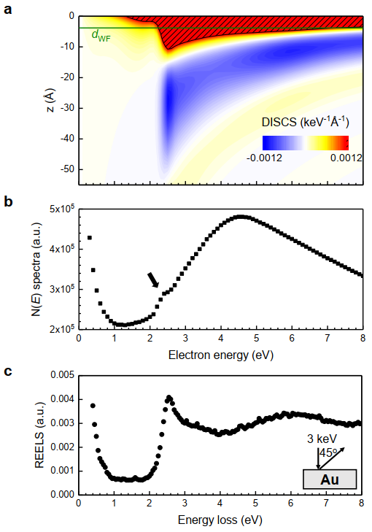
Figure 4. (a) Calculated differential inelastic scattering cross-section (DISCS) of an electron of 50 eV for a vacuum/Au system against energy of an escaping electron from the sample surface to the vacuum. The shaded regions are where the values for the DISCS are larger than 0.0012 keV⁻¹∙Å⁻¹. The corresponding d_{WF} for Au calculated by first-principles is 3.8 Å (olive line). (b) N(E) spectrum calculated by dividing the electron energy by the raw EN(E) spectra measured from bright regions on the polycrystalline Au surface with an incident electron energy of 10 keV. (c) Reflection electron energy loss spectroscopy (REELS) spectrum measured on a bare polycrystalline Au surface (Inset: the experimental geometry).
The differential inelastic scattering cross-section (DISCS) on the vacuum side (z < 0) for Au were calculated (Fig. 4a). Cross-sections with positive values dominate at short distances away from the surface (several angstroms), indicating a high possibility of surface plasmon loss, whereas those cross-sections with negative values, implying plasmon gains, appear at a certain range of distances, generally from several angstroms to several nanometers depending on the electron energy. The main region with negative values is located near 2.3 eV consistent with the energy position of peaks observed in the J_{B} spectra in N(E) mode (Fig. 4b), as highlighted by black arrow. When the electron energy is above 2.3 eV, the negative cross-section region expands and moves away gradually from the Au surface as a function of electron energy, but when the electron energy is below 2.3 eV, the intensity of the negative cross-section of Au decline sharply with decreasing electron energy. This behavior of the negative cross-section region below 2.3 eV is also one reason that the plasmon gain is observed using the Au sample rather than other metallic samples such as Ag and Cu. In comparing the J_{B} spectra partially contributed by plasmon gain and the reflection electron energy loss spectroscopy (REELS) mainly contributed by surface plasmon loss, the REELS spectra for Au (Fig. 4c) and the J_{B} spectra present almost the same spectral features at the surface plasmon energy, even though the mechanisms behind these features—surface plasmon loss in the REELS spectra and plasmon gain in the J_{B} spectra —are completely reversed. When electrons backscattered from the tailor-made polycrystalline Au surface are collected as scattering emission, almost the same spectral features associated with surface plasmons are remarkedly present at both high and low-energy sides mirror-symmetrically, as the form of the plasmon loss features displayed in the spectra and the plasmon gain features are buried in the strong SE background.
We remark that we have verified in experiments that this plasmon gain cannot be significantly observed for normal incidence on a single-crystal Au sample surface. One possible reason is that a planar Au sample possess one characteristic surface plasmon mode, which make the coupling between energetic SEs and excited surface plasmon difficult, because the SEs and surface plasmon should not only satisfy the energy–momentum conservation, but also the component of the electric field in the direction of the electron propagation (longitudinal direction) must be positive to accelerate the electrons [27]. This limitation can be overcome when a Au sample with micro- or nano-scaled structures is employed such that there are multiple modes with size-dependent dispersion that increase the possibility of coupling between energetic SEs and surface plasmon, and thus the plasmon gain becomes observable, as verified here using polycrystalline Au samples. On the basis of this theory, the larger the structural fluctuation of a Au sample is, the stronger the plasmon gain intensity should be observed, and thus, theoretically, a proper sized Au nanoparticle film with high level cleanness may possess a more significant plasmon gain phenomenon than the Au film sample. According to the above analysis, the Au nanoparticles film sample with diameters on a scale of hundreds of nanometers to micrometers, may show strong plasmon gain when using in situ AES technique to ensure their cleanness.
One aspect should be noted. Plasmon gain occurring only in vacuum is one possible reverse reaction associated with electron supersurface scattering [28], in which in vacuum an electron loses a part of its energy in exciting a surface plasmon above the surface of a medium. Therefore, this plasmon gain is the final piece of the puzzle concerning electron–plasmon interactions. Energetic electron loss/gain of energy to/from a plasmon inside a medium corresponds to the conventional plasmon loss/gain, whereas that outside the medium corresponds to electron supersurface scattering or presented plasmon gain.
Finally, compared with plasmon gain for core-level and elastic electrons, that for SEs is more complex because of the participation of the work function. However, from this new perspective, plasmon gain holds the potential to become another means to study the dynamics of surface plasmon generation in metal surfaces, and thereby brings hope in adding a new tool to electron-induced near-field electron microscopy through these ultra-strong signal intensities of SEs that rival those of core-level or elastic electrons.
ASSOCIATED CONTENT
Supporting Information.
The effective distances of the work function of a Au(111) surface and Au(111)-graphene calculated by First-principle calculations, the SEM, EBSD and EBSD-Q images of Au substrate film, the SEM images of few-layer graphene sheets on a Au substrate film, the raw, derivative, and difference spectra measured from bare Au film and few-layer graphene on a Au substrate, and dielectric response calculations of DISCS (PDF).
AUTHOR INFORMATION
Notes
The authors declare no competing financial interests.
ACKNOWLEDGMENT
We thank Prof K. Goto, Prof W. S. M. Werner, Prof S. F. Mao and Dr. Y. G. Li for helpful comments and discussions. This work was supported by the “Materials Research by Information Integration” Initiative (MI2I) Project of the Support Program for Starting Up Innovation Hub from the Japan Science and Technology Agency (JST). K.T. was supported by a Grant-in-Aid (Grant No. 18K18868) from Ministry of Education, Culture, Sports, Science and Technology (MEXT). J.H. was supported by the U.S. Department of Energy (DOE), Office of Science, Office of Basic Energy Sciences under Award DE-SC0019467. Z.J.D was supported by the National Natural Science Foundation of China (Grant No. 11574289).
REFERENCES
- Pines, D.; Bohm, D. A. Collective Description of Electron Interactions: II. Collective vs Individual Particle Aspects of the Interactions. Phys. Rev. 1952, 85, 338-353.
- Bohm, D.; Pines, D. A. Collective Description of Electron Interactions: III. Coulomb Interactions in a Degenerate Electron Gas. Phys. Rev. 1953, 92, 609-625.
- Ritchie, R. H. Plasma Losses by Fast Electrons in Thin Films. Phys. Rev. 1957, 106, 874-881.
- Jenkins, L. H.; Zehner, D. M.; Chung, M. F. Characteristic Energy Gain and Loss, Double Ionization, and Ionization Loss Events in Be and BeO Secondary Electron Spectra. Surf. Sci. 1973, 38, 327-340.
- Suleman, M.; Pattison, E. B. Observation of a Plasmon-Gain in the Fine Structure of the Aluminium Auger Spectrum. J. Phys. F: Metal Phys. 1971, 1, L21-L24.
- Powell, B. D.; Woodruff, D. P. Plasmon Effects in Electron Energy Loss and Gain Spectra in Aluminium. Surf. Sci. 1972, 33, 437-444.
- Barrie, A.; Street, F. J. An Auger and X-ray Photoelectron Spectroscopic Study of Sodium Metal and Sodium Oxide. J. Electron Spectrosc. Relat. Phenom. 1975, 7, 1-31.
- Matthew, J. A. D.; Watts, C. M. K. The Mechanism of Plasmon Gain in Auger Spectra. Phys. Lett. A 1971, 37, 239-240.
- Fuggle, J. C.; Watson, L. M.; Fabian, D. J.; Affrossman, S. X-ray Excited Auger and Photoelectron Spectra of Magnesium, Some Alloys of Magnesium and Its Oxide. J. Phys. F: Metal Phys. 1975, 5, 375-83.
- Abo-Namous, S. A.; Andrews, P. T.; Johnson, C. E. Plasmon Loss and Plasmon Gain in Mg-Cd Alloys. J. Phys. F: Metal Phys. 1979, 9, 61-70.
- Shung, K. W. K.; Langreth, D. C. Dynamical KLL Auger Process in Simple Metals and Their Plasmon Gain Satellites. Phys. Rev. B 1983, 28, 4976-4992.
- Schilling, J.; Raether, H. Energy Gain of Fast Electrons Interacting with Surface Plasmons. J. Phys. C: Solid State Phys. 1973, 6, L358-L360.
- Barwick, B.; Flannigan, D. J.; Zewail, A. H. Photon-Induced Near-Field Electron Microscopy. Nature 2009, 462, 902-906.
- Werner, W. S. M.; Ruocco, A.; Offi, F.; Iacobucci, S.; Smekal, W.; Winter, H.; Stefani, G. Role of Surface and Bulk Plasmon Decay in Secondary Electron Emission. Phys. Rev. B 2008, 78, 233403.
- Werner, W. S. M.; Salvat-Pujol, F.; Smekal, W.; Khalid, R.; Aumayr, F.; Störi, H.; Ruocco, A.; Offi, F.; Stefani, G.; Iacobucci, S. Contribution of Surface Plasmon Decay to Secondary Electron Emission from an Al Surface. Appl. Phys. Lett. 2011, 99, 184102.
- Werner, W. S. M.; Salvat-Pujol, F.; Bellissimo, A.; Khalid, R.; Smekal, W.; Novak, M.; Ruocco, A.; Stefani, G. Secondary-Electron Emission Induced by in vacuo Surface Excitations near a Polycrystalline Al Surface. Phys. Rev. B 2013, 88, 201407(R).
- Takeichi, Y.; Goto, K. True Auger Electron Spectra Measured with a Novel Cylindrical Mirror Analyser (Au, Ag and Cu). Surf. Interface Anal. 1997, 25, 17-24.
- Yin, L.; Vlasko-Vlasov, V. K.; Rydh, A.; Pearson, J.; Welp, U. Surface Plasmons at Single Nanoholes in Au Films. Appl. Phys. Lett. 2004, 85, 467-469.
- Genet, C.; Ebbesen, T. W. Light in Tiny Holes. Nature 2007, 445, 39-46.
- Link, S.; El-Sayed, M. A. Spectral Properties and Relaxation Dynamics of Surface Plasmon Electronic Oscillations in Gold and Silver Nanodots and Nanorods. J. Phys. Chem. B 1999, 103, 8410-8426.
- Jain, P. K.; Huang, W.; El-Sayed, M. A. On the Universal Scaling Behavior of the Distance Decay of Plasmon Coupling in Metal Nanoparticle Pairs: a Plasmon Ruler Equation. Nano Lett. 2007, 7, 2080-2088.
- Venghaus, H. Redetermination of the Dielectric Function of Graphite. Phys. Stat. Sol. (b) 1975, 71, 609-614.
- Palik, E. D. Handbook of Optical Constants of Solids; Academic Press: New York; 1985.
- Powell, C. J.; Jablonski, A. Electron Effective Attenuation Lengths for Applications in Auger Electron Spectroscopy and X-ray Photoelectron Spectroscopy. Surf. Interface Anal. 2002, 33, 211-229.
- Da, B. et al. Virtual Substrate Method for Nanomaterials Characterization. Nature Commun. 2017, 8, 15629.
- Salvat-Pujol, F.; Werner, W. S. M. Surface Excitations in Electron Spectroscopy. Part I: Dielectric Formalism and Monte Carlo Algorithm. Surf. Interface Anal. 2013, 45, 873-894.
- Park, S. T.; Lin, M.; Zewail, A. H. Photon-Induced Near-Field Electron Microscopy (PINEM): Theoretical and Experimental. New J. Phys. 2010, 12, 123028.
- Werner, W. S. M.; Novak, M.; Salvat-Pujol, F.; Zemek, J.; Jiricek, P. Electron Supersurface Scattering on Polycrystalline Au. Phys. Rev. Lett. 2013, 110, 086110.

