Development of high performance permanent magnets;
elements criticality, new demands, and extrinsic magnetic properties
H. Sepehri-Amin*, Xin Tang, J. S. Zhang, A. Bolyachkin, T. Ohkubo, K. Hono
National Institute for Materials Science, 1-2-1 Sengen, Tsukuba, 305-0047, Japna
*h.sepehriamin@nims.go.jp

Permanent magnets are widely used in green energy conversion applications. They therefore play an important role in achieving net-zero CO₂ emissions in our society. In order to maintain sustainable production of permanent magnets in the long term, it is necessary to eliminate the dependence of permanent magnets on critical elements such as Dy and to diversify the use of rare earths while maintaining sufficiently high coercivity and energy product in the magnets.
We will first present our fundamental research on the coercivity mechanism of Nd-Fe-B based permanent magnets which has provided us guideline to develop high coercivity Dy-free Nd-Fe-B magnets for applications in hybrid/electric vehicle traction motors and wind turbine generators. We will show how grain boundary/interface engineering in the hot formed Nd-Fe-B magnets has resuled in a high coercivity of 2.5 T, a remanent magnetisation of 1.32 T and excellent thermal stability of the coercivity [1]. Furthermore, it is discussed how the emergence of new applications for the permanent magnets has opened up new requirements, i.e. moderate room temperature coercivity and flat first order reversal curves for their applications in variable-magnetic-force motors, which can be achieved by reducing the grain size and using light rare earths in the hot-deformed (Nd,Ce,La)-Fe-B permanent magnets [2].
In the second part of the talk, we will discuss the potential of Fe-rich SmFe₁₂ based magnets [3], and the current challenges to realise these materials as new permanent magnets [4-5].We will show our recent success in realising a sufficiently large coercivity of 1.0 T in rare earth lean SmFe₁₂ based anisotropic sintered magnets (Fig. 1) assisted by machine learning [6]. Based on detailed microstructural characterisations, modelled thin films and micromagnetic simulations, the optimal microstructure that can lead to higher coercivity and remanent magnetisation in the SmFe₁₂-based magnets will be discussed.
References
[1] M. Korent et al. Scripta Mater. 205 (2021) 114206.
[2] X. Tang, H. Sepehri-Amin, et al. Acta Mater. 228 (2022) 117747.
[3] K. Ohashi et al. J. Appl. Phys. 64 (1988) 5714-5716.
[4] P. Tozman, H. Sepehri-Amin, et al. Acta Mater. 153 (2018) 354.
[5] H. Sepehri-Amin et al. Acta Mater. 194 (2020) 337.
[6] J.S. Zhang et al. Acta Mater. 238 (2022) 118228.

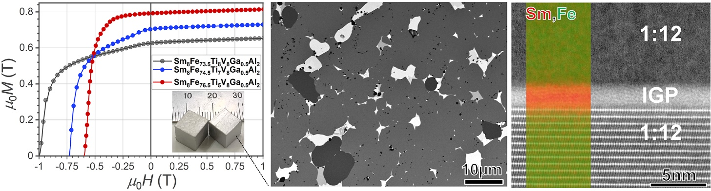
Figure 1: Realizing coercvity in anisotropic Sm(Fe,Ti,V)₁₂-based sintered magnets; demagnetization curves of Sm₈Fe_{73.5+x}Ti_{8-x}V₈Ga_{0.5}Al₂ at. % (x=0-3) sintered magnets, and backscattered electron (BSE) SEM image, high-angle annular dark-field (HAADF) scanning transmission electron microscopy (STEM) image, and superimposed STEM-EDS maps of Sm and Fe showing the overal microstructure of the magnet with coercivity of 1.0 T.

