Description

Dataset of B2-structured ternary alloys for magnetic moment, Curie temperature, and spin polarization calculated by KKR-CPA (AkaiKKR)
Yuma Iwasakiª
ª Center for Basic Research on Materials, National Institute for Materials Science, Tsukuba, Japan
*E-mail: IWASAKI.Yuma@nims.go.jp

ORCID
Yuma Iwasaki: 0000-0002-7117-277X

Datasets and high-throughput DFT calculation
To collect the data of magnetic ternary alloys with B2 structure, we made high-throughput ab initio calculations—density functional theory (DFT) calculations based on Green’s function—using the Korringa–Kohn–Rostoker coherent-potential approximation (KKR-CPA) method implemented in the AkaiKKR software [1-3]. Multi-elemental disordered phases can be calculated using CPA, which can simulate them with high accuracy, especially in alloy systems [4-6].
The B2 crystal structure is shown in Figure 1(a), comprising two different sites denoted as X and Y in red and blue, respectively. The X and Y sites are populated by elements from the red and blue regions of the periodic table, respectively, as illustrated in Figure 1(b). X sites are populated by one or two elements selected from {Li, Mg, Ti, V, Mn, Fe, Co, Ni, Cu, Ru, Rh, Pd, Ag, Cd, Ir, Pt, and Au}, while Y sites are populated by one or two elements selected from {Li, Be, B, Mg, Al, Si, Sc, Ti, V, Cr, Mn, Fe, Co, Ni, Cu, Zn, Ga, Ge, As, Y, Zr, Nb, Mo, Ru, Ag, In, Sn, Sb, Hf, Ta, W, Pt, and Pb}. One of these sites is disordered and contains two elements (atom1 and atom2 in the csv file), whereas the other site contains one element (atom3 in the csv file). Consequently, the ternary alloys are represented as $X_{1-x}^{1}X_{x}^{2}Y_{1}^{}$ and $X_{1}^{}Y_{1-x}^{1}Y_{x}^{2}$, where x denotes the composition in 0.2 increments. For instance, when two elements (e.g. Fe and Rh) are selected and disordered for the X site, only one element (e.g. Al) is selected for the Y site, the resulting ternary alloys are represented as Fe_{1-x}Rh_{x}Al. This study only considers ternary alloys containing either Fe, Co, or Ni elements and thus comprises a dataset of approximately 17,000 magnetic ternary alloys.
Lattice constants were determined to minimize the total energy. In the lattice constant optimization calculations, the spin–orbit interactions and relativistic effects were not considered. Therefore, the reltyp parameter was set to nrl. The imaginary part at the Fermi level (edelt) was set to 0.001. The bzqlty parameter, which determines the quality of the Brillouin zone mesh, was set to 3. The maximum considered angular momentum (xml) was 2. The exchange–correlation potential (sdftyp) was set to the local density approximation (mjw). The maximum number of iteration loops (maxitr) was set to 300. For the optimum lattice constant, high-precision DFT calculations were performed. In this calculation, the spin–orbit interaction and relativistic effects were considered. Therefore, the reltyp parameter was set to srals. The edelt, bzqlty, xml, and maxitr were set to 0.001, 6, 2, and 500, respectively. The lower end of the energy contour should not be on the core electrons nor on the valence electrons. Therefore, we first set the width of the energy contour (ewidth parameter) to a small value (i.e., 1) and verify that the lower edge of the energy contour is neither on the core electrons nor on the valence electrons. If the lower edge of the energy contour is on the core electrons or on the valence electrons, increase the value of ewidth slightly and verify again. According to this routine, the ewidth parameters were decided. If the ewidth can not be determined with this routine, the material has been removed from the datasets.
Based on the density of states (DoS) obtained from DFT calculations, magnetic moment M and spin polarization S were calculated. The S is represented by the following equation:
$$S=\frac{n^{↑}-n^{↓}}{n^{↑}+n^{↓}},$$
where n↑ and n↓ are the up spin and down spin DoS at Fermi energy, respectively. The Curie temperature T_{c} was estimated using the following equation:
$$T_{c}=\frac{2}{3}\frac{\left(E_{fmg}-E_{lmd}\right)}{nck_{B}},$$
where E_{fmg}, E_{lmd}, k_{B}, c and n are the total energy of ferromagnetic states, local moment disorder (LMD) states [7], Boltzmann constant, concentration of magnetic atoms, and number of sublattices, respectively. LMD calculation for some materials did not converge, therefore, they were removed from the datasets used in previous study [8].
There are a lot of high-throughput calculation databases such as AFLOW [9] and Materials Project [10]. The high-throughput calculation systems automatically and exhaustively perform ab-initio simulation. Therefore, not all materials in the datasets may be the most stable and synthesizable.

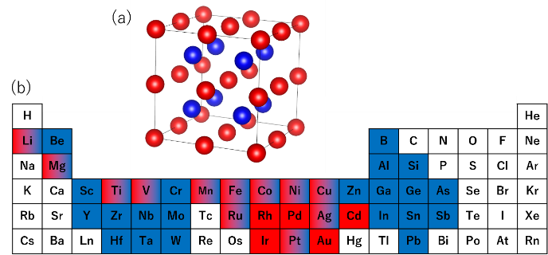
Figure 1. B2-structured ternary alloy. (a) The B2 crystal structure, which comprises two different sites denoted as X and Y in red and blue, respectively. (b) A periodic table representing the elements of X and Y sites. One of these sites is disordered and contains two elements, whereas the other site remains fixed.

References
[1] Akai H. Electronic structure Ni-Pd alloys calculated by the self-consistent KKR-CPA method. J Phys Soc Jpn. 1982;51:468–474.
[2] Akai H, Fast Korringa-Kohn-Rostoker coherent potential approximation and its application to FCC Ni-Fe systems. J Phys: Condens Matter. 1989;1:8045-8063
[3] AkaiKKR (machikaneyama), Ab-initio electronic-structure calculation code. http://kkr.issp.u-tokyo.ac.jp
[4] Khan SN, Staunton JB, Stocks GM. Statistical physics of multicomponent alloys using KKR-CPA. Phys Rev B. 2016;93:054206.
[5] Yang L, Liu B, Luo H, et al. Investigation of the site preference in Mn₂RuSn using KKR-CPA-LDA calculation. J Magn Mater. 2015;382(15):247–251.
[6] Jin K, Sales BC, Stocks GM, et al. Tailoring the physical properties of Ni-based single-phase equiatomic alloys by modifying the chemical complexity. Sci Rep. 2016;6:20159.
[7] Akai H, Dederichs PH. Local moment disorder in ferromagnetic alloys. Phys Rev B. 1993;47:8739-8747
[8] Jaekyun H, Iwasaki Y. Improving efficiency of autonomous material search via transfer learning from nontarget properties. Sci Technol Adv Mater: Methods. 2023;3(1):2254202.
[9] Curtarolo S, Setyawan W, Hart GLW, et al. AFLOW: An automatic framework for high-throughput materials discovery. Comput Mater Sci. 2012;58:218-226
[10] Jain A, Ong SP, Hautier G, et al. Commentary: The Materials Project: A materials genome approach to accelerating materials innovation. APL Mater. 2013;1(011002)

